**Valuation Report of the Immovable Property**

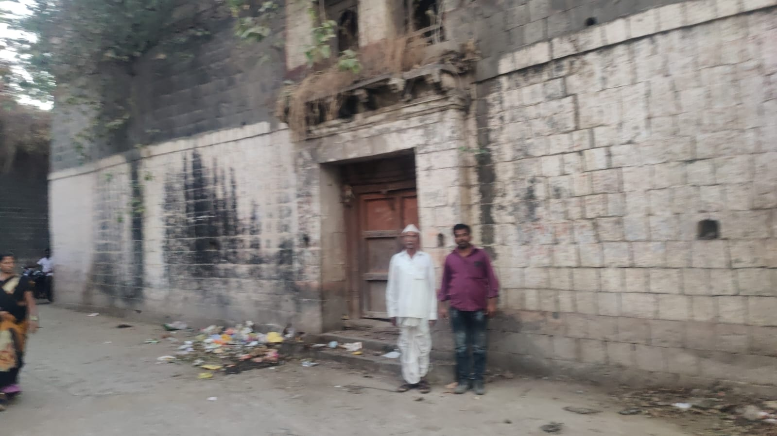

**Details of the property under consideration:**

Name of Owner: **Mr. Vijaykumar Vyankati Mahajan & Other**

Residential House No.156/1, Mahadev Mandir Road, Ward No 09, Mukhed, Taluka – Mukhed,

District – Nanded, Pin Code – 431715, State - Maharashtra, Country – India.

**Latitude Longitude - 18°42'08.4"N 77°21'51.3"E**

**Intended Users:**

**Mr. Vijaykumar Vyankati Mahajan**

**R/O Mahajan Niwas, Kaliji Tekadi Road, Old Mondha, Nanded - 431601**

Vastu/Mumbai/05/2024/013814/2310240

25/21-359-SPAS

Date: 24.01.2024

**VALUATION OPINION REPORT**

This is to certify that the property Residential House No.156/1, Mahadev Mandir Road, Ward No 09, Mukhed, Taluka – Mukhed, District – Nanded, Pin Code – 431715, State - Maharashtra, Country – India belongs to **Mr. Vijaykumar Vyankati Mahajan & Other.**

|  |  |
| --- | --- |
| Boundaries of the property. | |
| North | House of Shetkar |
| South | Road |
| East | Road |
| West | House of Sainath Kodgire |

Considering various parameters recorded, existing economic scenario, and the information that is available with reference to the development of neighbourhood and method selected for valuation, we are of the opinion that, the property premises can be assessed and valued for **Immigration Visa Application** purpose at

|  |  |  |  |  |
| --- | --- | --- | --- | --- |
|  | **Full House Value**  **In ₹** | **In US$** | **50% Value in ₹ (Consider for Valuation)** | **50% Value in US$ (Consider for Valuation)** |
| Value of the Property – FMV | **30,00,000.00** | 34,765.00 | 15,00,000 | 17,382.50 |
| Realizable Value (90%) | **27,00,000.00** | 31,288.50 | 13,50,000 | 15,644.25 |
| Distress Value (80%) | **24,00,000.00** | 27,812.00 | 12,00,000 | 13,906.00 |

**In ` 15,00,000.00 (Rupees Fifteen Lakh Only).**

**In US$ 17,382.50 (United State Doller Seventeen Thousand Three Hundred Eighty Two Only).**

**Note: at conversion rate of 1 Indian Rupee equals to 0.012 United States Dollar as on 24.01.2025**

The valuation of the property is based on the documents produced by the concern. Legal aspects have not been taken into considerations while preparing this report.

Hence certified

**Sharadkumar B. Chalikwar**

B.E. (Civil), M.E. (Civil), M.Sc. (Real Estate Valuation),

M.Sc. (P&M Valuation), FIE (I), FIV, FIWRS

Chairman & Managing Director

Govt. Reg. Valuer

Chartered Engineer (India)

Reg. No. (N) CCIT/1-14/52/2008-09

Reg No. IBBI/RV/07/2019/11744

Encl: Valuation report

**VALUATION REPORT IN RESPECT OF IMMOVABLE PROPERTY**

|  |  |  |  |  |  |
| --- | --- | --- | --- | --- | --- |
| 1 | Date of Inspection | | 20.01.2025 | | |
| 2 | Purpose of valuation | | As per the request from Mr. Vijaykumar Vyankati Mahajan, to assess Fair Market Value of the property under reference for **Immigration Visa Application** purpose | | |
| 3 | Name and address of the Valuer | | **Sharadkumar B. Chalikwar**  **Vastukala Consultants (I) Pvt. Ltd.**  28, Stadium Complex, Gokul Nagar, Nanded – 431 602.  Email: nanded@vastukala.co.in | | |
| 4 | List of Documents Handed Over to The Valuer By The Customer:   1. Copy of Court order for Property Tax No. O.N.163/NPM/2019 issued by Nagar Parishad Mukhed, dated 13.11.2019. 2. Copy of Property Tax receipt No 760/005, issued by Mukhed Nagar Parishad, dated 13.11.2019. | | | | |
| 5 | Details of enquiries made/ visited to government offices for arriving fair market value. | | Market analysis | | |
| 6 | Factors for determining its market value. | | Location, development of surrounding area, type of construction, construction specifications, age of building, condition of the premises & building, facilities provided and its prevailing market rate. | | |
| 7 | ANY CRITICAL ASPECTS ASSOCIATED WITH PROPERTY | | No | | |
| 8 | Present/Expected Income from the property | | ` 6,250.00 Expected rental income per month.  US$ 72.43 Expected rental income per month. | | |
|  | **Property Details** | |  | | |
| 9 | Name(s) of the Owner | | **Mr. Vijaykumar Vyankati Mahajan & Other** | | |
|  | Address | | Residential House No.156/1, Mahadev Mandir Road, Ward No 09, Mukhed, Taluka – Mukhed, District – Nanded, Pin Code – 431715, State - Maharashtra, Country – India. | | |
| 10 | If the property is under joint ownership/ co-ownership share of each such owner/ are the share is undivided. | | 50% ownership Share of the house owned by joint ownership. | | |
| 11 | Brief description of the property. | | The property is a Residential House of Ground + 1st Floor. It is at 1.3 Km. walkable distance from Mukhed Bus Stop. | | |
|  | **If under construction, extent of completion** | | **N.A.** | | |
| 12 | Location of the property (C.T.S. No., Survey No., Hissa No., Plot No., etc.). | | M. H. No. 156/1 of Village – Mukhed | | |
| 13 | **Boundaries** | | **As on site** | **As per documents** | |
|  | North | | House of Shetkar | Details not available | |
|  | South | | Road | Details not available | |
|  | East | | Road | Details not available | |
|  | West | | House of Sainath Kodgire | Details not available | |
| 14 | Matching of Boundaries | | - | | |
| 15 | Route map | | Enclosed | | |
| 16 | Any specific identification marks | | NA | | |
| 17 | Whether covered under Corporation/ Panchayat / Municipality. | | Nagar Parishad Mukhed | | |
| 18 | Whether covered under any land ceiling of State/ Central Government. | | No | | |
| 19 | Is the land freehold/ leasehold. | | Freehold | | |
| 20 | Are there any restrictive covenants in regard to use of Land? If so attach a copy of the covenant. | | NA | | |
| 21 | Type of the property | | Residential | | |
| 22 | Year of acquisition/ purchase. | | Old ancestors’ property | | |
| 23 | Purchase value as per document | | N.A. | | |
| 24 | Whether the property is occupied by owner or tenant. If occupied by tenant since how long he is staying and the amount of rent being paid. | | Under owner’s possession | | |
| 25 | Classification of the site | |  | | |
|  | 1. Population group | | Rural | | |
|  | 1. High/ Middle/ Poor class | | Middle Class | | |
|  | 1. Residential / Commercial | | Residential | | |
|  | 1. Development of surrounding area | | Developing | | |
|  | 1. Possibility of any threat to the property (Floods, calamities etc.). | | No | | |
| 26 | Proximity of civic amenities (like school, hospital, bus stop, market etc.). | | Near By | | |
| 27 | Level of the land (Plain, rock etc.) | | Plain | | |
| 28 | Terrain of the Land. | | Levelled | | |
| 29 | Shape of the land (Square/ rectangle etc.). | | Irregular | | |
| 30 | Type of use to which it can be put (for construction of house, factory etc.). | | Residential House | | |
| 31 | Whether the plot is under town planning approved layout? | | Information not Available | | |
| 32 | Whether the building is intermittent or corner? | | Intermittent | | |
| 33 | Whether any road facility is available? | | Yes | | |
| 34 | Type of road available (B.T/Cement Road etc.). | | B.T. Road | | |
| 35 | Front Width of the Road? | | 9.00 M. Wide Road | | |
| 36 | Source of water & water potentiality. | | Nagar Parishad Water Supply | | |
| 37 | Type of Sewerage System. | | Connected to Nagar Parishad Sewerage System | | |
| 38 | Availability of power supply. | | Yes | | |
| 39 | Advantages of the site. | | Located in developing area | | |
| 40 | Disadvantages of the site. | | No | | |
| 41 | Give instances of sales of immovable property in the locality on a separate sheet, indicating the name & address of the property, registration No. sale price and area of land sold. | | No | | |
|  | **Valuation of the property:** | | | | |
| 42 | Total area of the Residential House | | **Built Up Area in Sq. Ft. = 2,800.00**  **(Area as per Site Measurement)** | | |
| 43 | Prevailing market rate. | | ` 1,071.00 per Sq. Ft. on Built Up Area | | |
| 44 | Floor Rise Rate per Sq. Ft. | | ` 0.00 | | |
| 45 | PLC Rate per Sq. Ft. | | ` 0.00 | | |
| 46 | Total Rate per Sq. Ft. | | ` 1,071.00 per Sq. Ft. on Built Up Area | | |
| 47 | Value of the property | | **As per Valuation Table below** | | |
| 48 | The realizable value of the property (90%) | | **As per Valuation Table below** | | |
| 49 | Distress value of the property (80%) | | **As per Valuation Table below** | | |
| 50 | Insurable value of the property | | **As per Valuation Table below** | | |
|  | |  |  |  |  |  | | --- | --- | --- | --- | --- | |  | **Full House Value**  **In ₹** | **In US$** | **50% Value in ₹ (Consider for Valuation)** | **50% Value in US$ (Consider for Valuation)** | | Value of the Property – FMV | **30,00,000.00** | 34,765.00 | 15,00,000 | 17,382.50 | | Realizable Value (90%) | **27,00,000.00** | 31,288.50 | 13,50,000 | 15,644.25 | | Distress Value (80%) | **24,00,000.00** | 27,812.00 | 12,00,000 | 13,906.00 | | | | | |
|  | **Technical details of the building:** | | | | |
| 51 | Type of building (Residential/ Commercial/ Industrial). | | Residential | | |
| 52 | Year of construction. | | Old Ancestor Property (As per site information) | | |
| 53 | Future life of the property. | | Information Not Available | | |
| 54 | No. of floors and height of each floor including basement. | | Ground + 1 Upper Floor | | |
|  | **Type of construction** | | | | |
| 55 | (Load bearing/ R.C.C./ Steel framed) | | Load Bearing Structure | | |
|  | **Condition of the building.** | | | | |
| 56 | External (excellent/ good/ normal/ poor) | | Normal | | |
| 57 | Internal (excellent/ good/ normal/ poor). | | Normal | | |
| 58 | Whether the Residential House is constructed strictly according to the sanctioned plan, details of variations noticed if any and effect of the same on the valuation | | Copy of Approved Building plans were not provided and not verified. | | |
| 59 | **Remarks** | 1. **This Property have two owners, as per court order Vijaykumar Mahajan is having 50% share of ownership of this house because of that we have considered only 50% value for valuation.** | | | |
|  | **Specifications of Construction:** | | | | |
| **sr.** | **Description** | | **Ground & First Floor** | | |
| A | Foundation | | Load Bearing Structure | | |
| B | Basement | | No | | |
| C | Superstructure | | Load Bearing Structure with Stone Walls of Approx 2 Feet Width. | | |
| D | Joinery/Doors/Windows | | Stone door framed with Wooden doors; Wooden Framed windows with Panel Doors. | | |
| E | RCC Work | | No | | |
| F | Plastering | | No | | |
| G | Flooring, Skirting | | No | | |
| H | Kitchen Platform | | Granite kitchen platform | | |
| I | Whether any proof course is provided? | | No | | |
| J | Drainage | | Connected to Nagar Parishad Sewerage System | | |
| K | Compound Wall (Height, length and type of construction) | | No | | |
| L | Electric Installation (Type of wire, Class of construction) | | Open | | |
| M | Plumbing Installation (No. of closets and wash basins etc.) | | Open | | |
| N | Bore Well | | Not Provided | | |
| O | Wardrobes, if any | | No | | |
| P | Development of open area | | No | | |
|  | **Valuation of proposed construction/ additions/ renovation if any:** | | | | |
| 60 | **SUMMARY OF VALUATION:** | |  | | |
|  | Part I Land | | N.A. as composite method is used for valuation | | |
|  | Part II Building | | ` 30,00,000.00 | | US$ 34,765.00 |
|  | **We Consider 50% Value of Building** | | **₹ 15,00,000.00** | | **US$ 17,382.50** |
|  | Part III Other amenities/ Miscellaneous | | ` 0.00 | | |
|  | Part IV Proposed construction | | ` 0.00 | | |
|  | **TOTAL.** | | **` 15,00,000.00** | | **US$ 17,382.50** |
|  | **Calculation:** | | | | |
| **1** | **Construction** | |  | | |
| 1.01 | Built up Area of Residential House | | 2,800.00 Sq. Ft. | | |
| 1.02 | Rate per Sq. Ft. | | NA | | |
| 1.03 | Cost of Construction = (1.01x1.02) | | NA | | |
| **2** | **Value of property** | |  | | |
| 2.01 | Built Up Area of Residential House | | 2,800.00 Sq. Ft. | | |
| 2.02 | Rate per Sq. Ft. | | ` 1,071.00 | | |
| 2.03 | Value of Residential House = (2.01x2.02) | | **` 30,00,000.00** | | **US$ 34,765.00** |
| **3** | Total value of the property. | | ` 30,00,000.00 | | US$ 34,765.00 |
|  | **We Consider 50% Value of Building** | | **₹ 15,00,000.00** | | **US$ 17,382.50** |

I certify that,

I/ my authorized representative has inspected the subject property on 20.01.2024.

The rates for valuation of the property are in accordance with the prevailing market rates.

There is no direct/ indirect interest in the property valued.

The fair value of the property as on 24.01.2025 is

|  |  |  |  |  |
| --- | --- | --- | --- | --- |
|  | **Full House Value**  **In ₹** | **In US$** | **50% Value in ₹ (Consider for Valuation)** | **50% Value in US$ (Consider for Valuation)** |
| Value of the Property – FMV | **30,00,000.00** | 34,765.00 | 15,00,000 | 17,382.50 |
| Realizable Value (90%) | **27,00,000.00** | 31,288.50 | 13,50,000 | 15,644.25 |
| Distress Value (80%) | **24,00,000.00** | 27,812.00 | 12,00,000 | 13,906.00 |

**In ` 15,00,000.00 (Rupees Fifteen Lakh Only).**

**In US$ 17,382.00 (United State Doller Seventeen Thousand Three Hundred Eighty Two Only).**

**Note: at conversion rate of 1 Indian Rupee equals to 0.012 United States Dollar as on 24.01.2025**

Date: 24.01.2025

Place: Nanded

**Sharadkumar B. Chalikwar**

B.E. (Civil), M.E. (Civil), M.Sc. (Real Estate Valuation),

M.Sc. (P&M Valuation), FIE (I), FIV, FIWRS

Chairman & Managing Director

Govt. Reg. Valuer

Chartered Engineer (India)

Reg. No. (N) CCIT/1-14/52/2008-09

Reg No. IBBI/RV/07/2019/11744

**Actual site photographs**



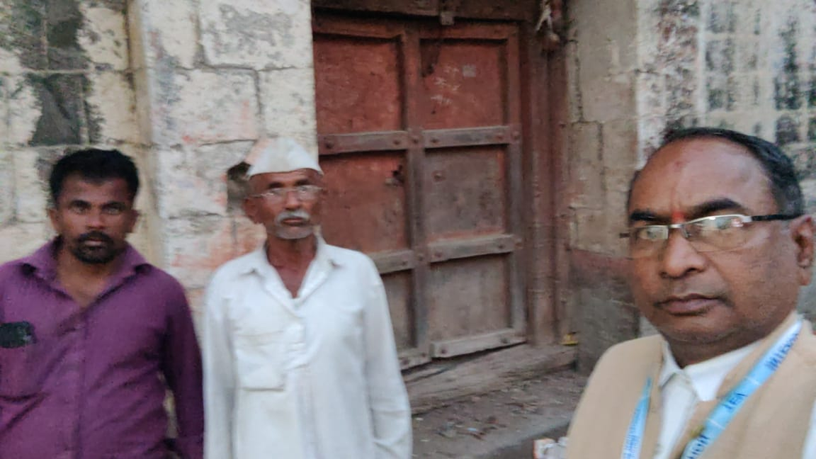

**Route Map of the property**

**Site u/r**

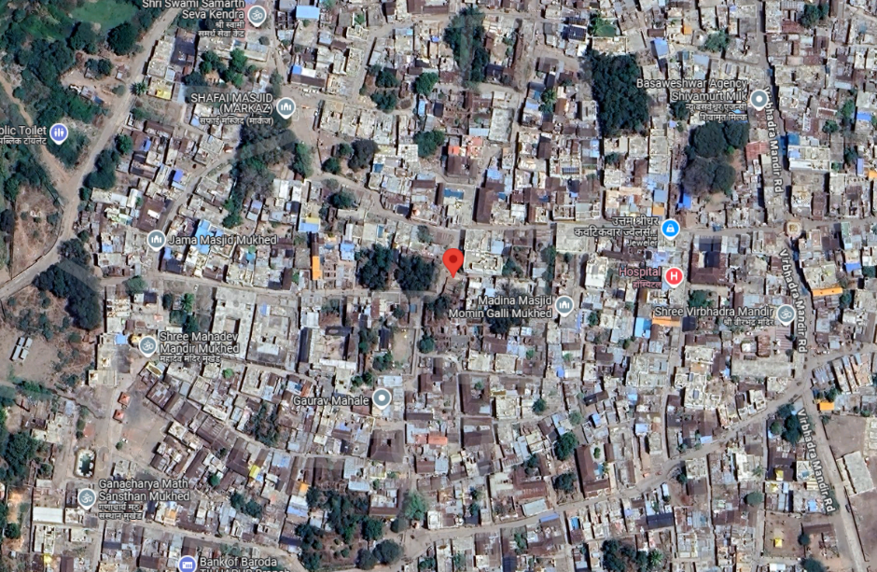

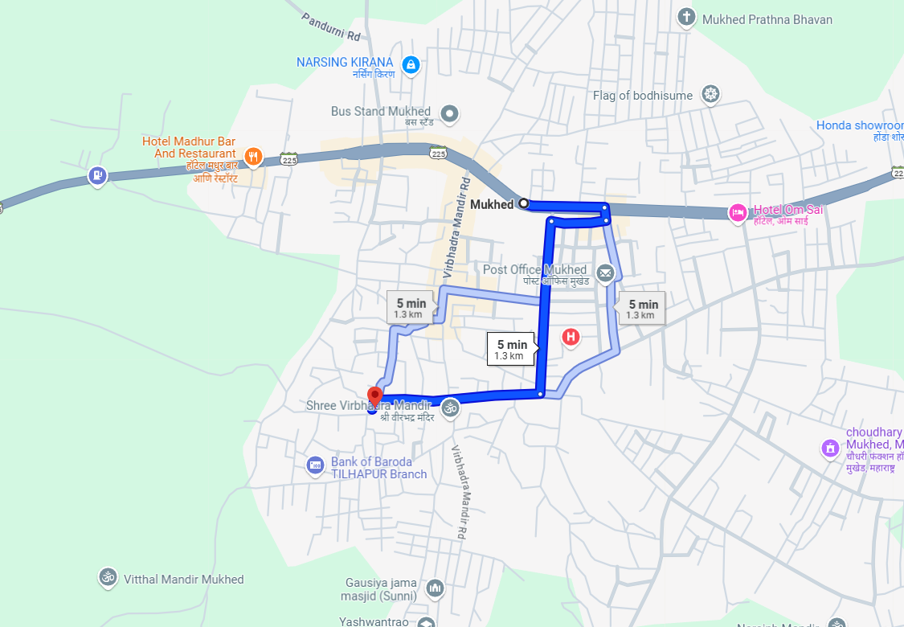

**Latitude Longitude - 18°42'08.4"N 77°21'51.3"E**

**Note**: The Blue line shows the route to site from nearest BUS station – (Mukhed– 1.3 KM)

**Currency Rate**

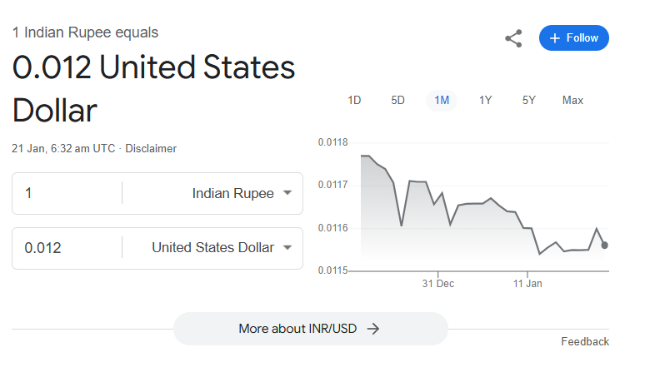

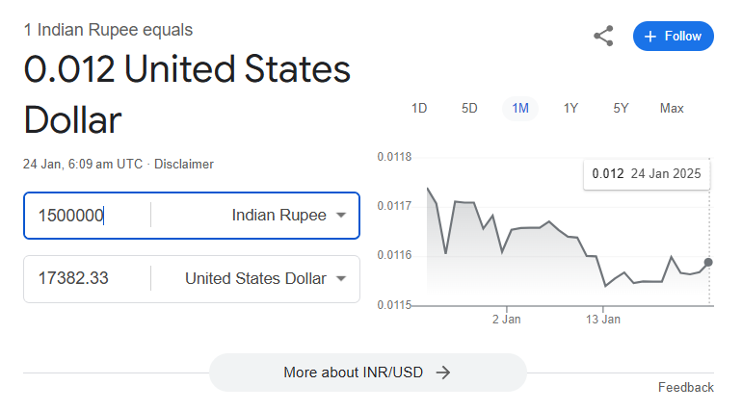

**DEFINITION OF VALUE FOR THIS SPECIFIC PURPOSE**

This exercise is to assess Fair Market Value of the property under reference for **Immigration Visa Application** purpose as on dated **24th January 2025.**

The term Fair Market Value is defined as

*"The most probable price, as of a specified date, in cash, terms equivalent to cash, or in other precisely revealed terms for which the specified property rights would sell after reasonable exposure in a competitive market under all conditions requisite to a fair sale, with the buyer and seller each acting prudently knowledgeably and for self-interest assuming that neither is under undue duress"*

Fundamental assumptions and conditions presumed in this definition are:

1. Buyer and seller are motivated by self-interest.
2. Buyer and seller are well informed and are acting prudently.
3. The property is exposed for a reasonable time on the open market.
4. Payment is made in cash or equivalent or in specified financing terms.

**ASSUMPTIONS, CAVEATS, LIMITATION AND DISCLAIMERS**

1. We assume no responsibility for matters of legal nature affecting the property appraised or the title thereto, nor do we render our opinion as to the title, which is assumed to be good and marketable.
2. The property is valued as though under responsible ownership.
3. It is assumed that there are no hidden or unapparent conditions of the subsoil or structure that would render it more or less valuable. No responsibility is assumed for such conditions or for engineering that might be required to discover such factors.
4. There is no direct/ indirect interest in the property valued.
5. The rates for valuation of the property are in accordance with the prevailing market rates.

**DECLARATION OF PROFESSIONAL FEES CHARGED**

We hereby declare that; our professional fees are not contingent upon the valuation findings. However, if the statute AND/OR clients demand that, the fees should be charged on the percentage of assessed value then, with the full knowledge of the AND/OR end user, it is being charged accordingly.

**VALUATION OF THE PROPERTY PREMISES**

Considering various parameters recorded, existing economic scenario, and the information that is available with reference to the development of neighbourhood and method selected for valuation, we are of the opinion that, the property premises can be assessed and valued for the specific purpose at

|  |  |  |  |  |
| --- | --- | --- | --- | --- |
|  | **Full House Value**  **In ₹** | **In US$** | **50% Value in ₹ (Consider for Valuation)** | **50% Value in US$ (Consider for Valuation)** |
| Value of the Property – FMV | **30,00,000.00** | 34,765.00 | 15,00,000 | 17,382.50 |
| Realizable Value (90%) | **27,00,000.00** | 31,288.50 | 13,50,000 | 15,644.25 |
| Distress Value (80%) | **24,00,000.00** | 27,812.00 | 12,00,000 | 13,906.00 |

**In ` 15,00,000.00 (Rupees Fifteen Lakh Only).**

**In US$ 17,382.50 (United State Doller Seventeen Thousand Three Hundred Eighty Two Only).**

**Note: at conversion rate of 1 Indian Rupee equals to 0.012 United States Dollar as on 24.01.2025**

**Sharadkumar B. Chalikwar**

B.E. (Civil), M.E. (Civil), M.Sc. (Real Estate Valuation),

M.Sc. (P&M Valuation), FIE (I), FIV, FIWRS

Chairman & Managing Director

Govt. Reg. Valuer

Chartered Engineer (India)

Reg. No. (N) CCIT/1-14/52/2008-09

Reg No. IBBI/RV/07/2019/11744