COST VETTING REPORT
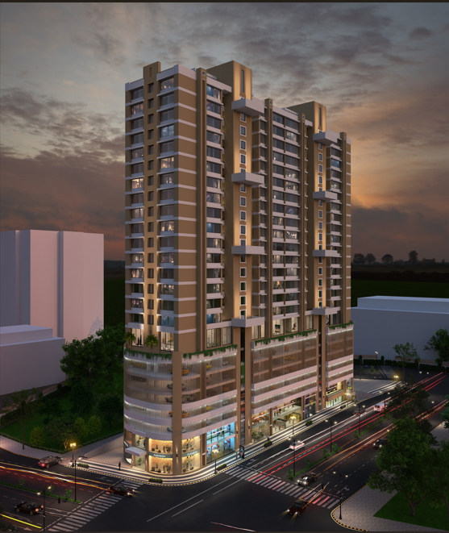

Details of the property under consideration:

Name of Project: "Munisuvrat Oasis"

"Munisuvrat Oasis", Proposed Residential Cum Commercial Building on plot bearing S. No. 124/125/159/161(Pt), 125/5/125/7/125/9 (Pt), 126/3/2 (Pt), 161/3/2 (Pt) and 161/3/1/D(Pt), Village – Kamatghar, Taluka – Bhiwandi, District – Thane, PIN – 421 302, Maharashtra, India.

Latitude Longitude: 19°16'29.4"N 73°02'48.1"E

Intended User:
State Bank of India
Wagle Ind. Est. Branch
Regional Business Office, Region-II, Wagle Ind. Area, Plot No. B-35, 2nd Floor,
Wagle Circle, Thane (West) - 400 604, Maharashtra, India.

Vastu/SBI/Mumbai/02/2025/13374/2310029
13/09-148-PY
Date: 10.02.2025

To,
The Branch Manager,
State Bank of India
Wagle Ind. Est. Branch
Regional Business Office, Region-II,
Wagle Ind. Area, Plot No. B-35,
2nd Floor, Wagle Circle,
Thane (West), PIN - 400 604,
Maharashtra, India.

Sub: Cost Vetting Report for "Munisuvrat Oasis" at Bhiwandi, Pin Code – 421 302.

Dear Sir,
In accordance with your letter of engagement as stated above, we enclose our Report on Cost Vetting Report for "Munisuvrat Oasis", Proposed Residential Cum Commercial Building on plot bearing S. No. 124/125/159/161(Pt), 125/5/125/7/125/9 (Pt), 126/3/2 (Pt), 161/3/2 (Pt) and 161/3/1/D(Pt), Village – Kamatghar, Taluka – Bhiwandi, District – Thane, PIN – 421 302, Maharashtra, India.
M/s. Munisuvrat Realty LLP is Proposed Residential Cum Commercial Building on plot bearing S. No. 124/125/159/161(Pt), 125/5/125/7/125/9 (Pt), 126/3/2 (Pt), 161/3/2 (Pt) and 161/3/1/D(Pt), Village – Kamatghar, Taluka – Bhiwandi, District – Thane, PIN – 421 302, Maharashtra, India. Project is comprising Sale Building.
Residential of Sale Building is proposed of Ground Floor + 1st to 24th (Part) Upper Floor with total RERA carpet area of 1,71,574.93 Sq. Ft. which consists 2 BHK & 3 BHK with 132 nos. of Sell flats, 1 Shop, 2 Office providing with Vegetable Market, Society Office & Other Amenities.
In this regard, SBI, Wagle Ind. Est. Branch Regional Business Office, Region-II, Wagle Ind. Area, Plot No. B-35, 2nd Floor, Wagle Circle, Thane (West), PIN - 400 604 has approached Vastukala Consultants (I) Pvt. Ltd. (VCIPL) to conduct a Cost Vetting of the said project.
Our analysis of the cost vetting is enclosed in this report. This Report forms an integral whole and cannot be split in parts. The outcome of the report/ study can only lead to proper conclusions if the Report as a whole is taken into account.

The information used by Vastukala Consultants (I) Pvt. Ltd. (VCIPL) in preparing this report has been obtained from a variety of sources and other relevant documents provided by the client & bank. As agreed, we have performed our cost vetting exercise with the data available related to the business, considering the market prospects and projections. Our results are dependent on documents provided by client & bank, the underlying assumptions, which has been analyzed at a broader level by VCIPL while assessing their reasonableness.
Total Project Cost for the completion of Project will be ` 86.10 Cr.

For Vastukala Consultants (I) Pvt. Ltd.

Manoj B. Chalikwar
Registered Valuer
Chartered Engineer (India)
Reg. No. IBBI / RV / 07/2018/10366
Reg. No. CAT-I-F-1763
SBI Empanelment No.: SME/TCC/38/IBBI/3
About the Project:
Proposed Residential Cum Commercial Building on plot bearing S. No. 124/125/159/161(Pt), 125/5/125/7/125/9 (Pt), 126/3/2 (Pt), 161/3/2 (Pt) and 161/3/1/D(Pt), Village – Kamatghar, Taluka – Bhiwandi, District – Thane, PIN – 421 302, It is about 1.6 KM travelling distance from Bhiwandi Railway station.

Area Statement as per Approved Plan
Sr. No |  | Title | Area Sq. M.
1 |  | Area of Plot (Minimum area of a. to be considered) (As per 7/12 Extract) | 4,997.87
 | a. | As per Ownership document (7/12 extract) | 4,997.87
 | b. | As per measurement sheet (T.I.LR.) | 5,206.82
 | c. | As per private survey | -
2 |  | Deduction for | -
 | a. | Area under 18M. Wide Road | 1,056.27
 | b. | Any D. P. Reservation Area | -
 |  | Total (a + b) | 1,056.27
3 |  | Balance area of Plot (1-2) (4997.87-1056.27) | 3,941.60
4 |  | Amenity Space | -
 | a. | Required | -
 | b. | Adjustment of 2(b) | -
 | c. | Balance proposed | -
5 |  | Net Area of plot (3-4(c )} | 3,941.60
6 |  | Recreational Open Space | -
 | a. | Required open space (10%) of net area of plot | 394.16
 | b. | Proposed Open Space | 398.45
7 |  | Internal road area | -
8 |  | Plotable area | -
9 |  | Built up area with reference to basic F.S.I. as per front road width (3 x 1.10) | 4,335.76
10 |  | Additional of FSI on payment of premium (Road as per 36.00M) | -
 | a. | Maximum permissible premium FSI based on road width / TOD Zone. | 2,498.93
 | b. | Proposed FSI on Payment of premium | 2,498.93
11 |  | In-Situ FSI/TDR loading (As per 36.00M Wide Road = 1.40 x 1a) | -
 | a. | In-situ area against 18M. Wide Road (1056.27 x 2) | 2,112.54
 | b. | In-Situ area against Amenity space if handed over | -
 | c. | TDR area as per 24M wide road (4997.87 x 1.15 = 5747.55 - 2112.54 = 3635.01) | 3,635.01
 | d. | Total In-situ / TDR loading proposed (9(a) + (b) + (c )) | 5,747.55
12 |  | Additional FSI area under Chapter No 7 | -
13 |  | Total entitlement of FSI in proposal | -
 | a. | [9+10(b) + 11(d) or 12] (4335.76 + 2498.93 + 4747.55) | 12,582.24
 | b. | Ancillary area FSI Upto 60% or 80% with payment of Charges. Commercial = 2987.53/1.80 = 1659.73 (80% of 1659.73 = 1327.78) Residential = (12582.27 - 1669.73 = 10922.51 x 60% = 6553.50) | 7,881.28
 | c. | Total entitlement (a + b) (12582.24 + 7881.28) | 20,463.52
14 |  | Maximum utilization limit of FSI (Building potential) Permissible as per road Width {(as per regulation no. 6.1 or 6.2 or 6.3 or 6.4 as applicable) x 1.6 or 1.8} | -
15 |  | Total built up in proposal
 | a. | Existing Built up area | -
 | b. | Proposed Built up Area | 20,429.88
 | c. | Total (a + b) | 20,429.88
16 |  | FSI Consumed (15/13) (20429.88/20463.52) | 0.99
17 |  | Area of inclusive housing if any | -
 | a. | Required (20% of Sr. No. 5) | -
 | b. | Proposed | -
18 |  | Total Non FSI Area | 10,360.70
19 |  | Total FSI & Non FSI Area (20429.88 + 10360.70) | 30,790.58

Construction Area as per Approved Plan for Sale Building

Sr. No. | Floor | Built Up Area in Sq. M. | Lift Area in Sq. M. | Vegetable Market Area in Sq. M. | Refuge Area in Sq. M. | Podium Area in Sq. M. | Balcony / Terrace Area in Sq. M. | Duct Area in Sq. M. | Total Area in Sq. M.
1 | Ground Floor | 502.52 | - | 986.05 | - | 770.77 | - | - | 2,259.34
2 | 1st Floor | 1,053.45 | 58.08 | - | - | 609.95 | - | - | 1,721.48
3 | 2nd Floor | - | - | - | - | 2,024.82 | - | - | 2,024.82
4 | 3rd Floor | - | - | - | - | 2,024.82 | - | - | 2,024.82
5 | 4th Floor | - | - | - | - | 2,024.82 | - | - | 2,024.82
6 | 5th Floor | - | - | - | - | 2,024.82 | - | - | 2,024.82
7 | 6th Floor | - | - | - | - | 2,024.82 | - | - | 2,024.82
8 | 7th Floor | 1,270.13 | 26.35 | - | - | 727.69 | - | - | 2,024.17
9 | 8th Floor | 1,066.80 | 26.35 | - | 50.20 | - | 101.84 | 58.85 | 1,304.04
10 | 9th Floor | 1,066.80 | 26.35 | - | - | - | 37.76 | 59.50 | 1,190.41
11 | 10th Floor | 1,066.80 | 26.35 | - | - | - | 37.76 | 59.50 | 1,190.41
12 | 11th Floor | 1,066.80 | 26.35 | - | - | - | 37.76 | 59.50 | 1,190.41
13 | 12th Floor | 1,066.80 | 26.35 | - | - | - | 37.76 | 59.50 | 1,190.41
14 | 13th Floor | 1,066.80 | 26.35 | - | 49.80 | - | 37.76 | 59.50 | 1,240.21
15 | 14th Floor | 1,066.80 | 26.35 | - | - | - | 37.76 | 59.50 | 1,190.41
16 | 15th Floor | 1,066.80 | 26.35 | - | - | - | 37.76 | 59.50 | 1,190.41
17 | 16th Floor | 1,066.80 | 26.35 | - | - | - | 37.76 | 59.50 | 1,190.41
18 | 17th Floor | 1,066.80 | 26.35 | - | - | - | 37.76 | 59.50 | 1,190.41
19 | 18th Floor | 1,066.80 | 26.35 | - | 49.80 | - | 37.76 | 59.50 | 1,240.21
20 | 19th Floor | 1,066.80 | 26.35 | - | - | - | 37.76 | 59.50 | 1,190.41
21 | 20th Floor | 1,066.80 | 26.35 | - | - | - | 37.76 | 59.50 | 1,190.41
22 | 21st Floor | 1,066.80 | 26.35 | - | - | - | 37.76 | 59.50 | 1,190.41
23 | 22nd Floor | 1,066.80 | 26.35 | - | - | - | 37.76 | 59.50 | 1,190.41
24 | 23rd Floor | 1,066.80 | 26.35 | - | 49.80 | - | 37.76 | 59.50 | 1,240.21
25 | 24th Floor | 534.98 | 26.35 | - | - | - | 569.58 | 59.50 | 1,190.41
26 | Terrace | - | 116.32 | - | - | - | - | - | 116.32
TOTAL |  | 20,429.88 | 648.70 | 986.05 | 199.60 | 12,232.51 | 1,237.82 | 1,010.85 | 36,745.41

Project Cost
Sr. No. | Particulars | Total Estimated Amount in ` | Total Estimated Amount  in ` Cr.
1 | Land Cost
 | Acquisition Cost of Land or Development Rights, and Legal Cost. | 4,23,70,900.00 | 4.24
 | Rent to Tenants, Lease premium, Lease Rent, interest cost incurred or payable on Land Cost | - | -
 | Amount of Premium payable to obtain development rights, FSI, additional FSI, fungible area, and any other incentive under DCR from Local Authority or State Government or any Statutory Authority. | 4,10,18,739.00 | 4.10
 | Acquisition cost of TDR (if any) | 61,54,380.00 | 0.62
2 | Cost of Construction
 | Estimated construction cost of rehab cum sale building including site development and infrastructure for the same. | 66,14,17,380.00 | 66.14
 | On site expenditure for development of entire project excluding cost of construction as per(i) above,
a. | Architect Fees & Consultant fees | 1,32,28,348.00 | 1.32
b. | Admin Cost includes salaries, site overheads, development works, cost of services (including water, electricity, sewerage, drainage, layout roads etc.), cost of machineries and equipment including its hire and maintenance cost, consumables etc. All costs directly incurred to complete the construction of the entire phase of the project registered. | 1,25,66,930.00 | 1.26
c. | Marketing Cost | 1,10,50,768.00 | 1.11
3 | Interest during the Project | 6,00,00,000.00 | 6.00
4. | Contingency Charges | 1,32,28,348.00 | 1.32
 | GRAND TOTAL: | 86,10,35,793.00 | 86.10

Manoj B. Chalikwar
Registered Valuer
Chartered Engineer (India)
Reg. No. IBBI / RV / 07/2018/10366
Reg. No. CAT-I-F-1763
SBI Empanelment No.: SME/TCC/38/IBBI/3
Comments on each element of Cost of Project: -
- Land Cost:
As per Present Ready Reckoner rate the Project Land Value is ` 3.39 Cr. considering Land Rate @ ` 8,600.00 per Sq. M. & Net Plot Area of 3,941.60 Sq. M.
As per sale deed land stamp duty cost is ` 4,23,70,900.00 i.e., ` 4.24 Cr. which is 4.92% of Total Project Cost.
Sr. No. | Date | Document Name | Description | Total Cost in ` | Incurred Cost in `
1 | 17-03-2023 | Sale Deed | Stamp Duty | 30,10,000.00 | 30,10,000.00
2 | 17-03-2023 | Sale Deed | Reg. Fees | 30,000.00 | 30,000.00
3 | 17-03-2023 | Sale Deed | Reg. Fees | 1,900.00 | 1,900.00
4 | 17-03-2023 | Sale Deed | Purchase Cost | 3,91,00,000.00 | 3,91,00,000.00
5 | 17-03-2023 | Sale Deed | Other Charges | 2,29,000.00 | 2,29,000.00
Total |  |  |  | 4,23,70,900.00 | 4,23,70,900.00

- Building Cost of Construction for Sale Building:
Construction Area of Sale Building = 36,745.41 Sq. M. i.e., 3,95,527.59 Sq. Ft.
Total estimated cost for construction of Building (includes cost of RCC work, manpower, lift, material, painting, finishing work, site development, etc.) is ` 66,14,17,380. i.e., ` 66.14 Cr. which comes ` 18,000.00 per Sq. M. on construction area for building.
The total construction area is 36,745.41 Sq. M. i.e., 3,95,527.59 Sq. Ft. projected cost of ` 66.14 Cr is 76.82% of total project cost
VCIPL opinion the construction cost of 18,000/- Per Sq. M. which is in line with Market-Trend.
Particulars | Rate per Sq. M.
Excavation Work | 1,000.00
Total RCC Work | 10,000.00
Final Finishing Work | 4,000.00
Other Work | 3,000.00
Cost of Construction | 18,000.00

- Approval Charges:
The Total Approval Cost as per challan provided by the developer will be ` 4,10,18,739.00 i.e., ` 4.10 Cr. which is 4.76 % of Total Project Cost.
As per information provided by developer.
Sr. | Particulars | Estimate Amount in `
1 | Scrutiny Fees | 58,291.00
2 | FSI Premium Cost | 19,14,129.00
3 | Ancillary FSI Cost | 41,41,376.00
4 | Development Fees | 53,69,172.00
5 | Security Fees | 1,97,080.00
6 | Labour Cess | 58,55,069.00
7 | Relaxation Charges | 54,23,642.00
8 | Fire NOC Fees | 42,29,980.00
9 | EC Permission Charges | 8,30,000.00
10 | Full FSI Permission Cost | 1,30,00,000.00
TOTAL |  | 4,10,18,739.00

- TDR Charges:
The TDR charges is ` 62,00,000.00 i.e., ` 0.62 Cr. which is 0.71% of Total Project Cost.
Sr. No. | Date | Description | Area in Sq. M. | Total Cost in ` | Incurred Cost in `
1 | 22.09.2021 | Stamp Duty | 277.00 | 1,71,000.00 | 1,71,000.00
2 | 22.09.2021 | Purchase Price | 277.00 | 57,00,000.00 | 57,00,000.00
Total |  |  | 351.36 | 76,80,000.00 | 76,80,000.00

- Professional Charges:
The total Architect charges of ` 1,32,28,348.00 i.e., ` 1.32 Cr. is 2.00% of total construction cost building & it is line up with Market trend.
The professional charge consists of Architect & Legal which in market is in the range of 2% - 5% of Total Construction cost of the project.

- Administrative Expenses:
Salaries, site overheads, development works, cost of services (including water, electricity, sewerage, drainage, layout roads etc.), cost of machineries and equipment including its hire and maintenance cost, consumables etc. All costs directly incurred to complete the construction of the entire phase of the project registered is estimated 1.90% of total construction cost Building which comes to ` 1,25,66,930.00 i.e., ` 1.26 Cr.
The admin charges which in market is in the range of 4% - 6% of Total Construction cost of the project.

- Marketing Expenses:
Marketing costs directly incurred to complete the construction of the entire phase of the project registered is estimated at 1% of total Sale income from the project which comes to ` 1,10,50,768.00 i.e., ` 1.11 Cr.
The marketing charge consists of brokerage & commission which in market is in the range of 1% - 3% of Total Sale income of the property.

- Interest Costs:
The Interest cost for the term loan is ` 6,00,00,000.00 i.e., ` 6.00 Cr., which is 6.97% of total project cost.
As per information provided by the client.

- Contingency Costs:
The contingency charges estimated at 2% total construction cost of building which comes to ` 1,32,28,348.00 i.e., ` 1.32 Cr.
Observation and Construction: -
Total estimated cost of project i.e., ` 86,10,35,793.00 (Rupees Eighty – Six Crore Ten Lakh Thirty – Five Thousand Seven Hundred Ninety – Three Only) i.e., ` 86.10 Cr. is fair & reasonable.
The project cost is including land premium payable to concern authorities, TDR Cost, Fungible FSI Premium, Cost of Construction of Sale Building, professional charges on site expenses including admin & marketing expenses, premiums / charges to be paid to competent authority and Bank interest, etc. we have not independently verified interest cost hence not consider in cost vetting.
As per present sanctioned building plan, permissible built-up area on the said plot is 30,790.58 Sq. M. The sale building is presently approved for Ground Floor (Vegetable Market/Commercial/Parking) + 1st Floor (Part Office / Part Podium) + 2nd to 6th Podium Floor + 7th Floor (Club House) + 8th Floor to 24th (Part) Floor only.
Total estimated cost of construction of Sales building is ` 66,14,17,380. i.e., ` 66.14 Cr. which comes ` 18,000.00 per Sq. M. on construction area for building., which is fair & reasonable considering the present status of project, type & quality of construction & specification of the building materials to be used, height of the structure, amenities to be provided in proposed building.

Assumptions & Remarks-
- The adequacy of Engineering / Structural design is beyond the scope of our assignment.
- Estimated project completion date is 31/03/2030. The cost is certified based on the assumptions that the project will be completed within time frame. Few assumptions are made regarding inflation & cost rise etc. during construction period.
Photo copy of following document is provided to us & this report should be read along with it:
- Copy of Sale Deed dated 17.03.2023 between Shri. Atul Kapurchand Gosrani & 9 Others (The Vendors) and M/s. Munisuvrat Realtors LLP (The Purchasers) through Reg. Doc. No. BVD – 2/3654/2023 dated 27.03.2023.
- Copy of 7/12 Extract.
- Copy of Legal Title Report dated 05.12.2024 issued by Shailesh Sumatilal Sabadra.
- Copy of Environmental Clearance Certificate Doc. No. SIA/MH/INFRA2/456743/2023 dated 09.10.2024 issued by Government of India, Ministry of Environment, Forest & Climate Change.
- Copy of Architect Certificate dated 09.12.2024 issued by R. R. Consulting Engineers.
- Copy of Engineers Certificate dated 09.12.2024 issued by R. R. Consulting Engineers.
- Copy of Revised Provisional Fire Safety Approval Doc. No. MFS/51/2024/311 dated 22.07.2024 issued by Government of Maharashtra, Directorate of Maharashtra Fire Service.
- Copy of Certificate of Incorporation dated 08.07.2017.
- Copy of NOC Certificate Doc. No. O. No./BNCM/PSC.3/SP/1101 dated 25.10.2023 issued by Bhiwandi Nizampur City Municipal Corporation.
- Copy of RERA Certificate RERA Reg. No. P51700078560 dated 27.12.2024 issued by Maharashtra Real Estate Regulatory Authority.
- Copy of N.A. Permission Doc. No. No/Revenue/K.1/T.10/SND/SR-11/2022/6324 dated 30.06.2022 issued by Tahasildar Office Bhiwandi.
- Copy of Water NOC Doc. No. O. No. / BNCM/WDD/33/2024 dated 09.01.2024 issued by Bhiwandi Nizampur City Municipal Corporation.
- Copy of Zone Certificate Doc. No. O. No./BNCM/City Planning/S.R.-17/34/1600 dated 03.06.2022 issued by Bhiwandi Nizampur City Municipal Corporation.
- Copy of Letter of Approvability (LOA) Certificate Doc. No. O. No./BNCM/N.R.V./158 dated 19.01.2024 issued by Bhiwandi Nizampur City Municipal Corporation.
- Copy of Letter of Approvability (LOA) Plan Doc. No. O. No./BNCM/N.R.V./158 dated 19.01.2024 issued by Bhiwandi Nizampur City Municipal Corporation.
Approved Upto: Ground Floor (Vegetable Market/Commercial/Parking) + 1st Floor (Part Office / Part Podium) + 2nd to 6th Podium Floor + 7th Floor (Club House) + 8th Floor to 24th (Part) Floor.
- Copy of Approved Plan Doc. No. O. No./B.P.C. (03) – 2023-2024 /44 dated 09.01.2024 issued by Bhiwandi Nizampur City Municipal Corporation.
Approved Upto: Ground Floor (Vegetable Market/Commercial/Parking) + 1st Floor (Part Office / Part Podium) + 2nd to 6th Podium Floor + 7th Floor (Club House) + 8th Floor to 15th Upper Floor.
- Copy of Commencement Certificate Doc. No. O. No./Town Planning Department / 44 dated 09.01.2024 issued by Bhiwandi Nizampur City Municipal Corporation.
Approved Upto: Ground Floor (Vegetable Market/Commercial/Parking) + 1st Floor (Part Office / Part Podium) + 2nd to 6th Podium Floor + 7th Floor (Club House) + 8th Floor to 15th Upper Floor.

Actual Site Photographs
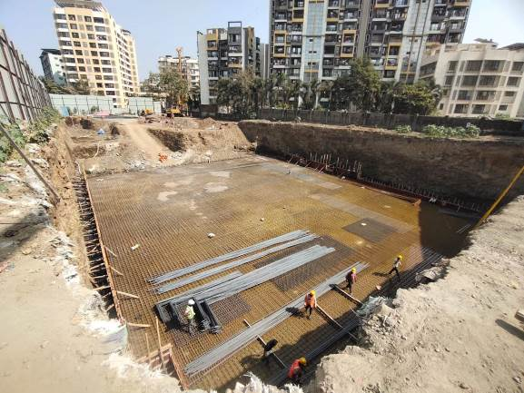
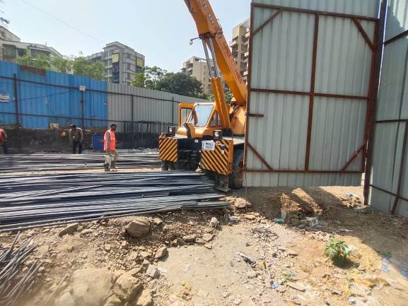
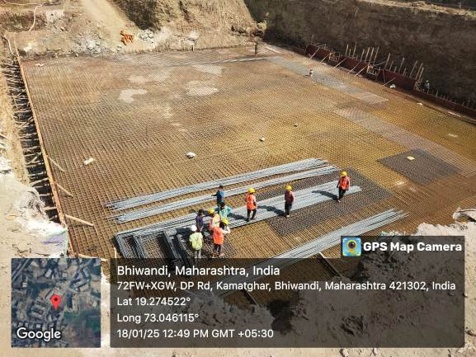

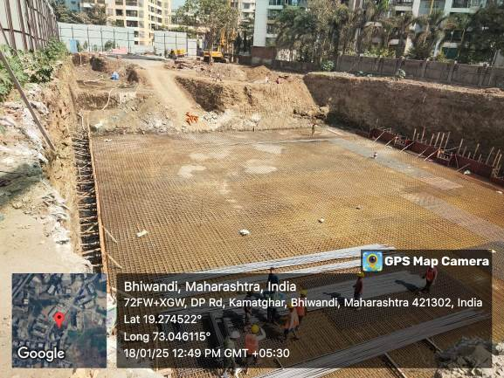

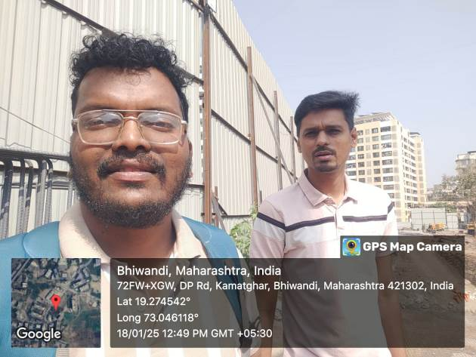

Route Map of the property
Site u/r
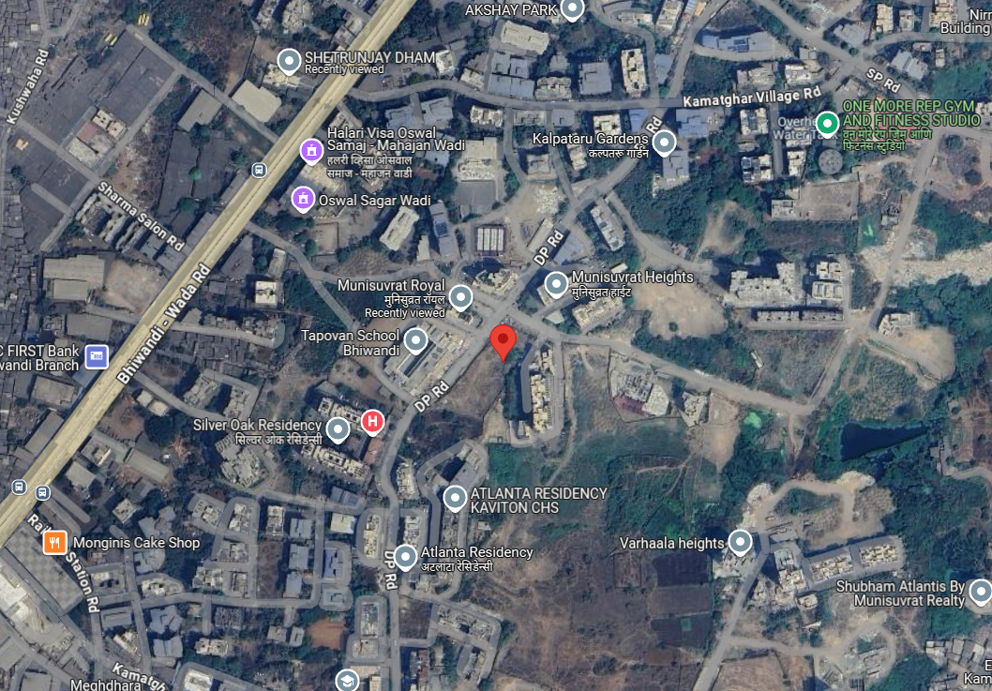

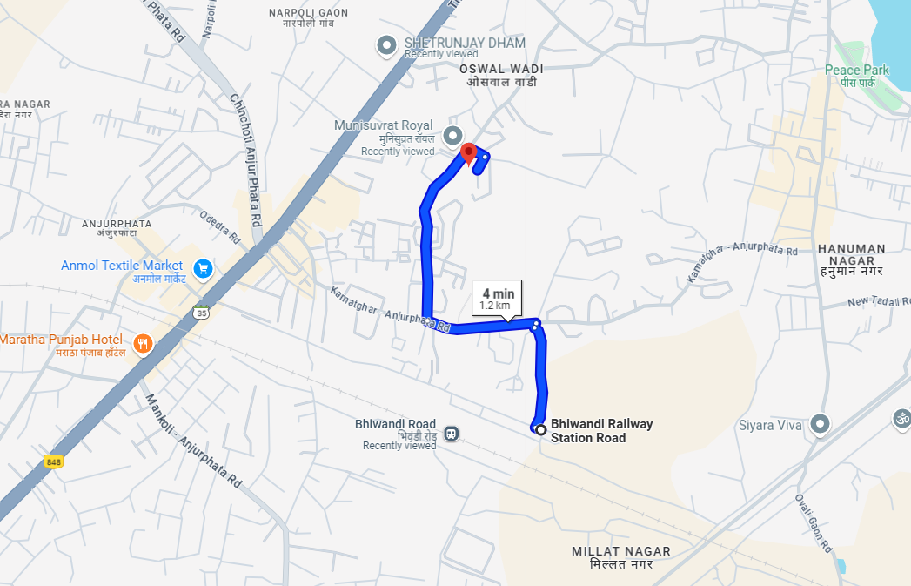

Latitude Longitude: 19°16'29.4"N 73°02'48.1"E
Note: The Blue line shows the route to site from nearest railway station (Bhiwandi Road –1.2 Km)

