**Valuation Report of the Immovable Property**

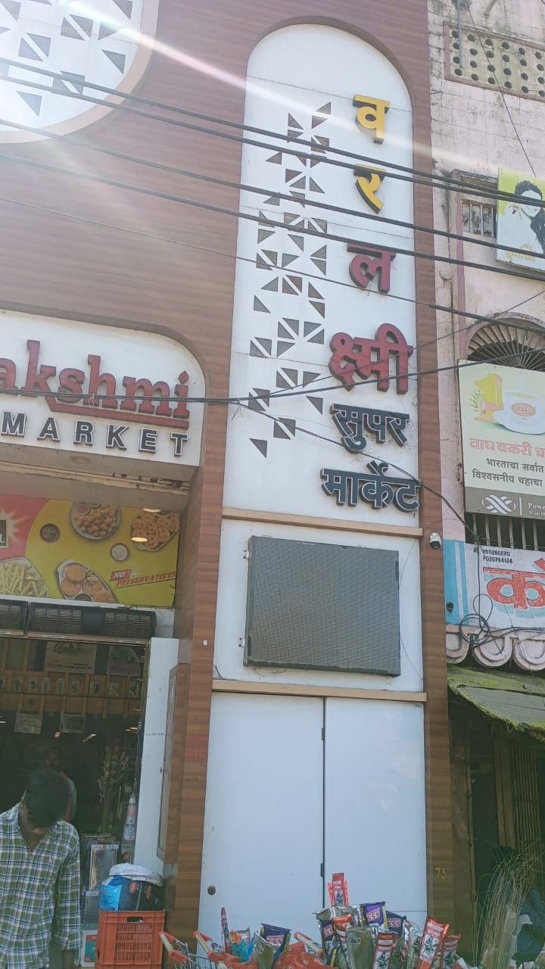

**Details of the property under consideration:**

Name of Owner: **Shri. Vijaykumar Venkati Mahajan**

Commercial Shop, **"Varlaxmi Supermarket"**, H No. 4-5-252(old) and 4-5-269 & 4-5-270 (New), CTS No. 16418, Old Mondha, Taluka – Nanded, District – Nanded, PIN Code – 431 601, Maharashtra, India

**Latitude Longitude - 19°08'52.9"N 77°19'08.5"E**

**Intended Users:**

**Shri. Vijaykumar Venkati Mahajan**

**R/O Mahajan Niwas, Kaliji Tekadi Road, Old Mondha, Nanded - 431601**

Vastu/Nanded/01/2025/013771/2310245

25/26-364 -RJVSAS

Date: 24.01.2025

**VALUATION OPINION REPORT**

This is to certify that the property bearing Commercial Shop, **"Varlaxmi Supermarket"**, H No. 4-5-252(old) and 4-5-269 & 4-5-270 (New), CTS No. 16418, Old Mondha, Taluka – Nanded, District – Nanded, PIN Code – 431 601, Maharashtra, India belongs to **Shri. Vijaykumar Venkati Mahajan.**

|  |  |  |
| --- | --- | --- |
| **Boundaries of the property.** | | |
| North | : | Mondha Road | |
| South | : | House of Haribhau Mahajan | |
| East | : | 5' Common lane and then after shop of Uttarwar and Rudrakanthwar | |
| West | : | House of Jawalekar | |

Considering various parameters recorded, existing economic scenario, and the information that is available with reference to the development of neighbourhood and method selected for valuation, we are of the opinion that, the property premises can be assessed and valued for the specific purpose at

**In ₹ 5,67,00,000.00 (Rupees Five Crores Sixty Seven Lakh Only).**

**In US$ 657,736.44 (United State Dollar Six Hundred Fifty Seven Thousand Seven Hundred Thirty Six Only).**

**Note: at conversion rate of 1 Indian Rupee equals to 0.012 United States Dollar as on 24.01.2025**

The valuation of the property is based on the documents produced by the concern. Legal aspects have not been taken into considerations while preparing this report.

Hence certified

**Sharadkumar B. Chalikwar**

B.E. (Civil), M.E. (Civil), M.Sc. (Real Estate Valuation),

M.Sc. (P&M Valuation), FIE (I), FIV, FIWRS

Chairman & Managing Director

Govt. Reg. Valuer

Chartered Engineer (India)

Reg. No. (N) CCIT/1-14/52/2008-09

Reg No. IBBI/RV/07/2019/11744

Encl: Valuation report

**VALUATION REPORT IN RESPECT OF IMMOVABLE PROPERTY**

|  |  |  |  |  |  |  |
| --- | --- | --- | --- | --- | --- | --- |
| 1 | Date of Inspection | | 18.01.2025 | | | |
| 2 | Purpose of valuation | | As per the request from Shri. Vijaykumar Venkati Mahajan to assess Fair Market Value of the property under reference for **Immigration Visa Application** purpose | | | |
| 3 | Name and address of the Valuer | | **Sharadkumar B. Chalikwar**  **Vastukala Consultants (I) Pvt. Ltd.**  28, Stadium Complex, Gokul Nagar, Nanded – 431602. | | | |
| 4 | List of Documents Handed Over to The Valuer By The Customer:   1. Copy of Sale Deed dated 11.05.2015 Ref. No. 3933/2015 2. Copy of Reminder letter of allotment dated. 05.02.2013 3. Copy of Sale Deed dated. 26.03.1999 between Shri. Dattatry Manohar Mahajan (The Transferor) and Shri. Vijaykumar Venkati Mahajan and Shri. Eknath Digamber Bidwai (Transferee) | | | | | |
| 5 | Details of enquiries made/ visited to government offices for arriving fair market value. | | Market analysis | | | |
| 6 | Factors for determining its market value. | | Location, development of surrounding area, type of construction, construction specifications, age of building, condition of the premises & building, facilities provided and its prevailing market rate. | | | |
| 7 | ANY CRITICAL ASPECTS ASSOCIATED WITH PROPERTY | | No | | | |
| 8 | Present/Expected Income from the property | | ₹ 1,42,000.00 Expected rental income per month.  US$ 1641.25 Expected rental income per month. | | | |
|  | **Property Details** | |  | | | |
| 9 | Name(s) of the Owner | | **Shri. Vijaykumar Venkati Mahajan** | | | |
|  | Address | | Commercial Shop, **"Varlaxmi Supermarket"**, H No. 4-5-252(old) and 4-5-269 & 4-5-270 (New), CTS No. 16418, Old Mondha, Taluka – Nanded, District – Nanded, PIN Code – 431 601, Maharashtra, India | | | |
| 10 | If the property is under joint ownership/ co-ownership share of each such owner/ are the share is undivided. | | Joint Ownership  Details of ownership share is not available | | | |
| 11 | Brief description of the property. | | The property is a commercial shop of Ground floor + Mezzanine floor. It is an RCC framed structure. The composition of commercial shop is single unit used as super market**.** The property is at 2 Km travelling distance from nearest railway station Nanded. | | | |
|  | **If under construction, extent of completion** | | **N.A.** | | | |
| 12 | Location of the property (C.T.S. No., Survey No., Hissa No., Plot No., etc.). | | CTS No. 16418, Village Old Mondha | | | |
| 13 | **Boundaries** | | **As on site** | **As per documents** | | |
| **Part of Shri. Vijaykumar Venkati Mahajan** | | **Part of Shri. Eknath Digamberrao Bidwai** |
|  | North | | Mondha Road | Old Mondha Play Ground | | Part of Shri. Vijaykumar Venkati Mahajan |
|  | South | | House of Haribhau Mahajan | Part of Shri. Eknath Digamberrao Bidwai and after that common staircase and open plot of Dattatray Mahajan. | | Common staircase and open plot of Dattatray Mahajan. |
|  | East | | 5' Common lane and then after shop of Uttarwar and Rudrakanthwar | 5’ common lane and shop pf Uttarwar | | 5' Common lane and then after shop of Uttarwar and Rudrakanthwar |
|  | West | | House of Jawalekar | House and shop of Jawalekar | | House and shop of Jawalekar |
| 14 | Matching of Boundaries | | - | | | |
| 15 | Route map | | Enclosed | | | |
| 16 | Any specific identification marks | | Near Clock Tower, Old Mondha | | | |
| 17 | Whether covered under Corporation/ Panchayat / Municipality. | | Nanded Municipal Corporation | | | |
| 18 | Whether covered under any land ceiling of State/ Central Government. | | No | | | |
| 19 | Is the land freehold/ leasehold. | | Freehold | | | |
| 20 | Are there any restrictive covenants in regard to use of Land? If so attach a copy of the covenant. | | As Per Agreement | | | |
| 21 | Type of the property | | Commercial | | | |
| 22 | Year of acquisition/ purchase. | | Sale Deed dated 11.05.2015 | | | |
| 23 | Purchase value as per document | | 2,11,00.00.00 | | | |
| 24 | Whether the property is occupied by owner or tenant. If occupied by tenant since how long he is staying and the amount of rent being paid. | | Owner Occupied | | | |
| 25 | Classification of the site | |  | | | |
|  | 1. Population group | | Semi Urban | | | |
|  | 1. High/ Middle/ Poor class | | Middle Class | | | |
|  | 1. Residential / Commercial | | Commercial | | | |
|  | 1. Development of surrounding area | | Developed | | | |
|  | 1. Possibility of any threat to the property (Floods, calamities etc.). | | No | | | |
| 26 | Proximity of civic amenities (like school, hospital, bus stop, market etc.). | | Near By | | | |
| 27 | Level of the land (Plain, rock etc.) | | Plain | | | |
| 28 | Terrain of the Land. | | Levelled | | | |
| 29 | Shape of the land (Square/ rectangle etc.). | | Irregular | | | |
| 30 | Type of use to which it can be put (for construction of house, factory etc.). | | Commercial Shop | | | |
| 31 | Whether the plot is under town planning approved layout? | | Information not Available | | | |
| 32 | Whether the building is intermittent or corner? | | Intermittent | | | |
| 33 | Whether any road facility is available? | | Yes | | | |
| 34 | Type of road available (B.T/Cement Road etc.). | | B.T. Road | | | |
| 35 | Front Width of the Road? | | 9.00 M. Wide Road | | | |
| 36 | Source of water & water potentiality. | | Municipal Water Supply | | | |
| 37 | Type of Sewerage System. | | Connected to Municipal Sewerage System | | | |
| 38 | Availability of power supply. | | Yes | | | |
| 39 | Advantages of the site. | | Located in developed area | | | |
| 40 | Disadvantages of the site. | | No | | | |
| 41 | Give instances of sales of immovable property in the locality on a separate sheet, indicating the name & address of the property, registration No. sale price and area of land sold. | | As per Sub-Registrar of Assurance records | | | |
|  | **Valuation of the property:** | | | | | |
| 42 | Total area of the Commercial Shop | | **Built Up Area in Sq. Ft. = 1,890.00**  **(Area as per Agreement for Sale)** | | | |
| 43 | Prevailing market rate. | | ₹ 30,000.00 per Sq. Ft. on Built Up Area | | | |
| 44 | Floor Rise Rate per Sq. Ft. | | ₹ 0.00 | | | |
| 45 | PLC Rate per Sq. Ft. | | ₹ 0.00 | | | |
| 46 | Total Rate per Sq. Ft. | | ₹ 30,000.00 per Sq. Ft. on Built Up Area | | | |
| 47 | Value of the property | | ₹ **5,67,00,000.00** | **US$ 657,736.44** | | |
| 48 | The realizable value of the property (90%) | | ₹ **5,10,30,000.00** | **US$ 591,962.80** | | |
| 49 | Distress value of the property (80%) | | ₹ **4,53,60,000.00** | **US$ 526,189.15** | | |
| 50 | Insurable value of the property | | ₹ **45,36,000.00** | **US$ 5,26,18.92** | | |
|  | **Technical details of the building:** | | | | | |
| 51 | Type of building (Residential/ Commercial/ Industrial). | | Commercial | | | |
| 52 | Year of construction. | | 33 Years (As per previous valuation report) | | | |
| 53 | Future life of the property. | | 27 years Subject to proper, preventive periodic maintenance & structural repairs. | | | |
| 54 | No. of floors and height of each floor including basement. | | Ground + Mezzanine Floor | | | |
|  | **Type of construction** | | | | | |
| 55 | (Load bearing/ R.C.C./ Steel framed) | | R.C.C. Framed Structure | | | |
|  | **Condition of the building.** | | | | | |
| 56 | External (excellent/ good/ normal/ poor) | | Good | | | |
| 57 | Internal (excellent/ good/ normal/ poor). | | Good | | | |
| 58 | Whether the Commercial Shop is constructed strictly according to the sanctioned plan, details of variations noticed if any and effect of the same on the valuation | | Copy of Approved Building plans were not provided and not verified. | | | |
| 59 | **Remarks** |  | | | | |
|  | **Specifications of Construction:** | | | | | |
| **sr.** | **Description** | | **Ground Floor** | | | |
| A | Foundation | | R.C.C. Foundation | | | |
| B | Basement | | No | | | |
| C | Superstructure | | R.C.C. frame work with 9 inch thick B. B. Masonry for external walls.6 inch thick B.B. Masonry for internal walls | | | |
| D | Joinery/Doors/Windows | | Glass Door with M.S. Rolling Shutter | | | |
| E | RCC Work | | R.C.C. Framed Structure | | | |
| F | Plastering | | Cement Plastering + POP finish +  Plastic emulsion paint | | | |
| G | Flooring, Skirting | | Ceramic Tiles | | | |
| H | Kitchen Platform | | N.A | | | |
| I | Whether any proof course is provided? | | Yes | | | |
| J | Drainage | | Connected to Municipal Sewerage System | | | |
| K | Compound Wall (Height, length and type of construction) | | N.A | | | |
| L | Electric Installation (Type of wire, Class of construction) | | Concealed | | | |
| M | Plumbing Installation (No. of closets and wash basins etc.) | | Concealed | | | |
| N | Bore Well | | Not Provided | | | |
| O | Wardrobes, if any | | Yes | | | |
| P | Development of open area | | Open Parking, Chequered tile in open spaces, etc. | | | |
|  | **Valuation of proposed construction/ additions/ renovation if any:** | | | | | |
| 60 | **SUMMARY OF VALUATION:** | |  | | | |
|  | Part I Land | | N.A. as composite method is used for valuation | | | |
|  | Part II Building | | ₹ **5,67,00,000.00** | | **US$ 657,736.44** | |
|  | Part III Other amenities/ Miscellaneous | | ₹ 0.00 | | | |
|  | Part IV Proposed construction | | ₹ 0.00 | | | |
|  | **TOTAL.** | | ₹ **5,67,00,000.00** | | **US$ 657,736.44** | |
|  | **Calculation:** | | | | | |
| **1** | **Construction** | |  | | | |
| 1.01 | Built up Area of Commercial Shop | | 1,890.00 Sq. Ft. | | | |
| 1.02 | Rate per Sq. Ft. | | ₹ 2,000.00 | | | |
| 1.03 | Cost of Construction = (1.01x1.02) | | ₹ 37,80,000.00 | | | |
| **2** | **Value of property** | |  | | | |
| 2.01 | Built Up Area of Commercial Shop | | 1,890.00 Sq. Ft. | | | |
| 2.02 | Rate per Sq. Ft. | | ₹ 30,000.00 | | | |
| 2.03 | Value of Commercial Shop (2.01x2.02) | | ₹ **5,67,00,000.00** | | **US$ 657,736.44** | |
| **3** | **Total value of the property.** | | ₹ **5,67,00,000.00** | | **US$ 657,736.44** | |

I certify that,

I/ my authorized representative has inspected the subject property on 18.01.2025.

The rates for valuation of the property are in accordance with the prevailing market rates.

There is no direct/ indirect interest in the property valued.

The fair value of the property as on 24.01.2025 is

**In ₹ 5,67,00,000.00 (Rupees Five Crores Sixty Seven Lakh Only).**

**In US$ 657,736.44 (United State Dollar Six Hundred Fifty Seven Thousand Seven Hundred Thirty Six Only).**

**Note: at conversion rate of 1 Indian Rupee equals to 0.012 United States Dollar as on 24.01.2025**

Date: 24.01.2025

Place: Nanded

**Sharadkumar B. Chalikwar**

B.E. (Civil), M.E. (Civil), M.Sc. (Real Estate Valuation),

M.Sc. (P&M Valuation), FIE (I), FIV, FIWRS

Chairman & Managing Director

Govt. Reg. Valuer

Chartered Engineer (India)

Reg. No. (N) CCIT/1-14/52/2008-09

Reg No. IBBI/RV/07/2019/11744

**Actual site photographs**

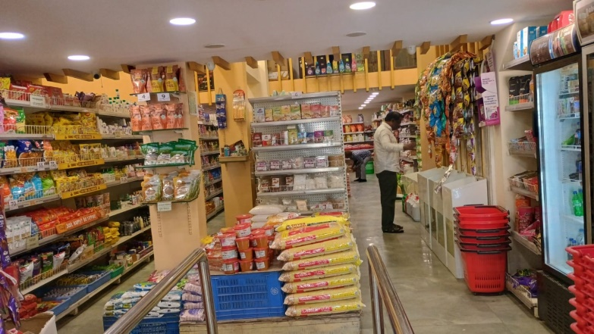

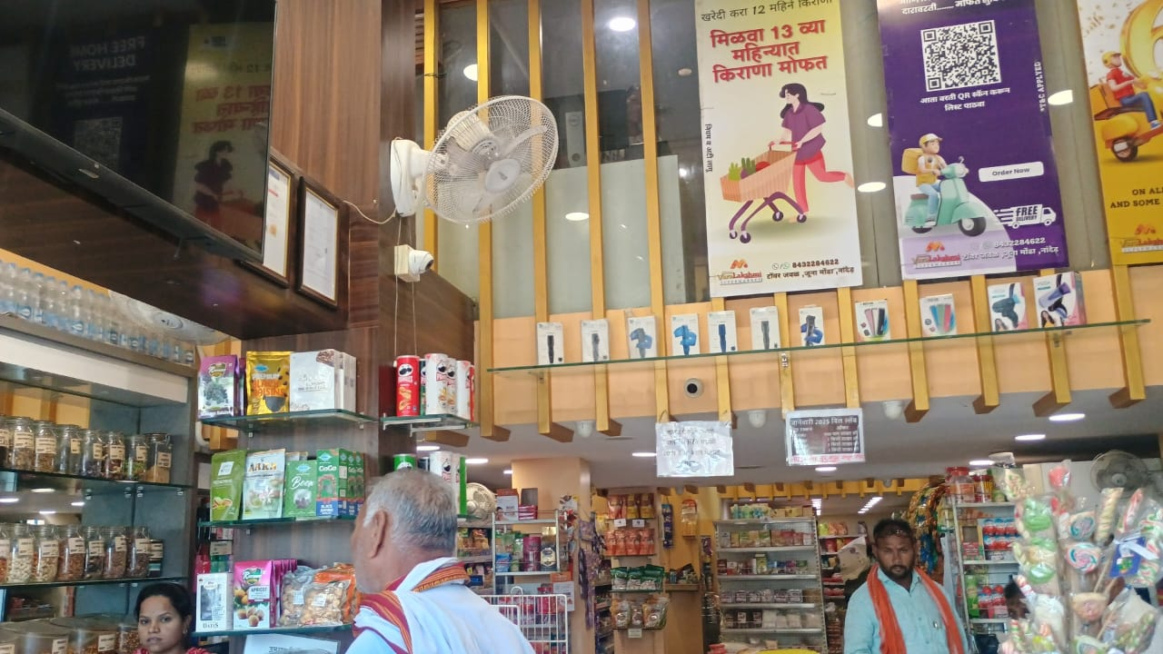

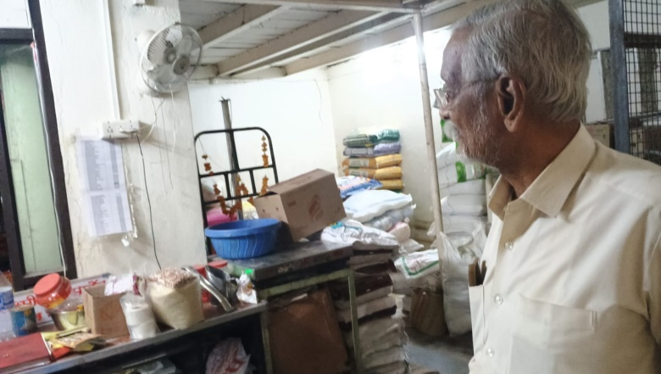

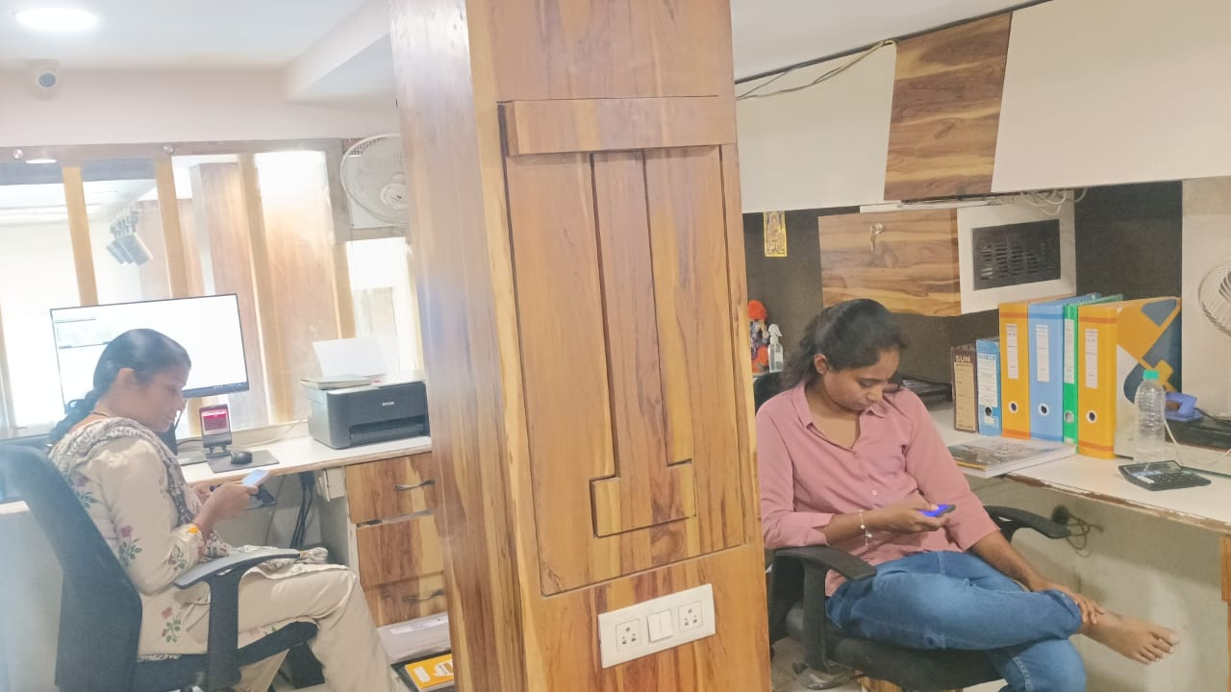

**Actual site photographs**

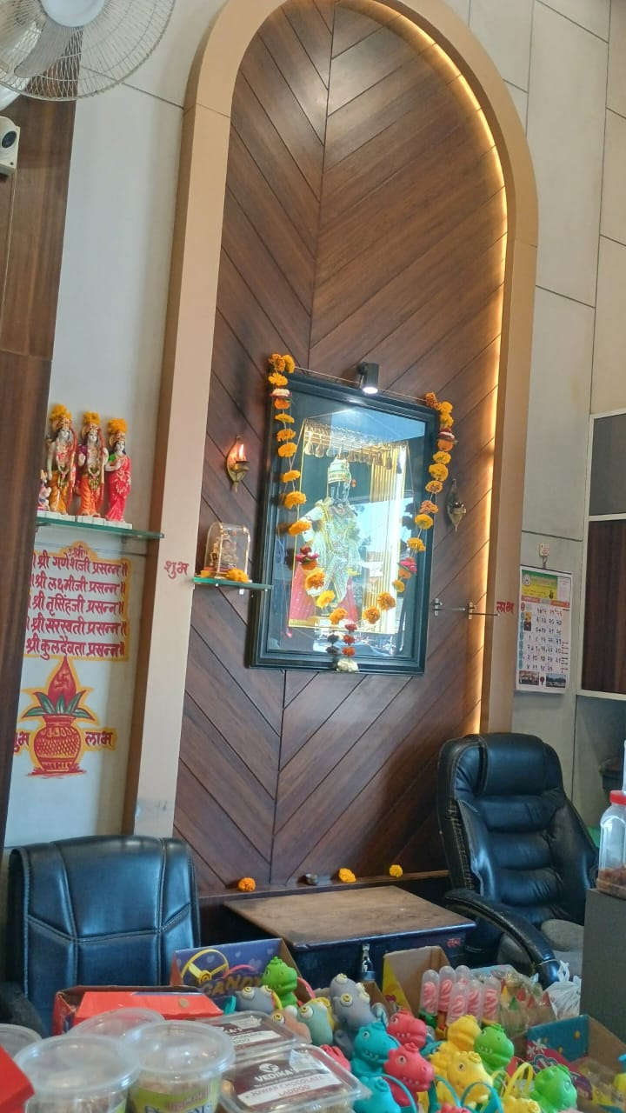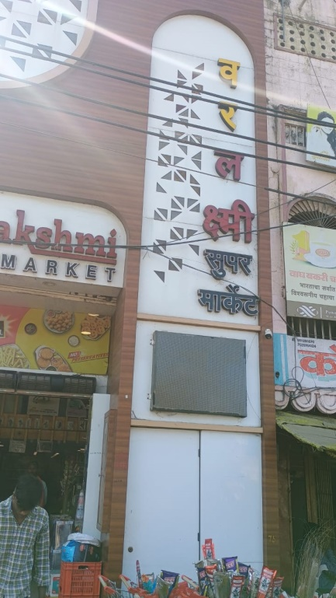

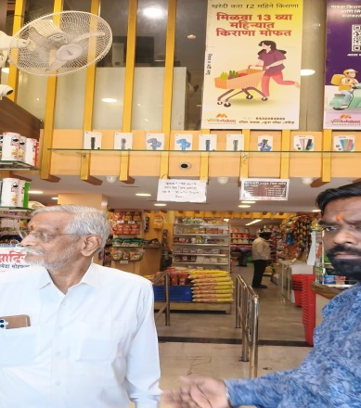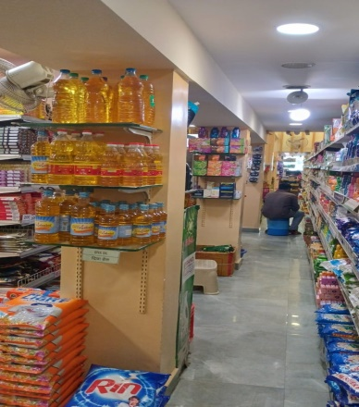

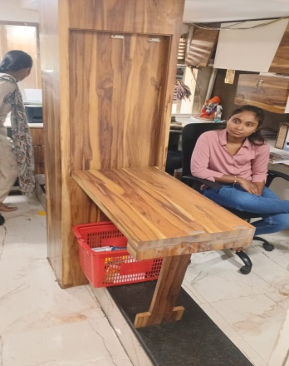

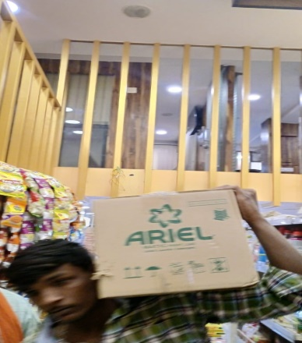

**Route Map of the property**

**Site u/r**

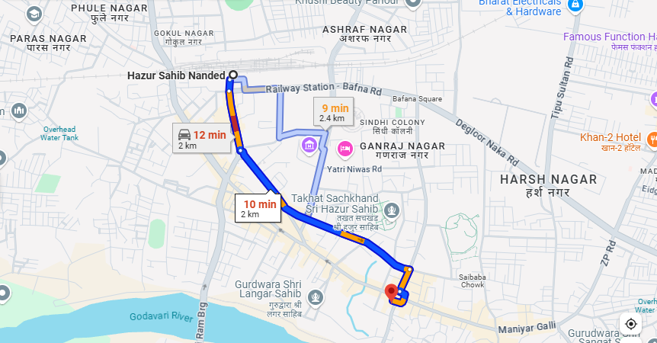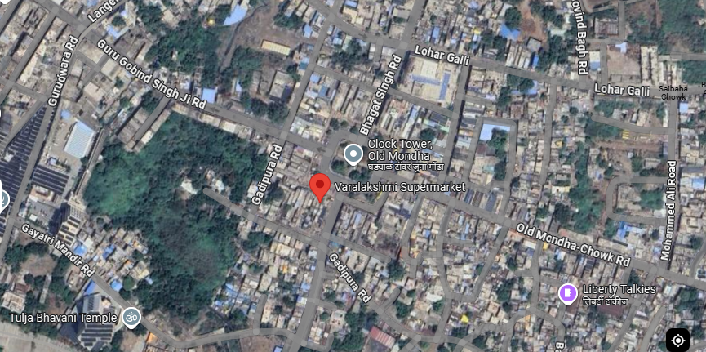

**Longitude Latitude: 19.148030, 77.319025  
Note:** The Blue line shows the route to site from nearest railway station (Nanded – 2 Km.)

**Currency Rate**

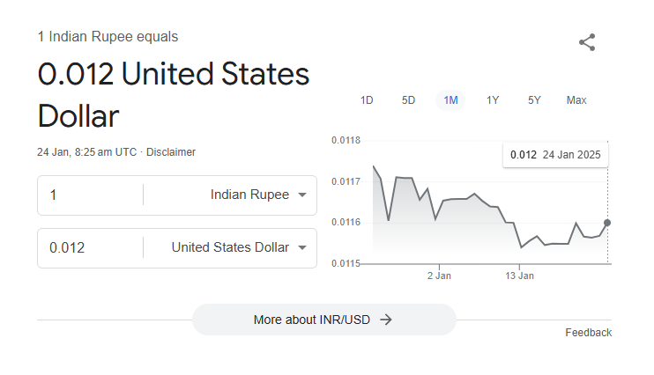

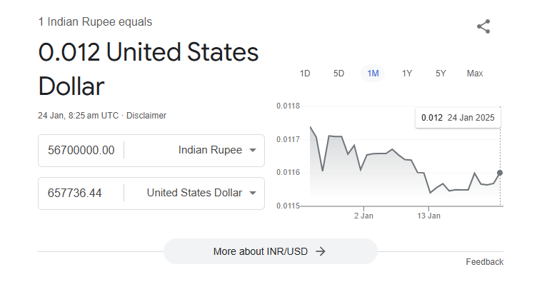

**Ready Reckoner Rate**

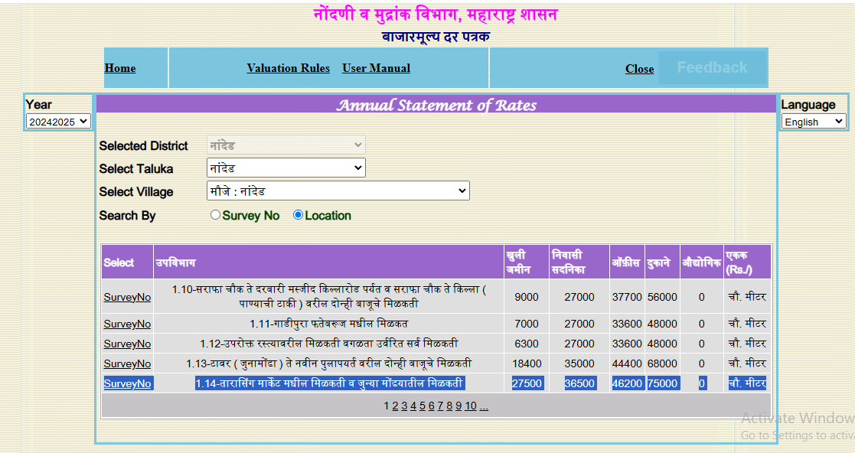

**DEFINITION OF VALUE FOR THIS SPECIFIC PURPOSE**

This exercise is to assess Fair Market Value of the property under reference for **Immigration Visa Application** purpose as on dated **24th January 2025.**

The term Fair Market Value is defined as

*"The most probable price, as of a specified date, in cash, terms equivalent to cash, or in other precisely revealed terms for which the specified property rights would sell after reasonable exposure in a competitive market under all conditions requisite to a fair sale, with the buyer and seller each acting prudently knowledgeably and for self-interest assuming that neither is under undue duress"*

Fundamental assumptions and conditions presumed in this definition are:

1. Buyer and seller are motivated by self-interest.
2. Buyer and seller are well informed and are acting prudently.
3. The property is exposed for a reasonable time on the open market.
4. Payment is made in cash or equivalent or in specified financing terms.

**ASSUMPTIONS, CAVEATS, LIMITATION AND DISCLAIMERS**

1. We assume no responsibility for matters of legal nature affecting the property appraised or the title thereto, nor do we render our opinion as to the title, which is assumed to be good and marketable.
2. The property is valued as though under responsible ownership.
3. It is assumed that there are no hidden or unapparent conditions of the subsoil or structure that would render it more or less valuable. No responsibility is assumed for such conditions or for engineering that might be required to discover such factors.
4. There is no direct/ indirect interest in the property valued.
5. The rates for valuation of the property are in accordance with the prevailing market rates.

**DECLARATION OF PROFESSIONAL FEES CHARGED**

We hereby declare that; our professional fees are not contingent upon the valuation findings. However, if the statute AND/OR clients demands that, the fees should be charged on the percentage of assessed value then, with the full knowledge of the AND/OR end user, it is being charged accordingly.

**VALUATION OF THE PROPERTY PREMISES**

Considering various parameters recorded, existing economic scenario, and the information that is available with reference to the development of neighbourhood and method selected for valuation, we are of the opinion that, the property premises can be assessed and valued for the specific purpose at

**In ₹ 5,67,00,000.00 (Rupees Five Crores Sixty Seven Lakh Only).**

**In US$ 657,736.44 (United State Dollar Six Hundred Fifty Seven Thousand Seven Hundred Thirty Six Only).**

**Note: at conversion rate of 1 Indian Rupee equals to 0.012 United States Dollar as on 24.01.2025**

**Sharadkumar B. Chalikwar**

B.E. (Civil), M.E. (Civil), M.Sc. (Real Estate Valuation),

M.Sc. (P&M Valuation), FIE (I), FIV, FIWRS

Chairman & Managing Director

Govt. Reg. Valuer

Chartered Engineer (India)

Reg. No. (N) CCIT/1-14/52/2008-09

Reg No. IBBI/RV/07/2019/11744