**Valuation Report of the Immovable Property**

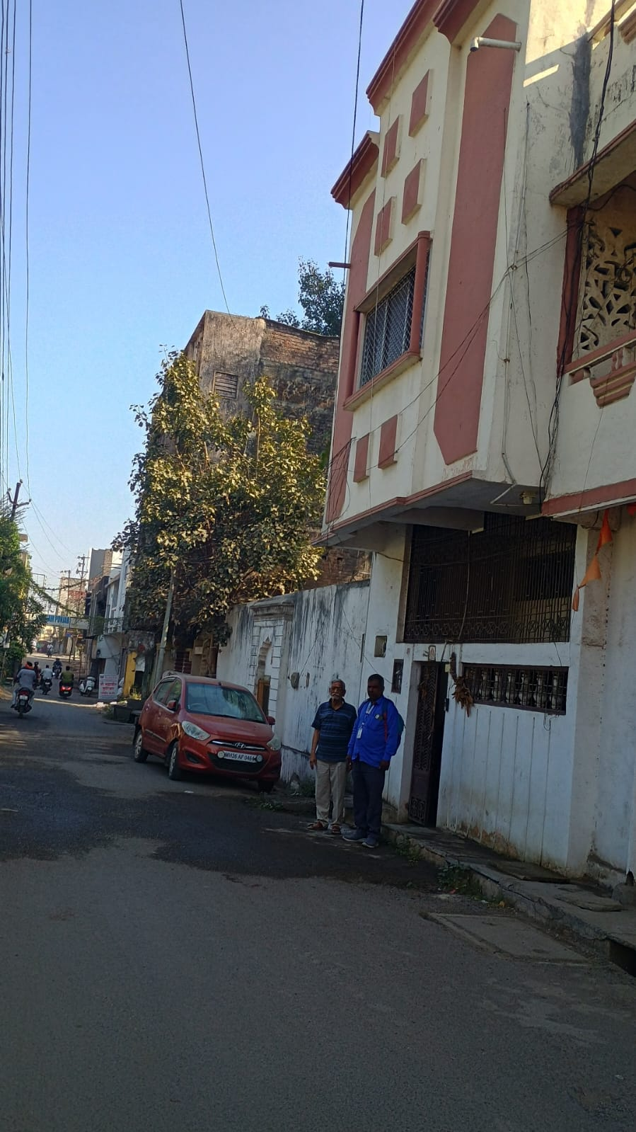

**Details of the property under consideration:**

Name of Owner: **Mr. Vijaykumar Vyankati Mahajan**

Residential Land & Building bearing CTS No. 262, M.H. No. 4-5-294(Old), 4-5-355 (New), Kaliji Tekadi Road,

Old Mondha, Taluka & District - Nanded, Pin Code – 431601, State - Maharashtra, Country – India

**Latitude Longitude - 19°08'52.4"N 77°19'05.6"E**

**Intended Users:**

**Mr. Vijaykumar Vyankati Mahajan**

**R/O Mahajan Niwas, Kaliji Tekadi Road, Old Mondha, Nanded - 431601**

Vastu/Nanded/01/2025/013766/2310242

25/23-361-SPAS

Date: 25.01.2024

**VALUATION OPINION REPORT**

This is to certify that the property Residential Land & Building bearing CTS No. 262, M.H. No. 4-5-294(Old), 4-5-355 (New), Kaliji Tekadi Road, Old Mondha, Taluka & District - Nanded, Pin Code – 431601, State - Maharashtra, Country – India belongs to **Mr. Vijaykumar Vyankati Mahajan.**

|  |  |
| --- | --- |
| Boundaries of the property. | |
| North | House of Mrs. Suman Srihari Ayya |
| South | House of Mr. Venkati Govind Mahajan |
| East | House of Mr. Prabhakar Sriram Ganjewar |
| West | Kaliji Tekadi Road |

Considering various parameters recorded, existing economic scenario, and the information that is available with reference to the development of neighbourhood and method selected for valuation, we are of the opinion that, the property premises can be assessed and valued for the specific purpose at

**In ` 79,35,240.00 (Rupees Seventy Nine Lakh Thirty Five Thousand Two Hundred Forty Only).**

**In US$ 92,044.98 (United State Doller Ninety Two Thousand Forty Four Only).**

**Note: at conversion rate of 1 Indian Rupee equals to 0.012 United States Dollar as on 25.01.2025**

The valuation of the property is based on the documents produced by the concern. Legal aspects have not been taken into considerations while preparing this report.

Hence certified

**Sharadkumar B. Chalikwar**

B.E. (Civil), M.E. (Civil), M.Sc. (Real Estate Valuation),

M.Sc. (P&M Valuation), FIE (I), FIV, FIWRS

Chairman & Managing Director

Govt. Reg. Valuer

Chartered Engineer (India)

Reg. No. (N) CCIT/1-14/52/2008-09

Reg No. IBBI/RV/07/2019/11744

Encl: Valuation report

**VALUATION REPORT IN RESPECT OF IMMOVABLE PROPERTY**

|  |  |  |  |  |  |  |  |  |  |  |
| --- | --- | --- | --- | --- | --- | --- | --- | --- | --- | --- |
| 1 | Date of Inspection | | | | | 20.01.2025 | | | | |
| 2 | Purpose of valuation | | | | | As per the request from Mr. Vijaykumar Vyankati Mahajan, to assess Fair Market Value of the property under reference for **Immigration Visa Application** purpose | | | | |
| 3 | Name and address of the Valuer | | | | | **Sharadkumar B. Chalikwar**  **Vastukala Consultants (I) Pvt. Ltd.**  28, Stadium Complex, Gokul Nagar, Nanded – 431 602.  Email: nanded@vastukala.co.in | | | | |
| 4 | List of Documents Handed Over to The Valuer By The Customer:   1. Copy of Sale Deed between Mr. Vijaykumar Vyankati Mahajan (Buyer) & Mr. Chandrakant Keraba Ganchewar (Seller) through Reg. Doc. No. 4294/1980, dated 13.11.1980 2. Copy of Property Tax receipt No 313/35, issued by Nanded Waghela City Municipal Corporation, Nanded, dated 31.03.2024. 3. Copy of Approved plan No. 36, O. No. 324/17/81/82 dated 10.06.1982 issued by Chief Officer Nanded Municipal Council, Nanded. | | | | | | | | | |
| 5 | Details of enquiries made/ visited to government offices for arriving fair market value. | | | | | Market analysis | | | | |
| 6 | Factors for determining its market value. | | | | | Location, development of surrounding area, type of construction, construction specifications, age of building, condition of the premises & building, facilities provided and its prevailing market rate. | | | | |
| 7 | ANY CRITICAL ASPECTS ASSOCIATED WITH PROPERTY | | | | | No | | | | |
| 8 | Present/Expected Income from the property | | | | | ` 16,531.00 Expected rental income per month.  US$ 191.75 Expected rental income per month. | | | | |
|  | **Property Details** | | | | |  | | | | |
| 9 | Name(s) of the Owner | | | | | **Mr. Vijaykumar Vyankati Mahajan** | | | | |
|  | Address | | | | | Residential Land & Building bearing CTS No. 262, M.H. No. 4-5-294(Old), 4-5-355 (New), Kaliji Tekadi Road, Old Mondha, Taluka & District - Nanded, Pin Code – 431601, State - Maharashtra, Country – India | | | | |
| 10 | If the property is under joint ownership/ co-ownership share of each such owner/ are the share is undivided. | | | | | Sole Ownership | | | | |
| 11 | Brief description of the property. | | | | | The property is a Residential Building located on Ground Floor & 1st Floor. The composition of Building is Ground Floor - Bedroom + Living Room + Kitchen + Toilet & on First Floor – Hall, Bedroom, Toilet **(i.e. 2 BHK).** It is at 1.9 Km travelling distance from Nanded railway station. | | | | |
|  | **If under construction, extent of completion** | | | | | **N.A.** | | | | |
| 12 | Location of the property (C.T.S. No., Survey No., Hissa No., Plot No., etc.). | | | | | CTS No. 262, M.H. No. 4-5-294(Old), 4-5-355(New) of Village – Juna Mondha, Nanded | | | | |
| 13 | **Boundaries** | | | | | **As on site** | | | **As per documents** | |
|  | North | | | | | House of Mrs. Suman Srihari Ayya | | | Details not available | |
|  | South | | | | | House of Mr. Venkati Govind Mahajan | | | Details not available | |
|  | East | | | | | House of Mr. Prabhakar Sriram Ganjewar | | | Details not available | |
|  | West | | | | | Kaliji Tekadi Road | | | Details not available | |
| 14 | Matching of Boundaries | | | | | - | | | | |
| 15 | Route map | | | | | Enclosed | | | | |
| 16 | Any specific identification marks | | | | | NA | | | | |
| 17 | Whether covered under Corporation/ Panchayat / Municipality. | | | | | Nanded Waghela City Municipal Corporation, Nanded | | | | |
| 18 | Whether covered under any land ceiling of State/ Central Government. | | | | | No | | | | |
| 19 | Is the land freehold/ leasehold. | | | | | Freehold | | | | |
| 20 | Are there any restrictive covenants in regard to use of Land? If so attach a copy of the covenant. | | | | | NA | | | | |
| 21 | Type of the property | | | | | Residential | | | | |
| 22 | Year of acquisition/ purchase. | | | | | 1980 | | | | |
| 23 | Purchase value as per document | | | | | Rs. 5,000.00 | | | | |
| 24 | Whether the property is occupied by owner or tenant. If occupied by tenant since how long he is staying and the amount of rent being paid. | | | | | Owner Occupied | | | | |
| 25 | Classification of the site | | | | |  | | | | |
|  | 1. Population group | | | | | Urban | | | | |
|  | 1. High/ Middle/ Poor class | | | | | Middle Class | | | | |
|  | 1. Residential / Commercial | | | | | Residential | | | | |
|  | 1. Development of surrounding area | | | | | Developing | | | | |
|  | 1. Possibility of any threat to the property (Floods, calamities etc.). | | | | | No | | | | |
| 26 | Proximity of civic amenities (like school, hospital, bus stop, market etc.). | | | | | Near By | | | | |
| 27 | Level of the land (Plain, rock etc.) | | | | | Plain | | | | |
| 28 | Terrain of the Land. | | | | | Levelled | | | | |
| 29 | Shape of the land (Square/ rectangle etc.). | | | | | Irregular | | | | |
| 30 | Type of use to which it can be put (for construction of house, factory etc.). | | | | | Residential House | | | | |
| 31 | Whether the plot is under town planning approved layout? | | | | | Yes, Approved plan Given & Verified. | | | | |
| 32 | Whether the building is intermittent or corner? | | | | | Intermittent | | | | |
| 33 | Whether any road facility is available? | | | | | Yes | | | | |
| 34 | Type of road available (B.T/Cement Road etc.). | | | | | B.T. Road | | | | |
| 35 | Front Width of the Road? | | | | | 9.00 M. Wide Road | | | | |
| 36 | Source of water & water potentiality. | | | | | Municipal Water Supply | | | | |
| 37 | Type of Sewerage System. | | | | | Connected to Municipal Sewerage System | | | | |
| 38 | Availability of power supply. | | | | | Yes | | | | |
| 39 | Advantages of the site. | | | | | Located in developing area | | | | |
| 40 | Disadvantages of the site. | | | | | No | | | | |
| 41 | Give instances of sales of immovable property in the locality on a separate sheet, indicating the name & address of the property, registration No. sale price and area of land sold. | | | | | No | | | | |
|  | **Part – A (Valuation of land)** | | | | | | | | | |
|  | Total area of the Residential land | | | | | 688.00 Sq. Ft. | | | | |
|  | Prevailing market rate | | | | | ` 10,000.00 | | | | |
|  | Estimated value of land | | | | | **` 68,80,000.00** | | | | |
|  | **Part – B (Valuation of Building)** | | | | |  | | | | |
| 42 | Total area of the Residential House | | | | | Built Up Area in Sq. Ft. = 1296.00  (Area as per Site Measurement)  Built Up Area in Sq. Ft. = 1084.00  (Area as per Approved Plan) | | | | |
|  | Area considered for valuation | | | | | Built Up Area in Sq. Ft. = 1084.00  (Area as per Approved Plan) | | | | |
|  | **Structure** | | **Built Up Area** | **Year Of Const.** | **Estimated Replacement Rate** | | **Final Depreciated Rate to be considered** | **Final Depreciated Value to be considered in ₹** | | **Estimated Replacement Cost / Insurable Value in ₹** |
|  | | **(Sq. Ft)** |  | **(₹)** | | **(₹)** | **(₹)** | | **(₹)** |
| Ground Floor | | 608.00 | 1982 | 2,000.00 | | 710.00 | 4,31,680.00 | | 12,16,000.00 |
| First floor | | 476.00 | 2002 | 2,000.00 | | 1,310.00 | 6,23,560.00 | | 9,52,000.00 |
| **Total BUA** | | **1084.00** |  |  | |  | **10,55,240.00** | | 21,68,000.00 |
| 47 | Value of Land | | | | | ₹ 68,80,000.00 | | | US$ 79,804.70 | |
| 48 | Value of the Structure | | | | | ₹ 10,55,240.00 | | | US$ 12,240.28 | |
| 49 | Total Value of Property | | | | | **₹ 79,35,240.00** | | | **US$ 92,044.98** | |
| 50 | The realizable value of the property (90%) | | | | | **₹ 77,76,535.00** | | | **US$ 90,204.07** | |
| 51 | Distress value of the property (80%) | | | | | **₹ 63,48,192.00** | | | **US$ 73,635.98** | |
| 52 | Insurable value of the property | | | | | **₹ 21,68,000.00** | | | **US$ 25,147.76** | |
|  | **Technical details of the building:** | | | | | | | | | |
| 53 | Type of building (Residential/ Commercial/ Industrial). | | | | | Residential | | | | |
| 54 | Year of construction. | | | | | 1982 – Ground Floor  2002 – First Floor (As per site information) | | | | |
| 55 | Future life of the property. | | | | | Information Not Available | | | | |
| 56 | No. of floors and height of each floor including basement. | | | | | Ground + 1 Upper Floor | | | | |
|  | **Type of construction** | | | | | | | | | |
| 57 | (Load bearing/ R.C.C./ Steel framed) | | | | | RCC Framed Structure | | | | |
|  | **Condition of the building.** | | | | | | | | | |
| 58 | External (excellent/ good/ normal/ poor) | | | | | Good | | | | |
| 59 | Internal (excellent/ good/ normal/ poor). | | | | | Good | | | | |
| 60 | Whether the Residential Flat is constructed strictly according to the sanctioned plan, details of variations noticed if any and effect of the same on the valuation | | | | | Copy of Approved plan No. 36, O. No. 324/17/81/82 dated 10.06.1982 issued by Chief Officer Nanded Municipal Council, Nanded has been verified. | | | | |
| 61 | **Remarks** |  | | | | | | | | |
|  | **Specifications of Construction:** | | | | | | | | | |
| **Sr.** | **Description** | | | | | **Ground & First Floor** | | | | |
| A | Foundation | | | | | RCC Framed Structure | | | | |
| B | Basement | | | | | No | | | | |
| C | Superstructure | | | | | RCC Framed Structure with 9” Masonry wall | | | | |
| D | Joinery/Doors/Windows | | | | | Wooden Flush Doors & Powder Coated Aluminium Windows. | | | | |
| E | RCC Work | | | | | Yes | | | | |
| F | Plastering | | | | | Cement Plastering | | | | |
| G | Flooring, Skirting | | | | | Polished Andhra Marble & Ceramic Tiling. | | | | |
| H | Kitchen Platform | | | | | Granite kitchen platform | | | | |
| I | Whether any proof course is provided? | | | | | Plastic Emulsion Paint | | | | |
| J | Drainage | | | | | Connected to Municipal Sewerage System | | | | |
| K | Compound Wall (Height, length and type of construction) | | | | | No | | | | |
| L | Electric Installation (Type of wire, Class of construction) | | | | | Ordinary, Open Casing Capping Electric Fitting | | | | |
| M | Plumbing Installation (No. of closets and wash basins etc.) | | | | | Open | | | | |
| N | Bore Well | | | | | Not Provided | | | | |
| O | Wardrobes, if any | | | | | No | | | | |
| P | Development of open area | | | | | No | | | | |
|  | **Valuation of proposed construction/ additions/ renovation if any:** | | | | | | | | | |
| 62 | **SUMMARY OF VALUATION:** | | | | |  | | | | |
|  | Part I Land | | | | | ₹ 68,80,000.00 | | | US$ 79,804.70 | |
|  | Part II Building | | | | | ₹ 10,55,240.00 | | | US$ 12,240.28 | |
|  | Part III Other amenities/ Miscellaneous | | | | | ` 0.00 | | | | |
|  | Part IV Proposed construction | | | | | ` 0.00 | | | | |
|  | **TOTAL.** | | | | | **₹ 79,35,240.00** | | | **US$ 92,044.98** | |
|  | **Calculation:** | | | | | | | | | |
| **1** | **Construction** | | | | |  | | | | |
| 1.01 | Built up Area of Residential House | | | | | 1,084.00 Sq. Ft. | | | | |
| 1.02 | Rate per Sq. Ft. | | | | | 2000.00 per Sq. Ft | | | | |
| 1.03 | Cost of Construction = (1.01x1.02) | | | | | 21,68,000.00 | | | | |
| **2** | **Value of property** | | | | |  | | | | |
|  | **Value of Residential Land** | | | | | **₹ 68,80,000.00** | | | **US$ 79,804.70** | |
| 2.01 | Built Up Area of Residential House | | | | | 1,084.00 Sq. Ft. | | | | |
| 2.02 | Rate per Sq. Ft. | | | | | As per Valuation Table | | | | |
| 2.03 | Value of Residential House | | | | | **₹ 10,55,240.00** | | | **US$ 12,240.28** | |
| **3** | **Total value of the property.** | | | | | **₹ 79,35,240.00** | | | **US$ 92,044.98** | |

I certify that,

I/ my authorized representative has inspected the subject property on 20.01.2025.

The rates for valuation of the property are in accordance with the prevailing market rates.

There is no direct/ indirect interest in the property valued.

The fair value of the property as on 20.01.2025 is

**In ` 79,35,240.00 (Rupees Seventy Nine Lakh Thirty Five Thousand Two Hundred Forty Only).**

**In US$ 92,044.98 (United State Doller Ninety Two Thousand Forty Four Only).**

**Note: at conversion rate of 1 Indian Rupee equals to 0.012 United States Dollar as on 25.01.2025**

Date: 25.01.2025

Place: Nanded

**Sharadkumar B. Chalikwar**

B.E. (Civil), M.E. (Civil), M.Sc. (Real Estate Valuation),

M.Sc. (P&M Valuation), FIE (I), FIV, FIWRS

Chairman & Managing Director

Govt. Reg. Valuer

Chartered Engineer (India)

Reg. No. (N) CCIT/1-14/52/2008-09

Reg No. IBBI/RV/07/2019/11744

**Actual site photographs**

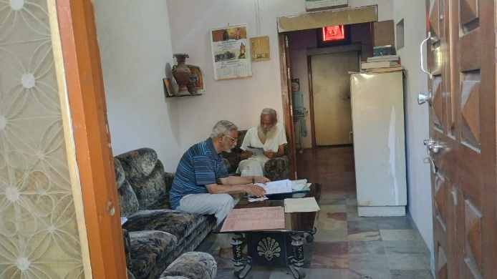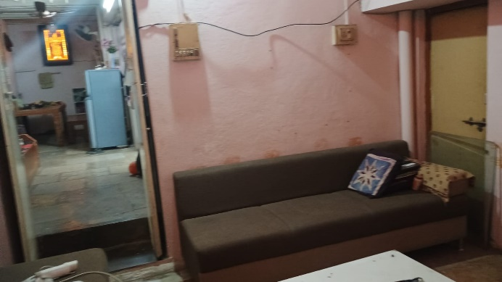

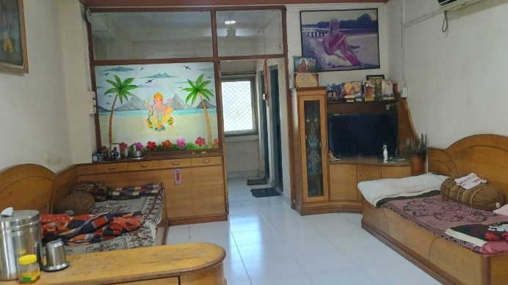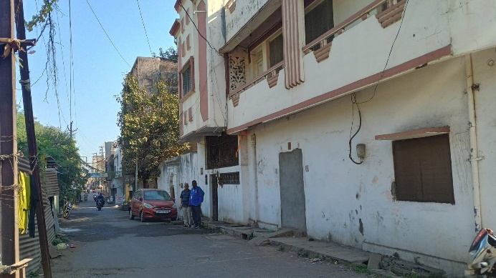

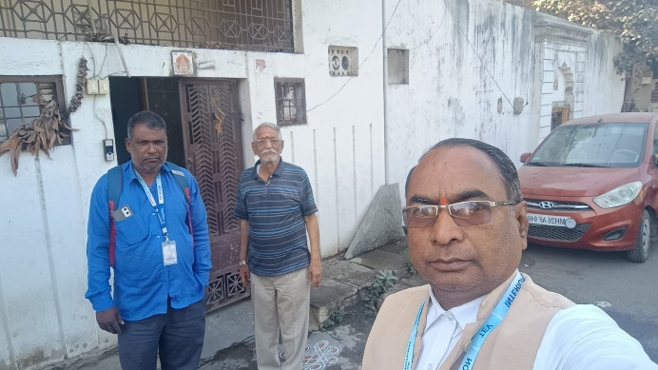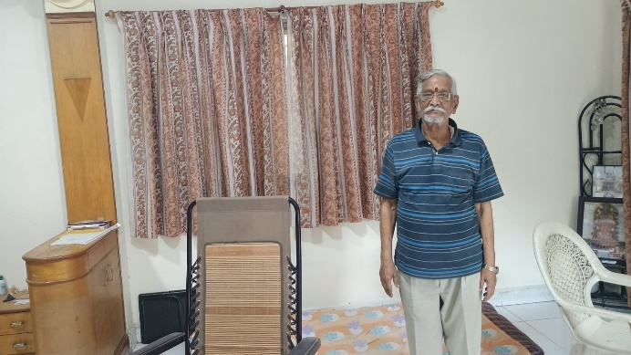

**Actual site photographs**

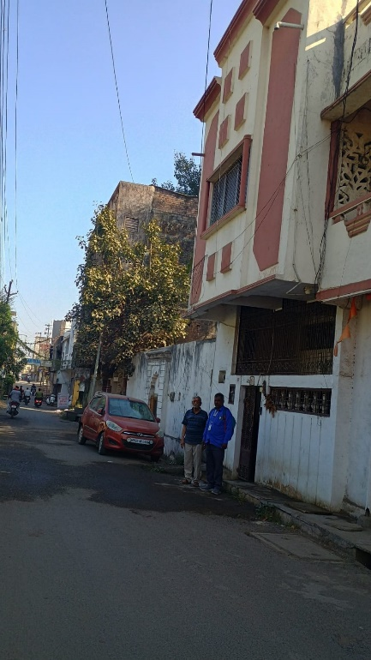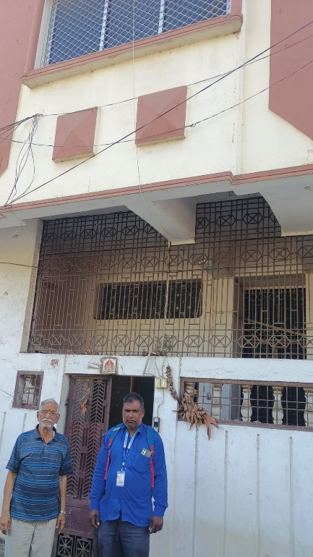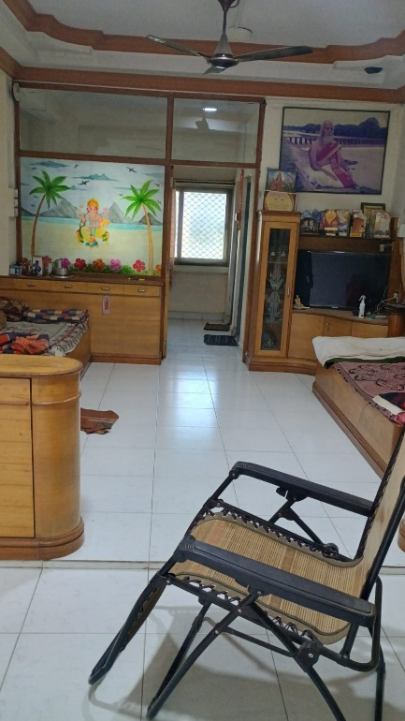

**Route Map of the property**

**Site u/r**

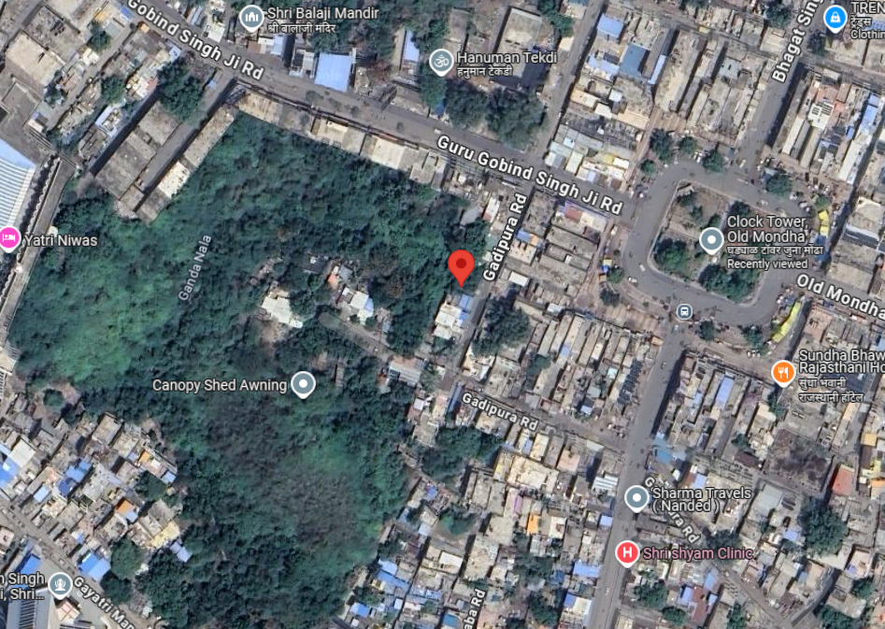

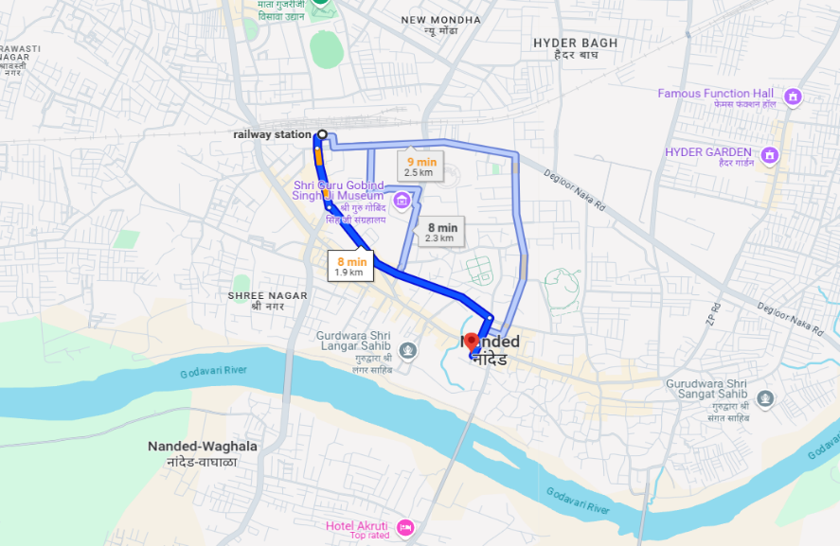

**Latitude Longitude - 19°08'53.6"N 77°19'05.5"E**

**Note**: The Blue line shows the route to site from nearest Railway station – (Nanded– 1.9 KM)

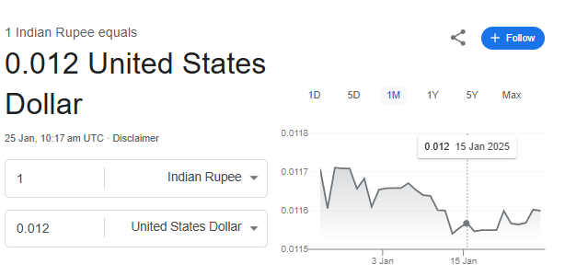**Currency Rate**

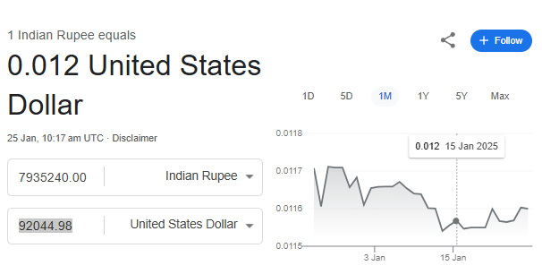

**Ready Reckoner**

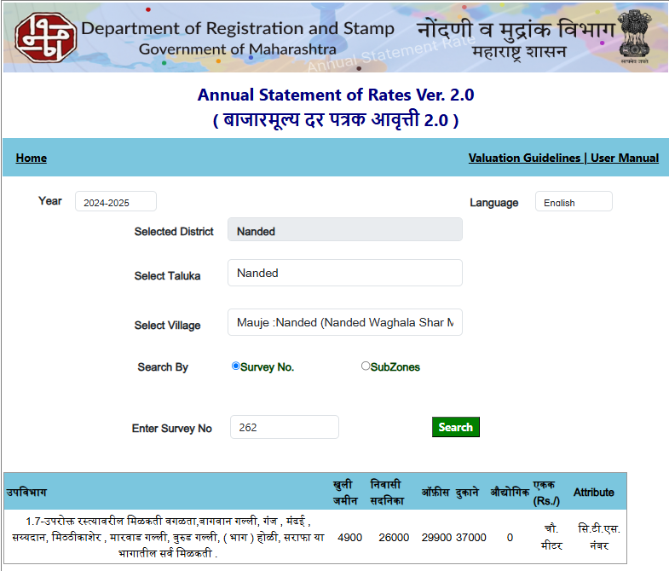

**DEFINITION OF VALUE FOR THIS SPECIFIC PURPOSE**

This exercise is to assess Fair Market Value of the property under reference for **Immigration Visa Application** purpose as on dated **25th January 2025.**

The term Fair Market Value is defined as

*"The most probable price, as of a specified date, in cash, terms equivalent to cash, or in other precisely revealed terms for which the specified property rights would sell after reasonable exposure in a competitive market under all conditions requisite to a fair sale, with the buyer and seller each acting prudently knowledgeably and for self-interest assuming that neither is under undue duress"*

Fundamental assumptions and conditions presumed in this definition are:

1. Buyer and seller are motivated by self-interest.
2. Buyer and seller are well informed and are acting prudently.
3. The property is exposed for a reasonable time on the open market.
4. Payment is made in cash or equivalent or in specified financing terms.

**ASSUMPTIONS, CAVEATS, LIMITATION AND DISCLAIMERS**

1. We assume no responsibility for matters of legal nature affecting the property appraised or the title thereto, nor do we render our opinion as to the title, which is assumed to be good and marketable.
2. The property is valued as though under responsible ownership.
3. It is assumed that there are no hidden or unapparent conditions of the subsoil or structure that would render it more or less valuable. No responsibility is assumed for such conditions or for engineering that might be required to discover such factors.
4. There is no direct/ indirect interest in the property valued.
5. The rates for valuation of the property are in accordance with the prevailing market rates.

**DECLARATION OF PROFESSIONAL FEES CHARGED**

We hereby declare that; our professional fees are not contingent upon the valuation findings. However, if the statute AND/OR clients demand that, the fees should be charged on the percentage of assessed value then, with the full knowledge of the AND/OR end user, it is being charged accordingly.

**VALUATION OF THE PROPERTY PREMISES**

Considering various parameters recorded, existing economic scenario, and the information that is available with reference to the development of neighbourhood and method selected for valuation, we are of the opinion that, the property premises can be assessed and valued for the specific purpose at

**In ` 79,35,240.00 (Rupees Seventy Nine Lakh Thirty Five Thousand Two Hundred Forty Only).**

**In US$ 92,044.98 (United State Doller Ninety Two Thousand Forty Four Only).**

**Note: at conversion rate of 1 Indian Rupee equals to 0.012 United States Dollar as on 25.01.2025**

**Sharadkumar B. Chalikwar**

B.E. (Civil), M.E. (Civil), M.Sc. (Real Estate Valuation),

M.Sc. (P&M Valuation), FIE (I), FIV, FIWRS

Chairman & Managing Director

Govt. Reg. Valuer

Chartered Engineer (India)

Reg. No. (N) CCIT/1-14/52/2008-09

Reg No. IBBI/RV/07/2019/11744