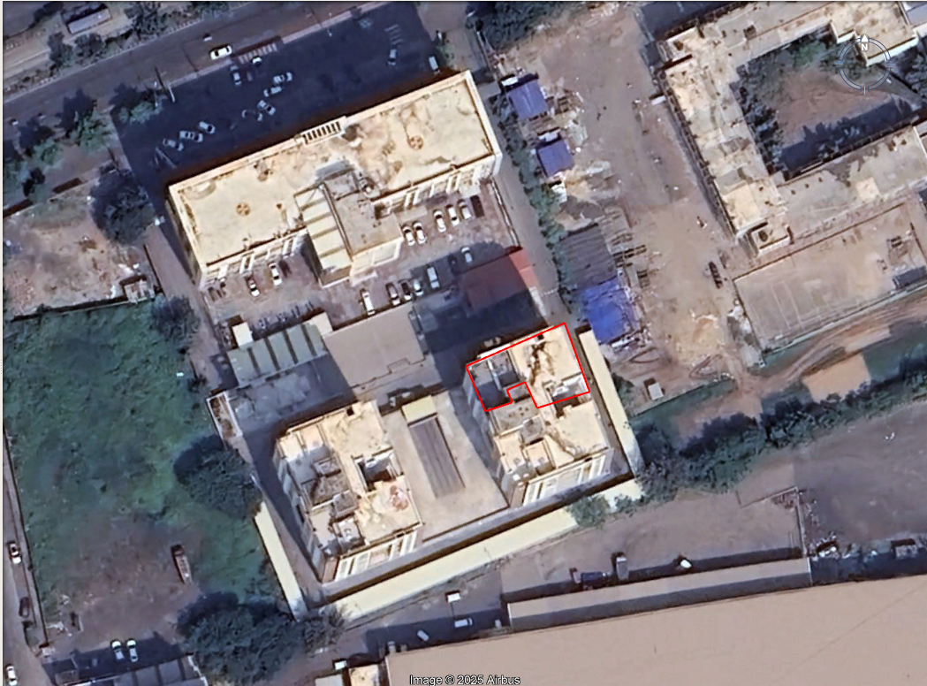

Flat no. 601, 6th floor, Bldg No. A, Western Residency, Vesu, Surat.

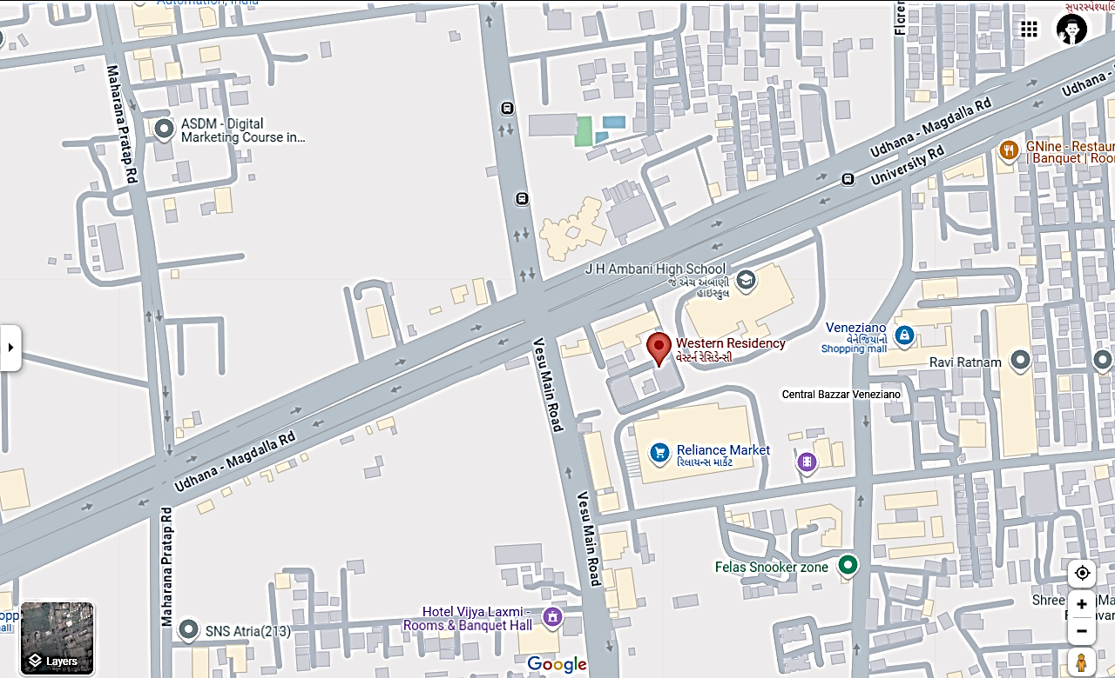

Western Residency, Vesu, Surat.