Vastu/Nashik/01/2025/013681/2310062
15/12-181-RVRJ
Date: 15.01.2025

To,
The Branch Manager,
State Bank of lndia
Maharashtra Eng. Research Institute Branch
Dindori Road, MERI, Nashik, Maharashtra, Nashik - 422004,
State - Maharashtra, Country - lndia.

Sub: Vetting of Extra Amenities

Sir,

With reference to above subject, we have evaluated the Extra Amenities for Residential Flat No. 404, 4th Floor, " Neelam Srushti ", Behind Nayara Petrol Pump, Near Hotel City Spice, Vaiduwadi, Plot No. 42, off Vani - Dindori Road, Village - Mhasrul, Taluka - Nashik, District - Nashik, Nashik, PIN Code - 422 004, State - Maharashtra, Country - India
belongs to Mr. Mansing Jagannath Sankpal & Mrs. Ashwini Mansing Sankpal.

We have verified the rates quoted as per current market rates. Details of Extra Amenities considered as per copy of Extra Amenities Agreement between Mr. Mansing Jagannath Sankpal & Mrs. Ashwini Mansing Sankpal. (First Party). Mr. Abhishek Subhash Barve (Second Party) received on dated 11.01.2025 The Extra Amenities amount is Rs. 8,00,000/- (Rupees Eight Lakh Only)

The said Cost Vetting Certificate is valid upto next 6 months Only.

Thanking you

Sincerely yours

Manoj B. Chalikwar
Registered Valuer
Chartered Engineer (India)
Reg. No. CAT-I-F-1763
SBI Empanelment No.: SME/TCC/2021-22/86/3
Encl. Valuation Report

Agreement for Extra Amenities
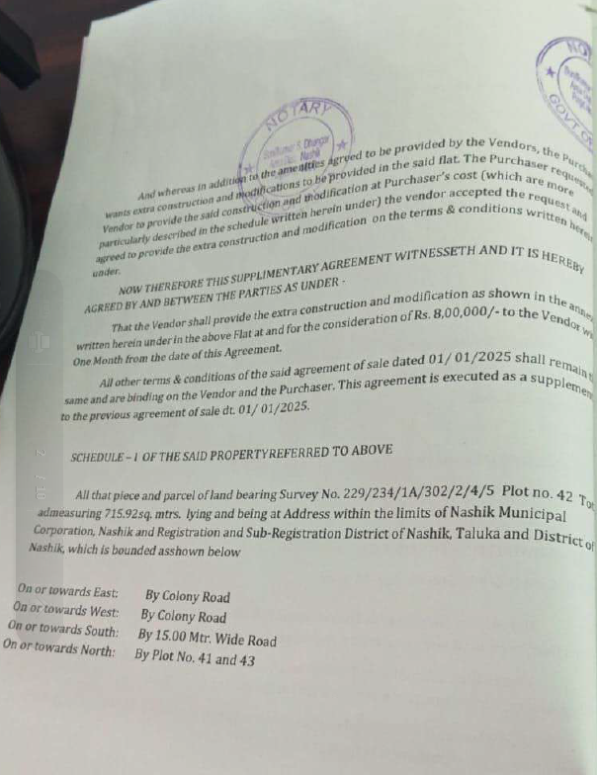
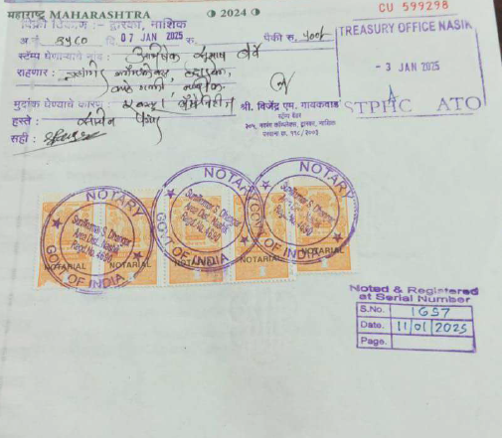

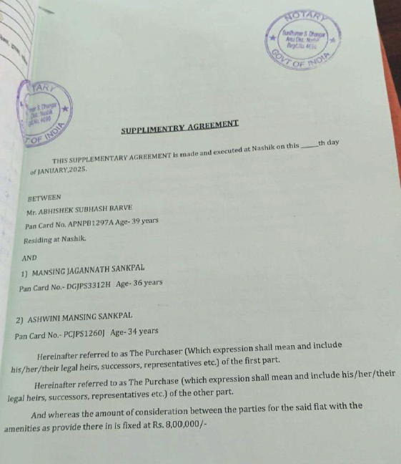

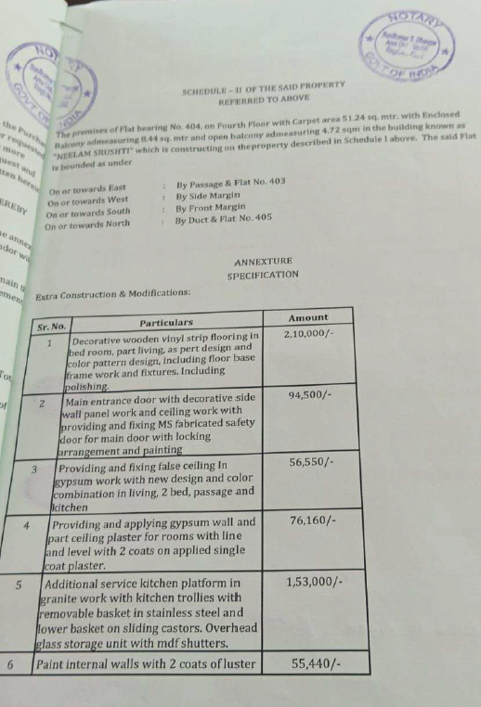
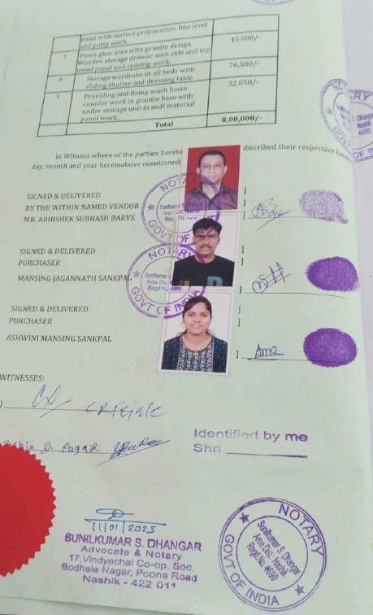

The Extra Amenities amount is Rs. 8,00,000/- (Rupees Eight Lakh Only)

