Valuation Report of the Immovable Property

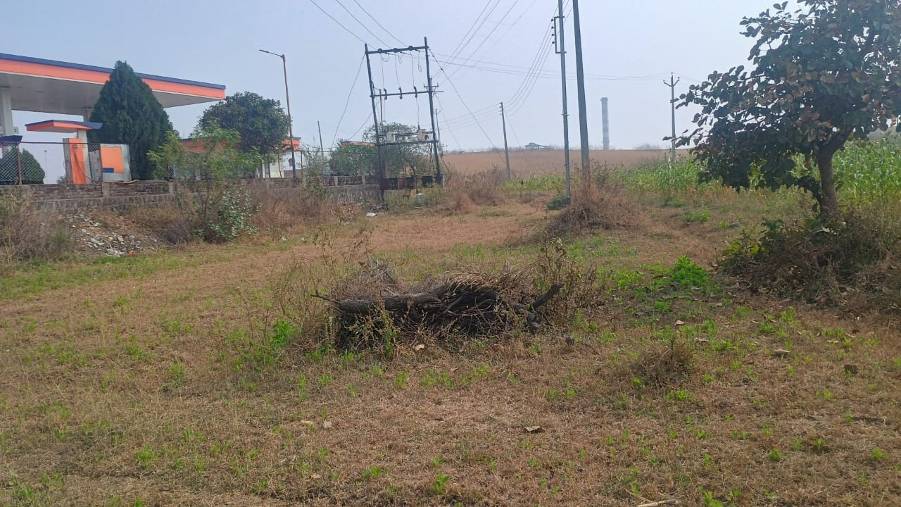
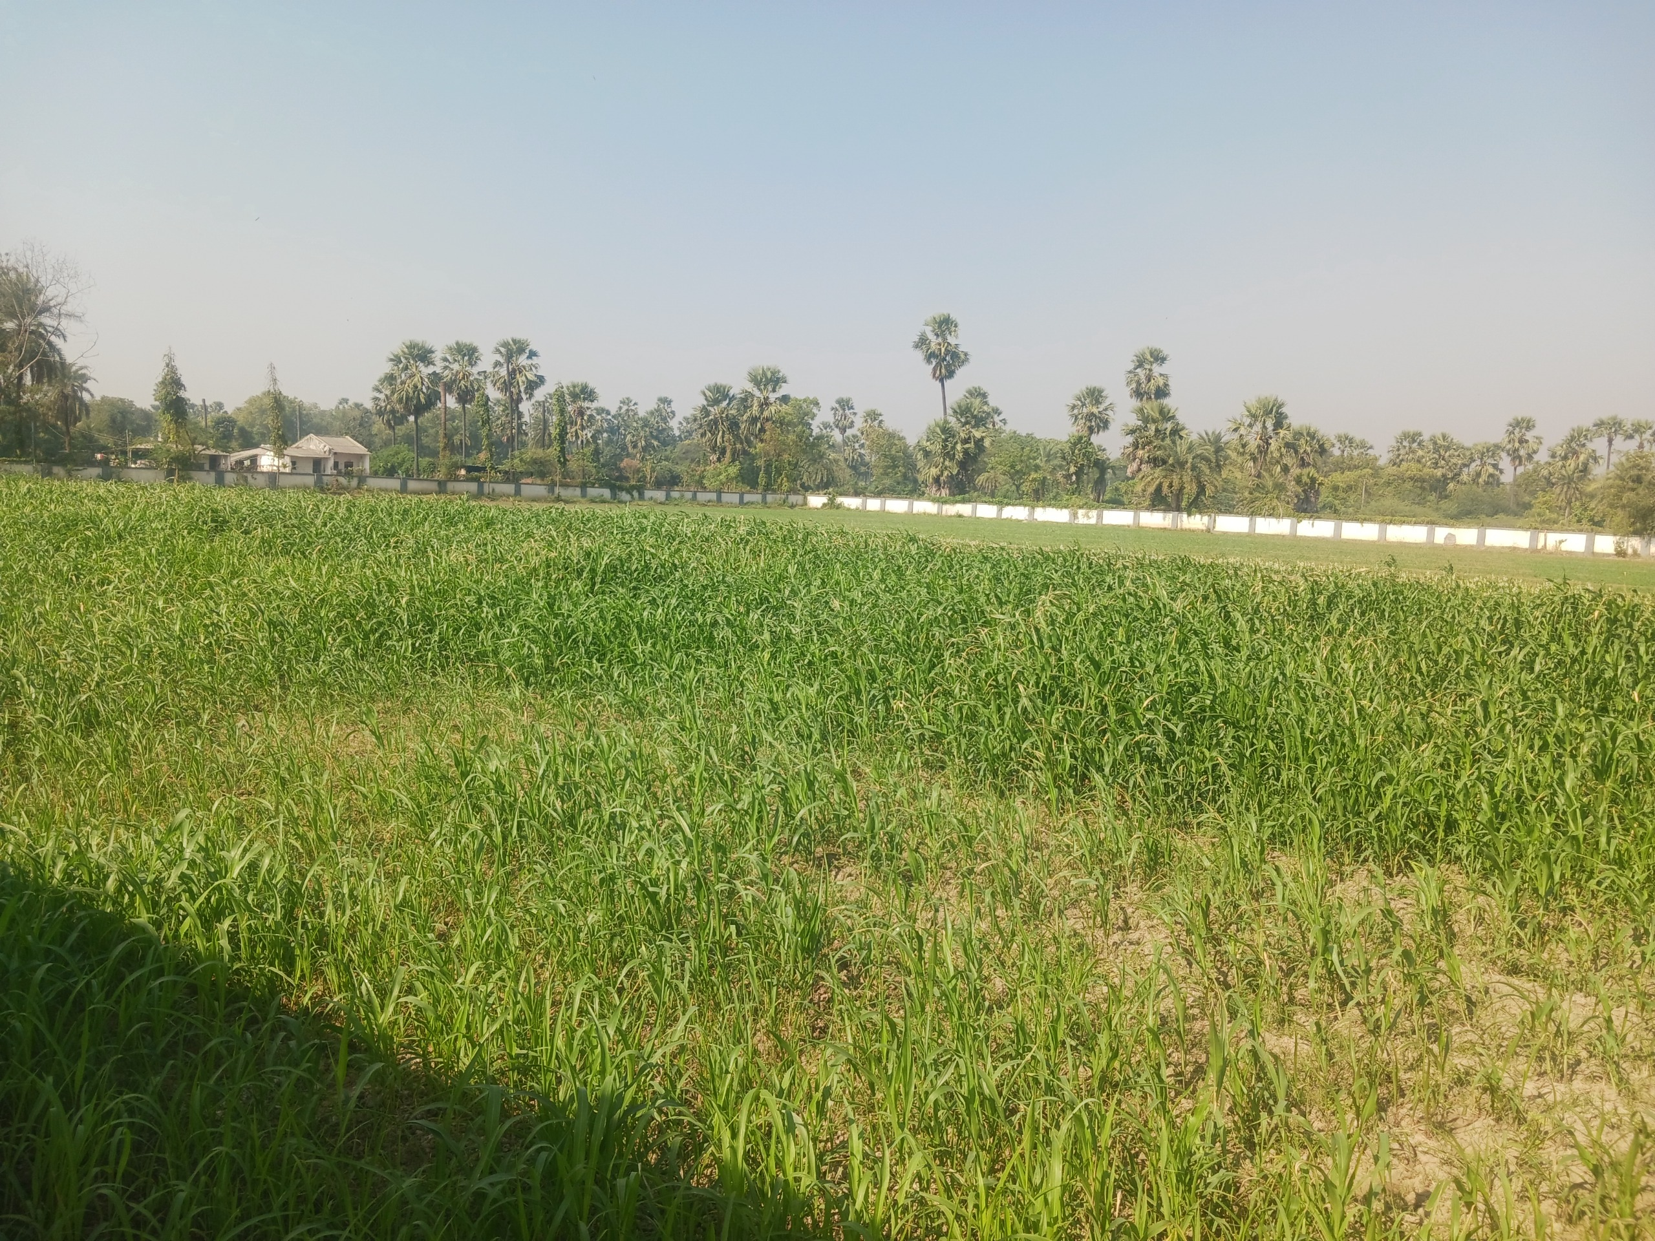

Details of the property under consideration:

Name of Owner: Mr. Vijay Pralhad Keshatwar

Commercial Land a part of Gut No. 122, Fronting on Shirur to Narsi State Highway No. 225, adjoining Abhijeet Petroleum, Indian Oil Corporation Petrol Pump, Mouje Kharab Khandgaon, Taluka Mukhed, District Nanded,

State - Maharashtra, India.

Longitude Latitude: 18°44'15.2"N 77°25'42.1"E

Intended User:

State Bank of India
RACPC Nanded
New Mondha, A P M C Branch Compound, 2nd Floor,
Nanded – 431602,
State - Maharashtra, India

Vastu/Mumbai/01/2025/013678/2309663
18/21-361-BSA
Date: 16.01.2025

VALUATION OPINION REPORT

This is to certify that the property Commercial Land a part of Gut No. 122, Fronting on Shirur to Narsi State Highway No. 225, adjoining Abhijeet Petroleum, Indian Oil Corporation Petrol Pump, Mouje Kharab Khandgaon, Taluka Mukhed, District Nanded, State - Maharashtra, India
belongs to Mr. Vijay Pralhad Keshatwar.

Boundaries of the property.
North | : | Abhijeet Petroleum & Mukund – Narsi State High Way No. 225
South | : | Gairan
East | : | Agricultural Land of Raziabi Issaqsab
West | : | Agricultural Land of Maroti Laxman Pullawad
Considering various parameters recorded, existing economic scenario, and the information that is available with reference to the development of neighborhood and method selected for valuation, we are of the opinion that, the property premises can be assessed and Fair Market Value for this particular purpose at
Particulars | Fair Market Value In (₹) | Realizable Value In (₹) | Distress Sale Value In (₹)
Commercial Land | 67,56,588/- | 60,80,929/- | 54,05,270/-
The valuation of the property is based on the documents produced by the concerned. Legal aspects have not been taken into consideration while preparing this valuation report.
Hence certified.

Sharadkumar B. Chalikwar
B.E. (Civil), M.E. (Civil), M.Sc. (Real Estate Valuation),
M.Sc. (P&M Valuation), FIE (I), FIV, FIWRS
Chairman & Managing Director
Govt. Reg. Valuer
Chartered Engineer (India)
Reg. No. (N) CCIT/1-14/52/2008-09

SBI Empanelment No.: SME/TCC/38/37

Encl: Valuation report.

Vastukala Consultants (I) Pvt. Ltd.
28, Stadium Complex, Gokul Nagar, Nanded – 431 602.

To,
The Branch Manager,
State Bank of India
RACPC Nanded
New Mondha, A P M C Branch Compound, 2nd Floor,
Nanded – 431602, State - Maharashtra, India

VALUATION REPORT (IN RESPECT OF COMMERCIAL LAND)
I | General
1. | Purpose for which the valuation is made |  |  | : | To assess Fair Market Value of the Property for banking purpose.
 | Authorization letter of Bank |  |  | : | No.
2. | a) | Date of inspection |  | : | 14.01.2025
 | b) | Date on which the valuation is made |  | : | 16.01.2025
3. | List of documents produced for perusal
- Copy of Sale Deed 1419/2012 dated 11.07.2012 between Mr. Sachin Subhash Bacchewar (Seller) AND Mr. Vijay Pralhad Keshatwar (Purchaser), Reg. No. 1491 dated 11.07.2012
- Photo Copy of N.A. Order, No. 2013 – A – Jama – Non Agricultural – Kaap - 129 dated 30.08.2013 issued by Tahsildar, Tahsil Office, Mukhed
- Photo Copy of Layout Plan No. AP / WUMH/14/880 dated 12.12.2013 of Retail Outlet, IOC Petrol Pump approved by Joint Chief Controller of Explosive
- Photo Copy of Tax Receipt No. 35 dated 15.12.2022 in the year 2022-23, G.P. House No. 496 issued by Gramsevak, Grampanchayat Office, Kharab Khandgaon, Taluka Mukhed, District Nanded
- Photo Copy of Gao Namuna No. 9 - A, Non – Agricultural Tax Receipt dated 30.01.2024, in the year 2023-24, Govt. of Maharashtra
- Photo Copy of Building Permission dated 26.07.2013 approved by Grampanchayat Kharab Khandgaon, Taluka Mukhed, District Nanded.
- Photo Copy of Detail Existing Layout Plan of Gat No. 122, Kharab Khandgaon, Taluka Mukhed, District Nanded dated 23.09.2021 Surveyed by Atharva Associates, Nanded.
4. | Name of the owner(s) and his / their address (es) with Phone no. (details of share of each owner in case of joint ownership) |  |  | : | Mr. Vijay Pralhad Keshatwar  Address: Commercial Land a part of Gut No. 122, Fronting on Shirur to Narsi State Highway No. 225, adjoining Abhijeet Petroleum, Indian Oil Corporation Petrol Pump, Mouje Kharab Khandgaon, Taluka Mukhed, District Nanded, State - Maharashtra, India.  Contact Person:  Mr. Vijay Pralhad Keshatwar  Contact No: +91 98225 99711, 77210 77211  Mr. Sachin Subhash Bacchewar (Manager)  Contact No: +91 98813 59389  Sole Ownership
5. | Brief description of the property (Including Leasehold / freehold etc.)
The property is located in a developing area having basic infrastructure, well connected by road. It is located at about 8.1 km. travelling distance from Mukhed Bus Stand.

Total Area of Land in Gut No. 122, Mouje Kharab Khandgaon is 3,238.00 Sqm.
Owner has obtained Commercial Non-Agriculture Permission from Tahsildar, Tahsil Office, Mukhed for Petrol Pump and Commercial activity.
As per the Measurement Plan provided by owner the land area details are as under:
The area of Abhijeet Petroleum Plot (Part- 1) is 2,233.45 Sqm.
The area of Commercial Plot (Part – 2) is 918.15 Sqm. the property under considered for the purpose of valuation.
6. | Location of property |  |  | :
 | a) | Plot No. / Survey No. |  | : | Gut No. 122
 | b) | Door No. |  | : | -
 | c) | C.T.S. No. / Village |  | : | Mouje Kharab Khandgaon
 | d) | Ward / Taluka |  | : | Taluka Mukhed
 | e) | Mandal / District |  | : | District Nanded
7. | Postal address of the property |  |  | : | Commercial Land a part of Gut No. 122, Fronting on Shirur to Narsi State Highway No. 225, adjoining Abhijeet Petroleum, Indian Oil Corporation Petrol Pump, Mouje Kharab Khandgaon, Taluka Mukhed, District Nanded, State - Maharashtra, India.
8. | City / Town |  |  | : | Mouje Kharab Khandgaon, Taluka Mukhed, District Nanded
 | Residential area |  |  | : | No
 | Commercial area |  |  | : | Yes
 | Industrial area |  |  | : | No
9. | Classification of the area |  |  | :
 | i) High / Middle / Poor |  |  | : | Middle Class
 | ii) Urban / Semi Urban / Rural |  |  | : | Rural
10. | Coming under Corporation limit / Village Panchayat / Municipality |  |  | : | Grampanchayat Kharab Khandgaon
11. | Whether covered under any State / Central Govt. enactments (e.g., Urban Land Ceiling Act) or notified under agency area/ scheduled area / cantonment area |  |  | : | No
12. | In Case it is agricultural Land, any conversion to house site plots is contemplated |  |  | : | N.A. Land for Commercial activity
13. | Boundaries of the property
 | Particulars |  | North | South |  | East |  | West
 | As per Site Inspection
 | Gut No. 122 |  | Abhijeet Petroleum & Mukund – Narsi State High Way No. 225 | Gairan |  | Agricultural Land of Raziabi Issaqsab |  | Agricultural Land of Maroti Laxman Pullawad
 | As per Documents
 | Gut No. 122 |  | Road | Gairan |  | Agricultural Land of Raziabi Issaqsab |  | Agricultural Land of Maroti Laxman Pullawad
14.1 | Dimensions of the site |  |  | :
 |  |  |  |  | A  As per the Documents |  | B  Actuals
 | North |  |  | : | As shown below
 | South |  |  | :
 | East |  |  | :
 | West |  |  | :
 | 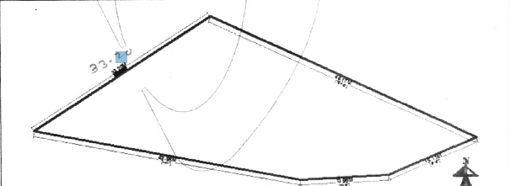
14.2 | Latitude, Longitude & Co-ordinates of property |  |  | : | 18°44'15.2"N 77°25'42.1"E
14. | Extent of the site |  |  | : | Land area = 918.15 Sqm.  (As per Plan)
15. | Extent of the site considered for Valuation (least of 14A& 14B) |  |  | :
16 | Whether occupied by the owner / tenant? If occupied by tenant since how long? Rent received per month. |  |  | : | Vacant and under owner’s possession
II | CHARACTERSTICS OF THE SITE
 | Classification of locality |  |  | : | Developing Locality
 | Development of surrounding areas |  |  | : | Normal
 | Possibility of frequent flooding/ sub-merging |  |  | : | No
 | Feasibility to the Civic amenities like School, Hospital, Bus Stop, Market etc. |  |  | : | All available near by
 | Level of land with topographical conditions |  |  | : | Plain
 | Shape of land |  |  | : | Irregular
 | Type of use to which it can be put |  |  | : | For commercial purpose
 | Any usage restriction |  |  | : | Commercial
 | Is plot in town planning approved layout? |  |  | : | No
 | Corner plot or intermittent plot? |  |  | : | Intermittent
 | Road facilities |  |  | : | Yes, fronting on Shirur to Narsi State High Way No. 225
 | Type of road available at present |  |  | : | B.T. Road
 | Width of road – is it below 20 ft. or more than 20 ft. |  |  | : | above 20 ft. Wide Road
 | Is it a Land – Locked land? |  |  | : | No
 | Water potentiality |  |  | : | Yes
 | Underground sewerage system |  |  | : | No
 | Is Power supply is available in the site |  |  | : | Yes
 | Advantages of the site |  |  | : | Property fronting on Shirur to Narsi State Highway No. 225, adjoining Abhijeet Petroleum, Indian Oil Corporation Petrol Pump
 | Special remarks, if any like threat of acquisition of land for publics service purposes, road widening or applicability of CRZ provisions etc. (Distance from sea-cost / tidal level must be incorporated) |  |  | : | No
Part – A (Valuation of land)
1 | Size of plot |  |  | : | Land area = 918.15 Sqm.
 | North & South |  |  | : | -
 | East & West |  |  | : | -
2 | Total extent of the plot |  |  | : | Land area = 918.15 Sqm.
3 | Prevailing market rate (Along with details / reference of at least two latest deals / transactions with respect to adjacent properties in the areas) |  |  | : | ₹ 6,000/- to ₹ 8,000/- per Sqm.  According to location, approach road and infra structure facilities available.  Online listing are attached.  Details of Price Indicators are not found.
4 | Ready Reckoner rate from Government Portal |  |  | : | ₹ 1,265/- per Sq. M.
 | In case of variation of 20% or more in the valuation proposed by the valuer and the Guideline value provided in the State Govt. notification or Income Tax Gazette justification on variation has to be given. |  |  | : | It is a foregone conclusion that market value is always more than RR prices. As the RR rates are fixed by respective state governments for computing stamp duty / registration Fees. Thus, the rates differ from place to place and location. The market rates are as per the demand and supply however the RR rates are for blocks.
5 | Assessed / adopted rate of valuation of Land (Pls. Refer Justification Note) |  |  | : | ₹ 7,250/- per Sq. M.
6 | Estimated value of land |  |  | : | ₹ 66,56,588/-
Part – B (Valuation of Building)
1 | Technical details of the building |  |  | :
 | - Type of Building (Residential / Commercial / Industrial) |  |  | : | Not applicable being valuation of land only
 | - Type of construction (Load bearing / RCC / Steel Framed) |  |  | : | Not applicable being valuation of land only
 | - Year of construction |  |  | : | Not applicable being valuation of land only
 | - Number of floors and height of each floor including basement, if any |  |  | : | Not applicable being valuation of land only
 | - Plinth area floor-wise |  |  | : | Not applicable being valuation of land only
 | - Condition of the building |  |  | : | Not applicable being valuation of land only
 | - Exterior – Excellent, Good, Normal, Poor |  |  | : | Not applicable being valuation of land only
 | - Interior – Excellent, Good, Normal, Poor |  |  | : | Not applicable being valuation of land only
 | - Date of issue and validity of layout of approved map |  |  | : | Not applicable being valuation of land only
 | - Approved map / plan issuing authority |  |  | :
 | - Whether genuineness or authenticity of approved map / plan is verified |  |  | :
 | - Any other comments by our empaneled valuers on authentic of approved plan |  |  | : | No

Specifications of construction (floor-wise) in respect of

Sr.  No. | Description
 | Foundation | : | Not applicable being valuation of land only
 | Basement | : | Not applicable being valuation of land only
 | Superstructure | : | Not applicable being valuation of land only
 | Joinery / Doors & Windows (Please furnish details about size of frames, shutters, glazing, fitting etc. and specify the species of timber | : | Not applicable being valuation of land only
 | RCC Works | : | Not applicable being valuation of land only
 | Plastering | : | Not applicable being valuation of land only
 | Flooring, Skirting, dado | : | Not applicable being valuation of land only
 | Special finish as marble, granite, wooden paneling, grills etc. | : | Not applicable being valuation of land only
 | Roofing including weatherproof course | : | Not applicable being valuation of land only
 | Drainage | : | Not applicable being valuation of land only
2. | Compound Wall | : | Yes, Partly Provided
 | Height | : | 6’3”
 | Length | : | 466.00 Rft.
 | Type of construction | : | UCRS in Plinth and Foundation, B.B. Masonary, M.S. Grill with welded mesh etc.
3. | Electrical installation | :
 | Type of wiring | : | Not applicable being valuation of land only
 | Class of fittings (superior / ordinary / poor) | : | Not applicable being valuation of land only
 | Number of light points | : | Not applicable being valuation of land only
 | Fan points | : | Not applicable being valuation of land only
 | Spare plug points | : | Not applicable being valuation of land only
 | Any other item | : | -
4. | Plumbing installation
 | - No. of water closets and their type | : | Not applicable being valuation of land only
 | - No. of wash basins | : | Not applicable being valuation of land only
 | - No. of urinals | : | Not applicable being valuation of land only
 | - No. of bathtubs | : | Not applicable being valuation of land only
 | - Water meters, taps etc. | : | Not applicable being valuation of land only
 | - Any other fixtures | : | Not applicable being valuation of land only

Part – C (Extra Items) |  | : | Amount in ₹
 | Portico | : | Not applicable being valuation of land only
 | Ornamental front door | :
 | Sit out / Verandah with steel grills | :
 | Overhead water tank | :
 | Extra steel / collapsible gates | :
 | Total

Part – D (Amenities) |  | : | Amount in ₹
 | Wardrobes | : | Not applicable being valuation of land only
 | Glazed tiles | :
 | Extra sinks and bathtub | :
 | Marble / ceramic tiles flooring | :
 | Interior decorations | :
 | Architectural elevation works
 | Paneling works
 | Aluminum works
 | Aluminum handrails
 | False ceiling
 | Total

Part – E (Miscellaneous) |  | : | Amount in ₹
 | Separate toilet room | : | Not applicable being valuation of land only
 | Separate lumber room | :
 | Separate water tank / sump | :
 | Trees, gardening | :
 | Total

Part – F (Services) |  | : | Amount in ₹
 | Water supply arrangements – Borewell – 6” dia @ 500’ deep, 7 HP submersible pump | : | ₹ 1,00,000/-
 | Drainage arrangements | :
 | Compound wall | :
 | C.B. deposits, fittings etc. | :
 | Pavement
 | Total

GOVERNMENT VALUE

Particulars | Area in Sqm. | Rate in ₹ | Value in ₹
Land | 918.15 | 1,265/- | 11,61,460/-

TOTAL ABSTRACT OF THE ENTIRE PROPERTY

Part - A | Land | ₹ 66,56,588/-
Part - B | Buildings | -
Part – C | Extra Items | -
Part – D | Amenities | -
Part - E | Miscellaneous | -
Part - F | Services - Borewell | ₹ 1,00,000/-
 | Total | ₹ 67,56,588/-
 | Fair Market Value In (`) | ₹ 67,56,588/-
 | Realizable Value In (`) | ₹ 60,80,929/-
 | Distress Sale Value In (`) | ₹ 54,05,270/-
 | Insurable Value In (`) | Not applicable being valuation of land only
Remarks

METHOD OF VALUATION / APPROACH

Land cost can be estimated using the Sales Comparison Approach or Market Approach by studying recent sales of land close to the subject property, and these sales should be comparable in size and location with subject property.

This approach is most commonly used for real estate properties that are not easily sold like schools, hospitals, government buildings and above type of property.
As the property is a commercial land, we have adopted Comparative Sales Method for the purpose of valuation. The Price for similar type of property in the nearby vicinity is in the range of ₹ 6,000/- to ₹ 8,000/- per Sqm. As the plot under reference is commercial use land, we have adopted ` 7,250/- per Sq. M. for the purpose of valuation. Considering the rate with attached report, current market conditions, demand and supply position, Land size, location, sustained demand for commercial use land, all round development of commercial application in the locality etc.
The saleability of the property is: Normal
Likely rental values in future in: N.A.
Any likely income it may generate: N.A.

ACTUAL SITE PHOTOGRAPHS
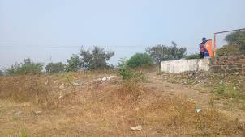

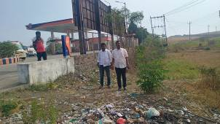

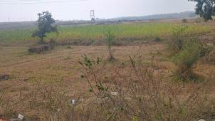
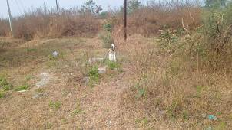

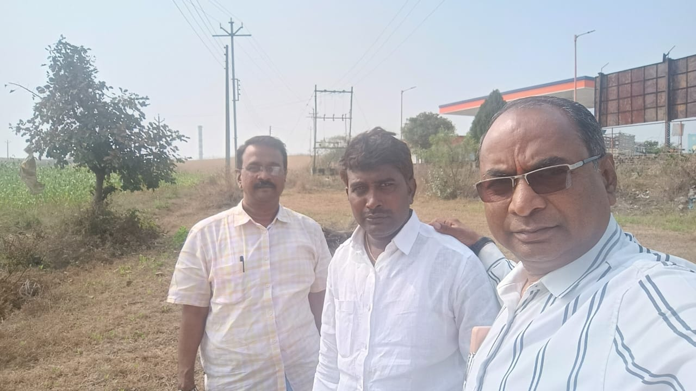

ROUTE MAP OF THE PROPERTY
Site u/r
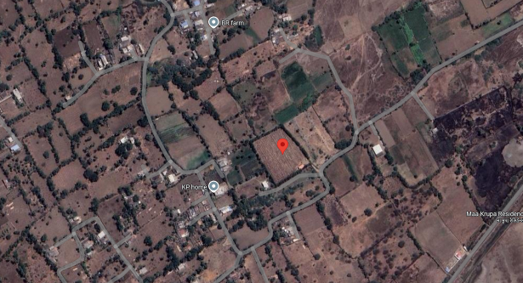
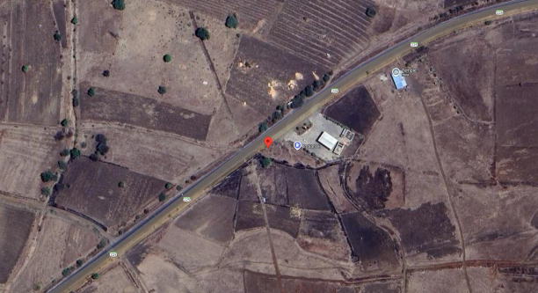

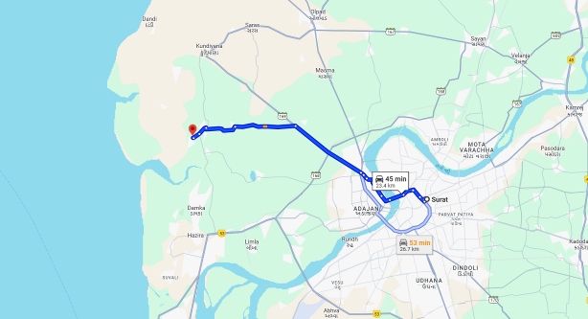
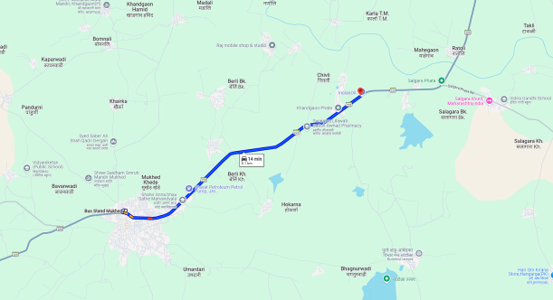

Longitude Latitude: 18°44'15.2"N 77°25'42.1"E
Note: The Blue line shows the route to site from nearest Bus Stand (Mukhed – 8.1 KM.)

LAYOUT PLAN
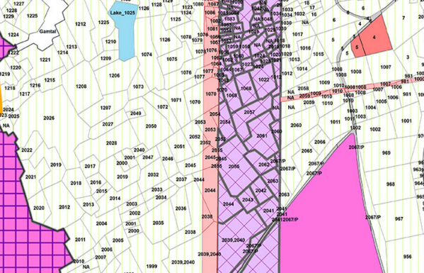
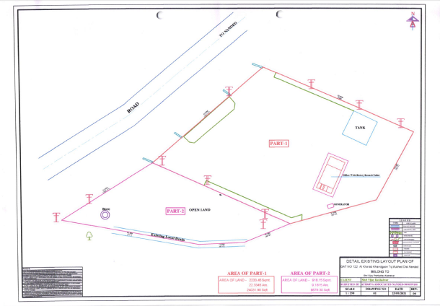

READY RECKONER RATE

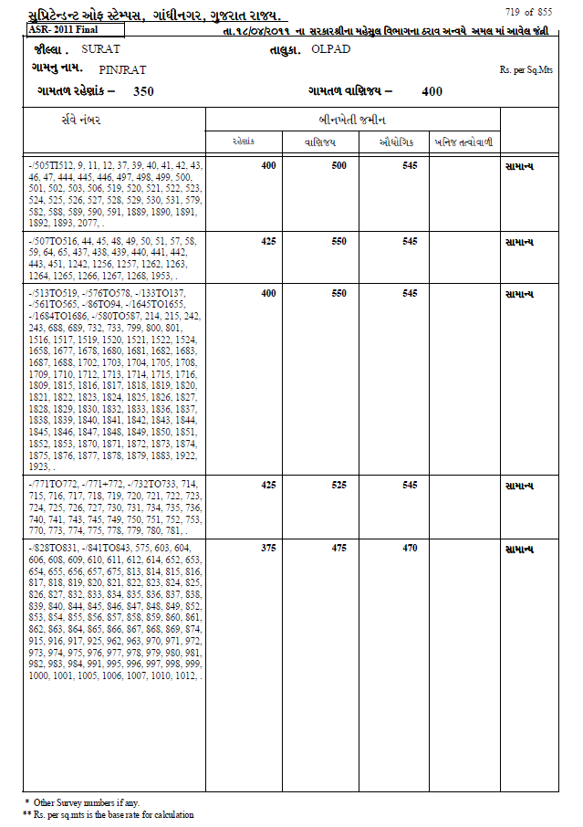
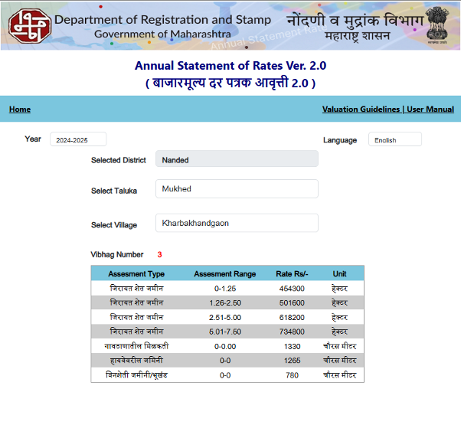

SALES INSTANCES

Land Area in Sq. M. | Price in ` | Rate / Sq. M.
111.00 | 4,50,000.00 | 4,054.00
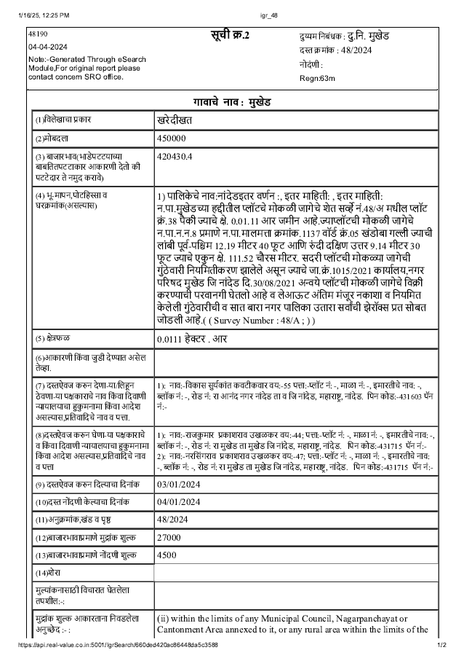

SALES INSTANCES

Land Area in Sq. M. | Price in ` | Rate / Sq. M.
74.00 | 2,90,000.00 | 3,919.00
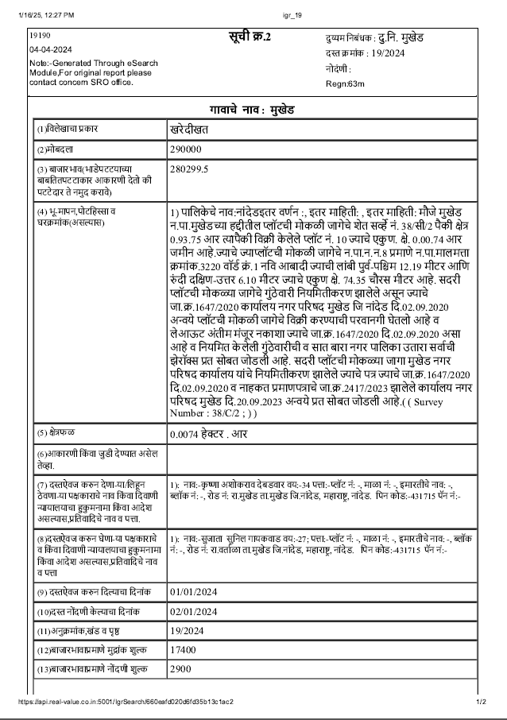

Justification to 5 - Part – A
(In case of variation of 20% or more in the valuation proposed by the valuer and the Guideline value provided in the State Govt. notification or Income Tax Gazette justification on variations).

The valuation of freehold property i.e. Commercial Land a part of Gut No. 122, Fronting on Shirur to Narsi State Highway No. 225, adjoining Abhijeet Petroleum, Indian Oil Corporation Petrol Pump, Mouje Kharab Khandgaon, Taluka Mukhed, District Nanded, State - Maharashtra, India belongs to Mr. Vijay Pralhad Keshatwar.

That, with respect to valuation Report II-Part – A the Justification for Market Rate is as under:

- The Ready Reckoner rate i.e. Guide Line rate for Land rate is Rs. 1,265.00 Per Sqm.
- Guideline Rates are basically generated for Stamp duty purpose, at the time of purchase the property which is fixed for year to year for particular Survey Nos., Gut Nos., CTS Nos., etc. Guideline rates are lower than market rates. There is no example to know guideline rates are lower than market rates. Guideline values. may not be considered for any actual transaction current market.
- Social Forces, Economic forces, Government / Legal and Physical / Environmental factors influence the value of Real Estate.
- This property is situated in developing area with easy access to all type of Civic Facilities.
- The Sales Comparison Approach and Market approach method are adopted to arrive the fair market value.
- As per the local enquiries in the market, the rates in the vicinity are ranging from Rs. 6,000.00 to 8,000.00 per Sq. M. The current trends in the market are to register the documents as per the Stamp Duty rate and not as per the Actual transaction to save the Stamp duty charges.
- Market Rates are not fixed but increase or decrease as per surrounding development, Approach location, Availability of amenities & services, demand in surrounding etc.
- As per the Hon. Supreme Court the Guideline rate is for stamp duty collection and not the Fair Market Value.
- In case of Jawaji Nagnathan vs. REV. DIV. Officer (1994) SCC – 4 Page 595 SC the Court held, “It is therefore, clear that the Basic Valuation Register prepared and maintained for the purpose of collecting stamp duty has no statutory base or force. It cannot form a foundation to determine the market value mentioned there under in instrument brought for registration. Evidence of bonafide sales between willing prudent vendor and prudent vendee of the land acquired or situated near about that land possessing same or similar advantageous features would furnish basis to determine market value.”
- After giving due consideration for various factors influencing the value of the property with respect to Physical, Legal, Social and Economical aspects, Location, Development in the vicinity, Road frontage, and local enquiries the Land rate of Rs. 7,250.00 Per Sq. M. is considered Fair and Reasonable and hence adopted to arrive the Fair Market value of the Property.

For, Vastukala Consultants (I) Pvt. Ltd.

Sharadkumar B. Chalikwar
B.E. (Civil), M.E. (Civil), M.Sc. (Real Estate Valuation), M.Sc. (P&M Valuation), FIE (I), FIV, FIWRS
Chairman & Managing Director
Govt. Reg. Valuer
Chartered Engineer (India)
Reg. No. (N) CCIT/1-14/52/2008-09
IBBI Reg.No. IBBI/RV/07/2019/1174
As a result of my appraisal and analysis, it is my considered opinion that the present Market value of the above property in the prevailing condition with aforesaid specifications is as follows:

Particulars | Fair Market Value In (`) | Realizable Value In (`) | Distress Sale Value In (`)
Commercial Land | 67,56,588/- | 60,80,929/- | 54,05,270/-

Place: Nanded
Date: 16.01.2025

Sharadkumar B. Chalikwar
B.E. (Civil), M.E. (Civil), M.Sc. (Real Estate Valuation),
M.Sc. (P&M Valuation), FIE (I), FIV, FIWRS
Chairman & Managing Director
Govt. Reg. Valuer
Chartered Engineer (India)
Reg. No. (N) CCIT/1-14/52/2008-09

SBI Empanelment No.: SME/TCC/38/37

The undersigned has inspected the property detailed in the Valuation Report dated _______________________

on ____________________. We are satisfied that the fair and reasonable market value of the property is

`_________________________ (Rupees ________________________________________________________

________________________________________only).

Date
Signature
(Name & Designation of the Inspecting Official/s)

Countersigned
(BRANCH MANAGER)

Enclosures
 | Declaration-cum-undertaking from the valuer (Annexure- IV) | Attached
 | Model code of conduct for valuer - (Annexure - V) | Attached
(Annexure-IV)

DECLARATION-CUM-UNDERTAKING

I, Sharadkumar Chalikwar son of Shri. Baburao Chalikwar do hereby solemnly affirm and state that:

- I am a citizen of India.

- I will not undertake valuation of any assets in which I have a direct or indirect interest or become so interested at any time during a period of three years prior to my appointment as valuer or three years after the valuation of assets was conducted by me.

- The information furnished in my valuation report dated 16.01.2025 is true and correct to the best of my knowledge and belief and I have made an impartial and true valuation of the property.

- I/ my authorized representative has personally inspected the property on 14.01.2025. The work is not sub - contracted to any other valuer and carried out by myself.

- Valuation report is submitted in the format as prescribed by the bank.

- I have not been depanelled / delisted by any other bank and in case any such depanelment by other banks during my empanelment with you, I will inform you within 3 days of such depanelment.

- I have not been removed / dismissed from service / employment earlier.

- I have not been convicted of any offence and sentenced to a term of imprisonment

- I have not been found guilty of misconduct in my professional capacity.

- I have not been declared to be unsound mind

- I am not an undischarged bankrupt, or has not applied to be adjudicated as a bankrupt;

- I am not an undischarged insolvent.

- I have not been levied a penalty under section 271J of Income-tax Act, 1961 (43 of 1961) and time limit for filing appeal before Commissioner of Income-tax (Appeals) or Income-tax Appellate Tribunal, as the case may be has expired, or such penalty has been confirmed by Income-tax Appellate Tribunal, and five years have not elapsed after levy of such penalty

- I have not been convicted of an offence connected with any proceeding under the Income Tax Act 1961, Wealth Tax Act 1957 or Gift Tax Act 1958 and

- My PAN Card number as applicable is AEAPC0117Q

- I undertake to keep you informed of any events or happenings which would make me ineligible for empanelment as a valuer

- I have not concealed or suppressed any material information, facts and records and I have made a complete and full disclosure

- I have read the Handbook on Policy, Standards and procedure for Real Estate Valuation, 2011 of the IBA and this report is in conformity to the "Standards" enshrined for valuation in the Part - B of the above handbook to the best of my ability.

- I have read the International Valuation Standards (IVS) and the report submitted to the Bank for the respective asset class is in conformity to the "Standards" as enshrined for valuation in the IVS in "General Standards" and "Asset Standards" as applicable. The valuation report is submitted in the prescribed format of the bank.

- I abide by the Model Code of Conduct for empanelment of valuer in the Bank. (Annexure V - A signed copy of same to be taken and kept along with this declaration)

- I am registered under Section 34 AB of the Wealth Tax Act, 1957.

- I am valuer registered with Insolvency & Bankruptcy Board of India (IBBI)

- My CIBIL Score and credit worthiness is as per Bank's guidelines.

- I am Chairman & Managing Director of the company, who is competent to sign this valuation report.

- I will undertake the valuation work on receipt of Letter of Engagement generated from the system (i.e. LLMS / LOS) only.

- Further, I hereby provide the following information.
Sr. No. | Particulars | Valuer comment
1 | Background information of the asset being valued; | The property is owned by Mr. Vijay Pralhad Keshatwar as per Sale Deed dated 11.07.2012 from Mr. Sachin Subhash Bacchewar.
2 | Purpose of valuation and appointing authority | As per the request from State Bank of India, RACPC Nanded to assess Fair Market Value of the property for banking purpose.
3 | Identity of the Valuer and any other experts involved in the valuation; | Sharadkumar B. Chalikwar – Regd. Valuer  Akhilesh Yadav – Technical Manager
4 | Disclosure of Valuer interest or conflict, if any; | We have no interest, either direct or indirect, in the property valued. Further to state that we do not have relation or any connection with property owner / applicant directly or indirectly. Further to state that we are an independent Valuer and in no way related to property owner / applicant
5 | Date of appointment, valuation date and date of report; | Date of Appointment – 14.01.2025  Valuation Date – 16.01.2025  Date of Report – 16.01.2025
6 | Inspections and/or investigations undertaken; | Physical Inspection done on 14.01.2025
7 | Nature and sources of the information used or relied upon; | - Market Survey at the time of site visit  - Ready Reckoner rates / Circle rates  - Enquiries with Real estate consultants  - Existing data of Valuation assignments carried out by us
8 | Procedures adopted in carrying out the valuation and valuation standards followed; | Comparative Sales Method (for Land component)
9 | Restrictions on use of the report, if any; | This valuation is for the use of the party to whom it is addressed and for no other purpose. No responsibility is accepted to any third party who may use or rely on the whole or any part of this valuation. The valuer has no pecuniary interest that would conflict with the proper valuation of the property.
10 | Major factors that were taken into account during the valuation. | Current market conditions, demand and supply position, land size, location, sustained demand for land. all round development of commercial application in the locality etc.
11 | Major factors that were taken into account during the valuation. | Nil
12 | Caveats, limitations, and disclaimers to the extent they explain or elucidate the limitations faced by valuer, which shall not be for the purpose of limiting his responsibility for the valuation report. | Attached

ASSUMPTIONS, DISCLAIMERS, LIMITATIONS & QUALIFICATIONS

Value Subject to Change
The subject appraisal exercise is based on prevailing market dynamics as on 16th January 2025 and does not take into account any unforeseeable developments which could impact the same in the future.
Our Investigations
We are not engaged to carry out all possible investigations in relation to the subject property. Where in our report we identify certain limitations to our investigations, this is to enable the reliant party to instruct further investigations where considered appropriate or where we recommend as necessary prior to reliance. Vastukala Consultants India Pvt. Ltd. (VCIPL) is not liable for any loss occasioned by a decision not to conduct further investigations.
Assumptions
Assumptions are a necessary part of undertaking valuations. VCIPL adopts assumptions for the purpose of providing valuation advise because some matters are not capable of accurate calculations or fall outside the scope of our expertise, or out instructions. The reliant party accepts that the valuation contains certain specific assumptions and acknowledge and accept the risk of that if any of the assumptions adopted in the valuation are incorrect, then this may have an effect on the valuation.
Information Supplied by Others
The appraisal is based on the information provided by the client. The same has been assumed to be correct and has been used for appraisal exercise. Where it is stated in the report that another party has supplied information to VCIPL, this information is believed to be reliable but VCIPL can accept no responsibility if this should prove not to be so.
Future Matters
To the extent that the valuation includes any statement as to a future matter, that statement is provided as an estimate and/or opinion based on the information known to VCIPL at the date of this document. VCIPL does not warrant that such statements are accurate or correct.
Map and Plans
Any sketch, plan or map
this report is included to assist the reader while visualizing the property and assume no responsibility in connection with such matters.

Site Details
Based on inputs received from Client's representative and site visit conducted, we understand that the subject property is currently a contiguous and commercial land parcel admeasuring 918.15 Sq. M. The property is owned by Mr. Vijay Pralhad Keshatwar. At present, the property is Owner Occupied. Further, VCIPL has assumed that the subject property is free from any encroachment and is available as on the date of the appraisal.
Property Title
Based on our discussion with the Client, we understand that the property is in the name of Mr. Vijay Pralhad Keshatwar. For the purpose of this appraisal exercise, we have assumed that the subject property has a clear title and is free from any encumbrances, disputes and claims. VCIPL has made no further enquiries with the relevant local authorities in this regard and does not certify the property as having a clear and marketable title. Further, no legal advice regarding the title and ownership of the subject property has been obtained for the purpose of this appraisal exercise. It has been assumed that the title deeds are clear and marketable.
Environmental Conditions
We have assumed that the subject property is not contaminated and is not adversely affected by any existing or proposed environmental law and any processes which are carried out on the property are regulated by environmental legislation and are properly licensed by the appropriate authorities.
Town Planning
The permissible land use, zoning, achievable FSI, area statement adopted for purpose of this valuation is based on the information provided by the Client's representative and the same has been adopted for this valuation purpose. VCIPL has assumed the same to be correct and permissible. VCIPL has not validated the same from any authority.
Area
Based on the documents, we understand that the subject property is contiguous and commercial land parcel admeasuring 918.15 Sq. M.
Condition & Repair
In the absence of any information to the contrary, we have assumed that there are no abnormal ground conditions, nor archaeological remains present which might adversely affect the current or future occupation, development or value of the property. The property is free from rat, infestation, structural or latent defect. No currently known deleterious or hazardous materials or suspect techniques will be used in the construction of or subsequent alteration or additions to the property and comments made in the property details do not purport to express an opinion about, or advise upon, the condition of uninspected parts and should not be taken as making an implied representation or statement about such parts.

Valuation Methodology
For the purpose of this valuation exercise, the valuation methodology used is Sales Comparison Approach.

Land cost can be estimated using the Sales Comparison Approach by studying recent sales of land close to the subject property, and these sales should be comparable in size and location with subject property.

Where reliance has been placed upon external sources of information in applying the valuation methodologies, unless otherwise specifically instructed by Client and/or stated in the valuation, VCIPL has not independently verified that information and VCIPL does not advise nor accept it as reliable. The person or entity to whom the report is addressed acknowledges and accepts the risk that if any of the unverified information in the valuation is incorrect, then this may have an effect on the valuation.
Not a Structural Survey
We state that this is a valuation report and not a structural survey.
Other
All measurements, areas and ages quoted in our report are approximate.
Legal
We have not made any allowances with respect to any existing or proposed local legislation relating to taxation on realization of the sale value of the subject property. VCIPL is not required to give testimony or to appear in court by reason of this appraisal report, with reference to the property in question, unless arrangement has been made thereof. Further, no legal advice on any aspects has been obtained for the purpose of this appraisal exercise.
Property specific assumptions
Based on inputs received from the client and site visit conducted, we understand that the subject property owner occupied, contiguous and commercial land parcel admeasuring 918.15 Sq. M.

ASSUMPTIONS, CAVEATS, LIMITATION AND DISCLAIMERS
- We assume no responsibility for matters of legal nature affecting the property appraised or the title thereto, nor do we render our opinion as to the title, which is assumed to be good and marketable.
- The property is valued as though under responsible ownership.
- It is assumed that the property is free of liens and encumbrances.
- It is assumed that there are no hidden or unapparent conditions of the subsoil or structure that would render it more or less valuable. No responsibility is assumed for such conditions or for engineering that might be required to discover such factors.
- There is no direct/ indirect interest in the property valued.
- The rates for valuation of the property are in accordance with the Govt. approved rates and prevailing market rates.
(Annexure - V)

MODEL CODE OF CONDUCT FOR VALUERS

Integrity and Fairness
- A valuer shall, in the conduct of his/its business, follow high standards of integrity and fairness in all his/its dealings with his/its clients and other valuers.
- A valuer shall maintain integrity by being honest, straightforward, and forthright in all professional relationships.
- A valuer shall endeavour to ensure that he/it provides true and adequate information and shall not misrepresent any facts or situations.
- A valuer shall refrain from being involved in any action that would bring disrepute to the profession.
- A valuer shall keep public interest foremost while delivering his services.
Professional Competence and Due Care
- A valuer shall render at all times high standards of service, exercise due diligence, ensure proper care and exercise independent professional judgment.
- A valuer shall carry out professional services in accordance with the relevant technical and professional standards that may be specified from time to time.
- A valuer shall continuously maintain professional knowledge and skill to provide competent professional service based on up-to-date developments in practice, prevailing regulations / guidelines and techniques.
- In the preparation of a valuation report, the valuer shall not disclaim liability for his/its expertise or deny his/its duty of care, except to the extent that the assumptions are based on statements of fact provided by the company or its auditors or consultants or information available in public domain and not generated by the valuer.
- A valuer shall not carry out any instruction of the client insofar as they are incompatible with the requirements of integrity, objectivity and independence.
- A valuer shall clearly state to his client the services that he would be competent to provide and the services for which he would be relying on other valuers or professionals or for which the client can have a separate arrangement with other valuers.
Independence and Disclosure of Interest
- A valuer shall act with objectivity in his/its professional dealings by ensuring that his/its decisions are made without the presence of any bias, conflict of interest, coercion, or undue influence of any party, whether directly connected to the valuation assignment or not.
- A valuer shall not take up an assignment if he/it or any of his/its relatives or associates is not independent in terms of association to the company.
- A valuer shall maintain complete independence in his/its professional relationships and shall conduct the valuation independent of external influences.
- A valuer shall wherever necessary disclose to the clients, possible sources of conflicts of duties and interests, while providing unbiased services.
- A valuer shall not deal in securities of any subject company after any time when he/it first becomes aware of the possibility of his / its association with the valuation, and in accordance with the Securities and Exchange Board of India (Prohibition of Insider Trading)Regulations,2015 or till the time the valuation report becomes public, whichever is earlier.
- A valuer shall not indulge in "mandate snatching" or offering "convenience valuations" in order to cater to a company or client's needs.
- As an independent valuer, the valuer shall not charge success fee.
- In any fairness opinion or independent expert opinion submitted by a valuer, if there has been a prior engagement in an unconnected transaction, the valuer shall declare the association with the company during the last five years.
Confidentiality
- A valuer shall not use or divulge to other clients or any other party any confidential information about the subject company, which has come to his / its knowledge without proper and specific authority or unless there is a legal or professional right or duty to disclose.
Information Management
- A valuer shall ensure that he/ it maintains written contemporaneous records for any decision taken, the reasons for taking the decision, and the information and evidence in support of such decision. This shall be maintained so as to sufficiently enable a reasonable person to take a view on the appropriateness of his /its decisions and actions.
- A valuer shall appear, co-operate and be available for inspections and investigations carried out by the authority, any person authorised by the authority, the registered valuers organisation with which he/it is registered or any other statutory regulatory body.
- A valuer shall provide all information and records as may be required by the authority, the Tribunal, Appellate Tribunal, the registered valuers organisation with which he/it is registered, or any other statutory regulatory body.
- A valuer while respecting the confidentiality of information acquired during the course of performing professional services, shall maintain proper working papers for a period of three years or such longer period as required in its contract for a specific valuation, for production before a regulatory authority or for a peer review. In the event of a pending case before the Tribunal or Appellate Tribunal, the record shall be maintained till the disposal of the case.

Gifts and hospitality:
- A valuer or his / its relative shall not accept gifts or hospitality which undermines or affects his independence as a valuer.
- Explanation: For the purposes of this code the term 'relative' shall have the same meaning as defined in clause (77) of Section 2 of the Companies Act, 2020.
- A valuer shall not offer gifts or hospitality or a financial or any other advantage to a public servant or any other person with a view to obtain or retain work for himself / itself, or to obtain or retain an advantage in the conduct of profession for himself / itself.
Remuneration and Costs.
- A valuer shall provide services for remuneration which is charged in a transparent manner, is a reasonable reflection of the work necessarily and properly undertaken, and is not inconsistent with the applicable rules.
- A valuer shall not accept any fees or charges other than those which are disclosed in a written contract with the person to whom he would be rendering service.
Occupation, employability and restrictions.
- A valuer shall refrain from accepting too many assignments, if he/it is unlikely to be able to devote adequate time to each of his/ its assignments.
- A valuer shall not conduct business which in the opinion of the authority or the registered valuer organisation discredits the profession.
Miscellaneous
- A valuer shall refrain from undertaking to review the work of another valuer of the same client except under written orders from the bank or housing finance institutions and with knowledge of the concerned valuer.
- A valuer shall follow this code as amended or revised from time to time.

Sharadkumar B. Chalikwar
B.E. (Civil), M.E. (Civil), M.Sc. (Real Estate Valuation),
M.Sc. (P&M Valuation), FIE (I), FIV, FIWRS
Chairman & Managing Director
Govt. Reg. Valuer
Chartered Engineer (India)
Reg. No. (N) CCIT/1-14/52/2008-09
SBI Empanelment No.: SME/TCC/38/37

