Vastu/Nashik/06/32014/2301224
22/20-325-RYBS
Date: 15.01.2024
To,
The Branch Manager,
Bank of Baroda
Regional Office
BSNL Building, Datta Mandir Road, Nashik Road,
Nashik, PIN – 422 101, State - Maharashtra, Country - India.

Sub: Vetting of Extra Amenities

Sir,

With reference to above subject, we have evaluated the Extra Amenities For Residential Flat No. 103, 1st Floor, " Shree Vaishnavi Apartment-I ", Near Podar International School, Buddha Vihar, Survey No - 239/ 2/ 1/ 2, Plot No. 28, off Ekta Green Villa Road, Village - Pathardi, Taluka - Nashik, District - Nashik, Nashik, PIN Code - 422 010, State - Maharashtra, India belongs to Shri. Laxman Mangaldas Chavan & Sau. Asmita Laxman Chavan.

We have verified the rates quoted as per current market rates. Details of Extra Amenities considered as per copy of Extra Amenities Agreement between Shri. Laxman Mangaldas Chavan & Sau. Asmita Laxman Chavan (First Party). Shri. Abid Anjun Ganiur Rahman (Second Party) received on dated. 06.01.2024. The Extra Amenities amount is Rs. 5,00,000/- (Rupees Five Lakh Only)

The said Cost Vetting Certificate is valid upto next 6 months Only.

Thanking you

Sincerely yours

Manoj B. Chalikwar
Registered Valuer
Chartered Engineer (India)
Reg. No. CAT-I-F-1763
Reg. No. IBBI/RV/07/2018/10366
BOB Empanelment No.: ZO:MZ:ADV:46:941
Encl: Valuation report.

Agreement for Extra Amenities
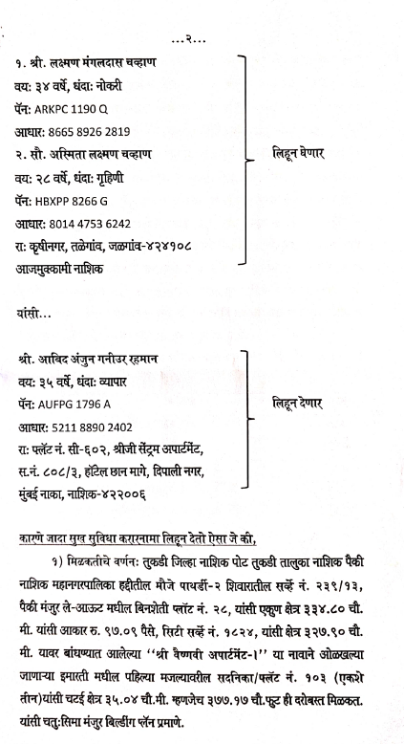
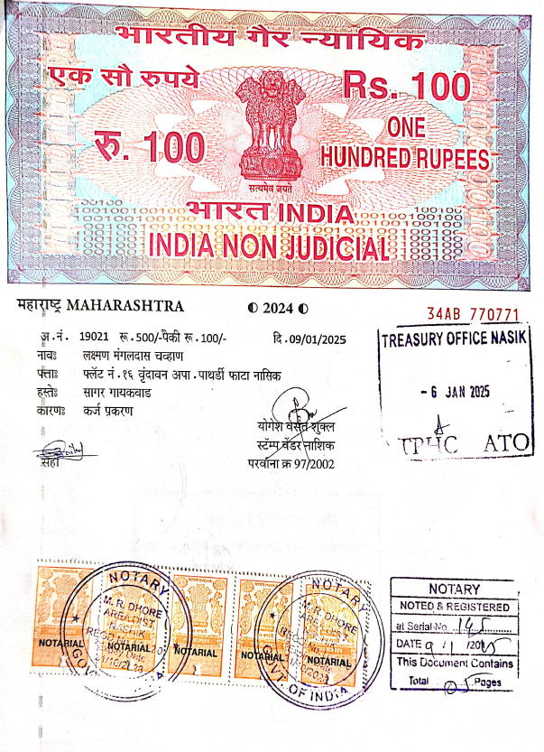

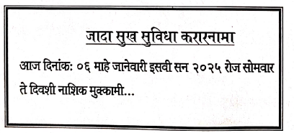

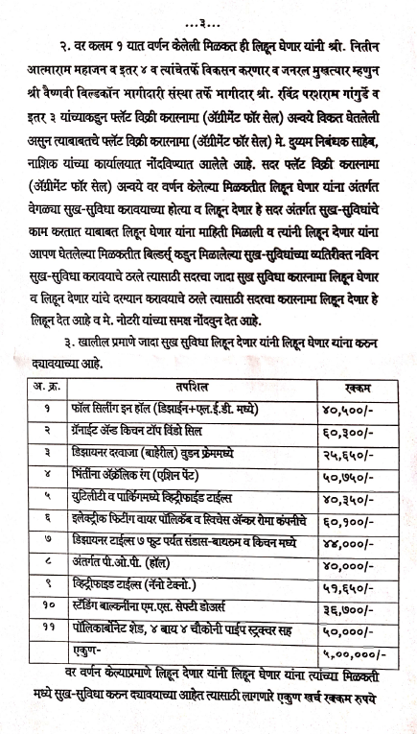
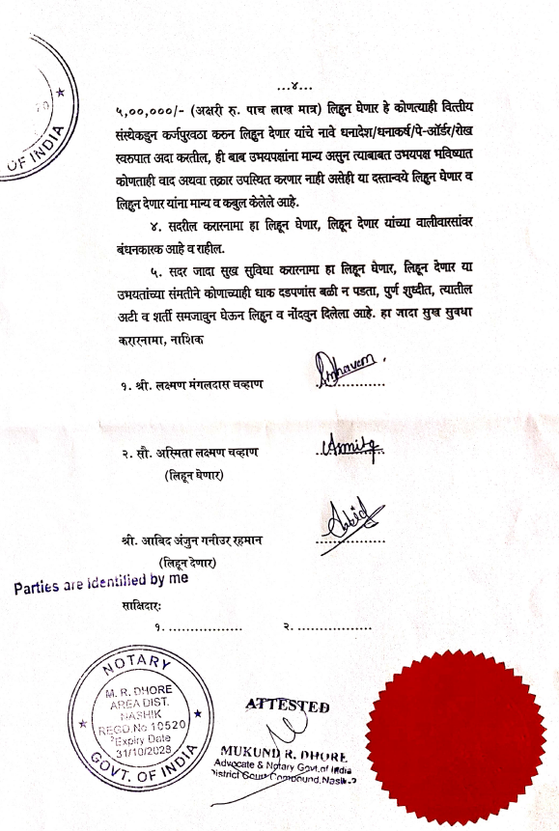

The Extra Amenities amount is Rs. 5,00,000/- (Rupees Five Lakh Only)

