Valuation Report of the Immovable Property

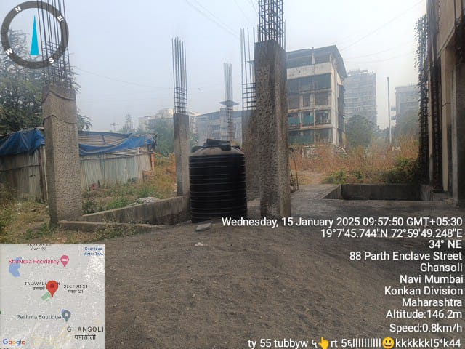

**Details of the property under consideration:**

Name of Owner: **Shri. Hukumchand Babulalji Gandhi (Jain), Proprietor of M/s. Jay Ratan Developers**

**Residential Land & Under Construction Building** on Plot No. 24, Sector – 21,

Village – Ghansoli, Taluka & District – Thane, Navi Mumbai – 400701, Maharashtra, India.

# Latitude Longitude - 19°07’45.8”N 72°59’47.9”E

# 

**Valuation Prepared for:**

**Cosmos Bank**

**Lower Parel Branch**

Manic Soc Sunmill Compound Lane, S J Marg, Lower Parel,

Mumbai 400013, Maharashtra, India

Vastu/Mumbai/01/2025/013631/2304078

20/13-307-SKVS Date: 17.01.2025

# VALUATION OPINION REPORT

The property bearing **Residential Land & Under Construction Building** on Plot No. 24, Sector – 21, Village – Ghansoli, Taluka & District – Thane, Navi Mumbai – 400701, Maharashtra, India belongs to **Shri. Hukumchand Babulalji Gandhi (Jain), Proprietor of M/s. Jay Ratan Developers.**

|  |  |  |
| --- | --- | --- |
| **Boundaries of the property.** | | |
| North | : | Road | |
| South | : | Plot No. 25 | |
| East | : | Plot No. 23 | |
| West | : | Open Plot | |

Considering various parameters recorded, existing economic scenario, and the information that is available with reference to the development of neighborhood and method selected for valuation, we are of the opinion that, the property premises can be assessed and valued for banking purpose as below –

|  |  |  |
| --- | --- | --- |
| **Particulars** | **Full Value (`)**  **(After Building Completion)** | **Proportionate Value (`)**  **(As per work completion 10% as on date)** |
| Land Value | 1,19,86,800.00 | 1,19,86,800.00 |
| Structure Value | 40,58,297.00 | 4,05,830.00 |
| **Total Fair Market Value** | **1,60,45,097.00** | **1,23,92,630.00** |
| **Realizable Value** | **1,44,40,587.00** | **1,11,53,367.00** |
| **Distress Value** | **1,28,36,078.00** | **99,14,104.00** |

The valuation of the property is based on the documents produced by the concern. Legal aspects have not been taken into considerations while preparing this valuation report.

Hence certified

## Manoj B. Chalikwar

Registered Valuer

Chartered Engineer (India)

Reg. No. IBBI / RV / 07/2018/10366

Reg. No. CAT-I-F-1763

**Valuation Report of Residential Land & Under Construction Building** on Plot No. 24,

Sector – 21, Village – Ghansoli, Taluka & District – Thane, Navi Mumbai – 400701, Maharashtra, India

*Form 0-1*

*(See Rule 8 D)*

REPORT OF VALUATION OF IMMOVABLE PROPERTY (OTHER THAN AGRICULTURAL LANDS, PLANTATIONS, FORESTS, MINES AND QUARRIES)

GENERAL:

|  |  |  |  |
| --- | --- | --- | --- |
| 1 | Purpose for which the valuation is made | | To assess the Fair Market Value as on 17.01.2025 for Bank loan Purpose |
| 2 | Date of inspection | | 15.01.2025 |
|  | Name of the owner/ owners | | **Shri. Hukumchand Babulalji Gandhi (Jain), Proprietor of M/s. Jay Ratan Developers** |
| 4 | If the property is under joint ownership / co-ownership, share of each such owner. Are the shares undivided? | | Proprietorship |
| 5 | Brief description of the property | | **Residential Land & Under Construction Building** on Plot No. 24, Sector – 21, Village – Ghansoli, Taluka & District – Thane, Navi Mumbai – 400701, Maharashtra, India |
| 6 | Location, street, ward no | | Village – Ghansoli, Taluka & District – Thane, Navi Mumbai – 400701, Maharashtra, India |
| 7 | Survey/ Plot no. of land | | Residential Land & Under Construction Building on Plot No. 24 |
| 8 | Is the property situated in residential/ commercial/ mixed area/ industrial area? | | Residential area |
| 9 | Classification of locality-high class/ middle class/poor class | | Middle Class |
| 10 | Proximity to civic amenities like schools, Hospitals, Offices, market, cinemas etc. | | All the amenities are available in the vicinity |
| 11 | Means and proximity to surface communication by which the locality is served | | Served by Buses and Private cars |
|  | *LAND* | |  |
| 12 | Area of land supported by documentary proof. Shape, dimension and physical features | | Plot Area is 99.89 Sq. Mtr.  (Area as per Tripartite Agreement)  As per Approved Plan, Built Up Area is as under   |  |  |  | | --- | --- | --- | | Floor | Built Up Area (Sq. Mtr.) | Built Up Area (Sq. Ft.) | | Ground Floor | 16.750 | 180.297 | | 1st Floor | 67.030 | 721.511 | | 2nd Floor | 67.030 | 721.511 | | Total | 150.810 | 1,623.319 | |
| 13 | Roads, Streets or lanes on which the land is abutting | | 11.0 M. Wide Road |
| 14 | If freehold or leasehold land | | Leasehold of CIDCO |
| 15 | If leasehold, the name of Lessor/lessee, nature of lease, date of commencement and termination of lease and terms of renewal of lease. | | Lessor – CIDCO  The Original Licensee – Smt. Anubai Babap Patil  The New Licensee - Shri. Hukumchand Babulalji Gandhi (Jain), Proprietor of M/s. Jay Ratan Developers  Date of Commencement – 14.10.2010  The plot under Gaothan Expansion Scheme of 12.5% Scheme. |
| (i) Initial premium | | Not applicable |
| (ii) Ground rent payable per annum | | Not applicable |
| (iii) Unearned increase payable to the Lessor in the event of sale or transfer | | Not applicable |
| 16 | Is there any restriction covenant in regard to use of land? If so attach a copy of the covenant. | | Residential purpose |
| 17 | Are there any agreements of easements? If so, attach a copy of the covenant | | Information not available |
| 18 | Does the land fall in an area included in any Town Planning Scheme or any Development Plan of Government or any statutory body? If so, give Particulars. | | No |
| 19 | Has any contribution been made towards development or is any demand for such contribution still outstanding? | | Information not available |
| 20 | Has the whole or part of the land been notified for acquisition by government or any statutory body? Give date of the notification. | | No |
| 21 | Attach a dimensioned site plan | | Copy of Approved Plan No. NRV / CC / 1991 / 2022 dated 29/06/2022 issued by Navi Mumbai Municipal Corporation. |
|  | *IMPROVEMENT* | |  |
| 22 | Attach plans and elevations of all structures standing on the land and a lay-out plan. | | Attached |
| 23 | Furnish technical details of the building on a separate sheet (The Annexure to this form may be used) | | Attached |
| 24 | Is the building owner occupied/tenanted/both? | | Owner Occupied, building is under construction |
|  | If the property owner occupied, specify portion and extent of area under owner-occupation | | Owner Occupied, building is under construction |
| 25 | What is the Floor Space Index permissible and Percentage actually utilized? | | FSI – 1.50 (As per Commencement Certificate & Approved Plan) |
| 26 | *RENTS* | |  |
|  | (i) | Names of tenants/ lessees/ licensees, etc. | N.A. |
|  | (ii) | Portions in their occupation | N.A. |
|  | (iii) | Monthly or annual rent/ compensation / license fee, etc. paid by each | N.A. |
|  | (iv) | Information not available | N.A. |
| 27 | Are any of the occupants related to, or close to business associates of the owner? | | N.A. |
| 28 | Is separate amount being recovered for the use of fixtures, like fans, geysers, refrigerators, cooking ranges, built-in wardrobes, etc. or for services charges? If so, give details | | N.A. |
| 29 | Give details of the water and electricity charges, if any, to be borne by the owner | | Information not available |
| 30 | Has the tenant to bear the whole or part of the cost repairs and maintenance? Give particulars | | N.A. |
| 31 | If a lift is installed, who is to bear the cost of maintenance and operation- owner or tenant? | | 1 Lift (Proposed) |
| 32 | If a pump is installed, who is to bear the cost of maintenance and operation- owner or tenant? | | N.A. |
| 33 | Who has to bear the cost of electricity charges for lighting of common space like entrance hall, stairs, passage, compound, etc. owner or tenant? | | N.A. |
| 34 | What is the amount of property tax? Who is to bear it? Give details with documentary proof | | Information not available |
| 35 | Is the building insured? If so, give the policy no., amount for which it is insured and the annual premium | | Information not available |
| 36 | Is any dispute between landlord and tenant regarding rent pending in a court of rent? | | N.A. |
| 37 | Has any standard rent been fixed for the premises under any law relating to the control of rent? | | As per CIDCO norms |
|  | *SALES* | |  |
| 38 | Give instances of sales of immovable property in the locality on a separate sheet, indicating the Name and address of the property, registration No., sale price and area of land sold. | | As per sub registrar of assurance |
| 39 | Land rate adopted in this valuation | | ` 1,20,000.00 Per Sq. M. including Land Development such as plot levelling, plot filling, M.S. gate, Compound wall, partition wall, lean to shed and other miscellaneous items. |
| 40 | If sale instances are not available or not relied up on, the basis of arriving at the land rate | | Online Price Indicators, Location, development of surrounding area, type of land and construction, construction specifications, age of building, condition of the premises & building, facilities provided and its prevailing market rate. |
|  | *COST OF CONSTRUCTION* | |  |
| 41 | Year of commencement of construction and year of completion | | Building is under construcion |
| 42 | What was the method of construction, by contract / By employing Labour directly / both? | | Information not available |
| 43 | For items of work done on contract, produce copies of agreements | | Information not available |
| 44 | For items of work done by engaging Labour directly, give basic rates of materials and Labour supported by documentary proof. | | Information not available |
| 45 | Remarks | | *As per site information, the construction work is stopped since last 6 months. The building is under construction.* |

*PART II- VALUATION*

GENERAL:

Under the instruction of Cosmos Bank, Lower Parel Branch, to assess fair market value as on **17th January 2025** for **Residential Land & Under Construction Building** on Plot No. 24, Sector – 21, Village – Ghansoli, Taluka & District – Thane, Navi Mumbai – 400701, Maharashtra, India belongs to **Shri. Hukumchand Babulalji Gandhi (Jain), Proprietor of M/s. Jay Ratan Developers.**

We are in receipt of the following documents:

|  |  |
| --- | --- |
|  | Copy of Tripartite Agreement date 03.06.2010 between City and Industrial Development Corporation of Maharashtra Ltd. (the Corporation) AND Smt. Anubai Baban Patil (the Original Licensee) AND Shri. Hukumchand Babulalji Gandhi (Jain), Proprietor of M/s. Jay Ratan Developers (the New Licensee) |
|  | Copy of Commencement Certificate No. NMMC / TPO / BP / 1991 / 2022 dated 29.06.2022 issued by Navi Mumbai Municipal Corporation. |
|  | Copy of Approved Plan No. NRV / CC / 1991 / 2022 dated 29/06/2022 issued by Navi Mumbai Municipal Corporation. |

**Land:**

The plot under valuation is Leasehold CIDCO Residential plot for the with structure standing thereon. The said plot is leased commencing from 14.01.2010 under Gaonthan Expansion Scheme of 12.5%.

**As per Tripartite Agreement Plot area is 99.89 Sq. M., which is considered for valuation.**

**Structure:**

As per approved plan, the building under reference is having proposed Ground + 2 Upper Floors. As per site information, the construction work is stopped since last 6 months. The building is under construction Extent of completion are as under:

|  |  |  |  |
| --- | --- | --- | --- |
| Foundation | **Completed** | RCC Plinth | **Completed** |
| **Total** | **10% work completed** |  |  |

The residential structure is ﬁnished with Proposed Vitrified tiles flooring, Proposed Teak wood door frame with flush shutters with MS safety door, Proposed Powder Coated Aluminum sliding windows & Proposed concealed electrification & concealed plumbing.

**VALUATION OF THE PROPERTY:**

1. **Value of Land:**

|  |  |
| --- | --- |
| Plot area | 99.89 Sq. M. |
| Rate adopted for valuation | ` 1,20,000.00 per Sq. M. |
| **Value** | **`** **1,19,86,800.00** |

1. **Value of Structures:**

|  |  |  |  |
| --- | --- | --- | --- |
| Floor | Built Up Area (Sq. Ft.) | Rate per Sq. Ft. on Built Up Area | Value (`) |
| Ground Floor | 180.297 | 2,500.00 | 4,50,743.00 |
| 1st Floor | 721.511 | 2,500.00 | 18,03,777.00 |
| 2nd Floor | 721.511 | 2,500.00 | 18,03,777.00 |
| Total Value (After Building Completion) | | | 40,58,297.00 |
| Proportionate Value (As per work completion 10% as on date) | | | 4,05,830.00 |

The Built-up area of the building : As per valuation table below

**Deduct Depreciation:**

Year of Construction of the building : Building is under construction

Expected total life of building : 60 years (After Building is under construction)

Age of the building as on 2025 : Building is under construction

Cost of Construction : `2,500.00 per Sq. Ft.

Depreciation : N.A. Building is under construction

**Government Value**

|  |  |  |  |  |
| --- | --- | --- | --- | --- |
| **Particulars** | **Area in Sq. M.** | **Rate in `** | **Value in `**  **(Full Value)** | **Value in `**  **(Proportionate Value)** |
| Land | 99.89 | 26,67,063.00 | 26,67,063.00 | 26,67,063.00 |
| Structure | As per valuation table | | 40,58,297.00 | 4,05,830.00 |
| **Total Value** | | | **67,25,360.00** | **30,72,893.00** |

**TOTAL VALUE OF THE PROPERTY:**

|  |  |  |
| --- | --- | --- |
| **Particulars** | **Full Value (`)**  **(After Building Completion)** | **Proportionate Value (`)**  **(As per work completion 10% as on date)** |
| Land Value | 1,19,86,800.00 | 1,19,86,800.00 |
| Structure Value | 40,58,297.00 | 4,05,830.00 |
| **Total Fair Market Value** | **1,60,45,097.00** | **1,23,92,630.00** |
| **Realizable Value** | **1,44,40,587.00** | **1,11,53,367.00** |
| **Distress Value** | **1,28,36,078.00** | **99,14,104.00** |

Taking into consideration above said facts, we can evaluate the value of **Residential Land & Under Construction Building** on Plot No. 24, Sector – 21, Village – Ghansoli, Taluka & District – Thane, Navi Mumbai – 400701, Maharashtra, India for this particular purpose at **` 1,60,45,097.00 (Amount in words One Crore Sixty Lakh Forty Five Thousand Ninety Seven Only)** as on **17th January 2025 (After Building Completion). Proportionate Value as on dated is ` 1,23,92,630.00 (Amount in words One Crore Twenty Three Lakh Ninety Two Thousand Six Hundred Thirty Only)**

**NOTES**

1. I, Manoj B. Chalikwar with my experience and ability to judgment I am of the considered opinion that the fair market value of the property as on 17th January 2025 is ` 1,60,45,097.00 (Amount in words One Crore Sixty Lakh Forty Five Thousand Ninety Seven Only) (After Building Completion). Proportionate Value as on dated is ` 1,23,92,630.00 (Amount in words One Crore Twenty Three Lakh Ninety Two Thousand Six Hundred Thirty Only)
2. Value varies with time and purpose and hence this value should not be referred for any purpose other than mentioned in this report.
3. This valuation is done on the basis of information, which the valuer has obtained by information provided by the client about the premises and location of the surrounding area and also prevailing rates in the surrounding area, and further subject to document as mentioned in valuation report.
4. This valuer should not be held responsible for authentication of documents, clear title and other such related matters. For that purpose, Latest Legal Opinion should be sought.

*PART III- DECLARATION*

I hereby declare that

* + 1. The information furnished in part I is true and correct to the best of my knowledge and belief;
    2. I have no direct or indirect interest in the property valued:

ANNEXURE TO FORM 0-1

Technical details Main Building

|  |  |  |
| --- | --- | --- |
| 1. | No. of floors and height of each floor | As per brief description |
| 2. | Plinth area floor wise as per IS- 1225 | Plot Area = 99.89 Sq. M.  Structure - As per valuation table |
| 3 | Year of construction | Building is under construction |
| 4 | Estimated future life | 60 Years (after building completion) Subject to proper, preventive periodic maintenance and structural repairs. |
| 5 | Type of construction- load bearing walls/RCC frame/ steel frame | Proposed RCC framed structure |
| 6 | Type of foundations | Proposed R.C.C. slab |
| 7 | Walls | Proposed All external walls are 9” thick and partition walls are 6” thick. |
| 8 | Partitions | Proposed 6” thick brick wall |
| 9 | Doors and Windows | Proposed Teak wood door frame with flush shutters with MS safety door, Proposed Powder Coated Aluminum sliding windows |
| 10 | Flooring | Proposed Vitrified tiles flooring |
| 11 | Finishing | Proposed cement plastering |
| 12 | Roofing and terracing | Proposed RCC slabs |
| 13 | Special architectural or decorative features, if any | Proposed POP false ceiling in office area |
| 14 | |  |  | | --- | --- | | (i) | Internal wiring – surface or conduit | | (ii) | Class of fittings: Superior/ Ordinary/ Poor. | | Proposed Concealed wiring  Proposed Ordinary |
| 15 | Sanitary installations   |  |  | | --- | --- | | (i) | No. of water closets | | (ii) | No. of lavatory basins | | (iii) | No. of urinals | | (iv) | No. of sinks |   Class of fittings: Superior colored / superior white/ordinary. | Proposed As per requirement  Proposed Ordinary |
| 16 | Compound wall  Height and length  Type of construction | Proposed Compound wall of R.C.C. columns with Brick Masonry wall |
| 17 | No. of lifts and capacity | 1 Lift (Proposed) |
| 18 | Underground sump – capacity and type of construction | Proposed R.C.C. |
| 19 | Over-head tank Location, capacity Type of construction | Proposed R.C.C. |
| 20 | Pumps- no. and their horse power | Information not available |
| 21 | Roads and paving within the compound approximate area and type of paving | Proposed Concrete cement finish in open spaces, etc. |
| 22 | Sewage disposal – whereas connected to public sewers, if septic tanks provided, no. and capacity | Proposed Connected to local sewer line |

**Actual site photographs**

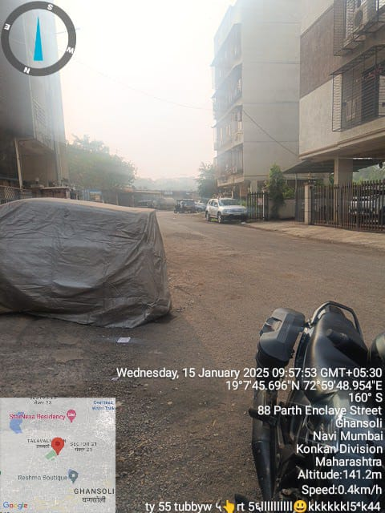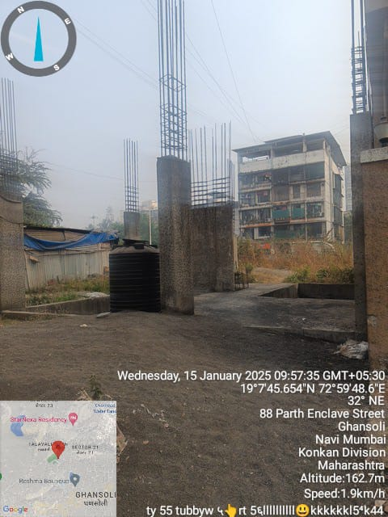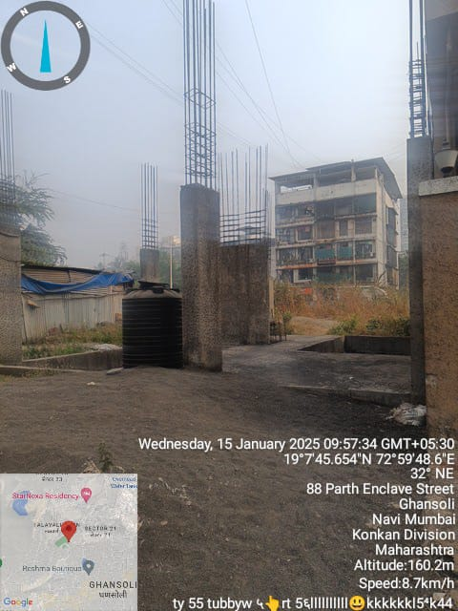

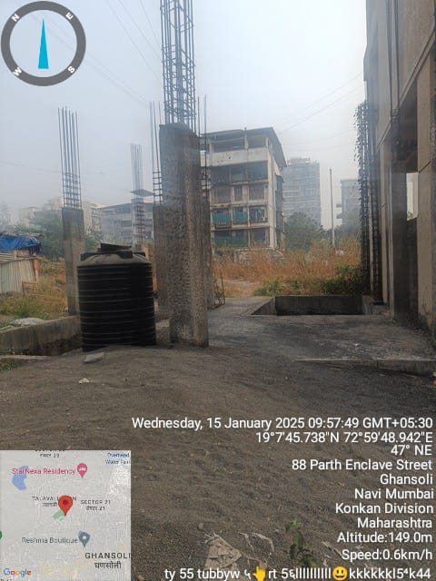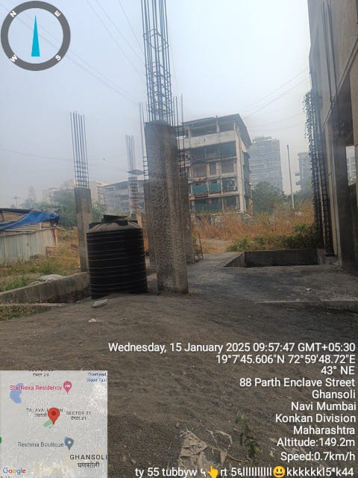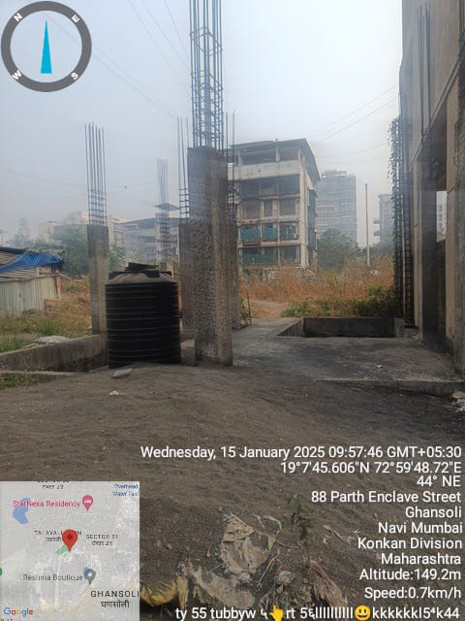

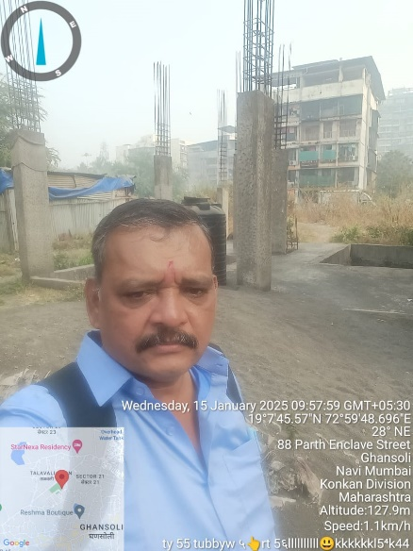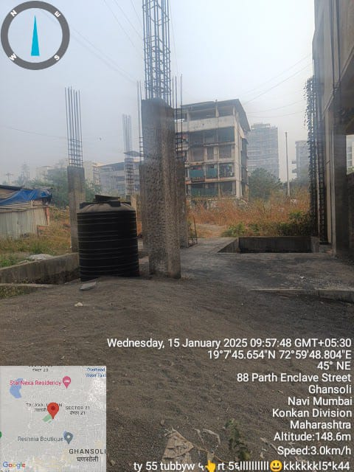

**Route Map of the property**

**Site u/r**

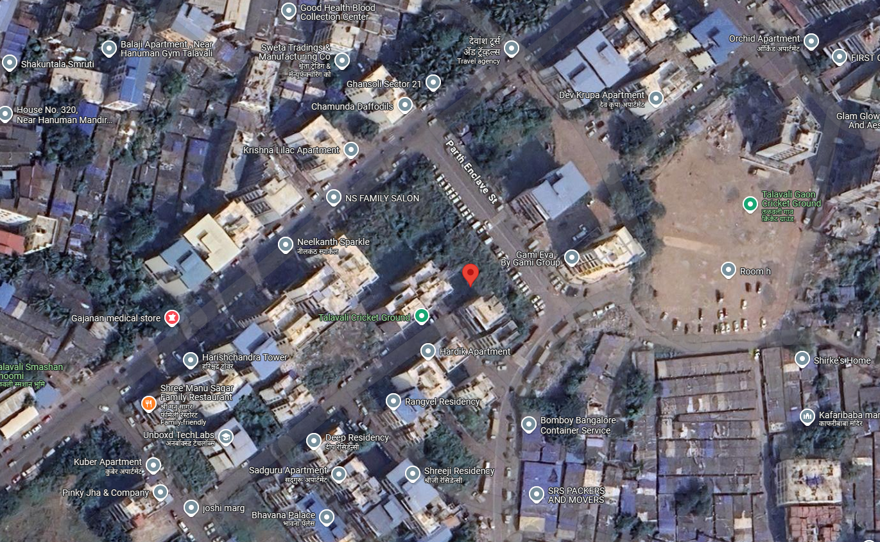

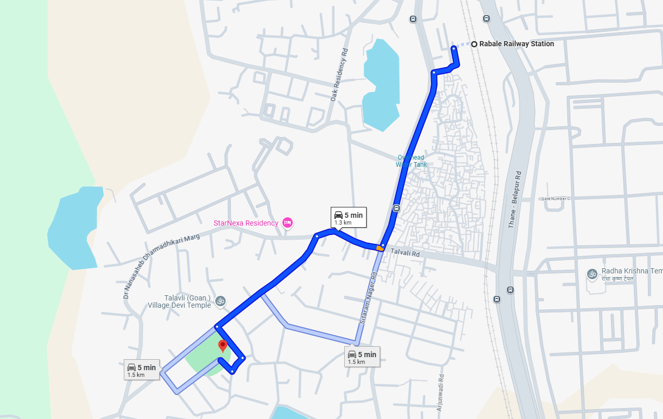

# Latitude Longitude - 19°07’45.8”N 72°59’47.9”E

# Note: The Blue line shows the route to site from nearest Railway Station (Rabale – 1.3 KM.)

**Ready Reckoner Rate**

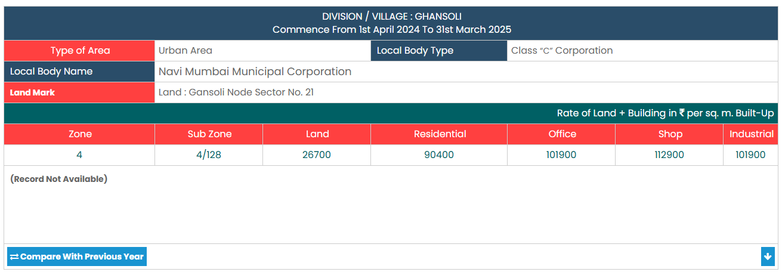

**Price Indicators**

|  |  |
| --- | --- |
| Plot area | 500.00 Sq. Ft. |
| Rate per Sq. Ft. | 6,600.00 |
| Rate Per Sq. M. | 71,042.00 |

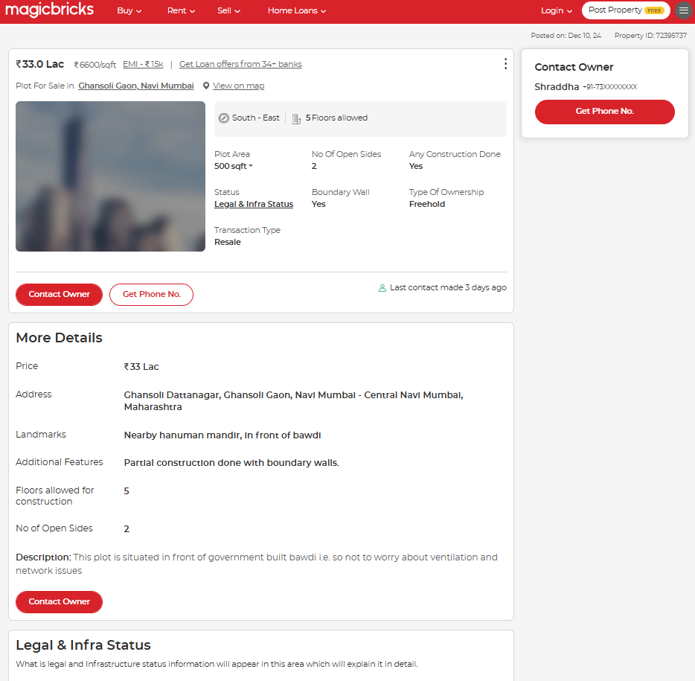

|  |  |
| --- | --- |
| Plot area | 10,000 Sq. Ft. |
| Rate per Sq. Ft. | 15,000.00 |
| Rate Per Sq. M. | 1,61,460.00 |

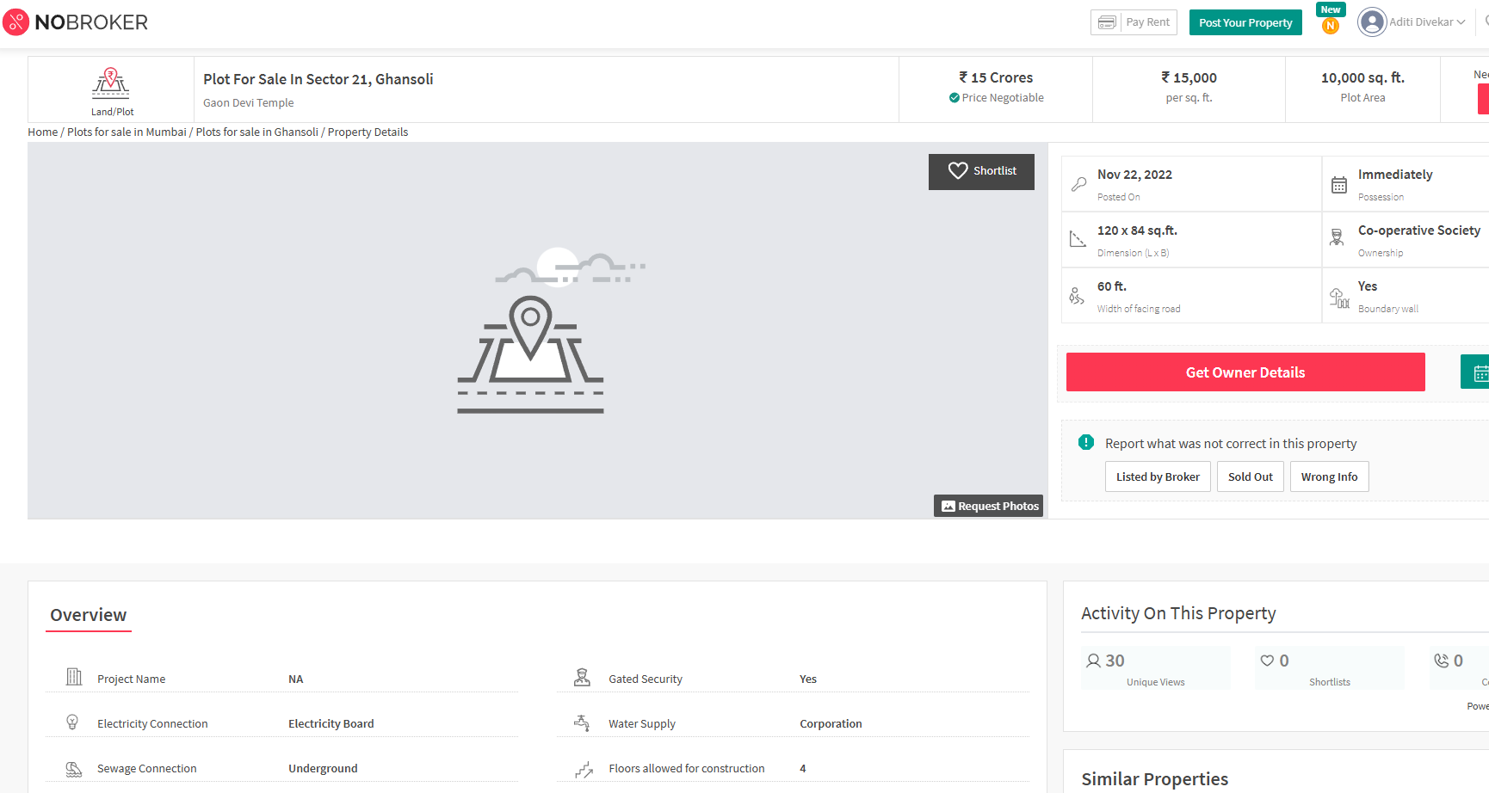

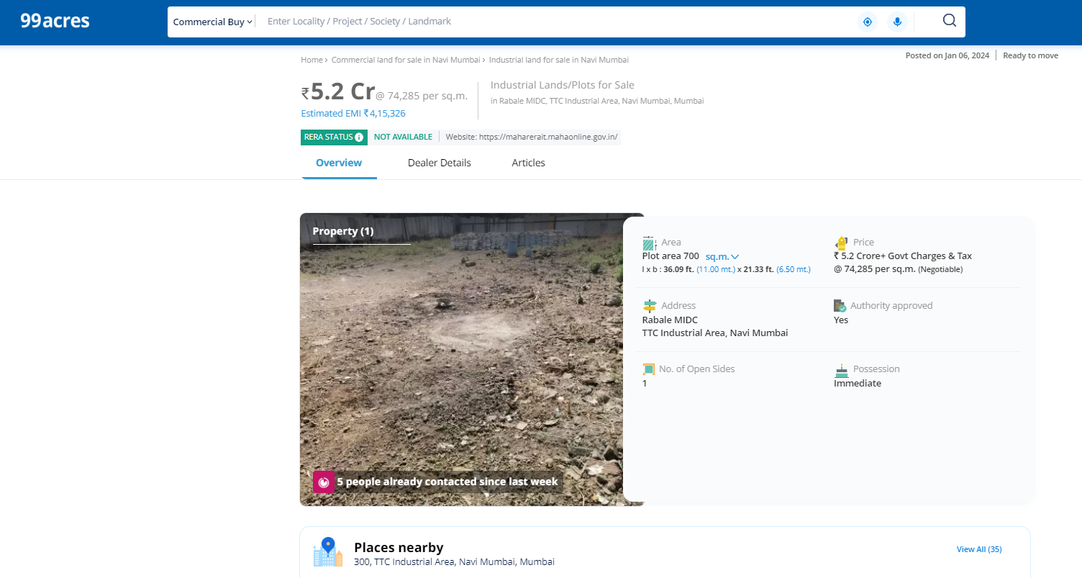

**DEFINITION OF VALUE FOR THIS SPECIFIC PURPOSE**

This exercise is to assess **Fair Market Value** of the property under reference as on **17th January 2025.**

The term **Fair Market Value** is defined as

*“The most probable price, as of a specified date, in cash, terms equivalent to cash, or in other precisely revealed terms for which the specified property rights would sell after reasonable exposure in a competitive market under all conditions requisite to a fair sale, with the buyer and seller each acting prudently knowledgeably and for self-interest assuming that neither is under undue duress”.*

Fundamental assumptions and conditions presumed in this definition are:

1. Buyer and seller are motivated by self-interest.

2. Buyer and seller are well informed and are acting prudently.

3. The property is exposed for a reasonable time on the open market.

4. Payment is made in cash or equivalent or in specified financing terms.

#### UNDER LYING ASSUMPTIONS

1. We assume no responsibility for matters of legal nature affecting the property appraised or the title thereto, nor do we render our opinion as to the title, which is assumed to be good and marketable.

2. The property is valued as though under responsible ownership.

3. It is assumed that the property is free of liens and encumbrances.

4. It is assumed that there are no hidden or unapparent conditions of the subsoil or structure that would render it more or less valuable. No responsibility is assumed for such conditions or for engineering that might be required to discover such factors.

5. There is no direct/ indirect interest in the property valued

6. The rates for valuation of the property are in accordance with the Govt. approved rates and prevailing market rates.

## Manoj B. Chalikwar

Registered Valuer

Chartered Engineer (India)

Reg. No. IBBI / RV / 07/2018/10366

Reg. No. CAT-I-F-1763