Vastu/Nashik/01/013628/2310024
13/4-143-RYRJ
Date: 13.01.2024
To,
The Branch Manager,
Bank of Baroda
Regional Office
BSNL Building, Datta Mandir Road, Nashik Road,
Nashik, PIN – 422 101, State - Maharashtra, Country - India.

Sub: Vetting of Extra Amenities

Sir,

With reference to above subject, we have evaluated the Extra Amenities For Row Bungalow No. 04, Ground + First Floor, " Chaitana Vatika ", Survey No. 570/ 2+3, Plot No. 2+3, Behind Lokmanya Multispecialty Hospital, Near MET BKC Hostel, Dhatrak Phata, Sagar Village, off Mumbai Agra Road, Village – Adgaon, Taluka & District - Nashik, PIN Code – 422 003, State – Maharashtra, Country – India. belongs to Name of Proposed Purchaser : Komal Sanjay Deore. Name of Owner : Shri. Rahul Ravindra Markande & Sau. Savita Ravindra Markande.

We have verified the rates quoted as per current market rates. Details of Extra Amenities considered as per copy of Extra Amenities Agreement between Komal Sanjay Deore (First Party). Sau. Sudha Ravindra Markande (Second Party) received on dated. 09.01.2024. The Extra Amenities amount is Rs. 9,00,000/- (Rupees Nine Lakh Only)

The said Cost Vetting Certificate is valid upto next 6 months Only.

Thanking you

Sincerely yours

Manoj B. Chalikwar
Registered Valuer
Chartered Engineer (India)
Reg. No. CAT-I-F-1763
Reg. No. IBBI/RV/07/2018/10366
BOB Empanelment No.: ZO:MZ:ADV:46:941
Encl: Valuation report.

Agreement for Extra Amenities
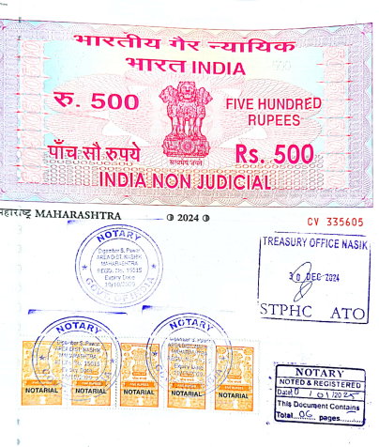
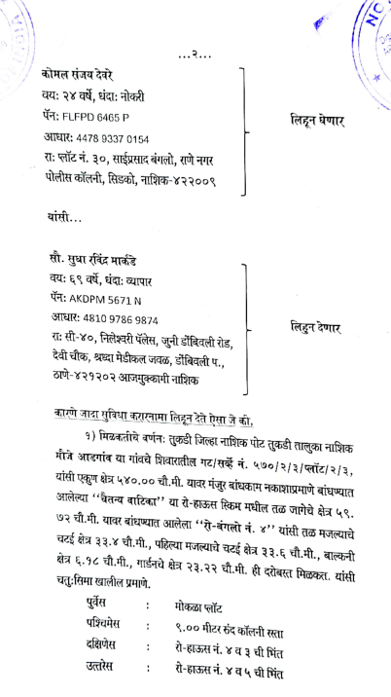

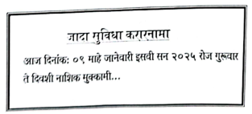

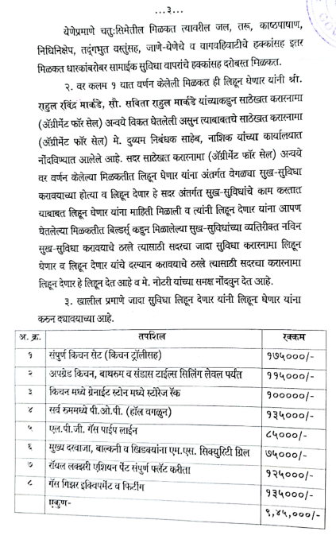
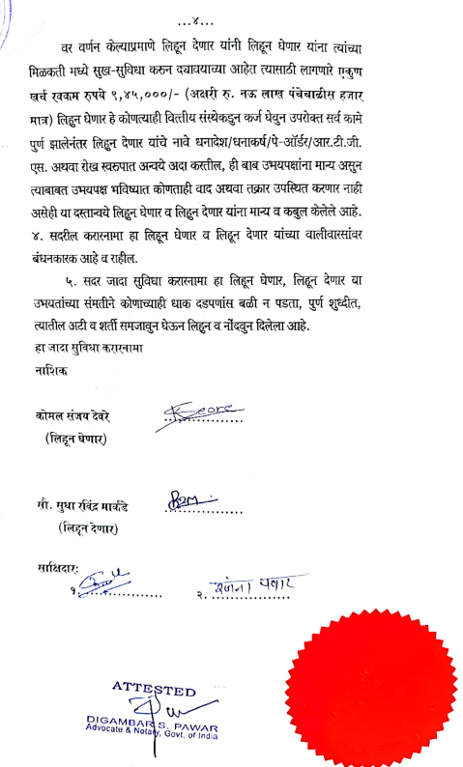

The Extra Amenities amount is Rs. 9,00,000/- (Rupees Nine Lakh Only)

