WORK PROGRESS REPORT
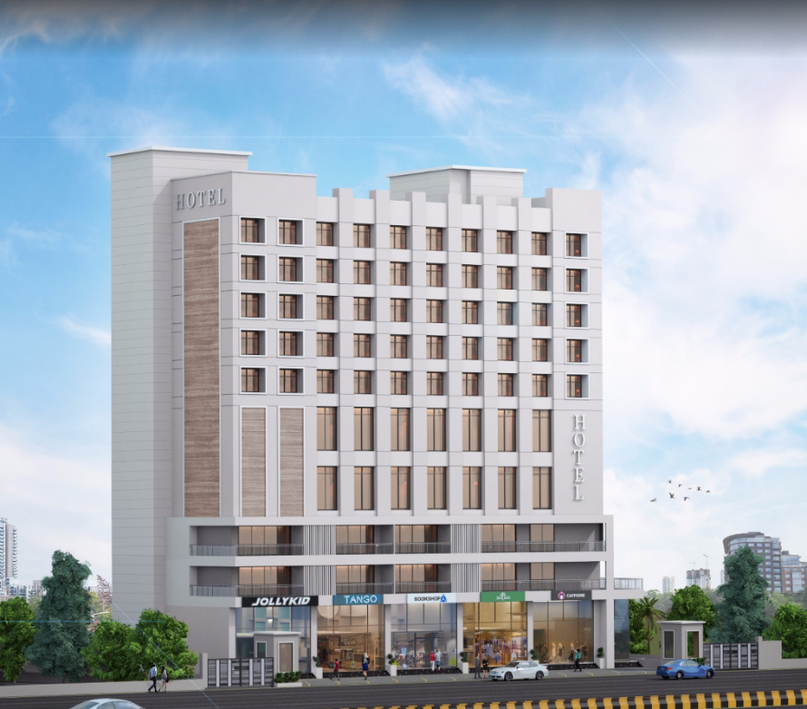

Details of the property under consideration:

Name of Owner: M/s. Gillani Hospitality Pvt. Ltd.

Proposed Commercial Cum Residential (3 Star Hotel) building on plot bearing Survey No. 804 / A / 9 / 1 & 2, Plot No. 1 & 2, Mumbai – Agra Road, Govind Nagar, Village – Nashik, Taluka & District – Nashik, Pin Code – 422 009, State – Maharashtra, Country – India

Latitude Longitude: 19°58'55.8"N 73°46'53.4"E

Intended User for:

M/s. Gillani Hospitality Pvt. Ltd.

Vastu/UBI/Nashik/01/2025/13617/2308658
17/07-198-PY
Date: - 10.01.2024

WORK PROGRESS REPORT
OF
"M/s. Gillani Hospitality Pvt. Ltd."
Commercial Cum Residential (3 Star Hotel) building on plot bearing Survey No. 804 / A / 9 / 1 & 2,
Plot No. 1 & 2, Mumbai – Agra Road, Govind Nagar, Village – Nashik, Taluka & District – Nashik,
PIN – 422 009, Maharashtra, India

Latitude Longitude: 19°58'55.8"N 73°46'53.4"E

NAME OF DEVELOPER: M/s. Gillani Hospitality Pvt. Ltd.
Pursuant to instructions from the client we have duly visited, inspected, surveyed & assessed the above said property on 03rd January 2025 for work progress report.

1. Location Details:
Proposed Commercial Cum Residential (3 Star Hotel) building on plot bearing Survey No. 804 / A / 9 / 1 & 2, Plot No. 1 & 2, Mumbai – Agra Road, Govind Nagar, Village – Nashik, Taluka & District – Nashik, Pin Code – 422 009. It is about 8.80 Km. travelling distance from Nashik Road Railway station. Surface transport to the property is by buses, taxis & private vehicles. The property is in developed locality. All the amenities like shops, banks, hotels, markets, schools, hospitals, etc. are all available in the surrounding locality. The area is higher middle class & developed.
2. Developer Details:
Name of Developer | M/s. Gillani Hospitality Pvt. Ltd.
Project Rera Registration Number | N. A.
Registered office address | 46, Aminabad Building, 7th Floor, Aga Hall, Nesbit Road, Mazgaon, Mumbai, Pin Code – 400 010, State – Maharashtra, Country – India
Contact details | Contact Person:  Mr. Zaheer Jamal  Mobile No. +91 9892216700
E – mail ID and website
3. Boundaries of the Property:
Direction | Particulars
On or towards North | Yashika Plaza
On or towards South | Open Plot
On or towards East | Service Road & Mumbai – Agra National Highway
On or towards West | Internal Road

LEVEL OF COMPLETION:

Construction of Building
Sr. No | Floor No. | Construction Area in Sq. M. | Completed Area in Sq. M. | % of work completed | Work Completion as on 03.01.2025
1 | Excavation & Shore Piling |  |  | 100% | Slab Work, Block work, Plaster work, Fire Fighting, Water proofing, Electrical, Plumbing, Flooring, toilet dado, sanitary fitting & painting work staircase flooring & grilling works, final finishing is completed Door & windows are installed.
2 | Basement – 2 Floor | 1,614.60 | 1,614.60
3 | Basement – 1 Floor | 1,657.54 | 1,657.54
4 | Lower Ground Floor | 1,588.16 | 1,588.16
5 | Ground Floor | 959.48 | 959.48
6 | 1st Floor | 664.42 | 664.42
7 | 2nd Floor | 892.55 | 892.55
8 | 3rd Floor | 900.01 | 900.01
9 | 4th Floor | 776.60 | 776.60
10 | 5th Floor | 776.60 | 776.60
11 | 6th Floor | 768.32 | 768.32
12 | 7th Floor | 768.32 | 768.32
13 | 8th Floor | 768.32 | 768.32
14 | 9th Floor | 776.60 | 776.60
15 | 10th Floor | 781.48 | 781.48
16 | 11th Floor | 1,018.22 | 1,018.22
17 | 12th Floor | 1,428.56 | 1,428.56
18 | 13th Floor | 756.79 | 756.79
19 | Terrace Floor & OHT & LMR Area | 756.79 | 756.79
Total |  | 17,653.36 | 17,653.36 | 100%

Plant and Machinery
Particulars | Work Completion as on 03.01.2025
Air – Conditioning | Installation is completed & working has started.
Lifts | All the 5 lifts are installed & started operating.
Kitchen & Refrigeration Equipments | Installation completed and functioning started.
Gym Equipment’s | Installation completed and functioning started
Fire Fighting Equipment’s, Sprinkler & Smoke Detector Systems | Installation completed and functioning started
DG Set | Installation completed and functioning started
Sewage Treatment Plant | Installation completed and functioning started
ELV Systems | Installation completed and functioning started
IT Equipment & Software | Installation completed and functioning started
Crockery, Cutlery & Glassware | Installation completed and functioning started
Housekeeping Supplies, Linens & Uniform | Installation completed and functioning started

Furniture and Fixture
Particulars | Work Completion as on 03.01.2025
FF for 125 rooms | Work for 80 rooms is completed. Balance room’s material received on site and interior work is in progress.
FF for Restaurant | Installation completed and functioning started
FF for Banquet | Installation completed and functioning started
FF for Reception | Installation completed and functioning started
FF for Meeting Rooms | Installation completed and functioning started
FF for Roof Top Bar | Order is placed & some material received on site and work is in progress.
FF for Other Public Area | Installation completed and functioning started
FF for BOH | Installation completed and functioning started

Cost of Construction as on 03rd January 2025:

Construction Cost of Building:
Floors | Total Construction Area in Sq. M. | Completed Area in Sq. M. | Revised Rate / Sq. M. | Full Value after completion | Percentage of work completed | Actual Expenditure till date in `
Basement - 2 | 1,614.60 | 1,614.60 | 26,080.00 | 42,108,768.00 | 100% | 42,108,768.00
Basement - 1 | 1,657.54 | 1,657.54 | 26,080.00 | 43,228,643.20 | 100% | 43,228,643.20
Lower Ground Floor | 1,588.16 | 1,588.16 | 26,080.00 | 41,419,212.80 | 100% | 41,419,212.80
Ground Floor | 959.48 | 959.48 | 26,080.00 | 25,023,238.40 | 100% | 25,023,238.40
1st Floor | 664.42 | 664.42 | 26,080.00 | 17,328,073.60 | 100% | 17,328,073.60
2nd Floor | 892.55 | 892.55 | 26,080.00 | 23,277,704.00 | 100% | 23,277,704.00
3rd Floor | 900.01 | 900.01 | 26,080.00 | 23,472,260.80 | 100% | 23,472,260.80
4th Floor | 776.60 | 776.60 | 26,080.00 | 20,253,728.00 | 100% | 20,253,728.00
5th Floor | 776.60 | 776.60 | 26,080.00 | 20,253,728.00 | 100% | 20,253,728.00
6th Floor | 768.32 | 768.32 | 26,080.00 | 20,037,785.60 | 100% | 20,037,785.60
7th Floor | 768.32 | 768.32 | 26,080.00 | 20,037,785.60 | 100% | 20,037,785.60
8th Floor | 768.32 | 768.32 | 26,080.00 | 20,037,785.60 | 100% | 20,037,785.60
9th Floor | 776.60 | 776.60 | 26,080.00 | 20,253,728.00 | 100% | 20,253,728.00
10th Floor | 781.48 | 781.48 | 26,080.00 | 20,380,998.40 | 100% | 20,380,998.40
11th Floor | 1,018.22 | 1,018.22 | 26,080.00 | 26,555,177.60 | 100% | 26,555,177.60
12th Floor | 1,428.56 | 1,428.56 | 26,080.00 | 37,256,844.80 | 100% | 37,256,844.80
13th Floor | 756.79 | 756.79 | 26,080.00 | 19,737,083.20 | 100% | 19,737,083.20
Terrace & OHT | 756.79 | 756.79 | 26,080.00 | 19,737,083.20 | 100% | 19,737,083.20
TOTAL | 17,653.36 | 17,653.36 |  | 46,03,99,628.80 | 100% | 46,03,99,628.80

Plant and Machinery:
Particulars | Percentage of work completed
Air – Conditioning | 100%
Lifts | 100%
Kitchen & Refrigeration Equipment’s | 100%
Gym Equipment’s | 100%
Fire Fighting Equipment’s, Sprinkler & Smoke Detector Systems | 100%
DG Set | 100%
Sewage Treatment Plant | 100%
ELV Systems | 100%
IT Equipment & Software | 100%
Crockery, Cutlery & Glassware | 100%
Housekeeping Supplies, Linens & Uniform | 100%

Furniture & Fixture:
Particulars | Percentage of work completed
FF for 80 Hotel Rooms | 100%
FF for 45 Hotel Rooms | 40%
FF for Restaurant | 100%
FF for Banquet | 100%
FF for Reception | 100%
FF for Meeting Rooms | 100%
FF for Roof Top Bar | 0%
FF for Other Public Area | 100%
FF for BOH | 100%

Note: Details of work completed is as per site visit dated 03.01.2025.

Mandatory Approval Status:
Sr. No. | Particulars | Name of Department | Status | Order Details
1 | IOD of Building | Nashik Municipal Corporation | Obtained | P-6954/2021/(669)/K/E Ward/Andheri dated 11.01.2022
1A | 1st Amended | Nashik Municipal Corporation | Obtained | P-6954/2021/(669)/K/E Ward/Andheri dated 13.04.2022
2A | First C.C. | Nashik Municipal Corporation | Obtained | P – 6954 / 2021 / (669) / K / E Ward / Andheri / FCC / New dated 21.10.2022 valid till 22.10.2023. This CC is endorsed for the work upto Ground for Parking + 1st to 10th Upper Floor of Wing A & B
2B | Second C.C. | Nashik Municipal Corporation | Obtained | P – 6954 / 2021 / (669) / K / E Ward / Andheri / FCC / 1 / Amend dated 09.11.2022 valid till 08.11.2023. This CC is endorsed for the work upto Ground for Parking + 1st to 10th Upper Floor of Wing A & B
3 | Occupancy | Nashik Municipal Corporation | Obtained | NMCB/FO/2024/APL/07483 dated 06.11.2024. This Full Occupancy is obtained for the Basement 2 + Basement 1 + Lower Ground Floor + Upper Ground Floor + 1st to 12th Floors + 12th Mezzanine (Part) + 13th Floor.
4 | Fire NOC | Nashik Municipal Corporation, Fire Department | Obtained | Dated 19.11.2024. This endorsed for Hotel and Lodging.
5 | FSSAI Certificate | Government of Maharashtra, Food and Drug Administration, Food Safety and Standards Authority of India. | Obtained | License Number: 11524072000464 dated 13.11.2024 valid upto 12.11.2029. It is used for Food Services – Hotel kind of business.
6 | Shop Act License for Hotel, Restaurant and Coffee Shop | The Maharashtra Shops and Establishment (Regulation of Employment and Condition of Service) Act, 2017, Office of the Deputy Commissioner of Labour, Nashik | Obtained | License Number: 2420600319479501 issued dated 05.12.2024. It is endorsed for Hotel, Restaurant and Coffee Shop purpose.
7 | Shop Act License for Lodging and Boarding | The Maharashtra Shops and Establishment (Regulation of Employment and Condition of Service) Act, 2017, Office of the Deputy Commissioner of Labour, Nashik | Obtained | License Number: 2420600319480238 issued dated 05.12.2024. It is endorsed for Lodging and Boarding purpose.

Observations & Conclusion:
- Overall Physical progress of the project site as on 03/01/2025 is 100% of construction work is completed. This consists of Basement 1 + Basement 2 + Lower Ground Floor + Upper Ground Floor + 1st to 12th Floor + 12th Mezzanine Floor + 13th Floor & Terrace Floor.
- Project has received Full Occupancy Certificate No. NMCB/FO/2024/APL/07483 dated 06.11.2024 issued by Nashik Municipal Corporation. It is obtained for Basement 2 + Basement 1 + Lower Ground Floor + Upper Ground Floor + 1st to 12th Floors + 12th Mezzanine (Part) + 13th Floor.
- Project has received Fire NOC Certificate dated 19.11.2024 issued by Nashik Municipal Corporation, Fire Department. This is endorsed for Hotel and Lodging Purpose.
- Client has received FSSAI certificate, Shop Act License for Hotel, Restaurant & Coffee Shop and Lodging & Boarding purpose.
- From the above approval status, the property can used for the Hotel and Lodging purpose.
- As per the site inspection, property has started functioning for Hotel & Restaurant purpose. The client is using the property from Basement 1 + Basement 2 + Lower Ground Floor + Upper Ground Floor + 1st & 2nd Floor + 7th to 12th Floor + 12th Mezzanine Floor + 13th Floor & Terrace Floor.
- During site inspection, 3rd to 6th floor interior work is in progress and it is expected to be completed and come in operation by March 2025.

Manoj B. Chalikwar
Registered Valuer
Chartered Engineer (India)
Reg. No. IBBI/RV/07/2018/10366

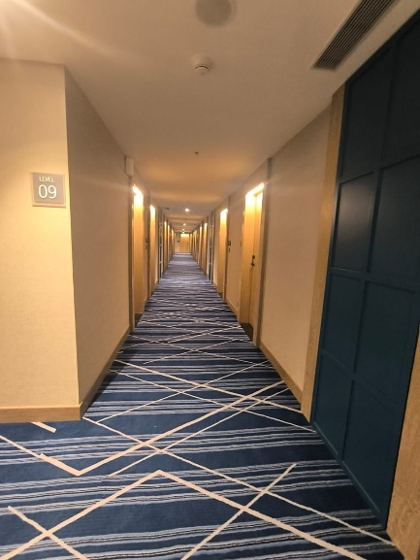
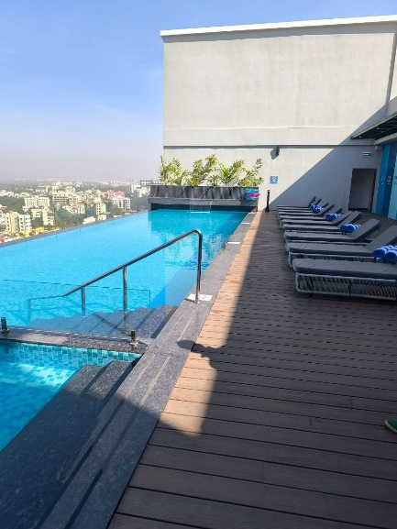
Actual Site Photographs as on 03.01.2025
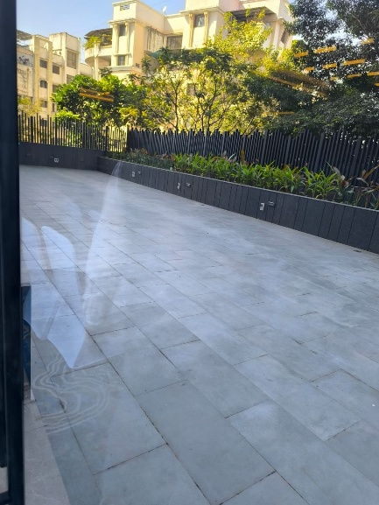

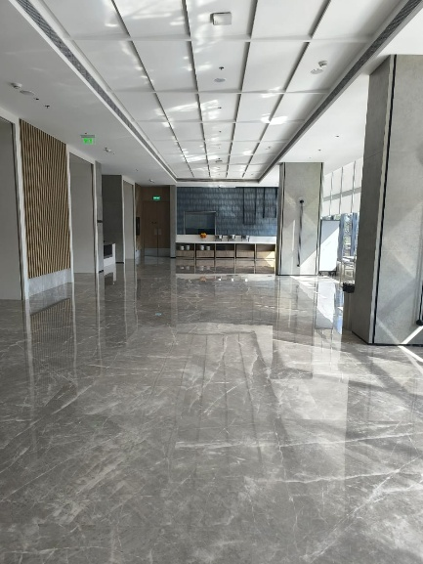
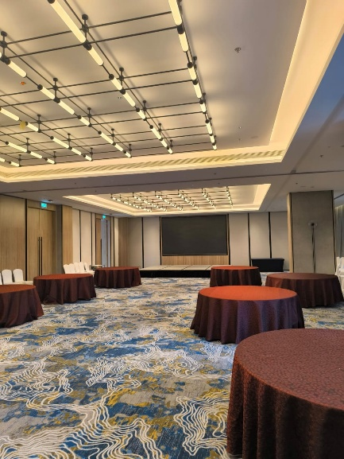
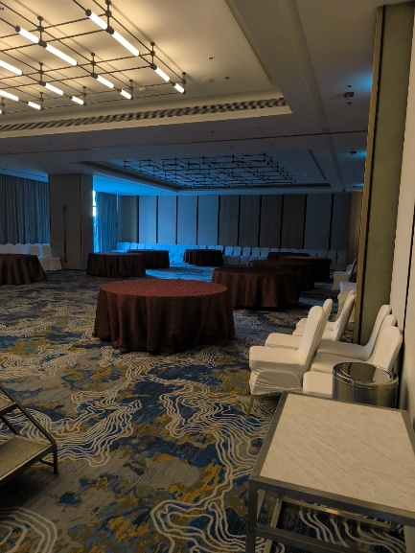

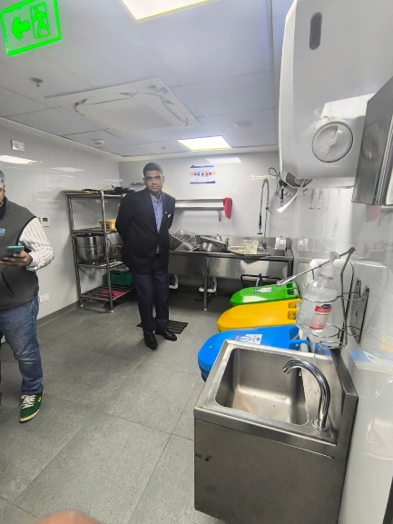
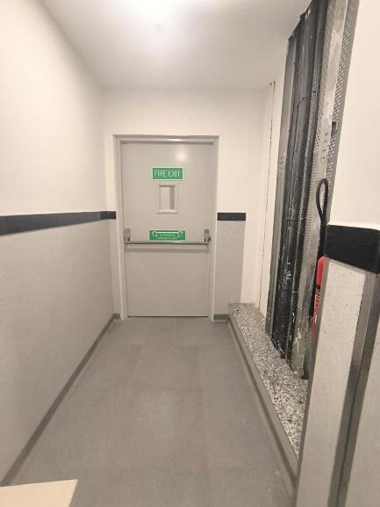
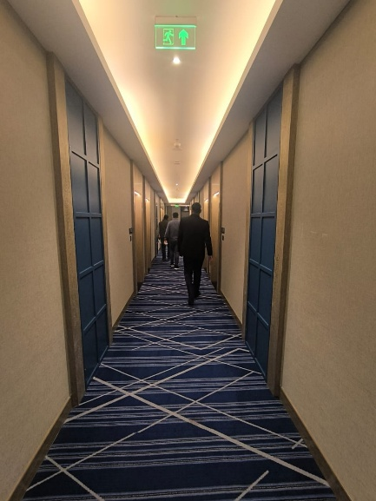

Actual Site Photographs as on 03.01.2025
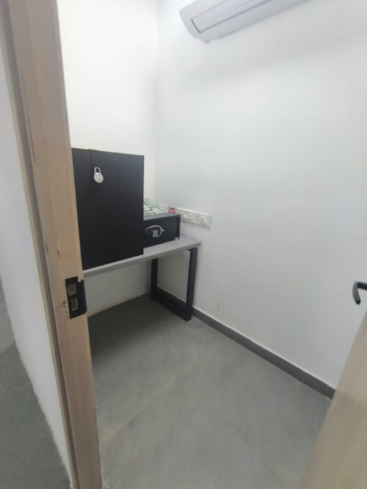
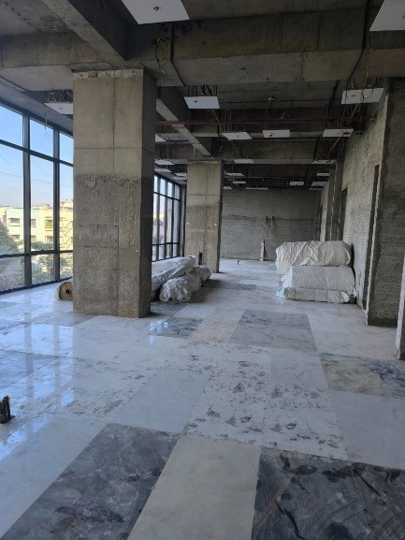
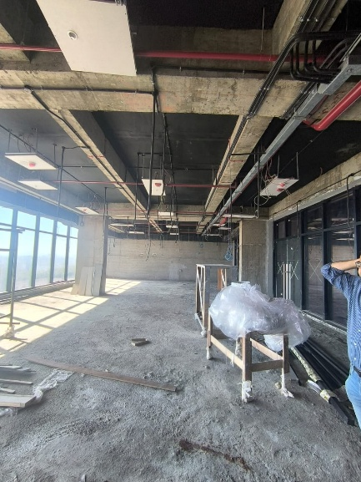
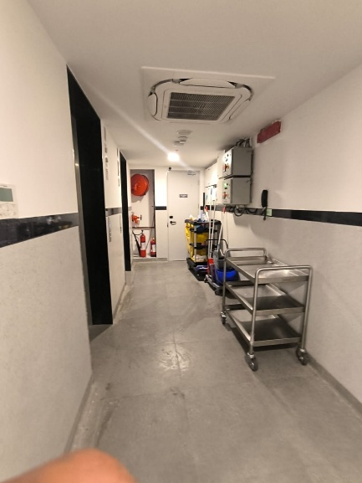
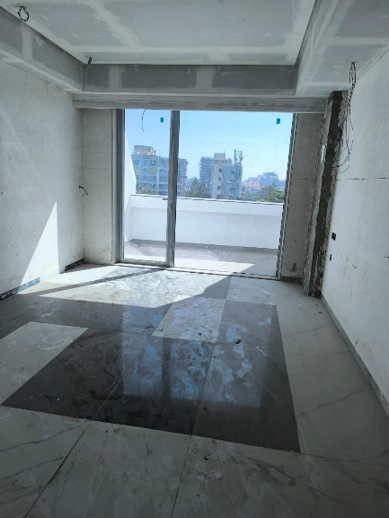
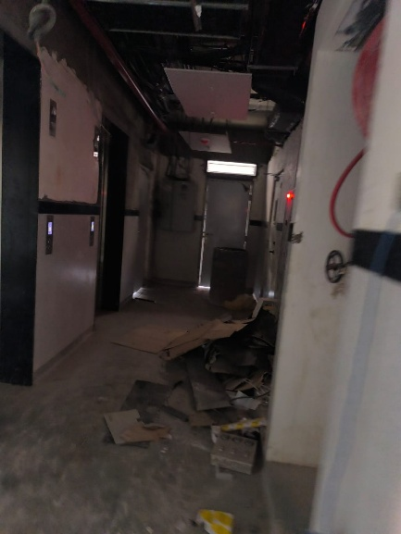
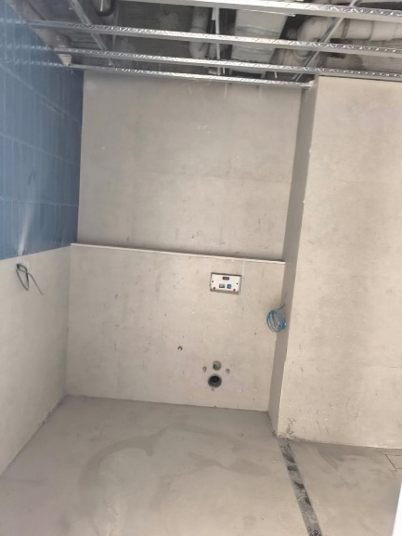
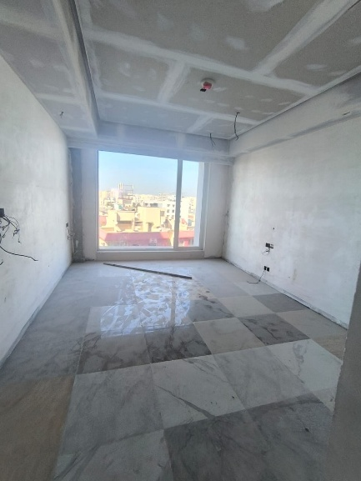
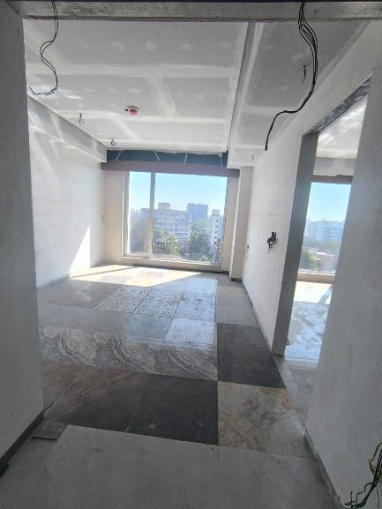
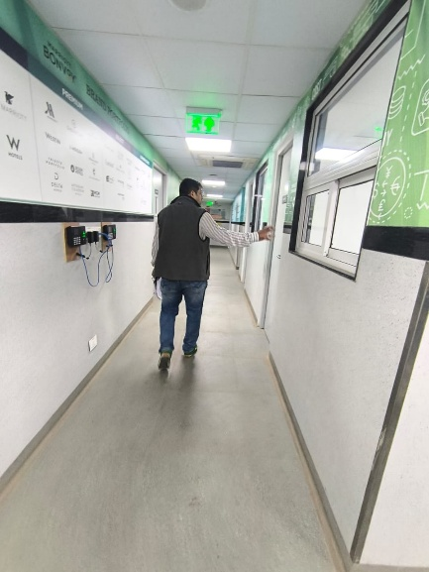
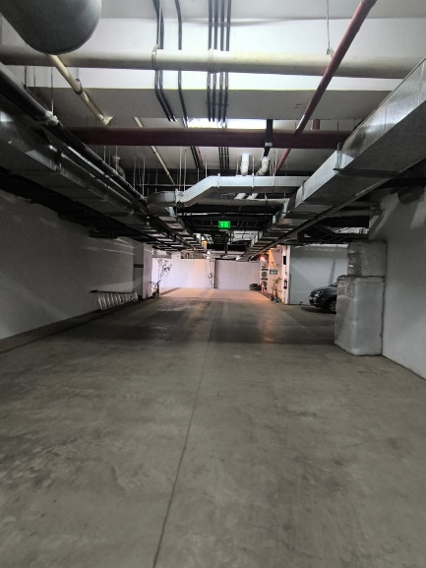
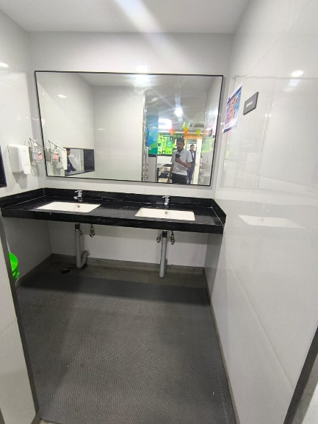
Actual Site Photographs as on 03.01.2025

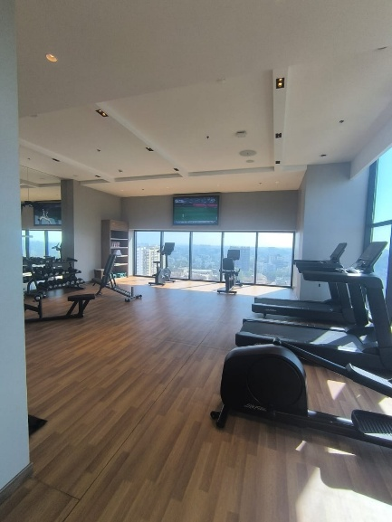
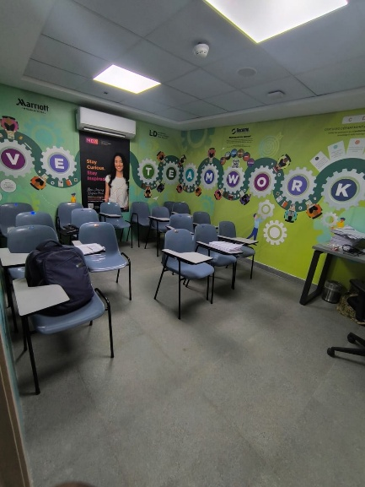
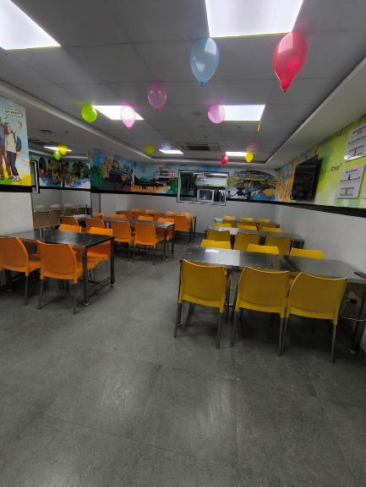
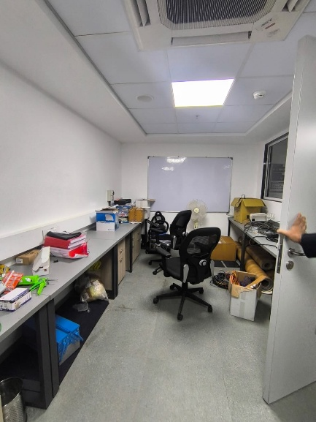
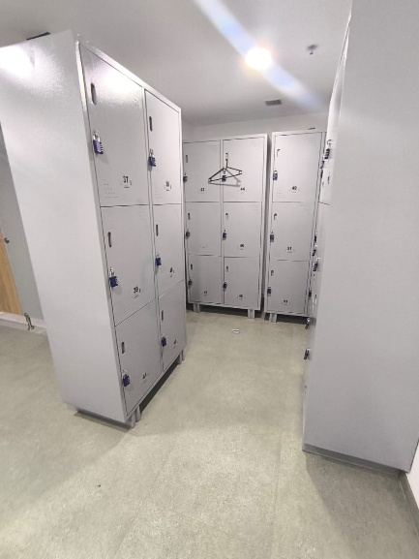
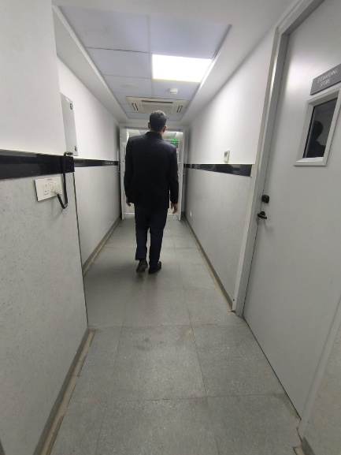
Actual Site Photographs as on 03.01.2025
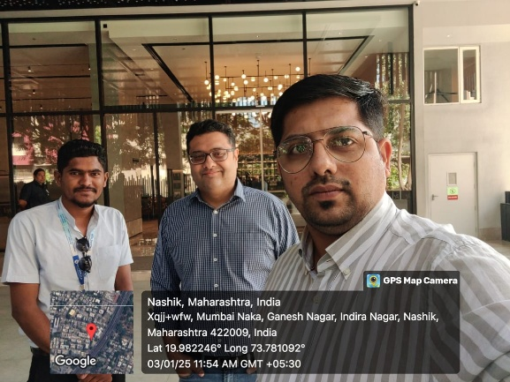
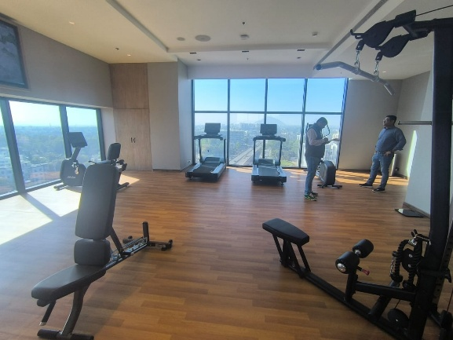
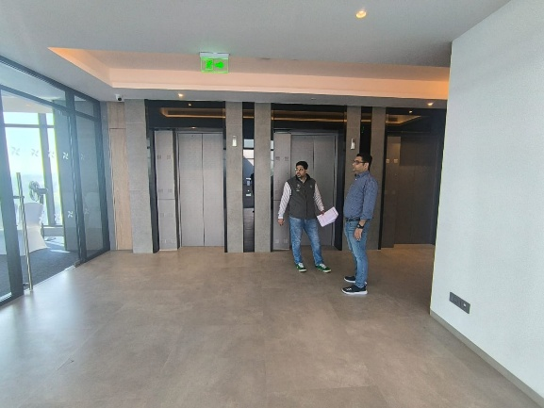
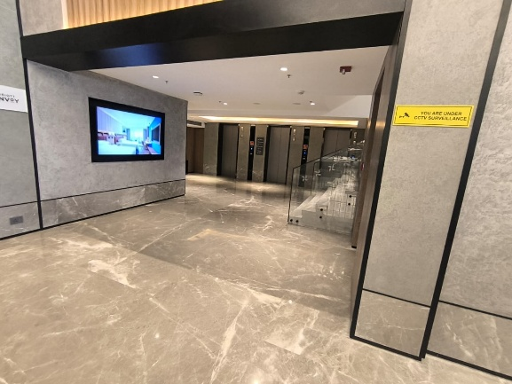
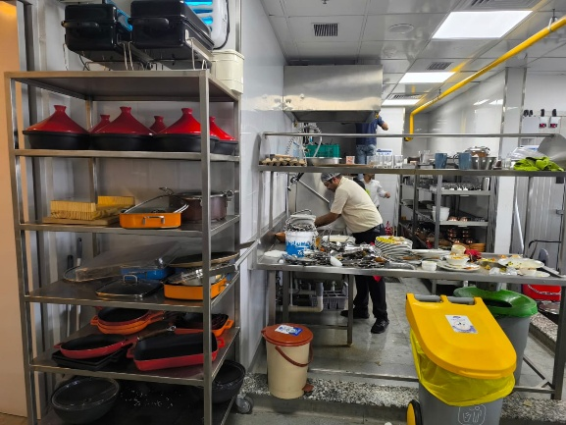
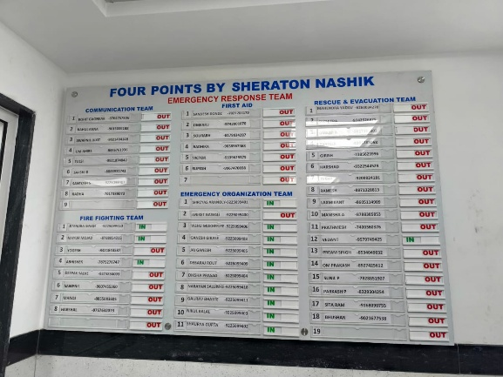
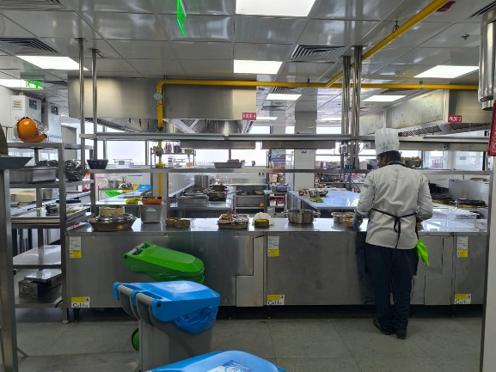
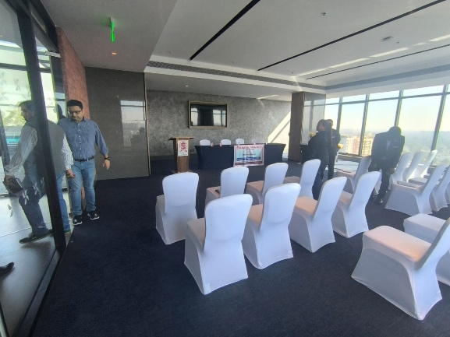
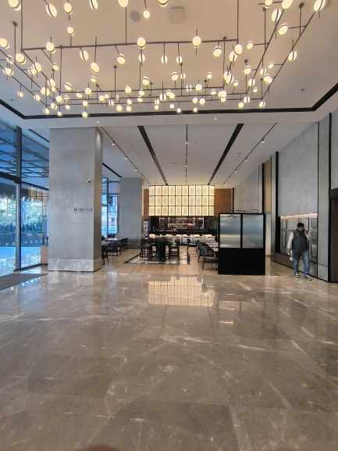
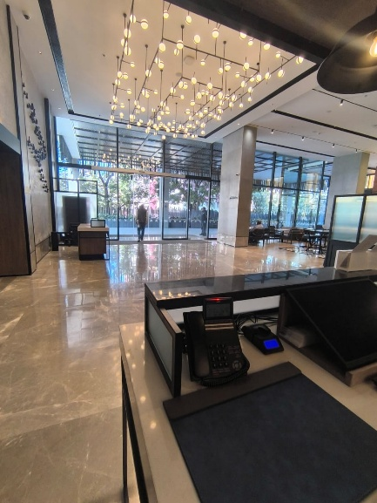
Actual Site Photographs as on 03.01.2025
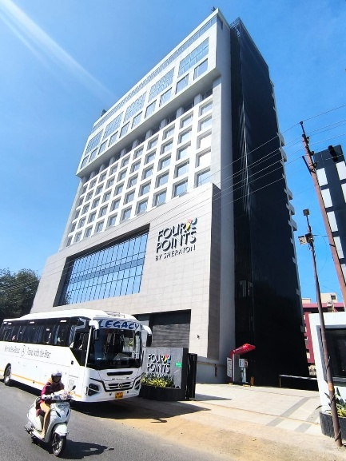
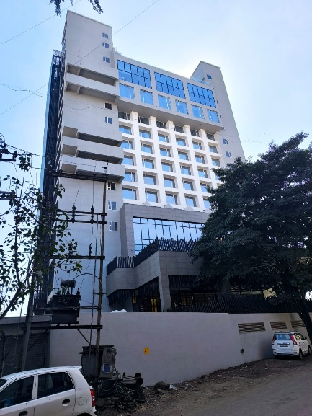
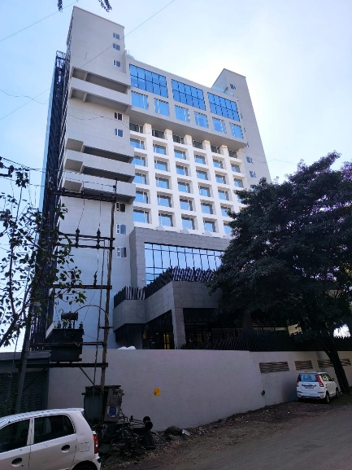
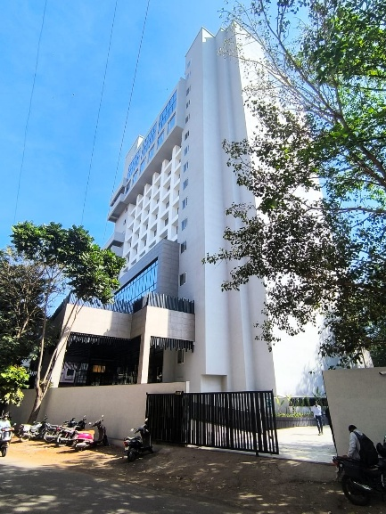
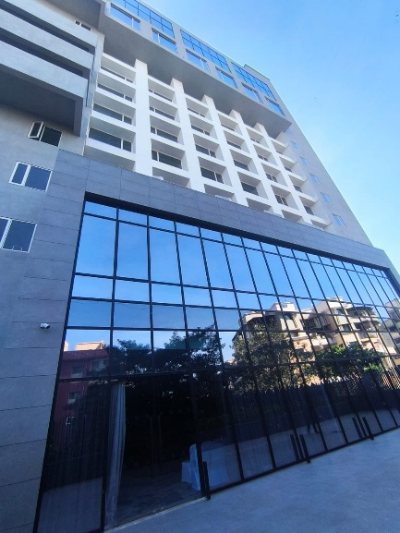
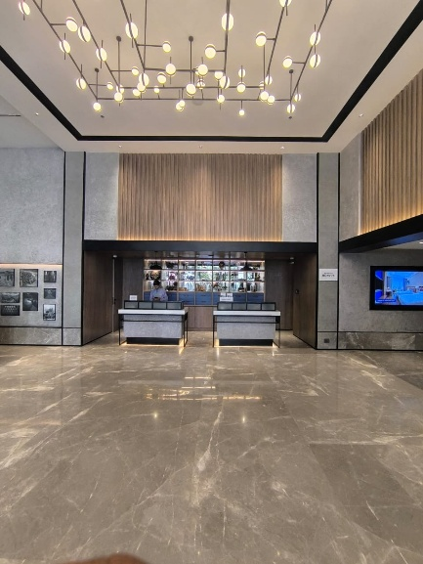
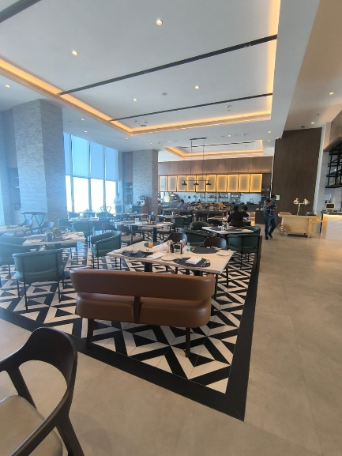
Route Map of the property
Site u/r
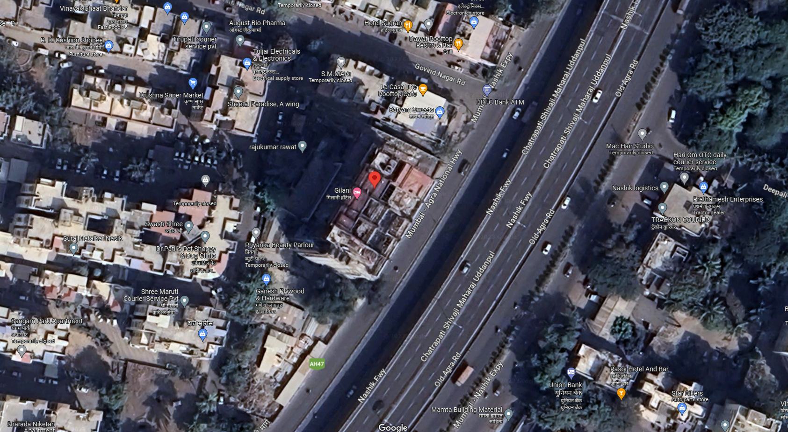

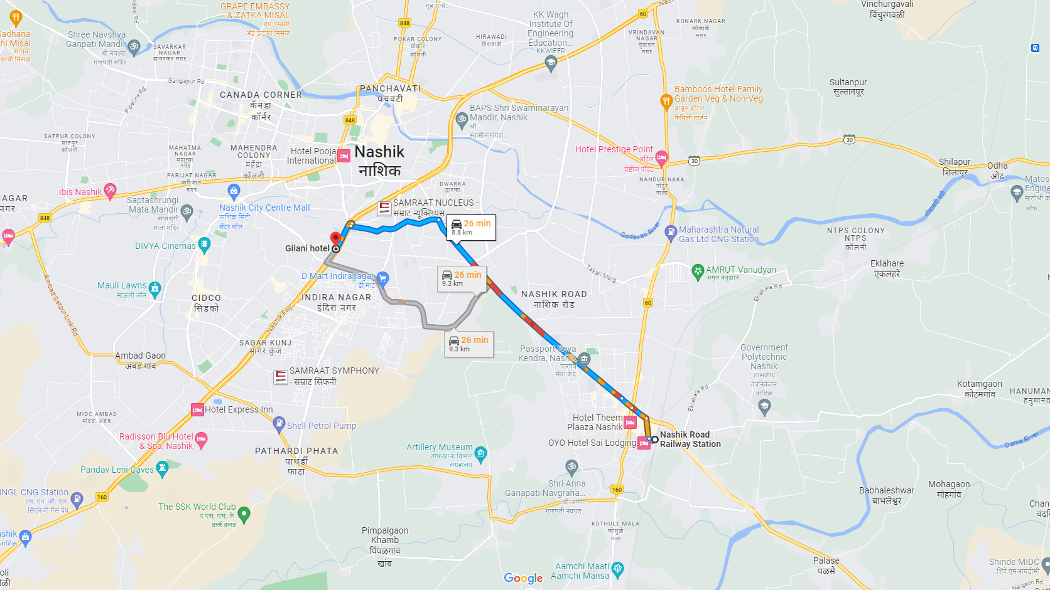

Latitude Longitude: 19°58'55.8"N 73°46'53.4"E
Note: The Blue line shows the route to site from nearest railway station (Nashik Road – 8.80 Km.)

