2nd LENDER’S INDEPENDENT ENGINEER REPORT

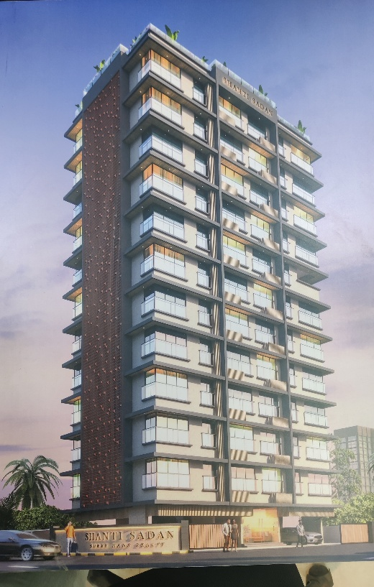

**Details of the property under consideration:**

**Name of Project: “Shanti Sadan”**

**"Shanti Sadan”, Proposed Redevelopment of the Existing Building Known as “Shanti Sadan Co – operative Housing Society Limited on Plot Bearing F. P. No. 50, TPS Vile Parle No. VI (1st Variation) (Final), Dadabhai Road, Navpada, Vile Parle (West), Mumbai – 400 056, Maharashtra, India**

**Latitude Longitude: 19°06'22.8"N 72°50'35.5"E**

Intended User:

State Bank of India

SME Chembur Branch

Unit No. 11, Building No. 11, Ground Floor, Corporate Park, Sion Trombay Road,

Chembur, Mumbai, Pin Code – 400 071, State - Maharashtra, Country – India

Vastu/SBI/Mumbai/01/2025/13591/2309443

07/06-141-PY

Date: - 10.01.2025

SECOND LENDER’S INDEPENDENT ENGINEER REPORT

**To,**

**State Bank of India**

SME Chembur Branch

Unit No. 11, Building No. 11,

Ground Floor, Corporate Park,

Sion Trombay Road, Chembur,

Mumbai, Pin Code – 400 071,

State - Maharashtra, Country – India

Subject: Construction of Proposed Redevelopment of the Existing Building Known as “Shanti Sadan Co – operative Housing Society Limited on Plot Bearing F. P. No. 50, TPS Vile Parle No. VI (1st Variation) (Final), Dadabhai Road, Navpada, Vile Parle (West), Mumbai – 400 056, Maharashtra, India.

**Ref:** You’re Request for Lenders Independent Engineer Report of under Construction Building.

**Dear Sir,**

1. As per your instruction, we have inspected the under-construction Rehab cum Sale Building project situated on plot bearing C.T.S. No. 503C, S. No. 212A, Hissa No. 3, S. No. 214 Part, Plot No. 1, Azad Lane, Off S. V. Road, K / W Ward, Village – Vile Parle, Andheri (West), Mumbai – 400 058, State - Maharashtra, Country - India which is being developed by M/s. Shree Hans Realtors LLP in order to give the physical progress at site and to certify cost incurred towards project as on 30/11/2024.
2. **The Construction work as per approved plan was in progress during the site visit on 07th January 2025.**
3. **Status of work:**
4. **For Rehab cum Sales Building:** 2nd Floor bottom slab work is completed.
5. As per cost incurred certificate issued by **CA Certificate actual total expenditure occurred as on 31/12/2024 is ` 5.48 Cr. for Residential of Rehab cum Sale Building & overall financial progress is 18.68% estimated cost of project.**
6. As per bills **actual total expenditure occurred as on 31/12/2024 is ` 5.45 Cr. for Residential of Rehab cum Sale Building & overall financial progress is 18.57% estimated cost of project.**
7. Overall Physical progress of the sale building construction as on 07/01/2025 is 16.49% as per physical site inspection.

**DECLARATION**

1. The information furnished in the report is based on our 2nd site visit Dated 07/01/2025 & Document Provided by Client.
2. Vastukala Consultants (I) Pvt. Ltd. 1st LIE Report of the project dated 07/12/2024.
3. Vastukala Consultants (I) Pvt. Ltd. Project Report of the project dated 03/10/2024.
4. Vastukala Consultants (I) Pvt. Ltd. Cost Vetting Report dated 03/10/2024.
5. I have no direct and indirect interest in the property examined for report.
6. I have not been found guilty of misconduct in my professional capacity.

**Manoj B. Chalikwar**

Registered Valuer

Chartered Engineer (India)

Reg. No. IBBI/RV/07/2018/10366

Encl.: LIE report

# Purpose & Methodology

• State Bank of India Banks and financial institutions require monitoring & an independent review of the progress of the sanctioned projects

**VCIPL** undertakes such study to independently review the progress of the project and put forward a comprehensive analysis

# Advantages:

* Assurance on present practices
* Identification of risk
* Analyzing the performance of third parties
* Recommendations

# The Methodology

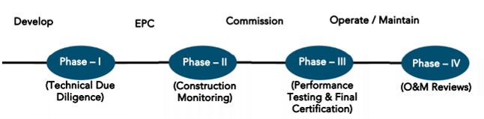

**SECOND LENDER’S INDEPENDENT ENGINEER REPORT**

**OF**

**"Shanti Sadan"**

**"Shanti Sadan”, Proposed Redevelopment of the Existing Building Known as “Shanti Sadan Co – operative Housing Society Limited on Plot Bearing F. P. No. 50, TPS Vile Parle No. VI (1st Variation) (Final),**

**Dadabhai Road, Navpada, Vile Parle (West), Mumbai – 400 056, Maharashtra, India**

**Latitude Longitude: 19°06'22.8"N 72°50'35.5"E**

**NAME OF DEVELOPER: M/s. Shree Hans Realtors LLP**

|  |
| --- |
| Pursuant to instructions from State of India, SME Chembur Branch, Chembur we have duly visited, inspected, surveyed & assessed the above said property on **07th January 2025** to determine the fair & reasonable market value of the said property/project as on Quarter ending **31st December 2024** for LIE purpose.  **1. Location Details:**  Proposed Redevelopment of the Existing Building Known as “Shanti Sadan Co – operative Housing Society Limited on Plot Bearing F. P. No. 50, TPS Vile Parle No. VI (1st Variation) (Final), Dadabhai Road, Navpada, Vile Parle (West), Mumbai – 400 056. It is about 950 M. travelling distance from Vile Parle (West) Railway station. Surface transport to the property is by buses, taxis & private vehicles. The property is in developed locality. All the amenities like shops, banks, hotels, markets, schools, hospitals, etc. are all available in the surrounding locality. The area is higher middle class & developed. |

**2. Developer Details:**

|  |  |
| --- | --- |
| **Name of builder** | **M/s.** **Shree Hans Realtors LLP** |
| **Project Rera Registration Number** | **P51800056441** |
| **Registered office address** | Office No. A – 5, Ground Floor, Mayur CHSL, Prem Nagar, Sodawala Lane, Borivali (West), Mumbai, Pin Code – 400092, Maharashtra, India |
| **Contact details** | **Contact Person:**  Mr. Kailas Sinari (Consultants)  Mobile No. 9820950342  Mr. Ravi Italia (Promoter)  Mobile No. 9820343346 |
| **E – mail ID and website** |  |

**3. Boundaries of the Property:**

|  |  |
| --- | --- |
| **Direction** | **Particulars** |
| **On or towards North** | Jas Villa Building |
| **On or towards South** | Dadabhai Road |
| **On or towards East** | Sri Ram Niwas |
| **On or towards West** | Internal Road |

# Introduction

**As per Information on site M/s. Shree Hans Realtors LLP** has acquired land by Developer Agreement Date 28.04.2023 through registered agreement Doc. No. BDR-1/6109/2023 dated 28.04.2023 admeasuring **area is 568.67 Sq. M.** bearing **F. P. 50, T. P. S. VI.** For the Proposed Redevelopment Residential Building.

# Area Statement:

# Land:

|  |  |  |
| --- | --- | --- |
| **Date** | **Particular** | **Area in Sq. M.** |
| 28.04.2023 | F. P. 50, T. P. S. VI | 568.67 |
| TOTAL | | 568.67 |

1. Copy of Developer Agreement dated 28.04.2023 between M/s. Shanti Sadan Co -operative Housing Society Limited (Society) and M/s. Shree Hans Realtors LLP (Developers) through registered agreement Doc. No. BDR-1/6109/2023 dated 28.04.2023.

# Building Area (As per Approved Plan):

| **A** | **Proforma A** |  |
| --- | --- | --- |
| **i** | **Area Statement** |  |
| **1** | Area of Plot | 568.57 |
| **a** | Area of Reservation in plot | - |
| **b** | Area of road set back | 3.64 |
| **c** | Area of DP road | - |
| **2** | Deduction for |  |
| **A** | For Reservations / Road Area |  |
| **a** | Road set – back area to be handed over (100%) (Regulation No. 16) | Nil |
| **b** | Proposed DP Road to be handed over (100%) (Regulation No. 16) | - |
| **i** | Reservation area plot to be handed over to (Regulation No. 17) | - |
| **ii** | Reservation area to be handed over as per AR (Regulation No. 17) | Nil |
| **d** | Any (Area of plot not in possession) | - |
| **B** | Total area under road / reservation / plot not in possession | - |
|  | For Amenity area to be handed over to MCGM | - |
| **a** | Area of amenity plot / plots to be handed over as per DCR 14(A) | - |
| **b** | Area of amenity plot / plots to be handed over as per DCR 14(B) | - |
| **c** | Area of amenity plot / plots to be handed over as per DCR 35 | - |
|  | Total Amenity area | - |
| **C** | Deduction of existing BUA to be retained if any / land component of existing BUA / Existing BUA as per regulation under which the development was allowed | - |
| **3** | Total deductions: [2(A) + 2(B) + 2(C)] | Nil |
| **4** | Balance area of plot (1 minus 3) | 564.93 |
| **5** | Plot area under development [Sr. No. 4 + 2(A) (c)(ii)] |  |
| **6** | Zonal (basic) FSI (0.50 or 0.75 or 1 or 1.33) | 1.00 |
| **7 a)** | Permissible built-up area as per zonal (basic) FSI (5 X 6) | 564.93 |
| **b)** | permissible built-up area as per regulation 30 (C) (protected development) (7100.49 Sq. Ft. / 10.764 = 659.65 Sq. M.) | 91.08 |
| **c)** | Permissible built-up area (7a or 7b above, whichever is more) | 656.01 |
| **8** | Built up equal to area of land handed over as per regulation 30(A) 3 (a) | - |
| **a)** | As per 2(A) and 2(B) except 2(A)(c)(ii) above with in cap of admissible TDR as column 6 of table – 12 on remaining / balance plot | - |
| **b)** | BUA for 2(A)(a) & 2(A)(b) above to be utilized over and above the permissible FSI as per column no. 7 of table 12 of regulation 30(A) and to be mentioned in table 12 A of regulation 32 (200% or 250%) | - |
| **c)** | In case of 2(A)(c)(ii) permissible over and above permissible BUA on remaining / balance plot [as per table no. 5 of regulation 17(1)] | 7.28 |
| **d)** | Total Additional BUA [8(b) + 8(c)] | Nil |
| **9** | Additional / Incentive BUA within the cap of admissible TDR as per Table 12 on balance plot |  |
| **a)** | In lieu of cost of construction of amenity buildings as per regulations 30(A)(3)(b) | - |
| **b)** | 50% of rehab component as per reg.33(7)(A) | - |
| **c)** | 15% of sr. no. 7b above or 10 Sq. M. per rehab tenement as per reg. 33(7) (B) (9X10) | - |
| **d)** | Total additional BUA / Incentive area |  |
| **10** | Built up area due to additional FSI on payment of premium as regulation no. 30(A) on remaining / balance plot table no. 12 of (50%) | - |
| **11** | Built up area due to admissible TDR as per table no. 12 of regulation no. 30(A) and 32 on remaining / balance ploy (90%) | - |
| **a)** | General TDR [(50% min & 80% max) of permissible TDR] | - |
| **b)** | Slum TDR [(20% min. & 50% max) of permissible TDR] | - |
| **c)** | TDR lieu of sr. no. [7(a) – 7(b)], 8(a), 8(b) & 9 above | - |
| **d)** | Total TDR | - |
| **12** | Permissible built-up area [7(c) + 8(d) + 9(d) + 10 + 11(d)] | 663.29 |
| **13** | Proposed built up area | 209.89 |
| **14** | TDR generated if any as per regulation 30(A) and 32 | - |
| **15** | Permissible Fungible Compensatory area as per regulation no. 31(3) I.E. (209.89 X 35% = 73.46) | 73.46 |
| **a)** | i) perm. Fungible compensatory area for rehab comp. w/o charging premium | - |
|  | ii) fungible compensatory area availed for rehab comp. w/o charging premium | - |
| **b)** | i) Permissible fungible compensatory area by charging premium | - |
|  | ii) Fungible compensatory area availed on payment of premium | - |
| **16** | Total BUA proposed including fungible compensatory area [13 + 15(a)(ii) + 15(b)(ii)] | 209.89 |
| **17** | FSI consumed on Net Plot [13/4] including setback over and above | 0.37 |
| **ii)** | Other requirements |  |
| **A)** | Reservation / Designation |  |
| **a)** | Name of Reservation | N/A |
| **b)** | Area of Reservation affecting the plot | N/A |
| **c)** | Area of Reservation land to be handed / handed over as per Regulation No. 17 | N/A |
| **d)** | Built Up area of Amenity to be handed over as per Regulation No. 17 | N/A |
| **e)** | Area / Built up area of designation | N/A |
| **B)** | Plot area / built up amenity to be handed over as per regulation no. |  |
| **i)** | 14(A) | - |
| **ii)** | 14(B) | - |
| **iii)** | 15 | - |
| **C)** | Requirement of recreational open space in layout / plot as per regulation no. 27 |  |
| **i)** | Requirement | - |
| **ii)** | Proposed | - |
| **D)** | Tenement Statement | - |
| **i)** | Proposed built up area (13 above) | 209.89 |
| **ii)** | Less deduction of Non – residential area (Shop, etc.) | Nil |
| **iii)** | Area available for tenements [(i) minus (ii)] | 209.89 |
| **iv)** | Tenements permissible (Density of tenements / hectare) | 9 |
| **v)** | Total number of tenements proposed on the plot | 3 Nos. |
| **vi)** | Tenements existing | Nil |
|  | Total number of tenements on the plot | 03 Nos. |
| **E)** | Parking Statement |  |
| **i)** | Parking required by regulations for | - |
|  | Car | 3 Nos. |
|  | Scooter / Motor cycle |  |
|  | Outsiders (visitors) |  |
| **ii)** | Covered garages permissible |  |
| **iii)** | Covered garages proposed |  |
|  | Car |  |
|  | Scooter / Motor cycle |  |
|  | Outsiders (visitors) |  |
| **iv)** | Total parking provided | 32 Nos. |
| **F)** | Transport Vehicles Parking |  |
| **i)** | Spaces for transport vehicles parking required by regulations | Nil |
| **ii)** | Total no. of transport vehicles parking spaces provided | Nil |

# Building Area (As per Concession Drawing Plan):

| **A** | **Proforma A** |  |
| --- | --- | --- |
| **i** | **Area Statement** |  |
| **1** | Area of Plot | 568.57 |
| **a** | Area of Reservation in plot | - |
| **b** | Area of road set back | Nil |
| **c** | Area of DP road | - |
| **2** | Deduction for |  |
| **A** | For Reservations / Road Area |  |
| **a** | Road set – back area to be handed over (100%) (Regulation No. 16) | Nil |
| **b** | Proposed DP Road to be handed over (100%) (Regulation No. 16) | - |
| **i** | Reservation area plot to be handed over to (Regulation No. 17) | - |
| **ii** | Reservation area to be handed over as per AR (Regulation No. 17) | Nil |
| **d** | Any (Area of plot not in possession) | - |
| **B** | Total area under road / reservation / plot not in possession | - |
|  | For Amenity area to be handed over to MCGM | - |
| **a** | Area of amenity plot / plots to be handed over as per DCR 14(A) | - |
| **b** | Area of amenity plot / plots to be handed over as per DCR 14(B) | - |
| **c** | Area of amenity plot / plots to be handed over as per DCR 35 | - |
|  | Total Amenity area | - |
| **C** | Deduction of existing BUA to be retained if any / land component of existing BUA / Existing BUA as per regulation under which the development was allowed | - |
| **3** | Total deductions: [2(A) + 2(B) + 2(C)] | Nil |
| **4** | Balance area of plot (1 minus 3) | 568.57 |
| **5** | Plot area under development [Sr. No. 4 + 2(A) (c)(ii)] |  |
| **6** | Zonal (basic) FSI (0.50 or 0.75 or 1 or 1.33) | 1.00 |
| **7 a)** | Permissible built-up area as per zonal (basic) FSI (5 X 6) | 564.93 |
| **b)** | permissible built-up area as per regulation 30 (C) (protected development) (7100.49 Sq. Ft. / 10.764 = 659.65 Sq. M.) | 91.08 |
| **c)** | Permissible built-up area (7a or 7b above, whichever is more) | 91.08 |
| **8** | Built up equal to area of land handed over as per regulation 30(A) 3 (a) | - |
| **a)** | As per 2(A) and 2(B) except 2(A)(c)(ii) above with in cap of admissible TDR as column 6 of table – 12 on remaining / balance plot | - |
| **b)** | BUA for 2(A)(a) & 2(A)(b) above to be utilized over and above the permissible FSI as per column no. 7 of table 12 of regulation 30(A) and to be mentioned in table 12 A of regulation 32 (200% or 250%) | - |
| **c)** | In case of 2(A)(c)(ii) permissible over and above permissible BUA on remaining / balance plot [as per table no. 5 of regulation 17(1)] | - |
| **d)** | Total Additional BUA [8(b) + 8(c)] | Nil |
| **9** | Additional / Incentive BUA within the cap of admissible TDR as per Table 12 on balance plot |  |
| **a)** | In lieu of cost of construction of amenity buildings as per regulations 30(A)(3)(b) | - |
| **b)** | 50% of rehab component as per reg.33(7)(A) | - |
| **c)** | 15% of sr. no. 7b above or 10 Sq. M. per rehab tenement as per reg. 33(7) (B) (9X10) | 90 |
| **d)** | Total additional BUA / Incentive area | 90 |
| **10** | Built up area due to additional FSI on payment of premium as regulation no. 30(A) on remaining / balance plot table no. 12 of (50%) | 284.29 |
| **11** | Built up area due to admissible TDR as per table no. 12 of regulation no. 30(A) and 32 on remaining / balance ploy (90%) | 511.71 |
| **a)** | General TDR [(50% min & 80% max) of permissible TDR] | 74.77 |
| **b)** | Slum TDR [(20% min. & 50% max) of permissible TDR] | 255.85 |
| **c)** | TDR lieu of sr. no. [7(a) – 7(b)], 8(a), 8(b) & 9 above | 181.08 |
| **d)** | Total TDR | 511.71 |
| **12** | Permissible built-up area [7(c) + 8(d) + 9(d) + 10 + 11(d)] | 1364.57 |
| **13** | Proposed built up area | 1364.57 |
| **14** | TDR generated if any as per regulation 30(A) and 32 | - |
| **15** | Permissible Fungible Compensatory area as per regulation no. 31(3) I.E. (1364.57 X 35% = 477.60) |  |
| **a)** | i) perm. Fungible compensatory area for rehab comp. w/o charging premium | 230.88 |
|  | ii) fungible compensatory area availed for rehab comp. w/o charging premium | 230.88 |
| **b)** | i) Permissible fungible compensatory area by charging premium | 246.72 |
|  | ii) Fungible compensatory area availed on payment of premium | 246.72 |
| **16** | Total BUA proposed including fungible compensatory area [13 + 15(a)(ii) + 15(b)(ii)] | 1842.17 |
| **17** | FSI consumed on Net Plot [13/4] including setback over and above | 2.40 |
| **ii)** | Other requirements |  |
| **A)** | Reservation / Designation |  |
| **a)** | Name of Reservation | N/A |
| **b)** | Area of Reservation affecting the plot | N/A |
| **c)** | Area of Reservation land to be handed / handed over as per Regulation No. 17 | N/A |
| **d)** | Built Up area of Amenity to be handed over as per Regulation No. 17 | N/A |
| **e)** | Area / Built up area of designation | N/A |
| **B)** | Plot area / built up amenity to be handed over as per regulation no. |  |
| **i)** | 14(A) | - |
| **ii)** | 14(B) | - |
| **iii)** | 15 | - |
| **C)** | Requirement of recreational open space in layout / plot as per regulation no. 27 |  |
| **i)** | Requirement | - |
| **ii)** | Proposed | - |
| **D)** | Tenement Statement | - |
| **i)** | Proposed built up area (13 above) | 1842.17 |
| **ii)** | Less deduction of Non – residential area (Shop, etc.) | Nil |
| **iii)** | Area available for tenements [(i) minus (ii)] | 1842.17 |
| **iv)** | Tenements permissible (Density of tenements / hectare) | 83 |
| **v)** | Total number of tenements proposed on the plot | 22 Nos. |
| **vi)** | Tenements existing | Nil |
|  | Total number of tenements on the plot | 22 Nos. |
| **E)** | Parking Statement |  |
| **i)** | Parking required by regulations for | - |
|  | Car | 32 Nos. |
|  | Scooter / Motor cycle |  |
|  | Outsiders (visitors) |  |
| **ii)** | Covered garages permissible |  |
| **iii)** | Covered garages proposed |  |
|  | Car |  |
|  | Scooter / Motor cycle |  |
|  | Outsiders (visitors) |  |
| **iv)** | Total parking provided | 32 Nos. |
| **F)** | Transport Vehicles Parking |  |
| **i)** | Spaces for transport vehicles parking required by regulations | Nil |
| **ii)** | Total no. of transport vehicles parking spaces provided | Nil |

# List of Approvals:

1. Copy of Intimation of Disapproval (IOD) Letter No. P-16851 / 2023 / K/W Ward / FP / IOD / 1 / New dated 06.02.2024 issued by Municipal Corporation of Greater Mumbai (MCGM).
2. Copy of Approved Plan No. P – 16851 / (2023) / K/W Ward / FP / 337 / 1 / New dated 06.02.2024 issued by Municipal Corporation of Greater Mumbai (MCGM).

**Approved upto: Ground Floor + 1st Upper Floors**

1. Copy of 1st Commencement Certificate No. P – 16851 / (2023) / K/W Ward / FP / CC / 1 / New dated 08.04.2024 valid upto 07.04.2025 issued by Municipal Corporation of Greater Mumbai (MCGM).

**(This CC is endorsed for the work for up to plinth level as per approved plan dated 06.02.2024)**

1. Copy of 2nd Commencement Certificate No. P – 16851 / (2023) / K/W Ward / FP / FCC / 1 / New dated 30.10.2024 valid upto 07.04.2025 issued by Municipal Corporation of Greater Mumbai (MCGM).

**(This CC is endorsed upto top of the 1st floor i.e., upto to height 6.54 meters AGL as per approved plan dated 06.02.2024)**

1. Copy of Concession Drawing Plan No. P – 16851 / (2023) / K/W Ward / FP / 337 / 1 / New Dated 28.08.2023 submitted to Municipal Corporation of Greater Mumbai (MCGM).

**Approval upto: Ground Floor + 1st to 11th Upper Floors**

# LEVEL OF COMPLETION:

# Rehab cum Sales Building

| Sr. No | Floor No. | Construction Area in Sq. Ft. | Completed Area in Sq. Ft. | Work Completion as on 07.01.2025 | Work Completion as 1st LIE Report |
| --- | --- | --- | --- | --- | --- |
| 1 | Excavation & Shore Piling | | | Work is Completed | Work is Completed |
| 2 | Ground Floor | 2,583.79 | 2,583.79 | Plinth work is completed | Plinth work is completed |
| 3 | 1st Floor | 2,583.79 | 2,583.79 | Slab work is completed | Slab shuttering work is in progress |
| 3 | 2nd Floor | 2,583.79 | 2,583.79 | Bottom Slab work is completed |  |
| 4 | 3rd Floor | 2,583.79 |  |  |  |
| 5 | 4th Floor | 2,583.79 |  |  |  |
| 6 | 5th Floor | 2,583.79 |  |  |  |
| 7 | 6th Floor | 2,583.79 |  |  |  |
| 8 | 7th Floor | 2,583.79 |  |  |  |
| 9 | 8th Floor | 2,583.79 |  |  |  |
| 10 | 9th Floor | 2,583.79 |  |  |  |
| 11 | 10th Floor | 2,583.79 |  |  |  |
| 12 | 11th Floor | 2,583.79 |  |  |  |
| 13 | Terrace Floor / OHT | 382.44 |  |  |  |
| Total | | **31,465.00** | **7,751.37** |  |  |
| No. of Stack Parking | | 32 Nos. |  |  |  |

# Details of the Project as Financed By SBI:

# Estimated Project Cost: (As per Cost Vetting Report)

|  |  |
| --- | --- |
| **Particulars** | **Estimated Cost (` in Cr.)** |
| Land & Stamp Cost | 0.51 |
| Rent Cost | 3.49 |
| Construction Cost of Building | 12.30 |
| TDR Cost | 2.62 |
| Approval Cost | 6.44 |
| Professional Cost | 0.62 |
| Administrative Cost | 0.49 |
| Marketing Cost | 0.74 |
| Interest Cost (Bank Loan) | 1.76 |
| Contingency Cost | 0.37 |
| **Total** | **29.34** |

# Project Cost: (as per C.A. Certificate)

|  |  |  |  |
| --- | --- | --- | --- |
| **Particulars** | **Incurred Cost (In Cr.) till 31.12.2024 by M/s Shyam Prajapati & Associates.** | **Incurred Cost (In Cr.) till 30.11.2024 by M/s Shyam Prajapati & Associates.** | **Net** |
| Land & Stamp Cost | 0.51 | 0.51 | - |
| Rent Cost | 0.83 | 0.80 | 0.03 |
| Construction Cost of Building | 3.09 | 0.81 | 2.28 |
| TDR Cost | - | - | - |
| Approval Cost | 0.50 | 0.47 | 0.03 |
| Professional Cost | 0.08 | 0.05 | 0.03 |
| Administrative Cost | 0.47 | 0.34 | 0.13 |
| Marketing Cost | - | - | - |
| Interest Cost (Bank Loan) | - | - | - |
| Contingency Cost | - | - | - |
| **Total** | **5.48** | **2.98** | **2.50** |

* **The Builder has incurred about 0.83 for rent cost, 3.09 Cr. as construction cost, 0.50 Cr. for approval cost, 0.08 Cr. for professional cost, 0.47 Cr. for admin cost till 31.12.2024 as per C.A. certificate issued by M/s. Shyam Prajapati & Associates dated 07.01.2025.**

# Project Cost: (as per Bills):

|  |  |  |  |
| --- | --- | --- | --- |
| **Particulars** | **Incurred Cost (in Cr.)** | | |
| **31.12.2024 as per Bill (Inclusive GST)** | **30.11.2024 as per Bill (Inclusive GST)** | **Net** |
| Land & Stamp Cost | 0.51 | 0.51 | - |
| Rent Cost | 0.83 | 0.77 | 0.06 |
| Construction Cost of Building | 2.93 | 0.83 | 2.10 |
| TDR Cost | - | - | - |
| Approval Cost | 0.48 | 0.48 | 0.00 |
| Professional Cost | 0.12 | 0.09 | 0.03 |
| Administrative Cost | 0.55 | 0.28 | 0.27 |
| Marketing Cost | 0.02 | 0.02 | - |
| Interest Cost (Bank Loan) | - | - | - |
| Contingency Cost | - | - | - |
| **Total** | **5.45** | **2.98** | **2.47** |

Note:

# Land Cost:

|  |  |  |  |  |  |
| --- | --- | --- | --- | --- | --- |
| Sr. No. | Date | Document Name | Description | Total Cost in ` | Incurred Cost in ` |
| 1 | 28/04/2023 | Developer Agreement | Stamp Duty | 51,00,045.00 | 51,00,045.00 |
| 2 | Reg. Fees | 30,000.00 | 30,000.00 |
| 3 | 2,600.00 | 2,600.00 |
| 4 | 28/04/2023 | General Power of Attorney | Stamp Duty | 500.00 | 500.00 |
| 5 | Reg. Fees | 100.00 | 100.00 |
| 6 | 640.00 | 640.00 |
| TOTAL | | | | **51,33,885.00** | **51,33,885.00** |

As per developer agreement & Power of Attorney.

|  |  |  |  |  |  |  |
| --- | --- | --- | --- | --- | --- | --- |
| **Summary of Bills** | | | | | | |
| **Sr. No.** | **Particulars** | **Amount in ` (till 30.11.2024)** | **Amount in ` (in Cr.)** | **Amount in ` (till 30.11.2024)** | **Amount in ` (in Cr.)** | **Net in ` (in Cr.)** |
| 1 | Construction Cost of Building | 2,93,22,858.00 | 2.93 | 83,40,156.00 | 0.83 | 2.10 |
| 2 | Rent Cost | 83,26,882.00 | 0.83 | 76,81,841.00 | 0.77 | 0.06 |
| 3 | TDR Cost | - | - | - | - | - |
| 4 | Approval Cost | 47,82,225.00 | 0.48 | 47,72,225.00 | 0.48 | 0.00 |
| 5 | Professional Cost | 11,80,440.00 | 0.12 | 8,57,412.00 | 0.09 | 0.03 |
| 6 | Administrative Cost | 55,23,558.00 | 0.55 | 27,92,120.00 | 0.28 | 0.27 |
| 7 | Marketing Cost | 2,00,836.00 | 0.02 | 2,00,836.00 | 0.02 | - |
| **TOTAL** | | **4,93,36,798.00** | **4.93** | **2,46,44,589.00** | **2.46** | **2.47** |

Note: Bills were provided by the client up to 31.12.2024

# Interest Cost:

|  |  |  |  |  |  |  |
| --- | --- | --- | --- | --- | --- | --- |
| **Sr. No** | **Particulars** | **Estimate Amount in `** | **Incurred Amount in ` (till 30.11.2024)** | **Incurred Amount in ` (till 30.11.2024)** | **Difference in `** | **Balance Amount in `** |
| **1** | Interest Cost | 1,76,00,000.00 | - | - | - | 1,76,00,000.00 |
| **TOTAL** | | **1,76,00,000.00** | **-** | **-** | **-** | **1,76,00,000.00** |

# Cost of Construction as on 07th January 2025:

# Rehab cum Sales Building

|  |  |  |  |  |  |  |  |
| --- | --- | --- | --- | --- | --- | --- | --- |
| Sr. No | Floor Nos. | Total Construction Area in Sq. Ft. | Completed Area in Sq. Ft. | Rate per Sq. Ft. | Full Value after completion | % of work completed | Actual Expenditure till date in ` |
| 1 | Excavation |  |  |  | 94,39,501.00 | 100% | 94,39,501.00 |
| 2 | Ground Floor | 2,583.79 | 2,583.79 | 3,000.00 | 77,51,372.00 | 50% | 38,75,686.00 |
| 3 | 1st Floor | 2,583.79 | 2,583.79 | 3,000.00 | 77,51,372.00 | 50% | 38,75,686.00 |
| 4 | 2nd Floor | 2,583.79 | 2,583.79 | 3,000.00 | 77,51,372.00 | 40% | 31,00,549.00 |
| 5 | 3rd Floor | 2,583.79 |  | 3,000.00 | 77,51,372.00 | 0% | - |
| 6 | 4th Floor | 2,583.79 |  | 3,000.00 | 77,51,372.00 | 0% | - |
| 7 | 5th Floor | 2,583.79 |  | 3,000.00 | 77,51,372.00 | 0% | - |
| 8 | 6th Floor | 2,583.79 |  | 3,000.00 | 77,51,372.00 | 0% | - |
| 9 | 7th Floor | 2,583.79 |  | 3,000.00 | 77,51,372.00 | 0% | - |
| 10 | 8th Floor | 2,583.79 |  | 3,000.00 | 77,51,372.00 | 0% | - |
| 11 | 9th Floor | 2,583.79 |  | 3,000.00 | 77,51,372.00 | 0% | - |
| 12 | 10th Floor | 2,583.79 |  | 3,000.00 | 77,51,372.00 | 0% | - |
| 13 | 11th Floor | 2,583.79 |  | 3,000.00 | 77,51,372.00 | 0% | - |
| 14 | Terrace / OHT | 35.53 |  | 3,000.00 | 11,47,335.00 | 0% | - |
| Sub - Total | | **31,465.00** | **7,751.37** |  | **10,38,34,510.00** | **19.54%** | **2,02,91,422.00** |
| 15 | Parking | 32.00 |  | 6,00,000.00 | 1,92,00,000.00 | 0.00% | - |
| Total | | | | | **12,30,34,510.00** | **16.49%** | **2,02,91,422.00** |

##### Note: Details of work completed is as per site visit dated 07.01.2025 but report is prepared for 31st December 2024.

|  |  |  |  |  |  |
| --- | --- | --- | --- | --- | --- |
| **Particulars** | **Estimated Cost (In Cr.)** | **Incurred Cost (in Cr.)** | | | **Net** |
| **Issued dated 07.01.2025 till 31.12.2024 as per CA** | **As per Bills upto 30.11.2024** | **As per Bills upto 30.11.2024** |
| Land & Stamp Cost | 0.51 | 0.51 | 0.51 | 0.51 | - |
| Rent Cost | 3.49 | 0.83 | 0.83 | 0.77 | 0.06 |
| Construction Cost of Building | 12.30 | 3.09 | 2.93 | 0.83 | 2.10 |
| TDR Cost | 2.62 | - | - | - | - |
| Approval Cost | 6.44 | 0.50 | 0.48 | 0.48 | 0.00 |
| Professional Cost | 0.62 | 0.08 | 0.12 | 0.09 | 0.03 |
| Administrative Cost | 0.49 | 0.47 | 0.55 | 0.28 | 0.27 |
| Marketing Cost | 0.74 | - | 0.02 | 0.02 | - |
| Interest Cost (Bank Loan) | 1.76 | - | - | - | - |
| Contingency Cost | 0.37 | - | - | - | - |
| **Total** | **29.34** | **5.48** | **5.45** | **2.98** | **2.47** |

Note:

As per site inspection, 16.49% of total work is completed, which amounts to ` 2.03 Cr. However, as per data provided by client, they have incurred the cost of ` 2.93 Cr. till 31.12.2024. which inclusive of material on site & adavance payment to contarctor.

# Comparison of Cost incurred on dated 31.12.2024 & 30.11.2024

|  |  |  |  |  |
| --- | --- | --- | --- | --- |
| Particulars | 31.12.2024 as per Bill | 30.11.2024 as per Bill | Net | % of net amount |
| Land & Stamp Cost | 0.51 | 0.51 | - | 0.00% |
| Rent Cost | 0.83 | 0.77 | 0.06 | 1.10% |
| Construction Cost of Building | 2.93 | 0.83 | 2.10 | 38.55% |
| TDR Cost | - | - | - | 0.00% |
| Approval Cost | 0.48 | 0.48 | 0.00 | 0.00% |
| Professional Cost | 0.12 | 0.09 | 0.03 | 0.55% |
| Administrative Cost | 0.55 | 0.28 | 0.27 | 4.96% |
| Marketing Cost | 0.02 | 0.02 | - | 0.00% |
| Interest Cost (Bank Loan) | - | - | - | 0.00% |
| Contingency Cost | - | - | - | 0.00% |
| Total | **5.45** | **2.98** | **2.47** | **45.35%** |

# % of Fund Utilised till 31st December 2024

|  |  |  |  |  |
| --- | --- | --- | --- | --- |
| Particulars | Estimated Cost (in Cr.) | Incurred Cost as on 31.12.2024 | % of Incurred Cost | % of Estimated Project Cost |
| Land & Stamp Cost | 0.51 | 0.51 | 100.00% | 1.75% |
| Rent Cost | 3.49 | 0.83 | 23.86% | 2.84% |
| Construction Cost of Building | 12.30 | 2.93 | 23.84% | 9.99% |
| TDR Cost | 2.62 | - | 0.00% | 0.00% |
| Approval Cost | 6.44 | 0.48 | 7.43% | 1.63% |
| Professional Cost | 0.62 | 0.12 | 19.04% | 0.40% |
| Administrative Cost | 0.49 | 0.55 | 112.73% | 1.88% |
| Marketing Cost | 0.74 | 0.02 | 2.71% | 0.07% |
| Interest Cost (Bank Loan) | 1.76 | - | 0.00% | 0.00% |
| Contingency Cost | 0.37 | - | 0.00% | 0.00% |
| Total | **29.34** | **5.45** | **18.57%** | **18.57%** |

Based on above Calculation it is found that total Project cost incurred is 18.57% of the Total Project Cost.

# Means of Finance:

|  |  |  |
| --- | --- | --- |
| **Sr. No.** | **Particulars** | **Exp. Cumulative (Cr.)** |
|  | Equity share capital / Quassi Loan from Promoter | 2.98 |
|  | Sales (Advance from customer) | 2.50 |
|  | Bank Laon Amount | - |
|  | **Total** | **5.48** |

The Details of the Means of Finance are provided by Client as on 31.12.2024.

# Mandatory Arrangements:

|  |  |  |
| --- | --- | --- |
| **Sr. No.** | **Particulars** | **Status** |
|  | Rainwater Harvesting | To be executed after RCC Structure |
|  | Firefighting System | To be executed after RCC Structure |
|  | Solid Waste Management | To be executed after RCC Structure |

# Quality of Construction:

|  |  |  |
| --- | --- | --- |
| **Sr. No.** | **Particulars** | **Status** |
|  | Soundness of Structures | Executing as per approved Structural Design |
|  | Look of Structures | Good |
|  | Quality of Material Used | Good |
|  | Safety Measures for Construction/labour | Taken Care by Contractor |

# Schedule V/s. Actual Progress:

| Activity | Date of Implementation | Date of Completion | Actual Date of Completion | Status |
| --- | --- | --- | --- | --- |
| Land | 30th October 2024 | |  | Completed |
| Development of Land |  | Completed |
| Foundation Work |  | Completed |
| Ground Floor Slab |  | Plinth work is completed |
| 1st Floor Slab | November 2024 | December 2024 | 15/12/2024 | Slab work is completed |
| 2nd Floor Slab | 04/01/2025 | Bottom Slab work is completed, delay by 4 days |
| 3rd Floor Slab | January 2025 | March 2025 |  |  |
| 4th Floor Slab |  |  |
| 5th Floor Slab |  |  |
| 6th Floor Slab |  |  |
| 7th Floor Slab | April 2025 | June 2025 |  |  |
| 8th Floor Slab |  |  |
| 9th Floor Slab |  |  |
| 10th Floor Slab |  |  |
| 11th Floor Slab | July 2025 | September 2025 |  |  |
| Block work / Internal Plaster work | July 2025 | March 2026 |  |  |
| Terrace Parapet wall / Overhead water tank / Lift Machine room / compound wall / External Plaster work |  |  |
| Electric Work | October 2025 | June 2026 |  |  |
| Water Proofing |  |  |
| Plumbing Work |  |  |
| Tiling / Marble Flooring | September 2026 |  |  |
| Door Frames |  |  |
| Window Installation |  |  |
| Staircase Flooring |  |  |
| Staircase Railing |  |  |
| Refuge Area Flooring |  |  |
| Internal Painting |  |  |
| External Painting |  |  |
| Lift Work |  |  |
| Fire Fighting Installation |  |  |
| Stack Parking |  |  |
| CP Fitting & Sanitary Work |  |  |
| Final Finishing & Fitting |  |  |

# Action initiated to complete the project in time:

**For Rehab Cum Sales Building:** 2nd Floor bottom slab work is completed.

# Comments related to cost overrun if any:

The cost of Project is ` 44.60 Cr.

# Balance investment required for completion of project:

We opinion amount of **` 23.89 Cr.** Will be required to complete the Project.

# Mandatory Approval Status:

|  |  |  |  |  |
| --- | --- | --- | --- | --- |
| **Sr. No.** | **Particulars** | **Name of Department** | **Status** | **Order Details** |
| **1** | IOD of Building & Approved Plan | Municipal Corporation of Greater Mumbai (MCGM). | Obtained and available at site | P-16851 / 2023 / K/W Ward / FP / IOD / 1 / New dated 06.02.2024 |
| **1A** | Approved Plan | Municipal Corporation of Greater Mumbai (MCGM). | Obtained and available at site | P – 16851 / (2023) / K/W Ward / FP / 337 / 1 / New dated 06.02.2024 |
| **1B** | Amended Approved Plan | Municipal Corporation of Greater Mumbai (MCGM). | Pending |  |
| **2A** | First C.C. | Municipal Corporation of Greater Mumbai (MCGM). | Obtained and available at site | P – 16851 / (2023) / K/W Ward / FP / CC / 1 / New dated 08.04.2024 valid upto 07.04.2025. This CC is endorsed for the work for up to plinth level as per approved plan dated 06.02.2024. |
| **2B** | Second C.C. | Municipal Corporation of Greater Mumbai (MCGM). | Obtained and available at site | P – 16851 / (2023) / K/W Ward / FP / FCC / 1 / New dated 30.10.2024 valid upto 07.04.2025. This CC is endorsed upto top of the 1st floor i.e., upto to height 6.54 meters AGL as per approved plan dated 06.02.2024 |
| **2C** | Third C. C. | Municipal Corporation of Greater Mumbai (MCGM). | Pending |  |
| **3B** | Occupancy | Municipal Corporation of Greater Mumbai (MCGM). | Pending (Project is not completed) |  |

# Status Insurance Coverage:

|  |  |  |  |
| --- | --- | --- | --- |
| **Particulars** | **Descriptions** | **Particulars** | **Descriptions** |
| **Policy No.** | 0000000041978034 | **Policy Issued Date** | 18.12.2024 |
| **Period of Insurance** | From 13/12/2024 to 31/12/2026 | **Total Sum Insured** | ` 12,31,00,000.00 |
| **Insurance Policy Name** | Contractors All Risk Policy | **Issued By** | SBI General Insurance |
| **Type of Cover / Benefit** | 1. Material Damage / Contract Price  2. Third Party Liabilities/ All accidents during policy period | | |

# Assumptions & Remarks:

* The adequacy of Engineering / Structural design is beyond the scope of our assignment.
* As per Bank sanctioned letter dated 09.12.2024 Rehab cum Sale building estimated completion dated is 30th September 2026.
* We opinion that the project is will be completed as per estimated completion date mentioned in draft sanctioned letter.
* As per RERA Certificate estimated project completion date is 31/12/2026.
* The cost is certified based on the assumptions that the project will be completed within period. Few assumptions were made regarding inflation & cost rise etc. during construction period.

**Manoj B. Chalikwar**

Registered Valuer

Chartered Engineer (India)

Reg. No. IBBI/RV/07/2018/10366

**About the Project:**

|  |  |  |
| --- | --- | --- |
| **1. Introduction** | |  |
| a) | Project Name  (With Address & Phone Nos.) | **"Shanti Sadan”,** Proposed Redevelopment of the Existing Building Known as “Shanti Sadan Co – operative Housing Society Limited on Plot Bearing F. P. No. 50, TPS Vile Parle No. VI (1st Variation) (Final), Dadabhai Road, Navpada, Vile Parle (West), Mumbai – 400 056, Maharashtra, India  Contact Person:  Mr. Ravi Italia (Promoter)  Mobile No. 9820343346  Mr. Kailas Sinari (Consultants)  Mobile No. 9820950342 |
| b) | Purpose of Valuation | As per request from State Bank of India, SME Chembur Branch to give the physical progress at site and to certify cost incurred towards project as on 31/12/2024 of the Project for LIE purpose. |
| c) | Date of Inspection of Property | 07.01.2025 |
| d) | Date of LIE Report | 10.01.2025 |
| e) | Name of the Developer of Property  (in case of developer built properties) | **M/s. Shree Hans Realtors LLP**  Office No. A – 5, Ground Floor, Mayur CHSL, Prem Nagar, Sodawala Lane, Borivali (West), Mumbai, Pin Code – 400092, State - Maharashtra, Country – India |
| **2. Physical Characteristics of the Property** | | |
| a) | Location of the Property | **"Shanti Sadan”,** Proposed Redevelopment of the Existing Building Known as “Shanti Sadan Co – operative Housing Society Limited on Plot Bearing F. P. No. 50, TPS Vile Parle No. VI (1st Variation) (Final), Dadabhai Road, Navpada, Vile Parle (West), Mumbai – 400 056, Maharashtra, India |
| Brief description of the property |  |
|  | **TYPE OF THE BUILDING**   1. **Rehab cum Sale Building)**  |  |  | | --- | --- | | No. of Floors | Ground Floor + 1st to 11th Upper Floors | | Building type | Residential Rehab cum Sale building |   Rehab cum Sales Building work is given on contract based for RCC contract. Developer has grant to the contractor do the work of construction and completion includes Concrete work, Reinforcement work, Masonry, Internal Plaster, External Plaster, and other miscellaneous work such as repairing, joints b/w concrete and masonry surface, etc. Bill must be paid on measurement of construction area exclusive of Steel, Cement & other construction material.  Lift & lift installation contract is not finalized till now.  Firefighting work contract is not finalized.  **PROPOSED DATE OF COMPLETION & FUTURE LIFE:**  Expected completion date as per RERA is 31st December 2026. | |
|  | Postal Address of the Property | **"Shanti Sadan”,** Proposed Redevelopment of the Existing Building Known as “Shanti Sadan Co – operative Housing Society Limited on Plot Bearing F. P. No. 50, TPS Vile Parle No. VI (1st Variation) (Final), Dadabhai Road, Navpada, Vile Parle (West), Mumbai – 400 056, Maharashtra, India |
|  | Area of the plot/land  (Supported by a plan) | Net Plot Area: 564.93 Sq. M. |
| Type of Land: Solid, Rocky, Marsh land, reclaimed land, Water-logged, Land locked. | Solid land |
|  | Independent access/approach to the property etc. | Yes |
| Google Map Location of the Property with a neighborhood layout map | Provided |
|  | Details of roads abutting the property | South Side - Road of 21 M wide road  West Side – Road of 12 M wide road |
| Description of adjoining property | Located in Higher Middle-class locality |
| Plot No. Survey No. | F. P. No. 50 |
| Ward/Village/Taluka | TPS Vile Parle No. VI, Village – Navpada, Taluka - Andheri |
| Sub-Registry/Block | Mumbai Suburban |
| District | District - Mumbai Suburban |
| b) | **Boundaries of the Plot** |  |
|  | |  |  |  |  | | --- | --- | --- | --- | |  | **As per Agreement** | **As per RERA Certificate** | **Actual** | | **North** | Jas Villa | Jas Villa | Jas Villa Building | | **South** | Dadabhai Road | Dadabhai Road | Dadabhai Road | | **East** | Ram Niwas | Ram Niwas | Sri Ram Niwas | | **West** | D. P. Road | D. P. Road | Internal Road | | |

|  |  |
| --- | --- |
| **4. Document Details and Legal Aspects of Property:** | |
| a) | Ownership Documents (**Building Permission, Commencement Certificate & Status of Plan)** |
|  | Sale Deed, Gift Deed, Lease Deed |
| 1. Copy of Developer Agreement dated 28.04.2023 between M/s. Shanti Sadan Co -operative Housing Society Limited (Society) and M/s. Shree Hans Realtors LLP (Developers) through registered agreement Doc. No. BDR-1/6109/2023 dated 28.04.2023. |
| 1. Copy of General Power of Attorney Agreement dated 28.04.2023 between M/s. Shanti Sadan Co -operative Housing Society Limited (Society) and M/s. Shree Hans Realtors LLP (Attorney) through registered agreement Doc. No. BDR – 1/6109/2023 dated 28.04.2023. |
| 1. Copy of Permanent Alternative Accommodation Agreement dated 29.08.2024 between M/s. Shree Hans Relators LLP (Developers) and Dr. (Mrs.) Nandini Ajay Shah & Mr. Ajay Vinod Shah (The Members) through registered agreement Doc. No. BDR – 1/11747/2024 dated 29.08.2024. (For Flat No. 101) |
| 1. Copy of Permanent Alternative Accommodation Agreement dated 29.08.2024 between M/s. Shree Hans Relators LLP (Developers) and Mr. Ankit Pramod Thakkar (The Members) through registered agreement Doc. No. BDR – 1/11746/2024 dated 29.08.2024. (For Flat No. 102) |
| 1. Copy of Permanent Alternative Accommodation Agreement dated 30.08.2024 between M/s. Shree Hans Relators LLP (Developers) and Mrs. Sarala Purshotamdas Thakkar (The Members) through registered agreement Doc. No. BDR – 1/11808/2024 dated 30.08.2024. (For Flat No. 103) |
| 1. Copy of Permanent Alternative Accommodation Agreement dated 29.08.2024 between M/s. Shree Hans Relators LLP (Developers) and Miss. Surangi Kishorbhai Jadav (The Members) through registered agreement Doc. No. BDR – 1/11548/2024 dated 29.08.2024. (For Flat No. 201) |
| 1. Copy of Permanent Alternative Accommodation Agreement dated 28.08.2024 between M/s. Shree Hans Relators LLP (Developers) and Mr. Naresh Himatlal Goradia & Mrs. Nayna N. Goradia (The Members) through registered agreement Doc. No. BDR – 1/11716/2024 dated 28.08.2024. (For Flat No. 401) |
| 1. Copy of Permanent Alternative Accommodation Agreement dated 28.08.2024 between M/s. Shree Hans Relators LLP (Developers) and Mr. Kirti Kantilal Doshi & Mrs. Kalpana Kirti Doshi (The Members) through registered agreement Doc. No. BDR – 1/11722/2024 dated 28.08.2024. (For Flat No. 402) |
| 1. Copy of Permanent Alternative Accommodation Agreement dated 30.08.2024 between M/s. Shree Hans Relators LLP (Developers) and Mrs. Ranjanben Chimanlal Choksi (The Members) through registered agreement Doc. No. BDR – 1/11813/2024 dated 30.08.2024. (For Flat No. 601) |
| 1. Copy of Permanent Alternative Accommodation Agreement dated 30.08.2024 between M/s. Shree Hans Relators LLP (Developers) and Mrs. Ranjanben Chimnalal Choksi (The Members) through registered agreement Doc. No. BDR – 1/11812/2024 dated 30.08.2024. (For Flat No. 602) |
| 1. Copy of Permanent Alternative Accommodation Agreement dated 29.08.2024 between M/s. Shree Hans Relators LLP (Developers) and Mr. Vijay Harshadrai Baxi & Mr. Aditya Vijay Baxi (The Members) through registered agreement Doc. No. BDR – 1/11749/2024 dated 29.08.2024. (For Flat No. 902) |
| 1. Copy of Permanent Alternative Accommodation Agreement dated 13.09.2024 between M/s. Shree Hans Relators LLP (Developers) and Mr. Girish Bhavanji Gala & Mrs. Kalpana Girish Gala (The Members) through registered agreement Doc. No. BDR – 1/12282/2024 dated 13.09.2024. (For Flat No. 701) |
| 1. Copy of Intimation of Disapproval (IOD) Letter No. P-16851 / 2023 / K/W Ward / FP / IOD / 1 / New dated 06.02.2024 issued by Municipal Corporation of Greater Mumbai (MCGM). |
| 1. Copy of Approved Plan No. P – 16851 / (2023) / K/W Ward / FP / 337 / 1 / New dated 06.02.2024 issued by Municipal Corporation of Greater Mumbai (MCGM).   **Approved upto: Ground Floor + 1st Upper Floors** |
| 1. Copy of 1st Commencement Certificate No. P – 16851 / (2023) / K/W Ward / FP / CC / 1 / New dated 08.04.2024 valid upto 07.04.2025 issued by Municipal Corporation of Greater Mumbai (MCGM).   **(This CC is endorsed for the work for up to plinth level as per approved plan dated 06.02.2024)** |
| 1. Copy of 2nd Commencement Certificate No. P – 16851 / (2023) / K/W Ward / FP / FCC / 1 / New dated 30.10.2024 valid upto 07.04.2025 issued by Municipal Corporation of Greater Mumbai (MCGM).   **(This CC is endorsed upto top of the 1st floor i.e., upto to height 6.54 meters AGL as per approved plan dated 06.02.2024)** |
| 1. Copy of Concession Drawing Plan No. P – 16851 / (2023) / K/W Ward / FP / 337 / 1 / New Dated 28.08.2023 submitted to Municipal Corporation of Greater Mumbai (MCGM).   **Approval upto: Ground Floor + 1st to 11th Upper** |
| 1. Copy of No Objection Certificate for Height Clearance Noc ID No. JUHU/WEST/B/042123/753707 dated 09.05.2023 valid upto 08.05.2031 issued Airports Authority of India. |
| 1. Copy of No Objection Certificate for Height Clearance Noc ID No. JUHU/WEST/B/101422/702617 dated 10.11.2022 valid upto 09.11.2030 issued Airports Authority of India. |
| 1. Copy of CA Certificate dated 01.10.2024 issued by M/s. Shyam Prajapati & Associates. |
| 1. Copy of CA Certificate dated 12.06.2024 issued by M/s. Shyam Prajapati & Associates. |
| 1. Copy of RERA Certificate RERA No. P51800056441 dated 31.05.2024 issued by Maharashtra Real Estate Regulatory Authority (MAHRERA). |
| 1. Copy of Estimated BMC approval cost bifurcation issued by M/s. Shree Hans Realtors LLP. |
| 1. Copy of Bills till 30.11.2024. |
| 1. Copy of CA Certificate dated 06.12.2024 incurred cost till 30.11.2024 issued by M/s. Shyam Prajapati & Associates. |

|  |  |
| --- | --- |
| b) | **Documents verified for present LIE report** |
|  | 1. Copy of CA Certificate dated 07.01.2025 incurred cost till 31.12.2024 issued by M/s. Shyam Prajapati & Associates |
| 1. Copy of Bank Sanctioned Letter dated 09.12.2024 issued by State Bank of India, SME Chembur Branch. |
| 1. Copy of Bills From 01.12.2024 to 31.12.2024 |
| 1. Copy of Insurance Policy No. 0000000041978034 dated 09.12.2024 issued by SBI General Insurance. |

**Actual Site Photographs As on 07.01.2025**

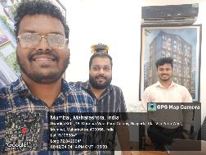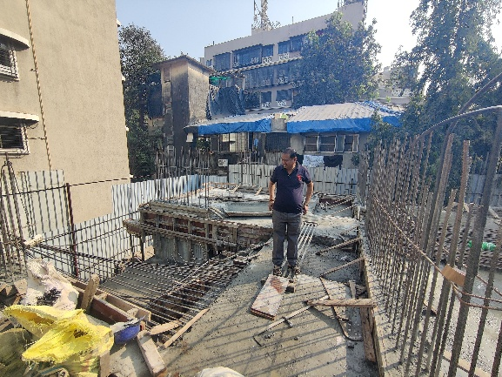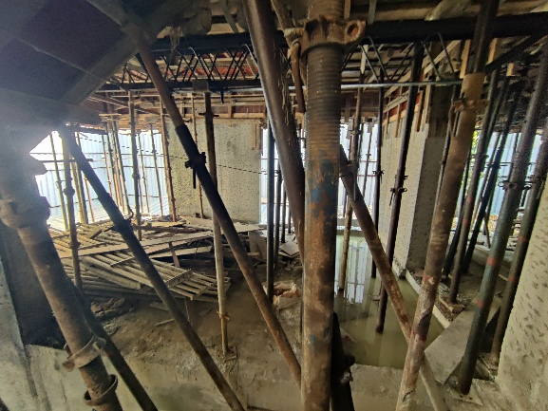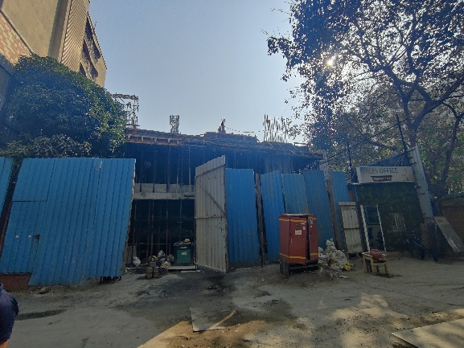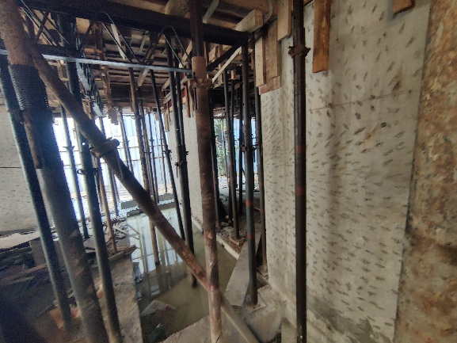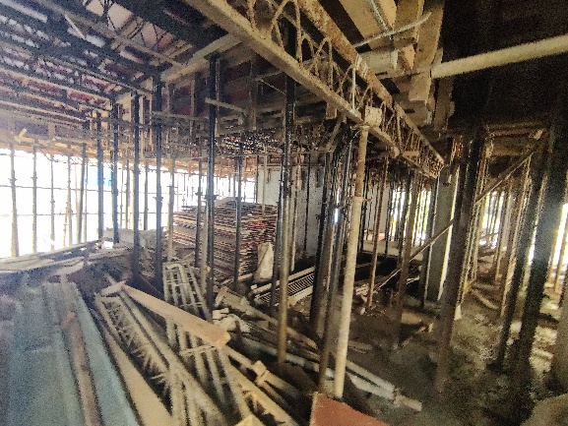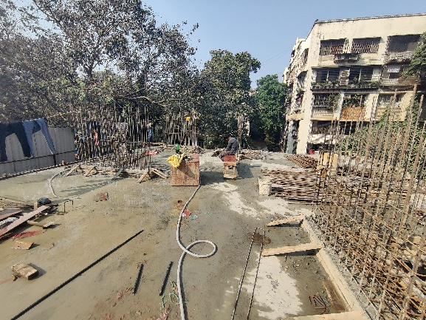

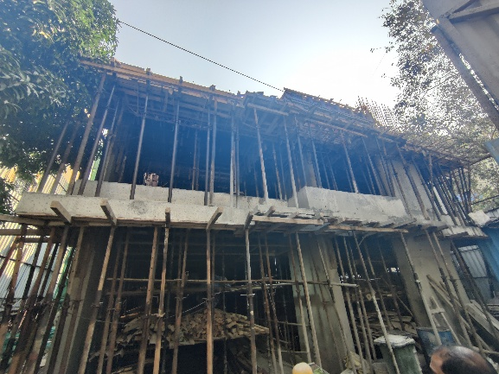

**Route Map of the property**

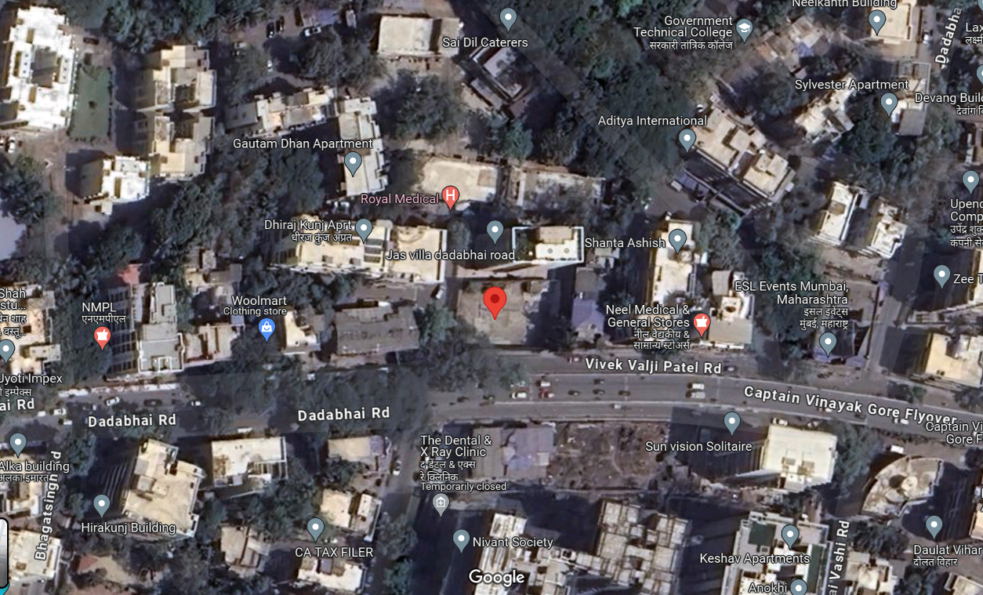**Site u/r**

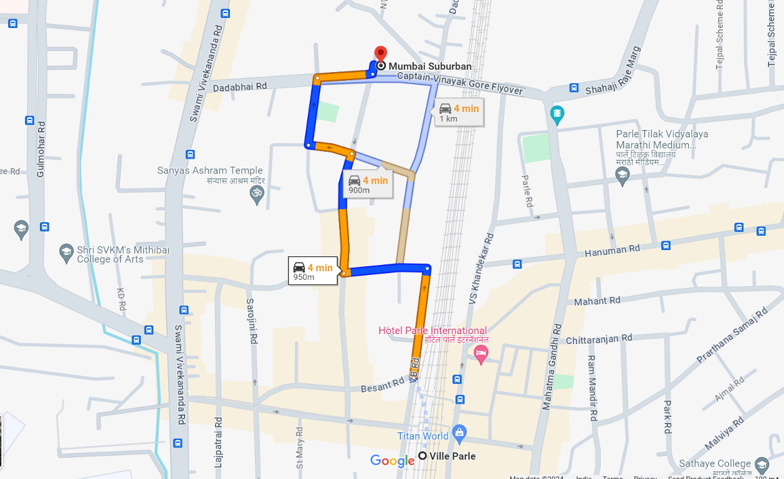

## Latitude Longitude: 19°06'22.8"N 72°50'35.5"E

Note: The Blue line shows the route to site from nearest railway station (Vile Parle – 950 M.)

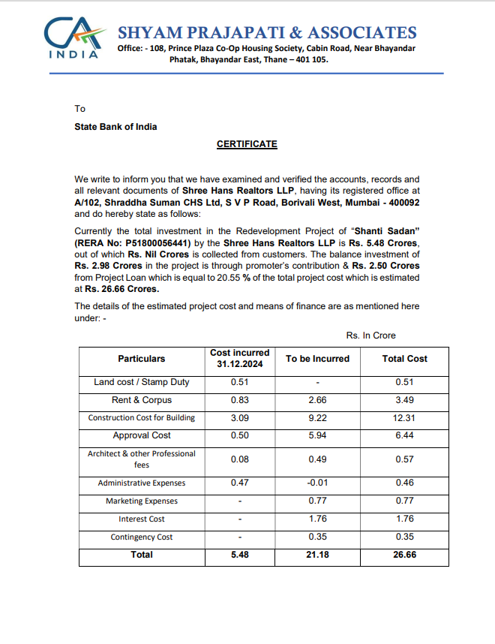**CA Certificate Dated 07.01.2024 till 31.12.2024 issued by M/s. Shyam Prajapati & Associates**

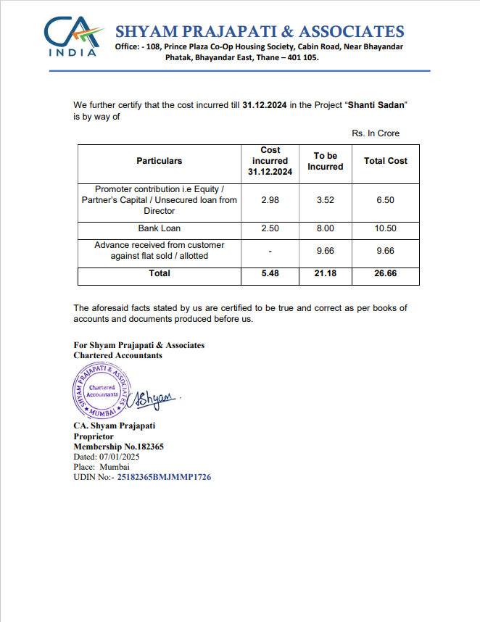**CA Certificate Dated 07.01.2024 till 31.12.2024 issued by M/s. Shyam Prajapati & Associates**