Vastu/Nashik/03/2023833/30490/46262
22/24-455-RYRJ
Date: 09.01.2025

To,
The Branch Manager,
Bank of Baroda
Regional Office
BSNL Building, Datta Mandir Road, Nashik Road,
Nashik, PIN – 422 101, State - Maharashtra, Country - India.

Sub: Vetting of Cost of Construction

Sir,

With reference to above subject, we have evaluated the Cost of Construction for Residential Land and Proposed Bungalow on Plot No.12, Survey No.455/ 1B/ 455/ 2, Near Ramkrushna Park, Takali Road, Village- Nashik, Taluka – Nashik, District – Nashik, Pin Code – 422 101, State - Maharashtra, Country – India. belongs Shri. Sandesh Suresh Pardeshi & Sau. Mamta Sandesh Pardeshi & Shri. Sagar Suresh Pardeshi & Sau. Manju Sangar Pardeshi.

We have verified the rates quoted as per current market rates. Details of Cost of Construction considered as per copy of Cost of Construction Agreement between Sandesh Suresh Pardeshi (First Party). Shaikh Firoz Nabab (Contractor) (Second Party) received on dated.17.10.2024. The Cost of Construction amount is Rs. 45,00,000/- (Rupees Forty Five Lakh Only)

The said Cost Vetting Certificate is valid up to next 6 months Only.

Thanking you

Sincerely yours

Manoj B. Chalikwar
Registered Valuer
Chartered Engineer (India)
Reg. No. CAT-I-F-1763
Reg. No. IBBI/RV/07/2018/10366
BOB Empanelment No.: ZO:MZ:ADV:46:941
Encl: Valuation Report.

Agreement For Cost of Construction
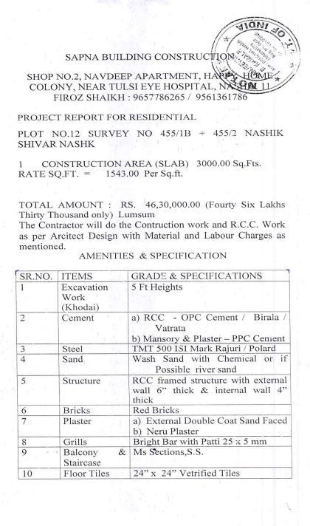
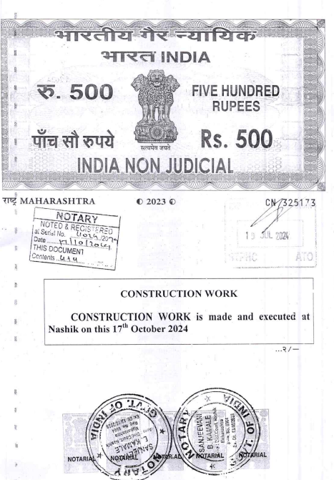

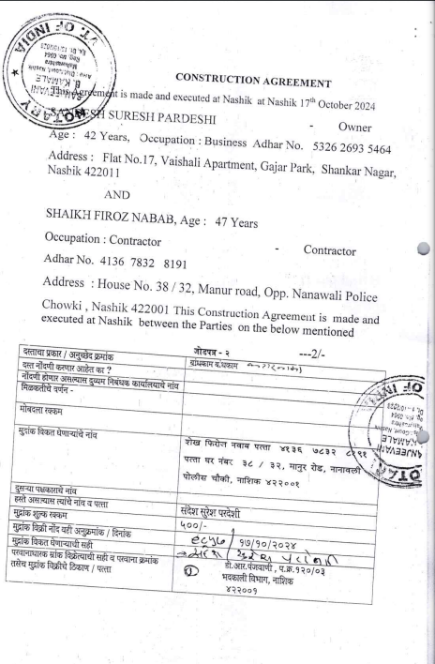

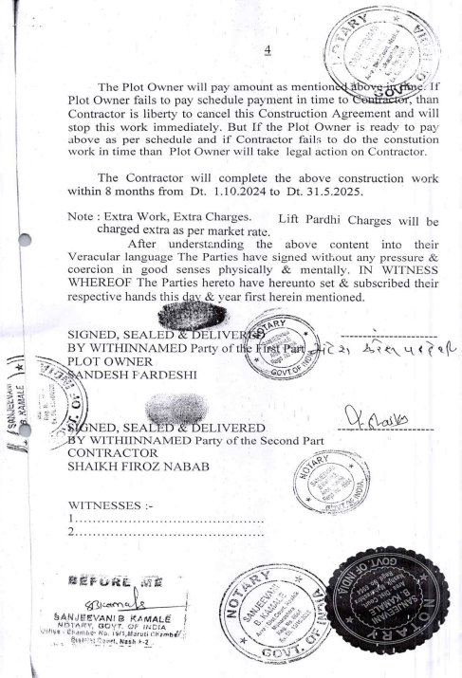
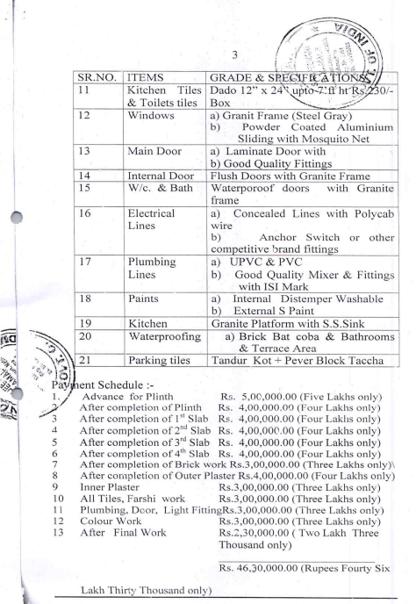

The Cost of Construction amount is Rs.45,00,000/- ( Rupees Forty Five Lakh Only. )

