Vastu/Nashik/07/2024/0010070/2307330
22/7-334-RPBS
Date: 09.01.2025

To, `
The Branch Manager,
Bank of Baroda
Regional Office Nashik Road Branch
BSNL Building, Datta Mandir Road, Nashik Road,
Nashik -422 101, State - Maharashtra, Country - India.

Sub: Vetting of Extra Amenities

Sir,

With reference to above subject, we have evaluated the Extra Amenities for Residential Flat No. 102, 1st Floor, "Saideep Apartment", Behind Thulja Bhavani Mandir, Near Rajmata Jijau Udyan, Shramik Nagar, Plot No. 12, Gangapur - Satpur Link Road, Village -Pimpalgaon Bahula, Taluka - Nashik, District - Nashik, Nashik, PIN Code - 422 011, State - Maharashtra, Country - India belongs to Shri. Shubham Pradeep Girase. Name of Proposed Purchaser is Sau. Amita Ajaykumar Mishra.

We have verified the rates quoted as per current market rates. Details of Extra Amenities considered as per copy of Agreement for Extra Amenities issued by to Sau. Amita Ajaykumar Mishra (First Party) Shri. Nagendra Shivprasad Rai (Second Party) received on dated 04.01.2025. The Extra Amenities amount is Rs.4,50,000/- (Rupees Four Lakh Fifty Thousand Only.)

The said Cost Vetting Certificate is valid upto next 6 months Only.

Thanking you

Sincerely yours

Manoj B. Chalikwar
Registered Valuer
Chartered Engineer (India)
Reg. No. CAT-I-F-1763
Reg. No. IBBI/RV/07/2018/10366
BOB Empanelment No.: ZO:MZ:ADV:46:941
Encl: Valuation report.

Agreement of Extra Amenities
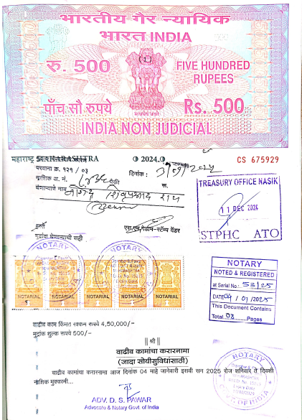
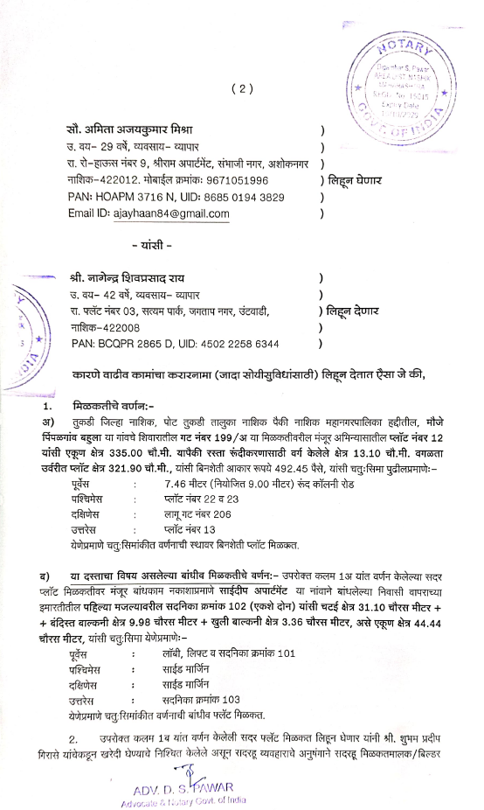

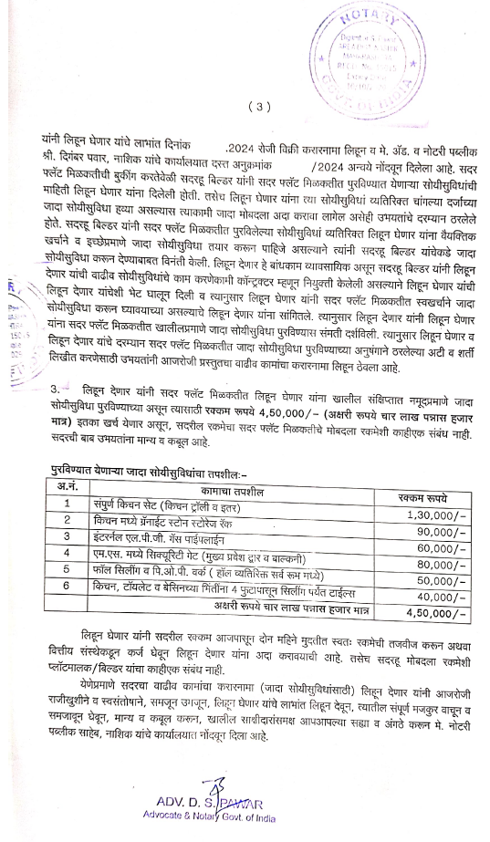
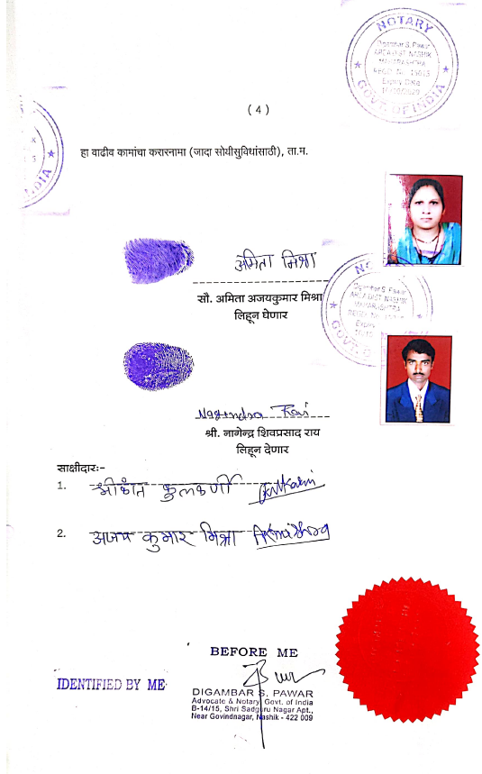

The Extra Work amount Rs.4,50,000/- (Rupees Four Lakh Fifty Thousand Only.)

