Rental Valuation of Immovable Property

Details of the property under consideration:

Name of Owner: Mumbai Agricultural Produce Market Committee

Office Block, Ground Floor, at “Auxiliary Building” Fruit Market, A. P. M. C.,
Near M/s. K.B. Export, Sector No. 18, Vashi, Navi Mumbai

Longitude Latitude: 19°04'25.8"N 73°00'39.2"E

Vastukala Consultants (I) Pvt. Ltd.
Mumbai • Nanded • Navi Mumbai • Aurangabad

Vastu/Mumbai/05/2016/17748
07/08/79-N
Date: 07.05.2016

CERTIFICATE

This is to certify that the property bearing Office Block, Ground Floor, at “Auxiliary Building” Fruit Market, A. P. M. C., Near M/s. K.B. Export, Sector No. 18, Vashi, Navi Mumbai belongs to Mumbai Agricultural Produce Market Committee.
Considering various parameters recorded, existing economic scenario, and the information that is available with reference to the development of neighborhood and method selected for rental valuation, we are of the opinion that, the property premises can be assessed and valued for this particular purpose of rental valuation at ` 40,000/- (Rupees Forty Thousand Only) Per month. The rental valuation is calculated depending upon floating population, business potential & Present Rental Income dilapidated condition of the structure.
Boundaries of the property.
North | : | Multipurpose Building
South | : | Road
East | : | C.F.B Building
West | : | Export House

The valuation of the property is based on the documents produced by the concern. Legal aspects have not been taken into considerations while preparing this valuation report.

Hence certified

Sharad B. Chalikwar
Govt. Reg. Valuer & Chartered Engineer (India)
Reg. No. (N) CCIT/1-14/52/2008-09
Encl: Valuation report.

VALUATION REPORT IN RESPECT OF IMMOVABLE PROPERTY

1 | Date of Inspection | : | 07th May 2016
 | Purpose of valuation | : | As per Owner’s request to assess Rental value of the property
2 | Name and address of the Valuer. | : | S. B. Chalikwar
2 | Name and address of the Valuer. | : | Vastukala Consultants (I) Pvt. Ltd.
2 | Name and address of the Valuer. | : | Office No. 121, First Floor, Ackruti Star, Central Road, MIDC, Andheri (E), Mumbai - 400 093
3 | List Of Documents Handed Over To The Valuer By The Bank
 | a. | : | Request letter from owner No. APMC / Develop / 90 / 16 dated 13.04.2016
4 | Details of enquiries made/ visited to govt. Offices for arriving fair market value.
 | a. | : | Market analysis and as per sub-registrar value.
5 | Factors for determining its market value. | : | Location, development of surrounding area, type of construction, construction specifications, age of building, condition of the premises & building, facilities provided and its prevailing market rate.  The rental valuation is calculated depending upon floating population & business potential of the respective unit.
6 | ANY CRITICAL ASPECTS ASSOCIATED WITH PROPERTY: No.
7 | Present/Expected Income from the property | : | ` 40,000/- Expected rental income per month
8 | Property Details : | :
 | Name(s) and Postal address of the owner(s). | : | Mumbai Agricultural Produce Market Committee
 |  | : | Office Block, Ground Floor, at “Auxiliary Building” Fruit Market, A. P. M. C., Near M/s. K.B. Export, Sector No. 18, Vashi, Navi Mumbai.
 | If the property is under joint ownership/ co-ownership share of each such owner/ are the share is undivided. | : | Company Ownership
 | Brief description of the property. | : | Commercial
 |  | : | The property is a located on Ground floor at A. P. M. C., Fruit Market. The property is at 5 - 10 minutes travelling distance from Turbhe Railway Station.
 | Location of the property. | : | Sector No. 18, Vashi, Navi Mumbai.
 | (C.T.S. No., Survey No., Hissa No., Plot No., etc.). |  | Sector No. 18, Vashi, Navi Mumbai.
 | Boundaries of the property. | :
 | North | : | Multipurpose Building
 | South | : | Road
 | East | : | C.F.B Building
 | West | : | Export House
 | Route map | : | Enclosed
 | Any specific identification marks | : | Fruit Market
 | Whether covered under Corporation/ Panchayat/ Municipality. | : | Navi Mumbai Municipal Corporation
 | Whether covered under any land ceiling of State/ Central Government. | : | No
 | Is the land freehold/ leasehold. | : | Leasehold
 | Are there any restrictive covenants in regard to use of Land? If so attach a copy of the covenant. | : | No
 |  | :
 | Type of the property | : | Commercial
 | Year of acquisition/ purchase. | : | Information not available
 | Whether the property is occupied by owner or tenant. If occupied by tenant since how long he is staying and the amount of rent being paid. | : | Vacant
 | Classification of the site. | :
 | a. Population group. | : | Urban
 | b. High/ Middle/ Poor class. | : | Middle class
 | c. Residential/ nonresidential. | : | Commercial
 | d. Development of surrounding area. | : | Good
 | e. Possibility of any threat to the property. | : | No
 | (Floods, calamities etc.). | :
 | Proximity of civic amenities. (like school, hospital, bus stop, market etc.). | : | All available near by
 | Level of the land (Plain, rock etc.). | : | Plain
 | Terrain of the Land. | : | Levelled
 | Shape of the land (Square/ rectangle etc.). | : | Rectangular
 | Type of use to which it can be put (for construction of house, factory etc.). | : | For Commercial purpose
 | Any usage restrictions on the property. | : | As per documents
 | Whether the plot is under town planning approved layout? | : | Yes
 | Whether the gala is intermittent or corner? | : | Intermittent
 | Whether any road facility is available? | : | Yes
 | Type of road available (B.T./Cement Road etc.). | : | B. T. Road
 | Front Width of the Road? | : | 24.00 M. wide road
 | Source of water & water potentiality. | : | Municipal Water supply
 | Type of Sewerage System. | : | Connected to Municipal sewer
 | Availability of power supply. | : | Yes
 | Advantages of the site. | : | Located in developed Market area
 | Disadvantages of the site. | : | No.
 | Give instances of sales of immovable property in the locality on a separate sheet, indicating the name & address of the property, registration No. sale price and area of land sold. | : | As per Sub-Registrar of Assurance records

9. | Valuation of the property :
 | Part-I: (Valuation of Unit) :
 | 1) Total area of the Block | :  : | Carpet area = 667.00 Sq. Ft  (Area as per actual site measurement)  Built up area = 800.00 Sq. Ft.  (Carpet area + 20%)
 | 2) Prevailing market Rent | : | ` 40/- to ` 50/- per Sq. Ft.
 | 3) Rate adopted for valuation | : | ` 50/- per Sq. Ft.
 | a. Technical details of the building :
 | Type of building (Residential/ Commercial/ Industrial). | : | Commercial
 | Year of construction. | : | 1998
 | Future life of the property. | : | 42 years subject to proper, preventive periodic maintenance & structural repairs.
 | No. of floors and height of each floor including basement. | : | Ground Floor + 1
 | Type of construction.
 | (Load bearing/ R.C.C./ Steel framed). | : | R.C.C. Framed Structure
 | Condition of the building. | :
 | External (excellent/ good/ normal/ poor). | : | Normal
 | Internal (excellent/ good/ normal/ poor). | : | Normal
 | Whether the building/ property is constructed strictly according to the sanctioned plan, details of variations noticed if any and effect of the same on the valuation. | : | The approved building plans were not provided and not verified

I certify that,

The property is inspected by Mr. Akash Gaikwad personally.

The rates for valuation of the property are in accordance with the Govt. approved rates and prevailing market rates.

There is no direct/ indirect interest in the property valued.

Sharad B. Chalikwar
Date: 07.05.2016
Place: Mumbai
Govt. Reg. Valuer & Chartered Engineer (India)
Reg. No. (N) CCIT/1-14/52/2008-09

Actual site photographs
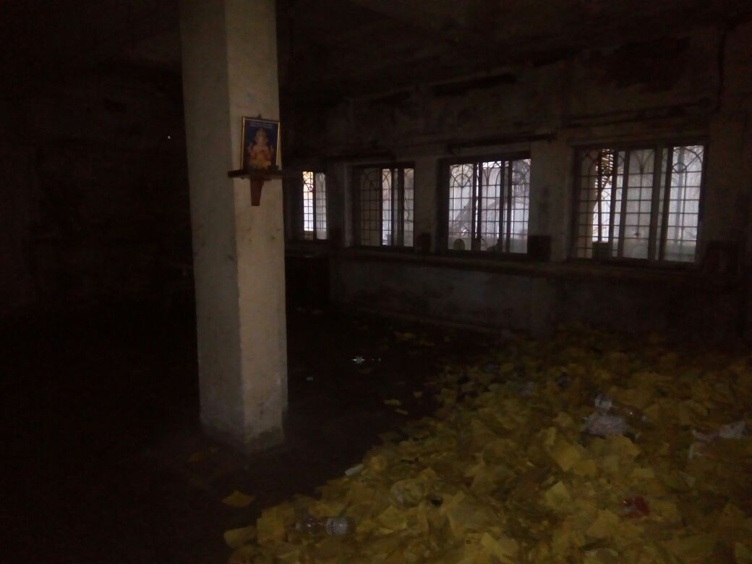

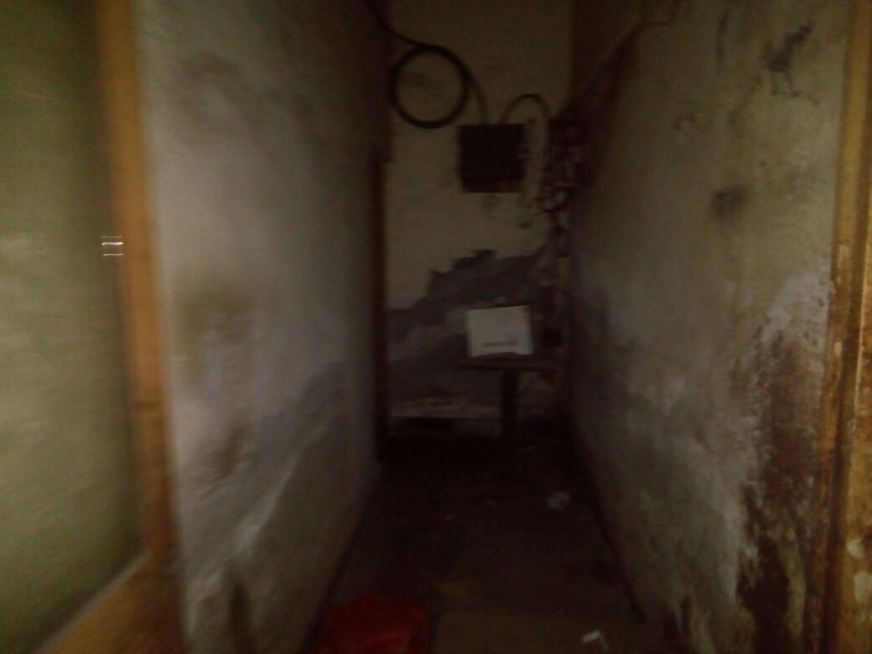

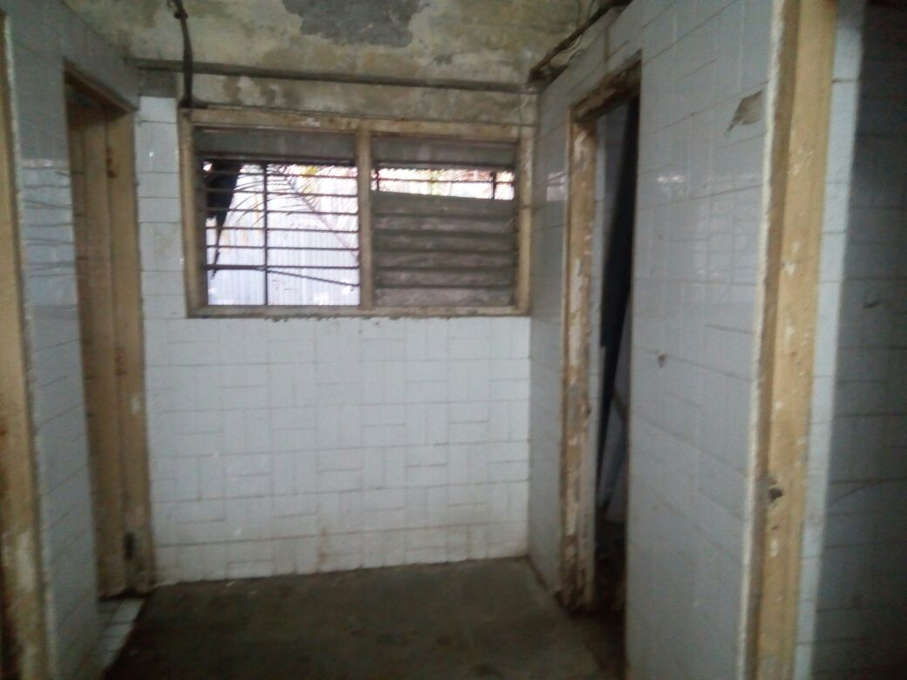

Route Map of the property
Site u/r
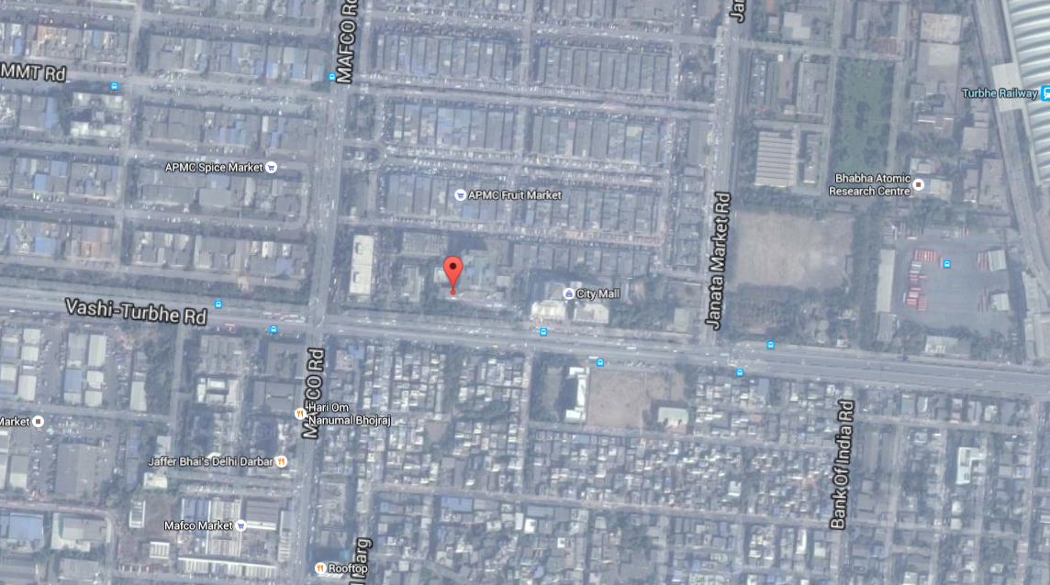

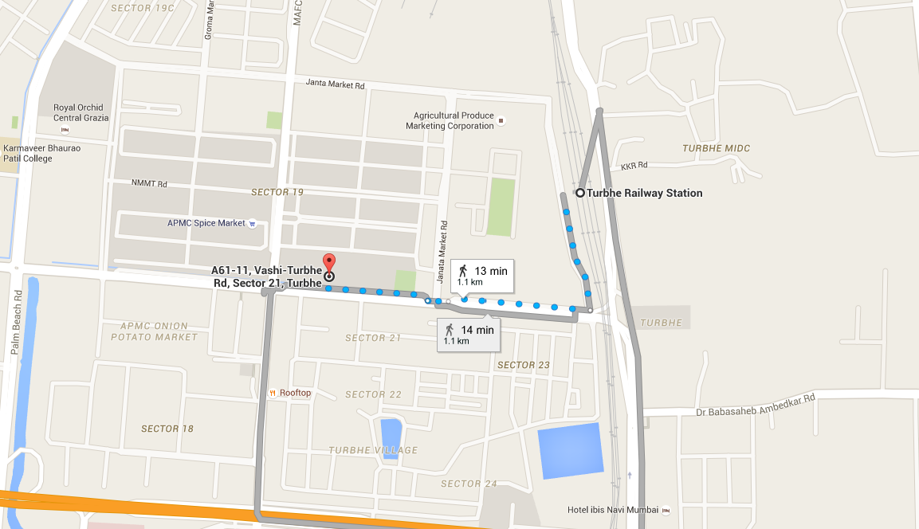

Longitude Latitude: 19°04'25.8"N 73°00'39.2"E

Note: The Blue line shows the route to site from railway station (Turbhe 1.1 Km)

DEFINITION OF VALUE FOR THIS SPECIFIC PURPOSE

This exercise is to assess Fair Market Value of the property under reference as on 07th May 2016.

The term Fair Market Value is defined as

“The most probable price, as of a specified date, in cash, terms equivalent to cash, or in other precisely revealed terms for which the specified property rights would sell after reasonable exposure in a competitive market under all conditions requisite to a fair sale, with the buyer and seller each acting prudently knowledgeably and for self-interest assuming that neither is under undue duress”.

Fundamental assumptions and conditions presumed in this definition are:

1. Buyer and seller are motivated by self-interest.
2. Buyer and seller are well informed and are acting prudently.
3. The property is exposed for a reasonable time on the open market.
4. Payment is made in cash or equivalent or in specified financing terms.

UNDER LYING ASSUMPTIONS
1. We assume no responsibility for matters of legal nature affecting the property appraised or the title thereto, nor do we render our opinion as to the title, which is assumed to be good and marketable.
2. The property is valued as though under responsible ownership.
3. It is assumed that the property is free of liens and encumbrances.
4. It is assumed that there are no hidden or unapparent conditions of the subsoil or structure that would render it more or less valuable. No responsibility is assumed for such conditions or for engineering that might be required to discover such factors.

Sharad B. Chalikwar
Govt. Reg. Valuer & Chartered Engineer (India)
Reg. No. (N) CCIT/1-14/52/2008-09

DECLARATION OF PROFESSIONAL FEES CHARGED

We hereby declare that, our professional fees are not contingent upon the valuation findings. However, if the statute AND/OR clients demands that, the fees should be charged on the percentage of assessed value then, with the full knowledge of the AND/OR end user, it is being charged accordingly.

VALUATION OF THE PROPERTY PREMISES

Considering various parameters recorded, existing economic scenario, and the information that is available with reference to the development of neighborhood and method selected for rental valuation, we are of the opinion that, the property premises can be assessed and valued for this particular purpose of rental valuation at ` 40,000/- (Rupees Forty Thousand Only) Per month. The rental valuation is calculated depending upon floating population, business potential & Present Rental Income dilapidated condition of the structure.

STATEMENT OF LIMITING CONDITIONS

1. Assumptions are made to the best of our knowledge and belief. Reliance is based on the information furnished to us by the identifier AND/OR client.
2. The valuer shall not be responsible for matters of legal nature that affects the value and opinion expressed by us.
3. If our appearance is required, we will be pleased to appear and give the necessary clarification, provided the fees for each appearance (excluding traveling, dearness allowance and out of pocket expenses) is pre-determined before the acceptance of the assignment under reference.
4. In no event shall the valuer be held responsible or liable for special, direct, indirect or consequential damages, as the assignment has been completed on best efforts, available knowledge and in good intentions of persons concerned and belief.
5. If it is proved that there is an apparent negligence on the part of a valuer, liability of this assignment (whether arising from this assignment, negligence or whatsoever) is limited in respect of anyone event or series of events to the actual loss or damage sustained subject to maximum of 80% of the professional fees for the services rendered and in any case not exceeding the amount of ` 1,000/- (Rupees one Thousand Only). All the claims against us shall expire after three month from the date of submission of the valuation report provided by us.
6. We hereby declare that, the information furnished above is true and correct to the best of our knowledge and belief. We have no direct or indirect interest in the assets valued. We have not been convicted of any offence and sentenced to a term of imprisonment. We have not been found guilty of misconduct in our professional capacity.

Sharad B. Chalikwar
Govt. Reg. Valuer & Chartered Engineer (India)
Reg. No. (N) CCIT/1-14/52/2008-09

