Valuation Report of the Immovable Property

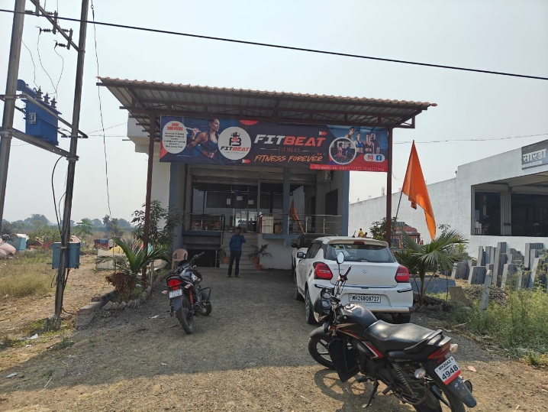

**Details of the property under consideration:**

**Name of Owner: Mr. Vishwanath P. Nagnath Dake**

**Land and Building** Known as **“Fitbeat Fitness Forever”**, House No. 776/3, Plot No. 01/P,   
Survey No. 110/1/K & 110/1/D, Near Kisan Tractors, Village - Basmath, Taluka – Basmath,   
District – Hingoli, PIN – 431 512, Maharashtra, India.

# **Longitude Latitude: 19°19’14.1”N 77°10’35.8”E**

**Valuation Done for:**

**Axis Bank**

**Basmat Hingoli Branch**

Plot No A-498, Ground Floor, Mama Chowk Basmath, Tal. - Basmath, Dist. – Hingoli, Basmath,

PIN – 431512, State – Maharashtra, Country – India

.

Vastu/Axis Bank/Nanded/01/2025/13548/2310006

10/08-125-SOVSM

Date: 10.01.2025

# **VALUER’S OPINION REPORT**

This is to certify that the property bearing **Land and Building** Known as **“Fitbeat Fitness Forever”**, House No. 776/3, Plot No. 01/P, Survey No. 110/1/K & 110/1/D, Near Kisan Tractors, Village - Basmath, Taluka – Basmath, District – Hingoli, PIN – 431 512, Maharashtra, India belongs to **Mr. Vishwanath P. Nagnath Dake.**

|  |  |  |
| --- | --- | --- |
| Boundaries of the property. | | |
| North | : | Parbhani Nanded Road | |
| South | : | Open Plot | |
| East | : | Open Plot | |
| West | : | Sarda Traders Shop & Open Plot | |

Considering various parameters recorded, existing economic scenario, and the information that is available with reference to the development of neighborhood and method selected for valuation, we are of the opinion that, the property premises can be assessed are as under:

|  |  |
| --- | --- |
| **Guideline Value of the Property** | **Rs. 67,79,023.00** |
| **Fair Market Value of the Property** | **Rs. 1,97,18,940.00** |
| **Realizable Value of the Property** | **Rs. 1,77,47,046.00** |
| **Forced/ Distress Sale value of the Property.** | **Rs. 1,57,75,152.00** |

The valuation of the property is based on the documents produced by the concern. Legal aspects have not been taken into considerations while preparing this valuation report.

Hence certified

For, **Vastukala Consultants (I) Pvt. Ltd.**

**Sharadkumar B. Chalikwar**

B.E. (Civil), M.E. (Civil), M.Sc. (Real Estate Valuation), M.Sc. (P&M Valuation), FIE (I), FIV, FIWRS

Chairman & Managing Director

Govt. Reg. Valuer

Chartered Engineer (India)

Reg. No. (N) CCIT/1-14/52/2008-09

IBBI Reg.No. IBBI/RV/07/2019/11744

|  |  |  |  |  |  |  |  |  |  |  |  |  |  |  |  |  |  |  |  |  |  |  |  |  |  |  |  |  |  |  |  |  |  |  |  |  |  |  |  |  |  |  |  |  |  |  |  |  |  |  |  |  |  |  |  |  |  |  |  |  |  |  |  |  |  |  |  |  |  |  |  |  |  |  |  |  |  |  |  |  |  |  |  |  |  |  |  |  |  |  |  |  |  |  |  |  |  |  |  |  |  |  |  |  |  |  |  |  |  |  |  |  |  |  |  |  |  |  |  |  |  |  |  |  |  |  |  |  |  |  |  |  |  |  |  |  |  |  |  |  |  |  |  |  |  |  |  |  |  |  |  |  |  |  |  |  |  |  |  |  |  |  |  |  |  |  |  |  |  |  |  |  |  |  |  |  |  |  |  |  |  |  |  |  |  |  |  |  |  |  |  |  |  |  |  |  |  |  |  |  |  |  |  |  |  |  |  |  |  |  |  |  |  |  |  |  |  |  |  |  |  |  |  |  |  |  |  |  |  |  |  |  |  |  |  |  |  |  |  |  |  |  |  |  |  |  |  |  |  |  |  |  |  |  |  |  |  |  |  |  |  |  |  |  |  |  |  |  |  |  |  |  |  |  |  |  |  |  |  |  |  |  |  |  |  |  |  |  |  |  |  |  |  |  |  |  |  |  |  |  |  |  |  |  |  |  |  |  |  |  |  |  |  |  |  |  |  |  |  |  |  |  |  |  |  |  |  |  |  |  |  |  |  |  |  |  |  |  |  |  |  |  |  |  |  |  |  |  |  |  |  |  |  |  |  |  |  |  |  |  |  |  |  |  |  |  |  |  |  |  |  |  |  |  |  |  |  |  |  |  |  |  |  |  |  |  |  |  |  |  |  |  |  |  |  |  |  |  |  |  |  |  |  |  |  |  |  |  |  |  |  |  |  |  |  |  |  |  |  |  |  |  |  |  |  |  |  |  |  |  |  |  |  |  |  |  |  |  |  |  |  |  |  |  |  |  |  |  |  |  |  |  |  |  |  |  |  |  |  |  |  |  |  |  |  |  |  |  |  |  |  |  |  |  |  |  |  |  |  |  |  |  |  |  |  |  |  |  |  |  |  |  |  |  |  |  |  |  |  |  |  |  |  |  |  |  |  |  |  |  |  |  |  |  |  |  |  |  |  |  |  |  |  |  |  |  |  |  |  |  |  |  |  |  |  |  |  |  |  |  |  |  |  |  |  |  |  |  |  |  |  |  |  |  |  |  |  |  |  |  |  |  |  |  |  |  |  |  |  |  |  |  |  |  |  |  |  |  |  |  |  |  |  |  |  |  |  |  |  |  |  |  |  |  |  |  |  |  |  |  |  |  |  |  |  |  |  |  |  |  |  |  |  |  |  |  |  |  |  |  |  |  |  |  |  |  |  |  |  |  |  |  |  |  |  |  |  |  |  |  |  |  |  |  |  |  |  |  |  |  |  |  |  |  |  |  |  |  |  |  |  |  |  |  |  |  |  |  |  |  |  |  |  |  |  |  |  |  |  |  |  |  |  |  |  |  |  |  |  |  |  |  |  |  |  |  |  |  |  |  |  |  |  |  |  |  |  |  |  |  |  |  |  |  |  |  |  |  |  |  |  |  |  |  |  |  |  |  |  |  |  |  |  |  |  |  |  |  |  |  |  |  |  |  |  |  |  |  |  |  |  |  |  |  |  |  |  |  |  |  |  |  |  |  |  |  |  |  |  |  |  |  |  |  |  |  |  |  |  |  |  |  |  |  |  |  |  |  |  |  |  |  |  |  |  |  |  |  |  |  |  |  |  |  |  |  |  |  |  |  |  |  |  |  |  |  |  |  |  |  |  |  |  |  |  |  |  |  |  |  |  |  |  |  |  |  |  |  |  |  |  |  |  |  |  |  |  |  |  |  |  |  |  |  |  |  |  |  |  |  |  |  |  |  |  |  |  |  |  |  |  |  |  |  |  |  |  |  |  |  |  |  |  |  |  |  |  |  |  |  |  |  |  |  |  |  |  |  |  |  |  |  |  |  |  |  |  |  |  |  |  |  |  |  |  |  |  |  |  |  |  |  |  |  |  |  |  |  |  |  |  |  |  |  |  |  |  |  |  |  |  |  |  |  |  |  |  |  |  |  |  |  |  |  |  |  |  |  |  |  |  |  |  |  |  |  |  |  |  |  |  |  |  |  |  |  |  |  |  |  |  |  |  |  |  |  |  |  |  |  |  |  |  |  |  |  |  |  |  |  |  |  |  |  |  |  |  |  |  |  |  |  |  |  |  |  |  |  |  |  |  |  |  |  |  |  |  |  |  |  |  |  |  |  |  |  |  |  |  |  |  |  |  |  |  |  |  |  |  |  |  |  |  |  |  |  |  |  |  |  |  |  |  |  |  |  |  |  |  |  |  |  |  |  |  |  |  |  |  |  |  |  |  |  |  |  |  |  |  |  |  |  |  |  |  |  |  |  |  |  |  |  |  |  |  |  |  |  |  |  |  |  |  |  |  |  |  |  |  |  |  |  |  |  |  |  |  |  |  |  |  |  |  |  |  |  |  |  |  |  |  |  |  |  |  |  |  |  |  |  |  |  |  |  |  |  |  |  |  |  |  |  |  |  |  |  |  |  |  |  |  |  |  |  |  |  |  |  |  |  |  |  |  |  |  |  |  |  |  |  |  |  |  |  |  |  |  |  |  |  |  |  |  |  |  |  |  |  |  |  |  |  |  |  |  |  |  |  |  |  |  |  |  |  |  |  |  |  |  |  |  |  |  |  |  |  |  |  |  |  |  |  |  |  |  |  |  |  |  |  |  |  |  |  |  |  |  |  |  |  |  |  |  |  |  |  |  |  |  |  |  |  |  |  |  |  |  |  |  |  |  |  |  |  |  |  |  |  |  |  |  |  |  |  |  |  |  |  |  |  |  |  |  |  |  |  |  |  |  |  |  |  |  |  |  |  |  |  |  |  |  |  |  |  |  |  |  |  |  |  |  |  |  |  |  |  |  |  |  |  |  |  |  |  |  |  |  |  |  |  |  |  |  |  |  |  |  |  |  |  |  |  |  |  |  |  |  |  |  |  |  |  |  |  |  |  |  |  |  |  |  |  |  |  |  |  |  |  |  |  |  |  |  |  |  |  |  |  |  |  |  |  |  |  |  |  |  |  |  |  |  |  |  |  |  |  |  |  |  |  |  |  |  |  |  |  |  |  |  |  |  |  |  |  |  |  |  |  |  |  |  |  |  |  |  |  |  |  |  |  |  |  |  |  |  |  |  |  |  |  |  |  |  |  |  |  |  |  |  |  |  |  |  |  |  |  |  |  |  |  |  |  |  |  |  |  |  |  |  |  |  |  |  |  |  |  |  |  |  |  |  |  |  |  |  |  |  |  |  |  |  |  |  |  |  |  |  |  |  |  |  |  |  |  |  |  |  |  |  |  |  |  |  |  |  |  |  |  |  |  |  |  |  |  |  |  |  |  |  |  |  |  |  |  |  |  |  |  |  |  |  |  |  |  |  |  |  |  |  |  |  |  |  |  |  |  |  |  |  |  |  |  |  |  |  |  |  |  |  |  |  |  |  |  |  |  |  |  |  |  |  |  |  |  |  |  |  |  |  |  |  |  |  |  |  |  |  |  |  |  |  |  |  |  |  |  |  |  |  |  |  |  |  |  |  |  |  |  |  |  |  |  |  |  |  |  |  |  |  |  |  |  |  |  |  |  |  |  |  |  |  |  |  |  |  |  |  |  |  |  |  |  |  |  |  |  |  |  |  |  |  |  |  |  |  |  |  |  |  |  |  |  |  |  |  |  |  |  |  |  |  |  |  |  |  |  |  |  |  |  |  |  |  |  |  |  |  |  |  |  |  |  |  |  |  |  |  |  |  |  |  |  |  |  |  |  |  |  |  |  |  |  |  |  |  |  |  |  |  |  |  |  |  |  |  |  |  |  |  |  |  |  |  |  |  |  |  |  |  |  |  |  |  |  |  |  |  |  |  |  |  |  |  |  |  |  |  |  |  |  |  |  |  |  |  |  |  |  |  |  |  |  |  |  |  |  |  |  |  |  |  |  |  |  |  |  |  |  |  |  |  |  |  |  |  |  |  |  |  |  |  |  |  |  |  |  |  |  |  |  |  |  |  |  |  |  |  |  |  |  |  |  |  |  |  |  |  |  |  |  |  |  |  |  |  |  |  |  |  |  |  |  |  |  |  |  |  |  |  |  |  |  |  |  |  |  |  |  |  |  |  |  |  |  |  |  |  |  |  |  |  |  |  |  |  |  |  |  |  |  |
| --- | --- | --- | --- | --- | --- | --- | --- | --- | --- | --- | --- | --- | --- | --- | --- | --- | --- | --- | --- | --- | --- | --- | --- | --- | --- | --- | --- | --- | --- | --- | --- | --- | --- | --- | --- | --- | --- | --- | --- | --- | --- | --- | --- | --- | --- | --- | --- | --- | --- | --- | --- | --- | --- | --- | --- | --- | --- | --- | --- | --- | --- | --- | --- | --- | --- | --- | --- | --- | --- | --- | --- | --- | --- | --- | --- | --- | --- | --- | --- | --- | --- | --- | --- | --- | --- | --- | --- | --- | --- | --- | --- | --- | --- | --- | --- | --- | --- | --- | --- | --- | --- | --- | --- | --- | --- | --- | --- | --- | --- | --- | --- | --- | --- | --- | --- | --- | --- | --- | --- | --- | --- | --- | --- | --- | --- | --- | --- | --- | --- | --- | --- | --- | --- | --- | --- | --- | --- | --- | --- | --- | --- | --- | --- | --- | --- | --- | --- | --- | --- | --- | --- | --- | --- | --- | --- | --- | --- | --- | --- | --- | --- | --- | --- | --- | --- | --- | --- | --- | --- | --- | --- | --- | --- | --- | --- | --- | --- | --- | --- | --- | --- | --- | --- | --- | --- | --- | --- | --- | --- | --- | --- | --- | --- | --- | --- | --- | --- | --- | --- | --- | --- | --- | --- | --- | --- | --- | --- | --- | --- | --- | --- | --- | --- | --- | --- | --- | --- | --- | --- | --- | --- | --- | --- | --- | --- | --- | --- | --- | --- | --- | --- | --- | --- | --- | --- | --- | --- | --- | --- | --- | --- | --- | --- | --- | --- | --- | --- | --- | --- | --- | --- | --- | --- | --- | --- | --- | --- | --- | --- | --- | --- | --- | --- | --- | --- | --- | --- | --- | --- | --- | --- | --- | --- | --- | --- | --- | --- | --- | --- | --- | --- | --- | --- | --- | --- | --- | --- | --- | --- | --- | --- | --- | --- | --- | --- | --- | --- | --- | --- | --- | --- | --- | --- | --- | --- | --- | --- | --- | --- | --- | --- | --- | --- | --- | --- | --- | --- | --- | --- | --- | --- | --- | --- | --- | --- | --- | --- | --- | --- | --- | --- | --- | --- | --- | --- | --- | --- | --- | --- | --- | --- | --- | --- | --- | --- | --- | --- | --- | --- | --- | --- | --- | --- | --- | --- | --- | --- | --- | --- | --- | --- | --- | --- | --- | --- | --- | --- | --- | --- | --- | --- | --- | --- | --- | --- | --- | --- | --- | --- | --- | --- | --- | --- | --- | --- | --- | --- | --- | --- | --- | --- | --- | --- | --- | --- | --- | --- | --- | --- | --- | --- | --- | --- | --- | --- | --- | --- | --- | --- | --- | --- | --- | --- | --- | --- | --- | --- | --- | --- | --- | --- | --- | --- | --- | --- | --- | --- | --- | --- | --- | --- | --- | --- | --- | --- | --- | --- | --- | --- | --- | --- | --- | --- | --- | --- | --- | --- | --- | --- | --- | --- | --- | --- | --- | --- | --- | --- | --- | --- | --- | --- | --- | --- | --- | --- | --- | --- | --- | --- | --- | --- | --- | --- | --- | --- | --- | --- | --- | --- | --- | --- | --- | --- | --- | --- | --- | --- | --- | --- | --- | --- | --- | --- | --- | --- | --- | --- | --- | --- | --- | --- | --- | --- | --- | --- | --- | --- | --- | --- | --- | --- | --- | --- | --- | --- | --- | --- | --- | --- | --- | --- | --- | --- | --- | --- | --- | --- | --- | --- | --- | --- | --- | --- | --- | --- | --- | --- | --- | --- | --- | --- | --- | --- | --- | --- | --- | --- | --- | --- | --- | --- | --- | --- | --- | --- | --- | --- | --- | --- | --- | --- | --- | --- | --- | --- | --- | --- | --- | --- | --- | --- | --- | --- | --- | --- | --- | --- | --- | --- | --- | --- | --- | --- | --- | --- | --- | --- | --- | --- | --- | --- | --- | --- | --- | --- | --- | --- | --- | --- | --- | --- | --- | --- | --- | --- | --- | --- | --- | --- | --- | --- | --- | --- | --- | --- | --- | --- | --- | --- | --- | --- | --- | --- | --- | --- | --- | --- | --- | --- | --- | --- | --- | --- | --- | --- | --- | --- | --- | --- | --- | --- | --- | --- | --- | --- | --- | --- | --- | --- | --- | --- | --- | --- | --- | --- | --- | --- | --- | --- | --- | --- | --- | --- | --- | --- | --- | --- | --- | --- | --- | --- | --- | --- | --- | --- | --- | --- | --- | --- | --- | --- | --- | --- | --- | --- | --- | --- | --- | --- | --- | --- | --- | --- | --- | --- | --- | --- | --- | --- | --- | --- | --- | --- | --- | --- | --- | --- | --- | --- | --- | --- | --- | --- | --- | --- | --- | --- | --- | --- | --- | --- | --- | --- | --- | --- | --- | --- | --- | --- | --- | --- | --- | --- | --- | --- | --- | --- | --- | --- | --- | --- | --- | --- | --- | --- | --- | --- | --- | --- | --- | --- | --- | --- | --- | --- | --- | --- | --- | --- | --- | --- | --- | --- | --- | --- | --- | --- | --- | --- | --- | --- | --- | --- | --- | --- | --- | --- | --- | --- | --- | --- | --- | --- | --- | --- | --- | --- | --- | --- | --- | --- | --- | --- | --- | --- | --- | --- | --- | --- | --- | --- | --- | --- | --- | --- | --- | --- | --- | --- | --- | --- | --- | --- | --- | --- | --- | --- | --- | --- | --- | --- | --- | --- | --- | --- | --- | --- | --- | --- | --- | --- | --- | --- | --- | --- | --- | --- | --- | --- | --- | --- | --- | --- | --- | --- | --- | --- | --- | --- | --- | --- | --- | --- | --- | --- | --- | --- | --- | --- | --- | --- | --- | --- | --- | --- | --- | --- | --- | --- | --- | --- | --- | --- | --- | --- | --- | --- | --- | --- | --- | --- | --- | --- | --- | --- | --- | --- | --- | --- | --- | --- | --- | --- | --- | --- | --- | --- | --- | --- | --- | --- | --- | --- | --- | --- | --- | --- | --- | --- | --- | --- | --- | --- | --- | --- | --- | --- | --- | --- | --- | --- | --- | --- | --- | --- | --- | --- | --- | --- | --- | --- | --- | --- | --- | --- | --- | --- | --- | --- | --- | --- | --- | --- | --- | --- | --- | --- | --- | --- | --- | --- | --- | --- | --- | --- | --- | --- | --- | --- | --- | --- | --- | --- | --- | --- | --- | --- | --- | --- | --- | --- | --- | --- | --- | --- | --- | --- | --- | --- | --- | --- | --- | --- | --- | --- | --- | --- | --- | --- | --- | --- | --- | --- | --- | --- | --- | --- | --- | --- | --- | --- | --- | --- | --- | --- | --- | --- | --- | --- | --- | --- | --- | --- | --- | --- | --- | --- | --- | --- | --- | --- | --- | --- | --- | --- | --- | --- | --- | --- | --- | --- | --- | --- | --- | --- | --- | --- | --- | --- | --- | --- | --- | --- | --- | --- | --- | --- | --- | --- | --- | --- | --- | --- | --- | --- | --- | --- | --- | --- | --- | --- | --- | --- | --- | --- | --- | --- | --- | --- | --- | --- | --- | --- | --- | --- | --- | --- | --- | --- | --- | --- | --- | --- | --- | --- | --- | --- | --- | --- | --- | --- | --- | --- | --- | --- | --- | --- | --- | --- | --- | --- | --- | --- | --- | --- | --- | --- | --- | --- | --- | --- | --- | --- | --- | --- | --- | --- | --- | --- | --- | --- | --- | --- | --- | --- | --- | --- | --- | --- | --- | --- | --- | --- | --- | --- | --- | --- | --- | --- | --- | --- | --- | --- | --- | --- | --- | --- | --- | --- | --- | --- | --- | --- | --- | --- | --- | --- | --- | --- | --- | --- | --- | --- | --- | --- | --- | --- | --- | --- | --- | --- | --- | --- | --- | --- | --- | --- | --- | --- | --- | --- | --- | --- | --- | --- | --- | --- | --- | --- | --- | --- | --- | --- | --- | --- | --- | --- | --- | --- | --- | --- | --- | --- | --- | --- | --- | --- | --- | --- | --- | --- | --- | --- | --- | --- | --- | --- | --- | --- | --- | --- | --- | --- | --- | --- | --- | --- | --- | --- | --- | --- | --- | --- | --- | --- | --- | --- | --- | --- | --- | --- | --- | --- | --- | --- | --- | --- | --- | --- | --- | --- | --- | --- | --- | --- | --- | --- | --- | --- | --- | --- | --- | --- | --- | --- | --- | --- | --- | --- | --- | --- | --- | --- | --- | --- | --- | --- | --- | --- | --- | --- | --- | --- | --- | --- | --- | --- | --- | --- | --- | --- | --- | --- | --- | --- | --- | --- | --- | --- | --- | --- | --- | --- | --- | --- | --- | --- | --- | --- | --- | --- | --- | --- | --- | --- | --- | --- | --- | --- | --- | --- | --- | --- | --- | --- | --- | --- | --- | --- | --- | --- | --- | --- | --- | --- | --- | --- | --- | --- | --- | --- | --- | --- | --- | --- | --- | --- | --- | --- | --- | --- | --- | --- | --- | --- | --- | --- | --- | --- | --- | --- | --- | --- | --- | --- | --- | --- | --- | --- | --- | --- | --- | --- | --- | --- | --- | --- | --- | --- | --- | --- | --- | --- | --- | --- | --- | --- | --- | --- | --- | --- | --- | --- | --- | --- | --- | --- | --- | --- | --- | --- | --- | --- | --- | --- | --- | --- | --- | --- | --- | --- | --- | --- | --- | --- | --- | --- | --- | --- | --- | --- | --- | --- | --- | --- | --- | --- | --- | --- | --- | --- | --- | --- | --- | --- | --- | --- | --- | --- | --- | --- | --- | --- | --- | --- | --- | --- | --- | --- | --- | --- | --- | --- | --- | --- | --- | --- | --- | --- | --- | --- | --- | --- | --- | --- | --- | --- | --- | --- | --- | --- | --- | --- | --- | --- | --- | --- | --- | --- | --- | --- | --- | --- | --- | --- | --- | --- | --- | --- | --- | --- | --- | --- | --- | --- | --- | --- | --- | --- | --- | --- | --- | --- | --- | --- | --- | --- | --- | --- | --- | --- | --- | --- | --- | --- | --- | --- | --- | --- | --- | --- | --- | --- | --- | --- | --- | --- | --- | --- | --- | --- | --- | --- | --- | --- | --- | --- | --- | --- | --- | --- | --- | --- | --- | --- | --- | --- | --- | --- | --- | --- | --- | --- | --- | --- | --- | --- | --- | --- | --- | --- | --- | --- | --- | --- | --- | --- | --- | --- | --- | --- | --- | --- | --- | --- | --- | --- | --- | --- | --- | --- | --- | --- | --- | --- | --- | --- | --- | --- | --- | --- | --- | --- | --- | --- | --- | --- | --- | --- | --- | --- | --- | --- | --- | --- | --- | --- | --- | --- | --- | --- | --- | --- | --- | --- | --- | --- | --- | --- | --- | --- | --- | --- | --- | --- | --- | --- | --- | --- | --- | --- | --- | --- | --- | --- | --- | --- | --- | --- | --- | --- | --- | --- | --- | --- | --- | --- | --- | --- | --- | --- | --- | --- | --- | --- | --- | --- | --- | --- | --- | --- | --- | --- | --- | --- | --- | --- | --- | --- | --- | --- | --- | --- | --- | --- | --- | --- | --- | --- | --- | --- | --- | --- | --- | --- | --- | --- | --- | --- | --- | --- | --- | --- | --- | --- | --- | --- | --- | --- | --- | --- | --- | --- | --- | --- | --- | --- | --- | --- | --- | --- | --- | --- | --- | --- | --- | --- | --- | --- | --- | --- | --- | --- | --- | --- | --- | --- | --- | --- | --- | --- | --- | --- | --- | --- | --- | --- | --- | --- | --- | --- | --- | --- | --- | --- | --- | --- | --- | --- | --- | --- | --- | --- | --- | --- | --- | --- | --- | --- | --- | --- | --- | --- | --- | --- | --- | --- | --- | --- | --- | --- | --- | --- | --- | --- | --- | --- | --- | --- | --- | --- | --- | --- | --- | --- | --- | --- | --- | --- | --- | --- | --- | --- | --- | --- | --- | --- | --- | --- | --- | --- | --- | --- | --- | --- | --- | --- | --- | --- | --- | --- | --- | --- | --- | --- | --- | --- | --- | --- | --- | --- | --- | --- | --- | --- | --- | --- | --- | --- | --- | --- | --- | --- | --- | --- | --- | --- | --- | --- | --- | --- | --- | --- | --- | --- | --- | --- | --- | --- | --- | --- | --- | --- | --- | --- | --- | --- | --- | --- | --- | --- | --- | --- | --- | --- | --- | --- | --- | --- | --- | --- | --- | --- | --- | --- | --- | --- | --- | --- | --- | --- | --- | --- | --- | --- | --- | --- | --- | --- | --- | --- | --- | --- | --- | --- | --- | --- | --- | --- | --- | --- | --- | --- | --- | --- | --- | --- | --- | --- | --- |
| **VALUATION REPORT (IN RESPECT OF LAND AND BUILDING)**   |  |  |  |  |  |  |  |  |  |  |  |  |  |  |  |  | | --- | --- | --- | --- | --- | --- | --- | --- | --- | --- | --- | --- | --- | --- | --- | --- | | 1. | CBB/CCMC/CCSU | | |  | | | |  | | | - | | | | | | - | | | - | | | | | | 2. | Name of Owner & Address: | | | | | | | **Mr. Vishwanath P. Nagnath Dake**  Gunj, Taluka Basmat, District Hingoli | | | | | | | | | Name of Borrower & Address | | | | | | | **Mr. Vishwanath P. Nagnath Dake**  Gunj, Taluka Basmat, District Hingoli | | | | | | | | | 3. | Name of the Bank Official Present | | | | | | | No. | | | | | | | | | Name of the Representative & Mobile No. | | | | | | | Mr. Gangaprasad Vishwanath Dake (Owner’s Son)  Mob. No. # 80077 77377 | | | | | | | | | **4.** | **Details of the Property Being Valued** | | | | | | | | | | | | | | | | 4.1 | Description of the Property | | | | | | | Semi Under Ground Floor + Ground Floor RCC framed structure with RCC slab. | | | | | | | | | 4.2 | Location of Property | | | | | | | **Land and Building** Known as **“Fitbeat Fitness Forever”**, House No. 776/3, Plot No. 01/P, Survey No. 110/1/K & 110/1/D, Near Kisan Tractors, Village - Basmath, Taluka – Basmath, District – Hingoli, PIN – 431 512, Maharashtra, India. | | | | | | | | | (Rural / Semi Urban / Urban) | | | | | | | Urban. | | | | | | | | | 4.3 | Documents Provided: | | | | | | | | | | | | | | | | 1 | Copy of Agreement for sale dated 17.01.2019 between Mr. Dattatray P. Gangadharsa Nampalli, Mr. Sanjay P. Harikishor Kabra, Mr. Arun P. Nagoba Shahari & Mr. Kamal Bh. Suresh Bobade (The Transferor) & Mr. Vishwanath P. Nagnath Dake (The Purchaser) | | | | | | | | | | | | | | | 2 | Copy of 7/12 Extract | | | | | | | | | | | | | | | 3 | Copy of N.A Order No. Ja. No. 2017/ Plot / 1 / Pra. No. 32 Dated. 15.06.2018 issued by District Collector Hingoli | | | | | | | | | | | | | | |  | 4 | Copy of Commencement Certificate No. vide Grampanchyat Tharav No. 09 / dated 23.08.2021 issued by Grampanchayat Malvata, Taluka Basmat, District Hingoli | | | | | | | | | | | | | | |  | 5 | Copy of Plan issued by Group Grampanch  ayat Malvata, Taluka Basmat, District Hingoli. | | | | | | | | | | | | | | |  | 6 | Copy of Property Tax Receipt No. 05 dated 18.04.2023 for the year 2023 – 2024 for House No. 776/3 issued by Gramp Panchayat Malvata. | | | | | | | | | | | | | | | 4.4 | Plot No / Survey No. / Gut No./ Khasra No: | | | House No. 776/3, Plot No. 01/P, Survey No. 110/1/K & 110/1/D | | | Road | | | | 12 Mtr. Service Road | | | | | | 4.5 | Colony / Nagar / Sector | | | Basmat | | | Locality / Landmark | | | | Near Kisan Tractors | | | | | | 4.6 | Village/Town/City | | | Village - Basmat | | | District: | | | | Hingoli | | | | | | 4.7 | State | | | Maharashtra | | | Pin code: | | | | 431 512 | | | | | | 4.8 | Distance from Area Office (Nanded Branch) | | | | | | @ 2.3 Km Basmat Main Branch | | | | | | | | | | **5.** | **Type of Property** | | | | | | | | | | | | | | | |  | **(A) Plot:** (Residential / Commercial / Industrial) | | | | | | | | | Commercial | | | | | | | Level of land with topographical conditions | | | | | | | | | Leveled | | | | | | | Whether situated in Municipal / Corporation Limit | | | | | | | | | Grampanchayat Basmat | | | | | | | Any construction observed on plot | | | | | | | | | Yes, Semi Under Ground Floor + Ground Floor | | | | | | | **(B) Residential Property: (**Independent house / Bungalow / Row House / Flat) | | | | | | | | | Commercial Property | | | | | | | Civic Amenities like school, hospital, market, etc. (Available, within the radius of Km./ Not Available) | | | | | | | | | All available in village Basmat. | | | | | | | **(C) Commercial / Industrial Property :** (Office / Shop / Unit in a Mall / Gowdown) | | | | | | | | | Commercial Property used for Gym and storage purpose. | | | | | | | **6.0** | **Accessibility / Boundaries / Others** | | | | | | | | | | | | | | | | 6.1 | Availability of local transport (Metro / Local Train / Bus / Personal Transport) | | | | | | | | Local Transport, Bus Stand, Railway Station, Personal Transport. | | | | | | | | 6.2 | Distance from Nanded Railway station @ 29.3 Km | | | | | | | | 2.2 km. from Basmat Bus Depo | | | | | | | | 6.3 | Does the approach road to the Property / Building is independent and accessible | | | | | Yes. | | | Will it be able to accommodate a fire extinguisher | | | | | | Yes | | 6.4 | Does the property fall under land locked area | | | | | No. | | | Does the property fall in a community dominated area | | | | | | No | | 6.5 | Cornered / Intermittent Plot | | | | | | | | Intermittent Plot. | | | | | | | | **6.6** | **Boundaries** | | | | | | | | | | | | | | | | **Boundaries** | | **As Per Sale Deed** | | | | | | **As Per Site** | | | | | | | |  | **North** | | 12 Mtr. Service Road | | | | | | Parbhani Nanded Road | | | | | | | | **South** | | Plot No. 2 | | | | | | Open Plot | | | | | | | | **East** | | 12 Mtr. Internal Road | | | | | | Open Plot | | | | | | | | **West** | | Part of Plot No. 1 belongs to Santosh Toshniwal | | | | | | Sarda Traders Shop & Open Plot | | | | | | | | 6.7 | Class of locality (Posh / Higher Middle Class / Middle Class / Lower Middle Class / Poor) | | | | | | | | Middle Class | | | | | | | | 6.8 | Quality of Infrastructure in the vicinity (Excellent / Good / Average / Poor) | | | | | | | | Good | | | | | | | | 6.9 | Ownership Status of the Property (Free Hold / Reg. Lease / Govt. Authority) | | | | | | | | Freehold | | | | | | | | 6.10 | Approved usage of property (Industrial / Commercial / Residential / Mix) | | | | Commercial as per Plan issued by Gram Sevak, Group Grampanchayat Malvata, Taluka Basmat, District Hingoli. | | | | Actual usage of property (Industrial / Commercial / Residential / Mix) | | | | Commercial | | | | 6.11 | Restrictive covenants in regards to Land Use, (if any) | | | | | | | | Commercial | | | | | | | | 6.12 | Type of Structure (Load Bearing / RCC / Alu form shuttering) | | | | | | | | RCC Framed Structure | | | | | | | | 6.13 | Number of floors | | | As per Actual | | | | | **Semi Under Ground Floor + Ground Floor**  Semi Under Ground Floor – Godown + Storage area  Ground floor – Gymkhana + Waiting area + Staircase | | | | | | | | As per Sanctioned Plan | | | | | **Semi Under Ground Floor + Ground Floor+ First floor**  Semi Under Ground Floor – Shop  Ground Floor – Shop  First Floor – Shop | | | | | | | | 6.14 | Occupancy Details (Self-Occupied / Rented / Vacant) | | | | | | | | Owner Occupied. | | | | | | | | **7.** | **If the property is on rent** | | | | | | | | | | | | | | | | 7.1 | Name of tenant / lease & Number of years in tenancy | | | | | | | | No. | | | | | | | | 7.2 | Was there any resistance for valuation | | | | No. | | | | If yes, from the current occupants | | | | | N.A. | | | 7.3 | Does property have basic amenities | | | | Yes. | | | | Development of surrounding area Underdeveloped / Developing / Developed | | | | | Under developed | | | **8.** | **If the property is Leasehold** | | | | | | | | | | | | | | | | 8.1 | Name of Lesser | | | N.A. | Nature of Lease: | | | | | | | | | N.A. | | | 8.2 | Total Period of Lease | | | N.A. | If yes, from the current occupants | | | | | | | | | N.A. | | | 8.3 | Does property have basic amenities | | | No. | Development of surrounding area Underdeveloped / Developing / Developed | | | | | | | | | Underdeveloped | | | **9.** | **Approval Details** | | | | | | | | | | | | | | | | 9.1 | RERA Registration Number | | | | | | | Not Applicable | | | | | | | | | 9.2 | Layout Approval Number: | | | | | | | Not Available. | | | | | | | | | Date of Approval | | | | | | | Not Available. | | | | | | | | | Expiry Date | | | | | | | Not Available. | | | | | | | | | 9.3 | Building Plan Approval Number: | | | | | | | Copy of Plan issued by Group Grampanchayat Malvata, Taluka Basmat, District Hingoli. | | | | | | | | | Date of Approval | | | | | | | Not mentioned in the plan | | | | | | | | | Expiry Date | | | | | | | Not mentioned in the plan | | | | | | | | | 9.4 | Occupancy Certificate | | | | | | | Not available. | | | | | | | | | **10.00** | **Plot Area Details.** | | | | | | | | | | | | | | | | **10.01** | **Plot Area** | | | | | | | | | | **Area in Sq. M.** | | | | | | 10.02 | Plot Area As per Sale Deed **(A) –** | | | | | | | | | | 311.58 | | | | | | 10.03 | Plot Area as per sanctioned Plan **(B)** | | | | | | | | | | 311.58 | | | | | | 10.04 | **Plot Area Considered for Valuation (Minimum of A & B)** | | | | | | | | | | **311.58** | | | | | | **10.05** | **Construction Area Details** | | | | | | | | | | | | | | | |  | **Floor** | | | **Built up area as per Sanctioned Plan in Sq. M.** | | | | **Floor** | | | **Constructed area as per Actual in Sq. M.** | | | | | | Semi Under Ground Floor | | | 303.51 | | | | Under Ground Floor = Godown + Store | | | 135.00 | | | | | | Ground Floor | | | 303.51 | | | | Ground Floor = Gym + Waiting + Staircase | | | 166.00 | | | | | | First Floor | | | 303.51 | | | | First Floor | | | Not constructed at site | | | | | | **Total** | | | **910.53** | | | | **Total** | | | **301.00** | | | | | |  |  | | | | | | | | | |  | | | | | | **10.06** | **Floor wise break up as follows** | | | | | | |  | | | | **Current Usage** | | | | |  | **Floor** | | | **Built up area as per Sanctioned Plan in Sq.M.** | | | | **Floor** | | **Actual Constructed area in Sq.M.** | | **(Storage / Commercial)** | | | | | Semi Under Ground Floor | | | 303.51 | | | | Under Ground Floor | | 135.00 | | Godown + Store | | | | | Ground Floor | | | 303.51 | | | | Ground | | 166.00 | | Gym + Waiting + Staircase | | | | | First Floor | | | 303.51 | | | | First Floor | | - | | Not constructed at site | | | | | **Total** | | | **910.53** | | | | **Total** | | **301.00** | |  | | | | | 10.07 | Amenities Details (if any): | | | | | | | RCC footing, Kota stone tiles, Vitrified tiles, granite trades and riser, SS railings, false ceiling, emulsion paint internally, cement paint external | | | | | | | | | 10.08 | Floor Space Index permissible | | | | | | | As per local norms | | | | | | | | | 10.09 | FSI Utilized | | | | | | | Details not available | | | | | | | | | 10.10 | Whether the construction is as per approved building plan and / or local building bye laws: | | | | | | | * No * We have considered actual area at site for valuation. | | | | | | | | | 10.11 | Details of Extra Construction | | | | | | | No | | | | | | | | | 10.12 | Percentage of Extra Construction | | | | | | | - | | | | | | | | | 10.13 | Whether the extra construction is Compoundable OR Non-Compoundable? | | | | | | | Not applicable | | | | | | | | | 10.14 | Quality of construction | | | | | | | Good. | | | | | | | | | 10.15 | Maintenance of the Property | | | | | | | Good | | | | | | | | | 10.16 | Condition of Building | | | | | | | Good. | | | | | | | | | 10.17 | Current Life of the structure | | | 3 Years | | | | Projected Future Life of the Structure | | | 57 Years. | | | | | | 10.18 | Land Revenue / Taxes Paid upto (for Land) | | | Details not available | | | | Municipal Taxes Paid up to (for Building) | | | Copy of Property Tax Receipt No. 05 dated 18.04.2023 for the year 2023 – 2024 for House No. 776/3 issued by Gram Panchayat Malwata | | | | | | **11.** | **Details of Valuation:** | | | | | | | | | | | | | | | |  | |  |  |  |  |  |  |  |  |  |  | | --- | --- | --- | --- | --- | --- | --- | --- | --- | --- | | **Floor** | **Constructed Area** | **Year Of Const.** | **Age of the building** | **Total Life of Structure** | **Estimated Replacement Rate** | **Balance Life of Structures in Years** | **Depreciated Rate to be considered** | **Depreciated Value to be considered** | **Replacement Cost** | |  | **(Sq. M)** |  | **(Years)** |  | **(`)** |  | **(`)** | **(`)** | **(`)** | | Under Ground Floor = Godown + Store | 135.00 | 2022 | 3 | 60.00 | 21,000.00 | 57.00 | N.A. | N.A. | 28,35,000.00 | | Ground = Gym + Waiting + Staircase | 166.00 | 2022 | 3 | 60.00 | 21,000.00 | 57.00 | N.A. | N.A. | 34,86,000.00 | |  |  |  |  |  |  |  |  | **TOTAL** | **63,21,000.00** | | | | | | | | | | | | | | | | | **12.** | **Government Guideline value** | | | | | | | | | | | | | | | |  | **Particulars** | | | | **Area in Sq. M.** | | | **Rate in Rs.** | | | | **Value in Rs.** | | | | | 1 | Land | | | | 311.58 | | | 1,470.00 | | | | 4,58,023.00 | | | | | 2 | Construction | | | | As per valuation table | | | | | | | 63,21,000.00 | | | | |  | **TOTAL** | | | | | | | | | | | **67,79,023.00** | | | | | 13. | **Market Value of Land** | | | | | | | | | | | | | | | |  | **Particulars** | | | | **Area in Sq. M.** | | | **Rate in Rs.** | | | | **Value in Rs.** | | | | | **Land** | | | | 311.58 | | | 43,000.00 | | | | 1,33,97,940.00 | | | | | 14. | **Value of the Property** | | | | | | | | | | | | | | | |  |  | | | | **Land** | | | **Building** | | | **Amenities** | **Total** | | | | | Market Value | | | | 1,33,97,940.00 | | | 63,21,000.00 | | | - | **1,97,18,940.00** | | | | | Interior and other Development | | | | | | | | | | | **-** | | | | | Land Development Value | | | | | | | | | | | **-** | | | | | Total Market Value | | | | | | | | | | | **1,97,18,940.00** | | | | | Realizable Value | | | | | | | | | | | **1,77,47,046.00** | | | | | Distressed/Forced Sale Value | | | | | | | | | | | **1,57,75,152.00** | | | | | Insurable Value | | | | | | | | | | | **53,72,850.00** | | | |  | |  | **Remark:**   1. We have considered the plot area as per Plan issued by Gram Sevak, Gram Panchayat Malvata. 2. As per Approved Plan structure is Semi Underground Floor + Ground floor + First Floor. As per site structure is Semi Underground Floor + Ground floor used for commercial purpose. 3. As per Approved Plan total Built up area of Semi Underground Floor + Ground floor + First Floor is 910.53 Sq. M. As per our actual site measurement area of Semi Underground Floor + Ground floor is 301.00 Sq. M. We have considered least area for the purpose of valuation. 4. Recent sale / purchase listings are not available on internet site. Our rate is based on local enquiry, Estate Agent etc. (Estate Agent – Kasim Popular - 91 70202 42685). All the sale transactions as per Government IGR site are very much below than the market rate. | | | | | | | | | | | | | | |  |   **Undertaking:**   1. I have / our / representative Md. Shareq has inspected the subject property on 10.01.2025 along with Mr. Vishwanath P. Nagnath Dake identified the same based on the documents provided. 2. I/We have no direct or Indirect interest in the property being valued. 3. The information furnished above is true and correct to my/our knowledge 4. I/ we have not been dismissed or removed from govt. Service or convicted of an offence connected with any proceedings of income tax act, wealth tax act or gift tax act or have been blacklisted by any bank/ financial institution/ govt. Department/ public sector enterprise/ body corporate etc. 5. This valuation is prepared without any prejudice or bias to any person or institution. 6. The value of land is taken into account by making due enquires in the locality and ascertaining the sales value of the properties in the locality. 7. Any additions/alterations made to the property after the date of valuations shall not fall under the scope of this report.   For, **Vastukala Consultants (I) Pvt. Ltd.**  **Sharadkumar B. Chalikwar**  B.E. (Civil), M.E. (Civil), M.Sc. (Real Estate Valuation), M.Sc. (P&M Valuation), FIE (I), FIV, FIWRS  Chairman & Managing Director  Govt. Reg. Valuer  Chartered Engineer (India)  Reg. No. (N) CCIT/1-14/52/2008-09  IBBI Reg.No. IBBI/RV/07/2019/11744  Date: 10.01.2025   |  |  |  | | --- | --- | --- | | **Attachments** | | | | Photographs of the Property from inside & outside | : | Attached | | Location sketch for the property: | : | Attached | | Geo Tagging | : | Attached | | Topography | : | Leveled Land | | Government Value Document | : | Attached | |

**Actual Site Photographs**

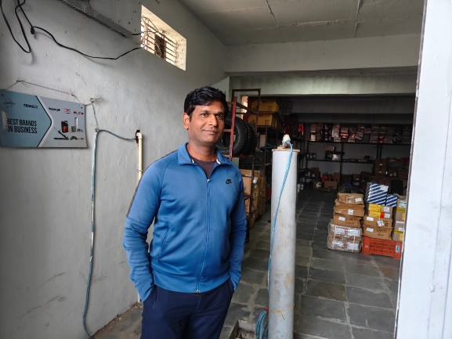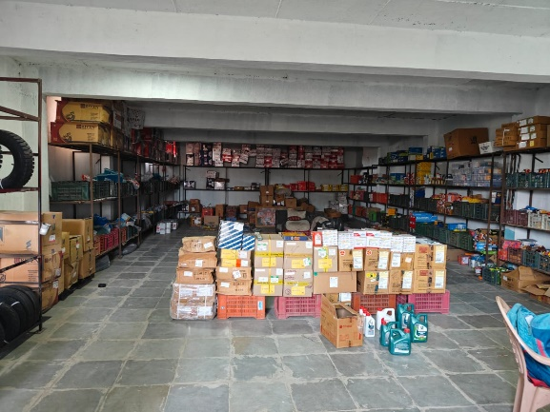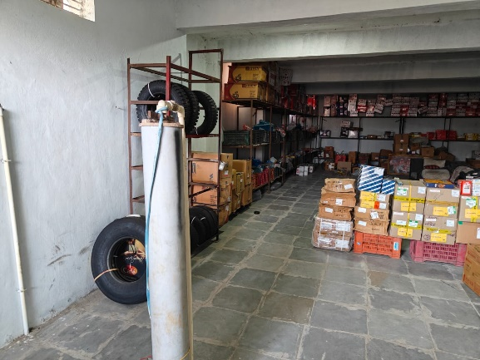

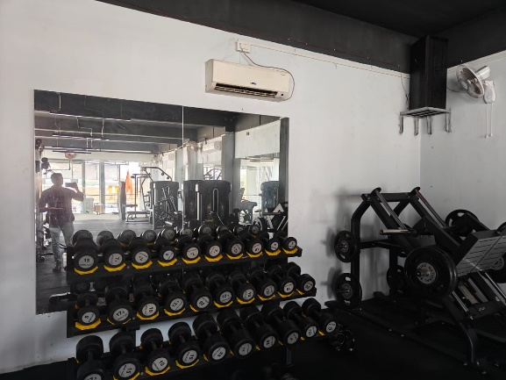

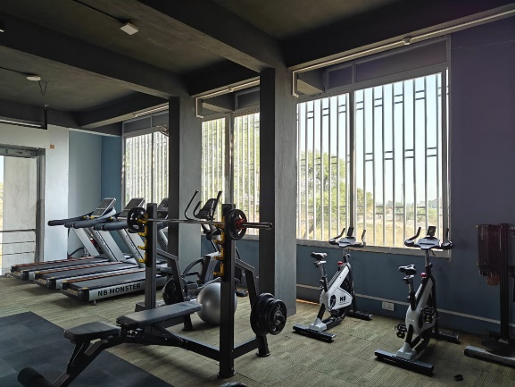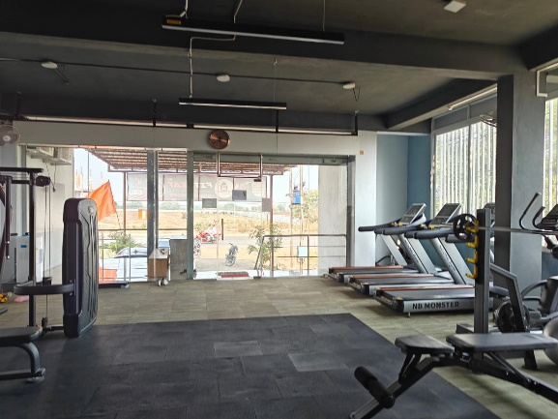

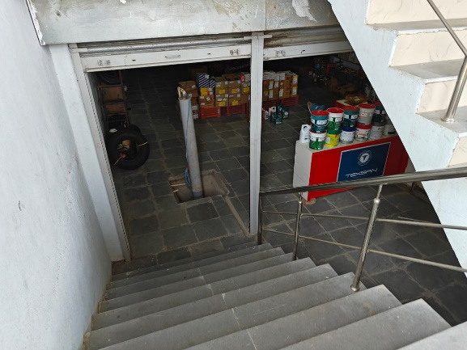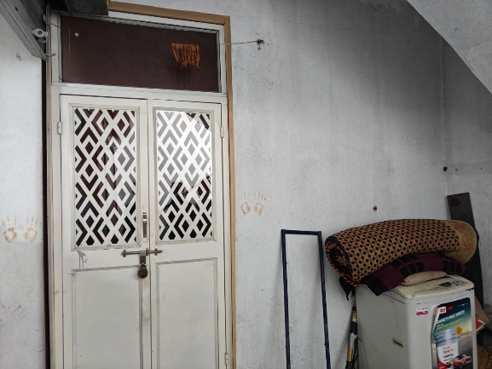

**Actual Site Photographs**

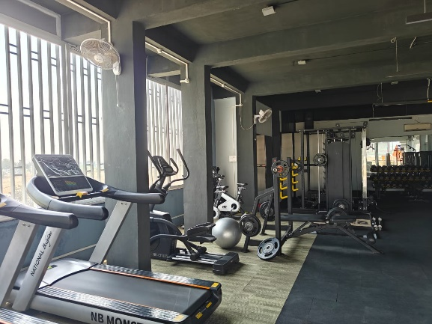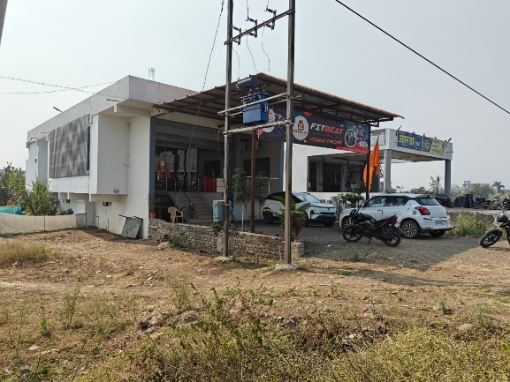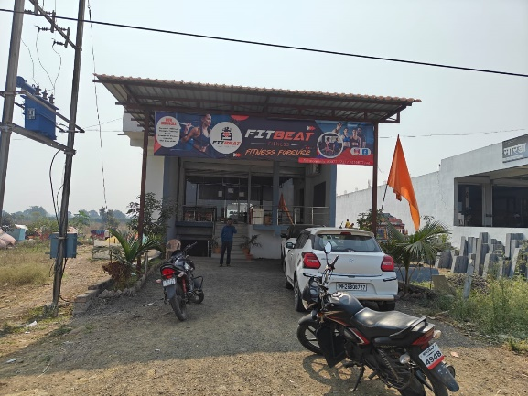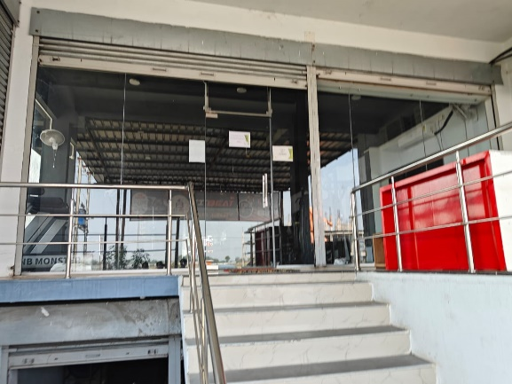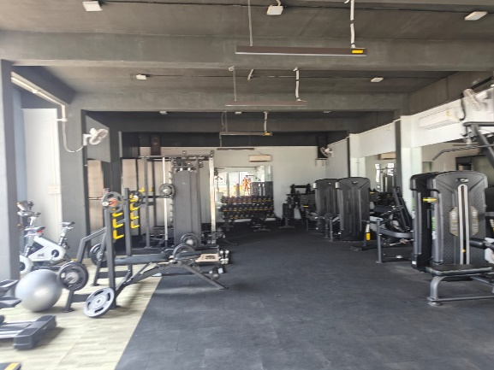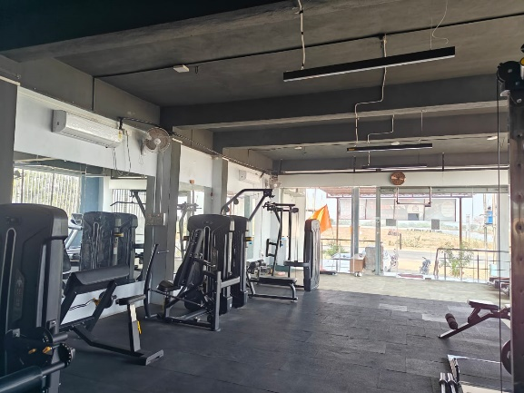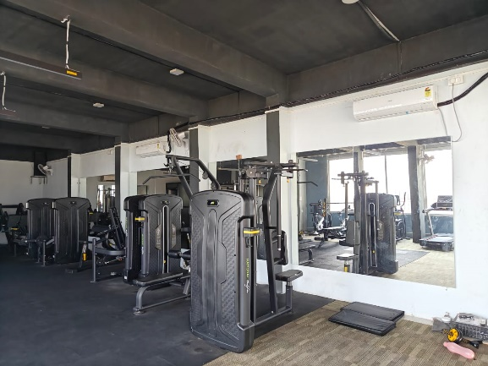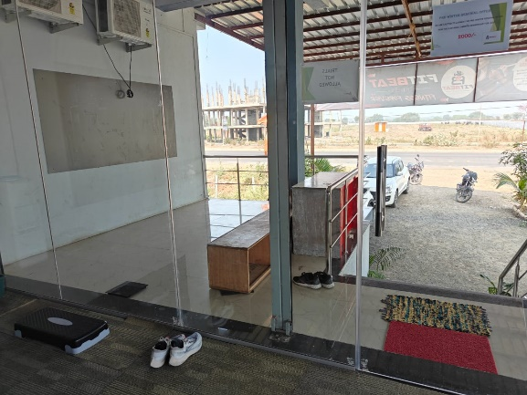 **Construction Plan issued by Group Gram Panchayat**

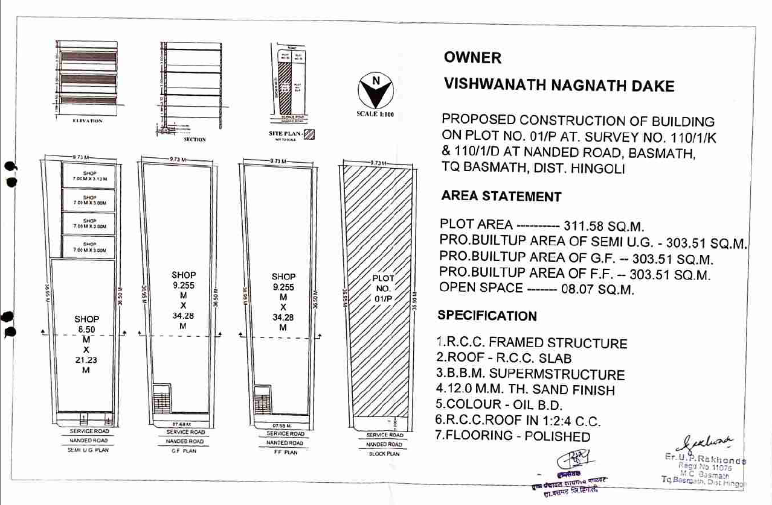

**Construction as per site**

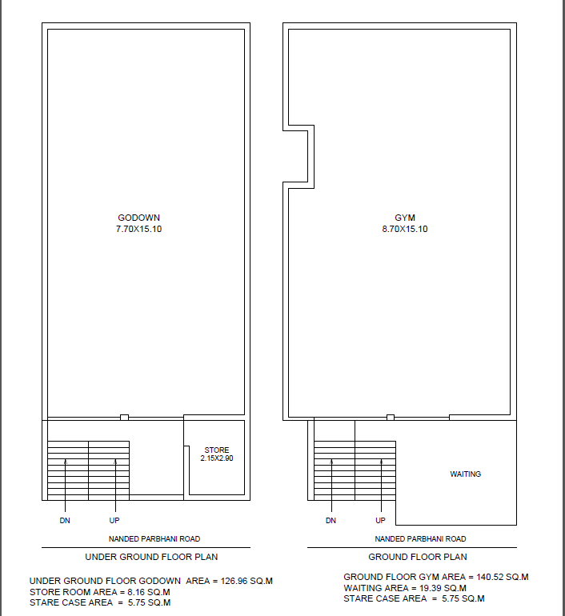

**Route Map of the property**

**Site u/r**

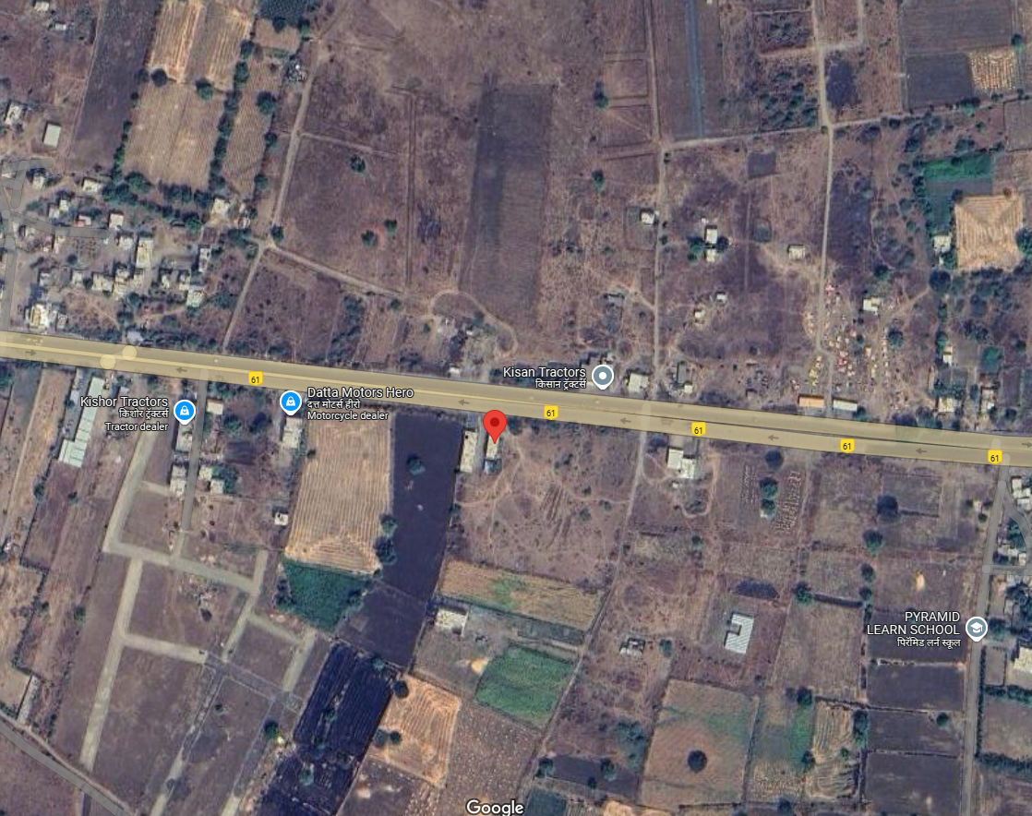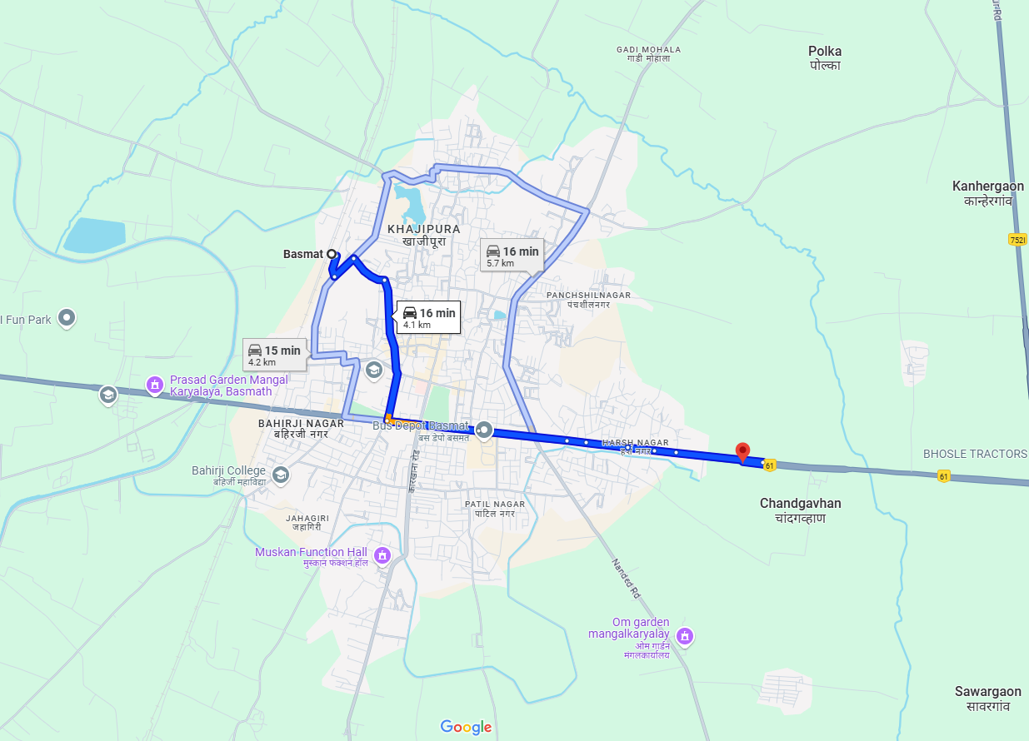

**Latitude Longitude: 19°19’14.1”N 77°10’35.8”E**

Note: The Blue line shows the route to site from nearest railway station (Basmat – 4.1 KM.)

**Ready Reckoner Rate**

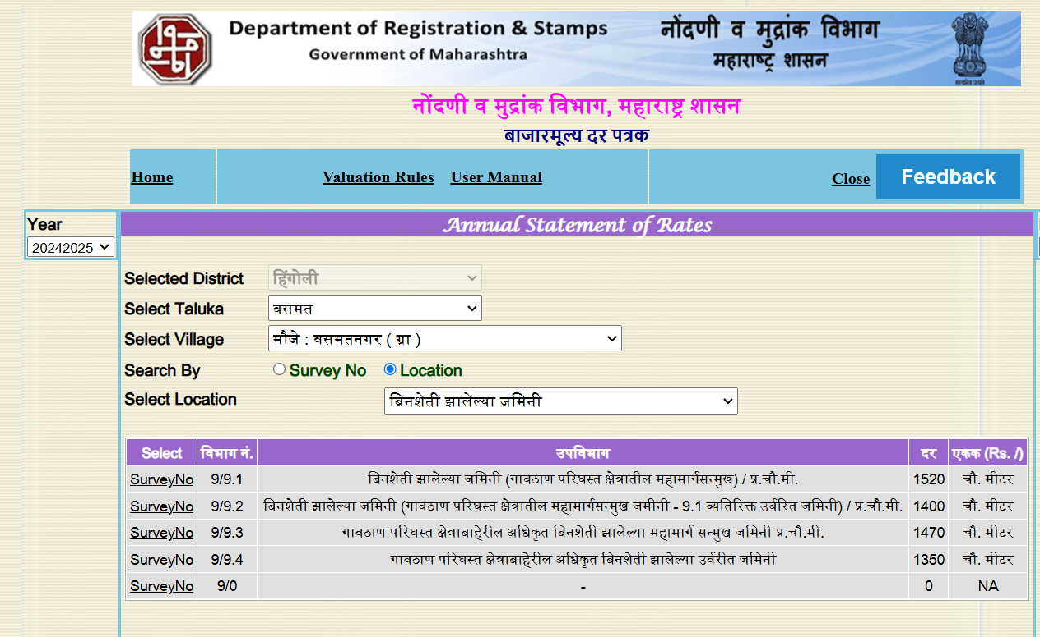

**ASSUMPTIONS, CAVEATS, LIMITATION AND DISCLAIMERS**

1. We assume no responsibility for matters of legal nature affecting the property appraised or the title thereto, nor do we render our opinion as to the title, which is assumed to be good and marketable.
2. The property is valued as though under responsible ownership.
3. It is assumed that the property is free of liens and encumbrances.
4. It is assumed that there are no hidden or unapparent conditions of the subsoil or structure that would render it more or less valuable. No responsibility is assumed for such conditions or for engineering that might be required to discover such factors.
5. The rates for valuation of the property are in accordance with the Govt. approved rates and prevailing market rates

For, **Vastukala Consultants (I) Pvt. Ltd.**

**Sharadkumar B. Chalikwar**

B.E. (Civil), M.E. (Civil), M.Sc. (Real Estate Valuation), M.Sc. (P&M Valuation), FIE (I), FIV, FIWRS

Chairman & Managing Director

Govt. Reg. Valuer

Chartered Engineer (India)

Reg. No. (N) CCIT/1-14/52/2008-09

IBBI Reg.No. IBBI/RV/07/2019/11744

Date: 10.01.2025

Place: Nanded.