Valuation Report of the Immovable Property
(For Capital Gain Purpose)
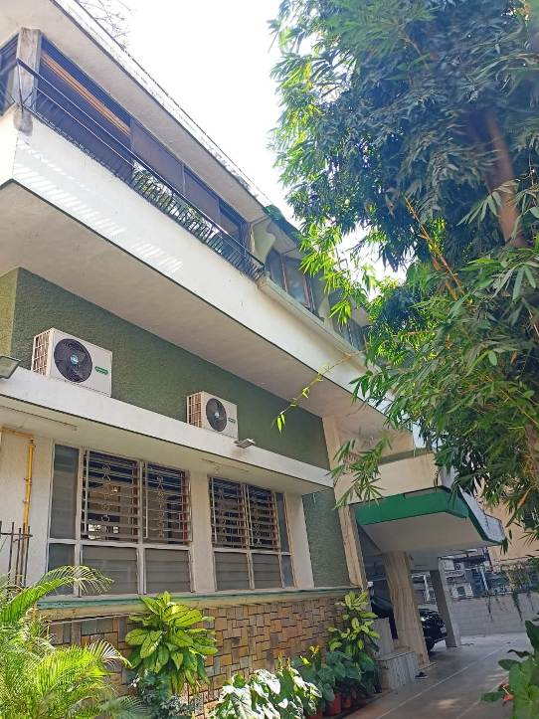

Details of the property under consideration:

Name of Client: Mr. Mayoor Natubhai Amin & Roopal Mayoor Amin

Residential Plot & Bungalow known as “Khooshboo”, Hatkesh Co-Op. Hsg. Soc. Ltd.”, Plot No. 15A, JVPD Scheme, N.S. Road No. 6, Vile Parle (West), Mumbai – 400 056, Maharashtra, India

Latitude Longitude: 19°06'19.1"N 72°49'59.9"E

Table of Contents
1. VALUATION OPINION REPORT 3
2. Part-1 Form 0-1 5
2.1. GENERAL: 5
2.2. LAND 6
2.3. IMPROVEMENTS 6
2.4. RENTS 7
2.5. SALES 8
2.6. COST OF CONSTRUCTION 8
3. PART II- VALUATION 8
3.1. General: 8
3.2. Location: 9
3.3. Building / Property: 9
3.4. History 9
3.5. Valuation as on 01st April 2001 of the Residential Flat: 10
3.6. NOTES 11
4. ANNEXURE TO FORM 0-1 11
5. PART III- DECLARATION 12
5.1. DECLARATION OF PROFESSIONAL FEES CHARGED 12
5.2. DEFINITION OF VALUE FOR THIS SPECIFIC PURPOSE 13
5.3. UNDER LYING ASSUMPTIONS 13
6. Actual site photographs 14
7. Actual site photographs 15
8. Actual site photographs 16
9. Route Map of the property 17
10. Ready Reckoner Rate for Year 2001 18
10.1. Rate for Property 18
10.1. Construction Rate 18
11. VALUATION OF THE PROPERTY PREMISES 19

Vastu/Mumbai/03/2025/13474/ 2310931
08/01-128-VSMU
Date: 08.03.2025

VALUATION OPINION REPORT

This is to certify that the property bearing Residential Plot & Bungalow known as “Khooshboo”, Hatkesh Co-Op. Hsg. Soc. Ltd.”, Plot No. 15A, JVPD Scheme, N.S. Road No. 6, Vile Parle (West), Mumbai – 400 056, Maharashtra, India was belonging to Mr. Mayoor Natubhai Amin & Roopal Mayoor Amin till they sold the property to Mr. Baneesh Dhar & Mrs. Nalini Dhar as per Agreement For Assignment dated 17.02.2025

Boundaries of the property.

North | : | Manju Villa
South | : | Mangalyam Building
East | : | Lahar Apartment
West | : | N.S. Road No. 6

- The purpose of this report is to ascertain the Indexed Cost of Acquisition ( F. Y. 2024 - 25) of the property as detailed above.
- The property premises can be assessed and valued for calculation of Capital Gain Tax purpose as on 01.04.2001 at ` 2,22,52,106.00 (Rupees Two Crore Twenty Two Lakh Fifty Two Thousand One Hundred Six Only).
- The following documents were perused :

- Copy of Agreement For Assignment dated 17.02.2025 between Mr. Mayoor Natubhai Amin & Roopal Mayoor Amin (Vendors) & Mr. Baneesh Dhar & Mrs. Nalini Dhar (Purchasers).
- Copy of Agreement to Sale dated 26.03.1973 between Smt. Indiraben Natubhai Amin & Mr. Mayoor Natubhai Amin (Purchasers) & Shri. Ramanbhai Premabhia Patel (Vendors).
- Copy of Indenture dated 02.02.1976 between Hatkesh Co-Op. Hsg. Soc. Ltd. (Lessor) and Smt. Indiraben Natubhai Amin & Mr. Mayoor Natubhai Amin (Lessee).
- Copy of Approved Plan vide No. CE / 840 / BPII / Misc dated 06.02.1978 issued by Municipal Corporation of Greater Mumbai.
- Copy of Occupancy Certificate vide No. CE / 5884 / BSII / A / K dated 26.04.1978 issued by Municipal Corporation of Greater Mumbai.
- Copy of Electricity Bill dated 08.02.2025 in the name of Smt. Indiraben Natubhai Amin.
- Copy of Property Tax Bill for the year 2024 – 2025 in the name of Smt. Indiraben Natubhai Amin.
- Copy of Water Bill dated 18.11.2024 in the name of Smt. Indiraben Natubhai Amin.
- Copy of Property Card.

This assignment is undertaken based on the request from our client Mr. Mayoor Natubhai Amin & Roopal Mayoor Amin

The valuation of the property is based on the documents produced by the concern. Legal aspects have not been taken into considerations while preparing this valuation report.

Hence certified.

For Vastukala Architects & Engineers

Sharadkumar B. Chalikwar
Govt. Reg. Valuer
Chartered Engineer (India)
Reg. No. (N) CCIT/1-14/52/2008-09
Encl: Valuation report in Form – 01
Valuation Report of Residential Plot & Bungalow known as “Khooshboo”, Hatkesh Co-Op. Hsg. Soc. Ltd.”, Plot No. 15A, JVPD Scheme, N.S. Road No. 6, Vile Parle (West), Mumbai – 400 056, Maharashtra, India

Part-1 Form 0-1

(See Rule 8 D)
REPORT OF VALUATION OF IMMOVABLE PROPERTY (OTHER THAN AGRICULTURAL LANDS, PLANTATIONS, FORESTS, MINES AND QUARRIES)

GENERAL:

1 | Purpose for which the valuation is made | To assess the Fair Market Value as on 01.04.2001 for computation of Capital Gains Tax.
2 | Date of Report | 08.03.2025
3 | Name of the Owner | Mr. Mayoor Natubhai Amin & Roopal Mayoor Amin as per Agreement to Sale dated 26.03.1973
4 | If the property is under joint ownership, Ownership / co-ownership, share of each such owner. Are the shares undivided? | Joint Ownership  Mr. Mayoor Natubhai Amin – 50%  Roopal Mayoor Amin – 50%  (As per Agreement to Assignment dated 17.02.2025)
5 | Brief description of the property | Residential Plot & Bungalow known as “Khooshboo”, Hatkesh Co-Op. Hsg. Soc. Ltd.”, Plot No. 15A, JVPD Scheme, N.S. Road No. 6, Vile Parle (West), Mumbai – 400 056, Maharashtra, India
6 | Location, street, ward no | Hatkesh Co-Op. Hsg. Soc. Ltd.”, Plot No. 15A, JVPD Scheme, N.S. Road No. 6
7 | Survey/ Plot no. of land | Plot No. 15A , CTS No. 123B, Village Vile Parle (West), Taluka Andheri, District Mumbai Suburban
8 | Is the property situated in Residential / commercial/ mixed area/ industrial area? | Residential
9 | Classification of locality-high class/ middle class/poor class | High Class
10 | Proximity to civic amenities like schools, Hospitals, Offices, market, cinemas etc. | All the amenities are available in the vicinity.
11 | Means and proximity to surface communication by which the locality is served | Served by Railway, BEST Buses, Auto, Taxies, Private Vehicles

LAND

12 | Area of land supported by documentary proof. Shape, dimension and physical features | Plot Area = 475.30 Sq. M.  (Area as per Agreement)  Ground Floor Area (Parking) = 13.50 Sq. M.  Ground Floor Area = 45.20 Sq. M.  First Floor Area = 78.00 Sq. M.  Second Floor Area = 132.80 Sq. M.  (Carpet Area as per Property Tax Annexure)  Built up area:  Ground Floor Area = 54.24 Sq. M.  First Floor Area = 93.6 Sq. M.  Second Floor Area = 159.36 Sq. M.  (Carpet Area as per Property Tax Annexure + 20%)
13 | Roads, Streets or lanes on which the land is abutting | N.S. Road No. 6
14 | If freehold or leasehold land | Leasehold
15 | If leasehold, the name of Lessor/lessee, nature of lease, date of commencement and termination of lease and terms of renewal of lease.  (i) Initial premium  (ii) Ground rent payable per annum  (iii) Unearned increase payable to the Lessor in the event of sale or transfer | Leasehold period - 999 years  Lessor - Hatkesh Co-Op. Hsg. Soc. Ltd.
16 | Is there any restriction covenant in regard to use of land? If so attach a copy of the covenant. | As per documents
17 | Are there any agreements of easements? If so attach a copy of the covenant | Not applicable
18 | Does the land fall in an area included in any Town Planning Scheme or any Development Plan of Government or any statutory body? If so give Particulars. | Municipal Corporation of Greater Mumbai
19 | Has any contribution been made towards development or is any demand for such contribution still outstanding. | No
20 | Has the whole or part of the land been notified for acquisition by government or any statutory body? Give date of the notification. | No
21 | Attach a dimensioned site plan | Attached

IMPROVEMENTS

22 | Attach plans and elevations of all structures standing on the land and a lay-out plan. | Attached
23 | Furnish technical details of the building on a separate sheet (The Annexure to this form may be used) | Attached
24 | Is the building owner occupied/ tenanted/ both? | Owner occupied
 | If the property owner occupied, specify portion and extent of area under owner-occupation | Fully occupied by owner
25 | What is the Floor Space Index permissible and Percentage actually utilized? | - Floor Space Index Permissible – 1 +TDR  - FSI percentage actually utilized – 0.67

RENTS

26 | (i) | Names of tenants/ lessees/ licensees, etc | N.A.
 | (ii) | Portions in their occupation | N.A.
 | (iii) | Monthly or annual rent /compensation/license fee, etc. paid by each | N.A.
 | (iv) | Gross amount received for the whole property | N.A.
27 | Are any of the occupants related to, or close to business associates of the owner? |  | N.A.
28 | Is separate amount being recovered for the use of fixtures, like fans, geysers, refrigerators, cooking ranges, built-in wardrobes, etc. or for services charges? If so, give details |  | N.A.
29 | Give details of the water and electricity charges, If any, to be borne by the owner |  | Electricity Charges of Rs. 6,600.00 as per Electricity Bill dated 08.02.2025  Water Charges of Rs. 2,858.00 as per Copy of Water Bill dated 18.11.2024
30 | Has the tenant to bear the whole or part of the cost repairs and maintenance? Give particulars |  | N.A.
31 | If a lift is installed, who is to bear the cost of maintenance and operation- owner or tenant? |  | N.A.
32 | If a pump is installed, who is to bear the cost of maintenance and operation- owner or tenant? |  | N.A.
33 | Who has to bear the cost of electricity charges for lighting of common space like entrance hall, stairs, passage, compound, etc. owner or tenant? |  | N.A.
34 | What is the amount of property tax? Who is to bear it? Give details with documentary proof |  | Property Tax of Rs. 10,368.00 as per Copy of Property Tax Bill for the year 2024 – 2025
35 | Is the building insured? If so, give the policy no., amount for which it is insured and the annual premium |  | Information not available
36 | Is any dispute between landlord and tenant regarding rent pending in a court of rent? |  | N. A.
37 | Has any standard rent been fixed for the premises under any law relating to the control of rent? |  | N. A.

SALES

38 | Give instances of sales of immovable property in the locality on a separate sheet, indicating the Name and address of the property, registration No., sale price and area of land sold. | As per sub registrar assurance records
39 | Land rate adopted in this valuation | N. A. as the property is valued by composite rate method
40 | If sale instances are not available or not relied up on, the basis of arriving at the land rate | Copy of Stamp Duty Ready Reckoner for the year 2001 attached

COST OF CONSTRUCTION

41 | Year of commencement of construction and year of completion | Year of Completion – 1978 (As per Occupancy Certificate)
42 | What was the method of construction, by contract/By employing Labour directly/ both? | Information not available
43 | For items of work done on contract, produce copies of agreements | N. A.
44 | For items of work done by engaging Labour directly, give basic rates of materials and Labour supported by documentary proof. | N. A.

PART II- VALUATION

General:

Under the instructions of Mr. Mayoor Natubhai Amin & Roopal Mayoor Amin, we have valued the Residential Plot & Bungalow known as “Khooshboo”, Hatkesh Co-Op. Hsg. Soc. Ltd.”, Plot No. 15A, JVPD Scheme, N.S. Road No. 6, Vile Parle (West), Mumbai – 400 056, Maharashtra, India to ascertain the market value of said property, as on 01.04.2001 for computation of Capital Gains Tax.

We are in receipt of the following documents:

- Copy of Agreement For Assignment dated 17.02.2025 between Mr. Mayoor Natubhai Amin & Roopal Mayoor Amin (Vendors) & Mr. Baneesh Dhar & Mrs. Nalini Dhar (Purchasers).
- Copy of Agreement to Sale dated 26.03.1973 between Smt. Indiraben Natubhai Amin & Mr. Mayoor Natubhai Amin (Purchasers) & Shri. Ramanbhai Premabhia Patel (Vendors) .
- Copy of Indenture dated 02.02.1976 between Hatkesh Co-Op. Hsg. Soc. Ltd. (Lessor) and Smt. Indiraben Natubhai Amin & Mr. Mayoor Natubhai Amin (Lessee).
- Copy of Approved Plan vide No. CE / 840 / BPII / Misc dated 06.02.1978 issued by Municipal Corporation of Greater Mumbai.
- Copy of Occupancy Certificate vide No. CE / 5884 / BSII / A / K dated 26.04.1978 issued by Municipal Corporation of Greater Mumbai.
- Copy of Electricity Bill dated 08.02.2025
- Copy of Property Tax Bill for the year 2024 – 2025
- Copy of Water Bill dated 18.11.2024
- Copy of Property Card.

Location:
The said building is located at Plot No. 15A, Hatkesh Co-Op. Hsg. Soc. Ltd., Village Vile Parle, Taluka Andheri, in Municipal Corporation of Greater Mumbai. The property falls in Residential Zone. It is at 1.7 Km travel distance from Vile Parle (West) railway station.

Building / Property:
The structure is a Stilt (Part) + Ground (Part) + 2 upper floors RCC framed structure. The bungalow is known as Khooshboo at “Hatkesh Co-Op. Hsg. Soc. Ltd.”. The bungalow is used for Residential purpose. It is without lift.

The composition of bungalow is :
Ground Floor : Part Ground / Stilt used for Parking. Part consists of a store room and one toilet. It also having 1 garage.
Split level & First floor : 1 Drawing Room + 1 Family Room + 1 Bedroom + Kitchen +1 Kitchen Store + 1 Toilet + Washing area + Pooja Area
Second Floor : 4 Bedrooms + Wardrobes + 3 Toilets + Lounge Area + Balcony.

It is finished with Marble flooring, M.S. Gate, Teak wood door frames with solid teakwood flush doors with Aluminum louver and Sliding windows, Concealed plumbing & Concealed electrification is provided. Open space is well developed.

History

The original owner of the property was Smt. Indiraben Natubhai Amin & Mr. Mayoor Natubhai Amin as per Agreement date 26.03.1973. Smt. Indiraben Natubhai Amin died on 01.08.2002 leaving behind her Last Will and Testament dated 15.04.2002 and husband Mr. Natubhai and her son Mr. Mayoor Natubhai Amin. As per Will she bequeathed her 50% undivided share, right, title and interest in the said property to her daughter-in-law Roopal Mayoor Amin. On 22.02.2007 her husband Mr. Natubhai Amin died leaving behind his Last Will and Testament dated 14.02.2007. After completion of all the formalities Mr. Mayoor Natubhai Amin & Roopal Mayoor Amin becomes the only owners having legal and beneficial right, title and interest in the said property.

Further Mr. Mayoor Natubhai Amin & Roopal Mayoor Amin Agreed to assign the lease of the said property to Mr. Baneesh Dhar & Mrs. Nalini Dhar as per Agreement For Assignment dated 17.02.2025.

Valuation as on 01st April 2001 of the Residential Plot & Bungalow:

Value of Plot:

Basic Land area | 475.30 Sq. M
Rae adopted for valuation | ` 29,000.00 pe Sq. M.
Value (A) | ` 1,37,83,700.00
Land with TDR Potential
Basic Land area | 475.30 Sq. M
Rae adopted for valuation | ` 11,600.00 pe Sq. M.
Value (B) | ` 55,13,480.00
Total value of plot (A + B ) | ` 1,92,97,180.00

Cost of Construction of Bungalow:

Floor | Carpet Area In Sq. M. | Built Up Area In Sq. M. | Year Of Const. | Valuation Year | Total Life of Structure | Full Rate | Age Of Build. | % of the depreciation rate to be deducted | % Value | Final Depreciated Rate to be considered | Final Depreciated Value to be considered
Parking | 13.5 | 13.5 | 1978 | 2001 | 60 | 2,200.00 | 23 | 34.5 | 759.00 | 1,441.00 | 19,454.00
Ground | 45.2 | 54.24 | 1978 | 2001 | 60 | 5,500.00 | 23 | 34.5 | 1,897.50 | 3,603.00 | 1,95,427.00
First | 78 | 93.6 | 1978 | 2001 | 60 | 5,500.00 | 23 | 34.5 | 1,897.50 | 3,603.00 | 3,37,241.00
Second | 132.8 | 159.36 | 1978 | 2001 | 60 | 5,500.00 | 23 | 34.5 | 1,897.50 | 3,603.00 | 5,74,174.00
TOTAL | 269.5 | 320.7 |  |  |  |  |  |  |  |  | 11,26,296.00

Value of Land and Bungalow as on 01.04.2001

Value of Land | : | ` 1,92,97,180.00
Depreciated cost of construction | : | ` 11,26,296.00
Land Development | : | ` 2,00,000.00
Total Value of the property | : | ` 2,06,23,476.00
Stamp Duty charges | : | ` 16,08,630.00
Registration charges | : | ` 20,000.00
Total Cost of Acquisition | : | ` 2,22,52,106.00

Taking into consideration above said facts, we can evaluate the value of Residential Plot & Bungalow known as “Khooshboo”, Hatkesh Co-Op. Hsg. Soc. Ltd.”, Plot No. 15A, JVPD Scheme, N.S. Road No. 6, Vile Parle (West), Mumbai – 400 056, Maharashtra, India for this particular purpose at ` 2,22,52,106.00 (Rupees Two Crore Twenty Two Lakh Fifty Two Thousand One Hundred Six Only) as on 01.04.2001.

NOTES
- I, Sharadkumar B. Chalikwar with my experience and ability to judgment I am of the considered opinion that the fair market value of the property as on 01.04.2001 is ` 2,22,52,106.00 (Rupees Two Crore Twenty Two Lakh Fifty Two Thousand One Hundred Six Only) Value varies with time and purpose and hence this value should not be referred for any purpose other than mentioned in this report.

- This valuation is done on the basis of information, which the valuer has obtained by information provided by the client about the premises and location of the surrounding area and also prevailing rates in the surrounding area, and further subject to document as mentioned in valuation report.

- This valuer should not be held responsible for authentication of documents, clear title and other such related matters. For that purpose Latest Legal Opinion should be sought.

ANNEXURE TO FORM 0-1

1. | No. of floors and height of each floor | Stilt (Part) + Part (Ground) + 2 upper floors
2. | Plinth area floor wise as per IS 3361-1966 | Information not available
3 | Year of construction | Year of Completion – 1978 (As per Occupancy Certificate)
4 | Estimated future life as on year 2001 | 37 years
5 | Type of construction- load bearing walls/RCC frame/ steel frame | R.C.C. Framed structure
6 | Type of foundations | R.C.C
7 | Walls | All external walls are 9” thick and partition walls are 6” thick.
8 | Partitions | 6” thick brick wall
9 | Doors and Windows | Teak wood door frames with solid teakwood flush doors with Aluminium Sliding and louvered windows, M.S, gate
10 | Flooring | Marble flooring
11 | Finishing | Internal walls are finished Cement Plaster. External walls are finished with sand faced plaster
12 | Roofing and terracing | RCC slab
13 | Special architectural or decorative features, if any | POP false ceiling
14 |  | Concealed  Superior
  (i) | Internal wiring – surface or conduit
  (ii) | Class of fittings: Superior / Ordinary / Poor.
15 | Sanitary installations  Class of fittings: Superior colored / superior white/ordinary. | As per requirement  Superior
  (i) | No. of water closets
  (ii) | No. of lavatory basins
  (iii) | No. of urinals
  (iv) | No. of sinks
16 | Compound wall  Height and length  Type of construction | 4’ to 5’ brick masonry compound wall
17 | No. of lifts and capacity | No lift
18 | Underground sump – capacity and type of construction | R.C.C. Tank
19 | Over-head tank  Location, capacity  Type of construction | Overhead Water Tank
20 | Pumps- no. and their horse power | Available as per requirement
21 | Roads and paving within the compound approximate area and type of paving | Cemented road in open spaces, Open parking Space etc.
22 | Sewage disposal – whereas connected to public sewers, if septic tanks provided, no. and capacity | Connected to Municipal Sewers

PART III- DECLARATION
I hereby declare that
    - The information furnished in part I is true and correct to the best of my knowledge and belief;
    - I have no direct or indirect interest in the property valued:

DECLARATION OF PROFESSIONAL FEES CHARGED

We hereby declare that, our professional fees are not contingent upon the valuation findings. However, if the statute AND/OR clients demands that, the fees should be charged on the percentage of assessed value then, with the full knowledge of the AND/OR end user, it is being charged accordingly.

DEFINITION OF VALUE FOR THIS SPECIFIC PURPOSE

This exercise is to assess Fair Market Value of the property under reference as on 01.04.2001 for calculation of Capital Gains Tax.

The term Fair Market Value is defined as

“The most probable price, as of a specified date, in cash, terms equivalent to cash, or in other precisely revealed terms for which the specified property rights would sell after reasonable exposure in a competitive market under all conditions requisite to a fair sale, with the buyer and seller each acting prudently knowledgeably and for self-interest assuming that neither is under undue duress”.
Fundamental assumptions and conditions presumed in this definition are:

1. Buyer and seller are motivated by self-interest.

2. Buyer and seller are well informed and are acting prudently.

3. The property is exposed for a reasonable time on the open market.

- Payment is made in cash or equivalent or in specified financing terms.

UNDER LYING ASSUMPTIONS
1. We assume no responsibility for matters of legal nature affecting the property appraised or the title thereto, nor do we render our opinion as to the title, which is assumed to be good and marketable.
2. The property is valued as though under responsible ownership.
3. It is assumed that the property is free of liens and encumbrances.
4. It is assumed that there are no hidden or unapparent conditions of the subsoil or structure that would render it more or less valuable. No responsibility is assumed for such conditions or for engineering that might be required to discover such factors.

Actual site photographs
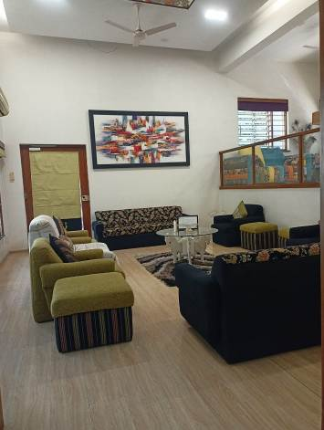
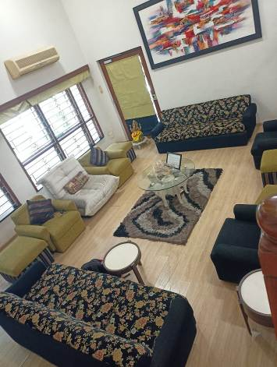
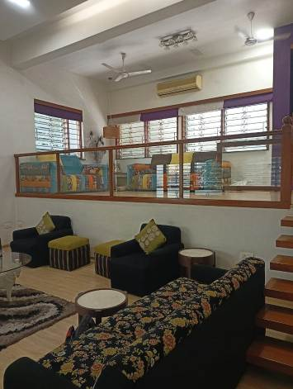

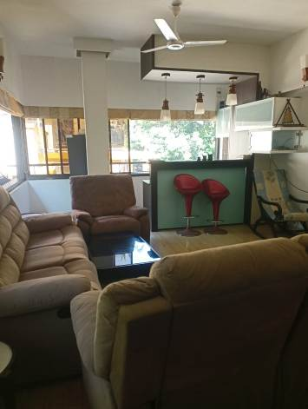
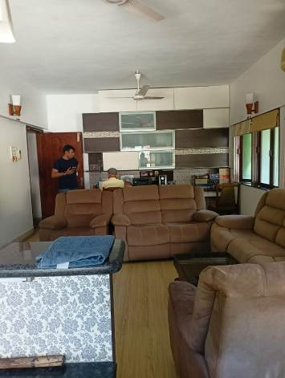
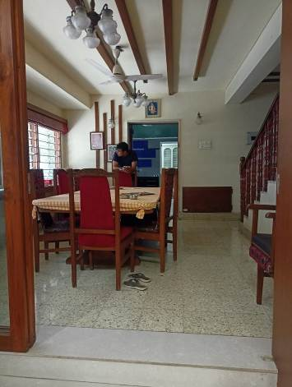

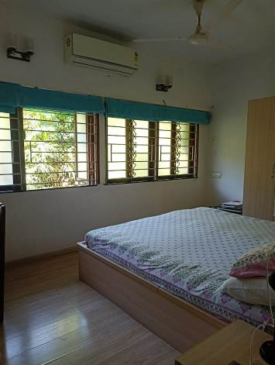
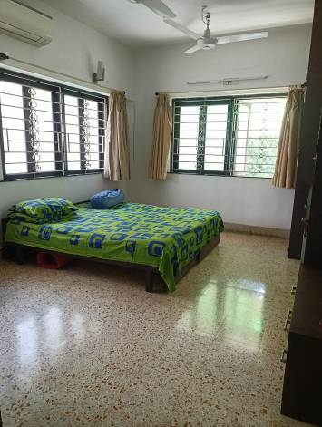
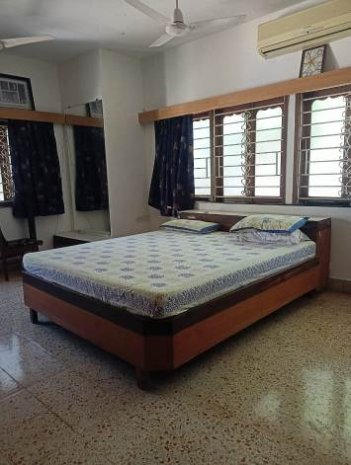

Actual site photographs
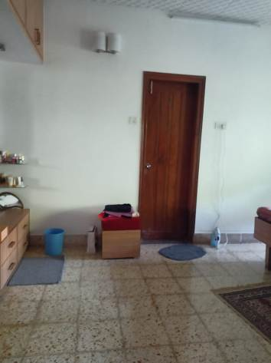
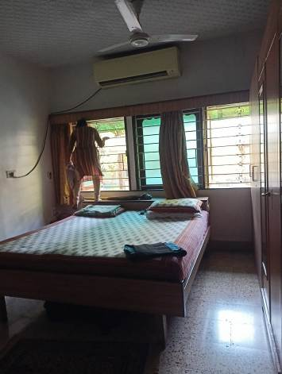
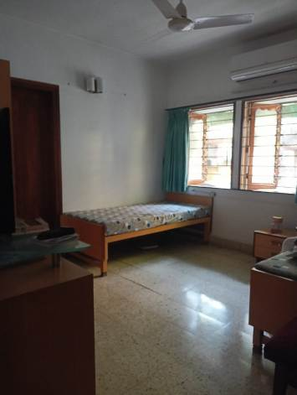
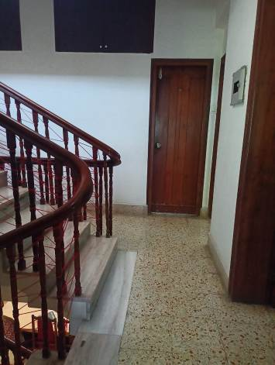
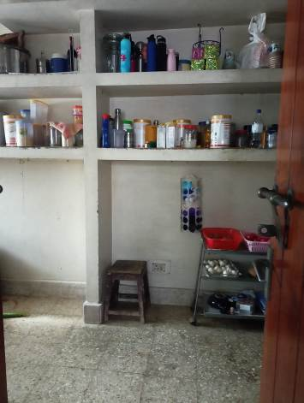
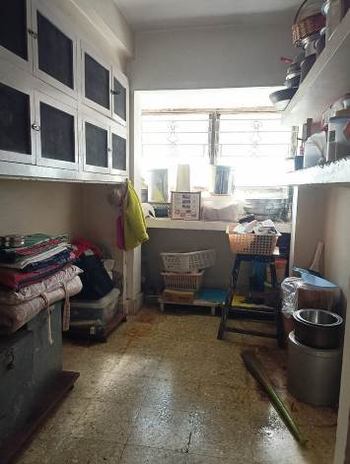
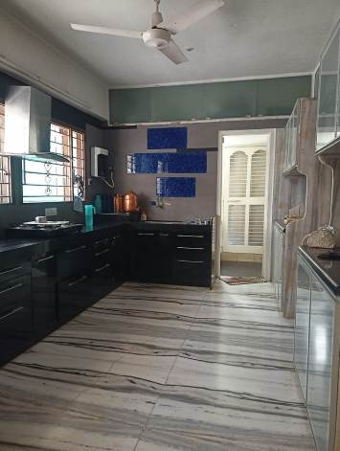
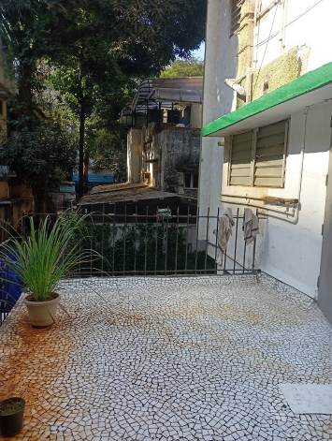
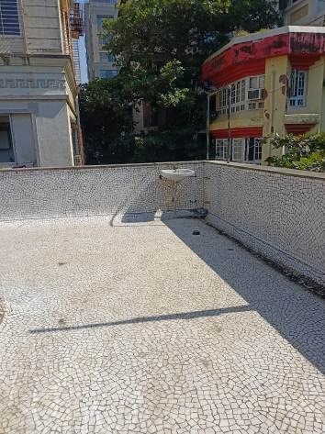

Actual site photographs
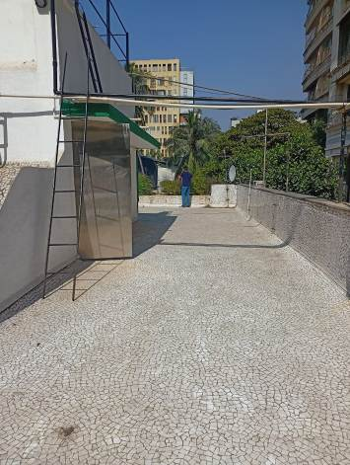
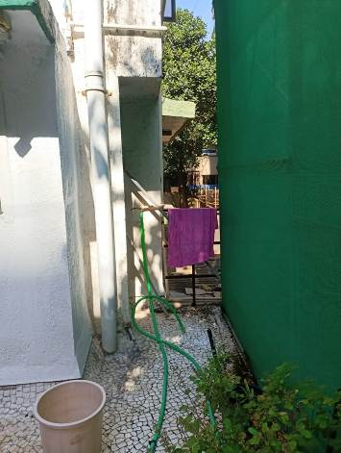
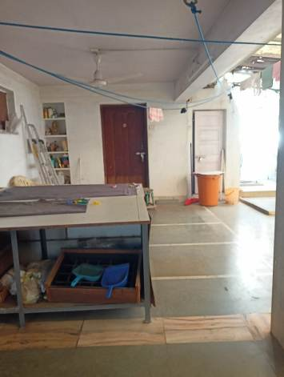

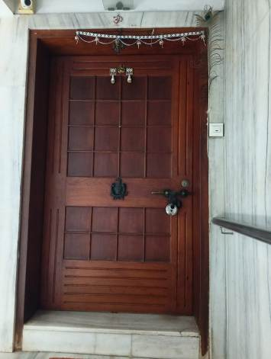
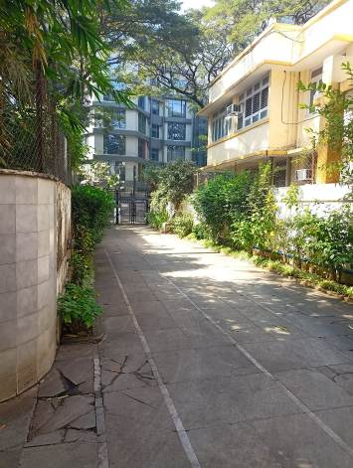
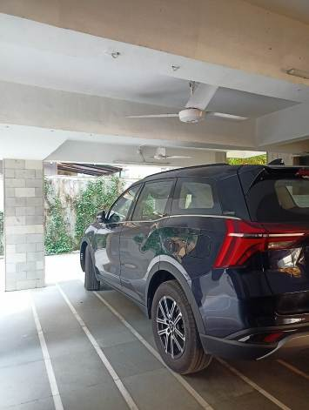
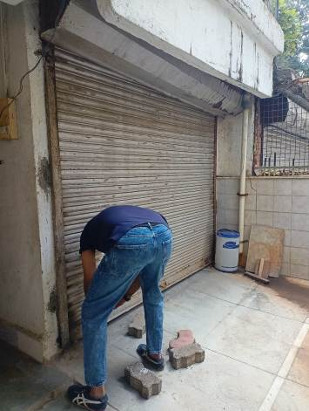
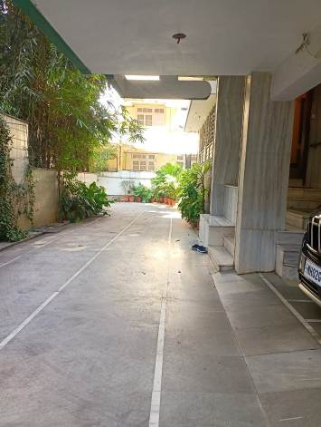
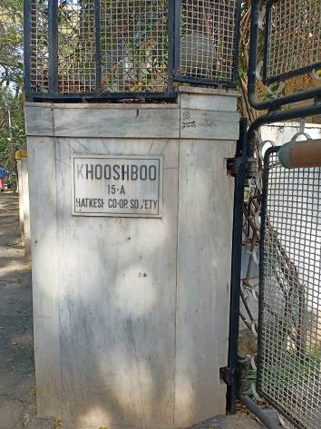

Route Map of the property
Site U/R
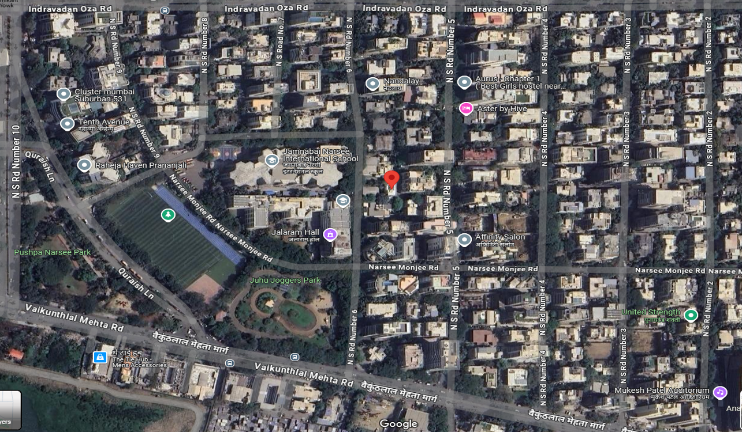

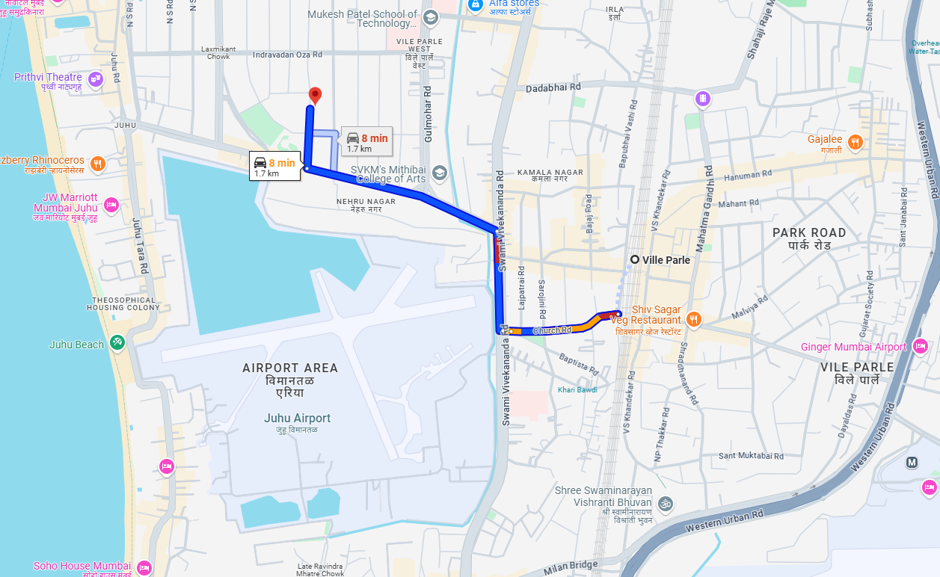

Latitude Longitude: 19°06'19.1"N 72°49'59.9"E

Note: The Blue line shows the route to site from nearest Railway station (Vile Parle – 1.7 Km.)

Ready Reckoner Rate for Year 2001

Rate for Property
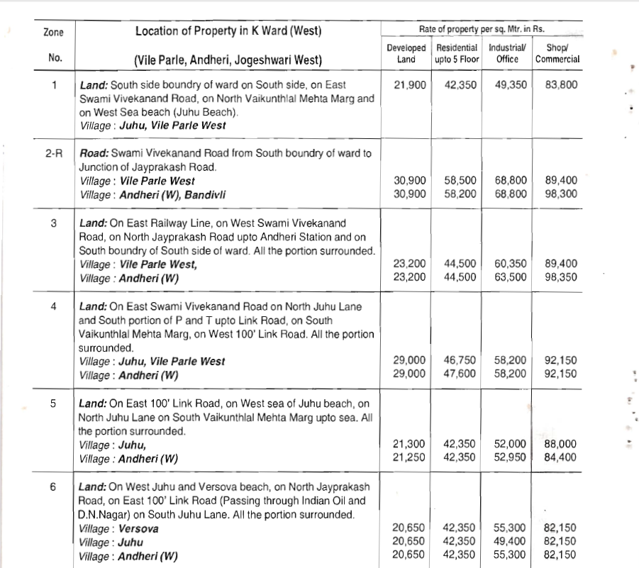

Construction Rate
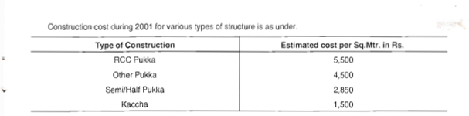

VALUATION OF THE PROPERTY PREMISES

Considering various parameters recorded herein above, existing economic scenario, and the information that is available with reference to the development of neighbourhood and method selected for valuation, we are of the opinion that, the property premises can be assessed and valued for calculation of Capital Gain Tax for ` 2,22,52,106.00 (Rupees Two Crore Twenty Two Lakh Fifty Two Thousand One Hundred Six Only)

For Vastukala Architects & Engineers

Sharadkumar B. Chalikwar
Govt. Reg. Valuer
Chartered Engineer (India)
Reg. No. (N) CCIT/1-14/52/2008-09

