COST VETTING REPORT

Details of the property under consideration:

Name of Project: "The Pallazo"

"The Pallazo", Proposed Residential Building on plot bearing C.T.S. No. 164, Hissa No 11, Near Shree Shetrunjay Dhaam, Opposite Oswal Wadi, Anjur Phata Village – Katamtghar Dapode, Taluka – Bhiwandi, District – Thane, Pin Code – 421 302, Maharashtra, India.

Latitude Longitude: 19°16'39.3"N 73°02'41.3"E

Intended User:
State Bank of India
Wagle Ind. Est. Branch
Regional Business Office, Region-II, Wagle Ind. Area, Plot No. B-35, 2nd Floor,
Wagle Circle, Thane (West) - 400 604, Maharashtra, India.

Vastu/SBI/Mumbai/01/2025/11512/2310028
13/08-147-PY
Date: 13.01.2025

To,
The Branch Manager,
State Bank of India
Wagle Ind. Est. Branch
Regional Business Office, Region-II,
Wagle Ind. Area, Plot No. B-35,
2nd Floor, Wagle Circle,
Thane (West) - 400 604, Maharashtra, India.

Sub: Project Valuation for "The Pallazo " at Bhiwandi, Pin Code – 421 302.

Dear Sir,
In accordance with your letter of engagement as stated above, we enclose our Report on Project Valuation for "The Pallazo", Proposed Residential Building on plot bearing C.T.S. No. 164, Hissa No 11, Near Shree Shetrunjay Dhaam, Opposite Oswal Wadi, Anjur Phata Village – Katamtghar Dapode, Taluka – Bhiwandi, District – Thane, Pin Code – 421 302, Maharashtra, India.
M/s. Shetrunjay Realty LLP is Proposed Residential Building on plot bearing C.T.S. No. 164, Hissa No 11, Near Shree Shetrunjay Dhaam, Opposite Oswal Wadi, Anjur Phata Village – Katamtghar Dapode, Taluka – Bhiwandi, District – Thane, Pin Code – 421 302, Maharashtra, India. Project is comprising Sale Building.
Residential of Sale Building is proposed of Ground Floor + 1st to 8th Upper Floor with total RERA carpet area of 39,464.05 Sq. Ft. which consists 2 BHK & 3 BHK with 48 nos. of Sell flats, providing with Society Office & Other Amenities.
In this regard, SBI, Wagle Ind. Est. Branch Regional Business Office, Region-II, Wagle Ind. Area, Plot No. B-35, 2nd Floor, Wagle Circle, Thane (West) - 400 604, State - Maharashtra, Country - India. has approached Vastukala Consultants (I) Pvt. Ltd. (VCIPL) to conduct a Project Valuation of the said project.
Our analysis of the project valuation is enclosed in this report. This Report forms an integral whole and cannot be split in parts. The outcome of the report/ study can only lead to proper conclusions if the Report as a whole is taken into account.

The information used by Vastukala Consultants (I) Pvt. Ltd. (VCIPL) in preparing this report has been obtained from a variety of sources and other relevant documents provided by the client & bank. As agreed, we have performed our project valuation exercise with the data available related to the business, considering the market prospects and projections. Our results are dependent on documents provided by client & bank, the underlying assumptions, which has been analysed at a broader level by VCIPL while assessing their reasonableness.
Sale Realisation from the Project is ` 33.54 Cr. and Net Present Value of the project as on date is ` 11.09 Cr.

For Vastukala Consultants (I) Pvt. Ltd.

Manoj B. Chalikwar
Registered Valuer
Chartered Engineer (India)
Reg. No. IBBI / RV / 07/2018/10366
Reg. No. CAT-I-F-1763
SBI Empanelment No.: SME/TCC/38/IBBI/3
About the Project:
Proposed Residential Building on plot bearing C.T.S. No. 164, Hissa No 11, Near Shree Shetrunjay Dhaam, Opposite Oswal Wadi, Anjur Phata Village – Katamtghar Dapode, Taluka – Bhiwandi, District – Thane, Pin Code – 421 302. It is about 1.6 Km travelling distance from Bhiwandi Railway station.

Area Statement as per Approved Plan
Sr. No. | Particular | Area in Sq. Mtr.
1 | Area of Plot (Minimum Area of a. b. c to be considered) or area of sub plot with sanctioned layout No. and sub plot No. | 4357.35
a | As per ownership document (7/12, CTS extract) | 4755
b | As per TILR or City Survey measurement sheet | 4755
c | As per Demarcated drawing area | 4357.35
 | Less | -
2 | Area not in possession | 824.8
3 | Entire Are (1-2) | 3532.55
4 | Deduction For | -
a | Proposed D.P. / D.P. Road widening Area / Service Road / Highway Widening | 323.18
b | Any D.P. Reservation Area | -
 | Total a + b | 323.18
5 | Balance Area of Plot (3-4) | 3209.37
6 | Amenity Space | -
 | (Applicable if (1) > 20000 Sq.M. | -
 | Required | -
 | a. Upto 20000 Sq. Mt | -
 | b. Above 20000 Sq. Mt - (a) + 5% of Total area | -
7 | Net Plot Area (5-6) | 3209.37
8 | Recreational Open Space | -
a | If area (6) is more than 4000 Sq. Mt. - 10% of (6) is required | -
 | Proposed | 390.05
b | If area is less than 4000 Sq. Mt. Check | -
i. | If it is full number like 1, 2, 125, 419, etc. As per 7.12 abstract or City Survey Number - No Recreational open Space is Required | -
ii. | If it is subdivision like 1/2, 2/5, 125/1, 419/1 etc. then recreational open space is required. | -
A | 10% Subject to minimum 200 Sq. Mt. | -
 | Proposed | 390.05
B | Exemption to leave open space subject to availing basic F.S.I. of 75% | -
C | Exemption to leave open space subject to payment of 10% land value of land at (7) as per annual statement of rate. | -

Construction Area as per Approved Plan for Sale Building

Sr. No. | Floor | Built Up Area in Sq. M. | Lift Area in Sq. M. | Other Area in Sq. M. | Total Area in Sq. M. | Total Area in Sq. Ft.
1 | Ground Floor | 154.50 | 12.20 | 494.78 | 661.48 | 7,120.17
2 | 1st Floor | 630.06 | 12.20 | 19.22 | 661.48 | 7,120.17
3 | 2nd Floor | 630.06 | 12.20 | 19.22 | 661.48 | 7,120.17
4 | 3rd Floor | 630.06 | 12.20 | 19.22 | 661.48 | 7,120.17
5 | 4th Floor | 630.06 | 12.20 | 19.22 | 661.48 | 7,120.17
6 | 5th Floor | 630.06 | 12.20 | 19.22 | 661.48 | 7,120.17
7 | 6th Floor | 630.06 | 12.20 | 19.20 | 661.46 | 7,119.96
8 | 7th Floor | 602.43 | 12.20 | 49.61 | 664.24 | 7,149.88
9 | 8th Floor | 630.06 | 12.20 | 19.22 | 661.48 | 7,120.17
10 | Terrace | - | 53.70 | - | 53.70 | 578.08
TOTAL |  | 5,167.35 | 163.50 | 678.91 | 6,009.76 | 64,689.11
No. of Puzzle Car Parking |  |  |  |  | 52.00

Project Cost
Sr. No. | Particulars | Total Estimated Amount in ` | Total Estimated Amount  in ` Cr.
1 | Land Cost
 | Acquisition Cost of Land or Development Rights, and Legal Cost. | 4,02,60,300.00 | 4.02
 | Rent to Tenants, Lease premium, Lease Rent, interest cost incurred or payable on Land Cost | - | -
 | Amount of Premium payable to obtain development rights, FSI, additional FSI, fungible area, and any other incentive under DCR from Local Authority or State Government or any Statutory Authority. | 90,00,000.00 | 0.90
 | Acquisition cost of TDR (if any) | - | -
2 | Cost of Construction
 | Estimated construction cost of sale building including site development and infrastructure for the same. | 16,12,19,704.00 | 16.12
 | On site expenditure for development of entire project excluding cost of construction as per(i) above,
a. | Architect Fees & Consultant fees | 48,36,591.00 | 0.48
b. | Admin Cost includes salaries, site overheads, development works, cost of services (including water, electricity, sewerage, drainage, layout roads etc.), cost of machineries and equipment including its hire and maintenance cost, consumables etc. All costs directly incurred to complete the construction of the entire phase of the project registered. | 64,48,788.00 | 0.64
c. | Marketing Cost | 67,08,889.00 | 0.67
3 | Interest during the Project | 3,00,00,000.00 | 3.00
4. | Contingency Charges | 32,24,394.00 | 0.32
 | GRAND TOTAL: | 26,16,98,666.00 | 26.16

Manoj B. Chalikwar
Registered Valuer
Chartered Engineer (India)
Reg. No. IBBI / RV / 07/2018/10366
Reg. No. CAT-I-F-1763
SBI Empanelment No.: SME/TCC/38/IBBI/3
Comments on each element of Cost of Project: -
- Land Cost:
As per Present Ready Reckoner rate the Project Land Value is ` 1.98 Cr. considering Land Rate @ ` 6,200.00 per Sq. M. & Plot Area of 3,209.37.00 Sq. M.
As per developer agreement land stamp duty cost is ` 4,02,60,300.00 i.e., ` 4.03 Cr. which is 15.38% of Total Building Cost.
Sr. No. | Date | Document Name | Description | Total Cost in ` | Incurred Cost in `
1 | 03-05-2023 | Sale Deed | Stamp Duty | 27,29,400.00 | 27,29,400.00
2 | 03-05-2023 | Sale Deed | Reg. Fees | 30,000.00 | 30,000.00
3 | 03-05-2023 | Sale Deed | Reg. Fees | 900.00 | 900.00
4 | 03-05-2023 | Sale Deed | Purchase Cost | 3,75,00,000.00 | 3,75,00,000.00
Total |  |  |  | 4,02,60,300.00 | 4,02,60,300.00

- Building Cost of Construction for Sale Building:
Construction Area of Sale Building = 6,009.76 Sq. M. i.e., 64,689.11 Sq. Ft.
No. of Stack Car Parking = 52 Nos.
Total estimated cost for construction of Building (includes cost of RCC work, manpower, lift, material, painting, finishing work, site development, etc.) is ` 13,52,19,704.00 i.e., ` 13.52 Cr. which comes ` 22,500.00 per Sq. M. on construction area for building and cost for stack parking is ` 2,60,00,000.00 i.e., ` 2.6 Cr. which comes ` 5,00,000.00 per stack parking.
Hence, total construction cost (Cost of construction of building + Cost of stack parking) (` 13,52,19,704.00 + `2,60,00,000.00) = ` 16,12,19,704.00 i.e., ` 16.12 Cr.
The total construction area is 6,009.76 Sq. M. i.e., 64,689.11 Sq. Ft. projected cost of ` 16.12 Cr is 61.61% of total project cost
VCIPL opinion the construction cost of 22,500/- Per Sq. M. which is in line with Market-Trend.
Particulars | Rate per Sq. M.
Excavation Work | 2,000.00
Total RCC Work | 11,000.00
Final Finishing Work | 5,000.00
Other Work | 4,500.00
Cost of Construction | 22,500.00
Stack Car Parking Cost | 5,00,000.00 per parking

- Approval Charges:
The Total Approval Cost as per challan provided by the developer will be ` 90,00,000.00 i.e., ` 0.9 Cr. which is 3.44 % of Total Building Cost.
As per information provided by developer.
Sr. | Particulars | Amount
1 | BNCMC Approval Cost | 13,00,000.00
2 | Scrutiny Cost | 1,00,000.00
3 | Development Charges | 38,00,000.00
4 | Garden NOC | 1,00,000.00
5 | Drainage NOC | 3,00,000.00
6 | Metro NOC | 10,00,000.00
7 | Fire NOC | 20,00,000.00
8 | OC Charges | 4,00,000.00
 | TOTAL | 90,00,000.00

- Professional Charges:
The total Architect charges of ` 48,36,591.00 i.e., ` 0.48 Cr. is 3% of total construction cost building & it is line up with Market trend.
The professional charge consists of Architect & Legal which in market is in the range of 2% - 5% of Total Construction cost of the building.

- Administrative Expenses:
Salaries, site overheads, development works, cost of services (including water, electricity, sewerage, drainage, layout roads etc.), cost of machineries and equipment including its hire and maintenance cost, consumables etc. All costs directly incurred to complete the construction of the entire phase of the project registered is estimated 4% of total construction cost Building which comes to ` 64,48,788.00 i.e., ` 0.64 Cr.
The admin charges which in market is in the range of 4% - 6% of Total Construction cost of the building.

- Marketing Expenses:
Marketing costs directly incurred to complete the construction of the entire phase of the project registered is estimated at 2% of total Sale income from the project which comes to ` 67,08,889.00 i.e., ` 0.67 Cr.
The marketing charge consists of brokerage & commission which in market is in the range of 1% - 3% of Total Sale income of the property.

- Interest Costs:
The Interest cost for the term loan is ` 3,00,00,000.00 i.e., ` 3.00 Cr., which is 11.46% of total project cost.
As per information provided by the client.
Observation and Construction: -
Total estimated cost of project i.e., ` 33,54,44,452.00 (Rupees Thirty-Three Crore Fifty-Four Lakh Forty – Four Thousand Four Hundred Fifty-Two Only) i.e., ` 33.54 Cr. is fair & reasonable.
The project cost is including land premium payable to concern authorities, Rent Cost, Cost of Construction of Sale Building, professional charges on site expenses including admin & marketing expenses, premiums / charges to be paid to competent authority and Bank interest, etc. we have not independently verified interest cost hence not consider in cost vetting.
As per present sanctioned building plan, permissible built-up area on the said plot is 5,167.35 Sq. M. The rehab cum sale building is presently approved for Ground Floor + 1st to 8th Upper Floors only.
Total estimated cost of construction of Sales building is ` 13,52,19,704.00 i.e., ` 13.52 Cr. which comes ` 22,500.00 per Sq. M. on construction area for building and cost for stack parking is ` 2,60,00,000.00 i.e., ` 2.6 Cr. which comes ` 5,00,000.00 per stack parking. Hence, total construction cost (Cost of construction of building + Cost of stack parking) (` 13,52,19,704.00 + `2,60,00,000.00) = ` 16,12,19,704.00 i.e., ` 16.12 Cr., which is fair & reasonable considering the present status of project, type & quality of construction & specification of the building materials to be used, height of the structure, amenities to be provided in proposed building.

Assumptions & Remarks-
- The adequacy of Engineering / Structural design is beyond the scope of our assignment.
- Estimated project completion date is 31/05/2029. The cost is certified based on the assumptions that the project will be completed within time frame. Few assumptions are made regarding inflation & cost rise etc. during construction period.
Photo copy of following document is provided to us & this report should be read along with it:
- Copy of Sale Deed between M/s. Shetrunjay Realty LLP through Its Partner Mr. Jiten Nathalal Shah (The Purchasers) and M/s. Matrushri Laxmiben Vaghji Jethabhai Dodhia Charitable Trust Through their Trustee Mr. Bharat Kantilala Shah (The Vendors) through Reg. Doc. No. BVD 2 / 6058 / 2023, dated 03.05.2023.
- Copy of Latest 7/12 Extract.
- Copy of Metro NOC No. Metro - PIU/T. P. Unit / ML – 5 / NOC / 74 / 1387 issued by Mumbai Municipal Regional Development Authority (MMRDA), dated 10.11.2023.
- Copy of FIRE NOC No. O. N. / BNCM / Fire / 213 / 2024 issued by Bhiwandi Nizampur City Municipal Corporation, Dated 18.04.2024.
- Copy of Title & Search Report issued by Ganesh B. Salgar dated 07.06.2023.
- Copy of Water Connection NOC No. O. No. BNMC / WDD / 1335 / 2023 issued by Bhiwandi-Nizampur Municipal Corporation dated 21.08.2023.
- Copy of Approved Plan No. BNMC / B / 2024 / APL / 00189 issued by Bhiwandi-Nizampur Municipal Corporation dated 18.04.2024.
- Approved Upto: Ground Floor + 1st Floor to 8th Upper Floor
- Copy of Commencement Certificate No. BNMC / B / 2024 / APL / 00189 issued by Bhiwandi-Nizampur Municipal Corporation dated 18.04.2024.
- Approved Upto: Ground Floor + 1st Floor to 8th Upper Floor
Copy of RERA Certificate RERA No. P51700076959 dated 10.07.2024 issued by Maharashtra Real Estate Regulatory Authority (MAHRERA).
Copy of Sale Deed between M/s. Shetrunjay Realty LLP through Its Partner Mr. Jiten Nathalal Shah (The Purchasers) and M/s. Matrushri Laxmiben Vaghji Jethabhai Dodhia Charitable Trust Through their Trustee Mr. Bharat Kantilala Shah (The Vendors) through Reg. Doc. No. BVD 2 / 6058 / 2023, dated 03.05.2023.
- Copy of Latest 7/12 Extract.
- Copy of Metro NOC No. Metro - PIU/T. P. Unit / ML – 5 / NOC / 74 / 1387 issued by Mumbai Municipal Regional Development Authority (MMRDA), dated 10.11.2023.
- Copy of FIRE NOC No. O. N. / BNCM / Fire / 213 / 2024 issued by Bhiwandi Nizampur City Municipal Corporation, Dated 18.04.2024.

Actual Site Photographs
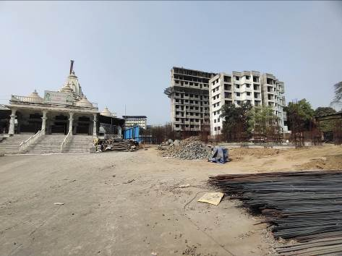
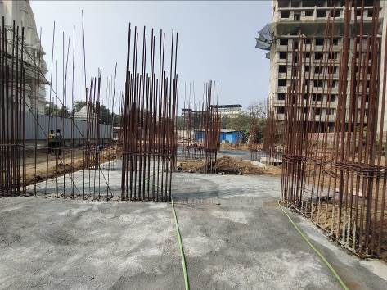
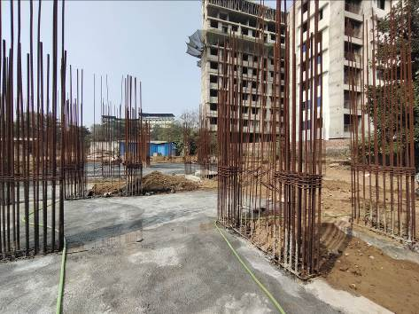
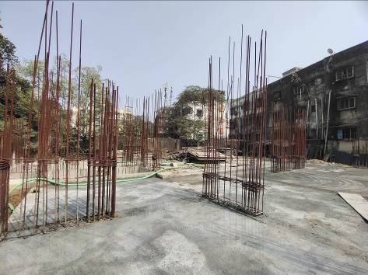
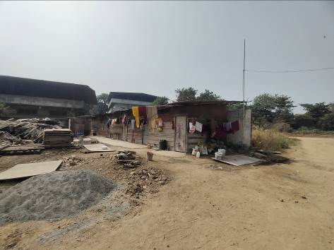
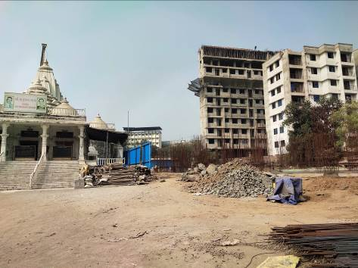
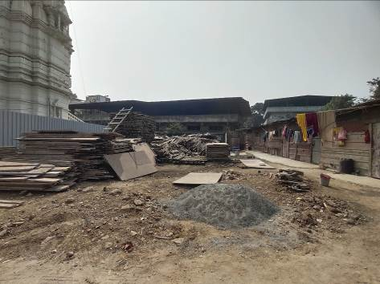

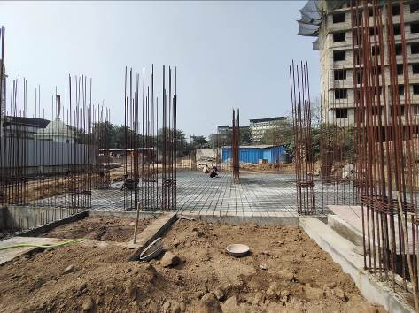

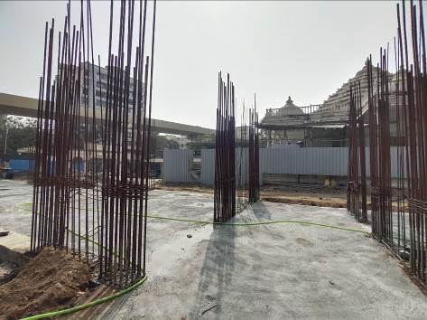

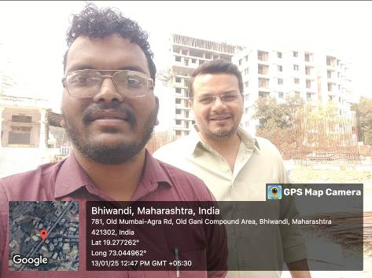

Route Map of the property
Site u/r
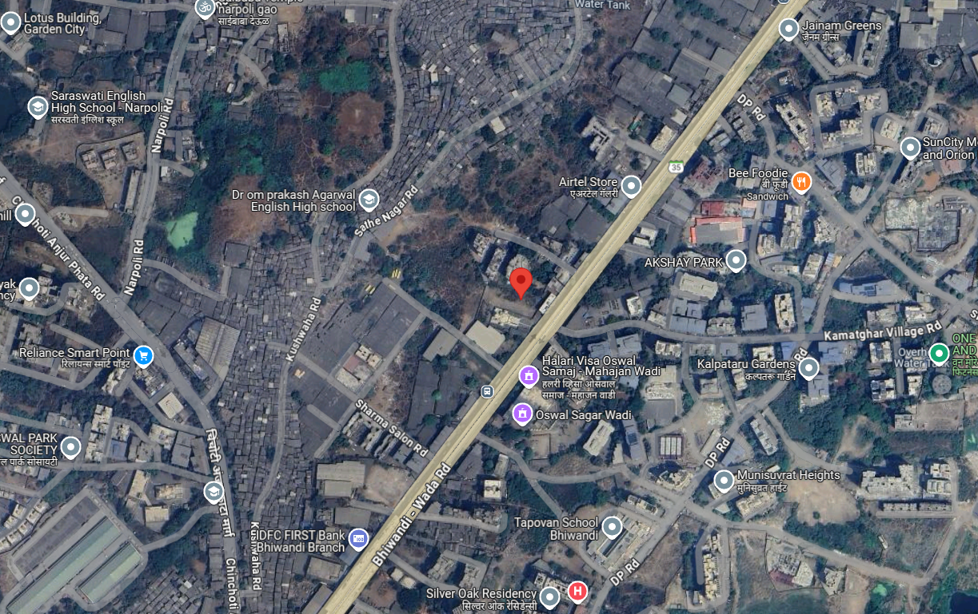

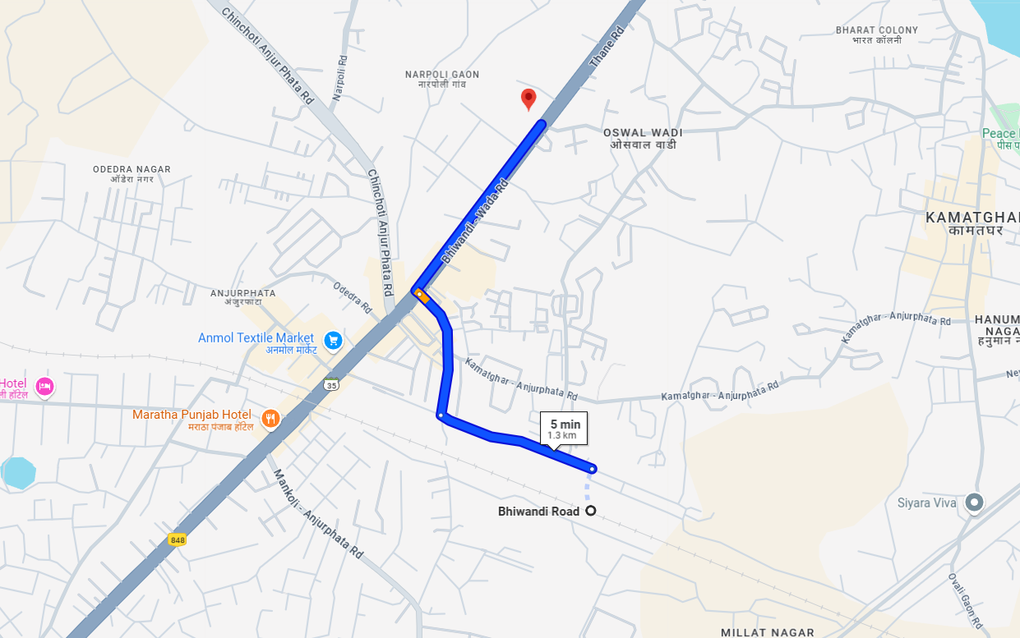

Latitude Longitude: 19°16'39.3"N 73°02'41.3"E
Note: The Blue line shows the route to site from nearest railway station (Bhiwandi –1.3 Km)

