Vastu/Mumbai/01/2025/013451/2305173  
27/04-395-JAVS  
 Date: 03.01.2025

**Structural Stability Report**

Structural Observation Report Residential Flat No. 206 & 207, 2nd Floor, Wing - A, **"Shivam Apartment",** Om Shivam Co-op. Hsg. Soc. Ltd., S. V. Road, Navghar Road, Village - Khari, Taluka - Thane, District - Thane, Bhayandar (East), PIN - 401 105, State - Maharashtra, Country - India.

Name of Client / Proposed Purchaser: **Mr. Soumen Sadhan Mukherjee & Mrs. Tiya Soumen Mukherjee**

Name of Owner: **Smt. Aruna Nawal Kishore Rungta**

This is to certify that on visual inspection, it appears that the structure at **"Om Shivam Co-op. Hsg. Soc. Ltd."** is in average condition and the future life can be reasonably taken under good condition and with proper periodic repairs & maintenance is about 18 years.

**General Information**:

|  |  |  |
| --- | --- | --- |
| **A.** | **Introduction** | |
| 1 | Name of Building | **“Om Shivam Co-op. Hsg. Soc. Ltd.”** |
| 2 | Property Address | Residential Flat No. 206 & 207, 2nd Floor, Wing - A, **"Shivam Apartment",** Om Shivam Co-op. Hsg. Soc. Ltd., S. V. Road, Navghar Road, Village - Khari, Taluka - Thane, District - Thane, Bhayandar (East), PIN - 401 105, State - Maharashtra, Country - India. |
| 3 | Type of Building | Residential |
| 4 | No. of Floors | Ground + 3 Upper Floors |
| 5 | Whether stilt / podium / open parking provided | No Parking Space available at site |
| 6 | Type of Construction | R.C.C. Framed Structure |
| 7 | Type of Foundation | R.C.C. Footing |
| 8 | Thickness of the External Walls | 9” thick brick walls both sides plastered |
| 9 | Type of Compound | Brick Masonry Walls |
| 10 | Year of Construction | 1983 (As per No Objection Certificate issued by Group Village Panchayat Navghar (Bhayandar East) |
| 11 | Present age of building | 42 years |
| 12 | Residual age of the building | 18 years Subject to proper, preventive periodic maintenance & structural repairs. |
| 13 | No. of flats (Per Floor) | 2nd Floor is having 7 Flats |
| 14 | Methodology adopted | As per visual site inspection |

|  |  |  |
| --- | --- | --- |
| **B.** | **External Observation of the Building** | |
| 1 | Plaster | Normal Condition |
| 2 | Chajjas | Normal Condition |
| 3 | Plumbing | Normal Condition |
| 4 | Cracks on the external walls | Minor Cracks Found |
| 5 | Filling cracks on the external walls | Not Found |
| 6 | Cracks on columns & beams | Not Found |
| 7 | Vegetation | Not Found |
| 8 | Leakages of water in the drainage pipes or water pipes | Not Found |
| 9 | Dampness external in the wall due to leakages | Not Found |
| 10 | Any other observation about the condition of external side of the building | Structural Stability Report from licensed structural engineers not provided for our verification. |
| **C** | **Internal Observation of the common areas of the building and captioned premises** | |
| 1 | Beams (Cracks & Leakages) | Not Found |
| 2 | Columns (Cracks & Leakages) | Not Found |
| 3 | Ceiling (Cracks & Leakages) | Not Found |
| 4 | Leakages inside the property | Not Found |
| 5 | Painting inside the property | Normal Condition |
| 6 | Maintenance of staircase & cracks | Normal |

|  |  |  |
| --- | --- | --- |
| **D** | **Common Observation** | |
| 1 | Structural Audit of the Building Under Bye – Laws No. 77 of the Model Bye Laws (Co-Operative Societies Act / Rules) | As per bye Laws No. 77 of Co-Op. Societies bye Laws under the Act the society shall conduct a Structural Audit of the building of the society as follows |
| 2 | Remark | 1. **At the time of site inspection, external condition of the building is average, dampness not found, leakages are not found & Cracks are not found.** 2. **Structural Stability Report from licensed structural engineers not provided for our verification.** |

|  |  |
| --- | --- |
| **E** | **Conclusion** |
| The captioned building is having Ground + 3 Upper Floors which are constructed in year 1983 (As per No Objection Certificate issued by Group Village Panchayat Navghar (Bhayandar East). Estimated future life under present circumstances is about 18 years subject to proper, preventive periodic maintenance & structural repairs.  The inspection dated 02.01.2025 of building. The building is well as the property is maintained in normal condition & will stand future life subject to proper, preventive periodic maintenance & Good structural repairs.  Our Observations about the structure are given above.  The above assessment is based on visual inspection only. Separate structural audit from licensed structural engineers is advised to assess exact balance life of structure. | |

## Sharadkumar B. Chalikwar

Structural Engineer Licence No. STATE/R/2022/APL/01785

Govt. Reg. Valuer

Chartered Engineer (India)

Reg No. (N) CCIT/1-14/52/2008-09

SBI Empanelment No.: SME / TCC / 2021 – 22 / 85 / 13

**Actual site photographs**

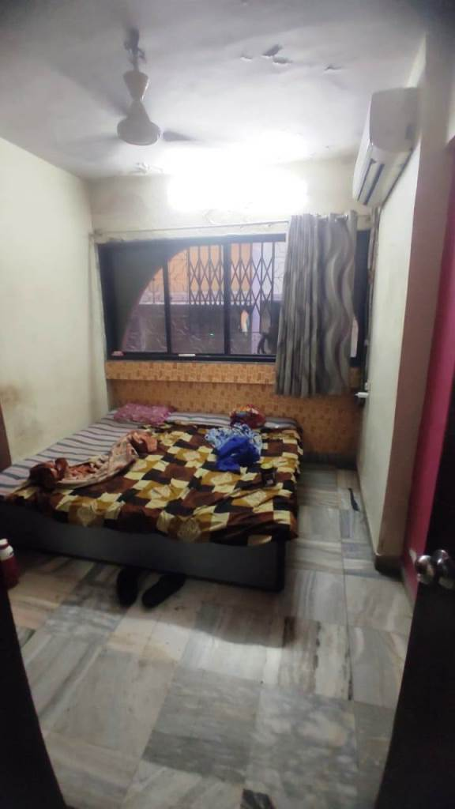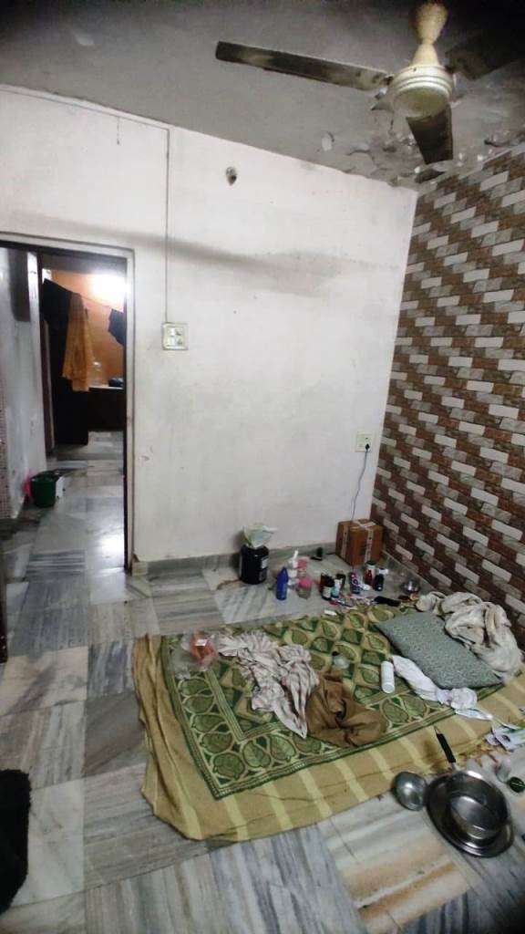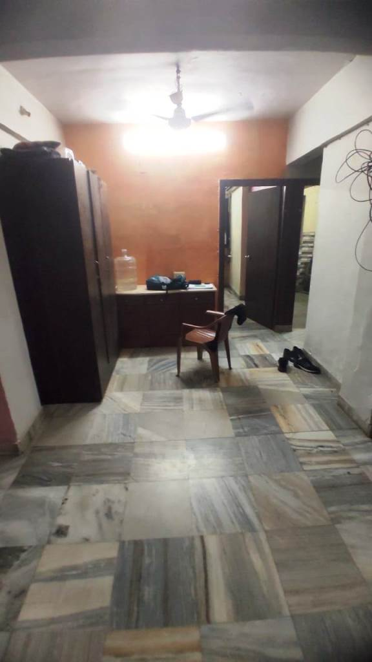

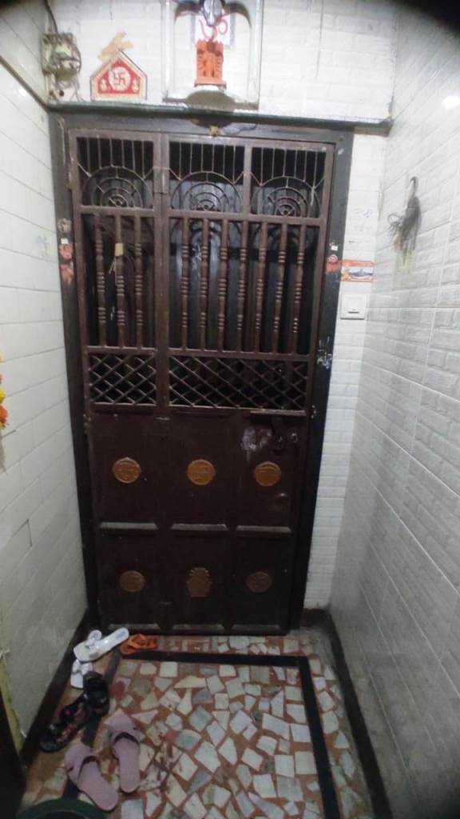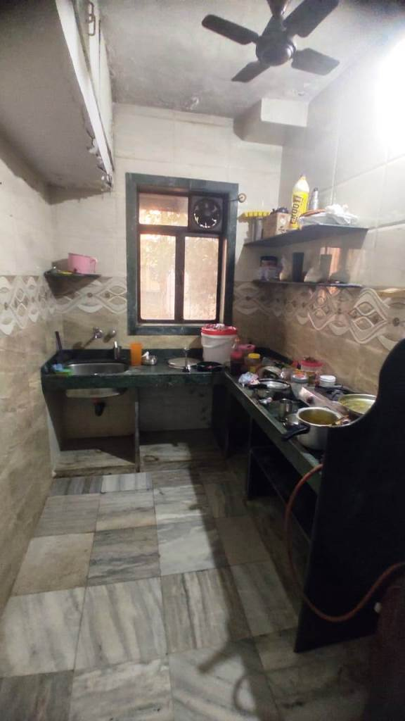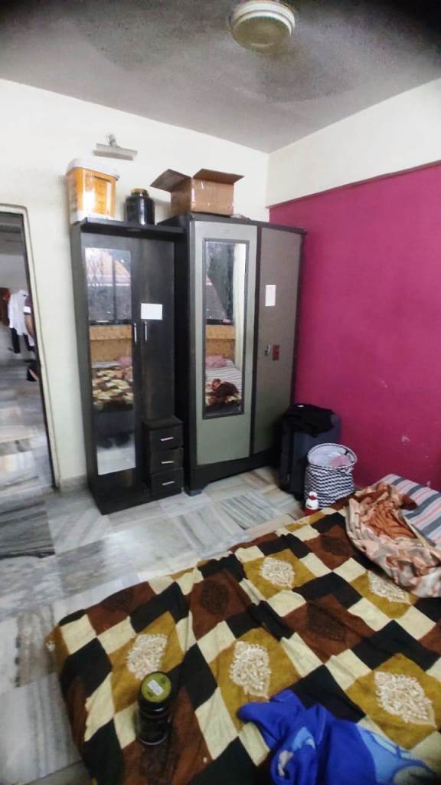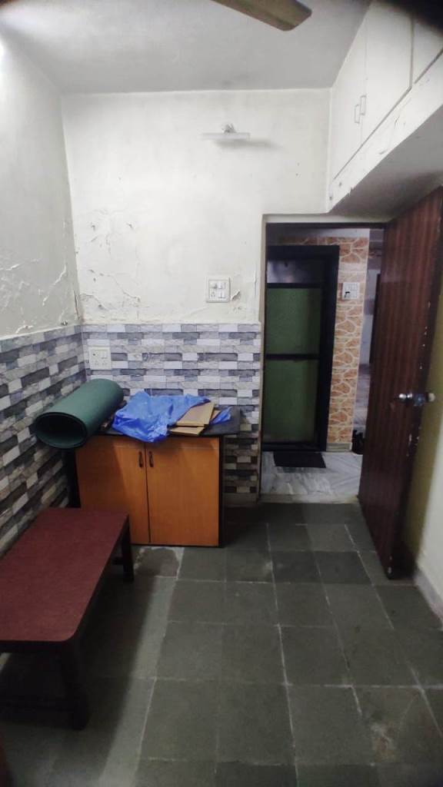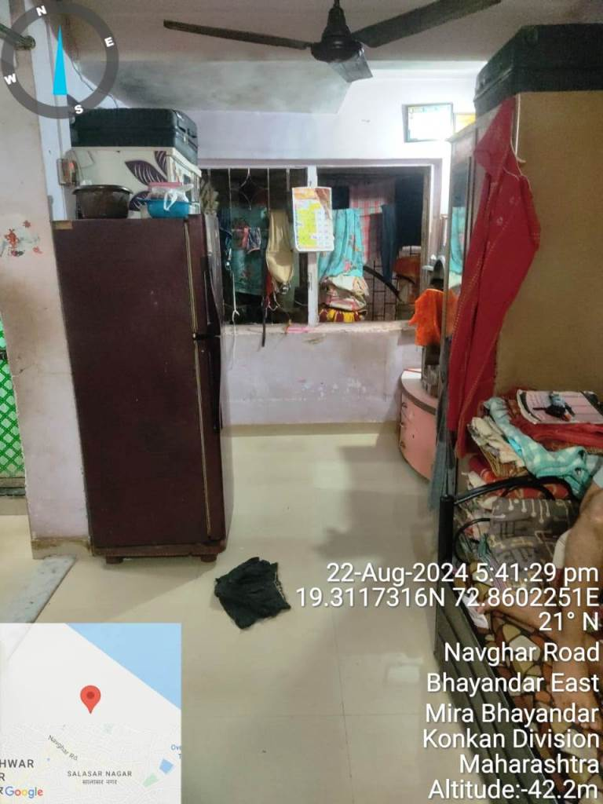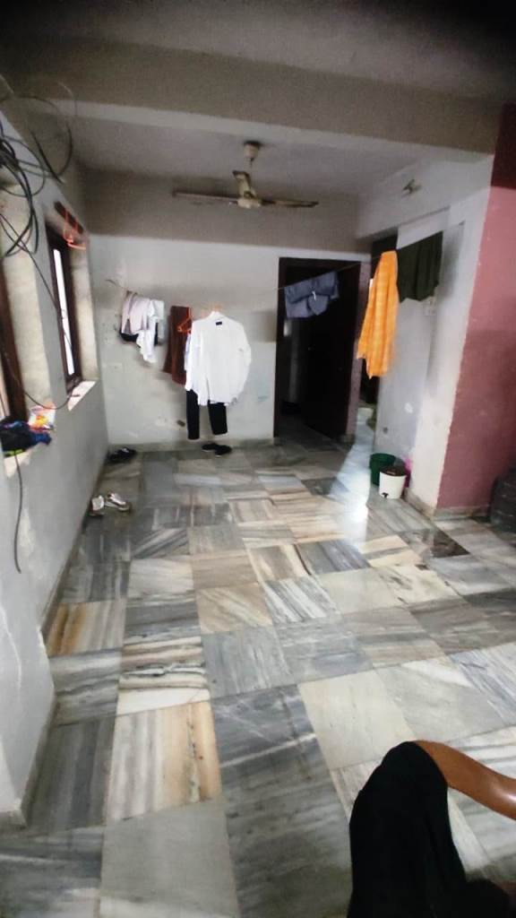

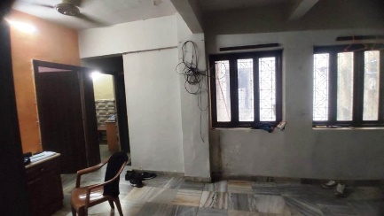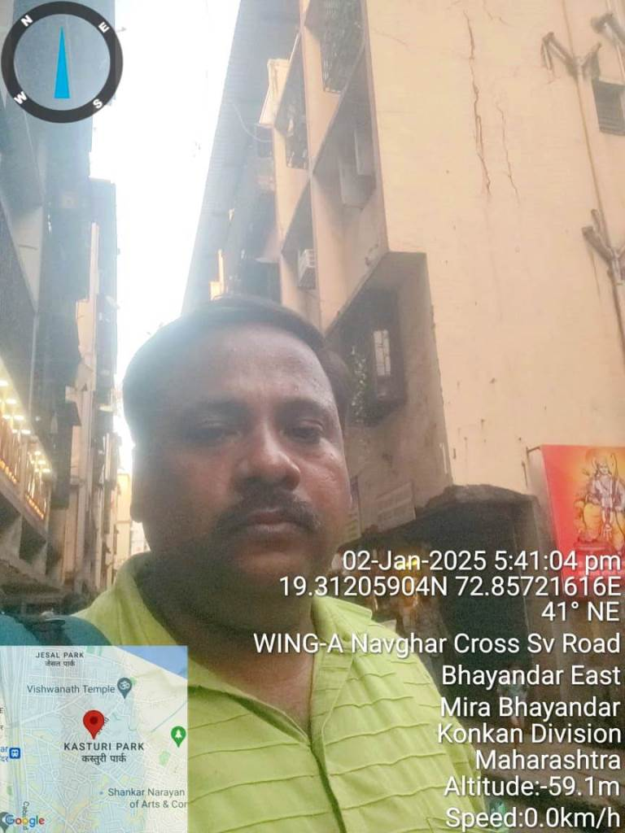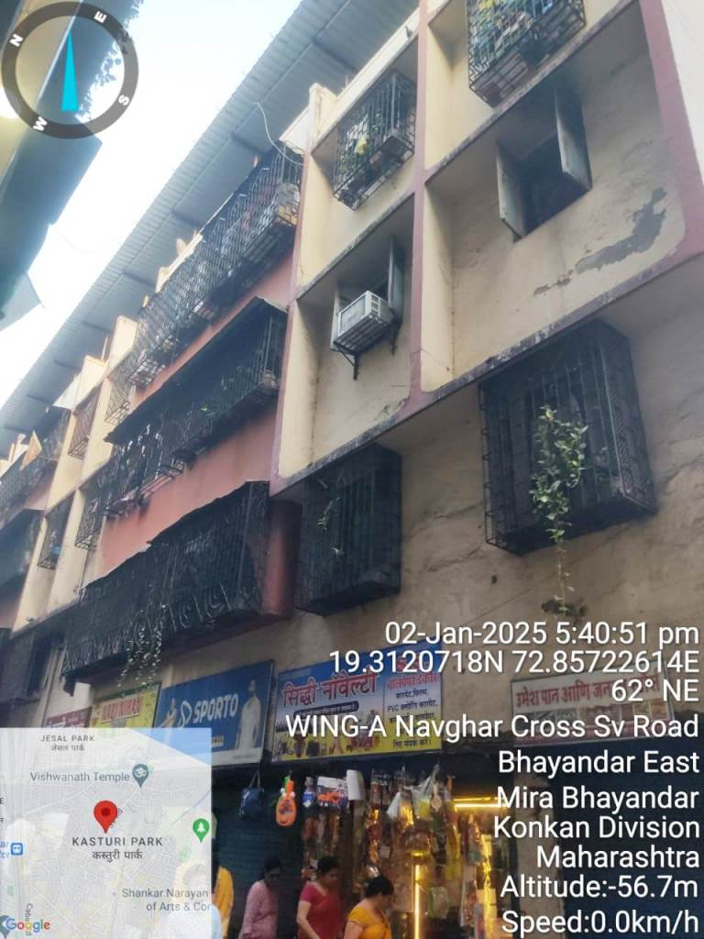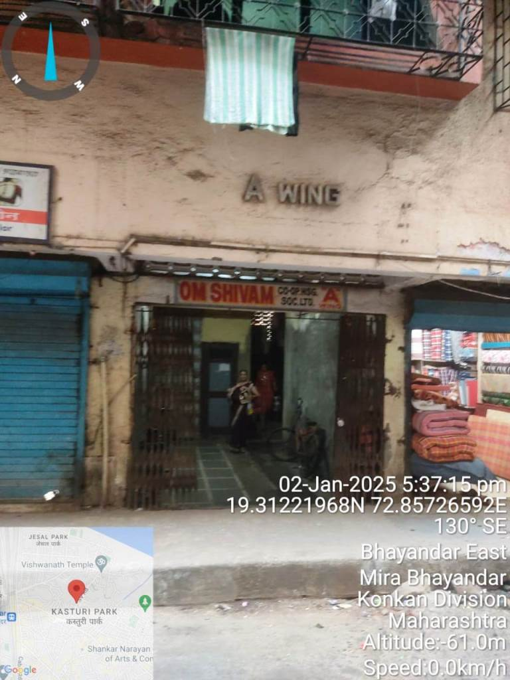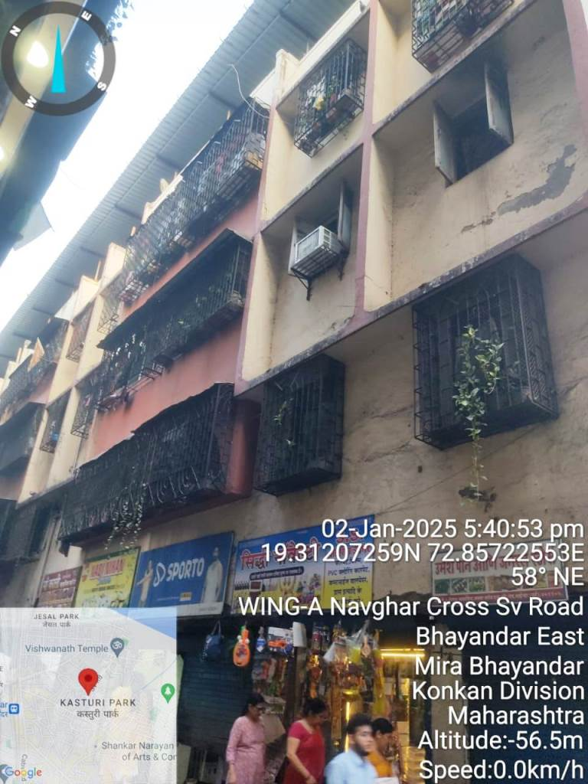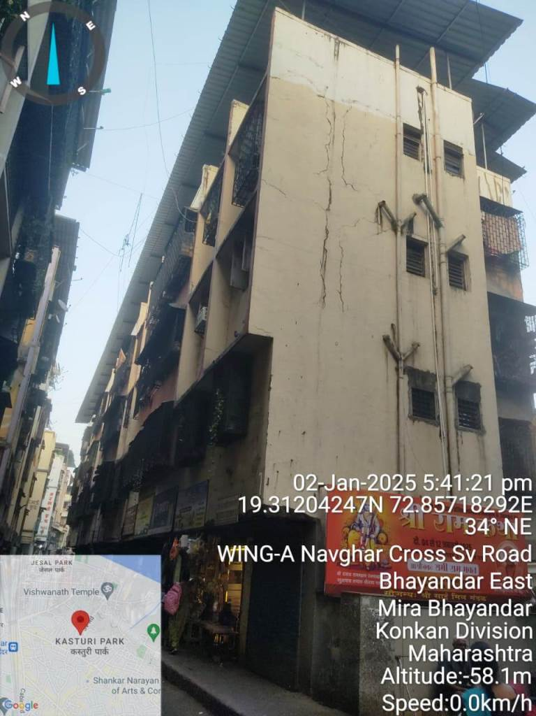**Actual site photographs**