Name of Owner: M/s. Prath Cotspin Pvt. Ltd.
Plant Location: - Gat No. 59, Village-Dahiwad, Taluka-Shirpur, District Dhule, PIN Code-425 405, State- Maharashtra, County-India.

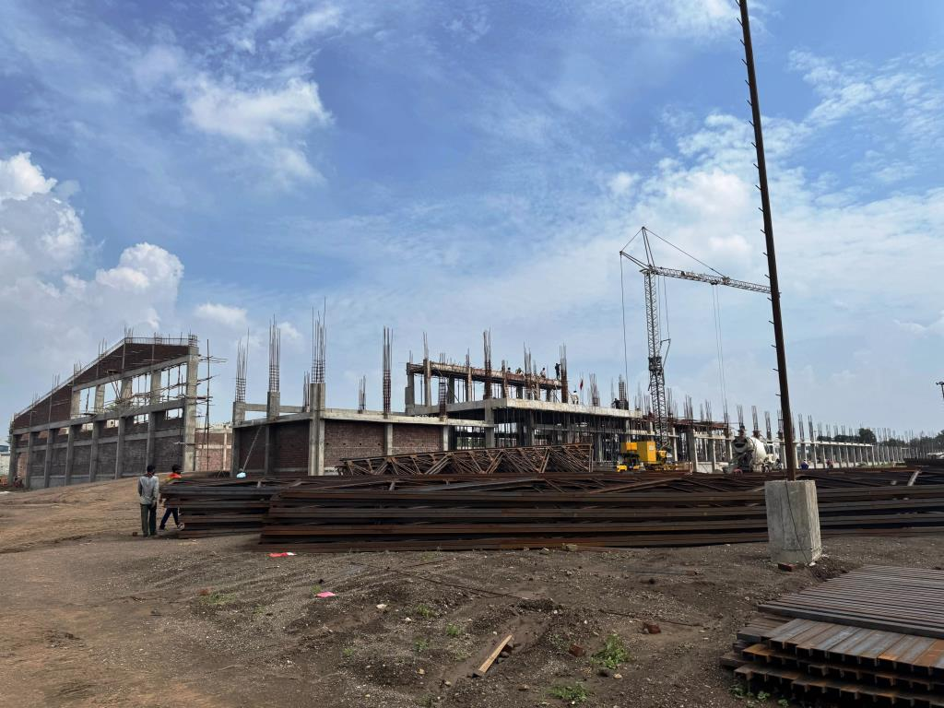

Report Prepared For
State Bank of India
Industrial Finance Branch, Andheri
102, Natraj, 194, Sir. M.V Road, W.E Highway-Metro Junction, Andheri (E )
Mumbai – 400 069, State – Maharashtra, Country – India

Vastukala Consultants (I) Pvt. Ltd.



B1-001, U/B Floor, Boomerang, Chandivali Farm Road, Powai, Andheri(East), Mumbai - 400 072.
: +91 2228371324/25 | : +91 98195 97579 | : www.vastukala.org

INDEX

CHAPTER | NAME | PAGE NO.
1 | PREAMBLE | 3
2 | ASSIGNMENT OVERVIEW | 4
3 | ABOUT COMPANY & THE PROJECT | 8
4 | PROJECT EXECUTION | 31
5 | PHOTOGRAPHS | 35
6 | NOTES, LIMITATIONS, DISCLAIMERS & CAVEATS | 40
7 | SUMMARY | 42
8 | OPINION | 44

Vastu/SBI / Mumbai/01/2025/13440/2309896
02/3-15-APU
Date: 02.01.2025

- PREAMBLE

State of India, Industrial Finance Branch, Andheri, 102, Natraj, 194, Sir. M.V Road, W.E Highway-Metro Junction, Andheri (E ), Mumbai – 400 069, State – Maharashtra, Country – India has appointed M/s Vastukala Consultants (I) Pvt. Ltd. (VCIPL) as Lender’s Independent Engineers for inspection and monitoring the progress of proposed 14,400 Cotton Spinning Mill facility of Rs. 7020.67 Lakhs by M/s Prath Cotspin Pvt. Ltd., (hereinafter referred to as either “PCPL” or “the borrower” or “the company”) on behalf of lenders. M/s Prath Cotspin Pvt. Ltd. is the borrower and the project is financed by State Bank of India, IFB Andheri (B), Branch as per the table mentioned below: -
(₹ in Lakhs)
S. No | Particular | Proposed
1 | Promoter Contribution | 900.00
2 | Term Loan | 4,700.00
3 | Unsecured Loans | 1,420.67
 | Total | 7,020.67

Pursuant to instructions from Relationship Manager of State of India, Industrial Finance Branch, Andheri, 102, Natraj, 194, Sir. M.V Road, W.E Highway-Metro Junction, Andheri (E ), Mumbai – 400 069, State – Maharashtra, Country – India, as appointment of Lender’s Independent Engineer, our Engineer visited the project site of proposed 14,400 Cotton Spinning Mill facility at Gat No. 59, Village-Dahiwad, Taluka-Shirpur, District Dhule, PIN Code-425 405, State- Maharashtra, County-India on 21.10.2024 with a view to ascertain and certify the quantity and amount of work progressively undertaken by the borrower.

- ASSIGNMENT OVERVIEW

2.1 NATURE OF ASSIGNMENT
To review the status of the proposed 14,400 Cotton Spinning Mill facility at Gat No. 59, Village-Dahiwad, Taluka-Shirpur, District Dhule, PIN Code-425 405, State- Maharashtra, County-India on behalf of State of India, Industrial Finance Branch, Andheri, 102, Natraj, 194, Sir. M.V Road, W.E Highway-Metro Junction, Andheri (E ), Mumbai – 400 069, State – Maharashtra, Country – India (Lender’s).

2.2 SCOPE OF WORK: -

The scope of work is under: -
- Executive Summary, Brief Profile/ Basic information of the applicant Company.
- Periodic Progress Monitoring Report.
- Financial Progress.
- Project Cost, Means of Finance details and Expenses.
- Bank related details.
- Physical Progress.
- Site Visit.
- Present Physical Status of the Project.
- Land Acquisition
- Building & Civil Work
- Status of Plant & Machinery and Miscellaneous Fixed Assets.
- Verification of Invoice/ Purchase Orders received for Civil construction work.
- Details of Plant & Machinery Installed.
- Statutory Approvals for the Projects
- Monitoring of obtainment of the statutory approvals, clearances from appropriate authorities.
- Monitoring of the actuals with the timelines initially set for different stages of implementation for monitoring the time over run if any.
- Review of the production capacity (in Capacity terms and volume) vis-a-vis the original projections.
- Monitoring of the disbursement made viz-a-vis the original schedule and ensuring infusion of margines.
- Monitoring of the purchases of assets from the related parties/group companies and payments made thereof.
- Verification of the invoices and validation of the rates/commercial terms and conditions thereof vis-a-viz the original projections.
- Monitoring of the payments made to the suppliers, contractors, vendors, etc.
- Monitoring changes in the external factors vis-à-vis the original estimates – government policies, policy changes.
- Monitoring of arrangement for continuous power and water supply, availability of labour.
- Environmental Clearances.
- Monitoring of logistics and infrastructure.

2.3 DATE OF VISIT: -
- VCIPL’s Engineer has visited the project site 1st time on 21.10.2024.

2.4 DOCUMENTS PROVIDED FOR VALUATION: -
The following documents were perused during the said assignment:
- Letter for appointment of Lenders Independent Engineer (LIE) issued by State of India, Industrial Finance Branch, Andheri, 102, Natraj, 194, Sir. M.V Road, W.E Highway-Metro Junction, Andheri (E ), Mumbai – 400 069, State – Maharashtra, Country – India vide Letter No. SBI/IFBA/RM- AMT-III/2024-25/119 dated 06.09.2024.
- Letter for Sanction of Credit Facilities issued by State of India, Industrial Finance Branch, Andheri, 102, Natraj, 194, Sir. M.V Road, W.E Highway-Metro Junction, Andheri (E), Mumbai – 400 069, State – Maharashtra, Country – India vide Letter No. SBI/RM- III/2023-24/276 dated 30.03.2024.
- TEV Report prepared by M/s. Resurgent India Ltd. dated February 2024.
- Articles of Association.
- Memorandum of Association.
- Certificate of Incorporation.
- Pan Card of Prath Cotspin Pvt. Ltd.
- Udyam Registration Certificate of Prath Cotspin Pvt. Ltd.
- Importer- Exporter Code Certificate.
- GST Registration Certificate.
- Registration cum membership certificate of Powerloom Development & Export Promotion Council (PDEPC) issued under the provisions of Foreign Trade Policy, Government of India.
- Lease deed dated 01.08.2024 made between M/s. Deesan Infrastructure Pvt. Ltd. (“The Lessor”) and M/s. Prath Cotspin Pvt. Ltd. (“The Lessee”) for a portion admeasuring 21,300 Sq. M bearing Gut No. 59 total admeasuring 2.00 Hector and 0 Aar and P.K 0-30 Aar, total 2 Hector and 13 Aar situated at Dahiwad, Tal. Shirpur, Dist. Dhule along with 7,000 Sq. M RCC Structure of Industrial shed upto 8 Meter height to be constructed by M/s. Deesan Infrastructure Pvt. Ltd. on own cost for the period of 10 years commencing from 1st day of July 2024 to 30th day of June 2034.
- Audited Balance sheet as at 31.03.2024.
- Sanction to Technical estimate & Load for New HT power supply of contract demand of 1860 KVA and connected load of 1488 KW under Shirpur-II Sdn on 33 kV Level under 1.3% Supervision Scheme issued by Superintending Engineer, MSEDCL, Dhule Circle vide Ref. No. SE/DHL/T/HT/Estt & Load Sanction No. 3604 dated 14.10.2024.
- Offer for Civil, Architectural, Structural Consultancy of M. K. Welankar & Associates vide Ref. No. Dev/99/AP dated 12.04.2024.
- LEI Registration Certificate.
- Statement of Accounts of CA-REGULAR-PUB-OTH-ALL-INR having Account No. 42656147491 of State Bank of India, IFB-Andheri (E) for the period 01.08.2024 to 04.11.2024.
- Statement of Accounts of CA-REGULAR-PUB-OTH-ALL-INR having Account No. 42656147491 of State Bank of India, IFB-Andheri (E) for the period 01.09.2023 to 20.08.2024.
- Grant of Consent to Establish under section 25 of the Water (Prevention & Control of Pollution) Act, 1974 under section 21 of the Air (Prevention & Control of Pollution) Act, 1981 issued by Maharashtra Pollution Control Board dated 27.08.2024 for a period up to commissioning of the unit or up to 5 year whichever is earlier.
- CA Certificate for advances issued for acquisition of Fixed Assets and the source for the same issued by M/s. S.V. Rathi and Co., Chartered Accountants, Shirpur dated 18.11.2024.
- Site Plan.

2.5 METHODOLOGY ADOPTED
- LIE visit to the project site 1st time on 21.10.2024.
- Perusal of documents and information provided by the Company.
- Physical verification of the project site with the following executives of the Company: -
- Mr. Chayan Agarwal, Office of PCPL.
- Explanations and information given by the following executives of the Company,
- Mr. Pusjpak Bansal, Group CFO.
- Mrs. Shifony Panth, Accounts & Finance.
- Examinations of documents provided by the Company.
- Selective photographs of the project site are enclosed.
- Finalization of LIE Report.

- ABOUT COMPANY & THE PROJECT

3.1. ABOUT COMPANY: -
M/s. Prath Cotspin Pvt. Ltd. (“PCPL” or “Company”) is a Private Limited Company incorporated on 10th July 2019. It is classified as non-government company and is registered at Registrar of Companies, Mumbai. Directors of Prath Cotspin are Mrs. Kruti Bhupesh Patel and Mrs. Ketki Mukesh Patel. PCPL's Corporate Identification Number (CIN) is U24100MH2019PTC327886 and its registration number is 327886. Its registered address is Basement No. 17, Vikas Centre, B Wing, 106, S.V. Road, Santacruz(W) Mumbai-400 054.

The company will be primarily involved in manufacturing of cotton yarn of low count range - carded (12s, 16s and 20s) and combed (20s). Low count yarn is used for terry towels. The promoters are having background of textile processing industry over many years. Total installed capacity of the proposed cotton spinning mill will be 14,400 ring spindles per Annum (355 operational days).

The estimated project cost of the textile processing unit remains at INR 7020.67 Lakh to be funded by INR 4700.00 Lakh term loan and rest by promoter funds/unsecured loans (project gearing: 2.03 times).

Unit will be located at Gat No. 59, Village Dahiwad, Taluka Shirpur, District Dhule, Maharashtra. The said land is leased to M/s. Deesan Infrastructure Pvt Limited (DIPL) by M/s. Priyadarshani Sahakari Soot Girni Ltd, Shirpur as per lease deed dated 4th July 2008 for a lease period of 99 years. M/s. Prath Cotspin Pvt Ltd has entered into a temporary lease agreement dated 12.02.2024 with DIPL for the purpose of registration and applying for various approvals/connections.

The company has registered the lease deed dated August 1, 2024, executed between
M/s. Deesan Infrastructure Pvt. Ltd. (referred to as "The Lessor") and M/s. Prath Cotspin Pvt. Ltd. (referred to as "The Lessee"). This lease pertains to a portion measuring 21,300 square meters, identified by Gut No. 59, which encompasses a total area of 2.00 hectares and 0 Aar and P.K. 0-30 Aar, specifically 2 hectares and 13 Aar. The property is in Dahiwad, Tal. Shirpur, Dist. Dhule, and includes a 7,000 square meter RCC structure of an industrial shed, which is to be constructed by M/s. Deesan Infrastructure Pvt. Ltd. at their own expense. The lease is set for a duration of 10 years, commencing on July 1, 2024, and concluding on June 30, 2034.

Key Objectives of the Company as per Memorandum of Association
The key objectives of the company as per memorandum of association are as under.
- To manufacture, produce, formulate, mix or prepare, enrich, import or otherwise acquire, own, hold, use, mortgage, pledge, buy, sell, exchange, distribute, assign, transfer or otherwise dispose of, trade, deal in and deal with, import and export any and all classes and kinds of finished, semi-finished, raw material goods agricultural chemicals, fertilisers, manures, their bye-products, mixtures, formulations, intermediates, derivatives and compounds, heavy chemicals, petrochemicals, fine chemicals and any and all classes and kinds of inorganic and organic chemicals, source materials, intermediates, ingredients, mixtures, derivatives and compounds thereof and any and all kinds of products of which any of the foregoing constitutes an ingredient or in the preparation, formulation, mixtures or production of which any of the foregoing is used or required.
- To carry on the business of manufacturers, producers, processors, exporters, importers, buyers and sellers of and dealers in and with all and any, sprays, vermifuges, fungicides, insecticides, germicides, disinfecting preparations, fumigators and of all kinds for agricultural products.
- To act as an import and export house and to perform all the functions and undertake all activities connected therewith including obtaining and dealing in licenses, quotas, certificates and other rights.

3.2. GENERAL INFORMATION: -
Particular | Details
CIN | U24100MH2019PTC327886
Company / LLP Name | Prath Cotspin Pvt. Ltd.
ROC Code | RoC-Mumbai
Registration Number | 327886
Company Category | Company limited by Shares
Company Sub Category | Non-govt company
Class of Company | Private
Authorised Capital(Rs) | 1,00,000
Paid up Capital(Rs) | 1,00,000
Date of Incorporation | 10.07.2019
Registered Address | Basement No. 17, Vikas Centre, B Wing, 106, S.V. Road, Santacruz(W) Mumbai-400 054.
Email Id | cs@deesantex.in

3.3. ABOUT DIRECTORS OF THE COMPANY:-
The company has two directors namely Mrs. Kruti Bhupesh Patel and Mrs. Ketki Mukesh Patel who have more than 12 years of experience in textile industry with good market reputation. Details of promoters are as follows –
Name | Age  (Yrs) | Qualification | Date of Birth | Pan No. | DIN Number
Mrs. Ketki Mukesh Patel | 66 | Graduate | 21.05.1958 | AAFPP6405K | 00488522
Mrs. Kruti Bhupesh Patel | 60 | Graduate | 09.07.1964 | AAFPP6553J | 00482326

1. Mrs Ketki Mukesh Patel
Ms. Ketki Mukesh Patel wife of Late Mr Mukesh Rasiklal Patel aged 66 years residence at Samriddhi Bunglow Plot no 72 9th Road, Nutan Laxmi CHS, Juhu Mumbai 400049. She is associated as director in PCPL since 2019 and having more than 12 Years of expertise in Textile Manufacturing Business. She is qualified graduate and having a good knowledge of textile industry.

2. Ms. Kruti Bhupesh Patel
Ms. Kruti Bhupesh Patel wife of Mr. Bhupesh Patel aged 60 years residence at Chintan Bunglow, 9th Road, Plot No 72 Nutan Laxmi Society, Juhu Mumbai 400058. She is associated as director in PCPL since 2019 and having more than 12 Years of expertise in Textile Manufacturing Business. She is qualified graduate and having a good knowledge of Textile Industry.

3.4 MANAGEMENT OF THE COMPANY:-
Both the directors of Prath Cotspin Pvt Ltd and their team are experienced to take care of day to day operations of processing and production of finished textile. Details of key personnel are as follows-
1. Mr. Jai Kishan Gupta (Operations Head):
Jai Kishan Gupta, Aged 58 years was Vice President with Welspun India Ltd till December 2023. He has more than 30 years of experience in textile spinning industry that includes production, maintenance, planning and management with major textile groups including Welspun, Vardhaman, RSWM (LNJ Group), STI India. Mr. Gupta a graduate in textile engineering and a MBA in Finance.

2. Mr. Sunil Mandora (Technical Advisor):
Mr Sunil Mandora aged 62 years qualified Diploma in Textile having an experience of Textile market of more than 34 years in this sector. He is associated with this group from last 25 Years. He is good in Technical of Textile market.

3. Mr. Pushpak Bansal (CFO):
Mr Pushpak Bansal aged 57 years residence at B-1004, Windermere near Best Colony Road, Andheri West, Mumbai -400102. He is associated with Deesan Group from last 12 years. He is qualified Chartered Accountant. He is having an experience of more than 30 years in Finance background and also having a Textile experience of more than 20 years.

3.5. SHAREHOLDING PATTERN: -
S No. | Name of Shareholder | Class of Share | No of Shares | % of Shareholding
1 | Chetan Patel | Equity Shares | 5,000 | 50%
2 | Janak Patel | Equity Shares | 5,000 | 50%
 |  | Total | 10,000 | 100%

3.6. ABOUT THE PROJECT
M/s. Prath Cotspin Pvt Ltd is establishing a cotton spinning mill with an installed capacity of 14,400 ring spindles per annum, operating for 355 days each year located at located at Gat No. 59, Village Dahiwad, Taluka Shirpur, District Dhule, Maharashtra.

The estimated project cost of the textile processing unit remains at Rs. 7020.67 Lakh to be funded by Rs. 4,700.00 Lakh term loan and rest by promoter funds/unsecured loans (project gearing: 2.03 times).

The company has registered the lease deed dated August 1, 2024, executed between
M/s. Deesan Infrastructure Pvt. Ltd. (referred to as "The Lessor") and M/s. Prath Cotspin Pvt. Ltd. (referred to as "The Lessee"). This lease pertains to a portion measuring 21,300 square meters, identified by Gut No. 59, which encompasses a total area of 2.00 hectares and 0 Aar and P.K. 0-30 Aar, specifically 2 hectares and 13 Aar. The property is in Dahiwad, Tal. Shirpur, Dist. Dhule, and includes a 7,000 Sq. M. RCC structure of an industrial shed, which is to be constructed by M/s. Deesan Infrastructure Pvt. Ltd. at their own expense. The lease is set for a duration of 10 years, commencing on July 1, 2024, and concluding on June 30, 2034. The said land is leased to M/s. Deesan Infrastructure Pvt Limited (DIPL) by M/s. Priyadarshani Sahakari Soot Girni Ltd, Shirpur as per lease deed dated 4th July 2008 for a lease period of 99 years.

LOCATION:-
The project shall be located at Gat No 59, Village-Dahiwad, Taluka-Shirpur, District-Dhule, Maharashtra, which is in an integrated textile park developed by M/s Deesan Infrastructure Private Limited (DIPL). DIPL has leased 21,300 Sq. M. and 7,000 Sq. M of RCC Structure of an Industrial Shed of the said land to PCPL for 10 years and the same is bounded as follows:
Direction | : | Boundaries
On or towards the East | : | Road, Beyond the road, there are Adeesh Texfab and Yogi Cotex
On or towards the west | : | Laxmi Textile
On or towards the North | : | Road and open plot
On or towards the South | : | Plot No 60

LOCATION ADVANTAGES –
The integrated textile park developed by DIPL aims to provide favourable infrastructure for the textile manufacturers like water connection, power connection and other facilities catering to the textile industry required for uninterrupted operations. The raw material (cotton) is widely available in the region and is further supported by government programs. Since the region is a hub for textile industry, skilled labours are available in abundance. The region is well connected by transportation with all major cities in India. The land location is suitable for operating the proposed manufacturing facility and infrastructure like Roads, Power, Water. Transportation, etc together with skilled/semi-skilled labour, etc are easily manageable due to the presence of the Textile Park by DIPL.
Particular | : | Details
Connectivity means to Dhule city and frequency – Bus, Auto availability, | : | Available
Distance from nearest state/national highway | : | Approximately 3 kms from Mumbai Agra National Highway
Ground status of the land where the company is being constructed – marshy, covered with bushes, trees | : | Partly covered with bushes.
Whether the locality is residential, commercial, surrounded by agricultural land, sparsely or moderately populated. |  | Industrial
Water sources status – bore well or any other source |  | Water from tube well, existing storage tanks of 2 lakh litres and one borewell is available
Landmarks. |  | Laxmi Textile

The Google Location for the same is as under:-
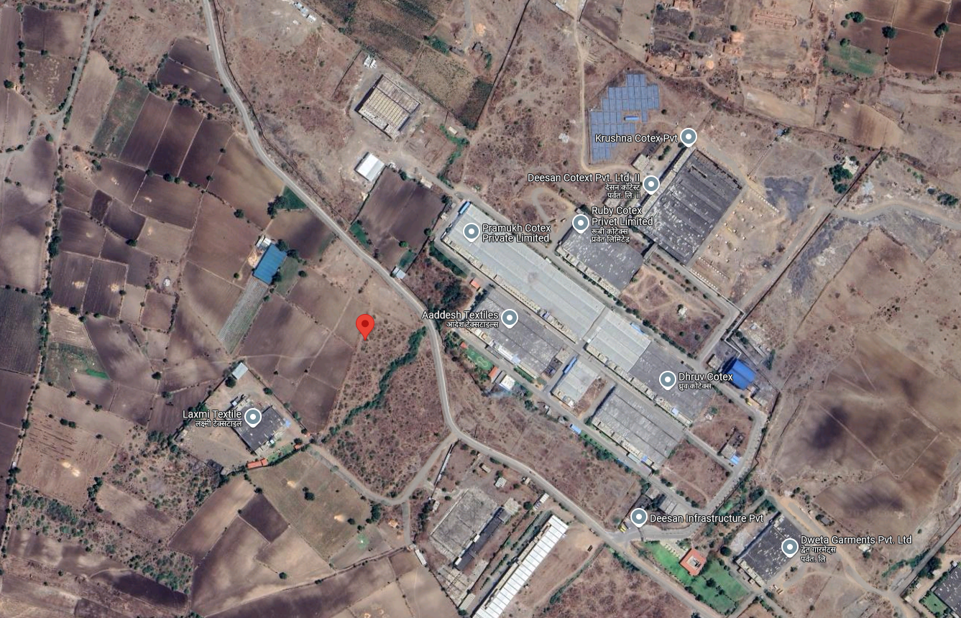

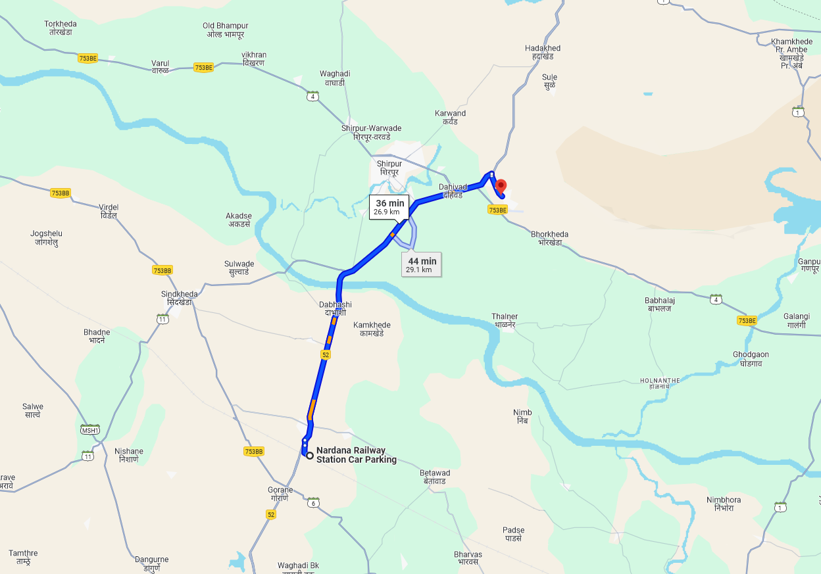
Longitude Latitude: 21°19'57.2"N 74°57'03.9"E
Note: The Blue line shows the route to site from nearest railway station (Nardana – 26.9 KM.)

As per TEV report Total area of proposed construction is admeasuring 10,412.39 Sq. M. comprising of proposed Ground Floor area of 9136.44 Sq. M and 1st Floor area of 1275.95 Sq. M. in the Registration District, Shirpur, and sub district Dahiwad.

PCPL intends to complete the project within 15 months and commencement of the commercial operations is expected by 1st April 2025.

The technologies as proposed to be utilized by the company for the project are internationally well-established technologies for manufacturing of PCPL product. All the equipment shall be of high quality and based on latest technology.

The water table is very high in the textile park and DIPL provides the water from Tube well to all the industrial units. The capacity of the tube well is 12 Lakh litres per day. In addition, DIPL (textile park) also has an existing water tank of 2 lakh litres as backup facility for supplying water to the unit’s operating in the park. Hence, water is adequately available. Also, one borewell is available.

The promoters plan to subscribe to power subsidies and the details for the same is as follows:
Power Subsidy
As per the New Textile Policy, Maharashtra government will provide the power subsidy benefit to Textile sector A subsidy of Rs 2 per unit will be given to textile sector unit to avail power subsidy benefits After getting this document verified from the power sector department, the subsidy benefit will be reflected in the power bill and will be availed by the manufacturer on a monthly basis.

Total estimated project cost is Rs. 7,020.67 Lakhs as indicated in table provided below for ready reference.
S. No | Particular of Project | Estimated Project Cost (₹ in Lakhs) | % of Project Cost
1. | Land & Site Development | 0.00 | 0.00%
2. | Factory Building | 0.00 | 0.00%
3. | Plant & Machinery | 5,265.69 | 75.00%
4. | Cost of GST on Plant & Machinery | 709.16 | 10.10%
5. | Pre-Operative Expenses | 100.00 | 1.42%
6. | Interest During Construction (IDC) | 130.82 | 1.86%
7. | Margin Money for Working Capital | 525.00 | 7.48%
8. | Contingencies | 290.00 | 4.13%
 | Total | 7,020.67 | 100.00%

NOTE:-
- Land and Building is leased from DIPL. Cost of Land and Buildings is in the Scope of DIPL, therefor the same is not considered in the project cost.
- As per TEV Report total project cost is estimated at Rs. 7,020.67 Lakhs.

MEANS OF FINANCE
(₹ in Lakhs)
S. No | Particular | Proposed
1 | Promoter Contribution | 900.00
2 | Term Loan | 4,700.00
3 | Unsecured Loans | 1,420.67
 | Total | 7,020.67

OBSERVATIONS:-
- The total cost of the proposed project is Rs. 7,020.67 Lakhs to be funded by Rs. 4,700.00 Lakh term loan form SBI and rest by promoter funds/unsecured loans (project gearing: 2.03 times).
- State of India, Industrial Finance Branch, Andheri has sanctioned a Term Loan of
Rs. 4,700.00 Lakhs to PCPL vide Letter for Sanction of Credit Facilities issued with Letter No. SBI/RM- III/2023-24/276 dated 30.03.2024.

3.7) LEASED LAND FOR THE PROJECT:-
The company has registered the lease deed dated August 1, 2024, executed between
M/s. Deesan Infrastructure Pvt. Ltd. (referred to as "The Lessor") and M/s. Prath Cotspin Pvt. Ltd. (referred to as "The Lessee"). This lease pertains to a portion measuring 21,300 square meters, identified by Gut No. 59, which encompasses a total area of 2.00 hectares and 0 Aar and P.K.
0-30 Aar, specifically 2 hectares and 13 Aar. The property is in Dahiwad, Tal. Shirpur, Dist. Dhule, and includes a 7,000 Sq. M. RCC structure of an industrial shed, which is to be constructed by M/s. Deesan Infrastructure Pvt. Ltd. at their own expense. The lease is set for a duration of 10 years, commencing on July 1, 2024, and concluding on June 30, 2034. The said land is leased to M/s. Deesan Infrastructure Pvt Limited (DIPL) by M/s. Priyadarshani Sahakari Soot Girni Ltd, Shirpur as per lease deed dated 4th July 2008 for a lease period of 99 years.

Note:-
- During the date and time of our visit, the construction activity was going on.
- Compound wall was not constructed due to which the demarcation of land not identified. Company should construct the boundary wall.
3.8) LEASED BUILDINGS FOR THE MANUFACTURING PROJECT: -
As per TEV report Total area of proposed construction is admeasuring 10,412.39 Sq. M. comprising of proposed Ground Floor area of 9136.44 Sq. M and 1st Floor area of 1275.95 Sq. M. in the Registration District, Shirpur, and sub district Dahiwad, the Built-up area for Building is as under:-
S No. | Name of Building | Area (Sq. M.)
1 | Ground Floor | 9,136.44
2 | First Floor | 1,275.95
 | Total | 10,412.39

Note:-
- As per TEV Report the total BUA is is 10,412.39 Sq. M., however the as per Lease deed the total BUA is 7,000 Sq. M.
- Company has not provided the plan approved by Malegaon Municipal Corporation.
- Construction of Proposed Building is in progress. The Plint work and beam work is completed. The Cost of Building is in the scope of DIPL.
3.9) PLANT & MACHINERY FOR THE PROJECT: -
The plant & machinery includes both imported as well as indigenous machineries. The total basic cost of plant & machinery is estimated at Rs. 5,265.69 Lakhs and Tax is Rs. 709.16 Lakhs. The total estimated project cost of Plant & Machinery including taxes is Rs. 5,974.85 Lakhs

3.9.1. ESTIMATED COST OF PLANT & MACHINERY: -
As per TEV report the estimated cost of Plant & Machinery is as under:-
S. No. | Name of Machine | Supplier Name | Supplier Country | Qty. | Total Basic Cost | Tax | Total
 |  |  |  |  | Rs. in Lakhs
1 | AutoconerX6 type V with 35WU, 42WU, 46WU | Murata Machinery Ltd | Japan | 1 | 1,247.11 | 0.00 | 1,247.11
2 | Blow Room Line | Truetzschler India Pvt Ltd | India | 1 | 175.02 | 35.00 | 210.02
3 | Truetzschler card TC 12-3 Linear Can Changer CCL-1000 Option/Feature-Flat Strip Suction | Truetzschler India Pvt Ltd | India | 36 | 453.00 | 91.00 | 544.00
4 | Roving Frames Auto speed 224 Spindles/220 mm Gauge Flyer Size 16X6" | Electro Jet Machinery | India | 4 | 394.08 | 79.00 | 473.08
5 | Breaker Draw Frame-SB D27, OMEG alps-E36 Comber-E86, ACC Combing, Finishers Draw Frame-RSB D55, ACC for Draw frame, ACC Various | Reiter India Pvt Ltd | India | 13 | 351.86 | 70.00 | 421.86
6 | Toyota high speed Ring Speed Frame RX 300 | Kirloskar Toyota Textile Machinery Pvt ltd | India | 10 | 1,512.00 | 302.40 | 1,814.40
7 | Miscellaneous items |  | India | Lot | 1,132.62 | 131.76 | 1,264.38
 |  |  |  | Total | 5,265.69 | 709.16 | 5,974.85
Note:-
- Conversion rate for Euro to Rs. is considered as 1 Euro = 93.38 Rs. and 1 CHF = 98.56 Rs.

3.9.2. DETAILS OF PO RAISED FOR PLANT & MACHINERY: -
Out of total estimated project cost including taxed of Plant & Machinery of Rs. 5,974.85 Lakhs, Company has issued the Purchase Order for Plant & Machinery for Rs. 5,052.55 Lakhs and the details for the same is as under:-

S. No. | Name of Machine | Supplier Name | Qty | PO No. | PO Date | Basic PO Value | Tax | Total
 |  |  |  |  |  | Rs. in Lakhs
1 | Murata Process Coner Alcone automic cone widnig machine type link coner with 1 cop robo total 160 Drums | Murata Machinery Ltd | 1 Set | PCPL/24-25/CP/08 | 29.08.2024 | 1,241.00 | 0.00 | 1,241.00
2 | Blow Room Line | Truetzschler India Pvt Ltd | 1.00 | PCPL/24-25/CP/02 | 21.08.2024 | 185.24 | 33.34 | 218.58
3 | B314B Truetzschler Card TC12 with Three Licker-in and B255 can Changer Liner CCL | Truetzschler India Pvt Ltd | 12.00 | PCPL/24-25/CP/03 | 21.08.2024 | 453.02 | 81.54 | 534.57
4 | 4 Rovematic ADR plus automatic roving frame of 216 Dpindle, fitted with triple transfer and 4 GR1-EM travelling cleaners | Electro Jet Machinery | 4.00 | PSPL/24-25/CP/05 | 22.08.2024 | 394.08 | 0.00 | 394.08
5 | Drawframe SB-D 27 | Reiter India Pvt Ltd | 2.00 | PSPL/24-25/CP/04 | 21.08.2024 | 46.00 | 8.28 | 54.28
6 | Omega Lap E36 | Reiter India Pvt Ltd | 1.00 | PSPL/24-25/CP/04 | 21.08.2024 | 58.50 | 10.53 | 69.03
7 | Comber E86 | Reiter India Pvt Ltd | 3.00 | PSPL/24-25/CP/04 | 21.08.2024 | 136.80 | 24.62 | 161.42
8 | Varoius accessories for combing | Reiter India Pvt Ltd | 1.00 | PSPL/24-25/CP/04 | 21.08.2024 | 11.56 | 2.08 | 13.65
9 | Drawframe RSB-D-55 | Reiter India Pvt Ltd | 1.00 | PSPL/24-25/CP/04 | 21.08.2024 | 24.00 | 4.32 | 28.32
10 | Various accessories for drawframes | Reiter India Pvt Ltd | 1.00 | PSPL/24-25/CP/04 | 21.08.2024 | 1.00 | 0.18 | 1.18
11 | Drawframe RSB-D-55 | Reiter India Pvt Ltd | 3.00 | PSPL/24-25/CP/04 | 21.08.2024 | 72.00 | 12.96 | 84.96
12 | Various accessories for drawframes | Reiter India Pvt Ltd | 1.00 | PSPL/24-25/CP/04 | 21.08.2024 | 2.00 | 0.36 | 2.36
13 | Toyota high speed Ring Speed Frame RX 300 | Kirloskar Toyota Textile Machinery Pvt ltd | 10.00 | PCPL001/ 2023-24 | 12.01.2024 | 1,501.20 | 270.22 | 1,771.42
14 | Misc. P&M
i | H Plant, Dust & Waste Removal System & Pneumafil Waste Collection System | Luwa India Pvt. Ltd. | Set | PCPL/24-25/CP/01 | 28.05.2024 | 161.50 | 29.07 | 190.57
ii | Automatic Bale Press with 4 Silos above conveyor | Tiny Engineering India Pvt. Ltd, | 1.00 | PSPC/24-25/CP/06 | 22.08.2024 | 24.50 | 4.41 | 28.91
iii | Uster Jossi Vision Shield T with Uster Jossi magic Eye 2 along with all standard accessories | Uster Technologies (India) Pvt. Ltd. | 1.00 | PCPL/24-25/07 | 22.08.2024 | 99.55 | 0.00 | 99.55
iv | Jacobi Bobbin Transport Sysyem | Jacobi Machinery Pvt. Ltd. | 1.00 | PSPL/24-25/CP/10 | 20.09.2024 | 66.96 | 12.05 | 79.01
v | Flat Clipping Machine PFC4-40 with Tear off attachment | Perfect Equipments Pvt. Ltd. | 1.00 | PCPL/24-25/CP/12-A | 29.10.2024 | 7.21 | 1.30 | 8.51
vi | Automatic Flat Gringing Machine, AFG3-40" | Perfect Equipments Pvt. Ltd. | 1.00 | PCPL/24-25/CP/12-A | 29.10.2024 | 6.76 | 1.22 | 7.98
vii | Card Flat Grinding Roller-40" | Perfect Equipments Pvt. Ltd. | 1.00 | PCPL/24-25/CP/12-A | 29.10.2024 | 1.50 | 0.27 | 1.78
viii | Multi Roller Mounting/ C:RMM1 | Perfect Equipments Pvt. Ltd. | 1.00 | PCPL/24-25/CP/12-A | 29.10.2024 | 6.77 | 1.22 | 7.99
ix | Traversing Stone Grinder-40" | Perfect Equipments Pvt. Ltd. | 1.00 | PCPL/24-25/CP/12-A | 29.10.2024 | 4.39 | 0.79 | 5.18
x | Transportation Trolley for Lickerin | Perfect Equipments Pvt. Ltd. | 1.00 | PCPL/24-25/CP/12-A | 29.10.2024 | 0.80 | 0.14 | 0.94
xi | Cot Grinding Machine-BM1-AF | Perfect Equipments Pvt. Ltd. | 1.00 | PCPL/24-25/CP/12-A | 29.10.2024 | 7.78 | 1.40 | 9.18
xii | Cot Checking Instrument | Perfect Equipments Pvt. Ltd. | 1.00 | PCPL/24-25/CP/12-A | 29.10.2024 | 0.30 | 0.05 | 0.35
xiii | Hydraulic Cot Mounting Machine:CMHY | Perfect Equipments Pvt. Ltd. | 1.00 | PCPL/24-25/CP/12-A | 29.10.2024 | 2.03 | 0.37 | 2.40
xiv | Auto Top Roll Greasing Machine:ARG | Perfect Equipments Pvt. Ltd. | 1.00 | PCPL/24-25/CP/12-A | 29.10.2024 | 0.60 | 0.11 | 0.71
xv | Arbour Flushing Machine:ARF-1 | Perfect Equipments Pvt. Ltd. | 1.00 | PCPL/24-25/CP/12-A | 29.10.2024 | 0.53 | 0.10 | 0.63
xvi | Clearer Roller Cleaning Machine:CRCSAF | Perfect Equipments Pvt. Ltd. | 1.00 | PCPL/24-25/CP/12-A | 29.10.2024 | 2.03 | 0.37 | 2.40
xvii | Flutted Roller Turning Machine:FRTM | Perfect Equipments Pvt. Ltd. | 1.00 | PCPL/24-25/CP/12-A | 29.10.2024 | 0.40 | 0.07 | 0.47
xviii | GreCon Automatic Fire Extinguisher System, Automatic Metal and Spark detention & Diversion System | Sri Laxmi Fire Controls | Set | PSPL/24-25/CP/13 | 09.10.2024 | 31.15 | 0.00 | 31.15
 |  |  |  |  | Total | 4,551.17 | 501.37 | 5,052.55

OBSERVATIONS: -
- As per PO provided by the Company, the cost value of PO issued for Plant & Machinery including taxes is Rs. 5,052.55 Lakhs.

3.9.3. DETAILS OF PI RECEIVED FOR PLANT & MACHINERY: -
Party has provide the proforma invoice received for various suppliers and the details for the same is as under:-
S. No. | Name of Machine | Supplier Name | Qty | PI No. | PI Date | Basic PO Value | Tax | Total
 |  |  |  |  |  | Rs. in Lakhs
1 | Murata Process Coner Alcone automic cone widnig machine type link coner with 1 cop robo total 160 Drums | Murata Machinery Ltd | 1 Set | DT-M-240614-I | 14.06.2024 | 1,241.00 | 0.00 | 1,241.00
2 | Blow Room Line | Truetzschler India Pvt Ltd | 1.00 | MUM/D/QON/ 2324/00229 | 30.11.2023 | 175.02 | 31.50 | 206.53
3 | B314B Truetzschler Card TC12 with Three Licker-in and B255 can Changer Liner CCL | Truetzschler India Pvt Ltd | 12.00 | MUM/D/QON/ 2324/00228 | 30.11.2023 | 453.02 | 81.54 | 534.57
4 | Ring Frame RX 300-E draft with toyota Toyota Compact Attachment EST - 3, Having 1440 Spindle Per Machine Inclusive of Toyota Auto Doffer (SCD), Suitable to Link With Auto Coner. | Kirloskar Toyota Textile Machinery Pvt ltd | 8.00 | 24/KTTM/ PCPL/01A |  | 1,200.96 | 216.17 | 1,417.13
5 | Ring Frame RX 300-E draft with toyota Toyota Compact Attachment EST - 3, Having 1440 Spindle Per Machine Inclusive of Toyota Auto Doffer (SCD), Suitable to Link With Auto Coner. | Kirloskar Toyota Textile Machinery Pvt ltd | 2.00 | 24/KTTM/ PCPL/01B |  | 300.24 | 54.04 | 354.28
6 | Draw frame SB-D 27 | Reiter India Pvt Ltd | 2.00 | 14340197 | 08.01.2024 | 46.00 | 8.28 | 54.28
7 | Omega Lap E36 | Reiter India Pvt Ltd | 1.00 |  |  | 58.50 | 10.53 | 69.03
8 | Comber E86 | Reiter India Pvt Ltd | 3.00 |  |  | 136.80 | 24.62 | 161.42
9 | Various accessories for combing | Reiter India Pvt Ltd | 1.00 |  |  | 11.56 | 2.08 | 13.65
10 | Draw frame RSB-D-55 | Reiter India Pvt Ltd | 1.00 |  |  | 24.00 | 4.32 | 28.32
11 | Various accessories for draw frames | Reiter India Pvt Ltd | 1.00 |  |  | 1.00 | 0.18 | 1.18
12 | Draw frame RSB-D-55 | Reiter India Pvt Ltd | 3.00 |  |  | 72.00 | 12.96 | 84.96
13 | Various accessories for draw frames | Reiter India Pvt Ltd | 1.00 |  |  | 2.00 | 0.36 | 2.36
 | Misc.
14 | CTO - USTER JOSSI VISION SHIELD & CTO - USTER JOSSI VISION SHIELD | Uster Technologies (India) Pvt. Ltd. | Set | I1800003254 | 16.08.2024 | 99.55 | 0.00 | 99.55
15 | Automatic Bale Press with 4 Silos above conveyor | Tiny Engineering India Pvt. Ltd, | 1.00 | PI-037 | 29.04.2024 | 24.50 | 4.41 | 28.91
 |  |  |  |  | Total | 3,846.15 | 451.01 | 4,297.16

OBSERVATIONS: -
- As per PI provided by the Company, the cost value of PI received for Plant & Machinery including taxes is Rs. 4,297.16 Lakhs.

3.9.4. PLANT & MACHINERY COST COMPARISON: -
Plant & Machinery cost comparison as per Estimated Cost of Plant & Machinery mentioned in TEV report, PO issued and PI received is as under: -
S. No. | Name of Machine | Supplier Name | Qty. | Cost As per TEV | Cost as per PO | Cost as per PI | Remark
 |  |  |  | Rs. in Lakhs
1 | AutoconerX6 type V with 35WU, 42WU, 46WU | Murata Machinery Ltd | 1 | 1,247.11 | 1,241.00 | 1,241.00
2 | Blow Room Line | Truetzschler India Pvt Ltd | 1 | 210.02 | 218.58 | 206.53
3 | Truetzschler card TC 12-3 Linear Can Changer CCL-1000 Option/Feature-Flat Strip Suction | Truetzschler India Pvt Ltd | 36 | 544.00 | 534.57 | 534.57 | As per TEV qty. mentioned is 36, however actual qty. is 12 Set (each set includes 1 No. of Card, 1 No. of Linear Can Changer CCl1000 & 1 No. of Flat Strip
4 | Roving Frames Auto speed 224 Spindles/220 mm Gauge Flyer Size 16X6" | Electro Jet Machinery | 4 | 473.08 | 394.08 | 0
5 | Breaker Draw Frame-SB D27, OMEG alps-E36 Comber-E86, ACC Combing, Finishers Draw Frame-RSB D55, ACC for Draw frame, ACC Various | Reiter India Pvt Ltd | 13 | 421.86 | 415.20 | 415.20
6 | Toyota high speed Ring Speed Frame RX 300 | Kirloskar Toyota Textile Machinery Pvt ltd | 10 | 1,814.40 | 1,771.42 | 1,771.42
7 | Miscellaneous items |  | Lot | 1,264.38 | 477.71 | 128.46
 |  |  | Total | 5,974.85 | 5,052.55 | 4,297.16

3.10) Soft cost: -
Soft cost for proposed project estimated by the company is as under:-
S. No. | Description | Estimated Project Cost (Rs. in Lakhs)
1 | Pre-Operative Expenses | 100.00
2 | Interest During Construction (IDC) | 130.82
3 | Margin Money for Working Capital | 525.00
4 | Contingencies | 290.00
 | Total | 1,045.82

3.11) STATUTORY CLEARANCES AND APPROVALS: -
Status of Approvals and clearances is as under: -
S. No. | Approvals / Certifications | Approving / Sanctioning Authority | Status
1 | Incorporation certificate | Registrar of Companies | Registered with ROC Mumbai on 10-07-2019 with U24100MH2019PTC327886
2 | Udhyam Aadhar | Ministry of MSME | Received. UDYAM-MH-19-0079031
3 | GST Registration | Goods & Service Tax Department | Received. Registration Number: 27AAKCP6584B2Z5
4 | PAN | Income Tax Department, Govt. of India | AAKCP6584B
5 | LEI Code | Legal Entity identifier India Limited | 984500E05B96AFEFD219
6 | Import Exporter Code | Ministry of Commerce and Industry | AAKCP6584B
7 | Approved Building Plan | Malegaon Municipal Corporation | Not received
8 | Consent to Establish | Maharashtra Pollution Control Board | Received dated 27.08.2024
9 | Consent to Operate | Maharashtra Pollution Control Board | Not applicable at this stage. Required before commercial operations
10 | Factory Licence | Director of Industrial Safety & Health | Not applicable at this stage. to be obtained after commissioning of unit but before commercial operations
11 | Electricity Load Approval | MSEDCL | Load Sanction No. 3604 dated 14.10.2024
12 | Provisional Fire NOC | Malegaon Municipal Corporation | Not received
13 | Final Fire NOC | Malegaon Municipal Corporation | Not applicable at this stage

OBSERVATIONS: -
- Company has not provided the Approved Plan, provisional fire NOC.
- The borrowers to undertake an Erection All Risk Policy for the project to provide coverage against any physical loss/damage caused due to construction work, installation of machinery, etc.

3.12) IMPLEMENTATION SCHEDULE: -
Implementation Schedule for the Proposed Project is as under:-
S. No. | Activity | Date | Remark
1 | Machine Order | 15.01.2024 | 85% of Machinery order Placed.
2 | Advance given for Machine | 31.01.2024 | 15% Advance paid
3 | Machine LC Opening | 31.05.2024 | -
4 | Electricity Board | 30.09.2024 | -
5 | Building Completion (to be taken on lease) | 31.10.2024 | Not yet completed
6 | Machine delivery | Nov-2024 to Jan-2025 | Not yet started
7 | Part Disbursement of TL | Nov-2024 to Jan-2025
8 | Machine Installation | 28.02.2025
9 | Approvals | 28.02.2025
10 | Commissioning of Plant | 28.02.2025
11 | Start of Commercial Production | 01.04.2025

OBSERVATIONS: -
- The progress of the project is slow as per original implementation schedule. Company should expedite the execution of the project.

3.13) INSURANCE: -
Company has not provided the insurance policy.

OBSERVATIONS: -
- Company should to undertake an Erection All Risk Policy and Contractor all risk policy for the project to provide coverage against any physical loss/damage caused due to construction work, installation of machinery, etc.

3.14) MANUFACTURING PROCESS: -
Implementation Schedule for the Proposed Project is as under:-
Cotton yarn is created by inserting a twist into the mass of fibres. There is a significant amount of variation to be found in the thickness of the yarn. The number of strands per inch is the standard method for describing the thickness of the yarn. A count is a number that reflects the fineness or coarseness of the yarn. It may also be described as the number. A wide variety of machines, which are together referred to as spinning machines, are required for the production of yarns from staple cotton fibres.

Stage 1: Blow room
In a cotton yarn spinning factory, the first process involved is cleaning the fibre using a blow room. The basic blow room processes include:
- Opening the bales of fibres and making cotton tufts as small as possible.
- Cleaning the fibres removing all dirt, dust and waste materials from it.
- Blending and mixing is essential to improve yarn quality and reduce production cost.
- Removal of micro dust particles
- Feeding to the carding machine
- Waste recycling

Stage 2: Carding
Carding involves the cleaning and aligning of fibres to prepare them for spinning. In this process, the fibres are passed through a series of carding machines equipped with fine wires or teeth that separate and align the fibres in a parallel arrangement. This helps in removing impurities, short fibres, and any remaining debris.

Stage 2 (A): Combing (optional process involved only for finer counts)
After carding, the fibres may go through the combing process if finer counts of yarn are to be produced. Combing is an additional step used to produce finer, smoother yarn. In this process, the carded fibres are passed through combing machines equipped with fine-toothed metal combs. These combs straighten the fibres further, removing any remaining short fibres and aligning the longer ones in a parallel arrangement. Combing also removes any remaining impurities and ensures a more uniform yarn with higher strength and quality.

Stage 3: Drawing
After carding (combing optional), the fibres undergo the drawing process. Drawing involves stretching the fibres to the desired thickness and length. This process helps in further alignment of fibres and enhances the overall strength and consistency of the yarn.

Stage 4: Spinning
4A Roving: The sliver (a long bundle of fibre) which is taken from the draw or the combed frame is thick and are passed through roving frames (also called simplex or speed frames). Roving is a preparatory process the sliver is drawn further and given a slight twist to minimize the sliver weight to a suitable size (diameter) for spinning into yarn.

4B: Ring spinning: Post roving, the slivers are spun using ring spinning frames into yarn which is spun and wound around a rotating spindle. Ring spinning is a method of spinning cotton fibres to make a yarn. In ring spinning, the roving is the first within an independently rotating ring flyer. Traditionally ring frames could only be used for the coarse attenuated by using drawing rollers, then spun and wound around a rotating spindle which in its turn is contained counts.

Stage 5: Winding
The ring frame bobbins are having yarn content of around 60-70 gms. In order to achieve longer length, the finished yarn from ring frames is wound onto cones and packaged for distribution to textile manufacturers or other end-users using an Auto-coner or link coner. During the process, the yarn is also scanned for any defects.

Stage 6: Packaging
Finally, the finished yarn is wound onto cones, tubes, or spools and packaged for distribution to textile manufacturers.

Flow chart of the manufacturing process is as follows-

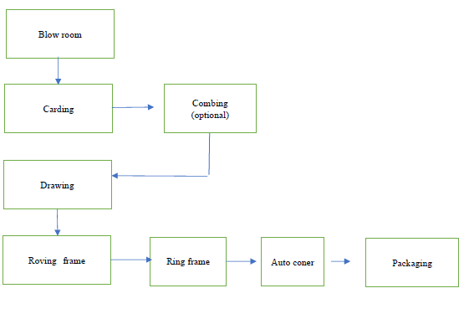

- PROJECT EXECUTION

4.1) SITE SETUP: -
The project site setup is as under: -
S. No | Particular | Status as on LIE 1st Visit
1 | Power | Available for construction
2 | Water | Available for construction
3 | Project Team | Available
4 | Timing | 8.00 a.m to 6.00 p.m
5 | Project Office Setup | Furniture and office Equipments etc.
6 | Staff | Recruitment ongoing
7 | Lighting | Flood Lights
8 | Labour Camp | Available
9 | Canteen | Available

OBSERVATIONS:-
The site setup is satisfactory. The photographs of site setup are provided for ready reference in Photograph Section.

4.2) COST OF THE PROJECT: -
Total estimated project cost is Rs. 7020.67 Lakhs as indicated in table provided below for ready reference.
S. No | Particular of Project | Estimated Project Cost (₹ in Lakhs) | % of Project Cost
1. | Land & Site Development | 0.00 | 0.00%
2. | Factory Building | 0.00 | 0.00%
3. | Plant & Machinery | 5265.69 | 75.00%
4. | Cost of GST on Plant & Machinery | 709.16 | 10.10%
5. | Pre-Operative Expenses | 100.00 | 1.42%
6. | Interest During Construction (IDC) | 130.82 | 1.86%
7. | Margin Money for Working Capital | 525.00 | 7.48%
8. | Contingencies | 290.00 | 4.13%
 | Total | 7020.67 | 100.00%
NOTE: -
- Land and Building is leased from DIPL. Cost of Land and Buildings is in the Scope of DIPL, therefor the same is not considered in the project cost.
- As per TEV Report total project cost is estimated at Rs. 7020.67 Lakhs.

MEANS OF FINANCE
(₹ in Lakhs)
S. No | Particular | Proposed
1 | Promoter Contribution | 900.00
2 | Term Loan | 4,700.00
3 | Unsecured Loans | 1,420.67
 | Total | 7,020.67

4.3) EXPENDITURE ON PROJECT: -
The expenditure on Cost on Project as on 15.11.2024 as per CA Certificate is as under: -
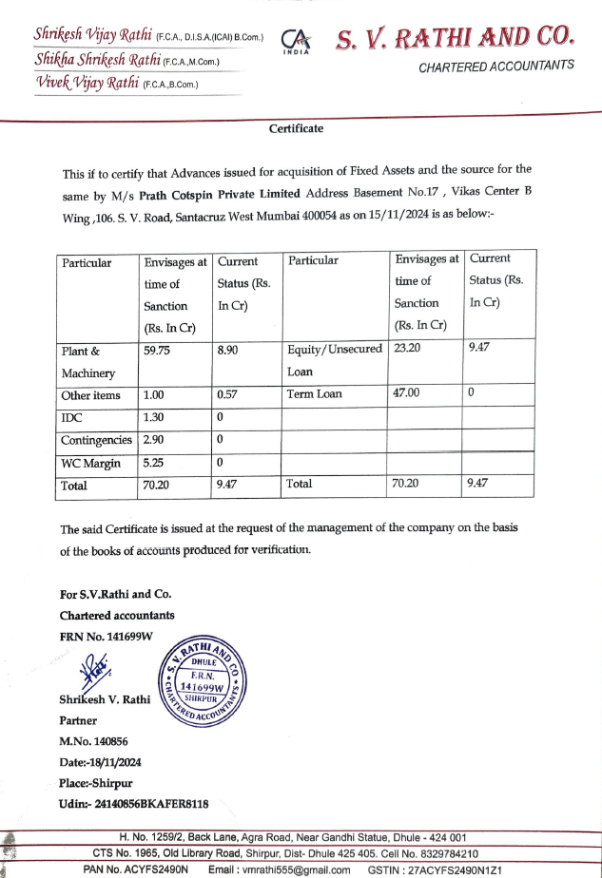
OBSERVATIONS: -
- The Total Cost incurred for the proposed project as per CA Certificate is Rs. 9.47 Crores.

4.4) SUMMARY OF TOTAL COST INCURRED TOWARDS PROJECT: -
Cost incurred towards Project Heat as per LIE is as under:-
S. No | Particular of Project | Estimated Project Cost  (₹ in Lakhs) | Cost incurred till 15.11.2024  (₹ in Lakhs)
1. | Land & Site Development | 0.00 | 0.00
2. | Factory Building | 0.00 | 0.00
3. | Plant & Machinery | 5265.69 | 890.00
4. | Cost of GST on Plant & Machinery | 709.16 | 0.00
5. | Pre-Operative Expenses | 100.00 | 57.09
6. | Interest During Construction (IDC) | 130.82 | 0.00
7. | Margin Money for Working Capital | 525.00 | 0.00
8. | Contingencies | 290.00 | 0.00
 | Total | 7020.67 | 947.09

OBSERVATIONS: -
- Proposed Factory Shed is under Construction.

- PHOTOGRAPHS

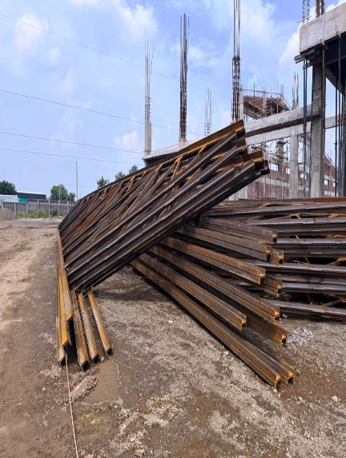
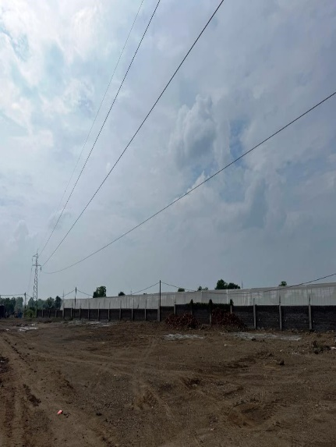
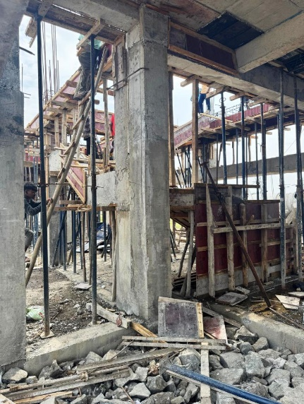
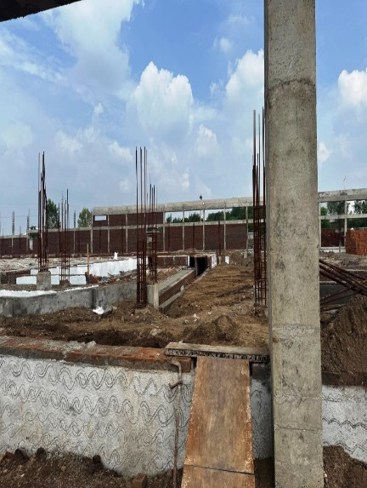
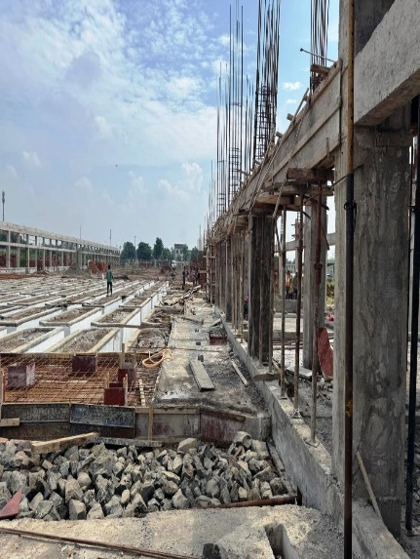
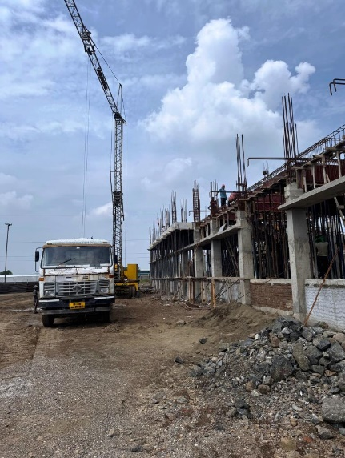
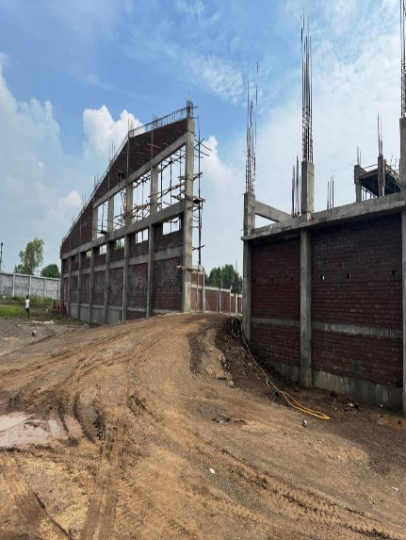
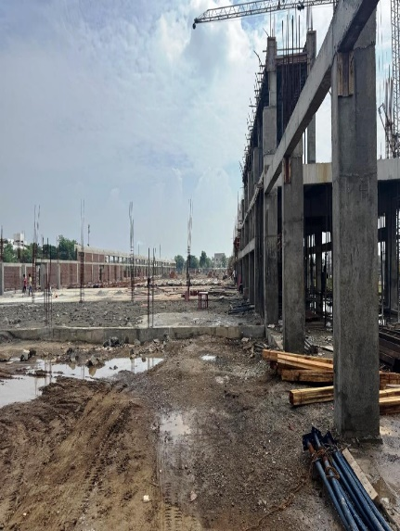
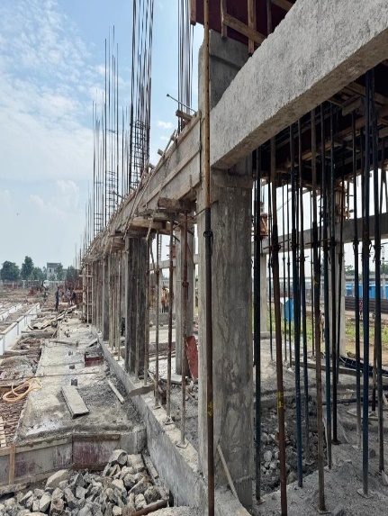
ACTUAL SITE PHOTOGRAPHS
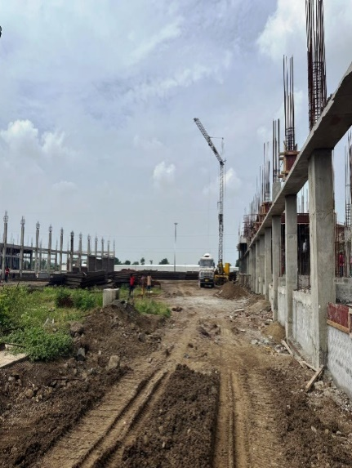
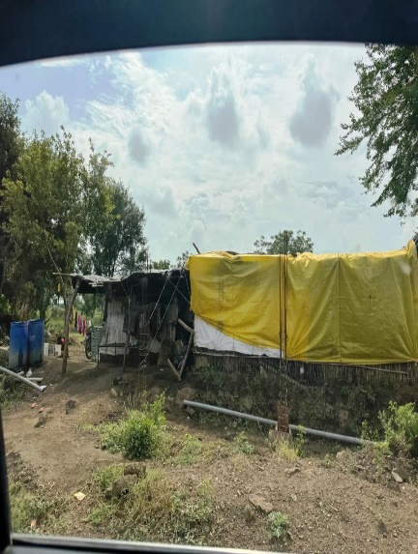
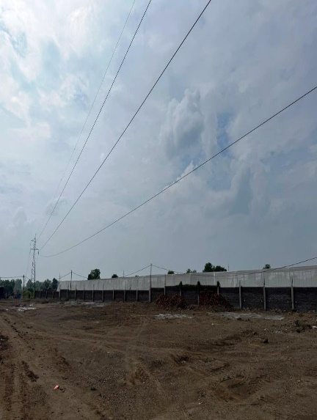
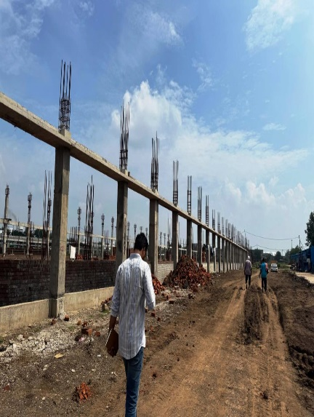
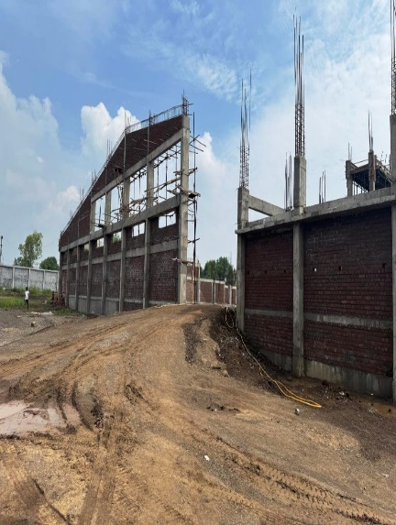
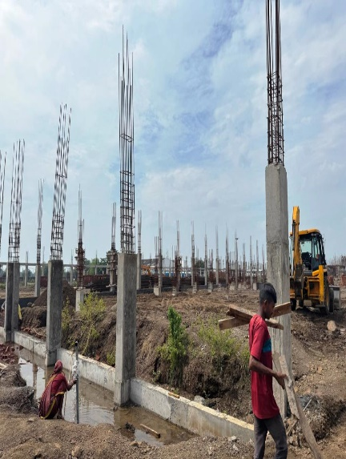
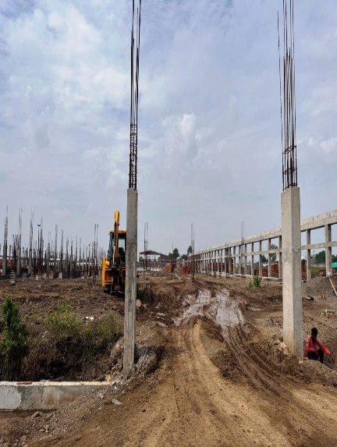
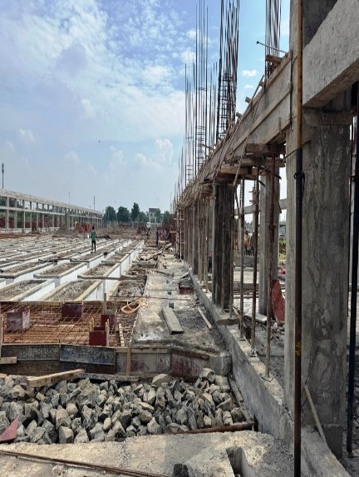
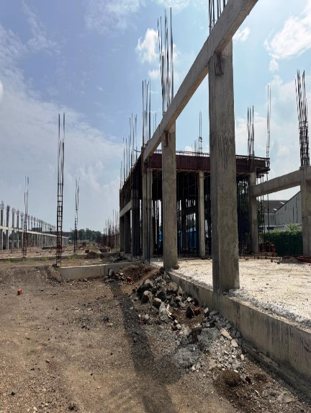
ACTUAL SITE PHOTOGRAPHS
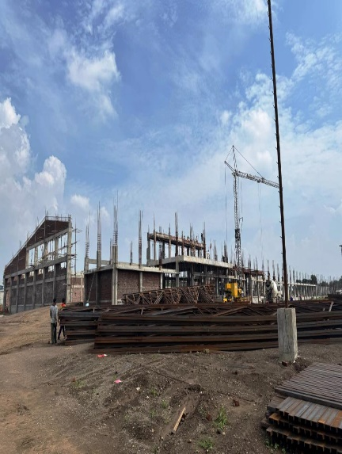
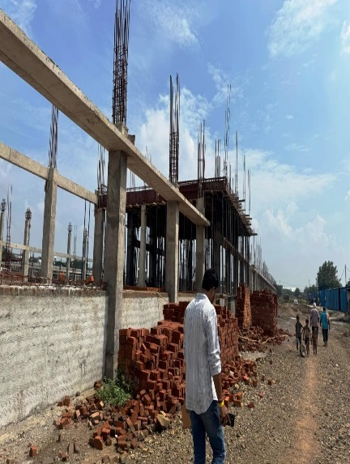
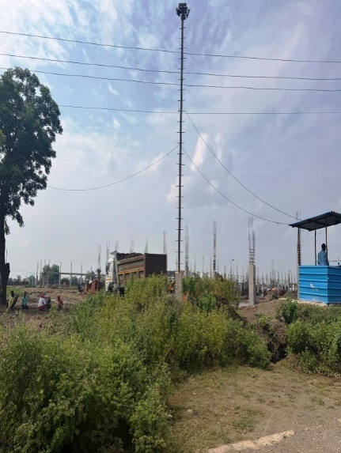
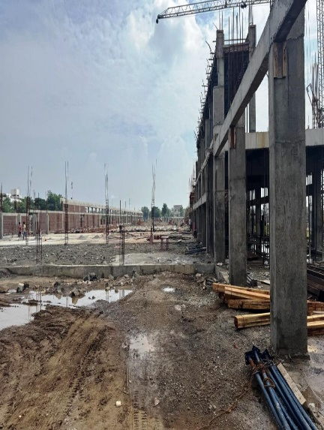
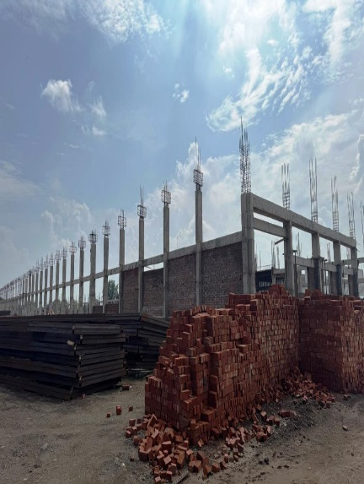
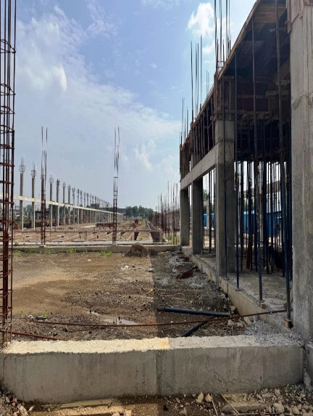
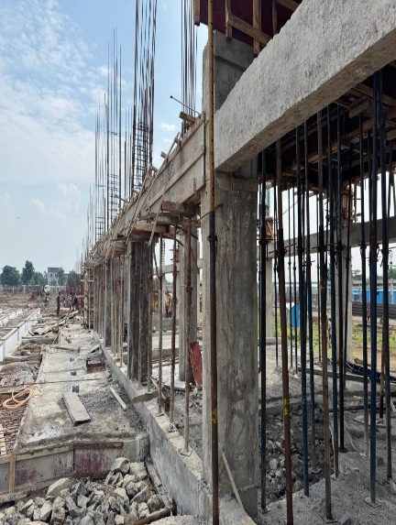
ACTUAL SITE PHOTOGRAPHS
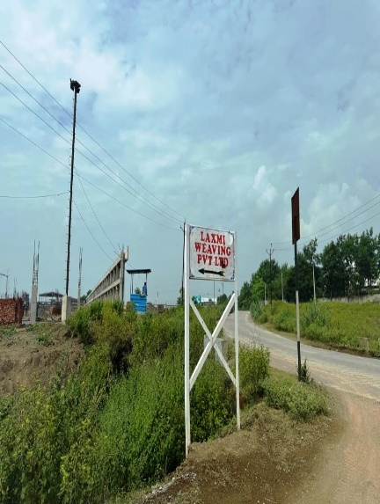
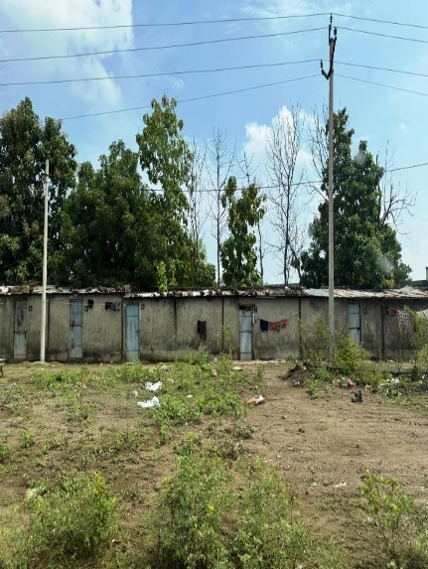
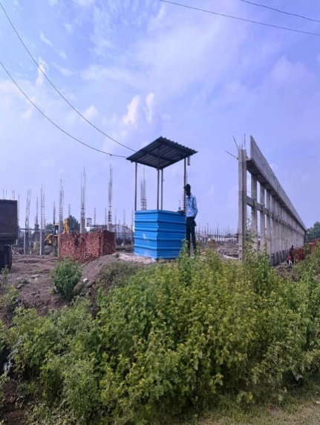
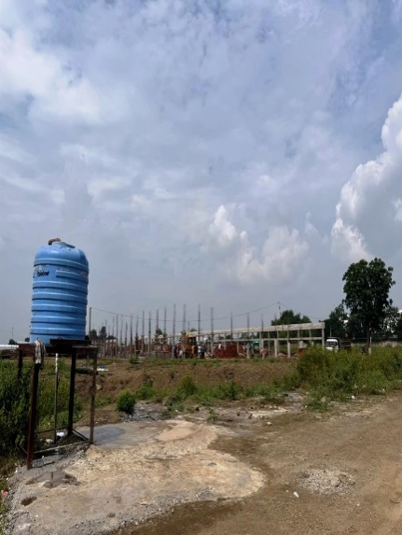
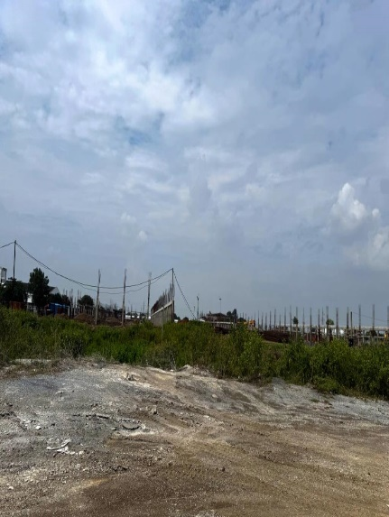
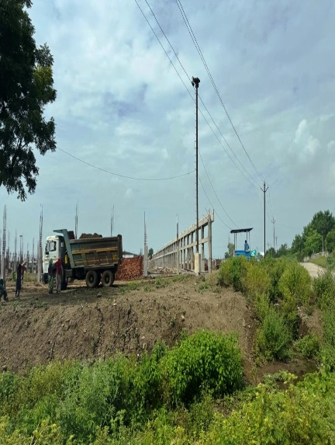
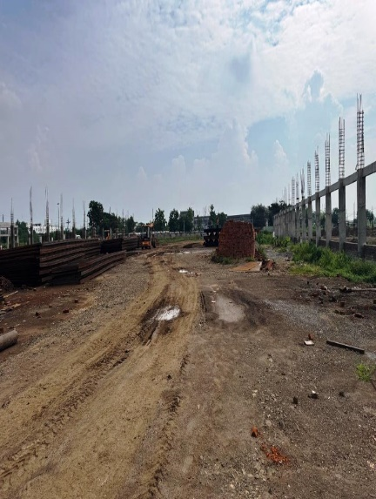
ACTUAL SITE PHOTOGRAPHS
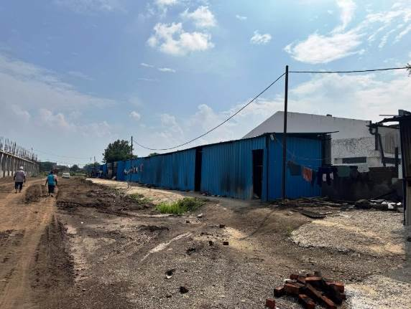
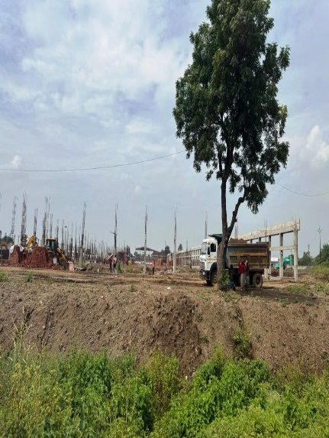
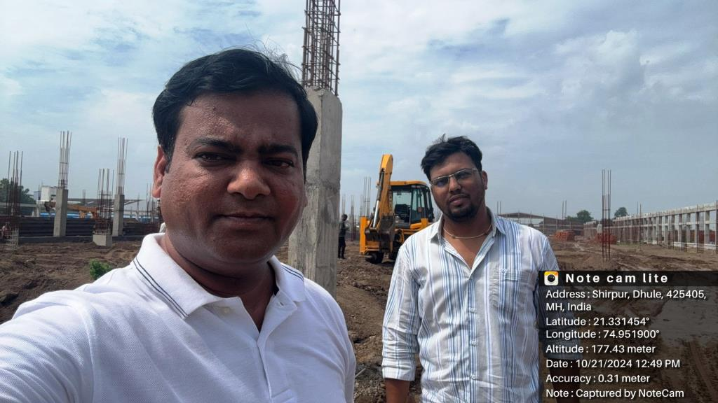
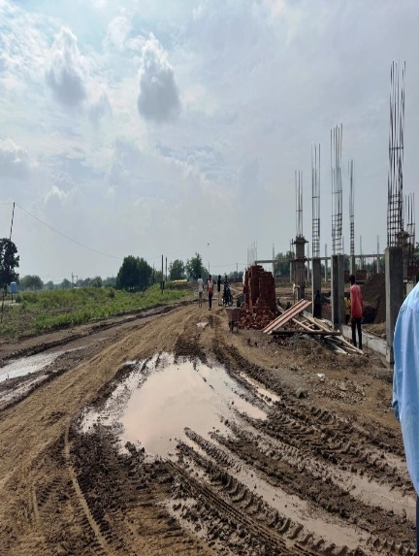
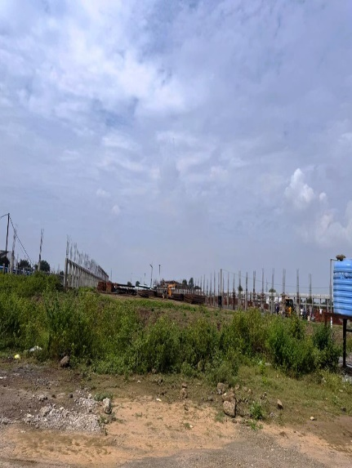
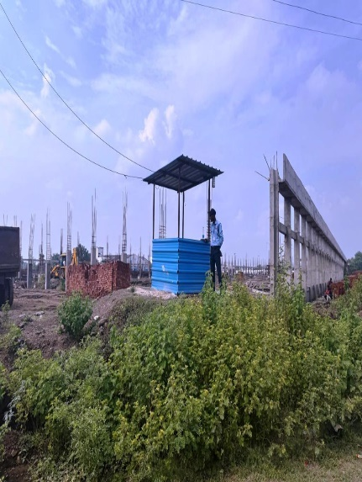

- NOTES, LIMITATIONS, DISCLAIMERS & CAVEATS

Notes, Limitations, Disclaimers & Caveats forms important part of the report.
- The Lender’s independent engineer report is made to review the progress of project activities and to prepare the detail report outlining all activities completed along with the status.
- Our Engineer has visited the project site of on 21.10.2024 with a view to ascertain and certify the quantity and amount of work progressively undertaken by the borrower.
- LIE progress report is based on the physical verification of the site on 21.10.2024, invoices provided, discussions held with the Directors of the Company and information and explanation given & documents provided. Accordingly, the percentage of work of completion of project activities is worked out. The photographs are enclosed.
- The Company has provided the necessary documents. LIE has referred the same for preparation of report.
- During the date and time of our visit to the project site, the execution of project activities like construction of Building, Foundation Work, Drainage and Road was going on and it can be clearly seen from the photographs enclosed.
- The Credit details in other bank accounts are not verified by us and we have relied on documents issued by the party.
- Our report does not cover verification of ownership, title clearance, or legality and subject to adequacy of engineering / structural design.
- Our report does not cover verification of ownership, title clearance, or legality and subject to adequacy of engineering / structural design. The report is delayed as compared with the visit date because of delay in receipt of documents.
- It should be noted that VCIPL’s project progress assessments are based upon the facts and evidence available at the time of assessment and the documents provided. The lenders should do the progress assessment from time to time.
- The legal documents pertaining to the ownership of the properties has been referred to on its face value and that is presumed that Bank /financer have got the same verified through its legal counsel. We do not certify the veracity of the documents. This report does not certify valid or legal or marketable title of any of the parties over the property. Our report does not cover verification of ownership, title clearance, or legality and subject to adequacy of engineering / structural design.
- Our report is only for the use of the party to whom it is addressed, and no responsibility is accepted to any third party for the whole or any part of its contents.
- It is presumed that the soft copies of documents are taken from the originals duly tested and verified at the party’s end.
- The progress report is made based on our visit, information furnished, discussions, documents made available at the time of visit. We presume optimistically that the project assessed by us will be a top success project. In case on a future date if the project does not come up to an expectation of the lenders and borrowers, due to various factors i.e., socio, economic and political factors in this region and country, any decrease in projections, profits, non-repayment of regular installments of loan and interest thereon, the VCIPL should not be held responsible on a future date. The market scenario in India at particular and the whole world at large is at volatile trend since last many months and future cannot be anticipated as of date.
- Our report should be read along with disclaimers. We have given our opinion as the percentage of work completion of the project as on date of visit to the project site.

- SUMMARY

7.1) WORK COMPLETION FOR THE PROJECT: -
Location wise the progress of the project is as under: -
S. No. | Activities | % of Work Completion
 | Project Documentation
1 | Detailed Project Report | 100%
 | Statutory Clearances
2 | Building Plan (initial approval) | 0%
3 | Pollution Control Board - Consent to establish | 100%
4 | Pollution Control Board - Consent to operate | 0%
5 | Power Sanction | 100%
6 | Insurance | 0%
7 | Bank Loan Sanction | 100%
8 | Disbursement – Term loan (Fund + non-Fund) | 0%
9 | Environment Clearance | 0%
10 | Fire NOC
11 | Factory License
 | Site Setup
12 | Office setup at Site | 50%
13 | Recruitment | Ongoing
 | Leasehold Building
14 | Foundation | 100%
15 | Flooring Work | 0%
16 | Brick Work | 0%
17 | Roof | 0%
18 | Finishing | 0%
 | Plant & Machinery
19 | Vendor Selection | 85%
20 | Purchase Order/ Contract | 85%
21 | Delivery | 0%
22 | Erection | 0%
23 | Installation | 0%
24 | Electrification | 0%
25 | Trials & Commissioning | 0%
 | Electrical Fittings
26 | Vendor Selection | 0%
27 | Purchase Order/ Contract | 0%
28 | Delivery | 0%
29 | Erection | 0%
30 | Installation | 0%
31 | Electrification | 0%
32 | Trials & Commissioning | 0%
 | Total Work Completed | 15%

7.2) DRAW DOWN SCHEDULE: -
The estimated draw down schedule is as under: -
(Rs. in Crores)
S. No. | Disbursement till | Total
 | Project Cost
1 | 01.12.2024 to 31.01.2025 | 27.23
2 | 01.02.2025 to 28.02.2025 | 14.00
3 | 01.03.2025 to 31.03.2025 | 5.77
 | Total | 47.00

OBSERVATIONS: -
- Company has not provided the revised Draw Down Schedule.

- OPINION

Based on the physical inspection and verification of project site, information and explanation given to us and the documents referred by us; we are of the opinion that the progress of proposed 14,400 Cotton Spinning Mill facility at Gat No. 59, Village-Dahiwad, Taluka-Shirpur, District Dhule, PIN Code-425 405, State- Maharashtra, County-India belonging to M/s. Prath Cotspin Pvt. Ltd. is 15 % completed as per our information provided by the party, observation made during LIE 1st visit to the project site on 21.10.2024 subject to observations made in the main report.
Date:-02.01.2025
Place:- Mumbai

For Vastukala Consultants (I) Pvt. Ltd.

Umang A Patel
Registered Valuer
Chartered Engineer (India)
Reg. No. IBBI/RV/04/2019/10803

