Valuation Report of the Immovable Property

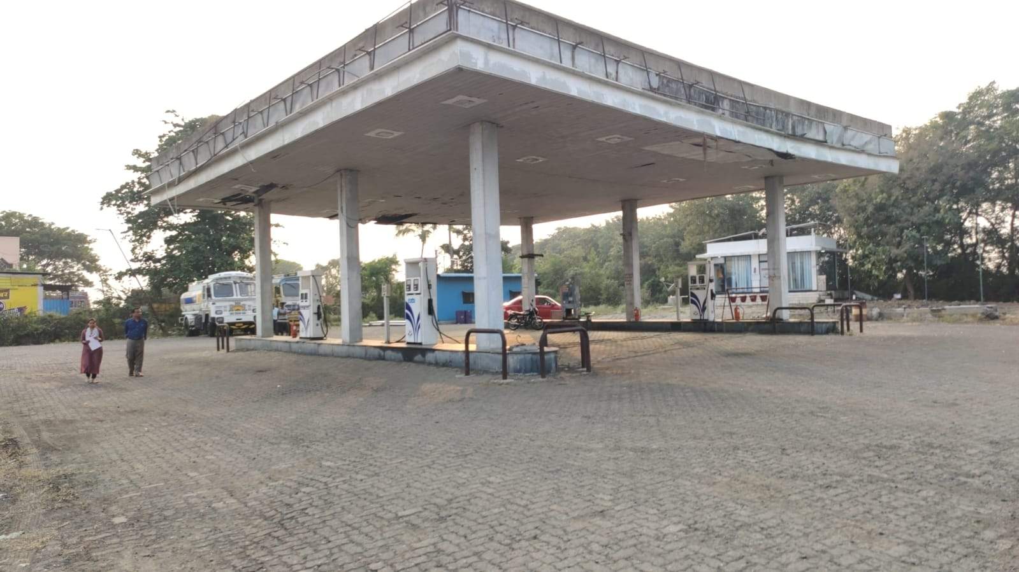

Details of the property under consideration:

Name of Client / Proposed Purchaser: Ms. Sujaya D/o Ashokrao Chavan

Name of Owner: Mr. Arun S/o Hanumant Ingewad

Commercial Land a part of Gut No. 30, Village - Babapur, Taluka – Ardhapur,
District - Nanded, PIN - 431 745, State - Maharashtra, India.

Longitude Latitude: 19°13'19.8"N 77°21'03.7"E

Intended Users

Ms. Sujaya D/o Ashokrao Chavan

Valuation Report: Pvt. / Ms. Sujaya D/o Ashokrao Chavan (13417 /2309439) Page 2 of 17

Vastu/Nanded/01/2025/13417/2309439
07/2-137-BHAK
Date: 02.01.2025

VALUATION OPINION REPORT

This is to certify that the property Commercial Land a part of Gut No. 30, Village - Babapur, Taluka – Ardhapur, District - Nanded, PIN - 431 745, State - Maharashtra, India belongs to Mr. Arun S/o Hanumant Ingewad. Name of Client / Proposed Purchaser is Ms. Sujaya D/o Ashokrao Chavan.

Boundaries of the property.

North | : | Agricultural land of Digambar Deshmukh
South | : | Agricultural land of Nagorao Deshmukh
East | : | National Highway No. NH361
West | : | Canal
Considering various parameters recorded, existing economic scenario, and the information that is available with reference to the development of neighbourhood and method selected for valuation, we are of the opinion that, the property premises can be assessed and valued for this particular purpose ` 38,40,720.00 (Rupees Thirty Eight Lakh Forty Thousand Seven Hundred Twenty Only).

The valuation of the property is based on the documents produced by the concern. Legal aspects have not been taken into considerations while preparing this valuation report.

Hence certified

Sharadkumar B. Chalikwar
B.E. (Civil), M.E. (Civil), M.Sc. (Real Estate Valuation)
M.Sc. (P&M Valuation), FIE (I), FIV, FIWRS
Chairman & Managing Director
Govt. Reg. Valuer Chartered Engineer (India)
Reg. No. (N) CCIT/1-14/52/2008-09 IBBI
Reg. No. IBBI/RV/07/2019/11744
Encl: Valuation report.

Vastukala Consultants (I) Pvt. Ltd.
B1-001, U/B Floor, Boomerang, Chandivali Farm Road, Powai, Andheri (East), Mumbai – 400 072

VALUATION REPORT
(IN RESPECT OF LAND)
I | General
1. | Purpose for which the valuation is made |  | : | To assess Fair market value of the property
2. | a) | Date of inspection | : | 31.12.2024
 | b) | Date on which the valuation is made | : | 02.01.2025
3. | List of documents produced for perusal
- Copy of Sauda Chitthee dated 02.08.2024 between Mr. Arun S/o Hanumant Ingewad (Seller) AND Ms. Sujaya D/o Ashokrao Chavan (Purchaser)
- Copy of 7/12 Extract
- Copy of Land Sale Permission Letter No. 2024 / BHUSU / AADI / 36 (2) / CR-36 dated 11.10.2024 issued by Nanded Collector Office
- Copy of Indenture of Lease dated 10.12.1997 between Shri. Hunumantrao Ramji Waghalekar (The Lessor) AND Hindustan Petrol Corporation Ltd. (The Lessee).
- Copy of N.A. Permission No. 1992 / L.N.D. / B / N.A./ CR – 1 dated 03.03.1995 issued by Sub- Divisional Officer, Nanded.
- Copy of Site Layout Plan of Saikrupa HPCL petrol pump
- Copy of Mulaykan Letter No. 2024/Mulayakan/6606 dated 15.05.2024
4. | Name of the owner(s) and his / their address (es) with Phone no.  (Details of share of each owner in case of joint ownership) |  | : | Name of Client / Proposed Purchaser:  Ms. Sujaya D/o Ashokrao Chavan  R/o. Anand Nilayam, Shivaji Nagar,  Nanded-431602  Maharashtra, India  Contact No .8369034386  Aadhar No. 4707 9992 5901  Name of Owner:  Mr. Arun S/o Hanumant Ingewad  R/o Waghala Taluka & Dist Nanded  Maharashtra, India  Aadhar no. 5430 8322 9227  Sole Ownership
 | Persons present at the time of inspection |  |  | Mr. Sandeep Patil  Contact No. 9890479550  Mr. Shivaji Gire (Employee)  Contact No. 91127 17999
5. | Brief description of the property  (Including Leasehold / freehold etc.) |  | : | The subject property under valuation is freehold piece of commercial NA land in Village Babapur S.No. / G. No. 30, Taluka Ardhapur Dist Nanded The area of land is 3693.00 Sqm. The land is fronting on NH-361 national highway in developing area of village Babapur, well connected by road and train. It is located at about 11 Km. from Nanded Station.  The demised property under valuation is a Freehold tribal land owned by Lessor Mr. Arun S/o Hanumant Ingewad.  Ms.Sujaya D/o Ashokrao Chavan non-tribal has agreed to purchase the commercial land under Rule 36(A) of MLR 1966.  The Collector Nanded has accorded the permission for sale vide letter no. 2024/BhuSu/Adi/3692)/CR-36 dated 11.10.2024.  It is a commercial land Known as “Saikrupa Petroleum”, HPCL Petroleum Outlet being used by Lessee Hindustan Petrol Corporation Ltd. on lease basis starting from 01.03.1995 and ending on 28.02.2024. Now the lease has been expired. The land is having the structures required for Petrol pump & its related ancillary activities.  Since the structures are constructed and developed by the Lessee HPCL, the cost of structures is not considered for valuation.
6. | Location of property |  | :
 | a) | Plot No. / Survey No. | : | A part of Gut No. 30
 | b) | Door No. | : | Not applicable
 | c) | T.S. No. / Village | : | Village - Babapur
 | d) | Ward / Taluka | : | Taluka – Ardhapur
 | e) | Mandal / District | : | District –Nanded
7. | Postal address of the property |  | : | Saikrupa Petroleum, Gut No. 30, Village - Babapur, Taluka – Ardhapur, District - Nanded, PIN - 431 745, State - Maharashtra, India.
8. | City / Town |  | : | Nanded
 | Residential area |  | : | No
 | Commercial area |  | : | Yes
 | Industrial area |  | : | No
9. | Classification of the area |  | :
 | i) High / Middle / Poor |  | : | Middle Class
 | ii) Urban / Semi Urban / Rural |  | : | Rural
10. | Coming under Corporation limit / Village Panchayat / Municipality |  | : | Village - Babapur, Taluka – Ardhapur, District - Nanded
11. | Whether covered under any State / Central Govt. enactments (e.g., Urban Land Ceiling Act) or notified under agency area/ scheduled area / cantonment area |  | : | Tribal Land
12. | In Case it is Agricultural land, any conversion to house site plots is contemplated |  | : | Commercial NA Land  NA Order No. 1992/LND/B/N/CR-1, Sub-Divisional Officer, Nanded Dated 3-3-1995
13. | Boundaries of the property |  |  | Actual |  | As per document
 | North |  | : | Agricultural land of Digambar Deshmukh |  | Agricultural land of Digambar Deshmukh
 | South |  | : | Agricultural land of Nagorao Deshmukh |  | Agricultural land of Nagorao Deshmukh
 | East |  | : | National Highway No. NH361 |  | Nanded – Akola Road
 | West |  | : | Canal |  | Canal
14 | Dimensions of the site
 | North |  | : | As per Site Layout Plan
 | South |  | :
 | East |  | :
 | West |  | :
15 | Latitude, Longitude & Co-ordinates of property |  | : | 19°13'19.8"N 77°21'03.7"E
16 | Extent of the site |  | : | 3,693.00 Sqm.
17 | Whether occupied by the owner / tenant? If occupied by tenant since how long? Rent received per month. |  | : | Occupied by Lessee HPCL
 |  |  |  | Period |  |  | Rent per month in Rs
 |  |  |  | From | To
 |  |  |  | 01.03.1995 | 28.02.2005 |  | 3,500.00
 |  |  |  | 01-03-2005 | 28.02.2015 |  | 4,000.00
 |  |  |  | 01.03.2015 | 28.02.2024 |  | 5,000.00
II | CHARACTERISTICS OF THE SITE
 | Classification of locality |  | : | Middle class
 | Development of surrounding areas |  | : | Normal
 | Possibility of frequent flooding/ sub-merging |  | : | No
 | Feasibility to the Civic amenities like School, Hospital, Bus Stop, Market etc. |  | : | All available near by
 | Level of land with topographical conditions |  | : | Plain
 | Shape of land |  | : | Irregular
 | Type of use to which it can be put |  | : | Commercial land
 | Any usage restriction |  | : | Commercial use
 | Is plot in town planning approved layout? |  | : | Yes
 | Corner plot or intermittent plot? |  | : | Intermittent
 | Road facilities |  | : | Yes
 | Type of road available at present |  | : | B.T. Road
 | Width of road – is it below 20 ft. or more than 20 ft. |  | : | More 20 ft.
 | Is it a Land – Locked land? |  | : | No
 | Water potentiality |  | : | Yes
 | Underground sewerage system |  | : | Yes
 | Is Power supply is available in the site |  | : | Yes
 | Advantages of the site |  | : | Located in developing area
 | Special remarks, if any like threat of acquisition of land for publics service purposes, road widening or applicability of CRZ provisions etc.(Distance from sea-cost / tidal level must be incorporated) |  | : | No
Part – A (Valuation of land)
1 | Total extent of the plot  ((Area as per 7/12 Extract)) |  | : | 3,693.00 Sq. M.
2 | Prevailing market rate per Sqm |  | : | ` 1,040.00
3 | Government Ready Reckoner Rates per Sqm |  | : | ` 1,040.00
4 | Assessed / adopted rate of valuation |  | : | ` 1,040.00
6 | Value of land |  | : | ` 38,40,720.00
 | Total Estimated Value of Land |  | : | ` 38,40,720.00
Part – B (Valuation of Building)
1 | Technical details of the building |  | :
 | - Type of Building (Residential / Commercial / Industrial) |  | : | N.A., The property under consideration is only open land.
 | - Type of construction (Load bearing / RCC / Steel Framed) |  | : | N.A., The property under consideration is only open land.
 | - Year of construction |  | : | N.A., The property under consideration is only open land.
 | - Number of floors and height of each floor including basement, if any |  | : | N.A., The property under consideration is only open land.
 | - Plinth area floor-wise |  | : | N.A., The property under consideration is only open land.
 | - Condition of the building |  | :
 | - Exterior – Excellent, Good, Normal, Poor |  | : | N.A., The property under consideration is only open land.
 | - Interior – Excellent, Good, Normal, Poor |  | : | N.A., The property under consideration is only open land.
 | - Date of issue and validity of layout of approved map |  | : | N.A., The property under consideration is only open land.
 | - Approved map / plan issuing authority |  | :
 | - Whether genuineness or authenticity of approved map / plan is verified |  | : | N.A., The property under consideration is only open land.
 | - Any other comments by our empaneled Valuers on authentic of approved plan |  | : | No

Specifications of construction (floor-wise) in respect of

Sr.  No. | Description
 | Foundation | : | N.A., The property under consideration is only plot of land.
 | Basement | :
 | Superstructure | :
 | Joinery / Doors & Windows (Please furnish details about size of frames, shutters, glazing, fitting etc. and specify the species of timber | :
 | RCC Works | :
 | Plastering | :
 | Flooring, Skirting, dado | :
 | Special finish as marble, granite, wooden paneling, grills etc. | :
 | Roofing including weather proof course | :
 | Drainage | :
2. | Compound Wall | :
 | Height | : | Wire Fencing
 | Length | :
 | Type of construction | :
3. | Electrical installation | :
 | Type of wiring | : | 4 points, Solar System provided
 | Class of fittings (superior / ordinary / poor) | :
 | Number of light points | :
 | Fan points | :
 | Spare plug points | :
 | Any other item | :
4. | Plumbing installation
 | - No. of water closets and their type | : | N.A., The property under consideration is only plot of land.
 | - No. of wash basins | :
 | - No. of urinals | :
 | - No. of bath tubs | :
 | - Water meters, taps etc. | :
 | - Any other fixtures | :

B - Structure

S. No | Particulars of item | Built up Area In | Age of building | Estimated replacement rate of construction | Replacement cost | Depreciation | Net Value after depreciation
 |  | (Sq. M) |  | (`) | (`) | (`) | (`)
Nil

Part – C (Extra Items) |  | : | Amount in `
 | Portico | : | N.A., The property under consideration is only plot of land.
 | Ornamental front door | :
 | Sit out / Verandah with steel grills | :
 | Overhead water tank | :
 | Extra steel / collapsible gates | :
 | Total

Part – D (Amenities) |  | : | Amount in `
 | Wardrobes | : | N.A., The property under consideration is only plot of land.
 | Glazed tiles | :
 | Extra sinks and bath tub | :
 | Marble / ceramic tiles flooring | :
 | Interior decorations | :
 | Architectural elevation works
 | Paneling works
 | Aluminum works
 | Aluminum hand rails
 | False ceiling
 | Total

Part – E (Miscellaneous) |  | : | Amount in `
 | Separate toilet room | : | N.A., The property under consideration is only plot of land.
 | Separate lumber room | :
 | Separate water tank / sump | :
 | Trees, gardening | :
 | Total

Part – F (Services) |  | : | Amount in `
 | Water supply arrangements | : | N.A., The property under consideration is only plot of land.
 | Drainage arrangements | :
 | Compound wall | :
 | C.B. deposits, fittings etc. | :
 | Pavement
 | Total

Government Value

Particulars | Area in Sq. M. | Rate in ` | Value in `
Land | 3,693.00 | 1,040.00 | 38,40,720.00
Total |  |  | 38,40,720.00
Govt Value as per the Collectorate Stamps Letter No. 6606 dated 05.05.2024 |  |  | 24,56,325.00

Total abstract of the entire property

Part – A | Land | : | 38,40,720.00
Part – B | Structure | : | -
Part – C | Extra Items | : | -
Part - D | Amenities | : | -
Part – E | Miscellaneous | : | -
Part – F | Services | : | -
 | Fair Market Value | : | ` 38,40,720.00
Remarks

Land cost can be estimated using the Sales Comparison Approach by studying recent sales of land close to the subject property, and these sales should be comparable in size and location with subject property. As the property is a Commercial land, we have adopted Sales Comparison Approach Method for the purpose of valuation. The Price for similar type of property in the nearby vicinity is in the range of ` 1,000.00 to ` 1,600.00 per Sq. M. for land Considering the rate with attached report, current market conditions, demand and supply position, Land size, location, sustained demand for Commercial Plot, all round development of commercial application in the locality etc. We estimate ` 1,040.00 per Sq. M. for Land for valuation which is fair and reasonable.

The salability of the property is: Normal
Likely rental values in future in: ` 50,000.00 expected rental income per month
Any likely income it may generate: Rental Income and revenue from Sales from petroleum products.

Actual Site Photographs

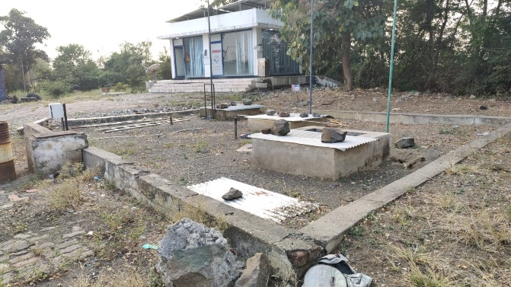
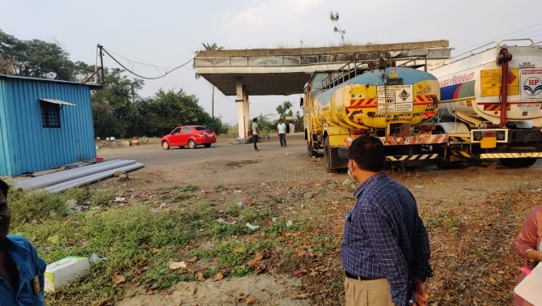
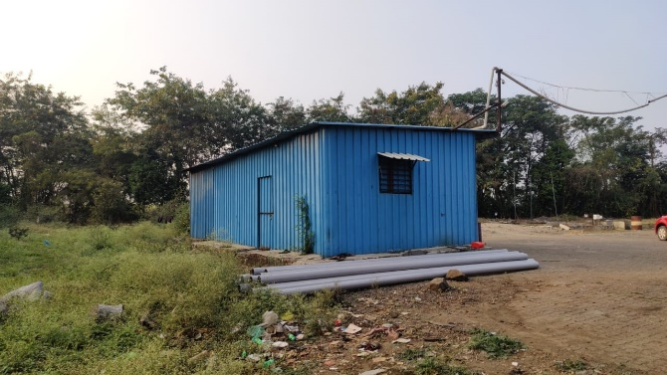
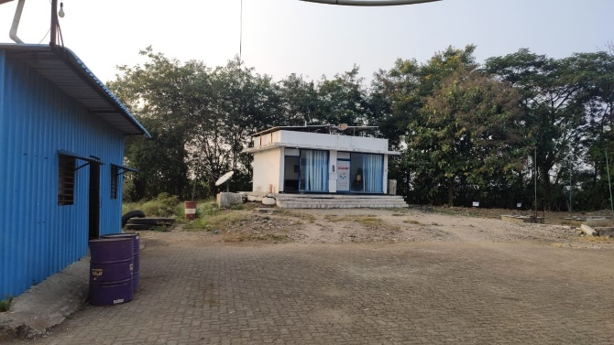
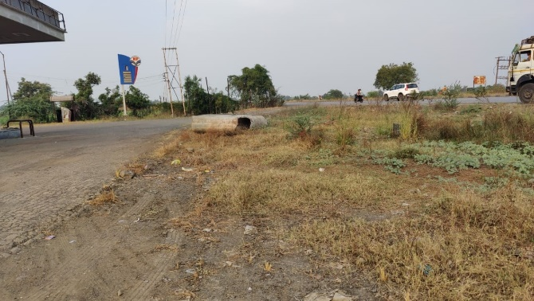
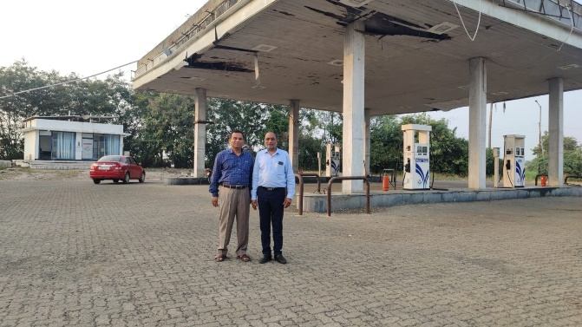
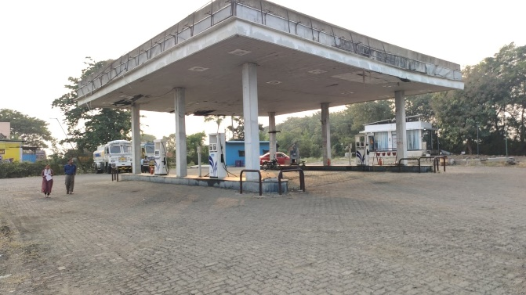
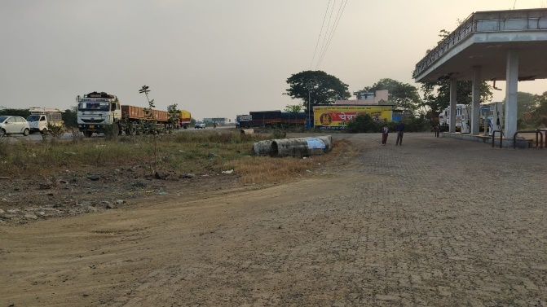

Route Map of the property
Site u/r
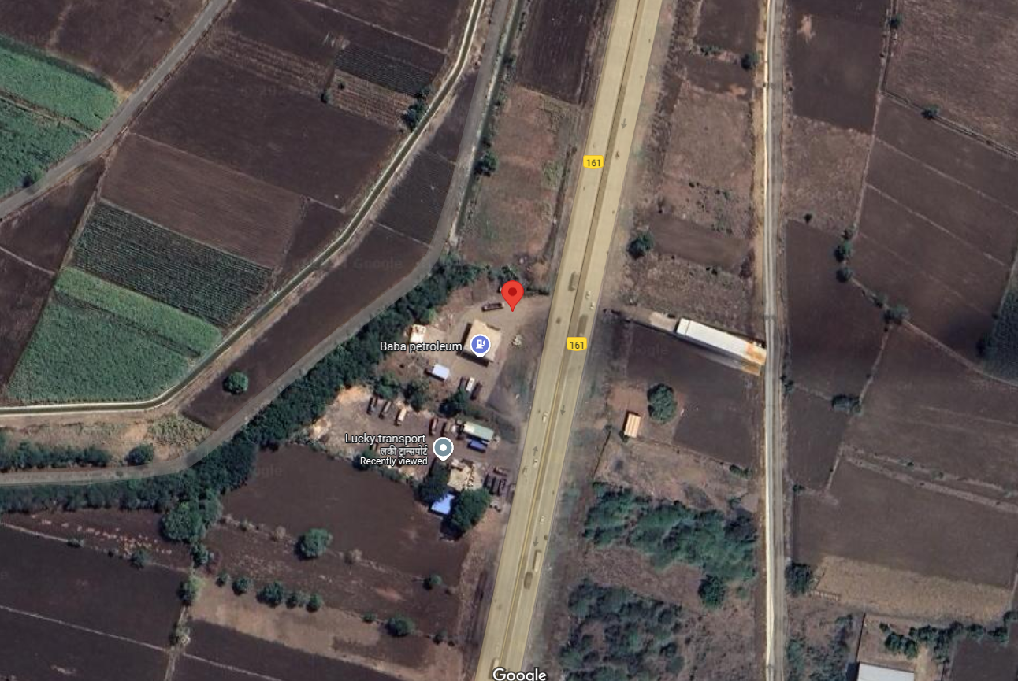

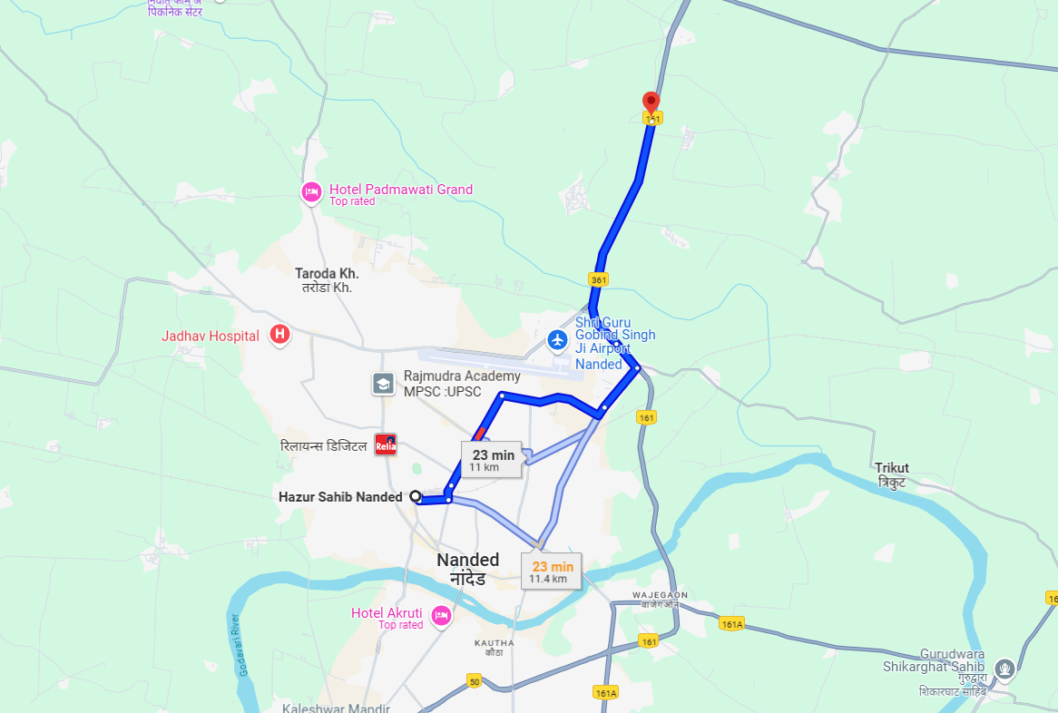

Longitude Latitude: 19°13'19.8"N 77°21'03.7"E

Note: The Blue line shows the route to site from nearest Metro (Nanded – 11 KM.)

Government Ready Reckoner Rate
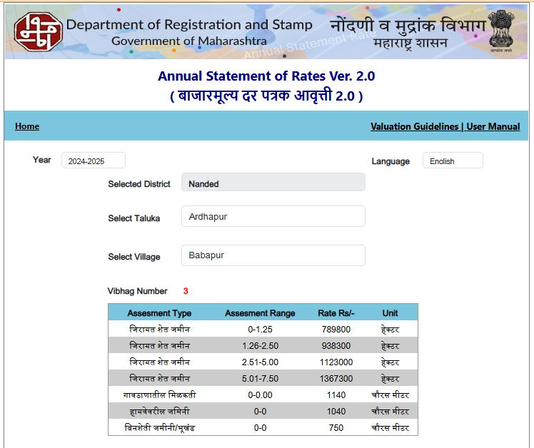

As a result of my appraisal and analysis, it is my considered opinion that Fair Market Value of the above property in the prevailing condition with aforesaid specification is ` 38,40,720.00 (Rupees Thirty Eight Lakh Forty Thousand Seven Hundred Twenty Only).

Place: Nanded
Date: 02.01.2025

Sharadkumar B. Chalikwar
B.E. (Civil), M.E. (Civil), M.Sc. (Real Estate Valuation)
M.Sc. (P&M Valuation), FIE (I), FIV, FIWRS
Chairman & Managing Director
Govt. Reg. Valuer Chartered Engineer (India)
Reg. No. (N) CCIT/1-14/52/2008-09 IBBI
Reg. No. IBBI/RV/07/2019/11744

 | Particulars | Valuer comment
 | Background information of the asset being valued | The land is Owned by Mr. Arun S/o Hanumant Ingewad. Name of Client / Proposed Purchaser is Ms. Sujaya D/o Ashokrao Chavan.
 | Purpose of valuation and appointing authority | As per the request from Private Client to assess Fair market value of the property.
 | Identity of the Valuer and any other experts involved in the valuation; | Sharadkumar B. Chalikwar – Regd. Valuer  Akhilesh Yadav – Technical Manager  Bhavika Chavan – Technical Officer
 | Disclosure of Valuer interest or conflict, if any; | We have no interest, either direct or indirect, in the property valued. Further to state that we do not have relation or any connection with property owner / applicant directly or indirectly. Further to state that we are an independent Valuer and in no way related to property owner / applicant
 | Date of appointment, valuation date and date of report; | Date of Appointment – 31.12.2024  Valuation Date – 02.01.2025  Date of Report – 02.01.2025
 | Inspections and/or investigations undertaken; | Physical Inspection done on date 31.12.2024
 | Nature and sources of the information used or relied upon; | Market Survey at the time of site visit  Ready Reckoner rates / Circle rates  Enquiries with Real estate consultants  Existing data of Valuation assignments carried out by us
 | Procedures adopted in carrying out the valuation and valuation standards followed; | Comparative Sales Method
 | Restrictions on use of the report, if any; | This valuation is for the use of the party to whom it is addressed and for no other purpose. No responsibility is accepted to any third party who may use or rely on the whole or any part of this valuation. The valuer has no pecuniary interest that would conflict with the proper valuation of the property.
- . | Major factors that were taken into account during the valuation; | Current market conditions, demand and supply position, land size, location, sustained demand for such land, all round development of commercial application in the locality etc.
 | Caveats, limitations and disclaimers to the extent they explain or elucidate the limitations faced by valuer, which shall not be for the purpose of limiting his responsibility for the valuation report. | Attached

ASSUMPTIONS, CAVEATS, LIMITATION AND DISCLAIMERS
1. We assume no responsibility for matters of legal nature affecting the property appraised or the title thereto, nor do we render our opinion as to the title, which is assumed to be good and marketable.
2. The property is valued as though under responsible ownership.
3. It is assumed that the property is free of liens and encumbrances.
4. It is assumed that there are no hidden or unapparent conditions of the subsoil or structure that would render it more or less valuable. No responsibility is assumed for such conditions or for engineering that might be required to discover such factors.
5. There is no direct/ indirect interest in the property valued.
6. The rates for valuation of the property are in accordance with the Govt. approved rates and prevailing market rates.

DEFINITION OF VALUE FOR THIS SPECIFIC PURPOSE

This exercise is to assess Value of the property under reference as on 02nd January 2025.

The term Fair Market Value is defined as

“The most probable price, as of a specified date, in cash, terms equivalent to cash, or in other precisely revealed terms for which the specified property rights would sell after reasonable exposure in a competitive market under all conditions requisite to a fair sale, with the buyer and seller each acting prudently knowledgeably and for self-interest assuming that neither is under undue duress”.
Fundamental assumptions and conditions presumed in this definition are:
1. Buyer and seller are motivated by self-interest.
2. Buyer and seller are well informed and are acting prudently.
3. The property is exposed for a reasonable time on the open market.
4. Payment is made in cash or equivalent or in specified financing terms.
DECLARATION OF PROFESSIONAL FEES CHARGED

We hereby declare that, our professional fees are not contingent upon the valuation findings. However, if the statute AND/OR clients demands that, the fees should be charged on the percentage of assessed value then, with the full knowledge of the AND/OR end user, it is being charged accordingly.

VALUATION OF THE PROPERTY PREMISES

Considering various parameters recorded, existing economic scenario, and the information that is available with reference to the development of neighborhood and method selected for valuation, we are of the opinion that, the property premises can be assessed and valued for this particular purpose at ` 38,40,720.00 (Rupees Thirty Eight Lakh Forty Thousand Seven Hundred Twenty Only).

Sharadkumar B. Chalikwar
B.E. (Civil), M.E. (Civil), M.Sc. (Real Estate Valuation)
M.Sc. (P&M Valuation), FIE (I), FIV, FIWRS
Chairman & Managing Director
Govt. Reg. Valuer Chartered Engineer (India)
Reg. No. (N) CCIT/1-14/52/2008-09 IBBI
Reg. No. IBBI/RV/07/2019/11744
Encl: Property Documents
7/12 Extracts
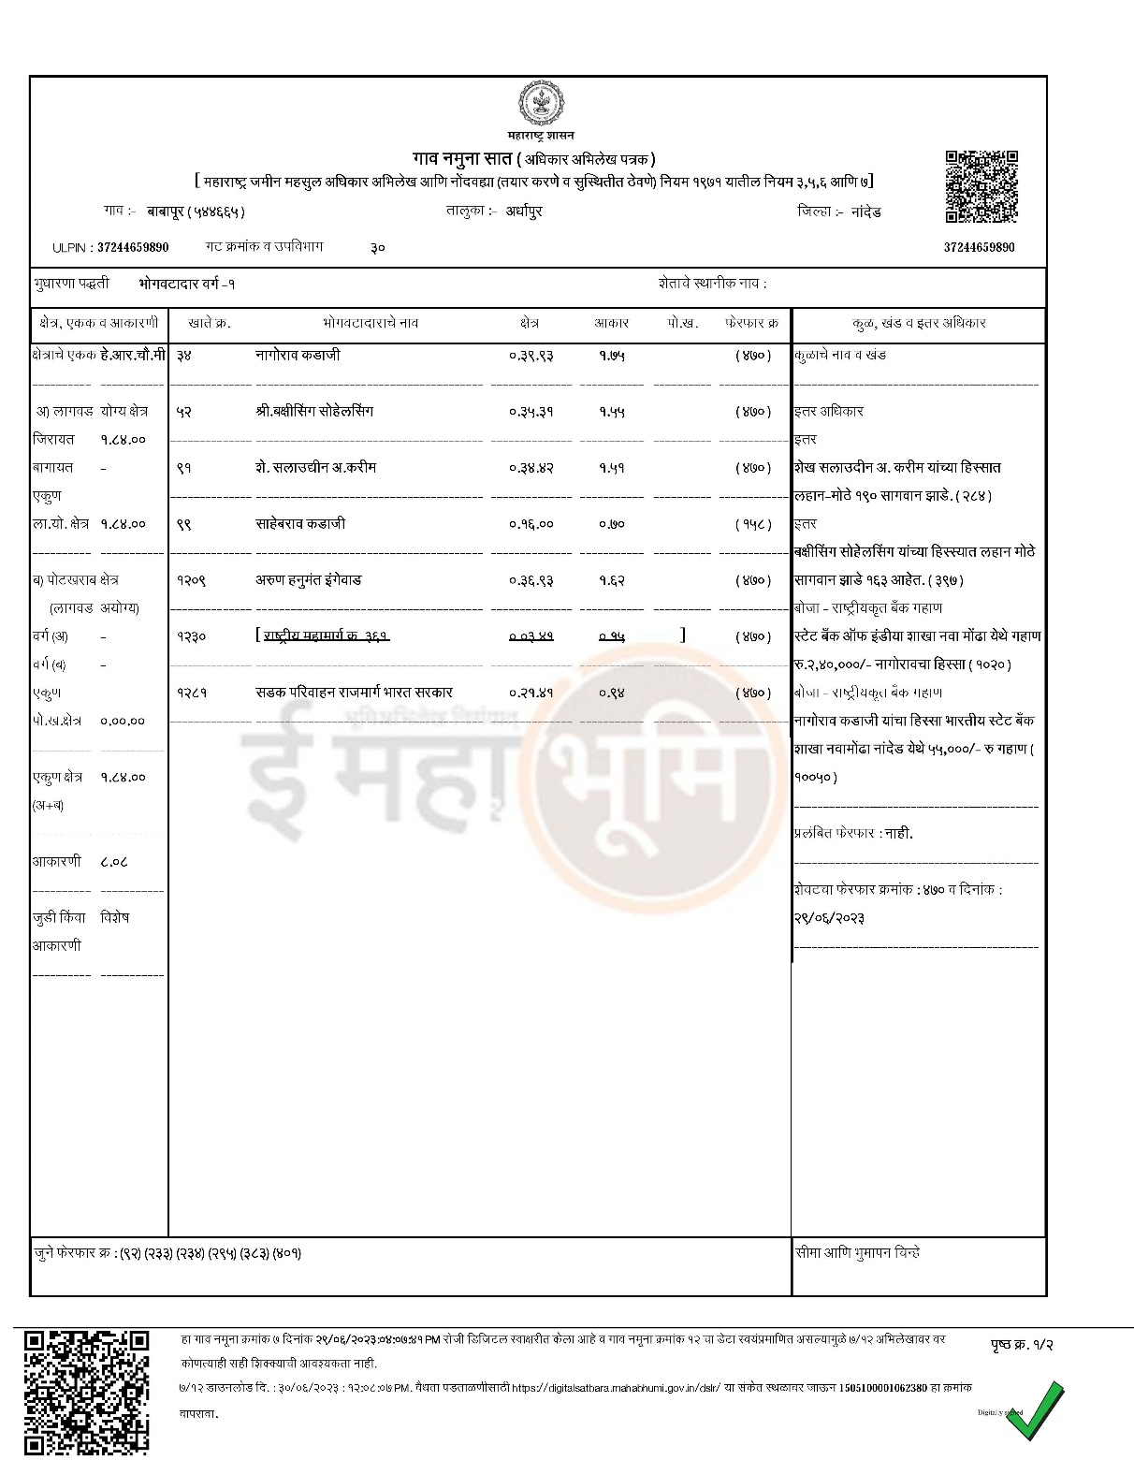
Sauda Chitthee

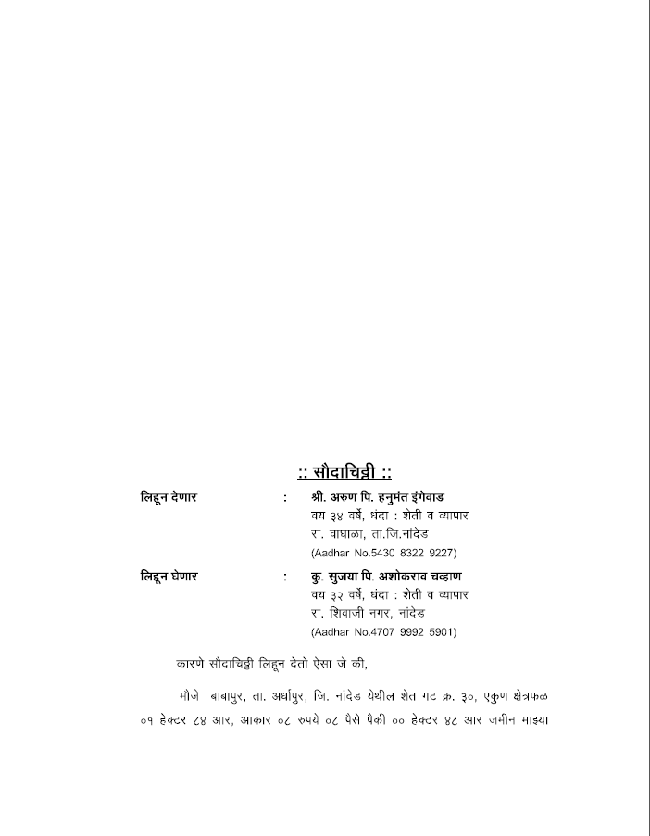

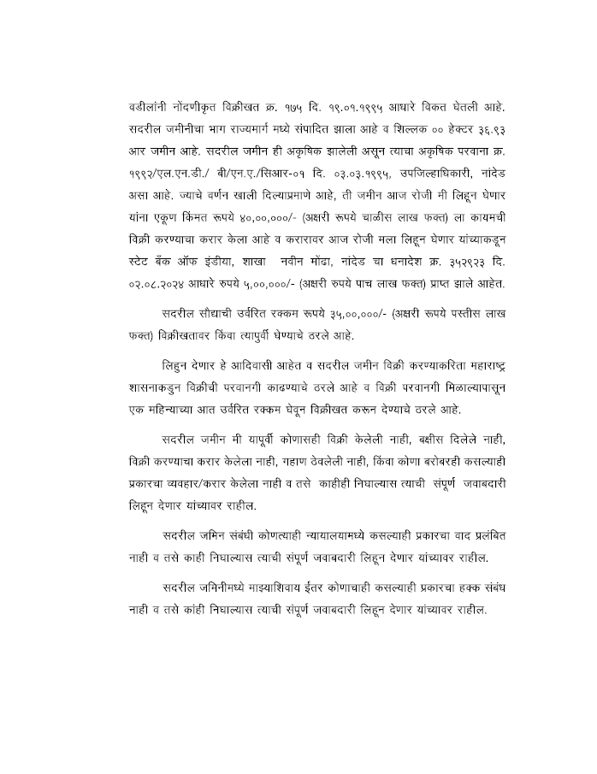

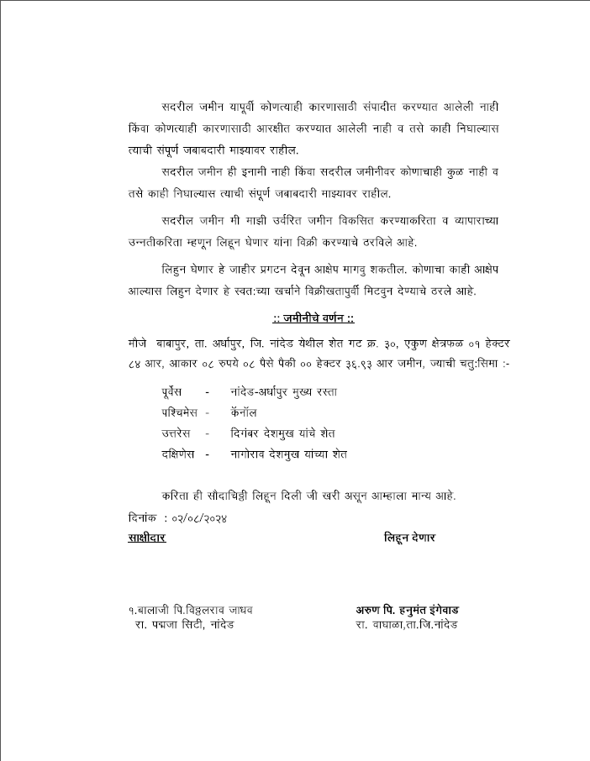



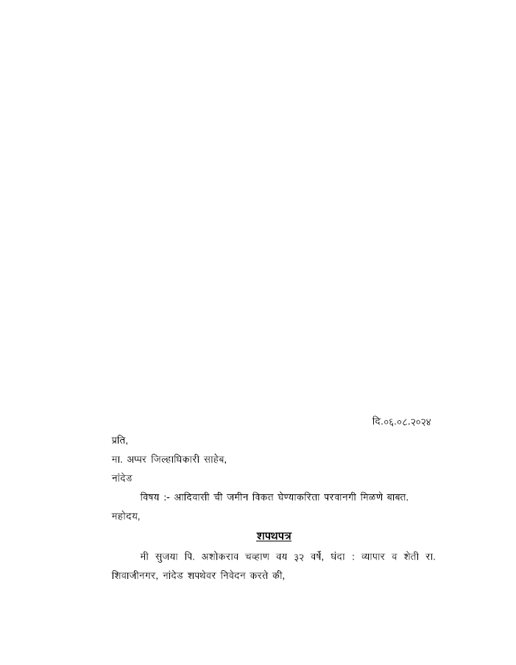

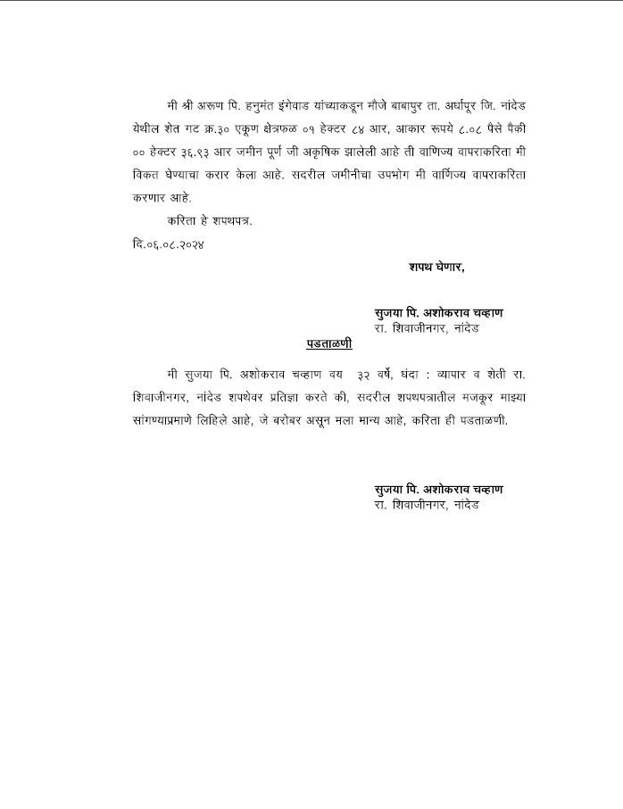

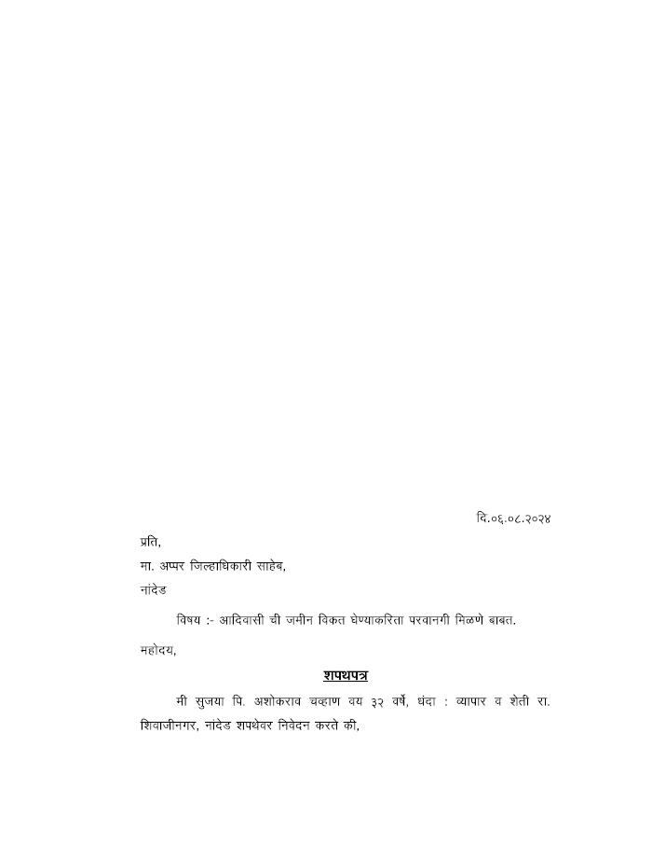

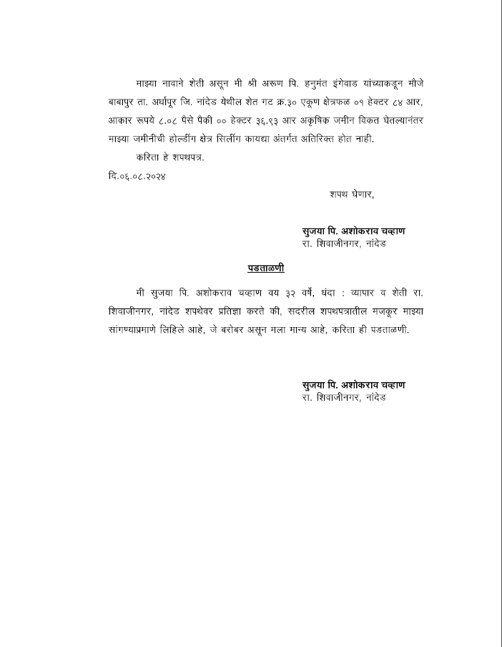

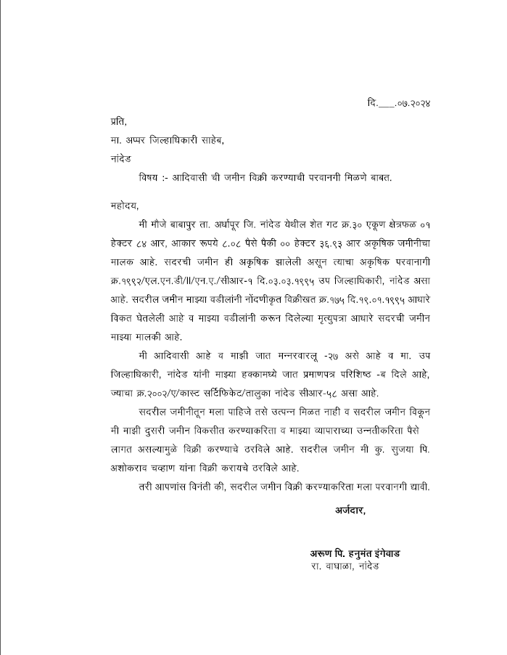

N.A. Permission
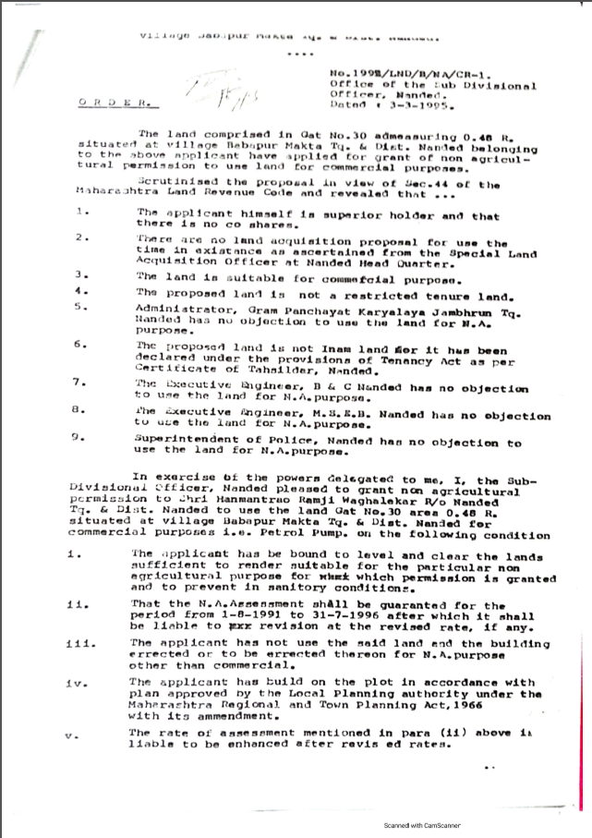

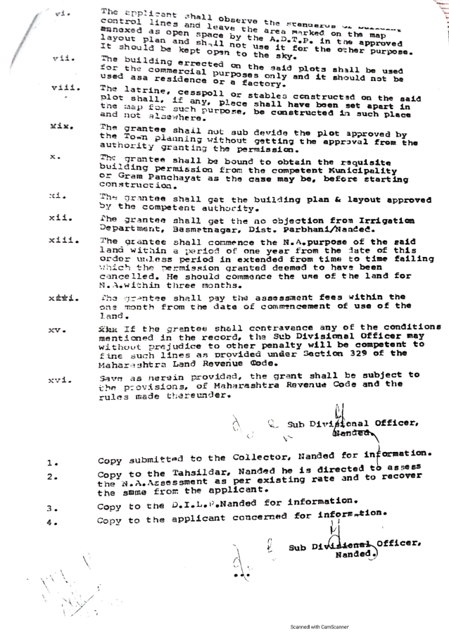

Land Sale Permission

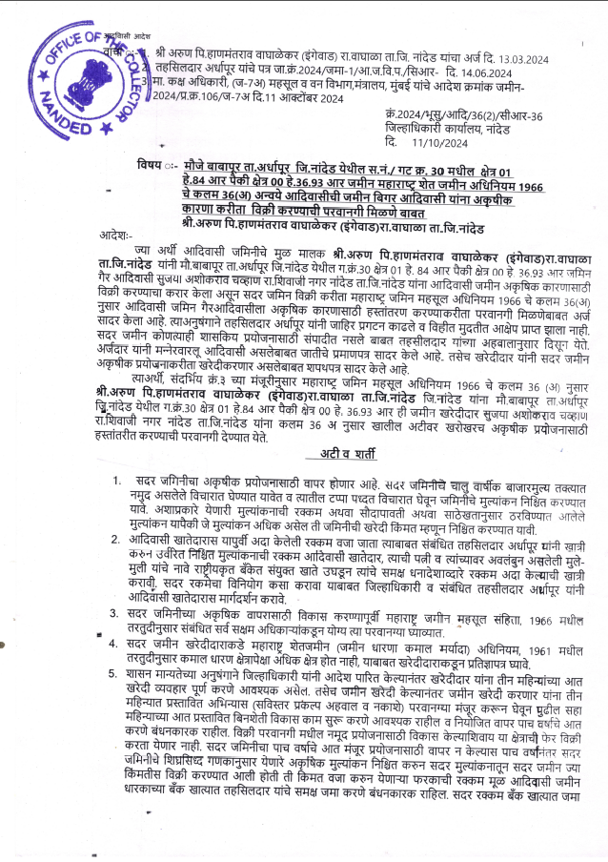

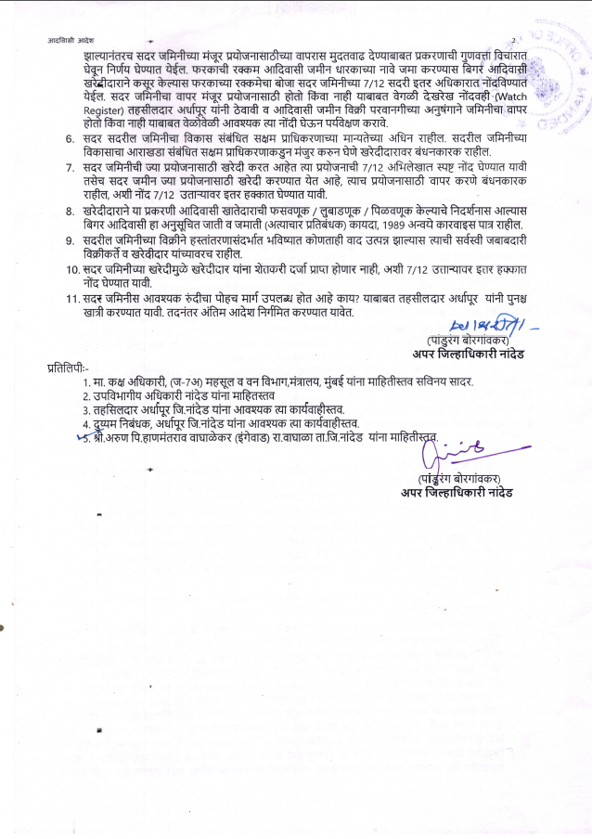

Lease Deed
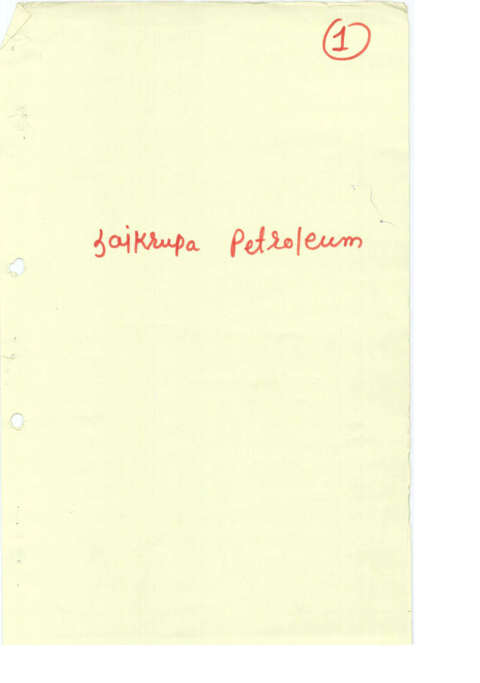

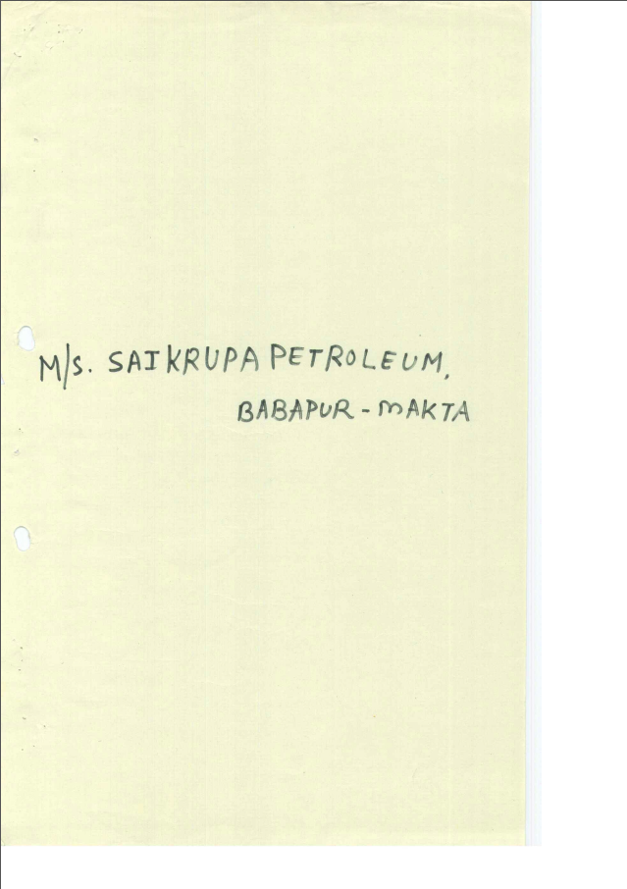

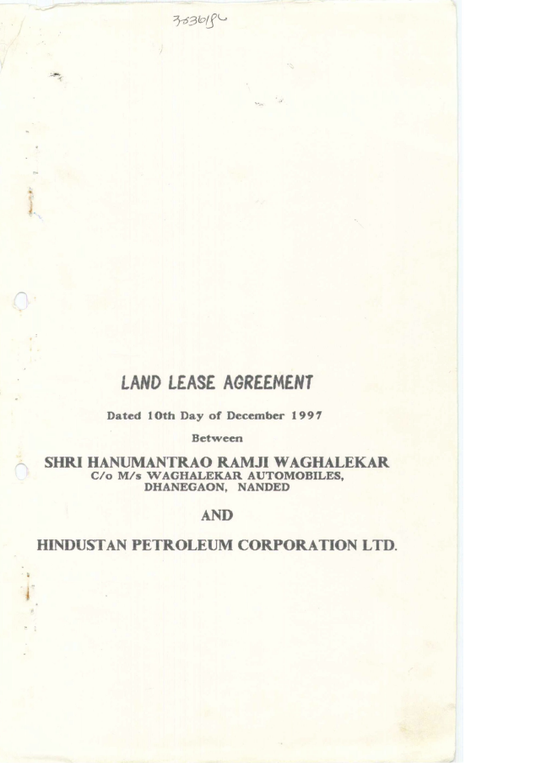

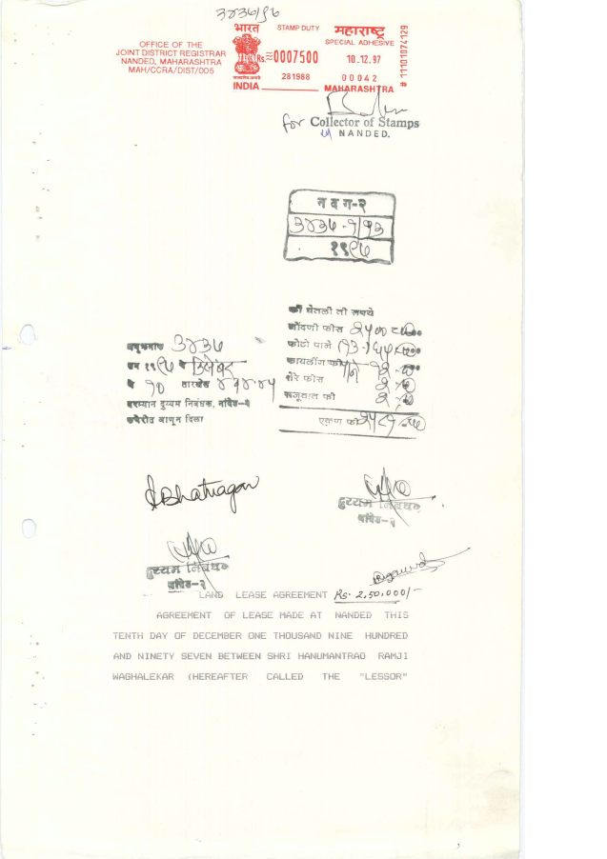

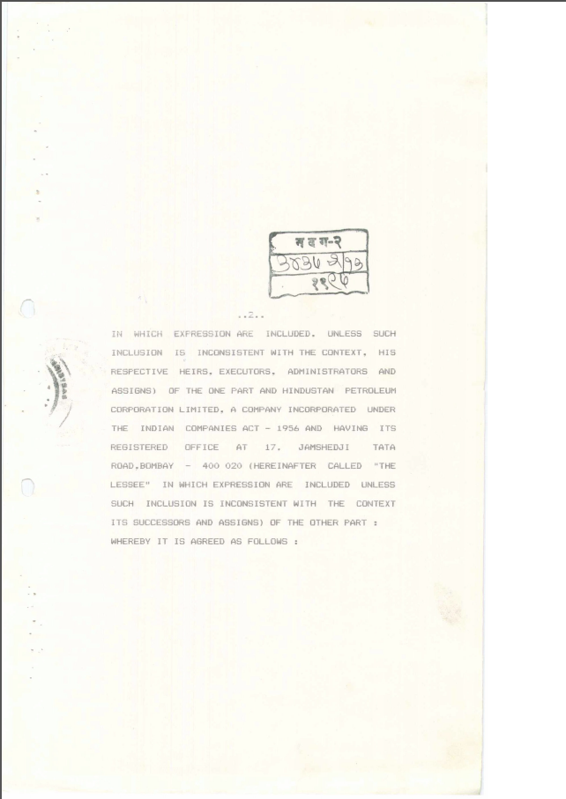

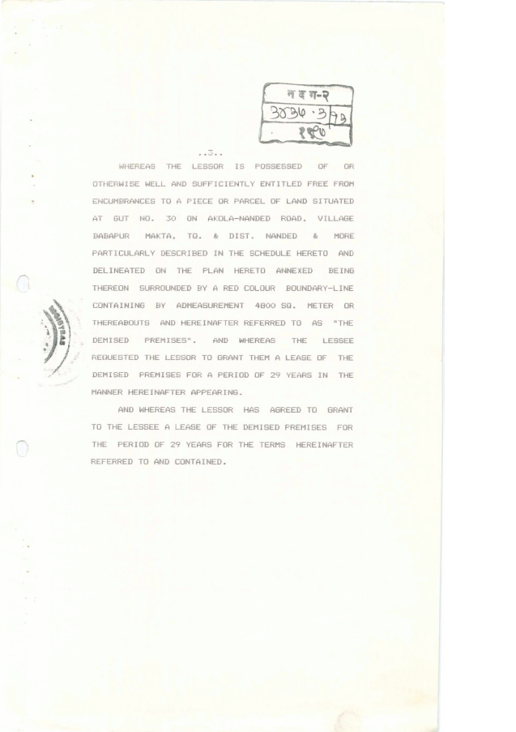

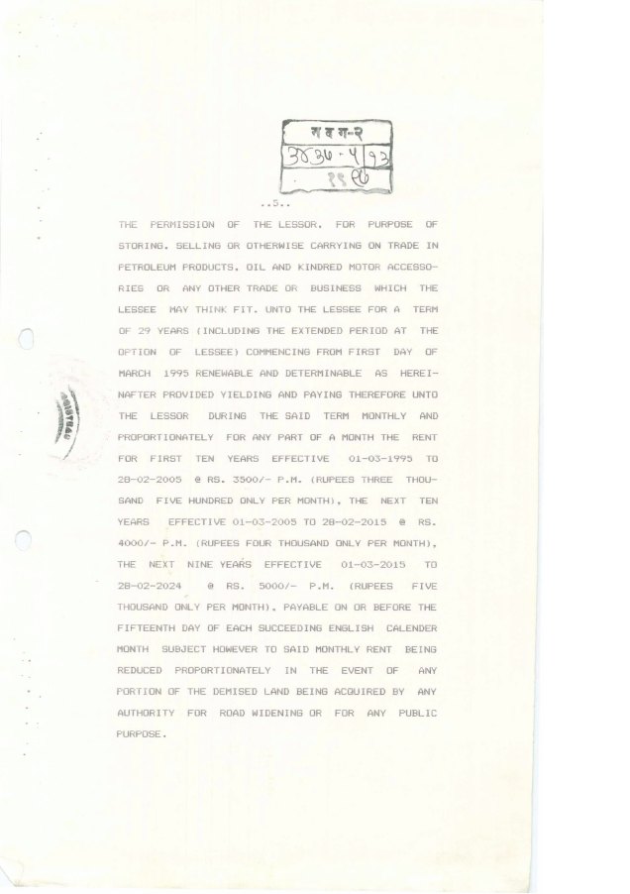

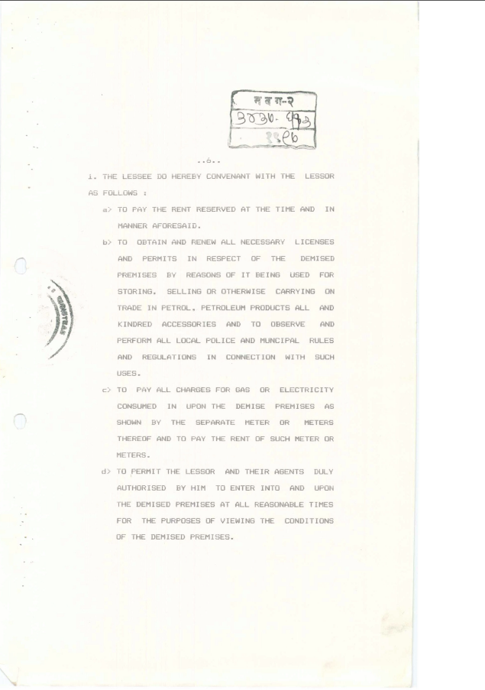

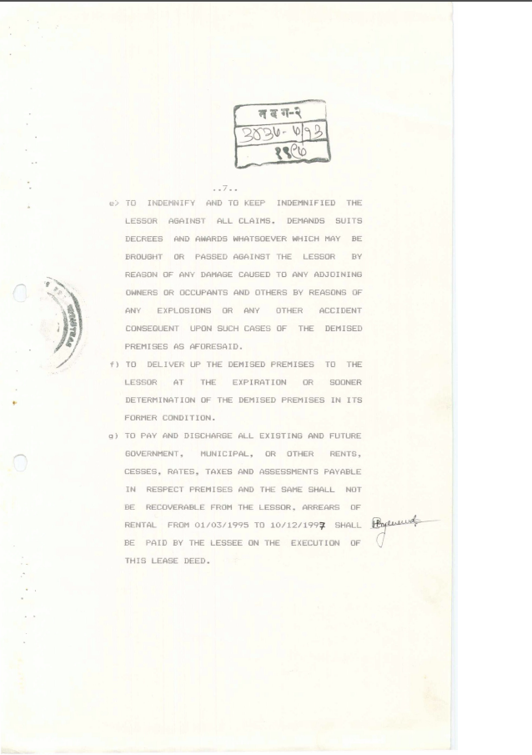

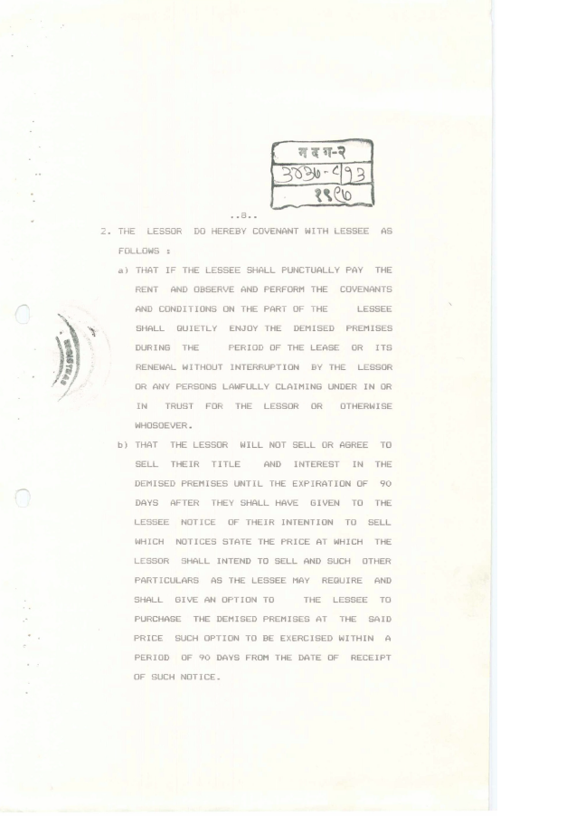

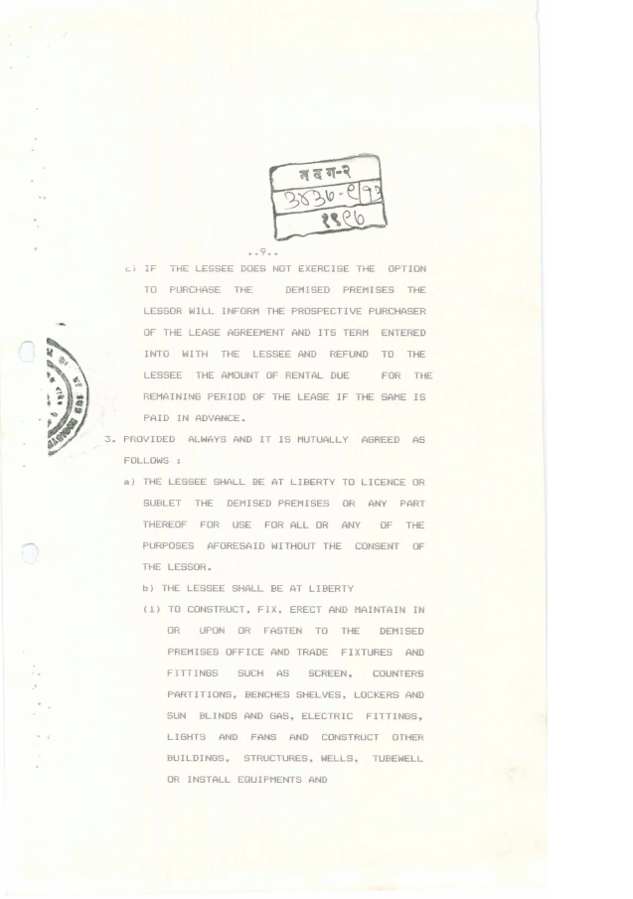

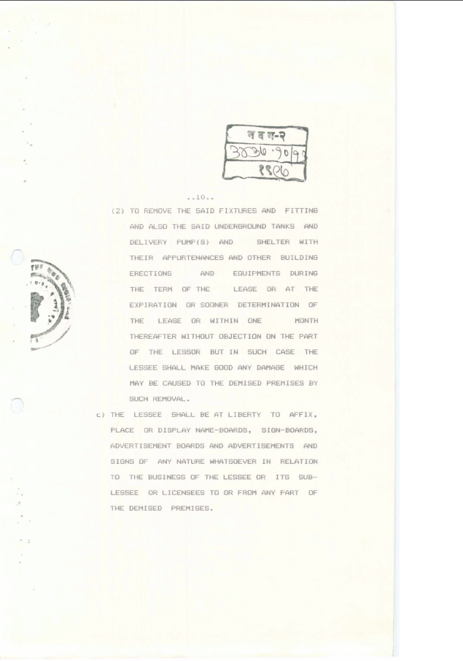

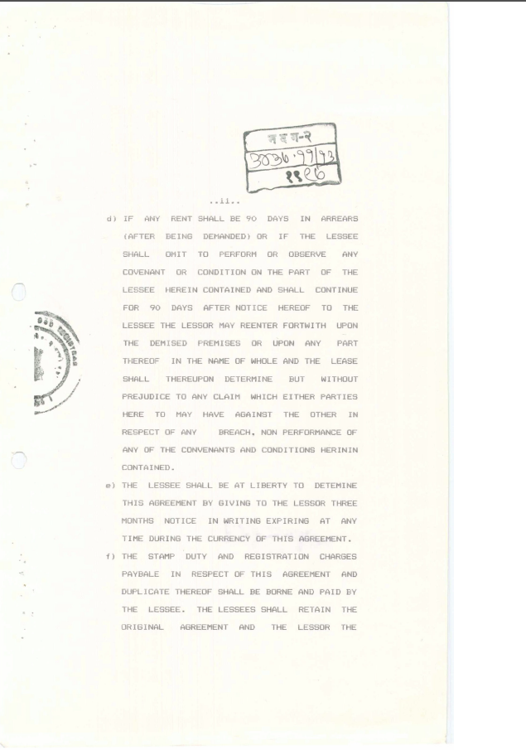

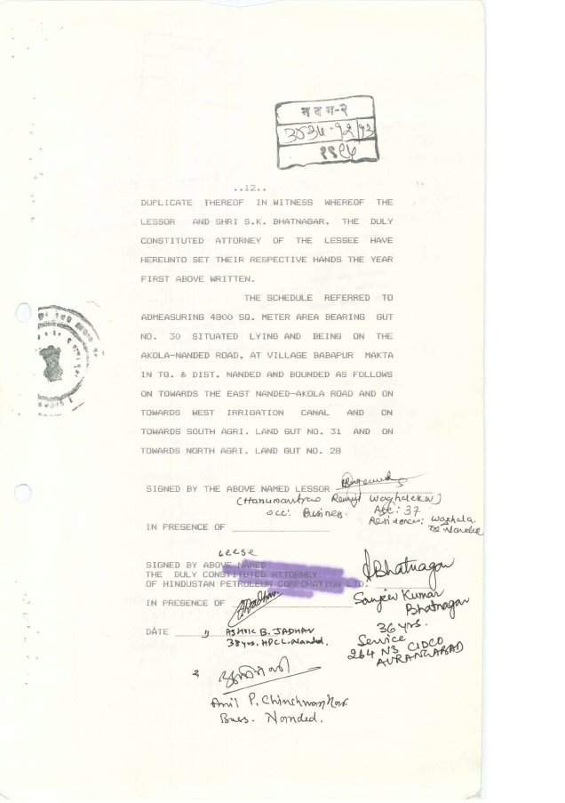

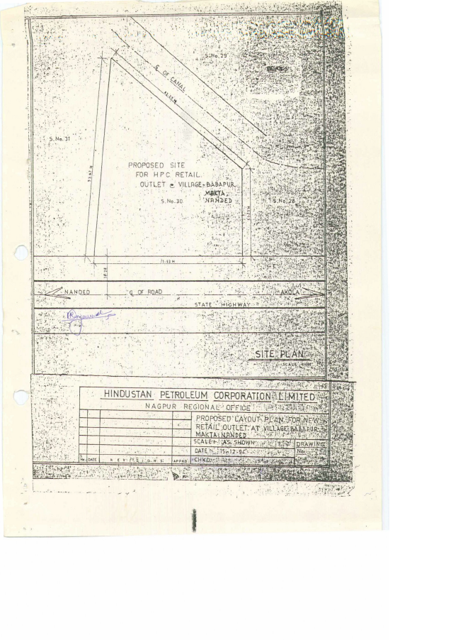

Mulayakan Letter
