Vastu/Nashik/12/2024/013385/2309836
28/8-534-CCRJ
Date: 28.12.2024

To, `
The Branch Manager,
Bank of Baroda
Regional Office Nashik Road Branch
BSNL Building, Datta Mandir Road, Nashik Road,
Nashik -422 101, State - Maharashtra, Country - India.

Sub: Vetting of Extra Amenities

Sir,

With reference to above subject, we have evaluated the Extra Amenities for Residential Flat No.701, 7th Floor, " Rudra Heights ", Near Omeshwar Heights , Dhruv Nagar, Plot No.52, Right Canal Road, Village-Gangapur, Taluka-Nashik, District Nashik, Nashik PlN Code-422002 State Maharashtra, Country - lndia belongs to M/s.S.V.S Conctruction. Name of Proposed Purchaser: Komal Anil Kumavat & Sau.Vandana Anil Kumavat.

We have verified the rates quoted as per current market rates. Details of Extra Amenities considered as per copy of Agreement for Extra Amenities issued by to Komal Anil Kumavat & Sau.Vandana Anil Kumavat. (First Party) Tulsabai Madhukar Kumavat (Second Party) received on dated 27.12.2024. The Extra Amenities amount is Rs.8,00,000/- (Rupees Eight Lakh Only.)

The said Cost Vetting Certificate is valid up to next 6 months Only.

Thanking you

Sincerely yours

Manoj B. Chalikwar
Registered Valuer
Chartered Engineer (India)
Reg. No. CAT-I-F-1763
Reg. No. IBBI/RV/07/2018/10366
BOB Empanelment No.: ZO:MZ:ADV:46:941
Encl: Valuation report.

Agreement of Extra Amenities
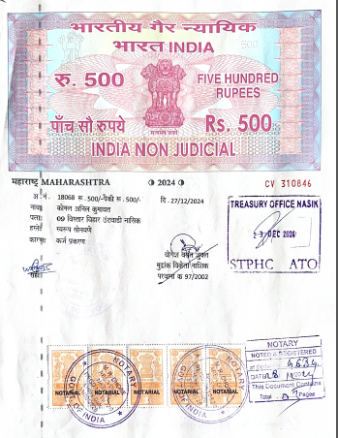


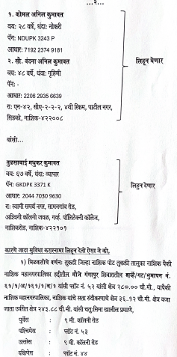
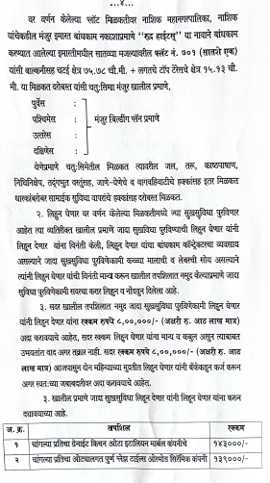

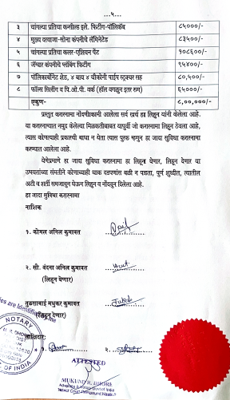

The Extra Work amount Rs.8,00,000/- (Rupees Eight Lakh Only.)

