MASTER VALUATION REPORT
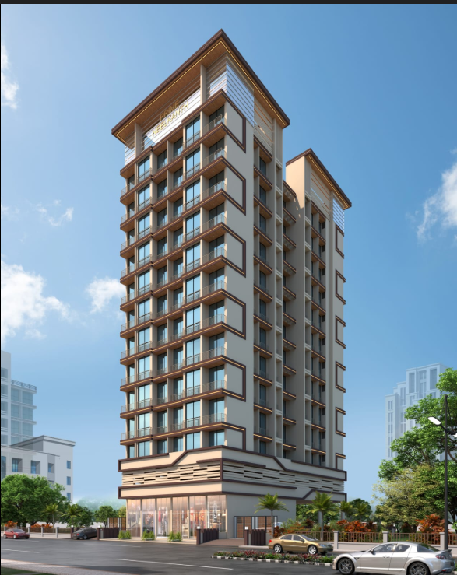

Details of the property under consideration:

Name of Project: "Prime Neelkanth"

"Prime Neelkanth", Proposed Residential Cum Commercial Cum Building on Plot No. 137, Sector 26,
Village – Pushpak Wahal, Taluka - Panvel, District - Raigad, Navi Mumbai, PIN – 410 206, Maharashtra, India.

Latitude Longitude: 18°58’02.6”N 73°01’41.4”E

Intended User:
State Bank of India
HLST Belapur Branch
Administrative Office,I, 5th Floor, Belapur Railway Station Complex,
CBD Belapur, Navi Mumbai, PIN - 400 614,
State - Maharashtra, Country - India.

Vastu/SBI/Mumbai/12/2024/13291/2309796
26/16-494-SSPV
Date: 28.12.2024

MASTER VALUATION REPORT
OF
"Prime Neelkanth"

"Prime Neelkanth", Proposed Residential Cum Commercial Cum Building on Plot No. 137, Sector 26,
Village – Pushpak Wahal, Taluka - Panvel, District - Raigad, Navi Mumbai,
PIN – 410 206, Maharashtra, India.

Latitude Longitude: 18°58’02.6”N 73°01’41.4”E

NAME OF DEVELOPER: M/s. Prime Neelkanth LLP.

Pursuant to instructions from State Bank of India, HLST Belapur Branch, Navi Mumbai, we have duly visited, inspected, surveyed & assessed the above said property to determine the fair & reasonable market value of the said property as on 27th December 2024 for approval of Advance Processing Facility.

1. Location Details:
The property is situated at "Prime Neelkanth", Proposed Residential Cum Commercial Cum Building on Plot No. 137, Sector 26, Village – Pushpak Wahal, Taluka - Panvel, District - Raigad, Navi Mumbai, PIN – 410 206, Maharashtra, India. It is about 1.3 KM. travel distance from Bamandongri railway station on Harbour Line of Central Railway. Surface transport to the property is by buses, Auto, taxis & private vehicles. The property is in developing locality. All the amenities like shops, banks, hotels, markets, schools, hospitals, etc. are all available in the surrounding locality. The locality is middle class & developing.

2. Developer Details:

Name of builder | M/s. Prime Neelkanth LLP.
Project Registration Number
  Project | RERA Project Number
  Prime Neelkanth | P52000055569
Register office address | M/s. Prime Neelkanth LLP.  Address:  Shop No. 4, “Om Shanti Premises”, Plot No. 10, Sector 23, CBD Belapur, Near Apollo Hospital, Taluka & Dist. – Thane, Navi Mumbai, PIN Code - 400 614, State - Maharashtra, Country - India
Contact Numbers | Contact Person :  Mr. Suyog Wayangankar (Sales Person – Mobile No. 9011942580)
E – mail ID & Website

3. Boundaries of the Property:

Direction | Particulars
On or towards North | Road & Under Construction Building
On or towards South | Open Plot
On or towards East | Open Plot & Road
On or towards West | Open Plot & Under Construction Building

Vastukala Consultants (I) Pvt. Ltd.
B1-001, U/B Floor, Boomerang, Chandivali Farm Road, Powai, Andheri (East), Mumbai – 400 072

To,
The Branch Manager,
State Bank of India
HLST Belapur Branch
Administrative Office,I, 5th Floor,
Belapur Railway Station Complex,
CBD Belapur, Navi Mumbai, PIN - 400 614,
State - Maharashtra, Country - India.

VALUATION REPORT (IN RESPECT OF MASTER VALUATION REPORT)
I | General
1. | Purpose for which the valuation is made |  |  |  |  |  | : |  | As per request from State Bank of India, HLST Belapur Branch, Navi Mumbai to assess fair market value of the property for bank loan purpose.
2. | a) |  |  | Date of inspection |  |  | : |  | 27.12.2024
 | b) |  |  | Date on which the valuation is made |  |  | : |  | 28.12.2024
3. | List of documents produced for perusal
 | - Copy of Legal Title Report dated 17.02.2024 issued by Adv. R.R. Jindal (Jindal & Jindal)
 | - Copy of Tripartite Agreement date 07.10.2022 b/w. CIDCO (the Lessor) AND Mr. Suryakant K. Deshmukh & others (the Origional Licensee) AND M/s. Prime Neelkanth LLP (the New Licesnsees)
 | - Copy of Engineer’s Certificate issued by Vijay Kumar Singh dated 20.01.2024.
 | - Copy of Affidavit cum Declaration of Mr. Abhay Gupta date 20.01.2024.
 | - Copy of Agreement to Lease date 23.03.2022 b/w. CIDCO (the Licensor) AND Mr. Suryakant K. Deshmukh & others (the Licensee)
 | - Copy of LLP Agreement date 13.11.2021 b/w. Mr. Rahul D. Patel (the 1st Party) AND Mr. Nikunj M. Agarwal & others 3rd Party)
 | - Copy of MOU year 2024 b/w. Mr. Suryakant K. Deshmukh & others (the Plot Owners) AND M/s. Prime Neelkanth LLP (the Developers)
 | - Copy of Architect’s Certificate date 20.01.2024 issued by Edge Architects
 | - Copy of NOC for Height Clearance Certificate No. NAVI / WEST / B / 121522 / 731967 date 04.01.2023 issued by Airports Authority of India, Valid Upto – 03.01.2031.
 | - Copy of Fire Brigade Provisional NOC No. CIDCO / FIRE / HQ / 2024 / E-339221 issued by City & Industrial Development Corporation of Maharashtra Limited (CIDCO) dated 09.09.2024.
 | - Copy of MAHARERA Registration Certificate of Project No. P52000055569 issued by Maharashtra Real Estate Regulatory Authority date 02.04.2024.
- Copy of Amended Commencement Certificate No. CIDCO/BP-18491/TPO(NM & K)/2023/13032 date 24.09.2024 issued by City & Industrial Development Corporation of Maharashtra Limited (CIDCO).

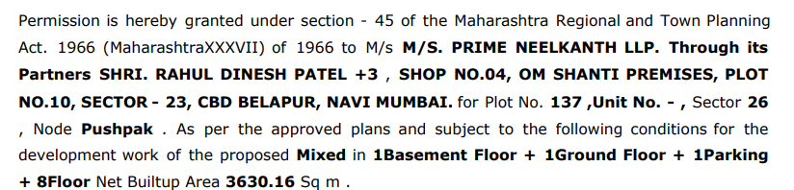

- Copy of Approved Plan No. CIDCO/BP-18491/TPO(NM & K)/2023/13032 dated 24.09.2024 issued by City & Industrial Development Corporation of Maharashtra Limited (CIDCO) (Number of Copies – Four - Sheet No. 1/4 to 4/4)
Approved upto:
Project | Number of Floors
Prime Neelkanth | Basement + Ground / Stilt + 1st Floor (Podium) + 2nd to 9th Upper Floors.

 | Project Name  (with address & phone nos.) |  |  |  |  |  | : |  | "Prime Neelkanth", Proposed Residential Cum Commercial Cum Building on Plot No. 137, Sector 26, Village – Pushpak Wahal, Taluka - Panvel, District - Raigad, Navi Mumbai, PIN – 410 206, Maharashtra, India
4. | Name of the owner(s) and his / their address (es) with Phone no. (details of share of each owner in case of joint ownership) |  |  |  |  |  | : |  | M/s. Prime Neelkanth LLP.  Address:  Shop No. 4, “Om Shanti Premises”, Plot No. 10, Sector 23, CBD Belapur, Near Apollo Hospital, Taluka & Dist. – Thane, Navi Mumbai, PIN Code - 400 614, State - Maharashtra, Country - India  Contact Person :  Mr. Suyog Wayangankar (Sales Person – Mobile No. 9011942580)
5. | Brief description of the property (Including Leasehold / freehold etc.) |  |  |  |  |  | :
About "Prime Neelkanth" Project: Prime Neelkanth is a budget friendly Project located in Ulwe, Panvel and well connected by major road(s) like Uran Road. The total area in which Prime Neelkanth has been built is 0.29 acre. This project has been developed by Prime Neelkanth LLP who are one of the reputed developers in the Navi Mumbai. The Project current status is New Launch. It has 22 Units. The RERA registration number of this project is P52000055569.

TYPE OF THE BUILDING
Project | Number of Floors
Prime Neelkanth | Proposed Basement + Ground / Stilt + 1st Floor (Podium) + 2nd to 12th Upper Floors as per information provided by builder and Area Statment. The building permission as on date is received till Basement + Ground / Stilt + 1st Floor (Podium) + 2nd to 9th Upper Floors.

LEVEL OF COMPLETEION:
Project | Present stage of Construction | Percentage of work completion
Prime Neelkanth | RCC work upto 1st floor is in progress. | 12%
DATE OF COMPLETION & FUTURE LIFE:
Expected completion date as informed by builder is 31.12.2028 (As per MAHARERA Certificate)

Future estimated life of the Structure is 60 years (after completion) Subject to proper, preventive periodic maintenance & Structural repairs.

PROPOSED PROJECT AMENITIES:
- Vitrified tiles flooring in all rooms
- Granite Kitchen platform with Stainless Steel Sink
- Powder coated aluminum sliding windows with M.S. Grills
- Laminated wooden flush doors with Safety door
- Concealed wiring
- Concealed plumbing
- Creche/Day Care
- Jogging Track
- Sun Deck
- Yoga Meditation Area
- Clubhouse
- Gymnasium
- Garden
- Jogging Track
- Indoor Game
- Children Play Area
- Fitness Centre
- Gated Community

6. | Location of property |  |  |  |  |  | :
 | a) |  | Plot No. / Survey No. |  |  |  | : | Plot No 137
 | b) |  | Door No. |  |  |  | : | Not applicable
 | c) |  | C. T.S. No. / Village |  |  |  | : | Plot No. 137, Sector No. 26, Village – Pushpak Wahal
 | d) |  | Ward / Taluka |  |  |  | : | Panvel
 | e) |  | Mandal / District |  |  |  | : | Raigad
7. | Postal address of the property |  |  |  |  |  | : | "Prime Neelkanth", Proposed Residential Cum Commercial Cum Building on Plot No. 137, Sector 26, Village – Pushpak Wahal, Taluka - Panvel, District - Raigad, Navi Mumbai, PIN – 410 206, Maharashtra, India
8. | City / Town |  |  |  |  |  | : | Pushpak Wahal, Navi Mumbai
 | Residential area |  |  |  |  |  | : | Yes
 | Commercial area |  |  |  |  |  | : | Yes
 | Industrial area |  |  |  |  |  | : | No
9. | Classification of the area |  |  |  |  |  | :
 | i) High / Middle / Poor |  |  |  |  |  | : | Middle Class
 | ii) Urban / Semi Urban / Rural |  |  |  |  |  | : | Semi Urban
10. | Coming under Corporation limit / Village Panchayat / Municipality |  |  |  |  |  | : | City & Industrial Development Corporation of Maharashtra Limited (CIDCO)  Village – Pushpak Wahal
11. | Whether covered under any State / Central Govt. enactments (e.g., Urban Land Ceiling Act) or notified under agency area/ scheduled area / cantonment area |  |  |  |  |  | : | No
12. | In Case it is Agricultural land, any conversion to house site plots is contemplated |  |  |  |  |  | : | N.A.
13. |  | Boundaries of the property |  |  | As per Documents | As per RERA Certificate |  |  |  |  | As per Site
 |  | North |  |  | 20.00 M. Wide Road | 20.00 M. Wide Road |  |  |  |  | Road & Under Construction Building
 |  | South |  |  | Plot No. 142F & 142E | Plot No. 142F & 142E |  |  |  |  | Open Plot
 |  | East |  |  | Plot No. 136 | Plot No. 136 |  |  |  |  | Open Plot & Road
 |  | West |  |  | Plot No. 138 | Plot No. 138 |  |  |  |  | Open Plot & Under Construction Building
14.1 |  | Dimensions of the site |  |  |  |  |  |  |  | N. A. as the land is irregular in shape
 |  |  |  |  |  |  |  |  |  | A As per the Deed |  | B Actuals
 |  | North |  |  |  |  |  | : |  | - |  | -
 |  | South |  |  |  |  |  | : |  | - |  | -
 |  | East |  |  |  |  |  | : |  | - |  | -
 |  | West |  |  |  |  |  | : |  | - |  | -
14.2 |  | Latitude, Longitude & Co-ordinates of property |  |  |  |  |  | : |  | 18°58’02.6”N 73°01’41.4”E
14. |  | Extent of the site |  |  |  |  |  | : |  | Plot area – 1209.980 Sq. M. (As per Approved Plan & RERA Certificate)  Structure - As per table attached to the report
15. |  | Extent of the site considered for Valuation (least of 14A& 14B) |  |  |  |  |  | : |  | Plot area – 1209.980 Sq. M. (As per Approved Plan & RERA Certificate)  Structure - As per table attached to the report
16 |  | Whether occupied by the owner / tenant? If occupied by tenant since how long? Rent received per month. |  |  |  |  |  | : |  | N.A. Building Construction work is in progress
II |  | CHARACTERSTICS OF THE SITE
 |  | Classification of locality |  |  |  |  |  | : |  | Middle class
 |  | Development of surrounding areas |  |  |  |  |  | : |  | Good
 |  | Possibility of frequent flooding/ sub-merging |  |  |  |  |  | : |  | No
 |  | Feasibility to the Civic amenities like School, Hospital, Bus Stop, Market etc. |  |  |  |  |  | : |  | All available near by
 |  | Level of land with topographical conditions |  |  |  |  |  | : |  | Plain
 |  | Shape of land |  |  |  |  |  | : |  | Irregular
 |  | Type of use to which it can be put |  |  |  |  |  | : |  | For residential purpose
 |  | Any usage restriction |  |  |  |  |  | : |  | Residential
 |  | Is plot in town planning approved layout? |  |  |  |  |  | : |  | Copy of Approved Plan No. CIDCO/BP-18491/TPO(NM & K)/2023/13032 dated 24.09.2024 issued by City & Industrial Development Corporation of Maharashtra Limited (CIDCO) (Number of Copies – Four - Sheet No. 1/4 to 4/4)  Approved upto:
  Project | Number of Floors
  Prime Neelkanth | Basement + Ground / Stilt + 1st Floor (Podium) + 2nd to 9th Upper Floors.
 |  | Corner plot or intermittent plot? |  |  |  |  |  | : |  | Intermittent
 |  | Road facilities |  |  |  |  |  | : |  | Yes
 |  | Type of road available at present |  |  |  |  |  | : |  | B. T. Road
 |  | Width of road – is it below 20 ft. or more than 20 ft. |  |  |  |  |  | : |  | 20.00 Mtr. Wide Road
 |  | Is it a Land – Locked land? |  |  |  |  |  | : |  | No
 |  | Water potentiality |  |  |  |  |  | : |  | Municipal Water supply
 |  | Underground sewerage system |  |  |  |  |  | : |  | Connected to Municipal sewer
 |  | Is Power supply is available in the site |  |  |  |  |  | : |  | Yes
 |  | Advantages of the site |  |  |  |  |  | : |  | Located in developing area
 |  | Special remarks, if any like threat of acquisition of land for publics service purposes, road widening or applicability of CRZ provisions etc.(Distance from sea-cost / tidal level must be incorporated) |  |  |  |  |  | : |  | No
Part – A (Valuation of land)
1 |  | Size of plot |  |  |  |  |  | : |  | Plot area – 1209.980 Sq. M. (As per Approved Plan & RERA Certificate)
 |  | North & South |  |  |  |  |  | : |  | -
 |  | East & West |  |  |  |  |  | : |  | -
2 |  | Total extent of the plot |  |  |  |  |  | : |  | As per table attached to the report
3 |  | Prevailing market rate ( Along With details / reference of at least two latest deals / transactions with respect to adjacent properties in the areas) |  |  |  |  |  | : |  | As per table attached to the report  Details of recent transactions/online listings are attached with the report.
4 |  | Guideline rate obtained from the Register’s Office ( an evidence thereof to be enclosed) |  |  |  |  |  | : |  | ` 56,700.00 per Sq. M. for Residential  ` 4,750.00 per Sq. M. for Land
5 |  | Assessed / adopted rate of valuation |  |  |  |  |  | : |  | As per table attached to the report
6 |  | Estimated value of land |  |  |  |  |  | :
  Land Area in Sq. M. | Rate in  Sq. M. | Value in (`)
  1209.980 | 4750 | 57,47,405.00
Part – B (Valuation of Building)
1 |  | Technical details of the building |  |  |  |  |  | :
 |  | - Type of Building (Residential / Commercial / Industrial) |  |  |  |  |  | : |  | Residential
 |  | - Type of construction (Load bearing / RCC / Steel Framed) |  |  |  |  |  | : |  | N.A. Building Construction work is in progress
 |  | - Year of construction |  |  |  |  |  | : |  | N.A. Building Construction work is in progress
 |  | - Number of floors and height of each floor including basement, if any |  |  |  |  |  | :
Project | Number of Floors
Prime Neelkanth | Proposed Basement + Ground / Stilt + 1st Floor (Podium) + 2nd to 12th Upper Floors as per information provided by builder and Area Statment. The building permission as on date is received till Basement + Ground / Stilt + 1st Floor (Podium) + 2nd to 9th Upper Floors.

 |  | - Plinth area floor-wise |  |  |  |  |  | : |  | As per table attached to the report
 |  | - Condition of the building |  |  |  |  |  | :
 |  | - Exterior – Excellent, Good, Normal, Poor |  |  |  |  |  | : |  | N.A. Building Construction work is in progress
 |  | - Interior – Excellent, Good, Normal, Poor |  |  |  |  |  | : |  | N.A. Building Construction work is in progress
 |  | - Date of issue and validity of layout of approved map |  |  |  |  |  | : |  | Copy of Approved Plan No. CIDCO/BP-18491/TPO(NM & K)/2023/13032 dated 24.09.2024 issued by City & Industrial Development Corporation of Maharashtra Limited (CIDCO) (Number of Copies – Four - Sheet No. 1/4 to 4/4)  Approved upto:
  Project | Number of Floors
  Prime Neelkanth | Basement + Ground / Stilt + 1st Floor (Podium) + 2nd to 9th Upper Floors.
 |  | - Approved map / plan issuing authority |  |  |  |  |  | :
 |  | - Whether genuineness or authenticity of approved map / plan is verified |  |  |  |  |  | : |  | Yes
 |  | - Any other comments by our empanelled valuers on authentic of approved plan |  |  |  |  |  | : |  | No.

Specifications of construction (floor-wise) in respect of

Sr.  No. | Description
 | Foundation | : | Proposed R.C.C. Footing
 | Basement | : | N.A. Building Construction work is in progress
 | Superstructure | : | Proposed as per IS Code requirements
 | Joinery / Doors & Windows (Please furnish details about size of frames, shutters, glazing, fitting etc. and specify the species of timber | : | Proposed
 | RCC Works | : | N.A. Building Construction work is in progress
 | Plastering | : | N.A. Building Construction work is in progress
 | Flooring, Skirting, dado | : | N.A. Building Construction work is in progress
 | Special finish as marble, granite, wooden paneling, grills etc. | : | N.A. Building Construction work is in progress
 | Roofing including weather proof course | : | N.A. Building Construction work is in progress
 | Drainage | : | Proposed
2. | Compound Wall | :
 | Height | : | N.A. Building Construction work is in progress
 | Length | : | N.A. Building Construction work is in progress
 | Type of construction | : | N.A. Building Construction work is in progress
3. | Electrical installation | : | N.A. Building Construction work is in progress
 | Type of wiring | : | N.A. Building Construction work is in progress
 | Class of fittings (superior / ordinary / poor) | : | N.A. Building Construction work is in progress
 | Number of light points | : | N.A. Building Construction work is in progress
 | Fan points | : | N.A. Building Construction work is in progress
 | Spare plug points | : | N.A. Building Construction work is in progress
 | Any other item | : | -
4. | Plumbing installation
 | - No. of water closets and their type | : | N.A. Building Construction work is in progress
 | - No. of wash basins | : | N.A. Building Construction work is in progress
 | - No. of urinals | : | N.A. Building Construction work is in progress
 | - No. of bath tubs | : | N.A. Building Construction work is in progress
 | - Water meters, taps etc. | : | N.A. Building Construction work is in progress
 | - Any other fixtures | : | N.A. Building Construction work is in progress

CONFIGURATION OF PROJECT AS PER DEVELOPER’S INFORMATION:

Remarks:

Proposed as per site information & Area Statement | As per Sanctioned Approval Plan
 | Copy of Approved Plan No. CIDCO/BP-18491/TPO(NM & K)/2023/13032 dated 24.09.2024 issued by City & Industrial Development Corporation of Maharashtra Limited (CIDCO)  Approved upto:
  Project | Number of Floors
  Prime Neelkanth | Proposed Basement + Ground / Stilt + 1st Floor (Podium) + 2nd to 12th Upper Floors.
  Project | Number of Floors
  Prime Neelkanth | Basement + Ground / Stilt + 1st Floor (Podium) + 2nd to 9th Upper Floors.

We have done the valuation of entire proposed construction, however the Market Values of the flats assessed in the reports which are not yet sanctioned are realized only after the approval of said plans by Competent Authority i.e., City & Industrial Development Corporation of Maharashtra Limited (CIDCO). Accordingly, we have given the separate valuation of approved and proposed construction given by Builder only.

1a) Prime Neelkanth (Approved Plan Inventory):
Sr. No. | Flat No. | Floor No. | Comp | As per Approved Plan |  | As per Builder |  | Total Area Sq. Ft. | Built up Area in Sq. Ft. | Rate per  Sq. ft. on Total Area  in ` | Realizable Value / Fair Market Value as on date in ` | Final Realizable Value after completion of flat (Including Car parking, GST & Other Charges) in ` | Expected Rent per month (After Completion) in ` | Cost of Construction in `
 |  |  |  |  |  | Chajja Area in Sq.Ft. | Natural Terrace Area in Sq.Ft.
 |  |  |  | Carpet Area in  Sq. Ft. | Balcony Area in Sq. Ft.
1 | 201 | 2 | 2 BHK | 566 | 25 | 62 | 55 | 708 | 779 | 12500 | 88,50,000 | 98,23,500 | 20500 | 20,24,880
2 | 202 | 2 | 2 BHK | 566 | 25 | 62 | 55 | 708 | 779 | 12500 | 88,50,000 | 98,23,500 | 20500 | 20,24,880
3 | 203 | 2 | 1 BHK | 362 | 0 | 71 | 130 | 563 | 619 | 12500 | 70,37,500 | 78,11,625 | 16500 | 16,10,180
4 | 204 | 2 | 2 BHK | 512 | 0 | 87 | 20 | 619 | 681 | 12500 | 77,37,500 | 85,88,625 | 18000 | 17,70,340
5 | 205 | 2 | 2 BHK | 547 | 0 | 85 | 50 | 682 | 750 | 12500 | 85,25,000 | 94,62,750 | 19500 | 19,50,520
6 | 206 | 2 | 1 BHK | 354 | 0 | 57 | 105 | 516 | 568 | 12500 | 64,50,000 | 71,59,500 | 15000 | 14,75,760
7 | 207 | 2 | 1 BHK | 362 | 0 | 71 | 110 | 543 | 597 | 12500 | 67,87,500 | 75,34,125 | 15500 | 15,52,980
8 | 301 | 3 | 2 BHK | 566 | 25 | 63 | 0 | 654 | 719 | Land Owner’s Share |  |  |  | 18,70,440
9 | 302 | 3 | 2 BHK | 566 | 25 | 63 | 0 | 654 | 719 | 12550 | 82,07,700 | 91,10,547 | 19000 | 18,70,440
10 | 303 | 3 | 2 BHK | 512 | 0 | 88 | 0 | 600 | 660 | Land Owner’s Share |  |  |  | 17,16,000
11 | 304 | 3 | 2 BHK | 547 | 0 | 86 | 0 | 633 | 696 | 12550 | 79,44,150 | 88,18,007 | 18500 | 18,10,380
12 | 305 | 3 | 1 BHK | 354 | 0 | 60 | 0 | 414 | 455 | 12550 | 51,95,700 | 57,67,227 | 12000 | 11,84,040
13 | 306 | 3 | 1 BHK | 362 | 0 | 71 | 0 | 433 | 476 | 12550 | 54,34,150 | 60,31,907 | 12500 | 12,38,380
14 | 401 | 4 | 2 BHK | 566 | 25 | 63 | 0 | 654 | 719 | Land Owner’s Share |  |  |  | 18,70,440
15 | 402 | 4 | 2 BHK | 566 | 25 | 63 | 0 | 654 | 719 |  |  |  |  | 18,70,440
16 | 403 | 4 | 1 BHK | 362 | 0 | 71 | 0 | 433 | 476 | 12600 | 54,55,800 | 60,55,938 | 12500 | 12,38,380
17 | 404 | 4 | 2 BHK | 512 | 0 | 88 | 0 | 600 | 660 | 12600 | 75,60,000 | 83,91,600 | 17500 | 17,16,000
18 | 405 | 4 | 2 BHK | 547 | 0 | 86 | 0 | 633 | 696 | 12600 | 79,75,800 | 88,53,138 | 18500 | 18,10,380
19 | 406 | 4 | 1 BHK | 354 | 0 | 60 | 0 | 414 | 455 | 12600 | - | - | 0 | 11,84,040
20 | 407 | 4 | 1 BHK | 362 | 0 | 71 | 0 | 433 | 476 | 12600 | 54,55,800 | 60,55,938 | 12500 | 12,38,380
21 | 501 | 5 | 2 BHK | 566 | 25 | 63 | 0 | 654 | 719 | Land Owner’s Share |  |  |  | 18,70,440
22 | 502 | 5 | 2 BHK | 566 | 25 | 63 | 0 | 654 | 719 |  |  |  |  | 18,70,440
23 | 503 | 5 | 1 BHK | 362 | 0 | 71 | 0 | 433 | 476 |  |  |  |  | 12,38,380
24 | 504 | 5 | 2 BHK | 512 | 0 | 88 | 0 | 600 | 660 |  |  |  |  | 17,16,000
25 | 505 | 5 | 2 BHK | 547 | 0 | 86 | 0 | 633 | 696 | 12650 | 80,07,450 | 88,88,270 | 18500 | 18,10,380
26 | 506 | 5 | 1 BHK | 354 | 0 | 60 | 0 | 414 | 455 | 12650 | 52,37,100 | 58,13,181 | 12000 | 11,84,040
27 | 507 | 5 | 1 BHK | 362 | 0 | 71 | 0 | 433 | 476 | 12650 | 54,77,450 | 60,79,970 | 12500 | 12,38,380
28 | 601 | 6 | 2 BHK | 566 | 25 | 63 | 0 | 654 | 719 | 12700 | 83,05,800 | 92,19,438 | 19000 | 18,70,440
29 | 602 | 6 | 2 BHK | 566 | 25 | 63 | 0 | 654 | 719 | Land Owner’s Share |  |  |  | 18,70,440
30 | 603 | 6 | 1 BHK | 362 | 0 | 71 | 0 | 433 | 476 | 12700 | 54,99,100 | 61,04,001 | 12500 | 12,38,380
31 | 604 | 6 | 2 BHK | 512 | 0 | 88 | 0 | 600 | 660 | Land Owner’s Share |  |  |  | 17,16,000
32 | 605 | 6 | 2 BHK | 547 | 0 | 86 | 0 | 633 | 696 | 12700 | 80,39,100 | 89,23,401 | 18500 | 18,10,380
33 | 606 | 6 | 1 BHK | 354 | 0 | 60 | 0 | 414 | 455 | Land Owner’s Share |  |  |  | 11,84,040
34 | 607 | 6 | 1 BHK | 362 | 0 | 71 | 0 | 433 | 476 | 12700 | 54,99,100 | 61,04,001 | 12500 | 12,38,380
35 | 701 | 7 | 2 BHK | 566 | 25 | 63 | 0 | 654 | 719 | 12750 | 83,38,500 | 92,55,735 | 19500 | 18,70,440
36 | 702 | 7 | 2 BHK | 566 | 25 | 63 | 0 | 654 | 719 | 12750 | 83,38,500 | 92,55,735 | 19500 | 18,70,440
37 | 703 | 7 | 1 BHK | 362 | 0 | 71 | 0 | 433 | 476 | Land Owner’s Share |  |  |  | 12,38,380
38 | 704 | 7 | 2 BHK | 512 | 0 | 88 | 0 | 600 | 660 |  |  |  |  | 17,16,000
39 | 705 | 7 | 2 BHK | 547 | 0 | 86 | 0 | 633 | 696 | 12750 | 80,70,750 | 89,58,533 | 18500 | 18,10,380
40 | 706 | 7 | 1 BHK | 354 | 0 | 60 | 0 | 414 | 455 | Land Owner’s Share |  |  |  | 11,84,040
41 | 707 | 7 | 1 BHK | 362 | 0 | 71 | 0 | 433 | 476 |  |  |  |  | 12,38,380
42 | 801 | 8 | 2 BHK | 566 | 25 | 63 | 0 | 654 | 719 | 12800 | 83,71,200 | 92,92,032 | 19500 | 18,70,440
43 | 802 | 8 | 2 BHK | 566 | 25 | 63 | 0 | 654 | 719 | 12800 | 83,71,200 | 92,92,032 | 19500 | 18,70,440
44 | 803 | 8 | 1 BHK | 362 | 0 | 71 | 0 | 433 | 476 | Land Owner’s Share |  |  |  | 12,38,380
45 | 804 | 8 | 2 BHK | 512 | 0 | 88 | 0 | 600 | 660 |  |  |  |  | 17,16,000
46 | 805 | 8 | 2 BHK | 547 | 0 | 86 | 0 | 633 | 696 |  |  |  |  | 18,10,380
47 | 806 | 8 | 1 BHK | 354 | 0 | 60 | 0 | 414 | 455 |  |  |  |  | 11,84,040
48 | 807 | 8 | 1 BHK | 362 | 0 | 71 | 0 | 433 | 476 |  |  |  |  | 12,38,380
49 | 901 | 9 | 2 BHK | 566 | 25 | 63 | 0 | 654 | 719 | 12850 | 84,03,900 | 93,28,329 | 19500 | 18,70,440
50 | 902 | 9 | 2 BHK | 566 | 25 | 63 | 0 | 654 | 719 | 12850 | 84,03,900 | 93,28,329 | 19500 | 18,70,440
51 | 903 | 9 | 1 BHK | 362 | 0 | 71 | 0 | 433 | 476 | 12850 | 55,64,050 | 61,76,096 | 13000 | 12,38,380
52 | 904 | 9 | 2 BHK | 512 | 0 | 88 | 0 | 600 | 660 | 12850 | 77,10,000 | 85,58,100 | 18000 | 17,16,000
53 | 905 | 9 | 2 BHK | 547 | 0 | 86 | 0 | 633 | 696 | 12850 | 81,34,050 | 90,28,796 | 19000 | 18,10,380
54 | 906 | 9 | 1 BHK | 354 | 0 | 60 | 0 | 414 | 455 | 12850 | 53,19,900 | 59,05,089 | 12500 | 11,84,040
55 | 907 | 9 | 1 BHK | 362 | 0 | 71 | 0 | 433 | 476 | 12850 | 55,64,050 | 61,76,096 | 13000 | 12,38,380
Total |  |  |  | 25790 | 400 |  | 525 | 30653 | 33718 |  | 24,41,21,700 | 27,09,75,091 |  | 8,76,67,580

1b) Prime Neelkanth (Proposed Inventory, Pending Approval):
Sr. No. | Flat No. | Floor No. | Comp | As per Builder |  |  |  | Total Area Sq. Ft. | Built up Area in Sq. Ft. | Rate per  Sq. ft. on Total Area  in ` | Realizable Value / Fair Market Value as on date in ` | Final Realizable Value after completion of flat (Including Car parking, GST & Other Charges) in ` | Expected Rent per month (After Completion) in ` | Cost of Construction in `
 |  |  |  | Carpet Area in  Sq. Ft. | Balcony Area in Sq. Ft. | Chajja Area in Sq.Ft. | Natural Terrace Area in Sq.Ft.
56 | 1001 | 10 | 2 BHK | 566 | 25 | 63 | 0 | 654 | 719 | 12900 | 84,36,600 | 93,64,626 | 19500 | 18,70,440
57 | 1002 | 10 | 2 BHK | 566 | 25 | 63 | 0 | 654 | 719 | 12900 | 84,36,600 | 93,64,626 | 19500 | 18,70,440
58 | 1003 | 10 | 1 BHK | 362 | 0 | 71 | 0 | 433 | 476 | 12900 | 55,85,700 | 62,00,127 | 13000 | 12,38,380
59 | 1004 | 10 | 2 BHK | 512 | 0 | 88 | 0 | 600 | 660 | 12900 | 77,40,000 | 85,91,400 | 18000 | 17,16,000
60 | 1005 | 10 | 2 BHK | 547 | 0 | 86 | 0 | 633 | 696 | 12900 | 81,65,700 | 90,63,927 | 19000 | 18,10,380
61 | 1006 | 10 | 1 BHK | 354 | 0 | 60 | 0 | 414 | 455 | 12900 | 53,40,600 | 59,28,066 | 12500 | 11,84,040
62 | 1007 | 10 | 1 BHK | 362 | 0 | 71 | 0 | 433 | 476 | 12900 | 55,85,700 | 62,00,127 | 13000 | 12,38,380
63 | 1101 | 11 | 2 BHK | 566 | 25 | 63 | 0 | 654 | 719 | 12950 | 84,69,300 | 94,00,923 | 19500 | 18,70,440
64 | 1102 | 11 | 2 BHK | 566 | 25 | 63 | 0 | 654 | 719 | 12950 | 84,69,300 | 94,00,923 | 19500 | 18,70,440
65 | 1103 | 11 | 1 BHK | 362 | 0 | 71 | 0 | 433 | 476 | 12950 | 56,07,350 | 62,24,159 | 13000 | 12,38,380
66 | 1104 | 11 | 2 BHK | 487 | 25 | 64 | 0 | 576 | 634 | 12950 | 74,59,200 | 82,79,712 | 17000 | 16,47,360
67 | 1105 | 11 | 2 BHK | 522 | 25 | 63 | 0 | 610 | 671 | 12950 | 78,99,500 | 87,68,445 | 18500 | 17,44,600
68 | 1106 | 11 | 1 BHK | 354 | 0 | 59 | 0 | 413 | 454 | 12950 | 53,48,350 | 59,36,669 | 12500 | 11,81,180
69 | 1107 | 11 | 1 BHK | 362 | 0 | 70 | 0 | 432 | 475 | 12950 | 55,94,400 | 62,09,784 | 13000 | 12,35,520
70 | 1201 | 12 | 2 BHK | 566 | 25 | 63 | 0 | 654 | 719 | 13000 | 85,02,000 | 94,37,220 | 19500 | 18,70,440
71 | 1202 | 12 | 2 BHK | 566 | 25 | 63 | 0 | 654 | 719 | 13000 | 85,02,000 | 94,37,220 | 19500 | 18,70,440
72 | 1203 | 12 | 1 BHK | 362 | 0 | 71 | 0 | 433 | 476 | 13000 | 56,29,000 | 62,48,190 | 13000 | 12,38,380
73 | 1204 | 12 | 1 BHK | 364 | 52 | 19 | 89 | 524 | 576 | 13000 | 68,12,000 | 75,61,320 | 16000 | 14,98,640
74 | 1205 | 12 | 1 BHK | 398 | 52 | 18 | 89 | 557 | 613 | 13000 | 72,41,000 | 80,37,510 | 16500 | 15,93,020
75 | 1206 | 12 | 1 BHK | 311 | 42 | 22 | 0 | 375 | 413 | 13000 | 48,75,000 | 54,11,250 | 11500 | 10,72,500
76 | 1207 | 12 | 1 BHK | 362 | 0 | 70 | 0 | 432 | 475 | 13000 | 56,16,000 | 62,33,760 | 13000 | 12,35,520
Total |  |  |  | 9417 | 346 | 1281 | 178 | 11222 | 12344 |  | 14,53,15,300 | 16,12,99,984 |  | 3,20,94,920

Summary of the Project:

Particulars | Comp. | Total Number of Flats | Carpet Area in Sq. Ft. | Built up Area in Sq. Ft. | Realizable Value / Fair Market Value as on date in ` | Final Realizable Value  After Completion in `
Approved | 1 BHK - 23 2 BHK - 32 | 55 | 30653 | 33718 | 24,41,21,700.00 | 27,09,75,091.00
Proposed | 1 BHK - 11 2 BHK – 10 | 21 | 11222 | 12344 | 14,53,15,300.00 | 16,12,99,984.00
Total |  | 76 | 41875 | 46063 | 38,94,37,000.00 | 43,22,75,075.00

Particulars | Market Value (`)
Realizable Value / Fair Market Value as on date in ` | 38,94,37,000.00
Final Realizable Value After Completion in ` | 43,22,75,075.00
Cost of Construction  (Total Built up area x Rate)  46063 Sq. Ft. x ` 2600.00 | 11,97,62,500.00

Percentage of work done as on date | Built up area  in Sq. Ft. | Total Cost Of Construction | Cost of construction as  of today
12 | 46063 | 11,97,62,500.00 | 1,43,71,500.00

[
Part – C (Extra Items) |  | : | Amount in `
 | Portico | : | N.A. Building Construction work is in progress
 | Ornamental front door | : | N.A. Building Construction work is in progress
 | Sit out / Verandah with steel grills | : | N.A. Building Construction work is in progress
 | Overhead water tank | : | N.A. Building Construction work is in progress
 | Extra steel / collapsible gates | : | N.A. Building Construction work is in progress
 | Total

Part – D (Amenities) |  | : | Amount in `
 | Wardrobes | : | N.A. Building Construction work is in progress
 | Glazed tiles | : | N.A. Building Construction work is in progress
 | Extra sinks and bath tub | : | N.A. Building Construction work is in progress
 | Marble / ceramic tiles flooring | : | N.A. Building Construction work is in progress
 | Interior decorations | : | N.A. Building Construction work is in progress
 | Architectural elevation works |  | N.A. Building Construction work is in progress
 | Paneling works |  | N.A. Building Construction work is in progress
 | Aluminum works |  | N.A. Building Construction work is in progress
 | Aluminum hand rails |  | N.A. Building Construction work is in progress
 | False ceiling |  | N.A. Building Construction work is in progress
 | Total

Part – E (Miscellaneous) |  | : | Amount in `
 | Separate toilet room | : | N.A. Building Construction work is in progress
 | Separate lumber room | : | N.A. Building Construction work is in progress
 | Separate water tank / sump | : | N.A. Building Construction work is in progress
 | Trees, gardening | : | N.A. Building Construction work is in progress
 | Total

Part – F (Services) |  | : | Amount in `
 | Water supply arrangements | : | N.A. Building Construction work is in progress
 | Drainage arrangements | : | N.A. Building Construction work is in progress
 | Compound wall | : | N.A. Building Construction work is in progress
 | C.B. deposits, fittings etc. | : | N.A. Building Construction work is in progress
 | Pavement |  | N.A. Building Construction work is in progress
 | Total

Total abstract of the entire property
Part – A | Land | : | As per table attached to the report
Part – B | Building | : | As per table attached to the report
 | Land development |  | As per table attached to the report
Part – C | Compound wall | : | As per table attached to the report
Part - D | Amenities | : | As per table attached to the report
Part – E | Pavement | : | As per table attached to the report
Part – F | Services | : | As per table attached to the report
Realizable Value / Fair Market Value as on date in ` |  | : | ` 38,94,37,000.00
Final Realizable Value After Completion in ` |  | : | ` 43,22,75,075.00

The sales comparison approach uses the market data of sale prices to estimate the value of a real estate property. Property valuation in this method is done by comparing a property to other similar properties that have been recently sold. Comparable properties, also known as comparable, or comps, must share certain features with the property in question. Some of these include physical features such as square footage, number of rooms, condition, and age of the building; however, the most important factor is no doubt the location of the property. Adjustments are usually needed to account for differences as no two properties are exactly the same. To make proper adjustments when comparing properties, real estate appraisers must know the differences between the comparable properties and how to value these differences. The sales comparison approach is commonly used for Residential Flat, where there are typically many comparables available to analyze. As the property is a residential flat, we have adopted Sale Comparison Approach Method for the purpose of valuation .The Price for similar type of property in the nearby vicinity is in the range of ` 11,500.00 to ` 14,000.00 per Sq. Ft. on Carpet area Considering the rate with attached report, current market conditions , demand and supply position, Flat size, location, upswing in real estate prices, sustained demand for Residential Flat, all round development of commercial and residential application in the locality etc. We estimate ` 12,500.00 per Sq. Ft. (with floorwise rate) on Carpet Area for valuation.
Actual Site Photographs
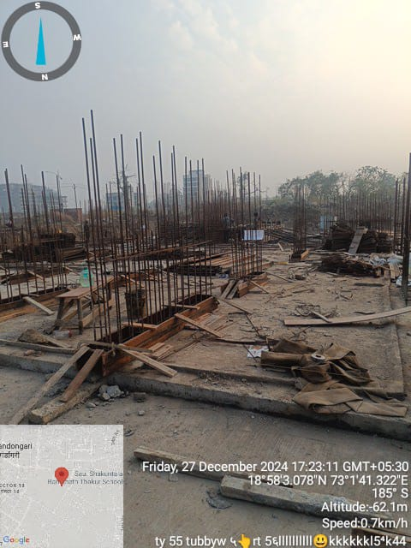
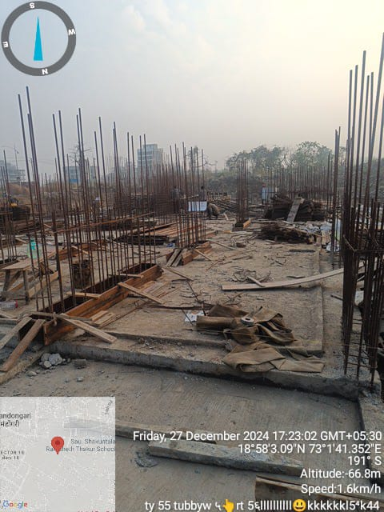

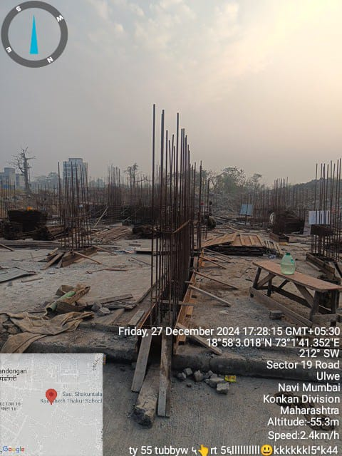
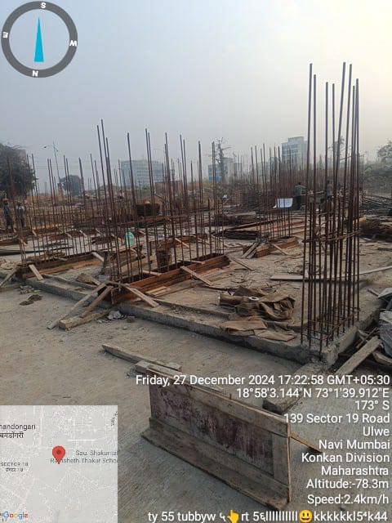

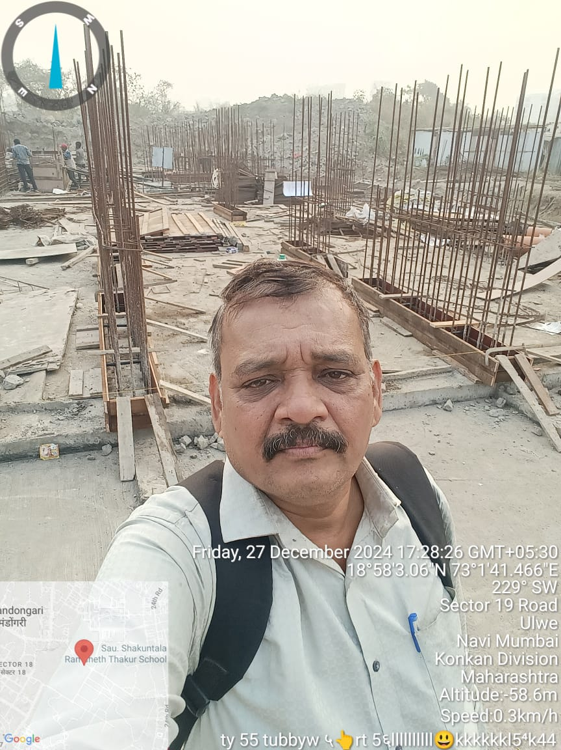
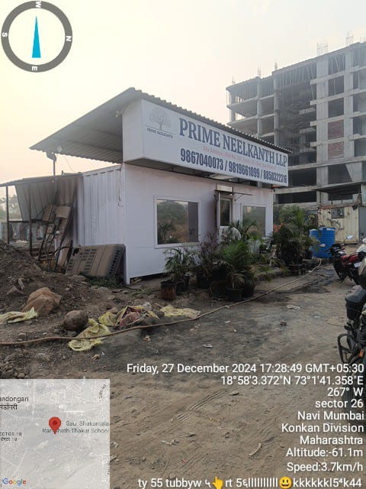

Route Map of the property
Site u/r
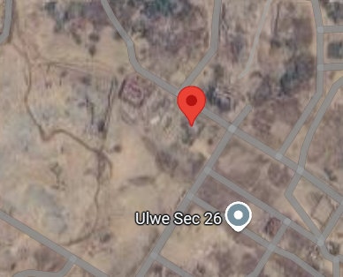

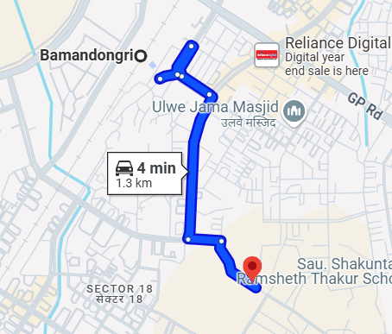

Latitude Longitude: 18°58’02.6”N 73°01’41.4”E

Note: The Blue line shows the route to site from nearest railway station (Bamandongari – 1.3 Km.)

Ready Reckoner Rate
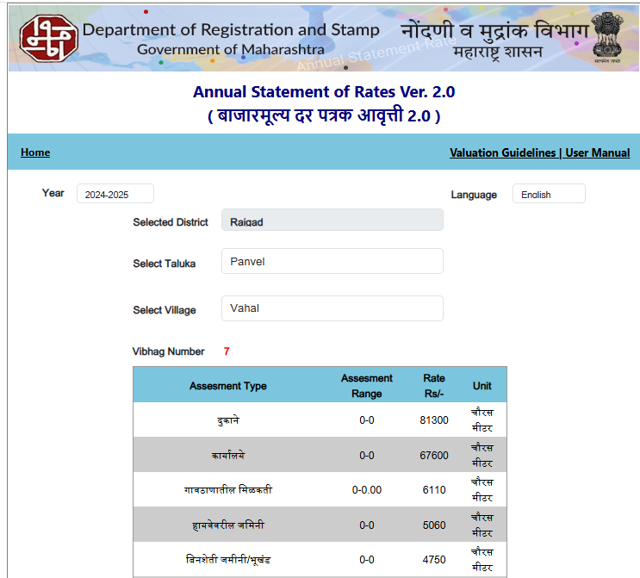

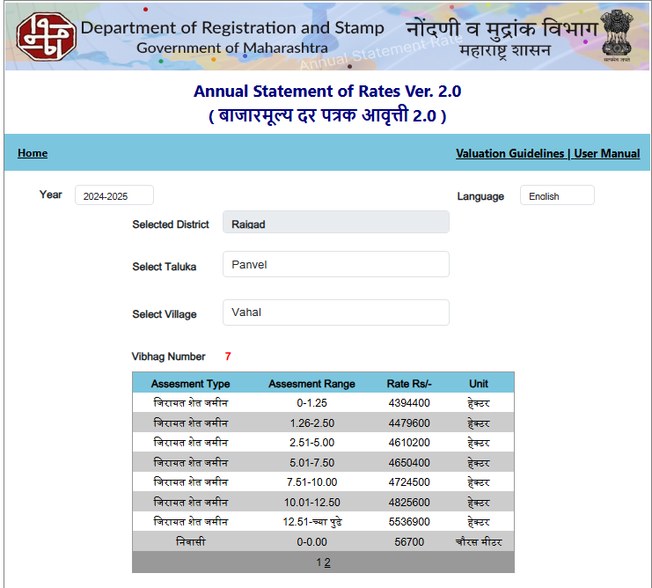

Sales Instance nearby
Regd. Doc. No. | Date | Agreement Value in ` | Carpet Area in Sq. M. | Carpet Area in Sq. Ft. | Rate Per Sq. Ft.
137 / 2024 | 02.01.2024 | 44,75,000.00 | 33.49 | 360.00 | 12,414.00
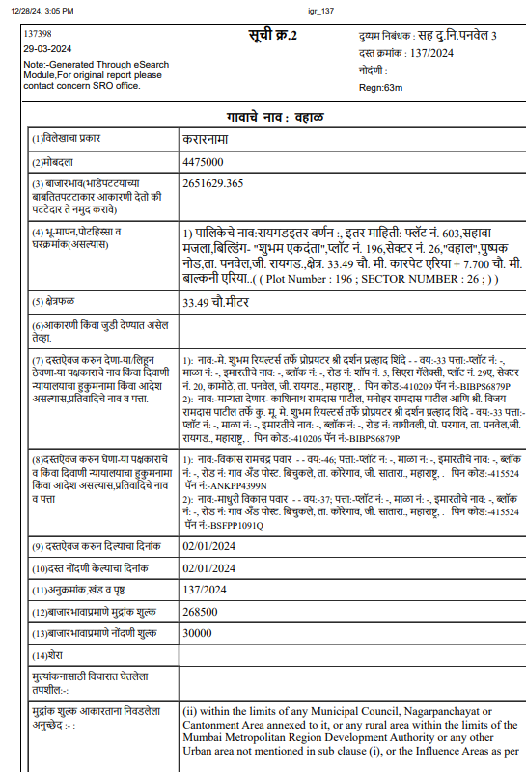
Sales Instance nearby
Regd. Doc. No. | Date | Agreement Value in ` | Carpet Area in Sq. M. | Carpet Area in Sq. Ft. | Rate Per Sq. Ft.
4741 / 2024 | 27.03.2024 | 44,95,000.00 | 37.58 | 405.00 | 11,112.00
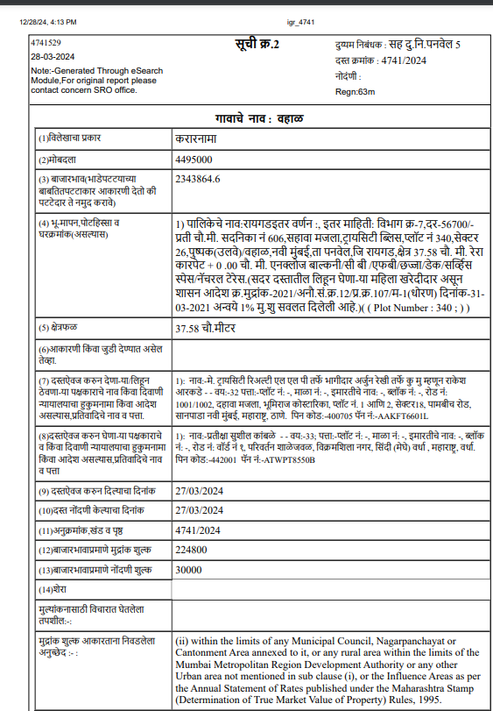
Sales Instance nearby
Regd. Doc. No. | Date | Agreement Value in ` | Carpet Area in Sq. M. | Carpet Area in Sq. Ft. | Rate Per Sq. Ft.
838 / 2024 | 12.01.2024 | 39,00,000.00 | 28.99 | 312.00 | 12,500.00
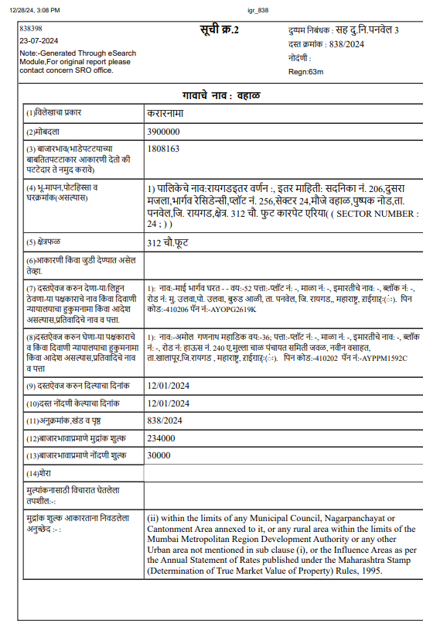

Sales Instance nearby
Regd. Doc. No. | Date | Agreement Value in ` | Carpet Area in Sq. M. | Carpet Area in Sq. Ft. | Rate Per Sq. Ft.
6688 / 2024 | 29.08.2024 | 44,90,000.00 | 30.63 | 330.00 | 13,620.00
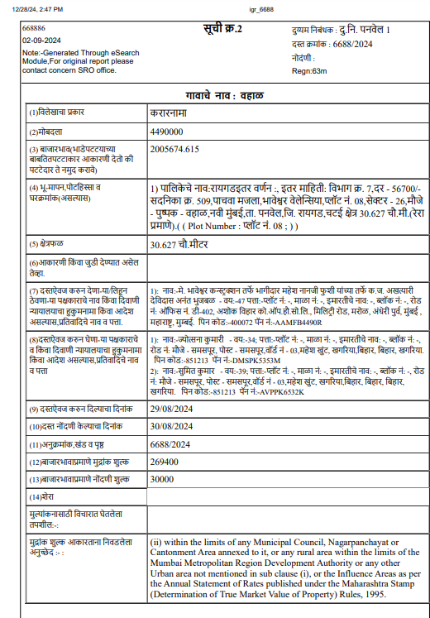

Price Indicators
Projects nearby Locality

Comp. | Source | Carpet Area in Sq. Ft. | Value in ` | Rate Per Sq. Ft.
2 BHK | housing.com | 549.00 | 66,74,000.00 | 12,157.00
2 BHK | housing.com | 634.00 | 79,80,000.00 | 12,587.00
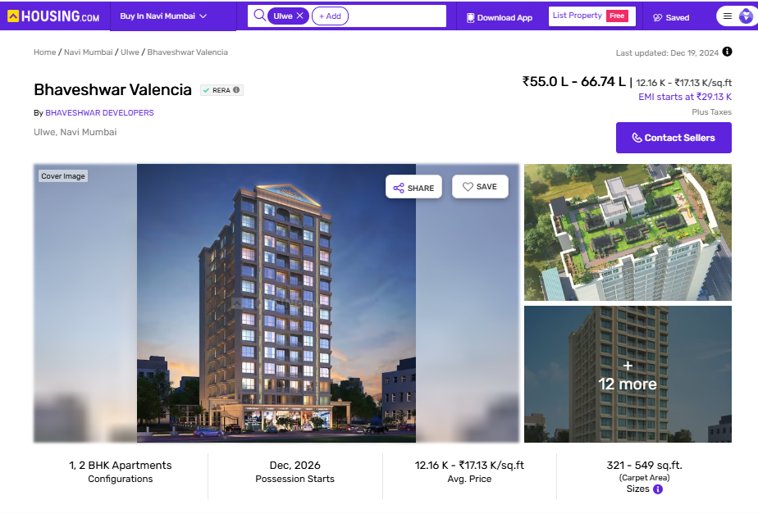

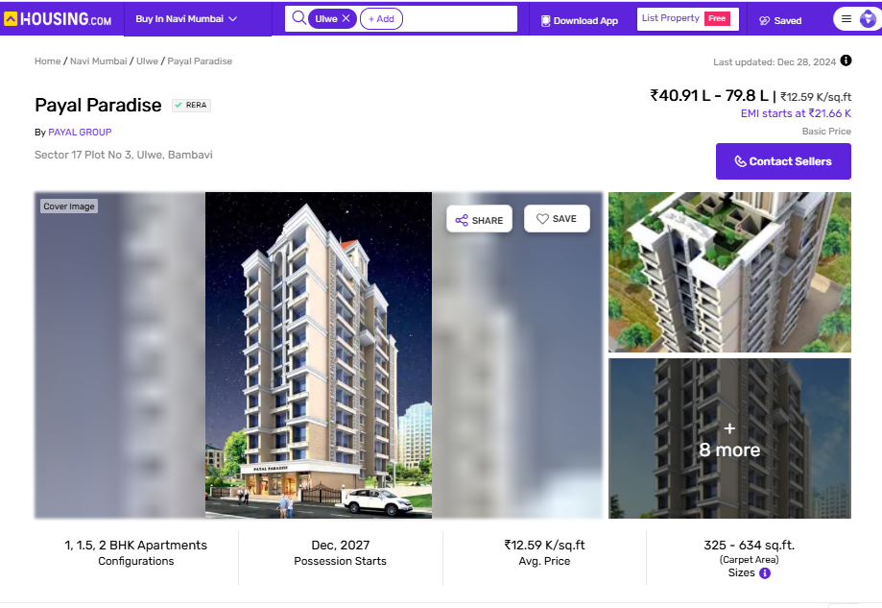
Price Indicators
Projects nearby Locality

Comp. | Source | Carpet Area in Sq. Ft. | Value in ` | Rate Per Sq. Ft.
2 BHK | housing.com | 616.00 | 79,00,000.00 | 12,825.00
2 BHK | housing.com | 740.00 | 94,90,000.00 | 12,825.00
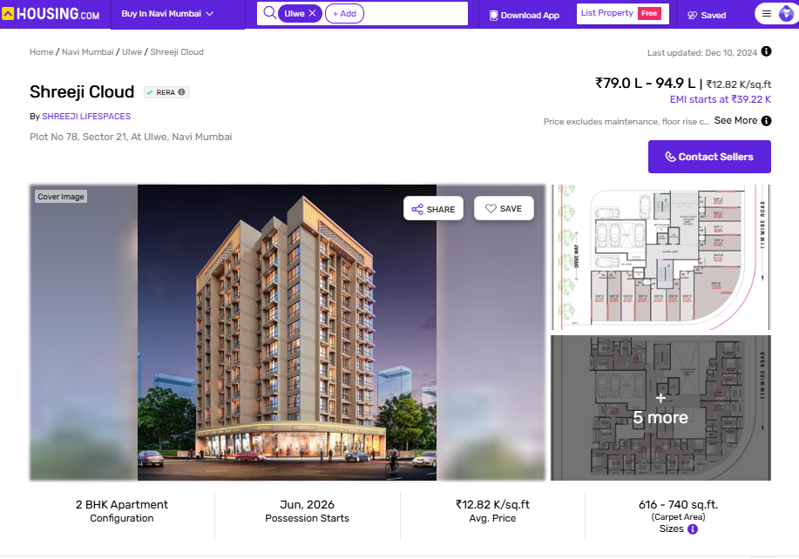
Price Indicators
Projects nearby Locality

Comp. | Source | Carpet Area in Sq. Ft. | Value in ` | Rate Per Sq. Ft.
1 BHK | magicbricks.com | 380.00 | 48,00,000.00 | 12,632.00
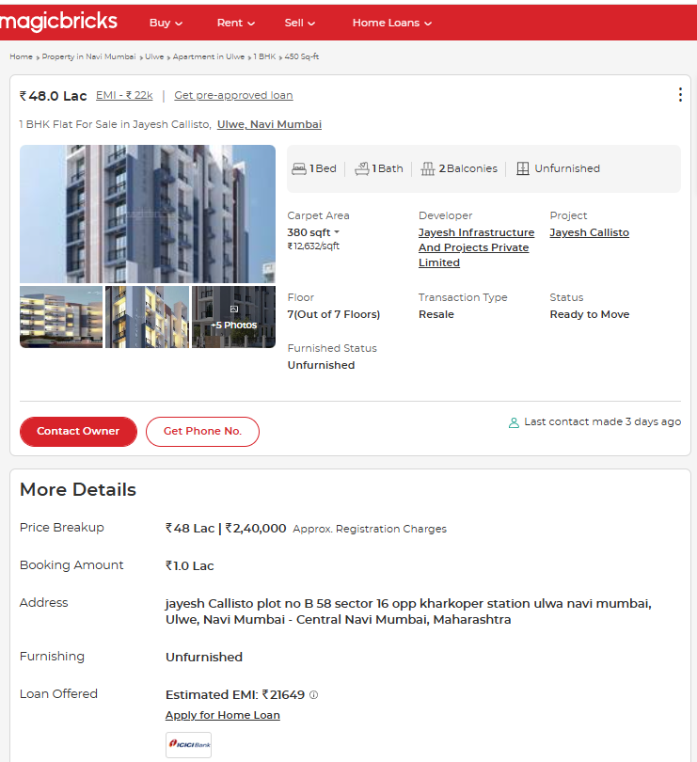

Price Indicators
Projects nearby Locality
Comp. | Source | Carpet Area in Sq. Ft. | Value in ` | Rate Per Sq. Ft.
1 BHK | magicbricks.com | 482.00 | 60,00,000.00 | 12,448.00
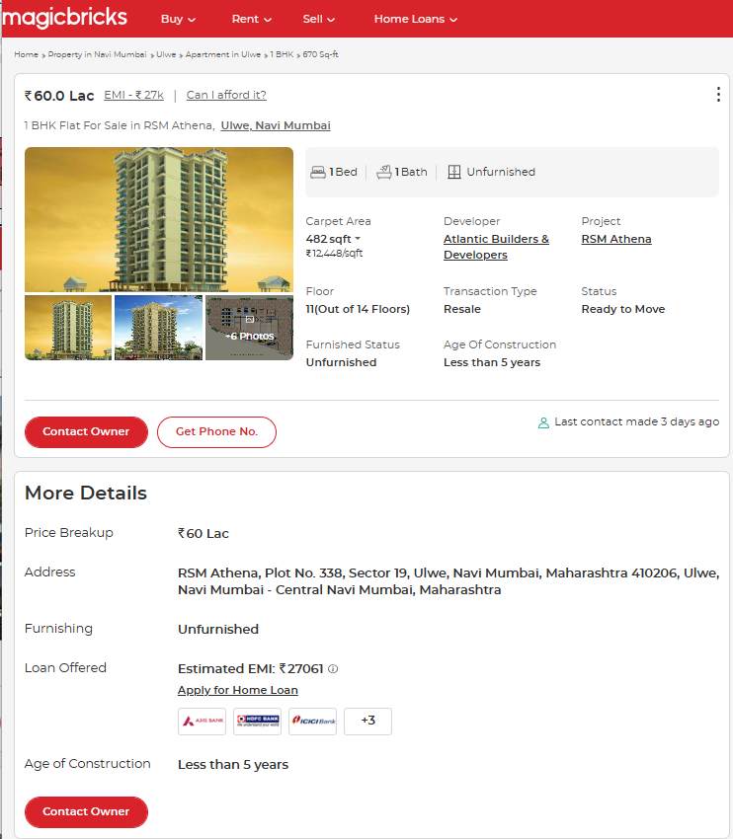

Price Indicators
Projects nearby Locality

Comp. | Source | Carpet Area in Sq. Ft. | Value in ` | Rate Per Sq. Ft.
2 BHK | magicbricks.com | 687.00 | 94,80,000.00 | 13,799.00
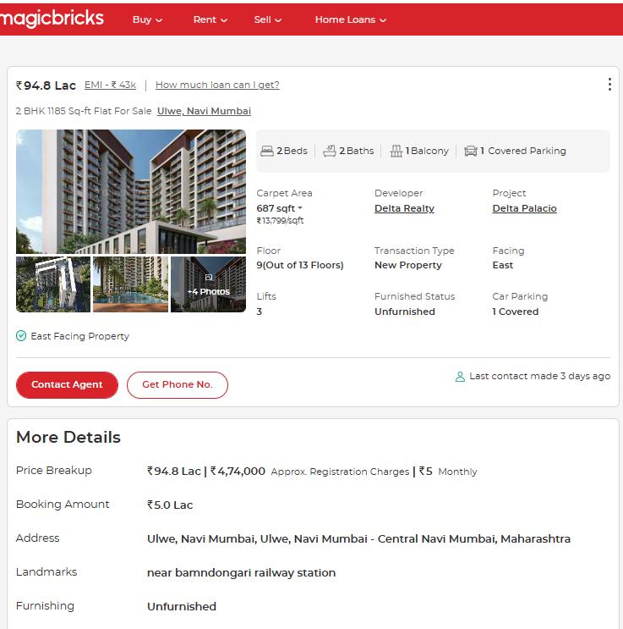

Price Indicators
Projects nearby Locality

Comp. | Source | Carpet Area in Sq. Ft. | Value in ` | Rate Per Sq. Ft.
1 BHK | magicbricks.com | 534.00 | 63,00,000.00 | 11,798.00
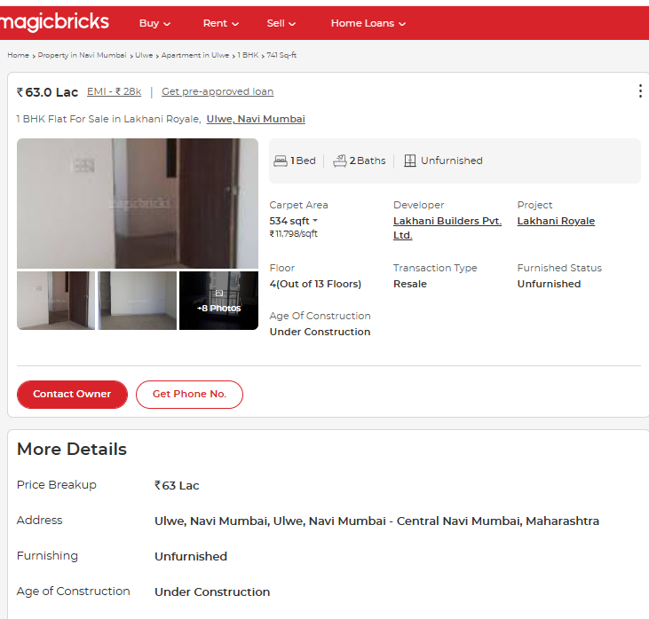

Price Indicators
Projects nearby Locality

Comp. | Source | Carpet Area in Sq. Ft. | Value in ` | Rate Per Sq. Ft.
2 BHK | magicbricks.com | 690.00 | 86,00,000.00 | 12,464.00
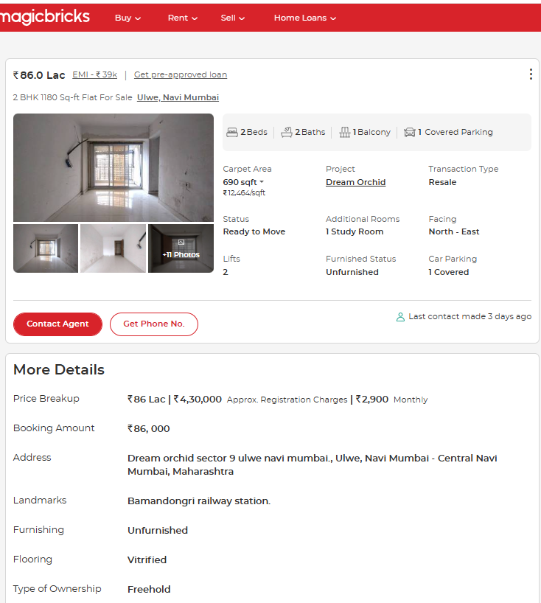

Price Indicators
Projects nearby Locality
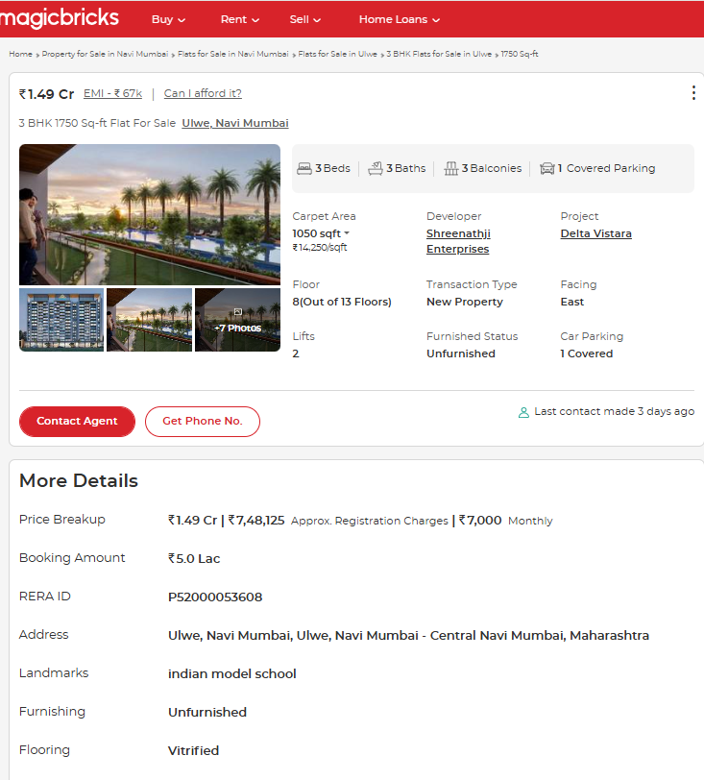
Comp. | Source | Carpet Area in Sq. Ft. | Value in ` | Rate Per Sq. Ft.
3 BHK | magicbricks.com | 1050.00 | 1,49,00,000.00 | 14,250.00

As a result of my appraisal and analysis, it is my considered opinion that the realizable Value of the above
property in the prevailing condition with aforesaid specification is (As per table attached to the report)

Place : Mumbai
Date : 28.12.2024

Manoj B. Chalikwar
Govt. Registered Valuer
Chartered Engineer (India)
Reg. No. IBBI/RV/07/2018/10366
SBI Empanelment No.: SME/TCC/38/IBBI/3

The undersigned has inspected the property detailed in the Valuation Report dated _______________________

on ____________________. We are satisfied that the fair and reasonable market value of the property is

`_________________________ (Rupees ________________________________________________________

________________________________________only).

Date
Signature
(Name & Designation of the Inspecting Official/s)

Countersigned
(BRANCH MANAGER)

Enclosures
 | Declaration-cum-undertaking from the valuer (Annexure- I) | Attached
 | Model code of conduct for valuer - (Annexure - II) | Attached
(Annexure-I)

DECLARATION-CUM-UNDERTAKING

I, Manoj Chalikwar son of Shri. Baburao Chalikwar do hereby solemnly affirm and state that:

- I am a citizen of India.

- I will not undertake valuation of any assets in which I have a direct or indirect interest or become so interested at any time during a period of three years prior to my appointment as valuer or three years after the valuation of assets was conducted by me.

- The information furnished in my valuation report dated 28.12.2024 is true and correct to the best of my knowledge and belief and I have made an impartial and true valuation of the property.

- I/ my authorized representative have personally inspected the property on 27.12.2024 The work is not sub - contracted to any other valuer and carried out by myself.

- Valuation report is submitted in the format as prescribed by the bank.

- I have not been depanelled / delisted by any other bank and in case any such depanelment by other banks during my empanelment with you, I will inform you within 3 days of such depanelment.

- I have not been removed / dismissed from service / employment earlier.

- I have not been convicted of any offence and sentenced to a term of imprisonment

- I have not been found guilty of misconduct in my professional capacity.

- I have not been declared to be unsound mind

- I am not an undischarged bankrupt, or has not applied to be adjudicated as a bankrupt;

- I am not an undischarged insolvent.

- I have not been levied a penalty under section 271J of Income-tax Act, 1961 (43 of 1961) and time limit for filing appeal before Commissioner of Income-tax (Appeals) or Income-tax Appellate Tribunal, as the case may be has expired, or such penalty has been confirmed by Income-tax Appellate Tribunal, and five years have not elapsed after levy of such penalty

- I have not been convicted of an offence connected with any proceeding under the Income Tax Act 1961, Wealth Tax Act 1957 or Gift Tax Act 1958 and

- My PAN Card number as applicable is AERPC9086P

- I undertake to keep you informed of any events or happenings which would make me ineligible for empanelment as a valuer

- I have not concealed or suppressed any material information, facts and records and I have made a complete and full disclosure

- I have read the Handbook on Policy, Standards and procedure for Real Estate Valuation, 2011 of the IBA and this report is in conformity to the "Standards" enshrined for valuation in the Part - B of the above handbook to the best of my ability.

- I have read the International Valuation Standards (IVS) and the report submitted to the Bank for the respective asset class is in conformity to the "Standards" as enshrined for valuation in the IVS in "General Standards" and "Asset Standards" as applicable. The valuation report is submitted in the prescribed format of the bank.

- I abide by the Model Code of Conduct for empanelment of valuer in the Bank. (Annexure V - A signed copy of same to be taken and kept along with this declaration)

- I am valuer registered with Insolvency & Bankruptcy Board of India (IBBI)

- My CIBIL Score and credit worthiness is as per Bank's guidelines.

- I am the Director of the company, who is competent to sign this valuation report.

- I will undertake the valuation work on receipt of Letter of Engagement generated from the system (i.e. LLMS / LOS) only.

- Further, I hereby provide the following information.

 | Particulars | Valuer comment
 | Background information of the asset being valued; | The property under consideration was purchased by M/s. Prime Neelkanth LLP.
 | Purpose of valuation and appointing authority | As per request from State Bank of India, HLST Belapur Branch, Navi Mumbai to assess fair market value of the property for bank loan purpose.
 | Identity of the Valuer and any other experts involved in the valuation; | Manoj B. Chalikwar – Regd. Valuer  Rajesh Ghadi – Valuation Engineer  Vinita Surve – Technical Manager
 | Disclosure of Valuer interest or conflict, if any; | We have no interest, either direct or indirect, in the property valued. Further to state that we do not have relation or any connection with property owner / applicant directly or indirectly. Further to state that we are an independent Valuer and in no way related to property owner / applicant
 | Date of appointment, valuation date and date of report; | Date of Appointment – 27.12.2024  Valuation Date – 28.12.2024  Date of Report – 28.12.2024
 | Inspections and/or investigations undertaken; | Physical Inspection done on date 27.12.2024
 | Nature and sources of the information used or relied upon; | Market Survey at the time of site visit  Ready Reckoner rates / Circle rates  Online search for Registered Transactions  Online Price Indicators on real estate portals  Enquiries with Real estate consultants  Existing data of Valuation assignments carried out by us
 | Procedures adopted in carrying out the valuation and valuation standards followed; | Sales Comparative Method
 | Restrictions on use of the report, if any; | This valuation is for the use of the party to whom it is addressed and for no other purpose. No responsibility is accepted to any third party who may use or rely on the whole or any part of this valuation. The valuer has no pecuniary interest that would conflict with the proper valuation of the property.
- . | Major factors that were taken into account during the valuation; | Current market conditions, demand and supply position, industrial land size, location, sustained demand for industrial land, all round development of commercial and industrial application in the locality etc.
 | Caveats, limitations and disclaimers to the extent they explain or elucidate the limitations faced by valuer, which shall not be for the purpose of limiting his responsibility for the valuation report. | Attached

Assumptions, Disclaimers, Limitations & Qualifications
Value Subject to Change
The subject appraisal exercise is based on prevailing market dynamics as on 28th December 2024 and does not take into account any unforeseeable developments which could impact the same in the future.
Our Investigations
We are not engaged to carry out all possible investigations in relation to the subject property. Where in our report we identify certain limitations to our investigations, this is to enable the reliant party to instruct further investigations where considered appropriate or where we recommend as necessary prior to reliance. Vastukala Consultants India Pvt. Ltd. (VCIPL) is not liable for any loss occasioned by a decision not to conduct further investigations
Assumptions
Assumptions are a necessary part of undertaking valuations. VCIPL adopts assumptions for the purpose of providing valuation advise because some matters are not capable of accurate calculations or fall outside the scope of our expertise, or out instructions. The reliant party accepts that the valuation contains certain specific assumptions and acknowledge and accept the risk of that if any of the assumptions adopted in the valuation are incorrect, then this may have an effect on the valuation.
Information Supplied by Others
The appraisal is based on the information provided by the client. The same has been assumed to be correct and has been used for appraisal exercise. Where it is stated in the report that another party has supplied information to VCIPL, this information is believed to be reliable but VCIPL can accept no responsibility if this should prove not to be so.
Future Matters
To the extent that the valuation includes any statement as to a future matter, that statement is provided as an estimate and/or opinion based on the information known to VCIPL at the date of this document. VCIPL does not warrant that such statements are accurate or correct.
Map and Plans
Any sketch, plan or map in this report is included to assist the reader while visualising the property and assume no responsibility in connection with such matters.

Site Details
Based on inputs received from Client's representative and site visit conducted, we understand that the subject property is currently a Building Under Construction work is in progress contiguous and non-agricultural land parcel admeasuring as per table attached to the report and in the name M/s. Prime Neelkanth LLP. Further, VCIPL has assumed that the subject property is free from any encroachment and is available as on the date of the appraisal.
Property Title
Based on our discussion with the Client, we understand that the subject property is owned by M/s. Prime Neelkanth LLP. For the purpose of this appraisal exercise, we have assumed that the subject property has a clear title and is free from any encumbrances, disputes and claims. VCIPL has made no further enquiries with the relevant local authorities in this regard and does not certify the property as having a clear and marketable title. Further, no legal advice regarding the title and ownership of the subject property has been obtained for the purpose of this appraisal exercise. It has been assumed that the title deeds are clear and marketable.
Environmental Conditions
We have assumed that the subject property is not contaminated and is not adversely affected by any existing or proposed environmental law and any processes which are carried out on the property are regulated by environmental legislation and are properly licensed by the appropriate authorities.
Town Planning
The permissible land use, zoning, achievable FSI, area statement adopted for purpose of this valuation is based on the information provided by the Client's representative and the same has been adopted for this valuation purpose. VCIPL has assumed the same to be correct and permissible. VCIPL has not validated the same from any authority.
Area
Based on the information provided by the Client's representative, we understand that the subject property is a Building Under Construction work is in progress, contiguous and non-agricultural land parcel admeasuring as per table attached to the report.
Condition & Repair
In the absence of any information to the contrary, we have assumed that there are no abnormal ground conditions, nor archaeological remains present which might adversely affect the current or future occupation, development or value of the property. The property is free from rat, infestation, structural or latent defect. No currently known deleterious or hazardous materials or suspect techniques will be used in the construction of or subsequent alteration or additions to the property and comments made in the property details do not purport to express an opinion about , or advise upon, the condition of uninspected parts and should not be taken as making an implied representation or statement about such parts
Valuation Methodology
For the purpose of this valuation exercise, the valuation methodology used is Direct Comparison Approach Method and proposed Highest and Best Use model is used for analysing development potential.
The Direct Comparison Approach involves a comparison of the property being valued to similar properties that have actually been sold in arms - length transactions or are offered for sale. This approach demonstrates what buyers have historically been willing to pay (and sellers willing to accept) for similar properties in an open and competitive market and is particularly useful in estimating the value of the land and properties that are typically traded on a unit basis.
In case of inadequate recent transaction activity in the subject micro-market, the appraiser would collate details of older transactions. Subsequently, the appraiser would analyse rental / capital value trends in the subject micro-market in order to calculate the percentage increase / decrease in values since the date of the identified transactions. This percentage would then be adopted to project the current value of the same.
Where reliance has been placed upon external sources of information in applying the valuation methodologies, unless otherwise specifically instructed by Client and/or stated in the valuation, VCIPL has not independently verified that information and VCIPL does not advise nor accept it as reliable. The person or entity to whom the report is addressed acknowledges and accepts the risk that if any of the unverified information in the valuation is incorrect, then this may have an effect on the valuation.
Not a Structural Survey
We state that this is a valuation report and not a structural survey
Other
All measurements, areas and ages quoted in our report are approximate
Legal
We have not made any allowances with respect to any existing or proposed local legislation relating to taxation on realization of the sale value of the subject property. VCIPL is not required to give testimony or to appear in court by reason of this appraisal report, with reference to the property in question, unless arrangement has been made thereof. Further, no legal advice on any aspects has been obtained for the purpose of this appraisal exercise
Property specific assumptions
Based on inputs received from the client and site visit conducted, we understand that the subject property is currently Building Under Construction work is in progress, contiguous and non-agricultural land parcel admeasuring area as per table attached to the report.

ASSUMPTIONS, CAVEATS, LIMITATION AND DISCLAIMERS
- We assume no responsibility for matters of legal nature affecting the property appraised or the title thereto, nor do we render our opinion as to the title, which is assumed to be good and marketable.
- The property is valued as though under responsible ownership.
- It is assumed that the property is free of liens and encumbrances.
- It is assumed that there are no hidden or unapparent conditions of the subsoil or structure that would render it more or less valuable. No responsibility is assumed for such conditions or for engineering that might be required to discover such factors.
- There is no direct/ indirect interest in the property valued.
- The rates for valuation of the property are in accordance with the Govt. approved rates and prevailing market rates.

(Annexure - II)

MODEL CODE OF CONDUCT FOR VALUERS

Integrity and Fairness
- A valuer shall, in the conduct of his/its business, follow high standards of integrity and fairness in all his/its dealings with his/its clients and other valuers.
- A valuer shall maintain integrity by being honest, straightforward, and forthright in all professional relationships.
- A valuer shall endeavour to ensure that he/it provides true and adequate information and shall not misrepresent any facts or situations.
- A valuer shall refrain from being involved in any action that would bring disrepute to the profession.
- A valuer shall keep public interest foremost while delivering his services.

Professional Competence and Due Care
- A valuer shall render at all times high standards of service, exercise due diligence, ensure proper care and exercise independent professional judgment.
- A valuer shall carry out professional services in accordance with the relevant technical and professional standards that may be specified from time to time.
- A valuer shall continuously maintain professional knowledge and skill to provide competent professional service based on up-to-date developments in practice, prevailing regulations / guidelines and techniques.
- In the preparation of a valuation report, the valuer shall not disclaim liability for his/its expertise or deny his/its duty of care, except to the extent that the assumptions are based on statements of fact provided by the company or its auditors or consultants or information available in public domain and not generated by the valuer.
- A valuer shall not carry out any instruction of the client insofar as they are incompatible with the requirements of integrity, objectivity and independence.
- A valuer shall clearly state to his client the services that he would be competent to provide and the services for which he would be relying on other valuers or professionals or for which the client can have a separate arrangement with other valuers.
Independence and Disclosure of Interest
- A valuer shall act with objectivity in his/its professional dealings by ensuring that his/its decisions are made without the presence of any bias, conflict of interest, coercion, or undue influence of any party, whether directly connected to the valuation assignment or not.
- A valuer shall not take up an assignment if he/it or any of his/its relatives or associates is not independent in terms of association to the company.
- A valuer shall maintain complete independence in his/its professional relationships and shall conduct the valuation independent of external influences.
- A valuer shall wherever necessary disclose to the clients, possible sources of conflicts of duties and interests, while providing unbiased services.
- A valuer shall not deal in securities of any subject company after any time when he/it first becomes aware of the possibility of his / its association with the valuation, and in accordance with the Securities and Exchange Board of India (Prohibition of Insider Trading)Regulations,2015 or till the time the valuation report becomes public, whichever is earlier.
- A valuer shall not indulge in "mandate snatching" or offering "convenience valuations" in order to cater to a company or client's needs.
- As an independent valuer, the valuer shall not charge success fee.
- In any fairness opinion or independent expert opinion submitted by a valuer, if there has been a prior engagement in an unconnected transaction, the valuer shall declare the association with the company during the last five years.
Confidentiality
- A valuer shall not use or divulge to other clients or any other party any confidential information about the subject company, which has come to his / its knowledge without proper and specific authority or unless there is a legal or professional right or duty to disclose.
Information Management
- A valuer shall ensure that he/ it maintains written contemporaneous records for any decision taken, the reasons for taking the decision, and the information and evidence in support of such decision. This shall be maintained so as to sufficiently enable a reasonable person to take a view on the appropriateness of his /its decisions and actions.
- A valuer shall appear, co-operate and be available for inspections and investigations carried out by the authority, any person authorised by the authority, the registered valuers organisation with which he/it is registered or any other statutory regulatory body.
- A valuer shall provide all information and records as may be required by the authority, the Tribunal, Appellate Tribunal, the registered valuers organisation with which he/it is registered, or any other statutory regulatory body.
- A valuer while respecting the confidentiality of information acquired during the course of performing professional services, shall maintain proper working papers for a period of three years or such longer period as required in its contract for a specific valuation, for production before a regulatory authority or for a peer review. In the event of a pending case before the Tribunal or Appellate Tribunal, the record shall be maintained till the disposal of the case.
Gifts and hospitality:

- A valuer or his / its relative shall not accept gifts or hospitality which undermines or affects his independence as a valuer.
Explanation: For the purposes of this code the term 'relative' shall have the same meaning as defined in clause (77) of Section 2 of the Companies Act, 2013 (18 of 2013).
- A valuer shall not offer gifts or hospitality or a financial or any other advantage to a public servant or any other person with a view to obtain or retain work for himself / itself, or to obtain or retain an advantage in the conduct of profession for himself / itself.

Remuneration and Costs.
- A valuer shall provide services for remuneration which is charged in a transparent manner, is a reasonable reflection of the work necessarily and properly undertaken, and is not inconsistent with the applicable rules.
- A valuer shall not accept any fees or charges other than those which are disclosed in a written contract with the person to whom he would be rendering service.

Occupation, employability and restrictions.

- A valuer shall refrain from accepting too many assignments, if he/it is unlikely to be able to devote adequate time to each of his/ its assignments.
- A valuer shall not conduct business which in the opinion of the authority or the registered valuer organisation discredits the profession.
Miscellaneous
- A valuer shall refrain from undertaking to review the work of another valuer of the same client except under written orders from the bank or housing finance institutions and with knowledge of the concerned valuer.
- A valuer shall follow this code as amended or revised from time to time.

Manoj B. Chalikwar
Govt. Registered Valuer
Chartered Engineer (India)
Reg. No. IBBI/RV/07/2018/10366
SBI Empanelment No.: SME/TCC/38/IBBI/3

