Vastu/Nashik/06/32014/2301224
22/20-325-RYBS
Date: 26.12.2024

To,
The Branch Manager
Union Bank of India
RLP Nashik Branch
Nawandar Sankul, 1366, Racca Colony, Near Soni Paithani, Sharanpur Road,
Nashik – 422 002, State – Maharashtra, Country – India.

Sub: Vetting of Extra Work

Sir,

With reference to above subject, we have evaluated the Extra Work for Residential Row House No.02, Ground Floor + First Floor," Matoshree Row Houses ", Survey No. 381/ 6/ 7/ A, Plot No. 8/ 2, Near Air Force Station Borgad, Village – Makhmalabad , Taluka & District - Nashik, PIN Code – 422 003, State – Maharashtra, Country – India. belongs to Name of Proposed Purchaser: Shri. Shrirang Banshi Ghodake & Sau. Surekha Shrirang Ghodake. Name of Owner: Sau. Jayshree Nitin Rikame.

We have verified the rates quoted as per current market rates. Details of Extra Work considered as per copy of Extra Work Agreement between Shri. Shrirang Banshi Ghodake & Sau. Surekha Shrirang Ghodake (First Party). Shri. Anil Nanasaheb Sandhan (Second Party) received on dated.19.12.2024. The Extra Work amount is Rs. 3,40,000/- (Rupees Three Lakh Forty Thousand Only)

The said Cost Vetting Certificate is valid upto next 6 months Only.

Thanking you

Sincerely yours

Sharadkumar B. Chalikwar
Govt. Reg. Valuer
Chartered Engineer (India)
Reg. No. (N) CCIT/1-14/52/2008-09

Agreement for Extra Work
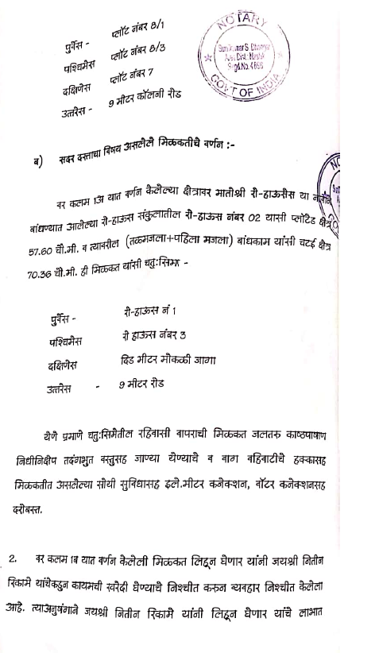
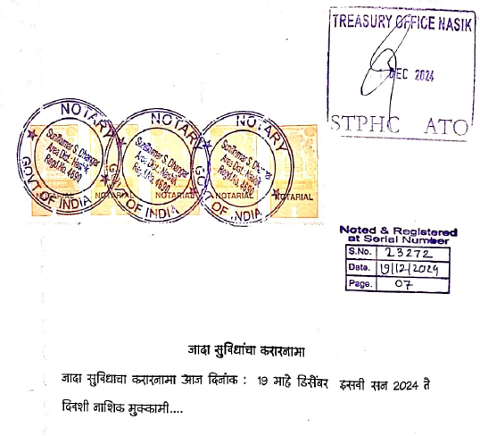

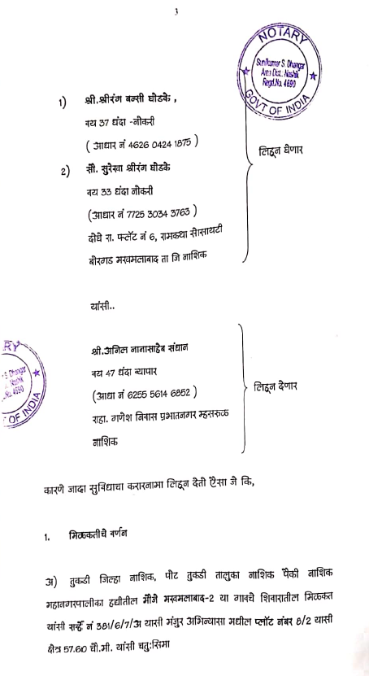

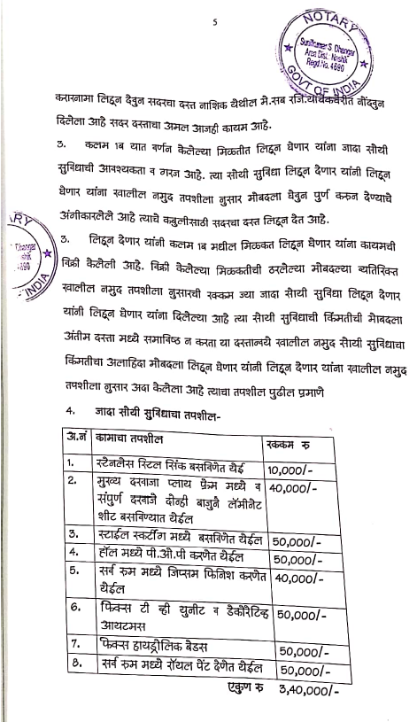
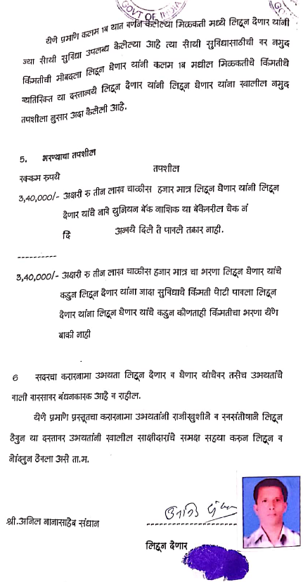

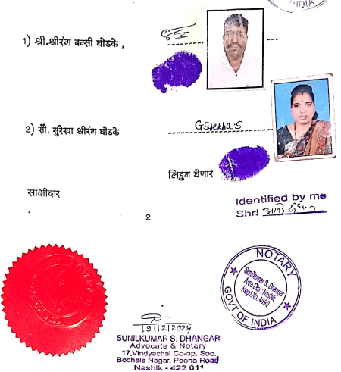

The Extra Work amount is Rs. 3,40,000/- (Rupees Three Lakh Forty Thousand Only)

