Valuation Report of the Immovable Property
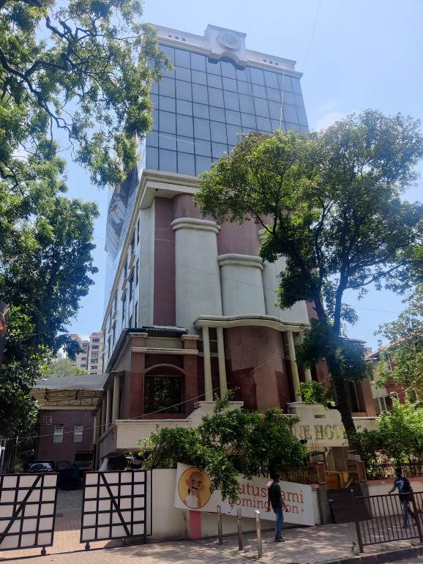

Details of the property under consideration:

Name of Owner: Ramee Hotels Pvt. Ltd.

"Ramee Guest Line" Hotel (4 Star) on Plot No. 3 New Survey No. 1258 & 1259, C. S. No. 9/10 of Matunga Division, Street No. 15, Opp. Swami Narayan Mandir, Near Dadar Railway Station, Dadar (East),
Mumbai – 400 014, Maharashtra, India

Longitude Latitude: 19°01'01.0"N 72°50'40.5"E

Intended User:
Bank of Baroda
Mid Corporate Branch, Nariman Point
222, Ground Floor, Maker Chamber – 4, Near Vidhan Bhavan,
Nariman Point, Mumbai – 400 021, Maharashtra, India

INDEX
Particulars Page No.
1. VALUATION OPINION REPORT 3
2. VALUATION REPORT (IN RESPECT OF INDUSTRIAL LAND & BUILDING) 4
3. TOTAL ABSTRACT VALUATION OF THE ENTIRE PROPERTY 11
4. METHOD OF VALUATION: COST APPROACH / LAND AND BUILDING METHOD 11
5. SOURCE OF DATA COLLECTION 12
6. IMPORTANT NOTES 12
7. ASSUMPTIONS, DISCLAIMERS, LIMITATIONS & QUALIFICATIONS 13
8. DECLARATION-CUM-UNDERTAKING 16
9. ACTUAL SITE PHOTOGRAPHS 20
10. GOOGLE MAP OF THE PROPERTY 24
11. READY RECKONER RATE 25
12. PRICE INDICATORS 26
13. SALE INSTANCES 28
14. JUSTIFICATION FOR PRICE /RATE 29
15. VALUATION OF THE PROPERTY PREMISES 30

Vastu/BOB/Mumbai/02/2025/13340/2310375
04/02-25-SSPPY
Date: 04.02.2025

VALUATION OPINION REPORT

This is to certify that the property bearing Residential Hotel Building on "Ramee Guest Line" Hotel (4 Star) on Plot No. 3 New Survey No. 1258 & 1259, C. S. No. 9/10 of Matunga Division, Street No. 15, Opp. Swami Narayan Mandir, Near Dadar Railway Station, Dadar (East), Mumbai – 400 014, Maharashtra, India belongs to Ramee Hotels Pvt. Ltd.

Boundaries of the property.
North | : | Kohinoor Hall & Lakhamsi Napoor Road
South | : | HDFC Bank & Rajgiri Court
East | : | Swami Gyan Jivandas Marg
West | : | BMC Ground & Shilpa Apartment
Considering various parameters recorded, existing economic scenario, and the information that is available with reference to the development of neighbourhood and method selected for valuation, we are of the opinion that, the property premises can be assessed and Value for this particular purpose at:
Particulars | Fair Market Value In (`) | Realizable Value In (`) | Distress Sale Value In (`)
Hotel Building | ` 133,72,27,370.00 | ` 120,35,04,633.00 | ` 106,97,81,896.00

The valuation of the property is based on the documents produced by the concern. Legal aspects have not been taken into considerations while preparing this valuation report.
Hence certified

Manoj B. Chalikwar
Registered Valuer
Chartered Engineer (India)
Reg. No. CAT–I–F–1763
BOB Empanelment No: ZO:MZ: ADV: 46:941
Vastukala Consultants (I) Pvt. Ltd.
B1-001, U/B Floor, Boomerang, Chandivali Farm Road, Powai, Andheri (East), Mumbai – 400 072

To,
The Chief Manager,
Bank Of Baroda
Mid Corporate Branch, Nariman Point
222, Ground Floor,
Maker Chamber – 4, Near Vidhan Bhavan,
Nariman Point, Mumbai – 400 021,
Maharashtra, India

VALUATION REPORT (IN RESPECT OF INDUSTRIAL LAND & BUILDING)

 | Ref No & Date |  |  | : | As per bank confirmation dated 17.12.2024
1 | Purpose for which the valuation is made |  |  | : | To ascertain the present market value of the Industrial Land & Building
2 | Type of Property |  |  | : | Residential Hotel Building
 | If the property is industrial state: |  |  | :
 | - for what type of activity, the premises is well suited: |  |  | : | 4 Star Hotel
 | - Sanctioned/connected power load: |  |  | : | Yes, 353 KW, Brihanmumbai Electricity Supply & Transportation.
 | - Type of activity presently going on at the premises: |  |  | : | 4 Star Hotel
3 | Date of visit |  |  |  | 18.12.2024
4 | Documents produced for scrutiny:
 | Description of the document |  |  | : | Document number |  | Document date
 | - Copy of Occupation Certificate |  |  | : | AC/Estates/13425/LB IV/20.12.2002 |  | 20.12.2002
 | - Copy of Occupation Certificate |  |  | : | EB/2700/FN/A |  | 01.11.2002
 | - Copy of Commencement Certificate |  |  | : | EB / 2700 / FN / A |  | 09.06.1986
 | - Copy of Completion Plan |  |  | : | EEBP / M. C. G. M. / 2700 / FN / A / dated 31.12.2002 |  | 31.12.2002
 | - Copy of 4 Star Hotel Certificate |  |  | : | 14-HRACC (17)/2019-H&R / 190824CS4878 |  | 02.08.2019
 | - Copy Fire Certificate |  |  | : | U/No. P -3534/2019/(9/10)/F/North/Matunga-CFO/1/New |  | 05.07.2022
 | - Copy of Fire Plan |  |  | : |  |  | 05.07.2022
 | - Copy of Insurance |  |  | : |  |  | 12.12.2024
 | - Copy of Property Tax |  |  | : | FN1301870090000 |  | 13.09.2024
 | - Copy Water bill Receipt |  |  | : | 2425HEW0917889 |  | 22.11.2024
 | - Copy of Electricity Bill |  |  | : | 410202156000 |  | 11.11.2024
 | Name of the owner(s) |  |  | : | Ramee Hotels Pvt. Ltd.
5 | Property Details:
 | House/Flat No/Door No. |  |  |  | N.A.
 | Plot No. |  |  |  | Plot No 3
 | Survey No |  |  |  | New Survey No. 1258 & 1259, C. S. No. 9/10
 | Ward & Block No. |  |  |  | N.A.
 | Location |  |  |  | Plot No. 3 New Survey No. 1258 & 1259, C. S. No. 9/10 of Matunga Division, Street No. 15.
 | Property is situated in (Gram Panchayat, Municipality, Municipal corporation) |  |  |  | Municipal Corporation
 | LANDMARK (Mandatory) |  |  |  | Opp. Swami Narayan Mandir
 | Full postal address of the property (FULL ADDRESS AND PINCODE MANDATORY) |  |  |  | "Ramee Guest Line" Hotel (4 Star) on Plot No. 3 New Survey No. 1258 & 1259, C. S. No. 9/10 of Matunga Division, Street No. 15, Opp. Swami Narayan Mandir, Near Dadar Railway Station, Dadar (East), Mumbai – 400 014, Maharashtra, India
6 | Brief Description/Specification of the property with comments on Right of Way and other Easement ARY Rights: |  |  | : | -
Located in Mumbai's commercial centre, Ramee Guest line Hotel, Dadar is a deluxe business hotel in Dadar that offers you a comfortable and relaxing stay. It is a home away from home for both corporate as well as leisure travellers. Designed with plush interiors and modern furnishing, our hotel in Dadar transmits energetic vibes soaking in plenty of natural light. Guests who are interested in visiting tourist attractions are in luck, for Hotel Ramee Guest line Dadar is in close proximity to crowd favourites like St. Michael's Church (2.9 km) and Worli Sea Face (2.9 km). With a stay at Ramee Guest line Hotel Dadar, you'll be centrally located in Mumbai, convenient to Plaza Cinema and Siddhi Vinayak Temple. This hotel is within close proximity of KEM Hospital and St. Michael's Church.

The land is Leasehold Land.

As per CFO Plan, the area of plot 1035.117 Sq. M. considered for valuation.

Structure:
Structure Area Consist of Basement + Ground Floor + Service Floor + 7th Upper Floor

As per Completion Plan the structure area is as under and considered for valuation –
Sr. No. | No. of Floors | Built up Area in Sq. Ft. | Excess Balcony Area in Sq. Ft. | Total Built up Area in Sq. Ft.  (Residential Area)
1 | Basement | 6889.58 | 0 | 6889.58
2 | Ground | 3084.72 | 0 | 3084.72
3 | 1st | 3906.99 | 0 | 3906.99
4 | Service Floor | 4324.375 | 0 | 4324.37
5 | 2nd | 2927.49 | 47.10 | 2974.59
6 | 3rd | 2927.49 | 47.10 | 2974.59
7 | 4th | 2927.49 | 47.10 | 2974.59
8 | 5th | 2416.35 | 141.64 | 2557.99
9 | 6th | 2480.10 | 49.49 | 2529.59
10 | 7th | 2335.018 | 0 | 2335.018
 | Total | 34219.603 | 332.445 | 34552.048

7.1 |  | Dimensions of the Plot of land (larger Extent)
 |  | Direction | As per the document Plan / title deed |  |  | Actual  (As per measurement of site visit)
 |  | North | N.A., the property under consideration is irregular in shape.
 |  | East
 |  | South
 |  | West
7.2 |  | Boundaries of the property (larger extent):
 |  | Direction | As per the document Plan/title deed |  |  | Actual  (As per the site during visit)
 |  | North | N.A. |  |  | N.A.
 |  | East | N.A. |  |  | N.A.
 |  | South | N.A. |  |  | N.A.
 |  | West | N.A. |  |  | N.A.
7.3 |  | Shape of the plot of land and remarks | Irregular in shape
7.4 |  | Boundaries of the property
 |  | Direction | As per the Completion Plan |  |  | Actual  (As per the site during visit)
 |  | North | N.A. |  |  | Kohinoor Hall & Lakhamsi Napoor Road
 |  | East | N.A. |  |  | HDFC Bank & Rajgiri Court
 |  | South | N.A. |  |  | Swami Gyan Jivandas Marg
 |  | West | N.A. |  |  | BMC Ground & Shilpa Apartment

8.0 | Property marking are available (Yes / No) | No
 | Dimensions of the Structure
 | Area of the unit | As per approved plan | As per the actual construction
 | Built up area | As per Brief Description | As per Brief Description
 | Common areas | - | -
 | Car Parking | - | -

8.1 Specification of Construction:
S. No. | Particulars | Comment
8.1.1 | Foundation | R.C.C.
8.1.2 | Basement | No
8.1.3 | Superstructure | RCC framed structure, Load bearing and MS sheet
8.1.4 | Joinery/Doors Windows | Wooden Fire Safety Doors, Powder Coated Aluminium Windows
8.1.5 | Walls and roof | RCC slab
8.1.6 | Doors | Wooden flush Doors.
8.1.7 | Windows | Aluminum frame sliding windows.
8.1.8 | Plastering | Cement plastering
8.1.9 | Flooring | Partly Italian Marble & Partly Vitrified Flooring
8.1.10 | Any special finishing | Granite Kitchen Platform
8.1.11 | Compound wall. | 5'6" High, R.C.C. columns with B. B. Masonry wall
8.1.12 | Water and sump | Municipal Water Supply and sewerage line.

9. | Details of Approval:
9.1 | Whether plan approval and required permission are issued by the competent authority (Yes/No) | Yes. MCGM Completion Plan
9.2 | Any other additional permissions / approval is required to be obtained. (Yes/No)  If yes please mention the details of permissions/approvals to be obtained. | Yes. MCGM Completion Plan
 | Whether building tax/land revenue has been paid up to date (Yes/No) | Yes
 | If building tax/land revenue tax is not required to be paid, state the reason for the same.: | Tax Paid till 2024
 | Details of approvals/permissions/ electricity connection/property tax/ (please include or delete any document as per applicability) | Issuing authority | Number of the document | Date of the document
 | a) Non agriculture land conversion order/  Data Bank Details of converted property | As per Occupation Certificate
 | b) Lay out approval/Regularization order of the plot.  b) Lay out approval/Regularization order of the plot issued by Govt.  If regularization of the plot is not required as per the aforesaid GO, reason for the same | Copy Completion Plan EEBP / M. C. G. M. / 2700 / FN / A / dated 31.12.2002
 | c) Building construction approval Certificate from the competent authority  (Applicable to MC where building is  constructed before …………... without  approved sanction plan) | N.A.
 | d) BPS/BRS/LRS order | Details Not Provided
 | e) Land use certificate | Details Not Provided
 | f) Commencement certificate | N.A.
 | g) Occupancy certificate | Details Not Provided
 | h) Patta Details: Type: Natham  Patta / Manaivari Patta etc  Patta No: (Applicable to TN) | Not Applicable as the property is located in the Maharashtra.
 | Restrictive Clauses as to uses, if any (whether Building use Certificate from the competent authority has been obtained etc.) | As per approved norms of MCGM.

9.4 | Description of the locality (Residential/commercial/mixed residential and commercial/industrial) | Commercial / Residential
9.5 | Classification of the Locality as per Municipal records | Higher Class
9.6 | Classification of locality (Higher class/Middle Class etc.) | Higher Class
 | Classification of area (Metro/Urban/Semi Urban / Rural) | Urban
9.7 | Title of the property (free hold, lease hold etc.) | Leasehold
 | If not free hold, what is the unexpired Period of contract in force? | N.A.
 | Please mention the details of the contract in force (for eg: name  of the tenant, date of effect of the lease/rental agreement, expiry date, monthly rent etc) | N.A.
9.8 | Presently used for (Residential / Commercial / Godown etc.) | Commercial / Residential
 | Type of the use to which it can be put to (in case of under construction / construction yet to be started units) | N.A.
9.9 | Building is vacant / occupied by owner / tenant | Owner Occupied
9.10 | Tentative monthly rent if let out. | N.A.
9.11 | Name of the present Owner | Ramee Hotels Pvt. Ltd.
 | Whether joint/co-ownership/others (specify) | Private Limited Company
 | In case of joint ownership please furnish shares of each owner and also whether the shares are undivided? | -
9.12 | Year of acquisition | 2002
9.13 | Purchase price
9.14 | Name of the person accompanied for inspection and contact number. | Mr. Ankit Kothari – Finance Controller  Mob. No. +91 75061 19647
9.15 | Name of the Bank Official accompanied for inspection and Branch name. | -
9.16 | Has the whole or part of the land been notified for acquisition by Government or Statutory Body? If so, give details | N.A.
9.17 | General remarks:
 | - Development of the surrounding areas. | Commercial / Residential
 | - Proximity of CIVIC amenities like schools, hospitals, offices, markets, entertainment centres, Commercial Malls etc. | All available near by
 | - Level of land with topographical conditions. | Plain
 | - Means and proximity of transportation facilities. | Trains, Bus
 | - Maintenance of the property. | Good
 | - Disadvantages if any. | No

9.2 Details of Previous Valuation:
Whether the subject property was valued earlier (Yes/No) | No
Date of earlier valuation | -
Name and address of the valuer | -
Purpose of earlier valuation | -
Basis of valuation (enclose a copy of the same) | -
Reason for increase or decrease in the valuation of the property | -

PART-1 | VALUATION OF THE PROPERTY | (STRUCTURE)
10.1.1 | Dimensions of the plot | Plot area = 1035.117 Sq. M.
10.1.2 | Extent of site | Plot area = 1035.117 Sq. M.  (Area as per Completion Plan)  Structure area = As per Brief Description
10.1.3 | Total area of the plot considered for valuation | Plot area = 10.35.117 Sq. M.  (Area as per Sale Deed)
10.1.4 | If there is a difference in extent of land considered in 10.1.3 and 10.1.2 above, please state the reason for the same. | N.A.
10.1.5 | Prevailing market rate (unit of measurement should be same as mentioned in 10.1.3) | ` 45,000/- to ` 49,000/- per Sq. M.  Details of online listings are attached with the report.
10.1.6 | Guide line rate obtained from the Registrar Office (unit of measurement should be same as mentioned in 10.1.3) | ` 1,82,910/- per Sq. M. i.e., ` 16,933/- per Sq. Ft. for Residential.  ₹ 3,30,300/- per Sq.M. i.e., ` 30,686/- per Sq. Ft. for  Commercial Shops
 | Guide line rate after depreciation | ` 1,61,759/- per Sq. M. i.e., ` 15,028/- per Sq. Ft. for Residential.  ₹ 2,75,250/- per Sq.M. i.e., ` 25,571/- per Sq. Ft. for  Commercial Shops
10.1.7 | Assessed/adopted rate of valuation (market) | ` 47,000/- per Sq. Ft.
10.1.8 | Estimated value of the land | Not Applicable We area considering Composite Rate for Valuation.
10.1.9 | Adverse effect of bank’s interest if any on accepting the property as security. | -

PART-2 | VALUATION OF THE PROPERTY | (STRUCTURE)
10.2.1 | Type of building  (Residential / Commercial / Industrial) | Commercial / Residential
10.2.2 | Year of construction | 2002
10.2.3 | Age of property | 23
10.2.4 | Appearance & Maintenance of the building | Good
10.2.5 | Residual life of the property | As per valuation table
10.2.6 | No. of floors and height of each floor | As per brief Description
10.2.7 | Type of structure (RCC/Load Bearing/Steel Framed) | As per brief Description
10.2.8 | Mortgaged Area | Details not provided
10.2.9 | F.A.R/F.S. I | Actual: 1 | Allowed: -
 | Deviation observed in construction (Yes/No) | Yes, additional MS Structure were constructed on site with plan approval from the local authority.
 | Percentage of deviation | -
 | Risk of demolition (Yes/No) | No
10.2.10 | Adverse effect of bank’s interest if any on accepting the property as security (in case if any deviation in construction is observed). | No
10.2.11 | Any addition of interiors / extension / addition is proposed (Yes/No) | No
10.2.12 | Valuation of Building

Valuation of Structure as on Date:

Sr. No. | No. of Floors | Built up Area in Sq. Ft. | Rate per Sq. Ft. on Built up Area | Value in `
1 | Basement | 6,889.58 | 20,000.00 | 13,77,91,600.00
2 | Ground | 3,084.72 | 52,000.00 | 16,04,05,440.00
3 | 1st | 3,906.99 | 47,000.00 | 18,36,28,530.00
4 | Service Floor | 4,324.38 | 20,000.00 | 8,64,87,500.00
5 | 2nd | 2,927.49 | 47,000.00 | 13,75,92,030.00
6 | 3rd | 2,927.49 | 47,000.00 | 13,75,92,030.00
7 | 4th | 2,927.49 | 47,000.00 | 13,75,92,030.00
8 | 5th | 2,416.35 | 47,000.00 | 11,35,68,450.00
9 | 6th | 2,480.10 | 47,000.00 | 11,65,64,700.00
10 | 7th | 2,335.02 | 47,000.00 | 10,97,45,846.00
 | Interior Cost | 5,419.74 | 3,000.00 | 1,62,59,214.00
Total / FMV |  |  |  | 133,72,27,370.00
Government Value

Sr. No. | No. of Floors | Built up Area in Sq. Ft. | Rate per Sq. Ft. on Built up Area | Value in `
1 | Basement | 6,889.58 | 17,900.00 | 12,33,23,482.00
2 | Ground | 3,084.72 | 25,571.00 | 7,88,79,375.00
3 | 1st | 3,906.99 | 15,028.00 | 5,87,14,246.00
4 | Service Floor | 4,324.38 | 10,520.00 | 4,54,92,425.00
5 | 2nd | 2,927.49 | 15,028.00 | 4,39,94,320.00
6 | 3rd | 2,927.49 | 15,028.00 | 4,39,94,320.00
7 | 4th | 2,927.49 | 15,028.00 | 4,39,94,320.00
8 | 5th | 2,416.35 | 15,028.00 | 3,63,12,908.00
9 | 6th | 2,480.10 | 15,028.00 | 3,72,70,943.00
10 | 7th | 2,335.02 | 15,028.00 | 3,50,90,651.00
Total |  |  |  | 54,70,66,990.00

TOTAL ABSTRACT VALUATION OF THE ENTIRE PROPERTY

Part - A | Land |  | -
Part - B | Buildings |  | ` 133,72,27,370-
Part – C | Compound Wall |  | -
Part – D | Amenities |  | -
Part - E | Pavement |  | -
Part - F | Services |  | -
 | Fair Market Value In (`) |  | ` 133,72,27,370/-
 | Realizable Value In (`) |  | ` 120,35,04,633/-
 | Distress Sale Value In (`) |  | ` 106,97,81,896/-
Remarks

METHOD OF VALUATION: COST APPROACH / LAND AND BUILDING METHOD
- The cost approach is a Real Property Valuation method which considers the value of a property as the cost of the land plus the replacement cost of the building (construction costs) minus the physical and functional depreciation.
- This approach is most commonly used for real estate properties that are not easily sold like schools, hospitals, government buildings and above type of property.
- Land cost can be estimated using the Sales Comparison Approach by studying recent sales of land close to the subject property, and these sales should be comparable in size and location with subject property.
- There are different ways to estimate replacement costs, the most common being finding out the cost to build a square foot of comparable properties multiplied by the total square footage of the building. The cost approach is commonly used for Residential Bungalow, Industrial Building and properties mentioned above. As the property is an industrial land and building thereof, we have adopted Cost approach / Land and Building Method for the purpose of valuation.
- The Price for similar type of property in the nearby vicinity is in the range of ` 45,000/- to ` 49,000/- per Sq. Ft. for land & Building Considering the rate with attached report, current market conditions, demand and supply position, Land size, location, sustained demand for Commercial/Residential building / Plot, all round development of commercial and Residential application in the locality etc. We estimate ` 47,000/- per Sq. M. for Land & Building with appropriate cost of construction for valuation.

SOURCE OF DATA COLLECTION
Please mention the sources of data collection for present market value and the guideline value.
- For Present Market Value- Source for Data Collection is Subject property Area Market Survey, Local Inquires from Estate Agents & Online Portals.
- For Guideline Value: https://igrmaharashtra.gov.in

As a result of my appraisal and analysis, it is my considered opinion that the Present Market Value of the above property in the prevailing condition with aforesaid specification is:
Particulars | Fair Market Value In (`) | Realizable Value In (`) | Distress Sale Value In (`)
Hotel Building | ` 133,72,27,370.00 | ` 120,35,04,633.00 | ` 106,97,81,896.00

Date: 04.02.2025
Place: Mumbai

Manoj B. Chalikwar
Registered Valuer
Chartered Engineer (India)
Reg. No. CAT–I–F–1763
BOB Empanelment No: ZO:MZ: ADV: 46:941
For Valuation Certificate: Please refer page No. 3 for the same.

IMPORTANT NOTES

Important Notes | We have considered the building built – up area as per approved plan.

ASSUMPTIONS, DISCLAIMERS, LIMITATIONS & QUALIFICATIONS

Value Subject to Change
The subject appraisal exercise is based on prevailing market dynamics as on 04th February 2025 and does not take into account any unforeseeable developments which could impact the same in the future.
Our Investigations
We are not engaged to carry out all possible investigations in relation to the subject property. Where in our report we identify certain limitations to our investigations, this is to enable the reliant party to instruct further investigations where considered appropriate or where we recommend as necessary prior to reliance. Vastukala Consultants India Pvt. Ltd. (VCIPL) is not liable for any loss occasioned by a decision not to conduct further investigations
Assumptions
Assumptions are a necessary part of undertaking valuations. VCIPL adopts assumptions for the purpose of providing valuation advise because some matters are not capable of accurate calculations or fall outside the scope of our expertise, or out instructions. The reliant party accepts that the valuation contains certain specific assumptions and acknowledge and accept the risk of that if any of the assumptions adopted in the valuation are incorrect, then this may have an effect on the valuation.
- The property is valued as though under responsible ownership.
- It is assumed that the property is free of liens and encumbrances.
- It is assumed that there are no hidden or unapparent conditions of the subsoil or structure that would render it more or less valuable. No responsibility is assumed for such conditions or for engineering that might be required to discover such factors.
- There is no direct/ indirect interest in the property valued.
- The rates for valuation of the property are in accordance with the Govt. approved rates and prevailing market rates
Information Supplied by Others
The appraisal is based on the information provided by the client. The same has been assumed to be correct and has been used for appraisal exercise. Where it is stated in the report that another party has supplied information to VCIPL, this information is believed to be reliable but VCIPL can accept no responsibility if this should prove not to be so.
Future Matters
To the extent that the valuation includes any statement as to a future matter, that statement is provided as an estimate and/or opinion based on the information known to VCIPL at the date of this document. VCIPL does not warrant that such statements are accurate or correct.

Map and Plans
Any sketch, plan or map in this report is included to assist the reader while visualizing the property and assume no responsibility in connection with such matters.
Site Details
Based on inputs received from Client's representative and site visit conducted, we understand that the subject property is an Industrial land and building. The property is owned by Ramee Hotels Pvt. Ltd. At present, the property is in owner’s possession. Further, VCIPL has assumed that the subject property is free from any encroachment and is available as on the date of the appraisal.
Property Title
Based on our discussion with the Client, we understand that the property is owned by Ramee Hotels Pvt. Ltd. For the purpose of this appraisal exercise, we have assumed that the subject property has a clear title and is free from any encumbrances, disputes and claims. VCIPL has made no further enquiries with the relevant local authorities in this regard and does not certify the property as having a clear and marketable title. Further, no legal advice regarding the title and ownership of the subject property has been obtained for the purpose of this appraisal exercise. It has been assumed that the title deeds are clear and marketable.
Environmental Conditions
We have assumed that the subject property is not contaminated and is not adversely affected by any existing or proposed environmental law and any processes which are carried out on the property are regulated by environmental legislation and are properly licensed by the appropriate authorities.
Town Planning
The permissible land use, zoning, achievable FSI, area statement adopted for purpose of this valuation is based on the information provided by the Client's representative and the same has been adopted for this valuation purpose. VCIPL has assumed the same to be correct and permissible. VCIPL has not validated the same from any authority.
Area
Based on the documents, we understand that the subject property is an Commercial / Residential land admeasuring 1035.117 Sq. M. and structure thereof.
Condition & Repair
In the absence of any information to the contrary, we have assumed that there are no abnormal ground conditions, nor archaeological remains present which might adversely affect the current or future occupation, development or value of the property. The property is free from rat, infestation, structural or latent defect. No currently known deleterious or hazardous materials or suspect techniques will be used in the construction of or subsequent alteration or additions to the property and comments made in the property details do not purport to express an opinion about, or advise upon, the condition of uninspected parts and should not be taken as making an implied representation or statement about such parts
Valuation Methodology
For the purpose of this valuation exercise, the valuation methodology used is Direct Comparison Approach Method and proposed Current use / Exiting use premise is considered for this assignment.
The Direct Comparison Approach involves a comparison of the property being valued to similar properties that have actually been sold in arms - length transactions or are offered for sale. This approach demonstrates what buyers have historically been willing to pay (and sellers willing to accept) for similar properties in an open and competitive market and is particularly useful in estimating the value of the land and properties that are typically traded on a unit basis.
In case of inadequate recent transaction activity in the subject micro-market, the appraiser would collate details of older transactions. Subsequently, the appraiser would analyse rental / capital value trends in the subject micro-market in order to calculate the percentage increase / decrease in values since the date of the identified transactions. This percentage would then be adopted to project the current value of the same.
Where reliance has been placed upon external sources of information in applying the valuation methodologies, unless otherwise specifically instructed by Client and/or stated in the valuation, VCIPL has not independently verified that information and VCIPL does not advise nor accept it as reliable. The person or entity to whom the report is addressed acknowledges and accepts the risk that if any of the unverified information in the valuation is incorrect, then this may have an effect on the valuation.
Not a Structural Survey
We state that this is a valuation report and not a structural survey
Other
All measurements, areas and ages quoted in our report are approximate
Legal
We have not made any allowances with respect to any existing or proposed local legislation relating to taxation on realization of the sale value of the subject property. VCIPL is not required to give testimony or to appear in court by reason of this appraisal report, with reference to the property in question, unless arrangement has been made thereof. Further, no legal advice on any aspects has been obtained for the purpose of this appraisal exercise
We assume no responsibility for matters of legal nature affecting the property appraised or the title thereto, nor do we render our opinion as to the title, which is assumed to be good and marketable.
Property specific assumptions
Based on inputs received from the client and site visit conducted, we understand that the subject property an Commercial / Residential land admeasuring 1035.117 Sq. M. and structure thereof.
The term Fair Market Value is defined as
“The most probable price, as of a specified date, in cash, terms equivalent to cash, or in other precisely revealed terms for which the specified property rights would sell after reasonable exposure in a competitive market under all conditions requisite to a fair sale, with the buyer and seller each acting prudently knowledgeably and for self-interest assuming that neither is under undue duress”.

DECLARATION-CUM-UNDERTAKING

I, Manoj Chalikwar son of Shri. Baburao Chalikwar do hereby solemnly affirm and state that:

- I am a citizen of India.
- I will not undertake valuation of any assets in which I have a direct or indirect interest or become so interested at any time during a period of three years prior to my appointment as valuer or three years after the valuation of assets was conducted by me.
- The information furnished in my valuation report dated 04.02.2025 is true and correct to the best of my knowledge and belief and I have made an impartial and true valuation of the property.
- I/ my authorized representative has personally inspected the property on 18.12.2024. The work is not sub - contracted to any other valuer and carried out by myself.
- Valuation report is submitted in the format as prescribed by the bank.
- I have not been depanelled / delisted by any other bank and in case any such depanelment by other banks during my empanelment with you, I will inform you within 3 days of such depanelment.
- I have not been removed / dismissed from service / employment earlier.
- I have not been convicted of any offence and sentenced to a term of imprisonment
- I have not been found guilty of misconduct in my professional capacity.
- I have not been declared to be unsound mind
- I am not an undischarged bankrupt or has not applied to be adjudicated as a bankrupt.
- I am not an undischarged insolvent.
- I have not been levied a penalty under section 271J of Income-tax Act, 1961 (43 of 1961) and time limit for filing appeal before Commissioner of Income-tax (Appeals) or Income-tax Appellate Tribunal, as the case may has expired, or such penalty has been confirmed by Income-tax Appellate Tribunal, and five years have not elapsed after levy of such penalty
- I have not been convicted of an offence connected with any proceeding under the Income Tax Act 1961, Wealth Tax Act 1957 or Gift Tax Act 1958 and
- My PAN Card number as applicable is AEAPC0117Q
- I undertake to keep you informed of any events or happenings which would make me ineligible for empanelment as a valuer.
- I have not concealed or suppressed any material information, facts and records and I have made a complete and full disclosure
- I have read the Handbook on Policy, Standards and procedure for Real Estate Valuation, 2011 of the IBA and this report is in conformity to the "Standards" enshrined for valuation in the Part - B of the above handbook to the best of my ability.
- I have read the International Valuation Standards (IVS) and the report submitted to the Bank for the respective asset class is in conformity to the "Standards" as enshrined for valuation in the IVS in "General Standards" and "Asset Standards" as applicable. The valuation report is submitted in the prescribed format of the bank.
- I abide by the Model Code of Conduct for empanelment of valuer in the Bank. (Annexure V - A signed copy of same to be taken and kept along with this declaration)
- I am valuer registered with Insolvency & Bankruptcy Board of India (IBBI)
- My CIBIL Score and credit worthiness is as per Bank's guidelines.
- I am Chairman & Managing Director of the company, who is competent to sign this valuation report.
- I will undertake the valuation work on receipt of Letter of Engagement generated from the system (i.e., LLMS / LOS) only.
- Further, I hereby provide the following information.

Sr. No. | Particulars | Valuer comment
1 | Background information of the asset being valued; | The property is owned by Ramee Hotels Pvt. Ltd. It is Obtained from Occupation Certificate.
2 | Purpose of valuation and appointing authority | As per the request from Bank of Baroda, Mid Corporate Branch, Nariman Point to assess Fair Market Value of the property for banking purpose..
3 | Identity of the Valuer and any other experts involved in the valuation; | Manoj B. Chalikwar – Regd. Valuer  Umang Patel – Regd. Valuer  Prayush P. Parekh – Senior Valuation Engineer  Saiprasad Patil – Valuation Engineer
4 | Disclosure of Valuer interest or conflict, if any; | We have no interest, either direct or indirect, in the property valued. Further to state that we do not have relation or any connection with property owner / applicant directly or indirectly. Further to state that we are an independent Valuer and in no way related to property owner / applicant
5 | Date of appointment, valuation date and date of report; | Date of Appointment – 17.18.2024  Valuation Date – 04.02.2025  Date of Report – 04.02.2025
6 | Inspections and/or investigations undertaken; | Physical Inspection done on date 18.12.2024
7 | Nature and sources of the information used or relied upon; | - Market Survey at the time of site visit  - Ready Reckoner rates / Circle rates  - Online search for Registered Transactions  - Online Price Indicators on real estate portals  - Enquiries with Real estate consultants  - Existing data of Valuation assignments carried out by us
8 | Procedures adopted in carrying out the valuation and valuation standards followed; | Cost Approach (For building construction)  Comparative Sales Method (For Land component)
9 | Restrictions on use of the report, if any; | This valuation is for the use of the party to whom it is addressed and for no other purpose. No responsibility is accepted to any third party who may use or rely on the whole or any part of this valuation. The valuer has no pecuniary interest that would conflict with the proper valuation of the property.
10 | Major factors that were taken into account during the valuation. | Current market conditions, demand and supply position, industrial land size, location, sustained demand for industrial land, all round development of commercial and industrial application in the locality etc.
11 | Caveats, limitations, and disclaimers to the extent they explain or elucidate the limitations faced by valuer, which shall not be for the purpose of limiting his responsibility for the valuation report. | Attached

For Branch Use

The undersigned has inspected the property detailed in the valuation report dt. ________, we are satisfied that the fair and reasonable value of the property is Rs. ____________ (___________________________________ in words).
Name of the inspecting officer:
Signature of the inspecting officer:
Designation of the inspecting officer:
Employee code:
Branch:
Seen and Noted
Name of the branch head/unit head:
Signature of the Branch head/Unit head:
Designation:
Employee code:
Branch:

ACTUAL SITE PHOTOGRAPHS
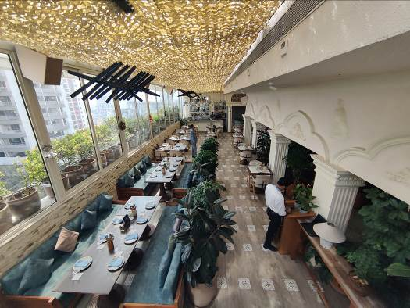
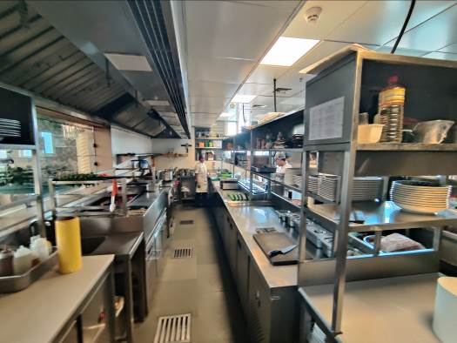
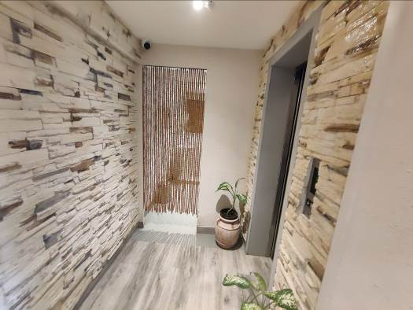
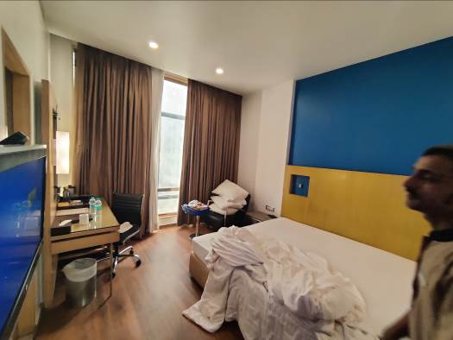
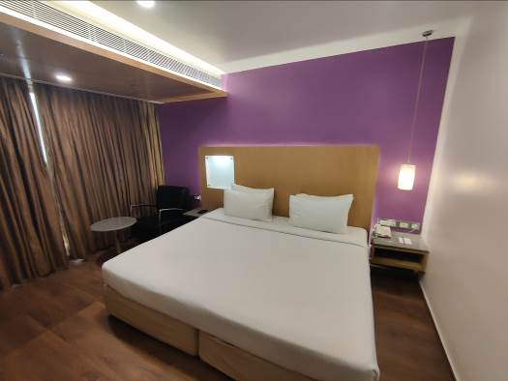

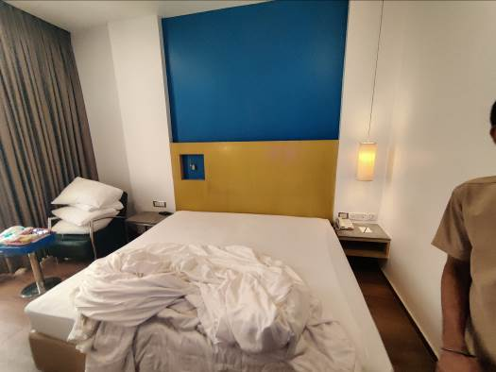

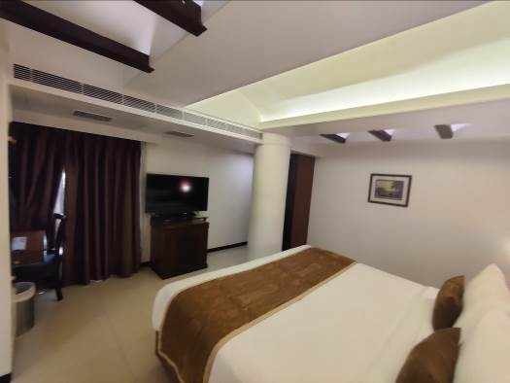

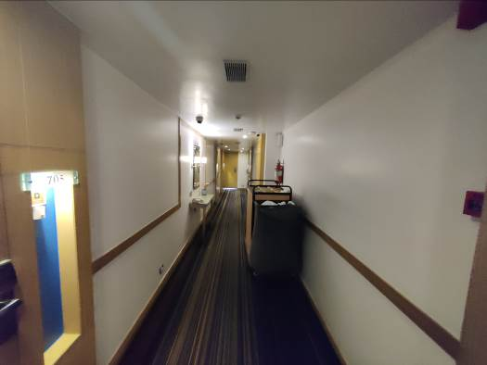

ACTUAL SITE PHOTOGRAPH
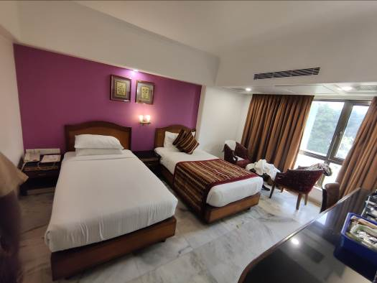
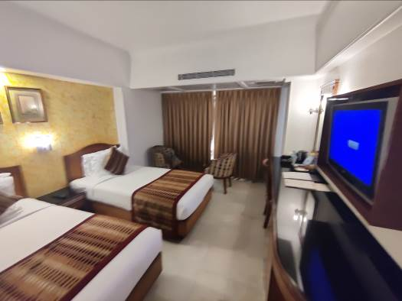
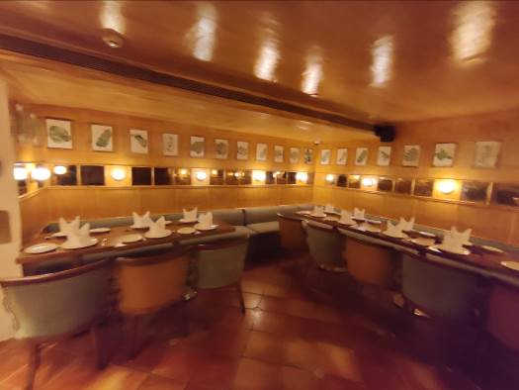

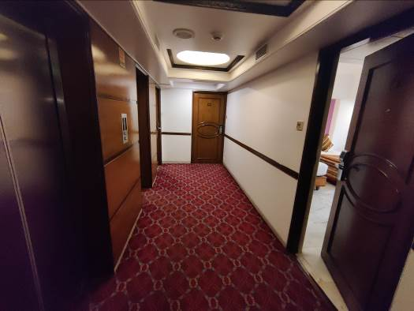
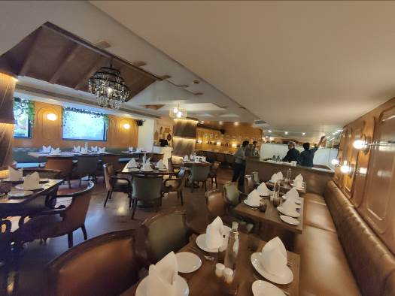

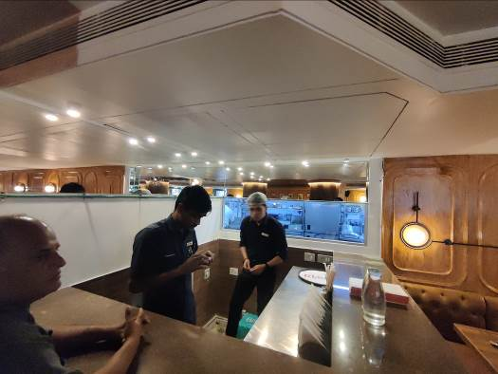

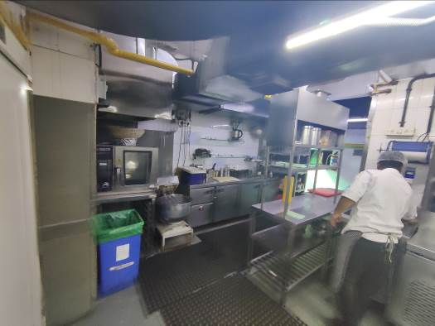
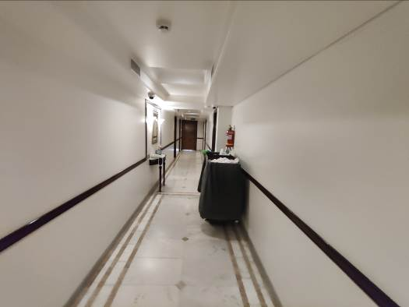

ACTUAL SITE PHOTOGRAPH
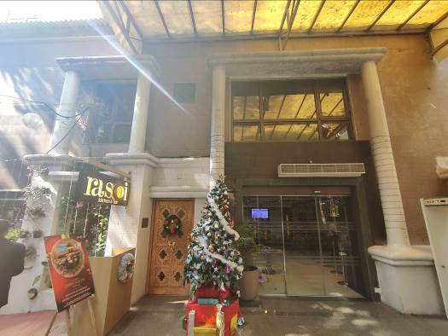
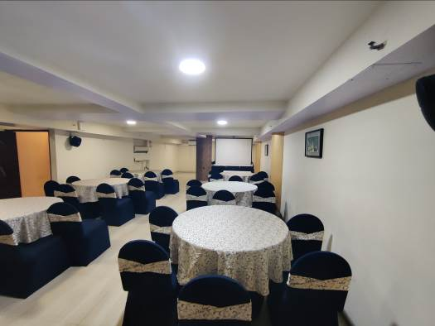
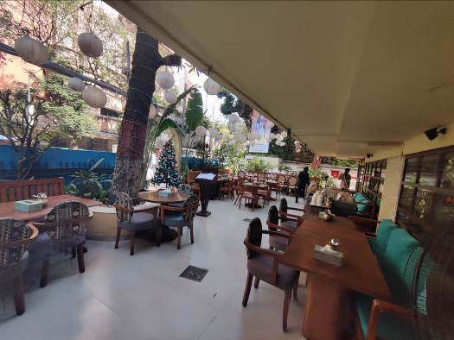
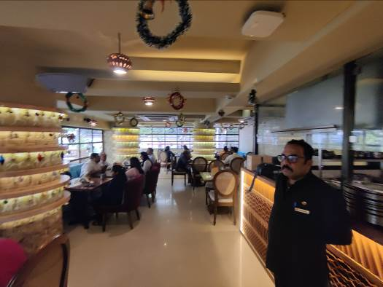
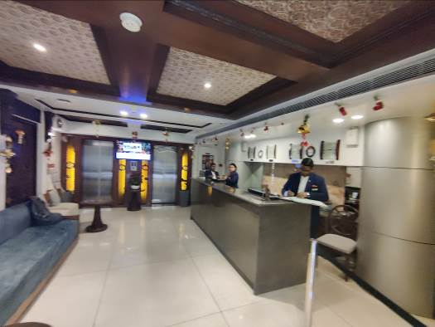

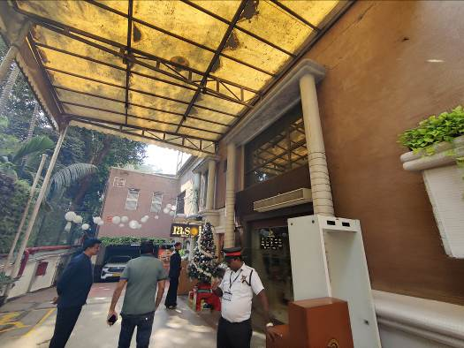

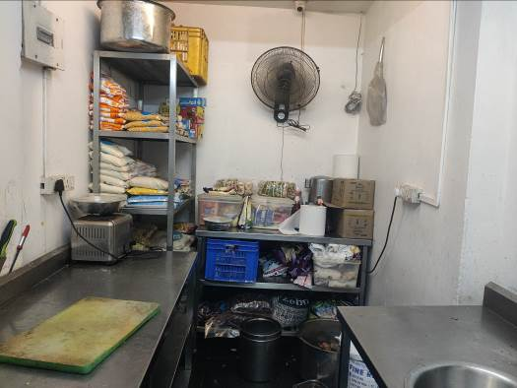

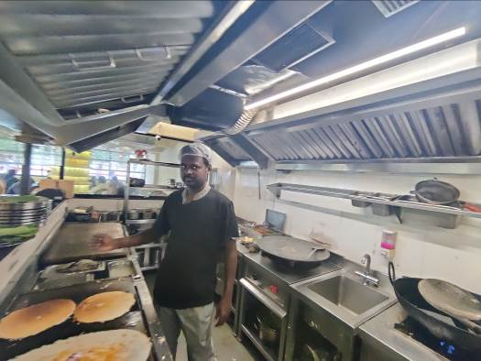

ACTUAL SITE PHOTOGRAPH
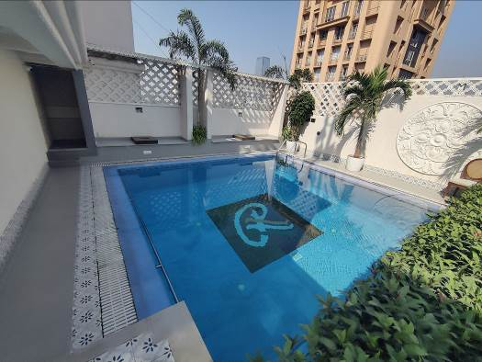
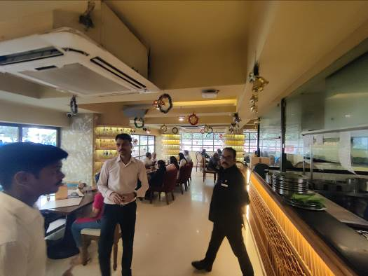
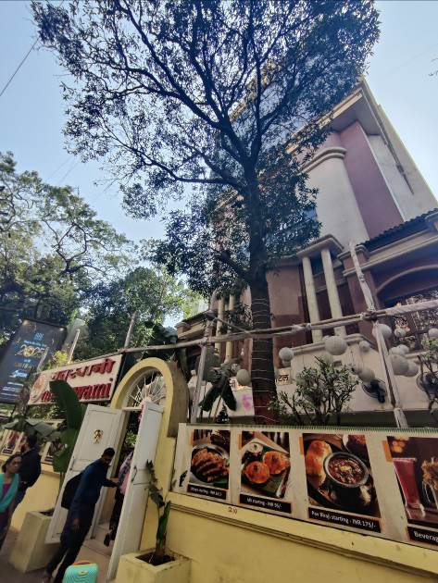
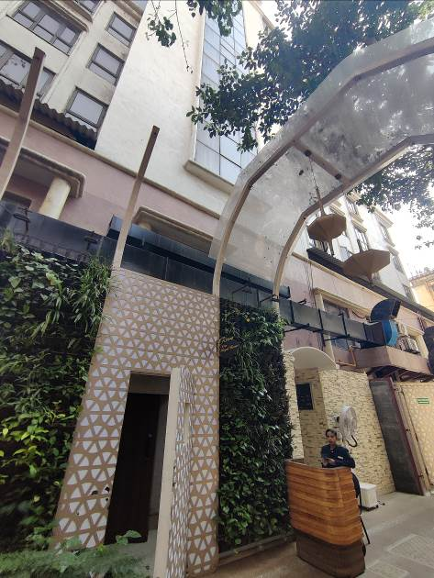
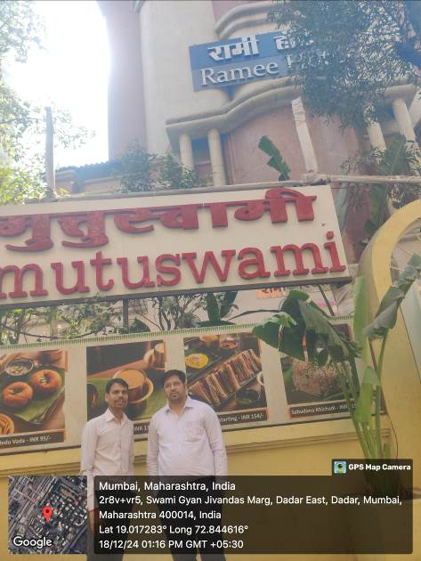

GOOGLE MAP OF THE PROPERTY
Site u/r
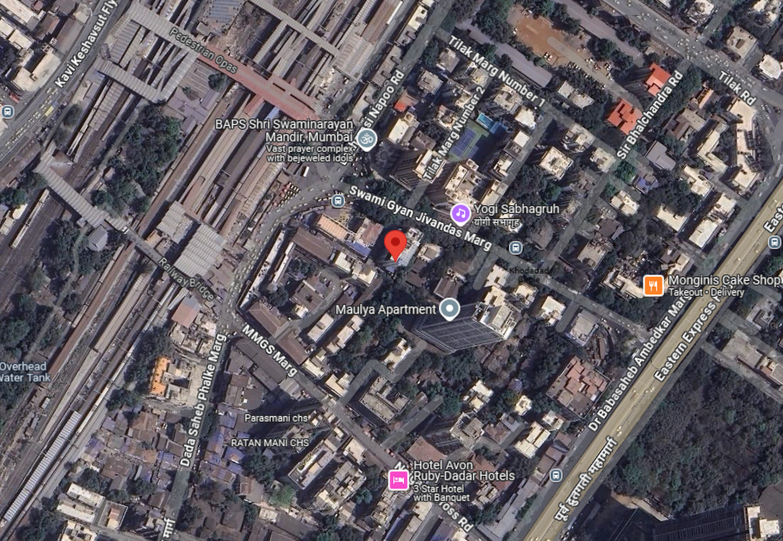

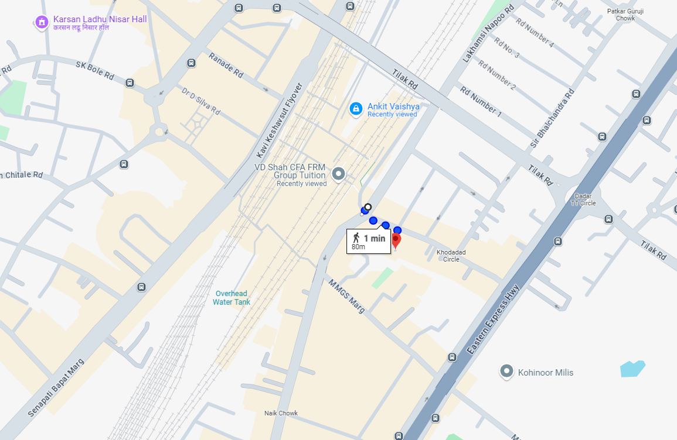

Longitude Latitude: 19°01'01.0"N 72°50'40.5"E
Note: The Blue line shows the route to site from nearest railway station (Dadar – 6.20KM.)

READY RECKONER RATE

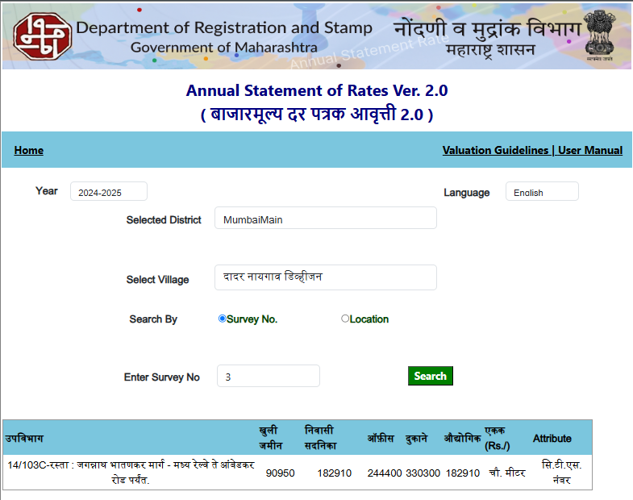

PRICE INDICATORS

Comp. | Source | Carpet Area in Sq. Ft. | Value in ` | Rate / Sq. Ft. on Carpet Area
3 BHK | 99acres.com | 2044.00 | 9,72,00,000.00 | 47,554.00
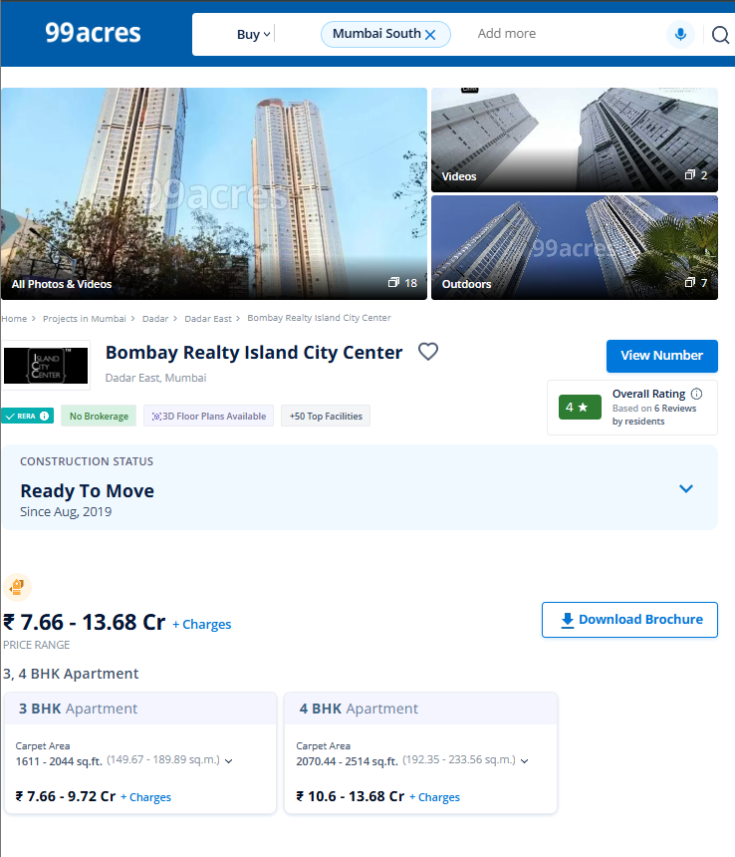

PRICE INDICATORS

Comp. | Source | Carpet Area in Sq. Ft. | Value in ` | Rate / Sq. Ft. on Carpet Area
3 BHK | Squareyards.com | 1519.00 | 7,59,00,000.00 | 49,967.00
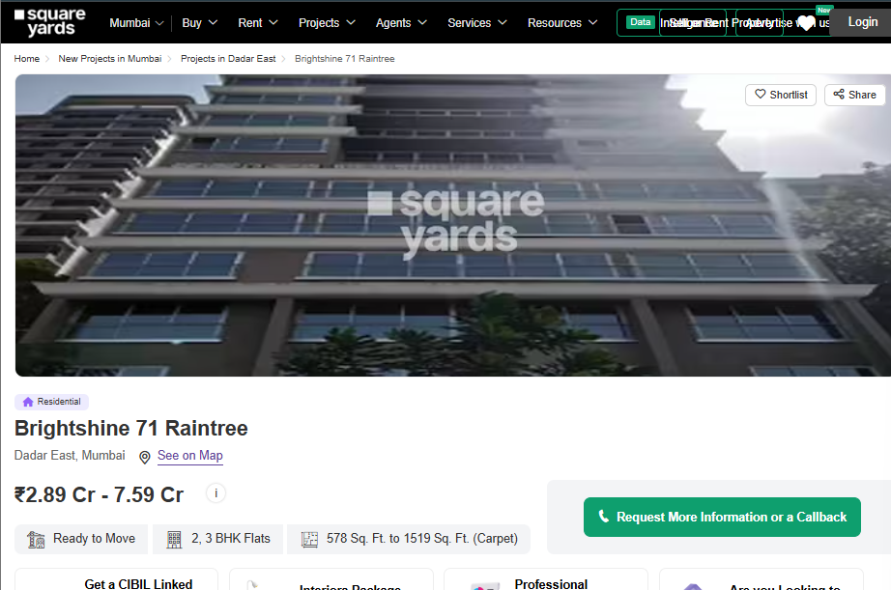

SALE INSTANCES
Regd. Doc. No. | Date | Agreement Value in ` | Carpet Area in Sq. Ft. | Rate / Sq. Ft. on Carpet Area
25043/2024 | 23.10.2024 | 10,40,00,000.00 | 2117.00 | 49,967.00
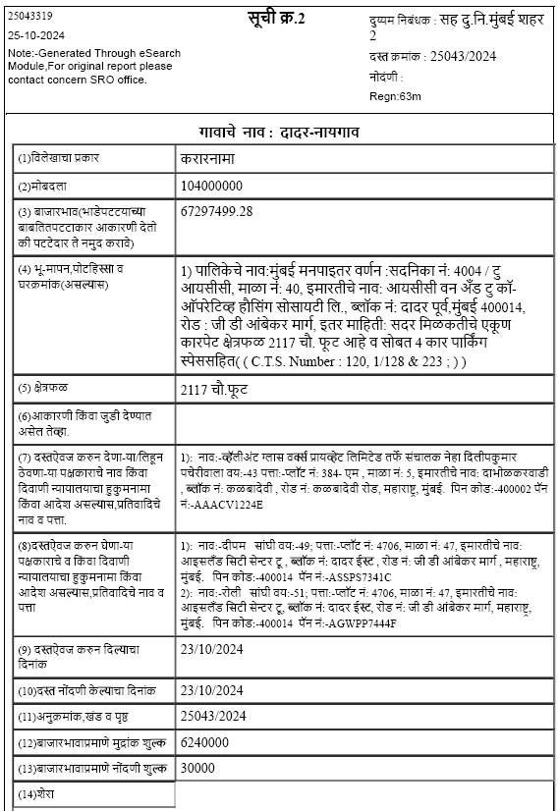

JUSTIFICATION FOR PRICE /RATE

The Market Value of the property is based on facts of markets discovered by us during our enquiries, however the government rate value in this case is less than the market value arrived by us. We are of the opinion that the value arrive by us will prove to be correct if an Auction of the subject property is carried out. As far as Market Value in Index II / Property Documents is concerned, it is not possible to comment on same, may be government rates are fixed by sampling during same point of time in part and whereas, Market values change every month.
In most of the cases the actual deal amount or Transaction value is not reflected in Index II / Property Documents because of various Market practices. As Valuer, we always try to give a value which is correct reflection of actual transaction value irrespective of any factors in market.
We hope this will satisfy your requirements.

VALUATION OF THE PROPERTY PREMISES

Considering various parameters recorded herein above, existing economic scenario, and the information that is available with reference to the development of neighborhood and method selected for valuation, we are of the opinion that, the property premises can be assessed and Fair Market Value for this particular purpose at:
Particulars | Fair Market Value In (`) | Realizable Value In (`) | Distress Sale Value In (`)
Hotel Building | ` 133,72,27,370.00 | ` 120,35,04,633.00 | ` 106,97,81,896.00

Manoj B. Chalikwar
Registered Valuer
Chartered Engineer (India)
Reg. No. CAT–I–F–1763
BOB Empanelment No: ZO:MZ: ADV: 46:941

