**Valuation Report of the Immovable Property**

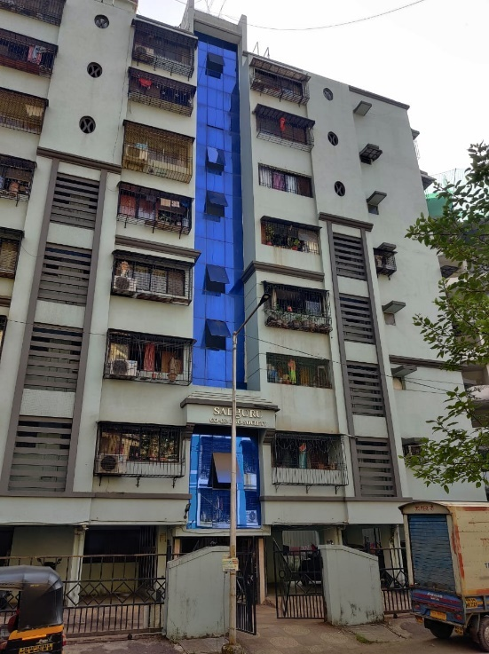

**Details of the property under consideration:**

Name of Owner: **Shri. Sachin Madhukar Paithankar & Mrs. Manjusha Sachin Paithankar**

Residential Flat No. 103, 1st Floor, **“Sadguru Co-op. Hsg. Soc. Ltd.”,** Nanepada Road,

Mulund (East), Mumbai – 400081, State - Maharashtra, Country – India.

# Latitude Longitude: 19°09’51.2”N 72°57’11.4”E

**Valuation Done for:**

**Cosmos Bank**

**Mulund (East) Branch**

Pornima Darshan Housing Socitey, 90 Feet DP Road, Mulund (East),

Mumbai – 400081, State - Maharashtra, Country – India

# Vastukala Consultants (I) Pvt. Ltd.

Mumbai • Delhi NCR • Aurangabad • Nanded • Indore • Pune

Raipur • Jaipur • Ahmedabad • Rajkot • Thane • Nashik

Vastu/Mumbai/12/2021/21963/38251

06/18-76-SKVS

Date: 06.12.2021

**VALUATION OPINION REPORT**

The property bearing Residential Flat No. 103, 1st Floor, **“Sadguru Co-op. Hsg. Soc. Ltd.”,** Nanepada Road, Mulund (East), Mumbai – 400081, State - Maharashtra, Country – India belongs to **Shri. Sachin Madhukar Paithankar & Mrs. Manjusha Sachin Paithankar.**

|  |  |
| --- | --- |
| Boundaries of the property. | |
| North | Palkhee Society |
| South | Sachin CHSL |
| East | Open Plot |
| West | Nanepada Road |
|  |  |

Considering various parameters recorded, existing economic scenario, and the information that is available with reference to the development of neighbourhood and method selected for valuation, we are of the opinion that, the property premises can be assessed and valued for banking purpose at **` 84,02,400.00 (Rupees Eighty Four Lakh Two Thousand Four Hundred Only)**

The valuation of the property is based on the documents produced by the concern. Legal aspects have not been taken into considerations while preparing this report.

Hence certified

**Sharadkumar B. Chalikwar**

Govt. Reg. Valuer

Chartered Engineer (India)

Reg. No. (N) CCIT/1-14/52/2008-09

Encl.: Valuation report

Valuation Report of Residential Flat No. 103, 1st Floor, **“Sadguru Co-op. Hsg. Soc. Ltd.”,** Nanepada Road,

Mulund (East), Mumbai – 400081, State - Maharashtra, Country – India

***Form 0-1***

*(See Rule 8 D)*

REPORT OF VALUATION OF IMMOVABLE PROPERTY (OTHER THAN AGRICULTURAL LANDS, PLANTATIONS, FORESTS, MINES AND QUARRIES)

**GENERAL:**

|  |  |  |  |
| --- | --- | --- | --- |
| 1 | Purpose for which the valuation is made | | To assess the Fair Market Value as on 06.12.2021 for Bank Loan Purpose |
| 2 | Date of inspection | | 27.11.2021 |
| 3 | Name of the owner/ owners | | **Shri. Sachin Madhukar Paithankar &**  **Mrs. Manjusha Sachin Paithankar** |
| 4 | If the property is under joint Ownership / co-ownership, share of each such owner. Are the shares undivided? | | Joint Ownership  (Details of ownership share not available) |
| 5 | Brief description of the property | | Residential Flat No. 103, 1st Floor, **“Sadguru Co-op. Hsg. Soc. Ltd.”,** Nanepada Road, Mulund (East), Mumbai – 400081, State - Maharashtra, Country – India |
| 6 | Location, street, ward no | | Nanepada Road, Mulund (East) |
| 7 | Survey/ Plot no. of land | | Survey No. 113, Hissa No. 4, C.T.S. No. 1057A of Village Mulund (East) |
| 8 | Is the property situated in residential/ commercial / mixed area / industrial area? | | Residential |
| 9 | Classification of locality-high class/ middle class/poor class | | Middle Class |
| 10 | Proximity to civic amenities like schools, Hospitals, Offices, market, cinemas etc. | | All the amenities are available in the vicinity |
| 11 | Means and proximity to surface communication by which the locality is served | | Served by Buses, Taxies, Auto and Private cars, Railway |
|  | **LAND** | |  |
| 12 | Area of land supported by documentary proof. Shape, dimension and physical features | | Carpet Area in Sq. Ft. = 414.00  (Area as per actual site measurement)  **Carpet Area in Sq. Ft. = 400.00**  **(Area as per Agreement for Sale)**  Built Up Area in Sq. Ft. = 480.00  (Carpet + 20%) |
| 13 | Roads, Streets or lanes on which the land is abutting | | Nanepada Road |
| 14 | If freehold or leasehold land | | Freehold |
| 15 | If leasehold, the name of Lessor/lessee, nature of lease, date of commencement and termination of lease and terms of renewal of lease.  (i) Initial premium  (ii) Ground rent payable per annum  (iii) Unearned increase payable to the Lessor in the event of sale or transfer | | N.A. |
| 16 | Is there any restriction covenant in regard to use of land? If so attach a copy of the covenant. | | As per documents provided |
| 17 | Are there any agreements of easements? If so, attach a copy of the covenant | | Information not available |
| 18 | Does the land fall in an area included in any Town Planning Scheme or any Development Plan of Government or any statutory body? If so, give Particulars. | | Information not available |
| 19 | Has any contribution been made towards development or is any demand for such contribution still outstanding? | | Information not available |
| 20 | Has the whole or part of the land been notified for acquisition by government or any statutory body? Give date of the notification. | | N.A. |
| 21 | Attach a dimensioned site plan | | Attached |
|  | **IMPROVEMENTS** | |  |
| 22 | Attach plans and elevations of all structures standing on the land and a lay-out plan. | | Information not available |
| 23 | Furnish technical details of the building on a separate sheet (The Annexure to this form may be used) | | Attached |
| 24 | Is the building owner occupied/tenanted/both? | | Tenant Occupied – Mr. Vinit Nilesh Kulkarni  Since – 2 Years |
| 25 | If the property owner occupied, specify portion and extent of area under owner-occupation | |
| 26 | What is the Floor Space Index permissible and Percentage actually utilized? | | Floor Space Index permissible - As per local norms  Percentage actually utilized – Details not available |
|  | **RENTS** | |  |
|  | (i) | Names of tenants/ lessees/ licensees, etc | N.A. |
|  | (ii) | Portions in their occupation | N.A. |
|  | (iii) | Monthly or annual rent /compensation/license fee, etc. paid by each | ` 17,500.00 expected rental income per month |
|  | (iv) | Gross amount received for the whole property | N.A. |
| 27 | Are any of the occupants related to, or close to business associates of the owner? | | N.A. |
| 28 | Is separate amount being recovered for the use of fixtures, like fans, geysers, refrigerators, cooking ranges, built-in wardrobes, etc. or for services charges? If so, give details | | N.A. |
| 29 | Give details of the water and electricity charges, if any, to be borne by the owner | | N.A. |
| 30 | Has the tenant to bear the whole or part of the cost repairs and maintenance? Give particulars | | N.A. |
| 31 | If a lift is installed, who is to bear the cost of maintenance and operation- owner or tenant? | | N.A. |
| 32 | If a pump is installed, who is to bear the cost of maintenance and operation- owner or tenant? | | N.A. |
| 33 | Who has to bear the cost of electricity charges for lighting of common space like entrance hall, stairs, passage, compound, etc. owner or tenant? | | N.A. |
| 34 | What is the amount of property tax? Who is to bear it? Give details with documentary proof | | Information not available |
| 35 | Is the building insured? If so, give the policy no., amount for which it is insured and the annual premium | | Information not available |
| 36 | Is any dispute between landlord and tenant regarding rent pending in a court of rent? | | N.A. |
| 37 | Has any standard rent been fixed for the premises under any law relating to the control of rent? | | N.A. |
|  | **SALES** | |  |
| 38 | Give instances of sales of immovable property in the locality on a separate sheet, indicating the Name and address of the property, registration No., sale price and area of land sold. | | As per sub register of assurance record |
| 39 | Land rate adopted in this valuation | | N. A. as the property under consideration is a Residential Flat in an apartment. The rate is considered as composite rate. |
| 40 | If sale instances are not available or not relied up on, the basis of arriving at the land rate | | N.A. |
|  | **COST OF CONSTRUCTION** | |  |
| 41 | Year of commencement of construction and year of completion | | Year of Construction – 2010 (As per Occupancy Certificate) |
| 42 | What was the method of construction, by contract/By employing Labour directly/ both? | | N.A. |
| 43 | For items of work done on contract, produce copies of agreements | | N.A. |
| 44 | For items of work done by engaging Labour directly, give basic rates of materials and Labour supported by documentary proof. | | N.A. |
| 45 | **Remarks** | |  |

***PART II- VALUATION***

**GENERAL:**

Under the instruction of Cosmos Bank, Mulund (East) Branch, we have valued Residential Flat No. 103, 1st Floor, **“Sadguru Co-op. Hsg. Soc. Ltd.”,** Nanepada Road, Mulund (East), Mumbai – 400081, State - Maharashtra, Country – India belongs to **Shri. Sachin Madhukar Paithankar & Mrs. Manjusha Sachin Paithankar**

We are in receipt of the following documents:

|  |  |
| --- | --- |
|  | Copy of Articles of Agreement dated 04.12.2009. |
|  | Copy of Occupancy Certificate No. CE / 4761 / BPES / AT dated 11.06.2010 issued by Municipal Corporation of Greater Mumbai. |
|  | Copy of Commencement Certificate No. CE / 4761 / BPES / AT dated 22.04.2004 issued by Municipal Corporation of Greater Mumbai. |
|  | Copy of Share Certificate No. 04 dated 01.09.2014 issued by Sadguru Co-op. Hsg. Soc. Ltd. |
|  | Copy of Approved Plan No. CE / 4761 / BPES / AT dated 11.06.2010 issued by Municipal Corporation of Greater Mumbai. |

**LOCATION:**

The said building is located Survey No. 113, Hissa No. 4, C.T.S. No. 1057A of Village Mulund (East), Taluka – Kurla, District – Mumbai Sububrban. The property falls in Residential Zone. It is about 1.1 Km. walkable distance from Mulund railway station.

**BUILDING:**

The building under reference is having Ground (Pt) + Stilt (Pt) + 1st to 5th + 6th (Part) + 7th Upper Floors (As per Occupancy Certificate). It is a R.C.C. framed structure with 9" thick external walls and 6" thick internal walls. The walls are having sand faced plaster from outside. The staircase is of R.C.C. with R.C.C. trades. The building external condition is good. The building is used for residential purpose. The 1st Floor is having 4 Residential Flats. 1 Lift is provided in the building.

**RESIDENTIAL FLAT:**

The residential flat under reference is situated on the 1st Floor. It consists of 1 Bedroom + Living Room + Dining + Kitchen + WC + Bath + Passage. The residential flat is ﬁnished with Vitrified tiles flooring, Teak wood door frame with flush doors, Powder coated aluminium sliding windows, Concealed and openable plumbing with C.P. fittings, Electrical wiring with concealed capping, Cement plastering with POP false ceiling.

**Valuation as on 03rd December 2021**

|  |  |
| --- | --- |
| The Carpet Area of the Residential Flat: | 35 480.00 Sq. Ft. |

**Deduct Depreciation:**

|  |  |  |
| --- | --- | --- |
| Year of Construction of the building | : | 2010 (As per Occupancy Certificate) |
| Expected total life of building | : | 60 Years |
| Age of the building as on 2021 | : | 11 Years |
| Cost of Construction | : | 480.00 X 3,000.00 = ` 14,40,000.00 |
| Depreciation {(100 -10) X 11 / 60} | : | 16.50% |
| Amount of Depreciation | : | ` 2,37,600.00 |
| Guideline rate obtained from the Stamp Duty Ready Reckoner for new property | : | ` 1,39,250.00 per Sq. M.  i.e. ` 12,937.00 per Sq. Ft. |
| Guideline rate (after depreciate) |  | ` 1,24,534.00 per Sq. M.  i.e. ` 11,569.00 per Sq. Ft. |
| Prevailing market rate | : | ` 18,000.00 per Sq. Ft. |
| **Value of property as on 06.12.2021** | : | **480.00 Sq. Ft. X ` 18,000.00 = ` 86,40,000.00** |
|  |  |  |

(Area of property x market rate of developed land & Residential premises as on 2021 published in The Indian Valuer’s Directory and Reference Book for purpose of valuation. – Depreciation)

|  |  |  |
| --- | --- | --- |
| **Depreciated fair value of the property**  **as on 06.12.2021** | : | **` 86,40,000.00 (-) ` 2,37,600.00 =**  **` 84,02,400.00** |
| **Total Value of the property** | **:** | **` 84,02,400.00** |
| **The realizable value of the property** | **:** | **` 75,62,160.00** |
| **Distress value of the property** | **:** | **` 67,21,920.00** |
| **Insurable value of the property** | **:** | **` 14,40,000.00** |

Taking into consideration above said facts, we can evaluate the value of Residential Flat No. 103, 1st Floor, **“Sadguru Co-op. Hsg. Soc. Ltd.”,** Nanepada Road, Mulund (East), Mumbai – 400081, State - Maharashtra, Country – India for this particular purpose at **` 84,02,400.00 (Rupees Eighty Four Lakh Two Thousand Four Hundred Only)** as on 06th December 2021.

**NOTES**

1. I, Sharadkumar B. Chalikwar with my experience and ability to judgment I am of the considered opinion that the fair market value of the property as on 06th December 2021 is at **` 84,02,400.00 (Rupees Eighty Four Lakh Two Thousand Four Hundred Only).** Value varies with time and purpose and hence this value should not be referred for any purpose other than mentioned in this report.
2. This valuation is done on the basis of information, which the Valuer has obtained by information provided by the client about the premises and location of the surrounding area and also prevailing rates in the surrounding area, and further subject to document as mentioned in valuation report.
3. This Valuer should not be held responsible for authentication of documents, clear title and other such related matters. For that purpose Latest Legal Opinion should be sought.

**PART III- DECLARATION**

I hereby declare that

1. The information furnished in part I is true and correct to the best of my knowledge and belief;
2. I have no direct or indirect interest in the property valued:

**ANNEXURE TO FORM 0-1**

|  |  |  |  |
| --- | --- | --- | --- |
| 1 | No. of floors and height of each floor | | Ground (Pt) + Stilt (Pt) + 1st to 5th + 6th (Part) + 7th Upper Floors (As per Occupancy Certificate) |
| 2 | Plinth area floor wise as per IS 3361-1966 | | N.A. as the said property is a Residential Flat on 1st Floor |
| 3 | Year of construction | | 2011 (As per Occupancy Certificate) |
| 4 | Estimated future life | | 49 years Subject to proper, preventive periodic maintenance and structural repairs. |
| 5 | Type of construction- load bearing walls/RCC frame/ steel frame | | R.C.C. Framed Structure |
| 6 | Type of foundations | | R.C.C. Foundation |
| 7 | Walls | | All external walls are 9" thick and partition walls are 6" thick. |
| 8 | Partitions | | 6" thick brick wall |
| 9 | Doors and Windows | | Teak Wood door frame with flush doors, Powder coated aluminium sliding windows |
| 10 | Flooring | | Vitrified tiles flooring |
| 11 | Finishing | | Cement Plastering with POP false ceiling |
| 12 | Roofing and Terracing | | R.C.C. Slab |
| 13 | Special architectural or decorative features, if any | | No. |
| 15 | (i) | Internal wiring: surface /conduit | Concealed wiring |
|  | (ii) | Class of fittings: Superior/Ordinary/Poor. | Good |
| 15 | Sanitary installations | |  |
|  | (i) | No. of water closets | As per requirement |
|  | (ii) | No. of lavatory basins |
|  | (iii) | No. of urinals |
|  | (iv) | No. of sinks |
| 16 | Class of fittings: Superior coloured / superior white/ordinary. | | Superior white |
| 17 | Compound wall  Height and length  Type of construction | | 5'.6" High, R.C.C. columns with B. B. Masonry wall. |
| 18 | No. of lifts and capacity | | 1 Lift |
| 19 | Underground sump – capacity and type of construction | | R.C.C tank |
| 20 | Over-head tank  Location, capacity  Type of construction | | R.C.C tank on Terrace |
| 21 | Pumps- no. and their horse power | | May be provide as per requirement |
| 22 | Roads and paving within the compound approximate area and type of paving | | Chequered tiles in open spaces, etc. |
| 23 | Sewage disposal – whereas connected to public sewers, if septic tanks provided, no. and capacity | | Connected to Municipal Sewerage System |

**Actual site photographs**

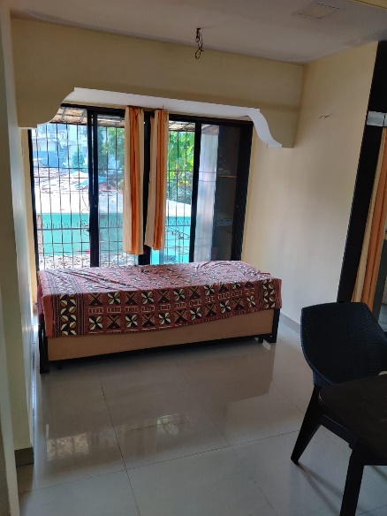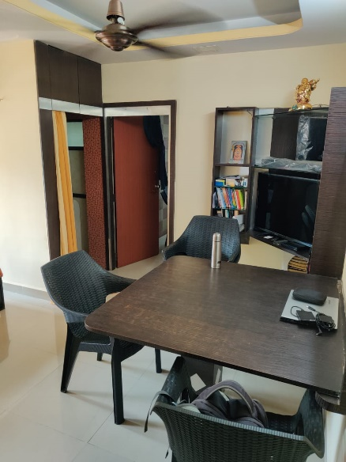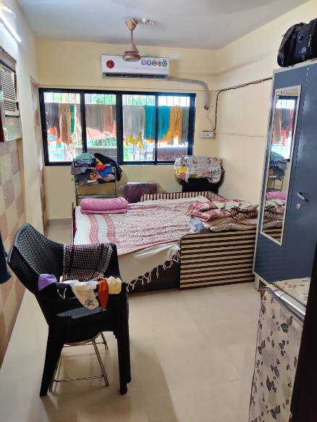

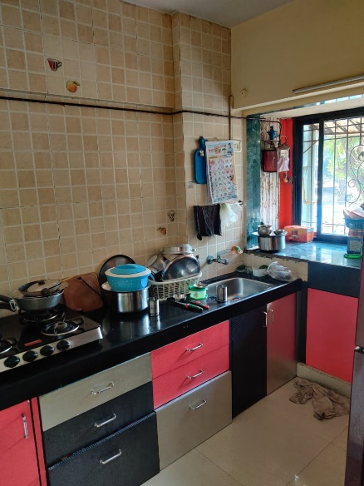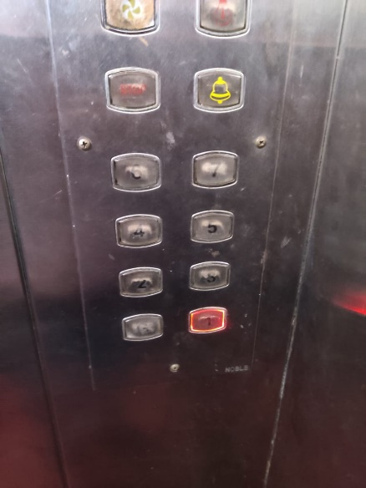

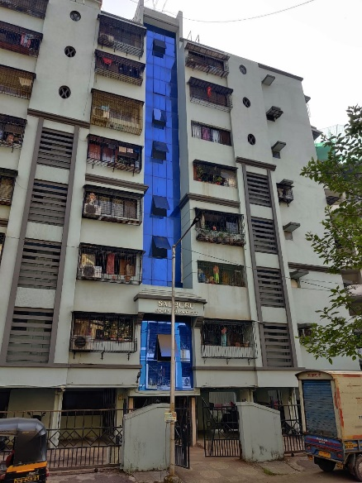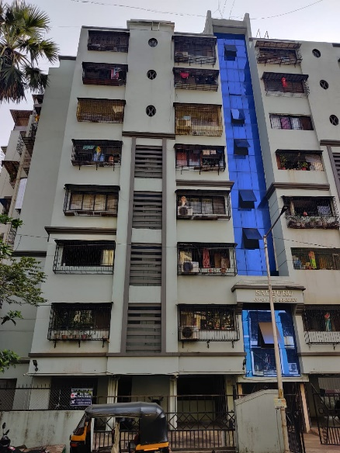

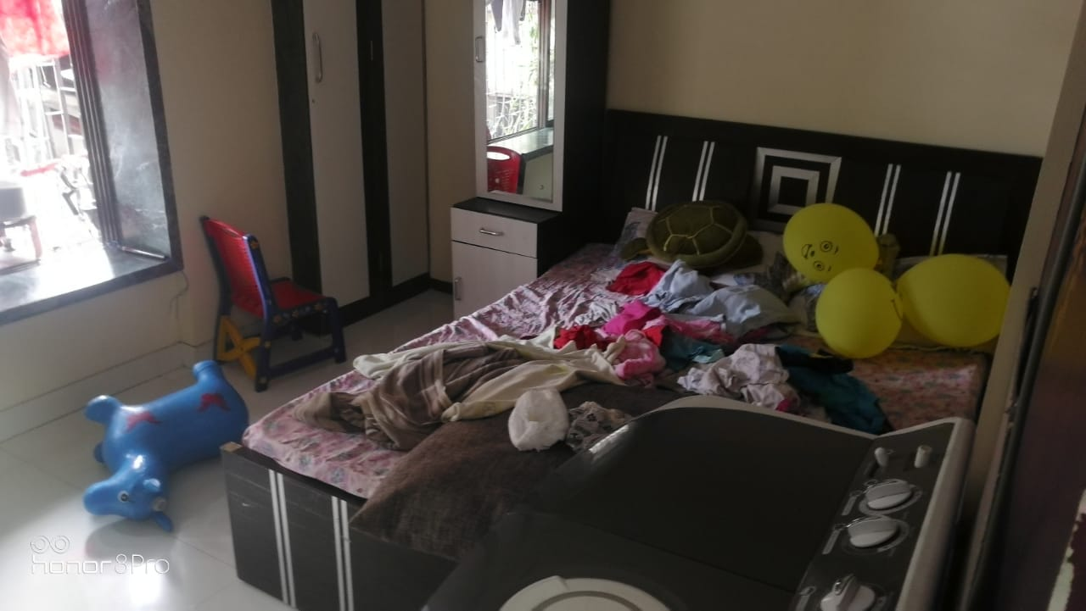**Route Map of the property**

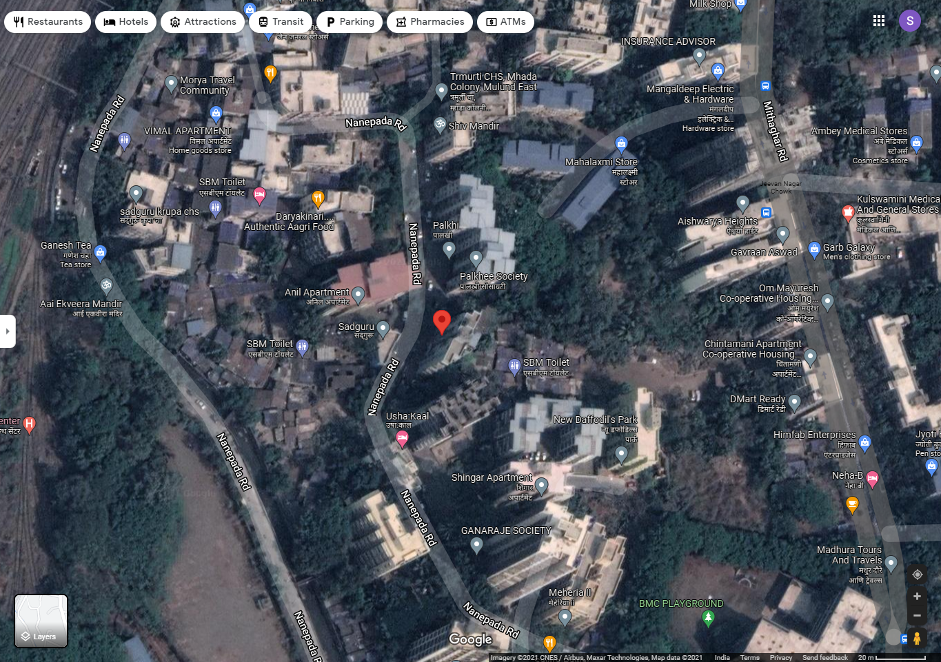**Site u/r**

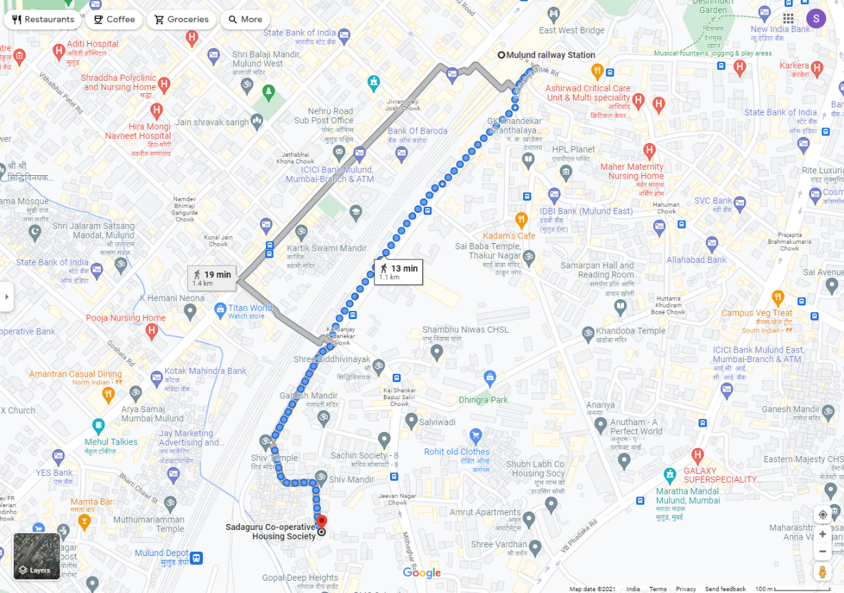

# Latitude Longitude: 19°09’51.2”N 72°57’11.4”E

**Note**: The Blue line shows the route to site from nearest Railway Station (Mulund – 1.1 Km.)

**Ready Reckoner**

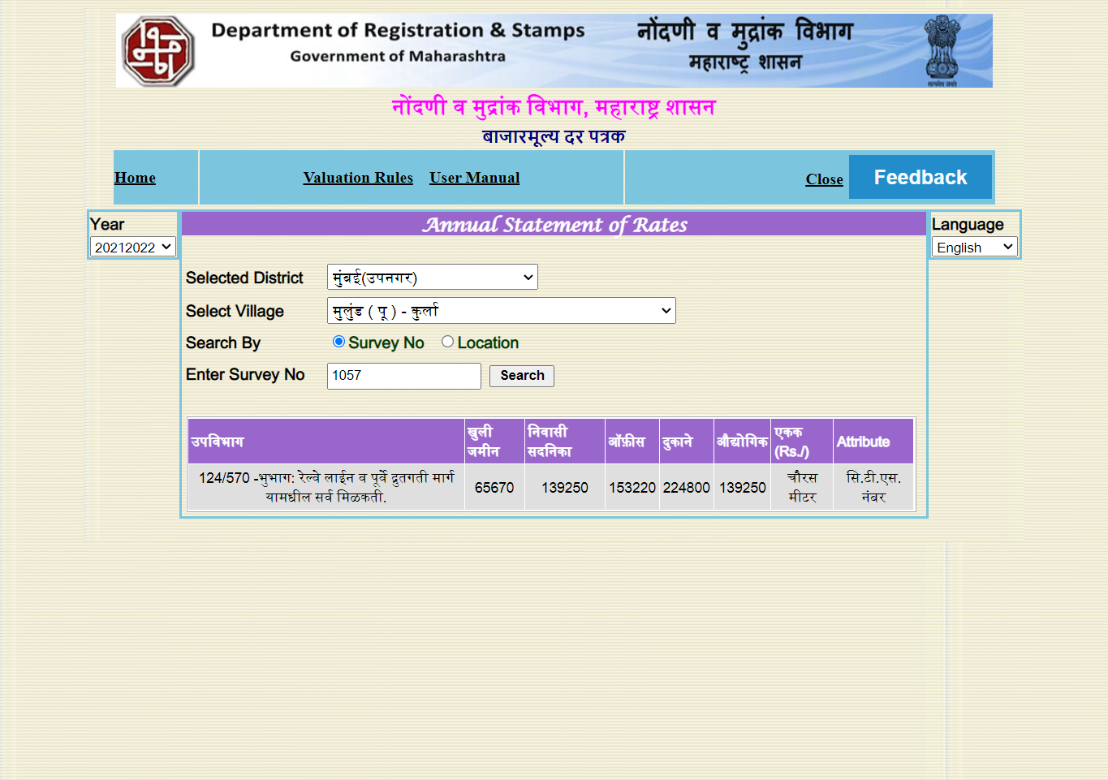

**Price Indicators**

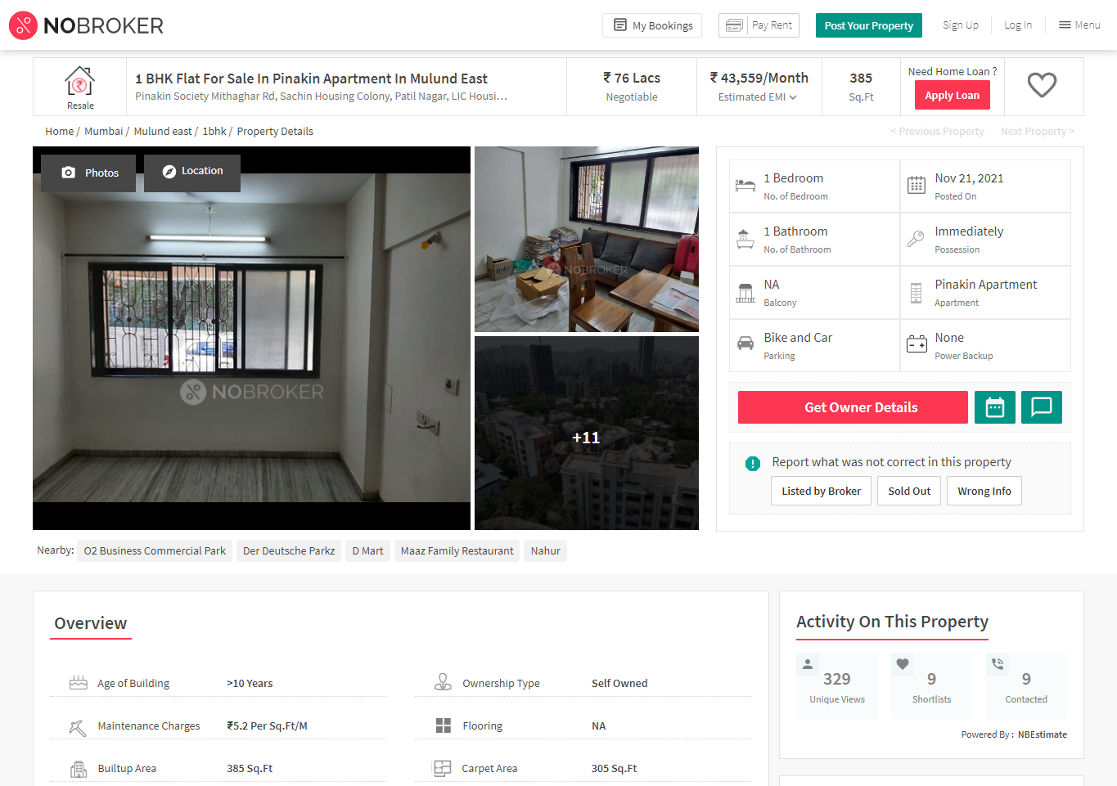

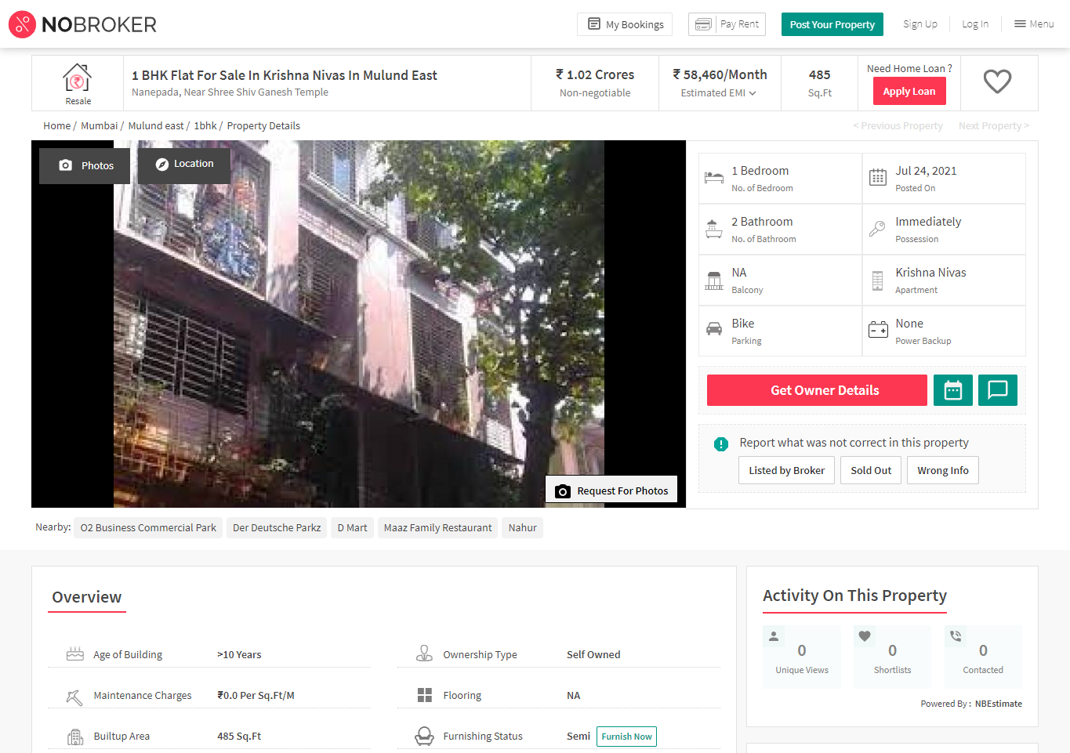

**Sale Instance**

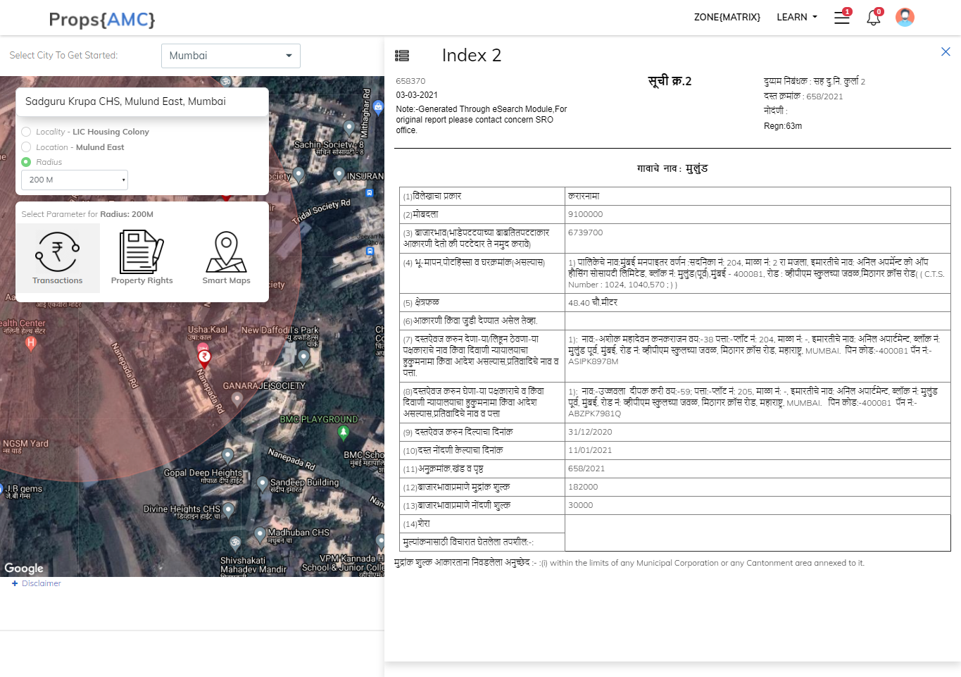

**DEFINITION OF VALUE FOR THIS SPECIFIC PURPOSE**

This exercise is to assess **Fair Market Value** of the property under reference as on **06th December 2021**

The term Value is defined as

*“The most probable price, as of a specified date, in cash, terms equivalent to cash, or in other precisely revealed terms for which the specified property rights would sell after reasonable exposure in a competitive market under all conditions requisite to a fair sale, with the buyer and seller each acting prudently knowledgeably and for self interest assuming that neither is under undue duress”.*

Fundamental assumptions and conditions presumed in this definition are:

1. Buyer and seller are motivated by self-interest.

2. Buyer and seller are well informed and are acting prudently.

3. The property is exposed for a reasonable time on the open market.

4. Payment is made in cash or equivalent or in specified financing terms.

#### **UNDER LYING ASSUMPTIONS**

1. We assume no responsibility for matters of legal nature affecting the property appraised or the title thereto, nor do we render our opinion as to the title, which is assumed to be good and marketable.

2. The property is valued as though under responsible ownership.

3. It is assumed that the property is free of liens and encumbrances.

4. It is assumed that there are no hidden or unapparent conditions of the subsoil or structure that would render it more or less valuable. No responsibility is assumed for such conditions or for engineering that might be required to discover such factors.

5. There is no direct/ indirect interest in the property valued.

6. The rates for valuation of the property are in accordance with the Govt. approved rates and prevailing market rates.

##### **DECLARATION OF PROFESSIONAL FEES CHARGED**

We hereby declare that, our professional fees are not contingent upon the valuation findings. However, if the statute AND/OR clients demands that, the fees should be charged on the percentage of assessed value then, with the full knowledge of the AND/OR end user, it is being charged accordingly.

# VALUATION OF THE PROPERTY PREMISES

Considering various parameters recorded herein above, existing economic scenario, and the information that is available with reference to the development of neighborhood and method selected for valuation, we are of the opinion that, the property premises can be assessed and valued for banking purpose as on day for ` 84,02,400.00 (Rupees Eighty Four Lakh Two Thousand Four Hundred Only)

## **Sharadkumar B. Chalikwar**

## Govt. Reg. Valuer

## Chartered Engineer (India)

## Reg. No. (N) CCIT/1-14/52/2008-09