Vastu/Nashik/12/2024/013272/2309728
23/4-426 -RPBS
Date: 23.12.2024

To, `
The Branch Manager,
Bank of Baroda
Regional Office Nashik Road Branch
BSNL Building, Datta Mandir Road, Nashik Road,
Nashik -422 101, State - Maharashtra, Country - India.

Sub: Vetting of Extra Amenities

Sir,

With reference to above subject, we have evaluated the Extra Amenities for Residential Flat No.06, 6h Floor, "Shriniwas Apartment", Near Kalika Park Garden, Jagtap Nagar, PlotNo.6, off Untwadi Road,Taluka-Nashik,Dishict Nashik, Nashik PlN Code-422002'State' Maharashtra, Country - lndia' belongs to Shri. Dhiraj Vijay Bagul & Sau. Harshal Dhiraj Bagul.

We have verified the rates quoted as per current market rates. Details of Extra Amenities considered as per copy of Agreement for Extra Amenities issued by to Shri. Dhiraj Vijay Bagul & Sau. Harshal Dhiraj Bagul. (First Party) Shri.Gaurav Govind Malpure (Second Party) received on dated 12.12.2024. The Extra Amenities amount is Rs.12,00,000/- (Rupees Twelve Lakh Only.)

The said Cost Vetting Certificate is valid up to next 6 months Only.

Thanking you

Sincerely yours

Manoj B. Chalikwar
Registered Valuer
Chartered Engineer (India)
Reg. No. CAT-I-F-1763
Reg. No. IBBI/RV/07/2018/10366
BOB Empanelment No.: ZO:MZ:ADV:46:941
Encl: Valuation report.

Agreement of Extra Amenities
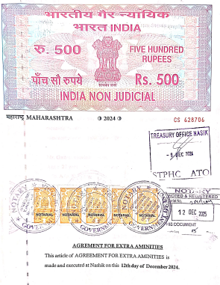
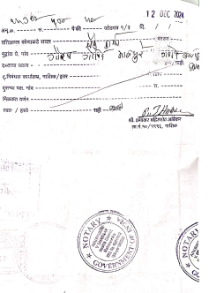

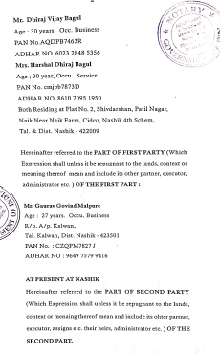
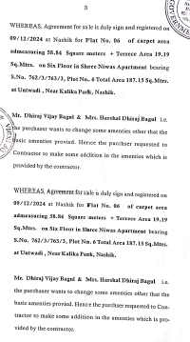

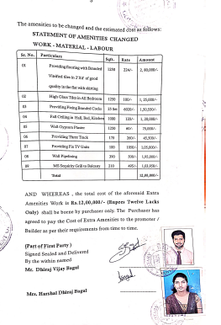
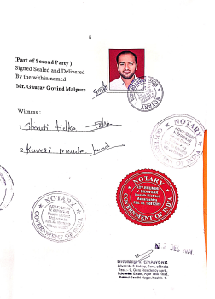

The Extra Work amount Rs.12,00,000/- (Rupees Twelve Lakh Only.)

