Vastu/Nashik/12/2024/013239 /2309705
20/20-403-RPBS
Date: 20.12.2024

To, `
The Branch Manager,
Bank of Baroda
Regional Office Nashik Road Branch
BSNL Building, Datta Mandir Road, Nashik Road,
Nashik -422 101, State - Maharashtra, Country - India.

Sub: Vetting of Extra Amenities

Sir,

With reference to above subject, we have evaluated the Extra Amenities for Residential Flat No. 405, 4th Floor, "Dels Murlidhar", Tanaji Chowk, Sutar Lane, Viman Nagar, Village - Ozar, Taluka - Niphad, District - Nashik, Nashik, 422207, State - Maharashtra, India belongs to M/s. Dels Estate. Name of Proposed Purchaser is Sau. Swity Babalu Thapa.

We have verified the rates quoted as per current market rates. Details of Extra Amenities considered as per copy of Agreement for Extra Amenities issued by to Sau. Swity Babalu Thapa. (First Party) Shri. Madhukar Khanderao Lande (Second Party) received on dated 05.03.2024. The Extra Amenities amount is Rs.7,10,000/- (Rupees Seven Lakh Ten Thousand Only.)

The said Cost Vetting Certificate is valid upto next 6 months Only.

Thanking you

Sincerely yours

Manoj B. Chalikwar
Registered Valuer
Chartered Engineer (India)
Reg. No. CAT-I-F-1763
Reg. No. IBBI/RV/07/2018/10366
BOB Empanelment No.: ZO:MZ:ADV:46:941
Encl: Valuation report.

Agreement of Extra Amenities
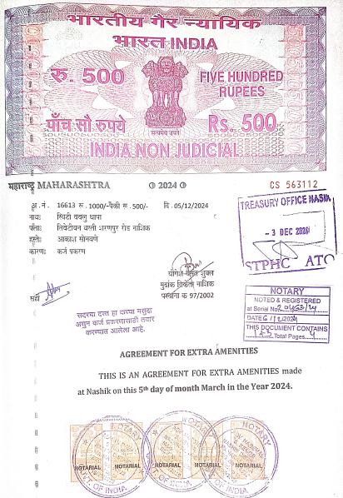
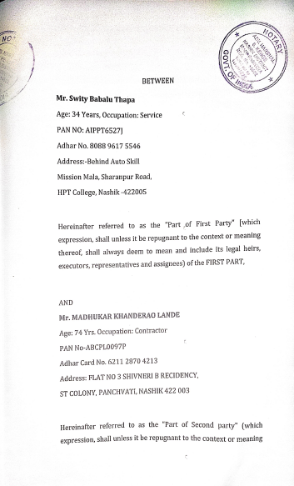

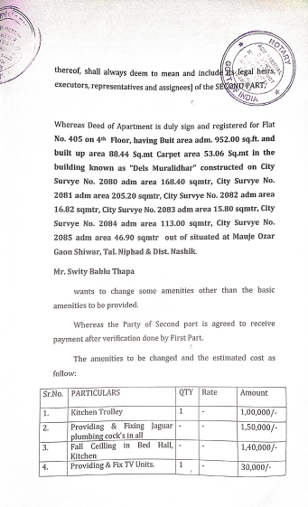
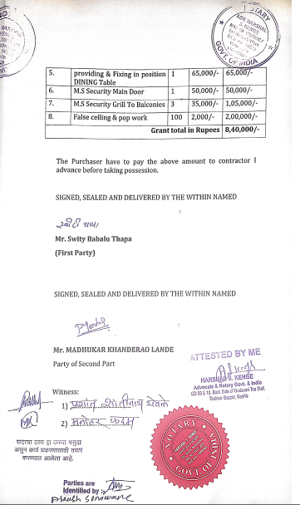

The Extra Work amount Rs.7,10,000/- (Rupees Seven Lakh Ten Thousand Only.)

