Valuation Report of the Immovable Property
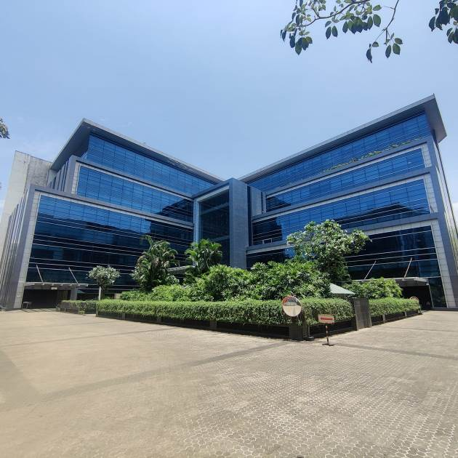

Details of the property under consideration:

Name of Owner / Developer: M/s. Prestige Properties

Commercial Premises Unit No. 201B & 301A located on 2nd & 3rd floors in the building “Silver Utopia”,
Wing A & B, Cardinal Gracious Road, Village - Chakala, Andheri (East),
Mumbai - 400 099, Maharashtra, India

Latitude Longitude : 19°06'46.1"N 72°51'36.7"E

Intended User:
Bank of Baroda
MMWR – Vile Parle (West)
Sharda Bhavan, opp. Mithibai College, V. M. Road, J.V.P.D Scheme,
Mumbai 400 056, State – Maharashtra, Country – India

Vastu/Mumbai/01/2025/013217/2309893
01/12-12-SPBS
Date: 01.01.2025

VALUATION OPINION REPORT

This is to certify that the property bearing Commercial Premises Unit No. 201B & 301A located on 2nd & 3rd floors in the building “Silver Utopia”, Wing A & B, Cardinal Gracious Road, Village – Chakala, Andheri (East), Mumbai – 400 099, State – Maharashtra, Country – India belongs to M/s. Prestige Properties.

Boundaries of the property.
North | : | Pramukh Plaza
South | : | Satellite Gazebo
East | : | Solitaire Corporate Park 1
West | : | Cardinal Gracious Road

Considering various parameters recorded, existing economic scenario, and the information that is available with reference to the development of neighborhood and method selected for valuation, we are of the opinion that, the property premises can be assessed and valued for this particular purpose at ` 126,42,59,380.00 (Rupees One Hundred Twenty-Six Crore Forty-Two Lakh Fifty-Nine Thousand Three Hundred Eighty Only).

The valuation of the property is based on the documents produced by the concern. Legal aspects have not been taken into considerations while preparing this valuation report.

Hence certified.

Sharadkumar B. Chalikwar
Govt. Reg. Valuer
Chartered Engineer (India)
Reg. No. (N) CCIT/1-14/52/2008-09
UBI Emp. No. ROS:ADV:Valuer/033:008:2021-2208:2021-22
Encl: Valuation report.

Vastukala Consultants (I) Pvt. Ltd.
B1-001, U/B Floor, Boomerang, Chandivali Farm Road, Powai, Andheri (East), Mumbai – 400 072
To,
The Branch Manager,
Bank of Baroda
MMWR – Vile Parle (West) Branch
Sharda Bhavan, opp. Mithibai College,
V. M. Road, J.V.P.D Scheme, Mumbai 400 056,
State – Maharashtra, Country – India

VALUATION REPORT (IN RESPECT OF COMMERCIAL BUILDING)
I | General
1. | Purpose for which the valuation is made |  | : | As per the request from Bank of Baroda MMWR – Vile Parle (West) Branch, to assess fair market value of the property for bank purpose.
2. | a) | Date of inspection | : | 27.12.2024 & 28.12.2024
 | b) | Date on which the valuation is made | : | 01.01.2025
3 | List of documents produced for perusal: |  | :
- Copy of Leave and License Agreement dated 29.11.2022 (Reg. No. BDR-15/15905/2022 dated 29.11.2022) between M/s. Prestige Properties (The Licensor) and M/s. Pharmarack Technologies Private Limited (The Licensee).
- Copy of Leave and License Agreement dated 20.10.2023 (Reg. No. BDR-15/17526/2023 dated 20.10.2023) between M/s. Prestige Properties (The Licensor) and Indostar Capital Finance Limited (The Licensee).
- Copy of Approved Plan No. CE/8138/BSI/WS/AK/377/1/Amend dated 16.02.2022 issued by Municipal Corporation of Greater Mumbai (MCGM).
- Copy of Part Occupancy Certificate No. CE/8138/WS/AK dated 08.08.2012 issued by Municipal Corporation of Greater Mumbai (MCGM).
(Approved For: 2 level Basement + Ground Floor + 1st to 7th Upper Floors).
- Copy of Joint Venture Agreement dated 08.05.2006 (Reg. No. BDR/15/3753/2006 dated 10.05.2006) between M/s. Goldfilled Mercantile Company (First Part), Ikbal Sultan Nathani (Second Part) & Mukesh M. Mehta & Kamlesh V. Shah (Third Part).
- Copy of Self Declaration letter dated 29.04.2023 issued by M/s. Prestige Properties.
4. | Name of the owner(s) and his / their address (es) with Phone no. (details of share of each owner in case of joint ownership) |  | : | Name of Owner: M/s. Prestige Properties  Address: Commercial Premises Unit No. 201B & 301A located on 2nd & 3rd floors in the building “Silver Utopia”, Wing A & B, Cardinal Gracious Road, Village – Chakala, Andheri (East), Mumbai – 400 099, State – Maharashtra, Country – India  Contact Person:  Mrs. Forum Mehta (Owner)  Mb. No. +91 98219 50502.  Company Ownership
5. | Brief description of the property (Including Leasehold / freehold etc.):
The property is located in a developed area having good infrastructure, well connected by road and train.

The immovable property comprises of Commercial Premises Unit No. 201A & 301B located on 2nd & 3rd floors in the building “Silver Utopia”. The building is of 2 Basements + Ground + 1st to 8th upper floors. It is located at about 800 M. distance from Western Express Highway Metro Station & 2.40 Km. distance from Andheri Railway Station.

As per site inspection, the property under considerations is tenant occupied. The details are as below -
Sr. No. | Name of Tenants | Unit No. | Floor | Carpet Area in Sq. Ft. as per Leave & License Agreement
1 | Indostar Capital finance limited | 301A | Third | 17,353.00
2 | Pharmarack Technologies Pvt. Ltd. | 201B | Second | 13,500.00
TOTAL |  |  |  | 30,853.00

Approaches for valuation:

There are 3 main approaches for valuation of real estate property:

1- The Income Approach
The income approach is a property valuation method that is particularly common in commercial real estate and rental properties. The main idea behind the income approach is to calculate the current value of a real estate property based on the net income it generates divided by the capitalization rate.

As a start, the appraiser needs to collect income and expenses statements for the subject real estate property and for similar properties in the same area in order to estimate the net operating income. Estimating the net operating income (NOI) is broken down into four steps:
1- Estimate the gross potential income: The total income a real estate property generates with a 100% occupancy.
2- Estimate the effective gross income: Simply done by estimating vacancy costs based on similar properties in the local area. This figure reflects the normal loss of income caused by probable vacancies.
3- Estimate property expenses: Expenses fall into two categories: fixed and variable expenses. Fixed expenses are expenses that do not change with time, like property taxes and mortgage payments. Variable expenses are all the other expenses such as utilities, management fees, and so on.
4- Calculate NOI: By subtracting the estimated expenses from the effective gross income.

The next step would be choosing an appropriate cap rate. A real estate investor or a property appraiser estimates cap rate using market sales of comparable properties that have been sold recently.
(A property with a NOI of Rs. 20,000 that sells for Rs. 200,000 has a CAP rate of 10%).
PROPERTY VALUE = NOI/CAP RATE

2- The Sales Comparison Approach
As the name suggests, the sales comparison approach uses the market data of sale prices to estimate the value of a real estate property. Property valuation in this method is done by comparing a property to other similar properties that have been recently sold. Comparable properties, also known as comparables, or comps, must share certain features with the property in question. Some of these include physical features such as square footage, number of rooms, condition, and age of the building; however, the most important factor is no doubt the location of the property.
Adjustments are usually needed to account for differences as no two properties are exactly the same. To make proper adjustments when comparing properties, real estate appraisers must know the differences between the comparable properties and how to value these differences.
The sales comparison approach is commonly used for Residential Flat, where there are typically many comparables available to analyze.

3- The Cost Approach
The cost approach is a real estate property valuation method which considers the value of a property as the cost of the land plus the cost of replacing the property (construction costs) minus the physical and functional depreciation. This approach is most commonly used for real estate properties that are not easily sold like schools, hospitals, and government buildings.
Land cost can be estimated using the sales comparison approach by studying recent sales of land close to the subject property, and these sales should be comparable in size and location. There are different ways to estimate replacement costs, the most common being finding out the cost to build a square foot of comparable properties multiplied by the total square footage of the building.

RECOMMENDATION:
As the Property is Owned by Company which is in to Renting of Office Premises, we have relied upon the present rental agreements even though the present agreement is for short term period we expect the premises will be re-leased for future term, hence we have calculated the capitalization as on perpetuality.

- We have considered interest on refundable Security Deposit @ 5.00% per Annum.
- The rate of capitalization is considered at 7.00 % per Annum.
- The Base Rent & Refundable Security Deposit is considered taking average of remaining period of lease.
- We have considered present property tax for entire period & deducted the property tax from gross rent per annum to calculate net rent per annum.

The income approach is recommended for the valuation of Rented Properties / Multiplex/ Cinema hall for assessment purposes.

The theory behind the income approach to value is that a property’s value reflects the present worth of anticipated or forecast future benefits from the real estate. As such, the income approach analyses the income and expenses of a shopping Centre and converts the typical net revenue into an estimate of value.

APPLICATION OF THE INCOME APPROACH:

INCOME APPROACH METHODS:
In general, there are two methods available to convert future income into a present value:
1. Direct capitalization method, and
2. Yield capitalization (discounted cash flow analysis).
Direct capitalization method
The direct capitalization method is most applicable to the valuation of income-producing properties in a mass appraisal environment. It requires the least amount of data to apply, reflects typical rents and market conditions, and is best suited to the use of statistical analysis. The yield capitalization method is not suitable for use in mass appraisal valuations in Saskatchewan due to its consideration of individual investor preferences (reflects personal versus typical market conditions), its need for more market data and numerous estimates of rents, holding periods and projected reversions, and its lack of suitability for statistical analysis. For these reasons the yield capitalization method will not be further detailed in this Guide.

OVERVIEW OF THE DIRECT CAPITALIZATION METHOD:
The analysis in this section presents a direct capitalization method that is suited for mass appraisal applications.
Direct capitalization converts or “capitalizes” the expected level of potential net income into a market value-based assessment using an overall capitalization rate. The conversion factor or capitalization rate reflects all of the investor’s relative and comparative feelings and aspirations about the property in light of the investment characteristics offered by the asset and in comparison, to other investment opportunities on the market.
In its most basic form, the direct capitalization method is an elementary mathematical ratio involving the estimation of typical net operating income (NOI) as of the base date, which is then capitalized into value to produce a market value-based assessment.

THE DIRECT CAPITALIZATION METHOD:

Market Value | = Net Annual Operating Income |  | V | = NOI
 |  | Capitalization Rate |  |  | R

Although there are other methods of converting expected future income into an estimate of value (e.g., discounted cash flow), the direct capitalization method lends itself to mass appraisal applications. It is possible to develop market value-based assessments under this formula through proper evaluation of the potential net income and through the selection of an appropriate capitalization rate.
In establishing market value-based assessments using the income approach, the objective is to evaluate the typical income generated by the real estate. For shopping centers, this task is simplified by the fact that leases are typically established on a net basis (tenant pays all operating expenses including taxes). This factor serves to limit the number of adjustments required in order to determine the net operating income attributable to the real estate.

6. | Location of property |  | :
 | a) | Plot No. / Survey No. | :
 | b) | Door No. | : | As per Brief Description
 | c) | T.S. No. / Village | : | CTS No. 477,477/1,477/2 & 478, 478/1 of Village - Chakala
 | d) | Ward / Taluka | : | Taluka – Andheri
 | e) | Mandal / District | : | Mumbai Suburban District
7. | Postal address of the property |  | : | Commercial Premises Unit No. 201B & 301A located on 2nd & 3rd floors in the building “Silver Utopia”, Wing A & B, Cardinal Gracious Road, Village – Chakala, Andheri (East), Mumbai – 400 099, State – Maharashtra, Country – India
8. | City / Town |  | :
 | Residential area |  | : | No
 | Commercial area |  | : | Yes
 | Industrial area |  | : | No
9. | Classification of the area |  | :
 | i) High / Middle / Poor |  | : | Higher Middle Class
 | ii) Urban / Semi Urban / Rural |  | : | Urban
10. | Coming under Corporation limit / Village Panchayat / Municipality |  | : | Village – Chakala, Andheri (East)  Municipal Corporation of Greater Mumbai
11. | Whether covered under any State / Central Govt. enactments (e.g., Urban Land Ceiling Act) or notified under agency area/ scheduled area / cantonment area |  | : | No
12. | In Case it is Agricultural land, any conversion to house site plots is contemplated |  | : | N.A.
13. | Boundaries of the property |  |  | As per Agreement | As per Site
 | North |  | : | As per below table | Pramukh Plaza
 | South |  | : | As per below table | Satellite Gazebo
 | East |  | : | As per below table | Solitaire Corporate Park 1
 | West |  | : | As per below table | Cardinal Gracious Road
Boundaries as per Agreement:
 | CTS No. 477, 477/1 & 477/2 | CTS No. 478 & 478/1
North | Partly Survey No. 9A, Partly by Survey No. 49B, Partly by Survey No. 87 | Hissa NO. 2 (pt.) of Survey No. 47
South | Partly by Survey No. 45A, Partly by Survey No. 85 & Partly by Survey No. 115 | Hissa No. 4 & Partly by Survey No. 46/1 & NA No. 45-3
East | Survey No. 117 | Survey No. 48
West | Partly by Survey No. 47A, Partly by Survey No. 47, Hissa No. 2 (Pt.) | Road

14.1 | Dimensions of the site |  |  | A As per the Deed | B Actuals
 | North |  | : | N.A, as the property is irregular in Shape.
 | South |  | :
 | East |  | :
 | West |  | :
14.2 | Latitude, Longitude & Co-ordinates of Property |  | : | 19°06'46.1"N 72°51'36.7"E
15. | Extent of the site |  | : | As per Brief Description
16. | Extent of the site considered for Valuation (least of 14A& 14B) |  | : | As per Brief Description
17. | Whether occupied by the owner / tenant? If occupied by tenant since how long? Rent received per month. |  | : | 2nd & 3rd Floors are occupied by the tenants as per above description table
II | CHARACTERSTICS OF THE SITE
 | Classification of locality |  | : | Located in Higher Middle-class locality
 | Development of surrounding areas |  | : | Developed
 | Possibility of frequent flooding/ sub-merging |  | : | No
 | Feasibility to the Civic amenities like School, Hospital, Bus Stop, Market etc. |  | : | All available near by
 | Level of land with topographical conditions |  | : | Plain
 | Shape of land |  | : | Irregular
 | Type of use to which it can be put |  | : | For commercial purpose
 | Any usage restriction |  | : | Industrial
 | Is plot in town planning approved layout? |  | : | Yes
 | Corner plot or intermittent plot? |  | : | Intermittent
 | Road facilities |  | : | Yes
 | Type of road available at present |  | : | B.T. Road
 | Width of road – is it below 20 ft. or more than 20 ft. |  | : | More than 20 ft.
 | Is it a Land – Locked land? |  | : | No
 | Water potentiality |  | : | Connected to Municipal. Water Supply
 | Underground sewerage system |  | : | Connected to Municipal Sewerage System
 | Is Power supply is available in the site |  | : | Yes
 | Advantages of the site |  | : | Located in developed area
 | Special remarks, if any like threat of acquisition of land for publics service purposes, road widening or applicability of CRZ provisions etc. (Distance from sea-cost / tidal level must be incorporated) |  | : | No
Part – A (Valuation of land)
1 | Size of plot |  | : | Total Plot Area = 8,341.30 Sq. M.  (Area as per Approved Plan)
 | North & South |  | : | -
 | East & West |  | : | -
2 | Total extent of the plot |  | : | Total Plot Area = 8,341.30 Sq. M.  (Area as per Approved Plan)  Total Carpet Area = 30,853.00 Sq. Ft.  (Area as per Leave and License Agreement)
3 | Prevailing market rate (Along With details / reference of at least two latest deals / transactions with respect to adjacent properties in the areas) |  | : | Sales Comparison Approach Method is used for this valuation report.
4 | Guideline rate obtained from the Stamp Duty Ready Reckoner for New property |  | : | As mentioned Below
 | Guideline rate obtained from the Stamp Duty Ready Reckoner After Depreciation |  | : | As mentioned Below
Floor | For New Property |  | After Deprecation
 | Rate for Sq. M. | Rate for Sq. Ft. | Rate for Sq. M. | Rate for Sq. Ft.
 | (`) | (`) | (`) | (`)
Second & Third | 2,08,180.00 | 19,340.00 | 1,96,094.00 | 18,218.00

 | In case of variation of 20% or more in the valuation proposed by the valuer and the Guideline value provided in the State Govt. notification or Income Tax Gazette justification on variation has to be given. |  | : | It is a foregone conclusion that market value is always more than RR prices. As the RR rates are fixed by respective state governments for computing stamp duty / regn. Fees. Thus, the rates differ from place to place and location. Amenities per se as evident from the fact that even RR rates decided by Govt. differ.
5 | Assessed / adopted rate of valuation |  | : | Sales Comparison Approach & Income Approach Method is used for this valuation report.
6 | Estimated value of land |  | : | N.A.
Part – B (Valuation of Building)
1 | Technical details of the building |  | :
 | - Type of Building (Residential / Commercial / Industrial) |  | : | Commercial
 | - Type of construction (Load bearing / RCC / Steel Framed) |  | : | RCC framed structure
 | - Year of construction |  | : | 12.01.2012
 | - Age of the building |  | : | 12 Year
 | - Balance Life of the building |  | : | 48 years Subject to proper, preventive periodic maintenance & structural repairs.
 | - Total Life of the building |  | : | 60 Years
 | - Number of floors and height of each floor including basement if any |  | : | As per brief description
 | - Plinth area floor-wise |  | : | As per area statement
 | - Condition of the building |  | :
 | - Exterior – Excellent, Good, Normal, Poor |  | : | Good condition
 | - Interior – Excellent, Good, Normal, Poor |  | : | Good condition
 | - Date of issue and validity of layout of approved map |  | : | - Copy of Approved Plan No. CE/8138/BSI/WS/AK/377/1/Amend dated 16.02.2022 issued by Municipal Corporation of Greater Mumbai (MCGM).  - Copy of Part Occupancy Certificate No. CE/8138/WS/AK dated 08.08.2012 issued by Municipal Corporation of Greater Mumbai (MCGM).  (Approved For: 2 level Basement + Ground Floor + 1st to 7th Upper Floors).
 | - Approved map / plan issuing authority |  | :
 | - Whether genuineness or authenticity of approved map / plan is verified |  | : | Plan is verified
 | - Any other comments by our empanelled valuers on authentic of approved plan |  | : | -

Specifications of construction (floor-wise) in respect of
Sr. No. |  | Description
 |  | Foundation | : | RCC
 |  | Basement | : | Yes
 |  | Superstructure | : | B. B. Masonry
 |  | Joinery / Doors & Windows (Please furnish details about size of frames, shutters, glazing, fitting etc. and specify the species of timber | : | Provided
 |  | RCC Works | : | As per brief description
 |  | Plastering | : | Cement plastering to structures
 |  | Flooring, Skirting, dado | : | Cemented
 |  | Special finish as marble, granite, wooden paneling, grills etc. | : | Nil
 |  | Roofing including weatherproof course | : | RCC slab and GI Sheet roofing
 |  | Drainage | : | Connected to public sewer
2. | Compound Wall |  | : | 5'.6" High, R.C.C. columns with B. B. Masonry wall.
 | Height |  | : | 5'.6" High, R.C.C. columns with B. B. Masonry wall.
 | Length |  | : | 5'.6" High, R.C.C. columns with B. B. Masonry wall.
 | Type of construction |  | : | 5'.6" High, R.C.C. columns with B. B. Masonry wall.
3. | Electrical installation |  | : | Provided as per requirement
 | Type of wiring |  | : | Provided as per requirement
 | Class of fittings (superior / ordinary / poor) |  | : | Provided as per requirement
 | Number of light points |  | : | Provided as per requirement
 | Fan points |  | : | Provided as per requirement
 | Spare plug points |  | : | Provided as per requirement
 | Any other item |  | : | Provided as per requirement
4. | Plumbing installation |  |  | Provided as per requirement
 | - No. of water closets and their type |  | : | Provided as per requirement
 | - No. of wash basins |  | : | Provided as per requirement
 | - No. of urinals |  | : | Provided as per requirement
 | - No. of bathtubs |  | : | Provided as per requirement
 | - Water meters, taps etc. |  | : | Provided as per requirement
 | - Any other fixtures |  | : | Provided as per requirement
Part – C (Extra Items) |  |  | : | Amount in `
 | Portico |  | : | Included in the Cost of Construction
 | Ornamental front door |  | : | Included in the Cost of Construction
 | Sit out / Verandah with steel grills |  | : | Included in the Cost of Construction
 | Overhead water tank |  | : | Included in the Cost of Construction
 | Extra steel / collapsible gates |  | : | Included in the Cost of Construction
 | Total |  |  | Included in the Cost of Construction
Part – D (Amenities) |  |  | : | Amount in `
 | Wardrobes |  | : | Included in the Cost of Construction
 | Glazed tiles |  | : | Included in the Cost of Construction
 | Extra sinks and bathtub |  | : | Included in the Cost of Construction
 | Marble / ceramic tiles flooring |  | : | Included in the Cost of Construction
 | Interior decorations |  | : | Included in the Cost of Construction
 | Architectural elevation works |  |  | Included in the Cost of Construction
 | Paneling works |  |  | Included in the Cost of Construction
 | Aluminum works |  |  | Included in the Cost of Construction
 | Aluminum handrails |  |  | Included in the Cost of Construction
 | False ceiling |  |  | Included in the Cost of Construction
 | Total |  |  | Included in the Cost of Construction
Part – E (Miscellaneous) |  |  | : | Amount in `
 | Separate toilet room |  | : | Included in the Cost of Construction
 | Separate lumber room |  | : | Included in the Cost of Construction
 | Separate water tank / sump |  | : | Included in the Cost of Construction
 | Trees, gardening |  | : | Included in the Cost of Construction
 | Total |  |  | Included in the Cost of Construction
Part – F (Services) |  |  | : | Amount in `
 | Water supply arrangements |  | : | Included in the Cost of Construction
 | Drainage arrangements |  | : | Included in the Cost of Construction
 | Compound wall |  | : | Included in the Cost of Construction
 | C.B. deposits, fittings etc. |  | : | Included in the Cost of Construction
 | Pavement |  |  | Included in the Cost of Construction
 | Total |  |  | Included in the Cost of Construction

Valuation as per Sales Comparison Approach Method:
Sr. No. | 1 | 2
Unit No. | 301A | 201B
Floor | Third | Second
Carpet Area in Sq. Ft. | 17,353.00 | 13,500.00
Rate per Sq. Ft. on Carpet Area | 36,960.00 | 36,960.00
Value of Office | 64,13,66,880.00 | 49,89,60,000.00
Interior Cost | 4,33,82,500.00 | 3,37,50,000.00
No. of Car Parking | 26.00 | 13.00
Rate per Car Parking | 12,00,000.00 | 12,00,000.00
Value of Car Parking | 3,12,00,000.00 | 1,56,00,000.00
Total Value of The Units | 71,59,49,380.00 | 54,83,10,000.00
Total | 126,42,59,380.00
Fair Market Value | 126,42,59,380.00
Realizable Value | 113,78,33,442.00
Distress Sale Value | 101,14,07,504.00

VALUATION OF THE PROPERTY
Part – A | Land | : | -
Part – B | Office Premises | : | ` 1,26,42,59,380.00
Part – C | Compound wall | :
Part - D | Amenities | :
Part – E | Pavement | :
Part – F | Services | :
Fair Market Value |  | : | ` 1,26,42,59,380.00
Realizable Value |  | : | ` 113,78,33,442.00
Distress Sale Value |  | : | ` 101,14,07,504.00
Insurable value (37,024 X 3,000.00) |  | : | ` 11,10,72,000.00
Government Value (37,024 X 18,218.00) |  | : | ` 67,45,03,232.00
Remarks | - For the purpose of valuation, we have considered the carpet area as per leave and License agreement.  - At the time of site inspection, property on 2nd & 3rd floor were occupied by tenants as per brief description.

Sales Comparison Approach Method:
The sales comparison approach uses the market data of sale prices to estimate the value of a real estate property. Property valuation in this method is done by comparing a property to other similar properties that have been recently sold. Comparable properties, also known as comparables, or comps, must share certain features with the property in question. Some of these include physical features such as square footage, number of rooms, condition, and age of the building; however, the most important factor is no doubt the location of the property. Adjustments are usually needed to account for differences as no two properties are exactly the same. To make proper adjustments when comparing properties, real estate appraisers must know the differences between the comparable properties and how to value these differences. The sales comparison approach is commonly used for Commercial Office, where there are typically many comparables available to analyze. As the property is a commercial Office, we have adopted Sale Comparison Approach Method for the purpose of valuation. The Price for similar type of property in the nearby vicinity is in the range of ` 36,000.00 to ` 38,000.00 per Sq. Ft. on Carpet Area. Considering the rate with attached report, current market conditions, demand and supply position, Office size, location, upswing in real estate prices, sustained demand for Commercial Office, all-round development in the locality etc.
We estimate ` 36,960.00 per Sq. Ft. on Carpet Area for valuation after depreciation.

Income Approach Method:
Rental method of valuation: in this method, the net income by way of rent is found out by deducting all outing goings from the gross rent. A suitable rate of interest as prevailing in the market is assumed and year’s purchase is calculated. This net income multiplied by Y.P gives the capitalized value or valuation of the property. This method is applicable when the rent is known, or probable rent is determined by enquiries.
Valuation based on profit: this method of valuation is suitable for buildings like Office on Rental, hotels, cinema theatres etc. for which the capitalized value depends on the profit. In such cases the net annual income is worked out after deducting from the gross income all possible working expressions, outgoings, interest on the capital invested etc. the net profit is multiplied by Y.P to get the capitalized value. In such case the valuation may work out to be too high in comparison with the cost of construction.
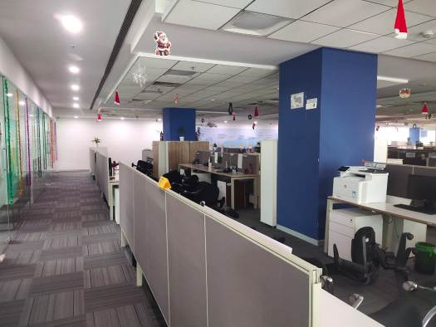
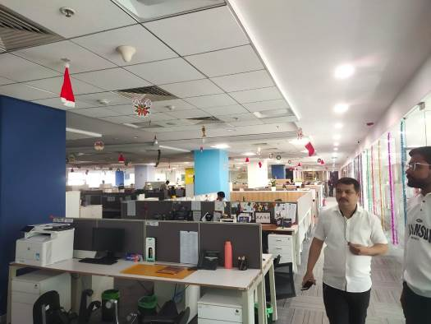
Actual Site Photographs


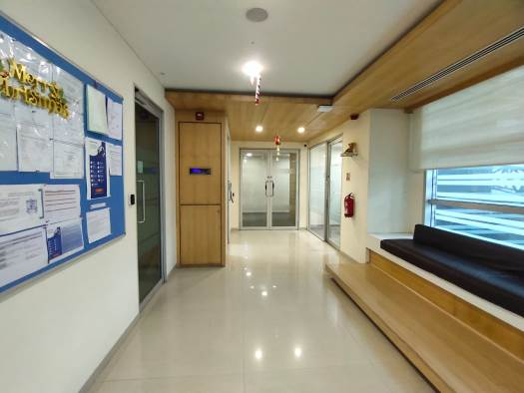
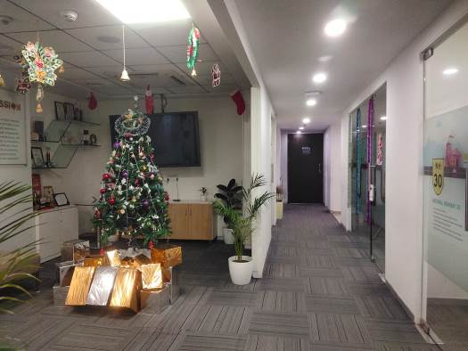
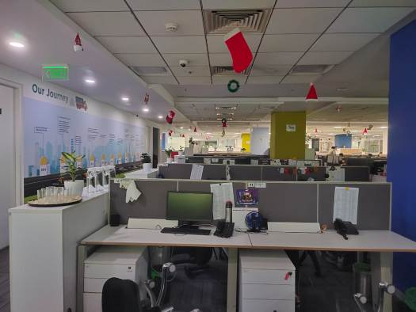
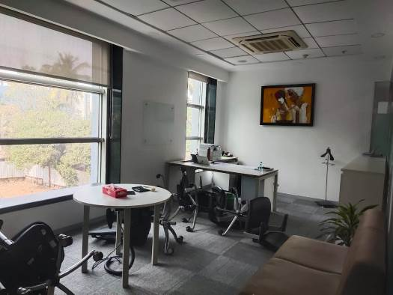
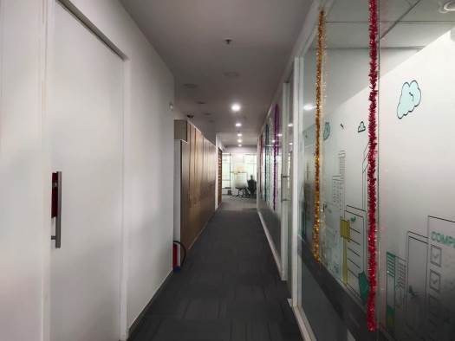
Actual Site Photographs
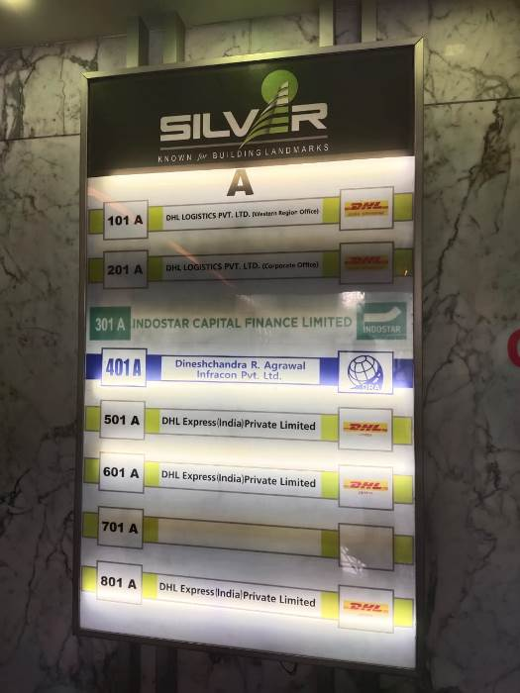
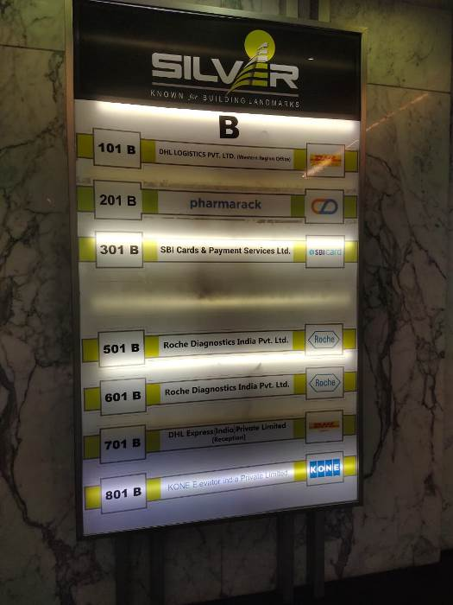
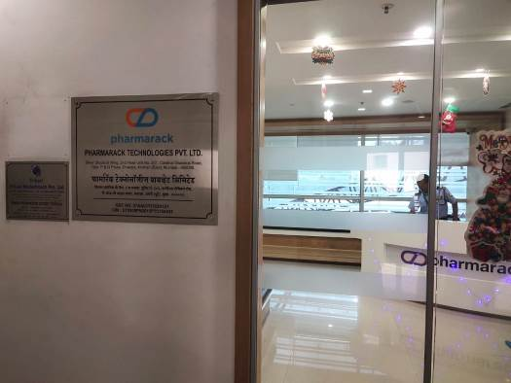
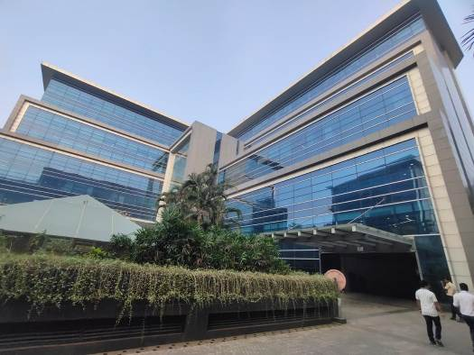
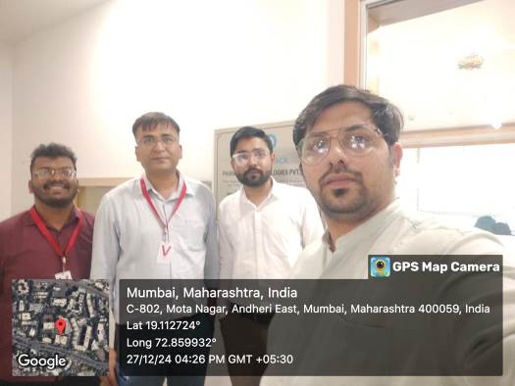

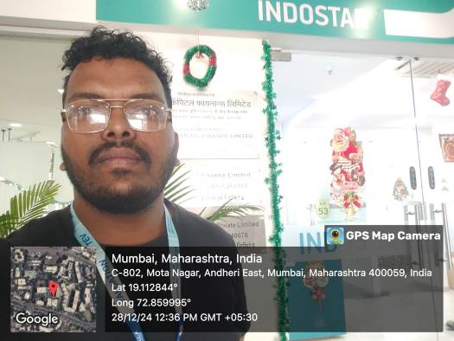
Route Map of the property
Site u/r
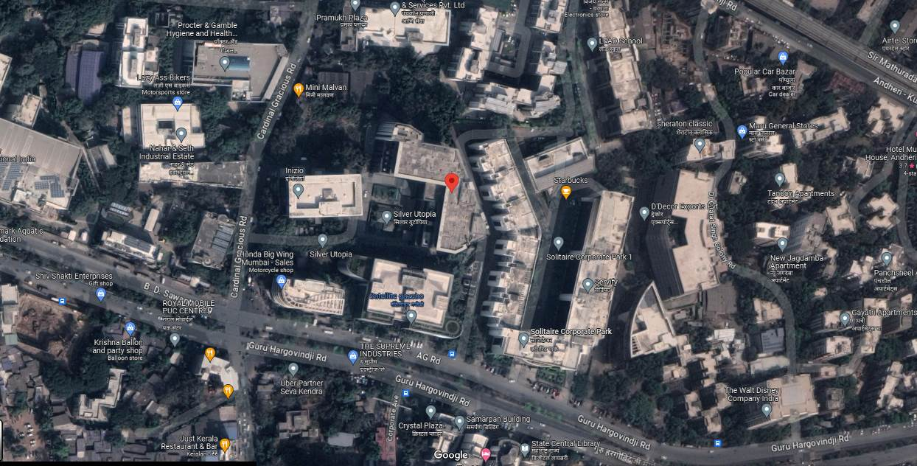

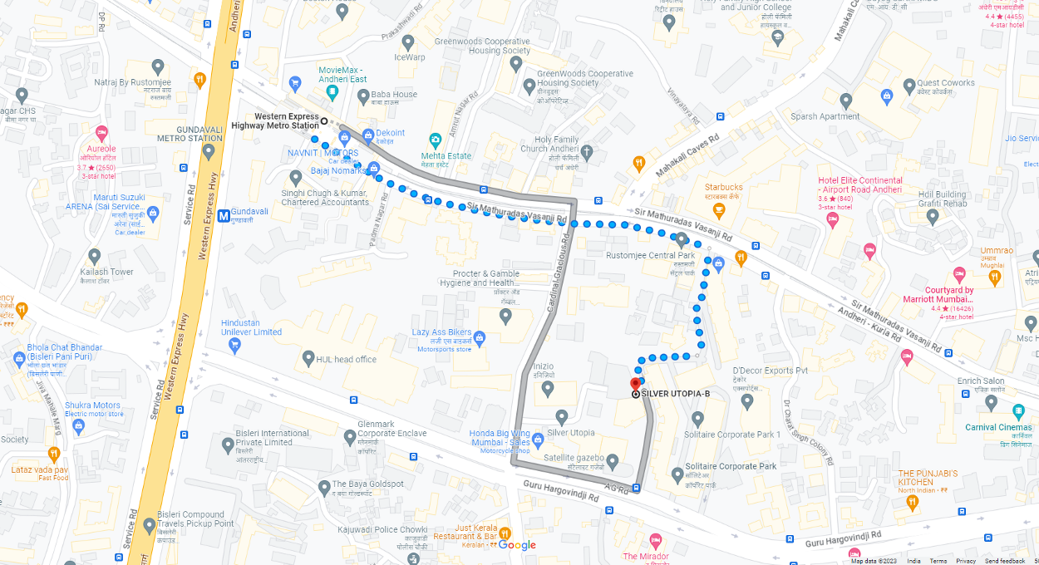

Latitude Longitude: 19°04'08.6"N 72°52'09.5"E

Note: The Blue line shows the route to site from nearest Metro Station (Western Express Highway – 800 M.)

READY RECKONER RATE
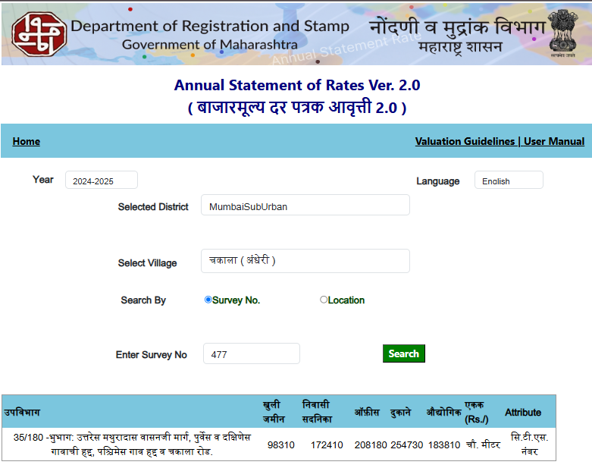

PRICE INDICATOR
Comp. | Source | Carpet Area in Sq. Ft. | Value in ` | Rate / Sq. Ft. on Carpet Area
Unit | 99acres.com | 800.00 | 3,28,00,000.00 | 41,000.00
Unit | Magicbricks.com | 24500.00 | 90,00,00,000.00 | 36,735.00
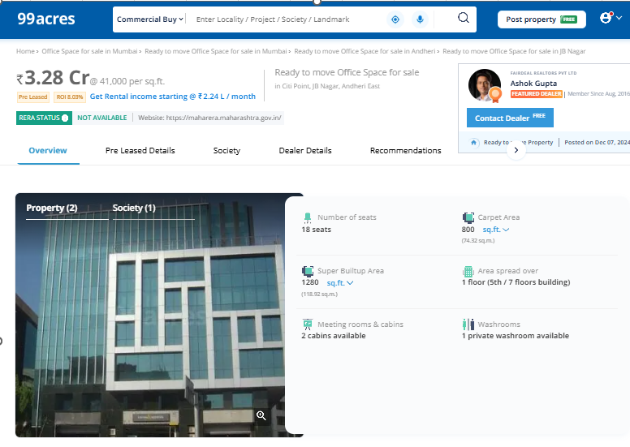

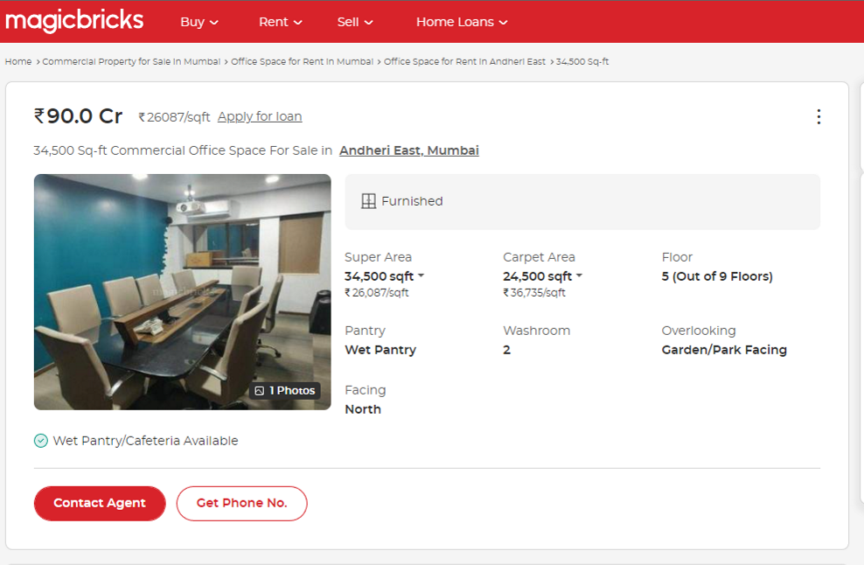
PRICE INDICATOR
Comp. | Source | Carpet Area in Sq. Ft. | Value in ` | Rate / Sq. Ft. on Carpet Area
Unit | 99acres.com | 1896.00 | 7,50,00,000.00 | 39,556.96
Unit | Magicbricks.com | 12009.00 | 43,00,00,000.00 | 35,806.47
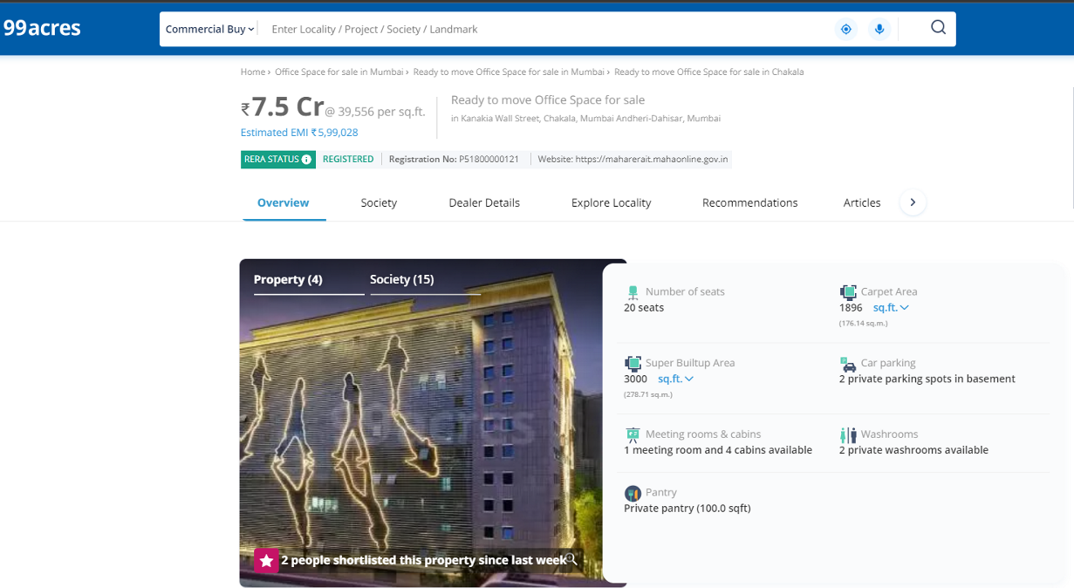

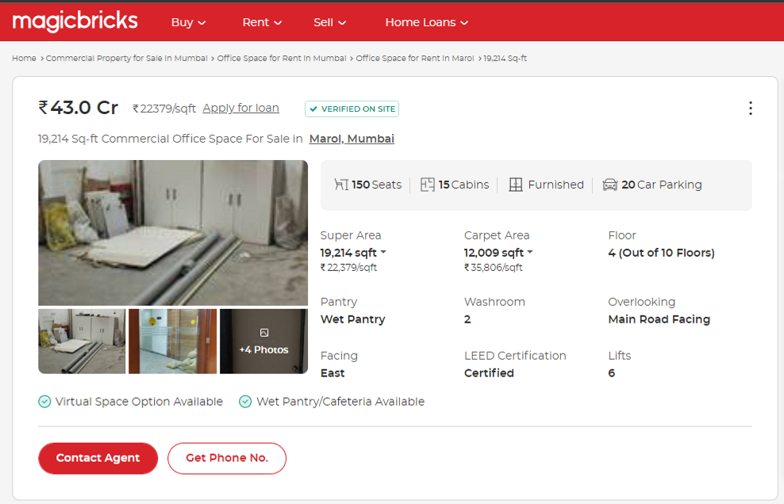

PRICE INDICATOR

Comp. | Source | Carpet Area in Sq. Ft. | Value in ` | Rate / Sq. Ft. on Carpet Area
Unit | 99acres.com | 1608.00 | 6,25,00,000.00 | 38,868.15
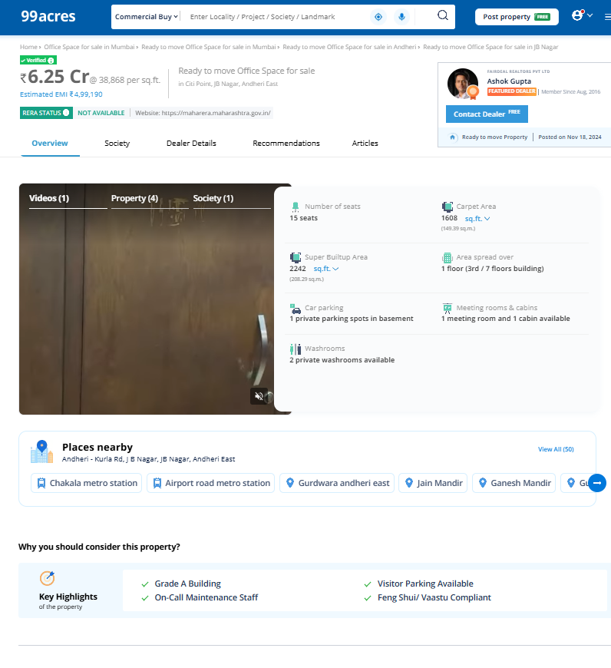

Sales Instances
Regd. Doc. No. | Date | Agreement Value in ` | Carpet Area in Sq. M. | Carpet Area in Sq. Ft. | Rate / Sq. Ft. on Carpet Area
7468 / 2024 | 06.07.2024 | 2,50,00,000.00 | - | 779.00 | 32,092.00
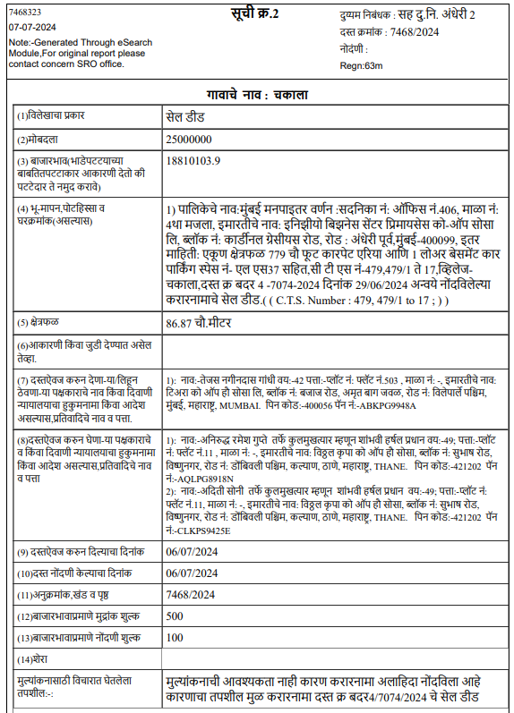

Sales Instances
Regd. Doc. No. | Date | Agreement Value in ` | Carpet Area in Sq. M. | Carpet Area in Sq. Ft. | Rate / Sq. Ft. on Carpet Area
13285 / 2022 | 09.11.2022 | 2,52,00,000.00 | - | 779.00 | 32,349.00
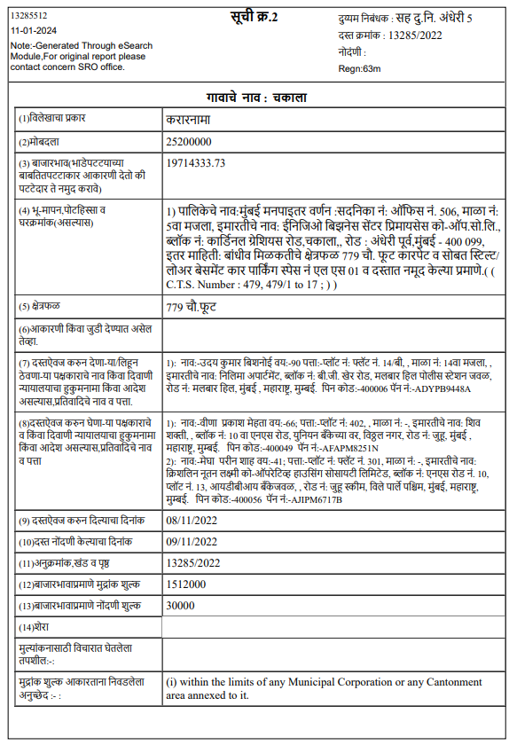

JUSTIFICATION FOR PRICE /RATE

The Market Value of the property is based on facts of markets discovered by us during our enquiries, however the government rate value in this case is less than the market value arrived by us. We are of the opinion that the value arrive by us will prove to be correct if an Auction of the subject property is carried out. As far as Market Value in Index II / Property Documents is concerned, it is not possible to comment on same, may be government rates are fixed by sampling during same point of time in part and whereas, Market values change every month.
In most of the cases the actual deal amount or Transaction value is not reflected in Index II / Property Documents because of various Market practices. As Valuer, we always try to give a value which is correct reflection of actual transaction value irrespective of any factors in market.
We Hope this will satisfy your requirements.

As a result of my appraisal and analysis, it is my considered opinion that
- The present Market value of the above property in the prevailing condition with aforesaid specifications is ` 126,42,59,380.00 (Rupees One Hundred Twenty-Six Crore Forty-Two Lakh Fifty-Nine Thousand Three Hundred Eighty Only).
- The Realizable Value of the above property is ` 113,78,33,442.00 (Rupees One Hundred Thirteen Crore Seventy-Eight Lakh Thirty-Three Thousand Four Hundred Forty-Two Only).
- The distress value ` 101,14,07,504.00 (Rupees One Hundred One Crore Fourteen Lakh Seven Thousand Five Hundred Four Only).

Place: Mumbai
Date: 01.01.2025

Sharadkumar B. Chalikwar
Govt. Reg. Valuer
Chartered Engineer (India)
Reg. No. (N) CCIT/1-14/52/2008-09
UBI Emp. No. ROS:ADV:Valuer/033:008:2021-22

The undersigned has inspected the property detailed in the Valuation Report dated _______________________

on ____________________. We are satisfied that the fair and reasonable market value of the property is

`_________________________ (Rupees ________________________________________________________

________________________________________only).

Date
Signature
(Name of the Branch Manager with Official seal)

Enclosures
 | Declaration From Valuers (Annexure- II) | Attached
 | Model code of conduct for valuer - (Annexure III) | Attached

Annexure-II
DECLARATION FROM VALUERS

I, hereby declare that:

- The information furnished in my valuation report dated 01.01.2025 is true and correct to the best of my knowledge and belief and I have made an impartial and true valuation of the property.

- I have no direct or indirect interest in the property valued.

- I/ my authorized representative has personally inspected the property on 27.12.2024 & 28.12.2024 The work is not sub - contracted to any other valuer and carried out by myself.

- I have not been convicted of any offence and sentenced to a term of Imprisonment.

- I have not been found guilty of misconduct in my professional capacity.

- I have read the Handbook on Policy, Standards, and procedure for Real Estate Valuation, 2011 of the IBA and this report is in conformity to the "Standards" enshrined for valuation in the Part - B of the above handbook to the best of my ability.

- I have read the International Valuation Standards (IVS) and the report submitted to the Bank for the respective asset class is in conformity to the "Standards" as enshrined for valuation in the IVS in "General Standards" and "Asset Standards" as applicable. The valuation report is submitted in the prescribed format of the bank.

- I abide by the Model Code of Conduct for empanelment of valuer in the Bank. (Annexure III - A signed copy of same to be taken and kept along with this declaration)

- I am Director of the company, who is competent to sign this valuation report.

- Further, I hereby provide the following information.

Sr.  No. | Particulars | Valuer comment
 | Background information of the asset being valued; | The property under consideration is owned by M/s. Prestige Properties
 | Purpose of valuation and appointing authority | As per the request from Bank of Baroda, MMWR – Vile Parle (West) to assess Fair Market value of the property for Bank purpose.
 | Identity of the valuer and any other experts involved in the valuation; | Sharadkumar B. Chalikwar – Regd. Valuer  Manoj B. Chalikwar – Regd. Valuer  Prayush Parekh – Senior Valuation Engineer  Saiprasad Patil – Valuation Engineer  Binumon Moozhickal – Technical Manager
 | Disclosure of valuer interest or conflict, if any; | We have no interest, either direct or indirect, in the property valued. Further to state that we do not have relation or any connection with property owner / applicant directly or indirectly. Further to state that we are an independent Valuer and in no way related to property owner / applicant
 | Date of appointment, valuation date and date of report; | Date of Appointment – 25.12.2024  Valuation Date – 01.01.2025  Date of Report – 01.01.2025
 | Inspections and/or investigations undertaken; | Physical Inspection done on 27.12.2024 & 28.12.2024
 | Nature and sources of the information used or relied upon; | - Market Survey at the time of site visit  - Ready Reckoner rates / Circle rates  - Online search for Registered Transactions  - Online Price Indicators on real estate portals  - Enquiries with Real estate consultants  - Existing data of Valuation assignments carried out by us
 | Procedures adopted in carrying out the valuation and valuation standards followed; | Sales Comparison Approach & Income Approach Method is used for this valuation report.
 | Restrictions on use of the report, if any; | This valuation is for the use of the party to whom it is addressed and for no other purpose. No responsibility is accepted to any third party who may use or rely on the whole or any part of this valuation. The valuer has no pecuniary interest that would conflict with the proper valuation of the property.
 | Major factors that were taken into account during the valuation. | current market conditions, demand and supply position, Commercial shop size, location, upswing in real estate prices, sustained demand for Commercial shop, all round development of commercial and residential application in the locality etc.
 | Caveats, limitations, and disclaimers to the extent they explain or elucidate the limitations faced by valuer, which shall not be for the purpose of limiting his responsibility for the valuation report. | Attached

Assumptions, Disclaimers, Limitations & Qualifications
Value Subject to Change
The subject appraisal exercise is based on prevailing market dynamics as on 01st January 2025 and does not take into account any unforeseeable developments which could impact the same in the future.
Our Investigations
We are not engaged to carry out all possible investigations in relation to the subject property. Where in our report we identify certain limitations to our investigations, this is to enable the reliant party to instruct further investigations where considered appropriate or where we recommend as necessary prior to reliance. Vastukala Consultants India Pvt. Ltd. (VCIPL) is not liable for any loss occasioned by a decision not to conduct further investigations.
Assumptions
Assumptions are a necessary part of undertaking valuations. VCIPL adopts assumptions for the purpose of providing valuation advise because some matters are not capable of accurate calculations or fall outside the scope of our expertise, or out instructions. The reliant party accepts that the valuation contains certain specific assumptions and acknowledge and accept the risk of that if any of the assumptions adopted in the valuation are incorrect, then this may have an effect on the valuation.

Information Supplied by Others
The appraisal is based on the information provided by the client. The same has been assumed to be correct and has been used for appraisal exercise. Where it is stated in the report that another party has supplied information to VCIPL, this information is believed to be reliable but VCIPL can accept no responsibility if this should prove not to be so.
Future Matters
To the extent that the valuation includes any statement as to a future matter, that statement is provided as an estimate and/or opinion based on the information known to VCIPL at the date of this document. VCIPL does not warrant that such statements are accurate or correct.
Map and Plans
Any sketch, plan or map in this report is included to assist the reader while visualising the property and assume no responsibility in connection with such matters.
Site Details
Based on inputs received from Client's representative and site visit conducted, we understand that the subject property is currently a commercial office admeasuring Carpet Area is 30,853.00 Sq. Ft. The property owned by M/s. Prestige Properties. Further, VCIPL has assumed that the subject property is free from any encroachment and is available as on the date of the appraisal.
Property Title
Based on our discussion with the Client, we understand that the subject property is owned by M/s. Prestige Properties. For the purpose of this appraisal exercise, we have assumed that the subject property has a clear title and is free from any encumbrances, disputes and claims. VCIPL has made no further enquiries with the relevant local authorities in this regard and does not certify the property as having a clear and marketable title. Further, no legal advice regarding the title and ownership of the subject property has been obtained for the purpose of this appraisal exercise. It has been assumed that the title deeds are clear and marketable.
Environmental Conditions
We have assumed that the subject property is not contaminated and is not adversely affected by any existing or proposed environmental law and any processes which are carried out on the property are regulated by environmental legislation and are properly licensed by the appropriate authorities.

Town Planning
The permissible land use, zoning, achievable FSI, area statement adopted for purpose of this valuation is based on the information provided by the Client's representative and the same has been adopted for this valuation purpose. VCIPL has assumed the same to be correct and permissible. VCIPL has not validated the same from any authority.
Area
Based on the documents, we understand that the subject property is commercial office admeasuring Carpet Area is 30,853.00 Sq. Ft.
Condition & Repair
In the absence of any information to the contrary, we have assumed that there are no abnormal ground conditions, nor archaeological remains present which might adversely affect the current or future occupation, development or value of the property. The property is free from rat, infestation, structural or latent defect. No currently known deleterious or hazardous materials or suspect techniques will be used in the construction of or subsequent alteration or additions to the property and comments made in the property details do not purport to express an opinion about, or advise upon, the condition of uninspected parts and should not be taken as making an implied representation or statement about such parts

Valuation Methodology
For the purpose of this valuation exercise, the valuation methodology used is Direct Comparison Approach Method and proposed Highest and Best Use model is used for analysing development potential.
The Direct Comparison Approach involves a comparison of the property being valued to similar properties that have actually been sold in arms - length transactions or are offered for sale. This approach demonstrates what buyers have historically been willing to pay (and sellers willing to accept) for similar properties in an open and competitive market and is particularly useful in estimating the value of the land and properties that are typically traded on a unit basis.
In case of inadequate recent transaction activity in the subject micro-market, the appraiser would collate details of older transactions. Subsequently, the appraiser would analyse rental / capital value trends in the subject micro-market in order to calculate the percentage increase / decrease in values since the date of the identified transactions. This percentage would then be adopted to project the current value of the same.
Where reliance has been placed upon external sources of information in applying the valuation methodologies, unless otherwise specifically instructed by Client and/or stated in the valuation, VCIPL has not independently verified that information and VCIPL does not advise nor accept it as reliable. The person or entity to whom the report is addressed acknowledges and accepts the risk that if any of the unverified information in the valuation is incorrect, then this may have an effect on the valuation.
Not a Structural Survey
We state that this is a valuation report and not a structural survey
Other
All measurements, areas and ages quoted in our report are approximate
Legal
We have not made any allowances with respect to any existing or proposed local legislation relating to taxation on realization of the sale value of the subject property. VCIPL is not required to give testimony or to appear in court by reason of this appraisal report, with reference to the property in question, unless arrangement has been made thereof. Further, no legal advice on any aspects has been obtained for the purpose of this appraisal exercise
Property specific assumptions
Based on inputs received from the client and site visit conducted, we understand that the subject property is commercial office admeasuring Carpet Area is 30,853.00 Sq. Ft.

ASSUMPTIONS, CAVEATS, LIMITATION AND DISCLAIMERS
- We assume no responsibility for matters of legal nature affecting the property appraised or the title thereto, nor do we render our opinion as to the title, which is assumed to be good and marketable.
- The property is valued as though under responsible ownership.
- It is assumed that the property is free of liens and encumbrances.
- It is assumed that there are no hidden or unapparent conditions of the subsoil or structure that would render it more or less valuable. No responsibility is assumed for such conditions or for engineering that might be required to discover such factors.
- There is no direct/ indirect interest in the property valued.
- The rates for valuation of the property are in accordance with the Govt. approved rates and prevailing market rates
Annexure - III

MODEL CODE OF CONDUCT FOR VALUERS
{Adopted in line with Companies (Registered Valuers and Valuation Rules, 2017)}
All valuers empanelled with bank shall strictly adhere to the following code of conduct:

Integrity and Fairness
- A valuer shall, in the conduct of his/its business, follow high standards of integrity and fairness in all his/its dealings with his/its clients and other valuers.
- A valuer shall maintain integrity by being honest, straightforward, and forthright in all professional relationships.
- A valuer shall endeavour to ensure that he/it provides true and adequate information and shall not misrepresent any facts or situations.
- A valuer shall refrain from being involved in any action that would bring disrepute to the profession.
- A valuer shall keep public interest foremost while delivering his services.
Professional Competence and Due Care
- A valuer shall render at all times high standards of service, exercise due diligence, ensure proper care and exercise independent professional judgment.
- A valuer shall carry out professional services in accordance with the relevant technical and professional standards that may be specified from time to time.
- A valuer shall continuously maintain professional knowledge and skill to provide competent professional service based on up-to-date developments in practice, prevailing regulations / guidelines and techniques.
- In the preparation of a valuation report, the valuer shall not disclaim liability for his/its expertise or deny his/its duty of care, except to the extent that the assumptions are based on statements of fact provided by the company or its auditors or consultants or information available in public domain and not generated by the valuer.
- A valuer shall not carry out any instruction of the client insofar as they are incompatible with the requirements of integrity, objectivity and independence.
- A valuer shall clearly state to his client the services that he would be competent to provide and the services for which he would be relying on other valuers or professionals or for which the client can have a separate arrangement with other valuers.
Independence and Disclosure of Interest
- A valuer shall act with objectivity in his/its professional dealings by ensuring that his/its decisions are made without the presence of any bias, conflict of interest, coercion, or undue influence of any party, whether directly connected to the valuation assignment or not.
- A valuer shall not take up an assignment if he/it or any of his/its relatives or associates is not independent in terms of association to the company.
- A valuer shall maintain complete independence in his/its professional relationships and shall conduct the valuation independent of external influences.
- A valuer shall wherever necessary disclose to the clients, possible sources of conflicts of duties and interests, while providing unbiased services.
- A valuer shall not deal in securities of any subject company after any time when he/it first becomes aware of the possibility of his / its association with the valuation, and in accordance with the Securities and Exchange Board of India (Prohibition of Insider Trading)Regulations,2015 or till the time the valuation report becomes public, whichever is earlier.
- A valuer shall not indulge in "mandate snatching" or offering "convenience valuations" in order to cater to a company or client's needs.
- As an independent valuer, the valuer shall not charge success fee. (Success fees may be defined as a compensation / incentive paid to any third party for successful closure of transaction. In this case, approval of credit proposals).
- In any fairness opinion or independent expert opinion submitted by a valuer, if there has been a prior engagement in an unconnected transaction, the valuer shall declare the association with the company during the last five years.
Confidentiality
- A valuer shall not use or divulge to other clients or any other party any confidential information about the subject company, which has come to his / its knowledge without proper and specific authority or unless there is a legal or professional right or duty to disclose.
Information Management
- A valuer shall ensure that he/ it maintains written contemporaneous records for any decision taken, the reasons for taking the decision, and the information and evidence in support of such decision. This shall be maintained so as to sufficiently enable a reasonable person to take a view on the appropriateness of his /its decisions and actions.
- A valuer shall appear, co-operate and be available for inspections and investigations carried out by the authority, any person authorised by the authority, the registered valuers organisation with which he/it is registered or any other statutory regulatory body.
- A valuer shall provide all information and records as may be required by the authority, the Tribunal, Appellate Tribunal, the registered valuers organisation with which he/it is registered, or any other statutory regulatory body.
- A valuer while respecting the confidentiality of information acquired during the course of performing professional services, shall maintain proper working papers for a period of three years or such longer period as required in its contract for a specific valuation, for production before a regulatory authority or for a peer review. In the event of a pending case before the Tribunal or Appellate Tribunal, the record shall be maintained till the disposal of the case.
Gifts and hospitality:
- A valuer or his / its relative shall not accept gifts or hospitality which undermines or affects his independence as a valuer.
- Explanation: For the purposes of this code the term 'relative' shall have the same meaning as defined in clause (77) of Section 2 of the Companies Act, 2013 (18 of 2013).
- A valuer shall not offer gifts or hospitality or a financial or any other advantage to a public servant or any other person with a view to obtain or retain work for himself / itself, or to obtain or retain an advantage in the conduct of profession for himself / itself.
Remuneration and Costs.
- A valuer shall provide services for remuneration which is charged in a transparent manner, is a reasonable reflection of the work necessarily and properly undertaken, and is not inconsistent with the applicable rules.
- A valuer shall not accept any fees or charges other than those which are disclosed in a written contract with the person to whom he would be rendering service.
Occupation, employability and restrictions.
- A valuer shall refrain from accepting too many assignments, if he/it is unlikely to be able to devote adequate time to each of his/ its assignments.
- A valuer shall not conduct business which in the opinion of the authority or the registered valuer organisation discredits the profession.

DEFINITION OF VALUE FOR THIS SPECIFIC PURPOSE

This exercise is to assess Fair Market Value of the property under reference as on 01st January 2025.

The term Fair Market Value is defined as

“The most probable price, as of a specified date, in cash, terms equivalent to cash, or in other precisely revealed terms for which the specified property rights would sell after reasonable exposure in a competitive market under all conditions requisite to a fair sale, with the buyer and seller each acting prudently knowledgeably and for self-interest assuming that neither is under undue duress”.

Fundamental assumptions and conditions presumed in this definition are:

1. Buyer and seller are motivated by self-interest.
2. Buyer and seller are well informed and are acting prudently.
3. The property is exposed for a reasonable time on the open market.
4. Payment is made in cash or equivalent or in specified financing terms.
DECLARATION OF PROFESSIONAL FEES CHARGED

We hereby declare that, our professional fees are not contingent upon the valuation findings. However, if the statute AND/OR clients demands that, the fees should be charged on the percentage of assessed value then, with the full knowledge of the AND/OR end user, it is being charged accordingly.

VALUATION OF THE PROPERTY PREMISES

Considering various parameters recorded, existing economic scenario, and the information that is available with reference to the development of neighborhood and method selected for valuation, we are of the opinion that, the property premises can be assessed and valued for this particular purpose at ` 1,26,42,59,380.00.00 (Rupees One Hundred Twenty-Six Crore Forty-Two Lakh Fifty-Nine Thousand Three Hundred Eighty Only).

Sharadkumar B. Chalikwar
Govt. Reg. Valuer
Chartered Engineer (India)
Reg. No. (N) CCIT/1-14/52/2008-09
UBI Emp. No. ROS:ADV:Valuer/033:008:2021-22

