Vastu/Nashik/12/2024/013184 /2309666
19/03-364-RPSP
Date: 19.12.2024

To, `
The Branch Manager,
Bank of Baroda
Regional Office Nashik Road Branch
BSNL Building, Datta Mandir Road, Nashik Road,
Nashik -422 101, State - Maharashtra, Country - India.

Sub: Vetting of Extra Amenities

Sir,

With reference to above subject, we have evaluated the Extra Amenities for Residential Flat No. 202, 2nd Floor, "Tathastu", Near NMC Water Tank, Vrundavan Colony, Siddhtek Nagar, off ITI Ambad Road, Village - Kamatwade, Taluka - Nashik, District - Nashik, Nashik, PIN Code - 422 007, State - Maharashtra, Country - India belongs to M/s. SS Construction. Name of Proposed Purchaser is Shri. Chinteshwar Khushal Deore.

We have verified the rates quoted as per current market rates. Details of Extra Amenities considered as per copy of Agreement for Extra Amenities issued by to. Shri. Chinteshwar Khushal Deore (First Party) Shri. Manish Uday Kasar (Second Party) received on dated 17.12.2024. The Extra Amenities amount is Rs.8,10,000/- (Rupees Eight Lakh Ten Thousand Only.)

The said Cost Vetting Certificate is valid upto next 6 months Only.

Thanking you

Sincerely yours

Manoj B. Chalikwar
Registered Valuer
Chartered Engineer (India)
Reg. No. CAT-I-F-1763
Reg. No. IBBI/RV/07/2018/10366
BOB Empanelment No.: ZO:MZ:ADV:46:941
Encl: Valuation report.

Agreement of Extra Amenities
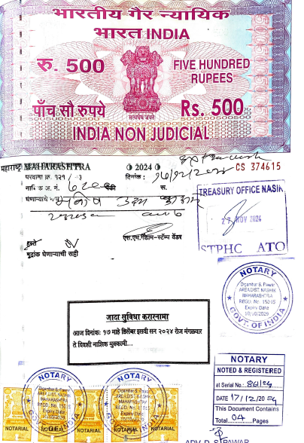
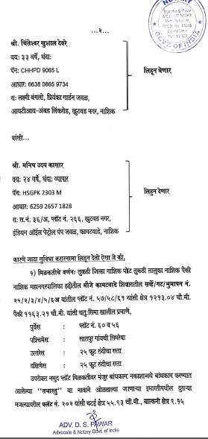

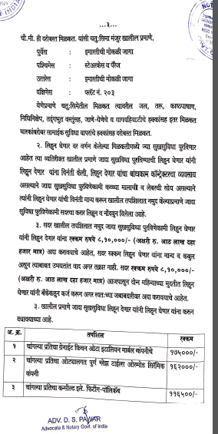
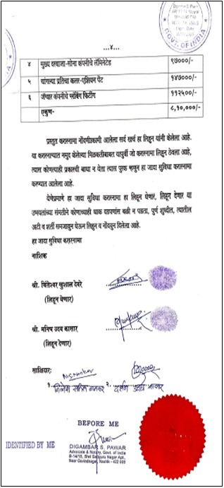

The Extra Work amount Rs. 8,10,000/- (Rupees Eight Lakh Ten Thousand Only.)

