Vastu/Nashik/12/2024/013159 /2309657
18/15-355-RPSP
Date: 18.12.2024

To, `
The Branch Manager,
Bank of Baroda
Regional Office Nashik Road Branch
BSNL Building, Datta Mandir Road, Nashik Road,
Nashik -422 101, State - Maharashtra, Country - India.

Sub: Vetting of Extra Amenities

Sir,

With reference to above subject, we have evaluated the Extra Amenities for Residential Flat No. 404, 4th Floor, " Delse Murlidhar ", CTS No - 2080 to 2085, Tanaji Chowk, Sutar Lane, Viman Nagar, Village - Ozar, Taluka - Niphad, District - Nashik, Nashik,422207, State - Maharashtra, lndia belongs to M/s. Delse Estate. Name of Proposed Purchaser is Shri. Rohan Sunil Hote & Sau. Darshana Rohan Hote.

We have verified the rates quoted as per current market rates. Details of Extra Amenities considered as per copy of Agreement for Extra Amenities issued by to Shri. Rohan Sunil Hote & Sau. Darshana Rohan Hote. (First Party) Shri. Sunil Laxman Bhoge. (Second Party) received on dated 17.12.2024. The Extra Amenities amount is Rs.4,00,000/- (Rupees Four Lakh Only.)

The said Cost Vetting Certificate is valid upto next 6 months Only.

Thanking you

Sincerely yours

Manoj B. Chalikwar
Registered Valuer
Chartered Engineer (India)
Reg. No. CAT-I-F-1763
Reg. No. IBBI/RV/07/2018/10366
BOB Empanelment No.: ZO:MZ:ADV:46:941
Encl: Valuation report.

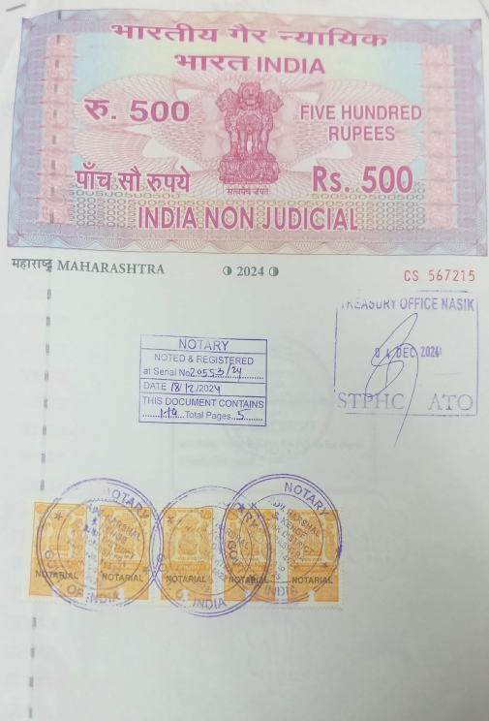
Agreement of Extra Amenities
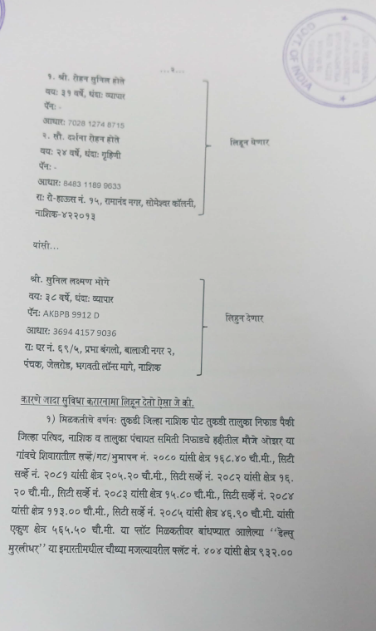

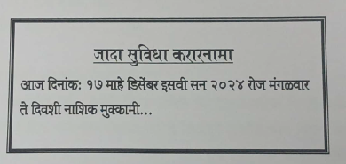

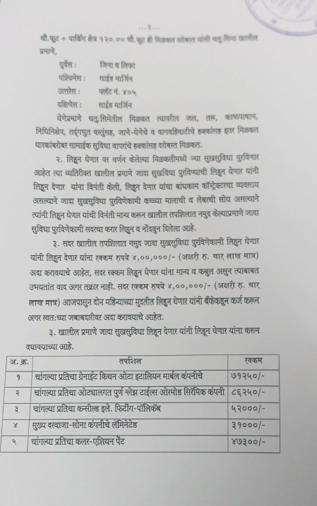
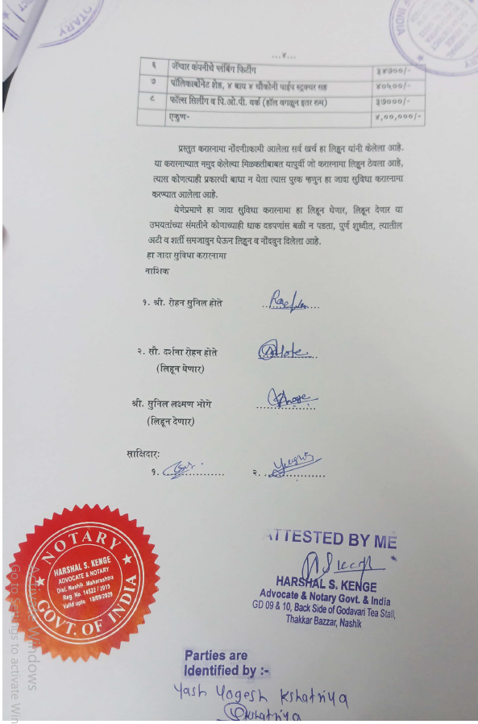

The Extra Work amount Rs. 4,00,000/- (Rupees Four Lakh Only.)

