Vastu/Nashik/07/2024/0010070/2307330
22/7-334-RPBS
Date: 17.12.2024

To, `
The Branch Manager,
Bank of Baroda
Regional Office Nashik Road Branch
BSNL Building, Datta Mandir Road, Nashik Road,
Nashik -422 101, State - Maharashtra, Country - India.

Sub: Vetting of Extra Amenities

Sir,

With reference to above subject, we have evaluated the Extra Amenities for Residential Flat No. B-08, 2nd Floor, Wing - B, "Samarth Park", Behind Diamond Residency, Sanju Nagar, Plot No. 30 to 71, off Ambad Satpur Link Rd, Village - Chunchale, Taluka - Nashik, District - Nashik, Nashik, PIN Code - 422 010, State - Maharashtra, India belongs to M/s. Jadhav Builders.Name of Proposed Purchaser is Shri. Rahul Aadhar Mali & Sau. Leelabai Aadhar Mali.

We have verified the rates quoted as per current market rates. Details of Extra Amenities considered as per copy of Agreement for Extra Amenities issued by to Shri. Rahul Aadhar Mali & Sau. Leelabai Aadhar Mali. (First Party) Shri. Sagar Nagorao Dindekar (Second Party) received on dated 11.12.2024. The Extra Amenities amount is Rs.3,20,000/- (Rupees Three Lakh Twenty Thousand Only.)

The said Cost Vetting Certificate is valid upto next 6 months Only.

Thanking you

Sincerely yours

Manoj B. Chalikwar
Registered Valuer
Chartered Engineer (India)
Reg. No. CAT-I-F-1763
Reg. No. IBBI/RV/07/2018/10366
BOB Empanelment No.: ZO:MZ:ADV:46:941
Encl: Valuation report.
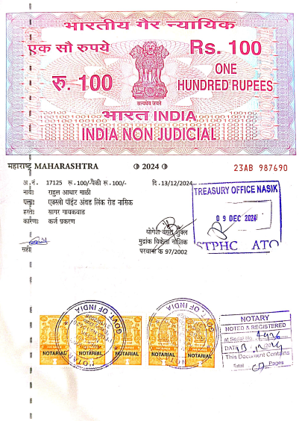
Agreement of Extra Amenities
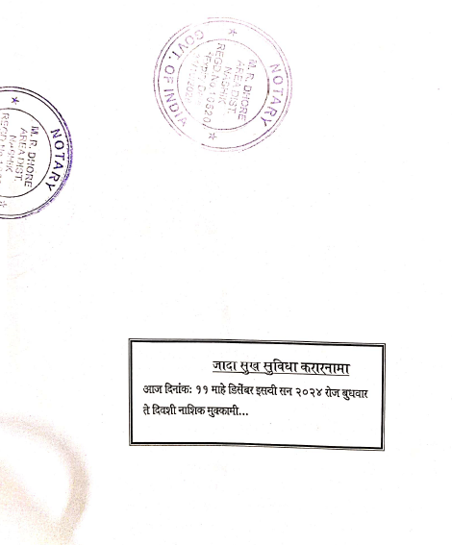

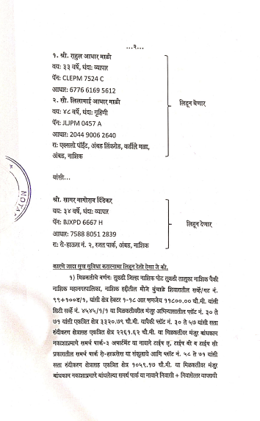
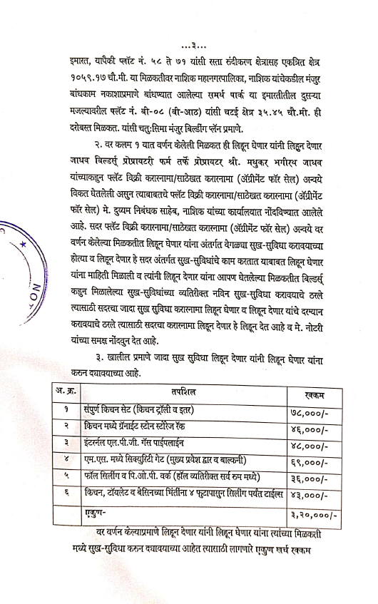

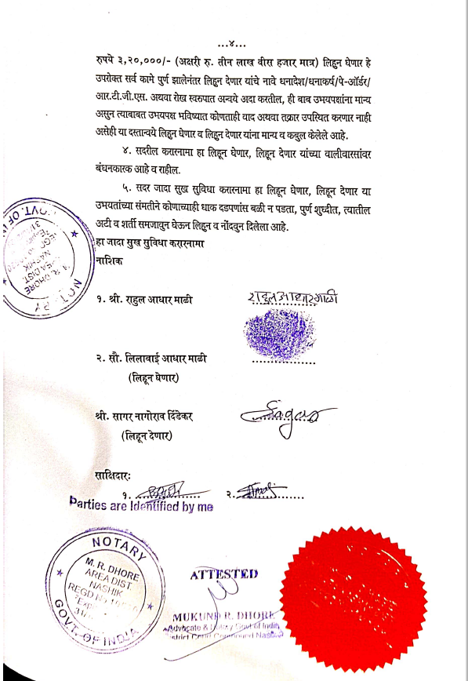

The Extra Work amount Rs.3,20,000/- (Rupees Three Lakh Twenty Thousand Only.)

