Vastu/Nashik/12/2024/013107/2309620
17/3-318-RPBS
Date: 17.12.2024

To, `
The Branch Manager,
Bank of Baroda
Regional Office Nashik Road Branch
BSNL Building, Datta Mandir Road, Nashik Road,
Nashik -422 101, State - Maharashtra, Country - India.

Sub: Vetting of Extra Amenities

Sir,

With reference to above subject, we have evaluated the Extra Amenities for Residential Flat No. 703, 7th Floor, Wing - B, "Shubharambh Apartment", Near Sanklecha Apartment, Swami Samarth Nagar, Plot No. 4+5, Jatra - Nandur Road, Village - Adgaon, Taluka -Nashik, District - Nashik, Nashik, PIN Code - 422 003, State - Maharashtra, Country - India belongs to Mr. Sunil Ganesh Pandit.

We have verified the rates quoted as per current market rates. Details of Extra Amenities considered as per copy of Agreement for Extra Amenities issued by to Mr. Sunil Ganesh Pandit. (First Party) Shri. Shyam Sainaji Bansode (Second Party) received on dated 07.12.2024. The Extra Amenities amount is Rs.3,40,000/- (Rupees Three Lakh Forty Thousand Only.)

The said Cost Vetting Certificate is valid upto next 6 months Only.

Thanking you

Sincerely yours

Manoj B. Chalikwar
Registered Valuer
Chartered Engineer (India)
Reg. No. CAT-I-F-1763
Reg. No. IBBI/RV/07/2018/10366
BOB Empanelment No.: ZO:MZ:ADV:46:941
Encl: Valuation report.

Agreement of Extra Amenities
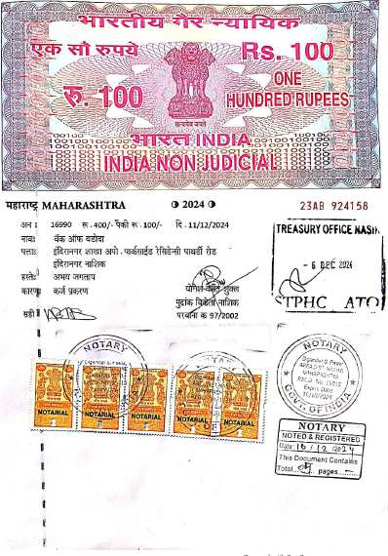
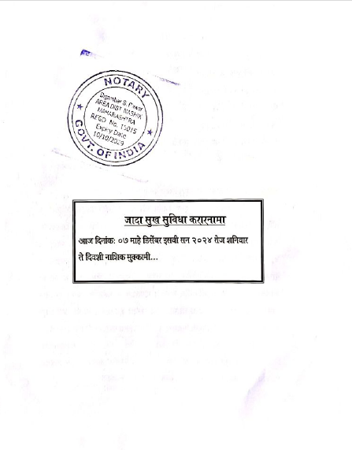

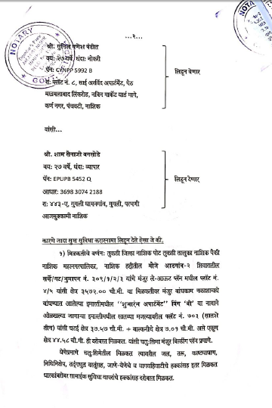
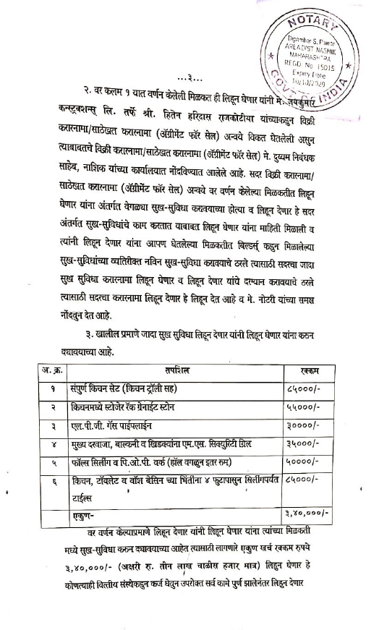

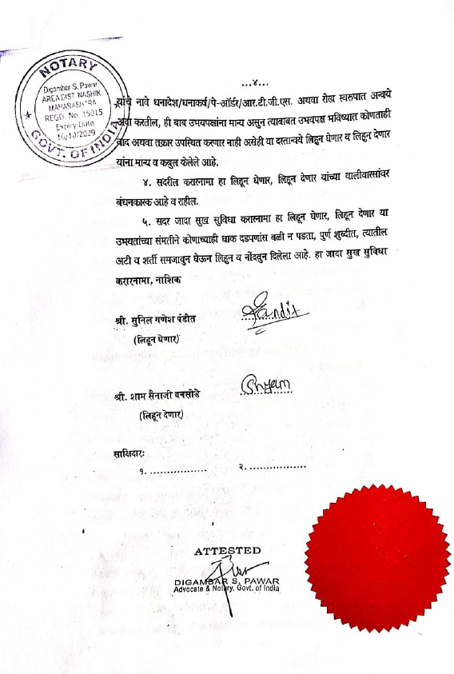

The Extra Work amount Rs.3,40,000/- (Rupees Three Lakh Forty Thousand Only.)

