Vastu/Nashik/07/2024/0010070/2307330
22/7-334-RPBS
Date: 13.12.2024

To, `
The Branch Manager,
Bank of Baroda
Regional Office Nashik Road Branch
BSNL Building, Datta Mandir Road, Nashik Road,
Nashik -422 101, State - Maharashtra, Country - India.

Sub: Vetting of Extra Amenities

Sir,

With reference to above subject, we have evaluated the Extra Amenities for Residential Flat No. 602, 6th Floor, Wing - A, "Avadh Elite", Burkule Hall, More Mala, Ekdant Nagar, Ambad - Trimurti Chowk Link Road, Village - Ambad Khurd, District - Nashik, Nashik, 422010, State - Maharashtra, India belongs to Mr. Gorakh Vinayak Arkhade & Mrs.Bharati
Gorakh Arkhade.

We have verified the rates quoted as per current market rates. Details of Extra Amenities considered as per copy of Agreement for Extra Amenities issued by to Shri. Gorakh Vinayak Arkhade & Sau. Bharati Gorakh Arkhade (First Party) Shri. Rohit Shivaji Khairnar (Second Party) received on dated 10.12.2024. The Extra Amenities amount is Rs.6,50,000/- (Rupees Six Lakh Fifty Thousand Only.)

The said Cost Vetting Certificate is valid upto next 6 months Only.

Thanking you

Sincerely yours

Manoj B. Chalikwar
Registered Valuer
Chartered Engineer (India)
Reg. No. CAT-I-F-1763
Reg. No. IBBI/RV/07/2018/10366
BOB Empanelment No.: ZO:MZ:ADV:46:941
Encl: Valuation report.

Agreement of Extra Amenities
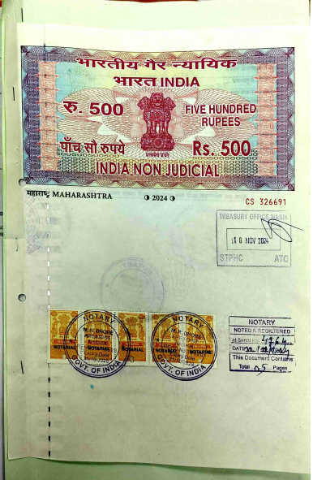

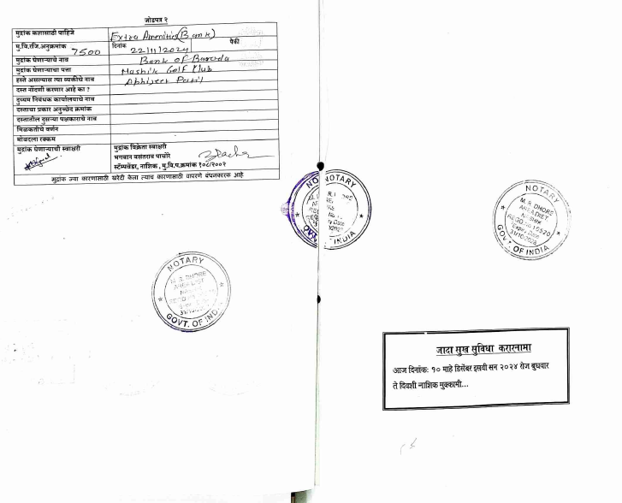

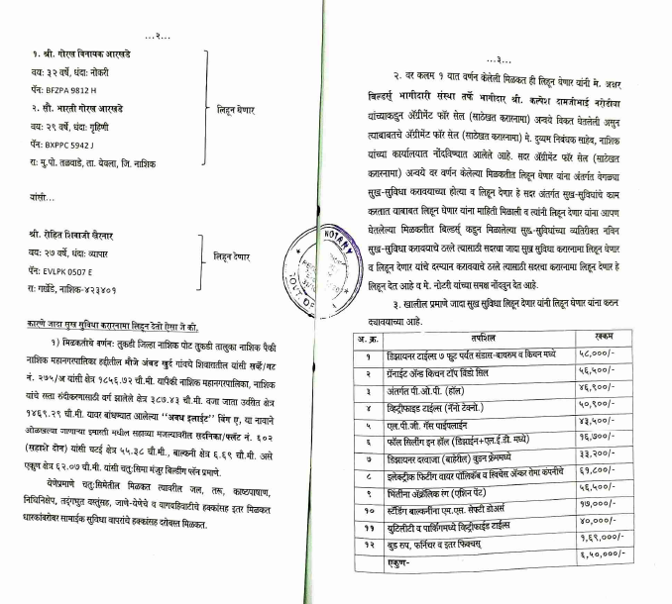

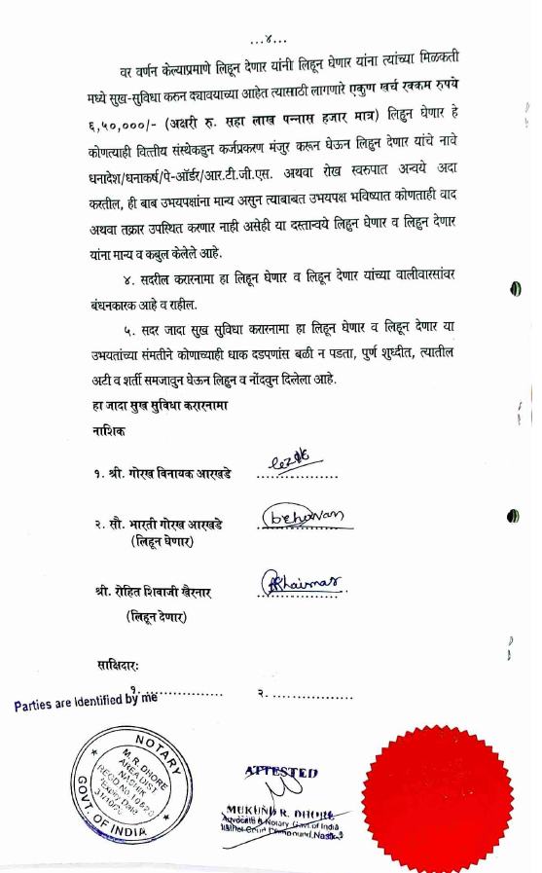

The Extra Work amount Rs.6,50,000/- (Rupees Six Lakh Fifty Thousand Only.)

