Vastu/Nashik/06/32014/2301224
22/20-325-RYBS
Date: 11.12.2024
To,
The Branch Manager,
Bank of Baroda
Regional Office
BSNL Building, Datta Mandir Road, Nashik Road,
Nashik, PIN – 422 101, State - Maharashtra, Country - India.

Sub: Vetting of Extra Amenities

Sir,

With reference to above subject, we have evaluated the Extra Amenities For Residential Flat No. 304, 3rd Floor, "Shivganga Avenue-D", Near Marigold Bungalow, Narhari Nagar, Pathardi Phata, Survey No - 312/ 4, Plot No. 17+18, Pakhal Road, Village - Pathardi, Taluka - Nashik, District - Nashik, Nashik, PIN Code - 422 010, State - Maharashtra, Country - India belongs to M/s. Shivprasad Enterprises, Partnership Firm. Name of Proposed Purchaser is Shri. Dyaneshwar Shamrao Sonawane & Sau. Sonali Dyaneshwar Sonawane.

We have verified the rates quoted as per current market rates. Details of Extra Amenities considered as per copy of Extra Amenities Agreement between Shri. Dyaneshwar Shamrao Sonawane & Sau. Sonali Dyaneshwar Sonawane (First Party). Shri. Shridhar Vaman Bhagyawant (Second Party) received on dated. 03.12.2024. The Extra Amenities amount is Rs. 5,00,000/- (Rupees Five Lakh Only)

The said Cost Vetting Certificate is valid upto next 6 months Only.

Thanking you

Sincerely yours

Manoj B. Chalikwar
Registered Valuer
Chartered Engineer (India)
Reg. No. CAT-I-F-1763
Reg. No. IBBI/RV/07/2018/10366
BOB Empanelment No.: ZO:MZ:ADV:46:941
Encl: Valuation report.

Agreement for Extra Amenities
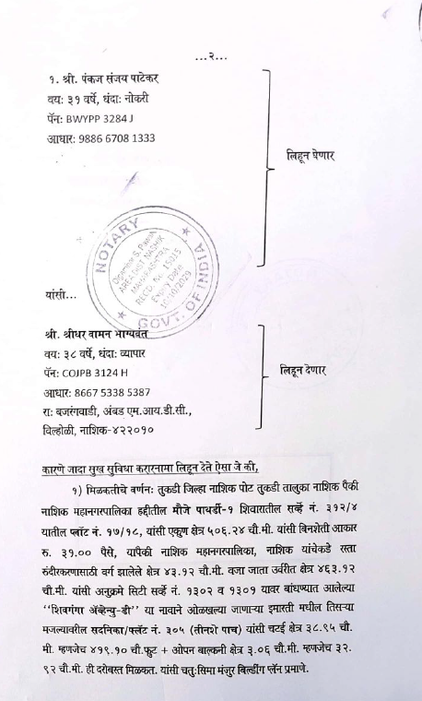
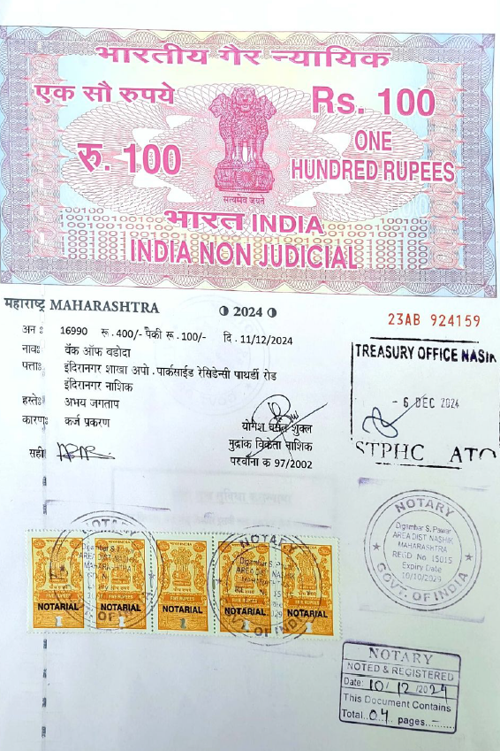

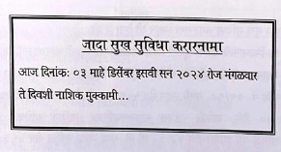

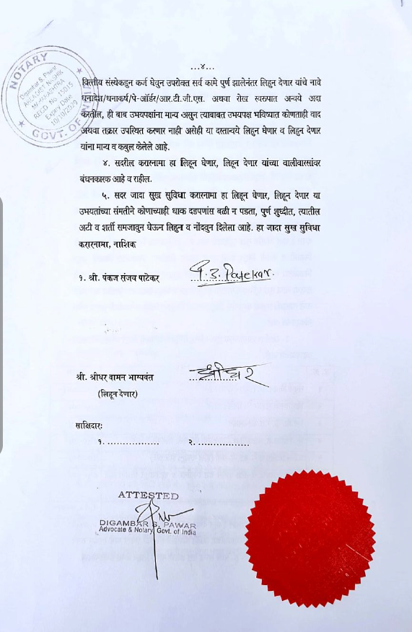
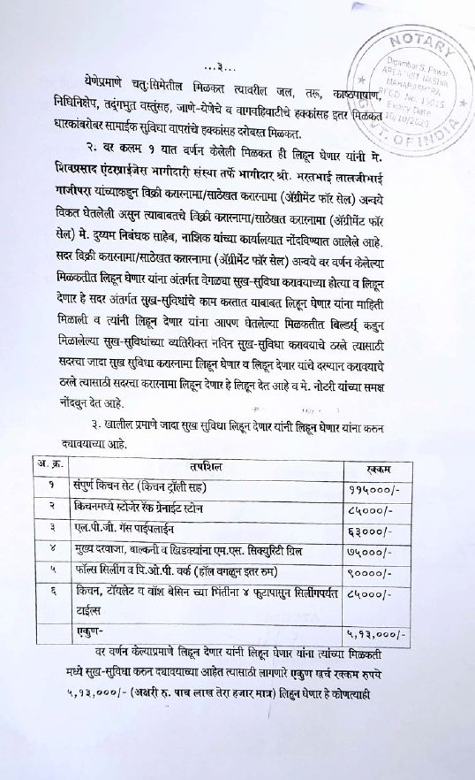

The Extra Amenities amount is Rs. 5,00,000/- (Rupees Five Lakh Only)

