COST VETTING REPORT
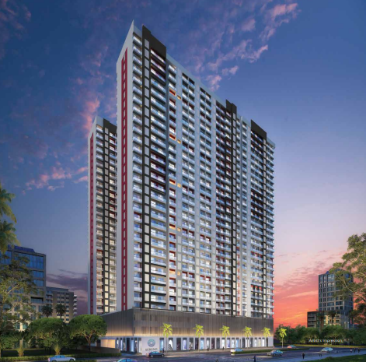

Details of the property under consideration:

Name of Project: "Sereno”

"Sereno”, Proposed Residential with Shopline, Building No. 3, Wing E & H, in Sector – III on Plot Bearing Survey No 81, Hissa No. 18, Survey No. 76, 82, Hissa No. 1, 2, 3/3, 8/1, 10, Survey No. 76,
Village – Gokhiware, Taluka – Vasai, District – Palghar, Pin Code – 401 208, Maharashtra, India.

Latitude Longitude: 19°23'44.5"N 72°50'51.1"E

Intended User:
State Bank of India
Industrial Finance Branch, Malad (West)
Industrial Finance Branch, Near Chincholi Phatak Signal, S. V. Road,
Malad (West), Mumbai - 400 064, State - Maharashtra, Country – India.

Vastu/SBI/Mumbai/12/2024/12952/2309501
09/37-199-PY
Date: 09.12.2024

To,
The Branch Manager,
State Bank of India
Industrial Finance Branch, Malad (West)
Industrial Finance Branch, Near Chincholi Phatak Signal,
S. V. Road, Malad (West), Mumbai - 400 064,
State - Maharashtra, Country – India.

Sub: Cost Vetting Report for "Sereno”, Wing E & H, Gokhiware, Pin Code – 401 208.

Dear Sir,
In accordance with your letter of engagement as stated above, we enclose our Report on Cost Vetting for "Sereno”, Proposed Residential with Shopline, Building No. 3, Wing E & H, in Sector – III on Plot Bearing Survey No 81, Hissa No. 18, Survey No. 76, 82, Hissa No. 1, 2, 3/3, 8/1, 10, Survey No. 76, Village – Gokhiware, Taluka – Vasai, District – Palghar, Pin Code – 401 208, Maharashtra, India.
M/s. TRIO Infrastructure Pvt. Ltd. is proposing Proposed Residential with Shopline, Building No. 3, Wing E & H, in Sector – III on Plot Bearing Survey No 81, Hissa No. 18, Survey No. 76, 82, Hissa No. 1, 2, 3/3, 8/1, 10, Survey No. 76, Village – Gokhiware, Taluka – Vasai, District – Palghar, Pin Code – 401 208, Maharashtra, India. Project is comprising Sale Building (Wing E to H) & Club House.
Residential of Sale Building (Wing E & H) is proposed of Ground Floor + P1 + P2 + 22nd Upper Floors with total RERA carpet area of 2,02,638.00 Sq. Ft. which consists 1 BHK & 2 BHK with 432 nos. of Sell flats & 17 nos. of Shops providing with Club House, Fitness Centre, Society Office, & Other Amenities.
In this regard, SBI, Industrial Finance Branch, Malad (West), Industrial Finance Branch, Near Chincholi Phatak Signal, S. V. Road, Malad (West), Mumbai - 400 064 has approached Vastukala Consultants (I) Pvt. Ltd. (VCIPL) to conduct a Cost Vetting of the said project.
Our analysis of the cost vetting is enclosed in this report. This Report forms an integral whole and cannot be split in parts. The outcome of the report/ study can only lead to proper conclusions if the Report as a whole is taken into account.

The information used by Vastukala Consultants (I) Pvt. Ltd. (VCIPL) in preparing this report has been obtained from a variety of sources and other relevant documents provided by the client & bank. As agreed, we have performed our cost vetting exercise with the data available related to the business, considering the market prospects and projections. Our results are dependent on documents provided by client & bank, the underlying assumptions, which has been analyzed at a broader level by VCIPL while assessing their reasonableness.
Total Project Cost for the completion of Project will be ` 145.19 Cr.

For Vastukala Consultants (I) Pvt. Ltd.

Manoj B. Chalikwar
Registered Valuer
Chartered Engineer (India)
Reg. No. IBBI / RV / 07/2018/10366
Reg. No. CAT-I-F-1763
SBI Empanelment No.: SME/TCC/38/IBBI/3
About the Project:
Residential with Shopline, Building No. 3, Wing E & H, in Sector – III on Plot Bearing Survey No 81, Hissa No. 18, Survey No. 76, 82, Hissa No. 1, 2, 3/3, 8/1, 10, Survey No. 76, Village – Gokhiware, Taluka – Vasai, District – Palghar, Pin Code – 401 208, Maharashtra, India. It is about 5.0 Km travelling distance from Vasai Railway station.

Construction Area as per Approved Plan for Sale Building (Wing E & H)

Sr. | Floor | FSI Area in Sq. M. | NON FSI Area in Sq. M. | Refuge Area in Sq. M. | Podium Area in Sq. M. | Lift Well Area in Sq. M. | Open to Sky Area in Sq. M. | A. P. Area in Sq. M. | Total Construction Area in Sq. M.
1 | Ground Floor | 177.51 | 106.50 | - | 1,023.31 | 42.80 | 40.05 | 59.28 | 1,449.45
2 | Podium - I Floor | - | - | - | 1,357.25 | 42.80 | - | - | 1,400.05
3 | Podium - II Floor | - | - | - | 1,357.25 | 42.80 | - | - | 1,400.05
4 | 1st Floor | 737.89 | 442.74 | - | - | 42.80 | 119.95 | 72.05 | 1,415.43
5 | 2nd Floor | 737.89 | 442.74 | - | - | 42.80 | - | 144.06 | 1,367.49
6 | 3rd Floor | 737.89 | 442.74 | - | - | 42.80 | - | 144.06 | 1,367.49
7 | 4th Floor | 737.89 | 442.74 | - | - | 42.80 | - | 144.06 | 1,367.49
8 | 5th Floor | 702.55 | 421.53 | 64.29 | - | 42.80 | - | 135.88 | 1,367.05
9 | 6th Floor | 737.89 | 442.74 | - | - | 42.80 | - | 144.06 | 1,367.49
10 | 7th Floor | 737.89 | 442.74 | - | - | 42.80 | - | 144.06 | 1,367.49
11 | 8th Floor | 737.89 | 442.74 | - | - | 42.80 | - | 144.06 | 1,367.49
12 | 9th Floor | 737.89 | 442.74 | - | - | 42.80 | - | 144.06 | 1,367.49
13 | 10th Floor | 702.55 | 421.53 | 64.29 | - | 42.80 | - | 135.88 | 1,367.05
14 | 11th Floor | 737.89 | 442.74 | - | - | 42.80 | - | 144.06 | 1,367.49
15 | 12th Floor | 737.89 | 442.74 | - | - | 42.80 | - | 144.06 | 1,367.49
16 | 13th Floor | 737.89 | 442.74 | - | - | 42.80 | - | 144.06 | 1,367.49
17 | 14th Floor | 737.89 | 442.74 | - | - | 42.80 | - | 144.06 | 1,367.49
18 | 15th Floor | 702.55 | 421.53 | 64.29 | - | 42.80 | - | 135.88 | 1,367.05
19 | 16th Floor | 737.89 | 442.74 | - | - | 42.80 | - | 144.06 | 1,367.49
20 | 17th Floor | 737.89 | 442.74 | - | - | 42.80 | - | 144.06 | 1,367.49
21 | 18th Floor | 737.89 | 442.74 | - | - | 42.80 | - | 144.06 | 1,367.49
22 | 19th Floor | 737.89 | 442.74 | - | - | 42.80 | - | 144.06 | 1,367.49
23 | 20th Floor | 702.55 | 421.53 | 64.29 | - | 42.80 | - | 135.88 | 1,367.05
24 | 21st Floor | 737.89 | 442.74 | - | - | 42.80 | - | 144.06 | 1,367.49
25 | 22nd Floor | 737.89 | 442.74 | - | - | 42.80 | - | 144.06 | 1,367.49
26 | LMR / OHT / Terrace | - | 442.74 | - | - | 42.80 | - | 144.06 | 629.60
TOTAL |  | 16,269.73 | 10,204.68 | 257.16 | 3,737.81 | 1,112.80 | 160.00 | 3,267.93 | 35,010.11

Project Cost
Sr. No. | Particulars | Total Estimated Amount in ` | Total Estimated Amount  in ` Cr.
1 | Land Cost
 | Acquisition Cost of Land or Development Rights, and Legal Cost. | 30,15,32,840.00 | 30.15
 | Rent to Tenants, Lease premium, Lease Rent, interest cost incurred or payable on Land Cost | - | -
 | Amount of Premium payable to obtain development rights, FSI, additional FSI, fungible area, and any other incentive under DCR from Local Authority or State Government or any Statutory Authority. | - | -
 | Acquisition cost of TDR (if any) | - | -
2 | Cost of Construction
 | Estimated construction cost of rehab cum sale building including site development and infrastructure for the same. | 95,50,75,801.00 | 95.51
 | On site expenditure for development of entire project excluding cost of construction as per(i) above,
a. | Architect Fees & Consultant fees | 59,69,224.00 | 0.60
b. | Admin Cost includes salaries, site overheads, development works, cost of services (including water, electricity, sewerage, drainage, layout roads etc.), cost of machineries and equipment including its hire and maintenance cost, consumables etc. All costs directly incurred to complete the construction of the entire phase of the project registered. | 4,18,32,320.00 | 4.18
c. | Marketing Cost | 3,90,34,058.00 | 3.90
3 | Interest during the Project | 10,85,00,000.00 | 10.85
4. | Contingency Charges | - | -
 | GRAND TOTAL: | 145,19,44,243.00 | 145.19

Manoj B. Chalikwar
Registered Valuer
Chartered Engineer (India)
Reg. No. IBBI / RV / 07/2018/10366
Reg. No. CAT-I-F-1763
SBI Empanelment No.: SME/TCC/38/IBBI/3
Comments on each element of Cost of Project: -
- Land Cost:
As per Present Ready Reckoner rate the Project Land Value is ` 1.79 Cr. considering Land Rate @ ` 12,300.00 per Sq. M. & Net Plot Area of 1,462.11 Sq. M.
As per document purchase cost of land & stamp duty cost is ` 28,56,60,000.00 i.e., ` 28.57 Cr. which is 20.77% of Total Project Cost.
Sr. | Dated | Agreement | Particulars | Amount in `
1 | 06-04-2023 | Developer Agreement | Purchase Cost | 28,56,60,000.00
2 | 06-04-2023 | Developer Agreement | Stamp Duty | 1,52,28,600.00
3 | 06-04-2023 | Developer Agreement | Reg. Fees | 33,120.00
4 | 06-04-2023 | Developer Agreement | Penalties Charges | 6,09,200.00
5 | 24-07-2023 | Power of Attorney | Stamp Duty | 500.00
6 | 24-07-2023 | Power of Attorney | Reg. Fees | 1,420.00
TOTAL |  |  |  | 30,15,32,840.00

- Building Cost of Construction for Sale Building:
Total Construction Area of Sale Building = 35,010.11 Sq. M. i.e., 3,76,848.82 Sq. Ft.
Total estimated cost for construction of Building (includes cost of RCC work, manpower, lift, material, painting, finishing work, site development, etc.) is ` 86,82,50,728.00 i.e., ` 86.83 Cr. which comes ` 24,800.00 per Sq. M. on construction area for building and deep excavation & piling cost is ` 8,68,25,073.00 i.e., ` 8.68 Cr. which comes 10% of cost of construction.
Hence, total construction cost (Cost of construction of building + Cost of Deep Excavation Cost) (` 86,82,50,728.00 + ` 8,68,25,073.00) = ` 95,50,75,801.00 i.e., ` 95.51 Cr.
The total construction area is 35,010.11 Sq. M. i.e., 3,76,848.82 Sq. Ft., projected cost of ` 95.51 Cr is 65.78% of total project cost
VCIPL opinion the construction cost of 24,800/- Per Sq. M. which is in line with Market-Trend.
Particulars | Rate per Sq. Ft
Excavation Work | 1,400.00
Total RCC Work | 12,000.00
Final Finishing Work | 6,000.00
Other Work | 5,400.00
Cost of Construction | 24,800.00
Deep Excavation & Piling Cost | 10% of Cost of Construction

- Professional Cost:
The total Architect charges of ` 59,69,224.00 i.e., ` 0.60 Cr. is 0.625% of total construction cost building & it is less than Market trend.
The professional charge consists of Architect & Legal which in market is in the range of 2% - 5% of Total Construction cost of the project but developer has inhouse team i.e., professional cost is less than market range.

- Project Overheads & Admin Exps.:
Salaries, site overheads, development works, cost of services (including water, electricity, sewerage, drainage, layout roads etc.), cost of machineries and equipment including its hire and maintenance cost, consumables etc. All costs directly incurred to complete the construction of the entire phase of the project registered is estimated 4.38% of total construction cost Building which comes to ` 4,18,32,320.00 i.e., ` 4.18 Cr.
The admin charges which in market is in the range of 4% - 6% of Total Construction cost of the project.

- Marketing Cost:
Marketing costs directly incurred to complete the construction of the entire phase of the project registered is estimated at 2% of total Sale income from the project which comes to ` 3,90,34,058.00 i.e., ` 3.9 Cr.
The marketing charge consists of brokerage & commission which in market is in the range of 1% - 3% of Total Sale income of the property.

- Interest Costs:
The Interest cost for the term loan is ` 10,85,00,000.00 i.e., ` 10.85 Cr., which is 7.47% of total project cost.
As per information provided by the client.
Note:
As the developer has executed the development agreement with the owners and confirming parties. Developer has received the development rights on the said plot. Building construction approval has been applied and received by the owners and confirming parties. They cost towards the same is incurred by the owners and confirming parties. Hence, approval cost is not considered in the project cost.
Observation and Construction: -
Total estimated cost of project i.e., ` 145,19,44,243.00 (Rupees One Hundred Forty – Five Crore Nineteenth Lakh Forty – Four Thousand Two Hundred Forty – Three Only) i.e., ` 145.19 Cr. is fair & reasonable.
The project cost is including land premium payable to concern authorities, Cost of Construction of Sale Building, professional charges on site expenses including admin & marketing expenses, premiums / charges to be paid to competent authority and Bank interest, etc. we have not independently verified interest cost hence not consider in cost vetting.
As per present sanctioned building plan, permissible built-up area on the said plot is 20,900.00 Sq. M. The sale building (Wing E & H) is presently approved for Ground Floor + 1st to 2nd Podium Floor + 1st to 22nd Upper Floors only. Estimated cost of entire project of 22nd upper floors are considered.
Total estimated cost of construction of Sales building is ` ` 86,82,50,728.00 i.e., ` 86.83 Cr. which comes ` 24,800.00 per Sq. M. on construction area for building and deep excavation & piling cost is ` 8,68,25,073.00 i.e., ` 8.68 Cr. which comes 10% of cost of construction. Hence, total construction cost (Cost of construction of building + Cost of Deep Excavation Cost) (` 86,82,50,728.00 + ` 8,68,25,073.00) = ` 95,50,75,801.00 i.e., ` 95.51 Cr., which is fair & reasonable considering the present status of project, type & quality of construction & specification of the building materials to be used, height of the structure, amenities to be provided in proposed building.

Assumptions & Remarks-
- The adequacy of Engineering / Structural design is beyond the scope of our assignment.
- Estimated project completion date is 30/12/2027. The cost is certified based on the assumptions that the project will be completed within time frame. Few assumptions are made regarding inflation & cost rise etc. during construction period.

Photo copy of following document is provided to us & this report should be read along with it:
- Copy of Development Agreement dated 24.07.2023 between M/s. Rashmi Ameya Developers Housing & Estate Realtors Pvt. Ltd (Owner No 1) and M/s. Sai Rydam Realtors Pvt Ltd. (Owner No 2) and Mr. Devendra Rajnikant Ladhani (Confirming Party No 1) & Others and M/s. TRIO Infrastructure Pvt, Ltd. (Purchaser) through registered agreement Doc. No. Vasai – 5/11399/2023 dated 06.04.2023.
- Copy of Power of Attorney by M/s. Rashmi Ameya Developers Housing & Estate Realtors Pvt. Ltd. To M/s. Sai Rydam Realtors Pvt Ltd. Through registered agreement Doc. No. Vasai-5/11401/2023 dated 24.07.2023.
- Copy of 7/12 Extract.
- Copy of N. A. Order No. SR 62 / 2018 dated 24.01.2019 issued by Tagasildar Vasai.
- Copy of Approved Plan office Letter No. VVCMC/TP/Amend/VP/0329,0815 & 0509/246/2023-24 dated 31.01.2024 issued by Vasai Virar City Municipal Corporation (VVCMC).
Approved upto:
Wing E – Ground Floor + 1st & 2nd Podium Floor + 1st to 22nd Residential Upper Floors
Wing H – Ground (Shops) Floor + 1st & 2nd Podium Floor + 1st to 22nd Residential Upper Floors
- Copy of Commencement Certificate No. VVCMC/TP/RDP/VP - 0329, 0815 & 0509/246/2023-24 dated 31.01.2024 issued by Vasai Virar City Municipal Corporation (VVCMC).
Sanctioned Upto:
Wing E – Ground Floor + 1st & 2nd Podium Floor + 1st to 22nd Residential Upper Floors
Wing H – Ground (Shops) Floor + 1st & 2nd Podium Floor + 1st to 22nd Residential Upper Floors
- Copy of Provisional Fire Safety Approval No. MFS/51/2024/237 dated 01.04.2024 issued Directorate of Maharashtra Fire Service, Government of Maharashtra.
- Copy of RERA Certificate RERA No. P99000053269 dated 15.04.2023 issued by Maharashtra Real Estate Regulatory Authority (MAHRERA).
- Copy of RERA Extension Certificate No. P99000053269 dated 15.04.2023 issued by Maharashtra Real Estate Regulatory Authority (MAHRERA).

Actual Site Photographs
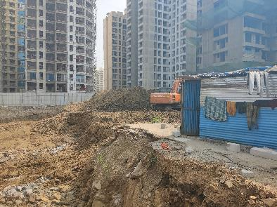
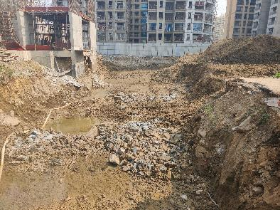
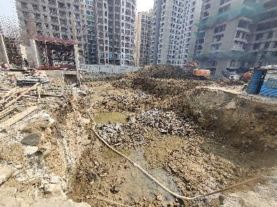
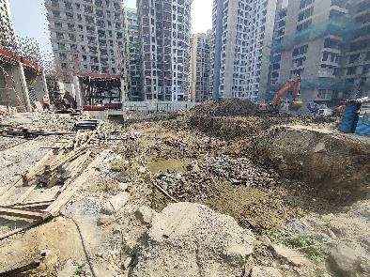
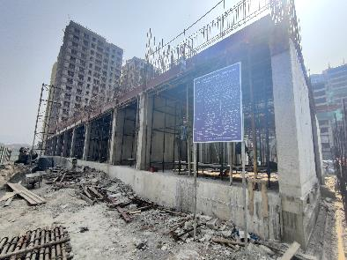
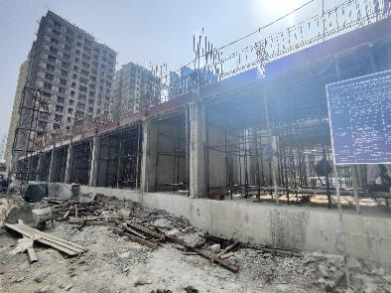
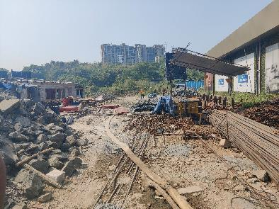
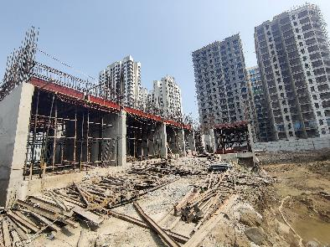
Actual Site Photographs
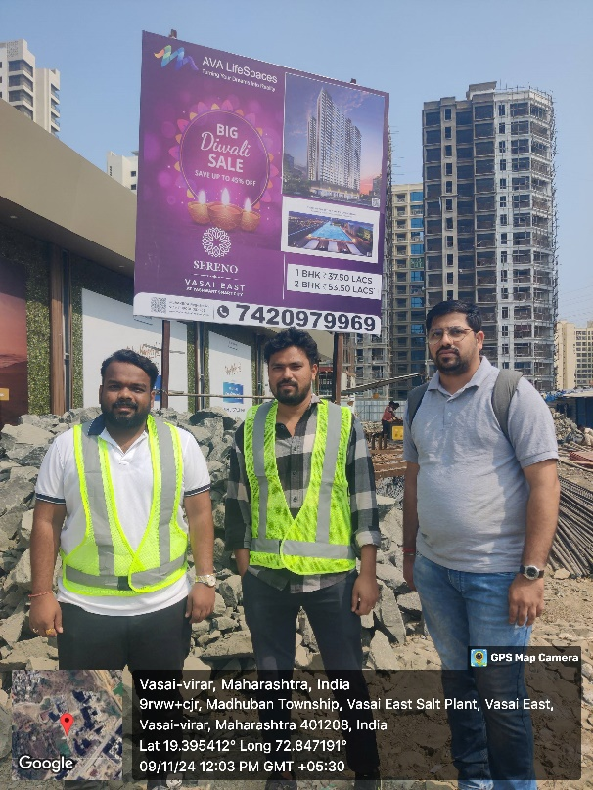
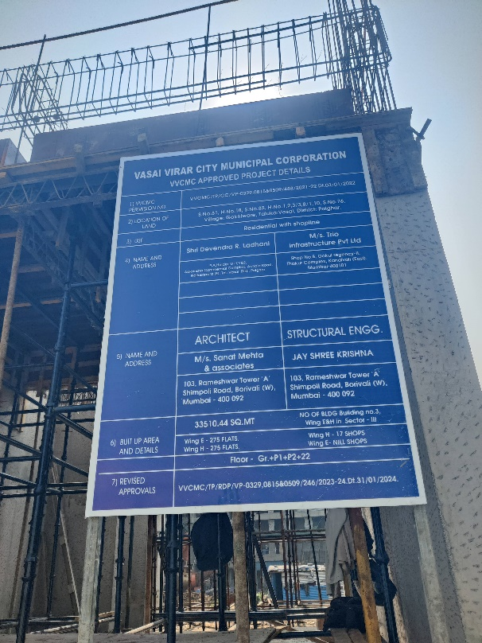
Route Map of the property
Site u/r
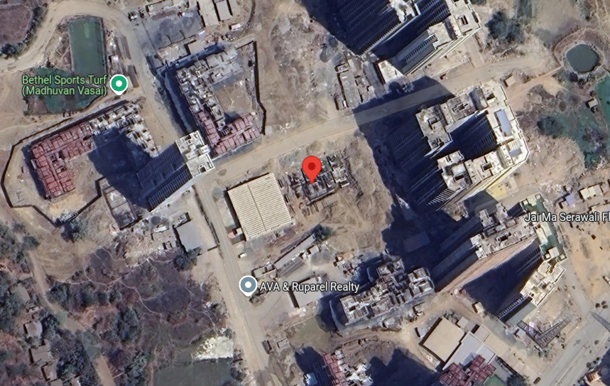

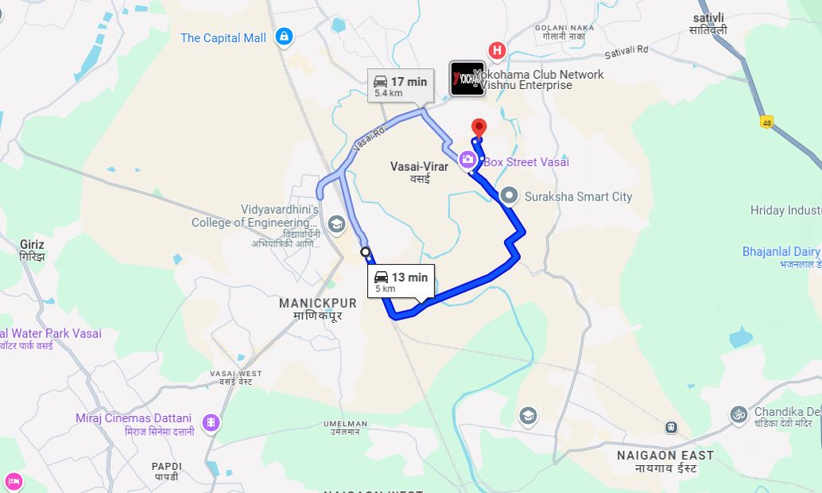

Latitude Longitude: 19°23'44.5"N 72°50'51.1"E
Note: The Blue line shows the route to site from nearest railway station (Vasai – 5.0 Km)

