|  |
| --- |
| Techno-Economic Viability    Study Report On  Sereno    Name of Owner : M/s. Trio Infrastructure Private Limited (TIPL)  *Proposed Residential with Shopline Building No. 3, Wing E & H in Sector – III on land bearing S. No. 81, H. No. 18, S. No. 82, H. No. 1, 2, 3/3, 8/1, 10, S. No. 76, Village – Gokhiware, Taluka – Vasai, District – Palghar, Pin Code – 401 208, Maharashtra, India.*  TEV Report for :State Bank of India  ***Industrial Finance Branch****,*  *Near Chincholi Phatak Signal, S. V. Road, Malad (West), Mumbai, Pin Code – 400 064, Maharashtra, India*  Consultants **:** Vastukala Consultants (I) Pvt. Ltd. (VCIPL)  *B1 – 001, Upper Basement, Boomerang Building, Chandivali Farm Road, Andheri (East), Mumbai - 400 072* |
|  |

**Table of Contents**

Executive Summary 4

Scope of the Work 13

Methodology 14

Real Industry Analysis 21

Segments in the Indian Real Estate Sector 26

Market Size of the India Real Estate 27

About Vasai 28

Connectivity with nearby localities 28

Civic Amenities & Infrastructure 28

PRICE TRENDS IN Vasai 29

PRICE TRENDS IN Vasai 30

PRICE TRENDS IN Vasai 31

READY RECKONER RATE 32

Project Details 33

Location & Connectivity 35

Land Details 36

Project Area Statement as per Approved Building Plan 37

Floor wise Built – up Area Statement / FSI Area 37

Project Cost 38

Means of Finance 39

Project Approvals and their Status 39

Current Status of the Project 40

Implementation Schedule 40

Economic Viability 41

Construction Area 41

Inventory 43

Projected Revenue 43

Sale Projection 44

Sales and Cost Working 44

Profitability Projections 46

Cashflow Statement 47

Financial Analysis 48

Debt Equity Ratio 48

Loan-to-Sale Value (LTSV) 48

Debt Service Coverage Ratio (DSCR) 48

Internal Rate of Return (IRR) 49

Sensitivity Analysis 49

Swot Analysis 50

Risk Analysis and Mitigation 51

Conclusion 53

Annexure – 1 Projected Profitability Statement 54

Annexure – 2 Projected Balance Sheet 55

Annexure -3 Projected Cashflow Statement 56

Annexure - 4 Debt Service Coverage Statement 59

Annexure - 5 Repayment of Term Loan 59

Annexure - 7 Photographs 60

Disclaimer 62

Vastu/SBI/Mumbai/11/2024/12951/2304993

15/13-215-SSPPY

Date: 09.12.2024

# Executive Summary

**State Bank of India,** Industrial Finance Branch, Malad (West), Mumbai through Mr. Manish Ramteke, RMSME has appointed **Vastukala Consultants (I) Private Limited (VCIPL)** for undertaking the Techno-Economic Viability (**TEV**) study of the real estate project, namely, **Sereno** in Vasai developed by **M/s. Trio Infrastructure Private Limited (TIPL).**

The study would be to assess the technical, commercial and financial viability of the said real estate project through a detailed analysis of the project and evaluation of the constraints and future potential.

**M/s. Trio Infrastructure Private Limited (TIPL)** is developing Residential cum Commercial Project in Vasai in the name of **“Sereno”.** It is a residential cum commercial project. The project is being developed in single Phase. Project comprises of two buildings.

The project offers Residential Flats & Commercial Shops with perfect combination of contemporary architecture and features to provide comfortable spaces with the amenities to match the lifestyles.

**Sereno,** consists of Residential cum Commercial building totaling 432 Sale Flats & 17 Shops. The Commencement certificate and MahaRERA registration is obtained for totaling about 432 Residential Flats & 17 commercial units.

RERA registration number of project is P99000053269.

|  |  |  |  |  |
| --- | --- | --- | --- | --- |
| **Building** | **Proposed Completion** | **Levels** | **Present stage of Construction** | **Approval Current Status** |
| **Sale Residential Building No. E** | 30th December 2027  (As per RERA Extension Certificate) | Proposed Sale Building Ground Floor + 1st & 2nd Podium Floor + 3rd Floor to 22nd Upper Floor | Excavation Work Started | Commencement Certificate is obtained for Ground Floor + 1st & 2nd Podium Floor + 3rd Floor to 22nd Upper Floor |
| **Sale Residential cum Commercial Building No. H** | Proposed Sale Building Ground Floor + 1st & 2nd Podium Floor + 3rd Floor to 22nd Upper Floor | Ground Floor work is Completed | Commencement Certificate is obtained for Ground Floor + 1st & 2nd Podium Floor + 3rd Floor to 22nd Upper Floor |

|  |  |
| --- | --- |
| **Parameter** | **Details** |
| Asset Class | Residential & Commercial |
| Category | Mid Segment |
| Location | S. No. 81, H. No. 18, S. No. 82, H. No. 1, 2, 3/3, 8/1, 10, S. No. 76, Village – Gokhiware, Taluka – Vasai, District – Palghar, Pin Code – 401 208, Maharashtra, India. |
| Land Area | Net Plot area – 1,462.11 Sq. M. |
| Land Purchased in | As per Developer Agreement For sale dated 06/04/2023 |
| Land Financed by | - |
| Project Type | Residential cum Commercial |
| Applicable DCRs | Vasai-Virar Municipal Corporation |
| Development Potential | As per table attached |
| Sales begun in | October 2024 |
| Carpet Sale Area | As per table attached |
| Construction Start Date | As per revised CC dated 31/01/2024 |
| Construction End Date as per information uploaded by the Developer on the RERA Website | 30th December 2027 (As per RERA Extension Certificate) |
| Architect and Planning | As per table attached |
| Key Project Consultants |
| Landscaping Consultant |
| Structural Consulting |
| Project Contractors |

**Project Cost**

The total project cost estimated by **TIPL** works out to **INR 145.19 Crore**. The detailed acquisition cost is as tabulated below:

**INR in Crore**

|  |  |  |
| --- | --- | --- |
| Particulars | Total Project Cost | %tage of Total |
| Land & Stamp Duty Cost | 30.15 | 20.77% |
| Construction Cost | 95.51 | 65.78% |
| Architect & Consultancy Expenses | 0.60 | 0.41% |
| Project Overheads & Admin Exps. | 4.18 | 2.88% |
| Marketing Cost | 3.90 | 2.69% |
| Interest to Bank Finance upto construction period | 10.85 | 7.47% |
| Total | **145.19** | **100.00%** |

**Cost Incurred till October 31, 2024**

The cost incurred on project the till **October 31, 2024** is as tabulated below:

**INR in Crore**

|  |  |
| --- | --- |
| Particulars | Cost incurred till 31/10/2024 |
| Land & Stamp Duty Cost | 21.26 |
| Construction Cost | 12.68 |
| Architect & Consultancy Expenses | - |
| Project Overheads & Admin Exps. | 0.15 |
| Marketing Cost | 0.19 |
| Interest to Bank Finance upto construction period | - |
| Total | **34.28** |

**Balance Cost to Complete the Project**

The balance cost to complete the project budgeted by **TIPL** is as tabulated below:

**INR in Crore**

|  |  |
| --- | --- |
| Particulars | Balance Cost to be Incurred |
| Land & Stamp Duty Cost | 8.89 |
| Construction Cost | 82.83 |
| Architect & Consultancy Expenses | 0.60 |
| Project Overheads & Admin Exps. | 4.03 |
| Marketing Cost | 3.71 |
| Interest to Bank Finance upto construction period | 10.85 |
| Total | **110.91** |

**Means of Finance**

The means of finance proposed for the said project cost shall be as tabulated below:

**INR in Crore**

|  |  |  |
| --- | --- | --- |
| Particulars | Total Funds to be Raised | %tage of Total |
| Promoters Contribution |  |  |
| Promoters Contribution | 20.50 | 14.10% |
| Unsecured Loan | 14.50 | 10.00% |
| Bank Loan |  |  |
| Term Loan | 48.00 | 33.10% |
| Customer Advances | 62.19 | 42.80% |
| Total | **145.19** | **100.0%** |

**Analysis on Project Sales**

The analysis for project sales is as tabulated below:

**Inventory Details: -**

|  |  |  |
| --- | --- | --- |
| Particulars | No. of Unit | Carpet Area in Sq. Ft. |
| Unsold Flat of Wing E | **216.00** | **1,00,210.00** |
| Unsold Flat of Wing H | **113.00** | **50,342.00** |
| Unsold Shop of Wing H | **2.00** | **383.00** |
| Sold Flat of Wing H | **103.00** | **49,349.00** |
| Sold Shop of Wing H | **15.00** | **2,354.00** |
| Total | **449.00** | **2,02,638.00** |

**Profitability Statement**

The project sales from receivables on sold inventory and sale of unsold inventory is as tabulated below:

**INR in Crore**

|  |  |  |  |  |  |  |
| --- | --- | --- | --- | --- | --- | --- |
| Particulars | FY 23-24 | FY 24-25 | FY 25-26 | FY 26-27 | FY 27-28 | FY 28-29 |
| Revenue |  |  |  |  |  |  |
| Sales | 1.15 | 18.04 | 21.72 | 18.49 | 44.44 | 91.33 |
| Closing WIP – TIPL | 32.79 | 45.79 | 63.20 | 79.52 | 59.94 | 0.80 |
| Total Revenue | **33.94** | **63.83** | **84.92** | **98.01** | **104.38** | **92.13** |
|  |  |  |  |  |  |  |
| Expenses |  |  |  |  |  |  |
| Expenses incurred during the year | 33.09 | 29.42 | 36.57 | 32.07 | 15.48 | 2.46 |
| Opening WIP - TIPL | 0.80 | 32.79 | 45.79 | 63.20 | 79.52 | 59.94 |
|  |  |  |  |  |  |  |
| Operating Profit | **0.05** | **1.62** | **2.56** | **2.74** | **9.38** | **29.73** |
|  |  |  |  |  |  |  |
| PBT | **0.05** | **1.62** | **2.56** | **2.74** | **9.38** | **29.73** |
| Tax | - | 0.40 | 0.64 | 0.68 | 2.35 | 7.43 |
| PAT | **0.05** | **1.22** | **1.92** | **2.05** | **7.04** | **22.30** |

**Balance Sheet**

The projected Balance sheet of the project is as tabulated below:

**INR in Crore**

|  |  |  |  |  |  |  |
| --- | --- | --- | --- | --- | --- | --- |
| Particulars | FY 23-24 | FY 24-25 | FY 25-26 | FY 26-27 | FY 27-28 | FY 28-29 |
| Shareholder Funds | **3.70** | **21.51** | **23.43** | **25.48** | **32.52** | **54.81** |
| Share capital | 3.91 | 20.50 | 20.50 | 20.50 | 20.50 | 20.50 |
| Reserve & Surplus | (0.21) | 1.01 | 2.93 | 4.98 | 12.02 | 34.31 |
|  |  |  |  |  |  |  |
| Non-current Liabilities | **12.82** | **25.00** | **40.90** | **56.50** | **56.51** | **16.51** |
| Term Loan | - | 13.00 | 27.00 | **41.00** | 40.00 | - |
| Promotors Loan | 12.82 | 12.00 | 13.90 | 15.50 | 16.51 | 16.51 |
|  |  |  |  |  |  |  |
| Current Liabilities | **22.51** | **4.86** | **4.30** | **21.81** | **14.81** | **0.57** |
| Unsecured loan |  |  |  |  |  |  |
| Advance received | 2.17 | 3.96 | 3.31 | 19.20 | 11.25 | - |
| Sundry Creditors | 0.63 | 0.60 | 0.66 | 1.12 | 1.23 | 0.01 |
| Provision | 0.34 | 0.30 | 0.33 | 0.56 | 0.62 | 0.01 |
| Others | 19.37 | - | - | 0.93 | 1.71 | 0.55 |
|  |  | - |  |  |  |  |
| Total Liabilities | **39.03** | **51.37** | **68.63** | **103.79** | **103.84** | **71.89** |
|  |  |  |  |  |  |  |
| Asset |  |  |  |  |  |  |
| Non-Current Assets |  |  |  |  |  |  |
| Fixed Assets | 0.13 | 0.13 | 0.13 | 0.13 | 0.13 | 0.13 |
|  |  | - | - |  |  |  |
| Project WIP | 32.79 | 45.79 | 63.20 | 79.52 | 59.94 | 0.80 |
|  |  |  |  |  |  |  |
| Current Assets |  |  |  |  |  |  |
| Advance for Plots | - | - | - | 15.00 | 25.00 | 60.00 |
| Sundry Debtors | 0.49 | 0.22 |  |  |  |  |
| other current assets |  | - | - | 1.00 | 9.40 | - |
| Loans & Advances | 4.72 | 1.51 | 2.09 | 1.50 | 1.75 | 1.80 |
| Cash & Cash Equivalent | 0.90 | 1.12 | 0.61 | 4.04 | 5.02 | 6.55 |
| Total Current Assets | **38.90** | **48.64** | **65.90** | **101.06** | **101.11** | **69.15** |
|  |  |  |  |  |  |  |
| Total | **39.03** | **48.77** | **66.03** | **101.19** | **101.24** | **69.28** |

**Debt Service Coverage Ratio**

The Debt service coverage ratio of the project is tabulated below: -

**INR in Crore**

|  |  |  |  |  |  |  |
| --- | --- | --- | --- | --- | --- | --- |
| Particular | FY24 | FY25 | FY26 | FY27 | FY28 | FY29 |
| EBITDA | 0.05 | 2.05 | 4.94 | 6.79 | 14.68 | 31.75 |
| Interest on Term Loan | - | 0.43 | 2.38 | 4.05 | 5.30 | 2.02 |
| Repayment of Term Loan | - | - | - | - | 8.00 | 40.00 |
| Coverage | 0.05 | 2.48 | 7.32 | 10.84 | 27.98 | 73.77 |
| Debt Service | - | 0.43 | 2.38 | 4.05 | 13.30 | 42.02 |
| DSCR | **-** | **5.77** | **3.08** | **2.68** | **2.10** | **1.76** |
| Average DSCR | **2.56** | | | | | |

**Interest Coverage Ratio**

The Interest coverage ratio of the project is tabulated below: -

**INR in Crore**

|  |  |  |  |  |  |  |
| --- | --- | --- | --- | --- | --- | --- |
| Particular | FY24 | FY25 | FY26 | FY27 | FY28 | FY29 |
| EBIT | 0.05 | 2.12 | 5.34 | 7.46 | 15.57 | 32.09 |
| Interest on Term Loan | - | 0.43 | 2.38 | 4.05 | 5.30 | 2.02 |
| Interest Coverage Ratio | **-** | **4.93** | **2.24** | **1.84** | **2.94** | **15.89** |
| Average Interest Coverage Ratio | **4.64** | | | | | |

**Internal Rate of Return**

The **IRR** for the project is worked out for the following scenarios:

**INR in Crore**

|  |  |  |  |  |  |  |  |  |  |  |  |
| --- | --- | --- | --- | --- | --- | --- | --- | --- | --- | --- | --- |
| Particular | FY24 | | FY25 | | FY26 | | FY27 | FY28 | | FY29 | |
| Cash Inflow |  | |  | |  | |  |  | |  | |
| Amount Received | 1.15 | | 18.04 | | 21.72 | | 18.49 | 44.44 | | 91.33 | |
| Cash Outflow |  | |  | |  | |  |  | |  | |
| Cash outflow | 33.09 | | 29.42 | | 36.57 | | 32.07 | 15.48 | | 2.46 | |
| Net Cashflow | **-31.94** | | **-11.38** | | **-14.85** | | **-13.58** | **28.96** | | **88.87** | |
|  |  |  | |  | |  | | |  | |  |
| Internal Rate of Return | **14.38%** | | | | | | | | | | |

The internal rate of return (**IRR**) for the projects works out to **14.38%.**

**Sensitivity Analysis**

A sensitivity analysis was carried out to assess the impact of the following scenarios on the following major parameters.

* Average Debt Service Coverage Ratio (**Average DSCR)**
* Minimum Debt Service Coverage Ratio (**Min. DSCR)**
* Average Interest Coverage Ratio **(Average ICR)**
* Minimum Interest Coverage Ratio **(Min. ICR)**
* Internal Rate of Return (**IRR**)
* Cash Break-Even Point (**BEP**)

|  |  |  |  |  |  |  |  |
| --- | --- | --- | --- | --- | --- | --- | --- |
| Particulars | Average DSCR | Average ICR | Min. DSCR | Min. ICR | IRR | Actual return of Project | NPV |
| Base Case | 2.56 | 4.64 | 1.00 | 1.5 | 14.38% | 17.71% | 3.57 |
| Sales reduce by 5% | 2.53 | 3.88 | 1.00 | 1.5 | 12.41% | 15.37% | 2.98 |
| Price reduces by 5% | 2.53 | 3.89 | 1.00 | 1.5 | 12.48% | 15.45% | 3.00 |
| Cost increase by 5% | 2.55 | 4.14 | 1.00 | 1.5 | 12.92% | 16.15% | 3.25 |
| Interest cost increase by 2% | 2.42 | 3.81 | 1.00 | 1.5 | 13.65% | 16.80% | 3.39 |

Note: 1. Actual return of project is higher than IRR, accordingly project is feasible.

2. NPV of the project is positive, accordingly project is feasible

The sensitivity analysis shows that the project **IRR,** average and minimum **DSCR and ICR** are sensitive to reduction in the ***Sales & Price*** and increase in the ***Operating Expenses***.

In all scenarios, the **IRR**, average **DSCR, average ICR** are not adversely affected by a drastic change in the scenarios.

**Project Status**

|  |  |  |  |  |
| --- | --- | --- | --- | --- |
| **Building** | **Proposed Completion** | **Levels** | **Present stage of Construction** | **Approval Current Status** |
| **Sale Residential Building No. E** | 30th December 2027 (As per RERA Extension Certificate) | Proposed Sale Building Ground Floor + 1st & 2nd Podium Floor + 3rd Floor to 22nd Upper Floor | Excavation Work Started | Commencement Certificate is obtained for Ground Floor + 1st & 2nd Podium Floor + 3rd Floor to 22nd Upper Floor |
| **Sale Residential cum Commercial Building No. H** | Proposed Sale Building Ground Floor + 1st & 2nd Podium Floor + 3rd Floor to 22nd Upper Floor | Ground Floor work is Completed | Commencement Certificate is obtained for Ground Floor + 1st & 2nd Podium Floor + 3rd Floor to 22nd Upper Floor |

**Approvals Status of the Project**

|  |  |  |  |
| --- | --- | --- | --- |
| Approval/ Consent | Approving Authority | Status | Doc. No. / Dated |
| NA Permission | Tahasildar Vasai | Obtained | SR 62 / 2018 dated 24.01.2019 |
| Layout Plan | Vasai Virar City Municipal Corporation | Obtained | Dated 31.03.2023 |
| Approval Plan | Vasai Virar City Municipal Corporation | Obtained | Dated 31.01.2024 |
| Commencement Certificate | Vasai Virar City Municipal Corporation | Obtained | Permit No. VVCMC/TP/RDP/VP-0329, 0815 & 0509 / 246/ 2023-24, dated 31.01.2024 |
| Development Agreement | Vasai Joint Sub Registrar. | Obtained | Registered Doc. No. Vasai-5/11399/2023. Dated 06.04.2023. |
| Fire NOC Certificate | Fire Safety Department, Vasai Virar City Municipal Corporation | Obtained | Provisional Fire NOC dated 10.06.2024 |
| Occupancy Certificate | Vasai Municipal Corporation | To be obtained after building work is completed | - |

**Conclusion**

***Vastukala Consulting (I) Pvt. Ltd. believes that the promoters have the financial and technical capability and have tied up with M/s. Trio Infrastructure Private Limited (TIPL) to construct the real estate project and to market the same successfully. In view of adequate promoter experience, fair market conditions, proper project planning and the ability of the project to service the debt within a reasonable time, the proposal for real estate project of M/s. Trio Infrastructure Private Limited (TIPL) is considered Technically Feasible and Economically Viable.***

# Scope of the Work

**State Bank India** has appointed **Vastukala Consultants (I) Pvt. Ltd.** for assessing the technical, commercial and financial viability of real estate project, namely, **“Sereno”** in Vasai being developed by the **Company**. The study would be to assess the techno-economic viability of the project through a detailed techno – financial analysis of the project and evaluation of the constraints and future potential.

The scope of work was finalized a under:

• **Vastukala Consultants (I) Pvt. Ltd.** will validate the cost of the proposed project, given the specifications on CIRP Cost and payment to Secured & Unsecured lenders.

• **Vastukala Consultants Pvt. Ltd.** will analyse the revenue and cost estimates for the project. Various financial tools such as debt service coverage ratio (**DSCR**), internal rate of return (**IRR**), etc., will be used to arrive at a conclusion on the viability of the project.

# Methodology

The techno-economic viability study assigned to **Vastukala Consultants (I) Pvt. Ltd.** was carried out in the following sequence:

* Verification of the documents provided by the client, identification of missing information, and requesting for the revised list of documents required from **TIPL**.
* Visit to the project sites.
* Assessment of the project cost reasonableness for the proposed project.
* Assessment of revenue and cost estimates of the project.
* Secondary research to understand industry specific benchmarks.
* Assessment of financial projection and to derive various financial ratios to assess viability of the financial project.
* To carry out sensitivity analysis, **SWOT** analysis and to identify risk & its mitigation pertaining to the project.

**M/s Trio Infrastructure Private Limited (TIPL)**

M/s Trio Infrastructure Private Limited**,** a Private Limited (LLPIN-ABC -6916) having PAN No – AADCT8955B and GSTIN 27AADCT8955B2Z was incorporated on 25th June 2011 through private limited company with 3 directors with the prime objective to carry on the business as builder and property developers and civil contractors, etc. and other allied / or any ancillary business and may carry on any other business.

Presently there are 3 directors, in the company and the sharing of Profits and Losses between directors and other shareholders has mentioned hereunder: -

|  |  |  |  |
| --- | --- | --- | --- |
| Sr. | Partners Name | No. of Shares of Rs. 10 Each | Profit sharing Ratio |
| 1 | Mr. Balaji Raghvan | 1,04,00,000.00 | 50.73% |
| 2 | Mr. Manojshankar Tripathi | 30,00,000.00 | 14.63% |
| 3 | Mr. Rushab Chaubey | 45,00,000.00 | 21.95% |
| 4 | Other Shareholders | 26,00,000.00 | 12.68% |
|  | **Total** | **2,50,00,000.00** | **100.00%** |

**The brief details of directors / promoters Bio Data is as follows**

|  |  |
| --- | --- |
| Name of Promoter | BALAJI RAGHAVAN |
| Residential Address | 301, 9th Floor, The Woodside CHS, Gokhale Road, Dadar West Mumbai-400028 |
| Personal Mobile No. | 9867250956 |
| Personal Email ID: | balaji.bala.raghavan50@gmail.com |
| Date of Birth | 29/10/1971 |
| Educational Qualification | Post graduate in Management |
| Business Details | Real Estate Builder & Developer |
| Experience Details | 30 Years |
| PAN No. | ADTPR6887N |
| AADHAR No. | 225960783627 |
| Passport No. | Z3395828 |
| Area to be taken care in current project | Policy Formation and Strategic Planning |
| Any Post in held in CREDAI or NAREDCO |  |

|  |  |
| --- | --- |
| Name of Promoter | MANOJSHANKAR AMBIKAPRASAD TRIPATHI |
| Residential Address | A-1504 Raheja Eternity Thakur Village Rajeha Reflectio-II, Kandivali East Mumbai-400101 |
| Personal Mobile No. | 9324603467 |
| Personal Email ID: | manojtripathi3371@gmail.com |
| Date of Birth | 03/03/1971 |
| Educational Qualification | Diploma in Computer Engineering |
| Business Details | Builder & Developer |
| Experience Details | 16 Yrs. |
| PAN No. | ACQPT3523R |
| AADHAR No. | 997939547652 |
| Passport No. | NA |
| Area to be taken care in current project | Project Planning & Implementation |

|  |  |
| --- | --- |
| Name of Promoter | RUSHABH ALOK CHAUBEY |
| Residential Address | F-6, Preetam Villa, Thakur Complex, Kandivali East, Mumbai - 400 101 |
| Personal Mobile No. | 9819798428 |
| Personal Email ID: | Yokaran.chaubey@gmail.com |
| Date of Birth | 01/11/2001 |
| Educational Qualification | Graduate |
| Business Details | Real Estate Builder & Developer |
| Experience Details | 3 Years |
| PAN No. | CXPPC6210E |
| AADHAR No. | 441408784312 |
| Passport No. | P9060169 |
| Area to be taken care in current project | Project Marketing & Sales |

**About the Project In-charge “Balaji Raghavan”**

Balaji, a post graduate in Management, carries 25 years of experience in the Real Estate investment and Banking industries.

Since joining IIFL in 2010, he had led the Real Estate business, building an investment book of over INR 12,000 Cr. (USD1.5 bn) with over 100 transactions. He launched and headed the domestic Real Estate fund management business and managed the top investor and developer relationships across the country.

Prior to IIFL, he headed the mortgage finance business for ICICI Bank and was key contributor in ICICI’s mortgage business

growth. He successfully managed an INR 60,000 (USD 7.5 bn) crore portfolio across various parameters of distribution, risk and relationships in the industry. He was one of first few members of ICICI’s consumer banking team when its retail business started. Previously he had worked with ABN Amro Bank NV as a Regional Business Head.

Having left a successful professional career in 2021, he started two ventures in India. One in the financial services domain, Basav Capital Advisory, which primarily focuses on advisory services for leading real estate developers across the Financial, process and sales and marketing domain.

Secondly, having gained rich experience in the real estate domain, Balaji has commenced a residential development with a focus on affordable housing, of a million square feet in Mumbai, along with significant partners and investors.

Balaji comes on board with a deep understanding of real estate financing and capital raising and established credibility with

significant investors.

**M/s. Trio Infrastructure Private Limited (TIPL)**

**ABOUT THE GROUP**

Trio Infrastructure Private Limited is one of the Group Concern of AVA Life Spaces Group, who are one of the renowned groups in the real estate sector of Vasai. The group is headed Mr. Balaji Raghavan & Mr. Manojshankar Tripathi. There are 3 partners - Balaji Raghavan, Manojshankar Ambikaprasad Tripathi & Rushabh Alok Chaubey. AVA Life Spaces Group has completed residential and commercial properties in their portfolio. The group has residential development till date with of over 8.50 lac sq. ft. area and have created homes for more than 500 families.

AVA Life Spaces Group have become a renowned name in the construction industry with a host of residential and commercial properties in their portfolio. GROUP is engaged in development of projects for upper and mid- income group offering wide range of features for qualitative and affordable living. The GROUP construct buildings providing excellence in quality of construction and exceptional elevation in recent years, with expert team of architect engineers and contractors having vast knowledge and experience in their respective fields. GROUP makes an impression with its gracious, luxurious, lush green and eco-friendly surrounding on the concept of community living. You will be amazed to find the home beautifully created in harmony with large open spaces landscaped gardens, well–lit board concrete roads adorned by foliage of trees and more.

The GROUP, today is progressing steadily mainly due to the references from thoroughly delighted customers who always have had words of praise and acknowledgment for us. We can today convincingly offer guarantees to its customers both on concrete and abstract parameters in the delivering of any assigned project. We concentrate largely on meeting customers demand for dream home and is strongly founded to continue doing so. We venture into projects with focus on innovation, integrity and trust and are well on a way to becoming one of the most trusted names in the real estate sector.

The group focus primarily on use of the most modern technologies, cost effective construction methods and for the timely completion of its projects. In addition to the latest technology, the Promoters have always focused on its social responsibilities like the preservation of environment, employee safety and activities that will benefit the society at large. Accordingly, we are continuously keeping ourselves abreast with changing global and national trends.

In an endeavour to transform the current real estate scenario and set new benchmarks for quality and satisfaction in the industry, the Group are having good name in real estate sector. They have built the Group by prioritizing stringent quality control systems, maximum customer satisfaction and timely delivery. The group plans to secure the ideals and standards set by the industry leaders, using innovative technology and modernization of operations in order to deliver an exceptional experience to every customer. Their leadership has given the company wings to fly and made many dreams a reality. The company strives to make an aspirational lifestyle a reality for all valued customers.

**Key highlights of the Group:**

* 10 Years of excellence
* 10+ Projects already completed
* 9 Lakhs+ sq. fts. of area constructed
* 500+ Happy Families

**Vision**

GROUP has been incorporated with its vision as **"Enriching Humanity"**. They aim to be known as a premium construction company in terms of residential and commercial endeavours. They also strive to make a benchmark in the construction industry by adhering to environmental norms and international standards. They strive to provide modern, affordable yet comfortable homes to our clients. They believe that the customer is the 'KING’ of the market.

**Mission**

GROUP believe in the mission that, **“Together Everyone Achieves More”** and practice it overtime and at every assignment. The culture is extended even to the client's place of operation and this has invariably produced best results. They also believe that adhering not only to engineering standards but also to abstract factors like time consciousness and quality of execution goes a long way in developing customer confidence and this has always been the hallmark of GROUP. GROUP, today is progressing steadily mainly due to the references from thoroughly delighted customers who always have had words of praise and acknowledgment for us. They can today convincingly offer guarantees to its customers both on concrete and abstract parameters in the delivering of any assigned project. They concentrate largely on meeting customers demand for dream home and is strongly founded to continue doing so. They venture into projects with focus on innovation, integrity and trust and are well on a way to becoming one of the most trusted names in the real estate sector.

**ONGOING PROJECTS: -**

1. **Signature 1 – Dahisar East**
2. **Signature 2 – Dahisar East**
3. **Dahisar Suprabhat – Dahisar East**
4. **Hanuman Nagar - Kandivali East**
5. **Kulupwadi 1 – Dahisar East**
6. **Kulupwadi 2 – Dahisar East**
7. **Ruparel Oracle – Vasai East**

**PAST COMPLETED PROJECT OF THE GROUP: -**

|  |  |  |  |
| --- | --- | --- | --- |
| **Project Name** | **Location** | **Building Description** | **Completion Date** |
| Guru Dwarka | Dahisar (East) | Sale Building – Stilt + 23rd Floors Rehab Building – Ground + 10th Floors | Sale Building – December 2023 Rehab Building - June 2023 |
| Prabhat 1 | Dahisar (East) | Rehab Building 1 – Ground + 7th FloorsRehab Building 2 – Ground + 10th Floors | Rehab Building 1 – May 2013Rehab Building 2 - June 2023 |
| Signature 1 (Sale Building) | Dahisar (East) | Ground + 22nd Floors | June 2023 |
| Khushi Paradise | Dahisar (East) | Ground + 22nd Floors | March 2023 |

# Real Industry Analysis

**Introduction**

In India, the real estate sector is the second-highest employment generator, after the agriculture sector. Real estate sector in India is expected to reach US$ 1 trillion in market size by 2030, up from US$ 200 billion in 2021. By 2025, it will contribute 13% to country’s GDP. Emergence of nuclear families, rapid urbanisation and rising household income are likely to remain the key drivers for growth in all spheres of real estate, including residential, commercial, and retail. Rapid urbanisation in the country is pushing the growth of real estate. >70-75% of India’s GDP will be contributed by urban areas by 2020.

Around 40 million square feet were delivered in India in 2021. It is expected that the country will have a 40% market share in the next 2-3 years. India is expected to deliver 46 million square feet in 2022.

As per ICRA estimates, Indian firms are expected to raise >Rs. 3.5 trillion (US$ 48 billion) through infrastructure and real estate investment trusts in 2022, as compared with raised funds worth US$ 29 billion to date.

India’s real estate sector saw over 1,700 acres of land deals in the top 7 cities in 1 year. Foreign investments in the commercial real estate sector were at US$ 10.3 billion between 2017-21. As of February 2022, Developers expect demand for office spaces in SEZs to shoot up after the replacement of the existing SEZs act.

Private market investor, Blackstone, which has significantly invested in the Indian real estate sector (worth Rs. 3.8 lakh crore (US$ 50 billion), is seeking to invest an additional Rs. 1.7 lakh crore (US$ 22 billion) by 2030.

India's Global Real Estate Transparency Index ranking improved by five notches from 39 to 34 since the past six years from 2014 until 2020 on the back of regulatory reforms, better market data and green initiatives, according to property consultant JLL.

According to Savills India, real estate demand for data centres is expected to increase by 15-18 million sq. ft. by 2025.

The institutional investments in the Indian real estate sector are expected to increase by 4% to reach Rs. 36,500 crore (US$ 5 billion) in 2021, driven by rising interest of investors towards capturing attractive valuations amid the pandemic. Between January 2021 and September 2021, private equity investment inflows into the real estate sector in India stood at US$ 3.3 billion. In the first quarter of 2022, the gross leasing volume of India’s top seven office markets was at 11.55 million sq. ft.

The office market in top eight cities recorded transactions of 22.2 msf from July 2020-December 2020, whereas new completions were recorded at 17.2 msf in the same period. In terms of share of sectoral occupiers, Information Technology (IT/ITeS) sector dominated with a 41% share in second half of 2020, followed by BSFI and Manufacturing sectors with 16% each, while Other Services and Co-working sectors recorded 17% and 10%, respectively. The office space leasing activity is expected to pick up in 2021 and is likely to be at par with the 10-year average, i.e., 30-31 million sq. ft. Of the total PE investments in real estate in Q4 FY21, the office segment attracted 71% share, followed by retail at 15% and residential and warehousing with 7% each.

Demand for residential real estate revived in Q4 FY21 as homebuyers took advantage of low mortgage rates and incentives rendered by developers. Residential sales in this quarter recovered to >90% volumes recorded in 2020 across the top seven cities. In the first half of 2022, office absorption in the top 7 cities stood at 27.20 million Sq. ft.

Home sales volume across seven major cities in India surged 113% YoY to reach ~62,800 units in the third quarter 2021, from 29,520 units in the same period last year, signifying healthy recovery post the strict lockdown imposed in the second quarter due to the spread of COVID-19 in the country.

According to the Economic Times Housing Finance Summit, about 3 houses are built per 1,000 people per year compared with the required construction rate of five houses per 1,000 population. The current shortage of housing in urban areas is estimated to be ~10 million units. An additional 25 million units of affordable housing are required by 2030 to meet the growth in the country’s urban population.

The Government of India has been supportive towards the real estate sector. In August 2015, the Union Cabinet approved 100 Smart City Projects in India. The Government has also raised FDI (Foreign Direct Investment) limits for townships and settlements development projects to 100%. Real estate projects within Special Economic Zones (SEZ) are also permitted for 100% FDI. Construction is the third-largest sector in terms of FDI inflow. FDI in the sector (including construction development & activities) stood at US$ 55.18 billion from April 2000-September 2022.

Exports from SEZs reached Rs. 7.96 lakh crore (US$ 113.0 billion) in FY20 and grew ~13.6% from Rs. 7.1 lakh crore (US$ 100.3 billion) in FY19. Indian real estate is expected to attract a substantial amount of FDI in the next two years with US$ 8 billion capital infusion by FY22. As of June 30, 2021, India formally approved 427 SEZs.

In the first-half of 2021, India registered investments worth US$ 2.4 billion into real estate assets, a growth of 52% YoY.

Share of the top listed developers in the Indian residential market is expected to increase to 29% in FY24, from 25% in FY21, driven by a strong pipeline for residential project launch.

Between July 2021-September 2021, a total of 55,907 new housing units were sold in the eight micro markets in India (59% YoY growth).

Between July 2021-September 2021, housing sales in the NCR surged 97% to reach 10,220 units compared with the same period last year.

In the third quarter of 2021 (between July 2021-September 2021), new housing supply stood at 65,211 units, increased by 228% YoY across the top eight cities compared with ~19,865 units launched in the third quarter of 2020.

In 2021-22, the commercial space is expected to record increasing investments. For instance, in October 2021, Chintels Group announced to invest Rs. 400 crore (US$ 53.47 million) to build a new commercial project in Gurugram, covering a 9.28 lakh square feet area.

Government of India’s Housing for All initiative is expected to bring US$ 1.3 trillion investments in the housing sector by 2025. As of December 2019, under Pradhan Mantri Awas Yojana (Urban) [PMAY (U)], 1.12 crore houses were sanctioned in urban areas, with a potential to create 1.20 crore jobs. The scheme is expected to push affordable housing and construction in the country and give a boost to the real estate sector. On July 09, 2020, Union Cabinet approved the development of Affordable Rental Housing Complexes (AHRCs) for urban migrants and poor as a sub-scheme under PMAY–U.

In October 2021, the RBI announced to keep benchmark interest rate unchanged at 4%, giving a major boost to the real estate sector in the country. The low home loan interest rates regime is expected to drive the housing demand and increase sales by 35-40% in the festive season in 2021.

Government has also released draft guidelines for investment by Real Estate Investment Trusts (REITs) in non-residential segment.

The Ministry of Housing and Urban Affairs has recommended all the states to consider reducing stamp duty of property transactions in a bid to push real estate activity, generate more revenue and aid economic growth.

In July 2021, the Securities and Exchange Board of India lowered the minimum application value for Real Estate Investment Trusts from Rs. 50,000 to Rs. 10,000-15,000 to make the market more accessible to small and retail investors.

Construction is the third-largest sector in terms of FDI inflow. FDI in the sector, including construction development and construction activities stood at US$ 42.66 billion between April 2000 and June 2020. Government of India’s ‘Housing for All’ initiative is expected to bring US$ 1.3 trillion investment in the housing sector by 2025.

***Source: KPMG, World Bank, Census 2011, Credai-JLL report, United Nations World Urbanization Prospects 2018, CBRE, India’s Urban System: Sustainability and Imbalanced Growth of Cities***

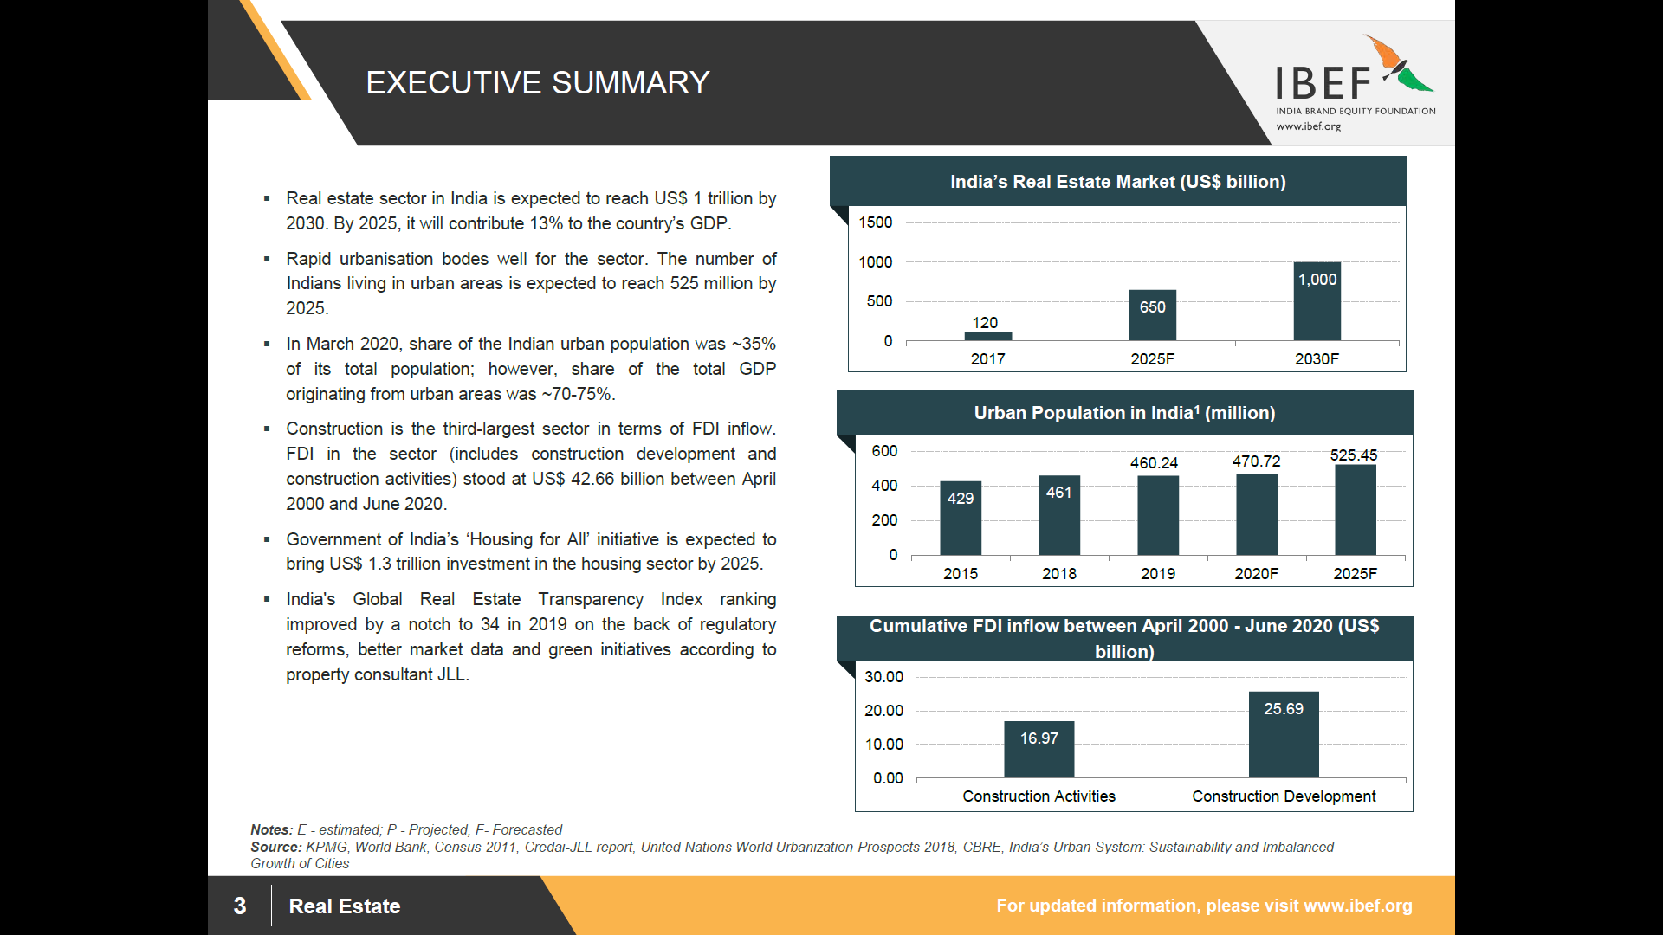

**Advantage India**

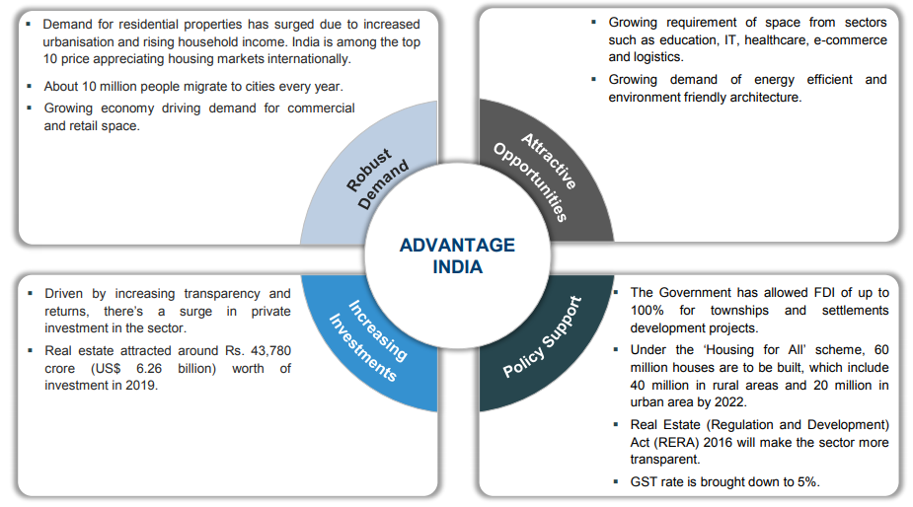

## Segments in the Indian Real Estate Sector

The Real Estate Sector is divided into several market namely residential, commercial, retail space, hospitality & Special Economic Zones (SEZs). The residential segment contributes approximately 80 per cent to the real estate sector. New housing launches across top eight cities in India are expected to increase by 23 per cent year-on-year by 2019 to 2,23,325 units. As far as the commercial segment is concerned, there are only a few players with presence across India and most of the activity is in the leasing segment. FDI in multi brand retail is expected to boost demand.

In 2019, Retail segment in Indian attracted private equity (PE) investment of around US$ 1 billion and supply of around another 39 million sq. ft. is expected in 2022. In the hospitality segment, Supply of Hotel room in India has increased 5.4 per cent year-on-year in 2019, totalling to 133,359 rooms at the end of 2019. The sector is likely to attract an annual investment between US$ 0.5-0.6 billion during 2018-2022, with total investment reaching US$ 2.8 billion by 2022. As on July 31, 2020, India had formally approved 423 SEZs, of which 248 were in operation. Majority of the SEZs are in the IT/ ITeS sector. In March 2020, the Government had approved proposals from TCS and DLF to set up SEZs for IT sector in Haryana and Uttar Pradesh.

## Market Size of the India Real Estate

The Real Estate sector in India is expected to reach a market size of US$ 1 trillion in market size by 2030, up from US$ 120 billion in 2017. It has been estimated that India’s real estate market will grow at a CAGR of 19.5% during 2017- 2028. Increasing share of real estate in the GDP would be supported by increasing industrial activity, improving income level and urbanization. The government also launched 10 key policies for real estate sector, namely: Real Estate Regulatory Act, Benami Transactions Act, boost to affordable housing construction, Interest subsidy to home buyers, change in arbitration norms, service tax exemption, Dividend Distribution Tax (DDT) exemption, Goods and Services Tax, Demonetization & PR for foreign investors.

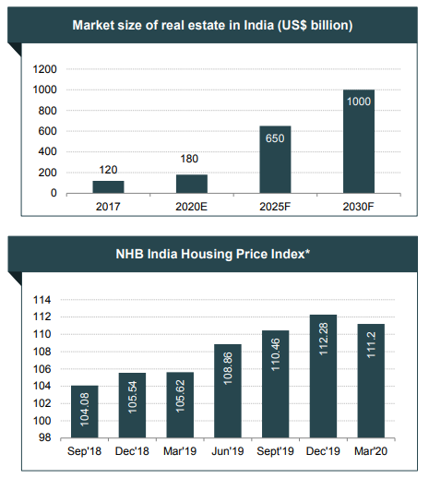

***CAGR - Compounded Annual Growth Rate***

***\*average of indices of all cities***

## About Vasai

Vasai is a historical place and city located in Palghar district; which was partitioned out of the Thana district in 2014. It also forms a part of Vasai-Virar twin cities in the Konkan division, Maharashtra, India, and comes under the Police Jurisdiction of Mira-Bhayander, Vasai-Virar Police Commissionerate.

## ****Connectivity with nearby localities****

* The local railway station is known as Vasai Road. It is a major railway station which bypasses Mumbai and connects the trains coming from Vadodara to Konkan Railway and Pune Junction railway station and further towards cities of Bengaluru and Hyderabad.
* The Vasai-Virar Municipal Corporation buses run on all major routes and State Transport buses provide long-distance travel to and from Vasai. Besides that, auto rickshaws are the main source of transport in the region.
* The upgraded local train runs between Virar and Churchgate and has a frequency of a train every 4 minutes.

## Civic Amenities & Infrastructure

* The Vasai Fort, originally built in 1184, is a major tourist attraction in the region. The Archaeological Survey of India has started restoration work of the fort, although the quality of the work has been severely criticized by conservation activists. In August 2010 a wall of the fort collapsed, raising questions about the quality of the work.
* There are also three well-known religious sites including the Vajreshwari Temple, St. Francis Xavier's Church, Giriz and the Datta Mandir of Dongri. There are various festivals tourists come to visit.
* There are famous and peaceful beaches are also located such as Suruchi beach, Bena beach, Rangaon beach, Bhuigaon beach, Kalamb beach, Rajodi beach, Navapur, etc. Vasai Police maintains eight police stations in the Vasai city subdivision that cover the metropolitan area of the city.

## PRICE TRENDS IN Vasai

# 

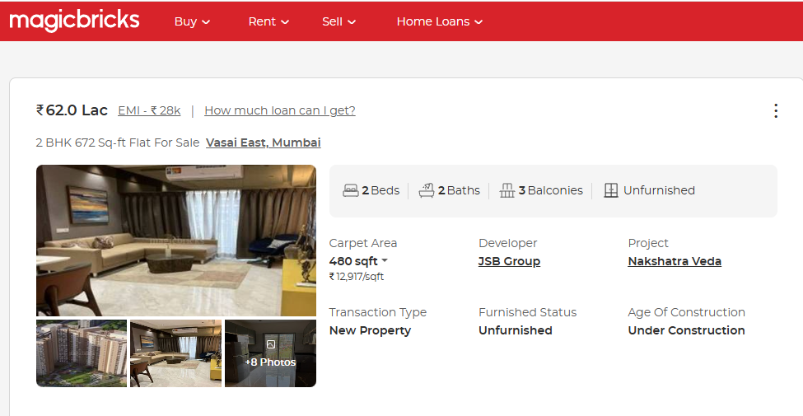

## PRICE TRENDS IN Vasai

# 

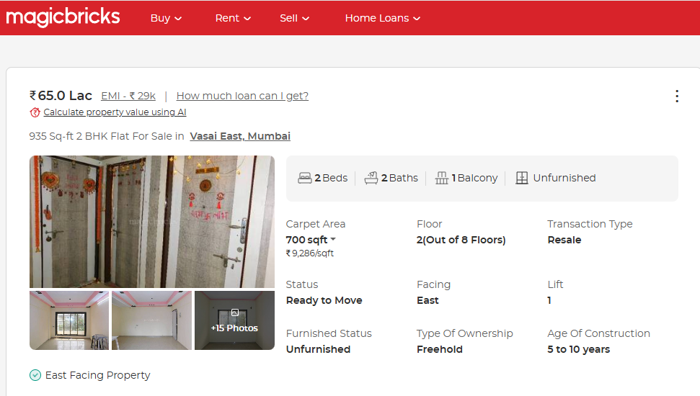

## PRICE TRENDS IN Vasai

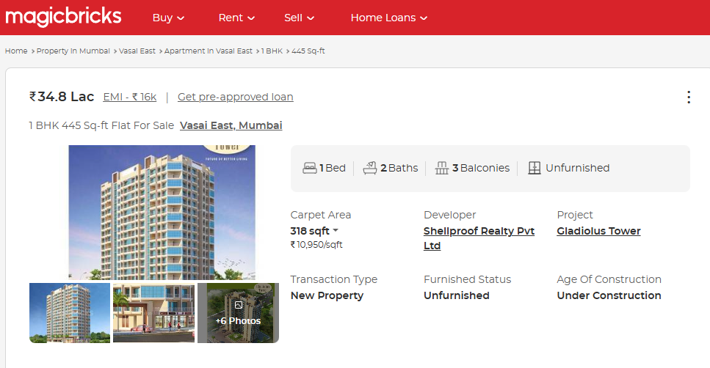

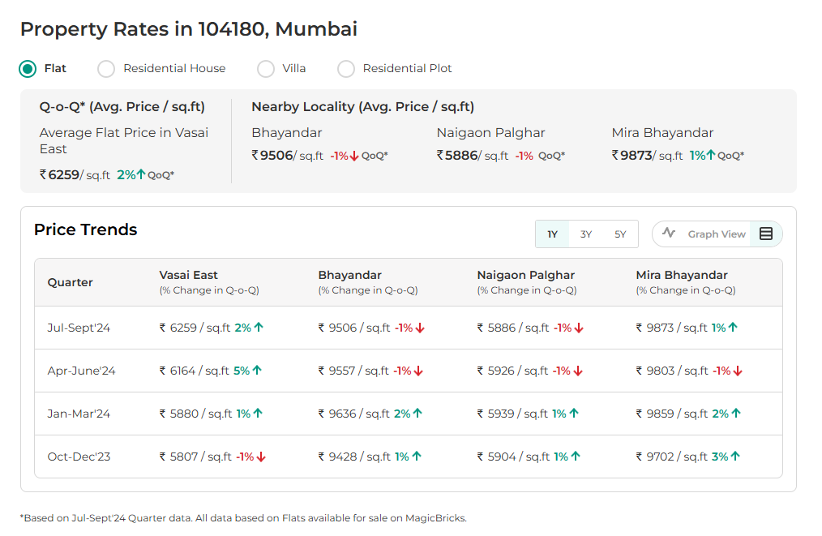

## READY RECKONER RATE

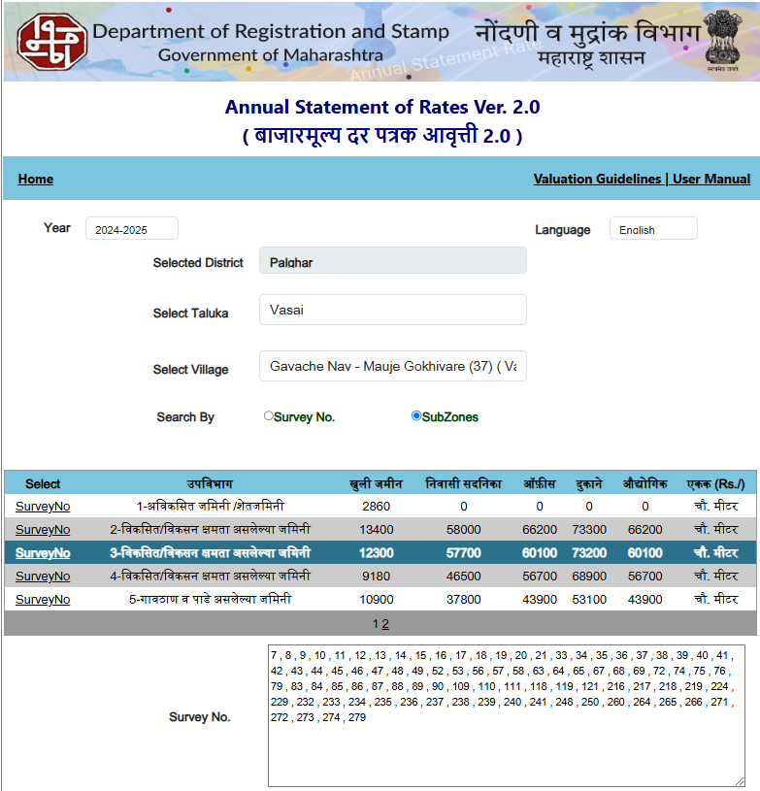

# Project Details

**M/s. Trio Infrastructure Private Limited (TIPL)** is developing Residential & Commercial Project in Vasai in the name of **“Sereno”.** It is a Residential & commercial project. The project is being developed in single Phases. Project comprises of Two Wing buildings.

The project offers Shops & Residential Flats with perfect combination of contemporary architecture and features to provide comfortable spaces with the amenities to match the lifestyles.

**Sereno,** consists of Residential cum Commercial building totaling 17 Shops & 432 Sale Flats. The Commencement certificate and MahaRERA registration is obtained for totaling about 17 Shops & 432 Residential Sale Flats. RERA registration number of project is P99000053269.

**About Residential cum Commercial Building**

Details of the units are as below

**Inventory Details: -**

|  |  |  |
| --- | --- | --- |
| Particulars | No. of Unit | Carpet Area in Sq. Ft. |
| Unsold Flat of Wing E | **216.00** | **1,00,210.00** |
| Unsold Flat of Wing H | **113.00** | **50,342.00** |
| Unsold Shop of Wing H | **2.00** | **383.00** |
| Sold Flat of Wing H | **103.00** | **49,349.00** |
| Sold Shop of Wing H | **15.00** | **2,354.00** |
| Total | **449.00** | **2,02,638.00** |

Amenities available for the convenience of residents are closed car parking areas, open area for fire protection system, Fire sprinklers, fire safety equipment, well-lit internal roads, regular supply of water, and other facilities are provided in the complex. All work related to solid waste management and disposal, treatment of sewage and sullage water, sewerage chamber, lines, septic tank, and STP are taken care with the best technology in the premises. Water conservation, energy management, and rainwater harvesting, recreational activities, landscaping and tree planting are under taken to make buildings sustainable, protect the environment & optimize the resources.

## Location & Connectivity

**Project Sereno** on Land bearing S. No. 81, H. No. 18, S. No. 82, H. No. 1, 2, 3/3, 8/1, 10, S. No. 76, Village – Gokhiware, Taluka – Vasai, District – Palghar, Pin Code – 401 208, Maharashtra, India.

The satellite location of the site is 19.395414 North and 72.847188 East.

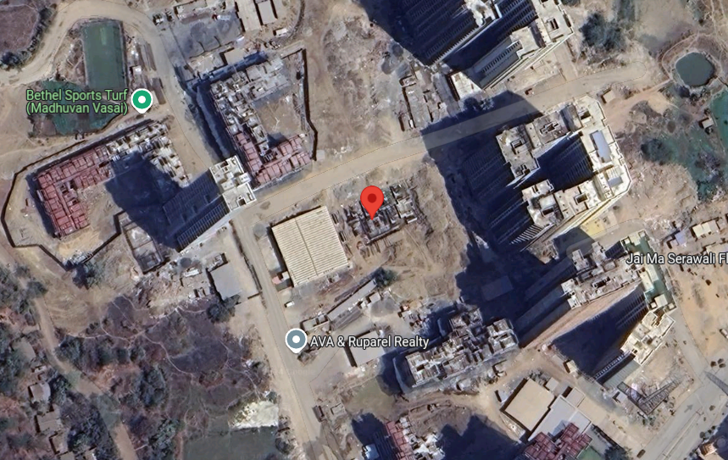

Location

The project is closely connected with railways and city roads. The Vasai Railway Station is about 5.00 Km from the project site. The Vasai Bus Station is located about 8.1 km from the said property. The said property is located in a mixed-use developing area where there are residential and commercial establishments. The site is accessible by road. There are buses, taxis and richshaws available to reach the site.

## Land Details

* The altogether FSI built up area of 20,900.00 Sq. M. to be constructed on part land area of 8,880.00 Sq. M. was taken for development through Development Agreement dated 06.04.2023 and Reg. No. Vasai – 5/11399/2023 dated 24.07.2023.

|  |  |  |  |  |
| --- | --- | --- | --- | --- |
| **Sr.** | **Dated** | **Agreement** | **Particulars** | **Amount in `** |
| 1 | 06-04-2023 | Developer Agreement | Purchase Cost | 28,56,60,000.00 |
| 2 | Stamp Duty | 1,52,28,600.00 |
| 3 | Reg. Fees | 33,120.00 |
| 4 | Penalties Charges | 6,09,200.00 |
| 5 | 24-07-2023 | Power of Attorney | Stamp Duty | 500.00 |
| 6 | Reg. Fees | 1,420.00 |
| **TOTAL** | | | | **30,15,32,840.00** |

**Project Configuration**

**Sereno**

This Project is being constructed on land bearing S. No. 81, H. No. 18, S. No. 82, H. No. 1, 2, 3/3, 8/1, 10, S. No. 76, of admeasuring approx. plot area of **8,800.00 Sq. M.** of Village Gokhiware, Vasai having built up FSI area is **16,269.73 Sq. M. i.e., 1,75,127.37 Sq. Ft.**

**Details for Sale Building**:

According to the information uploaded on the RERA website the Proposed Date of completion of this project is **December 30, 2027**. The RERA website further indicates that this building comprises of Ground Floor + 1st & 2nd Podium Floor + 3rd Floor to 22nd Upper Floor

*\* Information culled out of from https://maharerait.mahaonline.gov.in/SearchList/Search*

## Project Area Statement as per Approved Building Plan

## Floor wise Built – up Area Statement / FSI Area

|  |  |  |  |
| --- | --- | --- | --- |
| Sr. | Floor | FSI Area in Sq. M. | NON FSI Area (Ancillary) in Sq. M. |
| 1 | Ground Floor | 177.51 | 106.50 |
| 2 | Podium - I Floor | - | - |
| 3 | Podium - II Floor | - | - |
| 4 | 1st Floor | 737.89 | 442.74 |
| 5 | 2nd Floor | 737.89 | 442.74 |
| 6 | 3rd Floor | 737.89 | 442.74 |
| 7 | 4th Floor | 737.89 | 442.74 |
| 8 | 5th Floor | 702.55 | 421.53 |
| 9 | 6th Floor | 737.89 | 442.74 |
| 10 | 7th Floor | 737.89 | 442.74 |
| 11 | 8th Floor | 737.89 | 442.74 |
| 12 | 9th Floor | 737.89 | 442.74 |
| 13 | 10th Floor | 702.55 | 421.53 |
| 14 | 11th Floor | 737.89 | 442.74 |
| 15 | 12th Floor | 737.89 | 442.74 |
| 16 | 13th Floor | 737.89 | 442.74 |
| 17 | 14th Floor | 737.89 | 442.74 |
| 18 | 15th Floor | 702.55 | 421.53 |
| 19 | 16th Floor | 737.89 | 442.74 |
| 20 | 17th Floor | 737.89 | 442.74 |
| 21 | 18th Floor | 737.89 | 442.74 |
| 22 | 19th Floor | 737.89 | 442.74 |
| 23 | 20th Floor | 702.55 | 421.53 |
| 24 | 21st Floor | 737.89 | 442.74 |
| 25 | 22nd Floor | 737.89 | 442.74 |
| 26 | LMR / OHT / Terrace Area | - | 442.74 |
| TOTAL | | **16,269.73** | **10,204.68** |

## Project Cost

The total project cost estimated by **TIPL** works out to **INR 145.19 Crore**. The detailed acquisition cost is as tabulated below:

**INR in Crore**

|  |  |  |  |  |
| --- | --- | --- | --- | --- |
| Particulars | Total Project Cost | Cost incurred till date | Balance Cost to be Incurred | %tage of Total |
| Land & Stamp Duty | 30.15 | 21.26 | 8.89 | 20.77% |
| Construction Cost | 95.51 | 12.68 | 82.83 | 65.78% |
| Architect & Consultancy Expenses | 0.60 | - | 0.60 | 0.41% |
| Project Overheads & Admin Exps. | 4.18 | 0.15 | 4.03 | 2.88% |
| Marketing Cost | 3.90 | 0.19 | 3.71 | 2.69% |
| Interest to Bank Finance upto construction period | 10.85 | - | 10.85 | 7.47% |
| Total | **145.19** | **34.28** | **110.91** | **100.0%** |

* The land cost works out to **20.77%** of the total project cost incurred till **October 31, 2024**. This cost generally ranges from **20%** to **30%** for comparable projects. The total land cost on the consolidated level for the said project shall work out to about **20.77%**.
* The total construction cost works out to about **65.78%** of the total project cost. This cost generally ranges from **50%** to **70%** for comparable projects.
* The architect & Consultancy Expenses in the project works out to about **0.41%.**
* The Project Overheads & Admin Exps. in the project works out to about **2.88%.**
* The marketing cost in the project works out to about **2.69%.**
* The bank interest in the project works out to about **7.47%.**
* Total cost incurred till **October 31, 2024** is **INR 34.28 Crore** and balance cost to complete work out to **INR 110.91 Crore**
* Considering all the cost we feel that the project cost seems reasonable.

## Means of Finance

The means of finance proposed for the said project cost shall be as tabulated below:

**INR In Crore**

|  |  |  |
| --- | --- | --- |
| Particulars | Total Funds to be Raised | %tage of Total |
| Promoters Contribution |  |  |
| Promoters Contribution | 20.50 | 14.10% |
| Unsecured Loan | 14.50 | 10.00% |
| Bank Loan |  |  |
| Term Loan | 48.00 | 33.10% |
| Customer Advances | 62.19 | 42.80% |
| Total | **145.19** | **100.0%** |

The means of finance proposed to fund the balance cost of construction for the project seems justified.

## Project Approvals and their Status

|  |  |  |  |
| --- | --- | --- | --- |
| Approval/ Consent | Approving Authority | Status | Doc. No. / Dated |
| NA Permission | Tahasildar Vasai | Obtained | SR 62 / 2018 dated 24.01.2019 |
| Layout Plan | Vasai Virar City Municipal Corporation | Obtained | Dated 31.03.2023 |
| Approval Plan | Vasai Virar City Municipal Corporation | Obtained | Dated 31.01.2024 |
| Commencement Certificate | Vasai Virar City Municipal Corporation | Obtained | Permit No. VVCMC/TP/RDP/VP-0329, 0815 & 0509 / 246/ 2023-24, dated 31.01.2024 |
| Development Agreement | Vasai Joint Sub Registrar. | Obtained | Registered Doc. No. Vasai-5/11399/2023. Dated 06.04.2023. |
| Fire NOC Certificate | Fire Safety Department, Vasai Virar City Municipal Corporation | Obtained | Provisional Fire NOC dated 10.06.2024 |
| Occupancy Certificate | Vasai Municipal Corporation | To be obtain after then building work is completed | - |

## Current Status of the Project

* To have actual feel of the project we have visited the site on 09.11.2024 following person were present

|  |  |  |  |
| --- | --- | --- | --- |
| Sr. | Name |  | Contact No |
| 1 | **Suraj Singh** | **Sales Head**  M/s. Trio Infrastructure Private Limited (TIPL) | **+91 - 7499469249** |
| 2 | **Pratik Bodhe** | **Site In charge**  M/s. Trio Infrastructure Private Limited (TIPL) | **+91 - 9619554656** |
| 3 | **Aftab Alam** | **Site Engineer**  M/s. Trio Infrastructure Private Limited (TIPL) | **+91 - 9326579997** |
| 4 | **Prayush Parekh** | **Senior Valuation Engineer**  Vastukala Consultants (I) Pvt. Ltd. | **+91 - 9767983840** |

* For E Wing – Excavation work is in progress.
* For H Wing – Plinth work is completed, 1st floor work is in Progress.

## Implementation Schedule

|  |  |  |  |  |
| --- | --- | --- | --- | --- |
| **Activity** | **Building No. H** | | **Building No. E** | |
| **Start** | **End** | **Start** | **End** |
| Pre-Construction & Development | Completed | Completed | Completed | Completed |
| Excavation & Plinth | Completed | Completed | Started | 31/01/2025 |
| RCC Work | Started | 30/06/2026 | 01/02/2025 | 30/09/2026 |
| Brick Work | 01/08/2025 | 31/08/2026 | 01/12/2025 | 30/11/2026 |
| Façade & Elevation Treatment Work | 01/09/2026 | 30/11/2026 | 01/12/2026 | 28/02/2027 |
| Cladding & Flooring | 01/11/2025 | 30/11/2026 | 01/03/2026 | 28/02/2027 |
| Plumbing & Fitting | 01/12/2026 | 28/02/2027 | 01/03/2027 | 31/05/2027 |
| Lift & Mechanical Parking Work | 01/11/2027 | 31/12/2027 | 01/11/2027 | 31/12/2027 |
| Painting & Possession | 01/12/2026 | 30/11/2027 | 01/03/2027 | 30/11/2027 |
| Final Finishing Work | 01/12/2027 | 31/12/2027 | 01/12/2027 | 31/12/2027 |

The implementation schedule is stretched over **47 months** starting from dated 31.01.2024 i.e., date of receipt of revised C. C. The bottleneck of all tasks is Building Construction and Statutory approvals but enough contingency time has been allocated for each activity so that if there is any time overrun it can be taken care off. The time line allocated for each activity/ task is found to be adequate. We believe that this time frame is reasonable for completion of the project and the proposed completion date of **December 30, 2027** for project sale building and as per RERA completion date is **December 30, 2027** is realistic provided the company adheres to the timelines projected in this TEV Report.

# 

# Economic Viability

## Construction Area

|  |  |  |  |  |  |  |  |  |  |
| --- | --- | --- | --- | --- | --- | --- | --- | --- | --- |
| Sr. | Floor | FSI Area in Sq. M. | NON FSI Area in Sq. M. | Refuge Area in Sq. M. | Podium Area in Sq. M. | Lift Well Area in Sq. M. | Open to Sky Area in Sq. M. | A. P. Area in Sq. M. | Total Construction Area in Sq. M. |
| 1 | Ground Floor | 177.51 | 106.50 | - | 1,023.31 | 42.80 | 40.05 | 59.28 | 1,449.45 |
| 2 | Podium - I Floor | - | - | - | 1,357.25 | 42.80 | - | - | 1,400.05 |
| 3 | Podium - II Floor | - | - | - | 1,357.25 | 42.80 | - | - | 1,400.05 |
| 4 | 1st Floor | 737.89 | 442.74 | - | - | 42.80 | 119.95 | 72.05 | 1,415.43 |
| 5 | 2nd Floor | 737.89 | 442.74 | - | - | 42.80 | - | 144.06 | 1,367.49 |
| 6 | 3rd Floor | 737.89 | 442.74 | - | - | 42.80 | - | 144.06 | 1,367.49 |
| 7 | 4th Floor | 737.89 | 442.74 | - | - | 42.80 | - | 144.06 | 1,367.49 |
| 8 | 5th Floor | 702.55 | 421.53 | 64.29 | - | 42.80 | - | 135.88 | 1,367.05 |
| 9 | 6th Floor | 737.89 | 442.74 | - | - | 42.80 | - | 144.06 | 1,367.49 |
| 10 | 7th Floor | 737.89 | 442.74 | - | - | 42.80 | - | 144.06 | 1,367.49 |
| 11 | 8th Floor | 737.89 | 442.74 | - | - | 42.80 | - | 144.06 | 1,367.49 |
| 12 | 9th Floor | 737.89 | 442.74 | - | - | 42.80 | - | 144.06 | 1,367.49 |
| 13 | 10th Floor | 702.55 | 421.53 | 64.29 | - | 42.80 | - | 135.88 | 1,367.05 |
| 14 | 11th Floor | 737.89 | 442.74 | - | - | 42.80 | - | 144.06 | 1,367.49 |
| 15 | 12th Floor | 737.89 | 442.74 | - | - | 42.80 | - | 144.06 | 1,367.49 |
| 16 | 13th Floor | 737.89 | 442.74 | - | - | 42.80 | - | 144.06 | 1,367.49 |
| 17 | 14th Floor | 737.89 | 442.74 | - | - | 42.80 | - | 144.06 | 1,367.49 |
| 18 | 15th Floor | 702.55 | 421.53 | 64.29 | - | 42.80 | - | 135.88 | 1,367.05 |
| 19 | 16th Floor | 737.89 | 442.74 | - | - | 42.80 | - | 144.06 | 1,367.49 |
| 20 | 17th Floor | 737.89 | 442.74 | - | - | 42.80 | - | 144.06 | 1,367.49 |
| 21 | 18th Floor | 737.89 | 442.74 | - | - | 42.80 | - | 144.06 | 1,367.49 |
| 22 | 19th Floor | 737.89 | 442.74 | - | - | 42.80 | - | 144.06 | 1,367.49 |
| 23 | 20th Floor | 702.55 | 421.53 | 64.29 | - | 42.80 | - | 135.88 | 1,367.05 |
| 24 | 21st Floor | 737.89 | 442.74 | - | - | 42.80 | - | 144.06 | 1,367.49 |
| 25 | 22nd Floor | 737.89 | 442.74 | - | - | 42.80 | - | 144.06 | 1,367.49 |
| 26 | LMR / OHT / Terrace | - | 442.74 | - | - | 42.80 | - | 144.06 | 629.60 |
| TOTAL | | **16,269.73** | **10,204.68** | **257.16** | **3,737.81** | **1,112.80** | **160.00** | **3,267.93** | **35,010.11** |

**Construction Cost: -**

Total Construction area = 35,010.11 Sq. M. i.e., 3,76,848.82 Sq. Ft.

Total estimated cost for construction of Building (includes cost of RCC work, manpower, lift, material, painting, finishing work, site development, etc.) is ` 86,82,50,728.00 i.e., ` 86.83 Cr. which comes ` 24,800.00 per Sq. M. on construction area for building and deep excavation & piling cost is ` 8,68,25,073.00 i.e., ` 8.68 Cr. which comes 10% of cost of construction.

VCIPL opinion the construction cost of 24,800/- Per Sq. M. which is in line with Market-Trend.

**Architect Cost, RCC & Other Professional Charges: -**

The total Architect charges of ` 59,69,224.00 i.e., ` 0.60 Cr. is 0.41% of total estimated project cost building.

**Project Overheads & Admin Exps.: -**

Salaries, site overheads, development works, cost of services (including water, electricity, sewerage, drainage, layout roads etc.), cost of machineries and equipment including its hire and maintenance cost, consumables etc. All costs directly incurred to complete the construction of the entire phase of the project registered is estimated 4.38% of total construction cost Building which comes to ` 4,18,32,320.00 i.e., ` 4.18 Cr.

The admin charges which in market is in the range of 4% - 6% of Total Construction cost of the project.

**Marketing Expenses: -**

Marketing costs directly incurred to complete the construction of the entire phase of the project registered is estimated at 2% of total Sale income from the project which comes to ` 3,90,34,058.00 i.e., ` 3.90 Cr.

The marketing charge consists of brokerage & commission which in market is in the range of 1% - 3% of Total Sale income of the property.

**Interest Costs: -**

The Interest cost for the term loan is ` 10,85,00,000.00 i.e., ` 10.85 Cr., which is 7.47% of total project cost.

As per information shared by banker & developer

**As the developer has executed the development agreement with the owners and confirming parties. Developer has received the development rights on the said plot. Building construction approval has been applied and received by the owners and confirming parties. They cost towards the same is incurred by the owners and confirming parties.**

**Hence, approval cost is not considered in the project cost.**

## Inventory

**TIPL** offers residential flats and commercial shops with perfect combination of contemporary architecture and features to provide comfortable living. It offers varies flats & shops in configurations. Details of the units are as below: -

**Inventory Details: -**

|  |  |  |
| --- | --- | --- |
| Particulars | No. of Unit | Carpet Area in Sq. Ft. |
| Unsold Flat of Wing E | **216.00** | **1,00,210.00** |
| Unsold Flat of Wing H | **113.00** | **50,342.00** |
| Unsold Shop of Wing H | **2.00** | **383.00** |
| Sold Flat of Wing H | **103.00** | **49,349.00** |
| Sold Shop of Wing H | **15.00** | **2,354.00** |
| Total | **449.00** | **2,02,638.00** |

## Projected Revenue

The proposed revenue from the sale of flats & shops are as follows: -

|  |  |  |  |  |  |  |  |  |
| --- | --- | --- | --- | --- | --- | --- | --- | --- |
| Particulars | Units | Till Date | FY24 - 25 | FY25 - 26 | FY26 - 27 | FY27 - 28 | FY28 - 29 | Total |
| Sale Building | No. |  |  |  |  |  |  |  |
| Flats | 103.00 | 111.00 | 74.00 | 69.00 | 64.00 | 114.00 | 432.00 |
| Shops | 15.00 | 15.00 | 2.00 | - | - | - | 17.00 |
| Total | **118.00** | **126.00** | **76.00** | **69.00** | **64.00** | **114.00** | **449.00** |
| Revenue |  |  |  |  |  |  |  |  |
| Sale Building | INR in Cr. |  |  |  |  |  |  |  |
| Flats & Shops | 12.29 | 19.19 | 21.72 | 18.49 | 44.21 | 91.56 | 195.17 |
| Total Revenue to be collected | **12.29** | **19.19** | **21.72** | **18.49** | **44.21** | **91.56** | **195.17** |

## Sale Projection

|  |  |  |  |  |  |
| --- | --- | --- | --- | --- | --- |
| Quarter | No of Units Estimated to be Sold | Estimated Cumulative Units to be Sold | Estimated Area to be Sold | Estimated Amount to be received in Rs. Cr. | Sale value of booked units in Rs. Cr. |
|  | - | - | - | - |  |
| Till date | 118.00 | 118 | 51,703.00 | 12.29 | 46.56 |
| 2024-25 Q3 | 2.00 | 120 | 784.00 | 3.50 | 0.74 |
| 2024-25 Q4 | 6.00 | 126 | 2,712.00 | 3.40 | 2.58 |
| 2025-26 Q1 | 19.00 | 145 | 8,504.00 | 5.17 | 8.20 |
| 2025-26 Q2 | 21.00 | 166 | 9,321.00 | 5.37 | 9.17 |
| 2025-26 Q3 | 16.00 | 182 | 7,644.00 | 5.46 | 7.46 |
| 2025-26 Q4 | 20.00 | 202 | 9,334.00 | 5.72 | 9.26 |
| 2026-27 Q1 | 17.00 | 219 | 7,893.00 | 5.23 | 7.86 |
| 2026-27 Q2 | 15.00 | 234 | 7,010.00 | 4.32 | 6.92 |
| 2026-27 Q3 | 17.00 | 251 | 8,002.00 | 4.42 | 7.90 |
| 2026-27 Q4 | 20.00 | 271 | 9,253.00 | 4.52 | 9.31 |
| 2027-28 Q1 | 18.00 | 289 | 8,355.00 | 4.65 | 8.21 |
| 2027-28 Q2 | 11.00 | 300 | 5,188.00 | 4.73 | 5.05 |
| 2027-28 Q3 | 10.00 | 310 | 4,609.00 | 4.83 | 4.72 |
| 2027-28 Q4 | 25.00 | 335 | 11,316.00 | 30.00 | 11.22 |
| 2028-29 Q1 | 33.00 | 368 | 15,134.00 | 31.00 | 15.01 |
| 2028-29-Q2 | 37.00 | 405 | 16,637.00 | 32.00 | 16.07 |
| 2028-29-Q3 | 44.00 | 449 | 19,239.00 | 28.56 | 18.92 |
| Total | **449.00** |  | **2,02,638.00** | **195.17** | **195.17** |

## Sales and Cost Working

**INR in Crore**

|  |  |  |  |  |  |  |  |  |
| --- | --- | --- | --- | --- | --- | --- | --- | --- |
| Particulars | Till Date | FY25 | FY26 | FY27 | FY28 | FY29 | FY30 | Total |
|  |  |  |  |  |  |  |  |  |
| Revenue |  |  |  |  |  |  |  |  |
| Sale Building | 1.15 | 18.04 | 21.72 | 18.49 | 44.44 | 91.33 | - | 195.17 |
| Total Revenue | **1.15** | **18.04** | **21.72** | **18.49** | **44.44** | **91.33** | **-** | **195.17** |
|  |  |  |  |  |  |  |  |  |
| Construction Cost | **Till date** | **FY25** | **FY26** | **FY27** | **FY28** | **FY29** | **FY30** | **Total** |
| Land & Stamp Duty | 21.26 | 30.15 | - | - | - | - | - | **30.15** |
| Construction Cost | 12.68 | 30.34 | 31.40 | 25.29 | 8.48 | - | - | **95.51** |
| Administrative Expenses | 0.15 | 0.85 | 1.34 | 1.24 | 0.75 | - | - | **4.18** |
| Marketing Expenses | 0.19 | 0.69 | 1.25 | 1.29 | 0.58 | - | - | **3.81** |
| Professional Charges | - | 0.05 | 0.20 | 0.20 | 0.15 | - |  | **0.60** |
| Contingous Cost | - | - | - | - | - | - | - | **-** |
| Interest during moratorium period | - | 0.43 | 2.38 | 4.05 | 1.96 | - | - | **8.82** |
| Total Cost Incurred | **34.28** | **62.51** | **36.57** | **32.07** | **11.92** | **-** | **-** | **143.07** |

## Profitability Projections

The projected profitability statement for the said project is as follows:

**INR in Crore**

|  |  |  |  |  |  |  |
| --- | --- | --- | --- | --- | --- | --- |
| Particulars | FY 23-24 | FY 24-25 | FY 25-26 | FY 26-27 | FY 27-28 | FY 28-29 |
| Revenue |  |  |  |  |  |  |
| Sales | 1.15 | 18.04 | 21.72 | 18.49 | 44.44 | 91.33 |
| Closing WIP – TIPL | 32.79 | 45.79 | 63.20 | 79.52 | 59.94 | 0.80 |
| Total Revenue | **33.94** | **63.83** | **84.92** | **98.01** | **104.38** | **92.13** |
|  |  |  |  |  |  |  |
| Expenses |  |  |  |  |  |  |
| Expenses incurred during the year | 33.09 | 29.42 | 36.57 | 32.07 | 15.48 | 2.46 |
| Opening WIP - TIPL | 0.80 | 32.79 | 45.79 | 63.20 | 79.52 | 59.94 |
|  |  |  |  |  |  |  |
| Operating Profit | **0.05** | **1.62** | **2.56** | **2.74** | **9.38** | **29.73** |
|  |  |  |  |  |  |  |
| PBT | **0.05** | **1.62** | **2.56** | **2.74** | **9.38** | **29.73** |
| Tax | - | 0.40 | 0.64 | 0.68 | 2.35 | 7.43 |
| PAT | **0.05** | **1.22** | **1.92** | **2.05** | **7.04** | **22.30** |

## Cashflow Statement

The Cashflow statement of the project are as follows: -

**INR in Crore**

|  |  |  |  |  |  |  |  |  |
| --- | --- | --- | --- | --- | --- | --- | --- | --- |
| Particulars | Till Date | FY25 | FY26 | FY27 | FY28 | FY29 | FY30 | Total |
|  |  |  |  |  |  |  |  |  |
| Revenue |  |  |  |  |  |  |  |  |
| Sale Building | 1.15 | 18.04 | 21.72 | 18.49 | 44.44 | 91.33 | - | 195.17 |
| Total Revenue | **1.15** | **18.04** | **21.72** | **18.49** | **44.44** | **91.33** | **-** | **195.17** |
|  |  |  |  |  |  |  |  |  |
| Construction Cost | **Till date** | **FY25** | **FY26** | **FY27** | **FY28** | **FY29** | **FY30** | **Total** |
| Land & Stamp Duty | 21.26 | 30.15 | - | - | - | - | - | **30.15** |
| Construction Cost | 12.68 | 30.34 | 31.40 | 25.29 | 8.48 | - | - | **95.51** |
| Administrative Expenses | 0.15 | 0.85 | 1.34 | 1.24 | 0.75 | - | - | **4.18** |
| Marketing Expenses | 0.19 | 0.69 | 1.25 | 1.29 | 0.58 | - | - | **3.81** |
| Professional Charges | - | 0.05 | 0.20 | 0.20 | 0.15 | - |  | **0.60** |
| Contingous Cost | - | - | - | - | - | - | - | **-** |
| Interest during moratorium period | - | 0.43 | 2.38 | 4.05 | 1.96 | - | - | **8.82** |
| Total Cost Incurred | **34.28** | **62.51** | **36.57** | **32.07** | **11.92** | **-** | **-** | **143.07** |
|  |  |  |  |  |  |  |  |  |
| Work Completed |  | 40% | 73% | 101% | 112% |  |  | 100% |
| Sales Completed |  | 9% | 20% | 30% | 53% |  |  | 100% |
| Cost of Sales |  | 8.95 | 18.22 | 22.21 | 43.94 |  |  | **93.31** |
| Sales Recognised |  | 7.25 | 21.60 | 29.96 | 55.71 |  |  | **114.53** |
| Closing WIP |  | 87.84 | 106.19 | 116.06 | 84.04 |  |  |  |
| Cash Collection |  | 1.15 | 18.04 | 21.72 | 18.49 |  |  | **59.40** |

# Financial Analysis

## Debt Equity Ratio

As per **Vastukala** assessment, the debt-equity ratio of the balance project shall be **1.372** times based on the promoter’s contribution including unsecured loan of **INR 35.00 crore** and construction loan of **INR 48.00 crore**.

**Vastukala** believes a debt-equity ratio of **1.372** is negative for a lender, considering the size of the project the same is justified.

## Loan-to-Sale Value (LTSV)

The total construction loan proposed by **TIPL** is to the tune of **INR 48.00 crore**. The sale of the total area available to the developer shall result in cash inflow of **INR 195.17 crore.** Thus, the **LTSV** works out to **24.59%**. We believe, this provides the lender with a comfortable cushion in case of a severe correction in the real estate sector.

## Debt Service Coverage Ratio (DSCR)

The **average Cash DSCR** of the projects is **2.56**. The Cash debt service coverage ratio (**DSCR**) working of the project is as given in the table below:

**INR in Crore**

|  |  |  |  |  |  |  |
| --- | --- | --- | --- | --- | --- | --- |
| Particular | FY24 | FY25 | FY26 | FY27 | FY28 | FY29 |
| EBITDA | 0.05 | 2.05 | 4.94 | 6.79 | 14.68 | 31.75 |
| Interest on Term Loan | - | 0.43 | 2.38 | 4.05 | 5.30 | 2.02 |
| Repayment of Term Loan | - | - | - | - | 8.00 | 40.00 |
| Coverage | 0.05 | 2.48 | 7.32 | 10.84 | 27.98 | 73.77 |
| Debt Service | - | 0.43 | 2.38 | 4.05 | 13.30 | 42.02 |
| DSCR | **-** | **5.77** | **3.08** | **2.68** | **2.10** | **1.76** |
| Average DSCR | **2.56** | | | | | |

We feel that the **Cash** **DSCR** for the project is in the acceptable range.

## Interest Coverage Ratio (ICR)

The average interest coverage ratio **(Average ICR)** of the projects is 4.64.

**INR in Crore**

|  |  |  |  |  |  |  |
| --- | --- | --- | --- | --- | --- | --- |
| Particular | FY24 | FY25 | FY26 | FY27 | FY28 | FY29 |
| EBIT | 0.05 | 2.12 | 5.34 | 7.46 | 15.57 | 32.09 |
| Interest on Term Loan | - | 0.43 | 2.38 | 4.05 | 5.30 | 2.02 |
| Interest Coverage Ratio | **-** | **4.93** | **2.24** | **1.84** | **2.94** | **15.89** |
| Average Interest Coverage Ratio | **4.64** | | | | | |

## Internal Rate of Return (IRR)

The internal rate of return (**IRR**) for the projects works out to **14.38%.**

**INR in Crore**

|  |  |  |  |  |  |  |  |  |  |  |  |
| --- | --- | --- | --- | --- | --- | --- | --- | --- | --- | --- | --- |
| Particular | FY24 | | FY25 | | FY26 | | FY27 | FY28 | | FY29 | |
| Cash Inflow |  | |  | |  | |  |  | |  | |
| Amount Received | 1.15 | | 18.04 | | 21.72 | | 18.49 | 44.44 | | 91.33 | |
| Cash Outflow |  | |  | |  | |  |  | |  | |
| Cash outflow | 33.09 | | 29.42 | | 36.57 | | 32.07 | 15.48 | | 2.46 | |
| Net Cashflow | **-31.94** | | **-11.38** | | **-14.85** | | **-13.58** | **28.96** | | **88.87** | |
|  |  |  | |  | |  | | |  | |  |
| Internal Rate of Return | **14.38%** | | | | | | | | | | |

The **IRR** is in line with industry standards for similar real estate projects.

## Sensitivity Analysis

A sensitivity analysis was carried out to assess the impact of the following scenarios on the following major parameters.

* Internal Rate of Return (**IRR**).
* Average Debt Service Coverage Ratio (**Average** **DSCR).**
* Average Interest Coverage Ratio (**Average** **ICR).**
* Minimum Debt Service Coverage Ratio (**Min** **DSCR).**
* Minimum Interest Coverage Ratio (**Min** **ICR).**

The summary of sensitivity analysis is provided in the following exhibit.

The sensitivity analysis shows that the project **IRR,** average **DSCR** and **ICR** are sensitive to reduction in the selling price and increase in the construction cost. However, in all the scenarios, the **IRR** andaverage **DSCR** are not adversely affected by a drastic change in the scenarios.

# Swot Analysis

**Strengths**

* The promoters have vast experience in real estate and infrastructure development and have already successfully delivered several projects in Vasai.
* The loan-to-sale value (**LTSV**) of the project is only **12.93%**. This covers the lenders in case of any eventuality faced in project completion.

**Weakness**

* The said projects are targeted for the Upper-Middle Income Group segment. Currently, the demand for this segment is tepid on account of excess supply.

**Mitigation**

* The Company has been consistently achieving sales for the said project by leveraging the Brand and quality construction coupled with amenities.
* The project is able to offer products across various configurations and stages of construction which helps in offering larger choice to customer and in turn achieving sales.

**Opportunities**

* In case the property market improves over the next **3 - 6 months**, as is expected**,** the company will stand to gain from the sale of the property, thus, further boosting the profitabilityof the project.
* The company can leverage on this project and capture the Vasai micro-market which looks quite promising.

**Threats**

* There are number of real estate players developing commercial projects in Vasai. There is a possibility of the supply increasing beyond the demand.

**Threat Mitigation**

* The developer shall deal with competition by delivering a quality product with various amenities proposed by the developers. At the same time the developer will also price the project attractively to ensure and maintain an edge over the competition.

# Risk Analysis and Mitigation

Risk management strengthens the robustness of the business. Risk Analysis and management refers to the formal processes whereby risks associated with a project are managed. Risk analysis and mitigation encompasses the following sequence

* Identification of risk and risk carrier
* Evaluation of the risks as to the likelihood and consequences
* Assessment of options for mitigating the risks
* Authorization for implementation of the risk management plans
* Implementation and review of the risk management efforts

Some of the risks associated with the project and the related mitigation plans are discussed hereunder.

| **Key Risk** | | **Risk Carrier** | | **Proposed Mitigation of Risk** | |
| --- | --- | --- | --- | --- | --- |
| *Experience & Capability* | | ***TIPL*** | | *The partners have experience in real estate project.*    *Promoters have appointed requisite technical consultants and staff with adequate knowledge of executing the said project.* | |
|  | |  | | *Land for the project is already in the possession of* ***TIPL****. During our visit the work on the work on the projects was in progress. The project is being executed as per the implementation schedule.*  ***TIPL*** *should adhere to the proposed implementation schedule so as to ensure no time overrun.* | |
| *Time Overrun* | | ***TIPL*** | | *The partners have experience in real estate project.*    *Promoters have appointed requisite technical consultants and staff with adequate knowledge of executing the said project.* | |
| *Funding Risk* | | ***TIPL*** | | *The total promoter’s contribution including unsecured loan towards project cost shall* *be* ***INR 35.00 Crore****. We do not envisage any funding risk to the said project.* | |
| *Cost Overrun* | | ***TIPL*** | | *We do not expect a cost overrun in the said project. We have made contingencies provision of 5%. However, we recommend the lenders to insist any cost overrun in the project to be funded by the promoters. We suggest the lenders to Appoint Lender’s Engineer to monitor the cost of the project* | |
| *Demand Risk* | ***TIPL*** | | *The company was already doing great business and APIPL* has *set up a professional team of marketing executives to sell the flats proposed in the said project. Promoter have great knowledge in marketing and running the business.* | |
|  | ***TIPL*** | | *We do not envisage off-take or demand risk for this project of* ***TIPL****.* | |
| *Statutory Approvals* | ***TIPL*** | | *We believe,* ***TIPL*** *has necessary approval for undertaking the construction at the site.* | |
| *Pricing Level & Sustainability* | ***TIPL*** | | *The selling price per sq. ft. is based on market trends. A significant drop in price below the assumed price will adversely affect the project. However, considering the demand potential of the project,* ***Vastukala*** *believes that the assumed prices are sustainable.* | |
| *Force Majeure Risk* | ***TIPL*** | | *The lender may insist the company to take adequate insurance cover for insurable Force Majeure risks.* | |

# Conclusion

The objective of the study was to assess techno – economic viability of the proposal of Residential comprising buildings Sereno**,** Vasai in used development by M/s. Trio Infrastructure Private Limited (TIPL).

**Vastukala** had to evaluate the capability of the company to repay the term loan which they propose in the CIRP process. **Vastukala** has assessed the techno – economic viability of the project based on the data provided by the company and other market information based on primary and secondary research.

While assessing the viability of the project, **Vastukala** considered the following major factors:

* Project specific attributes – both positive and negative.
* The promoter group companies background analysis was not identified in our scope of work
* Appropriate revenue assumptions and projections.
* Reasonable assessment of the Repayment capabilities of Secured loan and unsecured loan.

***Vastukala believes that the promoters have the financial and technical capability to operate the said project and to market the same successfully. In view of adequate promoter experience, fair market conditions, proper project planning and the ability of the project to service the debt within a reasonable time, the proposal for Real estate project of M/s. Trio Infrastructure Private Limited (TIPL) in Vasai is considered Technically Feasible and Economically Viable.***

For **Vastukala Consultants (I) Pvt Ltd.**

|  |  |
| --- | --- |
| Manoj B. Chalikwar  Registered Valuer  Chartered Engineer (India)  Reg. No. IBBI / RV / 07/2018/10366  Reg. No. CAT-I-F-1763 |  |
| SBI TEV Empanelment No.: SME/TCC/150/5 | |

# Annexure – 1 Projected Profitability Statement

**INR in Crore**

|  |  |  |  |  |  |  |
| --- | --- | --- | --- | --- | --- | --- |
| Particulars | FY 23-24 | FY 24-25 | FY 25-26 | FY 26-27 | FY 27-28 | FY 28-29 |
| Revenue |  |  |  |  |  |  |
| Sales | 1.15 | 18.04 | 21.72 | 18.49 | 44.44 | 91.33 |
| Closing WIP – TIPL | 32.79 | 45.79 | 63.20 | 79.52 | 59.94 | 0.80 |
| Total Revenue | **33.94** | **63.83** | **84.92** | **98.01** | **104.38** | **92.13** |
|  |  |  |  |  |  |  |
| Expenses |  |  |  |  |  |  |
| Expenses incurred during the year | 33.09 | 29.42 | 36.57 | 32.07 | 15.48 | 2.46 |
| Opening WIP - TIPL | 0.80 | 32.79 | 45.79 | 63.20 | 79.52 | 59.94 |
|  |  |  |  |  |  |  |
| Operating Profit | **0.05** | **1.62** | **2.56** | **2.74** | **9.38** | **29.73** |
|  |  |  |  |  |  |  |
| PBT | **0.05** | **1.62** | **2.56** | **2.74** | **9.38** | **29.73** |
| Tax | - | 0.40 | 0.64 | 0.68 | 2.35 | 7.43 |
| PAT | **0.05** | **1.22** | **1.92** | **2.05** | **7.04** | **22.30** |

# Annexure – 2 Projected Balance Sheet

**INR in Crore**

|  |  |  |  |  |  |  |
| --- | --- | --- | --- | --- | --- | --- |
| Particulars | FY 23-24 | FY 24-25 | FY 25-26 | FY 26-27 | FY 27-28 | FY 28-29 |
| Shareholder Funds | **3.70** | **21.51** | **23.43** | **25.48** | **32.52** | **54.81** |
| Share capital | 3.91 | 20.50 | 20.50 | 20.50 | 20.50 | 20.50 |
| Reserve & Surplus | (0.21) | 1.01 | 2.93 | 4.98 | 12.02 | 34.31 |
|  |  |  |  |  |  |  |
| Non-current Liabilities | **12.82** | **25.00** | **40.90** | **56.50** | **56.51** | **16.51** |
| Term Loan | - | 13.00 | 27.00 | **41.00** | 40.00 | - |
| Promotors Loan | 12.82 | 12.00 | 13.90 | 15.50 | 16.51 | 16.51 |
|  |  |  |  |  |  |  |
| Current Liabilities | **22.51** | **4.86** | **4.30** | **21.81** | **14.81** | **0.57** |
| Unsecured loan |  |  |  |  |  |  |
| Advance received | 2.17 | 3.96 | 3.31 | 19.20 | 11.25 | - |
| Sundry Creditors | 0.63 | 0.60 | 0.66 | 1.12 | 1.23 | 0.01 |
| Provision | 0.34 | 0.30 | 0.33 | 0.56 | 0.62 | 0.01 |
| Others | 19.37 | - | - | 0.93 | 1.71 | 0.55 |
|  |  | - |  |  |  |  |
| Total Liabilities | **39.03** | **51.37** | **68.63** | **103.79** | **103.84** | **71.89** |
|  |  |  |  |  |  |  |
| Asset |  |  |  |  |  |  |
| Non-Current Assets |  |  |  |  |  |  |
| Fixed Assets | 0.13 | 0.13 | 0.13 | 0.13 | 0.13 | 0.13 |
|  |  | - | - |  |  |  |
| Project WIP | 32.79 | 45.79 | 63.20 | 79.52 | 59.94 | 0.80 |
|  |  |  |  |  |  |  |
| Current Assets |  |  |  |  |  |  |
| Advance for Plots | - | - | - | 15.00 | 25.00 | 60.00 |
| Sundry Debtors | 0.49 | 0.22 |  |  |  |  |
| other current assets |  | - | - | 1.00 | 9.40 | - |
| Loans & Advances | 4.72 | 1.51 | 2.09 | 1.50 | 1.75 | 1.80 |
| Cash & Cash Equivalent | 0.90 | 1.12 | 0.61 | 4.04 | 5.02 | 6.55 |
| Total Current Assets | **38.90** | **48.64** | **65.90** | **101.06** | **101.11** | **69.15** |
|  |  |  |  |  |  |  |
| Total | **39.03** | **48.77** | **66.03** | **101.19** | **101.24** | **69.28** |

# Annexure -3 Projected Cashflow Statement

**INR in Crore**

|  |  |  |  |  |  |  |  |  |
| --- | --- | --- | --- | --- | --- | --- | --- | --- |
| Particulars | Till Date | FY25 | FY26 | FY27 | FY28 | FY29 | FY30 | Total |
|  |  |  |  |  |  |  |  |  |
| Revenue |  |  |  |  |  |  |  |  |
| Sale Building | 1.15 | 18.04 | 21.72 | 18.49 | 44.44 | 91.33 | - | 195.17 |
| Total Revenue | **1.15** | **18.04** | **21.72** | **18.49** | **44.44** | **91.33** | **-** | **195.17** |
|  |  |  |  |  |  |  |  |  |
| Construction Cost | **Till date** | **FY25** | **FY26** | **FY27** | **FY28** | **FY29** | **FY30** | **Total** |
| Land & Stamp Duty | 21.26 | 30.15 | - | - | - | - | - | **30.15** |
| Construction Cost | 12.68 | 30.34 | 31.40 | 25.29 | 8.48 | - | - | **95.51** |
| Administrative Expenses | 0.15 | 0.85 | 1.34 | 1.24 | 0.75 | - | - | **4.18** |
| Marketing Expenses | 0.19 | 0.69 | 1.25 | 1.29 | 0.58 | - | - | **3.81** |
| Professional Charges | - | 0.05 | 0.20 | 0.20 | 0.15 | - |  | **0.60** |
| Contingous Cost | - | - | - | - | - | - | - | **-** |
| Interest during moratorium period | - | 0.43 | 2.38 | 4.05 | 1.96 | - | - | **8.82** |
| Total Cost Incurred | **34.28** | **62.51** | **36.57** | **32.07** | **11.92** | **-** | **-** | **143.07** |
|  |  |  |  |  |  |  |  |  |
| Work Completed |  | 40% | 73% | 101% | 112% |  |  | 100% |
| Sales Completed |  | 9% | 20% | 30% | 53% |  |  | 100% |
| Cost of Sales |  | 8.95 | 18.22 | 22.21 | 43.94 |  |  | **93.31** |
| Sales Recognised |  | 7.25 | 21.60 | 29.96 | 55.71 |  |  | **114.53** |
| Closing WIP |  | 87.84 | 106.19 | 116.06 | 84.04 |  |  |  |
| Cash Collection |  | 1.15 | 18.04 | 21.72 | 18.49 |  |  | **59.40** |

**Quarterly Cashflow**

| **PARTICULARS** | **Upto Oct-24** | **Dec-24** | **Mar-25** | **Jun-25** | **Sep-25** | **Dec-25** | **Mar-26** | **Jun-26** | **Sep-26** | **Dec-26** | **Mar-27** | **Jun-27** | **Sep-27** | **Dec-27** | **Mar-28** | **Jun-28** | **Sep-28** | **Dec-28** | **Total** |
| --- | --- | --- | --- | --- | --- | --- | --- | --- | --- | --- | --- | --- | --- | --- | --- | --- | --- | --- | --- |
| **CASH INFLOW** |  |  |  |  |  |  |  |  |  |  |  |  |  |  |  |  |  |  |  |
| Sale of Residential Regular | 12.29 | 3.50 | 3.40 | 5.17 | 5.37 | 5.46 | 5.72 | 5.23 | 4.32 | 4.42 | 3.52 | 2.65 | 1.73 | 1.43 | 30.00 | 31.00 | 32.00 | 28.56 | 185.77 |
|  |  | 0.00 | 0.00 | 0.00 | 0.00 | 0.00 | 0.00 | 0.00 | 0.00 | 0.00 | 1.00 | 2.00 | 3.00 | 3.40 |  |  |  |  | 9.40 |
| **TOTAL INFLOW** | 12.29 | 3.50 | 3.40 | 5.17 | 5.37 | 5.46 | 5.72 | 5.23 | 4.32 | 4.42 | 4.52 | 4.65 | 4.73 | 4.83 | 30.00 | 31.00 | 32.00 | 28.56 | 195.17 |
| Less: Land Owner's Share |  |  |  |  |  |  |  |  |  |  |  |  |  |  |  |  |  |  | - |
| **TOTAL INFLOW** | 12.29 | 3.50 | 3.40 | 5.17 | 5.37 | 5.46 | 5.72 | 5.23 | 4.32 | 4.42 | 4.52 | 4.65 | 4.73 | 4.83 | 30.00 | 31.00 | 32.00 | 28.56 | 195.17 |
| **COMULATIVE INFLOW (A)** | 12.29 | 15.79 | 19.19 | 24.36 | 29.73 | 35.19 | 40.91 | 46.14 | 50.46 | 54.88 | 59.40 | 64.05 | 68.78 | 73.61 | 103.61 | 134.61 | 166.61 | 195.17 |  |
|  |  |  |  |  |  |  |  |  |  |  |  |  |  |  |  |  |  |  | - |
| **CASH OUTFLOW** |  |  |  |  |  |  |  |  |  |  |  |  |  |  |  |  |  |  | - |
| Acquisition cost of land | 21.26 | 8.89 | 0.00 | 0.00 | 0.00 | 0.00 | 0.00 | 0.00 | 0.00 | 0.00 | 0.00 | 0.00 | 0.00 | 0.00 |  |  |  |  | 30.15 |
| Cost of Permission | 0.00 | 0.00 | 0.00 | 0.00 | 0.00 | 0.00 | 0.00 | 0.00 | 0.00 | 0.00 | 0.00 | 0.00 | 0.00 | 0.00 |  |  |  |  | - |
| Construction Cost | 12.68 | 9.81 | 7.85 | 7.85 | 7.85 | 7.85 | 7.85 | 7.16 | 6.37 | 6.37 | 5.39 | 3.43 | 2.94 | 2.11 |  |  |  |  | 95.51 |
| Administrative Expenses | 0.15 | 0.35 | 0.35 | 0.35 | 0.35 | 0.32 | 0.32 | 0.32 | 0.32 | 0.30 | 0.30 | 0.25 | 0.25 | 0.25 | 0.13 | 0.15 | 0.15 | 0.15 | 4.75 |
| Marketing Expenses | 0.19 | 0.25 | 0.25 | 0.30 | 0.31 | 0.32 | 0.32 | 0.32 | 0.33 | 0.34 | 0.30 | 0.25 | 0.25 | 0.17 | 0.00 | 0.00 | 0.00 | 0.00 | 3.90 |
| Professional Charges | 0.00 | 0.00 | 0.05 | 0.05 | 0.05 | 0.05 | 0.05 | 0.05 | 0.05 | 0.05 | 0.05 | 0.05 | 0.05 | 0.05 |  |  |  |  | 0.60 |
| Contingous Cost | 0.00 | 0.00 | 0.00 | 0.00 | 0.00 | 0.00 | 0.00 | 0.00 | 0.00 | 0.00 | 0.00 | 0.00 | 0.00 | 0.00 | 0.00 |  |  |  | - |
| Interest during moratorium period | 0.00 | 0.12 | 0.31 | 0.44 | 0.54 | 0.65 | 0.75 | 0.86 | 0.96 | 1.06 | 1.17 | 1.26 | 1.33 | 1.40 | 1.31 | 1.07 | 0.71 | 0.24 | 14.18 |
| Payment of Income Tax | 0.00 |  |  |  |  |  |  |  |  |  |  |  |  |  |  |  |  |  | - |
| Other Current Assets | 0.00 |  |  |  |  |  |  |  |  |  | 1.00 | 2.00 | 3.00 | 3.40 |  |  |  | -9.40 | - |
| Advances to Suppliers / Investment | 0.00 |  |  |  |  |  |  |  |  |  |  |  |  |  |  |  |  |  | - |
| **TOTAL OUTFLOW** | **34.28** | **19.42** | **8.81** | **8.99** | **9.10** | **9.19** | **9.29** | **8.71** | **8.03** | **8.12** | **8.21** | **7.24** | **7.82** | **7.38** | **1.44** | **1.22** | **0.86** | **-9.01** | **149.09** |
| **COMULATIVE OUTFLOW (B)** | **34.28** | **53.70** | **62.51** | **71.50** | **80.60** | **89.79** | **99.08** | **107.79** | **115.82** | **123.94** | **132.15** | **139.39** | **147.21** | **154.59** | **156.03** | **157.25** | **158.10** | **149.09** | **149.09** |
| **NET FLOW (B-A) IN DEBIT BALANCE (GAP) (C)** | 21.99 | 37.91 | 43.32 | 47.14 | 50.87 | 54.60 | 58.17 | 61.65 | 65.36 | 69.06 | 72.75 | 75.34 | 78.43 | 80.98 | 52.42 | 22.64 | -8.51 | -46.08 |  |
| PROMOTER CONTRIBUTION | 20.50 |  |  |  |  |  |  |  |  |  |  |  |  |  |  |  |  |  | 20.50 |
| Unsecured Loans | 1.49 | 8.00 | 0.50 | 0.50 | 0.50 | 0.50 | 0.40 | 0.40 | 0.40 | 0.40 | 0.40 | 0.40 | 0.40 | 0.21 |  |  |  |  | 14.50 |
| **CUMULATIVE PROMOTERS’ CONTRIBUTION (D)** | 21.99 | 29.99 | 30.49 | 30.99 | 31.49 | 31.99 | 32.39 | 32.79 | 33.19 | 33.59 | 33.99 | 34.39 | 34.79 | 35.00 | 35.00 | 35.00 | 35.00 | 35.00 |  |
| **Net Gap** | 0.00 | 7.92 | 12.83 | 16.15 | 19.38 | 22.61 | 25.78 | 28.86 | 32.17 | 35.47 | 38.76 | 40.95 | 43.64 | 45.98 | 17.42 | -12.36 | -43.51 | -81.08 |  |
| BANK FUNDING (C-D) | 0.00 | 7.92 | 12.83 | 16.15 | 19.38 | 22.61 | 25.78 | 28.86 | 32.17 | 35.47 | 38.76 | 40.95 | 43.64 | 45.98 | 17.42 | -12.36 | -43.51 | -81.08 |  |
| Bank Funding During the Quarter |  | 7.92 | 4.91 | 3.32 | 3.23 | 3.23 | 3.17 | 3.08 | 3.31 | 3.30 | 3.29 | 2.19 | 2.69 | 2.34 |  |  |  |  |  |
| REPAYMENT* |  |  |  |  |  |  |  |  |  |  |  |  |  |  | 8.00 | 8.00 | 16.00 | 16.00 | 48.00 |
| LOAN BALANCE /OUTSTANDING* |  | 8.00 | 13.00 | 16.50 | 20.00 | 23.50 | 27.00 | 30.50 | 34.00 | 37.50 | 41.00 | 43.50 | 46.00 | 48.00 | 40.00 | 32.00 | 16.00 | 0.00 |  |
| BALANCE IN ESCROW AC OR CURRENT AC | 0.00 | -0.08 | -0.17 | -0.35 | -0.62 | -0.89 | -1.22 | -1.64 | -1.83 | -2.03 | -2.24 | -2.55 | -2.36 | -2.02 | -22.58 | -44.36 | -59.51 | -81.08 | - |
| BANK FUNDING/GAP (%) | 0.00 | 20.89 | 29.62 | 34.26 | 38.10 | 41.41 | 44.32 | 46.81 | 49.22 | 51.36 | 53.28 | 54.35 | 55.64 | 56.78 | 33.23 | -54.60 | 511.43 | 175.95 |  |
| BANK FUNDING / TOTAL COST (%) | 0.00 | 5.31 | 8.61 | 10.83 | 13.00 | 15.17 | 17.29 | 19.36 | 21.58 | 23.79 | 26.00 | 27.47 | 29.27 | 30.84 | 11.68 | -8.29 | -29.18 | -54.38 | - |

# Annexure - 4 Debt Service Coverage Statement

**INR in Crore**

|  |  |  |  |  |  |  |
| --- | --- | --- | --- | --- | --- | --- |
| Particular | FY24 | FY25 | FY26 | FY27 | FY28 | FY29 |
| EBITDA | 0.05 | 2.05 | 4.94 | 6.79 | 14.68 | 31.75 |
| Interest on Term Loan | - | 0.43 | 2.38 | 4.05 | 5.30 | 2.02 |
| Repayment of Term Loan | - | - | - | - | 8.00 | 40.00 |
| Coverage | 0.05 | 2.48 | 7.32 | 10.84 | 27.98 | 73.77 |
| Debt Service | - | 0.43 | 2.38 | 4.05 | 13.30 | 42.02 |
| DSCR | **-** | **5.77** | **3.08** | **2.68** | **2.10** | **1.76** |
| Average DSCR | **2.56** | | | | | |

# Annexure - 5 Repayment of Term Loan

|  |  |
| --- | --- |
| **Particulars** | **INR in Crore** |
| Secured Loan | 48.00 |

**Disbursement & Repayment Schedule of the INR 25.00 Crore Secured Loan are as follows: -**

**INR in Crore**

|  |  |  |  |  |  |  |
| --- | --- | --- | --- | --- | --- | --- |
| Particular | Till Oct 2024 | FY24 - 25 | FY25 -26 | FY26 - 27 | FY27 - 28 | FY28 -29 |
| Loan Disbursement | - | 13.00 | 14.00 | 14.00 | 7.00 | - |
| Rate of Interest |
| Interest Payment | - | 0.43 | 2.38 | 4.05 | 5.30 | 2.02 |
| Loan Repayment |  | - | - | - | 8.00 | 40.00 |

**M/s. Trio Infrastructure Private Limited (TIPL)** has initially proposed a moratorium period of **38 months** for the term loan from last disbursement. We have assumed that the repayment of the term loan shall start in **January 2028.** Although, the company is required of money for the construction, we feel the moratorium till **December 2027** is reasonable.

# Annexure - 7 Photographs

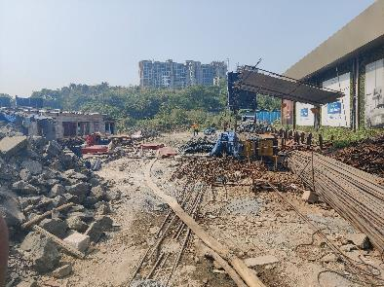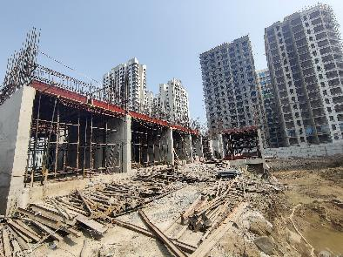 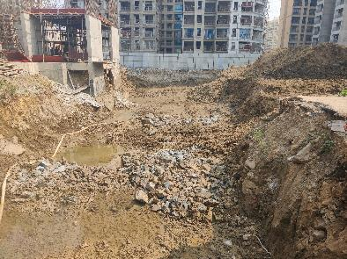

**ACTUAL SITE PHOTOGRAPHS**

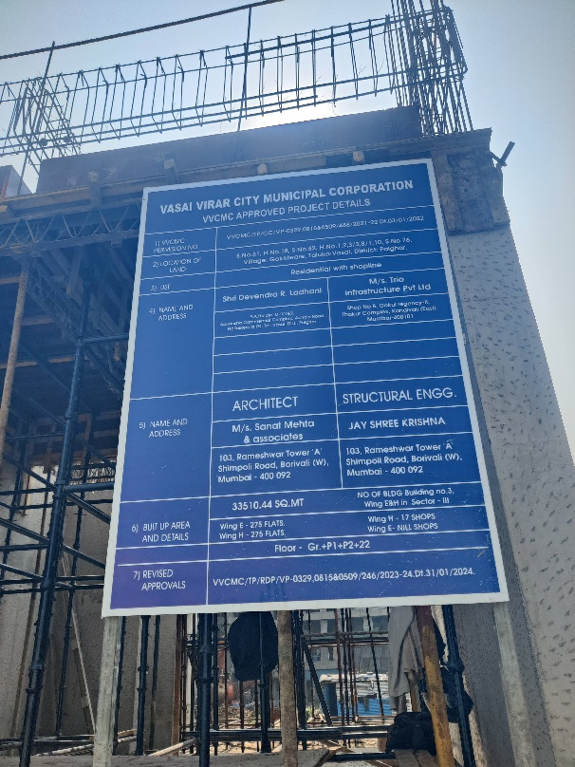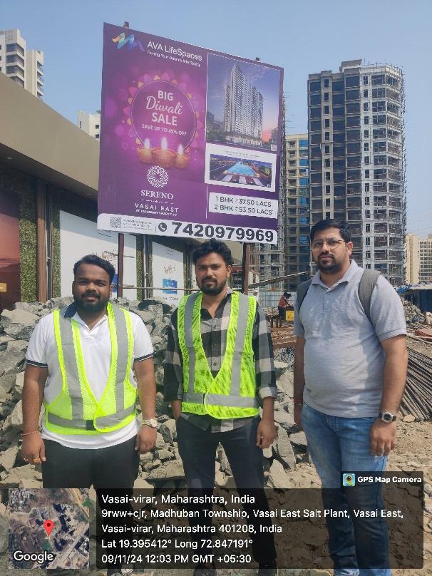

# Disclaimer

This Techno Economic Viability (**TEV**) Report is submitted on the basis that this Report and its contents will be held in complete confidence. Accordingly, by accepting a copy of this report, the recipient agrees to keep its contents and any other information, which is disclosed to such recipient, confidential and shall not divulge, distribute or disseminate any information contained herein, in part or in full, without the prior written approval of **Vastukala Consultants (India) Pvt. Ltd.**

The Report has been prepared for private circulation as required by the State Bank of India **(SBI)** for evaluating the proposed ongoing Real estate project by **M/s. Trio Infrastructure Private Limited (TIPL).** This report has been prepared on the basis of details provided by the company and discussions held with **TIPL**’s officials. The industry norms, studies and other information / documents obtained by **Vastukala Consultants (India) Pvt. Ltd.** from various sources available publicly, which **Vastukala Consultants (India) Pvt. Ltd.** believes to be reliable, were the basis of this report. **Vastukala Consultants (India) Pvt. Ltd.** has not carried out any independent verification for the truthfulness of the same. We have tried our best to independently verify the same. We have not checked the title clearance or the legality of the documents of the said property or the invoices / quotations of the machinery submitted by **TIPL** to us. The net worth of the promoters of the company has been provided to us and **Vastukala Consultants (India) Pvt. Ltd.** has not independently verified the same. This report is purely an opinion and has no legal or contractual obligation on our part. We have no direct or indirect interest in the company, its directors, their suppliers / vendors and / or the said project.