Valuation Report of the Immovable Property
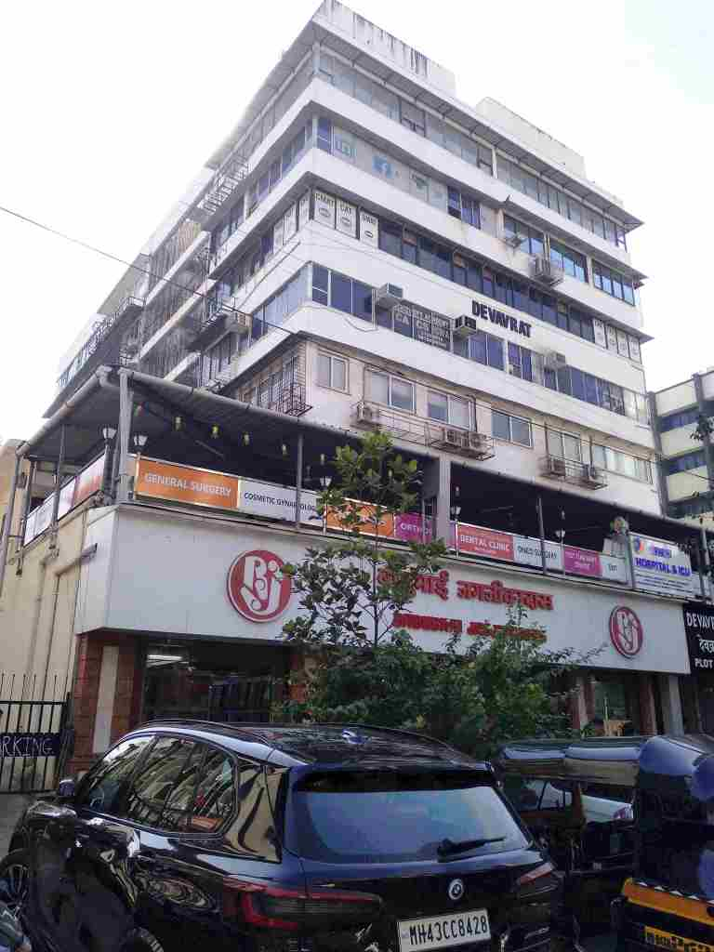

Details of the property under consideration:

Name of Owner: Miss Rishika Kajaria

Commercial Office No. 302, 3rd Floor, Devavrata Premises Co-op. Society Ltd., Plot No. 83, Sector - 17, Vashi Navi Mumbai, Taluka & District - Thane, PIN - 400 705, State - Maharashtra, India.

Latitude Longitude: 19°04'09.3"N 72°59'57.7"E

Intended User:

Punjab National Bank
MCC Western One
PNB Pragati Tower C‐9, G - Block, Ground Floor, Bandra Kurla Complex, Bandra (East)
Mumbai – 400 051, State - Maharashtra, India

Vastu/Mumbai/12/2024/012912/2308792

24/8-332-JABS

Date: 19.12.2024

VALUATION OPINION REPORT
This is to certify that the property bearing Commercial Office No. 302, 3rd Floor, Devavrata Premises Co-op. Society Ltd., Plot No. 83, Sector - 17, Vashi, Navi Mumbai, Taluka & District - Thane, PIN - 400 705, State - Maharashtra, India belongs to Miss Rishika Kajaria.

Boundaries of the property.
North | : | Parking Open Area & Road
South | : | Open Land & Road
East | : | Internal Road & Plot No. 84 (Vardhaman Chambers)
West | : | Plot No. 82 (Liberty Housing Society)
Considering various parameters recorded, existing economic scenario, and the information that is available with reference to the development of neighborhood and method selected for valuation, we are of the opinion that, the property premises can be assessed and this particular purpose at ₹ 1,20,29,048.00 (Rupees One Crore Twenty Lakh Twenty Nine Thousand Forty Eight Only).
The valuation of the property is based on the documents produced by the concern. Legal aspects have not been taken into considerations while preparing this valuation report.

Hence certified

Sharadkumar B. Chalikwar
Govt. Reg. Valuer
Chartered Engineer (India)
Reg. No. (N) C.C.I.T/I-14/52/2008-09
Punjab National Bank Empanelment No. : REF: ZO: SAMD:1138

Encl: Valuation report.

Valuation Report of Immovable Property

I | General
1. | Name and Address of the Valuer |  |  | : | Sharadkumar B. Chalikwar  Vastukala Consultants (I) Pvt. Ltd.  B1-001, U/B Floor, Boomerang, Chandivali Farm Road,  Powai, Andheri (East), Mumbai - 400 072.
2. | Purpose for which the valuation is made |  |  | : | To assess Fair Market value of the property for Bank Loan Purpose.
3. | a) | Date of inspection |  | : | 09/12/2024
 | b) | Date of valuation |  | : | 19/12/2024
 | c) | Title Deed Number & Date |  |  | TNN6-3520-2015 dated 01/07/2015
4. | List of documents produced for perusal:  - Copy of Deed of Sale-Cum-Transfer dated 30/06/2015 between Mrs. Kejal Haresh Anawadia (the Vendor/Transferor) AND Miss Rishika Kajaria (the Transferee/Purchasers)  - Copy of Occupancy Certificate No. BP/V/17-83/444 dated 02/04/1986 issued by CIDCO.  - Copy of Share Certificate No. 46 Bearing Nos. 0226 to 0230 having 5 Shares of Rs. 50/- each transferred in the name of Miss Rishika Kajaria by Devavrata Premises Co-op. Society Ltd.
5. | Name of the owner(s) and his / their address (es) with Phone no. (details of share of each owner in case of joint ownership) |  |  | : | Miss Rishika Kajaria  Commercial Office No. 302, 3rd Floor, Devavrata Premises Co-op. Society Ltd., Plot No. 83, Sector - 17, Vashi, Navi Mumbai, Taluka & District - Thane, PIN - 400 705, State - Maharashtra, India.  Contact Person:  Mr. Lalan Singh (Representative of Owner)  Mobile No. 9820226317  Sole Ownership
6. | Brief description of the property |  |  | : | The property is a Commercial Office located on 3rd Floor. The composition of Amalgamated Office No. 301 & 302 is Conference Room + Working Office Area + Server Room.  The property is at 900m. walkable distance from Vashi Railway Station.
7. | Location of property |  |  | :
 | a) |  | Plot No. / Survey No. | : | Plot No. 83, Sector - 17
 | b) |  | Door No. | : | Commercial Office No. 302
 | c) |  | C.T.S. No. / Village | : | Village - Vashi
 | d) |  | Ward / Taluka | : | Taluka - Thane
 | e) |  | Mandal / District | : | District - Thane
 | f) |  | Date of issue and validity of layout of approved map / plan | : | As Occupancy Certificate is received it may be assumed that the construction is as per Sanctioned Plan.
 | g) |  | Approved map / plan issuing authority | :
 | h) |  | Whether genuineness or authenticity of approved map/ plan is verified | : | N.A.
 | i) |  | Any other comments by our empanelled valuers on authentic of approved plan | : | No
 | j) |  | Comment on unauthorizes Construction if any |  | No
 | k) |  | Comment on demolition proceedings if any
8. | Postal address of the property |  |  | : | Commercial Office No. 302, 3rd Floor, Devavrata Premises Co-op. Society Ltd., Plot No. 83, Sector - 17, Vashi, Navi Mumbai, Taluka & District - Thane, PIN - 400 705, State - Maharashtra, India.
9. | City / Town |  |  | : | Vashi, Thane
 | Residential area |  |  | : | Yes
 | Commercial area |  |  | : | No
 | Industrial area |  |  | : | No
10. | Classification of the area |  |  | :
 | i) High / Middle / Poor |  |  | : | Middle Class
 | ii) Urban / Semi Urban / Rural |  |  | : | Urban
11. | Comment on whether the society where the offices are located is freely Accessible? |  |  |  | Yes
12. | Coming under Corporation limit / Village Panchayat / Municipality |  |  | : | Village - Vashi  Navi Mumbai Municipal Corporation
13. | Whether covered under any State / Central Govt. enactments (e.g., Urban Land Ceiling Act) or notified under agency area/ scheduled area / cantonment area |  |  | : | No
14. | Boundaries of the property |  |  |  | As per Site | As per Document
 | North |  |  | : | Parking Open Area & Road | Road
 | South |  |  | : | Open Land & Road | Pedestrian
 | East |  |  | : | Internal Road & Plot No. 84 (Vardhaman Chambers) | Plot No. 84
 | West |  |  | : | Plot No. 82 (Liberty Housing Society) | Plot No. 82
15. | Dimensions of the site / office |  |  |  | N. A. as property under consideration is a Commercial Office in a building.
 |  |  |  |  | A As per the Deed | B  Actuals
 | North |  |  | : | - | -
 | South |  |  | : | - | -
 | East |  |  | : | - | -
 | West |  |  | : | - | -
16. | Extent of the site |  |  | : | Carpet Area of Amalgamated Office Premises in Sq. Ft. = 827.00.00  (Area as per Site measurement)  Built-up Area in Sq. Ft. = 562.00 Sq. Ft.  (Area as per Deed of Sale-Cum-Transfer)
16.1 | Latitude, Longitude & Co-ordinates of Commercial Office |  |  | : | 19°04'09.3"N 72°59'57.7"E
17. | Extent of the site considered for Valuation (least of 13A& 13B) |  |  | : | Built-up Area in Sq. Ft. = 562.00 Sq. Ft.  (Area as per Deed of Sale-Cum-Transfer)
18. | Whether occupied by the owner / tenant? If occupied by tenant since how long? Rent received per month. |  |  | : | Tenant Occupied from 1.5 Years  Name: NTE Process (MNC Company)  ` 1,00,000/- Present rental income per month.
II | APARTMENT BUILDING
 | Name of the Apartment |  |  | : | Devavrata Premises Co-op. Society Ltd.
 | Description of the locality Residential / Commercial / Mixed |  |  | : | Commercial
3 | Year of Construction |  |  | : | 1986 (As per Occupancy Certificate)
4 | Number of Floors |  |  | : | Ground + 7 Upper Floors
5 | Type of Structure |  |  | : | R.C.C. framed structure
6 | Number of Dwelling units in the building |  |  | : | 3rd Floor is having 11 Units
7 | Quality of Construction |  |  | : | Good
8 | Appearance of the Building |  |  | : | Good
9 | Maintenance of the Building |  |  | : | Good
10 | Facilities Available |  |  | :
 | Lift |  |  | : | 2 Lift(s)
 | Protected Water Supply |  |  | : | Municipal Water supply
 | Underground Sewerage |  |  | : | Connected to Municipal Sewerage System
 | Car parking - Open / Covered |  |  | : | Open Parking Space
 | Is Compound wall existing? |  |  | : | Yes
 | Is pavement laid around the building |  |  | : | Yes

III | Commercial Office
1 | The floor in which the office is situated | : | 3rd Floor
2 | Door No. of the Office | : | Commercial Office No. 302
3 | Specifications of the Office | :
 | Roof | : | R.C.C. slab
 | Flooring | : | Vitrified tiles flooring
 | Doors | : | MS rolling shutter with full height glazed glass shutter to main entrance
 | Windows | : | Powder coated Aluminum sliding windows
 | Fittings | : | Concealed plumbing with C.P. fittings. Electrical wiring with Concealed.
 | Finishing | : | Cement Plastering with POP finish
4 | House Tax | :
 | Assessment No. | : | Information not available
 | Tax paid in the name of: | : | Information not available
 | Tax amount: | : | Information not available
5 | Electricity Service connection No. | : | Information not available
 | Meter Card is in the name of | : | Information not available
6 | How is the maintenance of the Office? | : | Good
7 | Sale Deed executed in the name of | : | Miss Rishika Kajaria
8 | What is the undivided area of land as per Sale Deed? | : | Information not available
9 | What is the plinth area of the Office? | : | Built-up Area in Sq. Ft. = 562.00 Sq. Ft.  (Area as per Deed of Sale-Cum-Transfer)
10 | What is the floor space index (app.) | : | As per CIDCO / NMMC norms
11 | What is the Carpet Area of the Office? | : | Carpet Area of Amalgamated Office Premises in Sq. Ft. = 827.00.00  (Area as per Site measurement)
12 | Is it Posh / I Class / Medium / Ordinary? | : | Medium
13 | Is it being used for Residential or Commercial purpose? | : | Commercial purpose
14 | Is it Owner-occupied or let out? | : | Tenant Occupied
15 | If rented, what is the monthly rent? | : | ` 1,00,000/- Present rental income per month.
IV | MARKETABILITY | :
1 | How is the marketability? | : | Good
2 | What are the factors favouring for an extra Potential Value? | : | Located in developed area
3 | Any negative factors are observed which affect the market value in general? | : | No
V | Rate | :
1 | After analyzing the comparable sale instances, what is the composite rate for a similar commercial office with same specifications in the adjoining locality? - (Along with details / reference of at - least two latest deals / transactions with respect to adjacent properties in the areas) | : | ₹ 24,000/- to ₹ 30,000/- per Sq. Ft. on Carpet Area  ₹ 20,000/- to ₹ 25,000/- per Sq. Ft. on Built-up Area
2 | Assuming it is a new construction, what is the adopted basic composite rate of the commercial office under valuation after comparing with the specifications and other factors with the commercial office under comparison (give details). | : | ` 23,000.00 per Sq. Ft. on Built-up Area
3 | Break – up for the rate | :
 | I. Building + Services | : | ` 2,800.00 per Sq. Ft.
 | II. Land + others | : | ` 20,200.00 per Sq. Ft.
4 | Guideline rate obtained from the Registrar's Office (evidence thereof to be enclosed) | : | ` 1,76,700/- Per Sq. M.  i.e., ` 16,416/- Per Sq. Ft.
 | Guideline rate (evidence thereof to be enclosed) |  | ` 1,38,358/- Per Sq. M.  i.e., ` 12,854/- Per Sq. Ft.
5 | In case of variation of 20% or more in the valuation proposed by the Valuer and the Guideline value provided in the State Govt. notification or Income Tax Gazette justification on variation has to be given | : | It is a foregone conclusion that market value is always more than the RR price. As the RR Rates area Fixed by respective State Government for computing Stamp Duty / Rgstn. Fees. Thus, the differs from place to place and Location, Amenities per se as evident from the fact than even RR Rates Decided by Government Differs.
VI | COMPOSITE RATE ADOPTED AFTER DEPRECIATION
a | Depreciated building rate | :
 | Replacement cost of commercial office | : | ` 2,800.00 per Sq. Ft.
 | Age of the building | : | 36 Years
 | Life of the building estimated | : | 22 Years (Subject to proper, preventive periodic maintenance & structural repairs.)
 | Depreciation percentage assuming the salvage value as 10% | : | 57.00%
 | Depreciated Ratio of the building | : | -
b | Total composite rate arrived for Valuation | :
 | Depreciated building rate VI (a) | : | ` 1,204.00 per Sq. Ft.
 | Rate for Land & other V (3) ii | : | ` 20,200.00 per Sq. Ft.
 | Total Composite Rate | : | ` 21,404.00 per Sq. Ft.
 | Remark: As per Site Inspection, Office Premises No. 301 & 302 are internally amalgamated with common entrances. Two office premises are internally amalgamated to form a single office. For the purpose of valuation, we have considered area as per documents of Office Premises No. 302 only.

Details of Valuation:

Sr. No. | Description | Qty. | Rate per  unit (`) | Estimated  Value (`)
1 | Present value of the Commercial Office | 562.00 Sq. Ft. | 21,404.00 | 1,20,29,048.00

The sales comparison approach uses the market data of sale prices to estimate the value of a real estate property. Property valuation in this method is done by comparing a property to other similar properties that have been recently sold. Comparable properties, also known as comparables, or comps, must share certain features with the property in question. Some of these include physical features such as square footage, number of rooms, condition, and age of the building; however, the most important factor is no doubt the location of the property. Adjustments are usually needed to account for differences as no two properties are exactly the same. To make proper adjustments when comparing properties, real estate appraisers must know the differences between the comparable properties and how to value these differences. The sales comparison approach is commonly used for Commercial office, where there are typically many comparables available to analyze. As the property is a Commercial office, we have adopted Sale Comparison Approach Method for the purpose of valuation. The Price for similar type of property in the nearby vicinity is in the range of i.e., ` 24,000/- to ₹ 30,000/- per Sq. Ft. on Carpet Area / ₹ 20,000/- to ₹ 25,000/- per Sq. Ft. on Built Up Area. Considering the rate with attached report, current market conditions, demand and supply position, Commercial office size, location, upswing in real estate prices, sustained demand for Commercial office, all-round development of residential and commercial application in the locality etc. We estimate ` 21,404.00 per Sq. Ft. on Built-up Area for valuation after depreciation.

As a result of my appraisal and analysis, it is my considered opinion that the value of the above property in the prevailing condition with aforesaid specifications is ₹ 1,20,29,048.00 (Rupees One Crore Twenty Lakh Twenty Nine Thousand Forty Eight Only). The Realizable Value of the above property is ₹ 1,08,26,143.00 (Rupees One Crore Eight Lakh Twenty Six Thousand One Hundred Forty Three Only). The Distress Value is ₹ 96,23,238.00 (Rupees Ninety Six Lakh Twenty Three Thousand Two Hundred Thirty Eight Only).

I | Date of Purchase of Immovable Property | : | 30/06/2015
II | Purchase Price of immovable property | : | ` 55,00,000.00
III | Book value (Purchase Price) of immovable property: | : | ` 58,60,000.00
IV | Fair Market Value of immovable property: |  | ` 1,20,29,048.00
V | Realizable Value of immovable property: | : | ` 1,08,26,143.00
VI | Distress Sale Value of immovable property: | : | ` 96,23,238.00
VII | Guideline Value (562.00 Sq. Ft. x 12,854.00) | : | ` 72,23,948.00
VIII | Insurable value of the property (562.00 Sq. Ft. x 2,800.00) | : | ₹ 15,73,600.00
IX | Value of property of similar nature in the same locality drawn from any one of the popular property websites such as Magic bricks, 99 Acres, Housing NHB Residex etc. | : | Please Refer Page No. 13, 14 & 15

Sharadkumar B. Chalikwar
Govt. Reg. Valuer
Chartered Engineer (India)
Reg. No. (N) C.C.I.T/I-14/52/2008-09
Punjab National Bank Empanelment No.: REF: ZO: SAMD:1138

Enclosures
1. | Declaration from the valuer
2. | Model code of conduct for valuer
3. | Photograph of owner with the property in the background
4. | Screen shot (in hard copy) of Global Positioning System (GPS)/Various Applications (Apps)/Internet sites (e.g., Google earth) etc.
5. | Any other relevant documents/extracts

Actual Site Photographs
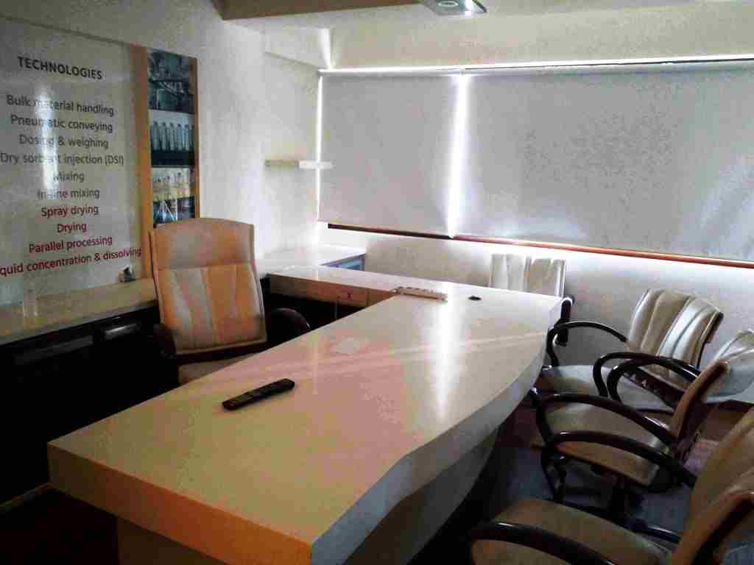
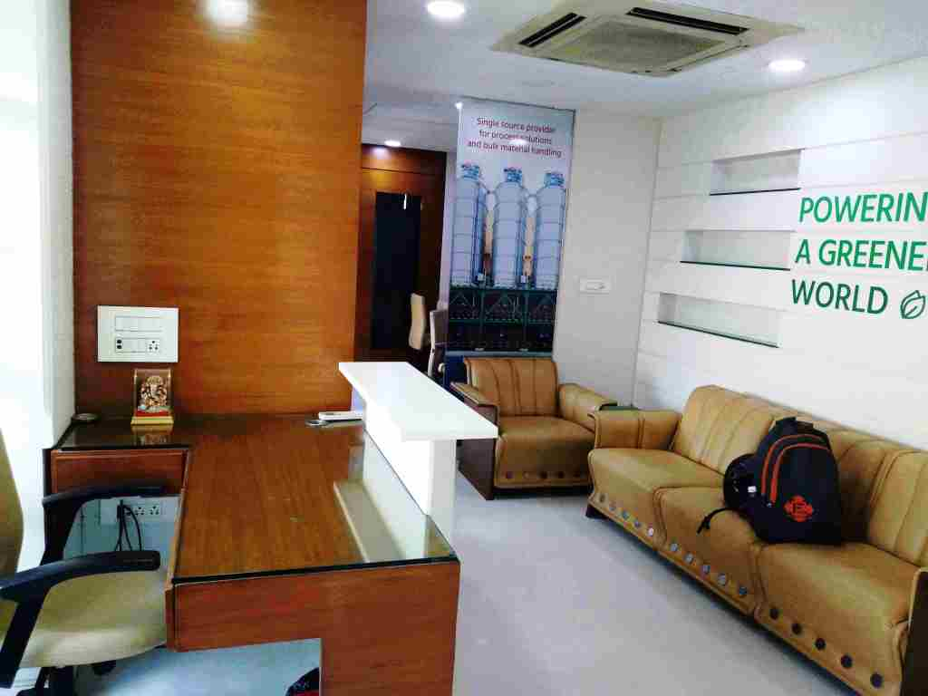

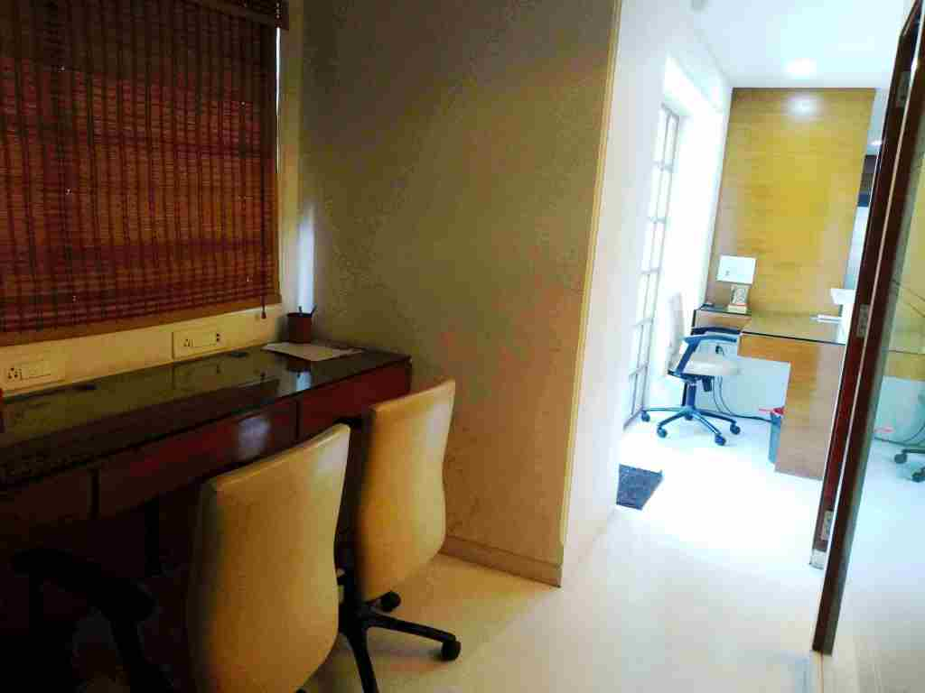
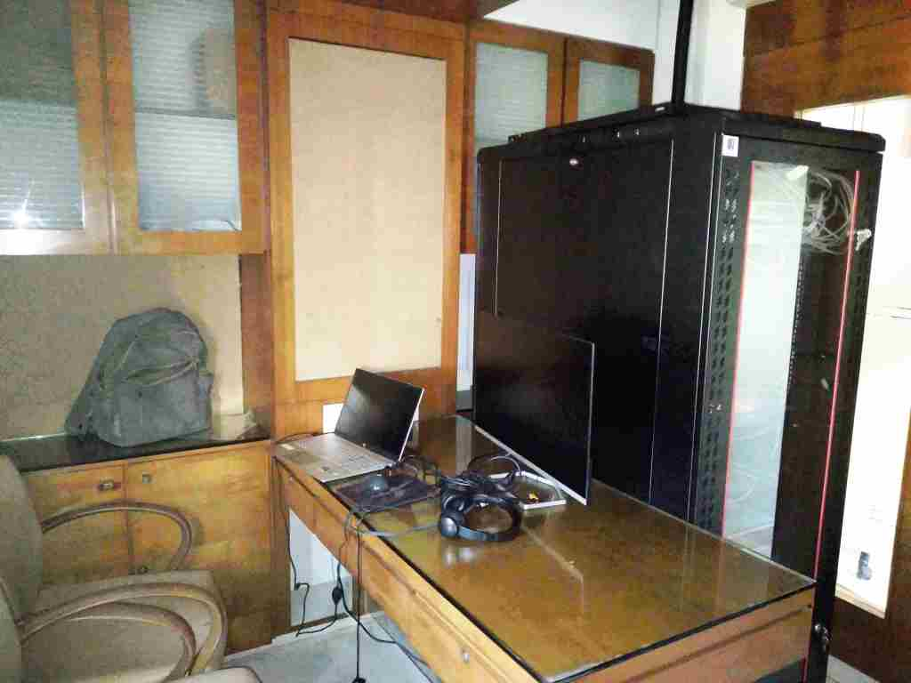

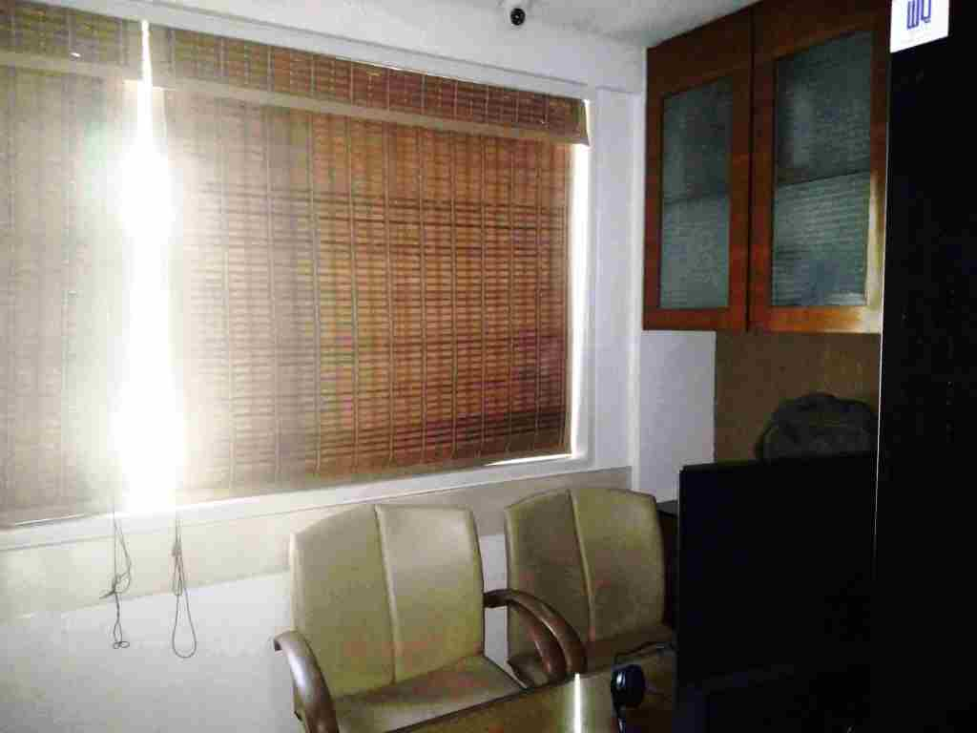


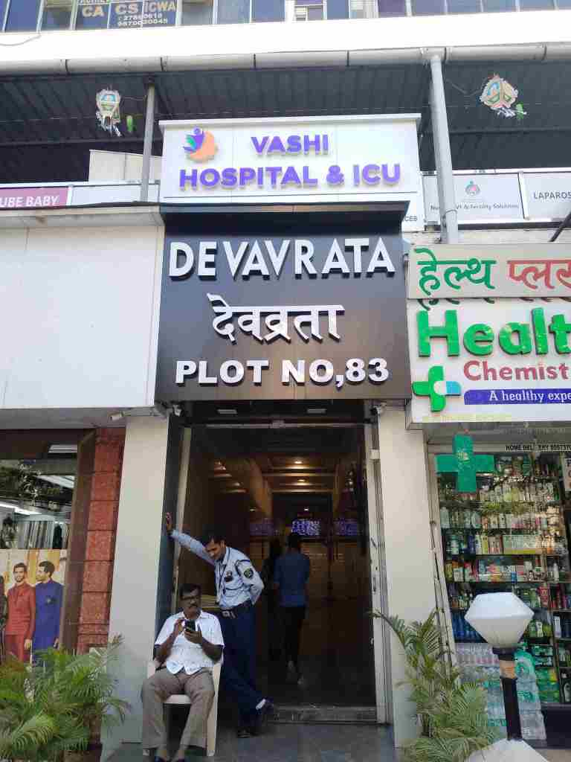
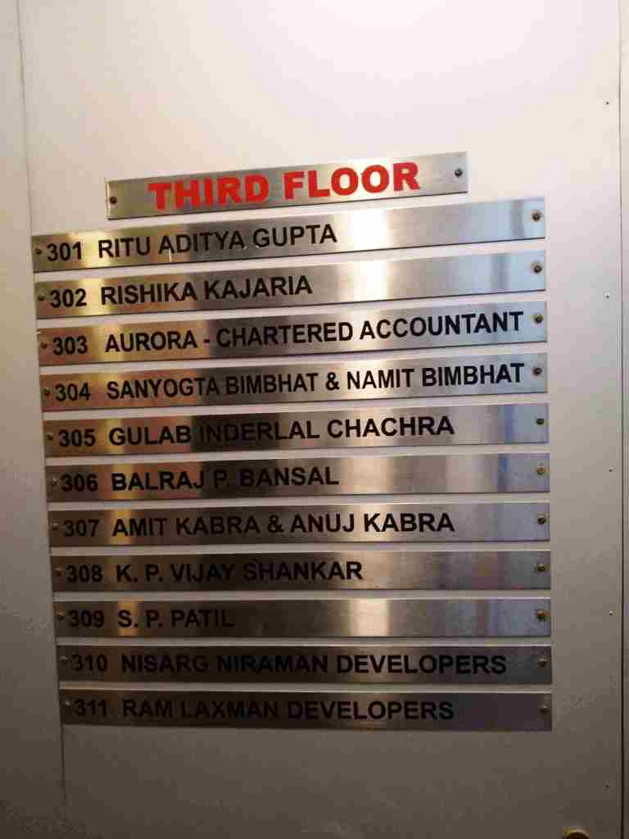
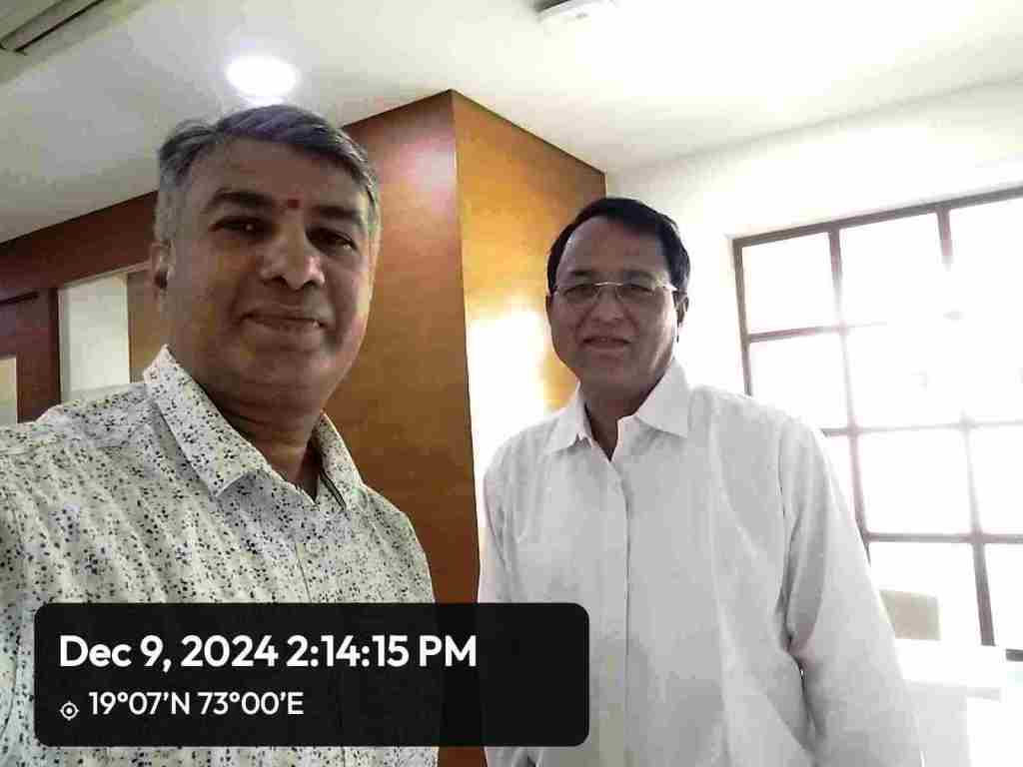
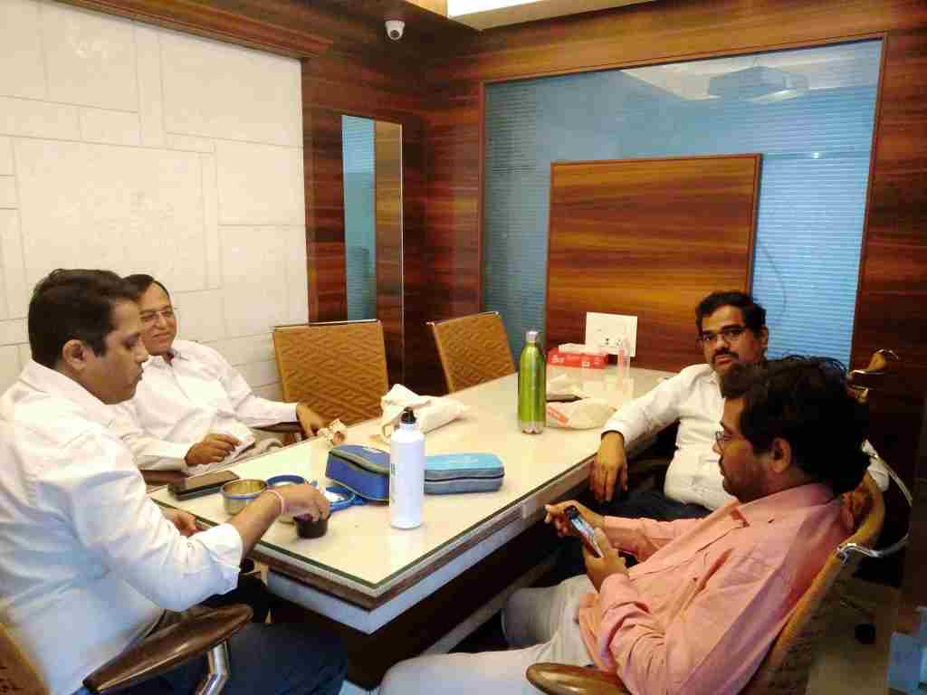
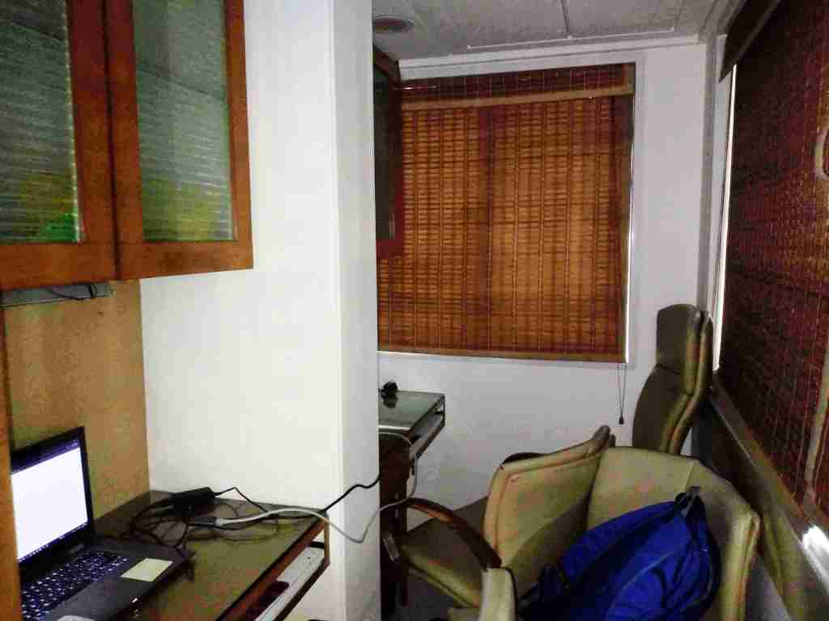
Actual Site Photographs

Route Map of the property
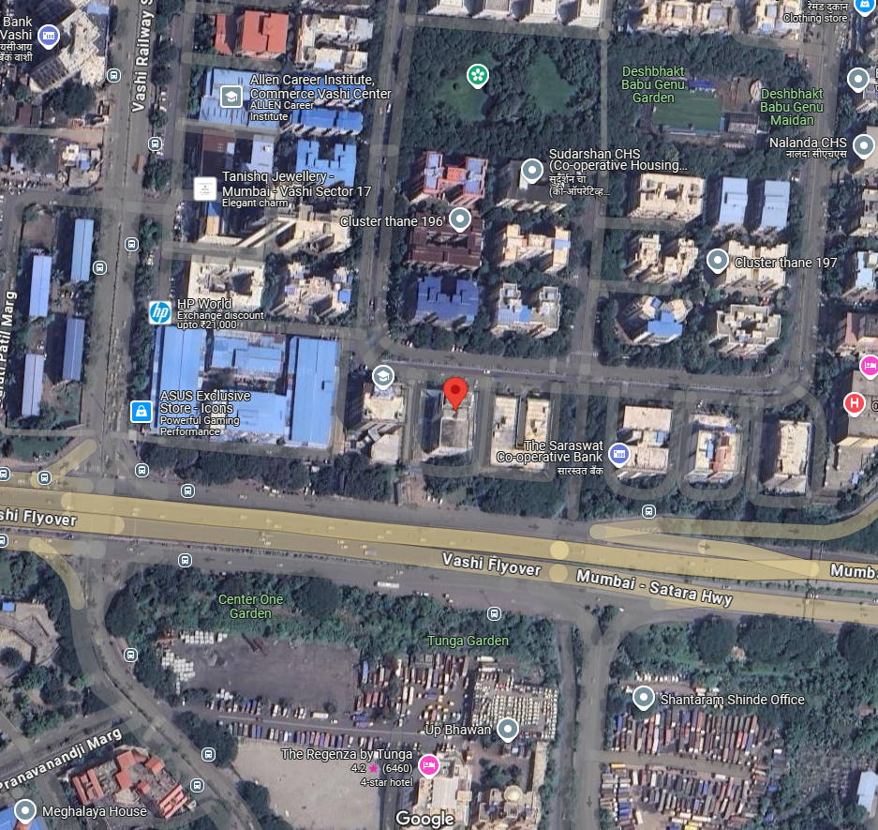

Note: Red Marks shows the exact location of the property
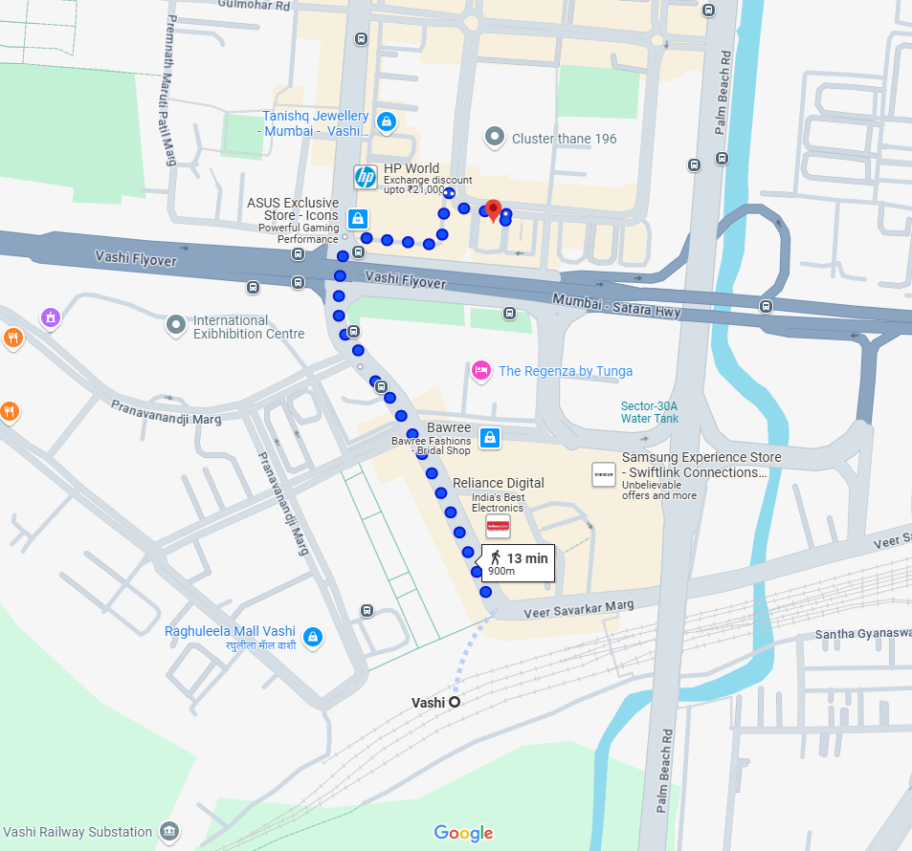

Longitude Latitude - 19°04'09.3"N 72°59'57.7"E

Note: The Blue line shows the route to site from nearest Railway station (Vashi – 900m.)

Ready Reckoner Rate
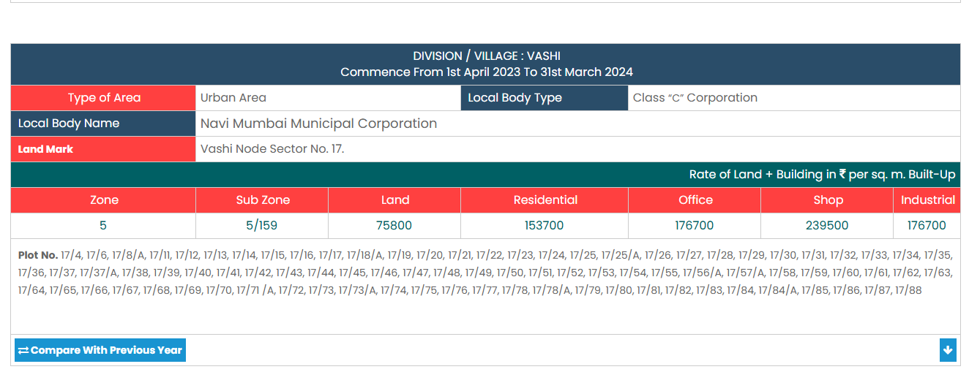

Stamp Duty Ready Reckoner Market Value Rate for Office | 1,76,700.00
No Increase on Office Premises Located on 3rd Floor | 00.00
Stamp Duty Ready Reckoner Market Value Rate (After Reduced) (A) | 1,76,700.00 | Sq. Mt. | 16,416.00 | Sq. Ft.
Stamp Duty Ready Reckoner Market Value Rate for Land (B) | 75,800.00
The difference between land rate and building rate (A – B = C) | 1,00,900.00
Depreciation Percentage as per table (D) [100% - 38%]  (Age of the Building – 38 Years) | 62%
Rate to be adopted after considering depreciation [B + (C x D)] | 1,38,358.00 | Sq. Mt. | 12,854.00 | Sq. Ft.

Multi-Storied building with Lift
For residential premises / commercial unit / office on above floor in multistoried building, the rate mentioned in the ready reckoner will be increased as under:
 | Location of Flat / Commercial Unit in the building | Rate
a) | On Ground to 4 Floors | No increase for all floors from ground to 4 floors
b) | 5 Floors to 10 Floors | Increase by 5% on units located between 5 to 10 floors
c) | 11 Floors to 20 Floors | Increase by 10% on units located between 11 to 20 floors
d) | 21 Floors to 30 Floors | Increase by 15% on units located between 21 to 30 floors
e) | 31 Floors and above | Increase by 20% on units located on 31 and above floors
Table – D: Depreciation Percentage Table
Completed Age of Building in Years | Value in percent after depreciation
 | R.C.C. Structure / other Pukka Structure | Cessed Building, Half or Semi – Pukka Structure & Kaccha Structure.
0 to 2 Years | 100% | 100%
Above 2 & up to 5 Years | 95% | 95%
Above 5 Years | After initial 5 year for every year 1% depreciation is to be considered. However maximum deduction available as per this shall be 70% of Market Value rate | After initial 5 year for every year 1.5% depreciation is to be considered. However maximum deduction available as per this shall be 85% of Market Value rate
Price Indicator
Property | Office Space
Source | 99acres
Floor | -
 | Carpet | Built Up | Saleable
Area | 375.00 | 450.00 | -
Percentage | - | 20% | -
Rate Per Sq.Ft. | 28,000.00 | ₹ 23,333.00 | -
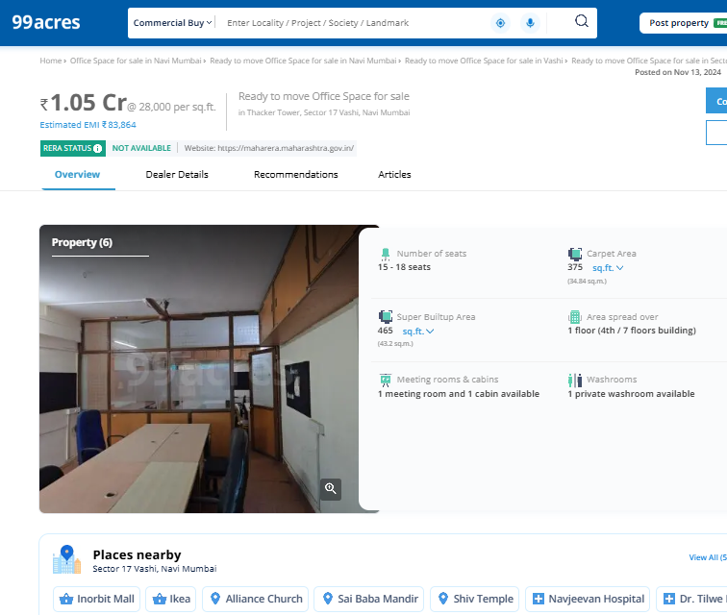

Price Indicator
Property | Office Space
Source | 99acres
Floor | -
 | Carpet | Built Up | Saleable
Area | 1,200.00 | 1,440.00 | -
Percentage | - | 20% | -
Rate Per Sq.Ft. | ₹ 29,167.00 | ₹ 24,306.00 | -
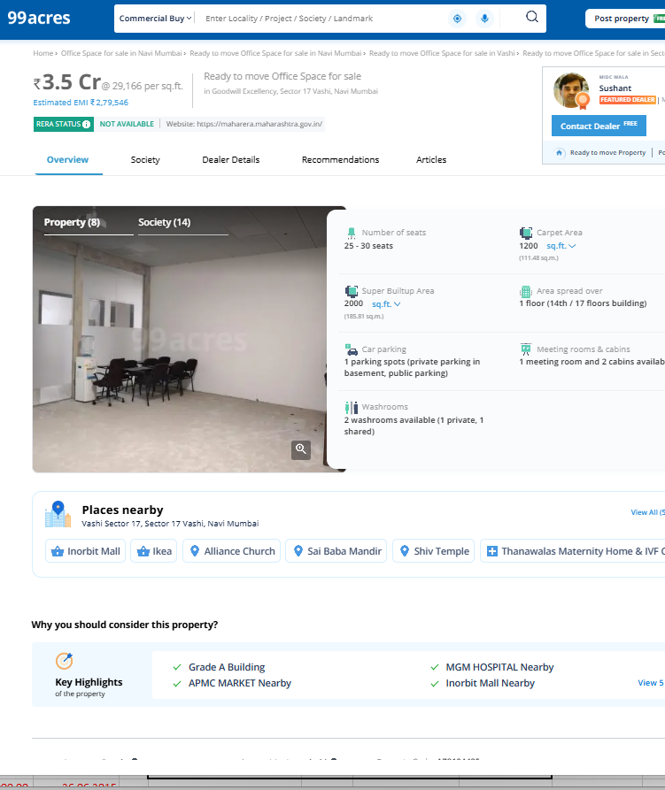
Sale Instances
Property | Office
Source | Index No. 2
Floor | -
 | Carpet | Built Up | Saleable
Area | 198.33 | 338.00 | -
Percentage | - | 20% | -
Rate Per Sq. Ft. | ₹ 30,253.00 | ₹ 25,210.00 | -
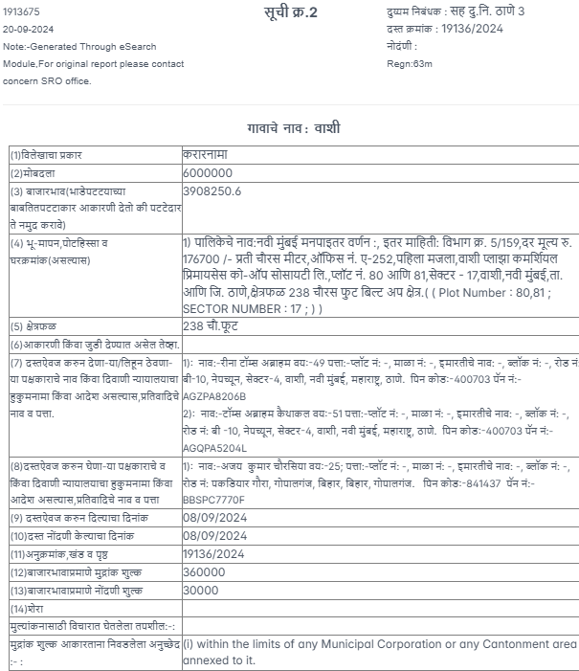

Sale Instances
Property | Office
Source | Index No. 2
Floor | -
 | Carpet | Built Up | Saleable
Area | 564.00 | 676.80 | -
Percentage | - | 20% | -
Rate Per Sq.Ft. | ₹ 24,535.00 | ₹ 20,445.00 | -
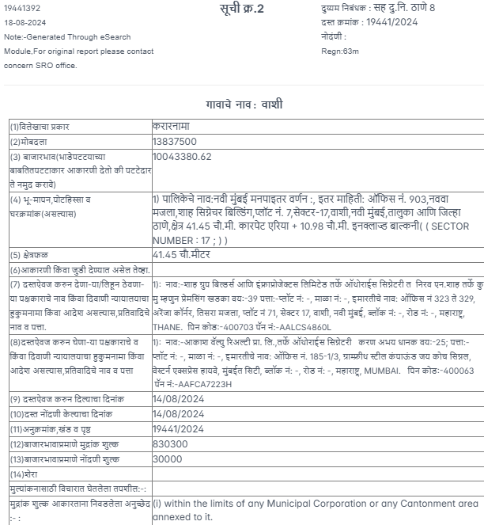
Justification for price /rate

The Market Value of the property is based on facts of markets discovered by us during our enquiries, however the government rate value in this case is less than the market value arrived by us. We are of the opinion that the value arrive by us will prove to be correct if an Auction of the subject property is carried out. As far as Market Value in Index II is concerned, it is not possible to comment on same, may be government rates are fixed by sampling during same point of time in part and whereas, Market values change every month.
In most of the cases the actual deal amount or Transaction value is not reflected in Index II because of various Market practices. As Valuer, we always try to give a value which is correct reflection of actual transaction value irrespective of any factors in market.
APPENDIX V

DECLARATION FROM VALUERS

I hereby declare that-

- The information furnished in my valuation report dated 19.12.2024 is true and correct to the best of my knowledge and belief and I have made an impartial and true valuation of the property.

- I have no direct or indirect interest in the property valued;

- I/ my authorized representative has personally visited the property on 09.12.2024. The work is not sub- contracted to any other valuer and carried out by myself.

- I have not been convicted of any offence and sentenced to a term of Imprisonment.

- I have not been found guilty of misconduct in my professional capacity.

- I have read the Handbook on Policy, Standards and procedure for Real Estate Valuation, 2011 of the IBA and this report is in conformity to the "Standards" as enshrined for valuation in the Part - B of the above handbook to the best of my ability.

- I have read the International Valuation Standards (IVS) and the report submitted to the Bank for the respective asset class is in conformity to the "Standards" as enshrined for valuation in the IVS in "General Standards" and "Asset Standards" as applicable. The valuation report is submitted in the prescribed format of the bank.

- I abide by the Model Code of Conduct for empanelment of valuer in the Bank. (Annexure III - A signed copy of same to be taken and kept along with this declaration)

- I am registered under Section 34 AB of the Wealth Tax Act, 1957.

- I am the proprietor / partner / authorized official of the firm / company, who is competent to sign this valuation report.

- Further, I hereby provide the following information.

No. | Particulars | Valuer comment
 | Background information of the asset being valued; | The property under consideration is Purchased by Miss. Rishika Kajaria from Mrs. Kejal Haresh Anawadia, as pe Deed of Sale-Cum-Transfer dated 30/06/2015.
 | Purpose of valuation and appointing authority | As per the request from Punjab National Bank, MCC Western One to assess Fair Market Value of the property for Housing Loan purpose
 | Identity of the valuer and any other experts involved in the valuation; | Sharadkumar Chalikwar - Regd. Valuer  Vaibhav Bhagat - Valuation Engineer  Binumon Moozhickal - Technical Manager  Jayaraja Acharya - Technical Officer
 | Disclosure of valuer interest or conflict, if any; | We have no interest, either direct or indirect, in the property valued. Further to state that we do not have relation or any connection with property owner / applicant directly or indirectly. Further to state that we are an independent Valuer and in no way related to property owner / applicant
 | Date of appointment, valuation date and date of report; | Date of Appointment – 09.12.2024  Valuation Date – 19.12.2024  Date of Report – 19.12.2024
 | Inspections and/or investigations undertaken; | Physical Inspection done on – 09.12.2024
 | Nature and sources of the information used or relied upon; | Market Survey at the time of site visit  Ready Reckoner rates / Circle rates  Online search for Registered Transactions  Online Price Indicators on real estate portals  Enquiries with Real estate consultants  Existing data of Valuation assignments carried out by us
 | Procedures adopted in carrying out the valuation and valuation standards followed; | Sales Comparative Method
 | Restrictions on use of the report, if any; | This valuation is for the use of the party to whom it is addressed and for no other purpose. No responsibility is accepted to any third party who may use or rely overall or any part of this valuation. The valuer has no pecuniary interest that would conflict with the proper valuation of the property.
 | Major factors that were taken into account during the valuation; | current market conditions, demand and supply position, Commercial Office size, location, upswing in real estate prices, sustained demand for Commercial Office, all-round development of commercial and Commercial application in the locality etc.
 | Major factors that were not taken into account  during the valuation; | -
 | Caveats, limitations, and disclaimers to the extent they explain or elucidate the limitations faced by valuer, which shall not be for the purpose of limiting his responsibility for the valuation report. | Attached

APPENDIX VI
MODEL CODE OF CONDUCT FOR VALUERS

{Adopted in line with Companies (Registered Valuers and Valuation Rules, 2017)}
All valuers empanelled with bank shall strictly adhere to the following code of conduct:

Integrity and Fairness
- A valuer shall, in the conduct of his/its business, follow high standards of integrity and fairness in all his/its dealings with his/its clients and other valuers.
- A valuer shall maintain integrity by being honest, straightforward, and forthright in all professional relationships.
- A valuer shall endeavour to ensure that he/it provides true and adequate information and shall not misrepresent any facts or situations.
- A valuer shall refrain from being involved in any action that would bring disrepute to the profession.
- A valuer shall keep public interest foremost while delivering his services.
Professional Competence and Due Care
- A valuer shall render at all times high standards of service, exercise due diligence, ensure proper care and exercise independent professional judgment.
- A valuer shall carry out professional services in accordance with the relevant technical and professional standards that may be specified from time to time.
- A valuer shall continuously maintain professional knowledge and skill to provide competent professional service based on up-to-date developments in practice, prevailing regulations / guidelines and techniques.
- In the preparation of a valuation report, the valuer shall not disclaim liability for his/its expertise or deny his/its duty of care, except to the extent that the assumptions are based on statements of fact provided by the company or its auditors or consultants or information available in public domain and not generated by the valuer.
- A valuer shall not carry out any instruction of the client insofar as they are in compatible with the requirements of integrity, objectivity and independence.
- A valuer shall clearly state to his client the services that he would be competent to provide and the services for which he would be relying on other valuers or professionals or for which the client can have a separate arrangement with other valuers.
Independence and Disclosure of Interest
- A valuer shall act with objectivity in his/its professional dealings by ensuring that his/its decisions are made without the presence of any bias, conflict of interest, coercion, or undue influence of any party, whether directly connected to the valuation assignment or not.
- A valuer shall not take up an assignment if he/it or any of his/its relatives or associates is not independent in terms of association to the company.
- A valuer shall maintain complete independence in his/its professional relationships and shall conduct the valuation independent of external influences.
- A valuer shall wherever necessary disclose to the clients, possible sources of conflicts of duties and interests, while providing unbiased services.
- A valuer shall not deal in securities of any subject company after any time when he/it first becomes aware of the possibility of his / its association with the valuation, and in accordance with the Securities and Exchange Board of India (Prohibition of Insider Trading)Regulations,2015 or till the time the valuation report becomes public, whichever is earlier.
- A valuer shall not indulge in "mandate snatching" or offering "convenience valuations" in order to cater to a company or client's needs.
- As an independent valuer, the valuer shall not charge success fee (Success fees may be defined as a compensation / incentive paid to any third party for successful closure of transaction. In this case, approval of credit proposals).
- In any fairness opinion or independent expert opinion submitted by a valuer, if there has been a prior engagement in an unconnected transaction, the valuer shall declare the association with the company during the last five years.
Confidentiality
- A valuer shall not use or divulge to other clients or any other party any confidential information about the subject company, which has come to his / its knowledge without proper and specific authority or unless there is a legal or professional right or duty to disclose.
Information Management
- A valuer shall ensure that he/ it maintains written contemporaneous records for any decision taken, the reasons for taking the decision, and the information and evidence in support of such decision. This shall be maintained so as to sufficiently enable a reasonable person to take a view on the appropriateness of his /its decisions and actions.
- A valuer shall appear, co-operate and be available for inspections and investigations carried out by the authority, any person authorised by the authority, the registered valuers organisation with which he/it is registered or any other statutory regulatory body.
- A valuer shall provide all information and records as may be required by the authority, the Tribunal, Appellate Tribunal, the registered valuers organisation with which he/it is registered, or any other statutory regulatory body.
- A valuer while respecting the confidentiality of information acquired during the course of performing professional services, shall maintain proper working papers for a period of three years or such longer period as required in its contract for a specific valuation, for production before a regulatory authority or for a peer review. In the event of a pending case before the Tribunal or Appellate Tribunal, the record shall be maintained till the disposal of the case.
Gifts and hospitality:
- A valuer or his / its relative shall not accept gifts or hospitality which undermines or affects his independence as a valuer.
Explanation, - For the purposes of this code the term 'relative' shall have the same meaning as defined in clause (77) of Section 2 of the Companies Act, 2013 (18 of 2013).
- A valuer shall not offer gifts or hospitality or a financial or any other advantage to a public servant or any other person with a view to obtain or retain work for himself / itself, or to obtain or retain an advantage in the conduct of profession for himself / itself.
Remuneration and Costs.
- A valuer shall provide services for remuneration which is charged in a transparent manner, is a reasonable reflection of the work necessarily and properly undertaken, and is not inconsistent with the applicable rules.
- A valuer shall not accept any fees or charges other than those which are disclosed in a written contract with the person to whom he would be rendering service.

Occupation, employability, and restrictions.
- A valuer shall refrain from accepting too many assignments, if he/it is unlikely to be able to devote adequate time to each of his/ its assignments.
- A valuer shall not conduct business which in the opinion of the authority or the registered valuer organisation discredits the profession.

APPENDIX VII
UNDERTAKING

I, Sharadkumar Chalikwar son of Shri. Baburao Chalikwar do hereby solemnly affirm and state that:

- I am a citizen of India.
- I have not been removed / dismissed from service / employment earlier.
- I have not been convicted of any offence and sentenced to a term of imprisonment.
- I have not been found guilty of misconduct in my professional capacity.
- I am not an undischarged insolvent.
- I have not been convicted of an offence connected with any proceeding under the Income Tax Act 1961, Wealth Tax Act 1957, or Gift Tax Act 1958 and
- My PAN Card number as applicable is AEAPC0117Q.
- I have read and understood the ‘Handbook on Policy, Standards and Procedures for real Estate Valuation by Banks and HFI in India 2010’ of the IBA and fulfil all the conditions of criteria for Empanelment as listed therein.
- I undertake to keep you informed of any events or happenings which would make me ineligible for empanelment as a valuer.
- I have not concealed or suppressed any material information, facts and record and I have made a complete and full disclosure.
- I have not been found guilty of misconduct in professional capacity. In case I am found guilty of misconduct/adoption of unethical practices/submission of under or overvalued valuation reports, in professional capacity, in Punjab National Bank OR in some other Bank/Institution and brought to the notice of Punjab National Bank, by IBA/Central Bureau of Investigation (CBI)/ Reserve Bank of India (RBI)/Any other Govt. Agency/Body, my empanelment will stand cancelled with Punjab National Bank, without referring to Grievances Redressal System of the Bank. PNB will be free to report to the IBA, Institute of Valuers etc. about the misconduct/adoption of unethical practices and may take appropriate legal action for deficiency in services.

Sharadkumar B. Chalikwar
Govt. Reg. Valuer
Chartered Engineer (India)
Reg. No. (N) C.C.I.T/I-14/52/2008-09
Punjab National Bank Empanelment No.: REF: ZO: SAMD:1138

