Vastu/Nashik/12/2024/012902/2309437
06/39-135 -RPBS
Date: 06.12.2024

To, `
The Branch Manager,
Bank of Baroda
Regional Office Nashik Road Branch
BSNL Building, Datta Mandir Road, Nashik Road,
Nashik -422 101, State - Maharashtra, Country - India.

Sub: Vetting of Extra Work

Sir,

With reference to above subject, we have evaluated the Extra Work for Residential Flat No. 2206, 22nd Floor, Wing - C, "Shreeji Excelencia", Opposite Radiant Hyundai Service, Serene Meadows, Gangapur Road, Village - Anandvalli,
Taluka - Nashik, District - Nashik, 422013, State - Maharashtra, India belongs to Miss. Rupal Rahul Harkal.

We have verified the rates quoted as per current market rates. Details of Extra Work considered as per copy of Agreement for Extra Work issued by to Mrs. Rupal Rahul Harkal (First Party) Sunil Mohan Kolvankar & Shyam Kashinath Kumbhar (Second Party) received on dated 27.09.2024. The Extra Work amount is Rs.15,00,000/- (Rupees Fifteen Lakh Only.)

The said Cost Vetting Certificate is valid upto next 6 months Only.

Thanking you

Sincerely yours

Manoj B. Chalikwar
Registered Valuer
Chartered Engineer (India)
Reg. No. CAT-I-F-1763
Reg. No. IBBI/RV/07/2018/10366
BOB Empanelment No.: ZO:MZ:ADV:46:941
Encl: Valuation report.

Agreement of Extra Work
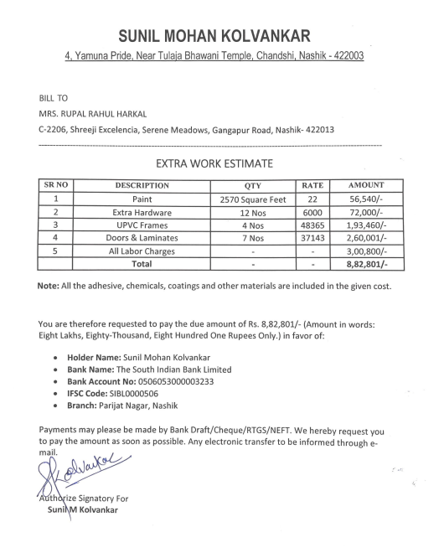

Agreement of Extra Work
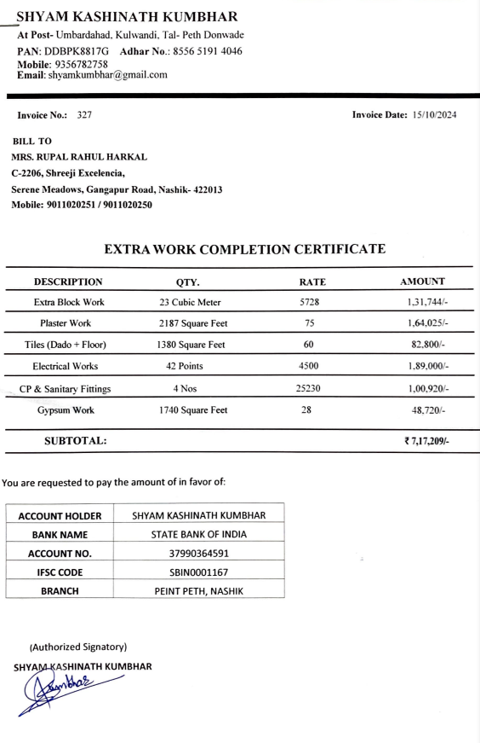

The Extra Work amount is Rs.15,00,000/- (Rupees Fifteen Lakh Only.)

