Vastu/Nashik/06/32014/2301224
22/20-325-RYBS
Date: 06.12.2024

To,
The Branch Manager,
Union Bank of India
RLP Nashik
Union Loanpoint Nashiik, Nawandar Sankul Racca Colony, Near Soni Paithani,
Sharanpur road Nashik-02.

Sub: Vetting of Extra Work

Sir,

With reference to above subject, we have evaluated the Extra Work for Residential Flat No. 101, 1st Floor, "Shiv Vandana Heights", Opp. to RTO Office, Pawar Mala, Survey No - 445/2, Plot No. 4, Peth Road, Village - Makhamalabad, Taluka - Nashik, District - Nashik, Nashik, PIN Code - 422 003, State - Maharashtra, Country - India belongs to Tejal Bhavansing Solnake Alias Sau. Tejal Prashant Pawar. Name of Proposed Purchaser is Shri. Santosh Dattatraya Jamhadhe & Sau. Nikita Santosh Jamhadhe.

We have verified the rates quoted as per current market rates. Details of Extra Work considered as per copy of Extra Work Agreement between Shri. Santosh Dattatraya Jamhadhe & Sau. Nikita Santosh Jamhadhe (First Party). Shri. Rajendra Devsingh Jadhav (Second Party) received on dated 21.11.2024. The Extra Work amount is Rs. 1,50,000/- (Rupees One Lakh Fifty Thousand Only)

The said Cost Vetting Certificate is valid upto next 6 months Only.

Thanking you

Sincerely yours

Sharadkumar B. Chalikwar
Govt. Reg. Valuer
Chartered Engineer (India)
Reg. No. (N) CCIT/1-14/52/2008-09

Agreement for Extra Work
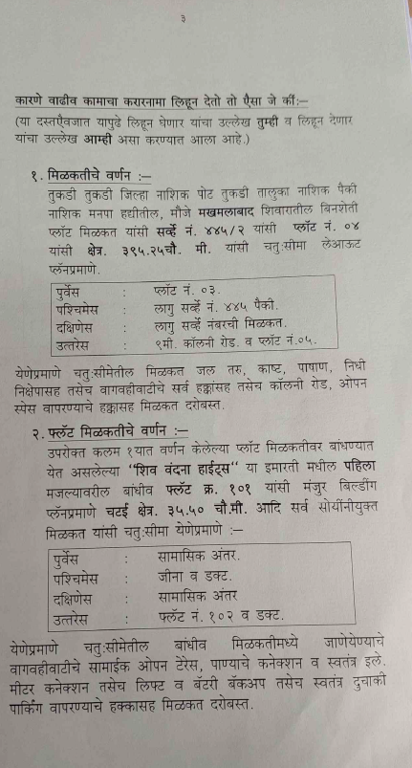
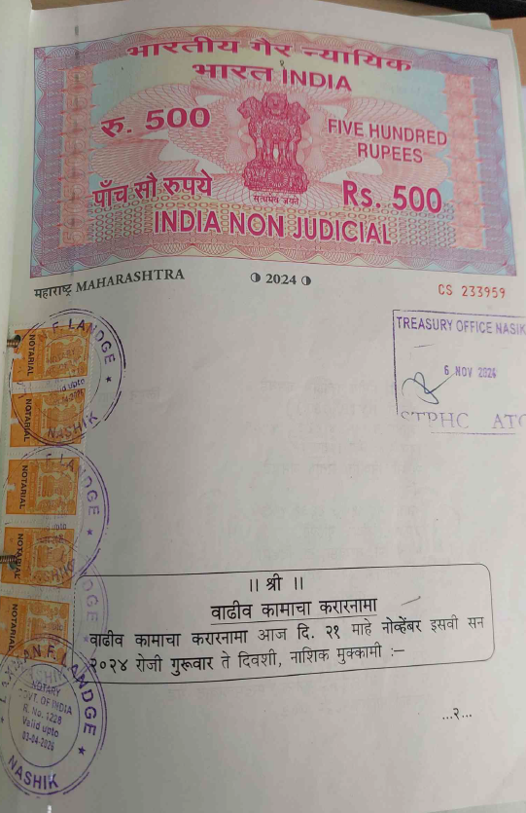

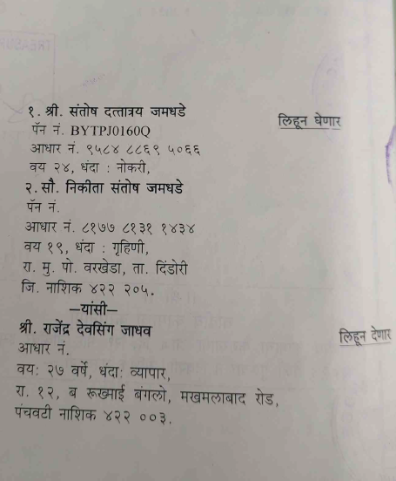

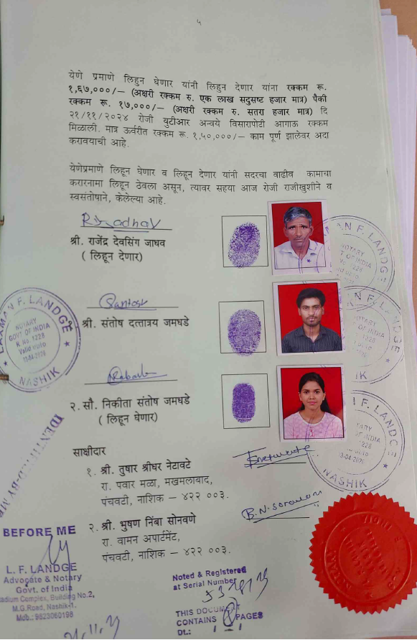
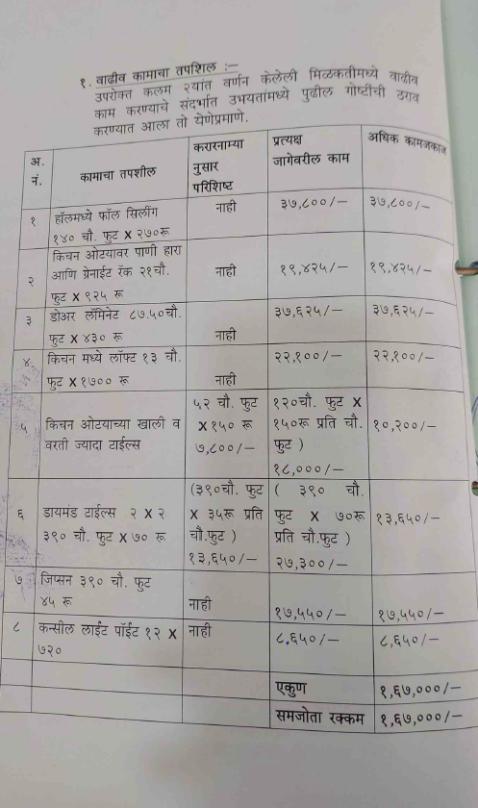

The Extra Work amount is Rs. 1,65,000/- (Rupees One Lakh Fifty Thousand Only)

