Valuation Report of the Immovable Property

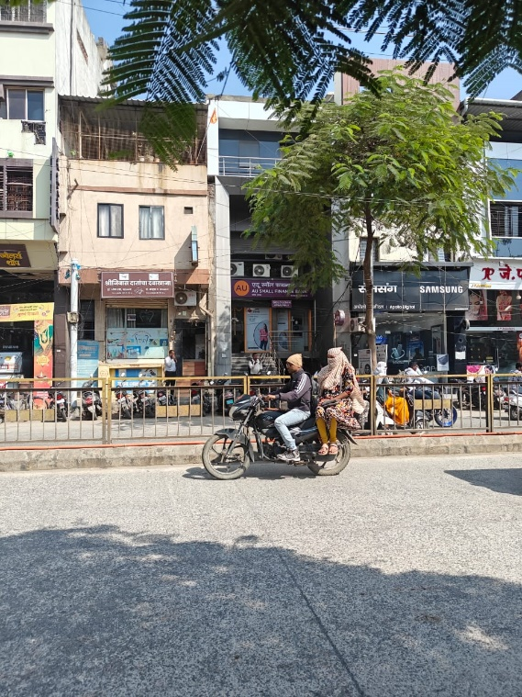

**Details of the property under consideration:**

Name of Client: **Sow. Chandrabhagabai W/o. Omprakash Gilda**

M. H. No. 3-1-512, 513, Pin No. 4040301694, Plot in C.T.S. No. 3330, Near Apollo Digital Samsung Store, Opposite to S. P. Office, Kalamandir to Vazirabad Road, Vazirabad Chowk, Mouje Vazirabad, PIN - 431 601

Tal. & Dist. – Nanded, State – Maharashtra, India.

# **Longitude Latitude: 19.155364, 77.309396**

**Intended Users:**

**Axis Bank**

**Regional Legal & Tech. Manager**

 Stellar Enclave, Shop No. 203-204, 2nd Floor, Above McDonalds, Aundh,

Pune- 411 007, State – Maharashtra, India.

Vastu/Nanded/12/2024/012884 /2309402

06/4-100-BHBS

Date: 06.12.2024

# **VALUER’S OPINION REPORT**

This is to certify that the property situated M. H. No. 3-1-512, 513, Pin No. 4040301694, Plot in C.T.S. No. 3330, Near Apollo Digital Samsung Store, Opposite to S. P. Office, Kalamandir to Vazirabad Road, Vazirabad Chowk, Mouje Vazirabad, PIN - 431 601, Tal. & Dist. – Nanded, State – Maharashtra, India is belonging to **Shri. Omprakash S/o. Kannaiyalal Gilda.**

|  |  |  |
| --- | --- | --- |
| Boundaries of the property. | | |
|  |  | **As Per Site** | | **As per mail** |
| North | : | Property of Agarwal | | House of Agarwal |
| South | : | Property of Shri Gangasharan Mirkut Agarwal | | House of Gangasharan Mirkut Agarwal |
| East | : | 3.05 M wide Road | | Cement Road |
| West | : | Kalamandir to Vazirabad Road | | House of Mrs. Chandrabhagabai Gilda |

Considering various parameters recorded, existing economic scenario, and the information that is available with reference to the development of neighborhood and method selected for valuation, we are of the opinion that, the property premises can be assessed are as under:

|  |  |
| --- | --- |
| **Guideline Value of the Property** | **Rs. 1,08,74,718.00** |
| **Fair Market Value of the Property** | **Rs. 2,72,80,995.00** |
| **Realizable Value of the Property** | **Rs. 2,45,52,896.00`** |
| **Forced/ Distress Sale value of the Property.** | **Rs 2,18,24,796.00** |

The valuation of the property is based on the documents produced by the concern. Legal aspects have not been taken into considerations while preparing this valuation report.

Hence certified

For, **Vastukala Consultants (I) Pvt. Ltd.**

**Sharadkumar B. Chalikwar**

B.E. (Civil), M.E. (Civil), M.Sc. (Real Estate Valuation), M.Sc. (P&M Valuation), FIE (I), FIV, FIWRS

Chairman & Managing Director

Govt. Reg. Valuer

Chartered Engineer (India)

Reg. No. (N) CCIT/1-14/52/2008-09

IBBI Reg.No. IBBI/RV/07/2019/11744

Encl: Valuation report.

|  |  |  |  |  |  |  |  |  |  |  |  |  |  |  |  |  |  |  |  |  |  |  |  |  |  |  |  |  |  |  |  |  |  |  |  |  |  |  |  |  |  |  |  |  |  |  |  |  |  |  |  |  |  |  |  |  |  |  |  |  |  |  |  |  |  |  |  |  |  |  |  |  |  |  |  |  |  |  |  |  |  |  |  |  |  |  |  |  |  |  |  |  |  |  |  |  |  |  |  |  |  |  |  |  |  |  |  |  |  |  |  |  |  |  |  |  |  |  |  |  |  |  |  |  |  |  |  |  |  |  |  |  |  |  |  |  |  |  |  |  |  |  |  |  |  |  |  |  |  |  |  |  |  |  |  |  |  |  |  |  |  |  |  |  |  |  |  |  |  |  |  |  |  |  |  |  |  |  |  |  |  |  |  |  |  |  |  |  |  |  |  |  |  |  |  |  |  |  |  |  |  |  |  |  |  |  |  |  |  |  |  |  |  |  |  |  |  |  |  |  |  |  |  |  |  |  |  |  |  |  |  |  |  |  |  |  |  |  |  |  |  |  |  |  |  |  |  |  |  |  |  |  |  |  |  |  |  |  |  |  |  |  |  |  |  |  |  |  |  |  |  |  |  |  |  |  |  |  |  |  |  |  |  |  |  |  |  |  |  |  |  |  |  |  |  |  |  |  |  |  |  |  |  |  |  |  |  |  |  |  |  |  |  |  |  |  |  |  |  |  |  |  |  |  |  |  |  |  |  |  |  |  |  |  |  |  |  |  |  |  |  |  |  |  |  |  |  |  |  |  |  |  |  |  |  |  |  |  |  |  |  |  |  |  |  |  |  |  |  |  |  |  |  |  |  |  |  |  |  |  |  |  |  |  |  |  |  |  |  |  |  |  |  |  |  |  |  |  |  |  |  |  |  |  |  |  |  |  |  |  |  |  |  |  |  |  |  |  |  |  |  |  |  |  |  |  |  |  |  |  |  |  |  |  |  |  |  |  |  |  |  |  |  |  |  |  |  |  |  |  |  |  |  |  |  |  |  |  |  |  |  |  |  |  |  |  |  |  |  |  |  |  |  |  |  |  |  |  |  |  |  |  |  |  |  |  |  |  |  |  |  |  |  |  |  |  |  |  |  |  |  |  |  |  |  |  |  |  |  |  |  |  |  |  |  |  |  |  |  |  |  |  |  |  |  |  |  |  |  |  |  |  |  |  |  |  |  |  |  |  |  |  |  |  |  |  |  |  |  |  |  |  |  |  |  |  |  |  |  |  |  |  |  |  |  |  |  |  |  |  |  |  |  |  |  |  |  |  |  |  |  |  |  |  |  |  |  |  |  |  |  |  |  |  |  |  |  |  |  |  |  |  |  |  |  |  |  |  |  |  |  |  |  |  |  |  |  |  |  |  |  |  |  |  |  |  |  |  |  |  |  |  |  |  |  |  |  |  |  |  |  |  |  |  |  |  |  |  |  |  |  |  |  |  |  |  |  |  |  |  |  |  |  |  |  |  |  |  |  |  |  |  |  |  |  |  |  |  |  |  |  |  |  |  |  |  |  |  |  |  |  |  |  |  |  |  |  |  |  |  |  |  |  |  |  |  |  |  |  |  |  |  |  |  |  |  |  |  |  |  |  |  |  |  |  |  |  |  |  |  |  |  |  |  |  |  |  |  |  |  |  |  |  |  |  |  |  |  |  |  |  |  |  |  |  |  |  |  |  |  |  |  |  |  |  |  |  |  |  |  |  |  |  |  |  |  |  |  |  |  |  |  |  |  |  |  |  |  |  |  |  |  |  |  |  |  |  |  |  |  |  |  |  |  |  |  |  |  |  |  |  |  |  |  |  |  |  |  |  |  |  |  |  |  |  |  |  |  |  |  |  |  |  |  |  |  |  |  |  |  |  |  |  |  |  |  |  |  |  |  |  |  |  |  |  |  |  |  |  |  |  |  |  |  |  |  |  |  |  |  |  |  |  |  |  |  |  |  |  |  |  |  |  |  |  |  |  |  |  |  |  |  |  |  |  |  |  |  |  |  |  |  |  |  |  |  |  |  |  |  |  |  |  |  |  |  |  |  |  |  |  |  |  |  |  |  |  |  |  |  |  |  |  |  |  |  |  |  |  |  |  |  |  |  |  |  |  |  |  |  |  |  |  |  |  |  |  |  |  |  |  |  |  |  |  |  |  |  |  |  |  |  |  |  |  |  |  |  |  |  |  |  |  |  |  |  |  |  |  |  |  |  |  |  |  |  |  |  |  |  |  |  |  |  |  |  |  |  |  |  |  |  |  |  |  |  |  |  |  |  |  |  |  |  |  |  |  |  |  |  |  |  |  |  |  |  |  |  |  |  |  |  |  |  |  |  |  |  |  |  |  |  |  |  |  |  |  |  |  |  |  |  |  |  |  |  |  |  |  |  |  |  |  |  |  |  |  |  |  |  |  |  |  |  |  |  |  |  |  |  |  |  |  |  |  |  |  |  |  |  |  |  |  |  |  |  |  |  |  |  |  |  |  |  |  |  |  |  |  |  |  |  |  |  |  |  |  |  |  |  |  |  |  |  |  |  |  |  |  |  |  |  |  |  |  |  |  |  |  |  |  |  |  |  |  |  |  |  |  |  |  |  |  |  |  |  |  |  |  |  |  |  |  |  |  |  |  |  |  |  |  |  |  |  |  |  |  |  |  |  |  |  |  |  |  |  |  |  |  |  |  |  |  |  |  |  |  |  |  |  |  |  |  |  |  |  |  |  |  |  |  |  |  |  |  |  |  |  |  |  |  |  |  |  |  |  |  |  |  |  |  |  |  |  |  |  |  |  |  |  |  |  |  |  |  |  |  |  |  |  |  |  |  |  |  |  |  |  |  |  |  |  |  |  |  |  |  |  |  |  |  |  |  |  |  |  |  |  |  |  |  |  |  |  |  |  |  |  |  |  |  |  |  |  |  |  |  |  |  |  |  |  |  |  |  |  |  |  |  |  |  |  |  |  |  |  |  |  |  |  |  |  |  |  |  |  |  |  |  |  |  |  |  |  |  |  |  |  |  |  |  |  |  |  |  |  |  |  |  |  |  |  |  |  |  |  |  |  |  |  |  |  |  |  |  |  |  |  |  |  |  |  |  |  |  |  |  |  |  |  |  |  |  |  |  |  |  |  |  |  |  |  |  |  |  |  |  |  |  |  |  |  |  |  |  |  |  |  |  |  |  |  |  |  |  |  |  |  |  |  |  |  |  |  |  |  |  |  |  |  |  |  |  |  |  |  |  |  |  |  |  |  |  |  |  |  |  |  |  |  |  |  |  |  |  |  |  |  |  |  |  |  |  |  |  |  |  |  |  |  |  |  |  |  |  |  |  |  |  |  |  |  |  |  |  |  |  |  |  |  |  |  |  |  |  |  |  |  |  |  |  |  |  |  |  |  |  |  |  |  |  |  |  |  |  |  |  |  |  |  |  |  |  |  |  |  |  |  |  |  |  |  |  |  |  |  |  |  |  |  |  |  |  |  |  |  |  |  |  |  |  |  |  |  |  |  |  |  |  |  |  |  |  |  |  |  |  |  |  |  |  |  |  |  |  |  |  |  |  |  |  |  |  |  |  |  |  |  |  |  |  |  |  |  |  |  |  |  |  |  |  |  |  |  |  |  |  |  |  |  |  |  |  |  |  |  |  |  |  |  |  |  |  |  |  |  |  |  |  |  |  |  |  |  |  |  |  |  |  |  |  |  |  |  |  |  |  |  |  |  |  |  |  |  |  |  |  |  |  |  |  |  |  |  |  |  |  |  |  |  |  |  |  |  |  |  |  |  |  |  |  |  |  |  |  |  |  |  |  |  |  |  |  |  |  |  |  |  |  |  |  |  |  |  |  |  |  |  |  |  |  |  |  |  |  |  |  |  |  |  |  |  |  |  |  |  |  |  |  |  |  |  |  |  |  |  |  |  |  |  |  |  |  |  |  |  |  |  |  |  |  |  |  |  |  |  |  |  |  |  |  |  |  |  |  |  |  |  |  |  |  |  |  |  |  |  |  |  |  |  |  |  |  |  |  |  |  |  |  |  |  |  |  |  |  |  |  |  |  |  |  |  |  |  |  |  |  |  |  |  |  |  |  |  |  |  |  |  |  |  |  |  |  |  |  |  |  |  |  |  |  |  |  |  |  |  |  |  |  |  |  |  |  |  |  |  |  |  |  |  |  |  |  |  |  |  |  |  |  |  |  |  |  |  |  |  |  |  |  |  |  |  |  |  |  |  |  |  |  |  |  |  |  |  |  |  |  |  |  |  |  |  |  |  |  |  |  |  |  |  |  |  |  |  |  |  |  |  |  |  |  |  |  |  |  |  |  |  |  |  |  |  |  |  |  |  |  |  |  |  |  |  |  |  |  |  |  |  |  |  |  |  |  |  |  |  |  |  |  |  |  |  |  |  |  |  |  |  |  |  |  |  |  |  |  |  |  |  |  |  |  |  |  |  |  |  |  |  |  |  |  |  |  |  |  |  |  |  |  |  |  |  |  |  |  |  |  |  |  |  |  |  |  |  |  |  |  |  |  |  |  |  |  |  |  |  |  |  |  |  |  |  |  |  |  |  |  |  |  |  |  |  |  |  |  |  |  |  |  |  |  |  |  |  |  |  |  |  |  |  |  |  |  |  |  |  |  |  |  |  |  |  |  |  |  |  |  |  |  |  |  |  |  |  |  |  |  |  |  |  |  |  |  |  |  |  |  |  |  |  |  |  |  |  |  |  |  |  |  |  |  |  |  |  |  |  |  |  |  |  |  |  |  |  |  |  |  |  |  |  |  |  |  |  |  |  |  |  |  |  |  |  |  |  |  |  |  |  |  |  |  |  |  |  |  |  |  |  |  |  |  |  |  |  |  |  |  |  |  |  |  |  |  |  |  |  |  |  |  |  |  |  |  |  |  |  |  |  |  |  |  |  |  |  |  |  |  |  |  |  |  |  |  |  |  |  |  |  |  |  |  |  |  |  |  |  |  |  |  |  |  |  |  |  |  |  |  |  |  |  |  |  |  |  |  |  |  |  |  |  |  |  |  |  |  |  |  |  |  |  |  |  |  |  |  |  |  |  |  |  |  |  |  |  |  |  |  |  |  |  |  |  |  |  |  |  |  |  |  |  |  |  |  |  |  |  |  |  |  |  |  |  |  |  |  |  |  |  |  |  |  |  |  |  |  |  |  |  |  |  |  |  |  |  |  |  |  |  |  |  |  |  |  |  |  |  |  |  |  |  |  |  |  |  |  |  |  |  |  |  |  |  |  |  |  |  |  |  |  |  |  |  |  |  |  |  |  |  |  |  |  |  |  |  |  |  |  |  |  |  |  |  |  |  |  |  |  |  |  |  |  |  |  |  |  |  |  |  |  |  |  |  |  |  |  |  |  |  |  |  |  |  |  |  |  |  |  |  |  |  |  |  |  |  |  |  |  |  |  |  |  |  |  |  |  |  |  |  |  |  |  |  |  |  |  |  |  |  |  |  |  |  |  |  |  |  |  |  |  |  |  |  |  |  |  |  |  |  |  |  |  |  |  |  |  |  |  |  |  |  |  |  |  |  |  |  |  |  |  |  |  |  |  |  |  |  |  |  |  |  |  |  |  |  |  |  |  |  |  |  |  |  |  |  |  |  |  |  |  |  |  |  |  |  |  |  |  |  |  |  |  |  |  |  |  |  |  |  |  |  |  |  |  |  |  |  |  |  |  |  |  |  |  |  |  |  |  |  |  |  |  |  |  |  |  |  |  |  |  |  |  |  |  |  |  |  |  |  |  |  |  |  |  |  |  |  |  |  |  |  |  |  |  |  |  |  |  |  |  |  |  |  |  |  |  |  |  |  |  |  |  |  |  |  |  |  |  |  |  |  |  |  |  |  |  |  |  |  |  |  |  |  |  |  |  |  |  |  |  |  |  |  |  |  |  |  |  |  |  |  |  |  |  |  |  |  |  |  |  |  |  |  |  |  |  |  |  |  |  |  |  |  |  |  |  |  |  |  |  |  |  |  |  |  |  |  |  |  |  |  |  |  |  |  |  |  |  |  |  |  |  |  |  |  |  |  |  |  |  |  |  |  |  |  |  |  |  |  |  |  |  |  |  |  |  |  |  |  |  |  |  |  |  |  |  |  |  |  |  |  |  |  |  |  |  |  |  |  |  |  |  |  |  |  |  |  |  |  |  |  |  |  |  |  |  |  |  |  |  |  |  |  |  |  |  |  |  |  |  |  |  |  |  |  |  |  |  |  |  |  |  |  |  |  |  |  |  |  |  |  |  |  |  |  |  |  |  |  |  |  |  |  |  |  |  |  |  |  |  |  |  |  |  |  |  |  |  |  |  |  |  |  |  |  |  |  |  |  |  |  |  |  |  |  |  |  |  |  |  |  |  |  |  |  |  |  |  |  |  |  |  |  |  |  |  |  |  |  |  |  |  |  |  |  |  |  |  |  |  |  |  |  |  |  |  |  |  |  |  |  |  |  |  |  |  |  |  |  |  |  |  |  |  |  |  |  |  |  |  |  |  |  |  |  |  |  |  |  |  |  |  |  |  |  |  |  |  |  |  |  |  |  |  |  |  |  |  |  |  |  |  |  |  |  |  |  |  |  |  |  |  |  |  |  |  |  |  |  |  |  |  |  |  |  |  |  |  |  |  |  |  |  |  |  |  |  |  |  |  |  |  |  |  |  |  |  |  |  |  |  |  |  |  |  |  |  |  |  |  |  |  |  |  |  |  |  |  |  |  |  |  |  |  |  |  |  |  |  |  |  |  |  |  |  |  |  |  |  |  |  |  |  |  |  |  |  |  |  |  |  |  |  |  |  |  |  |  |  |  |  |  |  |  |  |  |  |  |  |  |  |  |  |  |  |  |  |  |  |  |  |  |  |  |  |  |  |  |  |  |  |  |  |  |  |  |  |  |  |  |  |  |  |  |  |  |  |  |  |  |  |  |  |  |  |  |  |  |  |  |  |  |  |  |  |  |  |  |  |  |  |  |  |  |  |  |  |  |  |  |  |  |  |  |  |  |  |  |  |  |  |  |  |  |  |  |  |  |  |  |  |  |  |  |  |  |  |  |  |  |  |  |  |  |  |  |  |  |  |  |  |  |  |  |  |  |  |  |  |  |  |  |  |  |  |  |  |  |  |  |  |  |  |  |  |  |  |  |  |  |  |  |  |  |  |  |  |  |  |  |  |  |  |  |  |  |  |  |  |  |  |  |  |  |  |  |  |  |  |  |  |  |  |  |  |  |  |  |  |  |  |  |  |  |  |  |  |  |  |  |  |  |  |  |  |  |  |  |  |  |  |  |  |  |  |  |  |  |  |  |  |  |  |  |  |  |  |  |  |  |  |  |  |  |  |  |  |  |  |  |  |  |  |  |  |  |  |  |  |  |  |  |  |  |  |  |  |  |  |  |  |  |  |  |  |  |  |  |  |  |  |  |  |  |  |  |  |  |  |  |  |  |  |  |  |  |  |  |  |  |  |  |  |  |  |  |  |  |  |  |  |  |  |  |  |  |  |  |  |  |  |  |  |  |  |  |  |  |  |  |  |  |  |  |  |  |  |  |  |  |  |  |  |  |  |  |  |  |  |  |  |  |  |  |  |  |  |  |  |  |  |  |  |  |  |  |  |  |  |  |  |  |  |  |  |  |  |  |  |  |  |  |  |  |  |  |  |  |  |  |  |  |  |  |  |  |  |  |  |  |  |  |  |  |  |  |  |  |  |  |  |  |  |  |  |  |  |  |  |  |  |  |  |  |  |  |  |  |  |  |  |  |  |  |  |  |  |  |  |  |  |  |  |  |  |  |  |  |  |  |  |  |  |  |  |  |  |  |  |  |  |  |  |  |  |  |  |  |  |  |  |  |  |  |  |  |  |  |  |  |  |  |  |  |  |  |  |  |  |  |  |  |  |  |  |  |  |  |  |  |  |  |  |  |  |  |  |  |  |  |  |  |  |  |  |  |  |  |  |  |  |  |  |  |  |  |  |  |  |  |  |  |  |  |  |  |  |  |  |  |  |  |  |  |  |  |  |  |  |  |  |  |  |  |  |  |  |  |  |  |  |  |  |  |  |  |  |  |  |  |  |  |  |  |  |  |  |  |  |  |  |  |  |  |  |  |  |  |  |  |  |  |  |  |  |  |  |  |  |  |  |  |  |  |  |  |  |  |  |  |  |  |  |  |  |  |  |  |  |  |  |  |  |  |  |  |  |  |  |  |  |  |  |  |  |  |  |  |  |  |  |  |  |  |  |  |  |  |  |  |  |  |  |  |  |  |  |  |  |  |  |  |  |  |  |  |  |  |  |  |  |  |  |  |  |  |  |  |  |  |  |  |  |  |  |  |  |  |  |  |  |  |  |  |  |  |  |  |  |  |  |  |  |  |  |  |  |  |  |  |  |  |  |  |  |  |  |  |  |  |  |  |  |  |  |  |  |  |  |  |  |  |  |  |  |  |  |  |  |  |  |  |  |  |  |  |  |  |  |  |  |  |  |  |  |  |  |  |  |  |  |  |  |  |  |  |  |  |  |  |  |  |  |  |  |  |  |  |  |  |  |  |  |  |  |  |  |  |  |  |  |  |  |  |  |  |  |  |  |  |  |  |  |  |  |  |  |  |  |  |  |  |  |  |  |  |  |  |  |  |  |  |  |  |  |  |  |  |  |  |  |  |  |  |  |  |  |  |  |  |  |  |  |  |  |  |  |  |  |  |  |  |  |  |  |  |  |  |  |  |  |  |  |  |  |  |  |  |  |  |  |  |  |  |  |  |  |  |  |  |  |  |  |  |  |  |  |  |  |  |  |  |  |  |  |  |  |  |  |  |  |  |  |  |  |  |  |  |  |  |  |  |  |  |  |  |  |  |  |  |  |  |  |  |  |  |  |  |  |  |  |  |  |  |  |  |  |  |  |  |  |  |  |  |  |  |  |  |  |  |  |  |  |  |  |  |  |  |  |  |  |  |  |  |  |  |  |  |  |  |  |  |  |  |  |  |  |  |  |  |  |  |  |  |  |  |  |  |  |  |  |  |  |  |  |  |  |  |  |  |  |  |  |  |  |  |  |  |  |  |  |  |  |  |  |  |  |  |  |  |  |  |  |  |  |  |  |  |  |  |  |  |  |  |  |  |  |  |  |  |  |  |  |  |  |  |  |  |  |  |  |  |  |  |  |  |  |  |  |  |  |  |  |  |  |  |  |  |  |  |  |  |  |  |  |  |  |  |  |  |  |  |  |  |  |  |  |  |  |  |  |  |  |  |  |  |  |  |  |  |  |  |  |  |  |  |  |  |  |  |  |  |  |  |  |  |  |  |  |  |  |  |  |  |  |  |  |  |  |  |  |  |  |  |  |  |  |  |  |  |  |  |  |  |  |  |  |  |  |  |  |  |  |  |  |  |  |  |  |  |  |  |  |  |  |  |  |  |  |  |  |  |  |  |  |  |  |  |  |  |  |  |  |  |  |  |  |  |  |  |  |  |  |  |  |  |  |  |  |  |  |  |  |  |  |  |  |  |  |  |  |  |  |  |  |  |  |  |  |  |  |  |  |  |  |  |  |  |  |  |  |  |  |  |  |  |  |  |  |  |  |  |  |  |  |  |  |  |  |  |  |  |  |  |  |  |  |  |  |  |  |  |  |  |  |  |  |  |  |  |  |  |  |  |  |  |  |  |  |  |  |  |  |  |  |  |  |  |  |  |  |  |  |  |  |  |  |  |  |  |  |  |  |  |  |  |  |  |  |  |  |  |  |  |  |  |  |  |  |  |  |  |  |  |  |  |  |  |  |  |  |  |  |  |  |  |  |  |  |  |  |  |  |  |  |  |  |  |  |  |  |  |  |  |  |  |  |  |  |  |  |  |  |  |  |  |  |  |  |  |  |  |  |  |  |  |  |  |  |  |  |  |  |  |  |  |  |  |  |  |  |  |  |  |  |  |  |  |  |  |  |  |  |  |  |  |  |  |  |  |  |  |  |  |  |  |  |  |  |  |  |  |  |  |  |  |  |  |  |  |  |  |  |  |  |  |  |  |  |  |  |  |  |  |  |  |  |  |  |  |  |  |  |  |  |  |  |  |  |  |  |  |  |  |  |  |  |  |  |  |  |  |  |  |  |  |  |  |  |  |  |  |  |  |  |  |  |  |  |  |  |  |  |  |  |  |  |  |  |  |  |  |  |  |  |  |  |  |  |  |  |  |  |  |  |  |  |  |  |  |  |  |  |  |  |  |  |  |  |  |  |  |  |  |  |  |  |  |  |  |  |  |  |  |  |  |  |  |  |  |  |  |  |  |  |  |  |  |  |  |  |  |  |  |  |  |  |  |  |  |  |  |  |  |  |  |  |  |  |  |  |  |  |  |  |  |  |  |  |  |  |  |  |  |  |  |  |  |  |  |  |  |  |  |  |  |  |  |  |  |  |  |  |  |  |  |  |  |  |  |  |  |  |  |  |  |  |  |  |  |  |  |  |  |  |  |  |  |  |  |  |  |  |  |  |  |  |  |  |  |  |  |  |  |  |  |  |  |  |  |  |  |  |  |  |  |  |  |  |  |  |  |  |  |  |  |  |  |  |  |  |  |  |  |  |  |  |  |  |  |  |  |  |  |  |  |  |  |  |  |  |  |  |  |  |  |  |  |  |  |  |  |  |  |  |  |  |  |  |  |  |  |  |  |  |  |  |  |  |  |  |  |  |  |  |  |  |  |  |  |  |  |  |  |  |  |  |  |  |  |  |  |  |  |  |  |  |  |  |  |  |  |  |  |  |  |  |  |  |  |  |  |  |  |  |  |  |  |  |  |  |  |  |  |  |  |  |  |  |  |  |  |  |  |  |  |  |  |  |  |  |  |  |  |  |  |  |  |  |  |  |  |  |  |  |  |  |  |  |  |  |  |  |  |  |  |  |  |  |  |  |  |  |  |  |  |  |  |  |  |  |  |
| --- | --- | --- | --- | --- | --- | --- | --- | --- | --- | --- | --- | --- | --- | --- | --- | --- | --- | --- | --- | --- | --- | --- | --- | --- | --- | --- | --- | --- | --- | --- | --- | --- | --- | --- | --- | --- | --- | --- | --- | --- | --- | --- | --- | --- | --- | --- | --- | --- | --- | --- | --- | --- | --- | --- | --- | --- | --- | --- | --- | --- | --- | --- | --- | --- | --- | --- | --- | --- | --- | --- | --- | --- | --- | --- | --- | --- | --- | --- | --- | --- | --- | --- | --- | --- | --- | --- | --- | --- | --- | --- | --- | --- | --- | --- | --- | --- | --- | --- | --- | --- | --- | --- | --- | --- | --- | --- | --- | --- | --- | --- | --- | --- | --- | --- | --- | --- | --- | --- | --- | --- | --- | --- | --- | --- | --- | --- | --- | --- | --- | --- | --- | --- | --- | --- | --- | --- | --- | --- | --- | --- | --- | --- | --- | --- | --- | --- | --- | --- | --- | --- | --- | --- | --- | --- | --- | --- | --- | --- | --- | --- | --- | --- | --- | --- | --- | --- | --- | --- | --- | --- | --- | --- | --- | --- | --- | --- | --- | --- | --- | --- | --- | --- | --- | --- | --- | --- | --- | --- | --- | --- | --- | --- | --- | --- | --- | --- | --- | --- | --- | --- | --- | --- | --- | --- | --- | --- | --- | --- | --- | --- | --- | --- | --- | --- | --- | --- | --- | --- | --- | --- | --- | --- | --- | --- | --- | --- | --- | --- | --- | --- | --- | --- | --- | --- | --- | --- | --- | --- | --- | --- | --- | --- | --- | --- | --- | --- | --- | --- | --- | --- | --- | --- | --- | --- | --- | --- | --- | --- | --- | --- | --- | --- | --- | --- | --- | --- | --- | --- | --- | --- | --- | --- | --- | --- | --- | --- | --- | --- | --- | --- | --- | --- | --- | --- | --- | --- | --- | --- | --- | --- | --- | --- | --- | --- | --- | --- | --- | --- | --- | --- | --- | --- | --- | --- | --- | --- | --- | --- | --- | --- | --- | --- | --- | --- | --- | --- | --- | --- | --- | --- | --- | --- | --- | --- | --- | --- | --- | --- | --- | --- | --- | --- | --- | --- | --- | --- | --- | --- | --- | --- | --- | --- | --- | --- | --- | --- | --- | --- | --- | --- | --- | --- | --- | --- | --- | --- | --- | --- | --- | --- | --- | --- | --- | --- | --- | --- | --- | --- | --- | --- | --- | --- | --- | --- | --- | --- | --- | --- | --- | --- | --- | --- | --- | --- | --- | --- | --- | --- | --- | --- | --- | --- | --- | --- | --- | --- | --- | --- | --- | --- | --- | --- | --- | --- | --- | --- | --- | --- | --- | --- | --- | --- | --- | --- | --- | --- | --- | --- | --- | --- | --- | --- | --- | --- | --- | --- | --- | --- | --- | --- | --- | --- | --- | --- | --- | --- | --- | --- | --- | --- | --- | --- | --- | --- | --- | --- | --- | --- | --- | --- | --- | --- | --- | --- | --- | --- | --- | --- | --- | --- | --- | --- | --- | --- | --- | --- | --- | --- | --- | --- | --- | --- | --- | --- | --- | --- | --- | --- | --- | --- | --- | --- | --- | --- | --- | --- | --- | --- | --- | --- | --- | --- | --- | --- | --- | --- | --- | --- | --- | --- | --- | --- | --- | --- | --- | --- | --- | --- | --- | --- | --- | --- | --- | --- | --- | --- | --- | --- | --- | --- | --- | --- | --- | --- | --- | --- | --- | --- | --- | --- | --- | --- | --- | --- | --- | --- | --- | --- | --- | --- | --- | --- | --- | --- | --- | --- | --- | --- | --- | --- | --- | --- | --- | --- | --- | --- | --- | --- | --- | --- | --- | --- | --- | --- | --- | --- | --- | --- | --- | --- | --- | --- | --- | --- | --- | --- | --- | --- | --- | --- | --- | --- | --- | --- | --- | --- | --- | --- | --- | --- | --- | --- | --- | --- | --- | --- | --- | --- | --- | --- | --- | --- | --- | --- | --- | --- | --- | --- | --- | --- | --- | --- | --- | --- | --- | --- | --- | --- | --- | --- | --- | --- | --- | --- | --- | --- | --- | --- | --- | --- | --- | --- | --- | --- | --- | --- | --- | --- | --- | --- | --- | --- | --- | --- | --- | --- | --- | --- | --- | --- | --- | --- | --- | --- | --- | --- | --- | --- | --- | --- | --- | --- | --- | --- | --- | --- | --- | --- | --- | --- | --- | --- | --- | --- | --- | --- | --- | --- | --- | --- | --- | --- | --- | --- | --- | --- | --- | --- | --- | --- | --- | --- | --- | --- | --- | --- | --- | --- | --- | --- | --- | --- | --- | --- | --- | --- | --- | --- | --- | --- | --- | --- | --- | --- | --- | --- | --- | --- | --- | --- | --- | --- | --- | --- | --- | --- | --- | --- | --- | --- | --- | --- | --- | --- | --- | --- | --- | --- | --- | --- | --- | --- | --- | --- | --- | --- | --- | --- | --- | --- | --- | --- | --- | --- | --- | --- | --- | --- | --- | --- | --- | --- | --- | --- | --- | --- | --- | --- | --- | --- | --- | --- | --- | --- | --- | --- | --- | --- | --- | --- | --- | --- | --- | --- | --- | --- | --- | --- | --- | --- | --- | --- | --- | --- | --- | --- | --- | --- | --- | --- | --- | --- | --- | --- | --- | --- | --- | --- | --- | --- | --- | --- | --- | --- | --- | --- | --- | --- | --- | --- | --- | --- | --- | --- | --- | --- | --- | --- | --- | --- | --- | --- | --- | --- | --- | --- | --- | --- | --- | --- | --- | --- | --- | --- | --- | --- | --- | --- | --- | --- | --- | --- | --- | --- | --- | --- | --- | --- | --- | --- | --- | --- | --- | --- | --- | --- | --- | --- | --- | --- | --- | --- | --- | --- | --- | --- | --- | --- | --- | --- | --- | --- | --- | --- | --- | --- | --- | --- | --- | --- | --- | --- | --- | --- | --- | --- | --- | --- | --- | --- | --- | --- | --- | --- | --- | --- | --- | --- | --- | --- | --- | --- | --- | --- | --- | --- | --- | --- | --- | --- | --- | --- | --- | --- | --- | --- | --- | --- | --- | --- | --- | --- | --- | --- | --- | --- | --- | --- | --- | --- | --- | --- | --- | --- | --- | --- | --- | --- | --- | --- | --- | --- | --- | --- | --- | --- | --- | --- | --- | --- | --- | --- | --- | --- | --- | --- | --- | --- | --- | --- | --- | --- | --- | --- | --- | --- | --- | --- | --- | --- | --- | --- | --- | --- | --- | --- | --- | --- | --- | --- | --- | --- | --- | --- | --- | --- | --- | --- | --- | --- | --- | --- | --- | --- | --- | --- | --- | --- | --- | --- | --- | --- | --- | --- | --- | --- | --- | --- | --- | --- | --- | --- | --- | --- | --- | --- | --- | --- | --- | --- | --- | --- | --- | --- | --- | --- | --- | --- | --- | --- | --- | --- | --- | --- | --- | --- | --- | --- | --- | --- | --- | --- | --- | --- | --- | --- | --- | --- | --- | --- | --- | --- | --- | --- | --- | --- | --- | --- | --- | --- | --- | --- | --- | --- | --- | --- | --- | --- | --- | --- | --- | --- | --- | --- | --- | --- | --- | --- | --- | --- | --- | --- | --- | --- | --- | --- | --- | --- | --- | --- | --- | --- | --- | --- | --- | --- | --- | --- | --- | --- | --- | --- | --- | --- | --- | --- | --- | --- | --- | --- | --- | --- | --- | --- | --- | --- | --- | --- | --- | --- | --- | --- | --- | --- | --- | --- | --- | --- | --- | --- | --- | --- | --- | --- | --- | --- | --- | --- | --- | --- | --- | --- | --- | --- | --- | --- | --- | --- | --- | --- | --- | --- | --- | --- | --- | --- | --- | --- | --- | --- | --- | --- | --- | --- | --- | --- | --- | --- | --- | --- | --- | --- | --- | --- | --- | --- | --- | --- | --- | --- | --- | --- | --- | --- | --- | --- | --- | --- | --- | --- | --- | --- | --- | --- | --- | --- | --- | --- | --- | --- | --- | --- | --- | --- | --- | --- | --- | --- | --- | --- | --- | --- | --- | --- | --- | --- | --- | --- | --- | --- | --- | --- | --- | --- | --- | --- | --- | --- | --- | --- | --- | --- | --- | --- | --- | --- | --- | --- | --- | --- | --- | --- | --- | --- | --- | --- | --- | --- | --- | --- | --- | --- | --- | --- | --- | --- | --- | --- | --- | --- | --- | --- | --- | --- | --- | --- | --- | --- | --- | --- | --- | --- | --- | --- | --- | --- | --- | --- | --- | --- | --- | --- | --- | --- | --- | --- | --- | --- | --- | --- | --- | --- | --- | --- | --- | --- | --- | --- | --- | --- | --- | --- | --- | --- | --- | --- | --- | --- | --- | --- | --- | --- | --- | --- | --- | --- | --- | --- | --- | --- | --- | --- | --- | --- | --- | --- | --- | --- | --- | --- | --- | --- | --- | --- | --- | --- | --- | --- | --- | --- | --- | --- | --- | --- | --- | --- | --- | --- | --- | --- | --- | --- | --- | --- | --- | --- | --- | --- | --- | --- | --- | --- | --- | --- | --- | --- | --- | --- | --- | --- | --- | --- | --- | --- | --- | --- | --- | --- | --- | --- | --- | --- | --- | --- | --- | --- | --- | --- | --- | --- | --- | --- | --- | --- | --- | --- | --- | --- | --- | --- | --- | --- | --- | --- | --- | --- | --- | --- | --- | --- | --- | --- | --- | --- | --- | --- | --- | --- | --- | --- | --- | --- | --- | --- | --- | --- | --- | --- | --- | --- | --- | --- | --- | --- | --- | --- | --- | --- | --- | --- | --- | --- | --- | --- | --- | --- | --- | --- | --- | --- | --- | --- | --- | --- | --- | --- | --- | --- | --- | --- | --- | --- | --- | --- | --- | --- | --- | --- | --- | --- | --- | --- | --- | --- | --- | --- | --- | --- | --- | --- | --- | --- | --- | --- | --- | --- | --- | --- | --- | --- | --- | --- | --- | --- | --- | --- | --- | --- | --- | --- | --- | --- | --- | --- | --- | --- | --- | --- | --- | --- | --- | --- | --- | --- | --- | --- | --- | --- | --- | --- | --- | --- | --- | --- | --- | --- | --- | --- | --- | --- | --- | --- | --- | --- | --- | --- | --- | --- | --- | --- | --- | --- | --- | --- | --- | --- | --- | --- | --- | --- | --- | --- | --- | --- | --- | --- | --- | --- | --- | --- | --- | --- | --- | --- | --- | --- | --- | --- | --- | --- | --- | --- | --- | --- | --- | --- | --- | --- | --- | --- | --- | --- | --- | --- | --- | --- | --- | --- | --- | --- | --- | --- | --- | --- | --- | --- | --- | --- | --- | --- | --- | --- | --- | --- | --- | --- | --- | --- | --- | --- | --- | --- | --- | --- | --- | --- | --- | --- | --- | --- | --- | --- | --- | --- | --- | --- | --- | --- | --- | --- | --- | --- | --- | --- | --- | --- | --- | --- | --- | --- | --- | --- | --- | --- | --- | --- | --- | --- | --- | --- | --- | --- | --- | --- | --- | --- | --- | --- | --- | --- | --- | --- | --- | --- | --- | --- | --- | --- | --- | --- | --- | --- | --- | --- | --- | --- | --- | --- | --- | --- | --- | --- | --- | --- | --- | --- | --- | --- | --- | --- | --- | --- | --- | --- | --- | --- | --- | --- | --- | --- | --- | --- | --- | --- | --- | --- | --- | --- | --- | --- | --- | --- | --- | --- | --- | --- | --- | --- | --- | --- | --- | --- | --- | --- | --- | --- | --- | --- | --- | --- | --- | --- | --- | --- | --- | --- | --- | --- | --- | --- | --- | --- | --- | --- | --- | --- | --- | --- | --- | --- | --- | --- | --- | --- | --- | --- | --- | --- | --- | --- | --- | --- | --- | --- | --- | --- | --- | --- | --- | --- | --- | --- | --- | --- | --- | --- | --- | --- | --- | --- | --- | --- | --- | --- | --- | --- | --- | --- | --- | --- | --- | --- | --- | --- | --- | --- | --- | --- | --- | --- | --- | --- | --- | --- | --- | --- | --- | --- | --- | --- | --- | --- | --- | --- | --- | --- | --- | --- | --- | --- | --- | --- | --- | --- | --- | --- | --- | --- | --- | --- | --- | --- | --- | --- | --- | --- | --- | --- | --- | --- | --- | --- | --- | --- | --- | --- | --- | --- | --- | --- | --- | --- | --- | --- | --- | --- | --- | --- | --- | --- | --- | --- | --- | --- | --- | --- | --- | --- | --- | --- | --- | --- | --- | --- | --- | --- | --- | --- | --- | --- | --- | --- | --- | --- | --- | --- | --- | --- | --- | --- | --- | --- | --- | --- | --- | --- | --- | --- | --- | --- | --- | --- | --- | --- | --- | --- | --- | --- | --- | --- | --- | --- | --- | --- | --- | --- | --- | --- | --- | --- | --- | --- | --- | --- | --- | --- | --- | --- | --- | --- | --- | --- | --- | --- | --- | --- | --- | --- | --- | --- | --- | --- | --- | --- | --- | --- | --- | --- | --- | --- | --- | --- | --- | --- | --- | --- | --- | --- | --- | --- | --- | --- | --- | --- | --- | --- | --- | --- | --- | --- | --- | --- | --- | --- | --- | --- | --- | --- | --- | --- | --- | --- | --- | --- | --- | --- | --- | --- | --- | --- | --- | --- | --- | --- | --- | --- | --- | --- | --- | --- | --- | --- | --- | --- | --- | --- | --- | --- | --- | --- | --- | --- | --- | --- | --- | --- | --- | --- | --- | --- | --- | --- | --- | --- | --- | --- | --- | --- | --- | --- | --- | --- | --- | --- | --- | --- | --- | --- | --- | --- | --- | --- | --- | --- | --- | --- | --- | --- | --- | --- | --- | --- | --- | --- | --- | --- | --- | --- | --- | --- | --- | --- | --- | --- | --- | --- | --- | --- | --- | --- | --- | --- | --- | --- | --- | --- | --- | --- | --- | --- | --- | --- | --- | --- | --- | --- | --- | --- | --- | --- | --- | --- | --- | --- | --- | --- | --- | --- | --- | --- | --- | --- | --- | --- | --- | --- | --- | --- | --- | --- | --- | --- | --- | --- | --- | --- | --- | --- | --- | --- | --- | --- | --- | --- | --- | --- | --- | --- | --- | --- | --- | --- | --- | --- | --- | --- | --- | --- | --- | --- | --- | --- | --- | --- | --- | --- | --- | --- | --- | --- | --- | --- | --- | --- | --- | --- | --- | --- | --- | --- | --- | --- | --- | --- | --- | --- | --- | --- | --- | --- | --- | --- | --- | --- | --- | --- | --- | --- | --- | --- | --- | --- | --- | --- | --- | --- | --- | --- | --- | --- | --- | --- | --- | --- | --- | --- | --- | --- | --- | --- | --- | --- | --- | --- | --- | --- | --- | --- | --- | --- | --- | --- | --- | --- | --- | --- | --- | --- | --- | --- | --- | --- | --- | --- | --- | --- | --- | --- | --- | --- | --- | --- | --- | --- | --- | --- | --- | --- | --- | --- | --- | --- | --- | --- | --- | --- | --- | --- | --- | --- | --- | --- | --- | --- | --- | --- | --- | --- | --- | --- | --- | --- | --- | --- | --- | --- | --- | --- | --- | --- | --- | --- | --- | --- | --- | --- | --- | --- | --- | --- | --- | --- | --- | --- | --- | --- | --- | --- | --- | --- | --- | --- | --- | --- | --- | --- | --- | --- | --- | --- | --- | --- | --- | --- | --- | --- | --- | --- | --- | --- | --- | --- | --- | --- | --- | --- | --- | --- | --- | --- | --- | --- | --- | --- | --- | --- | --- | --- | --- | --- | --- | --- | --- | --- | --- | --- | --- | --- | --- | --- | --- | --- | --- | --- | --- | --- | --- | --- | --- | --- | --- | --- | --- | --- | --- | --- | --- | --- | --- | --- | --- | --- | --- | --- | --- | --- | --- | --- | --- | --- | --- | --- | --- | --- | --- | --- | --- | --- | --- | --- | --- | --- | --- | --- | --- | --- | --- | --- | --- | --- | --- | --- | --- | --- | --- | --- | --- | --- | --- | --- | --- | --- | --- | --- | --- | --- | --- | --- | --- | --- | --- | --- | --- | --- | --- | --- | --- | --- | --- | --- | --- | --- | --- | --- | --- | --- | --- | --- | --- | --- | --- | --- | --- | --- | --- | --- | --- | --- | --- | --- | --- | --- | --- | --- | --- | --- | --- | --- | --- | --- | --- | --- | --- | --- | --- | --- | --- | --- | --- | --- | --- | --- | --- | --- | --- | --- | --- | --- | --- | --- | --- | --- | --- | --- | --- | --- | --- | --- | --- | --- | --- | --- | --- | --- | --- | --- | --- | --- | --- | --- | --- | --- | --- | --- | --- | --- | --- | --- | --- | --- | --- | --- | --- | --- | --- | --- | --- | --- | --- | --- | --- | --- | --- | --- | --- | --- | --- | --- | --- | --- | --- | --- | --- | --- | --- | --- | --- | --- | --- | --- | --- | --- | --- | --- | --- | --- | --- | --- | --- | --- | --- | --- | --- | --- | --- | --- | --- | --- | --- | --- | --- | --- | --- | --- | --- | --- | --- | --- | --- | --- | --- | --- | --- | --- | --- | --- | --- | --- | --- | --- | --- | --- | --- | --- | --- | --- | --- | --- | --- | --- | --- | --- | --- | --- | --- | --- | --- | --- | --- | --- | --- | --- | --- | --- | --- | --- | --- | --- | --- | --- | --- | --- | --- | --- | --- | --- | --- | --- | --- | --- | --- | --- | --- | --- | --- | --- | --- | --- | --- | --- | --- | --- | --- | --- | --- | --- | --- | --- | --- | --- | --- | --- | --- | --- | --- | --- | --- | --- | --- | --- | --- | --- | --- | --- | --- | --- | --- | --- | --- | --- | --- | --- | --- | --- | --- | --- | --- | --- | --- | --- | --- | --- | --- | --- | --- | --- | --- | --- | --- | --- | --- | --- | --- | --- | --- | --- | --- | --- | --- | --- | --- | --- | --- | --- | --- | --- | --- | --- | --- | --- | --- | --- | --- | --- | --- | --- | --- | --- | --- | --- | --- | --- | --- | --- | --- | --- | --- | --- | --- | --- | --- | --- | --- | --- | --- | --- | --- | --- | --- | --- | --- | --- | --- | --- | --- | --- | --- | --- | --- | --- | --- | --- | --- | --- | --- | --- | --- | --- | --- | --- | --- | --- | --- | --- | --- | --- | --- | --- | --- | --- | --- | --- | --- | --- | --- | --- | --- | --- | --- | --- | --- | --- | --- | --- | --- | --- | --- | --- | --- | --- | --- | --- | --- | --- | --- | --- | --- | --- | --- | --- | --- | --- | --- | --- | --- | --- | --- | --- | --- | --- | --- | --- | --- | --- | --- | --- | --- | --- | --- | --- | --- | --- | --- | --- | --- | --- | --- | --- | --- | --- | --- | --- | --- | --- | --- | --- | --- | --- | --- | --- | --- | --- | --- | --- | --- | --- | --- | --- | --- | --- | --- | --- | --- | --- | --- | --- | --- | --- | --- | --- | --- | --- | --- | --- | --- | --- | --- | --- | --- | --- | --- | --- | --- | --- | --- | --- | --- | --- | --- | --- | --- | --- | --- | --- | --- | --- | --- | --- | --- | --- | --- | --- | --- | --- | --- | --- | --- | --- | --- | --- | --- | --- | --- | --- | --- | --- | --- | --- | --- | --- | --- | --- | --- | --- | --- | --- | --- | --- | --- | --- | --- | --- | --- | --- | --- | --- | --- | --- | --- | --- | --- | --- | --- | --- | --- | --- | --- | --- | --- | --- | --- | --- | --- | --- | --- | --- | --- | --- | --- | --- | --- | --- | --- | --- | --- | --- | --- | --- | --- | --- | --- | --- | --- | --- | --- | --- | --- | --- | --- | --- | --- | --- | --- | --- | --- | --- | --- | --- | --- | --- | --- | --- | --- | --- | --- | --- | --- | --- | --- | --- | --- | --- | --- | --- | --- | --- | --- | --- | --- | --- | --- | --- | --- | --- | --- | --- | --- | --- | --- | --- | --- | --- | --- | --- | --- | --- | --- | --- | --- | --- | --- | --- | --- | --- | --- | --- | --- | --- | --- | --- | --- | --- | --- | --- | --- | --- | --- | --- | --- | --- | --- | --- | --- | --- | --- | --- | --- | --- | --- | --- | --- | --- | --- | --- | --- | --- | --- | --- | --- | --- | --- | --- | --- | --- | --- | --- | --- | --- | --- | --- | --- | --- | --- | --- | --- | --- | --- | --- | --- | --- | --- | --- | --- | --- | --- | --- | --- | --- | --- | --- | --- | --- | --- | --- | --- | --- | --- | --- | --- | --- | --- | --- | --- | --- | --- | --- | --- | --- | --- | --- | --- | --- | --- | --- | --- | --- | --- | --- | --- | --- | --- | --- | --- | --- | --- | --- | --- | --- | --- | --- | --- | --- | --- | --- | --- | --- | --- | --- | --- | --- | --- | --- | --- | --- | --- | --- | --- | --- | --- | --- | --- | --- | --- | --- | --- | --- | --- | --- | --- | --- | --- | --- | --- | --- | --- | --- | --- | --- | --- | --- | --- | --- | --- | --- | --- | --- | --- | --- | --- | --- | --- | --- | --- | --- | --- | --- | --- | --- | --- | --- | --- | --- | --- | --- | --- | --- | --- | --- | --- | --- | --- | --- | --- | --- | --- | --- | --- | --- | --- | --- | --- | --- | --- | --- | --- | --- | --- | --- | --- | --- | --- | --- | --- | --- | --- | --- | --- | --- | --- | --- | --- | --- | --- | --- | --- | --- | --- | --- | --- | --- | --- | --- | --- | --- | --- | --- | --- | --- | --- | --- | --- | --- | --- | --- | --- | --- | --- | --- | --- | --- | --- | --- | --- | --- | --- | --- | --- | --- | --- | --- | --- | --- | --- | --- | --- | --- | --- | --- | --- | --- | --- | --- | --- | --- | --- | --- | --- | --- | --- | --- | --- | --- | --- | --- | --- | --- | --- | --- | --- | --- | --- | --- | --- | --- | --- | --- | --- | --- | --- | --- | --- | --- | --- | --- | --- | --- | --- | --- | --- | --- | --- | --- | --- | --- | --- | --- | --- | --- | --- | --- | --- | --- | --- | --- | --- | --- | --- | --- | --- | --- | --- | --- | --- | --- | --- | --- | --- | --- | --- | --- | --- | --- | --- | --- | --- | --- | --- | --- | --- | --- | --- | --- | --- | --- | --- | --- | --- | --- | --- | --- | --- | --- | --- | --- | --- | --- | --- | --- | --- | --- | --- | --- | --- | --- | --- | --- | --- | --- | --- | --- | --- | --- | --- | --- | --- | --- | --- | --- | --- | --- | --- | --- | --- | --- | --- | --- | --- | --- | --- | --- | --- | --- | --- | --- | --- | --- | --- | --- | --- | --- | --- | --- | --- | --- | --- | --- | --- | --- | --- | --- | --- | --- | --- | --- | --- | --- | --- | --- | --- | --- | --- | --- | --- | --- | --- | --- | --- | --- | --- | --- | --- | --- | --- | --- | --- | --- | --- | --- | --- | --- | --- | --- | --- | --- | --- | --- | --- | --- | --- | --- | --- | --- | --- | --- | --- | --- | --- | --- | --- | --- | --- | --- | --- | --- | --- | --- | --- | --- | --- | --- | --- | --- | --- | --- | --- | --- | --- | --- | --- | --- | --- | --- | --- | --- | --- | --- | --- | --- | --- | --- | --- | --- | --- | --- | --- | --- | --- | --- | --- | --- | --- | --- | --- | --- | --- | --- | --- | --- | --- | --- | --- | --- | --- | --- | --- | --- | --- | --- | --- | --- | --- | --- | --- | --- | --- | --- | --- | --- | --- | --- | --- | --- | --- | --- | --- | --- | --- | --- | --- | --- | --- | --- | --- | --- | --- | --- | --- | --- | --- | --- | --- | --- | --- | --- | --- | --- | --- | --- | --- | --- | --- | --- | --- | --- | --- | --- | --- | --- | --- | --- | --- | --- | --- | --- | --- | --- | --- | --- | --- | --- | --- | --- | --- | --- | --- | --- | --- | --- | --- | --- | --- | --- | --- | --- | --- | --- | --- | --- | --- | --- | --- | --- | --- | --- | --- | --- | --- | --- | --- | --- | --- | --- | --- | --- | --- | --- | --- | --- | --- | --- | --- | --- | --- | --- | --- | --- | --- | --- | --- | --- | --- | --- | --- | --- | --- | --- | --- | --- | --- | --- | --- | --- | --- | --- | --- | --- | --- | --- | --- | --- | --- | --- | --- | --- | --- | --- | --- | --- | --- | --- | --- | --- | --- | --- | --- | --- | --- | --- | --- | --- | --- | --- | --- | --- | --- | --- | --- | --- | --- | --- | --- | --- | --- | --- | --- | --- | --- | --- | --- | --- | --- | --- | --- | --- | --- | --- | --- | --- | --- | --- | --- | --- | --- | --- | --- | --- | --- | --- | --- | --- | --- | --- | --- | --- | --- | --- | --- | --- | --- | --- | --- | --- | --- | --- | --- | --- | --- | --- | --- | --- | --- | --- | --- | --- | --- | --- | --- | --- | --- | --- | --- | --- | --- | --- | --- | --- | --- | --- | --- | --- | --- | --- | --- | --- | --- | --- | --- | --- | --- | --- | --- | --- | --- | --- | --- | --- | --- | --- | --- | --- | --- | --- | --- | --- | --- | --- | --- | --- | --- | --- | --- | --- | --- | --- | --- | --- | --- | --- | --- | --- | --- | --- | --- | --- | --- | --- | --- | --- | --- | --- | --- | --- | --- | --- | --- | --- | --- | --- | --- | --- | --- | --- | --- | --- | --- | --- | --- | --- | --- | --- | --- | --- | --- | --- | --- | --- | --- | --- | --- | --- | --- | --- | --- | --- | --- | --- | --- | --- | --- | --- | --- | --- | --- | --- | --- | --- | --- | --- | --- | --- | --- | --- | --- | --- | --- | --- | --- | --- | --- | --- | --- | --- | --- | --- | --- | --- | --- | --- | --- | --- | --- | --- | --- | --- | --- | --- | --- | --- | --- | --- | --- | --- | --- | --- | --- | --- | --- | --- | --- | --- | --- | --- | --- | --- | --- | --- | --- | --- | --- | --- | --- | --- | --- | --- | --- | --- | --- | --- | --- | --- | --- | --- | --- | --- | --- | --- | --- | --- | --- | --- | --- | --- | --- | --- | --- | --- | --- | --- | --- | --- | --- | --- | --- | --- | --- | --- | --- | --- | --- | --- | --- | --- | --- | --- | --- | --- | --- | --- | --- | --- | --- | --- | --- | --- | --- | --- | --- | --- | --- | --- | --- | --- | --- | --- | --- | --- | --- | --- | --- | --- | --- | --- | --- | --- | --- | --- | --- | --- | --- | --- | --- | --- | --- | --- | --- | --- | --- | --- | --- | --- | --- | --- | --- | --- | --- | --- | --- | --- | --- | --- | --- | --- | --- | --- | --- | --- | --- | --- | --- | --- | --- | --- | --- | --- | --- | --- | --- | --- | --- | --- | --- | --- | --- | --- | --- | --- | --- | --- | --- | --- | --- | --- | --- | --- | --- | --- | --- | --- | --- | --- | --- | --- | --- | --- | --- | --- | --- | --- | --- | --- | --- | --- | --- | --- | --- | --- | --- | --- | --- | --- | --- | --- | --- | --- | --- | --- | --- | --- | --- | --- | --- | --- | --- | --- | --- | --- | --- | --- | --- | --- | --- | --- | --- | --- | --- | --- | --- | --- | --- | --- | --- | --- | --- | --- | --- | --- | --- | --- | --- | --- | --- | --- | --- | --- | --- | --- | --- | --- | --- | --- | --- | --- | --- | --- | --- | --- | --- | --- | --- | --- | --- | --- | --- | --- | --- | --- | --- | --- | --- | --- | --- | --- | --- | --- | --- | --- | --- | --- | --- | --- | --- | --- | --- | --- | --- | --- | --- | --- | --- | --- | --- | --- | --- | --- | --- | --- | --- | --- | --- | --- | --- | --- | --- | --- | --- | --- | --- | --- | --- | --- | --- | --- | --- | --- | --- | --- | --- | --- | --- | --- | --- | --- | --- | --- | --- | --- | --- | --- | --- | --- | --- | --- | --- | --- | --- | --- | --- | --- | --- | --- | --- | --- | --- | --- | --- | --- | --- | --- | --- | --- | --- | --- | --- | --- | --- | --- | --- | --- | --- | --- | --- | --- | --- | --- | --- | --- | --- | --- | --- | --- | --- | --- | --- | --- | --- | --- | --- | --- | --- | --- | --- | --- | --- | --- | --- | --- | --- | --- | --- | --- | --- | --- | --- | --- | --- | --- | --- | --- | --- | --- | --- | --- | --- | --- | --- | --- | --- | --- | --- | --- | --- | --- | --- | --- | --- | --- | --- | --- | --- | --- | --- | --- | --- | --- | --- | --- | --- | --- | --- | --- | --- | --- | --- | --- | --- | --- | --- | --- | --- | --- | --- | --- | --- | --- | --- | --- | --- | --- | --- | --- | --- | --- | --- | --- | --- | --- | --- | --- | --- | --- | --- | --- | --- | --- | --- | --- | --- | --- | --- | --- | --- | --- | --- | --- | --- | --- | --- | --- | --- | --- | --- | --- | --- | --- | --- | --- | --- | --- | --- | --- | --- | --- | --- | --- | --- | --- | --- | --- | --- | --- | --- | --- | --- | --- | --- | --- | --- | --- | --- | --- | --- | --- | --- | --- | --- | --- | --- | --- | --- | --- | --- | --- | --- | --- | --- | --- | --- | --- | --- | --- | --- | --- | --- | --- | --- | --- | --- | --- | --- | --- | --- | --- | --- | --- | --- | --- | --- | --- | --- | --- | --- | --- | --- | --- | --- | --- | --- | --- | --- | --- | --- | --- | --- | --- | --- | --- | --- | --- | --- | --- | --- | --- | --- | --- | --- | --- | --- | --- | --- | --- | --- | --- | --- | --- | --- | --- | --- | --- | --- | --- | --- | --- | --- | --- | --- | --- | --- | --- | --- | --- | --- | --- | --- | --- | --- | --- | --- | --- | --- | --- | --- | --- | --- | --- | --- | --- | --- | --- | --- | --- | --- | --- | --- | --- | --- | --- | --- | --- | --- | --- | --- | --- | --- | --- | --- | --- | --- | --- | --- | --- | --- | --- | --- | --- | --- | --- | --- | --- | --- | --- | --- | --- | --- | --- | --- | --- | --- | --- | --- | --- | --- | --- | --- | --- | --- | --- | --- | --- | --- | --- | --- | --- | --- | --- | --- | --- | --- | --- | --- | --- | --- | --- | --- | --- | --- | --- | --- | --- | --- | --- | --- | --- | --- | --- | --- | --- | --- | --- | --- | --- | --- | --- | --- | --- | --- | --- | --- | --- | --- | --- | --- | --- | --- | --- | --- | --- | --- | --- | --- | --- | --- | --- | --- | --- | --- | --- | --- | --- | --- | --- | --- | --- | --- | --- | --- | --- | --- | --- | --- | --- | --- | --- | --- | --- | --- | --- | --- | --- | --- | --- | --- | --- | --- | --- | --- | --- | --- | --- | --- | --- | --- | --- | --- | --- | --- | --- | --- | --- | --- | --- | --- | --- | --- | --- | --- | --- | --- | --- | --- | --- | --- | --- | --- | --- | --- | --- | --- | --- | --- | --- | --- | --- | --- | --- | --- | --- | --- | --- | --- | --- | --- | --- | --- | --- | --- | --- | --- | --- | --- | --- | --- | --- | --- | --- | --- | --- | --- | --- | --- | --- | --- | --- | --- | --- | --- | --- | --- | --- | --- | --- | --- | --- | --- | --- | --- | --- | --- | --- | --- | --- | --- | --- | --- | --- | --- | --- | --- | --- | --- | --- | --- | --- | --- | --- | --- | --- | --- | --- | --- | --- | --- | --- | --- | --- | --- | --- | --- | --- | --- | --- | --- | --- | --- | --- | --- | --- | --- | --- | --- | --- | --- | --- | --- | --- | --- | --- | --- | --- | --- | --- | --- | --- | --- | --- | --- | --- | --- | --- | --- | --- | --- | --- | --- | --- | --- | --- | --- | --- | --- | --- | --- | --- | --- | --- | --- | --- | --- | --- | --- | --- | --- | --- | --- | --- | --- | --- | --- | --- | --- | --- | --- | --- | --- | --- | --- | --- | --- | --- | --- | --- | --- | --- | --- | --- | --- | --- | --- | --- | --- | --- | --- | --- | --- | --- | --- | --- | --- | --- | --- | --- | --- | --- | --- | --- | --- | --- | --- | --- | --- | --- | --- | --- | --- | --- | --- | --- | --- | --- | --- | --- | --- | --- | --- | --- | --- | --- | --- | --- | --- | --- | --- | --- | --- | --- | --- | --- | --- | --- | --- | --- | --- |
| **VALUATION REPORT (IN RESPECT OF RESIDENTIAL LAND AND BUILDING)**   |  |  |  |  |  |  |  |  |  |  |  |  |  |  |  |  |  |  |  |  |  |  |  |  |  |  |  |  |  |  |  |  |  |  |  |  |  |  |  |  |  |  |  | | --- | --- | --- | --- | --- | --- | --- | --- | --- | --- | --- | --- | --- | --- | --- | --- | --- | --- | --- | --- | --- | --- | --- | --- | --- | --- | --- | --- | --- | --- | --- | --- | --- | --- | --- | --- | --- | --- | --- | --- | --- | --- | --- | | 1. | CBB/CCMC/CCSU | | | | | | | |  | | | | | | | | | | Assignment No | | | | | | | | | | | | | - | | | | | | | | | | | | Proposal No. | | | | | | | | | | | | | - | | | | | | | | | | | | 2. | Name of Owner & Address: | | | | | | | | | | | | | | | | | | **Sow. Chandrabhagabai W/o. Omprakash Gilda**  R/o. R/o. Visawa Nagar, Tq. & Dist. Nanded  Mob. No  Mob. No. # 9423090900 | | | | | | | | | | | | | | | | | | | | | | | | | Name of Borrower & Address | | | | | | | | | | | | | | | | | | **Shri. Omprakash S/o. Kannaiyalal Gilda**  R/o. Visawa Nagar, Tq. & Dist. Nanded (Shri. Omprakash Kannaiyalal Gilda)  **Shri. Omprakash S/o. Kannaiyalal Gilda,**  R/o. Visawa Nagar, Tq. & Dist. Nanded**,** State - Maharashtra, Country - India.  Mob. No. # 9423090900  **Shri. Anand S/o. Omprakash Gilda**  R/o. Rio. Visawa Nagar, Tq. & Dist. Nanded**,** State - Maharashtra, Country - India.  Mob. No. # 9823177299 | | | | | | | | | | | | | | | | | | | | | | | | | 3. | Name of the Bank Official Present | | | | | | | | | | | | | | | | | | No. | | | | | | | | | | | | | | | | | | | | | | | | | Name of the Representative & Mobile No. | | | | | | | | | | | | | | | | | | Owner's Representative, Shri. Vitthal Panjewar,  Mob. No. # 9370500553 | | | | | | | | | | | | | | | | | | | | | | | | | **4.** | **Details of the Property Being Valued** | | | | | | | | | | | | | | | | | | | | | | | | | | | | | | | | | | | | | | | | | | | 4.1 | Description of the Property | | | | | | | | | | | | | | | | | | **Underground + Ground Floor + Mezzanine Floor + 2 Storied + Commercial & Residential Building.** | | | | | | | | | | | | | | | | | | | | | | | | | 4.2 | Location of Property | | | | | | | | | | | | | | | | | | M. H. No. 3-1-512, 513, Pin No. 4040301694, Plot in C.T.S. No. 3330, Near Apollo Digital Samsung Store, Opposite to S. P. Office, Kalamandir to Vazirabad Road, Vazirabad Chowk, Mouje Vazirabad, PIN - 431 601, Tal. & Dist. – Nanded, State – Maharashtra, India | | | | | | | | | | | | | | | | | | | | | | | | | (Rural / Semi Urban / Urban) | | | | | | | | | | | | | | | | | | Urban | | | | | | | | | | | | | | | | | | | | | | | | | 4.3 | Documents Provided : | | | | | | | | | | | | | | | | | | | | | | | | | | | | | | | | | | | | | | | | | | | 1 | | | Details as per Mail Dated 23.11.2024 of Shri. Sandesh Burde (Regional Legal and Tech Manager of Axis Bank) | | | | | | | | | | | | | | | | | | | | | | | | | | | | | | | | | | | | | | | | 4.4 | Plot No / Survey No. / Gut No. / Khasra No: | | | | | | | | | M. H. No. 3-1-512, 513, Pin No. 4040301694, Plot in C.T.S. No. 3330, | | | | | | | | | | | | | Road | | | | | | 1. 3.05 M. wide Road towards East 2. Kalamandir to Vazirabad Main towards West. | | | | | | | | | | | | | | | 4.5 | Colony / Nagar / Sector | | | | | | | | | Opposite to S. P. Office, Kalamandir to Vazirabad Road | | | | | | | | | | | | | Locality / Landmark | | | | | | Mouje Vazirabad | | | | | | | | | | | | | | | 4.6 | Village/Town/City | | | | | | | | | Nanded | | | | | | | | | | | | | District: | | | | | | Nanded | | | | | | | | | | | | | | | 4.7 | State | | | | | | | | | Maharashtra | | | | | | | | | | | | | Pin code: | | | | | | 431 601 | | | | | | | | | | | | | | | 4.8 | Distance from Area Office (Nanded Branch) | | | | | | | | | | | | | | | | | | | | | | @ 6000 Mts. | | | | | | | | | | | | | | | | | | | | | **5.** | **Type of Property** | | | | | | | | | | | | | | | | | | | | | | | | | | | | | | | | | | | | | | | | | | |  | **(A) Plot:** (Residential / Commercial / Industrial) | | | | | | | | | | | | | | | | | | | | | | | | | | | Residential & Commercial | | | | | | | | | | | | | | | | Level of land with topographical conditions | | | | | | | | | | | | | | | | | | | | | | | | | | | Levelled | | | | | | | | | | | | | | | | Whether situated in Municipal / Corporation Limit | | | | | | | | | | | | | | | | | | | | | | | | | | | Corporate Limit | | | | | | | | | | | | | | | | Any construction observed on plot | | | | | | | | | | | | | | | | | | | | | | | | | | | Underground + Ground Floor + Mezzanine Floor + 2 Storied + Commercial & Residential Building. | | | | | | | | | | | | | | | | **(B) Residential Property: (**Independent house / Bungalow / Row House / Flat) | | | | | | | | | | | | | | | | | | | | | | | | | | | Residential | | | | | | | | Flat | | | | | | | | Commercial | | | | | | | | Office / Shop | | | | | | | | Civic Amenities like school, hospital, market, etc. (Available, within the radius of Km./ Not Available) | | | | | | | | | | | | | | | | | | | | | | | | | | | All available nearby. | | | | | | | | | | | | | | | | **(C) Commercial / Industrial Property :** (Office / Shop / Unit in a Mall / Gowdown) | | | | | | | | | | | | | | | | | | | | | | | | | | | Residential | | | | | | | | | Flat | | | | | | | Commercial | | | | | | | | | Office / Shop | | | | | | | **6.** | **Accessibility / Boundaries / Others** | | | | | | | | | | | | | | | | | | | | | | | | | | | | | | | | | | | | | | | | | | | 6.1 | Availability of local transport (Metro / Local Train / Bus / Personal Transport) | | | | | | | | | | | | | | | | | | | | | | | | | Local Transport, Bus Stand, Railway Station. | | | | | | | | | | | | | | | | | | 6.2 | Distance from Nanded Railway station 700 Mts. | | | | | | | | | | | | | | | | | | | | | | | | | Bus stop/ Taxi/ Auto Stand 100 Mts. | | | | | | | | | | | | | | | | | | 6.3 | Does the approach road to the Property / Building is independent and accessible | | | | | | | | | | | | | | | | | | Yes. | | | | | | | Will it be able to accommodate a fire extinguisher | | | | | | | | | | | | | | | | Yes | | 6.4 | Does the property fall under land locked area | | | | | | | | | | | | | | | | | | No. | | | | | | | Does the property fall in a community dominated area | | | | | | | | | | | | | | | | No. | | 6.5 | Cornered / Intermittent Plot | | | | | | | | | | | | | | | | | | | | | | | | | Intermittent. | | | | | | | | | | | | | | | | | | **6.6** | **Boundaries** | | | | | **As Per Site** | | | | | | | | | | | | | | | | | | | | **As Per Mail** | | | | | | | | | | | | | | | | | |  | **North** | | | | | Property of Agarwal | | | | | | | | | | | | | | | | | | | | House of Agarwal | | | | | | | | | | | | | | | | | | **South** | | | | | Property of Shri Gangasharan Mirkut Agarwal | | | | | | | | | | | | | | | | | | | | House of Gangasharan Mirkut | | | | | | | | | | | | | | | | | | **East** | | | | | 3.05 M wide Road | | | | | | | | | | | | | | | | | | | | Cement Road | | | | | | | | | | | | | | | | | | **West** | | | | | Kalamandir to Vazirabad Road | | | | | | | | | | | | | | | | | | | | House of Mrs. Chandrabhagabai Gilda | | | | | | | | | | | | | | | | | | 6.7 | Class of locality (Posh / Higher Middle Class / Middle Class / Lower Middle Class / Poor) | | | | | | | | | | | | | | | | | | | | | | | | | Higher Middle Class | | | | | | | | | | | | | | | | | | 6.8 | Quality of Infrastructure in the vicinity (Excellent / Good / Average / Poor) | | | | | | | | | | | | | | | | | | | | | | | | | Good | | | | | | | | | | | | | | | | | | 6.9 | Ownership Status of the Property (Free Hold / Reg. Lease / Govt. Authority) | | | | | | | | | | | | | | | | | | | | | | | | | Freehold | | | | | | | | | | | | | | | | | | 6.10 | Approved usage of property (Industrial / Commercial / Residential / Mix) | | | | | | | | | | | | | | | | | Residential & Commercial | | | | | | | | Actual usage of property (Industrial / Commercial / Residential / Mix) | | | | | | | | | | | | | | Residential & Commercial | | | | 6.11 | Restrictive covenants in regards to Land Use, (if any) | | | | | | | | | | | | | | | | | | | | | | | | | Residential & Commercial | | | | | | | | | | | | | | | | | | 6.12 | Type of Structure (Load Bearing / RCC / Aluform shuttering) | | | | | | | | | | | | | | | | | | | | | | | | | RCC Framed Structure | | | | | | | | | | | | | | | | | | 6.13 | Number of floors | | | | | | | | | | | | | As per Actual | | | | | | | | | | | | Underground + Ground Floor + Mezzanine Floor + 2 Storied + Commercial & Residential Building | | | | | | | | | | | | | | | | | | 6.14 | Occupancy Details (Self-Occupied / Rented / Vacant) | | | | | | | | | | | | | | | | | | | | | | | | | Owner Occupied | | | | | | | | | | | | | | | | | | **7.** | **If the property is on rent:** | | | | | | | | | | | | | | | | | | | | | | | | | | | | | | | | | | | | | | | | | | | 7.1 | Name of tenant / lease: N.A., | | | | | | | | | | | | | | | | | | | Number of years in tenancy: N. A. | | | | | | | | | | | | | | | | | | | | | | | | 7.2 | Was there any resistance for valuation: No | | | | | | | | | | | | | | | | | | | If yes, from the current occupants: N.A. | | | | | | | | | | | | | | | | | | | | | | | | 7.3 | Does property have basic amenities | | | | | | | | | | | | | | | Yes. | | | | Development of surrounding area Underdeveloped / Developing / Developed | | | | | | | | | | | | | | | | | | | | | Developed. | | | **8.** | **If the property is Leasehold** | | | | | | | | | | | | | | | | | | | | | | | | | | | | | | | | | | | | | | | | | | | 8.1 | Name of Lesser: N.A. | | | | | | | | | | | | | Nature of Lease: N.A. | | | | | | | | | | | | | | | | | | | | | | | | | | | | | | 8.2 | Total Period of Lease: N.A. | | | | | | | | | | | | | If yes, from the current occupants: N.A. | | | | | | | | | | | | | | | | | | | | | | | | | | | | | | 8.3 | Does property have basic amenities | | | | | | | | | | No. | | | Development of surrounding area Underdeveloped / Developing / Developed | | | | | | | | | | | | | | | | | | | | | Developed | | | | | | | | | **9.** | **Approval Details** | | | | | | | | | | | | | | | | | | | | | | | | | | | | | | | | | | | | | | | | | | | 9.1 | RERA Registration Number | | | | | | | | | | | | | | | | | | | | Not Applicable | | | | | | | | | | | | | | | | | | | | | | | 9.2 | Layout Approval Number: | | | | | | | | | | | | | | | | | | | | Not Available. | | | | | | | | | | | | | | | | | | | | | | | Date of Approval | | | | | | | | | | | | | | | | | | | | N.A. | | | | | | | | | | | | | | | | | | | | | | | Expiry Date | | | | | | | | | | | | | | | | | | | | N.A. | | | | | | | | | | | | | | | | | | | | | | | 9.3 | Building Plan Approval Number: | | | | | | | | | | | | | | | | | | | | Not Available. | | | | | | | | | | | | | | | | | | | | | | | Date of Approval | | | | | | | | | | | | | | | | | | | | N.A. | | | | | | | | | | | | | | | | | | | | | | | Expiry Date | | | | | | | | | | | | | | | | | | | | N.A. | | | | | | | | | | | | | | | | | | | | | | | **10.** | **Plot Area Details.** | | | | | | | | | | | | | | | | | | | | | | | | | | | | | | | | | | | | | | | | | | | **10.01** | **Plot Area** | | | | | | | | | | | | | | | | | | | | | | | | | | | | | | **Area in Sq. Ft.** | | | | | | | | | | | | | 10.02 | Plot Area As per Attached Mail | | | | | | | | | | | | | | | | | | | | | | | | | | | | | | 1691.02 | | | | | | | | | | | | | 10.03 | Plot Area As per Grampanchyat Sanctioned Plan | | | | | | | | | | | | | | | | | | | | | | | | | | | | | |  | | | | | | | | | | | | | 10.04 | Demarcation at Site | | | | | | | | | | | | | | | | | | | | | | | | | | | | | | Yes. | | | | | | | | | | | | | 10.05 | Plot Area Considered for Valuation | | | | | | | | | | | | | | | | | | | | | | | | | | | | | | **1691.02** | | | | | | | | | | | | | **10.06** | **Construction Area Details** | | | | | | | | | | | | | | | | | | | | | | | | | | | | | | | | | | | | | | | | | | |  | **Sr. No.** | | | | **Floor** | | | | | | | | | | | | | | | | | | | | **As Per Mail Area in Sq. Ft.** | | | | | | | | | | | | | | | | | | |  | | | | Total Area | | | | | | | | | | | | | | | | | | | | 4081.46 | | | | | | | | | | | | | | | | | | |  | | | |  | | | | | | | | | | | | | | | | | | | |  | | | | | | | | | | | | | | | | | | | **Total** | | | | | | | | | | | | | | | | | | | | | | | | **4081.46** | | | | | | | | | | | | | | | | | | | 10.07 | * As per Mail Built up Area Considered for Valuation**: 4081.46** | | | | | | | | | | | | | | | | | | | | | | | | | | | | | | | | | | | | | | | | | | | **10.08** | **Floor wise break up as follows** | | | | | | | | | | | | | | | | | | | | | | | | **Current Usage** | | | | | | | | | | | | | | | | | | |  | **Floor** | | | | | | **Actual Built-up Area in Sq. Ft.** | | | | | | | | | | | | | | | | | | (Storage / Parking / Commercial /Residential) | | | | | | | | | | | | | | | | | | |  | | | | | |  | | | | | | | | | | | | | | | | | |  | | | | | | | | | | | | | | | | | | |  | | | | | |  | | | | | | | | | | | | | | | | | | | 10.9 | Amenities Details (if any): | | | | | | | | | | | | | | | | | | | | | | | | Borewell etc. | | | | | | | | | | | | | | | | | | | 10.10 | Floor Space Index permissible. | | | | | | | | | | | | | | | | | | | | | | | | Basic FSI | | | | | | | | | - | | | | | | | | | | Premium FSI | | | | | | | | | - | | | | | | | | | | TDR | | | | | | | | | - | | | | | | | | | | Ancillary FSI | | | | | | | | | - | | | | | | | | | | Maximum building potential on Plot including in-situ FSI | | | | | | | | | - | | | | | | | | | | 10.11 | FSI Utilized | | | | | | | | | | | | | | | | | | | | | | | | - | | | | | | | | | | | | | | | | | | | 10.12 | Whether the construction is as per approved  building plan and / or local building bye laws: | | | | | | | | | | | | | | | | | | | | | | | |  | | | | | | | | | | | | | | | | | | | 10.13 | Details of Extra Construction | | | | | | | | | | | | | | | | | | | | | | | | Floor | | | | | | | | | | | Built up Area in Sq. Ft . | | | | | | | | - | | | | | | | | | | | - | | | | | | | | - | | | | | | | | | | | - | | | | | | | | **-** | | | | | | | | | | | **-** | | | | | | | | 10.14 | Percentage of Extra Construction | | | | | | | | | | | | | | | | | | | | | | | | - | | | | | | | | | | | | | | | | | | | 10.15 | Whether the extra construction is Compoundable OR Non-Compoundable? | | | | | | | | | | | | | | | | | | | | | | | | Compoundable. | | | | | | | | | | | | | | | | | | | 10.16 | Quality of construction | | | | | | | | | | | | | | | | | | | | | | | | Good. | | | | | | | | | | | | | | | | | | | 10.17 | Maintenance of the Property | | | | | | | | | | | | | | | | | | | | | | | | Well maintained. | | | | | | | | | | | | | | | | | | | 10.18 | Condition of Building | | | | | | | | | | | | | | | | | | | | | | | | Good. | | | | | | | | | | | | | | | | | | | 10.19 | Current Life of the structure | | | | | | | | | | | 9 year.  (As per Owners information) | | | | | | | | | | Projected Future Life of the Structure | | | | | | | 51 Years. | | | | | | | | | | | | | | | 10.20 | Land Revenue / Taxes Paid upto (for Land) | | | | | | | | | | | Details not available | | | | | | | | | | Municipal Taxes Paid upto (for Building) | | | | | | | Details not available | | | | | | | | | | | | | | | **11.** | **Details of Valuation:** | | | | | | | | | | | | | | | | | | | | | | | | | | | | | | | | | | | | | | | | | | |  | **S.L** | | **Particulars of Item** | | | | | **Plinth / Built up Area In Sq. Ft.** | | | | | | | | | **Age of Building** | | **Estimated Replacement Rate Of Construction** | | | | | | | | **Replacement cost** | | | | | | **Depreciation** | | | | | | | | **Net Value after Depreciation** | | | 1 | | Total Area | | | | | 4081.46 | | | | | | | | | 9 | | 1,500.00 | | | | | | | | 61,22,190.00 | | | | | | - 8,24,455.00 | | | | | | | | 52,97,735.00 | | | **Total** | | | | | | | | | | | | | | | | | | | | | | | | | | | | | | | | | | | | | | | | **52,97,735.00** | | | **12.** | **Details of Amenities** | | | | | | | | | | | | | | | | | | | | | | | | | | | | | | | | | | | | | | | | | | |  |  | | | NIL | | | | | | | | | | | | | | | | | | | | | | | | | | | | | | | | | | | | NIL | | | |  | | | | | | | | | | | | | | | | | | | | | | | | | | | | | | | | | | | | | | |  | | | | **13.** | | **Government Guideline value** | | | | | | | | | | | | | | | | | | | | | | | | | | | | | | | | | | | | | | | | | |  | | **Particulars** | | | | | | | | | | | **Area in Sq. Ft.** | | | | | | | | | | | **Rate in Rs.** | | | | | | | | | | | | | | **Value in Rs.** | | | | | | 1 | | **Land** | | | | | | | | | | | 1691.02 | | | | | | | | | | | 3298.00 | | | | | | | | | | | | | | 55,76,984.00 | | | | | | 2 | | **Construction** | | | | | | | | | | |  | | | | | | | | | | | | | | | | | | | | | | | | | 52,97,735.00 | | | | | |  | | **TOTAL** | | | | | | | | | | | | | | | | | | | | | | | | | | | | | | | | | | | | **1,08,74,719.00** | | | | | | 14. | | **Market Value of Land** | | | | | | | | | | | | | | | | | | | | | | | | | | | | | | | | | | | | | | | | | |  | | **Particulars** | | | | | | | | | | | | | **Area in Sq. Ft.** | | | | | | | | | **Rate in Rs.** | | | | | | | | | | | | | | **Value in Rs.** | | | | | | **Land** | | | | | | | | | | | | | 1691.02 | | | | | | | | | 13,000.00 | | | | | | | | | | | | | | **2,19,83,260.00** | | | | | | 15. | | **Value of the Property** | | | | | | | | | | | | | | | | | | | | | | | | | | | | | | | | | | | | | | | | | |  | |  | | | | | | | | | | | | | | **Land** | | | | | | | | **Building** | | | | | | **Amenities** | | | | | | | | | **Total** | | | | | Government Guideline value | | | | | | | | | | | | | | 55,76,984.00 | | | | | | | | 52,97,735.00 | | | | | | Nil | | | | | | | | | **1,08,74,718.00** | | | | | Market Value | | | | | | | | | | | | | | **2,19,83,260** | | | | | | | | 52,97,735.00 | | | | | | Nil | | | | | | | | | **2,72,80,995.00** | | | | | Realizable Value | | | | | | | | | | | | | |  | | | | | | | | | | | | | | | | | | | | | | | **2,45,52,896.00** | | | | | Distressed/Forced Sale Value | | | | | | | | | | | | | |  | | | | | | | | | | | | | | | | | | | | | | | **2,18,24,796.00** | | | | | **Remarks** | | | | | | | | | | | | | | | | | | | | | | | | | | | | | | | | | | | | | | | | | | * **Area of Valuation is Consider as per Mail Dated 23.11.2024 of Shri. Sandesh Burde (Regional Legal and Tech Manager of Axis Bank)** | | | | | | | | | | | | | | | | | | | | | | | | | | | | | | | | | | | | | | | | |   **Undertaking:**   1. I have / our / representative Sharadkumar B. Chalikwar (Chairman & Managing Director) has inspected the subject property on 28.11.2024 2. I/We have no direct or Indirect interest in the property being valued. 3. The information furnished above is true and correct to my/our knowledge 4. I/ we have not been dismissed or removed from govt. Service or convicted of an offence connected with any proceedings of income tax act, wealth tax act or gift tax act or have been blacklisted by any bank/ financial institution/ govt. Department/ public sector enterprise/ body corporate etc. 5. This valuation is prepared without any prejudice or bias to any person or institution. 6. The value of land is taken into account by making due enquires in the locality and ascertaining the sales value of the properties in the locality. 7. Any additions/alterations made to the property after the date of valuations shall not fall under the scope of this report.   For, **Vastukala Consultants (I) Pvt. Ltd.**  **Sharadkumar B. Chalikwar**  B.E. (Civil), M.E. (Civil), M.Sc. (Real Estate Valuation), M.Sc. (P&M Valuation), FIE (I), FIV, FIWRS  Chairman & Managing Director  Govt. Reg. Valuer  Chartered Engineer (India)  Reg. No. (N) CCIT/1-14/52/2008-09  IBBI Reg. No. IBBI/RV/07/2019/11744  Date: 06.12.2024   |  |  |  | | --- | --- | --- | | **Attachments** | | | | Photographs of the Property from inside & outside | : | Attached | | Location sketch for the property: | : | Attached. | | Geo Tagging | : | Attached. | | Topography | : | Leveled Land. | | Government Value Document | : | Attached. | |

**Actual Site Photographs**

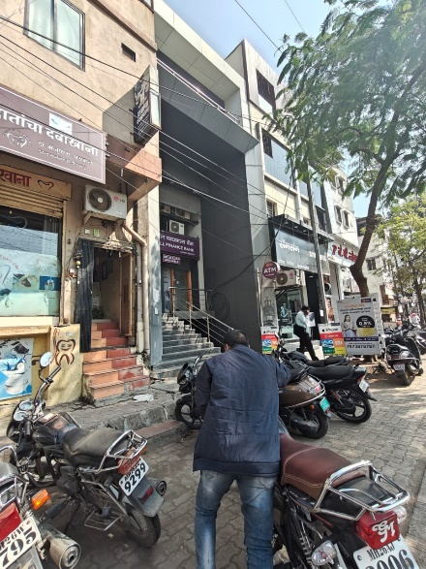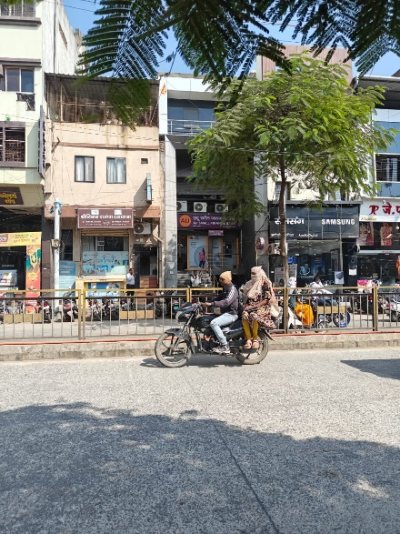

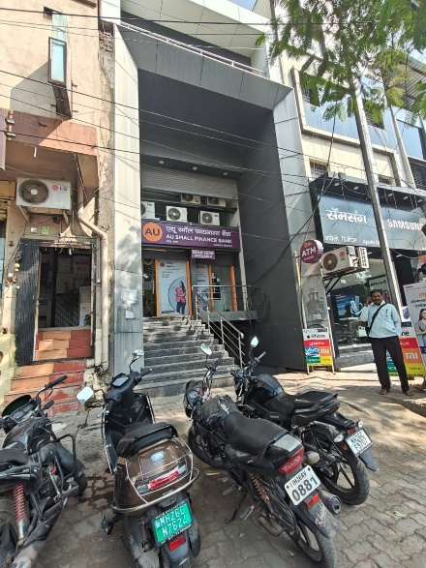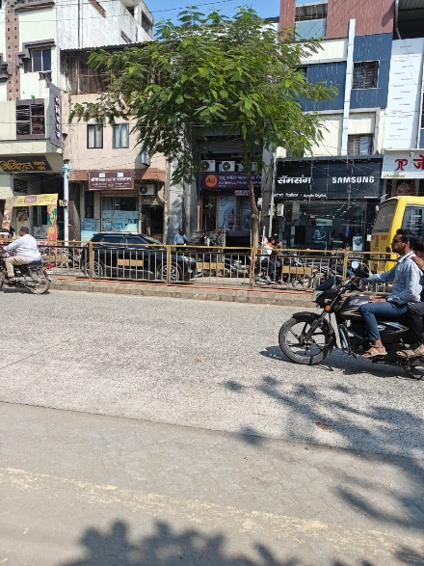 **Route Map of the Property**

# 

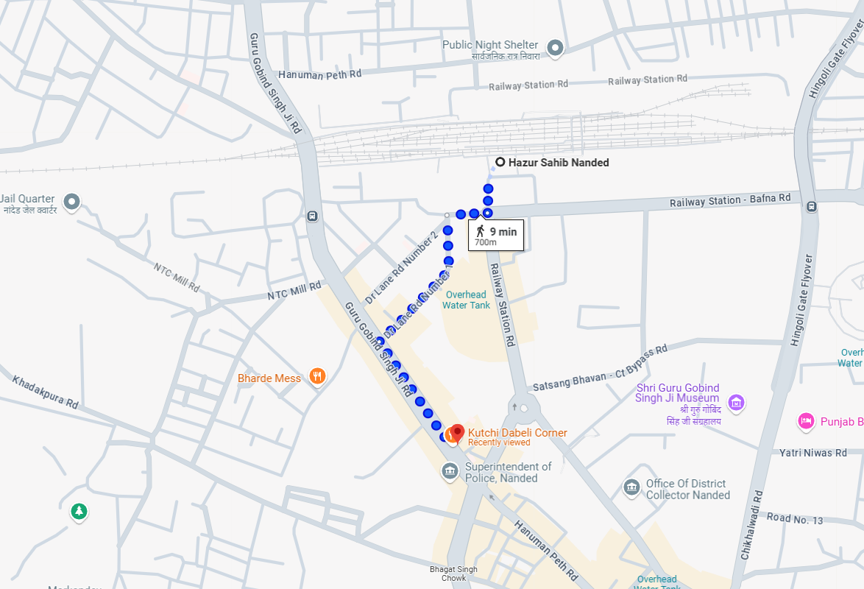

# **Longitude Latitude: 19.155364, 77.309396**

# **Note**:

* Red Pointer shows Approx. Property Location.
* 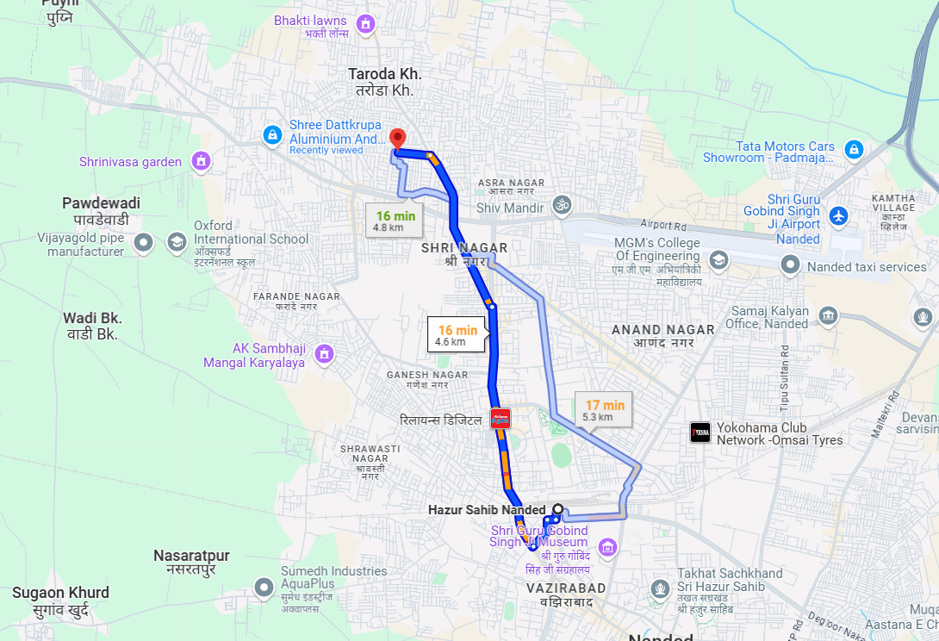 Blue line shows Route from Nanded Railway Station@ 700 Mts

**Ready Reckoner Rate**

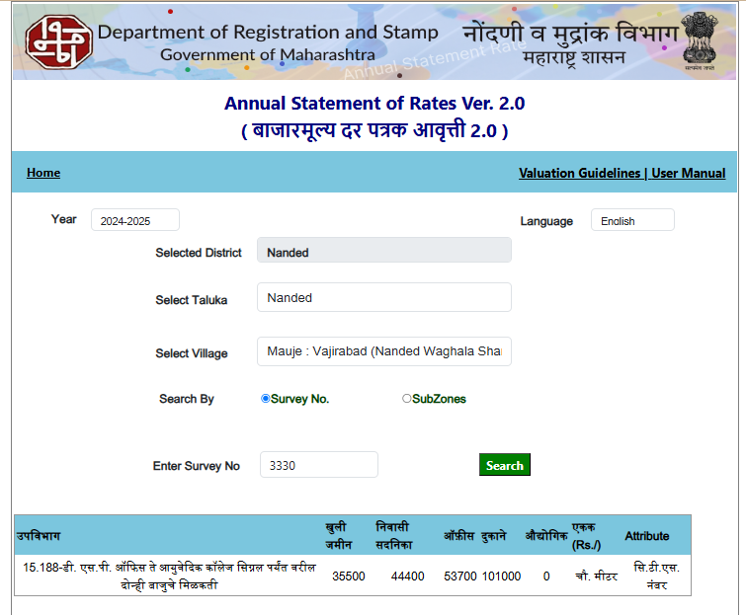

**Gmail Attachment**

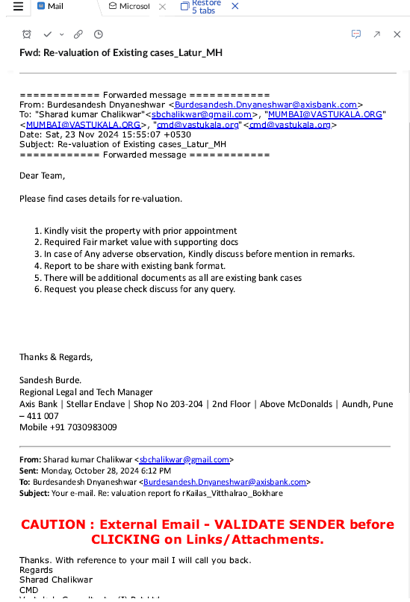

**Gmail Attachment**

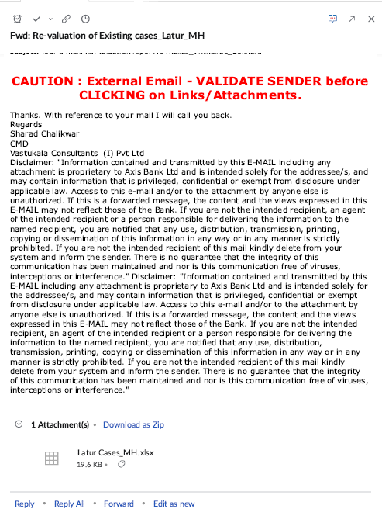

**ASSUMPTIONS, CAVEATS, LIMITATION AND DISCLAIMERS**

1. We assume no responsibility for matters of legal nature affecting the property appraised or the title thereto, nor do we render our opinion as to the title, which is assumed to be good and marketable.
2. The property is valued as though under responsible ownership.
3. It is assumed that the property is free of liens and encumbrances.
4. It is assumed that there are no hidden or unapparent conditions of the subsoil or structure that would render it more or less valuable. No responsibility is assumed for such conditions or for engineering that might be required to discover such factors.
5. The rates for valuation of the property are in accordance with the Govt. approved rates and prevailing market rates

For, **Vastukala Consultants (I) Pvt. Ltd.**

**Sharadkumar B. Chalikwar**

B.E. (Civil), M.E. (Civil), M.Sc. (Real Estate Valuation), M.Sc. (P&M Valuation), FIE (I), FIV, FIWRS

Chairman & Managing Director

Govt. Reg. Valuer

Chartered Engineer (India)

Reg. No. (N) CCIT/1-14/52/2008-09

IBBI Reg.No. IBBI/RV/07/2019/11744

Date: 06.12.2024

Place: Nanded.