Valuation Report of the Immovable Property

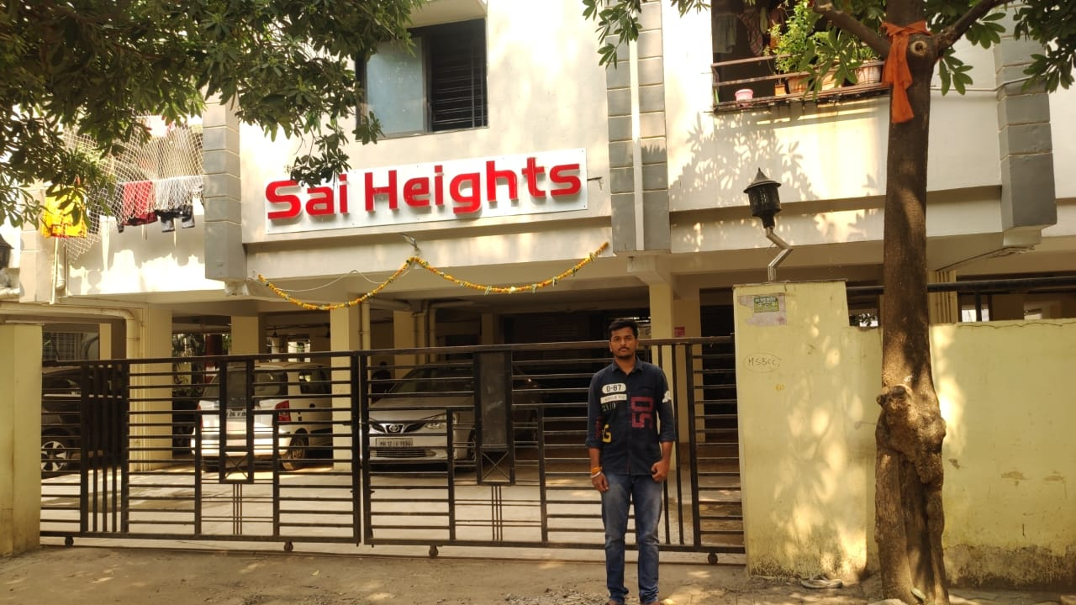

**Details of the property under consideration:**

Name of Owner: **Mr. Ramesh Balaji Yerawar**

Residential Flat No. 203, 2nd Stilt Floor, P. R. Card No. 10313(Part), **“Sai Heights”,** Anand Nagar,

Plot No. 13, 14 & 15, Survey No. 30/A/2 of Village – Asadullabad, Taluka – Nanded,

District – Nanded, PIN – 431601, Maharashtra, India.

# **Longitude Latitude: 19.197131, 77.301451**

**Valuation Done for:**

**Axis Bank**

**Kalamandir Branch**

Nikhil Heights, Vazirabad Bus Stand Road, Kalamandir, Nanded - 431601, Maharashtra, India.

# **Vastukala Consultants (I) Pvt. Ltd.**

Mumbai • Delhi NCR • Aurangabad • Nanded • Indore • Pune

Raipur • Jaipur • Ahmedabad • Rajkot • Thane • Nasik

# Vastu/Nanded/12/2024/012838/2309353

# 04/17-51-SCSK

# Date: 04.12.2024

# **VALUER’S OPINION REPORT**

This is to certify that the property bearing Residential Flat No. 203, 2nd Stilt Floor, P. R. Card No. 10313(Part), **“Sai Heights”,** Anand Nagar, Plot No. 13, 14 & 15, Survey No. 30/A/2 of Village – Asadullabad, Taluka – Nanded, District – Nanded, PIN – 431601, Maharashtra, India is belongs to **Mr. Ramesh Balaji Yerawar.**

Boundaries of the property

|  |  |
| --- | --- |
| North | Residential Building |
| South | Internal Road |
| East | Raj Residency |
| West | Open Plot |

Considering various parameters recorded, existing economic scenario, and the information that is available with reference to the development of neighborhood and method selected for valuation, we are of the opinion that, the property premises can be assessed are as under:

|  |  |
| --- | --- |
| **Fair Market Value of the Property** | **Rs. 62,09,670.00** |
| **Realizable Value** | **Rs. 55,88,703.00** |
| **Forced/ Distress Sale value.** | **Rs. 49,67,736.00** |
| **Guideline Value of the Property** | **Rs. 48,55,935.00** |

The valuation of the property is based on the documents produced by the concern. Legal aspects have not been taken into considerations while preparing this valuation report.

Hence certified

For, **Vastukala Consultants (I) Pvt. Ltd.**

**Sharadkumar B. Chalikwar**

B.E. (Civil), M.E. (Civil), M.Sc. (Real Estate Valuation), M.Sc. (P&M Valuation), FIE (I), FIV, FIWRS

Chairman & Managing Director

Govt. Reg. Valuer

Chartered Engineer (India)

Reg. No. (N) CCIT/1-14/52/2008-09

IBBI Reg.No. IBBI/RV/07/2019/11744

Encl: Valuation report.

|  |  |  |  |  |  |  |  |  |  |  |  |  |  |  |  |  |  |  |  |  |  |  |  |  |  |  |  |  |  |  |  |  |  |  |  |  |  |  |  |  |  |  |  |  |  |  |  |  |  |  |  |  |  |  |  |  |  |  |  |  |  |  |  |  |  |  |  |  |  |  |  |  |  |  |  |  |  |  |  |  |  |  |  |  |  |  |  |  |  |  |  |  |  |  |  |  |  |  |  |  |  |  |  |  |  |  |  |  |  |  |  |  |  |  |  |  |  |  |  |  |  |  |  |  |  |  |  |  |  |  |  |  |  |  |  |  |  |  |  |  |  |  |  |  |  |  |  |  |  |  |  |  |  |  |  |  |  |  |  |  |  |  |  |  |  |  |  |  |  |  |  |  |  |  |  |  |  |  |  |  |  |  |  |  |  |  |  |  |  |  |  |  |  |  |  |  |  |  |  |  |  |  |  |  |  |  |  |  |  |  |  |  |  |  |  |  |  |  |  |  |  |  |  |  |  |  |  |  |  |  |  |  |  |  |  |  |  |  |  |  |  |  |  |  |  |  |  |  |  |  |  |  |  |  |  |  |  |  |  |  |  |  |  |  |  |  |  |  |  |  |  |  |  |  |  |  |  |  |  |  |  |  |  |  |  |  |  |  |  |  |  |  |  |  |  |  |  |  |  |  |  |  |  |  |  |  |  |  |  |  |  |  |  |  |  |  |  |  |  |  |  |  |  |  |  |  |  |  |  |  |  |  |  |  |  |  |  |  |  |  |  |  |  |  |  |  |  |  |  |  |  |  |  |  |  |  |  |  |  |  |  |  |  |  |  |  |  |  |  |  |  |  |  |  |  |  |  |  |  |  |  |  |  |  |  |  |  |  |  |  |  |  |  |  |  |  |  |  |  |  |  |  |  |  |  |  |  |  |  |  |  |  |  |  |  |  |  |  |  |  |  |  |  |  |  |  |  |  |  |  |  |  |  |  |  |  |  |  |  |  |  |  |  |  |  |  |  |  |  |  |  |  |  |  |  |  |  |  |  |  |  |  |  |  |  |  |  |  |  |  |  |  |  |  |  |  |  |  |  |  |  |  |  |  |  |  |  |  |  |  |  |  |  |  |  |  |  |  |  |  |  |  |  |  |  |  |  |  |  |  |  |  |  |  |  |  |  |  |  |  |  |  |  |  |  |  |  |  |  |  |  |  |  |  |  |  |  |  |  |  |  |  |  |  |  |  |  |  |  |  |  |  |  |  |  |  |  |  |  |  |  |  |  |  |  |  |  |  |  |  |  |  |  |  |  |  |  |  |  |  |  |  |  |  |  |  |  |  |  |  |  |  |  |  |  |  |  |  |  |  |  |  |  |  |  |  |  |  |  |  |  |  |  |  |  |  |  |  |  |  |  |  |  |  |  |  |  |  |  |  |  |  |  |  |  |  |  |  |  |  |  |  |  |  |  |  |  |  |  |  |  |  |  |  |  |  |  |  |  |  |  |  |  |  |  |  |  |  |  |  |  |  |  |  |  |  |  |  |  |  |  |  |  |  |  |  |  |  |  |  |  |  |  |  |  |  |  |  |  |  |  |  |  |  |  |  |  |  |  |  |  |  |  |  |  |  |  |  |  |  |  |  |  |  |  |  |  |  |  |  |  |  |  |  |  |  |  |  |  |  |  |  |  |  |  |  |  |  |  |  |  |  |  |  |  |  |  |  |  |  |  |  |  |  |  |  |  |  |  |  |  |  |  |  |  |  |  |  |  |  |  |  |  |  |  |  |  |  |  |  |  |  |  |  |  |  |  |  |  |  |  |  |  |  |  |  |  |  |  |  |  |  |  |  |  |  |  |  |  |  |  |  |  |  |  |  |  |  |  |  |  |  |  |  |  |  |  |  |  |  |  |  |  |  |  |  |  |  |  |  |  |  |  |  |  |  |  |  |  |  |  |  |  |  |  |  |  |  |  |  |  |  |  |  |  |  |  |  |  |  |  |  |  |  |  |  |  |  |  |  |  |  |  |  |  |  |  |  |  |  |  |  |  |  |  |  |  |  |  |  |  |  |  |  |  |  |  |  |  |  |  |  |  |  |  |  |  |  |  |  |  |  |  |  |  |  |  |  |  |  |  |  |  |  |  |  |  |  |  |  |  |  |  |  |  |  |  |  |  |  |  |  |  |  |  |  |  |  |  |  |  |  |  |  |  |  |  |  |  |  |  |  |  |  |  |  |  |  |  |  |  |  |  |  |  |  |  |  |  |  |  |  |  |  |  |  |  |  |  |  |  |  |  |  |  |  |  |  |  |  |  |  |  |  |  |  |  |  |  |  |  |  |  |  |  |  |  |  |  |  |  |  |  |  |  |  |  |  |  |  |  |  |  |  |  |  |  |  |  |  |  |  |  |  |  |  |  |  |  |  |  |  |  |  |  |  |  |  |  |  |  |  |  |  |  |  |  |  |  |  |  |  |  |  |  |  |  |  |  |  |  |  |  |  |  |  |  |  |  |  |  |  |  |  |  |  |  |  |  |  |  |  |  |  |  |  |  |  |  |  |  |  |  |  |  |  |  |  |  |  |  |  |  |  |  |  |  |  |  |  |  |  |  |  |  |  |  |  |  |  |  |  |  |  |  |  |  |  |  |  |  |  |  |  |  |  |  |  |  |  |  |  |  |  |  |  |  |  |  |  |  |  |  |  |  |  |  |  |  |  |  |  |  |  |  |  |  |  |  |  |  |  |  |  |  |  |  |  |  |  |  |  |  |  |  |  |  |  |  |  |  |  |  |  |  |  |  |  |  |  |  |  |  |  |  |  |  |  |  |  |  |  |  |  |  |  |  |  |  |  |  |  |  |  |  |  |  |  |  |  |  |  |  |  |  |  |  |  |  |  |  |  |  |  |  |  |  |  |  |  |  |  |  |  |  |  |  |  |  |  |  |  |  |  |  |  |  |  |  |  |  |  |  |  |  |  |  |  |  |  |  |  |  |  |  |  |  |  |  |  |  |  |  |  |  |  |  |  |  |  |  |  |  |  |  |  |  |  |  |  |  |  |  |  |  |  |  |  |  |  |  |  |  |  |  |  |  |  |  |  |  |  |  |  |  |  |  |  |  |  |  |  |  |  |  |  |  |  |  |  |  |  |  |  |  |  |  |  |  |  |  |  |  |  |  |  |  |  |  |  |  |  |  |  |  |  |  |  |  |  |  |  |  |  |  |  |  |  |  |  |  |  |  |  |  |  |  |  |  |  |  |  |  |  |  |  |  |  |  |  |  |  |  |  |  |  |  |  |  |  |  |  |  |  |  |  |  |  |  |  |  |  |  |  |  |  |  |  |  |  |  |  |  |  |  |  |  |  |  |  |  |  |  |  |  |  |  |  |  |  |  |  |  |  |  |  |  |  |  |  |  |  |  |  |  |  |  |  |  |  |  |  |  |  |  |  |  |  |  |  |  |  |  |  |  |  |  |  |  |  |  |  |  |  |  |  |  |  |  |  |  |  |  |  |  |  |  |  |  |  |  |  |  |  |  |  |  |  |  |  |  |  |  |  |  |  |  |  |  |  |  |  |  |  |  |  |  |  |  |  |  |  |  |  |  |  |  |  |  |  |  |  |  |  |  |  |  |  |  |  |  |  |  |  |  |  |  |  |  |  |  |  |  |  |  |  |  |  |  |  |  |  |  |  |  |  |  |  |  |  |  |  |  |  |  |  |  |  |  |  |  |  |  |  |  |  |  |  |  |  |  |  |  |  |  |  |  |  |  |  |  |  |  |  |  |  |  |  |  |  |  |  |  |  |  |  |  |  |  |  |  |  |  |  |  |  |  |  |  |  |  |  |  |  |  |  |  |  |  |  |  |  |  |  |  |  |  |  |  |  |  |  |  |  |  |  |  |  |  |  |  |  |  |  |  |  |  |  |  |  |  |  |  |  |  |  |  |  |  |  |  |  |  |  |  |  |  |  |  |  |  |  |  |  |  |  |  |  |  |  |  |  |  |  |  |  |  |  |  |  |  |  |  |  |  |  |  |  |  |  |  |  |  |  |  |  |  |  |  |  |  |  |  |  |  |  |  |  |  |  |  |  |  |  |  |  |  |  |  |  |  |  |  |  |  |  |  |  |  |  |  |  |  |  |  |  |  |  |  |  |  |  |  |  |  |  |  |  |  |  |  |  |  |  |  |  |  |  |  |  |  |  |  |  |  |  |  |  |  |  |  |  |  |  |  |  |  |  |  |  |  |  |  |  |  |  |  |  |  |  |  |  |  |  |  |  |  |  |  |  |  |  |  |  |  |  |  |  |  |  |  |  |  |  |  |  |  |  |  |  |  |  |  |  |  |  |  |  |  |  |  |  |  |  |  |  |  |  |  |  |  |  |  |  |  |  |  |  |  |  |  |  |  |  |  |  |  |  |  |  |  |  |  |  |  |  |  |  |  |  |  |  |  |  |  |  |  |  |  |  |  |  |  |  |  |  |  |  |  |  |  |  |  |  |  |  |  |  |  |  |  |  |  |  |  |  |  |  |  |  |  |  |  |  |  |  |  |  |  |  |  |  |  |  |  |  |  |  |  |  |  |  |  |  |  |  |  |  |  |  |  |  |  |  |  |  |  |  |  |  |  |  |  |  |  |  |  |  |  |  |  |  |  |  |  |  |  |  |  |  |  |  |  |  |  |  |  |  |  |  |  |  |  |  |  |  |  |  |  |  |  |  |  |  |  |  |  |  |  |  |  |  |  |  |  |  |  |  |  |  |  |  |  |  |  |  |  |  |  |  |  |  |  |  |  |  |  |  |  |  |  |  |  |  |  |  |  |  |  |  |  |  |  |  |  |  |  |  |  |  |  |  |  |  |  |  |  |  |  |  |  |  |  |  |  |  |  |  |  |  |  |  |  |  |  |  |  |  |  |  |  |  |  |  |  |  |  |  |  |  |  |  |  |  |  |  |  |  |  |  |  |  |  |  |  |  |  |  |  |  |  |  |  |  |  |  |  |  |  |  |  |  |  |  |  |  |  |  |  |  |  |  |  |  |  |  |  |  |  |  |  |  |  |  |  |  |  |  |  |  |  |  |  |  |  |  |  |  |  |  |  |  |  |  |  |  |  |  |  |  |  |  |  |  |  |  |  |  |  |  |  |  |  |  |  |  |  |  |  |  |  |  |  |  |  |  |  |  |  |  |  |  |  |  |  |  |  |  |  |  |  |  |  |  |  |  |  |  |  |  |  |  |  |  |  |  |  |  |  |  |  |  |  |  |  |  |  |  |  |  |  |  |  |  |  |  |  |  |  |  |  |  |  |  |  |  |  |  |  |  |  |  |  |  |  |  |  |  |  |  |  |  |  |  |  |  |  |  |  |  |  |  |  |  |  |  |  |  |  |  |  |  |  |  |  |  |  |  |  |  |  |  |  |  |  |  |  |  |  |  |  |  |  |  |  |  |  |  |  |  |  |  |  |  |  |  |  |  |  |  |  |  |  |  |  |  |  |  |  |  |  |  |  |  |  |  |  |  |  |  |  |  |  |  |  |  |  |  |  |  |  |  |  |  |  |  |  |  |  |  |  |  |  |  |  |  |  |  |  |  |  |  |  |  |  |  |  |  |  |  |  |  |  |  |  |  |  |  |  |  |  |  |  |  |  |  |  |  |  |  |  |  |  |  |  |  |  |  |  |  |  |  |  |  |  |  |  |  |  |  |  |  |  |  |  |  |  |  |  |  |  |  |  |  |  |  |  |  |  |  |  |  |  |  |  |  |  |  |  |  |  |  |  |  |  |  |  |  |  |  |  |  |  |  |  |  |  |  |  |  |  |  |  |  |  |  |  |  |  |  |  |  |  |  |  |  |  |  |  |  |  |  |  |  |  |  |  |  |  |  |  |  |  |  |  |  |  |  |  |  |  |  |  |  |  |  |  |  |  |  |  |  |  |  |  |  |  |  |  |  |  |  |  |  |  |  |  |  |  |  |  |  |  |  |  |  |  |  |  |  |  |  |  |  |  |  |  |  |  |  |  |  |  |  |  |  |  |  |  |  |  |  |  |  |  |  |  |  |  |  |  |  |  |  |  |  |  |  |  |  |  |  |  |  |  |  |  |  |  |  |  |  |  |  |  |  |  |  |  |  |  |  |  |  |  |  |  |  |  |  |  |  |  |  |  |  |  |  |  |  |  |  |  |  |  |  |  |  |  |  |  |  |  |  |  |  |  |  |  |  |  |  |  |  |  |  |  |  |  |  |  |  |  |  |  |  |  |  |  |  |  |  |  |  |  |  |  |  |  |  |  |  |  |  |  |  |  |  |  |  |  |  |  |  |  |  |  |  |  |  |  |  |  |  |  |  |  |  |  |  |  |  |  |  |  |  |  |  |  |  |  |  |  |  |  |  |  |  |  |  |  |  |  |  |  |  |  |  |  |  |  |  |  |  |  |  |  |  |  |  |  |  |  |  |  |  |  |  |  |  |  |  |  |  |  |  |  |  |  |  |  |  |  |  |  |  |  |  |  |  |  |  |  |  |  |  |  |  |  |  |  |  |  |  |  |  |  |  |  |  |  |  |  |  |  |  |  |  |  |  |  |  |  |  |  |  |  |  |  |  |  |  |  |  |  |  |  |  |  |  |  |  |  |  |  |  |  |  |  |  |  |  |  |  |  |  |  |  |  |  |  |  |  |  |  |  |  |  |  |  |  |  |  |  |  |  |  |  |  |  |  |  |  |  |  |  |  |  |  |  |  |  |  |  |  |  |  |  |  |  |  |  |  |  |  |  |  |  |  |  |  |  |  |  |  |  |  |  |  |  |  |  |  |  |  |  |  |  |  |  |  |  |  |  |  |  |  |  |  |  |  |  |  |  |  |  |  |  |  |  |  |  |  |  |  |  |  |  |  |  |  |  |  |  |  |  |  |  |  |  |  |  |  |  |  |  |  |  |  |  |  |  |  |  |  |  |  |  |  |  |  |  |  |  |  |  |  |  |  |  |  |  |  |  |  |  |  |  |  |  |  |  |  |  |  |  |  |  |  |  |  |  |  |  |  |  |  |  |  |  |  |  |  |  |  |  |  |  |  |  |  |  |  |  |  |  |  |  |  |  |  |  |  |  |  |  |  |  |  |  |  |  |  |  |  |  |  |  |  |  |  |  |  |  |  |  |  |  |  |  |  |  |  |  |  |  |  |  |  |  |  |  |  |  |  |  |  |  |  |  |  |  |  |  |  |  |  |  |  |  |  |  |  |  |  |  |  |  |  |  |  |  |  |  |  |  |  |  |  |  |  |  |  |  |  |  |  |  |  |  |  |  |  |  |  |  |  |  |  |  |  |  |  |  |  |  |  |  |  |  |  |  |  |  |  |  |  |  |  |
| --- | --- | --- | --- | --- | --- | --- | --- | --- | --- | --- | --- | --- | --- | --- | --- | --- | --- | --- | --- | --- | --- | --- | --- | --- | --- | --- | --- | --- | --- | --- | --- | --- | --- | --- | --- | --- | --- | --- | --- | --- | --- | --- | --- | --- | --- | --- | --- | --- | --- | --- | --- | --- | --- | --- | --- | --- | --- | --- | --- | --- | --- | --- | --- | --- | --- | --- | --- | --- | --- | --- | --- | --- | --- | --- | --- | --- | --- | --- | --- | --- | --- | --- | --- | --- | --- | --- | --- | --- | --- | --- | --- | --- | --- | --- | --- | --- | --- | --- | --- | --- | --- | --- | --- | --- | --- | --- | --- | --- | --- | --- | --- | --- | --- | --- | --- | --- | --- | --- | --- | --- | --- | --- | --- | --- | --- | --- | --- | --- | --- | --- | --- | --- | --- | --- | --- | --- | --- | --- | --- | --- | --- | --- | --- | --- | --- | --- | --- | --- | --- | --- | --- | --- | --- | --- | --- | --- | --- | --- | --- | --- | --- | --- | --- | --- | --- | --- | --- | --- | --- | --- | --- | --- | --- | --- | --- | --- | --- | --- | --- | --- | --- | --- | --- | --- | --- | --- | --- | --- | --- | --- | --- | --- | --- | --- | --- | --- | --- | --- | --- | --- | --- | --- | --- | --- | --- | --- | --- | --- | --- | --- | --- | --- | --- | --- | --- | --- | --- | --- | --- | --- | --- | --- | --- | --- | --- | --- | --- | --- | --- | --- | --- | --- | --- | --- | --- | --- | --- | --- | --- | --- | --- | --- | --- | --- | --- | --- | --- | --- | --- | --- | --- | --- | --- | --- | --- | --- | --- | --- | --- | --- | --- | --- | --- | --- | --- | --- | --- | --- | --- | --- | --- | --- | --- | --- | --- | --- | --- | --- | --- | --- | --- | --- | --- | --- | --- | --- | --- | --- | --- | --- | --- | --- | --- | --- | --- | --- | --- | --- | --- | --- | --- | --- | --- | --- | --- | --- | --- | --- | --- | --- | --- | --- | --- | --- | --- | --- | --- | --- | --- | --- | --- | --- | --- | --- | --- | --- | --- | --- | --- | --- | --- | --- | --- | --- | --- | --- | --- | --- | --- | --- | --- | --- | --- | --- | --- | --- | --- | --- | --- | --- | --- | --- | --- | --- | --- | --- | --- | --- | --- | --- | --- | --- | --- | --- | --- | --- | --- | --- | --- | --- | --- | --- | --- | --- | --- | --- | --- | --- | --- | --- | --- | --- | --- | --- | --- | --- | --- | --- | --- | --- | --- | --- | --- | --- | --- | --- | --- | --- | --- | --- | --- | --- | --- | --- | --- | --- | --- | --- | --- | --- | --- | --- | --- | --- | --- | --- | --- | --- | --- | --- | --- | --- | --- | --- | --- | --- | --- | --- | --- | --- | --- | --- | --- | --- | --- | --- | --- | --- | --- | --- | --- | --- | --- | --- | --- | --- | --- | --- | --- | --- | --- | --- | --- | --- | --- | --- | --- | --- | --- | --- | --- | --- | --- | --- | --- | --- | --- | --- | --- | --- | --- | --- | --- | --- | --- | --- | --- | --- | --- | --- | --- | --- | --- | --- | --- | --- | --- | --- | --- | --- | --- | --- | --- | --- | --- | --- | --- | --- | --- | --- | --- | --- | --- | --- | --- | --- | --- | --- | --- | --- | --- | --- | --- | --- | --- | --- | --- | --- | --- | --- | --- | --- | --- | --- | --- | --- | --- | --- | --- | --- | --- | --- | --- | --- | --- | --- | --- | --- | --- | --- | --- | --- | --- | --- | --- | --- | --- | --- | --- | --- | --- | --- | --- | --- | --- | --- | --- | --- | --- | --- | --- | --- | --- | --- | --- | --- | --- | --- | --- | --- | --- | --- | --- | --- | --- | --- | --- | --- | --- | --- | --- | --- | --- | --- | --- | --- | --- | --- | --- | --- | --- | --- | --- | --- | --- | --- | --- | --- | --- | --- | --- | --- | --- | --- | --- | --- | --- | --- | --- | --- | --- | --- | --- | --- | --- | --- | --- | --- | --- | --- | --- | --- | --- | --- | --- | --- | --- | --- | --- | --- | --- | --- | --- | --- | --- | --- | --- | --- | --- | --- | --- | --- | --- | --- | --- | --- | --- | --- | --- | --- | --- | --- | --- | --- | --- | --- | --- | --- | --- | --- | --- | --- | --- | --- | --- | --- | --- | --- | --- | --- | --- | --- | --- | --- | --- | --- | --- | --- | --- | --- | --- | --- | --- | --- | --- | --- | --- | --- | --- | --- | --- | --- | --- | --- | --- | --- | --- | --- | --- | --- | --- | --- | --- | --- | --- | --- | --- | --- | --- | --- | --- | --- | --- | --- | --- | --- | --- | --- | --- | --- | --- | --- | --- | --- | --- | --- | --- | --- | --- | --- | --- | --- | --- | --- | --- | --- | --- | --- | --- | --- | --- | --- | --- | --- | --- | --- | --- | --- | --- | --- | --- | --- | --- | --- | --- | --- | --- | --- | --- | --- | --- | --- | --- | --- | --- | --- | --- | --- | --- | --- | --- | --- | --- | --- | --- | --- | --- | --- | --- | --- | --- | --- | --- | --- | --- | --- | --- | --- | --- | --- | --- | --- | --- | --- | --- | --- | --- | --- | --- | --- | --- | --- | --- | --- | --- | --- | --- | --- | --- | --- | --- | --- | --- | --- | --- | --- | --- | --- | --- | --- | --- | --- | --- | --- | --- | --- | --- | --- | --- | --- | --- | --- | --- | --- | --- | --- | --- | --- | --- | --- | --- | --- | --- | --- | --- | --- | --- | --- | --- | --- | --- | --- | --- | --- | --- | --- | --- | --- | --- | --- | --- | --- | --- | --- | --- | --- | --- | --- | --- | --- | --- | --- | --- | --- | --- | --- | --- | --- | --- | --- | --- | --- | --- | --- | --- | --- | --- | --- | --- | --- | --- | --- | --- | --- | --- | --- | --- | --- | --- | --- | --- | --- | --- | --- | --- | --- | --- | --- | --- | --- | --- | --- | --- | --- | --- | --- | --- | --- | --- | --- | --- | --- | --- | --- | --- | --- | --- | --- | --- | --- | --- | --- | --- | --- | --- | --- | --- | --- | --- | --- | --- | --- | --- | --- | --- | --- | --- | --- | --- | --- | --- | --- | --- | --- | --- | --- | --- | --- | --- | --- | --- | --- | --- | --- | --- | --- | --- | --- | --- | --- | --- | --- | --- | --- | --- | --- | --- | --- | --- | --- | --- | --- | --- | --- | --- | --- | --- | --- | --- | --- | --- | --- | --- | --- | --- | --- | --- | --- | --- | --- | --- | --- | --- | --- | --- | --- | --- | --- | --- | --- | --- | --- | --- | --- | --- | --- | --- | --- | --- | --- | --- | --- | --- | --- | --- | --- | --- | --- | --- | --- | --- | --- | --- | --- | --- | --- | --- | --- | --- | --- | --- | --- | --- | --- | --- | --- | --- | --- | --- | --- | --- | --- | --- | --- | --- | --- | --- | --- | --- | --- | --- | --- | --- | --- | --- | --- | --- | --- | --- | --- | --- | --- | --- | --- | --- | --- | --- | --- | --- | --- | --- | --- | --- | --- | --- | --- | --- | --- | --- | --- | --- | --- | --- | --- | --- | --- | --- | --- | --- | --- | --- | --- | --- | --- | --- | --- | --- | --- | --- | --- | --- | --- | --- | --- | --- | --- | --- | --- | --- | --- | --- | --- | --- | --- | --- | --- | --- | --- | --- | --- | --- | --- | --- | --- | --- | --- | --- | --- | --- | --- | --- | --- | --- | --- | --- | --- | --- | --- | --- | --- | --- | --- | --- | --- | --- | --- | --- | --- | --- | --- | --- | --- | --- | --- | --- | --- | --- | --- | --- | --- | --- | --- | --- | --- | --- | --- | --- | --- | --- | --- | --- | --- | --- | --- | --- | --- | --- | --- | --- | --- | --- | --- | --- | --- | --- | --- | --- | --- | --- | --- | --- | --- | --- | --- | --- | --- | --- | --- | --- | --- | --- | --- | --- | --- | --- | --- | --- | --- | --- | --- | --- | --- | --- | --- | --- | --- | --- | --- | --- | --- | --- | --- | --- | --- | --- | --- | --- | --- | --- | --- | --- | --- | --- | --- | --- | --- | --- | --- | --- | --- | --- | --- | --- | --- | --- | --- | --- | --- | --- | --- | --- | --- | --- | --- | --- | --- | --- | --- | --- | --- | --- | --- | --- | --- | --- | --- | --- | --- | --- | --- | --- | --- | --- | --- | --- | --- | --- | --- | --- | --- | --- | --- | --- | --- | --- | --- | --- | --- | --- | --- | --- | --- | --- | --- | --- | --- | --- | --- | --- | --- | --- | --- | --- | --- | --- | --- | --- | --- | --- | --- | --- | --- | --- | --- | --- | --- | --- | --- | --- | --- | --- | --- | --- | --- | --- | --- | --- | --- | --- | --- | --- | --- | --- | --- | --- | --- | --- | --- | --- | --- | --- | --- | --- | --- | --- | --- | --- | --- | --- | --- | --- | --- | --- | --- | --- | --- | --- | --- | --- | --- | --- | --- | --- | --- | --- | --- | --- | --- | --- | --- | --- | --- | --- | --- | --- | --- | --- | --- | --- | --- | --- | --- | --- | --- | --- | --- | --- | --- | --- | --- | --- | --- | --- | --- | --- | --- | --- | --- | --- | --- | --- | --- | --- | --- | --- | --- | --- | --- | --- | --- | --- | --- | --- | --- | --- | --- | --- | --- | --- | --- | --- | --- | --- | --- | --- | --- | --- | --- | --- | --- | --- | --- | --- | --- | --- | --- | --- | --- | --- | --- | --- | --- | --- | --- | --- | --- | --- | --- | --- | --- | --- | --- | --- | --- | --- | --- | --- | --- | --- | --- | --- | --- | --- | --- | --- | --- | --- | --- | --- | --- | --- | --- | --- | --- | --- | --- | --- | --- | --- | --- | --- | --- | --- | --- | --- | --- | --- | --- | --- | --- | --- | --- | --- | --- | --- | --- | --- | --- | --- | --- | --- | --- | --- | --- | --- | --- | --- | --- | --- | --- | --- | --- | --- | --- | --- | --- | --- | --- | --- | --- | --- | --- | --- | --- | --- | --- | --- | --- | --- | --- | --- | --- | --- | --- | --- | --- | --- | --- | --- | --- | --- | --- | --- | --- | --- | --- | --- | --- | --- | --- | --- | --- | --- | --- | --- | --- | --- | --- | --- | --- | --- | --- | --- | --- | --- | --- | --- | --- | --- | --- | --- | --- | --- | --- | --- | --- | --- | --- | --- | --- | --- | --- | --- | --- | --- | --- | --- | --- | --- | --- | --- | --- | --- | --- | --- | --- | --- | --- | --- | --- | --- | --- | --- | --- | --- | --- | --- | --- | --- | --- | --- | --- | --- | --- | --- | --- | --- | --- | --- | --- | --- | --- | --- | --- | --- | --- | --- | --- | --- | --- | --- | --- | --- | --- | --- | --- | --- | --- | --- | --- | --- | --- | --- | --- | --- | --- | --- | --- | --- | --- | --- | --- | --- | --- | --- | --- | --- | --- | --- | --- | --- | --- | --- | --- | --- | --- | --- | --- | --- | --- | --- | --- | --- | --- | --- | --- | --- | --- | --- | --- | --- | --- | --- | --- | --- | --- | --- | --- | --- | --- | --- | --- | --- | --- | --- | --- | --- | --- | --- | --- | --- | --- | --- | --- | --- | --- | --- | --- | --- | --- | --- | --- | --- | --- | --- | --- | --- | --- | --- | --- | --- | --- | --- | --- | --- | --- | --- | --- | --- | --- | --- | --- | --- | --- | --- | --- | --- | --- | --- | --- | --- | --- | --- | --- | --- | --- | --- | --- | --- | --- | --- | --- | --- | --- | --- | --- | --- | --- | --- | --- | --- | --- | --- | --- | --- | --- | --- | --- | --- | --- | --- | --- | --- | --- | --- | --- | --- | --- | --- | --- | --- | --- | --- | --- | --- | --- | --- | --- | --- | --- | --- | --- | --- | --- | --- | --- | --- | --- | --- | --- | --- | --- | --- | --- | --- | --- | --- | --- | --- | --- | --- | --- | --- | --- | --- | --- | --- | --- | --- | --- | --- | --- | --- | --- | --- | --- | --- | --- | --- | --- | --- | --- | --- | --- | --- | --- | --- | --- | --- | --- | --- | --- | --- | --- | --- | --- | --- | --- | --- | --- | --- | --- | --- | --- | --- | --- | --- | --- | --- | --- | --- | --- | --- | --- | --- | --- | --- | --- | --- | --- | --- | --- | --- | --- | --- | --- | --- | --- | --- | --- | --- | --- | --- | --- | --- | --- | --- | --- | --- | --- | --- | --- | --- | --- | --- | --- | --- | --- | --- | --- | --- | --- | --- | --- | --- | --- | --- | --- | --- | --- | --- | --- | --- | --- | --- | --- | --- | --- | --- | --- | --- | --- | --- | --- | --- | --- | --- | --- | --- | --- | --- | --- | --- | --- | --- | --- | --- | --- | --- | --- | --- | --- | --- | --- | --- | --- | --- | --- | --- | --- | --- | --- | --- | --- | --- | --- | --- | --- | --- | --- | --- | --- | --- | --- | --- | --- | --- | --- | --- | --- | --- | --- | --- | --- | --- | --- | --- | --- | --- | --- | --- | --- | --- | --- | --- | --- | --- | --- | --- | --- | --- | --- | --- | --- | --- | --- | --- | --- | --- | --- | --- | --- | --- | --- | --- | --- | --- | --- | --- | --- | --- | --- | --- | --- | --- | --- | --- | --- | --- | --- | --- | --- | --- | --- | --- | --- | --- | --- | --- | --- | --- | --- | --- | --- | --- | --- | --- | --- | --- | --- | --- | --- | --- | --- | --- | --- | --- | --- | --- | --- | --- | --- | --- | --- | --- | --- | --- | --- | --- | --- | --- | --- | --- | --- | --- | --- | --- | --- | --- | --- | --- | --- | --- | --- | --- | --- | --- | --- | --- | --- | --- | --- | --- | --- | --- | --- | --- | --- | --- | --- | --- | --- | --- | --- | --- | --- | --- | --- | --- | --- | --- | --- | --- | --- | --- | --- | --- | --- | --- | --- | --- | --- | --- | --- | --- | --- | --- | --- | --- | --- | --- | --- | --- | --- | --- | --- | --- | --- | --- | --- | --- | --- | --- | --- | --- | --- | --- | --- | --- | --- | --- | --- | --- | --- | --- | --- | --- | --- | --- | --- | --- | --- | --- | --- | --- | --- | --- | --- | --- | --- | --- | --- | --- | --- | --- | --- | --- | --- | --- | --- | --- | --- | --- | --- | --- | --- | --- | --- | --- | --- | --- | --- | --- | --- | --- | --- | --- | --- | --- | --- | --- | --- | --- | --- | --- | --- | --- | --- | --- | --- | --- | --- | --- | --- | --- | --- | --- | --- | --- | --- | --- | --- | --- | --- | --- | --- | --- | --- | --- | --- | --- | --- | --- | --- | --- | --- | --- | --- | --- | --- | --- | --- | --- | --- | --- | --- | --- | --- | --- | --- | --- | --- | --- | --- | --- | --- | --- | --- | --- | --- | --- | --- | --- | --- | --- | --- | --- | --- | --- | --- | --- | --- | --- | --- | --- | --- | --- | --- | --- | --- | --- | --- | --- | --- | --- | --- | --- | --- | --- | --- | --- | --- | --- | --- | --- | --- | --- | --- | --- | --- | --- | --- | --- | --- | --- | --- | --- | --- | --- | --- | --- | --- | --- | --- | --- | --- | --- | --- | --- | --- | --- | --- | --- | --- | --- | --- | --- | --- | --- | --- | --- | --- | --- | --- | --- | --- | --- | --- | --- | --- | --- | --- | --- | --- | --- | --- | --- | --- | --- | --- | --- | --- | --- | --- | --- | --- | --- | --- | --- | --- | --- | --- | --- | --- | --- | --- | --- | --- | --- | --- | --- | --- | --- | --- | --- | --- | --- | --- | --- | --- | --- | --- | --- | --- | --- | --- | --- | --- | --- | --- | --- | --- | --- | --- | --- | --- | --- | --- | --- | --- | --- | --- | --- | --- | --- | --- | --- | --- | --- | --- | --- | --- | --- | --- | --- | --- | --- | --- | --- | --- | --- | --- | --- | --- | --- | --- | --- | --- | --- | --- | --- | --- | --- | --- | --- | --- | --- | --- | --- | --- | --- | --- | --- | --- | --- | --- | --- | --- | --- | --- | --- | --- | --- | --- | --- | --- | --- | --- | --- | --- | --- | --- | --- | --- | --- | --- | --- | --- | --- | --- | --- | --- | --- | --- | --- | --- | --- | --- | --- | --- | --- | --- | --- | --- | --- | --- | --- | --- | --- | --- | --- | --- | --- | --- | --- | --- | --- | --- | --- | --- | --- | --- | --- | --- | --- | --- | --- | --- | --- | --- | --- | --- | --- | --- | --- | --- | --- | --- | --- | --- | --- | --- | --- | --- | --- | --- | --- | --- | --- | --- | --- | --- | --- | --- | --- | --- | --- | --- | --- | --- | --- | --- | --- | --- | --- | --- | --- | --- | --- | --- | --- | --- | --- | --- | --- | --- | --- | --- | --- | --- | --- | --- | --- | --- | --- | --- | --- | --- | --- | --- | --- | --- | --- | --- | --- | --- | --- | --- | --- | --- | --- | --- | --- | --- | --- | --- | --- | --- | --- | --- | --- | --- | --- | --- | --- | --- | --- | --- | --- | --- | --- | --- | --- | --- | --- | --- | --- | --- | --- | --- | --- | --- | --- | --- | --- | --- | --- | --- | --- | --- | --- | --- | --- | --- | --- | --- | --- | --- | --- | --- | --- | --- | --- | --- | --- | --- | --- | --- | --- | --- | --- | --- | --- | --- | --- | --- | --- | --- | --- | --- | --- | --- | --- | --- | --- | --- | --- | --- | --- | --- | --- | --- | --- | --- | --- | --- | --- | --- | --- | --- | --- | --- | --- | --- | --- | --- | --- | --- | --- | --- | --- | --- | --- | --- | --- | --- | --- | --- | --- | --- | --- | --- | --- | --- | --- | --- | --- | --- | --- | --- | --- | --- | --- | --- | --- | --- | --- | --- | --- | --- | --- | --- | --- | --- | --- | --- | --- | --- | --- | --- | --- | --- | --- | --- | --- | --- | --- | --- | --- | --- | --- | --- | --- | --- | --- | --- | --- | --- | --- | --- | --- | --- | --- | --- | --- | --- | --- | --- | --- | --- | --- | --- | --- | --- | --- | --- | --- | --- | --- | --- | --- | --- | --- | --- | --- | --- | --- | --- | --- | --- | --- | --- | --- | --- | --- | --- | --- | --- | --- | --- | --- | --- | --- | --- | --- | --- | --- | --- | --- | --- | --- | --- | --- | --- | --- | --- | --- | --- | --- | --- | --- | --- | --- | --- | --- | --- | --- | --- | --- | --- | --- | --- | --- | --- | --- | --- | --- | --- | --- | --- | --- | --- | --- | --- | --- | --- | --- | --- | --- | --- | --- | --- | --- | --- | --- | --- | --- | --- | --- | --- | --- | --- | --- | --- | --- | --- | --- | --- | --- | --- | --- | --- | --- | --- | --- | --- | --- | --- | --- | --- | --- | --- | --- | --- | --- | --- | --- | --- | --- | --- | --- | --- | --- | --- | --- | --- | --- | --- | --- | --- | --- | --- | --- | --- | --- | --- | --- | --- | --- | --- | --- | --- | --- | --- | --- | --- | --- | --- | --- | --- | --- | --- | --- | --- | --- | --- | --- | --- | --- | --- | --- | --- | --- | --- | --- | --- | --- | --- | --- | --- | --- | --- | --- | --- | --- | --- | --- | --- | --- | --- | --- | --- | --- | --- | --- | --- | --- | --- | --- | --- | --- | --- | --- | --- | --- | --- | --- | --- | --- | --- | --- | --- | --- | --- | --- | --- | --- | --- | --- | --- | --- | --- | --- | --- | --- | --- | --- | --- | --- | --- | --- | --- | --- | --- | --- | --- | --- | --- | --- | --- | --- | --- | --- | --- | --- | --- | --- | --- | --- | --- | --- | --- | --- | --- | --- | --- | --- | --- | --- | --- | --- | --- | --- | --- | --- | --- | --- | --- | --- | --- | --- | --- | --- | --- | --- | --- | --- | --- | --- | --- | --- | --- | --- | --- | --- | --- | --- | --- | --- | --- | --- | --- | --- | --- | --- | --- | --- | --- | --- | --- | --- | --- | --- | --- | --- | --- | --- | --- | --- | --- | --- | --- | --- | --- | --- | --- | --- | --- | --- | --- | --- | --- | --- | --- | --- | --- | --- | --- | --- | --- | --- | --- | --- | --- | --- | --- | --- | --- | --- | --- | --- | --- | --- | --- | --- | --- | --- | --- | --- | --- | --- | --- | --- | --- | --- | --- | --- | --- | --- | --- | --- | --- | --- | --- | --- | --- | --- | --- | --- | --- | --- | --- | --- | --- | --- | --- | --- | --- | --- | --- | --- | --- | --- | --- | --- | --- | --- | --- | --- | --- | --- | --- | --- | --- | --- | --- | --- | --- | --- | --- | --- | --- | --- | --- | --- | --- | --- | --- | --- | --- | --- | --- | --- | --- | --- | --- | --- | --- | --- | --- | --- | --- | --- | --- | --- | --- | --- | --- | --- | --- | --- | --- | --- | --- | --- | --- | --- | --- | --- | --- | --- | --- | --- | --- | --- | --- | --- | --- | --- | --- | --- | --- | --- | --- | --- | --- | --- | --- | --- | --- | --- | --- | --- | --- | --- | --- | --- | --- | --- | --- | --- | --- | --- | --- | --- | --- | --- | --- | --- | --- | --- | --- | --- | --- | --- | --- | --- | --- | --- | --- | --- | --- | --- | --- | --- | --- | --- | --- | --- | --- | --- | --- | --- | --- | --- | --- | --- | --- | --- | --- | --- | --- | --- | --- | --- | --- | --- | --- | --- | --- | --- | --- | --- | --- | --- | --- | --- | --- | --- |
| **VALUATION REPORT (IN RESPECT OF RESIDENTIAL FLAT)**   |  |  |  |  |  |  |  |  |  |  |  |  |  |  |  |  |  |  |  |  |  |  |  |  |  |  |  |  |  |  |  |  |  |  | | --- | --- | --- | --- | --- | --- | --- | --- | --- | --- | --- | --- | --- | --- | --- | --- | --- | --- | --- | --- | --- | --- | --- | --- | --- | --- | --- | --- | --- | --- | --- | --- | --- | --- | | 1. | | CBB/CCMC/CCSU | | |  | | | | | | | | | | | | | Assignment No | | | | | | | |  | | | | | | | | | 2. | | Name of Owner & Address: | | | | | | | | | | | | | | | | **Mr. Ramesh Balaji Yerawar**  Residential Flat No. 203, 2nd Stilt Floor, P. R. Card No. 10313(Part), **“Sai Heights”,** Anand Nagar, Plot No. 13, 14 & 15, Survey No. 30/A/2 of Village – Asadullabad, Taluka – Nanded, District – Nanded, PIN – 431601, Maharashtra, India. | | | | | | | | | | | | | | | | |  | | Name of Borrower & Address | | | | | | | | | | | | | | | | **Mr. Ramesh Balaji Yerawar**  Residential Flat No. 203, 2nd Stilt Floor, P. R. Card No. 10313(Part), **“Sai Heights”,** Anand Nagar, Plot No. 13, 14 & 15, Survey No. 30/A/2 of Village – Asadullabad, Taluka – Nanded, District – Nanded, PIN – 431601, Maharashtra, India. | | | | | | | | | | | | | | | | | 3. | | Name of the Bank Official Present | | | | | | | | | | | | | | | | **No.** | | | | | | | | | | | | | | | | | Name of the Representative & Mobile No. | | | | | | | | | | | | | | | | **Mr. Ramesh Balaji Yerawar**  Contact No.: 9423709472 | | | | | | | | | | | | | | | | | **4.** | | **Details of the Property Being Valued** | | | | | | | | | | | | | | | | | | | | | | | | | | | | | | | | | 4.1 | | Description of the Property | | | | | | | | | | | | | | **Stilt + 3 Upper Floors** | | | | | | | | | | | | | | | | | | | 4.2 | | Location of Property | | | | | | | | | | | | | | Residential Flat No. 203, 2nd Stilt Floor, P. R. Card No. 10313(Part), **“Sai Heights”,** Anand Nagar, Plot No. 13, 14 & 15, Survey No. 30/A/2 of Village – Asadullabad, Taluka – Nanded, District – Nanded, PIN – 431601, Maharashtra, India | | | | | | | | | | | | | | | | | | | (Rural / Semi Urban / Urban) | | | | | | | | | | | | | | Urban. | | | | | | | | | | | | | | | | | | | 4.3 | | Documents Provided:   1. Copy of Deed of Declaration dated 11.01.2011 between M/s. Sai Developers through its Partners Shri. Harish P. Mohandas Lalwani & Shri. Sunil P. Ramakant Jonnawar (the Builders) AND Mr. Ramesh Balaji Yerawar (the Purchasers). 2. Copy of Sauda Chitthi dated 16.08.2011 between M/s. Sai Developers through its Partners Shri. Harish P. Mohandas Lalwani & Shri. Sunil P. Ramakant Jonnawar (the Builders) AND Mr. Ramesh Balaji Yerawar (the Purchasers). 3. Copy of Sale Deed No. 10021/2011 dated 29.09.2011 between M/s. Sai Developers through its Partners Shri. Harish P. Mohandas Lalwani & Shri. Sunil P. Ramakant Jonnawar (the Builders) AND Mr. Ramesh Balaji Yerawar (the Purchasers). 4. Copy of Construction Permission No. NWCMNC / NRV / 119 / A / 10 dated 05.06.2010 issued by Nanded – Waghala City Municipal Corporation. 5. Copy of Construction Commencement Certificate No. NWCMNC / NRV / 119 / B / 10 dated 05.06.2010 issued by Nanded – Waghala City Municipal Corporation. 6. Copy of Approved Plan No. 119 / BP dated 05.06.2010 issued by Nanded – Waghala City Municipal Corporation. 7. Copy of Property Tax Receipt No. 17 dated 02.12.2023 in the name of Mr. Ramesh Balaji Yerawar issued by Nanded – Waghala City Municipal Corporation. | | | | | | | | | | | | | | | | | | | | | | | | | | | | | | | | | 4.4 | | Plot No / Survey No. / Gut No. / Khasra No: | | | | | | Plot No. 13, 14 & 15, Survey No. 30/A/2 of Village – Asadullabad | | | | | | | | | | | | | Road | | | | | | Bhagya Nagar Road | | | | | | | | 4.5 | | Colony / Nagar / Sector | | | | | | Anand Nagar | | | | | | | | | | | | | Locality / Landmark | | | | | | Near Raj Residency | | | | | | | | 4.6 | | Village/Town/City | | | | | | Asadullabad | | | | | | | | | | | | | District: | | | | | | Nanded | | | | | | | | 4.7 | | State | | | | | | Maharashtra | | | | | | | | | | | | | Pin code: | | | | | | 431601 | | | | | | | | 4.8 | | Distance from Area Office | | | | | | | | | | | | | | | | | | | 2.4 Km. | | | | | | | | | | | | | | **5.** | | **Type of Property** | | | | | | | | | | | | | | | | | | | | | | | | | | | | | | | | |  | | **(A) Plot:** (Residential / Commercial / Industrial) | | | | | | | | | | | | | | | | | | | | Residential | | | | | | | | | | | | | Level of land with topographical conditions | | | | | | | | | | | | | | | | | | | | Levelled | | | | | | | | | | | | | Whether situated in Municipal / Corporation Limit | | | | | | | | | | | | | | | | | | | | Corporation | | | | | | | | | | | | | Any construction observed on plot | | | | | | | | | | | | | | | | | | | | Stilt + 3 Upper Floors Residential Building | | | | | | | | | | | | | **(B) Residential Property: (**Independent house / Bungalow / Row House / Flat) | | | | | | | | | | | | | | | | | | | | Flat | | | | | | | | | | | | | Civic Amenities like school, hospital, market, etc. (Available, within the radius of Km./ Not Available) | | | | | | | | | | | | | | | | | | | | All available nearby. | | | | | | | | | | | | | **(C) Commercial / Industrial Property: (**Office / Shop / Unit in a Mall / Gowdown) | | | | | | | | | | | | | | | | | | | | No | | | | | | | | | | | | | **6.** | | **Accessibility / Boundaries / Others** | | | | | | | | | | | | | | | | | | | | | | | | | | | | | | | | | 6.1 | | Availability of local transport (Metro / Local Train / Bus / Personal Transport) | | | | | | | | | | | | | | | | | | Local Transport, Bus Stand, Railway Station. | | | | | | | | | | | | | | | 6.2 | | Distance from Nanded Railway station 2.4 Kms. | | | | | | | | | | | | | | | | | | Bus stop/ Taxi/ Auto Stand 500 M. | | | | | | | | | | | | | | | 6.3 | | Does the approach road to the Property / Building is independent and accessible | | | | | | | | | | | | Yes | | | | | | Will it be able to accommodate a fire extinguisher | | | | | | | | | | | | | No | | 6.4 | | Does the property fall under land locked area | | | | | | | | | | | | No | | | | | | Does the property fall in a community dominated area | | | | | | | | | | | | | No | | 6.5 | | Cornered / Intermittent Plot | | | | | | | | | | | | | | | | | | Intermittent. | | | | | | | | | | | | | | | **6.6** | | **Boundaries** | **As Per Site** | | | | | | | | | | | | | | | | | **As Per Sale Deed (Flat Boundaries)** | | | | | | | | | | | | | | |  | | **North** | Residential Building | | | | | | | | | | | | | | | | | Flat No. 202 | | | | | | | | | | | | | | | **South** | Internal Road | | | | | | | | | | | | | | | | | Road & Open Space | | | | | | | | | | | | | | | **East** | Raj Residency | | | | | | | | | | | | | | | | | Open Space | | | | | | | | | | | | | | | **West** | Open Plot | | | | | | | | | | | | | | | | | Flat No. 204 | | | | | | | | | | | | | | | 6.7 | | Class of locality (Posh / Higher Middle Class / Middle Class / Lower Middle Class / Poor) | | | | | | | | | | | | | | | | | | Middle Class | | | | | | | | | | | | | | | 6.8 | | Quality of Infrastructure in the vicinity (Excellent / Good / Average / Poor) | | | | | | | | | | | | | | | | | | Good | | | | | | | | | | | | | | | 6.9 | | Ownership Status of the Property (Free Hold / Reg. Lease / Govt. Authority) | | | | | | | | | | | | | | | | | | Freehold | | | | | | | | | | | | | | | 6.10 | | Approved usage of property (Industrial / Commercial / Residential / Mix) | | | | | | | | | | Residential | | | | | | | | Actual usage of property (Industrial / Commercial / Residential / Mix) | | | | | | | | | | | Residential | | | | 6.11 | | Restrictive covenants in regards to Land Use, (if any) | | | | | | | | | | | | | | | | | | Residential. | | | | | | | | | | | | | | | 6.12 | | Type of Structure (Load Bearing / RCC / Alu form shuttering) | | | | | | | | | | | | | | | | | | RCC Framed Structure | | | | | | | | | | | | | | | 6.13 | | Number of floors | | | | | | | As per Actual | | | | | | | | | | | Stilt + 3 Upper Floors | | | | | | | | | | | | | | | As per Sanctioned Plan | | | | | | | | | | | Stilt + 3 Upper Floors | | | | | | | | | | | | | | | 6.14 | | Occupancy Details (Owner Occupied / Rented / Vacant) | | | | | | | | | | | | | | | | | | Owner Occupied | | | | | | | | | | | | | | | **7.** | | **If the property is on rent:** | | | | | | | | | | | | | | | | | | | | | | | | | | | | | | | | | 7.1 | | Name of tenant / lease & Number of years in tenancy | | | | | | | | | | | | | | | | | N.A. | | | | | | | | | | | | | | | | 7.2 | | Was there any resistance for valuation: No | | | | | | | | | | | | | | | | | If yes, from the current occupants: N.A. | | | | | | | | | | | | | | | | 7.3 | | Does property have basic amenities | | | | | | | | Yes. | | | | | | | | | Development of surrounding area Underdeveloped / Developing / Developed | | | | | | | | | | | | | Developed | | | **8.** | | **If the property is Leasehold** | | | | | | | | | | | | | | | | | | | | | | | | | | | | | | | | | 8.1 | | Name of Lesser: N.A. | | | | | | | Nature of Lease: N.A. | | | | | | | | | | | | | | | | | | | | | | | | | | 8.2 | | Total Period of Lease: N.A. | | | | | | | If yes, from the current occupants: N.A. | | | | | | | | | | | | | | | | | | | | | | | | | | 8.3 | | Does property have basic amenities | | | | No. | | | Development of surrounding area Underdeveloped / Developing / Developed | | | | | | | | | | | | | | | | | | | Developed. | | | | | | | **9.** | | **Approval Details** | | | | | | | | | | | | | | | | | | | | | | | | | | | | | | | | | 9.1 | | RERA Registration Number: Not Applicable | | | | | | | | | | | | | | | Occupancy Certificate: Not Provided | | | | | | | | | | | | | | | | | | 9.2 | | Layout Approval Number: | | | | | | | | | | | | | | | Copy of Approved Plan No. 119 / BP dated 05.06.2010 issued by Nanded – Waghala City Municipal Corporation. | | | | | | | | | | | | | | | | | | Date of Approval | | | | | | | | | | | | | | | | Expiry Date | | | | | | | | | | | | | | | | 9.3 | | Building Plan Approval Number: | | | | | | | | | | | | | | | Copy of Approved Plan No. 119 / BP dated 05.06.2010 issued by Nanded – Waghala City Municipal Corporation. | | | | | | | | | | | | | | | | | | Date of Approval | | | | | | | | | | | | | | | | Expiry Date | | | | | | | | | | | | | | | | **10.** | | **Construction Details** | | | | | | | | | | | | | | | | | | | | | | | | | | | | | | | | | 10.1 | | Area of the Flat No. 203 As per Sauda Chitthi | | | | | | | | | | | | | | | | | **As Sale Deed & Deed of Declaration Total Area is 1,047.00 Sq. Ft. and Saleable Area is 1,347.00 Sq. Ft.** | | | | | | | | | | | | | | | | 10.2 | | Carpet Area | | | | | | | | | | | | | | | | | **-** | | | | | | | | | | | | | | | | 10.4 | | Demarcation at Site | | | | | | | | | | | | | | | | | **Yes** | | | | | | | | | | | | | | | | 10.5 | | Area Considered for Valuation | | | | | | | | | | | | | | | | | **As Sale Deed & Deed of Declaration Total Area is 1,047.00 Sq. Ft. and Saleable Area is 1,347.00 Sq. Ft. same is considered for valuation.** | | | | | | | | | | | | | | | | **10.6** | | **Floor wise break up as follows** | | | | | | | | | | | | | | | | | **Current Usage** | | | | | | | | | | | | | | | |  | | **Flat No.** | | **As per Sale Deed** | | | | | | | **As per Deed of Declaration** | | | | | | | | (Storage / Parking / Commercial / Residential) | | | | | | | | | | | | | | | | **Flat No. 203** | | **51.37** | | | | | | | **51.37 Sqm** | | | | | | | | Residential | | | | | | | | | | | | | | | | 10.7 | | Amenities Details (if any): | | | | | | | | | | | | | | | | | No. | | | | | | | | | | | | | | | | 10.8 | | Floor Space Index permissible.  (Max Building Potential on Plot + Ancillary FSI 60% As per UDCPR 2020) | | | | | | | | | | | | | | | | | 1.40 | | | | | | | | | | | | | | | |  | | Actually utilized F.S.I. | | | | | | | | | | | | | | | | | * It is an Apartment building. | | | | | | | | | | | | | | | | 10.9 | | Whether the construction is as per approved  building plan and / or local building bye laws: | | | | | | | | | | | | | | | | | * No. * Whereas developer has Declared the Saleable area in Deed of Declaration * Valuation is done for **"As is where is condition"** for the Saleable Area available as per Deed of Declaration. | | | | | | | | | | | | | | | | 10.10 | | Details of Extra Construction | | | | | | | | | | | | | | | | | N.A. | | | | | | | | | | | | | | | | 10.11 | | Percentage of Extra Construction | | | | | | | | | | | | | | | | | N.A. | | | | | | | | | | | | | | | | 10.12 | | Whether the extra construction is Compoundable OR Non-Compoundable? | | | | | | | | | | | | | | | | | Compoundable. | | | | | | | | | | | | | | | | 10.13 | | Quality of construction | | | | | | | | | | | Good. | | | | | | | | | | | | | | | | | | | | | | 10.14 | | Maintenance of the Property | | | | | | | | | | | Well maintained. | | | | | | | | | | | | | | | | | | | | | | 10.15 | | Condition of Building | | | | | | | | | | | Good | | | | | | | | | | | | | | | | | | | | | | 10.16 | | Current Life of the structure | | | | | 13 years. | | | | | | Projected Future Life of the Structure | | | | | | | | | | 47 Years. | | | | | | | | | | | | 10.17 | | Land Revenue / Taxes Paid upto (for Land) | | | | | Details not available | | | | | | Municipal Taxes Paid up to (for Flat) | | | | | | | | | | Tax Amount in Rs. 6,316.00, Tax Paid Receipt No. 17, dated 02.12.2023, PIN No. 4020119198. | | | | | | | | | | | | **11.** | | **Fair Market Value of Flat** | | | | | | | | | | | | | | | | | | | | | | | | | | | | | | | | |  | | **Particulars** | | | | | | | | | | | | | **Area in Sq. Ft.** | | | | | | | | | **Rate in Rs.** | | | | | **Value in Rs.** | | | | | | 1 | | **Flat No. 203** | | | | | | | | | | | | | **1,347.00** | | | | | | | | | **5,000.00** | | | | | **67,35,000.00** | | | | | | 2 | | **Depreciation:** 19.50 %  **(**1,347.00 Sq. Ft. x Rs. 2,000.00 x 19.50%) | | | | | | | | | | | | |  | | | | | | | | |  | | | | | - 5,25,330.00 | | | | | | 3 | | **TOTAL** (1-2) | | | | | | | | | | | | |  | | | | | | | | |  | | | | | **62,09,670.00** | | | | | | **12.** | | **Details of Amenities** | | | | | | | | | | | | | **No.** | | | | | | | | | | | | | | | | | | | | **13.** | | **Government Guideline value** | | | | | | | | | | | | | | | | | | | | | | | | | | | | | | | | |  | | **Particulars** | | | | | | | | | | | | | **Area in Sq. Ft.** | | | | | | | | | **Rate in Rs.** | | | | | **Value in Rs.** | | | | | | 1 | | **Flat No. 203** | | | | | | | | | | | | | **1,347.00** | | | | | | | | | **3,995.00** | | | | | **53,81,265.00** | | | | | | 2 | | **Depreciation:** 19.50 %  **(**1,347.00 Sq. Ft. x Rs. 2,000.00 x 19.50%) | | | | | | | | | | | | |  | | | | | | | | |  | | | | | - 5,25,330.00 | | | | | | 3 | | **TOTAL** (1-2) | | | | | | | | | | | | |  | | | | | | | | |  | | | | | **48,55,935.00** | | | | | |  | | | | | | | | | | | | | | | | | | | | | | | | | | | | | | | | | | | 14. | **Value of the Property** | | | | | | | | | | | | | | | | | | | | | | | | | | | | | | | | | |  |  | | | | | | | | | | | | | | **Flat No. 203** | | | | | | | | | | **Amenities** | | | | | **Total** | | | | | Government Guideline value | | | | | | | | | | | | | | **48,55,935.00** | | | | | | | | | | Nil | | | | | **48,55,935.00** | | | | | Market Value | | | | | | | | | | | | | | **62,09,670.00** | | | | | | | | | | Nil | | | | | **62,09,670.00** | | | | | Distressed/Forced Sale Value | | | | | | | | | | | | | |  | | | | | | | | | |  | | | | | **55,88,703.00** | | | | | Realizable Value | | | | | | | | | | | | | |  | | | | | | | | | |  | | | | | **49,67,736.00** | | | | | **Remarks** | | | | | | | | | | | | | | | | | | | | | | | | | | | | | | | | | | * Whereas developer has Declared the Saleable area in Deed of Declaration & Same is Considered for Valuation. * Valuation is done for **"As is where is condition"** for the Saleable Area available as per Deed of Declaration. | | | | | | | | | | | | | | | | | | | | | | | | | | | | | | | | |   **Undertaking:**   1. I have our representative, has inspected the subject property on 08.11.2024 visited the property & identified the same based on the documents provided. 2. I/We have no direct or Indirect interest in the property being valued. 3. The information furnished above is true and correct to my/our knowledge 4. I/ we have not been dismissed or removed from govt. Service or convicted of an offence connected with any proceedings of income tax act, wealth tax act or gift tax act or have been blacklisted by any bank/ financial institution/ govt. Department/ public sector enterprise/ body corporate etc. 5. This valuation is prepared without any prejudice or bias to any person or institution. 6. The value of land is taken into account by making due enquires in the locality and ascertaining the sales value of the properties in the locality. 7. Any additions/alterations made to the property after the date of valuations shall not fall under the scope of this report.   For, **Vastukala Consultants (I) Pvt. Ltd.**  **Sharadkumar B. Chalikwar**  B.E. (Civil), M.E. (Civil), M.Sc. (Real Estate Valuation), M.Sc. (P&M Valuation), FIE (I), FIV, FIWRS  Chairman & Managing Director  Govt. Reg. Valuer  Chartered Engineer (India)  Reg. No. (N) CCIT/1-14/52/2008-09  IBBI Reg.No. IBBI/RV/07/2019/11744  Date: 09.12.2024   |  |  |  | | --- | --- | --- | | **Attachments** | | | | Photographs of the Property from inside & outside | : | Attached | | Location sketch for the property: | : | Attached | | Geo Tagging | : | Attached | | Topography | : | Leveled Land | | Government Value Document | : | Attached | |

**Actual Site Photographs**

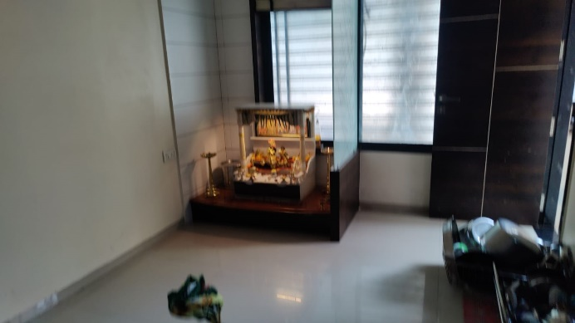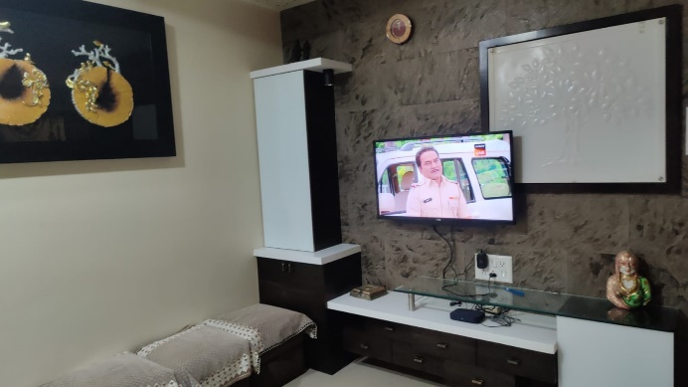

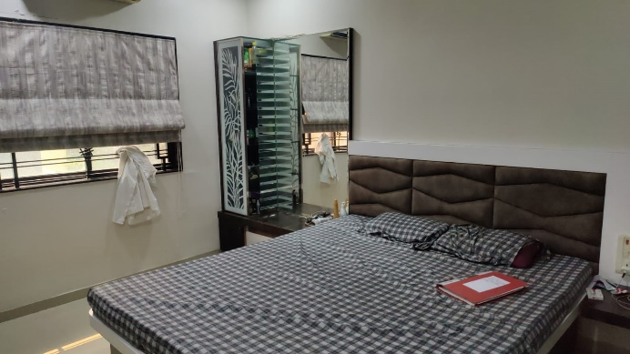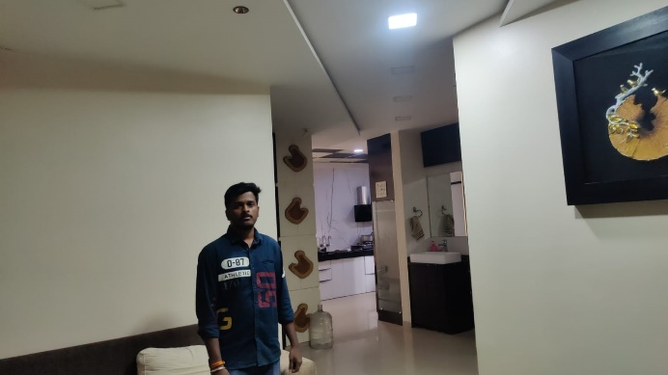

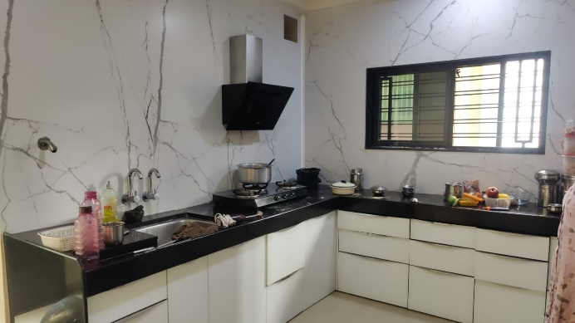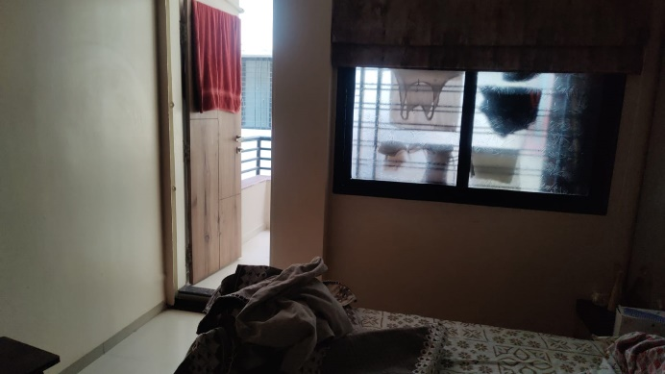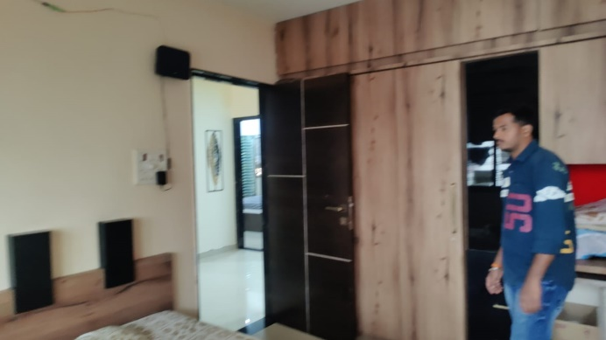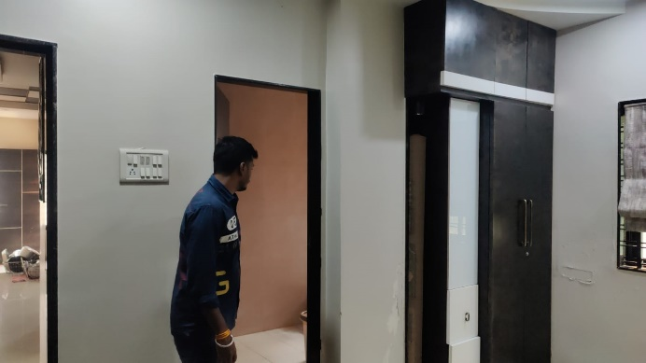

**Actual Site Photographs**

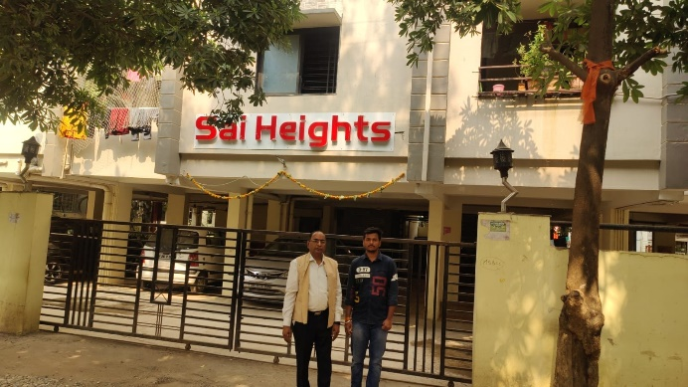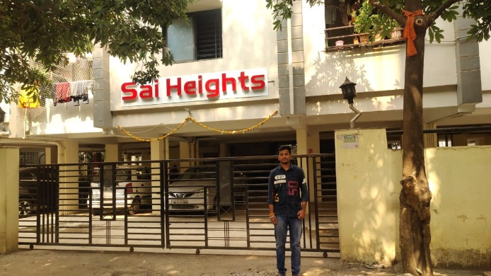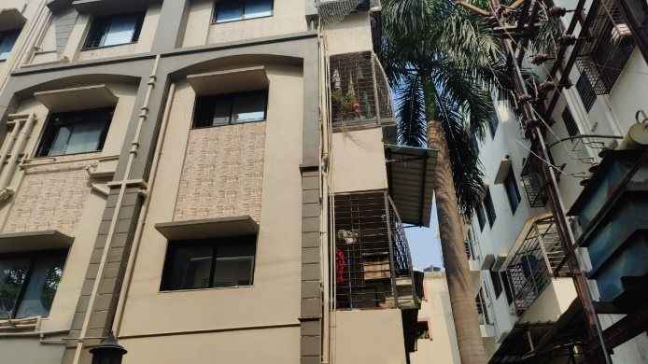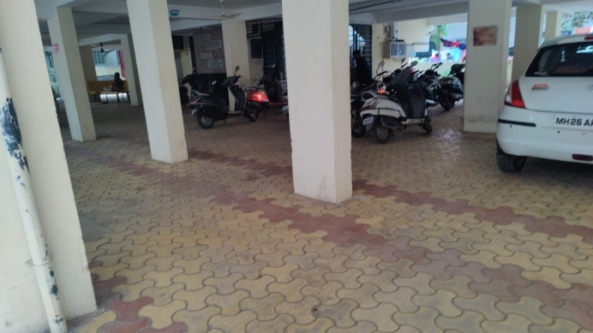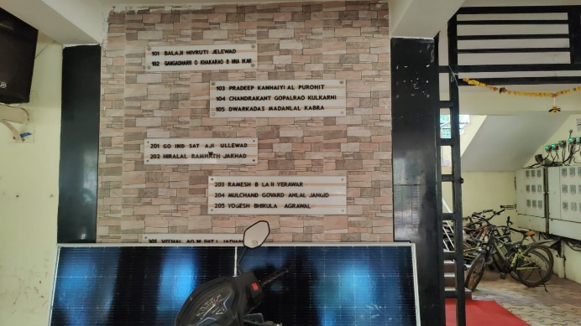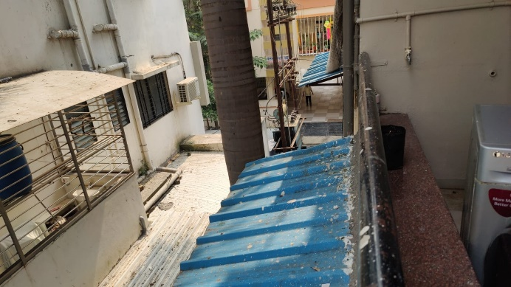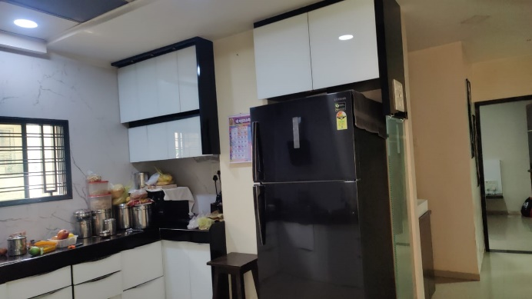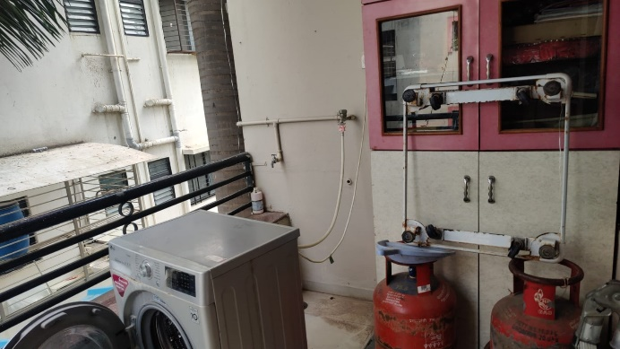

**Route Map of the Property**

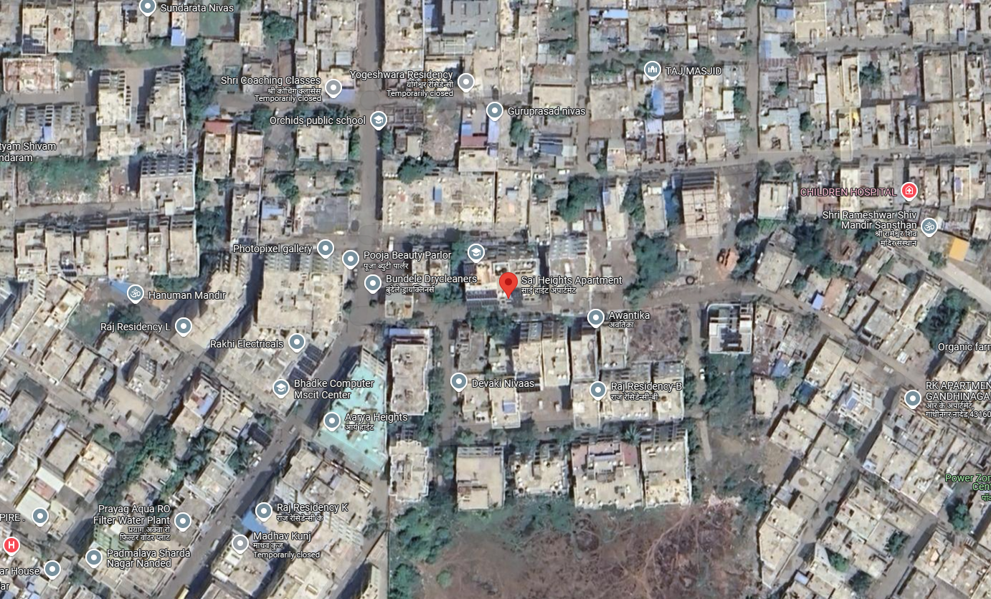

# 

# **Longitude Latitude: 19.197131, 77.301451**

**Note**:

* Red rectangle shows Approx. Property Location.
* Blue line shows Route from Nanded Railway Station @ 2.4 Km.

**Ready Reckoner Rate**

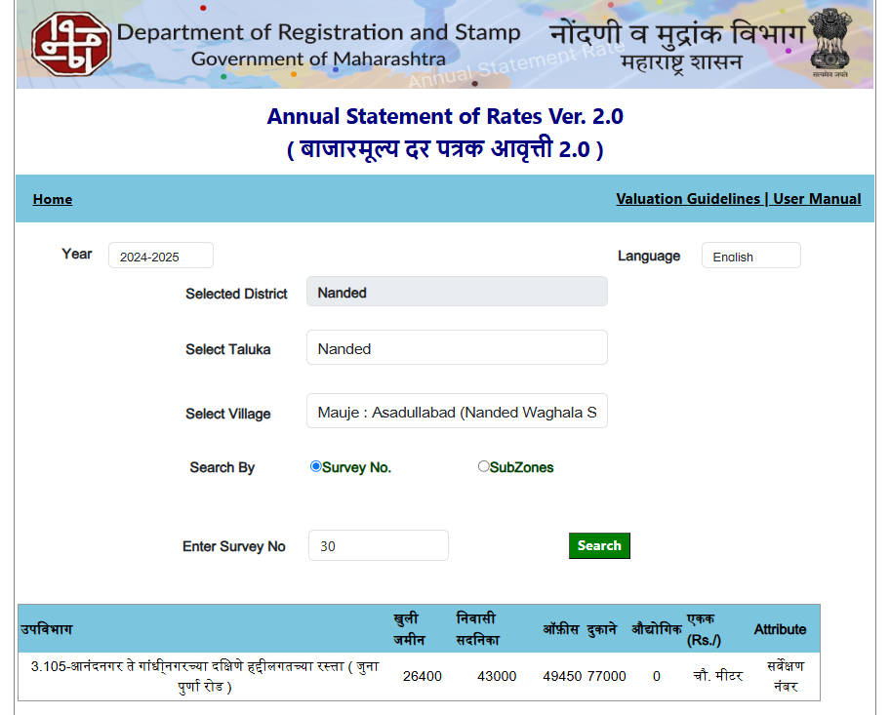

**ASSUMPTIONS, CAVEATS, LIMITATION AND DISCLAIMERS**

1. We assume no responsibility for matters of legal nature affecting the property appraised or the title thereto, nor do we render our opinion as to the title, which is assumed to be good and marketable.
2. The property is valued as though under responsible ownership.
3. It is assumed that the property is free of liens and encumbrances.
4. It is assumed that there are no hidden or unapparent conditions of the subsoil or structure that would render it more or less valuable. No responsibility is assumed for such conditions or for engineering that might be required to discover such factors.
5. The rates for valuation of the property are in accordance with the Govt. approved rates and prevailing market rates

For, **Vastukala Consultants (I) Pvt. Ltd.**

**Sharadkumar B. Chalikwar**

B.E. (Civil), M.E. (Civil), M.Sc. (Real Estate Valuation), M.Sc. (P&M Valuation), FIE (I), FIV, FIWRS

Chairman & Managing Director

Govt. Reg. Valuer

Chartered Engineer (India)

Reg. No. (N) CCIT/1-14/52/2008-09

IBBI Reg.No. IBBI/RV/07/2019/11744

Date: 09.12.2024

Place: Nanded.