Valuation Report of the Immovable Property

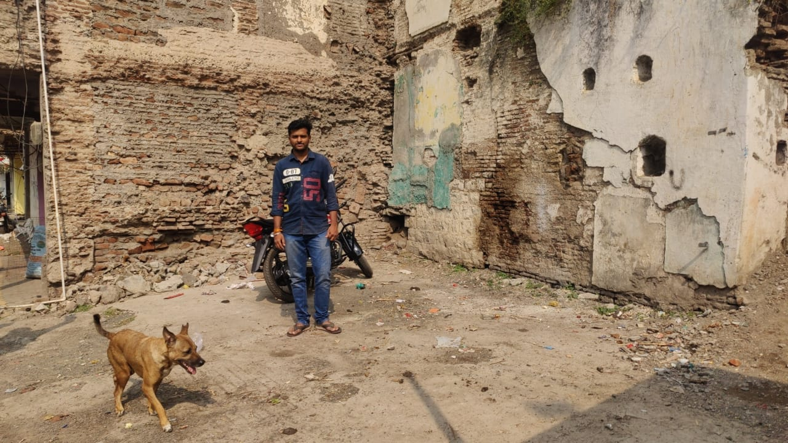

**Details of the property under consideration:**

Name of Client: **Mr. Ramesh Balaji Yerawar & Mr. Madhav Gangadhar Shiramwar**

Land bearing on C.T.S. No. 123 of Village - Nanded, Municipal No. 5-4-84, PIN No. 4030501318,

Bhojalal Chowk, Marwad Galli, Sarafa, Nanded – 431601, Maharashtra, India.

# **Longitude Latitude: 19.145069, 77.324923**

**Intended User:**

**Axis Bank**

**Kalamandir Branch**

Nikhil Heights, Vazirabad Bus Stand Road, Kalamandir, Nanded - 431601, Maharashtra, India.

# **Vastukala Consultants (I) Pvt. Ltd.**

Mumbai • Delhi NCR • Aurangabad • Nanded • Indore • Pune

Raipur • Jaipur • Ahmedabad • Rajkot • Thane • Nasik

# Vastu/Nanded/12/2024/012837/2309483

# 09/19-181-SCSK

# Date: 09.12.2024

# **VALUER’S OPINION REPORT**

This is to certify that the property Land bearing on C.T.S. No. 123 of Village - Nanded, Municipal No. 5-4-84, PIN No. 4030501318, Bhojalal Chowk, Marwad Galli, Sarafa, Nanded – 431601, Maharashtra, India belonging to  **Mr. Ramesh Balaji Yerawar & Mr. Madhav Gangadhar Shiramwar.**

Boundaries of the property

|  |  |
| --- | --- |
| North | House of Sow. Kalpana B. Shri Ram Kulathya & Sow. Kiran Shrikishan Kulathya |
| South | House of Shri. Gokuldas Govindprasad Sangi |
| East | House of Smt. Jankibai Bhairubhagat Dangi |
| West | 60’0” Main Road |

Considering various parameters recorded, existing economic scenario, and the information that is available with reference to the development of neighborhood and method selected for valuation, we are of the opinion that, the property premises can be assessed are as under:

|  |  |
| --- | --- |
| **Fair Market Value of the Property** | **Rs. 1,00,00,000.00** |
| **Realizable Value** | **Rs. 90,00,000.00** |
| **Forced/ Distress Sale value.** | **Rs. 80,00,000.00** |
| **Guideline Value of the Property** | **Rs. 1,79,335.00** |

The valuation of the property is based on the documents produced by the concern. Legal aspects have not been taken into considerations while preparing this valuation report.

Hence certified

For, **Vastukala Consultants (I) Pvt. Ltd.**

**Sharadkumar B. Chalikwar**

B.E. (Civil), M.E. (Civil), M.Sc. (Real Estate Valuation), M.Sc. (P&M Valuation), FIE (I), FIV, FIWRS

Chairman & Managing Director

Govt. Reg. Valuer

Chartered Engineer (India)

Reg. No. (N) CCIT/1-14/52/2008-09

IBBI Reg.No. IBBI/RV/07/2019/11744

Encl: Valuation report.

|  |  |  |  |  |  |  |  |  |  |  |  |  |  |  |  |  |  |  |  |  |  |  |  |  |  |  |  |  |  |  |  |  |  |  |  |  |  |  |  |  |  |  |  |  |  |  |  |  |  |  |  |  |  |  |  |  |  |  |  |  |  |  |  |  |  |  |  |  |  |  |  |  |  |  |  |  |  |  |  |  |  |  |  |  |  |  |  |  |  |  |  |  |  |  |  |  |  |  |  |  |  |  |  |  |  |  |  |  |  |  |  |  |  |  |  |  |  |  |  |  |  |  |  |  |  |  |  |  |  |  |  |  |  |  |  |  |  |  |  |  |  |  |  |  |  |  |  |  |  |  |  |  |  |  |  |  |  |  |  |  |  |  |  |  |  |  |  |  |  |  |  |  |  |  |  |  |  |  |  |  |  |  |  |  |  |  |  |  |  |  |  |  |  |  |  |  |  |  |  |  |  |  |  |  |  |  |  |  |  |  |  |  |  |  |  |  |  |  |  |  |  |  |  |  |  |  |  |  |  |  |  |  |  |  |  |  |  |  |  |  |  |  |  |  |  |  |  |  |  |  |  |  |  |  |  |  |  |  |  |  |  |  |  |  |  |  |  |  |  |  |  |  |  |  |  |  |  |  |  |  |  |  |  |  |  |  |  |  |  |  |  |  |  |  |  |  |  |  |  |  |  |  |  |  |  |  |  |  |  |  |  |  |  |  |  |  |  |  |  |  |  |  |  |  |  |  |  |  |  |  |  |  |  |  |  |  |  |  |  |  |  |  |  |  |  |  |  |  |  |  |  |  |  |  |  |  |  |  |  |  |  |  |  |  |  |  |  |  |  |  |  |  |  |  |  |  |  |  |  |  |  |  |  |  |  |  |  |  |  |  |  |  |  |  |  |  |  |  |  |  |  |  |  |  |  |  |  |  |  |  |  |  |  |  |  |  |  |  |  |  |  |  |  |  |  |  |  |  |  |  |  |  |  |  |  |  |  |  |  |  |  |  |  |  |  |  |  |  |  |  |  |  |  |  |  |  |  |  |  |  |  |  |  |  |  |  |  |  |  |  |  |  |  |  |  |  |  |  |  |  |  |  |  |  |  |  |  |  |  |  |  |  |  |  |  |  |  |  |  |  |  |  |  |  |  |  |  |  |  |  |  |  |  |  |  |  |  |  |  |  |  |  |  |  |  |  |  |  |  |  |  |  |  |  |  |  |  |  |  |  |  |  |  |  |  |  |  |  |  |  |  |  |  |  |  |  |  |  |  |  |  |  |  |  |  |  |  |  |  |  |  |  |  |  |  |  |  |  |  |  |  |  |  |  |  |  |  |  |  |  |  |  |  |  |  |  |  |  |  |  |  |  |  |  |  |  |  |  |  |  |  |  |  |  |  |  |  |  |  |  |  |  |  |  |  |  |  |  |  |  |  |  |  |  |  |  |  |  |  |  |  |  |  |  |  |  |  |  |  |  |  |  |  |  |  |  |  |  |  |  |  |  |  |  |  |  |  |  |  |  |  |  |  |  |  |  |  |  |  |  |  |  |  |  |  |  |  |  |  |  |  |  |  |  |  |  |  |  |  |  |  |  |  |  |  |  |  |  |  |  |  |  |  |  |  |  |  |  |  |  |  |  |  |  |  |  |  |  |  |  |  |  |  |  |  |  |  |  |  |  |  |  |  |  |  |  |  |  |  |  |  |  |  |  |  |  |  |  |  |  |  |  |  |  |  |  |  |  |  |  |  |  |  |  |  |  |  |  |  |  |  |  |  |  |  |  |  |  |  |  |  |  |  |  |  |  |  |  |  |  |  |  |  |  |  |  |  |  |  |  |  |  |  |  |  |  |  |  |  |  |  |  |  |  |  |  |  |  |  |  |  |  |  |  |  |  |  |  |  |  |  |  |  |  |  |  |  |  |  |  |  |  |  |  |  |  |  |  |  |  |  |  |  |  |  |  |  |  |  |  |  |  |  |  |  |  |  |  |  |  |  |  |  |  |  |  |  |  |  |  |  |  |  |  |  |  |  |  |  |  |  |  |  |  |  |  |  |  |  |  |  |  |  |  |  |  |  |  |  |  |  |  |  |  |  |  |  |  |  |  |  |  |  |  |  |  |  |  |  |  |  |  |  |  |  |  |  |  |  |  |  |  |  |  |  |  |  |  |  |  |  |  |  |  |  |  |  |  |  |  |  |  |  |  |  |  |  |  |  |  |  |  |  |  |  |  |  |  |  |  |  |  |  |  |  |  |  |  |  |  |  |  |  |  |  |  |  |  |  |  |  |  |  |  |  |  |  |  |  |  |  |  |  |  |  |  |  |  |  |  |  |  |  |  |  |  |  |  |  |  |  |  |  |  |  |  |  |  |  |  |  |  |  |  |  |  |  |  |  |  |  |  |  |  |  |  |  |  |  |  |  |  |  |  |  |  |  |  |  |  |  |  |  |  |  |  |  |  |  |  |  |  |  |  |  |  |  |  |  |  |  |  |  |  |  |  |  |  |  |  |  |  |  |  |  |  |  |  |  |  |  |  |  |  |  |  |  |  |  |  |  |  |  |  |  |  |  |  |  |  |  |  |  |  |  |  |  |  |  |  |  |  |  |  |  |  |  |  |  |  |  |  |  |  |  |  |  |  |  |  |  |  |  |  |  |  |  |  |  |  |  |  |  |  |  |  |  |  |  |  |  |  |  |  |  |  |  |  |  |  |  |  |  |  |  |  |  |  |  |  |  |  |  |  |  |  |  |  |  |  |  |  |  |  |  |  |  |  |  |  |  |  |  |  |  |  |  |  |  |  |  |  |  |  |  |  |  |  |  |  |  |  |  |  |  |  |  |  |  |  |  |  |  |  |  |  |  |  |  |  |  |  |  |  |  |  |  |  |  |  |  |  |  |  |  |  |  |  |  |  |  |  |  |  |  |  |  |  |  |  |  |  |  |  |  |  |  |  |  |  |  |  |  |  |  |  |  |  |  |  |  |  |  |  |  |  |  |  |  |  |  |  |  |  |  |  |  |  |  |  |  |  |  |  |  |  |  |  |  |  |  |  |  |  |  |  |  |  |  |  |  |  |  |  |  |  |  |  |  |  |  |  |  |  |  |  |  |  |  |  |  |  |  |  |  |  |  |  |  |  |  |  |  |  |  |  |  |  |  |  |  |  |  |  |  |  |  |  |  |  |  |  |  |  |  |  |  |  |  |  |  |  |  |  |  |  |  |  |  |  |  |  |  |  |  |  |  |  |  |  |  |  |  |  |  |  |  |  |  |  |  |  |  |  |  |  |  |  |  |  |  |  |  |  |  |  |  |  |  |  |  |  |  |  |  |  |  |  |  |  |  |  |  |  |  |  |  |  |  |  |  |  |  |  |  |  |  |  |  |  |  |  |  |  |  |  |  |  |  |  |  |  |  |  |  |  |  |  |  |  |  |  |  |  |  |  |  |  |  |  |  |  |  |  |  |  |  |  |  |  |  |  |  |  |  |  |  |  |  |  |  |  |  |  |  |  |  |  |  |  |  |  |  |  |  |  |  |  |  |  |  |  |  |  |  |  |  |  |  |  |  |  |  |  |  |  |  |  |  |  |  |  |  |  |  |  |  |  |  |  |  |  |  |  |  |  |  |  |  |  |  |  |  |  |  |  |  |  |  |  |  |  |  |  |  |  |  |  |  |  |  |  |  |  |  |  |  |  |  |  |  |  |  |  |  |  |  |  |  |  |  |  |  |  |  |  |  |  |  |  |  |  |  |  |  |  |  |  |  |  |  |  |  |  |  |  |  |  |  |  |  |  |  |  |  |  |  |  |  |  |  |  |  |  |  |  |  |  |  |  |  |  |  |  |  |  |  |  |  |  |  |  |  |  |  |  |  |  |  |  |  |  |  |  |  |  |  |  |  |  |  |  |  |  |  |  |  |  |  |  |  |  |  |  |  |  |  |  |  |  |  |  |  |  |  |  |  |  |  |  |  |  |  |  |  |  |  |  |  |  |  |  |  |  |  |  |  |  |  |  |  |  |  |  |  |  |  |  |  |  |  |  |  |  |  |  |  |  |  |  |  |  |  |  |  |  |  |  |  |  |  |  |  |  |  |  |  |  |  |  |  |  |  |  |  |  |  |  |  |  |  |  |  |  |  |  |  |  |  |  |  |  |  |  |  |  |  |  |  |  |  |  |  |  |  |  |  |  |  |  |  |  |  |  |  |  |  |  |  |  |  |  |  |  |  |  |  |  |  |  |  |  |  |  |  |  |  |  |  |  |  |  |  |  |  |  |  |  |  |  |  |  |  |  |  |  |  |  |  |  |  |  |  |  |  |  |  |  |  |  |  |  |  |  |  |  |  |  |  |  |  |  |  |  |  |  |  |  |  |  |  |  |  |  |  |  |  |  |  |  |  |  |  |  |  |  |  |  |  |  |  |  |  |  |  |  |  |  |  |  |  |  |  |  |  |  |  |  |  |  |  |  |  |  |  |  |  |  |  |  |  |  |  |  |  |  |  |  |  |  |  |  |  |  |  |  |  |  |  |  |  |  |  |  |  |  |  |  |  |  |  |  |  |  |  |  |  |  |  |  |  |  |  |  |  |  |  |  |  |  |  |  |  |  |  |  |  |  |  |  |  |  |  |  |  |  |  |  |  |  |  |  |  |  |  |  |  |  |  |  |  |  |  |  |  |  |  |  |  |  |  |  |  |  |  |  |  |  |  |  |  |  |  |  |  |  |  |  |  |  |  |  |  |  |  |  |  |  |  |  |  |  |  |  |  |  |  |  |  |  |  |  |  |  |  |  |  |  |  |  |  |  |  |  |  |  |  |  |  |  |  |  |  |  |  |  |  |  |  |  |  |  |  |  |  |  |  |  |  |  |  |  |  |  |  |  |  |  |  |  |  |  |  |  |  |  |  |  |  |  |  |  |  |  |  |  |  |  |  |  |  |  |  |  |  |  |  |  |  |  |  |  |  |  |  |  |  |  |  |  |  |  |  |  |  |  |  |  |  |  |  |  |  |  |  |  |  |  |  |  |  |  |  |  |  |  |  |  |  |  |  |  |  |  |  |  |  |  |  |  |  |  |  |  |  |  |  |  |  |  |  |  |  |  |  |  |  |  |  |  |  |  |  |  |  |  |  |  |  |  |  |  |  |  |  |  |  |  |  |  |  |  |  |  |  |  |  |  |  |  |  |  |  |  |  |  |  |  |  |  |  |  |  |  |  |  |  |  |  |  |  |  |  |  |  |  |  |  |  |  |  |  |  |  |  |  |  |  |  |  |  |  |  |  |  |  |  |  |  |  |  |  |  |  |  |  |  |  |  |  |  |  |  |  |  |  |  |  |  |  |  |  |  |  |  |  |  |  |  |  |  |  |  |  |  |  |  |  |  |  |  |  |  |  |  |  |  |  |  |  |  |  |  |  |  |  |  |  |  |  |  |  |  |  |  |  |  |  |  |  |  |  |  |  |  |  |  |  |  |  |  |  |  |  |  |  |  |  |  |  |  |  |  |  |  |  |  |  |  |  |  |  |  |  |  |  |  |  |  |  |  |  |  |  |  |  |  |  |  |  |  |  |  |  |  |  |  |  |  |  |  |  |  |  |  |  |  |  |  |  |  |  |  |  |  |  |  |  |  |  |  |  |  |  |  |  |  |  |  |  |  |  |  |  |  |  |  |  |  |  |  |  |  |  |  |  |  |  |  |  |  |  |  |  |  |  |  |  |  |  |  |  |  |  |  |  |  |  |  |  |  |  |  |  |  |  |  |  |  |  |  |  |  |  |  |  |  |  |  |  |  |  |  |  |  |  |  |  |  |  |  |  |  |  |  |  |  |  |  |  |  |  |  |  |  |  |  |  |  |  |  |  |  |  |  |  |  |  |  |  |  |  |  |  |  |  |  |  |  |  |  |  |  |  |  |  |  |  |  |  |  |  |  |  |  |  |  |  |  |  |  |  |  |  |  |  |  |  |  |  |  |  |  |  |  |  |  |  |  |  |  |  |  |  |  |  |  |  |  |  |  |  |  |  |  |  |  |  |  |  |  |  |  |  |  |  |  |  |  |  |  |  |  |  |  |  |  |  |  |  |  |  |  |  |  |  |  |  |  |  |  |  |  |  |  |  |  |  |  |  |  |  |  |  |  |  |  |  |  |  |  |  |  |  |  |  |  |  |  |  |  |  |  |  |  |  |  |  |  |  |  |  |  |  |  |  |  |  |  |  |  |  |  |  |  |  |  |  |  |  |  |  |  |  |  |  |  |  |  |  |  |  |  |  |  |  |  |  |  |  |  |  |  |  |  |  |  |  |  |  |  |  |  |  |  |  |  |  |  |  |  |  |  |  |  |  |  |  |  |  |  |  |  |  |  |  |  |  |  |  |  |  |  |  |  |  |  |  |  |  |  |  |  |  |  |  |  |  |  |  |  |  |  |  |  |  |  |  |  |  |  |  |  |  |  |  |  |  |  |  |  |  |  |  |  |  |  |  |  |  |  |  |  |  |  |  |  |  |  |  |  |  |  |  |  |  |  |  |  |  |  |  |  |  |  |  |  |  |  |  |  |  |  |  |  |  |  |  |  |  |  |  |  |  |  |  |  |  |  |  |  |  |  |  |  |  |  |  |  |  |  |  |  |  |  |  |  |  |  |  |  |  |  |  |  |  |  |  |  |  |  |  |  |  |  |  |  |  |  |  |  |  |  |  |  |  |  |  |  |  |  |  |  |  |  |  |  |  |  |  |  |  |  |  |  |  |  |  |  |  |  |  |  |  |  |  |  |  |  |  |  |  |  |  |  |  |  |  |  |  |  |  |  |  |  |  |  |  |  |  |  |  |  |  |  |  |  |  |  |  |  |  |  |  |  |  |  |  |  |  |  |  |  |  |  |  |  |  |  |  |  |  |  |  |  |  |  |  |  |  |  |  |  |  |  |  |  |  |  |  |  |  |  |  |  |  |  |  |  |  |  |  |  |  |  |  |  |  |  |  |  |  |  |  |  |  |  |  |  |  |  |  |  |  |  |  |  |  |  |  |  |  |  |  |  |  |  |  |  |  |  |  |  |  |  |  |  |  |  |  |  |  |  |  |  |  |  |  |  |  |  |  |  |  |  |  |  |  |  |  |  |  |  |  |  |  |  |  |  |  |  |  |  |  |  |  |  |  |  |  |  |  |  |  |  |  |  |  |  |  |  |  |  |  |  |  |  |  |  |  |  |  |  |  |  |  |  |  |  |  |  |  |  |  |  |  |  |  |  |  |  |  |  |  |  |  |  |  |  |  |  |  |  |  |  |  |  |  |  |  |  |  |  |  |  |  |  |  |  |  |  |  |  |  |  |  |  |  |  |  |  |  |  |  |  |  |  |  |  |  |  |  |  |  |  |  |  |  |  |  |  |  |  |  |  |  |  |  |  |  |  |  |  |  |  |  |  |  |  |  |  |  |  |  |  |  |  |  |  |  |  |  |  |  |  |  |  |  |  |  |  |  |  |  |  |  |  |  |  |  |  |  |  |  |  |  |  |  |  |  |  |  |  |  |  |  |  |  |  |  |  |  |  |  |  |  |  |  |  |  |  |  |  |  |  |  |  |  |  |  |  |  |  |  |  |  |  |  |  |  |  |  |  |  |  |  |  |  |  |  |  |  |  |  |  |  |  |  |  |  |  |  |  |  |  |  |  |  |  |  |  |  |  |  |  |  |  |  |  |  |  |  |  |  |  |  |  |  |  |  |  |  |  |  |  |  |  |  |  |  |  |  |  |  |  |  |  |  |  |  |  |  |  |  |  |  |  |  |  |  |  |  |  |  |  |  |  |  |  |  |  |  |  |  |  |  |  |  |  |  |  |  |  |  |  |  |  |  |  |  |  |  |  |  |  |  |  |  |  |  |  |  |  |  |  |  |  |  |  |  |  |  |  |  |  |  |  |  |  |  |  |  |  |  |  |  |  |  |  |  |  |  |  |  |  |  |  |  |  |  |  |  |  |  |  |  |  |  |  |  |  |  |  |  |  |  |  |  |  |  |  |  |  |  |  |  |  |  |  |  |  |  |  |  |  |  |  |  |  |  |  |  |  |  |  |  |  |  |  |  |  |  |  |  |  |  |  |  |  |  |  |  |  |  |  |  |  |  |  |  |  |  |  |  |  |  |  |  |  |  |  |  |  |  |  |  |  |  |  |  |  |  |  |  |  |  |  |  |  |  |  |  |  |  |  |  |  |  |  |  |  |  |  |  |  |  |  |  |  |  |  |  |  |  |  |  |  |  |  |  |  |  |  |  |  |  |  |  |  |  |  |  |  |  |  |  |  |  |  |  |  |  |  |  |  |  |  |  |  |  |  |  |  |  |  |  |  |  |  |  |  |  |  |  |  |  |  |  |  |  |  |  |  |  |  |  |  |  |  |  |  |  |  |  |  |  |  |  |  |  |  |  |  |  |  |  |  |  |  |  |  |  |  |  |  |  |  |  |  |  |  |  |  |  |  |  |  |  |  |  |  |  |  |  |  |  |  |  |  |  |  |  |  |  |  |  |  |  |  |  |  |  |  |  |  |  |  |  |  |  |  |  |  |  |  |  |  |  |  |  |  |  |  |  |  |  |  |  |  |  |  |  |  |  |  |  |  |  |  |  |  |  |  |  |  |  |  |  |  |  |  |  |  |  |  |  |  |  |  |  |  |  |  |  |  |  |  |  |  |  |  |  |  |  |  |  |  |  |  |  |  |  |  |  |  |  |  |  |  |  |  |  |  |  |  |  |  |  |  |  |  |  |  |  |  |  |  |  |  |  |  |  |  |  |  |  |  |  |  |  |  |  |  |  |  |  |  |  |  |  |  |  |  |  |  |  |  |  |  |  |  |  |  |  |  |  |  |  |  |  |  |  |  |  |  |  |  |  |  |  |  |  |  |  |  |  |  |  |  |  |  |  |  |  |  |  |  |  |  |  |  |  |  |  |  |  |  |  |  |  |  |  |  |  |  |  |  |  |  |  |  |  |  |  |  |  |  |  |  |  |  |  |  |  |  |  |  |  |  |  |  |  |  |  |  |  |  |  |  |  |  |  |  |  |  |  |  |  |  |  |  |  |  |  |  |  |  |  |  |  |  |  |  |  |  |  |  |  |  |  |  |  |  |  |  |  |  |  |  |  |  |  |  |  |  |  |  |  |  |  |  |  |  |  |  |  |  |  |  |  |  |  |  |  |  |  |  |  |  |  |  |  |  |  |  |  |  |  |  |  |  |  |  |  |  |  |  |  |  |  |  |  |  |  |  |  |  |  |  |  |  |  |  |  |  |  |  |  |  |  |  |  |  |  |  |  |  |  |  |  |  |  |  |  |  |  |  |  |  |  |  |  |  |  |  |  |  |  |  |  |  |  |  |  |  |  |  |  |  |  |  |  |  |  |  |  |  |  |  |  |  |  |  |  |  |  |  |  |  |  |  |  |  |  |  |  |  |  |  |  |  |  |  |  |  |  |  |  |  |  |  |  |  |  |  |  |  |  |  |  |  |  |  |  |  |  |  |  |  |  |  |  |  |  |  |  |  |  |  |  |  |  |  |  |  |  |  |  |  |  |  |  |  |  |  |  |  |  |  |  |  |  |  |  |  |  |  |  |  |  |  |  |  |  |  |  |  |  |  |  |  |  |  |  |  |  |  |  |  |  |  |  |  |  |  |  |  |  |  |  |  |  |  |  |  |  |  |  |  |  |  |  |  |  |  |  |  |  |  |  |  |  |  |  |  |  |  |  |  |  |  |  |  |  |  |  |  |  |  |  |  |  |  |  |  |  |  |  |  |  |  |  |  |  |  |  |  |  |  |  |  |  |  |  |  |  |  |  |  |  |  |  |  |  |  |  |  |  |  |  |  |  |  |  |  |  |  |  |  |  |  |  |  |  |  |  |  |  |  |  |  |  |  |  |  |  |  |  |  |  |  |  |  |  |  |  |  |  |  |  |  |  |  |  |  |  |  |  |  |  |  |  |  |  |  |  |  |  |  |  |  |  |  |  |  |  |  |  |  |  |  |  |  |  |  |  |  |  |  |  |  |  |  |  |  |  |  |  |  |  |  |  |  |  |  |  |  |  |  |  |  |  |  |  |  |  |  |  |  |  |  |  |  |  |  |  |  |  |  |  |  |  |  |  |  |  |  |  |  |  |  |  |  |  |  |  |  |  |  |  |  |  |  |  |  |  |  |  |  |  |  |  |  |  |  |  |  |  |  |  |  |  |  |  |  |  |  |  |  |  |  |  |  |  |  |  |  |  |  |  |  |  |  |  |  |  |  |  |  |  |  |  |  |  |  |  |  |  |  |  |  |  |  |  |  |  |  |  |  |  |  |  |  |  |  |  |  |  |  |  |  |  |  |  |  |  |  |  |  |  |  |  |  |  |  |  |  |  |  |  |  |  |  |  |  |  |  |  |  |  |  |  |  |  |  |  |  |  |  |  |  |  |  |  |  |  |  |  |  |  |  |  |  |  |  |  |  |  |  |  |  |  |  |  |  |  |  |  |  |  |  |  |  |  |  |  |  |  |  |  |  |  |  |  |  |  |  |  |  |  |  |  |  |  |  |  |  |  |  |  |  |  |  |  |  |  |  |  |  |  |  |  |  |  |  |  |  |  |  |  |  |  |  |  |  |  |  |  |  |  |  |  |  |  |  |  |  |  |  |  |  |  |  |  |  |  |  |  |  |  |  |  |  |  |  |  |  |  |  |  |  |  |  |  |  |  |  |  |  |  |  |  |  |  |  |  |  |  |  |  |  |  |  |  |  |  |  |  |  |  |  |  |  |  |  |  |  |  |  |  |  |  |  |  |  |  |  |  |  |  |  |  |  |  |  |  |  |  |  |  |  |  |  |  |  |  |  |  |  |  |  |  |  |  |  |  |  |  |  |  |  |  |  |  |  |  |  |  |  |  |  |  |  |  |  |  |  |  |  |  |  |  |  |  |  |  |  |  |  |  |  |  |  |  |  |  |  |  |  |  |  |  |  |  |  |  |  |  |  |  |  |  |
| --- | --- | --- | --- | --- | --- | --- | --- | --- | --- | --- | --- | --- | --- | --- | --- | --- | --- | --- | --- | --- | --- | --- | --- | --- | --- | --- | --- | --- | --- | --- | --- | --- | --- | --- | --- | --- | --- | --- | --- | --- | --- | --- | --- | --- | --- | --- | --- | --- | --- | --- | --- | --- | --- | --- | --- | --- | --- | --- | --- | --- | --- | --- | --- | --- | --- | --- | --- | --- | --- | --- | --- | --- | --- | --- | --- | --- | --- | --- | --- | --- | --- | --- | --- | --- | --- | --- | --- | --- | --- | --- | --- | --- | --- | --- | --- | --- | --- | --- | --- | --- | --- | --- | --- | --- | --- | --- | --- | --- | --- | --- | --- | --- | --- | --- | --- | --- | --- | --- | --- | --- | --- | --- | --- | --- | --- | --- | --- | --- | --- | --- | --- | --- | --- | --- | --- | --- | --- | --- | --- | --- | --- | --- | --- | --- | --- | --- | --- | --- | --- | --- | --- | --- | --- | --- | --- | --- | --- | --- | --- | --- | --- | --- | --- | --- | --- | --- | --- | --- | --- | --- | --- | --- | --- | --- | --- | --- | --- | --- | --- | --- | --- | --- | --- | --- | --- | --- | --- | --- | --- | --- | --- | --- | --- | --- | --- | --- | --- | --- | --- | --- | --- | --- | --- | --- | --- | --- | --- | --- | --- | --- | --- | --- | --- | --- | --- | --- | --- | --- | --- | --- | --- | --- | --- | --- | --- | --- | --- | --- | --- | --- | --- | --- | --- | --- | --- | --- | --- | --- | --- | --- | --- | --- | --- | --- | --- | --- | --- | --- | --- | --- | --- | --- | --- | --- | --- | --- | --- | --- | --- | --- | --- | --- | --- | --- | --- | --- | --- | --- | --- | --- | --- | --- | --- | --- | --- | --- | --- | --- | --- | --- | --- | --- | --- | --- | --- | --- | --- | --- | --- | --- | --- | --- | --- | --- | --- | --- | --- | --- | --- | --- | --- | --- | --- | --- | --- | --- | --- | --- | --- | --- | --- | --- | --- | --- | --- | --- | --- | --- | --- | --- | --- | --- | --- | --- | --- | --- | --- | --- | --- | --- | --- | --- | --- | --- | --- | --- | --- | --- | --- | --- | --- | --- | --- | --- | --- | --- | --- | --- | --- | --- | --- | --- | --- | --- | --- | --- | --- | --- | --- | --- | --- | --- | --- | --- | --- | --- | --- | --- | --- | --- | --- | --- | --- | --- | --- | --- | --- | --- | --- | --- | --- | --- | --- | --- | --- | --- | --- | --- | --- | --- | --- | --- | --- | --- | --- | --- | --- | --- | --- | --- | --- | --- | --- | --- | --- | --- | --- | --- | --- | --- | --- | --- | --- | --- | --- | --- | --- | --- | --- | --- | --- | --- | --- | --- | --- | --- | --- | --- | --- | --- | --- | --- | --- | --- | --- | --- | --- | --- | --- | --- | --- | --- | --- | --- | --- | --- | --- | --- | --- | --- | --- | --- | --- | --- | --- | --- | --- | --- | --- | --- | --- | --- | --- | --- | --- | --- | --- | --- | --- | --- | --- | --- | --- | --- | --- | --- | --- | --- | --- | --- | --- | --- | --- | --- | --- | --- | --- | --- | --- | --- | --- | --- | --- | --- | --- | --- | --- | --- | --- | --- | --- | --- | --- | --- | --- | --- | --- | --- | --- | --- | --- | --- | --- | --- | --- | --- | --- | --- | --- | --- | --- | --- | --- | --- | --- | --- | --- | --- | --- | --- | --- | --- | --- | --- | --- | --- | --- | --- | --- | --- | --- | --- | --- | --- | --- | --- | --- | --- | --- | --- | --- | --- | --- | --- | --- | --- | --- | --- | --- | --- | --- | --- | --- | --- | --- | --- | --- | --- | --- | --- | --- | --- | --- | --- | --- | --- | --- | --- | --- | --- | --- | --- | --- | --- | --- | --- | --- | --- | --- | --- | --- | --- | --- | --- | --- | --- | --- | --- | --- | --- | --- | --- | --- | --- | --- | --- | --- | --- | --- | --- | --- | --- | --- | --- | --- | --- | --- | --- | --- | --- | --- | --- | --- | --- | --- | --- | --- | --- | --- | --- | --- | --- | --- | --- | --- | --- | --- | --- | --- | --- | --- | --- | --- | --- | --- | --- | --- | --- | --- | --- | --- | --- | --- | --- | --- | --- | --- | --- | --- | --- | --- | --- | --- | --- | --- | --- | --- | --- | --- | --- | --- | --- | --- | --- | --- | --- | --- | --- | --- | --- | --- | --- | --- | --- | --- | --- | --- | --- | --- | --- | --- | --- | --- | --- | --- | --- | --- | --- | --- | --- | --- | --- | --- | --- | --- | --- | --- | --- | --- | --- | --- | --- | --- | --- | --- | --- | --- | --- | --- | --- | --- | --- | --- | --- | --- | --- | --- | --- | --- | --- | --- | --- | --- | --- | --- | --- | --- | --- | --- | --- | --- | --- | --- | --- | --- | --- | --- | --- | --- | --- | --- | --- | --- | --- | --- | --- | --- | --- | --- | --- | --- | --- | --- | --- | --- | --- | --- | --- | --- | --- | --- | --- | --- | --- | --- | --- | --- | --- | --- | --- | --- | --- | --- | --- | --- | --- | --- | --- | --- | --- | --- | --- | --- | --- | --- | --- | --- | --- | --- | --- | --- | --- | --- | --- | --- | --- | --- | --- | --- | --- | --- | --- | --- | --- | --- | --- | --- | --- | --- | --- | --- | --- | --- | --- | --- | --- | --- | --- | --- | --- | --- | --- | --- | --- | --- | --- | --- | --- | --- | --- | --- | --- | --- | --- | --- | --- | --- | --- | --- | --- | --- | --- | --- | --- | --- | --- | --- | --- | --- | --- | --- | --- | --- | --- | --- | --- | --- | --- | --- | --- | --- | --- | --- | --- | --- | --- | --- | --- | --- | --- | --- | --- | --- | --- | --- | --- | --- | --- | --- | --- | --- | --- | --- | --- | --- | --- | --- | --- | --- | --- | --- | --- | --- | --- | --- | --- | --- | --- | --- | --- | --- | --- | --- | --- | --- | --- | --- | --- | --- | --- | --- | --- | --- | --- | --- | --- | --- | --- | --- | --- | --- | --- | --- | --- | --- | --- | --- | --- | --- | --- | --- | --- | --- | --- | --- | --- | --- | --- | --- | --- | --- | --- | --- | --- | --- | --- | --- | --- | --- | --- | --- | --- | --- | --- | --- | --- | --- | --- | --- | --- | --- | --- | --- | --- | --- | --- | --- | --- | --- | --- | --- | --- | --- | --- | --- | --- | --- | --- | --- | --- | --- | --- | --- | --- | --- | --- | --- | --- | --- | --- | --- | --- | --- | --- | --- | --- | --- | --- | --- | --- | --- | --- | --- | --- | --- | --- | --- | --- | --- | --- | --- | --- | --- | --- | --- | --- | --- | --- | --- | --- | --- | --- | --- | --- | --- | --- | --- | --- | --- | --- | --- | --- | --- | --- | --- | --- | --- | --- | --- | --- | --- | --- | --- | --- | --- | --- | --- | --- | --- | --- | --- | --- | --- | --- | --- | --- | --- | --- | --- | --- | --- | --- | --- | --- | --- | --- | --- | --- | --- | --- | --- | --- | --- | --- | --- | --- | --- | --- | --- | --- | --- | --- | --- | --- | --- | --- | --- | --- | --- | --- | --- | --- | --- | --- | --- | --- | --- | --- | --- | --- | --- | --- | --- | --- | --- | --- | --- | --- | --- | --- | --- | --- | --- | --- | --- | --- | --- | --- | --- | --- | --- | --- | --- | --- | --- | --- | --- | --- | --- | --- | --- | --- | --- | --- | --- | --- | --- | --- | --- | --- | --- | --- | --- | --- | --- | --- | --- | --- | --- | --- | --- | --- | --- | --- | --- | --- | --- | --- | --- | --- | --- | --- | --- | --- | --- | --- | --- | --- | --- | --- | --- | --- | --- | --- | --- | --- | --- | --- | --- | --- | --- | --- | --- | --- | --- | --- | --- | --- | --- | --- | --- | --- | --- | --- | --- | --- | --- | --- | --- | --- | --- | --- | --- | --- | --- | --- | --- | --- | --- | --- | --- | --- | --- | --- | --- | --- | --- | --- | --- | --- | --- | --- | --- | --- | --- | --- | --- | --- | --- | --- | --- | --- | --- | --- | --- | --- | --- | --- | --- | --- | --- | --- | --- | --- | --- | --- | --- | --- | --- | --- | --- | --- | --- | --- | --- | --- | --- | --- | --- | --- | --- | --- | --- | --- | --- | --- | --- | --- | --- | --- | --- | --- | --- | --- | --- | --- | --- | --- | --- | --- | --- | --- | --- | --- | --- | --- | --- | --- | --- | --- | --- | --- | --- | --- | --- | --- | --- | --- | --- | --- | --- | --- | --- | --- | --- | --- | --- | --- | --- | --- | --- | --- | --- | --- | --- | --- | --- | --- | --- | --- | --- | --- | --- | --- | --- | --- | --- | --- | --- | --- | --- | --- | --- | --- | --- | --- | --- | --- | --- | --- | --- | --- | --- | --- | --- | --- | --- | --- | --- | --- | --- | --- | --- | --- | --- | --- | --- | --- | --- | --- | --- | --- | --- | --- | --- | --- | --- | --- | --- | --- | --- | --- | --- | --- | --- | --- | --- | --- | --- | --- | --- | --- | --- | --- | --- | --- | --- | --- | --- | --- | --- | --- | --- | --- | --- | --- | --- | --- | --- | --- | --- | --- | --- | --- | --- | --- | --- | --- | --- | --- | --- | --- | --- | --- | --- | --- | --- | --- | --- | --- | --- | --- | --- | --- | --- | --- | --- | --- | --- | --- | --- | --- | --- | --- | --- | --- | --- | --- | --- | --- | --- | --- | --- | --- | --- | --- | --- | --- | --- | --- | --- | --- | --- | --- | --- | --- | --- | --- | --- | --- | --- | --- | --- | --- | --- | --- | --- | --- | --- | --- | --- | --- | --- | --- | --- | --- | --- | --- | --- | --- | --- | --- | --- | --- | --- | --- | --- | --- | --- | --- | --- | --- | --- | --- | --- | --- | --- | --- | --- | --- | --- | --- | --- | --- | --- | --- | --- | --- | --- | --- | --- | --- | --- | --- | --- | --- | --- | --- | --- | --- | --- | --- | --- | --- | --- | --- | --- | --- | --- | --- | --- | --- | --- | --- | --- | --- | --- | --- | --- | --- | --- | --- | --- | --- | --- | --- | --- | --- | --- | --- | --- | --- | --- | --- | --- | --- | --- | --- | --- | --- | --- | --- | --- | --- | --- | --- | --- | --- | --- | --- | --- | --- | --- | --- | --- | --- | --- | --- | --- | --- | --- | --- | --- | --- | --- | --- | --- | --- | --- | --- | --- | --- | --- | --- | --- | --- | --- | --- | --- | --- | --- | --- | --- | --- | --- | --- | --- | --- | --- | --- | --- | --- | --- | --- | --- | --- | --- | --- | --- | --- | --- | --- | --- | --- | --- | --- | --- | --- | --- | --- | --- | --- | --- | --- | --- | --- | --- | --- | --- | --- | --- | --- | --- | --- | --- | --- | --- | --- | --- | --- | --- | --- | --- | --- | --- | --- | --- | --- | --- | --- | --- | --- | --- | --- | --- | --- | --- | --- | --- | --- | --- | --- | --- | --- | --- | --- | --- | --- | --- | --- | --- | --- | --- | --- | --- | --- | --- | --- | --- | --- | --- | --- | --- | --- | --- | --- | --- | --- | --- | --- | --- | --- | --- | --- | --- | --- | --- | --- | --- | --- | --- | --- | --- | --- | --- | --- | --- | --- | --- | --- | --- | --- | --- | --- | --- | --- | --- | --- | --- | --- | --- | --- | --- | --- | --- | --- | --- | --- | --- | --- | --- | --- | --- | --- | --- | --- | --- | --- | --- | --- | --- | --- | --- | --- | --- | --- | --- | --- | --- | --- | --- | --- | --- | --- | --- | --- | --- | --- | --- | --- | --- | --- | --- | --- | --- | --- | --- | --- | --- | --- | --- | --- | --- | --- | --- | --- | --- | --- | --- | --- | --- | --- | --- | --- | --- | --- | --- | --- | --- | --- | --- | --- | --- | --- | --- | --- | --- | --- | --- | --- | --- | --- | --- | --- | --- | --- | --- | --- | --- | --- | --- | --- | --- | --- | --- | --- | --- | --- | --- | --- | --- | --- | --- | --- | --- | --- | --- | --- | --- | --- | --- | --- | --- | --- | --- | --- | --- | --- | --- | --- | --- | --- | --- | --- | --- | --- | --- | --- | --- | --- | --- | --- | --- | --- | --- | --- | --- | --- | --- | --- | --- | --- | --- | --- | --- | --- | --- | --- | --- | --- | --- | --- | --- | --- | --- | --- | --- | --- | --- | --- | --- | --- | --- | --- | --- | --- | --- | --- | --- | --- | --- | --- | --- | --- | --- | --- | --- | --- | --- | --- | --- | --- | --- | --- | --- | --- | --- | --- | --- | --- | --- | --- | --- | --- | --- | --- | --- | --- | --- | --- | --- | --- | --- | --- | --- | --- | --- | --- | --- | --- | --- | --- | --- | --- | --- | --- | --- | --- | --- | --- | --- | --- | --- | --- | --- | --- | --- | --- | --- | --- | --- | --- | --- | --- | --- | --- | --- | --- | --- | --- | --- | --- | --- | --- | --- | --- | --- | --- | --- | --- | --- | --- | --- | --- | --- | --- | --- | --- | --- | --- | --- | --- | --- | --- | --- | --- | --- | --- | --- | --- | --- | --- | --- | --- | --- | --- | --- | --- | --- | --- | --- | --- | --- | --- | --- | --- | --- | --- | --- | --- | --- | --- | --- | --- | --- | --- | --- | --- | --- | --- | --- | --- | --- | --- | --- | --- | --- | --- | --- | --- | --- | --- | --- | --- | --- | --- | --- | --- | --- | --- | --- | --- | --- | --- | --- | --- | --- | --- | --- | --- | --- | --- | --- | --- | --- | --- | --- | --- | --- | --- | --- | --- | --- | --- | --- | --- | --- | --- | --- | --- | --- | --- | --- | --- | --- | --- | --- | --- | --- | --- | --- | --- | --- | --- | --- | --- | --- | --- | --- | --- | --- | --- | --- | --- | --- | --- | --- | --- | --- | --- | --- | --- | --- | --- | --- | --- | --- | --- | --- | --- | --- | --- | --- | --- | --- | --- | --- | --- | --- | --- | --- | --- | --- | --- | --- | --- | --- | --- | --- | --- | --- | --- | --- | --- | --- | --- | --- | --- | --- | --- | --- | --- | --- | --- | --- | --- | --- | --- | --- | --- | --- | --- | --- | --- | --- | --- | --- | --- | --- | --- | --- | --- | --- | --- | --- | --- | --- | --- | --- | --- | --- | --- | --- | --- | --- | --- | --- | --- | --- | --- | --- | --- | --- | --- | --- | --- | --- | --- | --- | --- | --- | --- | --- | --- | --- | --- | --- | --- | --- | --- | --- | --- | --- | --- | --- | --- | --- | --- | --- | --- | --- | --- | --- | --- | --- | --- | --- | --- | --- | --- | --- | --- | --- | --- | --- | --- | --- | --- | --- | --- | --- | --- | --- | --- | --- | --- | --- | --- | --- | --- | --- | --- | --- | --- | --- | --- | --- | --- | --- | --- | --- | --- | --- | --- | --- | --- | --- | --- | --- | --- | --- | --- | --- | --- | --- | --- | --- | --- | --- | --- | --- | --- | --- | --- | --- | --- | --- | --- | --- | --- | --- | --- | --- | --- | --- | --- | --- | --- | --- | --- | --- | --- | --- | --- | --- | --- | --- | --- | --- | --- | --- | --- | --- | --- | --- | --- | --- | --- | --- | --- | --- | --- | --- | --- | --- | --- | --- | --- | --- | --- | --- | --- | --- | --- | --- | --- | --- | --- | --- | --- | --- | --- | --- | --- | --- | --- | --- | --- | --- | --- | --- | --- | --- | --- | --- | --- | --- | --- | --- | --- | --- | --- | --- | --- | --- | --- | --- | --- | --- | --- | --- | --- | --- | --- | --- | --- | --- | --- | --- | --- | --- | --- | --- | --- | --- | --- | --- | --- | --- | --- | --- | --- | --- | --- | --- | --- | --- | --- | --- | --- | --- | --- | --- | --- | --- | --- | --- | --- | --- | --- | --- | --- | --- | --- | --- | --- | --- | --- | --- | --- | --- | --- | --- | --- | --- | --- | --- | --- | --- | --- | --- | --- | --- | --- | --- | --- | --- | --- | --- | --- | --- | --- | --- | --- | --- | --- | --- | --- | --- | --- | --- | --- | --- | --- | --- | --- | --- | --- | --- | --- | --- | --- | --- | --- | --- | --- | --- | --- | --- | --- | --- | --- | --- | --- | --- | --- | --- | --- | --- | --- | --- | --- | --- | --- | --- | --- | --- | --- | --- | --- | --- | --- | --- | --- | --- | --- | --- | --- | --- | --- | --- | --- | --- | --- | --- | --- | --- | --- | --- | --- | --- | --- | --- | --- | --- | --- | --- | --- | --- | --- | --- | --- | --- | --- | --- | --- | --- | --- | --- | --- | --- | --- | --- | --- | --- | --- | --- | --- | --- | --- | --- | --- | --- | --- | --- | --- | --- | --- | --- | --- | --- | --- | --- | --- | --- | --- | --- | --- | --- | --- | --- | --- | --- | --- | --- | --- | --- | --- | --- | --- | --- | --- | --- | --- | --- | --- | --- | --- | --- | --- | --- | --- | --- | --- | --- | --- | --- | --- | --- | --- | --- | --- | --- | --- | --- | --- | --- | --- | --- | --- | --- | --- | --- | --- | --- | --- | --- | --- | --- | --- | --- | --- | --- | --- | --- | --- | --- | --- | --- | --- | --- | --- | --- | --- | --- | --- | --- | --- | --- | --- | --- | --- | --- | --- | --- | --- | --- | --- | --- | --- | --- | --- | --- | --- | --- | --- | --- | --- | --- | --- | --- | --- | --- | --- | --- | --- | --- | --- | --- | --- | --- | --- | --- | --- | --- | --- | --- | --- | --- | --- | --- | --- | --- | --- | --- | --- | --- | --- | --- | --- | --- | --- | --- | --- | --- | --- | --- | --- | --- | --- | --- | --- | --- | --- | --- | --- | --- | --- | --- | --- | --- | --- | --- | --- | --- | --- | --- | --- | --- | --- | --- | --- | --- | --- | --- | --- | --- | --- | --- | --- | --- | --- | --- | --- | --- | --- | --- | --- | --- | --- | --- | --- | --- | --- | --- | --- | --- | --- | --- | --- | --- | --- | --- | --- | --- | --- | --- | --- | --- | --- | --- | --- | --- | --- | --- | --- | --- | --- | --- | --- | --- | --- | --- | --- | --- | --- | --- | --- | --- | --- | --- | --- | --- | --- | --- | --- | --- | --- | --- | --- | --- | --- | --- | --- | --- | --- | --- | --- | --- | --- | --- | --- | --- | --- | --- | --- | --- | --- | --- | --- | --- | --- | --- | --- | --- | --- | --- | --- | --- | --- | --- | --- | --- | --- | --- | --- | --- | --- | --- | --- | --- | --- | --- | --- | --- | --- | --- | --- | --- | --- | --- | --- | --- | --- | --- | --- | --- | --- | --- | --- | --- | --- | --- | --- | --- | --- | --- | --- | --- | --- | --- | --- | --- | --- | --- | --- | --- | --- | --- | --- | --- | --- | --- | --- | --- | --- | --- | --- | --- | --- | --- | --- | --- | --- | --- | --- | --- | --- | --- | --- | --- | --- | --- | --- | --- | --- | --- | --- | --- | --- | --- | --- | --- | --- | --- | --- | --- | --- | --- | --- | --- | --- | --- | --- | --- | --- | --- | --- | --- | --- | --- | --- | --- | --- | --- | --- | --- | --- | --- | --- | --- | --- | --- | --- | --- | --- | --- | --- | --- | --- | --- | --- | --- | --- | --- | --- | --- | --- | --- | --- | --- | --- | --- | --- | --- | --- | --- | --- | --- | --- | --- | --- | --- | --- | --- | --- | --- | --- | --- | --- | --- | --- | --- | --- | --- | --- | --- | --- | --- | --- | --- | --- | --- | --- | --- | --- | --- | --- | --- | --- | --- | --- | --- | --- | --- | --- | --- | --- | --- | --- | --- | --- | --- | --- | --- | --- | --- | --- | --- | --- | --- | --- | --- | --- | --- | --- | --- | --- | --- | --- | --- | --- | --- | --- | --- | --- | --- | --- | --- | --- | --- | --- | --- | --- | --- | --- | --- | --- | --- | --- | --- | --- | --- | --- | --- | --- | --- | --- | --- | --- | --- | --- | --- | --- | --- | --- | --- | --- | --- | --- | --- | --- | --- | --- | --- | --- | --- | --- | --- | --- | --- | --- | --- | --- | --- | --- | --- | --- | --- | --- | --- | --- | --- | --- | --- | --- | --- | --- | --- | --- | --- | --- | --- | --- | --- | --- | --- | --- | --- | --- | --- | --- | --- | --- | --- | --- | --- | --- | --- | --- | --- | --- | --- | --- | --- | --- | --- | --- | --- | --- | --- | --- | --- | --- | --- | --- | --- | --- | --- | --- | --- | --- | --- | --- | --- | --- | --- | --- | --- | --- | --- | --- | --- | --- | --- | --- | --- | --- | --- | --- | --- | --- | --- | --- | --- | --- | --- | --- | --- | --- | --- | --- | --- | --- | --- | --- | --- | --- | --- | --- | --- | --- | --- | --- | --- | --- | --- | --- | --- | --- | --- | --- | --- | --- | --- | --- | --- | --- | --- | --- | --- | --- | --- | --- | --- | --- | --- | --- | --- | --- | --- | --- | --- | --- | --- | --- | --- | --- | --- | --- | --- | --- | --- | --- | --- | --- | --- | --- | --- | --- | --- | --- | --- | --- | --- | --- | --- | --- | --- | --- | --- | --- | --- | --- | --- | --- | --- | --- | --- | --- | --- | --- | --- | --- | --- | --- | --- | --- | --- | --- | --- | --- | --- | --- | --- | --- | --- | --- | --- | --- | --- | --- | --- | --- | --- | --- | --- | --- | --- | --- | --- | --- | --- | --- | --- | --- | --- | --- | --- | --- | --- | --- | --- | --- | --- | --- | --- | --- | --- | --- | --- | --- | --- | --- | --- | --- | --- | --- | --- | --- | --- | --- | --- | --- | --- | --- | --- | --- | --- | --- | --- | --- | --- | --- | --- | --- | --- | --- | --- | --- | --- | --- | --- | --- | --- | --- | --- | --- | --- | --- | --- | --- | --- | --- | --- | --- | --- | --- | --- | --- | --- | --- | --- | --- | --- | --- | --- | --- | --- | --- | --- | --- | --- | --- | --- | --- | --- | --- | --- | --- | --- | --- | --- | --- | --- | --- | --- | --- | --- | --- | --- | --- | --- | --- | --- | --- | --- | --- | --- | --- | --- | --- | --- | --- | --- | --- | --- | --- | --- | --- | --- | --- | --- | --- | --- | --- | --- | --- | --- | --- | --- | --- | --- | --- | --- | --- | --- | --- | --- | --- | --- | --- | --- | --- | --- | --- | --- | --- | --- | --- | --- | --- | --- | --- | --- | --- | --- | --- | --- | --- | --- | --- | --- | --- | --- | --- | --- | --- | --- | --- | --- | --- | --- | --- | --- | --- | --- | --- | --- | --- | --- | --- | --- | --- | --- | --- | --- | --- | --- | --- | --- | --- | --- | --- | --- | --- | --- | --- | --- | --- | --- | --- | --- | --- | --- | --- | --- | --- | --- | --- | --- | --- | --- | --- | --- | --- | --- | --- | --- | --- | --- | --- | --- | --- | --- | --- | --- | --- | --- | --- | --- | --- | --- | --- | --- | --- | --- | --- | --- | --- | --- | --- | --- | --- | --- | --- | --- | --- | --- | --- | --- | --- | --- | --- | --- | --- | --- | --- | --- | --- | --- | --- | --- | --- | --- | --- | --- | --- | --- | --- | --- | --- | --- | --- | --- | --- | --- | --- | --- | --- | --- | --- | --- | --- | --- | --- | --- | --- | --- | --- | --- | --- | --- | --- | --- | --- | --- | --- | --- | --- | --- | --- | --- | --- | --- | --- | --- | --- | --- | --- | --- | --- | --- | --- | --- | --- | --- | --- | --- | --- | --- | --- | --- | --- | --- | --- | --- | --- | --- | --- | --- | --- | --- | --- | --- | --- | --- | --- | --- | --- | --- | --- | --- | --- | --- | --- | --- | --- | --- | --- | --- | --- | --- | --- | --- | --- | --- | --- | --- | --- | --- | --- | --- | --- | --- | --- | --- | --- | --- | --- | --- | --- | --- | --- | --- | --- | --- | --- | --- | --- | --- | --- | --- | --- | --- | --- | --- | --- | --- | --- | --- | --- | --- | --- | --- | --- | --- | --- | --- | --- | --- | --- | --- | --- | --- | --- | --- | --- | --- | --- | --- | --- | --- | --- | --- | --- | --- | --- | --- | --- | --- | --- | --- | --- | --- | --- | --- | --- | --- | --- | --- | --- | --- | --- | --- | --- | --- | --- | --- | --- | --- | --- | --- | --- | --- | --- | --- | --- | --- | --- | --- | --- | --- | --- | --- | --- | --- | --- | --- | --- | --- | --- | --- | --- | --- | --- | --- | --- | --- | --- | --- | --- | --- | --- | --- | --- | --- | --- | --- | --- | --- | --- | --- | --- | --- | --- | --- | --- | --- | --- | --- | --- | --- | --- | --- | --- | --- | --- | --- | --- | --- | --- | --- | --- | --- | --- | --- | --- | --- | --- | --- | --- | --- | --- | --- | --- | --- | --- | --- | --- | --- | --- | --- | --- | --- | --- | --- | --- | --- | --- | --- | --- | --- | --- | --- | --- | --- | --- | --- | --- | --- | --- | --- | --- | --- | --- | --- | --- | --- | --- | --- | --- | --- | --- | --- | --- | --- | --- | --- | --- | --- | --- | --- | --- | --- | --- | --- | --- | --- | --- | --- | --- | --- | --- | --- | --- | --- | --- | --- | --- | --- | --- | --- | --- | --- | --- | --- | --- | --- | --- | --- | --- | --- | --- | --- | --- | --- | --- | --- | --- | --- | --- | --- | --- | --- | --- | --- | --- | --- | --- | --- | --- | --- | --- | --- | --- | --- | --- | --- | --- | --- | --- | --- | --- | --- | --- | --- | --- | --- | --- | --- | --- | --- | --- | --- | --- | --- | --- | --- | --- | --- | --- | --- | --- | --- | --- | --- | --- | --- | --- | --- | --- | --- | --- | --- | --- | --- | --- | --- | --- | --- | --- | --- | --- | --- | --- | --- | --- | --- | --- | --- | --- | --- | --- | --- | --- | --- | --- | --- | --- | --- | --- | --- | --- | --- | --- | --- | --- | --- | --- | --- | --- | --- | --- | --- | --- | --- | --- | --- | --- | --- | --- | --- | --- | --- | --- | --- | --- | --- | --- | --- | --- | --- | --- | --- | --- | --- | --- | --- | --- | --- | --- | --- | --- | --- | --- | --- | --- | --- | --- | --- | --- | --- | --- | --- | --- | --- | --- | --- | --- | --- | --- | --- | --- | --- | --- | --- | --- | --- | --- | --- | --- | --- | --- | --- | --- | --- | --- | --- | --- | --- | --- | --- | --- | --- | --- | --- | --- | --- | --- | --- | --- | --- | --- | --- | --- | --- | --- | --- | --- | --- | --- | --- | --- | --- | --- | --- | --- | --- | --- | --- | --- | --- | --- | --- | --- | --- | --- | --- | --- | --- | --- | --- | --- | --- | --- | --- | --- | --- | --- | --- | --- | --- | --- | --- | --- | --- | --- | --- | --- | --- | --- | --- | --- | --- | --- | --- | --- | --- | --- | --- | --- | --- | --- | --- | --- | --- | --- | --- | --- | --- | --- | --- | --- | --- | --- | --- | --- | --- | --- | --- | --- | --- | --- | --- | --- | --- | --- | --- | --- | --- | --- | --- | --- | --- | --- | --- | --- | --- | --- | --- | --- | --- | --- | --- | --- | --- | --- | --- | --- | --- | --- | --- | --- | --- | --- | --- | --- | --- | --- | --- | --- | --- | --- | --- | --- | --- | --- | --- | --- | --- | --- | --- | --- | --- | --- | --- | --- | --- | --- | --- | --- | --- | --- | --- | --- | --- | --- | --- | --- | --- | --- | --- | --- | --- | --- | --- | --- | --- | --- | --- | --- | --- | --- | --- | --- | --- | --- | --- | --- | --- | --- | --- | --- | --- | --- | --- | --- | --- | --- | --- | --- | --- | --- | --- | --- | --- | --- | --- | --- | --- | --- | --- | --- | --- | --- | --- | --- | --- | --- | --- | --- | --- | --- | --- | --- | --- | --- | --- | --- | --- | --- | --- | --- | --- | --- | --- | --- | --- | --- | --- | --- | --- | --- | --- | --- | --- | --- | --- | --- | --- | --- | --- | --- | --- | --- | --- | --- | --- | --- | --- | --- | --- | --- | --- | --- | --- | --- | --- | --- | --- | --- | --- | --- | --- | --- | --- | --- | --- | --- | --- | --- | --- | --- | --- | --- | --- | --- | --- | --- | --- | --- | --- | --- | --- | --- | --- | --- | --- | --- | --- | --- | --- | --- | --- | --- | --- | --- | --- | --- | --- | --- | --- | --- | --- | --- | --- | --- | --- | --- | --- | --- | --- | --- | --- | --- | --- | --- | --- | --- | --- | --- | --- | --- | --- | --- | --- | --- | --- | --- | --- | --- | --- | --- | --- | --- | --- | --- | --- | --- | --- | --- | --- | --- | --- | --- | --- | --- | --- | --- | --- | --- | --- | --- | --- | --- | --- | --- | --- | --- | --- | --- | --- | --- | --- | --- | --- | --- | --- | --- | --- | --- | --- | --- | --- | --- | --- | --- | --- | --- | --- | --- | --- | --- | --- | --- | --- | --- | --- | --- | --- | --- | --- | --- | --- | --- | --- | --- | --- | --- | --- | --- | --- | --- | --- | --- | --- | --- | --- | --- | --- | --- | --- | --- | --- | --- | --- | --- | --- | --- | --- | --- | --- | --- | --- | --- | --- | --- | --- | --- | --- | --- | --- | --- | --- | --- | --- | --- | --- | --- | --- | --- | --- | --- | --- | --- | --- | --- | --- | --- | --- | --- | --- | --- | --- | --- | --- | --- | --- | --- | --- | --- | --- | --- | --- | --- | --- | --- | --- | --- | --- | --- | --- | --- | --- | --- | --- | --- | --- | --- | --- | --- | --- | --- | --- | --- | --- | --- | --- | --- | --- | --- | --- | --- | --- | --- | --- | --- | --- | --- | --- | --- | --- | --- | --- | --- | --- | --- | --- | --- | --- | --- | --- | --- | --- | --- | --- | --- | --- | --- | --- | --- | --- | --- | --- | --- | --- | --- | --- | --- | --- | --- | --- | --- | --- | --- | --- | --- | --- | --- | --- | --- | --- | --- | --- | --- | --- | --- | --- | --- | --- | --- | --- | --- | --- | --- | --- | --- | --- | --- | --- | --- | --- | --- | --- | --- | --- | --- | --- | --- | --- | --- | --- | --- | --- | --- | --- | --- | --- | --- | --- | --- | --- | --- | --- | --- | --- | --- | --- | --- | --- | --- | --- | --- | --- | --- | --- | --- | --- | --- | --- | --- | --- | --- | --- | --- | --- | --- | --- | --- | --- | --- | --- | --- | --- | --- | --- | --- | --- | --- | --- | --- | --- | --- | --- | --- | --- | --- | --- | --- | --- | --- | --- | --- | --- | --- | --- | --- | --- | --- | --- | --- | --- | --- | --- | --- | --- | --- | --- | --- | --- | --- | --- | --- | --- | --- | --- | --- | --- | --- | --- | --- | --- | --- | --- | --- | --- | --- | --- | --- | --- | --- | --- | --- | --- | --- | --- | --- | --- | --- | --- | --- | --- | --- | --- | --- | --- | --- | --- | --- | --- | --- | --- | --- | --- | --- | --- | --- | --- | --- | --- | --- | --- | --- | --- | --- | --- | --- | --- | --- | --- | --- | --- | --- | --- | --- | --- | --- | --- | --- | --- | --- | --- | --- | --- | --- | --- | --- | --- | --- | --- | --- | --- | --- | --- | --- | --- | --- | --- | --- | --- | --- | --- | --- | --- | --- | --- | --- | --- | --- | --- | --- | --- | --- | --- | --- | --- | --- | --- | --- | --- | --- | --- | --- | --- | --- | --- | --- | --- | --- | --- | --- | --- | --- | --- | --- | --- | --- | --- | --- | --- | --- | --- | --- | --- | --- | --- | --- | --- | --- | --- | --- | --- | --- | --- | --- | --- | --- | --- | --- | --- | --- | --- | --- | --- | --- | --- | --- | --- | --- | --- | --- | --- | --- | --- | --- | --- | --- | --- | --- | --- | --- | --- | --- | --- | --- | --- | --- | --- | --- | --- | --- | --- | --- | --- | --- | --- | --- | --- | --- | --- | --- | --- | --- | --- | --- | --- | --- | --- | --- | --- | --- | --- | --- | --- | --- | --- | --- | --- | --- | --- | --- |
| **VALUATION REPORT (IN RESPECT OF RESIDENTIAL LAND AND BUILDING)**   |  |  |  |  |  |  |  |  |  |  |  |  |  |  |  |  |  |  |  |  |  |  |  |  |  |  |  |  |  |  |  |  |  |  |  |  |  |  |  |  |  |  |  |  |  | | --- | --- | --- | --- | --- | --- | --- | --- | --- | --- | --- | --- | --- | --- | --- | --- | --- | --- | --- | --- | --- | --- | --- | --- | --- | --- | --- | --- | --- | --- | --- | --- | --- | --- | --- | --- | --- | --- | --- | --- | --- | --- | --- | --- | --- | | 1. | CBB/CCMC/CCSU | | | | | | | |  | | | | | | | | | | Assignment No | | | | | | | | | | | | | | | - | | | | | | | | | | | | Proposal No. | | | | | | | | | | | | | | | - | | | | | | | | | | | | 2. | Name of Client & Security Description Address: | | | | | | | | | | | | | | | | | | **Mr. Ramesh Balaji Yerawar & Mr. Madhav Gangadhar Shiramwar**  Contact No.: 9423709472 | | | | | | | | | | | | | | | | | | | | | | | | | | | 3. | Name of the Bank Official Present | | | | | | | | | | | | | | | | | | No. | | | | | | | | | | | | | | | | | | | | | | | | | | | **4.** | **Details of the Property Being Valued** | | | | | | | | | | | | | | | | | | | | | | | | | | | | | | | | | | | | | | | | | | | | | 4.1 | Description of the Property | | | | | | | | | | | | | | | | | | **Open Plot of Land only** | | | | | | | | | | | | | | | | | | | | | | | | | | | 4.2 | Location of Property | | | | | | | | | | | | | | | | | | Land bearing on C.T.S. No. 123 of Village - Nanded, Municipal No. 5-4-84, PIN No. 4030501318, Bhojalal Chowk, Marwad Galli, Sarafa, Nanded – 431601, Maharashtra, India. | | | | | | | | | | | | | | | | | | | | | | | | | | | (Rural / Semi Urban / Urban) | | | | | | | | | | | | | | | | | | Urban | | | | | | | | | | | | | | | | | | | | | | | | | | | 4.3 | Documents Provided:   1. Copy of Sale Deed No. 569/2021 dated 24.02.2021 between Mr. Vijay Harikishan Varma (Dhalla) (the Seller) AND Mr. Ramesh Balaji Yerawar & Mr. Madhav Gangadhar Shiramwar (the Purchasers). | | | | | | | | | | | | | | | | | | | | | | | | | | | | | | | | | | | | | | | | | | | | | 4.4 | Plot No / Survey No. / Gut No. / Khasra No: | | | | | | | | | C.T.S. No. 123 of Village - Nanded, Municipal No. 5-4-84 | | | | | | | | | | | | | | Road | | | | | | Sarafa Line | | | | | | | | | | | | | | | | 4.5 | Colony / Nagar / Sector | | | | | | | | | Bhojalal Chowk | | | | | | | | | | | | | | Locality / Landmark | | | | | | Bhojalal Chowk | | | | | | | | | | | | | | | | 4.6 | Village/Town/City | | | | | | | | | Nanded | | | | | | | | | | | | | | District: | | | | | | Nanded | | | | | | | | | | | | | | | | 4.7 | State | | | | | | | | | Maharashtra | | | | | | | | | | | | | | Pin code: | | | | | | 431601 | | | | | | | | | | | | | | | | **5.** | **Type of Property** | | | | | | | | | | | | | | | | | | | | | | | | | | | | | | | | | | | | | | | | | | | | |  | **(A) Plot:** (Residential / Commercial / Industrial) | | | | | | | | | | | | | | | | | | | | | | | | | | | | Residential NA Land | | | | | | | | | | | | | | | | | Level of land with topographical conditions | | | | | | | | | | | | | | | | | | | | | | | | | | | | Levelled | | | | | | | | | | | | | | | | | Whether situated in Municipal / Corporation Limit | | | | | | | | | | | | | | | | | | | | | | | | | | | | NWCMC | | | | | | | | | | | | | | | | | Any construction observed on plot | | | | | | | | | | | | | | | | | | | | | | | | | | | | N.A. being open plot of land only | | | | | | | | | | | | | | | | | **(B) Residential Property: (**Independent house / Bungalow / Row House / Flat) | | | | | | | | | | | | | | | | | | | | | | | | | | | | N.A. being open plot of land only | | | | | | | | | | | | | | | | | Civic Amenities like school, hospital, market, etc. (Available, within the radius of Km./ Not Available) | | | | | | | | | | | | | | | | | | | | | | | | | | | | All available nearby. | | | | | | | | | | | | | | | | | **(C) Commercial / Industrial Property :** (Office / Shop / Unit in a Mall / Gowdown) | | | | | | | | | | | | | | | | | | | | | | | | | | | | N.A. | | | | | | | | | | | | | | | | | **6.** | **Accessibility / Boundaries / Others** | | | | | | | | | | | | | | | | | | | | | | | | | | | | | | | | | | | | | | | | | | | | | 6.1 | Availability of local transport (Metro / Local Train / Bus / Personal Transport) | | | | | | | | | | | | | | | | | | | | | | | | | | Local Transport, Bus Stand, Railway Station. | | | | | | | | | | | | | | | | | | | 6.2 | Distance from Nanded Railway station 3 Km. | | | | | | | | | | | | | | | | | | | | | | | | | | Bus stop/ Taxi/ Auto Stand 100 Mts. | | | | | | | | | | | | | | | | | | | 6.3 | Does the approach road to the Property / Building is independent and accessible | | | | | | | | | | | | | | | | | | | Yes. | | | | | | | Will it be able to accommodate a fire extinguisher | | | | | | | | | | | | | | | | | Yes | | 6.4 | Does the property falls under land locked area | | | | | | | | | | | | | | | | | | | No. | | | | | | | Does the property falls in a community dominated area | | | | | | | | | | | | | | | | | No. | | 6.5 | Cornered / Intermittent Plot | | | | | | | | | | | | | | | | | | | | | | | | | | Intermittent. | | | | | | | | | | | | | | | | | | | **6.6** | **Boundaries** | | | | | **As Per Site** | | | | | | | | | | | | | | | | | | | | | **As Per Documents** | | | | | | | | | | | | | | | | | | |  | **North** | | | | | House of Sow. Kalpana B. Shri Ram Kulathya & Sow. Kiran Shrikishan Kulathya | | | | | | | | | | | | | | | | | | | | | House of Sow. Kalpana B. Shri Ram Kulathya & Sow. Kiran Shrikishan Kulathya | | | | | | | | | | | | | | | | | | | **South** | | | | | House of Shri. Gokuldas Govindprasad Sangi | | | | | | | | | | | | | | | | | | | | | House of Shri. Gokuldas Govindprasad Sangi | | | | | | | | | | | | | | | | | | | **East** | | | | | House of Smt. Jankibai Bhairubhagat Dangi | | | | | | | | | | | | | | | | | | | | | House of Smt. Jankibai Bhairubhagat Dangi | | | | | | | | | | | | | | | | | | | **West** | | | | | 60’0” Main Road | | | | | | | | | | | | | | | | | | | | | 60’0” Main Road | | | | | | | | | | | | | | | | | | | 6.7 | Class of locality (Posh / Higher Middle Class / Middle Class / Lower Middle Class / Poor) | | | | | | | | | | | | | | | | | | | | | | | | | | Middle Class | | | | | | | | | | | | | | | | | | | 6.8 | Quality of Infrastructure in the vicinity (Excellent / Good / Average / Poor) | | | | | | | | | | | | | | | | | | | | | | | | | | Good | | | | | | | | | | | | | | | | | | | 6.9 | Ownership Status of the Property (Free Hold / Reg. Lease / Govt. Authority) | | | | | | | | | | | | | | | | | | | | | | | | | | Freehold | | | | | | | | | | | | | | | | | | | 6.10 | Approved usage of property (Industrial / Commercial / Residential / Mix) | | | | | | | | | | | | | | | | | Residential | | | | | | | | | Actual usage of property (Industrial / Commercial / Residential / Mix) | | | | | | | | | | | | | | N.A. being open plot of land only | | | | | 6.11 | Restrictive covenants in regards to Land Use, (if any) | | | | | | | | | | | | | | | | | | | | | | | | | | N.A. being open plot of land only | | | | | | | | | | | | | | | | | | | 6.12 | Type of Structure (Load Bearing / RCC / Aluform shuttering) | | | | | | | | | | | | | | | | | | | | | | | | | | N.A. | | | | | | | | | | | | | | | | | | | 6.13 | Number of floors | | | | | | | | | | | | | As per Actual | | | | | | | | | | | | | N.A. | | | | | | | | | | | | | | | | | | | 6.14 | Occupancy Details (Self-Occupied / Rented / Vacant) | | | | | | | | | | | | | | | | | | | | | | | | | | N.A. | | | | | | | | | | | | | | | | | | | **7.** | **If the property is on rent:** | | | | | | | | | | | | | | | | | | | | | | | | | | | | | | | | | | | | | | | | | | | | | 7.1 | Name of tenant / lease: N.A., | | | | | | | | | | | | | | | | | | | | Number of years in tenancy: N. A. | | | | | | | | | | | | | | | | | | | | | | | | | 7.2 | Was there any resistance for valuation: No | | | | | | | | | | | | | | | | | | | | If yes, from the current occupants: N.A. | | | | | | | | | | | | | | | | | | | | | | | | | 7.3 | Does property have basic amenities | | | | | | | | | | | | | | | No | | | | | Development of surrounding area Underdeveloped / Developing / Developed | | | | | | | | | | | | | | | | | | | | | Developed. | | | | **8.** | **If the property is Leasehold** | | | | | | | | | | | | | | | | | | | | | | | | | | | | | | | | | | | | | | | | | | | | | 8.1 | Name of Lesser: N.A. | | | | | | | | | | | | | Nature of Lease: N.A. | | | | | | | | | | | | | | | | | | | | | | | | | | | | | | | | 8.2 | Total Period of Lease: N.A. | | | | | | | | | | | | | If yes, from the current occupants: N.A. | | | | | | | | | | | | | | | | | | | | | | | | | | | | | | | | 8.3 | Does property have basic amenities | | | | | | | | | | No. | | | Development of surrounding area Underdeveloped / Developing / Developed | | | | | | | | | | | | | | | | | | | | | | | Developed | | | | | | | | | **9.** | **Approval Details** | | | | | | | | | | | | | | | | | | | | | | | | | | | | | | | | | | | | | | | | | | | | | 9.1 | RERA Registration Number | | | | | | | | | | | | | | | | | | | | | | Not Applicable | | | | | | | | | | | | | | | | | | | | | | | 9.2 | Layout Approval Number: | | | | | | | | | | | | | | | | | | | | | | Not Available. | | | | | | | | | | | | | | | | | | | | | | | Date of Approval | | | | | | | | | | | | | | | | | | | | | | N.A. | | | | | | | | | | | | | | | | | | | | | | | Expiry Date | | | | | | | | | | | | | | | | | | | | | | N.A. | | | | | | | | | | | | | | | | | | | | | | | 9.3 | Building Plan Approval Number: | | | | | | | | | | | | | | | | | | | | | | Not Available. | | | | | | | | | | | | | | | | | | | | | | | Date of Approval | | | | | | | | | | | | | | | | | | | | | | N.A. | | | | | | | | | | | | | | | | | | | | | | | Expiry Date | | | | | | | | | | | | | | | | | | | | | | N.A. | | | | | | | | | | | | | | | | | | | | | | | **10.** | **Plot Area Details.** | | | | | | | | | | | | | | | | | | | | | | | | | | | | | | | | | | | | | | | | | | | | | **10.01** | **Plot Area** | | | | | | | | | | | | | | | | | | | | | | | | | | | | | | | | **Area in Sqm.** | | | | | | | | | | | | | 10.02 | Plot Area As per Sale Deed | | | | | | | | | | | | | | | | | | | | | | | | | | | | | | | | 27.59 | | | | | | | | | | | | | 10.03 | Plot Area As per Grampanchyat Sanctioned Plan | | | | | | | | | | | | | | | | | | | | | | | | | | | | | | | |  | | | | | | | | | | | | | 10.04 | Demarcation at Site | | | | | | | | | | | | | | | | | | | | | | | | | | | | | | | | Yes. | | | | | | | | | | | | | 10.05 | Plot Area Considered for Valuation | | | | | | | | | | | | | | | | | | | | | | | | | | | | | | | | 27.59 | | | | | | | | | | | | | **10.06** | **Construction Area Details** | | | | | | | | | | | | | | | | | | | | | | | | | | | | | | | | | | | | | | | | | | | | |  | **Sr. No.** | | | | **Floor** | | | | | | | | | | | | | | | | | | | | | **Built up Area in Sqm.** | | | | | | | | | | | | | | | | | | | | 1. | | | | Total Area | | | | | | | | | | | | | | | | | | | | | N.A. | | | | | | | | | | | | | | | | | | | | 2. | | | | First Floor | | | | | | | | | | | | | | | | | | | | | N.A. | | | | | | | | | | | | | | | | | | | | **Total** | | | | | | | | | | | | | | | | | | | | | | | | | **NIL** | | | | | | | | | | | | | | | | | | | | 10.07 | N.A. being open plot of land only | | | | | | | | | | | | | | | | | | | | | | | | | | | | | | | | | | | | | | | | | | | | | **10.08** | **Floor wise break up as follows** | | | | | | | | | | | | | | | | | | | | | | | | | **Current Usage** | | | | | | | | | | | | | | | | | | | |  | **Floor** | | | | | | **Actual Built-up Area in Sqm.** | | | | | | | | | | | | | | | | | | | **(Storage / Parking / Commercial /Residential)** | | | | | | | | | | | | | | | | | | | | Ground Floor | | | | | |  | | | | | | | | | | | | | | | | | | | N.A. | | | | | | | | | | | | | | | | | | | | First Floor | | | | | | - | | | | | | | | | | | | | | | | | | | | 10.9 | Amenities Details (if any): | | | | | | | | | | | | | | | | | | | | | | | | | Borewell etc. | | | | | | | | | | | | | | | | | | | | 10.10 | Floor Space Index permissible. | | | | | | | | | | | | | | | | | | | | | | | | | Basic FSI | | | | | | | | | | - | | | | | | | | | | Premium FSI | | | | | | | | | | - | | | | | | | | | | TDR | | | | | | | | | | - | | | | | | | | | | Ancillary FSI | | | | | | | | | | - | | | | | | | | | | Maximum building potential on Plot including in-situ FSI | | | | | | | | | | - | | | | | | | | | | 10.11 | FSI Utilized | | | | | | | | | | | | | | | | | | | | | | | | | - | | | | | | | | | | | | | | | | | | | | 10.12 | Whether the construction is as per approved  building plan and / or local building bye laws: | | | | | | | | | | | | | | | | | | | | | | | | | - | | | | | | | | | | | | | | | | | | | | 10.13 | Details of Extra Construction | | | | | | | | | | | | | | | | | | | | | | | | | Floor | | | | | | | | | | | | Built up Area in Sqm. | | | | | | | |  | | | | | | | | | | | |  | | | | | | | |  | | | | | | | | | | | |  | | | | | | | |  | | | | | | | | | | | |  | | | | | | | | 10.14 | Percentage of Extra Construction | | | | | | | | | | | | | | | | | | | | | | | | | - | | | | | | | | | | | | | | | | | | | | 10.15 | Whether the extra construction is Compoundable OR Non-Compoundable? | | | | | | | | | | | | | | | | | | | | | | | | | N.A. | | | | | | | | | | | | | | | | | | | | 10.16 | Quality of construction | | | | | | | | | | | | | | | | | | | | | | | | | N.A. | | | | | | | | | | | | | | | | | | | | 10.17 | Maintenance of the Property | | | | | | | | | | | | | | | | | | | | | | | | | N.A. | | | | | | | | | | | | | | | | | | | | 10.18 | Condition of Building | | | | | | | | | | | | | | | | | | | | | | | | | N.A. | | | | | | | | | | | | | | | | | | | | 10.19 | Current Life of the structure | | | | | | | | | | | N.A. | | | | | | | | | | Projected Future Life of the Structure | | | | | | | | | N.A. | | | | | | | | | | | | | | | 10.20 | Land Revenue / Taxes Paid upto (for Land) | | | | | | | | | | | Details not available | | | | | | | | | | Municipal Taxes Paid upto (for Building) | | | | | | | | | Details not available | | | | | | | | | | | | | | | **11.** | **Details of Valuation:** | | | | | | | | | | | | | | | | | | | | | | | | | | | | | | | | | | | | | | | | | | | | |  | **S.L** | | **Particulars of Item** | | | | | **Plinth / Built up Area In Sqm.** | | | | | | | | | **Age of Building** | | | **Estimated Replacement Rate Of Construction** | | | | | | | | **Replacement cost** | | | | | | | **Depreciation**  **13.50%** | | | | | | | | **Net Value after Depreciation** | | | 1 | |  | | | | |  | | | | | | | | |  | | |  | | | | | | | |  | | | | | | |  | | | | | | | | NIL | | | **Total** | | | | | | | | | | | | | | | | | | | | | | | | | | | | | | | | | | | | | | | | | | NIL | | | **12.** | **Details of Amenities** | | | | | | | | | | | | | | | | | | | | | | | | | | | | | | | | | | | | | | | | | | | | |  | 1 | | | NIL | | | | | | | | | | | | | | | | | | | | | | | | | | | | | | | | | | | | | NIL | | | | |  | | | | | | | | | | | | | | | | | | | | | | | | | | | | | | | | | | | | | | | |  | | | | | **13.** | | **Government Guideline value** | | | | | | | | | | | | | | | | | | | | | | | | | | | | | | | | | | | | | | | | | | | |  | | **Particulars** | | | | | | | | | | | **Area in Sqm.** | | | | | | | | | | | | **Rate in Rs.** | | | | | | | | | | | | | | **Value in Rs.** | | | | | | | 1 | | **Land** | | | | | | | | | | | 27.59 | | | | | | | | | | | | 6,500.00 | | | | | | | | | | | | | | 1,79,335.00 | | | | | | | 2 | | **Construction** | | | | | | | | | | |  | | | | | | | | | | | | | | | | | | | | | | | | | | NIL | | | | | | |  | | **TOTAL** | | | | | | | | | | | | | | | | | | | | | | | | | | | | | | | | | | | | | **1,79,335.00** | | | | | | | 14. | | **Market Value of Land** | | | | | | | | | | | | | | | | | | | | | | | | | | | | | | | | | | | | | | | | | | | |  | | **Particulars** | | | | | | | | | | | | | **Area in Sqm.** | | | | | | | | | | **Rate in Rs.** | | | | | | | | | | | | | | **Value in Rs.** | | | | | | | **Land** | | | | | | | | | | | | | 27.59 | | | | | | | | | | 3,62,500.00 | | | | | | | | | | | | | | **1,00,01,375.00** | | | | | | | 15. | | **Value of the Property** | | | | | | | | | | | | | | | | | | | | | | | | | | | | | | | | | | | | | | | | | | | |  | |  | | | | | | | | | | | | | | **Land** | | | | | | | | | **Building** | | | | | | | **Amenities** | | | | | | | | **Total** | | | | | | Government Guideline value | | | | | | | | | | | | | | **1,79,335.00** | | | | | | | | | Nil | | | | | | | Nil | | | | | | | | **1,79,335.00** | | | | | | Market Value | | | | | | | | | | | | | | **1,00,01,375.00** | | | | | | | | | Nil | | | | | | | Nil | | | | | | | | **1,00,01,375.00** | | | | | | Say Value | | | | | | | | | | | | | |  | | | | | | | | | | | | | | | | | | | | | | | | **1,00,00,00.00** | | | | | | Realizable Value | | | | | | | | | | | | | |  | | | | | | | | | | | | | | | | | | | | | | | | **90,00,000.00** | | | | | | Distressed/Forced Sale Value | | | | | | | | | | | | | |  | | | | | | | | | | | | | | | | | | | | | | | | **80,00,000.00** | | | | | | **Remarks** | | | | | | | | | | | | | | | | | | | | | | | | | | | | | | | | | | | | | | | | | | |   **Undertaking:**   1. I have / our / representative Sharadkumar B. Chalikwar (Chairman & Managing Director) has inspected the subject property on 08.11.2024 along with Owner Mr. Ramesh Balaji Yerawar identified the same based on the documents provided. 2. I/We have no direct or Indirect interest in the property being valued. 3. The information furnished above is true and correct to my/our knowledge 4. I/ we have not been dismissed or removed from govt. Service or convicted of an offence connected with any proceedings of income tax act, wealth tax act or gift tax act or have been blacklisted by any bank/ financial institution/ govt. Department/ public sector enterprise/ body corporate etc. 5. This valuation is prepared without any prejudice or bias to any person or institution. 6. The value of land is taken into account by making due enquires in the locality and ascertaining the sales value of the properties in the locality. 7. Any additions/alterations made to the property after the date of valuations shall not fall under the scope of this report.   For, **Vastukala Consultants (I) Pvt. Ltd.**  **Sharadkumar B. Chalikwar**  B.E. (Civil), M.E. (Civil), M.Sc. (Real Estate Valuation), M.Sc. (P&M Valuation), FIE (I), FIV, FIWRS  Chairman & Managing Director  Govt. Reg. Valuer  Chartered Engineer (India)  Reg. No. (N) CCIT/1-14/52/2008-09  IBBI Reg. No. IBBI/RV/07/2019/11744  Date: 05.12.2024   |  |  |  | | --- | --- | --- | | **Attachments** | | | | Photographs of the Property from inside & outside | : | Attached | | Location sketch for the property: | : | Attached. | | Geo Tagging | : | Attached. | | Topography | : | Leveled Land. | | Government Value Document | : | Attached. | |

**Actual Site Photographs**

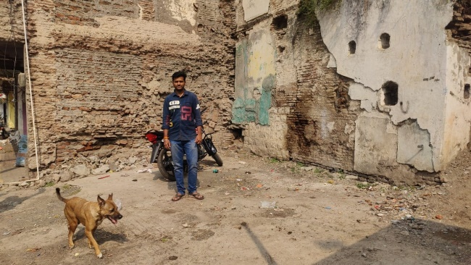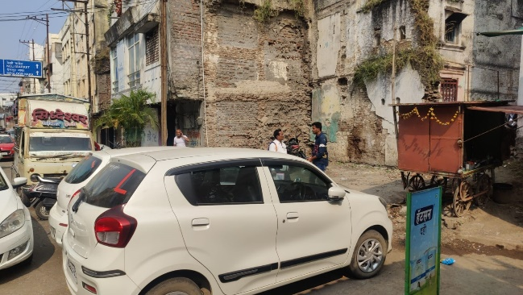

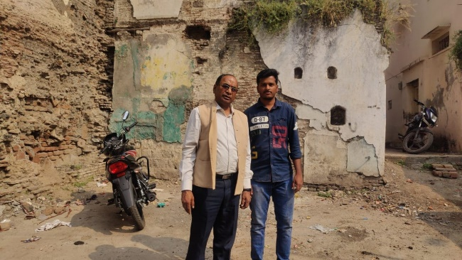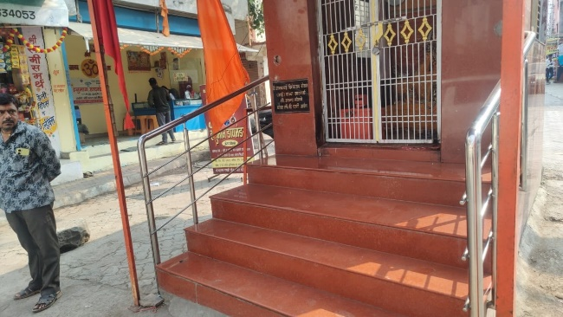

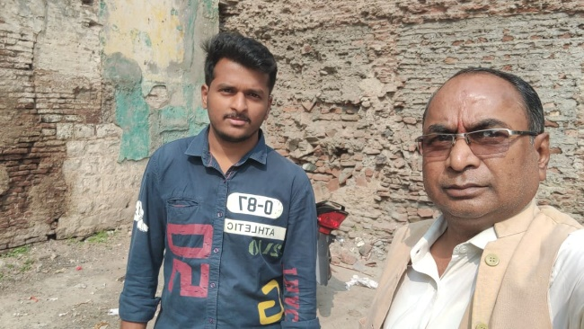

**Route Map of the Property**

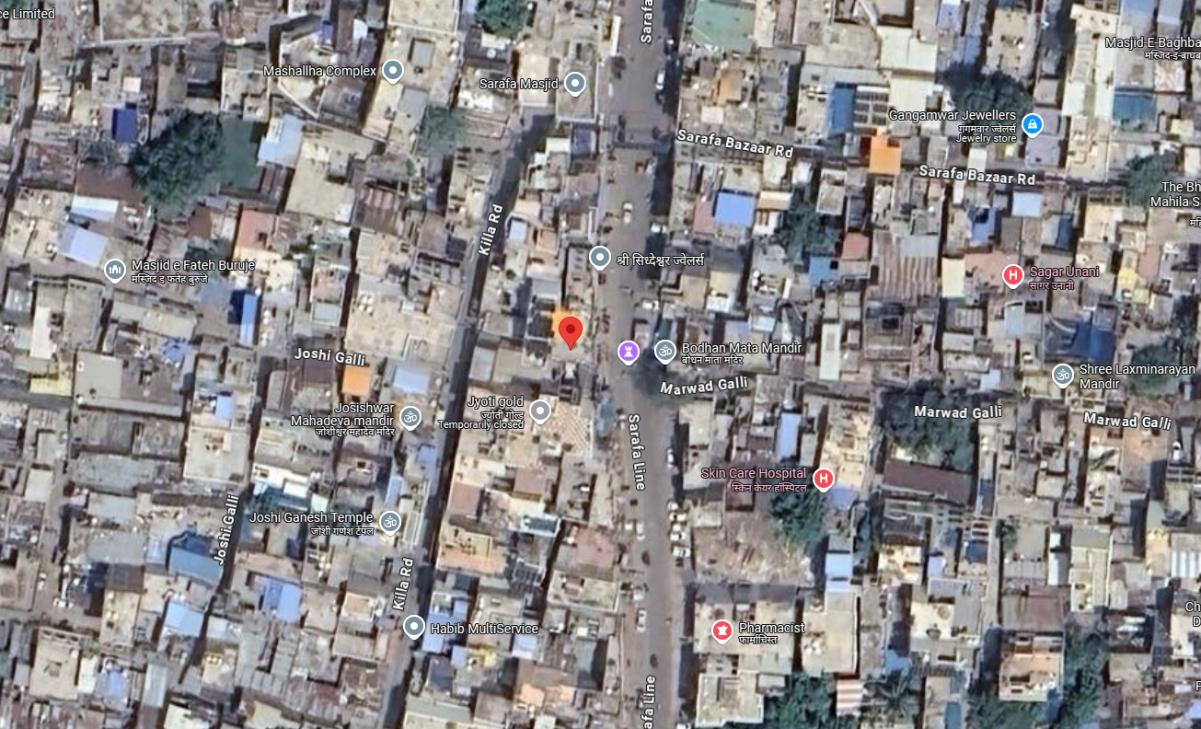

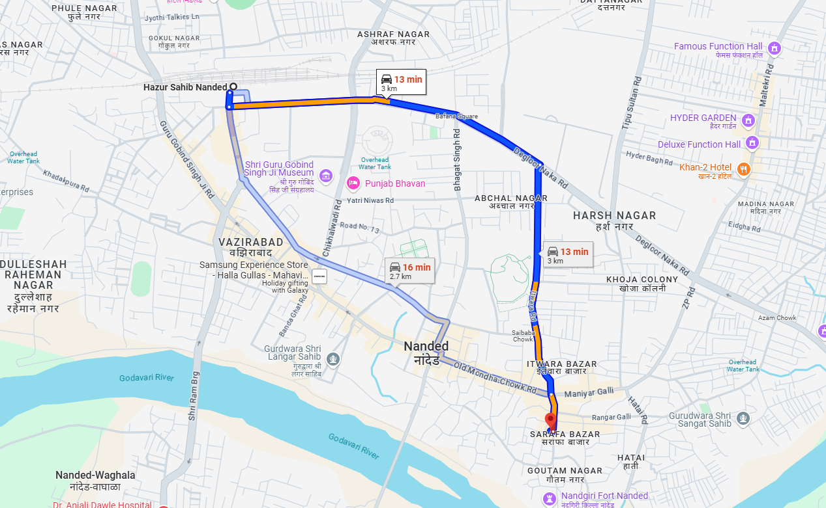

# **Longitude Latitude: 19.145069, 77.324923**

# **Note**:

* Red Pointer shows Approx. Property Location.
* 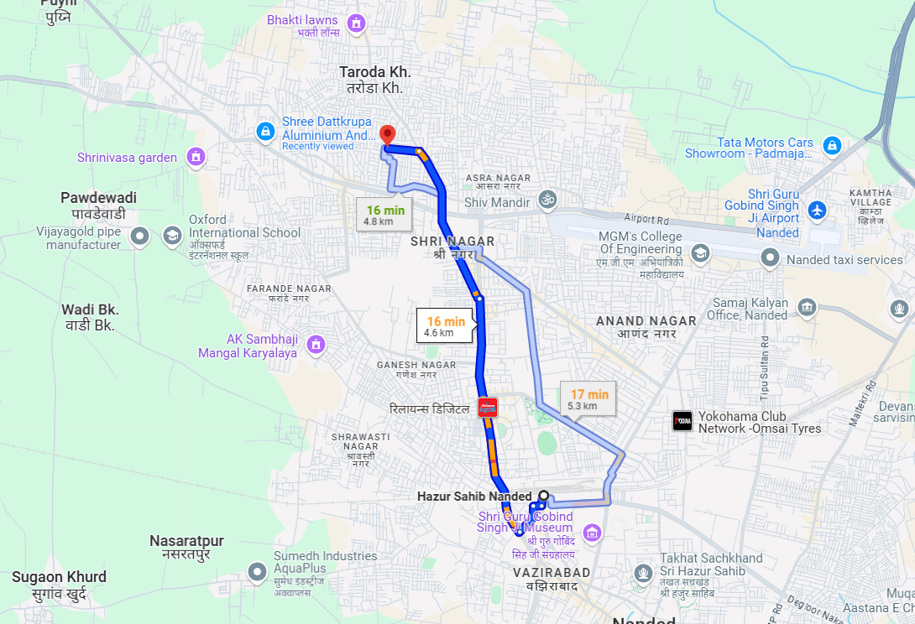 Blue line shows Route from Nanded Railway Station@ 3 Km.

**Ready Reckoner Rate**

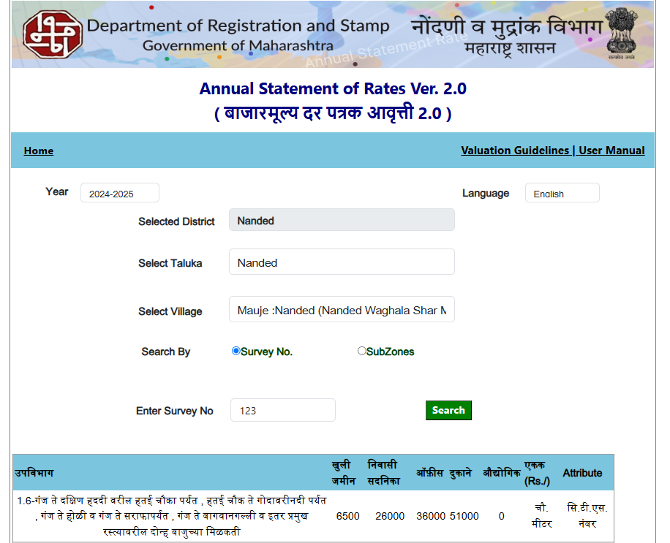

**ASSUMPTIONS, CAVEATS, LIMITATION AND DISCLAIMERS**

1. We assume no responsibility for matters of legal nature affecting the property appraised or the title thereto, nor do we render our opinion as to the title, which is assumed to be good and marketable.
2. The property is valued as though under responsible ownership.
3. It is assumed that the property is free of liens and encumbrances.
4. It is assumed that there are no hidden or unapparent conditions of the subsoil or structure that would render it more or less valuable. No responsibility is assumed for such conditions or for engineering that might be required to discover such factors.
5. The rates for valuation of the property are in accordance with the Govt. approved rates and prevailing market rates

For, **Vastukala Consultants (I) Pvt. Ltd.**

**Sharadkumar B. Chalikwar**

B.E. (Civil), M.E. (Civil), M.Sc. (Real Estate Valuation), M.Sc. (P&M Valuation), FIE (I), FIV, FIWRS

Chairman & Managing Director

Govt. Reg. Valuer

Chartered Engineer (India)

Reg. No. (N) CCIT/1-14/52/2008-09

IBBI Reg.No. IBBI/RV/07/2019/11744

Date: 05.12.2024

Place: Nanded.