Valuation Report of the Immovable Property

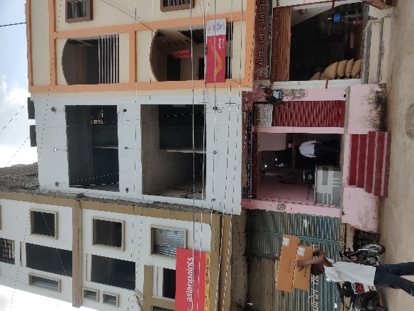

**Details of the property under consideration:**

**Name of Owner: Mr. Ganesh Venkatrao Achintalwar**

M. H. 6109, Market Yard, Mondha Area, Degloor, Taluka Degloor, Dist. Nanded,

PIN – 431 717, State – Maharashtra, Country – India.

# **Longitude Latitude: 18°33'01.3"N 77°34'33.8"E**

**Valuation Done for:**

**Axis Bank**

**Basmat Hingoli Branch**

Plot No A-498, Ground Floor, Mama Chowk Basmath, Tal. - Basmath, Dist. – Hingoli, Basmath,

PIN – 431512, State – Maharashtra, Country – India

.

Vastu/Axis Bank/Nanded/10/2024/011968 /2308826

25/9-366-SH

Date: 25.10.2024

# **VALUER’S OPINION REPORT**

This is to certify that the property bearing M. H. 6109, Market Yard, Mondha Area, Degloor, Taluka Degloor, Dist. Nanded, PIN – 431 717, State – Maharashtra, Country – India belongs to **Mr. Ganesh Venkatrao Achintalwar.**

|  |  |  |
| --- | --- | --- |
| Boundaries of the property. | | |
| North | : | Market Yard Road | |
| South | : | Shop of Mohd. Yunus Mohd. Yusuf | |
| East | : | Shop of Mohd. Yunus Mohd. Yusuf | |
| West | : | Shop of Sow Shobha Adishalawar | |

Considering various parameters recorded, existing economic scenario, and the information that is available with reference to the development of neighborhood and method selected for valuation, we are of the opinion that, the property premises can be assessed are as under:

|  |  |
| --- | --- |
| **Guideline Value of the Property** | **Rs. 3,31,204.00** |
| **Fair Market Value of the Property** | **Rs. 89,31,165.00** |
| **Realizable Value of the Property** | **Rs. 80,38,049.00** |
| **Forced/ Distress Sale value of the Property.** | **Rs. 71,44,932.00** |

The valuation of the property is based on the documents produced by the concern. Legal aspects have not been taken into considerations while preparing this valuation report.

Hence certified

For, **Vastukala Consultants (I) Pvt. Ltd.**

**Sharadkumar B. Chalikwar**

B.E. (Civil), M.E. (Civil), M.Sc. (Real Estate Valuation), M.Sc. (P&M Valuation), FIE (I), FIV, FIWRS

Chairman & Managing Director

Govt. Reg. Valuer

Chartered Engineer (India)

Reg. No. (N) CCIT/1-14/52/2008-09

IBBI Reg.No. IBBI/RV/07/2019/11744

|  |  |  |  |  |  |  |  |  |  |  |  |  |  |  |  |  |  |  |  |  |  |  |  |  |  |  |  |  |  |  |  |  |  |  |  |  |  |  |  |  |  |  |  |  |  |  |  |  |  |  |  |  |  |  |  |  |  |  |  |  |  |  |  |  |  |  |  |  |  |  |  |  |  |  |  |  |  |  |  |  |  |  |  |  |  |  |  |  |  |  |  |  |  |  |  |  |  |  |  |  |  |  |  |  |  |  |  |  |  |  |  |  |  |  |  |  |  |  |  |  |  |  |  |  |  |  |  |  |  |  |  |  |  |  |  |  |  |  |  |  |  |  |  |  |  |  |  |  |  |  |  |  |  |  |  |  |  |  |  |  |  |  |  |  |  |  |  |  |  |  |  |  |  |  |  |  |  |  |  |  |  |  |  |  |  |  |  |  |  |  |  |  |  |  |  |  |  |  |  |  |  |  |  |  |  |  |  |  |  |  |  |  |  |  |  |  |  |  |  |  |  |  |  |  |  |  |  |  |  |  |  |  |  |  |  |  |  |  |  |  |  |  |  |  |  |  |  |  |  |  |  |  |  |  |  |  |  |  |  |  |  |  |  |  |  |  |  |  |  |  |  |  |  |  |  |  |  |  |  |  |  |  |  |  |  |  |  |  |  |  |  |  |  |  |  |  |  |  |  |  |  |  |  |  |  |  |  |  |  |  |  |  |  |  |  |  |  |  |  |  |  |  |  |  |  |  |  |  |  |  |  |  |  |  |  |  |  |  |  |  |  |  |  |  |  |  |  |  |  |  |  |  |  |  |  |  |  |  |  |  |  |  |  |  |  |  |  |  |  |  |  |  |  |  |  |  |  |  |  |  |  |  |  |  |  |  |  |  |  |  |  |  |  |  |  |  |  |  |  |  |  |  |  |  |  |  |  |  |  |  |  |  |  |  |  |  |  |  |  |  |  |  |  |  |  |  |  |  |  |  |  |  |  |  |  |  |  |  |  |  |  |  |  |  |  |  |  |  |  |  |  |  |  |  |  |  |  |  |  |  |  |  |  |  |  |  |  |  |  |  |  |  |  |  |  |  |  |  |  |  |  |  |  |  |  |  |  |  |  |  |  |  |  |  |  |  |  |  |  |  |  |  |  |  |  |  |  |  |  |  |  |  |  |  |  |  |  |  |  |  |  |  |  |  |  |  |  |  |  |  |  |  |  |  |  |  |  |  |  |  |  |  |  |  |  |  |  |  |  |  |  |  |  |  |  |  |  |  |  |  |  |  |  |  |  |  |  |  |  |  |  |  |  |  |  |  |  |  |  |  |  |  |  |  |  |  |  |  |  |  |  |  |  |  |  |  |  |  |  |  |  |  |  |  |  |  |  |  |  |  |  |  |  |  |  |  |  |  |  |  |  |  |  |  |  |  |  |  |  |  |  |  |  |  |  |  |  |  |  |  |  |  |  |  |  |  |  |  |  |  |  |  |  |  |  |  |  |  |  |  |  |  |  |  |  |  |  |  |  |  |  |  |  |  |  |  |  |  |  |  |  |  |  |  |  |  |  |  |  |  |  |  |  |  |  |  |  |  |  |  |  |  |  |  |  |  |  |  |  |  |  |  |  |  |  |  |  |  |  |  |  |  |  |  |  |  |  |  |  |  |  |  |  |  |  |  |  |  |  |  |  |  |  |  |  |  |  |  |  |  |  |  |  |  |  |  |  |  |  |  |  |  |  |  |  |  |  |  |  |  |  |  |  |  |  |  |  |  |  |  |  |  |  |  |  |  |  |  |  |  |  |  |  |  |  |  |  |  |  |  |  |  |  |  |  |  |  |  |  |  |  |  |  |  |  |  |  |  |  |  |  |  |  |  |  |  |  |  |  |  |  |  |  |  |  |  |  |  |  |  |  |  |  |  |  |  |  |  |  |  |  |  |  |  |  |  |  |  |  |  |  |  |  |  |  |  |  |  |  |  |  |  |  |  |  |  |  |  |  |  |  |  |  |  |  |  |  |  |  |  |  |  |  |  |  |  |  |  |  |  |  |  |  |  |  |  |  |  |  |  |  |  |  |  |  |  |  |  |  |  |  |  |  |  |  |  |  |  |  |  |  |  |  |  |  |  |  |  |  |  |  |  |  |  |  |  |  |  |  |  |  |  |  |  |  |  |  |  |  |  |  |  |  |  |  |  |  |  |  |  |  |  |  |  |  |  |  |  |  |  |  |  |  |  |  |  |  |  |  |  |  |  |  |  |  |  |  |  |  |  |  |  |  |  |  |  |  |  |  |  |  |  |  |  |  |  |  |  |  |  |  |  |  |  |  |  |  |  |  |  |  |  |  |  |  |  |  |  |  |  |  |  |  |  |  |  |  |  |  |  |  |  |  |  |  |  |  |  |  |  |  |  |  |  |  |  |  |  |  |  |  |  |  |  |  |  |  |  |  |  |  |  |  |  |  |  |  |  |  |  |  |  |  |  |  |  |  |  |  |  |  |  |  |  |  |  |  |  |  |  |  |  |  |  |  |  |  |  |  |  |  |  |  |  |  |  |  |  |  |  |  |  |  |  |  |  |  |  |  |  |  |  |  |  |  |  |  |  |  |  |  |  |  |  |  |  |  |  |  |  |  |  |  |  |  |  |  |  |  |  |  |  |  |  |  |  |  |  |  |  |  |  |  |  |  |  |  |  |  |  |  |  |  |  |  |  |  |  |  |  |  |  |  |  |  |  |  |  |  |  |  |  |  |  |  |  |  |  |  |  |  |  |  |  |  |  |  |  |  |  |  |  |  |  |  |  |  |  |  |  |  |  |  |  |  |  |  |  |  |  |  |  |  |  |  |  |  |  |  |  |  |  |  |  |  |  |  |  |  |  |  |  |  |  |  |  |  |  |  |  |  |  |  |  |  |  |  |  |  |  |  |  |  |  |  |  |  |  |  |  |  |  |  |  |  |  |  |  |  |  |  |  |  |  |  |  |  |  |  |  |  |  |  |  |  |  |  |  |  |  |  |  |  |  |  |  |  |  |  |  |  |  |  |  |  |  |  |  |  |  |  |  |  |  |  |  |  |  |  |  |  |  |  |  |  |  |  |  |  |  |  |  |  |  |  |  |  |  |  |  |  |  |  |  |  |  |  |  |  |  |  |  |  |  |  |  |  |  |  |  |  |  |  |  |  |  |  |  |  |  |  |  |  |  |  |  |  |  |  |  |  |  |  |  |  |  |  |  |  |  |  |  |  |  |  |  |  |  |  |  |  |  |  |  |  |  |  |  |  |  |  |  |  |  |  |  |  |  |  |  |  |  |  |  |  |  |  |  |  |  |  |  |  |  |  |  |  |  |  |  |  |  |  |  |  |  |  |  |  |  |  |  |  |  |  |  |  |  |  |  |  |  |  |  |  |  |  |  |  |  |  |  |  |  |  |  |  |  |  |  |  |  |  |  |  |  |  |  |  |  |  |  |  |  |  |  |  |  |  |  |  |  |  |  |  |  |  |  |  |  |  |  |  |  |  |  |  |  |  |  |  |  |  |  |  |  |  |  |  |  |  |  |  |  |  |  |  |  |  |  |  |  |  |  |  |  |  |  |  |  |  |  |  |  |  |  |  |  |  |  |  |  |  |  |  |  |  |  |  |  |  |  |  |  |  |  |  |  |  |  |  |  |  |  |  |  |  |  |  |  |  |  |  |  |  |  |  |  |  |  |  |  |  |  |  |  |  |  |  |  |  |  |  |  |  |  |  |  |  |  |  |  |  |  |  |  |  |  |  |  |  |  |  |  |  |  |  |  |  |  |  |  |  |  |  |  |  |  |  |  |  |  |  |  |  |  |  |  |  |  |  |  |  |  |  |  |  |  |  |  |  |  |  |  |  |  |  |  |  |  |  |  |  |  |  |  |  |  |  |  |  |  |  |  |  |  |  |  |  |  |  |  |  |  |  |  |  |  |  |  |  |  |  |  |  |  |  |  |  |  |  |  |  |  |  |  |  |  |  |  |  |  |  |  |  |  |  |  |  |  |  |  |  |  |  |  |  |  |  |  |  |  |  |  |  |  |  |  |  |  |  |  |  |  |  |  |  |  |  |  |  |  |  |  |  |  |  |  |  |  |  |  |  |  |  |  |  |  |  |  |  |  |  |  |  |  |  |  |  |  |  |  |  |  |  |  |  |  |  |  |  |  |  |  |  |  |  |  |  |  |  |  |  |  |  |  |  |  |  |  |  |  |  |  |  |  |  |  |  |  |  |  |  |  |  |  |  |  |  |  |  |  |  |  |  |  |  |  |  |  |  |  |  |  |  |  |  |  |  |  |  |  |  |  |  |  |  |  |  |  |  |  |  |  |  |  |  |  |  |  |  |  |  |  |  |  |  |  |  |  |  |  |  |  |  |  |  |  |  |  |  |  |  |  |  |  |  |  |  |  |  |  |  |  |  |  |  |  |  |  |  |  |  |  |  |  |  |  |  |  |  |  |  |  |  |  |  |  |  |  |  |  |  |  |  |  |  |  |  |  |  |  |  |  |  |  |  |  |  |  |  |  |  |  |  |  |  |  |  |  |  |  |  |  |  |  |  |  |  |  |  |  |  |  |  |  |  |  |  |  |  |  |  |  |  |  |  |  |  |  |  |  |  |  |  |  |  |  |  |  |  |  |  |  |  |  |  |  |  |  |  |  |  |  |  |  |  |  |  |  |  |  |  |  |  |  |  |  |  |  |  |  |  |  |  |  |  |  |  |  |  |  |  |  |  |  |  |  |  |  |  |  |  |  |  |  |  |  |  |  |  |  |  |  |  |  |  |  |  |  |  |  |  |  |  |  |  |  |  |  |  |  |  |  |  |  |  |  |  |  |  |  |  |  |  |  |  |  |  |  |  |  |  |  |  |  |  |  |  |  |  |  |  |  |  |  |  |  |  |  |  |  |  |  |  |  |  |  |  |  |  |  |  |  |  |  |  |
| --- | --- | --- | --- | --- | --- | --- | --- | --- | --- | --- | --- | --- | --- | --- | --- | --- | --- | --- | --- | --- | --- | --- | --- | --- | --- | --- | --- | --- | --- | --- | --- | --- | --- | --- | --- | --- | --- | --- | --- | --- | --- | --- | --- | --- | --- | --- | --- | --- | --- | --- | --- | --- | --- | --- | --- | --- | --- | --- | --- | --- | --- | --- | --- | --- | --- | --- | --- | --- | --- | --- | --- | --- | --- | --- | --- | --- | --- | --- | --- | --- | --- | --- | --- | --- | --- | --- | --- | --- | --- | --- | --- | --- | --- | --- | --- | --- | --- | --- | --- | --- | --- | --- | --- | --- | --- | --- | --- | --- | --- | --- | --- | --- | --- | --- | --- | --- | --- | --- | --- | --- | --- | --- | --- | --- | --- | --- | --- | --- | --- | --- | --- | --- | --- | --- | --- | --- | --- | --- | --- | --- | --- | --- | --- | --- | --- | --- | --- | --- | --- | --- | --- | --- | --- | --- | --- | --- | --- | --- | --- | --- | --- | --- | --- | --- | --- | --- | --- | --- | --- | --- | --- | --- | --- | --- | --- | --- | --- | --- | --- | --- | --- | --- | --- | --- | --- | --- | --- | --- | --- | --- | --- | --- | --- | --- | --- | --- | --- | --- | --- | --- | --- | --- | --- | --- | --- | --- | --- | --- | --- | --- | --- | --- | --- | --- | --- | --- | --- | --- | --- | --- | --- | --- | --- | --- | --- | --- | --- | --- | --- | --- | --- | --- | --- | --- | --- | --- | --- | --- | --- | --- | --- | --- | --- | --- | --- | --- | --- | --- | --- | --- | --- | --- | --- | --- | --- | --- | --- | --- | --- | --- | --- | --- | --- | --- | --- | --- | --- | --- | --- | --- | --- | --- | --- | --- | --- | --- | --- | --- | --- | --- | --- | --- | --- | --- | --- | --- | --- | --- | --- | --- | --- | --- | --- | --- | --- | --- | --- | --- | --- | --- | --- | --- | --- | --- | --- | --- | --- | --- | --- | --- | --- | --- | --- | --- | --- | --- | --- | --- | --- | --- | --- | --- | --- | --- | --- | --- | --- | --- | --- | --- | --- | --- | --- | --- | --- | --- | --- | --- | --- | --- | --- | --- | --- | --- | --- | --- | --- | --- | --- | --- | --- | --- | --- | --- | --- | --- | --- | --- | --- | --- | --- | --- | --- | --- | --- | --- | --- | --- | --- | --- | --- | --- | --- | --- | --- | --- | --- | --- | --- | --- | --- | --- | --- | --- | --- | --- | --- | --- | --- | --- | --- | --- | --- | --- | --- | --- | --- | --- | --- | --- | --- | --- | --- | --- | --- | --- | --- | --- | --- | --- | --- | --- | --- | --- | --- | --- | --- | --- | --- | --- | --- | --- | --- | --- | --- | --- | --- | --- | --- | --- | --- | --- | --- | --- | --- | --- | --- | --- | --- | --- | --- | --- | --- | --- | --- | --- | --- | --- | --- | --- | --- | --- | --- | --- | --- | --- | --- | --- | --- | --- | --- | --- | --- | --- | --- | --- | --- | --- | --- | --- | --- | --- | --- | --- | --- | --- | --- | --- | --- | --- | --- | --- | --- | --- | --- | --- | --- | --- | --- | --- | --- | --- | --- | --- | --- | --- | --- | --- | --- | --- | --- | --- | --- | --- | --- | --- | --- | --- | --- | --- | --- | --- | --- | --- | --- | --- | --- | --- | --- | --- | --- | --- | --- | --- | --- | --- | --- | --- | --- | --- | --- | --- | --- | --- | --- | --- | --- | --- | --- | --- | --- | --- | --- | --- | --- | --- | --- | --- | --- | --- | --- | --- | --- | --- | --- | --- | --- | --- | --- | --- | --- | --- | --- | --- | --- | --- | --- | --- | --- | --- | --- | --- | --- | --- | --- | --- | --- | --- | --- | --- | --- | --- | --- | --- | --- | --- | --- | --- | --- | --- | --- | --- | --- | --- | --- | --- | --- | --- | --- | --- | --- | --- | --- | --- | --- | --- | --- | --- | --- | --- | --- | --- | --- | --- | --- | --- | --- | --- | --- | --- | --- | --- | --- | --- | --- | --- | --- | --- | --- | --- | --- | --- | --- | --- | --- | --- | --- | --- | --- | --- | --- | --- | --- | --- | --- | --- | --- | --- | --- | --- | --- | --- | --- | --- | --- | --- | --- | --- | --- | --- | --- | --- | --- | --- | --- | --- | --- | --- | --- | --- | --- | --- | --- | --- | --- | --- | --- | --- | --- | --- | --- | --- | --- | --- | --- | --- | --- | --- | --- | --- | --- | --- | --- | --- | --- | --- | --- | --- | --- | --- | --- | --- | --- | --- | --- | --- | --- | --- | --- | --- | --- | --- | --- | --- | --- | --- | --- | --- | --- | --- | --- | --- | --- | --- | --- | --- | --- | --- | --- | --- | --- | --- | --- | --- | --- | --- | --- | --- | --- | --- | --- | --- | --- | --- | --- | --- | --- | --- | --- | --- | --- | --- | --- | --- | --- | --- | --- | --- | --- | --- | --- | --- | --- | --- | --- | --- | --- | --- | --- | --- | --- | --- | --- | --- | --- | --- | --- | --- | --- | --- | --- | --- | --- | --- | --- | --- | --- | --- | --- | --- | --- | --- | --- | --- | --- | --- | --- | --- | --- | --- | --- | --- | --- | --- | --- | --- | --- | --- | --- | --- | --- | --- | --- | --- | --- | --- | --- | --- | --- | --- | --- | --- | --- | --- | --- | --- | --- | --- | --- | --- | --- | --- | --- | --- | --- | --- | --- | --- | --- | --- | --- | --- | --- | --- | --- | --- | --- | --- | --- | --- | --- | --- | --- | --- | --- | --- | --- | --- | --- | --- | --- | --- | --- | --- | --- | --- | --- | --- | --- | --- | --- | --- | --- | --- | --- | --- | --- | --- | --- | --- | --- | --- | --- | --- | --- | --- | --- | --- | --- | --- | --- | --- | --- | --- | --- | --- | --- | --- | --- | --- | --- | --- | --- | --- | --- | --- | --- | --- | --- | --- | --- | --- | --- | --- | --- | --- | --- | --- | --- | --- | --- | --- | --- | --- | --- | --- | --- | --- | --- | --- | --- | --- | --- | --- | --- | --- | --- | --- | --- | --- | --- | --- | --- | --- | --- | --- | --- | --- | --- | --- | --- | --- | --- | --- | --- | --- | --- | --- | --- | --- | --- | --- | --- | --- | --- | --- | --- | --- | --- | --- | --- | --- | --- | --- | --- | --- | --- | --- | --- | --- | --- | --- | --- | --- | --- | --- | --- | --- | --- | --- | --- | --- | --- | --- | --- | --- | --- | --- | --- | --- | --- | --- | --- | --- | --- | --- | --- | --- | --- | --- | --- | --- | --- | --- | --- | --- | --- | --- | --- | --- | --- | --- | --- | --- | --- | --- | --- | --- | --- | --- | --- | --- | --- | --- | --- | --- | --- | --- | --- | --- | --- | --- | --- | --- | --- | --- | --- | --- | --- | --- | --- | --- | --- | --- | --- | --- | --- | --- | --- | --- | --- | --- | --- | --- | --- | --- | --- | --- | --- | --- | --- | --- | --- | --- | --- | --- | --- | --- | --- | --- | --- | --- | --- | --- | --- | --- | --- | --- | --- | --- | --- | --- | --- | --- | --- | --- | --- | --- | --- | --- | --- | --- | --- | --- | --- | --- | --- | --- | --- | --- | --- | --- | --- | --- | --- | --- | --- | --- | --- | --- | --- | --- | --- | --- | --- | --- | --- | --- | --- | --- | --- | --- | --- | --- | --- | --- | --- | --- | --- | --- | --- | --- | --- | --- | --- | --- | --- | --- | --- | --- | --- | --- | --- | --- | --- | --- | --- | --- | --- | --- | --- | --- | --- | --- | --- | --- | --- | --- | --- | --- | --- | --- | --- | --- | --- | --- | --- | --- | --- | --- | --- | --- | --- | --- | --- | --- | --- | --- | --- | --- | --- | --- | --- | --- | --- | --- | --- | --- | --- | --- | --- | --- | --- | --- | --- | --- | --- | --- | --- | --- | --- | --- | --- | --- | --- | --- | --- | --- | --- | --- | --- | --- | --- | --- | --- | --- | --- | --- | --- | --- | --- | --- | --- | --- | --- | --- | --- | --- | --- | --- | --- | --- | --- | --- | --- | --- | --- | --- | --- | --- | --- | --- | --- | --- | --- | --- | --- | --- | --- | --- | --- | --- | --- | --- | --- | --- | --- | --- | --- | --- | --- | --- | --- | --- | --- | --- | --- | --- | --- | --- | --- | --- | --- | --- | --- | --- | --- | --- | --- | --- | --- | --- | --- | --- | --- | --- | --- | --- | --- | --- | --- | --- | --- | --- | --- | --- | --- | --- | --- | --- | --- | --- | --- | --- | --- | --- | --- | --- | --- | --- | --- | --- | --- | --- | --- | --- | --- | --- | --- | --- | --- | --- | --- | --- | --- | --- | --- | --- | --- | --- | --- | --- | --- | --- | --- | --- | --- | --- | --- | --- | --- | --- | --- | --- | --- | --- | --- | --- | --- | --- | --- | --- | --- | --- | --- | --- | --- | --- | --- | --- | --- | --- | --- | --- | --- | --- | --- | --- | --- | --- | --- | --- | --- | --- | --- | --- | --- | --- | --- | --- | --- | --- | --- | --- | --- | --- | --- | --- | --- | --- | --- | --- | --- | --- | --- | --- | --- | --- | --- | --- | --- | --- | --- | --- | --- | --- | --- | --- | --- | --- | --- | --- | --- | --- | --- | --- | --- | --- | --- | --- | --- | --- | --- | --- | --- | --- | --- | --- | --- | --- | --- | --- | --- | --- | --- | --- | --- | --- | --- | --- | --- | --- | --- | --- | --- | --- | --- | --- | --- | --- | --- | --- | --- | --- | --- | --- | --- | --- | --- | --- | --- | --- | --- | --- | --- | --- | --- | --- | --- | --- | --- | --- | --- | --- | --- | --- | --- | --- | --- | --- | --- | --- | --- | --- | --- | --- | --- | --- | --- | --- | --- | --- | --- | --- | --- | --- | --- | --- | --- | --- | --- | --- | --- | --- | --- | --- | --- | --- | --- | --- | --- | --- | --- | --- | --- | --- | --- | --- | --- | --- | --- | --- | --- | --- | --- | --- | --- | --- | --- | --- | --- | --- | --- | --- | --- | --- | --- | --- | --- | --- | --- | --- | --- | --- | --- | --- | --- | --- | --- | --- | --- | --- | --- | --- | --- | --- | --- | --- | --- | --- | --- | --- | --- | --- | --- | --- | --- | --- | --- | --- | --- | --- | --- | --- | --- | --- | --- | --- | --- | --- | --- | --- | --- | --- | --- | --- | --- | --- | --- | --- | --- | --- | --- | --- | --- | --- | --- | --- | --- | --- | --- | --- | --- | --- | --- | --- | --- | --- | --- | --- | --- | --- | --- | --- | --- | --- | --- | --- | --- | --- | --- | --- | --- | --- | --- | --- | --- | --- | --- | --- | --- | --- | --- | --- | --- | --- | --- | --- | --- | --- | --- | --- | --- | --- | --- | --- | --- | --- | --- | --- | --- | --- | --- | --- | --- | --- | --- | --- | --- | --- | --- | --- | --- | --- | --- | --- | --- | --- | --- | --- | --- | --- | --- | --- | --- | --- | --- | --- | --- | --- | --- | --- | --- | --- | --- | --- | --- | --- | --- | --- | --- | --- | --- | --- | --- | --- | --- | --- | --- | --- | --- | --- | --- | --- | --- | --- | --- | --- | --- | --- | --- | --- | --- | --- | --- | --- | --- | --- | --- | --- | --- | --- | --- | --- | --- | --- | --- | --- | --- | --- | --- | --- | --- | --- | --- | --- | --- | --- | --- | --- | --- | --- | --- | --- | --- | --- | --- | --- | --- | --- | --- | --- | --- | --- | --- | --- | --- | --- | --- | --- | --- | --- | --- | --- | --- | --- | --- | --- | --- | --- | --- | --- | --- | --- | --- | --- | --- | --- | --- | --- | --- | --- | --- | --- | --- | --- | --- | --- | --- | --- | --- | --- | --- | --- | --- | --- | --- | --- | --- | --- | --- | --- | --- | --- | --- | --- | --- | --- | --- | --- | --- | --- | --- | --- | --- | --- | --- | --- | --- | --- | --- | --- | --- | --- | --- | --- | --- | --- | --- | --- | --- | --- | --- | --- | --- | --- | --- | --- | --- | --- | --- | --- | --- | --- | --- | --- | --- | --- | --- | --- | --- | --- | --- | --- | --- | --- | --- | --- | --- | --- | --- | --- | --- | --- | --- | --- | --- | --- | --- | --- | --- | --- | --- | --- | --- | --- | --- | --- | --- | --- | --- | --- | --- | --- | --- | --- | --- | --- | --- | --- | --- | --- | --- | --- | --- | --- | --- | --- | --- | --- | --- | --- | --- | --- | --- | --- | --- | --- | --- | --- | --- | --- | --- | --- | --- | --- | --- | --- | --- | --- | --- | --- | --- | --- | --- | --- | --- | --- | --- | --- | --- | --- | --- | --- | --- | --- | --- | --- | --- | --- | --- | --- | --- | --- | --- | --- | --- | --- | --- | --- | --- | --- | --- | --- | --- | --- | --- | --- | --- | --- | --- | --- | --- | --- | --- | --- | --- | --- | --- | --- | --- | --- | --- | --- | --- | --- | --- | --- | --- | --- | --- | --- | --- | --- | --- | --- | --- | --- | --- | --- | --- | --- | --- | --- | --- | --- | --- | --- | --- | --- | --- | --- | --- | --- | --- | --- | --- | --- | --- | --- | --- | --- | --- | --- | --- | --- | --- | --- | --- | --- | --- | --- | --- | --- | --- | --- | --- | --- | --- | --- | --- | --- | --- | --- | --- | --- | --- | --- | --- | --- | --- | --- | --- | --- | --- | --- | --- | --- | --- | --- | --- | --- | --- | --- | --- | --- | --- | --- | --- | --- | --- | --- | --- | --- | --- | --- | --- | --- | --- | --- | --- | --- | --- | --- | --- | --- | --- | --- | --- | --- | --- | --- | --- | --- | --- | --- | --- | --- | --- | --- | --- | --- | --- | --- | --- | --- | --- | --- | --- | --- | --- | --- | --- | --- | --- | --- | --- | --- | --- | --- | --- | --- | --- | --- | --- | --- | --- | --- | --- | --- | --- | --- | --- | --- | --- | --- | --- | --- | --- | --- | --- | --- | --- | --- | --- | --- | --- | --- | --- | --- | --- | --- | --- | --- | --- | --- | --- | --- | --- | --- | --- | --- | --- | --- | --- | --- | --- | --- | --- | --- | --- | --- | --- | --- | --- | --- | --- | --- | --- | --- | --- | --- | --- | --- | --- | --- | --- | --- | --- | --- | --- | --- | --- | --- | --- | --- | --- |
| **VALUATION REPORT (IN RESPECT OF RESIDENTIAL LAND AND BUILDING)**   |  |  |  |  |  |  |  |  |  |  |  |  |  |  |  |  |  |  | | --- | --- | --- | --- | --- | --- | --- | --- | --- | --- | --- | --- | --- | --- | --- | --- | --- | --- | | 1. | CBB/CCMC/CCSU | | | |  | | | |  | | | | - | | | | | | - | | | | - | | | | | | 2. | Name of Owner & Address: | | | | | | | | **Mr. Ganesh Venkatrao Achintalwar**  M. H. 6109, Market Yard, Mondha Area, Degloor, Taluka Degloor, Dist. Nanded, PIN – 431 717, State – Maharashtra, Country – India  Mob. No. # 9422185107 | | | | | | | | | | Name of Borrower & Address | | | | | | | | **Mr. Ganesh Venkatrao Achintalwar**  M. H. 6109, Market Yard, Mondha Area, Degloor, Taluka Degloor, Dist. Nanded, PIN – 431 717, State – Maharashtra, Country – India  Mob. No. # 9422185107 | | | | | | | | | | 3. | Name of the Bank Official Present | | | | | | | | No. | | | | | | | | | | Name of the Representative & Mobile No. | | | | | | | | **Mr. Ganesh Venkatrao Achintalwar**  Mob. No. # 9422185107 | | | | | | | | | | **4.** | **Details of the Property Being Valued** | | | | | | | | | | | | | | | | | | 4.1 | Description of the Property | | | | | | | | **Ground + 2 Upper Floor** | | | | | | | | | | 4.2 | Location of Property | | | | | | | | M. H. 6109, Market Yard, Mondha Area, Degloor, Taluka Degloor, Dist. Nanded, PIN – 431 717, State – Maharashtra, Country – India | | | | | | | | | | (Rural / Semi Urban / Urban) | | | | | | | | Semi Urban. | | | | | | | | | | 4.3 | Documents Provided: | | | | | | | | | | | | | | | | | | 1 | | Photo Copy of Sale Deed No. 1859/2009, Registered at Sub. Register, Degloor | | | | | | | | | | | | | | | | 2 | | Photo Copy of Property Register Certificate Vide No. N. P. / 6362 / 2021, Dated 15.11.2021, Chief Officer, Degloor Municipal Council, Degloor. | | | | | | | | | | | | | | | |  | | Photo Copy Namuna No. 43 Rule (74) Tax Assessment Year 2000 – 2001 Dated 15.11.2021, Chief Officer, Degloor Municipal Council, Degloor. | | | | | | | | | | | | | | | |  | 3 | | Photo Copy of Tax Paid Receipt No. 07, Book No. 865, Dated 15.11.2021 upto 31.03.2022, Degloor Municipal Council, Degloor. | | | | | | | | | | | | | | | |  | 4 | | Photo Copy of Construction Permission Letter No. N. P. 09 / Construction 5190 / 11 Date 01.01.2011, Chief Officer, Degloor Municipal Council, Degloor. | | | | | | | | | | | | | | | |  | 5 | | Photo Copy of Sanctioned Plan Dated 01.01.2011, Chief Officer, Degloor Municipal Council, Degloor. | | | | | | | | | | | | | | | |  | 6 | | Photo Copy of Title Investigation Report Dated 27.11.2018, Prepared by Adv. Madhav B. Pawde, Nanded | | | | | | | | | | | | | | | |  | 7 | | Photo Copy of MSEDCL Light Bill Consumer No. 558010006067 in the month of October 2021 | | | | | | | | | | | | | | | | 4.4 | Plot No / Survey No. / Gut No./ Khasra No: | | | | Survey No. M.H. 6109 | | | Road | | | | | 20 Mts. Kaccha Road | | | | | | 4.5 | Colony / Nagar / Sector | | | | Mukund Nagar | | | Locality / Landmark | | | | | Near Degloor Market | | | | | | 4.6 | Village/Town/City | | | | Market Yard, Mondha Area, Degloor | | | District: | | | | | Nanded | | | | | | 4.7 | State | | | | Maharashtra | | | Pin code: | | | | | 431 717 | | | | | | 4.8 | Distance from Area Office (Nanded Branch) | | | | | | | @ 1.2 Km Nanded Main Branch | | | | | | | | | | | **5.** | **Type of Property** | | | | | | | | | | | | | | | | | |  | **(A) Plot:** (Residential / Commercial / Industrial) | | | | | | | | | | | Commercial | | | | | | | Level of land with topographical conditions | | | | | | | | | | | Leveled | | | | | | | Whether situated in Municipal / Corporation Limit | | | | | | | | | | | Corporation Limit | | | | | | | Any construction observed on plot | | | | | | | | | | | Yes, Ground Floor + 2 Upper Floor | | | | | | | **(B) Residential Property: (**Independent house / Bungalow / Row House / Flat) | | | | | | | | | | | Yes, Independent house | | | | | | | Civic Amenities like school, hospital, market, etc. (Available, within the radius of Km./ Not Available) | | | | | | | | | | | All available nearby. | | | | | | | **(C) Commercial / Industrial Property :** (Office / Shop / Unit in a Mall / Gowdown) | | | | | | | | | | | Commercial Property. | | | | | | | **6.0** | **Accessibility / Boundaries / Others** | | | | | | | | | | | | | | | | | | 6.1 | Availability of local transport (Metro / Local Train / Bus / Personal Transport) | | | | | | | | | Local Transport, Bus Stand, Railway Station, Personal Transport. | | | | | | | | | 6.2 | Distance from Nanded Railway station @ 1 Km | | | | | | | | | Bus stop/ Taxi/ Auto Stand @ 700 Mts. | | | | | | | | | 6.3 | Does the approach road to the Property / Building is independent and accessible | | | | | | Yes. | | | Will it be able to accommodate a fire extinguisher | | | | | | | Yes | | 6.4 | Does the property fall under land locked area | | | | | | No. | | | Does the property fall in a community dominated area | | | | | | | No | | 6.5 | Cornered / Intermittent Plot | | | | | | | | | Intermittent Plot. | | | | | | | | | **6.6** | **Boundaries** | | | | | | | | | | | | | | | | | | **Boundaries** | | | **As Per Sale Deed** | | | | | | | **As Per Site** | | | | | | | |  | **North** | | | Market Yard Road | | | | | | | Market Yard Road | | | | | | | | **South** | | | Shop of Mohd. Yunus Mohd. Yusuf | | | | | | | Shop of Mohd. Yunus Mohd. Yusuf | | | | | | | | **East** | | | Shop of Mohd. Yunus Mohd. Yusuf | | | | | | | Shop of Mohd. Yunus Mohd. Yusuf | | | | | | | | **West** | | | Shop of Sow Shobha Adishalawar | | | | | | | Shop of Sow Shobha Adishalawar | | | | | | | | 6.7 | Class of locality (Posh / Higher Middle Class / Middle Class / Lower Middle Class / Poor) | | | | | | | | | | Middle Class | | | | | | | | 6.8 | Quality of Infrastructure in the vicinity (Excellent / Good / Average / Poor) | | | | | | | | | | Good | | | | | | | | 6.9 | Ownership Status of the Property (Free Hold / Reg. Lease / Govt. Authority) | | | | | | | | | | Freehold | | | | | | | | 6.10 | Approved usage of property (Industrial / Commercial / Residential / Mix) | | | | | Residential | | | | | Actual usage of property (Industrial / Commercial / Residential / Mix) | | | | Hospital cum Residential Mix use. | | | | 6.11 | Restrictive covenants in regards to Land Use, (if any) | | | | | | | | | | Commercial | | | | | | | | 6.12 | Type of Structure (Load Bearing / RCC / Alu form shuttering) | | | | | | | | | | RCC Framed Structure | | | | | | | | 6.13 | Number of floors | | | | As per Actual | | | | | | **Ground + 2 Upper Floor**  **Ground floor** – Shop cum Godown, Staircase etc.  **First floor** & **Second Floor** – 3 Rooms Toilets each floor, Staircase etc. | | | | | | | | As per Sanctioned Plan | | | | | | **Ground + 2 Upper Floor**  **Ground floor -** 1 Bedrooms + Living Room + Kitchen + Toilet  **First floor -** 1 Bedrooms + Living Room + Kitchen + Toilet | | | | | | | | 6.14 | Occupancy Details (Self-Occupied / Rented / Vacant) | | | | | | | | | | Owner Occupied. | | | | | | | | **7.** | **If the property is on rent** | | | | | | | | | | | | | | | | | | 7.1 | Name of tenant / lease & Number of years in tenancy | | | | | | | | | | No. | | | | | | | | 7.2 | Was there any resistance for valuation | | | | | No. | | | | | If yes, from the current occupants | | | | | N.A. | | | 7.3 | Does property have basic amenities | | | | | Yes. | | | | | Development of surrounding area Underdeveloped / Developing / Developed | | | | | Developed. | | | **8.** | **If the property is Leasehold** | | | | | | | | | | | | | | | | | | 8.1 | Name of Lesser | | | | N.A. | Nature of Lease: | | | | | | | | | | N.A. | | | 8.2 | Total Period of Lease | | | | N.A. | If yes, from the current occupants | | | | | | | | | | N.A. | | | 8.3 | Does property have basic amenities | | | | No. | Development of surrounding area Underdeveloped / Developing / Developed | | | | | | | | | | Developed. | | | **9.** | **Approval Details** | | | | | | | | | | | | | | | | | | 9.1 | RERA Registration Number | | | | | | | | Not Applicable | | | | | | | | | | 9.2 | Layout Approval Number: | | | | | | | | Not Available. | | | | | | | | | | Date of Approval | | | | | | | | Not Available. | | | | | | | | | | Expiry Date | | | | | | | | Not Available. | | | | | | | | | | 9.3 | Building Plan Approval Number: | | | | | | | | Photo Copy of Sanctioned Plan Dated 01.01.2011, Chief Officer, Degloor Municipal Council, Degloor. | | | | | | | | | | Date of Approval | | | | | | | | 01.01.2011 | | | | | | | | | | Expiry Date | | | | | | | | As per Degloor Municipal Council valid till construction completion. | | | | | | | | | | 9.4 | Occupancy Certificate | | | | | | | | Not Available. | | | | | | | | | | **10.00** | **Plot Area Details.** | | | | | | | | | | | | | | | | | | **10.01** | **Plot Area** | | | | | | | | | | | | **Area in Sq. Ft.** | | | | | | 10.02 | Plot Area As per Sale Deed **(A) – (53.42 Sq. M.)** | | | | | | | | | | | | 575.00 | | | | | | 10.03 | Plot Area as per sanctioned Plan **(B)** | | | | | | | | | | | | 1455.00 | | | | | | 10.04 | **Plot Area Considered for Valuation (Minimum of A & B)** | | | | | | | | | | | | **1455.00** | | | | | | **10.05** | **Construction Area Details** | | | | | | | | | | | | | | | | | |  | **Floor** | | | | **Built up area as per Sanctioned Plan in Sq. Ft.** | | | | **Floor** | | | | **Built up area as per Actual in Sqm** | | | | | | Ground Floor | | | | 445.00 | | | | Ground Floor | | | | 534.00 | | | | | | First Floor | | | | 443.00 | | | | First Floor | | | | 532.00 | | | | | | **Total** | | | | **888.00** | | | | **Total** | | | | **1,066.00** | | | | | | 10.06 | **Built up area considered for Valuation.** | | | | | | | | | | | |  | | | | | | **10.07** | **Floor wise break up as follows** | | | | | | | |  | | | | | **Current Usage** | | | | |  | **Floor** | | | | **Built up area as per Sanctioned Plan in Sqm** | | | | **Floor** | | | **Actual Built-up area in Sqm** | | (Storage / Parking / Commercial /Residential) | | | | | Ground Floor | | | | 445.00 | | | | Ground Floor | | | 534.00 | | Ground Floor | | | | | First Floor | | | | 443.00 | | | | First Floor | | | 532.00 | | First Floor | | | | | **Total** | | | | **888.00** | | | | **Total** | | | **1,066.00** | | **Total** | | | | | 10.08 | Amenities Details (if any): | | | | | | | | RCC footing, ceramic tiles, granite trades and riser, SS railings, false ceiling, emulsion paint internally, cement paint external | | | | | | | | | | 10.9 | Floor Space Index permissible | | | | | | | | Maximum building potential on Plot including in-situ FSI (9.00 m. and above but below 12.00 m is 3.20) | | | | | | | | | | 10.10 | FSI Utilized | | | | | | | | 1.65 | | | | | | | | | | 10.11 | Whether the construction is as per approved building plan and / or local building bye laws: | | | | | | | | * No. * Hence Cost of Construction as per the Sanctioned Planisconsidered for Valuation. | | | | | | | | | | 10.12 | Details of Extra Construction | | | | | | | | Refer Sr. No. 10.05 & 10.07 | | | | | | | | | | 10.13 | Percentage of Extra Construction | | | | | | | | 20% | | | | | | | | | | 10.14 | Whether the extra construction is Compoundable OR Non-Compoundable? | | | | | | | | Non-Compoundable | | | | | | | | | | 10.15 | Quality of construction | | | | | | | | Good. | | | | | | | | | | 10.16 | Maintenance of the Property | | | | | | | | Good | | | | | | | | | | 10.17 | Condition of Building | | | | | | | | Good. | | | | | | | | | | 10.18 | Current Life of the structure | | | | Newly Completed | | | | Projected Future Life of the Structure | | | | 60 Years. | | | | | | 10.19 | Land Revenue / Taxes Paid upto (for Land) | | | | Details not available | | | | Municipal Taxes Paid up to (for Building) | | | | - | | | | | | **11.** | **Details of Valuation:** | | | | | | | | | | | | | | | | | |  | **S.L** | **Particulars of Item** | | | **Plinth / Built up Area In Sq. M.** | | | | **Estimated Replacement Rate of Construction** | | | | **Replacement cost** | | | **Net Value** | | | 1 | Ground Floor/First Floor & Second Floor | | | 89.10 | | | | Ground Floor | | | | 19602 | | | Ground Floor/First Floor & Second Floor | | | 3 | **Total** | | | **89.10** | | | | **Total** | | | | **19602** | | | **Total** | | | **12.** | **Details of Structural Value :** | | | | | | | | | | | | | | |  | | |  | |  |  |  |  |  |  |  |  |  |  | | --- | --- | --- | --- | --- | --- | --- | --- | --- | --- | | **Structure No.** | **Built Up Area** | **Year Of Const.** | **Valuation Year** | **Total Life of Structure** | **Estimated Replacement Rate** | **Balance Life of Structures in Years** | **Final Depreciated Rate to be considered** | **Final Depreciated Value to be considered** | **Estimated Replacement Cost / Insurable Value** | |  | **(Sq. Ft.)** |  |  |  | **(`)** |  | **(`)** | **(`)** | **(`)** | | Ground Floor | 89.10 | 2011 | 2024 | 60.00 | 19602 | 60.00 | 15780 | 1405998 | 1746538 | |  |  |  |  |  |  |  |  |  |  | | **Total BUA** | **89.10** |  |  |  |  |  | - | **14,05,998.00** | **17,46,538.00** | | | | | | | | | | | | | | | | | | | **13.** | **Government Guideline value** | | | | | | | | | | | | | | | | | |  | **Particulars** | | | | | **Area in Sq. M.** | | | **Rate in Rs.** | | | | | **Value in Rs.** | | | | | 1 | **Land** | | | | | **53.42** | | | 6200 | | | | | 331204.00 | | | | | 2 | **Construction:** Ground Floor, First Floor, Second Floor | | | | | **89.10** | | |  | | | | | 14,05,998.00 | | | | |  | **TOTAL** | | | | | | | | | | | | | **17,37,202.00** | | | | | 14. | **Market Value of Land** | | | | | | | | | | | | | | | | | |  | **Particulars** | | | | | **Area in Sq. M.** | | | **Rate in Rs.** | | | | | **Value in Rs.** | | | | | **Land** | | | | | **53.42** | | | 1,39,932.00 | | | | | **74,75,167.00** | | | | | 15. | **Value of the Property** | | | | | | | | | | | | | | | | | |  |  | | | | | **Land** | | | **Building** | | | | **Amenities** | **Total** | | | | | Market Value | | | | | **74,75,167.00** | | | **14,05,998.00** | | | | **50,000.00** | **89,31,165.00** | | | | | Interior Value | | | | | | | | | | | | | **0.00** | | | | | Land Development Value | | | | | | | | | | | | | **0.00** | | | | | Total Market Value | | | | | | | | | | | | | **89,31,165.00** | | | | | Realizable Value | | | | | | | | | | | | | **80,38,049.00** | | | | | Distressed/Forced Sale Value | | | | | | | | | | | | | **71,44,932.00** | | | | | Insurable Value | | | | | | | | | | | | | **17,46,538.00** | | | |  |   **Undertaking:**   1. I have / our / representative Sharadkumar B. Chalikwar has inspected the subject property on 22.10.2024 along with Mr. Ganesh Venkatrao Achintalwar Tungenwar identified the same based on the documents provided. 2. I/We have no direct or Indirect interest in the property being valued. 3. The information furnished above is true and correct to my/our knowledge 4. I/ we have not been dismissed or removed from govt. Service or convicted of an offence connected with any proceedings of income tax act, wealth tax act or gift tax act or have been blacklisted by any bank/ financial institution/ govt. Department/ public sector enterprise/ body corporate etc. 5. This valuation is prepared without any prejudice or bias to any person or institution. 6. The value of land is taken into account by making due enquires in the locality and ascertaining the sales value of the properties in the locality. 7. Any additions/alterations made to the property after the date of valuations shall not fall under the scope of this report.   For, **Vastukala Consultants (I) Pvt. Ltd.**  **Sharadkumar B. Chalikwar**  B.E. (Civil), M.E. (Civil), M.Sc. (Real Estate Valuation), M.Sc. (P&M Valuation), FIE (I), FIV, FIWRS  Chairman & Managing Director  Govt. Reg. Valuer  Chartered Engineer (India)  Reg. No. (N) CCIT/1-14/52/2008-09  IBBI Reg.No. IBBI/RV/07/2019/11744  Date: 25.10.2024     |  |  |  | | --- | --- | --- | | **Attachments** | | | | Photographs of the Property from inside & outside | : | Attached | | Location sketch for the property: | : | Attached | | Geo Tagging | : | Attached | | Topography | : | Leveled Land | | Government Value Document | : | Attached | |

**Actual Site Photographs**

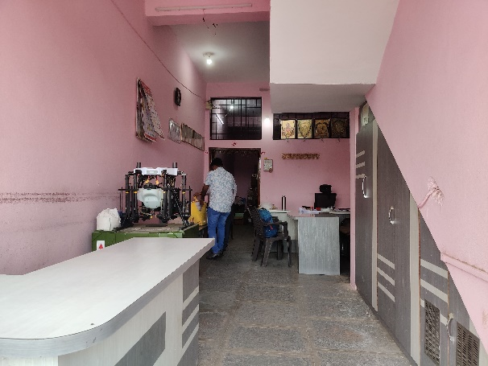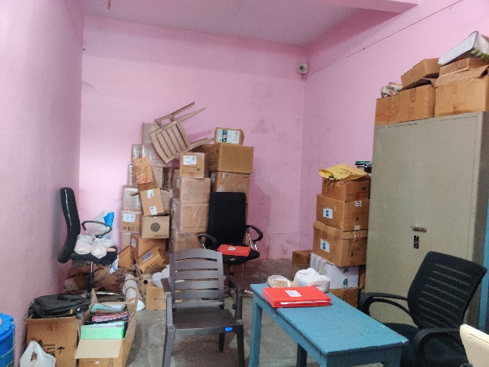

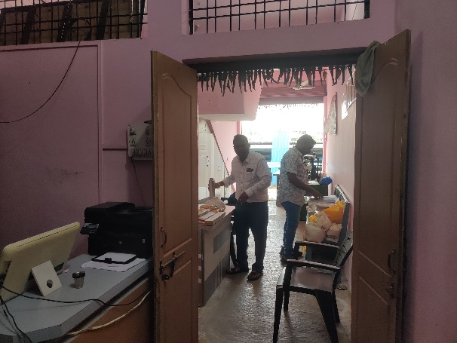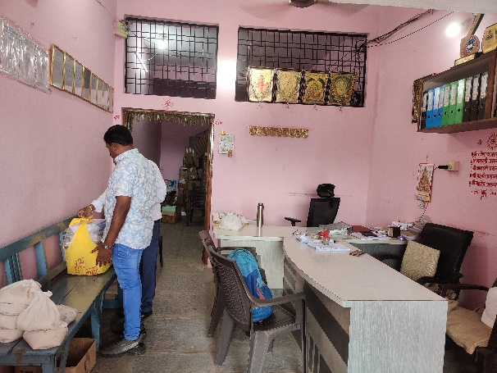

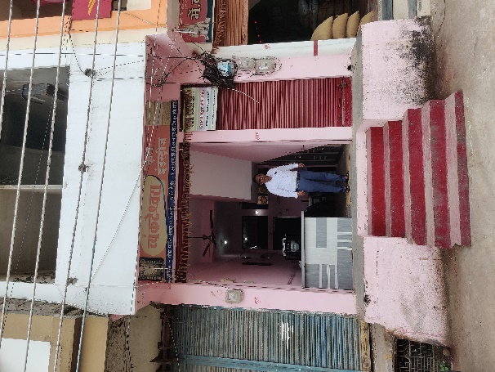

**Actual Site Photographs**

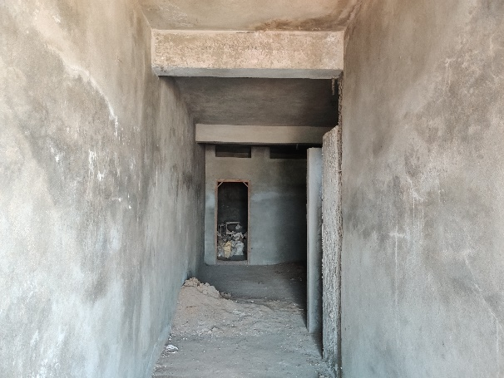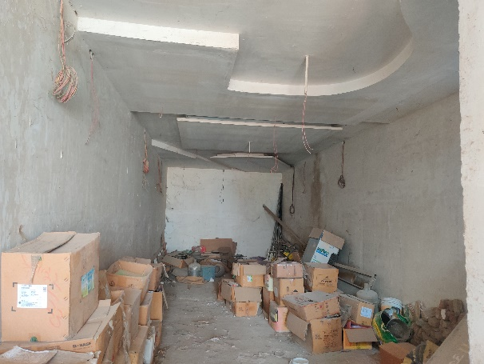

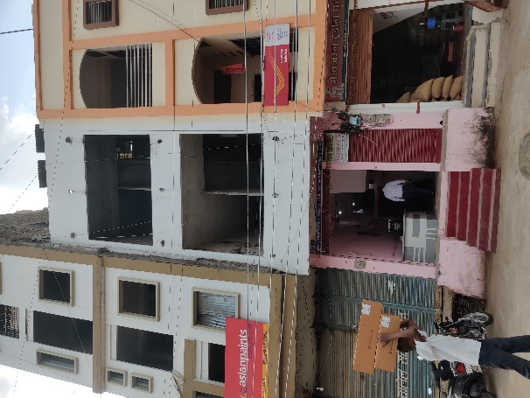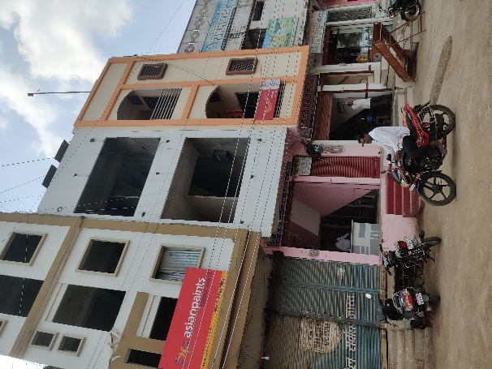

**Actual Construction Plan**

**Route Map of the property**

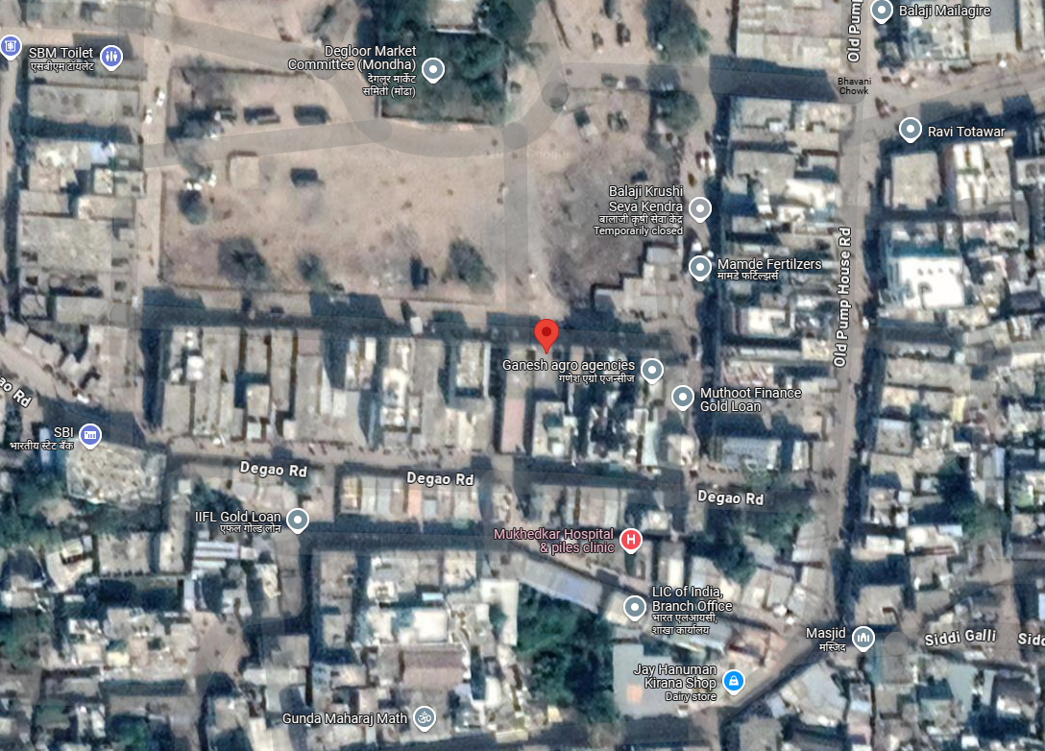**Site u/r**

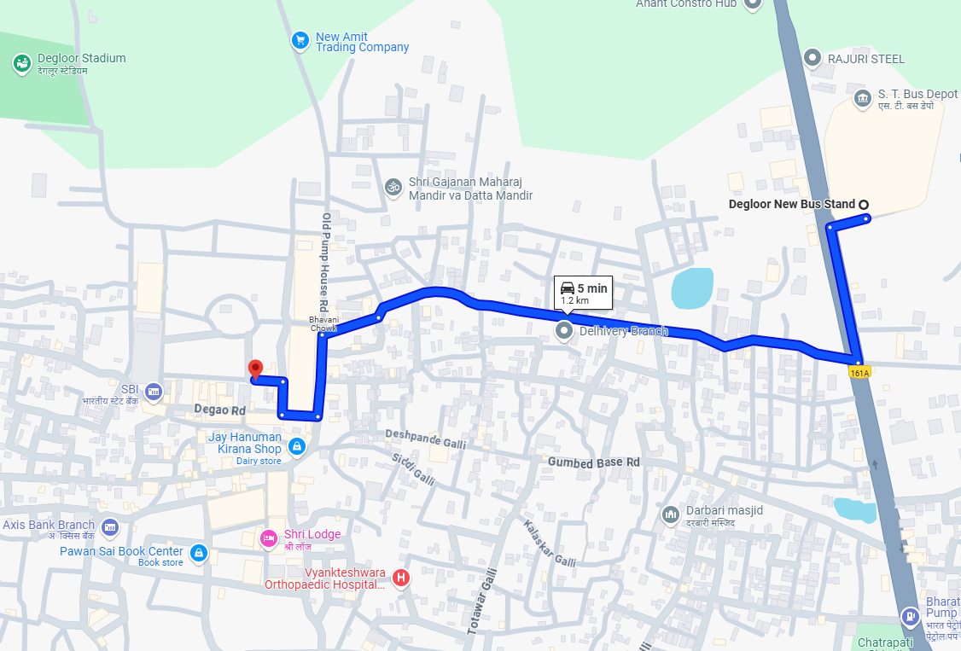

# **Latitude Longitude: 18°33'01.3"N 77°34'33.8"E**

Note: The Blue line shows the route to site from nearest Bus Stand (Degloor – 1.2 Km.)

.

**Ready Reckoner Rate**

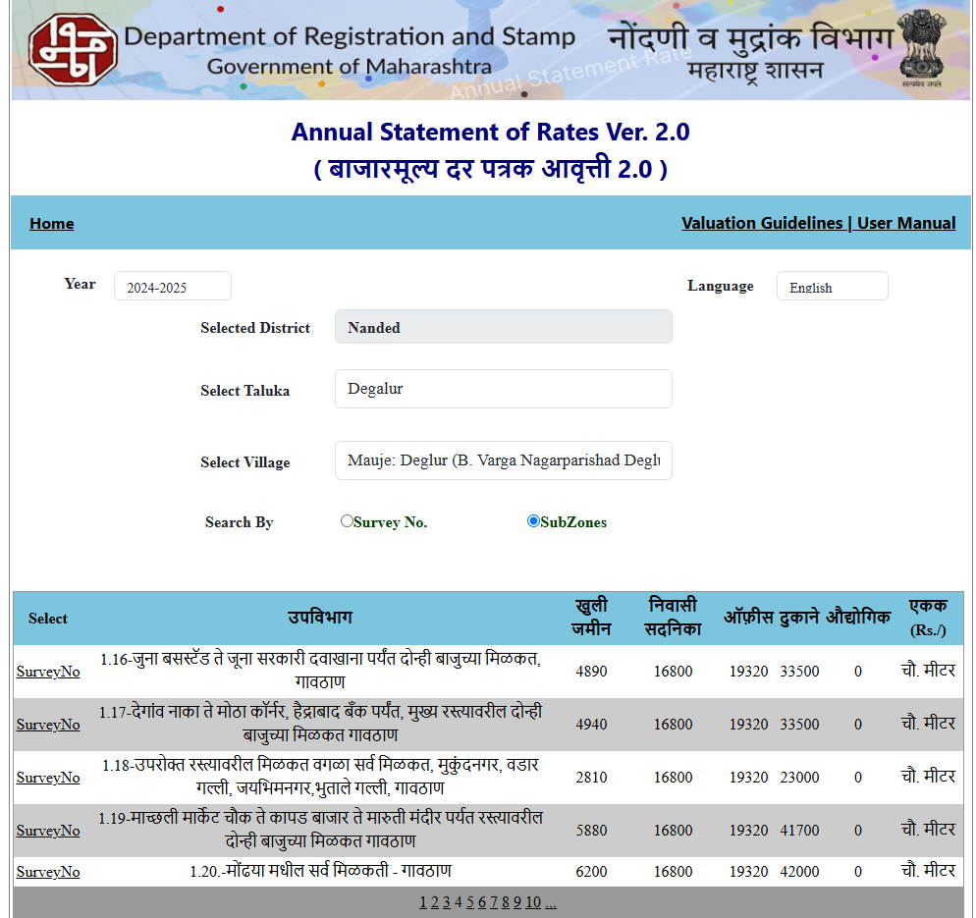

**Price Indicator**

**ASSUMPTIONS, CAVEATS, LIMITATION AND DISCLAIMERS**

1. We assume no responsibility for matters of legal nature affecting the property appraised or the title thereto, nor do we render our opinion as to the title, which is assumed to be good and marketable.
2. The property is valued as though under responsible ownership.
3. It is assumed that the property is free of liens and encumbrances.
4. It is assumed that there are no hidden or unapparent conditions of the subsoil or structure that would render it more or less valuable. No responsibility is assumed for such conditions or for engineering that might be required to discover such factors.
5. The rates for valuation of the property are in accordance with the Govt. approved rates and prevailing market rates

For, **Vastukala Consultants (I) Pvt. Ltd.**

**Sharadkumar B. Chalikwar**

B.E. (Civil), M.E. (Civil), M.Sc. (Real Estate Valuation), M.Sc. (P&M Valuation), FIE (I), FIV, FIWRS

Chairman & Managing Director

Govt. Reg. Valuer

Chartered Engineer (India)

Reg. No. (N) CCIT/1-14/52/2008-09

IBBI Reg.No. IBBI/RV/07/2019/11744

Date: 25.10.2024

Place: Nanded.