Valuation Report of the Immovable Property

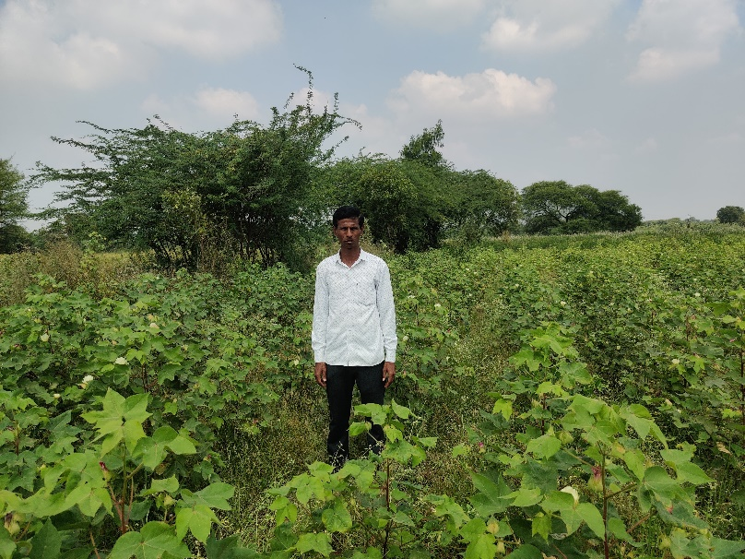

## Details of the property under consideration:

## Name of Owner: Mr. Ganesh Ventatrao Achintalwar

## Plot No. 33, Property No. 5/2489/10841, & Plot No. 34, Property No. 5/2490/10842,

## Gut No. 1023, Venkatesh Nagar, Degaon Road, Village – Degaloor,

## Taluka – Degaloor, District – Nanded, State – Maharashtra, Country - India.

**Longitude Latitude:** **18.555716, 77.568380**

# Intended User:

# Axis Bank

Nanded Branch.

Vastukala Consultants (I) Pvt. Ltd.

Mumbai • Delhi NCR • Aurangabad • Nanded • Indore • Pune

Raipur • Jaipur • Ahmedabad • Rajkot • Thane • Nasik

Vastu/Axis Bank/Nanded Br./11/2024/111285

Date: 29.02.2024

# VALUER’S OPINION REPORT

This is to certify that the property situated on Plot No. 33, Property No. 5/2489/10841, & Plot No. 34, Property No. 5/2490/10842, Gut No. 1023,

Venkatesh Nagar, Degaon Road, Village – Degaloor, Taluka – Degaloor, District – Nanded, State – Maharashtra, Country - India.

belongs to **Mr. Ganesh Ventatrao Achintalwar.**

|  |  |  |
| --- | --- | --- |
| **Boundaries of the property.** |  |  |
| On or towards the North by | : | Land of Gut No. 1029 |
| On or towards the South by | : | 6.00 m. vide Internal Road |
| On or towards the East by | : | Open Land  Land of Gut No. 1023 |
| On or towards the West by | : |  |

Considering various parameters recorded, existing economic scenario, and the information that is available with reference to the development of neighborhood

and method selected for valuation, we are of the opinion that, the property premises can be assessed are as under:

|  |  |
| --- | --- |
| **Guideline Value of the Property** | **Rs. 6,58,800.00** |
| **Fair Market Value of the Property** | **Rs. 21,60,000.00** |
| **Realizable Value of the Property** | **Rs. 19,44,000.00** |
| **Forced/ Distress Sale value of the Property** | **Rs. 17,28,000.00** |

The valuation of the property is based on the documents produced by the concern. Legal aspects have not been taken into considerations while preparing this valuation report.

Hence certified

**For, Vastukala Consultants (I) Pvt. Ltd.**

**Sharadkumar B. Chalikwar**

B.E. (Civil), M.E. (Civil), M.Sc. (Real Estate Valuation), M.Sc. (P&M Valuation), FIE (I), FIV, FIWRS

Chairman & Managing Director

Govt. Reg. Valuer Chartered Engineer (India)

Reg. No. (N) CCIT/1-14/52/2008-09 IBBI Reg.No. IBBI/RV/07/2019/11744

Encl: Valuation report.

## VALUATION REPORT (IN RESPECT OF RESIDENTIAL LAND)

|  |  |  |  |  |  |  |  |  |  |
| --- | --- | --- | --- | --- | --- | --- | --- | --- | --- |
| 1. | **CBB/CCMC/CCSU** | |  | | **Request No** | | - | | |
| **Proposal No.** | | - | | |
| 2. | Name of Owner & Address: | | | | **Mr. Ganesh Ventatrao Achintalwar**  R/o. Line Galli, Degloor, Tq. Degloor, Dist. Hingoli. Cell # 94221 85107 | | | | |
| Name of Borrower & Address | | | | **Mr. Ganesh Ventatrao Achintalwar**  R/o. Line Galli, Degloor, Tq. Degloor, Dist. Hingoli. Cell # 9422185107 | | | | |
| 3. | Name of the Bank Official Present | | | | No. | | | | |
| Name of the Representative & Mobile No. | | | | 1. Siddappa  (Owner’s Representative) Mob. # 9949044561 | | | | |
| **4.** | **Details of the Property Being Valued** | | | | | | | | |
| 4.1 | Description of the Property | | | | * The Subject Property under valuation is Freehold Open Plot No. 33, Property No. 5/2489/10841, & Plot No. 34, Property No. 5/2490/10842, Gut No. 1023, Venkatesh Nagar, Degaon Road, Village – Degaloor, Taluka – Degaloor, District – Nanded, State – Maharashtra, Country - India * There is no demarcation of layout * Presently land is being used for agriculture use only * Plot size: 12.00 m x 18.00 m. * Plot area: 216.00 Sq. m | | | | |
| 4.2 | Location of Property | | | | The Subject Property under valuation is Freehold Open Plot No. 33, Property No. 5/2489/10841, & Plot No. 34, Property No. 5/2490/10842, Gut No. 1023, Venkatesh Nagar, Degaon Road, Village – Degaloor, Taluka – Degaloor, District – Nanded, State – Maharashtra, Country - India | | | | |
| (Rural / Semi Urban / Urban) | | | | Urban | | | | |
| 4.3 | Documents Provided: | | | | | | | | |
| 1 | Photo Copy of Sale Deed No. 457/2013, dated. 31.12.2012, Registered at Sub – Registrar, Degloor | | | | | | | |
| 2 | Photo Copy of Gunthewari Order (Plot No. 33) vide Outward No. 4734/2012, Permit No. 295, dated 06.10.2012, Degloor  Municipal Council, Degloor. | | | | | | | |
| 3 | Photo Copy of Regularized under Gunthewaru Plan (Plot No. 33), Degloor Municipal Council, Degloor. | | | | | | | |
| 4 | Photo Copy of Gunthewari Order (Plot No. 34) vide Outward No. 4735/2012, Permit No. 296, dated 06.10.2012, Degloor  Municipal Council, Degloor. | | | | | | | |
|  | 5 | Photo Copy of Regularized under Gunthewaru Plan (Plot No. 34), Degloor Municipal Council, Degloor. | | | | | | | |
|  | 6 | Photo Copy of Property Certificate No. 798/16, dated. 25.01.2016, chief officer, Degloor Municipal Council, Degloor. | | | | | | | |
|  | 7 | Photo Copy of Namuna No. 43 Rule (74) Tax Assessement year 2000-2001 dated. 25.01.2016, chief officer, Degloor Municipal Council, Degloor. | | | | | | | |
|  | 8 | Photo Copy of Tax Paid Receipt in (Plot No. 33) No. 09, Block No. 865, dated. 15.11.2021, year 2021 – 2022, Degloor Municipal Council, Degloor. | | | | | | | |
|  | 9 | Photo Copy of Tax Paid Receipt in (Plot No. 34) No. 10, Block No. 865, dated. 15.11.2021, year 2021 – 2022, Degloor Municipal Council, Degloor. | | | | | | | |
|  | 10 | Photo copy of Title Investigation Report dated 27.11.2018, prepared by Adv. Madhav B. Pawde, Nanded. | | | | | | | |
| 4.4 | Plot No / Survey No. / Gut No. / Khasra No: | | | Plot No. 33 & Plot No. 34, Gut No. 1023 | | | | | |
| Road | | | Degaon Road | | | | | |
| 4.5 | Colony / Nagar / Sector | | | Pethampur | | Locality / Landmark | | | Opposite to Salvan Maruti Mandir |
| 4.6 | Village/Town/City | | | Degloor | | District: | | | Nanded |
| 4.7 | State | | | Maharashtra | | Pin code: | | | 431 717 |
| 4.8 | Distance from Area Office | | | | | @ 84 Km from Nanded Branch to Degloor | | | |
| **5.** | **Type of Property** | | | | | | | | |
|  | **(A) Plot:** (Residential / Commercial / Industrial) | | | | | | | Open Plot | |
| Level of land with topographical conditions | | | | | | | Plain | |
| Whether situated in Municipal / Corporation Limit | | | | | | | Village Panchayat. | |
| Any construction observed on plot | | | | | | | No. | |
| **(B) Residential Property: (**Independent house / Bungalow / Row House / Flat) | | | | | | | Open Plot | |
| Civic Amenities like school, hospital, market, etc. (Available, within the radius of Km./ Not Available) | | | | | | | All available nearby. | |
| **(C) Commercial / Industrial Property :** (Office / Shop / Unit in a Mall / Gowdown) | | | | | | | No. | |
| **6.** | **Accessibility / Boundaries / Others** | | | | | | | | |

,

|  |  |  |  |  |  |  |  |  |  |  |  |  |  |
| --- | --- | --- | --- | --- | --- | --- | --- | --- | --- | --- | --- | --- | --- |
| 6.1 | Availability of local transport (Metro / Local Train / Bus / Personal Transport)  . | | | | | | | Local Transport, Bus Stand, Personal Transport | | | | | |
| 6.2 | Distance from Nanded Railway station @ 84 Km | | | | | | | Bus stop/ Taxi/ Auto Stand @ 1.8 Km | | | | | |
| 6.3 | Does the approach road to the Property / Building is independent and accessible | | | | | Yes. | | Will it be able to accommodate a fire extinguisher | | | | | No. |
| 6.4 | Does the property falls under land locked  area | | | | | No. | | Does the property falls in a community  dominated area | | | | | No. |
| 6.5 | Cornered / Intermittent Plot | | | | | | | Intermittent | | | | | |
| **6.6** | **Gut No.105** | | | | | | | | | | | | |
|  | Boundaries | As Per Site | | | | | | As Per Sale Deed | | | | | |
| North | Land of Gut No. 1029 | | | | | | Land of Gut No. 1029 | | | | | |
| South | 6.00 m. vide Internal Road | | | | | | 6.00 m. vide Internal Road | | | | | |
| East | Open Lan d | | | | | | Open Land | | | | | |
| West | Land of Gut No. 1023 | | | | | | Land of Gut No. 1023 | | | | | |
| 6.7 | Class of locality (Posh / Higher Middle Class / Middle Class / Lower Middle Class / Poor) | | | | | | | Middle Class | | | | | |
| 6.8 | Quality of Infrastructure in the vicinity (Excellent / Good / Average / Poor) | | | | | | | No infrastructure developed. | | | | | |
| 6.9 | Ownership Status of the Property (Free Hold / Reg. Lease / Govt. Authority) | | | | | | | Freehold. | | | | | |
| 6.10 | Approved usage of property (Industrial / Commercial / Residencial / Mix) | | | | Open Plot | | | Actual usage of property (Industrial / Commercial / Residential / Mix) | | | Open Plot | | |
| 6.11 | Restrictive covenants in regards to Land Use, (if any) | | | | | | | Open Plot | | | | | |
| 6.12 | Type of Structure (Load Bearing / RCC / Aluform shuttering) | | | | | | | Not applicable being open plot | | | | | |
| 6.13 | Number of floors | | | | | | | Not applicable being open plot | | | | | |
| 6.14 | Occupancy Details (Self-Occupied / Rented / Vacant) | | | | | | | Not applicable being open plot | | | | | |
| **7.** | **If the property is on rent:** | | | | | | | | | | | | |
| 7.1 | Name of tenant / lease & Number of years in tenancy | | | | | | | Not applicable being open plot | | | | | |
| 7.2 | Was there any resistance for valuation: No | | | | | | If yes, from the current occupants: N.A. | | | | | | |
| 7.3 | Does property have basic amenities | | | No. | | | Development of surrounding area Underdeveloped / Developing / Developed | | | | | Developing. | |
| **8.** | **If the property is Leasehold** | | | | | | | | | | | | |
| 8.1 | Name of Lesser: | | N.A. | Nature of Lease: | | | | | | N.A. | | | |
| 8.2 | Total Period of Lease: | | N.A. | If yes, from the current occupants: | | | | | | N.A. | | | |
| 8.3 | Does property have basic amenities | | No. | Development of surrounding area Underdeveloped / Developing / Developed. | | | | | | Developing | | | |
| **9.** | **Approval Details** | | | | | | | | | | | | |
| 9.1 | RERA Registration Number | | | | | Not applicable being open plot | | | | | | | |
| 9.2 | Layout Approval Number: | | | | | - | | | | | | | |
| Date of Approval | | | | | - | | | | | | | |
| Expiry Date | | | | | - | | | | | | | |
| 9.3 | Building Plan Approval Number & Occupancy Certificate | | | | | Not applicable being open plot | | | | | | | |
| Date of Approval | | | | | - | | | | | | | |
| Expiry Date | | | | | - | | | | | | | |
| **10.00** | **Plot Area Details.** | | | | | | | | | | | | |
| **10.01** | **Plot Area** | | | | | | | | **Area in Sq. M.** | | | | |
| **10.02** | **Plot Area As per Sale Deed** | | | | | | | | 12.00 x 18.00 m. | | | | |
|  | **a) Plot No. 4 & Plot No. 5, Gut No. 1023** | | | | | | | | 216.00 Sq. m | | | | |

|  |  |  |  |  |  |  |  |  |  |  |  |  |  |  |  |  |  |  |
| --- | --- | --- | --- | --- | --- | --- | --- | --- | --- | --- | --- | --- | --- | --- | --- | --- | --- | --- |
|  | **Total Area as per Sale Deed** | | | | | | | | | | | | | **216.00 Sq. m** | | | |  |
| 10.03 | Demarcation at Site | | | | | | | | | | | | | No. | | | |
| 10.04 | Plot Area Considered for Valuation | | | | | | | | | | | | | **216.00 Sq. m** | | | |
| **10.05** | **Construction Area Details** | | | | | | | | | | | | | Not applicable being open plot | | | |
| **10.06** | **Floor wise break up as follows** | | | | | | | | | **Current Usage**  (Storage / Parking / Commercial /Residential) | | | | | | | |
|  | N.A. | | | | | | | | | N.A. | | | | | | | |
| 10.07 | Amenities Details (if any): | | | | | | | | | Not applicable being open plot | | | | | | | |
| 10.08 | FSI Utilized | | | | | | | | | Not applicable being open plot | | | | | | | |
| 10.09 | Whether the construction is as per approved building plan and / or local building bye laws: | | | | | | | | | Not applicable being open plot | | | | | | | |
| 10.10 | Details of Extra Construction | | | | | | | | | Not applicable being open plot | | | | | | | |
| 10.11 | Percentage of Extra Construction | | | | | | | | | Not applicable being open plot | | | | | | | |
| 10.12 | Whether the extra construction is Compoundable OR Non-Compoundable? | | | | | | | | | Not applicable being open plot | | | | | | | |
| 10.13 | Quality of construction | | | | | | | | | Not applicable being open plot | | | | | | | |
| 10.14 | Maintenance of the Property | | | | | | | | | Not applicable being open plot | | | | | | | |
| 10.15 | Condition of Building | | | | | | | | | Not applicable being open plot | | | | | | | |
| 10.16 | Current Life of the structure | | | Not applicable being open plot | | | Projected Future Life of the Structure | | | | | Not applicable being open plot | | | | | |
| 10.17 | Land Revenue / Taxes Paid upto (for Land) | | | Details not available | | | Municipal Taxes Paid upto (for Building) | | | | | Details not available. | | | | | |
| **11.** | **Details of Valuation:** | | | | | | | | | | | | | | | | |
|  | **S.L** | **Particulars of Item** | **Plinth / Built up Area In Sq. M.** | | | **Age of Building** | | **Estimated Replacement Rate Of Construction** | | | **Replacement cost** | | | | **Depreciation Nil** | | **Net Value after Depreciation** |
| **Nil** | | | | | | | | | | | | | | | | |
| **12.** | Details of Amenities | | | | | | | | | | | | | | | | N.A. |
| **13.** | **Government Guideline value** | | | | | | | | | | | | | | | | |
|  | **Particulars** | | | | **Area in Sq. M.** | | | | **Rate in Rs.** | | | | | | | **Value in Rs.** | |
| 1 | Land | | | | 216.00 | | | | 3,050.00 | | | | | | | **Rs. 6,58,800.00** | |
|  | **TOTAL** | | | | | | | | | | | | | | | **Rs. 6,58,800.00** | |
| 14. | **Market Value of Land** | | | | | | | | | | | | | | | | |
|  | **Particulars** | | | | **Area in Sq. M.** | | | | **Rate in Rs.** | | | | | | | **Value in Rs.** | |
| **Land** | | | | 216.00 | | | | 10,000.00 | | | | | | | **Rs. 15,05,547.00** | |
| 15. | **Value of the Property** | | | | | | | | | | | | | | | | |
|  |  | | | | **Land** | | | | **Building** | | | | **Amenities** | | | **Total** | |
| Government Guideline value | | | | **Rs. 6,58,800.00** | | | | Nil | | | | Nil | | | **Rs. 6,58,800.00** | |
| Market Value | | | | **Rs. 21,60,000.00** | | | | Nil | | | | Nil | | | **Rs. 21,60,000.00** | |
| Realizable Value | | | |  | | | | | | | | | | | **Rs. 19,44,000.00** | |
| Distressed/Forced Sale Value | | | |  | | | | | | | | | | | **Rs. 17,28,000.00** | |
| Insurable Value | | | |  | | | | | | | | | | | **Nil** | |
| **Remarks** | | | | | | | | | | | | | | | | |  |
| * No infrastructure is developed. | | | | | | | | | | | | | | | | |

### Undertaking:

* 1. I have / our / representative Md. Shareq Salim Md. Jilani Pasha (Technical Assistant) has inspected the subject property on 23.10.2024 along with Owner's Representative Mr.Siddappa identified the same based on the documents provided.
  2. I/We have no direct or Indirect interest in the property being valued.
  3. The information furnished above is true and correct to my/our knowledge
  4. I/ we have not been dismissed or removed from govt. Service or convicted of an offence connected with any proceedings of income tax act, wealth tax act or gift tax act or have been blacklisted by any bank/ financial institution/ govt. Department/ public sector enterprise/ body corporate etc.
  5. This valuation is prepared without any prejudice or bias to any person or institution.
  6. The value of land is taken into account by making due enquires in the locality and ascertaining the sales value of the properties in the locality.
  7. Any additions/alterations made to the property after the date of valuations shall not fall under the scope of this report.

## For, Vastukala Consultants (I) Pvt. Ltd.

### Sharadkumar B. Chalikwar

B.E. (Civil), M.E. (Civil), M.Sc. (Real Estate Valuation), M.Sc. (P&M Valuation), FIE (I), FIV, FIWRS Chairman & Managing Director

Govt. Reg. Valuer Chartered Engineer (India)

Reg. No. (N) CCIT/1-14/52/2008-09 IBBI Reg.No. IBBI/RV/07/2019/11744

Date: 29.02.2024

|  |  |  |
| --- | --- | --- |
| **Attachments** | | |
| Photographs of the Property from inside & outside | : | Attached |
| Location sketch for the property: | : | Attached |
| Geo Tagging | : | Attached |
| Topography | : | Leveled Land |
| Government Value Document | : | Attached |

**Actual Site Photographs**

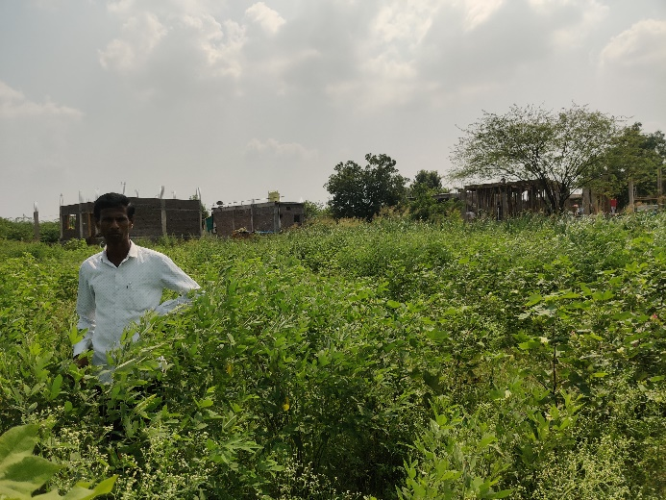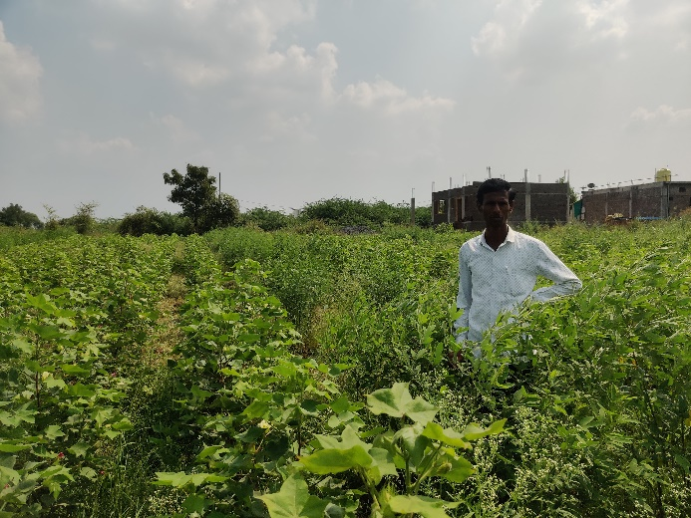

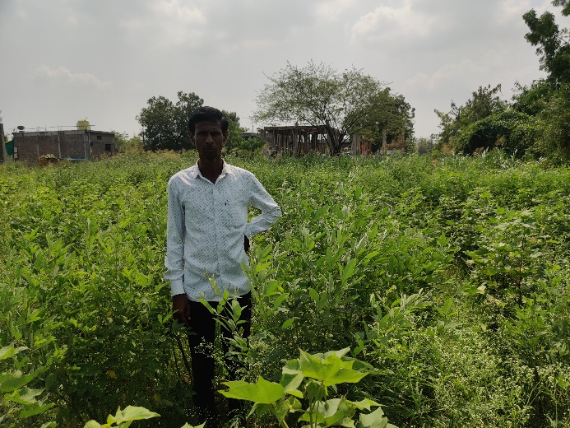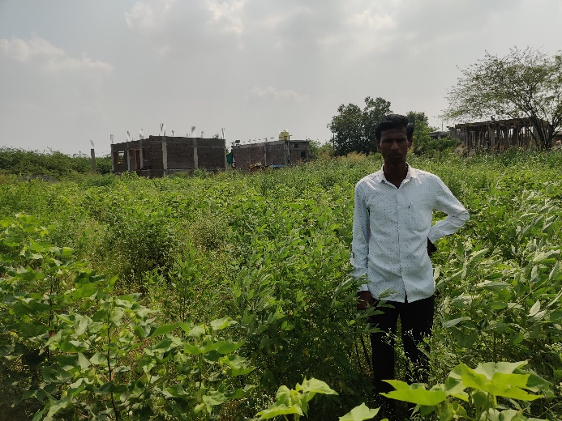

**Route Map of the Property**

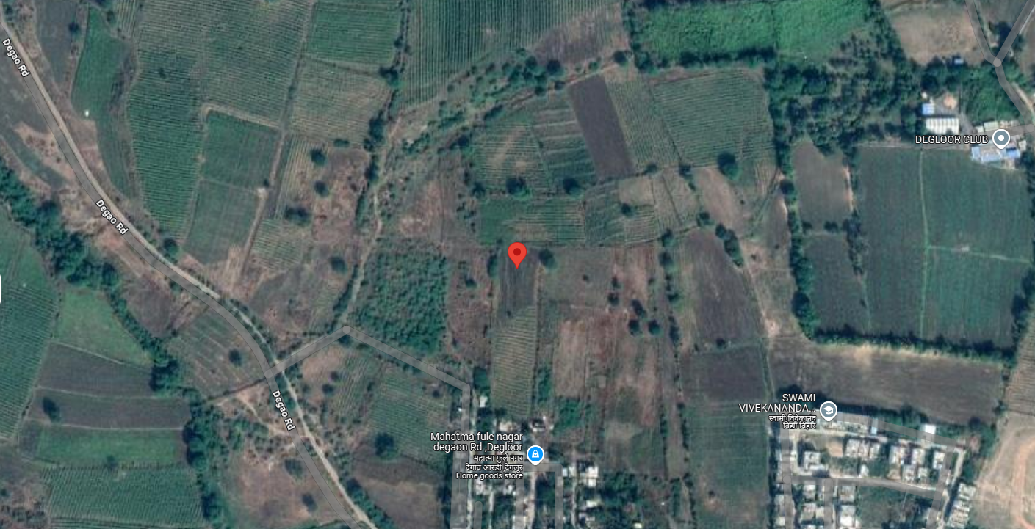

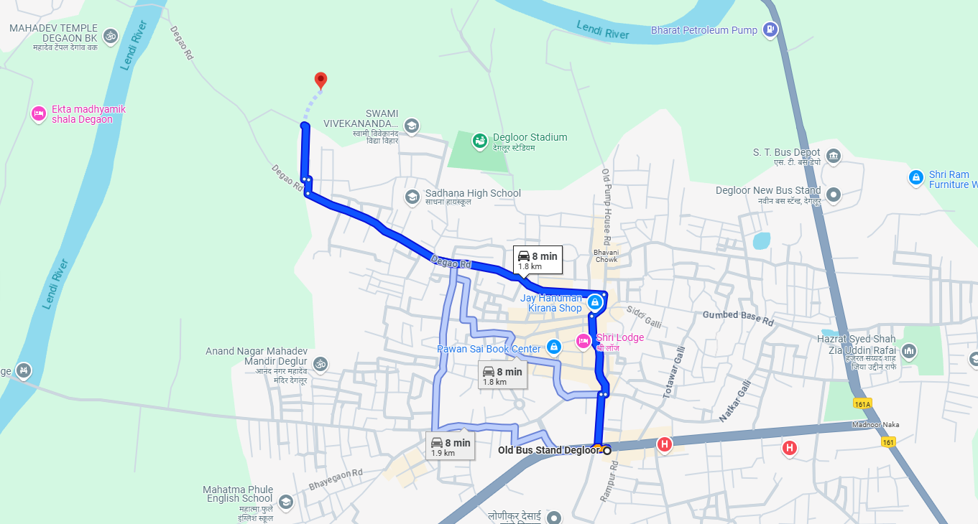

### Longitude Latitude: 18.555716, 77.568380

**Note**:

* Red Pointer shows Approx. Property Location.
* Blue line shows Route from Degloor Old Bus Stand @ 1.8 Km.

**Ready Reckoner Rate**

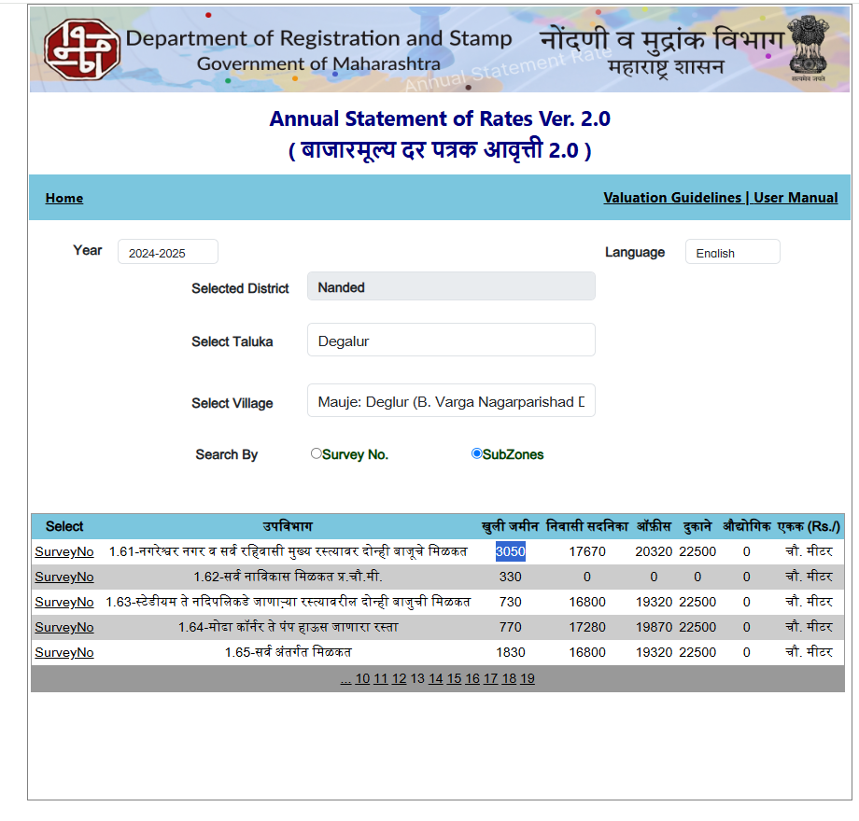

**Price Indicator**

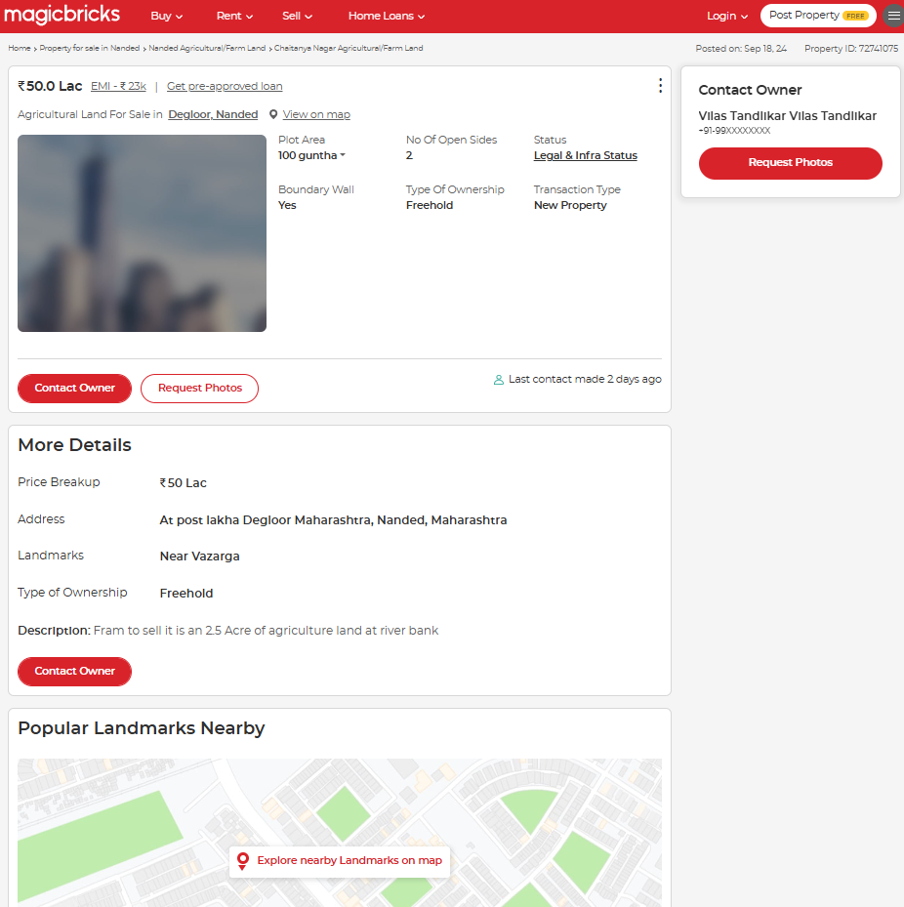

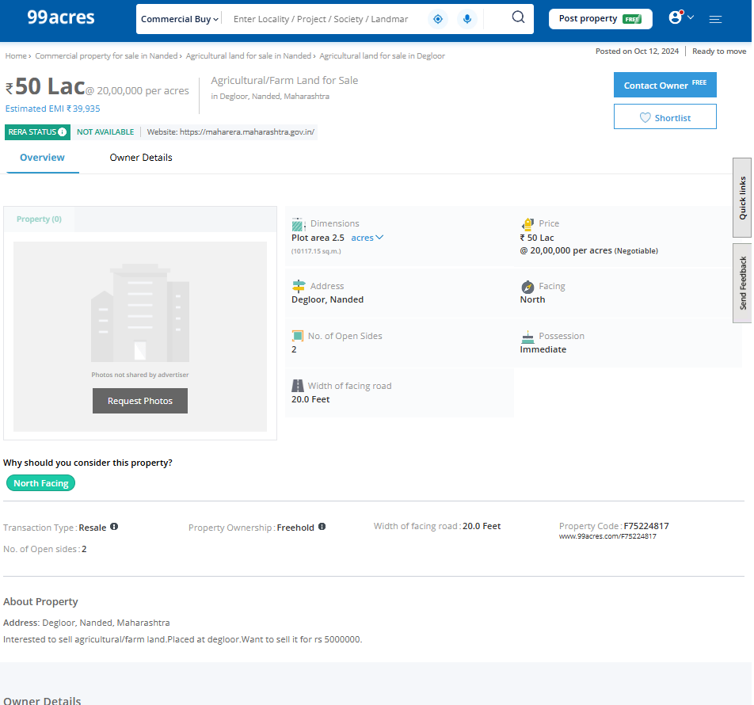

**ASSUMPTIONS, CAVEATS, LIMITATION AND DISCLAIMERS**

1. We assume no responsibility for matters of legal nature affecting the property appraised or the title thereto, nor do we render our opinion as to the title, which is assumed to be good and marketable.
2. The property is valued as though under responsible ownership.
3. It is assumed that the property is free of liens and encumbrances.
4. It is assumed that there are no hidden or unapparent conditions of the subsoil or structure that would render it more or less valuable. No responsibility is assumed for such conditions or for engineering that might be required to discover such factors.
5. The rates for valuation of the property are in accordance with the Govt. approved rates and prevailing market rates

## For, Vastukala Consultants (I) Pvt. Ltd.

### Sharadkumar B. Chalikwar

B.E. (Civil), M.E. (Civil), M.Sc. (Real Estate Valuation), M.Sc. (P&M Valuation), FIE (I), FIV, FIWRS Chairman & Managing Director

Govt. Reg. Valuer Chartered Engineer (India)

Reg. No. (N) CCIT/1-14/52/2008-09 IBBI Reg.No. IBBI/RV/07/2019/11744

Date: 29.02.2024

Place: Nanded.