Valuation Report of the Immovable Property

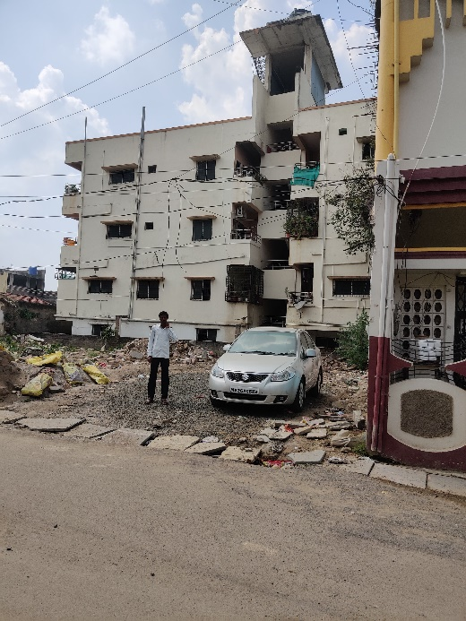

**Details of the property under consideration:**

Name of the Owner:

**Mr. Bhimesh S/o Vitthalrao Kotgire**

Residential Plot bearing M. H. No. 4643, Line Galli, (Pethamrapur), Village – Degloor,

Taluka – Degloor, District – Nanded, Maharashtra, India

# **Longitude Latitude: 18.549009,77.572007**

**Intended User:**

**State Bank of India**

**SME Nanded Branch**

Dr. Lane, Nanded, Maharashtra, India

# Vastu/Nanded /12/2024/012806/2309351

# 04/15-49-AS

# Date: 04.12.2024

# **VALUER’S OPINION REPORT**

This is to certify that the property bearing Residential Plot bearing M. H. No. 4643, Line Galli, (Pethamrapur), Village – Degloor, Taluka – Degloor, District – Nanded, Maharashtra, India belongs to **Mr. Bhimesh S/o Vitthalrao Kotgire.**

Boundaries of the property:

|  |  |  |
| --- | --- | --- |
| On or towards the North by | : | House of Mr. Pravin Venkatarao Achintalwar |
| On or towards the South by | : | House of Mr. Ram Narayan Mariwar |
| On or towards the East by | : | Line Galli Road |
| On or towards the West by | : | Sheri & Shri. Padamwar’s Apartment |

Considering various parameters recorded, existing economic scenario, and the information that is available with reference to the development of neighborhood and method selected for valuation, we are of the opinion that, the property premises can be assessed and valued for this particular purpose as under.

|  |  |
| --- | --- |
| **Fair Market Value of the Property** | **Rs. 48,79,000.00** |
| **Realizable Value** | **Rs. 43,91,000.00** |
| **Forced/ Distress Sale value** | **Rs. 39,03,000.00** |
| **Guideline Value of the Property** | **Rs. 2,77,134.00** |

Hence certified

For, **Vastukala Consultants (I) Pvt. Ltd.**

**Sharadkumar B. Chalikwar**

B.E. (Civil), M.E. (Civil), M.Sc. (Real Estate Valuation), M.Sc. (P&M Valuation), FIE (I), FIV, FIWRS

Chairman & Managing Director

Govt. Reg. Valuer

Chartered Engineer (India)

Reg. No. (N) CCIT/1-14/52/2008-09

IBBI Reg.No. IBBI/RV/07/2019/11744

SBI Empanelment No.: SME/TCC/38/37

Encl: Valuation report.

|  |  |  |  |  |  |  |  |  |  |  |  |  |  |  |  |  |  |  |  |  |  |  |  |  |  |  |  |  |  |  |  |  |  |  |  |  |  |  |  |  |  |  |  |  |  |  |  |  |  |  |  |  |  |  |  |  |  |  |  |  |  |  |  |  |  |  |  |  |  |  |  |  |  |  |  |  |  |  |  |  |  |  |  |  |  |  |  |  |  |  |  |  |  |  |  |  |  |  |  |  |  |  |  |  |  |  |  |  |  |  |  |  |  |  |  |  |  |  |  |  |  |  |  |  |  |  |  |  |  |  |  |  |  |  |  |  |  |  |  |  |  |  |  |  |  |  |  |  |  |  |  |  |  |  |  |  |  |  |  |  |  |  |  |  |  |  |  |  |  |  |  |  |  |  |  |  |  |  |  |  |  |  |  |  |  |  |  |  |  |  |  |  |  |  |  |  |  |  |  |  |  |  |  |  |  |  |  |  |  |  |  |  |  |  |  |  |  |  |  |  |  |  |  |  |  |  |  |  |  |  |  |  |  |  |  |  |  |  |  |  |  |  |  |  |  |  |  |  |  |  |  |  |  |  |  |  |  |  |  |  |  |  |  |  |  |  |  |  |  |  |  |  |  |  |  |  |  |  |  |  |  |  |  |  |  |  |  |  |  |  |  |  |  |  |  |  |  |  |  |  |  |  |  |  |  |  |  |  |  |  |  |  |  |  |  |  |  |  |  |  |  |  |  |  |  |  |  |  |  |  |  |  |  |  |  |  |  |  |  |  |  |  |  |  |  |  |  |  |  |  |  |  |  |  |  |  |  |  |  |  |  |  |  |  |  |  |  |  |  |  |  |  |  |  |  |  |  |  |  |  |  |  |  |  |  |  |  |  |  |  |  |  |  |  |  |  |  |  |  |  |  |  |  |  |  |  |  |  |  |  |  |  |  |  |  |  |  |  |  |  |  |  |  |  |  |  |  |  |  |  |  |  |  |  |  |  |  |  |  |  |  |  |  |  |  |  |  |  |  |  |  |  |  |  |  |  |  |  |  |  |  |  |  |  |  |  |  |  |  |  |  |  |  |  |  |  |  |  |  |  |  |  |  |  |  |  |  |  |  |  |  |  |  |  |  |  |  |  |  |  |  |  |  |  |  |  |  |  |  |  |  |  |  |  |  |  |  |  |  |  |  |  |  |  |  |  |  |  |  |  |  |  |  |  |  |  |  |  |  |  |  |  |  |  |  |  |  |  |  |  |  |  |  |  |  |  |  |  |  |  |  |  |  |  |  |  |  |  |  |  |  |  |  |  |  |  |  |  |  |  |  |  |  |  |  |  |  |  |  |  |  |  |  |  |  |  |  |  |  |  |  |  |  |  |  |  |  |  |  |  |  |  |  |  |  |  |  |  |  |  |  |  |  |  |  |  |  |  |  |  |  |  |  |  |  |  |  |  |  |  |  |  |  |  |  |  |  |  |  |  |  |  |  |  |  |  |  |  |  |  |  |  |  |  |  |  |  |  |  |  |  |  |  |  |  |  |  |  |  |  |  |  |  |  |  |  |  |  |  |  |  |  |  |  |  |  |  |  |  |  |  |  |  |  |  |  |  |  |  |  |  |  |  |  |  |  |  |  |  |  |  |  |  |  |  |  |  |  |  |  |  |  |  |  |  |  |  |  |  |  |  |  |  |  |  |  |  |  |  |  |  |  |  |  |  |  |  |  |  |  |  |  |  |  |  |  |  |  |  |  |  |  |  |  |  |  |  |  |  |  |  |  |  |  |  |  |  |  |  |  |  |  |  |  |  |  |  |  |  |  |  |  |  |  |  |  |  |  |  |  |  |  |  |  |  |  |  |  |  |  |  |  |  |  |  |  |  |  |  |  |  |  |  |  |  |  |  |  |  |  |  |  |  |  |  |  |  |  |  |  |  |  |  |  |  |  |  |  |  |  |  |  |  |  |  |  |  |  |  |  |  |  |  |  |  |  |  |  |  |  |  |  |  |  |  |  |  |  |  |  |  |  |  |  |  |  |  |  |  |  |  |  |  |  |  |  |  |  |  |  |  |  |  |  |  |  |  |  |  |  |  |  |  |  |  |  |  |  |  |  |  |  |  |  |  |  |  |  |  |  |  |  |  |  |  |  |  |  |  |  |  |  |  |  |  |  |  |  |  |  |  |  |  |  |  |  |  |  |  |  |  |  |  |  |  |  |  |  |  |  |  |  |  |  |  |  |  |  |  |  |  |  |  |  |  |  |  |  |  |  |  |  |  |  |  |  |  |  |  |  |  |  |  |  |  |  |  |  |  |  |  |  |  |  |  |  |  |  |  |  |  |  |  |  |  |  |  |  |  |  |  |  |  |  |  |  |  |  |  |  |  |  |  |  |  |  |  |  |  |  |  |  |  |  |  |  |  |  |  |  |  |  |  |  |  |  |  |  |  |  |  |  |  |  |  |  |  |  |  |  |  |  |  |  |  |  |  |  |  |  |  |  |  |  |  |  |  |  |  |  |  |  |  |  |  |  |  |  |  |  |  |  |  |  |  |  |  |  |  |  |  |  |  |  |  |  |  |  |  |  |  |  |  |  |  |  |  |  |  |  |  |  |  |  |  |  |  |  |  |  |  |  |  |  |  |  |  |  |  |  |  |  |  |  |  |  |  |  |  |  |  |  |  |  |  |  |  |  |  |  |  |  |  |  |  |  |  |  |  |  |  |  |  |  |  |  |  |  |  |  |  |  |  |  |  |  |  |  |  |  |  |  |  |  |  |  |  |  |  |  |  |  |  |  |  |  |  |  |  |  |  |  |  |  |  |  |  |  |  |  |  |  |  |  |  |  |  |  |  |  |  |  |  |  |  |  |  |  |  |  |  |  |  |  |  |  |  |  |  |  |  |  |  |  |  |  |  |  |  |  |  |  |  |  |  |  |  |  |  |  |  |  |  |  |  |  |  |  |  |  |  |  |  |  |  |  |  |  |  |  |  |  |  |  |  |  |  |  |  |  |  |  |  |  |  |  |  |  |  |  |  |  |  |  |  |  |  |  |  |  |  |  |  |  |  |  |  |  |  |  |  |  |  |  |  |  |  |  |  |  |  |  |  |  |  |  |  |  |  |  |  |  |  |  |  |  |  |  |  |  |  |  |  |  |  |  |  |  |  |  |  |  |  |  |  |  |  |  |  |  |  |  |  |  |  |
| --- | --- | --- | --- | --- | --- | --- | --- | --- | --- | --- | --- | --- | --- | --- | --- | --- | --- | --- | --- | --- | --- | --- | --- | --- | --- | --- | --- | --- | --- | --- | --- | --- | --- | --- | --- | --- | --- | --- | --- | --- | --- | --- | --- | --- | --- | --- | --- | --- | --- | --- | --- | --- | --- | --- | --- | --- | --- | --- | --- | --- | --- | --- | --- | --- | --- | --- | --- | --- | --- | --- | --- | --- | --- | --- | --- | --- | --- | --- | --- | --- | --- | --- | --- | --- | --- | --- | --- | --- | --- | --- | --- | --- | --- | --- | --- | --- | --- | --- | --- | --- | --- | --- | --- | --- | --- | --- | --- | --- | --- | --- | --- | --- | --- | --- | --- | --- | --- | --- | --- | --- | --- | --- | --- | --- | --- | --- | --- | --- | --- | --- | --- | --- | --- | --- | --- | --- | --- | --- | --- | --- | --- | --- | --- | --- | --- | --- | --- | --- | --- | --- | --- | --- | --- | --- | --- | --- | --- | --- | --- | --- | --- | --- | --- | --- | --- | --- | --- | --- | --- | --- | --- | --- | --- | --- | --- | --- | --- | --- | --- | --- | --- | --- | --- | --- | --- | --- | --- | --- | --- | --- | --- | --- | --- | --- | --- | --- | --- | --- | --- | --- | --- | --- | --- | --- | --- | --- | --- | --- | --- | --- | --- | --- | --- | --- | --- | --- | --- | --- | --- | --- | --- | --- | --- | --- | --- | --- | --- | --- | --- | --- | --- | --- | --- | --- | --- | --- | --- | --- | --- | --- | --- | --- | --- | --- | --- | --- | --- | --- | --- | --- | --- | --- | --- | --- | --- | --- | --- | --- | --- | --- | --- | --- | --- | --- | --- | --- | --- | --- | --- | --- | --- | --- | --- | --- | --- | --- | --- | --- | --- | --- | --- | --- | --- | --- | --- | --- | --- | --- | --- | --- | --- | --- | --- | --- | --- | --- | --- | --- | --- | --- | --- | --- | --- | --- | --- | --- | --- | --- | --- | --- | --- | --- | --- | --- | --- | --- | --- | --- | --- | --- | --- | --- | --- | --- | --- | --- | --- | --- | --- | --- | --- | --- | --- | --- | --- | --- | --- | --- | --- | --- | --- | --- | --- | --- | --- | --- | --- | --- | --- | --- | --- | --- | --- | --- | --- | --- | --- | --- | --- | --- | --- | --- | --- | --- | --- | --- | --- | --- | --- | --- | --- | --- | --- | --- | --- | --- | --- | --- | --- | --- | --- | --- | --- | --- | --- | --- | --- | --- | --- | --- | --- | --- | --- | --- | --- | --- | --- | --- | --- | --- | --- | --- | --- | --- | --- | --- | --- | --- | --- | --- | --- | --- | --- | --- | --- | --- | --- | --- | --- | --- | --- | --- | --- | --- | --- | --- | --- | --- | --- | --- | --- | --- | --- | --- | --- | --- | --- | --- | --- | --- | --- | --- | --- | --- | --- | --- | --- | --- | --- | --- | --- | --- | --- | --- | --- | --- | --- | --- | --- | --- | --- | --- | --- | --- | --- | --- | --- | --- | --- | --- | --- | --- | --- | --- | --- | --- | --- | --- | --- | --- | --- | --- | --- | --- | --- | --- | --- | --- | --- | --- | --- | --- | --- | --- | --- | --- | --- | --- | --- | --- | --- | --- | --- | --- | --- | --- | --- | --- | --- | --- | --- | --- | --- | --- | --- | --- | --- | --- | --- | --- | --- | --- | --- | --- | --- | --- | --- | --- | --- | --- | --- | --- | --- | --- | --- | --- | --- | --- | --- | --- | --- | --- | --- | --- | --- | --- | --- | --- | --- | --- | --- | --- | --- | --- | --- | --- | --- | --- | --- | --- | --- | --- | --- | --- | --- | --- | --- | --- | --- | --- | --- | --- | --- | --- | --- | --- | --- | --- | --- | --- | --- | --- | --- | --- | --- | --- | --- | --- | --- | --- | --- | --- | --- | --- | --- | --- | --- | --- | --- | --- | --- | --- | --- | --- | --- | --- | --- | --- | --- | --- | --- | --- | --- | --- | --- | --- | --- | --- | --- | --- | --- | --- | --- | --- | --- | --- | --- | --- | --- | --- | --- | --- | --- | --- | --- | --- | --- | --- | --- | --- | --- | --- | --- | --- | --- | --- | --- | --- | --- | --- | --- | --- | --- | --- | --- | --- | --- | --- | --- | --- | --- | --- | --- | --- | --- | --- | --- | --- | --- | --- | --- | --- | --- | --- | --- | --- | --- | --- | --- | --- | --- | --- | --- | --- | --- | --- | --- | --- | --- | --- | --- | --- | --- | --- | --- | --- | --- | --- | --- | --- | --- | --- | --- | --- | --- | --- | --- | --- | --- | --- | --- | --- | --- | --- | --- | --- | --- | --- | --- | --- | --- | --- | --- | --- | --- | --- | --- | --- | --- | --- | --- | --- | --- | --- | --- | --- | --- | --- | --- | --- | --- | --- | --- | --- | --- | --- | --- | --- | --- | --- | --- | --- | --- | --- | --- | --- | --- | --- | --- | --- | --- | --- | --- | --- | --- | --- | --- | --- | --- | --- | --- | --- | --- | --- | --- | --- | --- | --- | --- | --- | --- | --- | --- | --- | --- | --- | --- | --- | --- | --- | --- | --- | --- | --- | --- | --- | --- | --- | --- | --- | --- | --- | --- | --- | --- | --- | --- | --- | --- | --- | --- | --- | --- | --- | --- | --- | --- | --- | --- | --- | --- | --- | --- | --- | --- | --- | --- | --- | --- | --- | --- | --- | --- | --- | --- | --- | --- | --- | --- | --- | --- | --- | --- | --- | --- | --- | --- | --- | --- | --- | --- | --- | --- | --- | --- | --- | --- | --- | --- | --- | --- | --- | --- | --- | --- | --- | --- | --- | --- | --- | --- | --- | --- | --- | --- | --- | --- | --- | --- | --- | --- | --- | --- | --- | --- | --- | --- | --- | --- | --- | --- | --- | --- | --- | --- | --- | --- | --- | --- | --- | --- | --- | --- | --- | --- | --- | --- | --- | --- | --- | --- | --- | --- | --- | --- | --- | --- | --- | --- | --- | --- | --- | --- | --- | --- | --- | --- | --- | --- | --- | --- | --- | --- | --- | --- | --- | --- | --- | --- | --- | --- | --- | --- | --- | --- | --- | --- | --- | --- | --- | --- | --- | --- | --- | --- | --- | --- | --- | --- | --- | --- | --- | --- | --- | --- | --- | --- | --- | --- | --- | --- | --- | --- | --- | --- | --- | --- | --- | --- | --- | --- | --- | --- | --- | --- | --- | --- | --- | --- | --- | --- | --- | --- | --- | --- | --- | --- | --- | --- | --- | --- | --- | --- | --- | --- | --- | --- | --- | --- | --- | --- | --- | --- | --- | --- | --- | --- | --- | --- | --- | --- | --- | --- | --- | --- | --- | --- | --- | --- | --- | --- | --- | --- | --- | --- | --- | --- | --- | --- | --- | --- | --- | --- | --- | --- | --- | --- | --- | --- | --- | --- | --- | --- | --- | --- | --- | --- | --- | --- | --- | --- | --- | --- | --- | --- | --- | --- | --- | --- | --- | --- | --- | --- | --- | --- | --- | --- | --- | --- | --- | --- | --- | --- | --- | --- | --- | --- | --- | --- | --- | --- | --- | --- | --- | --- | --- | --- | --- | --- | --- | --- | --- | --- | --- | --- | --- | --- | --- | --- | --- | --- | --- | --- | --- | --- | --- | --- | --- | --- | --- | --- | --- | --- | --- | --- | --- | --- | --- | --- | --- | --- | --- | --- | --- | --- | --- | --- | --- | --- | --- | --- | --- | --- | --- | --- | --- | --- | --- | --- | --- | --- | --- | --- | --- | --- | --- | --- | --- | --- | --- | --- | --- | --- | --- | --- | --- | --- | --- | --- | --- | --- | --- | --- | --- | --- | --- | --- | --- | --- | --- | --- | --- | --- | --- | --- | --- | --- | --- | --- | --- | --- | --- | --- | --- | --- | --- | --- | --- | --- | --- | --- | --- | --- | --- | --- | --- | --- | --- | --- | --- | --- | --- | --- | --- | --- | --- | --- | --- | --- | --- | --- | --- | --- | --- | --- | --- | --- | --- | --- | --- | --- | --- | --- | --- | --- | --- | --- | --- | --- | --- | --- | --- | --- | --- | --- | --- | --- | --- | --- | --- | --- | --- | --- | --- | --- | --- | --- | --- | --- | --- | --- | --- | --- | --- | --- | --- | --- | --- | --- | --- | --- | --- | --- | --- | --- | --- | --- | --- | --- | --- | --- | --- | --- | --- | --- | --- | --- | --- | --- | --- | --- | --- | --- | --- | --- | --- | --- | --- | --- | --- | --- | --- | --- | --- | --- | --- | --- | --- | --- | --- | --- | --- | --- | --- | --- | --- | --- | --- | --- | --- | --- | --- | --- | --- | --- | --- | --- | --- | --- | --- | --- | --- | --- | --- | --- | --- | --- | --- | --- | --- | --- | --- | --- | --- | --- | --- | --- | --- | --- | --- | --- | --- | --- | --- | --- | --- | --- | --- | --- | --- | --- | --- | --- | --- | --- | --- | --- | --- | --- | --- | --- | --- | --- | --- | --- | --- | --- | --- | --- | --- | --- | --- | --- | --- | --- | --- | --- | --- | --- | --- | --- | --- | --- | --- | --- | --- | --- | --- | --- | --- | --- | --- | --- | --- | --- | --- | --- | --- | --- | --- | --- | --- | --- | --- | --- |
| **To,**  **State Bank of India**  **SME Nanded Branch**  **Dr. Lane, Nanded, Maharashtra, India**  **VALUATION REPORT**  (IN RESPECT OF LAND / SITE & BUILDING)   |  |  |  |  |  |  |  |  |  | | --- | --- | --- | --- | --- | --- | --- | --- | --- | | I. | **General** | | | | | | | | | 1. | Purpose for which the valuation is made | | | | | To assess Fair Market Value of the Property | | | |  | Authorization Letter of Bank | | | | | Telephonic discussion Mr. Sudhir Jadhav, Manager, State Bank of India, Dr. Lane, Nanded, dated 19.10.2024. | | | | 2. | a) | | Date of inspection | | | 23.10.2024 | | | |  | b) | | Date on which the valuation is made | | | 04.12.2024 | | | |  | c) | | Date of Report | | | 04.12.2024 | | | |  | d) | | Person present at the time of inspection | | | Property inspected with Mr. Nikhil S/o Mr. Ganesh Venkatrao Achintalwar. | | | | 3. | List of documents produced for perusal | | | | | | | | | 1 | Photo Copy of Sale Deed No.497/2014, dated 28.03.2014, Sub Registered, Degloor. | | | | | | | | 2 | Photo Copy of Gaothan Certificate vide No. N.P./6101 / 2021 dated 21.10.201 issued by Chief Officer, Degloor, Municipal Council. | | | | | | | | 3 | Photo Copy of property Register Certificate vide No. N.P./6101 / 2021 dated 21.10.201 issued by Chief Officer, Degloor, Municipal Council. | | | | | | | | 4 | Photo Copy of Namuna No.43 Rule (74) Tax Assessment dated 22.10.2021, Chief Officer, Degloor Municipal Council. | | | | | | | | 5 | Photo Copy of Paid Receipt No. 87, Book No. 856dated 18.10.2021, Degloor Municipal Council. | | | | | | | | 6 | Photo Copy of Mortgage Deed No. 952/2020 dated 26.06.2020 issued by Sub – Registrar, Degloor - 2. | | | | | | | | 4. | Name of the owner(s) and his / their address (es) with Phone no. (details of share of each owner in case of joint ownership) | | | | | **Mr. Bhimesh S/o Vitthalrao Kotgire**  R/o. Line Galli, Degloor, Tq. Degloor, Dist. Nanded.  Gansesh Achintalwar (Owner’s Representative)  Contact No. 9421849289  Sole Ownership | | | | 5. | Brief description of the property  (Including Leasehold / freehold etc.) | | | | | The Subject Property under valuation is Freehold Residential Plot Bearing M. H. No. 4643, Line Galli, (Pethamrapur), Village – Degloor, Taluka – Degloor, District – Nanded, Maharashtra, India.  There is no demarcation of layout. | | | | 6. | Location of property | | | | |  | | | |  | a) | | | | Plot No. / Survey No. | M. H. No. 4643 | | | |  | b) | | | | Door No. | M. H. No. 4643 | | | |  | c) | | | | T.S. No. / Village | Village – Degloor | | | |  | d) | | | | Ward / Taluka | Taluka – Degloor | | | |  | e) | | | | Mandal / District | District – Nanded | | | | 7. | Postal address of the property | | | | | Residential Plot bearing M. H. No. 4643, Line Galli, (Pethamrapur), Village – Degloor, Taluka – Degloor, District – Nanded, Maharashtra, India | | | | 8. | City / Town | | | | | Degloor, Nanded | | | | Residential area | | | | | Yes. | | | | Commercial area | | | | | No | | | | Industrial area | | | | | No. | | | | 9. | Classification of the area | | | | |  | | | | i) High / Middle / Poor | | | | | Middle Class | | | | ii) Urban / Semi Urban / Rural | | | | | Urban | | | | 10. | Coming under Corporation limit / Village Panchayat / Municipality | | | | | Degloor Municipal Council | | | | 11. | Whether covered under any State / Central Govt. enactments (e.g., Urban Land Ceiling Act) or notified under agency area/ scheduled area / cantonment area | | | | | No | | | | 12. | In Case it is Agricultural land, any conversion to house site plots is contemplated | | | | | N.A. | | | | 13. | Boundaries of the property | | | | | | | | | **Boundaries of the property** | | | | | **As Per Deed** | | **As per the Actual** | | **North** | | | | | House of Mr. Pravin Venkatarao Achintalwar | | House of Mr. Pravin Venkatarao Achintalwar | | **South** | | | | | House of Mr. Ram Narayan Mariwar | | House of Mr. Ram Narayan Mariwar | | **East** | | | | | Line Galli Road | | Line Galli Road | | **West** | | | | | Sheri & Shri. Padamwar’s Apartment | | Sheri & Shri. Padamwar’s Apartment | | 14 | Dimensions of the site in meter | | | | | **As Per Deed** | | **As per the Actual** | | **North** | | | | | 12.80 M. | | 12.80 M. | | **South** | | | | | 12.80 M. | | 12.80 M. | | **East** | | | | | 7.62 M. | | 7.62 M. | | **West** | | | | | 7.62 M. | | 7.62 M. | | 14.1 | Extent of the site (NA Plot) in Sqm. | | | | | **97.58 Sqm.**  **(Area as per Sale Deed)** | | | | 14.1 | Latitude, Longitude & Co-ordinates of Plot | | | | | 18.549009,77.572007 | | | | 15. | Extent of the site considered for Valuation (least of 14.1 A& 14.1 B) | | | | | **97.58 Sqm.**  **(Area as per Sale Deed)** | | | | 16 | Whether occupied by the owner / tenant? If occupied by tenant since how long? Rent received per month. | | | | | Vacant | | | | **II** | **CHARACTERSTICS OF THE SITE** | | | | | | | | |  | Classification of locality | | | | | Middle class | | | |  | Development of surrounding areas | | | | | Developing | | | |  | Possibility of frequent flooding/ sub-merging | | | | | No | | | |  | Feasibility to the Civic amenities like School, Hospital, Bus Stop, Market etc. | | | | | All available near by | | | |  | Level of land with topographical conditions | | | | | Plain | | | |  | Shape of land | | | | | Rectangular | | | |  | Type of use to which it can be put | | | | | Residential purpose | | | |  | Any usage restriction | | | | | Residential. | | | |  | Is plot in town planning approved layout? | | | | | Plot is Gaothan Area | | | |  | Corner plot or intermittent plot? | | | | | Intermittent plot | | | |  | Road facilities | | | | | Yes | | | |  | Type of road available at present | | | | | Cement Concrete Road | | | |  | Width of road – is it below 20 ft. or more than 20 ft. | | | | | More than 20 Ft Wide Road | | | |  | Is it a Land – Locked land? | | | | | No Land Lock | | | |  | Water potentiality | | | | | No | | | |  | Underground sewerage system | | | | | No | | | |  | Is Power supply is available in the site | | | | | No | | | |  | Advantages of the site | | | | | Property is Located in developed Residential Gaothan Area | | | |  | Special remarks, if any like threat of acquisition of land for publics service purposes, road widening or applicability of CRZ provisions etc.(Distance from sea-cost / tidal level must be incorporated) | | | | | No threat of acquisition of land for publics service purposes, road widening or applicability of CRZ provisions etc. | | | | **Part – A (Valuation of land)** | | | | | | | | | | 1 | Size of plot in Sq. M. | | | | | **97.58 Sqm.**  **(Area as per Sale Deed)** | | | | 2 | Total extent of the plot | | | | | **97.58 Sqm.**  **(Area as per Sale Deed)** | | | | 3 | Prevailing market rate (Along With details / reference of at least two latest deals / transactions with respect to adjacent properties in the areas) | | | | | **Rs. 48,000.00 to 52,000.00 per Sq. M.**  According to location, approach road and infra structure facilities available.  Details of online listings are attached with the report. | | | | 4 | Guideline rate obtained from the Register’s Office ( an evidence thereof to be enclosed) | | | | | **Rs. 2,130.00 per Sqm.** | | | | 5 | Assessed / adopted rate of valuation | | | | | **Rs. 50,000.00 per Sqm.** | | | | 6 | Estimated value of land | | | | | **Rs. 48,79,000.00** | | | | **Part – B (Valuation of Building)** | | | | | | | | | | 1 | Technical details of the building | | | | | |  | | |  | | | Type of Building (Residential / Commercial / Industrial) | | | Open Land | | |  | | | Type of construction (Load bearing / RCC / Steel Framed) | | | N.A. | | |  | | | Year of construction | | | N.A. | | |  | | | Number of floors and height of each floor including basement, if any | | | N.A. | | |  | | | Plinth area floor-wise | | | N.A. | | |  | | | Condition of the building | | |  | | |  | | | I. Exterior: Excellent, Good, Normal, Poor | | | N.A. | | | ii. Interior: Excellent, Good, Normal, Poor | | | N.A. | | |  | | | Date of issue and validity of layout of approved map | | | N.A. | | |  | | | Approved map / plan issuing authority | | | N.A. | | |  | | | Whether genuineness or authenticity of approved map / plan is verified` | | | N.A. | | |  | | | Any other comments by our empaneled valuers on authentic of approved plan | | | N.A. | |   **Specifications of construction in respect of**   |  |  |  | | --- | --- | --- | | **Sr.**  **No.** | **Description** | **Ground floor** | |  | Foundation | N.A. | |  | Basement | N.A. | |  | Superstructure | N.A. | |  | Joinery / Doors & Windows (Please furnish details about size of frames, shutters, glazing, fitting etc. and specify the species of timber | N.A. | |  | RCC Works | N.A. | |  | Plastering | N.A. | |  | Flooring, Skirting, dado | N.A. | |  | Special finish as marble, granite, wooden paneling, grills etc. | N.A. | |  | Roofing including weather proof course | N.A. | |  | Drainage | N.A. | |  | | | | **2.** | **Compound Wall** | N.A. | | Height |  | | Length |  | | Type of construction |  | |  | | | | **3.** | **Electrical installation** |  | | Type of wiring | N.A. | | Class of fittings (superior / ordinary / poor) | N.A. | | Number of light points | N.A. | | Fan points | N.A. | | Spare plug points | N.A. | |  | Power point | N.A. |      |  |  |  |  |  |  |  |  |  |  |  |  | | --- | --- | --- | --- | --- | --- | --- | --- | --- | --- | --- | --- | | **4.** | **Plumbing installation** | | | | | | | |  | | | |  | 1. No. of water closets and their type | | | | | | | | N.A. | | | |  | 1. No. of wash basins | | | | | | | | N.A. | | | |  | 1. No. of urinals | | | | | | | | N.A. | | | |  | 1. No. of bath tubs | | | | | | | | N.A. | | | |  | 1. Water meters, taps etc. | | | | | | | | N.A. | | | |  | 1. Any other fixtures | | | | | | | | N.A. | | | | **S. No** | **Particulars of item** | | **Plinth**  **Area** | **Roof height** | **Age of building** | **Estimated replacement rate of construction** | | **Replacement cost** | | **Depreciation** | **Net Value after depreciation** | |  |  | | **(Sqm.)** | **(R.M.)** | **(Years)** | **(Rs.)** | | **(Rs.)** | | **(Rs.)** | **(Rs.)** | | **N.A.** | | | | | | | | | | | | |  | **Total** | | | | | | | | | | **Nil** | | Part – C (Extra Items) | | | | | | | Amount in Rs. | | | | | |  | | Portico | | | | | N.A. | | | | | |  | | Ornamental front door | | | | | N.A. | | | | | |  | | Sit out / Verandah / Porch with steel grills | | | | | N.A. | | | | | |  | | Water tank | | | | | N.A. | | | | | |  | | Extra steel / collapsible gates | | | | | N.A. | | | | | |  | | **Total** | | | | | N.A. | | | | | |  | | | | | | | | | | | | | Part – D (Amenities) | | | | | | | Amount in Rs. | | | | | |  | | Wardrobes | | | | | N.A. | | | | | |  | | Glazed tiles | | | | | N.A. | | | | | |  | | Extra sinks and bath tub | | | | | N.A. | | | | | |  | | Marble / ceramic tiles flooring | | | | | N.A. | | | | | |  | | Interior decorations | | | | | N.A. | | | | | |  | | Architectural elevation works | | | | | N.A. | | | | | |  | | Paneling works | | | | | N.A. | | | | | |  | | Aluminum works | | | | | N.A. | | | | | |  | | Aluminum hand rails | | | | | N.A. | | | | | |  | | False ceiling | | | | | N.A. | | | | | |  | | **Total** | | | | | N.A. | | | | | |  | | | | | | | | | | | | | Part – E (Miscellaneous) | | | | | | | Amount in Rs. | | | | | |  | | Separate toilet room | | | | | NIL | | | | | |  | | Separate lumber room | | | | | NIL | | | | | |  | | Separate water tank / sump | | | | | NIL | | | | | |  | | Trees, gardening | | | | | NIL | | | | | |  | | **Total** | | | | | **00.00** | | | | | |  | | | | | | | | | | | | | Part – F (Services) | | | | | | | Amount in Rs. | | | | | |  | | Water supply arrangements | | | | | N.A. | | | | | |  | | Drainage arrangements | | | | | N.A. | | | | | |  | | Compound wall | | | | | N.A. | | | | | |  | | C.B. deposits, fittings etc. | | | | | N.A. | | | | | |  | | Site Development | | | | | N.A. | | | | | |  | | **Total** | | | | | N.A. | | | | |   **Total abstract of the entire property**   |  |  |  | | --- | --- | --- | | Part – A | Land | Rs. 48,79,000.00 | | Part – B | Building | Rs. NIL | | Part – C | Extra Items | Rs. NIL | | Part - D | Amenities | Rs. NIL | | Part – E | Miscellaneous | Rs. NIL | | Part – F | Services | Rs. NIL | | **Total** | **Rs. 48,79,000.00** | | **Say** | **Rs. 48,79,000.00** | | **Fair Market Value of the Property** | **Rs. 48,79,000.00** | | **Realizable Value of the Property** | **Rs. 43,91,000.00** | | **Distress / Force Sale Value** | **Rs. 39,03,000.00** | | **Guideline Value of the Property** | **Rs. 2,77,134.00** | | **Remarks** |  | |   Land cost can be estimated using the Sales Comparison Approach by studying recent sales of land close to the subject property, and these sales should be comparable in size and location with subject property.  As the property is a residential land, we have adopted Sales Comparison Approach Method for the purpose of valuation. The Price for similar type of property in the nearby vicinity is in the range of Rs. 48,000.00 to Rs. 52,000.00 per Sqm. for land Considering the rate with attached report, current market conditions, demand and supply position, Land size, location, upswing in real estate prices, sustained demand for Residential Plot, all round development of commercial and residential application in the locality etc. We estimate **Rs. 50,000.00** per Sqm. for Land for valuation.  The salability of the property is: Normal  Rental Income: N.A.  Any likely income it may generate: N.A.  For, **Vastukala Consultants (I) Pvt. Ltd**  **Sharadkumar B. Chalikwar**  B.E. (Civil), M.E. (Civil), M.Sc. (Real Estate Valuation), M.Sc. (P&M Valuation), FIE (I), FIV, FIWRS  Chairman & Managing Director  Govt. Reg. Valuer  Chartered Engineer (India)  Reg. No. (N) CCIT/1-14/52/2008-09  IBBI Reg.No. IBBI/RV/07/2019/11744  SBI Empanelment No.: SME/TCC/38/37  Date: 04.12.2024  Place: Nanded |

**Actual Site Photographs**

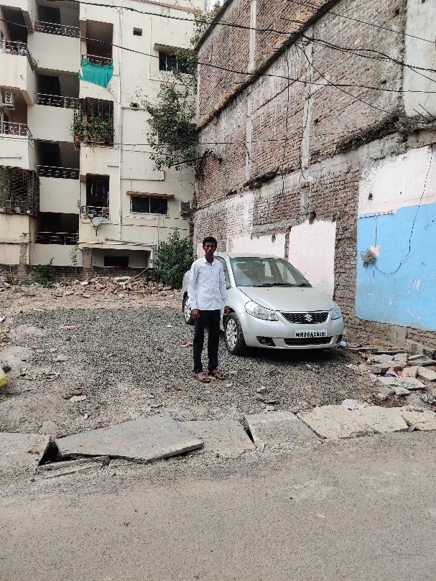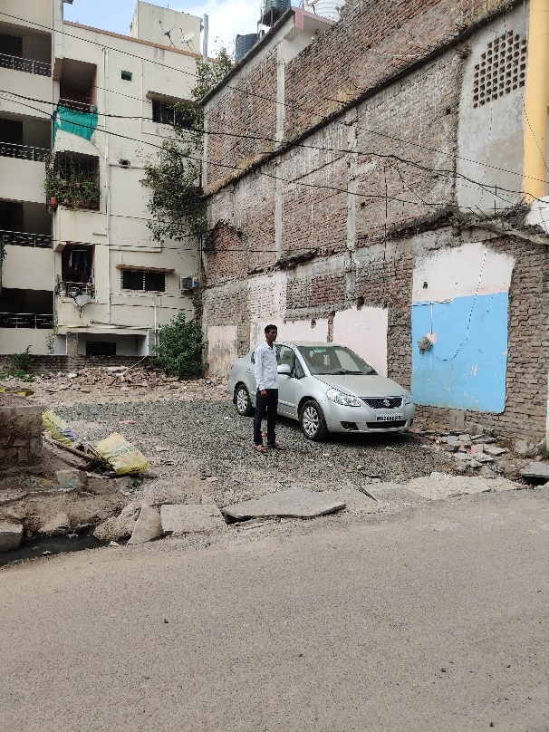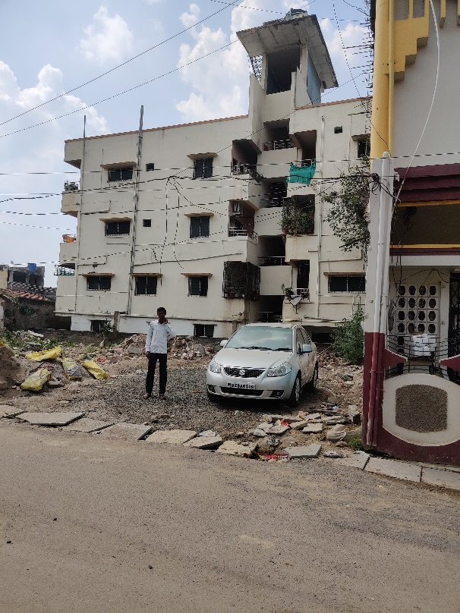

**Route Map of the property**

**Site u/r**

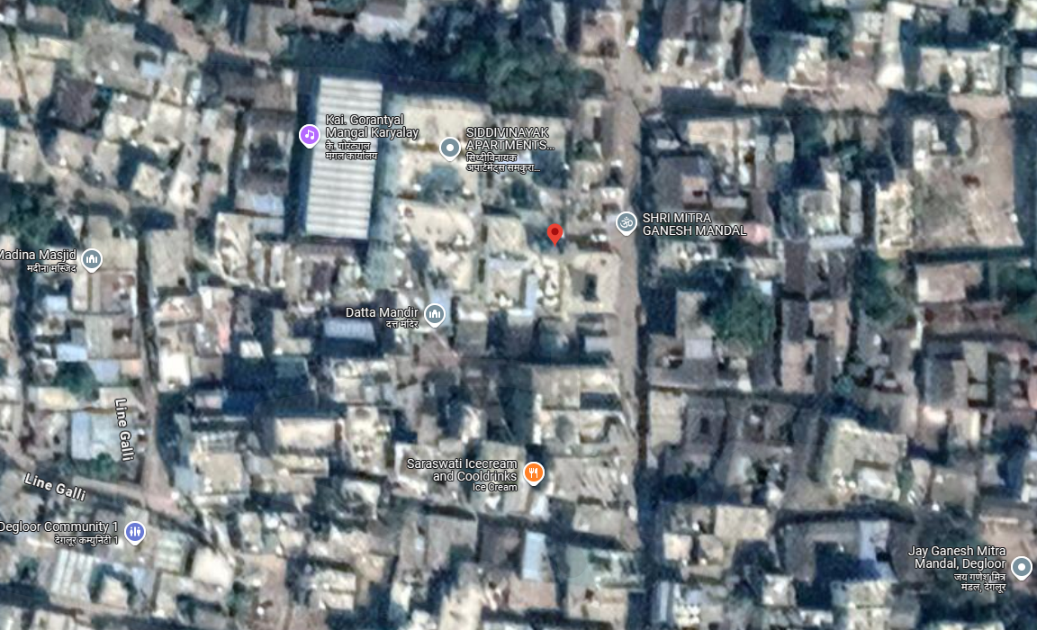

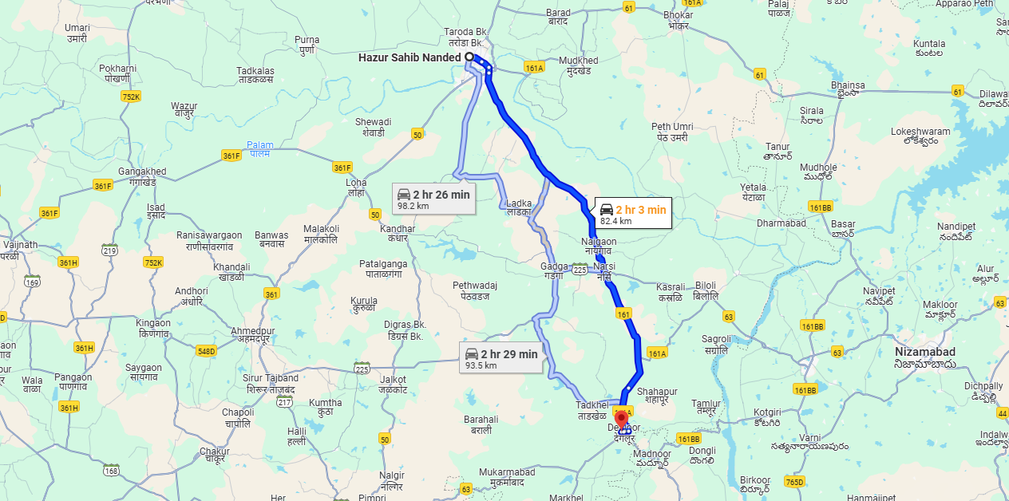

# Longitude Latitude: 18.549009,77.572007

# **Note:**

* Red Pointer shows Approx. Property Location
* Blue line shows Route from Nanded Railway Station (82.4 Km.)

Ready Reckoner Rate

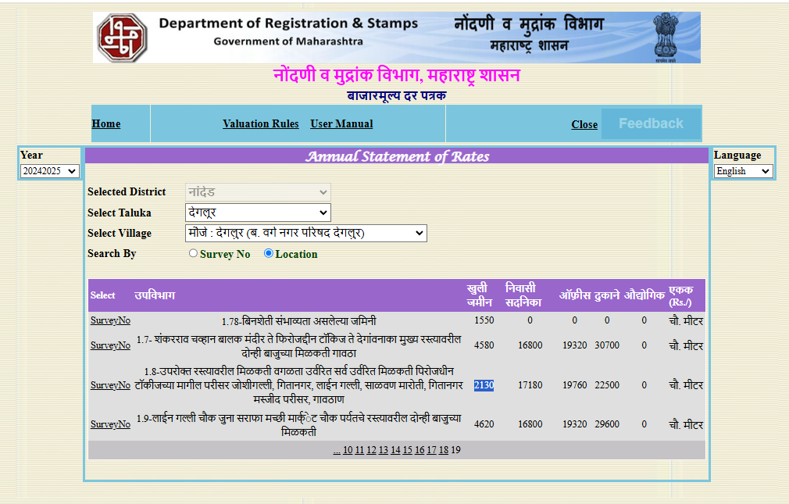

**Price Indicator**

|  |  |
| --- | --- |
| Plot area | 2100.00 Sq. Ft. |
| Rate per Sq. Ft. | 6, 714.00 |
| Rate Per Sq. M. | 72,273.00 |

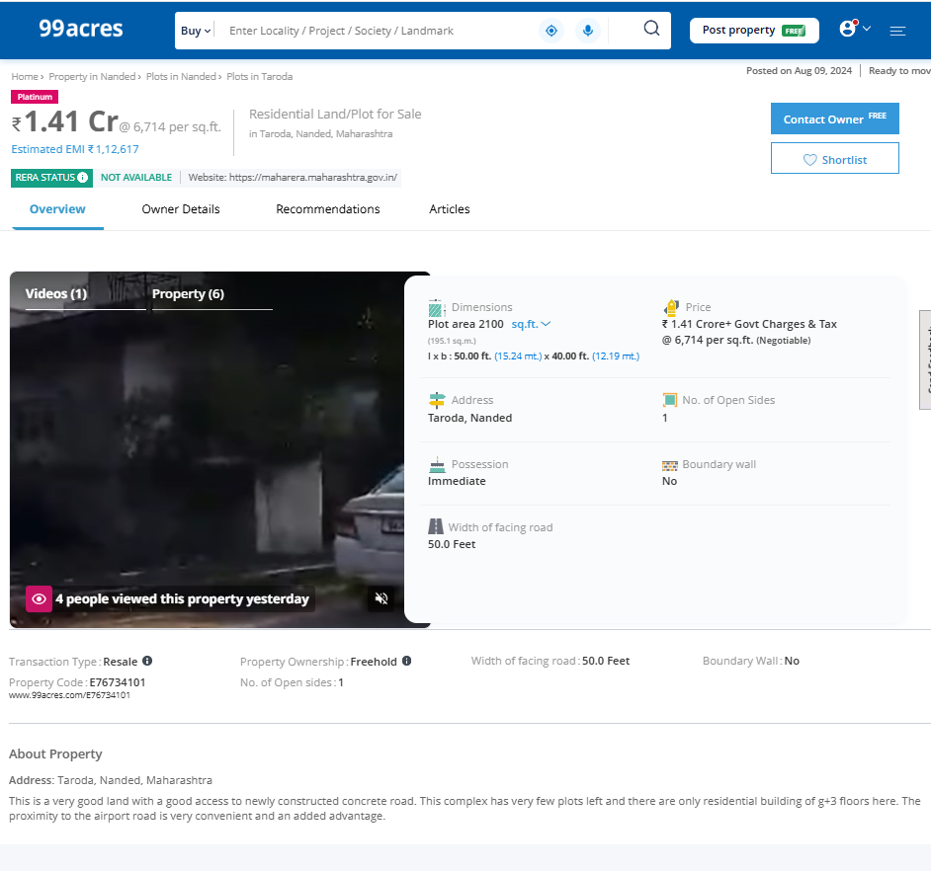

|  |  |
| --- | --- |
| Plot area | 1,454.00 Sq. Ft. |
| Rate per Sq. Ft. | 6, 877.00 |
| Rate Per Sq. M. | 74,030.00 |

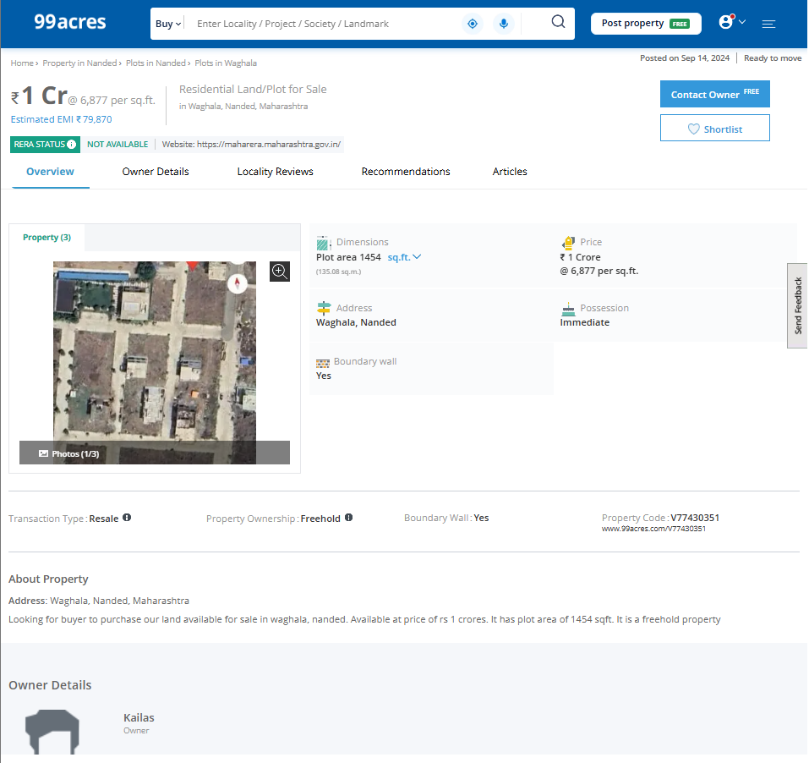

**Price Indicator**

|  |  |
| --- | --- |
| Plot area | 1,200.00 Sq. Ft. |
| Rate per Sq. Ft. | 6,000.00 |
| Rate Per Sq. M. | 64,584.00 |

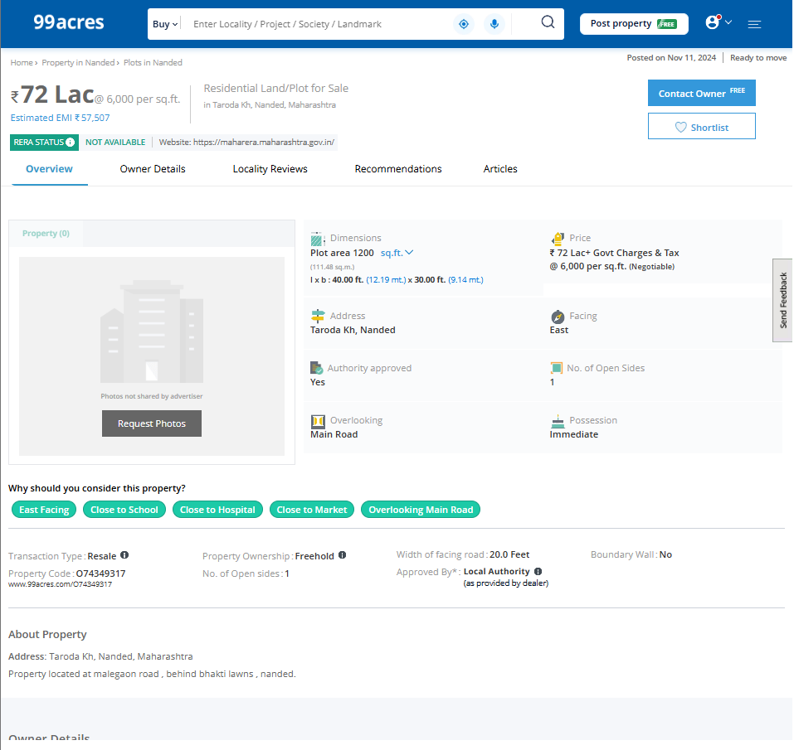

As a result of my appraisal and analysis, it is my considered opinion that Fair Market Value of the above property in the prevailing condition with aforesaid specifications is as under:

|  |  |
| --- | --- |
| **Fair Market Value of the Property** | **Rs. 48,79,000.00** |
| **Realizable Value** | **Rs. 43,91,000.00** |
| **Forced/ Distress Sale value** | **Rs. 39,03,000.00** |
| **Guideline Value of the Property** | **Rs. 2,77,134.00** |

Place: Nanded

Date: 04.12.2024

For, **Vastukala Consultants (I) Pvt. Ltd.**

**Sharadkumar B. Chalikwar**

B.E. (Civil), M.E. (Civil), M.Sc. (Real Estate Valuation), M.Sc. (P&M Valuation), FIE (I), FIV, FIWRS

Chairman & Managing Director

Govt. Reg. Valuer

Chartered Engineer (India)

Reg. No. (N) CCIT/1-14/52/2008-09

IBBI Reg.No. IBBI/RV/07/2019/11744

SBI Empanelment No.: SME/TCC/38/37

The undersigned has inspected the property detailed in the Valuation Report dated _______________________

on ____________________. We are satisfied that the fair and reasonable market value of the property is `_________________________ (Rupees ________________________________________________________

________________________________________only).

Date

Signature

(Name & Designation of the Inspecting Official/s)

Countersigned

(BRANCH MANAGER)

|  |  |  |
| --- | --- | --- |
| **Enclosures** | | |
|  | Declaration-cum-undertaking from the valuer (Annexure – I) | Attached |
|  | Model code of conduct for valuer (Annexure – II) | Attached |

(**Annexure – I)**

**DECLARATION-CUM-UNDERTAKING**

I, Sharadkumar Chalikwar son of Shri. Baburao Chalikwar do hereby solemnly affirm and state that:

1. I am a citizen of India.
2. I will not undertake valuation of any assets in which I have a direct or indirect interest or become so interested at any time during a period of three years prior to my appointment as valuer or three years after the valuation of assets was conducted by me.
3. The information furnished in my valuation report dated 04.12.2024 is true and correct to the best of my knowledge and belief and I have made an impartial and true valuation of the property.
4. I/ my authorized representative have personally inspected the property on 23.10.2024. The work is not sub - contracted to any other valuer and carried out by myself.
5. Valuation report is submitted in the format as prescribed by the bank.
6. I have not been depanelled / delisted by any other bank and in case any such depanelment by other banks during my empanelment with you, I will inform you within 3 days of such depanelment.
7. I have not been removed / dismissed from service / employment earlier.
8. I have not been convicted of any offence and sentenced to a term of imprisonment
9. I have not been found guilty of misconduct in my professional capacity.
10. I have not been declared to be unsound mind
11. I am not an undischarged bankrupt, or has not applied to be adjudicated as a bankrupt;
12. I am not an undischarged insolvent.
13. I have not been levied a penalty under section 271J of Income-tax Act, 1961 (43 of 1961) and time limit for filing appeal before Commissioner of Income-tax (Appeals) or Income-tax Appellate Tribunal, as the case may be has expired, or such penalty has been confirmed by Income-tax Appellate Tribunal, and five years have not elapsed after levy of such penalty
14. I have not been convicted of an offence connected with any proceeding under the Income Tax Act 1961, Wealth Tax Act 1957 or Gift Tax Act 1958 and
15. My PAN Card number as applicable is AEAPC0117Q.
16. I undertake to keep you informed of any events or happenings which would make me ineligible for empanelment as a valuer
17. I have not concealed or suppressed any material information, facts and records and I have made a complete and full disclosure

1. I have read the Handbook on Policy, Standards and procedure for Real Estate Valuation, 2011 of the IBA and this report is in conformity to the "Standards" enshrined for valuation in the Part - B of the above handbook to the best of my ability.
2. I have read the International Valuation Standards (IVS) and the report submitted to the Bank for the respective asset class is in conformity to the "Standards" as enshrined for valuation in the IVS in "General Standards" and "Asset Standards" as applicable. The valuation report is submitted in the prescribed format of the bank.
3. I abide by the Model Code of Conduct for empanelment of valuer in the Bank. (Annexure V - A signed copy of same to be taken and kept along with this declaration)
4. I am registered under Section 34 AB of the Wealth Tax Act, 1957.
5. I am valuer registered with Insolvency & Bankruptcy Board of India (IBBI).
6. My CIBIL Score and credit worthiness is as per Bank's guidelines.
7. I am Chairman & Managing Director of the company, who is competent to sign this valuation report.
8. I will undertake the valuation work on receipt of Letter of Engagement generated from the system (i.e. LLMS / LOS) only.
9. Further, I hereby provide the following information.

|  |  |  |
| --- | --- | --- |
| **Sr.**  **No.** | **Particulars** | **Valuer comment** |
|  | Background information of the asset being valued; | As per Sale Deed No.497/2014, dated 28.03.2014, Sub Registered, Degloor. the owner is Mr. Bhimesh S/o Vitthalrao Kotgire. |
|  | Purpose of valuation and appointing authority | As per the request from bank to assess the value of the property |
|  | Identity of the valuer and any other experts involved in the valuation; | Sharadkumar B. Chalikwar – Regd. Valuer  Mr. Md. Shareq Salim Md. Jilani Pasha – Technical Assistant  Akhilesh Yadav – Technical Manager |
|  | Disclosure of valuer interest or conflict, if any; | We have no interest, either direct or indirect, in the property valued. Further to state that we do not have relation or any connection with property owner / applicant directly or indirectly. Further to state that we are an independent Valuer and in no way related to property owner / applicant |
|  | Date of appointment, valuation date and date of report; | Date of Appointment – 23.10.2024  Valuation Date – 04.12.2024  Date of Report – 04.12.2024 |
|  | Inspections and/or investigations undertaken; | Physical Inspection done on 23.10.2024 |
|  | Nature and sources of the information used or relied upon; | * Market Survey at the time of site visit * Ready Reckoner rates / Circle rates * Online Price Indicators on real estate portals * Enquiries with Real estate consultants * Existing data of Valuation assignments carried out by us |
|  | Procedures adopted in carrying out the valuation and valuation standards followed; | Sales Comparison Method |
|  | Restrictions on use of the report, if any; | This valuation is for the use of the party to whom it is addressed and for no other purpose. No responsibility is accepted to any third party who may use or rely on the whole or any part of this valuation. The valuer has no pecuniary interest that would conflict with the proper valuation of the property. |
|  | Major factors that were taken into account during the valuation; | Current market conditions, demand and supply position, Residential Plot size, location, upswing in real estate prices, sustained demand for Residential Plot, all round development of commercial and residential application in the locality etc. |
|  | Caveats, limitations and disclaimers to the extent they explain or elucidate the limitations faced by valuer, which shall not be for the purpose of limiting his responsibility for the valuation report. | Attached |

For, **Vastukala Consultants (I) Pvt. Ltd.**

**Sharadkumar B. Chalikwar**

B.E. (Civil), M.E. (Civil), M.Sc. (Real Estate Valuation), M.Sc. (P&M Valuation), FIE (I), FIV, FIWRS

Chairman & Managing Director

Govt. Reg. Valuer

Chartered Engineer (India)

Reg. No. (N) CCIT/1-14/52/2008-09

IBBI Reg.No. IBBI/RV/07/2019/11744

SBI Empanelment No.: SME/TCC/38/37

## ASSUMPTIONS, CAVEATS, LIMITATION AND DISCLAIMERS

1. We assume no responsibility for matters of legal nature affecting the property appraised or the title thereto, nor do we render our opinion as to the title, which is assumed to be good and marketable.
2. The property is valued as though under responsible ownership.
3. It is assumed that the property is free of liens and encumbrances.
4. It is assumed that there are no hidden or unapparent conditions of the subsoil or structure that would render it more or less valuable. No responsibility is assumed for such conditions or for engineering that might be required to discover such factors.
5. There is no direct/ indirect interest in the property valued.
6. The rates for valuation of the property are in accordance with the Govt. approved rates and prevailing market rates

For, **Vastukala Consultants (I) Pvt. Ltd.**

**Sharadkumar B. Chalikwar**

B.E. (Civil), M.E. (Civil), M.Sc. (Real Estate Valuation), M.Sc. (P&M Valuation), FIE (I), FIV, FIWRS

Chairman & Managing Director

Govt. Reg. Valuer

Chartered Engineer (India)

Reg. No. (N) CCIT/1-14/52/2008-09

IBBI Reg.No. IBBI/RV/07/2019/11744

SBI Empanelment No.: SME/TCC/38/37

**(Annexure – II)**

**MODEL CODE OF CONDUCT FOR VALUERS**

**Integrity and Fairness**

1. A valuer shall, in the conduct of his/its business, follow high standards of integrity and fairness in all his/its dealings with his/its clients and other valuers.
2. A valuer shall maintain integrity by being honest, straightforward, and forthright in all professional relationships.
3. A valuer shall endeavour to ensure that he/it provides true and adequate information and shall not misrepresent any facts or situations.
4. A valuer shall refrain from being involved in any action that would bring disrepute to the profession.
5. A valuer shall keep public interest foremost while delivering his services.

**Professional Competence and Due Care**

1. A valuer shall render at all times high standards of service, exercise due diligence, ensure proper care and exercise independent professional judgment.
2. A valuer shall carry out professional services in accordance with the relevant technical and professional standards that may be specified from time to time.
3. A valuer shall continuously maintain professional knowledge and skill to provide competent professional service based on up-to-date developments in practice, prevailing regulations / guidelines and techniques.
4. In the preparation of a valuation report, the valuer shall not disclaim liability for his/its expertise or deny his/its duty of care, except to the extent that the assumptions are based on statements of fact provided by the company or its auditors or consultants or information available in public domain and not generated by the valuer.
5. A valuer shall not carry out any instruction of the client insofar as they are incompatible with the requirements of integrity, objectivity and independence.
6. A valuer shall clearly state to his client the services that he would be competent to provide and the services for which he would be relying on other valuers or professionals or for which the client can have a separate arrangement with other valuers.

**Independence and Disclosure of Interest**

1. A valuer shall act with objectivity in his/its professional dealings by ensuring that his/its decisions are made without the presence of any bias, conflict of interest, coercion, or undue influence of any party, whether directly connected to the valuation assignment or not.
2. A valuer shall not take up an assignment if he/it or any of his/its relatives or associates is not independent in terms of association to the company.
3. A valuer shall maintain complete independence in his/its professional relationships and shall conduct the valuation independent of external influences.
4. A valuer shall wherever necessary disclose to the clients, possible sources of conflicts of duties and interests, while providing unbiased services.
5. A valuer shall not deal in securities of any subject company after any time when he/it first becomes aware of the possibility of his / its association with the valuation, and in accordance with the Securities and Exchange Board of India (Prohibition of Insider Trading)Regulations,2015 or till the time the valuation report becomes public, whichever is earlier.
6. A valuer shall not indulge in "mandate snatching" or offering "convenience valuations" in order to cater to a company or client's needs.
7. As an independent valuer, the valuer shall not charge success fee.
8. In any fairness opinion or independent expert opinion submitted by a valuer, if there has been a prior engagement in an unconnected transaction, the valuer shall declare the association with the company during the last five years.

**Confidentiality**

1. A valuer shall not use or divulge to other clients or any other party any confidential information about the subject company, which has come to his / its knowledge without proper and specific authority or unless there is a legal or professional right or duty to disclose.

**Information Management**

1. A valuer shall ensure that he/ it maintains written contemporaneous records for any decision taken, the reasons for taking the decision, and the information and evidence in support of such decision. This shall be maintained so as to sufficiently enable a reasonable person to take a view on the appropriateness of his /its decisions and actions.
2. A valuer shall appear, co-operate and be available for inspections and investigations carried out by the authority, any person authorized by the authority, the registered valuer’s organization with which he/it is registered or any other statutory regulatory body.
3. A valuer shall provide all information and records as may be required by the authority, the Tribunal, Appellate Tribunal, the registered valuers organization with which he/it is registered, or any other statutory regulatory body.
4. A valuer while respecting the confidentiality of information acquired during the course of performing professional services, shall maintain proper working papers for a period of three years or such longer period as required in its contract for a specific valuation, for production before a regulatory authority or for a peer review. In the event of a pending case before the Tribunal or Appellate Tribunal, the record shall be maintained till the disposal of the case.

**Gifts and hospitality:**

1. A valuer or his / its relative shall not accept gifts or hospitality which undermines or affects his independence as a valuer.

Explanation: For the purposes of this code the term 'relative' shall have the same meaning as defined in clause (77) of Section 2 of the Companies Act, 2013 (18 of 2013).

1. A valuer shall not offer gifts or hospitality or a financial or any other advantage to a public servant or any other person with a view to obtain or retain work for himself / itself, or to obtain or retain an advantage in the conduct of profession for himself / itself.

**Remuneration and Costs.**

1. A valuer shall provide services for remuneration which is charged in a transparent manner, is a reasonable reflection of the work necessarily and properly undertaken, and is not inconsistent with the applicable rules.
2. A valuer shall not accept any fees or charges other than those which are disclosed in a written contract with the person to whom he would be rendering service.

**Occupation, employability and restrictions.**

1. A valuer shall refrain from accepting too many assignments, if he/it is unlikely to be able to devote adequate time to each of his/ its assignments.
2. A valuer shall not conduct business which in the opinion of the authority or the registered valuer organization discredits the profession.

**Miscellaneous**

1. A valuer shall refrain from undertaking to review the work of another valuer of the same client except under written orders from the bank or housing finance institutions and with knowledge of the concerned valuer.
2. A valuer shall follow this code as amended or revised from time to time.

For, **Vastukala Consultants (I) Pvt. Ltd.**

**Sharadkumar B. Chalikwar**

B.E. (Civil), M.E. (Civil), M.Sc. (Real Estate Valuation), M.Sc. (P&M Valuation), FIE (I), FIV, FIWRS

Chairman & Managing Director

Govt. Reg. Valuer

Chartered Engineer (India)

Reg. No. (N) CCIT/1-14/52/2008-09

IBBI Reg.No. IBBI/RV/07/2019/11744

SBI Empanelment No.: SME/TCC/38/37

**DEFINITION OF VALUE FOR THIS SPECIFIC PURPOSE**

This exercise is to assess **Fair Market Value** of the property under reference as on **04th December 2024.**

The term **Fair Market Value** is defined as

*“The most probable price, as of a specified date, in cash, terms equivalent to cash, or in other precisely revealed terms for which the specified property rights would sell after reasonable exposure in a competitive market under all conditions requisite to a fair sale, with the buyer and seller each acting prudently knowledgeably and for self-interest assuming that neither is under undue duress”.*

Fundamental assumptions and conditions presumed in this definition are:

1. Buyer and seller are motivated by self-interest.

2. Buyer and seller are well informed and are acting prudently.

3. The property is exposed for a reasonable time on the open market.

4. Payment is made in cash or equivalent or in specified financing terms.

#### UNDER LYING ASSUMPTIONS

1. We assume no responsibility for matters of legal nature affecting the property appraised or the title thereto, nor do we render our opinion as to the title, which is assumed to be good and marketable.

2. The property is valued as though under responsible ownership.

3. It is assumed that the property is free of liens and encumbrances.

4. It is assumed that there are no hidden or unapparent conditions of the subsoil or structure that would render it more or less valuable. No responsibility is assumed for such conditions or for engineering that might be required to discover such factors.

#### DECLARATION OF PROFESIONAL FEES CHARGED

We hereby declare, that our professional fees are not contingent upon the valuation findings, However, if the statute AND/OR clients demands that, the fees should be charged on the percentage of assessed value then, with the full knowledge of the AND/OR end user, it is being charged accordingly.

#### VALUATION OF THE PROPERTY PREMISES

Considering various parameters recorded, existing economic scenario, and the information that is available with reference to the development of neighborhood and method selected for valuation, we are of the opinion that, the property premises can be assessed and Fair Market Value for this particular purpose at **Rs. 48,79,000.00 (Rupees Forty Lakh Seventy Nine Thousand Only)**.

For, **Vastukala Consultants (I) Pvt. Ltd.**

**Sharadkumar B. Chalikwar**

B.E. (Civil), M.E. (Civil), M.Sc. (Real Estate Valuation), M.Sc. (P&M Valuation), FIE (I), FIV, FIWRS

Chairman & Managing Director

Govt. Reg. Valuer

Chartered Engineer (India)

Reg. No. (N) CCIT/1-14/52/2008-09

IBBI Reg.No. IBBI/RV/07/2019/11744

SBI Empanelment No.: SME/TCC/38/37