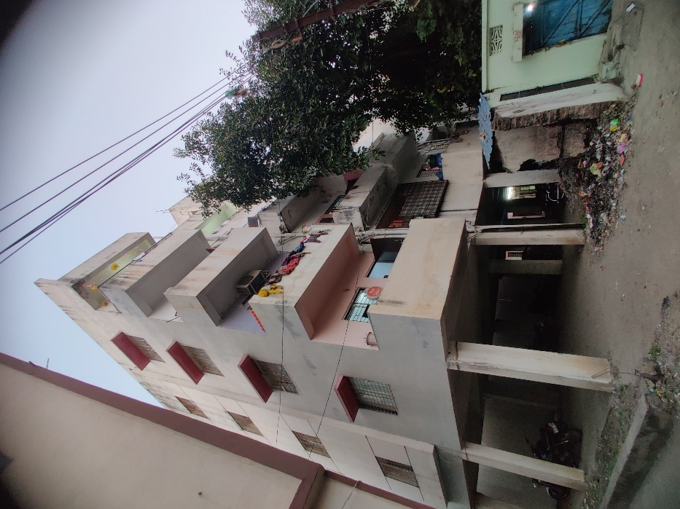

**Details of the property under consideration:**

Name of Owner**: Mr. Gurmeetsingh Indersingh Kankas**

**&**

**Mrs. Sukhrajkaur Gurmeetsingh Kankas**

Family Unit no. 304, third floor, **“Dashmesh Apartment”,**

M.C. House No. 3-6-242, 3-6-238, & 3-6-267, C.T.S. No. 2264, 2266, & 2267

Gurudwara Gate No. 4, Badpura, Nanded.

.

**Longitude Latitude: 19.153351,77.320349**

**Valuation Done for:**

**State Bank of India**

**VALUER’S OPINION REPORT**

The property bearing Family Unit No. 304, Third Floor, Dashmesh Apartment, M.C. House No. 1-6-242, 3-6-238, & 3-6-267, C.T.S. No. 2264, 2266, & 2267, Gurudwara Gate No. 4, Badpura, Nanded. Tq. & Dist. Nanded is belongs **Mr. Gurmeetsingh Indersingh Kankas & Mrs. Sukhrajkaur Gurmeetsingh Kankas.**

Boundaries of the property:

|  |  |
| --- | --- |
| North | Owner's Open space of Apartment |
| South | Owner's Open Space of Apartment |
| East | Flat No. 305 |
| West | Flat No. 303 |

Considering various parameters recorded, existing economic scenario, and the information that is available with reference to the development of neighborhood and method selected for valuation, we are of the opinion that, the property premises can be assessed and valued for this particular purpose as under.

|  |  |
| --- | --- |
| **Guideline Value of the Property** | **Rs. 30,62,490.00** |
| **Fair Market Value of the Property** | **Rs. 31,61,280.00** |
| **Realizable Value** | **Rs. 28,45,152.00** |
| **Forced/Distress Sale Value** | **Rs. 25,60,636.00** |
| **Insurable Value of the Property** | **Rs. 19,56,042.00** |

The valuation of the property is based on the documents produced by the concern. Legal aspects have not been taken into considerations while preparing this valuation report.

Hence certified

For, **Vastukala Consultants (1) Pvt. Ltd**

**Sharad B. Chalikwar**

C.M.D.

Govt. Reg. Valuer

Chartered Engineer (India)

Reg. No. (N) CCIT/1-14/52/2008-09

Encl: Valuation Report.

**Valuation Report of Immovable Property**

|  |  |  |
| --- | --- | --- |
| **Introduction** | | |
| a) | Name of the Property Owner  (with address & Phone nos.) | **Mr. Gurmeetsingh Indersingh Kankas & Mrs. Sukhrajkaur Gurmeetsingh Kankas.**  Family Unit No. 304, 3rd Floor, “Dashmesh Apartment”,  M.C. Housing No.1-6-242,3-6-238, & 3-6-267,  C.T.S. No. 2264,2266, & 2267,  Gurudwara gate no. 4, Badpura, Nanded,  Tq 7 Dist. Nanded.  Mob No.: 8806912037  A/C No.: 35419979241 |
| b) | Purpose for which the valuation is made | SARFASI Purpose |
| c) | Authorization letter of Bank | Asst. Manager, SBI, A.P.M.C Nanded Branch,  New Mondha, Oral Instruction, dated 09.10.2018 |
| d) | Date of inspection | 12.11.2024 |
| e) | Date on which the valuation is made | 12.11.2024 |
| f) | Name of the Developer of the Property  (in Case of developer-built properties) | Divya Amrit Construction 9I) Pvt. Ltd., Nanded |
| **1.Physical Characteristics of the Property** | | |
| a) | Location of the Property | Family Unit No. 304, Third Floor, **“Dashmesh** **Apartment”,** M.C. HOUSE No. 1-6-242, 3-6-238, & 3-6-267, C.T.S. No. 2264,2266, & 2267, Gurudwara Gate No. 4, Badpura, Nanded, Tq. & Dist. Nanded. |
| Brief description of the property | Residential Flat Property.  Family unit No. 304, third Floor,  **Dashmesh Apartment,**  Gurudwara Gate No. 4, Badpura, Nanded |
| Nearby Landmark | Badpura, Gurudwara Sachkhand Gate No. 4. |
| Postal Address of the Property | Mr. Gurmeetsingh Indersingh Kankas & Mrs. Sukhrajkaur Gurmeetsingh Kankas.  Family Unit No. 304, Third Floor, Dashmesh Apartment, M.C. House No.1-6-242,3-6-238, & 3-6-267, C.T.S.No. 2264,2266 & 2267, Gurudwara Gate No. 4, Badpura, Nanded. |
|  | Area of the Flat (Supported by a plan) | * Super B/U Area as per Registered Agreement to Sale Deed No.113/2016: 1106.67Sqft.:102.85 Sqm. * Super B/U Area as Per Arrangement letter dated 04.01.2016 & Notice of Intimation regarding mortgage by way of deposite (Equitable Mortgage No. BD/2015-2016 EM E-33, Dated 06.01.2015): 1062.00 Sqft. * Saleable area considered for valuation as per Equitable Mortgage i.e. 1062.00sqft.9879 Sqm. |
|  | Type of Land: Solid, Rocky, Marsh land, reclaimed land, Water-logged, Land locked. | Sale land |
| Independent access/approach to the property etc. | Yes |
| Google Map Location of the Property with a neighborhood layout map | Provided |
| Details of roads abutting the property | Lane connecting to Gurudwara Gate No. 4, Badpura |
| Description of adjoining property | Gurudwara Sachkhand Premises. |
| Plot No. Survey No. | M.C. House No. 1-6-242, 3-6-238, & 3-6-267,  C.T.S. No. 2264, 2266, & 2267. |
| Ward/Village/Taluka | Gurudwara Gate No. 4, Badpura, Nanded |
| Sub-Registry/Block | Jt-Sub Registrar, Nanded-2 |
| District | Nanded |
| Any other aspect | Congested Approach Road. |
| b) | Plinth Area, built up Area, and Saleable are to be mentioned separately and clarified | Gurudwara Sachkhand Premises.  M.C. House No. 1-6-242, 3-6-238, & 3-6-267,  C.T.S. No. 2264, 2266, & 2267.  Gurudwara Gate No. 4, Badpura, Nanded.  Jt-Sub Registrar, Nanded-2  Nanded.  Congested Approach Road.  • Super B/U Area as per Registered Agreement to Sale Deed No.113/2016: 1106.67 Sqft.: (102.85 Sqm.)  • Super B/U Area as per Arrangement letter dated 04.01.2016 & Notice of Intimation regarding mortgage by way of deposit (Equitable Mortgage No. BD/2015- 2016 EM E-33, dated 06.01.2015).: 1062.00 Sqft.  • **Saleable area considered for valuation as per Equitable Mortgage i.e. 1062.00 Sqft.: 98.79 Sqm.** |

|  |  |  |  |  |  |  |  |
| --- | --- | --- | --- | --- | --- | --- | --- |
| C) | **Boundaries of the Flat** | | **As per Sale Deed** | | | **Actual** | **Remarks** |
|  | North | | Owner's Open space of Apartment | | | Owner's Open space of Apartment. |  |
| South | | Owner's Open space of Apartment | | | Owner's Open space of Apartment. |  |
| East | | Flat No 305 | | | Flat No 305. |  |
| West | | Flat No.303. | | | Flat No. 303. |  |
| **3. Town Planning Parameters** | | | | | | | |
| **a)** | | Master Plan Provisions related to property in term of land use. | | Residential. | | | |
| Far-floor Area Rise/FSI- Floor Space Index Permitted & Consumed | | **2.00** | | | |
| Comment on whether Occupancy Certificate has been issued or not | | No | | | |
| Comment on unauthorized constructions any | | The actual construction is more than sanctioned built up area. | | | |
| Transferability of developmental rights if any, Building by-laws provision as applicable to the property viz. setbacks, height restriction etc. | | As per Sanctioned Plan, Parking is provided at Ground Floor. Whereas, in Parking Area there are Four Flats Constructed. | | | |
| Planning area/zone | | Residential. | | | |
| Developmental controls | | As per D.C.R. of Nanded Municipal Corporation | | | |
| Zoning regulations | | Residential | | | |
| Comment on the surrounding land uses a land uses and adjoining properties in terms of uses | | Residential development in the vicinity of Gurudwara Sachkhand | | | |
| Comment on demolition proceedings if any | | As per provisions of DCR. of Nanded Municipal Corporation | | | |
| Comment on compounding/regularization proceedings | | The excess construction may be compounded and / or regularized by applying to NWCMC, Nanded | | | |
| Any other Aspect | | * Family Unit No. 304 was locked at the time of inspection. * As per the instructions given by Mr. Premjitsingh Harisingh Shailendra (Mob no.:8308231313), Constructions of flat is Completed but, owner yet not occupied the Flat. * The specification of the flat is considered as per the information given by Mr. Premjitsingh Harisingh Shiledar. * Internal measurements of the flat were not taken being the flat was locked at the time of inspection. | | | |
|  | |  | | * The Super built up area is considered as per Sale Deed & Notice of Intimation to Sub-Registrar, Sub-Registrar Office, Nanded regarding mortgage by way of Deposit of Title Deed (Equitable Mortgage No. BD/2015-2016 EM E- 33, dated 06.01.2015). | | | |
| **4.** | | **Document Details and Legal Aspects of Property** | | | | | |
|  | | Ownership Documents (Sale Deed, Gift Deed, Lease Deed etc.) | | | Following documents were made available by the Bank- | | |
| 1 | | Photo Copy of Building Permission No. NWCMC/TP/211/15, dated 01.06.2015 issued by NWCMC, Nanded | | | | | |
| 2 | | Photo Copy of Deed of Declaration No.2594/2015 dated 19/05/2015 Issued by Joint Sub- Resister Class 2 Nanded2 | | | | | |
| 3 | | Photo Copy of Registered Agreement to Sale of Flat No. 304, (Under Apartment Ownership Act 1970) Document No. 113/2016, dated 05.01.2016, Joint Sub-Registrar, Class-2, Nanded | | | | | |
| 4 | | Photo copy of Notice of Intimation to Sub-Registrar, Sub-Registrar Office, Nanded regarding mortgage by way of Deposit of Title Deed (Equitable Mortgage No. BD/2015-2016 EM E-33, dated 06.01.2015) | | | | | |
| 5 | | Photo copy of Title investigation report prepared by Adv. S.D. Tuptewar, dated 23.12.2015. | | | | | |
| 6 | | Photo Copy of Notice No. CM/BR/SN/18-19, dated 18.09.2018, issued to Mr. Gurmeetsingh Indersingh Kankas & Mrs. Sukhrajkaur Gurmeetsingh Kankas. | | | | | |
| 7 | | Photo copy of Arrangement letter dated 04.01.2016 | | | | | |
| 8 | | Photo copy of Memorandum of Loan Agreement for Home Loan granted to Public dated 04.01.2016 | | | | | |
| a) | | TIR of the property | | | provided | | |
| b) | | Name of the Owner’s | | | **Mr. Gurmeetsingh Indersingh Kankas & Mrs. Sukhrajkaur Gurmeetsingh Kankas** | | |
| c) | | Ordinary status of freehold or leasehold including restrictions on transfer | | | Freehold | | |
| d) | | Agreement of easement if any | | | No. | | |
| e) | | Notification of road acquisition if any | | | No. | | |
| f) | | Notification of road widening if any | | | No. | | |

|  |  |  |  |  |  |  |  |  |  |  |  |
| --- | --- | --- | --- | --- | --- | --- | --- | --- | --- | --- | --- |
| g) | | Heritage restriction, if any | | | | No. | | | | | |
| h) | | Comment on transferability of the property ownership | | | | As per T.I. R | | | | | |
| I) | | Comment on existing mortgages/ charges/ encumbrances on the property, if any | | | | Mortgage with S.B. I | | | | | |
| J) | | Comment on whether the owners of the property have issued any guarantee (personal or corporate) as the case may be | | | | As per T.I. R | | | | | |
| K) | | Building plan sanction: Authority approving the plan Name of the Authority - Any violation from the approved Building Plan  Actual construction is more than the sanctioned plan | | | | * Commissioner, Nanded Waghala City Municipal Corporation, Nanded. * Actual construction is more than the sanctioned plan | | | | | |
| l) | | Whether Property is Agricultural Land if yes, any conversion is contemplated | | | | No. | | | | | |
| m) | | Whether the property is SARFAESI compliant | | | | Yes. | | | | | |
| n) | | a. All legal documents, receipts related to electricity, Water tax, Municipal tax and other building taxes to be verified and copies as applicable to be enclosed with  the report.  b. Observation on Dispute or Dues if any in payment of bills/taxes to be reported. | | | | Receipts Related to Electricity; Water Tax Municipal Tax Not made available for Verification | | | | | |
| o) | | Whether entire piece of land on which the unit is set up / property is situated has been mortgaged or to be | | | | Flat is mortgaged with S.B.I.  mortgaged | | | | | |
| p) | | Qualification in TIR/mitigation suggested if any. | | | | As per TIR report | | | | | |
| q) | | Any other aspect | | | | No. | | | | | |
| **5.** | | **Economic Aspects of the Property** | | | | | | | | | |
|  | | Reasonable letting value (After Completion) | | | **Rs. 4,000.00per month.:48,000.00P.A.** | | | | | | |
| If property is occupied by tenant | | | Not Applicable | | | | | | |
| Number of tenants | | | Not Applicable | | | | | | |
| Since how long (tenant-wise) | | | Not Applicable | | | | | | |
| Status of tenancy right | | | N.A. | | | | | | |
| Rent received per month (tenant-wise) with a comparison of existing market rent | | | Information not available | | | | | | |
| Taxes and other outings | | | Information not available | | | | | | |
| Property Insurance | | | Information not available | | | | | | |
|  | | Monthly maintenance charges | | | Information not available | | | | | | |
| Security charges | | | Information not available | | | | | | |
| Any other aspect | | | Lift not operational. | | | | | | |
| **6. Socio-cultural Aspects of Property** | | | | | | | | | | | |
| a) | Descriptive account of the location of the property in terms of social structure of the area, population, social stratification, regional origin, economic level, location of slums, squatter settlements nearby, etc. | | | | | | Situated in developing Middle class Residential area in the vicinity of Gurudwara Sachkhand. Without slums and squatter settlements nearby. | | | | |
| b) | Whether property belongs to social infrastructure like hospital, school, old age homes etc. | | | | | | No. | | | | |
| **7. Functional and utilitarian Aspects of the Property** | | | | | | | | | | | |
| a) | Description of the functionality and utility of the property in terms of: | | | | | |  | | | | |
| Space allocation | | | | | | Living, Bed room, Kitchen, Toilet | | | | |
| Storage Spaces Think Innovate | | | | | | No. | | | | |
| Utility spaces provided within the building | | | | | | No. | | | | |
| Car Parking facility | | | | | | Yes. | | | | |
| Balconies, etc. | | | | | | Yes. | | | | |
| b) | Any other aspect | | | | | | No. | | | | |
| **8. Infrastructure Availability** | | | | | | | | | | | |
|  | Description of aqua infrastructure availability in terms of Water Supply | | | | | | Bore well & Municipal water supply. | | | | |
| Sewerage/sanitation System Underground or Open | | | | | | Municipal Drainage. | | | | |
|  | Storm water drainage | | | | | | No. | | | | |
| b) | Description of other physical infrastructure facilities viz. | | | | | |  | | | | |
|  | Solid waste management | | | | | | Not Provided. | | | | |
| Electricity | | | | | | Available in the apartment. | | | | |
| Road and public transport connectivity | | | | | | Available. | | | | |
| Availability of other public utilities nearby | | | | | | All Available nearby. | | | | |
| c) | Social infrastructure in terms of  i. School  ii. Medical facilities  iii. Recreational facility in terms of parks and open space | | | | | | All Available nearby  All Available nearby | | | | |
| **9. Marketability of the Property** | | | | | | | | | | | |
| a) | Marketability of the property in terms of | | | | | | Location, development of surrounding area, type of construction, construction specifications, age of building, condition of the premises & building, facilities provided and its prevailing market rate | | | | |
|  | Locational attributes | | | | | | Property situated in Gurudwara Sachkhand vicinity. | | | | |
|  | Scarcity | | | | | | Normal | | | | |
|  | Demand and supply of the kind of subject property | | | | | | Normal | | | | |
|  | Comparable sale prices in the locality | | | | | | Price Indicators from online property portals attached. | | | | |
| b) | Any other aspect which has relevance on the value or marketability of the property | | | | | | * Property situated in Gurudwara Sachkhand Vicinity. * Congested Approach * Property was locked at the time of inspection. * Specifications are considered as per the information provided by Mr. Premjitsingh Harisingh Shiledar. * Property is unoccupied & locked since last 3 years. This will affect the marketability of the property. * Periodical maintenance is necessary for up-keeping the property. - | | | | |
| **10. Engineering and Technology Aspects of the Property** | | | | | | | | | | | |
| a) | | | Type of construction | | | | R.C.C. Framed Structure. | | | | |
|  | | | Material & technology used | | | | RCC with B.B. Masonry, Normal construction. | | | | |
|  | | | **Specifications** | | | |  | | | | |
| **Sr.No.** | | | **Description** | | | | **Third Floor Family Unit No. 304** | | | | |
| 1 | | | Foundation. | | | | R.C.C. Footing | | | | |
| 2 | | | Basement. | | | | BB Masonry. | | | | |
| 3 | | | Superstructure. | | | | II Class B.B. Masonry. | | | | |
| 4 | | | Joinery/ Doors & Windows. | | | | Commercial Flush Doors. Granite Frame & Aluminum Sliding Windows. | | | | |
| 5 | | | RCC work. | | | | Footing, Column, Beam, Slab etc. | | | | |
| 6 | | | Plastering | | | | Cement Plaster in C.M. & P.O. P | | | | |
| 7 | | | Flooring, Skirting. | | | | Vitrified Tiles. | | | | |
| 8 | | | Kitchen Pantry Platform | | | | Granite Kitchen Platform | | | | |
| 9 | | | Whether any weather proof course is provided. | | | | No. | | | | |
| 10 | | | Drainage | | | | Connected to Municipal Sewar. | | | | |
| 11 | | | Compound wall (Height, Length and type of construction) | | | | No. | | | | |
| 12 | | | Electric installation (Type of wire, Class of fittings) | | | | Concealed, Superior. | | | | |
| 13 | | | Plumbing installation (No. of water closets & wash basin etc.) | | | | Toilets. | | | | |
| 14 | | | Bore well. | | | | Provided. | | | | |
| 15 | | | Wardrobes, if any. | | | | No. | | | | |
| 16 | | | Development of open area | | | | C.C. Paving. | | | | |
| d) | | | Maintenance issues | | | | Periodical maintenance is needed | | | | |
| e) | | | Age of the building | | | | 3years. | | | | |
| f) | | | Total life of the building | | | | 65 years (Future) | | | | |
| g) | | | Extent of deterioration | | | | No. | | | | |
| h) | | | Extent of deterioration | | | | Sound. | | | | |
| i) | | | Protection against natural disaster viz. earthquakes, | | | | Not Provided. | | | | |
| j) | | | Visible damage in the building | | | | No. | | | | |
| k) | | | System of air-conditioning | | | | Not Provided. | | | | |
| l) | | | Provision of firefighting | | | | Not Provided. | | | | |
| m) | | | Copies of the plan and elevation of the building to be included | | | | Building Photographs enclosed. | | | | |
| **11.** **Environmental Factors** | | | | | | | | | | | |
| a) | | | Use of environment friendly building materials, Green Building techniques if any | | | | No. | | | | |
| b) | | | Provision of rain water harvesting | | | | No. | | | | |
| c) | | | Use of solar heating and lightening systems, etc., | | | | No. | | | | |
| d) | | | Presence of environmental pollution in the vicinity of the property in terms of industry, heavy traffic etc. | | | |  | | | | |
| **12. Architectural and aesthetic quality of the Property** | | | | | | | | | | | |
| a) | | | Descriptive account on whether the building is modern, old fashioned, plain looking or decorative, heritage value, presence of landscape elements etc. | | | | Modern | | | | |
|  | | |  | | | |  | | | | |
| **13. Valuation** | | | | | | | | | | | |
| a) | | | Methodology of valuation Procedures adopted for arriving at the valuation. Valuers may consider various approaches and state explicitly the reason for adopting particular approach and assumptions made, basis adopted with supporting data, comparable sales, and reconciliation of various factors on which final value judgment is arrived at | | | | | | | | Modern |
| b) | | | Prevailing Market Rate/Price trend of the Property in the locality/city from property search sites viz magickbricks.com, 99acres.com, makaan.com etc. if available | | | | Rs. 30,000/- to Rs. 33,000/- per Sqm as prevailing land rate. Considering the rate with attached report, current market conditions, demand and supply position, Commercial Building size, Terrace area, location, upswing in real estate prices, sustained demand for commercial building, all round development of commercial and residential application in the locality etc. Therefore, we estimate composite (Land + Building) rate at Rs. 32,000.00 per Sqm | | | | |
| c) | | | Guideline Rate obtained from the Stamp Duty  Ready Reckoner | | | | **Rs 31,000.00 per Sqm. (Composite rate).** | | | | |
| d) | | | Summary of Valuation | | | | | | | | |
| **i. Guideline Value** | | | | **Area in Sqm.** | **Rate in Rs** | | **Value in Rs** | |
| **Built-up Area: Third Floor Flat No. 304** | | | | **98.79** | **31,000.00** | | **30,62,490.00** | |
|  | | | **Total Guideline Value** | | | |  |  | | **30,62,490.00** | |
|  | | | **ii. Fair Market Value** | | | | |  | |  | |
|  | | | | **Area in Sqm** | **Rate in Rs** | | **Value in Rs** | |
| **Third Floor Flat No. 304** | | | | **98.79** | **32,000.00** | | **31,61,280.00** | |
| **Total Fair Market Value of the Property** | | | |  |  | | **31,61,280.00** | |
| **Summary of Valuation** | | | |  | | | | |
| **Guideline Value of the Property** | | | | **Rs. 30,62,490.00** | | | | |
| **Fair Market Value of the Property** | | | | **Rs. 31,61,280.00** | | | | |
| **Realizable Value** | | | | **Rs. 28,45,152.00** | | | | |
| **Forced/Distress Sale value.** | | | | **Rs. 25,60,636.00** | | | | |
| **Insurable value of the property** | | | | **Rs. 19,56,042.00** | | | | |
| e) | | | In case of variation of 20% or more in the valuation proposed by the valuer and the Guideline value provided in the State Govt. notification or Income Tax Gazette justification on variation has to be given. | | | | | |  | | |
| Details of last two transactions in the locality/area to be provided, if available. | | | | | | Not available | | |
|  | | | **General Remark:**   * Latest TIR Report shall be obtained. * For outstanding dues if any the Municipal Taxes, Electricity Bill, Water Tax and other taxes necessary bill shall be obtained from the concerned department. * Area as per Sale Deed, as per Equitable Mortgage are not matching. * The Area as per Equitable Mortgage i.e. 1062.00 Sqft.: 98.79 Sqm. is considered for valuation. | | | | | | | | |
| **14. Declaration** | | | | | | | | | | | |
| I hereby declare that:  1. The information provided is true and correct to the best of my knowledge and belief.  ii. The analysis and conclusions are limited by the reported assumptions and conditions.  iii. I have read the Handbook on Policy, Standard and Procedures for Real Estate Valuation by Banks and HFIs in India, 2011, issued by IBA and NHB, fully understood the provisions of the same and followed the provisions of the same to the best of my ability and this report is in conformity to the Standards of Reporting enshrined in the above Handbook.  iv. I have no direct or indirect interest in the above property valued.  V. I have personally inspected the subject property on 09.10.2018  vi. I am a registered Valuer under Section 34AB of Wealth Tax Act, 1957, Category-l for valuing property up to no limit  vii. I am an approved Valuer under SARFAESI ACT-2002 and am approved by the Bank.  viii. I have submitted the Valuation Report (s) directly to the Bank.  **S. B. Chalikwar**  Govt. Reg. Valuer  Chartered Engineer (India)  Wealth Tax Reg. No.: (N) CCIT/1-14/52/2008-09  **Address:**  **Name of Valuer association of which I am a bonafide member in good standing:**  1.Institution of Valuers, New Delhi.  2. Practicing Valuers Association of India, Mumbai.  Date: 10.10.2018  Mobile No.- +91 9422171100/9167204051  Email Id-sbchalikwar@gmail.com | | | | | | | | | | | |
| 15. Enclosures | | | | | | | | | | | |
| a) | | | | Layout plan sketch of the area in which the property is located with latitude and longitude | | Yes | | | | | |
| b) | | | | Site Photograph of the property | | Site photographs of the property is provided | | | | | |
| c) | | | | Certified copy of the approved / sanctioned plan wherever applicable from the concemed Property | | Not provided | | | | | |
| d) | | | | Google Map location of the property | | Provided | | | | | |
| **e)** | | | | Price trend of the Property in the locality/city from property search sites viz Magickbricks.com, 99Acres.com, Makan.com etc. | | Copy of RR Rate is attached. | | | | | |
| **f)** | | | | Any other relevant documents/extracts | | No. | | | | | |

**ACTUAL SITE PHOTOGRAPHS**

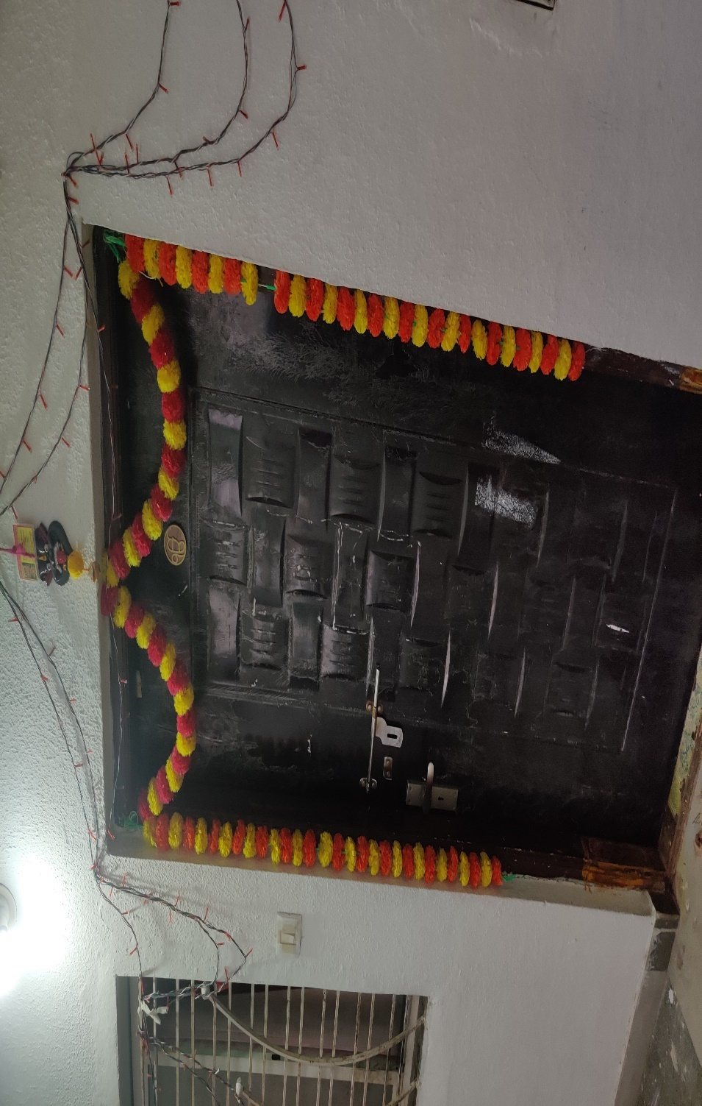

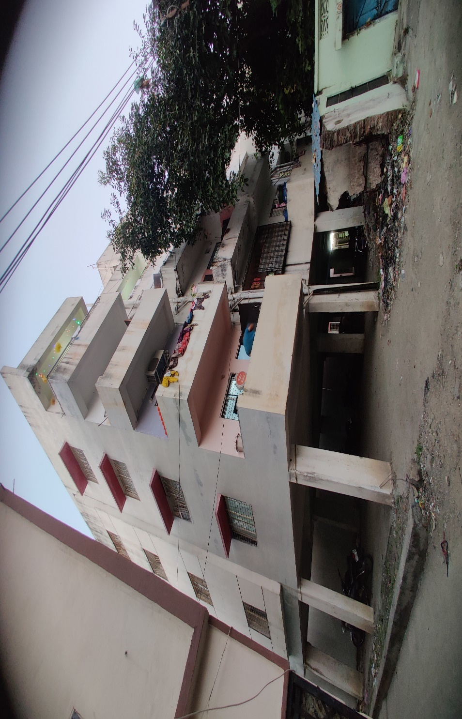

**ROUTE MAP OF THE PROPERTY**

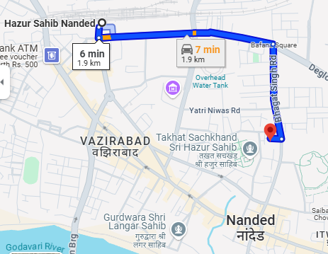

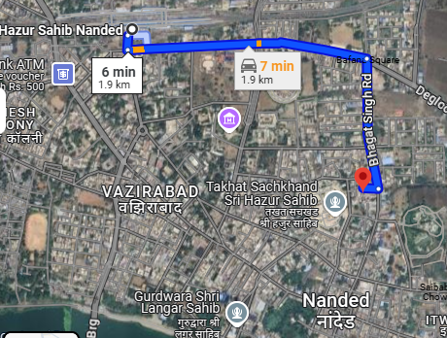

**Longitude Latitude: 19.153351,77.320349**

**Note:**

* Red rectangle shows Approx. Property Location.
* Blue line shows Route from Nanded Railway Station @ 1.9 Km.

**READY RECKONER RATE**

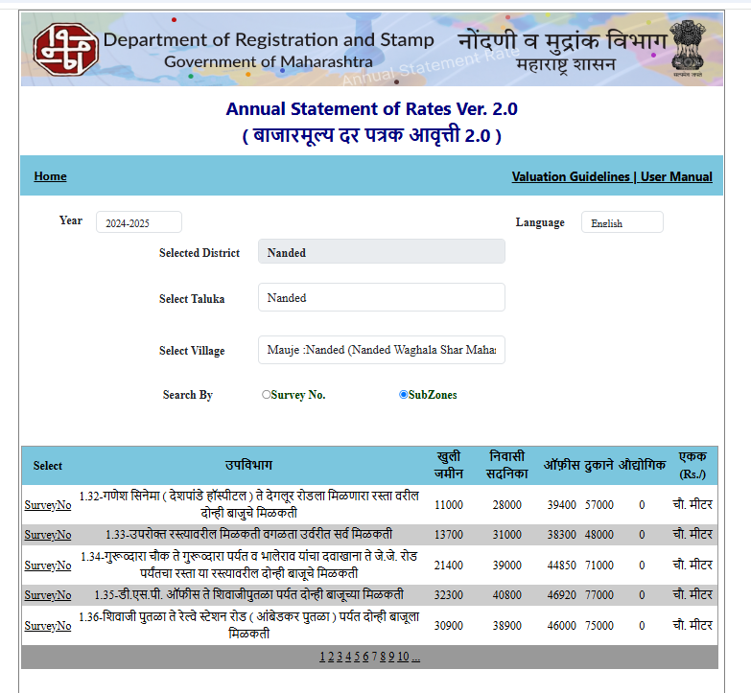

**DEFINITION OF VALUE FOR THIS SPECIFIC PURPOSE**

This exercise is to assess Fair Market Value of the property under reference as on dated 12th Nov, 2024.

The term **Fair Market Value** is defined as

***"The most probable price, as of a specified date, in cash, terms equivalent to cash, or in other precisely revealed terms for which the specified property rights would sell after reasonable exposure in a competitive market under all conditions requisite to a fair sale, with the buyer and seller each acting prudently knowledgeably and for self-interest assuming that neither is under undue duress"***

Fundamental assumptions and conditions presumed in this definition are:

1. Buyer and seller are motivated by self-interest.
2. Buyer and seller are well informed and are acting prudently.
3. The property is exposed for a reasonable time on the open market.
4. Payment is made in cash or equivalent or in specified financing terms.

**UNDER LYING ASSUMPTIONS**

1. We assume no responsibility for matters of legal nature affecting the property appraised or the title thereto, nor do we render our opinion as to the title, which is assumed to be good and marketable
2. The property is valued as though under responsible ownership.
3. It is assumed that the property is free of liens and encumbrances.
4. It is assumed that there are no hidden or unapparent conditions of the subsoil or structure that would render it more or less valuable. No responsibility is assumed for such conditions or for engineering that might be required to discover such factors.

For, **Vastukala Consultants (I) Pvt. Ltd.**

**Sharadkumar B. Chalikwar**

B.E. (Civil), M.E. (Civil), M.Sc. (Real Estate Valuation), M.Sc. (P&M Valuation), FIE (I), FIV, FIWRS

Chairman & Managing Director

Govt. Reg. Valuer

Chartered Engineer (India)

Reg. No. (N) CCIT/1-14/52/2008-09

IBBI Reg.No. IBBI/RV/07/2019/11744

**DECLARATION OF PROFESSIONAL FEES CHARGED**

We hereby declare that our professional fees are not contingent upon the valuation findings. However, if the statute AND/OR clients demands that, the fees should be charged on the percentage of assessed value then, with the full knowledge of the AND/OR end user, it is being charged accordingly.

**VALUATION OF THE PROPERTY PREMISES**

Considering various parameters recorded herein above, existing economic scenario, and the information that is available with reference to the development of neighbourhood and method selected for valuation, we are of the opinion that, the property premises can be assessed and valued for Banking Purpose as on day for

Rs. 1,83,33,000.00 (Rupees One Croce Eighty-Three Lac Thirty-Three Thousand Only).

**STATEMENT OF LIMITING CONDITIONS**

1. Assumptions are made to the best of our knowledge and belief. Reliance is based on the information furnished to us by the identifier AND/OR client.
2. The Valuer shall not be responsible for matters of legal nature that affects the value and opinion expressed by us.
3. If our appearance is required, we will be pleased to appear and give the necessary clarification, provided the fees for each appearance (excluding travelling, dearness allowance and out of pocket expenses) is pre-determined before the acceptance of the assignment under reference.
4. In no event shall the Valuer be held responsible or liable for special, direct, indirect or consequential damages, as the assignment has been completed on best efforts, available knowledge and in good intentions of persons concerned and belief.
5. If it is proved that there is an apparent negligence on the part of a Valuer, liability of this assignment (whether arising from this assignment, negligence or whatsoever) is limited in respect of anyone event or series of events to the actual loss or damage sustained subject to maximum of 80% of the professional fees for the services rendered and, in any case, not exceeding the amount of ` 1,000 (Rupees One Thousand Only). All the claims against us shall expire after three months from the date of submission of the valuation report provided by us.
6. We hereby declare that, the information furnished above is true and correct to the best of our knowledge and belief. We have no direct or indirect interest in the assets valued. We have not been convicted of any offence and sentenced to a term of imprisonment. We have not been found guilty of misconduct in our professional capacity. We have personally inspected the assets.

For, **Vastukala Consultants (I) Pvt. Ltd.,**

**Sharadkumar B. Chalikwar**

B.E. (Civil), M.E. (Civil), M.Sc. (Real Estate Valuation), M.Sc. (P&M Valuation), FIE (I), FIV, FIWRS

Chairman & Managing Director

Govt. Reg. Valuer

Chartered Engineer (India)

Reg. No. (N) CCIT/1-14/52/2008-09

IBBI Reg.No. IBBI/RV/07/2019/11744