`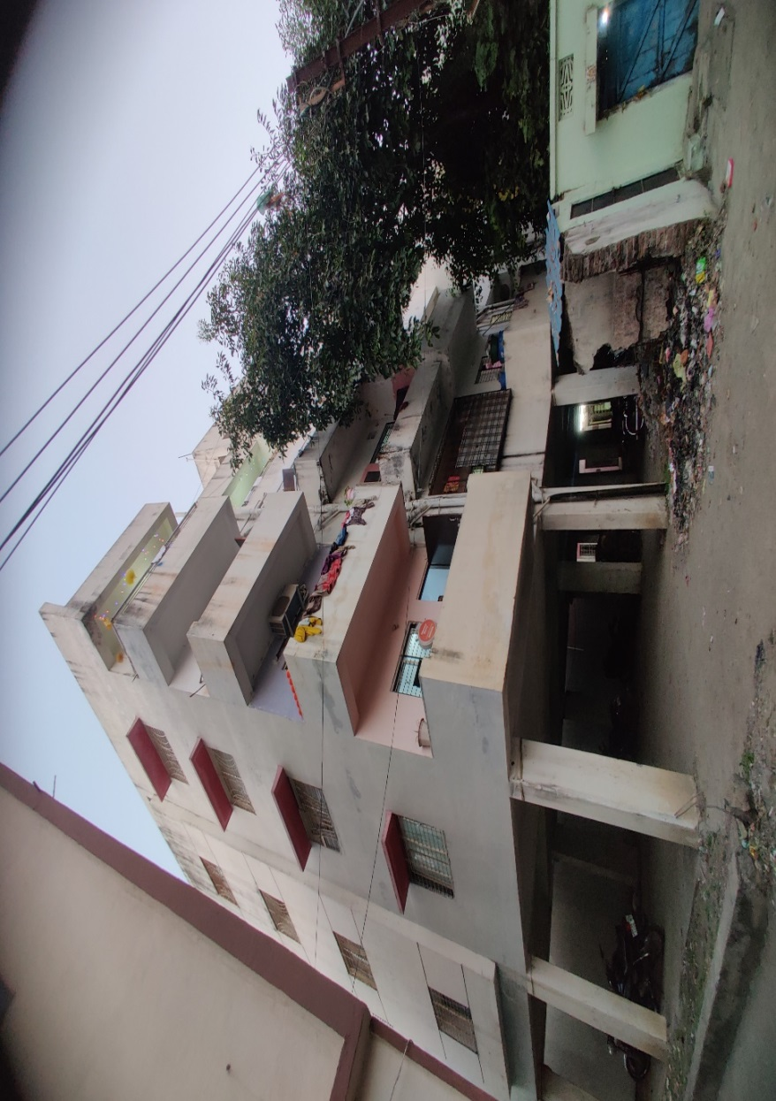

**Details of the property under consideration:**

Name of Owner**: Mr. Gurmeetsingh Tejasingh Raghi.**

Name of Owner: Mr. Gurmeetsingh Tejasingh Raghi. Flat No. 405, Fourth Floor, "Dashmesh Apartment", M. H. No. 3-6-242,3-6-238,3-6-238 & 3-6-267, C.T.S. No. 2264, 2266, & 2267 Gurudwara Gate No. 4, Badpura, Nanded, Taluka & District - Nanded.

.

**Longitude Latitude: 19.153351,77.320349**

**Valuation Done for:**

**State Bank of India**

**SARRAB Aurangabad.,**

**VALUER’S OPINION REPORT**

The property bearing Flat No. 405, Fourth Floor, Dashmesh Apartment, M.H. House No. 3-6-242, 3-6-238, & 3-6-267, C.T.S. No. 2264, 2266, & 2267, Gurudwara Gate No. 4, Badpura, Nanded. Tq. Dist. Nanded is belongs **Mr. Gurmeetsingh Tejasingh Raghi.**

Boundaries of the property:

|  |  |
| --- | --- |
| North | Open space of Apartment. |
| South | Open space of Apartment. |
| East | Open space of Apartment. |
| West | Flat No.404. |

Considering various parameters recorded, existing economic scenario, and the information that is available with reference to the development of neighborhood and method selected for valuation, we are of the opinion that, the property premises can be assessed and valued for this particular purpose as under.

|  |  |
| --- | --- |
| **Guideline Value of the Property** | **Rs. 32,29,792.00** |
| **Fair Market Value of the Property** | **Rs. 32,29,792.00** |
| **Realizable Value** | **Rs. 29,06,813.00** |
| **Forced/Distress Sale Value** | **Rs. 25,83,833.00** |

The valuation of the property is based on the documents produced by the concern. Legal aspects have not been taken into considerations while preparing this valuation report.

Hence certified

For, **Vastukala Consultants (1) Pvt. Ltd**

**Sharad B. Chalikwar**

B.E. (Civil), M.E. (Civil), M.Sc. (Real Estate Valuation), M.Sc. (P&M Valuation), FIE (I), FIV, FIWRS

Chairman & Managing Director

Govt. Reg. Valuer

Chartered Engineer (India)

Reg. No. (N) CCIT/1-14/52/2008-09

IBBI Reg. No. IBBI/RV/07/2019/11744

SBI Empanelment No.: SME/TCC/2021-22/85/13

Encl: Valuation Report.

Vastu/Nanded/12/2024/ 012797 / 2309356

04/20-54-SCBS

Date:04.12.2024

To,

Mr. Ashish K Deodhar,

Dy. Manager, SAARB, SBI,

Aurangabad.

**Valuation Report of Immovable Property**

|  |  |  |  |
| --- | --- | --- | --- |
| **Introduction** | | | |
| a) | Name of the Property Owner  (with address & Phone nos.) | | **Mr. Gurmeetsingh Tejasingh Raghi**. Flat No. 405, Fourth Floor**, "Dashmesh Apartment**, M. H. No. 3-6-242,3-6-238,3-6-238 & 3-6-267, C.T.S. No. 2264, 2266, & 2267, Gurudwara Gate No. 4, Badpura, Nanded |
| b) | Purpose for which the valuation is made | | SARFASI Purpose. |
| c) | Authorization letter of Bank | | As per oral instructions & Telephonic discussion with Mr. Ashish K Deodhar, Dy. Manager, SAARB, SBI, Aurangabad. |
| d) | Date of inspection | | 12.11.2024 |
| e) | Date on which the valuation is made | | 04.12.2024 |
| f) | Name of the Developer of the Property  (in Case of developer-built properties) | | Divya Amrit Construction (I) Pvt. Ltd., Nanded |
| 1. **Physical Characteristics of the Property** | | | |
| a) | Location of the Property | Flat No. 405, 4th Floor, "Dashmesh Apartment, M.C. House No. 3-6-242, 3-6-238, & 3-6-237, C.T.S. No. 2264, 2266, & 2267, Gurudwara Gate No. 4, Badpura, Nanded | |
| Brief description of the property | Residential Flat Property. Built up area= 115.06 Sqm | |
| Nearby Landmark | Gurudwara Sachkhand Gate No. 4. | |
| Postal Address of the Property | **Mr. Gurmeetsingh Tejasingh Raghi**.  Flat No. 405, 4th Floor, "Dashmesh Apartment, M.C. House No. 1-6-242, 3-6-238, & 3-6-237, C.T.S. No. 2264, 2266, & 2267, Gurudwara Gate No. 4, Badpur, Nanded. | |
|  | Area of the Flat (Supported by a plan) | As per Sale Deed and other documents made available by Bank area of Flat **is 115.06 Sqm** | |
|  | Type of Land: Solid, Rocky, Marsh land, reclaimed land, Water-logged, Land locked. | Solid land | |
| Independent access/approach to the property etc. | Yes | |
| Google Map Location of the Property with a neighborhood layout map | Provided | |
| Details of roads abutting the property | Lane connecting to Gurudwara Gate No. 4, Badpura | |
| Description of adjoining property | Gurudwara Sachkhand Premises. | |
| Plot No. Survey No. | M.C. House No. 3-6-242, 3-6-238, & 3-6-267, C.T.S. No. 2264, 2266, & 2267. | |
| Ward/Village/Taluka | Gurudwara Gate No. 4, Badpura, Nanded | |
| Sub-Registry/Block | Jt-Sub Registrar, Nanded-2 | |
| District | Nanded. | |
| Any other aspect | No. | |
| b) | Plinth Area, built up Area, and Saleable are to be mentioned separately and clarified | As per Sale Deed and other documents area of flat is 115.06 Sqm. | |

|  |  |  |  |  |  |  |
| --- | --- | --- | --- | --- | --- | --- |
| C) | **Boundaries of the Flat** | **As per Sale Deed** | | | **Actual** | **Remarks** |
|  | North | Open space of Apartment. | | | Open space of Apartment. |  |
| South | Open space of Apartment. | | | Open space of Apartment. |  |
| East | Open space of Apartment. | | | Open space of Apartment. |  |
| West | Flat No. 404. | | | Flat No.404. |  |
| **3.Town Planning Parameters** | | | | | | |
| **a)** | Master Plan Provisions related to property in term of land use. | | Residential. | | | |
| Far-floor Area Rise/FSI- Floor Space Index Permitted & Consumed | | 2.00 | | | |
| Comment on whether Occupancy Certificate has been issued or not | | No | | | |
| Comment on unauthorized constructions any | | Deviation is Actual Construction and Sanctioned Plan. | | | |
| Transferability of developmental rights if any, Building by-laws provision as applicable to the property viz. setbacks, height restriction etc. | | As per Nanded Waghala City Municipal Corporation. | | | |
| Planning area/zone | | Residential. | | | |
| Developmental controls | | UDPCR Nanded Waghala City Municipal Corporation. | | | |
| Zoning regulations | | UDPCR Nanded Waghala City Municipal Corporation. | | | |
| Comment on the surrounding land uses a land uses and adjoining properties in terms of uses | | Residential development in the vicinity of Gurudwara Sachkhand | | | |
| Comment on demolition proceedings if any | | Details not Available. | | | |
| Comment on compounding/regularization proceedings | | Completion certificate shall be obtained from competent Authority. | | | |
| Any other Aspect | | Completion certificate shall be obtained from competent Authority. | | | |
|  |  | | | | | |
| **4.** | **Document Details and Legal Aspects of Property** | | | | | |
| 1 | Photo Copy of Power of Autonomy No. 2193/2015, date 27.04.2015 issued by Joint Sub-Register, Nanded-2 | | | | | |
| 2 | Photo Copy of Building Permission No. NWCMC/TP/211/15, dated 01.06.2015 issued by NWCMC, Nanded. | | | | | |
| 3 | Photo Copy of Deed of Declaration No.2594/2015 dated 19/05/2015 Issued by Joint Sub-Resister Class 2 Nanded. | | | | | |
| 4 | Photo Copy of registered sale agreement of apartment No 405, (Under Apartment Ownership Act 1970) Document No.4936/2015, dated 27.08.2015, Joint Sub-Register, Class-2, Nanded. | | | | | |
| 5 | Photo copy of TIR Issued by Adv. Mr. S.D. Tuptewar dated 20.08.2015 | | | | | |
| 6 | Photo Copy of Notice No. AGM/BR/SN/2016-17/, dated 10.08.2017, issued to Mr. Gurmeetsingh Tejasingh Raghi. | | | | | |
| 7 | Photo Copy of Agreement Letter dated 21.08.2015 | | | | | |
| 8 | Photo Copy of Home Loan Agreement dated 21.08.2015 | | | | | |
| 9 | Photo Copy of Notice under Section 138 of the N.I. Act by Adv. Mr. J. S. Pande dated 03.01.2017. | | | | | |
|  | TIR of the property | | | provided | | |
| b) | Name of the Owner’s | | | **Mr. Gurmeetsingh Tejasingh Raghi.** | | |
| c) | Ordinary status of freehold or leasehold including restrictions on transfer | | | Freehold. | | |
| d) | Agreement of easement if any | | | No. | | |
| e) | Notification of road acquisition if any | | | Not apparent from the document provided. | | |
| f) | Notification of road widening if any | | | Not apparent from the document provided. | | |

|  |  |  |  |  |  |  |  |  |  |  |
| --- | --- | --- | --- | --- | --- | --- | --- | --- | --- | --- |
| g) | | Heritage restriction, if any | No. | | | | | | | |
| h) | | Comment on transferability of the property ownership | As per T.I. R | | | | | | | |
| I) | | Comment on existing mortgages/ charges/ encumbrances on the property, if any | Mortgage with S.B. I | | | | | | | |
| J) | | Comment on whether the owners of the property have issued any guarantee (personal or corporate) as the case may be | As per T.I. R | | | | | | | |
| K) | | Building plan sanction: Authority approving the plan Name of the Authority - Any violation from the approved Building Plan  Actual construction is more than the sanctioned plan | Commissioner, Nanded Waghala City Municipal Corporation, Nanded. Actual construction is more than the sanctioned plan. | | | | | | | |
| l) | | Whether Property is Agricultural Land if yes, any conversion is contemplated | No. | | | | | | | |
| m) | | Whether the property is SARFAESI compliant | Yes. | | | | | | | |
| n) | | a. All legal documents, receipts related to electricity, Water tax, Municipal tax and other building taxes to be verified and copies as applicable to be enclosed with  the report.  b. Observation on Dispute or Dues if any in payment of bills/taxes to be reported. | Receipts Related to Electricity; Water Tax Municipal Tax Not made available for Verification | | | | | | | |
| o) | | Whether entire piece of land on which the unit is set up / property is situated has been mortgaged or to be | Flat No. 405 is mortgaged with S.B. I | | | | | | | |
| p) | | Qualification in TIR/mitigation suggested if any. | As per TIR report | | | | | | | |
| q) | | Any other aspect | No. | | | | | | | |
| **5.** | | **Economic Aspects of the Property** | | | | | | | | |
|  | | Reasonable letting value (After Completion) | Work is Rs. 8000.00 per month.: Rs.96,000.00 P.A. | | | | | | | |
| If property is occupied by tenant | Owner occupied. | | | | | | | |
| Number of tenants | Not Applicable | | | | | | | |
| Since how long (tenant-wise) | Not Applicable | | | | | | | |
| Status of tenancy right | N.A. | | | | | | | |
| Rent received per month (tenant-wise) with a comparison of existing market rent | Information not available | | | | | | | |
| Taxes and other outings | Information not available | | | | | | | |
| Property Insurance | Information not available | | | | | | | |
|  | | Monthly maintenance charges | Information not available | | | | | | | |
| Security charges | Information not available | | | | | | | |
| Any other aspect | Lift not operational. | | | | | | | |
| **6. Socio-cultural Aspects of Property** | | | | | | | | | | |
| a) | | Descriptive account of the location of the property in terms of social structure of the area, population, social stratification, regional origin, economic level, location of slums, squatter settlements nearby, etc. | Situated in developing Middle class Residential area in the vicinity of Gurudwara Sachkhand. Without slums and squatter settlements nearby. | | | | | | | |
| b) | | Whether property belongs to social infrastructure like hospital, school, old age homes etc. | No. | | | | | | | |
| **7. Functional and utilitarian Aspects of the Property** | | | | | | | | | | |
| a) | | Description of the functionality and utility of the property in terms of: |  | | | | | | | |
| Space allocation | Living, Bed room, Kitchen, Toilet | | | | | | | |
| Storage Spaces Think Innovate | No. | | | | | | | |
| Utility spaces provided within the building | No. | | | | | | | |
| Car Parking facility | Yes. | | | | | | | |
| Balconies, etc. | Balcony to Kitchen & Bed Room. | | | | | | | |
| b) | | Any other aspect | No. | | | | | | | |
| **8. Infrastructure Availability** | | | | | | | | | | |
|  | | Description of aqua infrastructure availability in terms of Water Supply | Bore well & Corporation Water supply System. | | | | | | | |
| Sewerage/sanitation System Underground or Open | Underground Municipal Sewer line. | | | | | | | |
|  | | Storm water drainage | Municipal Sewer line. | | | | | | | |
| b) | | Description of other physical infrastructure facilities viz. |  | | | | | | | |
|  | | Solid waste management | Not Provided. | | | | | | | |
| Electricity | Available in the apartment. | | | | | | | |
| Road and public transport connectivity | Connected by all-weather road. | | | | | | | |
| Availability of other public utilities nearby | All Available nearby. | | | | | | | |
| c) | | Social infrastructure in terms of  i. School  ii. Medical facilities  iii. Recreational facility in terms of parks and open space | Approximately 500m.  Approximately 500m.  Approximately 1.00km. | | | | | | | |
|  | |  |  | | | | | | | |
| **9. Marketability of the Property** | | | | | | | | | | |
| a) | | Marketability of the property in terms of | Location, development of surrounding area, type of construction, construction specifications, age of building, condition of the premises & building, facilities provided and its prevailing market rate | | | | | | | |
|  | | Locational attributes | Developing area. | | | | | | | |
|  | | Scarcity | Normal | | | | | | | |
|  | | Demand and supply of the kind of subject property | Normal | | | | | | | |
|  | | Comparable sale prices in the locality | Refer Annexure A. | | | | | | | |
| b) | | Any other aspect which has relevance on the value or marketability of the property | Property situated in Gurudwara Sachkhand Vicinity | | | | | | | |
| **10. Engineering and Technology Aspects of the Property** | | | | | | | | | | |
| a) | | Type of construction | R.C.C. Framed Structure. | | | | | | | |
|  | | Material & technology used | RCC with B.B. Masonry, Normal construction. | | | | | | | |
|  | | **Specifications** |  | | | | | | | |
| Sr.No | | **Description** | **Ground Floor Flat No.405.** | | | | | | | |
| 1 | | Foundation. | R.C.C. Footing | | | | | | | |
| 2 | | Basement. | BB Masonry. | | | | | | | |
| 3 | | Superstructure. | II Class B.B. Masonry. | | | | | | | |
| 4 | | Joinery/ Doors & Windows. | Commercial Flush Doors, Granite Frame & Aluminum  Sliding Windows. | | | | | | | |
| 5 | | RCC work. | Footing, Column, Beam, Slab etc. | | | | | | | |
| 6 | | Plastering | Cement Plaster in C.M. & P.O.P. | | | | | | | |
| 7 | | Flooring, Skirting. | Vitrified Tiles. | | | | | | | |
| 8 | | Kitchen Pantry Platform | Granite Kitchen Platform. | | | | | | | |
| 9 | | Whether any weather proof course is provided. | No. | | | | | | | |
| 10 | | Drainage | Connected to Municipal Sewar. | | | | | | | |
| 11 | | Compound wall (Height, Length and type of construction) | No. | | | | | | | |
| 12 | | Electric installation (Type of wire, Class of fittings) | Concealed, Superior. | | | | | | | |
| 13 | | Plumbing installation (No. of water closets & wash basin etc.) | 2 Toilet. | | | | | | | |
| 14 | | Bore well. | Provided. | | | | | | | |
| 15 | | Wardrobes, if any. | No. | | | | | | | |
| 16 | | Development of open area | C.C. Paving. | | | | | | | |
| d) | | Maintenance issues | Periodical maintenance is needed | | | | | | | |
| e) | | Age of the building | 6years. | | | | | | | |
| f) | | Total life of the building | 54 years | | | | | | | |
| g) | | Extent of deterioration | No. | | | | | | | |
| h) | | Structural safety | Structurally safe. | | | | | | | |
| i) | | Protection against natural disaster viz. earthquakes, | Not Provided. | | | | | | | |
| j) | | Visible damage in the building | No. | | | | | | | |
| k) | | System of air-conditioning | Not Provided. | | | | | | | |
| l) | | Provision of firefighting | Not Provided. | | | | | | | |
| m) | | Copies of the plan and elevation of the building to be included | Not provided. | | | | | | | |
| 11. Environmental Factors | | | | | | | | | | |
| a) | | Use of environment friendly building materials, Green Building techniques if any | No. | | | | | | | |
| b) | | Provision of rain water harvesting | No. | | | | | | | |
| c) | | Use of solar heating and lightening systems, etc., | No. | | | | | | | |
| d) | | Presence of environmental pollution in the vicinity of the property in terms of industry, heavy traffic etc. |  | | | | | | | |
| **12. Architectural and aesthetic quality of the Property** | | | | | | | | | | |
| a) | Descriptive account on whether the building is modern, old fashioned, plain looking or decorative, heritage value, presence of landscape elements etc. | | Modern | | | | | | | |
|  |  | |  | | | | | | | |
| **13.** **Valuation** | | | | | | | | | | |
| a) | Methodology of valuation Procedures adopted for arriving at the valuation. Valuers may consider various approaches and state explicitly the reason for adopting particular approach and assumptions made, basis adopted with supporting data, comparable sales, and reconciliation of various factors on which final value judgment is arrived at | | | | | | | | | Modern |
| b) | Prevailing Market Rate/Price trend of the Property in the locality/city from property search sites viz magickbricks.com, 99acres.com, makaan.com etc. if available | | Rs. 30,000.00 to Rs. 35,000.00 per Sqm. as prevailing Flat rate. Considering the rate with attached report, current market conditions, demand and supply position, Commercial Building size, Terrace area, location, upswing in real estate prices, sustained demand for commercial building, all round development of commercial and residential application in the locality etc. Therefore, we estimate composite Land Building) rate at Rs. 31,000.00 | | | | | | | |
| c) | Guideline Rate obtained from the Stamp Duty  Ready Reckoner | | **Rs 31000.00 per Sqm. (Composite rate).** | | | | | | | |
| d) | Summary of Valuation | | | | | | | | | |
| **i. Guideline Value** | | | **Area in Sqm.** | | **Rate in Rs** | | | **Value in Rs** | |
| **A. Built-up Area: Flat No. 405**  (115.06Sqm. X Rs. 31000.00 per Sqm.) | | | **115.06** | | **31,000.00** | | | **35,66,860.00** | |
| **B. Depreciation: 13.50%**  (115.06 Sqm. X Rs. 21,700.00x13.50%) | | |  | |  | | | **-3,37,068.00** | |
|  | **ii. Guideline Value of the Flat**  **(A-B)** | | |  | |  | | | **32,29,792.00** | |
|  | **iii. Fair Market Value** | | | **Area in Sqm** | **Rate in Rs** | | | | **Value in Rs** | |  |
| **C. Built-up Area: Flat No. 405.**  (115.06 Sqm. X Rs. 31000.00 per Sqm.) | | | **115.06** | **31,000.00** | | | | **35,66,860.00** | |
| **D. Depreciation: 13.50%**  (115.06 Sqm. X Rs. 21,700.00x13.5%) | | |  |  | | | | **-3,37,068.00** | |  |
| **Fair Market Value of the Flat**  **(C-D)** | | |  |  | | | | **32,29,792.00** | |  |
| **Summary of Valuation** | | |  |  | | | | | |
| **Guideline Value of the Property** | | | **Rs.** **32,29,792.00** | | | | | | |
| **Fair Market Value of the Property** | | | **Rs.** **32,29,792.00** | | | | | | |
| **Realizable Value** | | | **Rs.** **29,06,813.00** | | | | | | |
| **Forced/Distress Sale value.** | | | **Rs.** **25,83,833.00** | | | | | | |
| e) | In case of variation of 20% or more in the valuation proposed by the valuer and the Guideline value provided in the State Govt. notification or Income Tax Gazette justification on variation has to be given | | | | | | | | | |
| * Subject property under valuation is Flat No. G-02, Ground Floor, "Dashmesh Apartment, M. H. No.3-6- 242,3-6-238,3-6-238 & 3-6-267, C.T.S. No. 2264, 2266, & 2267, Gurudwara Gate No. 4, Badpura, Nanded, Tq. & Dist. Nanded. * All Civic amenities are available nearby. * To obtain the Sales Instances in the vicinity, we visited the Joint Sub Registrar Office, Nanded. * The Ready Reckoner rate i.e. Guide Line rate for Residential Flatted Rate property in zone 1.33 is Rs. 31,000.00 per Sqm. * The above Guide line Rate is for entire block of zone 1.33. * Guideline Rates are basically generated for stamp duty purpose, at the time of purchase of the property, which are fixed for year to year for particular survey Nos., Gut Nos., CTS Nos., etc. * There is market trend to register the document as per the Guideline rates and not as per the market rate just to save the Stamp duty. * Market Rates are not fixed. Market rates depend mainly on demand and supply. * Market rates may increase or decrease as per surrounding devolvement, approach road, location, availability of amenities & services, demand and supply in surrounding areas etc. * The Market value obtained in this report is defined as follows: * Market value is the estimated amount for which an asset should exchange on the date of valuation between a willing seller in an Arm's length wherein the parties had each acted knowledgeably and without compulsion. {as defined by the international valuation committee, London}. Thus, the characteristics of the Market Value are: * It is free will sale. * b. It is an estimated amount and not a predetermined or an actual sale price. * c. It depends on purpose of valuation. * d. It is time-specific as on the given date. * e. Buyers and sellers are actuated by business principles. They are unrelated & are acting independently * Assets would be exposed to the market in the most appropriate manor to affect its disposal at the best price. | | | | | | | | | | |
| * As per the Supreme Court the Guideline rate is for stamp duty collection and not the Fair Market Value In case of Jawaji Nagnathan vs. REV. DIV. Officer (1994) SCC-4 Page 595 SC the Court held, "It is therefore, clear that the Basic Valuation Register prepared and maintained for the purpose of collecting stamp duty has no statutory base or force. It cannot form a foundation to determine the market value mentioned there under in instrument brought for registration. Evidence of bonafide sales between willing prudent vendor and prudent vendee of the land acquired or situated near about that land possessing same or similar advantageous features would furnish basis to determine market value." * Social Forces, Economic forces, Government/Legal and Physical/Environmental factors influence the value of Real Estate. * This property is situated in the developing area of Badpura, Nanded. * There is no scarcity of land in the vicinity. * The cost of construction is arrived by considering the type of construction and grade, constructions specification, and Age of Building. * The Cost Approach and Market Approach Method is adopted to arrive the Fair Market Value. * After giving due consideration for various factors influencing the value of the property with respect to Physical, Legal, Social and Economic aspects, Location, Development in the vicinity, Road frontage, the rate of Rs. 31,000.00 Per Sqm. Residential Flatted Rate is considered Fair and Reasonable and hence adopted to arrive the Fair Market value of the Flat | | | | | | | | | | |
| Details of last two transactions in the locality/area to be provided, if available | | | | | | | | Enclosed. | | |
|  | | **General Remark:**   1. Latest TIR Report is not available. 2. The effect of demonetization is not accounted for in the valuation. 3. The property has no provision for car parking. 4. Flat work is incomplete at the time of Inspection | | | | | | | | |
| **14. Declaration** | | | | | | | | | | |
| I hereby declare that:  1. The information provided is true and correct to the best of my knowledge and belief.  ii. The analysis and conclusions are limited by the reported assumptions and conditions.  iii. I have read the Handbook on Policy, Standard and Procedures for Real Estate Valuation by Banks and HFIs in India, 2011, issued by IBA and NHB, fully understood the provisions of the same and followed the provisions of the same to the best of my ability and this report is in conformity to the Standards of Reporting enshrined in the above Handbook.  iv. I have no direct or indirect interest in the above property valued.  V. I have personally inspected the subject property on 09.10.2018  vi. I am a registered Valuer under Section 34AB of Wealth Tax Act, 1957, Category-l for valuing property up to no limit  vii. I am an approved Valuer under SARFAESI ACT-2002 and am approved by the Bank.  viii. I have submitted the Valuation Report (s) directly to the Bank.  **S. B. Chalikwar**  Govt. Reg. Valuer  Chartered Engineer (India)  Wealth Tax Reg. No.: (N) CCIT/1-14/52/2008-09  **Address:**  **Name of Valuer association of which I am a bonafide member in good standing:**  1.Institution of Valuers, New Delhi.  2. Practicing Valuers Association of India, Mumbai.  Date: 10.10.2018  Mobile No.- +91 9422171100/9167204051  Email [Id-sbchalikwar@gmail.com](mailto:Id-sbchalikwar@gmail.com) | | | | | | | | | | |
| 15. Enclosures | | | | | | | | | | |
| **a)** | | Layout plan sketch of the area in which the property is located with latitude and longitude | | | | | Yes | | | |
| **b)** | | Site Photograph of the property | | | | | Site photographs of the property is provided | | | |
| **c)** | | Certified copy of the approved / sanctioned plan wherever applicable from the concemed Property | | | | | Not provided | | | |
| **d)** | | Google Map location of the property | | | | | Provided | | | |
| **e)** | | Price trend of the Property in the locality/city from property search sites viz Magickbricks.com, 99Acres.com, Makan.com etc. | | | | | Copy of RR Rate is attached. | | | |
| **f)** | | Any other relevant documents/extracts | | | | | No. | | | |
|  | | | | | | | | | | |

**ACTUAL SITE PHOTOGRAPHS**

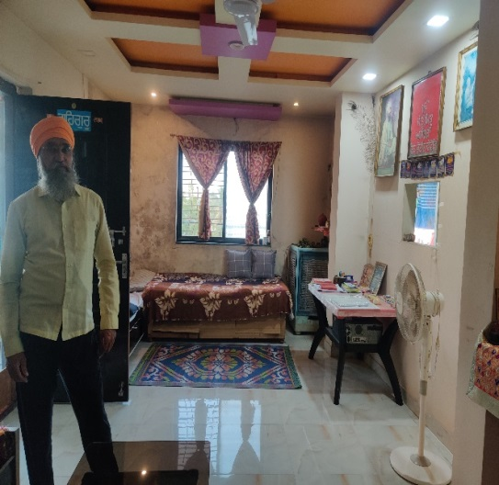 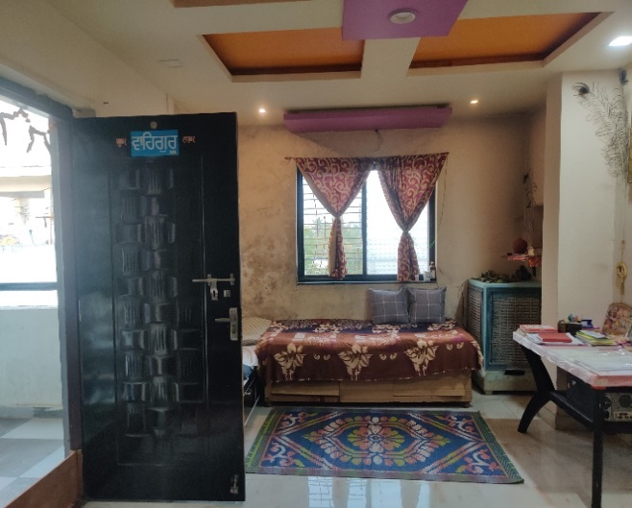

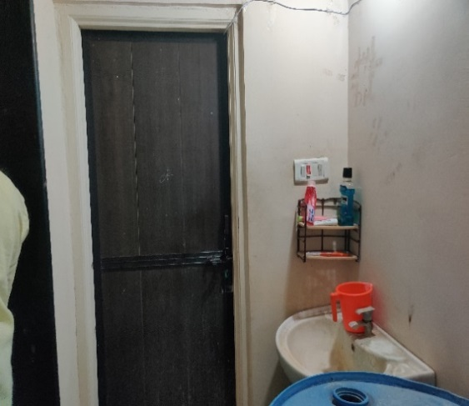 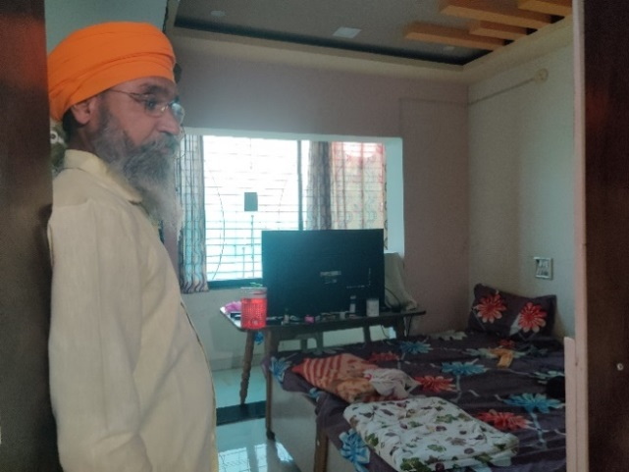

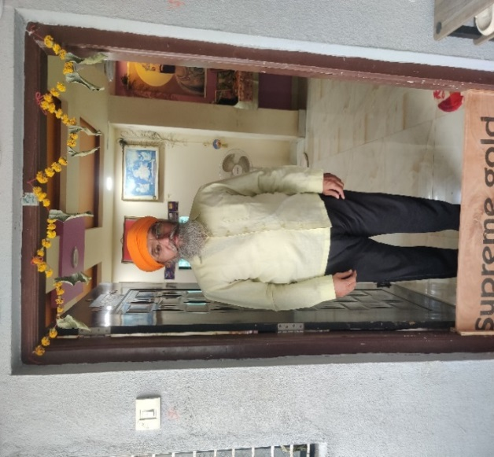 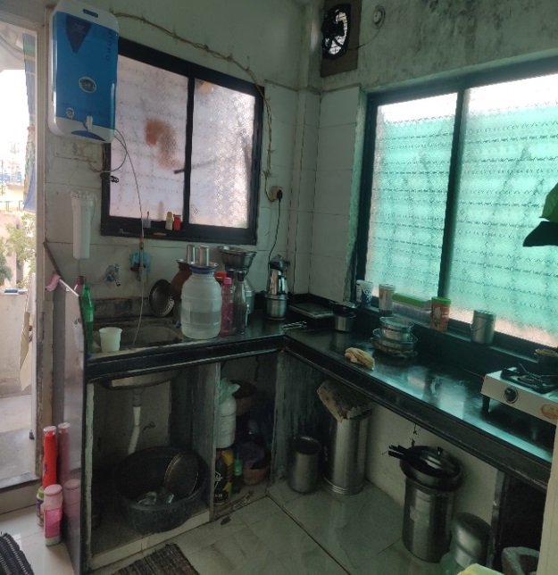

**ROUTE MAP OF THE PROPERTY**

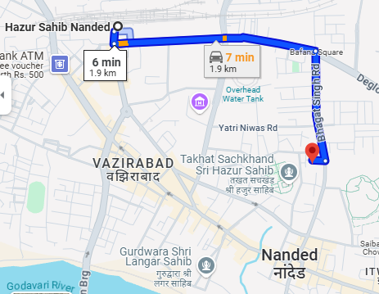

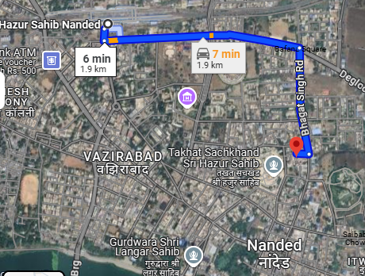

**READY RECKONER RATE**

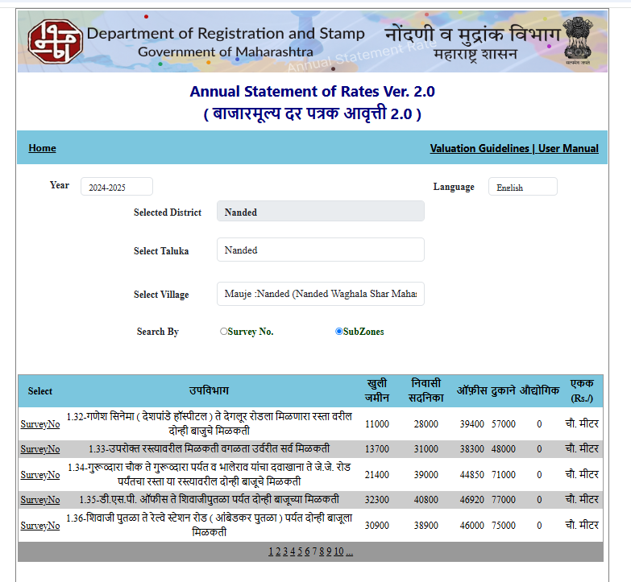

**DEFINITION OF VALUE FOR THIS SPECIFIC PURPOSE**

This exercise is to assess Fair Market Value of the property under reference as on dated 04th December, 2024.

The term **Fair Market Value** is defined as

***"The most probable price, as of a specified date, in cash, terms equivalent to cash, or in other precisely revealed terms for which the specified property rights would sell after reasonable exposure in a competitive market under all conditions requisite to a fair sale, with the buyer and seller each acting prudently knowledgeably and for self-interest assuming that neither is under undue duress"***

Fundamental assumptions and conditions presumed in this definition are:

1. Buyer and seller are motivated by self-interest.
2. Buyer and seller are well informed and are acting prudently.
3. The property is exposed for a reasonable time on the open market.
4. Payment is made in cash or equivalent or in specified financing terms.

**UNDER LYING ASSUMPTIONS**

1. We assume no responsibility for matters of legal nature affecting the property appraised or the title thereto, nor do we render our opinion as to the title, which is assumed to be good and marketable
2. The property is valued as though under responsible ownership.
3. It is assumed that the property is free of liens and encumbrances.
4. It is assumed that there are no hidden or unapparent conditions of the subsoil or structure that would render it more or less valuable. No responsibility is assumed for such conditions or for engineering that might be required to discover such factors.

For, **Vastukala Consultants (I) Pvt. Ltd.**

**Sharadkumar B. Chalikwar**

B.E. (Civil), M.E. (Civil), M.Sc. (Real Estate Valuation), M.Sc. (P&M Valuation), FIE (I), FIV, FIWRS

Chairman & Managing Director

Govt. Reg. Valuer

Chartered Engineer (India)

Reg. No. (N) CCIT/1-14/52/2008-09

IBBI Reg.No. IBBI/RV/07/2019/11744

**DECLARATION OF PROFESSIONAL FEES CHARGED**

We hereby declare that our professional fees are not contingent upon the valuation findings. However, if the statute AND/OR clients demands that, the fees should be charged on the percentage of assessed value then, with the full knowledge of the AND/OR end user, it is being charged accordingly.

**VALUATION OF THE PROPERTY PREMISES**

Considering various parameters recorded herein above, existing economic scenario, and the information that is available with reference to the development of neighbourhood and method selected for valuation, we are of the opinion that, the property premises can be assessed and valued for Banking Purpose as on day for

Rs. 32,29,792.00 (Rupees Thirty-Two Lakhs Twenty-Nine Thousand Seven Hundred Ninety Two Only).

**STATEMENT OF LIMITING CONDITIONS**

1. Assumptions are made to the best of our knowledge and belief. Reliance is based on the information furnished to us by the identifier AND/OR client.
2. The Valuer shall not be responsible for matters of legal nature that affects the value and opinion expressed by us.
3. If our appearance is required, we will be pleased to appear and give the necessary clarification, provided the fees for each appearance (excluding travelling, dearness allowance and out of pocket expenses) is pre-determined before the acceptance of the assignment under reference.
4. In no event shall the Valuer be held responsible or liable for special, direct, indirect or consequential damages, as the assignment has been completed on best efforts, available knowledge and in good intentions of persons concerned and belief.
5. If it is proved that there is an apparent negligence on the part of a Valuer, liability of this assignment (whether arising from this assignment, negligence or whatsoever) is limited in respect of anyone event or series of events to the actual loss or damage sustained subject to maximum of 80% of the professional fees for the services rendered and, in any case, not exceeding the amount of ` 1,000 (Rupees One Thousand Only). All the claims against us shall expire after three months from the date of submission of the valuation report provided by us.
6. We hereby declare that, the information furnished above is true and correct to the best of our knowledge and belief. We have no direct or indirect interest in the assets valued. We have not been convicted of any offence and sentenced to a term of imprisonment. We have not been found guilty of misconduct in our professional capacity. We have personally inspected the assets.

For, **Vastukala Consultants (I) Pvt. Ltd.,**

**Sharadkumar B. Chalikwar**

B.E. (Civil), M.E. (Civil), M.Sc. (Real Estate Valuation), M.Sc. (P&M Valuation), FIE (I), FIV, FIWRS

Chairman & Managing Director

Govt. Reg. Valuer

Chartered Engineer (India)

Reg. No. (N) CCIT/1-14/52/2008-09

IBBI Reg.No. IBBI/RV/07/2019/11744