Valuation Report of the Immovable Property

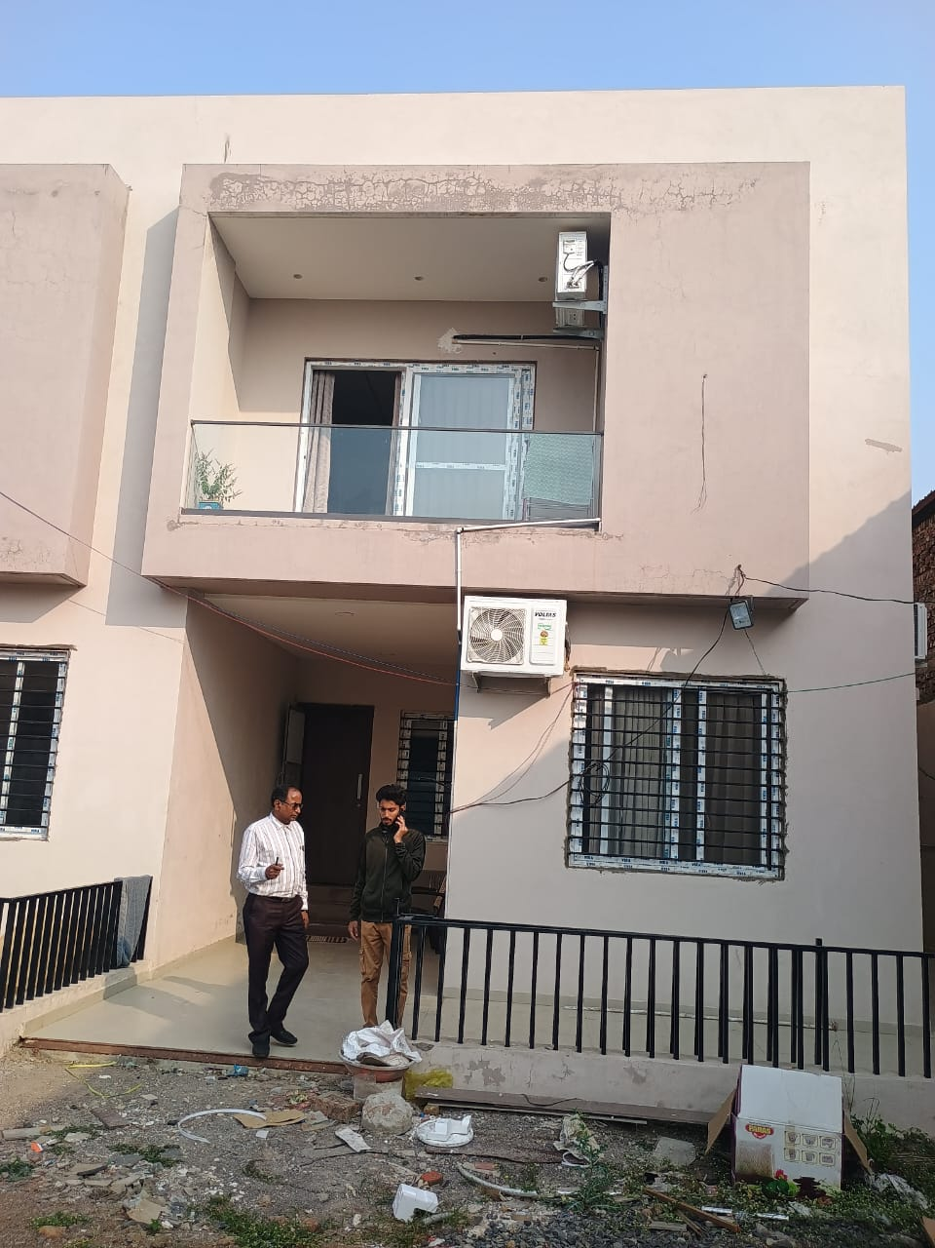

Details of the property under consideration:

Name of the Owner:

Mr. Deepak Shribhagawan Gaggad

Residential Row House No. 06, Plot No 36,37,38,39, Survey No. 61/A/1 (Part), Abhinandan Casa,
Village Vasarani, Nanded - 431 206, Taluka & Dist. Nanded, Maharashtra, India

Longitude Latitude: 19°07'29.9"N 77°18'24.7"E

Intended User:
State Bank of India
RACPC, New Mondha, Nanded
A, P, M, C, Branch Compound, Second Floor, Nanded,
Maharashtra, Pin Code – 431 602.

Vastu/Nanded /11/2024/012759/2309340

04/4-38-AS

Date: 04.12.2024

VALUER’S OPINION REPORT

This is to certify that the Residential Row House No. 06, Plot No 36,37,38,39, Survey No. 61/A/1 (Part), Abhinandan Casa, Village Vasarani, Nanded - 431 206, Taluka & Dist. Nanded, Maharashtra, India belongs to Mr. Deepak Shribhagawan Gaggad.

Boundaries of the property:
On or towards the North by | : | Row House No. 05
On or towards the South by | : | Part of Survey No 61
On or towards the East by | : | Plot No. 32,33,34,35
On or towards the West by | : | 6.00 M Wide Road

Considering various parameters recorded, existing economic scenario, and the information that is available with reference to the development of neighborhood and method selected for valuation, we are of the opinion that, the property premises can be assessed and valued for this particular purpose as under:

Guideline Value of the Property | Rs. 61,89,950.00
Fair Market Value of the Property | Rs. 1,18,95,000.00
Realizable Value | Rs. 1,13,00,000.00
Forced/ Distress Sale value. | Rs. 1,01,70,000.00

Hence certified
For, Vastukala Consultants (I) Pvt. Ltd.

Sharadkumar B. Chalikwar
B.E. (Civil), M.E. (Civil), M.Sc. (Real Estate Valuation), M.Sc. (P&M Valuation), FIE (I), FIV, FIWRS
Chairman & Managing Director
Govt. Reg. Valuer
Chartered Engineer (India)
Reg. No. (N) CCIT/1-14/52/2008-09
IBBI Reg.No. IBBI/RV/07/2019/11744
SBI Empanelment No.: SME/TCC/2017-18/942/178

Encl: Valuation report.
To,
State Bank of India
RACPC, New Mondha, Nanded
A, P, M, C, Branch Compound, Second Floor,
Nanded, Maharashtra, Pin Code – 431 602

VALUATION REPORT
(IN RESPECT OF LAND / SITE &BUILDING)
I. | General
1. | Purpose for which the valuation is made |  |  |  |  | To assess Fair Market Value of the Property as Request from Mr.Amit Krishn Paridha 7045263272  amitparidha210@gmail.com  amit.paridha@sbi.co.in
2. | a) |  | Date of inspection |  |  | 23.11.2024
 | b) |  | Date on which the valuation is made |  |  | 04.12.2024
 | c) |  | Date of Report |  |  | 04.12.2024
3. | List of documents produced for perusal
 | 1 | Copy of Correction deed No. 8124/2024 received on 03.12.2024
 | 2 | Copy of Sale Deed between Mr. Deepak Gaggad (Buyer) AND M/s. Abhinandan Developers & Partners (Seller) through Registered Doc No. NDG3/2989/2024 dated 22.07.2024.
 | 3 | Copy of Commencement Certificate No. DDMCW/RB/2023/APL/00023 dated 21.09.2023 issued by Nanded Waghala City Municipal Corporation, Nanded
 | 4 | Copy of Layout dated 26.09.2007 sanctioned by Nanded Waghala Municipal Corporation
 | 5 | Copy of N.A. order dated 09.06.2008.
 | 6 | Copy of Approved plan dated 21.09.2023, Doc No. DDMCW/RB/2023/APL/00023 sanctioned by Nanded Waghala City Municipal Corporation, Nanded.
 | 7 | Copy of Lease deed dated 25.07.2024 between Mr. Deepak Shribhagawan Daggad (The Lessor) AND SJVN Green Energy Limited (SGCL) (The Lessee) through registered Agreement No. NDH1/939/2024.
 | 8 | Copy of Property Tax Receipt dated 13.11.2024 issued by Nanded Waghala City Municipal Corporation.
4. | Name of the owner(s) and his / their address (es) with Phone no. (details of share of each owner in case of joint ownership) |  |  |  |  | Mr. Deepak Shribhagawan Gaggad  9309763988 (Krishna Deepak Gaggad)  Sole Ownership
5. | Brief description of the property  (Including Leasehold / freehold etc.) |  |  |  |  | Freehold Property.  Residential Row House No. 06, Plot No 36,37,38,39, Survey No. 61/A/1 (Part), Abhinandan Casa, Village Vasarani, Nanded - 431 206, Taluka & Dist. Nanded, Maharashtra, India.  It is fully furnished service Row House.
6. | Location of property
 | a) |  |  |  | Plot No. / Survey No. | Plot No 36,37,38,39, Survey No 61/A/1 (Part)
 | b) |  |  |  | Door No. | Row House No 6
 | c) |  |  |  | T.S. No. / Village | Vasarani
 | d) |  |  |  | Ward / Taluka | Nanded
 | e) |  |  |  | Mandal / District | Nanded
7. | Postal address of the property |  |  |  |  | Residential Row House No. 06, Plot No 36,37,38,39, Survey No. 61/A/1 (Part), Abhinandan Casa, Village Vasarani, Nanded - 431 206, Taluka & Dist. Nanded, Maharashtra, India
8. | City / Town |  |  |  |  | Vasarani, Nanded
 | Residential area |  |  |  |  | Yes.
 | Commercial area |  |  |  |  | No
 | Industrial area |  |  |  |  | No.
9. | Classification of the area
 | i) High / Middle / Poor |  |  |  |  | Higher Middle Class
 | ii) Urban / Semi Urban / Rural |  |  |  |  | Urban
10. | Coming under Corporation limit / Village Panchayat / Municipality |  |  |  |  | Nanded Waghala City Municipal Corporation, Nanded
11. | Whether covered under any State / Central Govt. enactments (e.g., Urban Land Ceiling Act) or notified under agency area/ scheduled area / cantonment area |  |  |  |  | No
12. | In Case it is Agricultural land, any conversion to house site plots is contemplated |  |  |  |  | N.A.
13. | Boundaries of the property
 | Boundaries of the property |  |  |  |  | As Per Deed |  | As per the Actual
 | North |  |  |  |  | Row House No. 5 on  Plot No. 38 |  | Row House No. 05
 | South |  |  |  |  | Part of Survey No. 61 |  | Part of Survey No 61
 | East |  |  |  |  | Plot No 32 |  | Plot No. 32,33,34,35
 | West |  |  |  |  | 6.00-Meter-Wide Road |  | 6.00 M Wide Road
14 | Dimensions of the site in meter |  |  |  |  | As Per Deed |  | As per the Actual
 | North |  |  |  |  | 6.00 M. |  | 6.00 M.
 | South |  |  |  |  | 6.00 M. |  | 6.00 M.
 | East |  |  |  |  | 18.00 M. |  | 18.00 M.
 | West |  |  |  |  | 18.00 M. |  | 18.00 M.
14.1 | Extent of the site (NA Plot) in Sqm. / Sq. Ft. |  |  |  |  | Plot area = 144.00 Sq. Mts. i.e., 1,550.00 Sq. Ft.  (Area as per Sale Agreement)  Built up area = 218.21 Sq. Mts.  (Area as per Sale Agreement)
14.1 | Latitude, Longitude & Co-ordinates of flat |  |  |  |  | 19°07'29.9"N 77°18'24.7"E
15. | Extent of the site considered for Valuation (least of 14.1 A& 14.1 B) |  |  |  |  | Plot area = 144.00 Sq. Mts. i.e., 1,550.00 Sq. Ft.  (Area as per Sale Agreement)  Built up area = 218.21 Sq. Mts.  (Area as per Sale Agreement)
16 | Whether occupied by the owner / tenant? If occupied by tenant since how long? Rent received per month. |  |  |  |  | Tenant Occupied – M/s. SJVN Green Energy Limited since 01.08.2024 to 31.07.2027.  Rent – 1,62,000/- per month with annual increment of 7%
II | CHARACTERSTICS OF THE SITE
 | Classification of locality |  |  |  |  | Middle class
 | Development of surrounding areas |  |  |  |  | Good
 | Possibility of frequent flooding/ sub-merging |  |  |  |  | No
 | Feasibility to the Civic amenities like School, Hospital, Bus Stop, Market etc. |  |  |  |  | All available near by
 | Level of land with topographical conditions |  |  |  |  | Plain
 | Shape of land |  |  |  |  | Rectangular
 | Type of use to which it can be put |  |  |  |  | Residential purpose
 | Any usage restriction |  |  |  |  | Residential.
 | Is plot in town planning approved layout? |  |  |  |  | Yes.
 | Corner plot or intermittent plot? |  |  |  |  | Intermittent plot
 | Road facilities |  |  |  |  | Yes
 | Type of road available at present |  |  |  |  | Cement Concrete Road
 | Width of road – is it below 20 ft. or more than 20 ft. |  |  |  |  | More than 6.00 Meter Wide Road
 | Is it a Land – Locked land? |  |  |  |  | No Land Lock
 | Water potentiality |  |  |  |  | Yes
 | Underground sewerage system |  |  |  |  | No.
 | Is Power supply is available in the site |  |  |  |  | Yes
 | Advantages of the site |  |  |  |  | Located in developing Residential Area
 | Special remarks, if any like threat of acquisition of land for publics service purposes, road widening or applicability of CRZ provisions etc.(Distance from sea-cost / tidal level must be incorporated) |  |  |  |  | No threat of acquisition of land for publics service purposes, road widening or applicability of CRZ provisions etc.
Part – A (Valuation of land)
1 | Size of plot in M. |  |  |  |  | 144.00 Sq Mts. i.e. 1,550.00 Sq.Ft.  (Area as per Sale Agreement)
2 | Total extent of the plot |  |  |  |  | 144.00 Sq Mts. i.e. 1,550.00 Sq.Ft.  (Area as per Sale Agreement).
3 | Prevailing market rate (Along With details / reference of at least two latest deals / transactions with respect to adjacent properties in the areas) |  |  |  |  | Rs. 2,600.00 to 3,100.00 per Sq. Ft.  According to location, approach road and infra structure facilities available.
4 | Guideline rate obtained from the Register’s Office (an evidence thereof to be enclosed) |  |  |  |  | Rs. 5,100.00 per Sqm.  i.e., Rs. 474.00 Per Sq. Ft.
5 | Assessed / adopted rate of valuation |  |  |  |  | Rs. 3,000.00 Per Sq. Ft.
6 | Estimated value of land |  |  |  |  | Rs. 46,50,000.00
Part – B (Valuation of Building)
1 | Technical details of the building
 |  |  |  | Type of Building (Residential / Commercial / Industrial) |  |  | Residential
 |  |  |  | Type of construction (Load bearing / RCC / Steel Framed) |  |  | RCC Framed Structure
 |  |  |  | Year of construction |  |  | 2024(As per Site Information)
 |  |  |  | Number of floors and height of each floor including basement, if any |  |  | As per Observation– Ground Floor + 1st Floor & 2ndFloor (3.00 Mts. floor height)
 |  |  |  | Plinth area floor-wise |  |  | Built up area –218.01 Sq. M.  (As per Sale Agreement)
 |  |  |  | Condition of the building
 |  |  |  | I. Exterior: Excellent, Good, Normal, Poor |  |  | Good
 |  |  |  | ii. Interior: Excellent, Good, Normal, Poor |  |  | Good
 |  |  |  | Date of issue and validity of layout of approved map |  |  | Copy of Approved plan dated 21.09.2023, Doc No. DDMCW/RB/2023/APL/00023 issued by Nanded Waghala City Municipal Corporation Has been Verified.
 |  |  |  | Approved map / plan issuing authority
 |  |  |  | Whether genuineness or authenticity of approved map / plan is verified`
 |  |  |  | Any other comments by our empaneled valuers on authentic of approved plan |  |  | No.

Specifications of construction in respect of

Sr.  No. | Description | Ground floor
 | Foundation | RCC Framed Structure
 | Basement | No
 | Superstructure | Brickwork with plaster
 | Joinery / Doors & Windows (Please furnish details about size of frames, shutters, glazing, fitting etc. and specify the species of timber | M.S Grill, Aluminum Sliding Window, Teak wood door frame with flush doors
 | RCC Works | RCC Slab, Beam, Column
 | Plastering | Cement Plastering
 | Flooring, Skirting, dado | Vitrified tiles in all rooms, Anti – skild tiles in balcony
 | Special finish as marble, granite, wooden paneling, grills etc. | Provided
 | Roofing including weather proof course | RCC Slab
 | Drainage | Connected to Municipal Sewerage System
2. | Compound Wall | N.A.
 | Height
 | Length
 | Type of construction
3. | Electrical installation
 | Type of wiring | N.A.
 | Class of fittings (superior / ordinary / poor) | N.A.
 | Number of light points | N.A.
 | Fan points | N.A.
 | Spare plug points | N.A.
 | Power point | N.A.

4. | Plumbing installation
 | - No. of water closets and their type |  |  |  |  |  | N.A.
 | - No. of wash basins |  |  |  |  |  | N.A.
 | - No. of urinals |  |  |  |  |  | N.A.
 | - No. of bath tubs |  |  |  |  |  | N.A.
 | - Water meters, taps etc. |  |  |  |  |  | N.A.
 | - Any other fixtures |  |  |  |  |  | N.A.
S. No | Particulars of item | Plinth  Area | Roof height | Age of building | Estimated replacement rate of construction | Replacement cost |  | Depreciation | Net Value after depreciation
 |  | (Sq.M.) | (R.M.) | (Years) | (Rs.) | (Rs.) |  | (Rs.) | (Rs.)
1. | Built up area | 218.21 | 3.00 | New Construction | 25,000.00 | 54,55,250.00 |  | Nill | 54,55,250.0
 | Total |  |  |  |  |  |  |  | 54,55,250.0

Interior

Particulars | Lumpsum Value In Rs.
Interior, Furniture & Fixtures | 17,89,750.00

Part – C (Extra Items) |  | Amount in Rs.
 | Portico | Included in the Cost of Construction
 | Ornamental front door
 | Sit out / Verandah / Porch with steel grills
 | Water tank
 | Extra steel / collapsible gates
 | Total
Part – D (Amenities) |  | Amount in Rs.
 | Wardrobes | Included in the Cost of Construction
 | Glazed tiles
 | Extra sinks and bath tub
 | Marble / ceramic tiles flooring
 | Interior decorations
 | Architectural elevation works
 | Paneling works
 | Aluminum works
 | Aluminum hand rails
 | False ceiling
 | Total
Part – E (Miscellaneous) |  | Amount in Rs.
 | Separate toilet room | Included in the Cost of Construction
 | Separate lumber room
 | Separate water tank / sump
 | Trees, gardening
 | Total
Part – F (Services) |  | Amount in Rs.
 | Water supply arrangements | Included in the Cost of Construction
 | Drainage arrangements
 | Compound wall
 | C.B. deposits, fittings etc.
 | Site Development
 | Total

Total abstract of the entire property

Part – A | Land | Rs. 46,50,000.00
Part – B | Building | Rs. 54,55,250.00
 | Interior and other Development | Rs. 17,89,750.00
Part – C | Extra Items | Rs. NIL
Part - D | Amenities | Rs. NIL
Part – E | Miscellaneous | Rs. NIL
Part – F | Services | Rs. NIL
 | Total | Rs. 1,18,95,000.00
 | Fair Market Value of the Property | Rs. 1,18,95,000.00
 | Realizable Value of the Property | Rs. 1,13,00,000.00
 | Distress / Force Sale Value | Rs. 1,01,70,000.00
 | Guideline Value of the Property | Rs. 61,89,950.00
Remarks

The cost approach is a Real Property Valuation method which considers the value of a property as the cost of the land plus the replacement cost of the building (construction costs) minus the physical and functional depreciation.
This approach is most commonly used for real estate properties that are not easily sold like schools, hospitals, and government buildings.

Land cost can be estimated using the Sales Comparison Approach by studying recent sales of land close to the subject property, and these sales should be comparable in size and location with subject property.

There are different ways to estimate replacement costs, the most common being finding out the cost to build a square foot of comparable properties multiplied by the total square footage of the building. The cost approach is commonly used for Residential Bungalow, Industrial Building and properties mentioned above.

As the property is a residential Building thereof, we have adopted Cost approach /Land And Building Method for the purpose of valuation. The Price for similar type of property in the nearby vicinity is in the range of Rs.2,600.00 to Rs.3,100.00 per Sq. Ft. for land Considering the rate with attached report, current market conditions, demand and supply position, Land size, location, upswing in real estate prices, sustained demand for Residential Bungalow / Plot, all round development of commercial and residential application in the locality etc. We estimate Rs.3,000.00 per Sq. Ft. for Land for valuation.

The salability of the property is: Normal
Likely rental values in future in: ` 1,62,000/- per month with annual increment of 7%
Any likely income it may generate: Rental Income

For, Vastukala Consultants (I) Pvt. Ltd

Sharadkumar B. Chalikwar
B.E. (Civil), M.E. (Civil), M.Sc. (Real Estate Valuation), M.Sc. (P&M Valuation), FIE (I), FIV, FIWRS
Chairman & Managing Director
Govt. Reg. Valuer
Chartered Engineer (India)
Reg. No. (N) CCIT/1-14/52/2008-09
IBBI Reg.No. IBBI/RV/07/2019/11744
SBI Empanelment No.: SME/TCC/2017-18/942/178
Date:04.12.2024
Place: Nanded
Actual Site Photographs
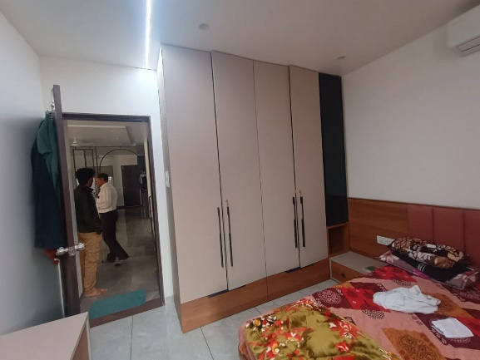
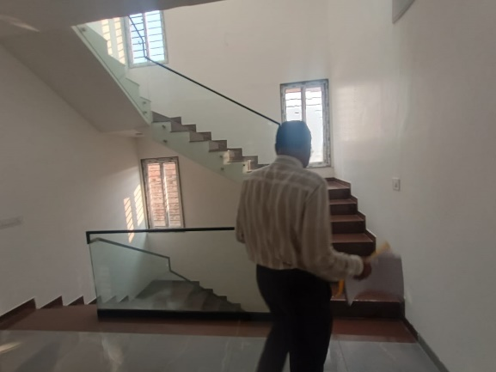
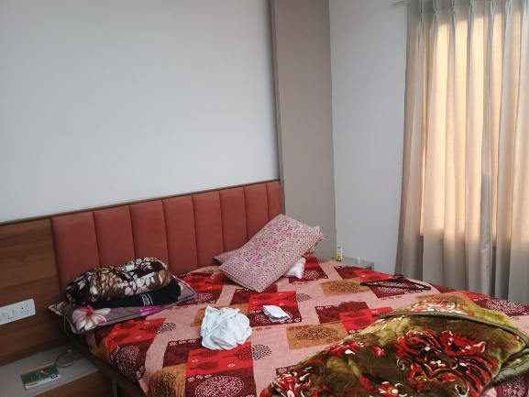
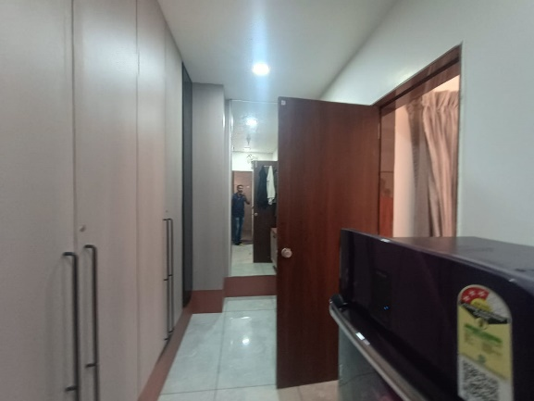
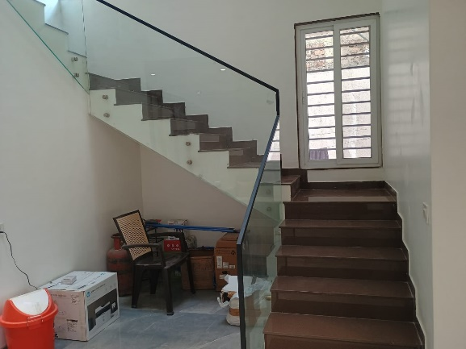
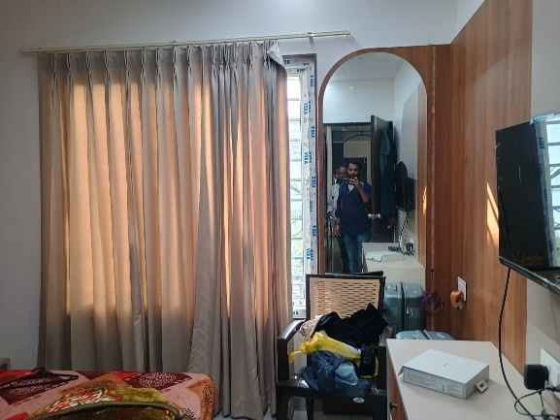
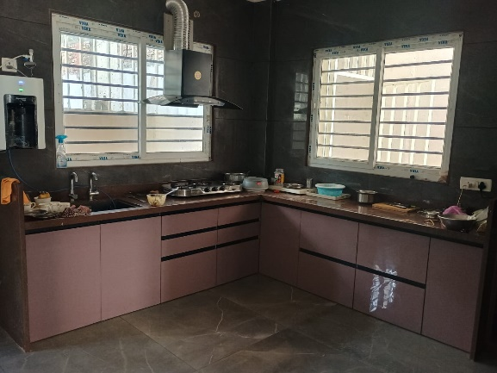
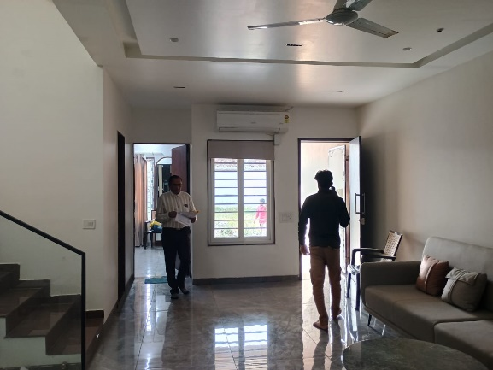

Actual Site Photographs
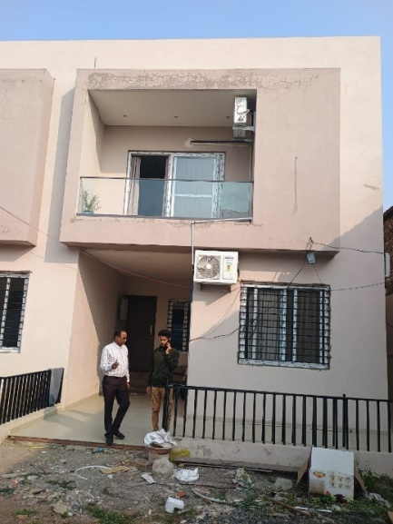
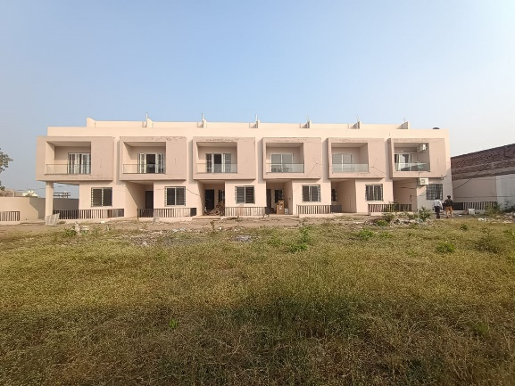
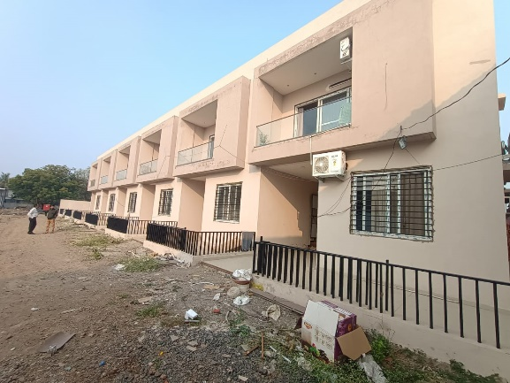
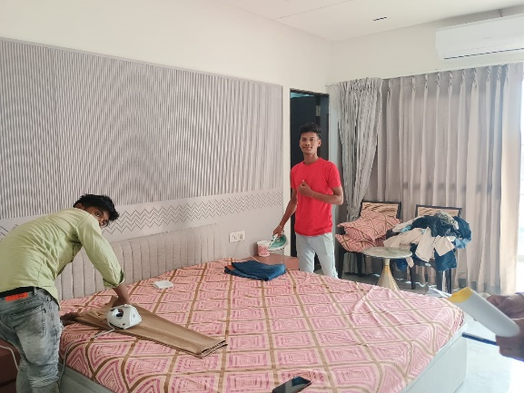
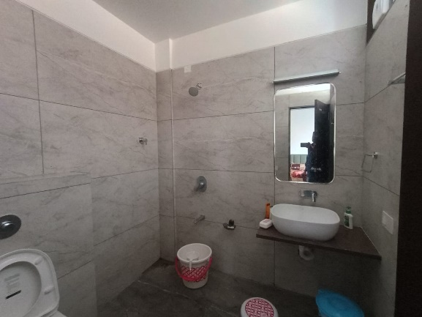
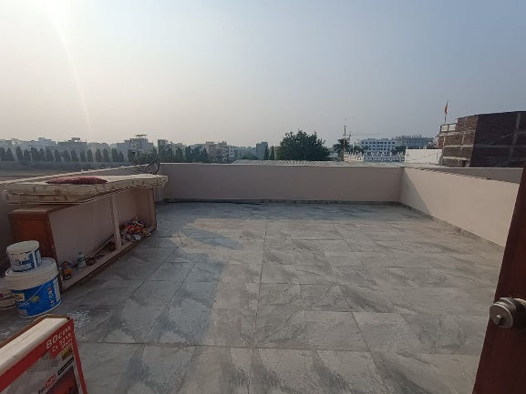
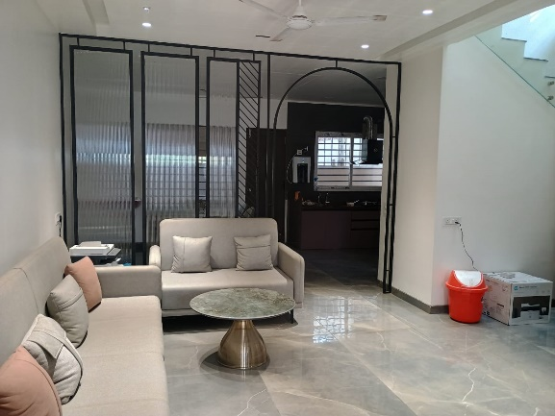
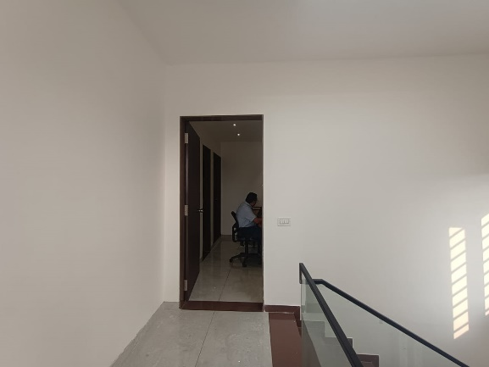
Route Map of the property
Site u/r
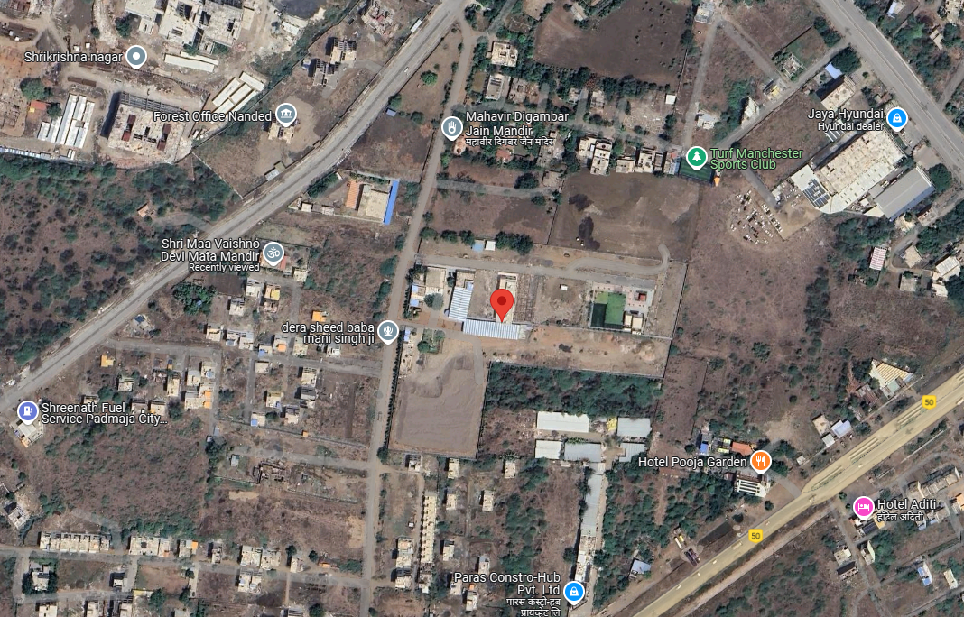

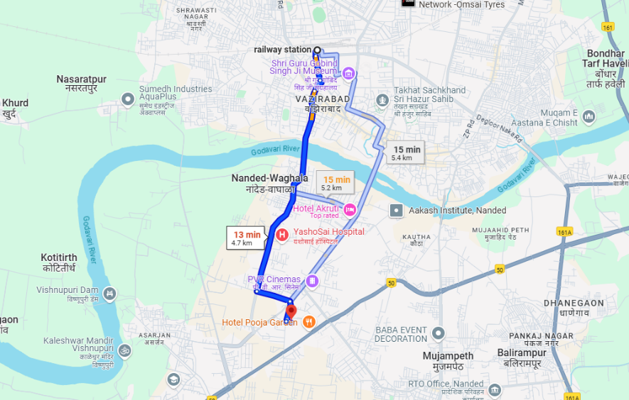

LATITUDE & LONGITUDE: 19°07'29.9"N 77°18'24.7"E

Note:
- Red Pointer shows Approx. Property Location
- Blue line shows Route from Nanded Railway Station (4.7 Km.)

Ready Reckoner Rate

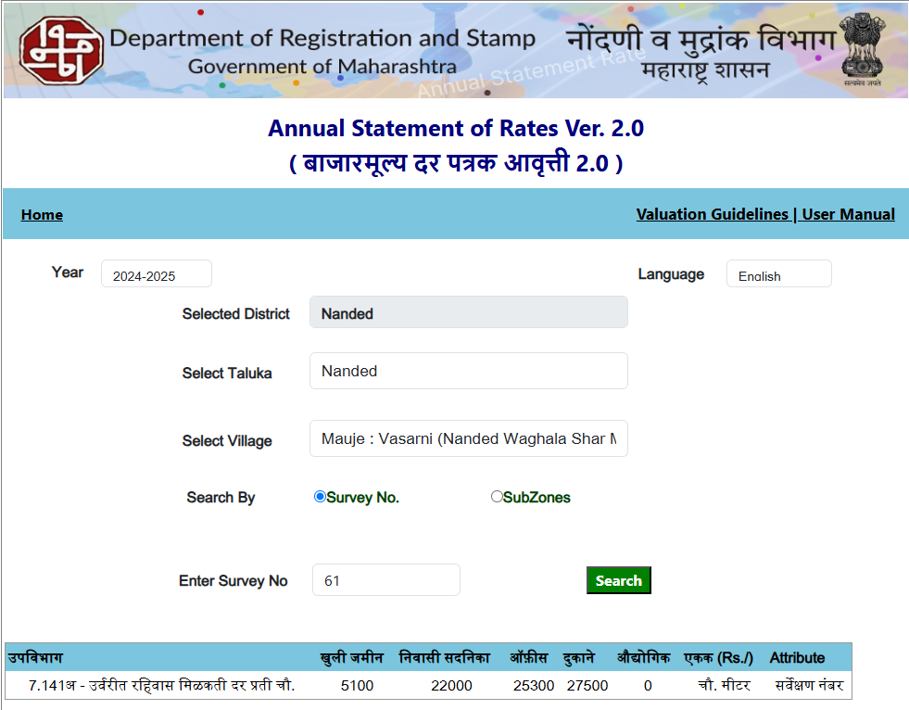

Project Photos

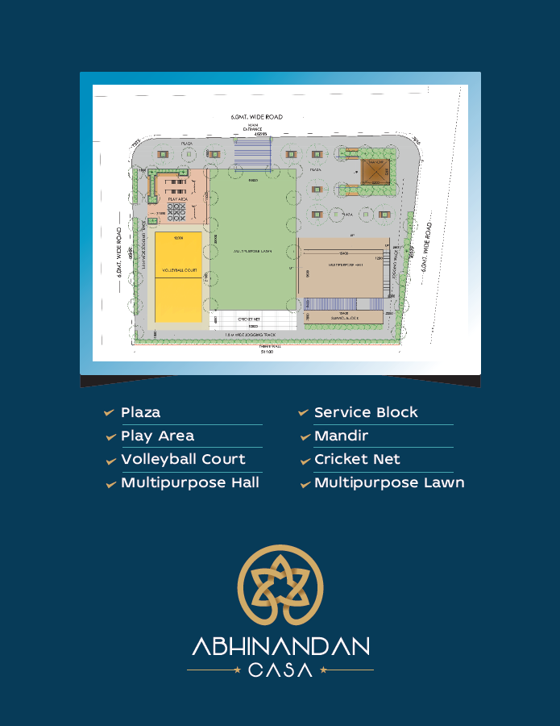



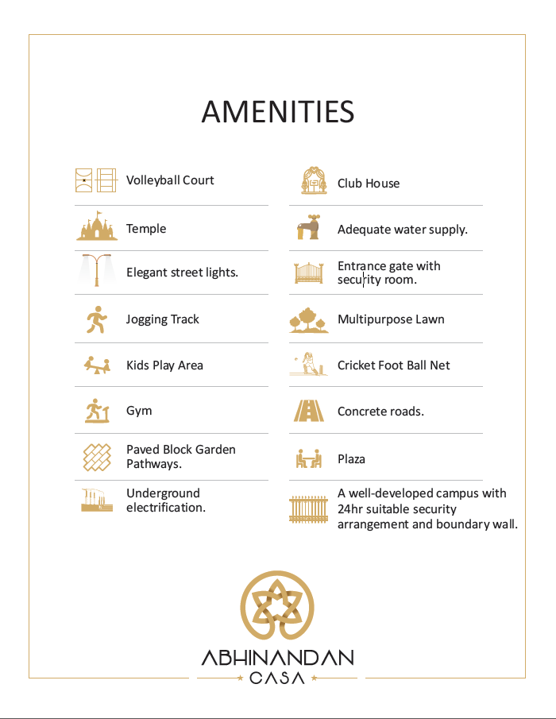
Building Construction Permission
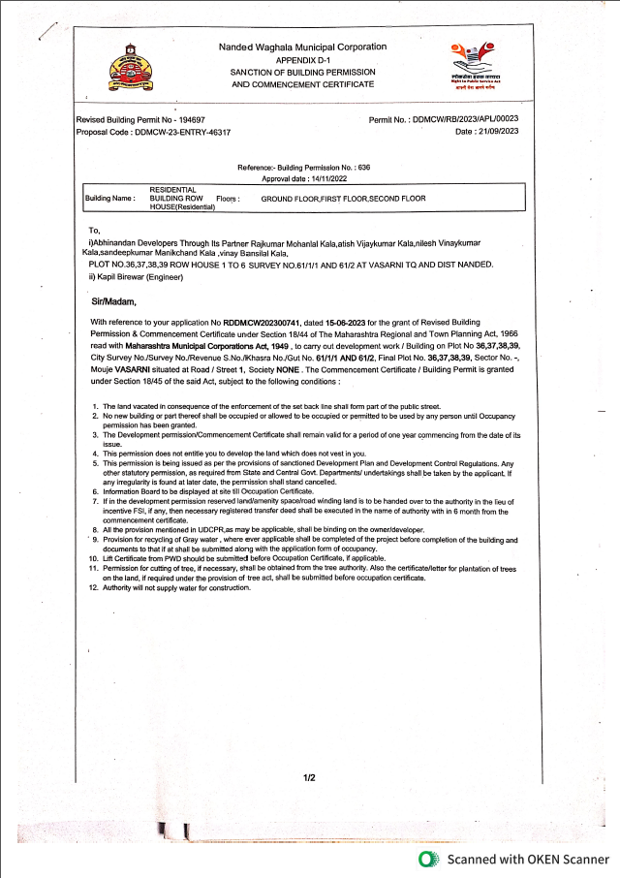

Layout Plan

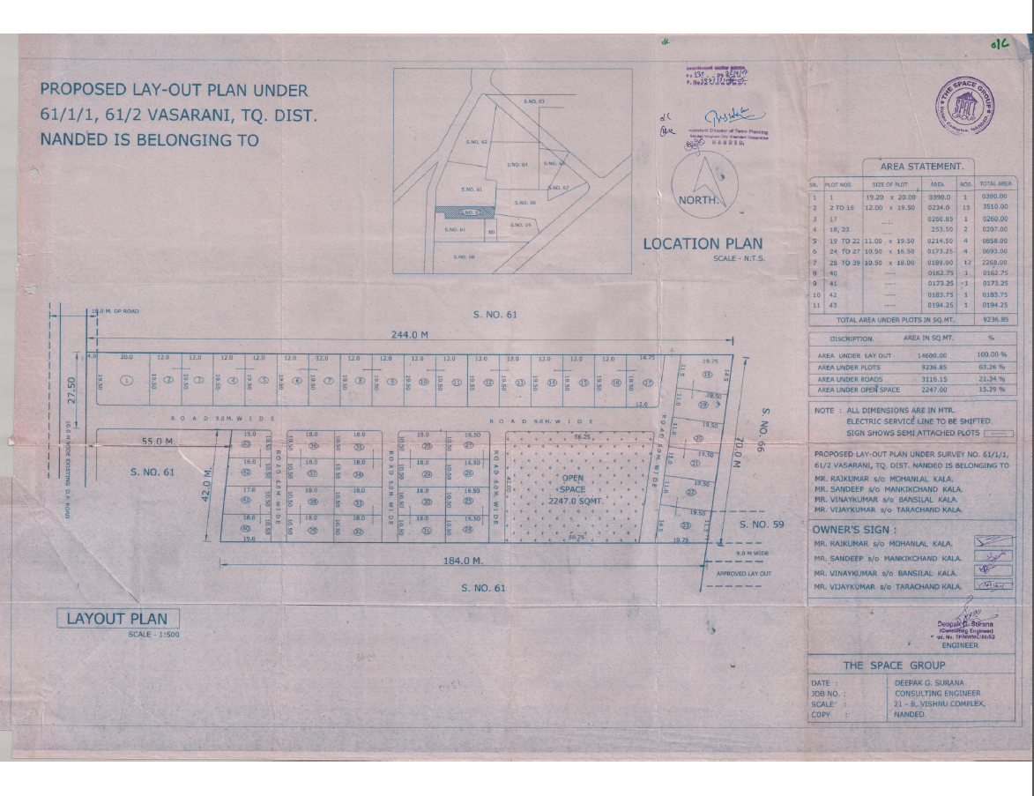

Approved Building Plan
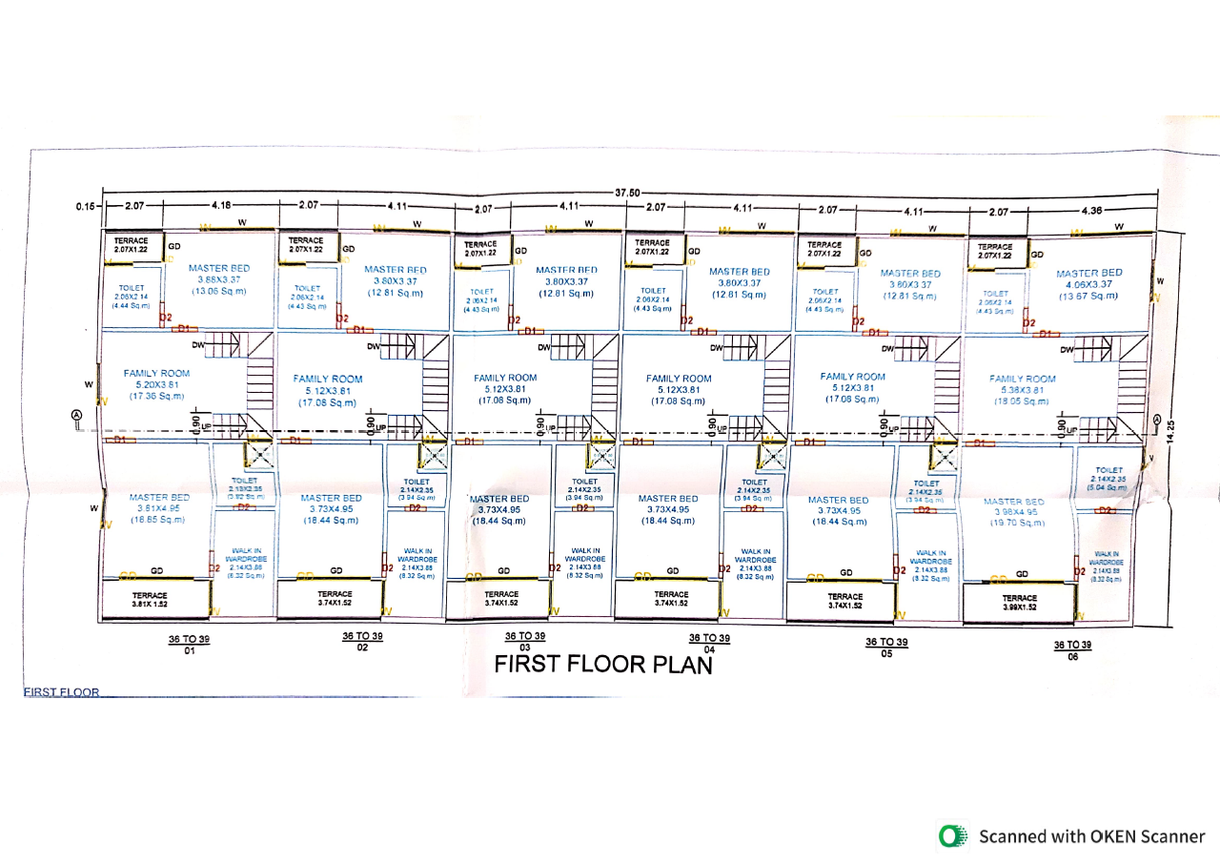
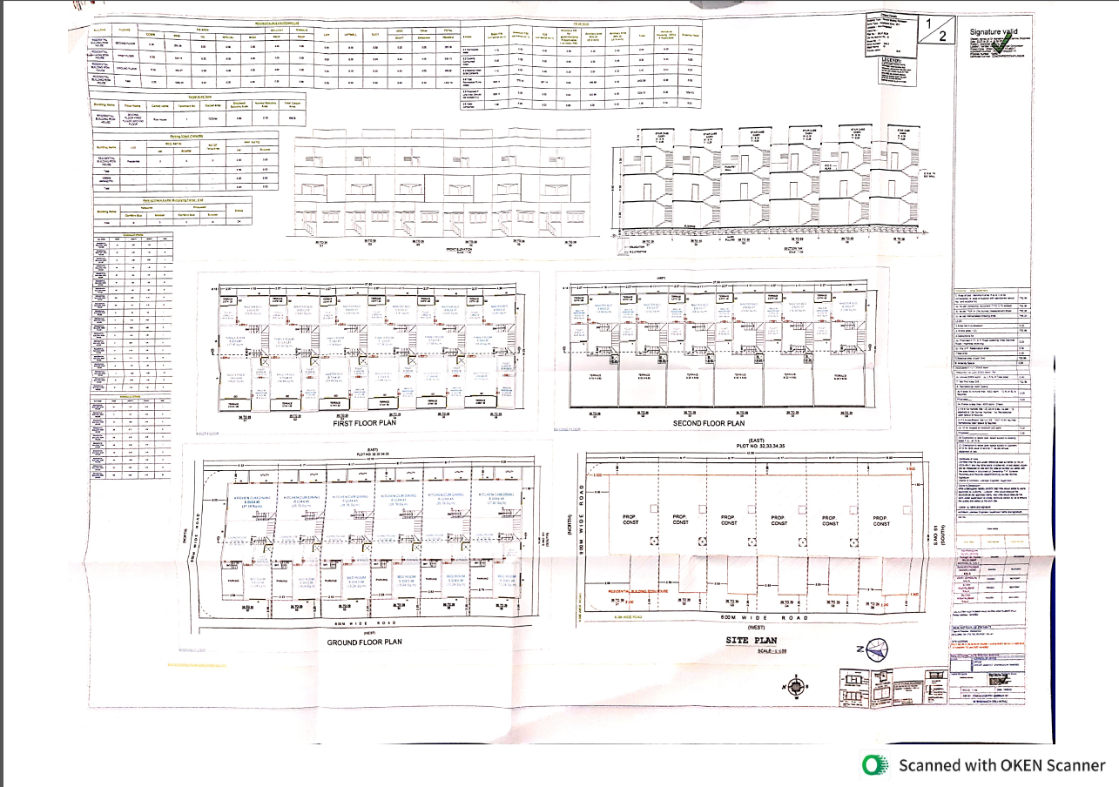
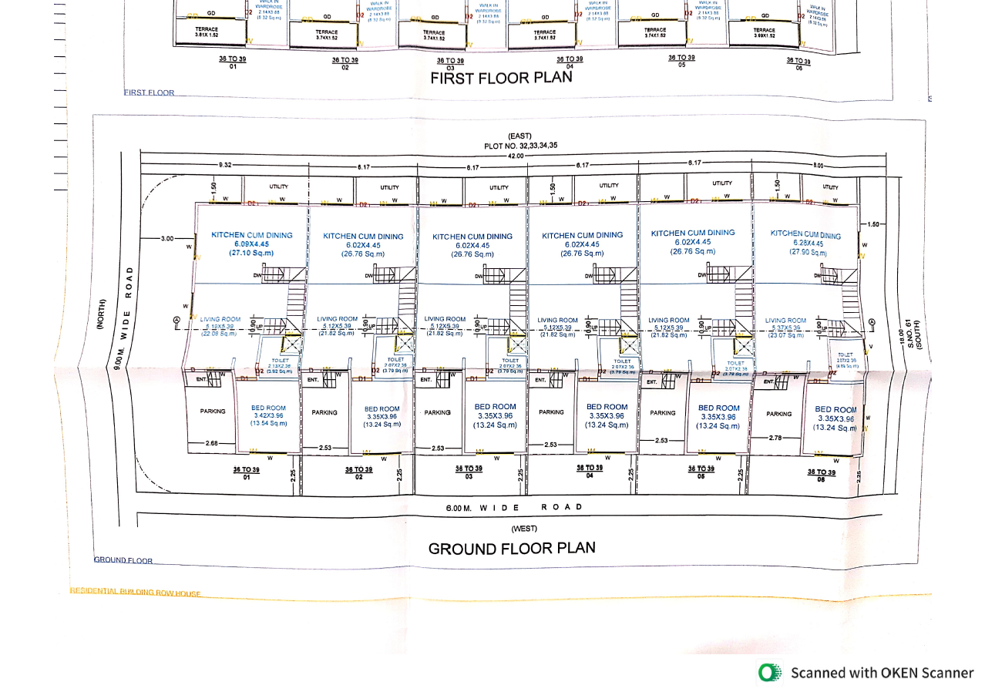
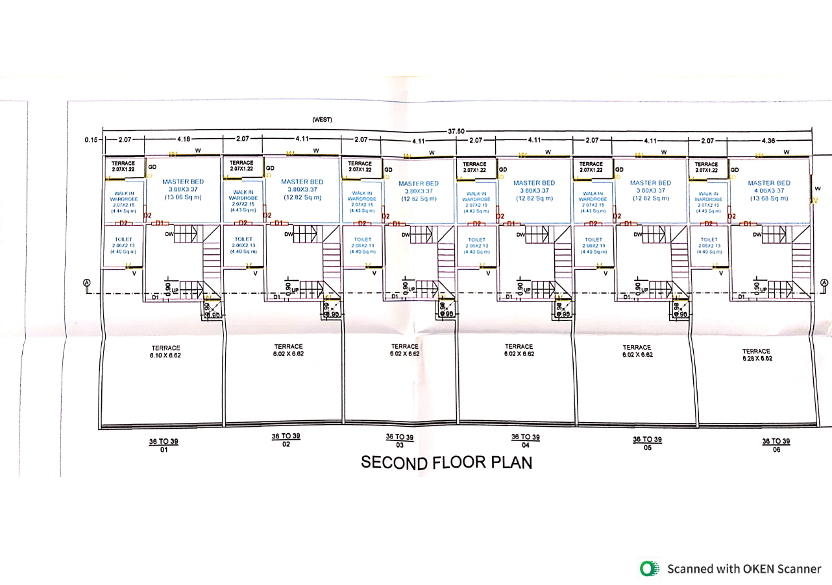

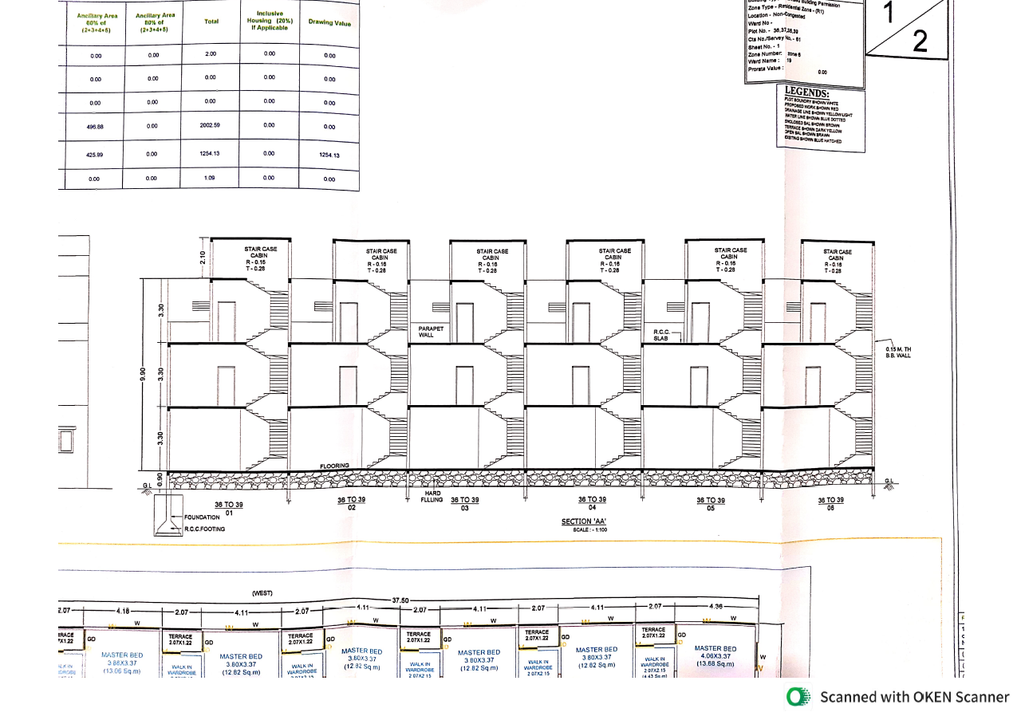
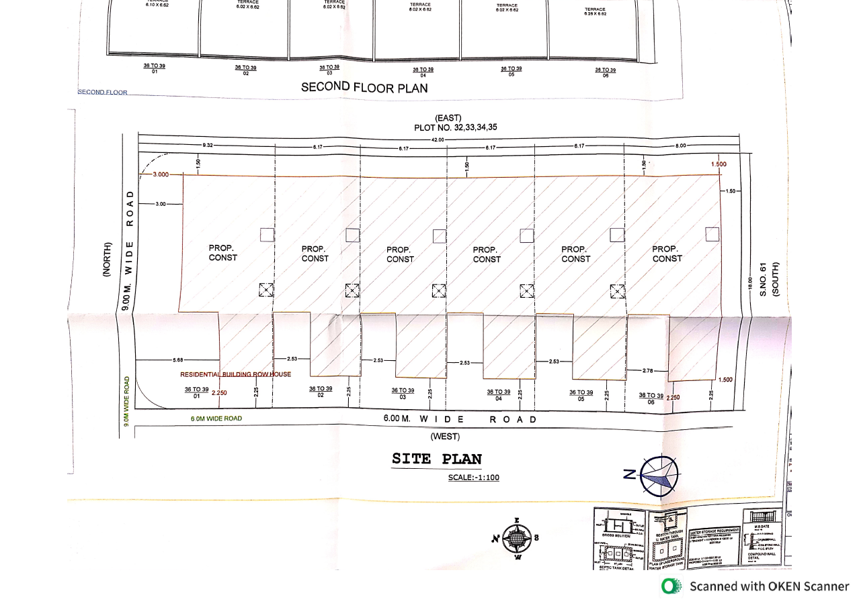
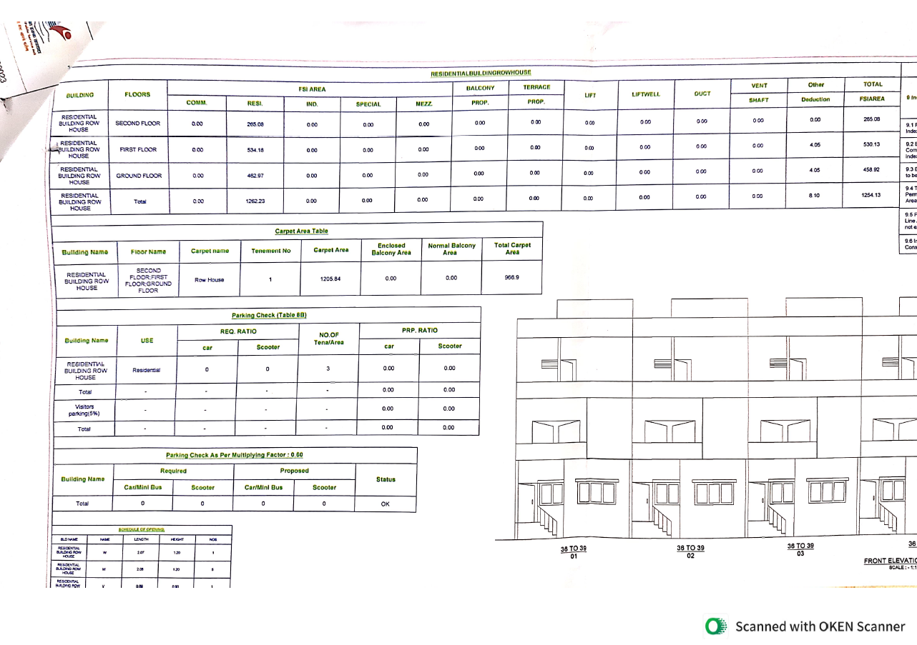
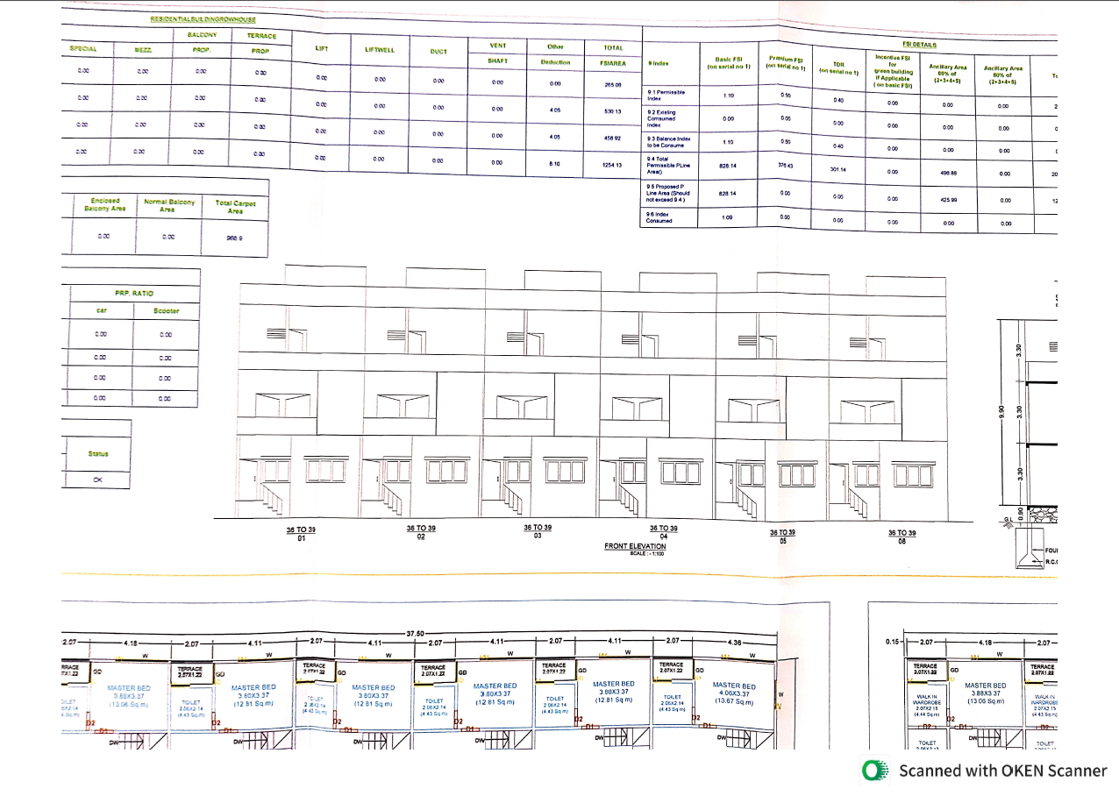
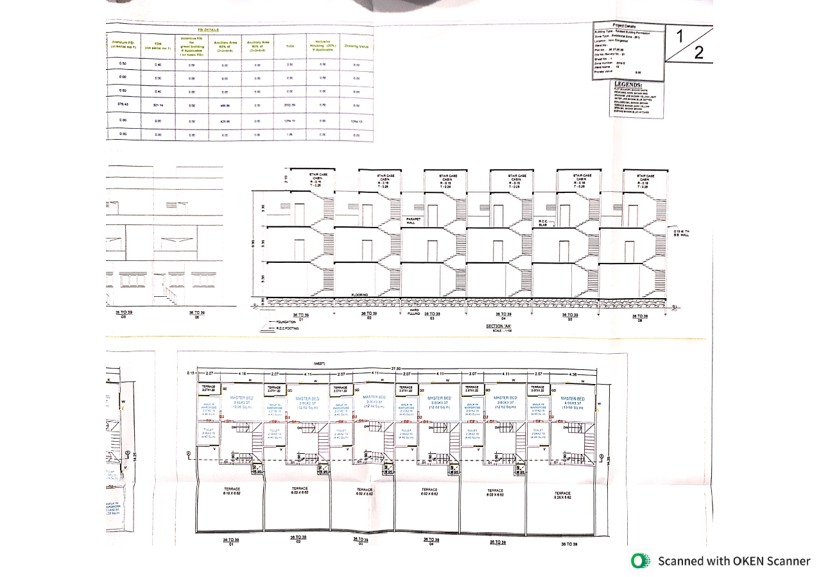
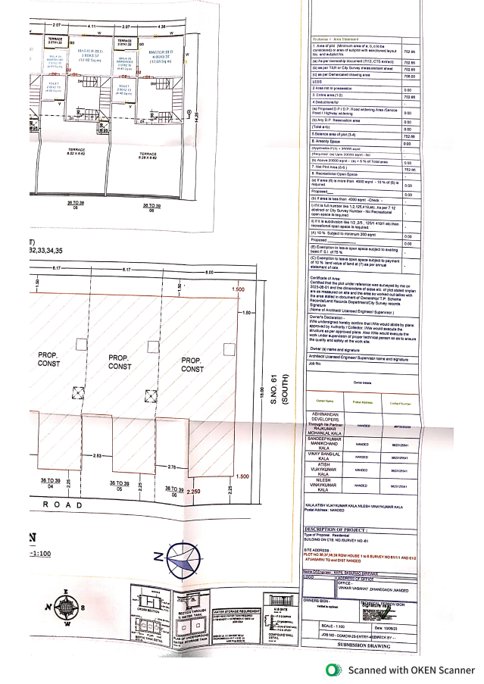

As a result of my appraisal and analysis, it is my considered opinion that the Fair Market Value for this particular above property in the prevailing condition with aforesaid specification is ` 1,18,95,000.00 (Rupees One Crore Eighteen Lakh Ninety Five Thousand Only). The Realizable Value is ` 1,13,00,000.00 (Rupees One Crore Thirteen Lakh Only) and the Distress value is ` 1,01,70,000.00 (Rupees One Crore One Lakh Seventy Thousand Only).

For,Vastukala Consultants (I) Pvt. Ltd.,

Sharadkumar B. Chalikwar
B.E. (Civil), M.E. (Civil), M.Sc. (Real Estate Valuation), M.Sc. (P&M Valuation), FIE (I), FIV, FIWRS
Chairman & Managing Director
Govt. Reg. Valuer
Chartered Engineer (India)
Reg. No. (N) CCIT/1-14/52/2008-09
IBBI Reg.No. IBBI/RV/07/2019/11744
SBI Empanelment No.: SME/TCC/2017-18/942/178

Place: Nanded
Date: 04.12.2024

The undersigned has inspected the property detailed in the Valuation Report dated _______________________

On ____________________. We are satisfied that the fair and reasonable market value of the property is

`_________________________ (Rupees ________________________________________________________

________________________________________only).

Date
Signature
(Name & Designation of the Inspecting Official/s)

Countersigned
(BRANCH MANAGER)

Enclosures
 | Declaration-cum-undertaking from the valuer (Annexure- I) | Attached
 | Model code of conduct for valuer - (Annexure - II) | Attached

(Annexure – I)

DECLARATION FROM VALUERS

I, Sharadkumar Chalikwar son of Shri. Baburao Chalikwar declares that:

- The information furnished in my valuation report dated 04.12.2024 is true and correct to the best of my knowledge and belief and I have made an impartial and true valuation of the property.

- I have no direct or indirect interest in the property valued;

- I/ my authorized representative have personally inspected the property on 23.11.2024. The work is not sub - contracted to any other valuer and carried out by myself.

- I have not been convicted of any offence and sentenced to a term of imprisonment.

- I have not been found guilty of misconduct in my professional capacity.

- I have read the Handbook on Policy, Standards and procedure for Real Estate Valuation, 2011 of the IBA and this report is in conformity to the "Standards" enshrined for valuation in the Part - B of the above handbook to the best of my ability.

- I have read the International Valuation Standards (IVS) and the report submitted to the Bank for the respective asset class is in conformity to the "Standards" as enshrined for valuation in the IVS in "General Standards" and "Asset Standards" as applicable.
- I abide by the Model Code of Conduct for empanelment of valuer in the Bank. (Annexure IV - A signed copy of same to be taken and kept along with this declaration)
- I am valuer registered with Insolvency & Bankruptcy Board of India (IBBI).

- I am Director of the company, who is competent to sign this valuation report.

- Further, I hereby provide the following information

 | Particulars | Valuer comment
 | Background information of the asset being valued; | The property under consideration is being owned by Mr. Deepak Shribhagawan Gaggad.
 | Purpose of valuation and appointing authority | As per the request from State Bank of India, RACPC, New Mondha, Nanded Branch to assess Market value of the property Banking purpose.
 | Identity of the Valuer and any other experts involved in the valuation; | Sharadkumar B. Chalikwar – Regd. Valuer  Akhilesh Yadav – Technical Manager
 | Disclosure of Valuer interest or conflict, if any; | We have no interest, either direct or indirect, in the property valued. Further to state that we do not have relation or any connection with property owner / applicant directly or indirectly. Further to state that we are an independent Valuer and in no way related to property owner / applicant
 | Date of appointment, valuation date and date of report; | Date of Appointment | 23.11.2024
 |  | Valuation Date | 04.12.2024
 |  | Date of Report | 04.12.2024
 | Inspections and/or investigations undertaken; | Physical Inspection done on date 23.11.2024
 | Nature and sources of the information used or relied upon; | - Market Survey at the time of site visit  - Ready Reckoner rates / Circle rates  - Enquiries with Real estate consultants  - Existing data of Valuation assignments carried out by us
 | Procedures adopted in carrying out the valuation and valuation standards followed; | Cost Approach (For building construction)  Comparative Sales Method (For Land component)
 | Restrictions on use of the report, if any; | This valuation is for the use of the party to whom it is addressed and for no other purpose. No responsibility is accepted to any third party who may use or rely on the whole or any part of this valuation. The valuer has no pecuniary interest that would conflict with the proper valuation of the property.
 | Major factors that were taken into account during the valuation; | Current market conditions, demand and supply position, Residential land size, location, sustained demand for Residential land, all round development of commercial and Residential application in the locality etc.
 | Major factors that were not taken into account during the valuation; | Nil
 | Caveats, limitations and disclaimers to the extent they explain or elucidate the limitations faced by valuer, which shall not be for the purpose of limiting his responsibility for the valuation report. | Attached

Assumptions, Disclaimers, Limitations & Qualifications
Value Subject to Change
The subject appraisal exercise is based on prevailing market dynamics as on 4th December, 2024 and does not take into account any unforeseeable developments which could impact the same in the future.
Our Investigations
We are not engaged to carry out all possible investigations in relation to the subject property. Where in our report we identify certain limitations to our investigations, this is to enable the reliant party to instruct further investigations where considered appropriate or where we recommend as necessary prior to reliance. Vastukala Consultants India Pvt. Ltd. (VCIPL) is not liable for any loss occasioned by a decision not to conduct further investigations
Assumptions
Assumptions are a necessary part of undertaking valuations. VCIPL adopts assumptions for the purpose of providing valuation advise because some matters are not capable of accurate calculations or fall outside the scope of our expertise, or out instructions. The reliant party accepts that the valuation contains certain specific assumptions and acknowledge and accept the risk of that if any of the assumptions adopted in the valuation are incorrect, then this may have an effect on the valuation.
Information Supplied by Others
The appraisal is based on the information provided by the client. The same has been assumed to be correct and has been used for appraisal exercise. Where it is stated in the report that another party has supplied information to VCIPL, this information is believed to be reliable but VCIPL can accept no responsibility if this should prove not to be so.
Future Matters
To the extent that the valuation includes any statement as to a future matter, that statement is provided as an estimate and/or opinion based on the information known to VCIPL at the date of this document. VCIPL does not warrant that such statements are accurate or correct.
Map and Plans
Any sketch, plan or map in this report is included to assist the reader while visualising the property and assume no responsibility in connection with such matters.
Site Details
Based on inputs received from Client's representative and site visit conducted, we understand that the subject property is Plot admeasuring Plot Area 1,550.00 Sq. Ft. And Structure thereof. in the name of Mr. Deepak Shribhagawan Gaggad. Further, VCIPL has assumed that the subject property is free from any encroachment and is available as on the date of the appraisal.

Property Title
Based on our discussion with the Client's representative, we understand that the subject property is owned by Mr. Deepak Shribhagawan Gaggad. For the purpose of this appraisal exercise, we have assumed that the subject property has a clear title and is free from any encumbrances, disputes and claims. VCIPL has made no further enquiries with the relevant local authorities in this regard and does not certify the property as having a clear and marketable title. Further, no legal advice regarding the title and ownership of the subject property has been obtained for the purpose of this appraisal exercise. It has been assumed that the title deeds are clear and marketable.

Environmental Conditions
We have assumed that the subject property is not contaminated and is not adversely affected by any existing or proposed environmental law and any processes which are carried out on the property are regulated by environmental legislation and are properly licensed by the appropriate authorities.
Area
Based on the information provided by the Client's representative, we understand that the Plot admeasuring area Plot Area 1,550.00 Sq. Ft. And Structure thereof.

Condition & Repair
In the absence of any information to the contrary, we have assumed that there are no abnormal ground conditions, nor archaeological remains present which might adversely affect the current or future occupation, development or value of the property. The property is free from rat, infestation, structural or latent defect. No currently known deleterious or hazardous materials or suspect techniques will be used in the construction of or subsequent alteration or additions to the property and comments made in the property details do not purport to express an opinion about, or advise upon, the condition of uninspected parts and should not be taken as making an implied representation or statement about such parts
Valuation Methodology
For the purpose of this valuation exercise, the valuation methodology used is Direct Comparison Approach Method and proposed Highest and Best Use model is used for analysing development potential.
The Direct Comparison Approach involves a comparison of the property being valued to similar properties that have actually been sold in arms - length transactions or are offered for sale. This approach demonstrates what buyers have historically been willing to pay (and sellers willing to accept) for similar properties in an open and competitive market and is particularly useful in estimating the value of the flat and properties that are typically traded on a unit basis.
In case of inadequate recent transaction activity in the subject micro-market, the appraiser would collate details of older transactions. Subsequently, the appraiser would analyse rental / capital value trends in the subject micro-market in order to calculate the percentage increase / decrease in values since the date of the identified transactions. This percentage would then be adopted to project the current value of the same.
Where reliance has been placed upon external sources of information in applying the valuation methodologies, unless otherwise specifically instructed by Client and/or stated in the valuation, VCIPL has not independently verified that information and VCIPL does not advise nor accept it as reliable. The person or entity to whom the report is addressed acknowledges and accepts the risk that if any of the unverified information in the valuation is incorrect, then this may have an effect on the valuation.
Not a Structural Survey
We state that this is a valuation report and not a structural survey
Other
All measurements, areas and ages quoted in our report are approximate
Legal
We have not made any allowances with respect to any existing or proposed local legislation relating to taxation on realization of the sale value of the subject property. VCIPL is not required to give testimony or to appear in court by reason of this appraisal report, with reference to the property in question, unless arrangement has been made thereof. Further, no legal advice on any aspects has been obtained for the purpose of this appraisal exercise

.

Property specific assumptions
Based on inputs received from the client's representative and site visit conducted, we understand that the subject property is Plot Area 1,550.00 Sq. Ft. And Structure thereof.

ASSUMPTIONS, CAVEATS, LIMITATION AND DISCLAIMERS
- We assume no responsibility for matters of legal nature affecting the property appraised or the title thereto, nor do we render our opinion as to the title, which is assumed to be good and marketable.
- The property is valued as though under responsible ownership.
- It is assumed that the property is free of liens and encumbrances.
- It is assumed that there are no hidden or unapparent conditions of the subsoil or structure that would render it more or less valuable. No responsibility is assumed for such conditions or for engineering that might be required to discover such factors.
- There is no direct/ indirect interest in the property valued.
- The rates for valuation of the property are in accordance with the Govt. approved rates and prevailing market rates
- The impact on real estate market due to pandemic Covid-19 is not considered for this valuation report

DEFINITION OF VALUE FOR THIS SPECIFIC PURPOSE

This exercise is to assess Fair Market Value of the property under reference as on 4th December 2024.
The term Fair Market Value is defined as

“The most probable price, as of a specified date, in cash, terms equivalent to cash, or in other precisely revealed terms for which the specified property rights would sell after reasonable exposure in a competitive market under all conditions requisite to a fair sale, with the buyer and seller each acting prudently knowledgeably and for self-interest assuming that neither is under undue duress”.
Fundamental assumptions and conditions presumed in this definition are:

1. Buyer and seller are motivated by self-interest.
2. Buyer and seller are well informed and are acting prudently.
3. The property is exposed for a reasonable time on the open market.
4. Payment is made in cash or equivalent or in specified financing terms.

UNDER LYING ASSUMPTIONS
1. We assume no responsibility for matters of legal nature affecting the property appraised or the title thereto, nor do we render our opinion as to the title, which is assumed to be good and marketable.
2. The property is valued as though under responsible ownership.
3. It is assumed that the property is free of liens and encumbrances.
4. It is assumed that there are no hidden or unapparent conditions of the subsoil or structure that would render it more or less valuable. No responsibility is assumed for such conditions or for engineering that might be required to discover such factors.

For, Vastukala Consultants (I) Pvt. Ltd.

Sharadkumar B. Chalikwar
B.E.(Civil), M.E.(Civil), M.Sc. (Real Estate Valuation), M.Sc. (P&M Valuation),FIE(I), FIV, FIWRS
Chairman & Managing Director
Govt. Reg. Valuer
Chartered Engineer (India)
Reg. No. (N) CCIT/1-14/52/2008-09
IBBI Reg.No. IBBI/RV/07/2019/11744

