Vastu/Nashik/07/2024/0010070/2307330
22/7-334-RPBS
Date: 03.12.2024

To, `
The Branch Manager,
Bank of Baroda
Regional Office Nashik Road Branch
BSNL Building, Datta Mandir Road, Nashik Road,
Nashik -422 101, State - Maharashtra, Country - India.

Sub: Vetting of Extra Amenities

Sir,

With reference to above subject, we have evaluated the Extra Amenities for Residential Flat No. 202, 2nd Floor, "Dwarkadhish Residency", Near The SSK World Club, Plot No. 04, Pathardi-Gaulane Rd, Village - Pathardi, Taluka - Nashik, District - Nashik, Nashik, Pin Code - 422 010, State - Maharashtra, India belongs to Shri. Pavan Bhikan Varule & Shri. Kalpesh Bhikan Varule, Sau. Sunanda Bhikan Varule.

We have verified the rates quoted as per current market rates. Details of Extra Amenities considered as per copy of Agreement for Extra Amenities issued by to Shri. Pavan Bhikan Varule & Shri. Kalpesh Bhikan Varule, Sau. Sunanda Bhikan Varule (First Party) Shri. Kamlesh Suresh Suryawnshi (Second Party) received on dated 27.09.2024. The Extra Amenities amount is Rs.9,50,000/- (Rupees Nine Lakh Fifty Thousand Only.)

The said Cost Vetting Certificate is valid upto next 6 months Only.

Thanking you

Sincerely yours

Manoj B. Chalikwar
Registered Valuer
Chartered Engineer (India)
Reg. No. CAT-I-F-1763
Reg. No. IBBI/RV/07/2018/10366
BOB Empanelment No.: ZO:MZ:ADV:46:941
Encl: Valuation report.

Agreement of Extra Amenities
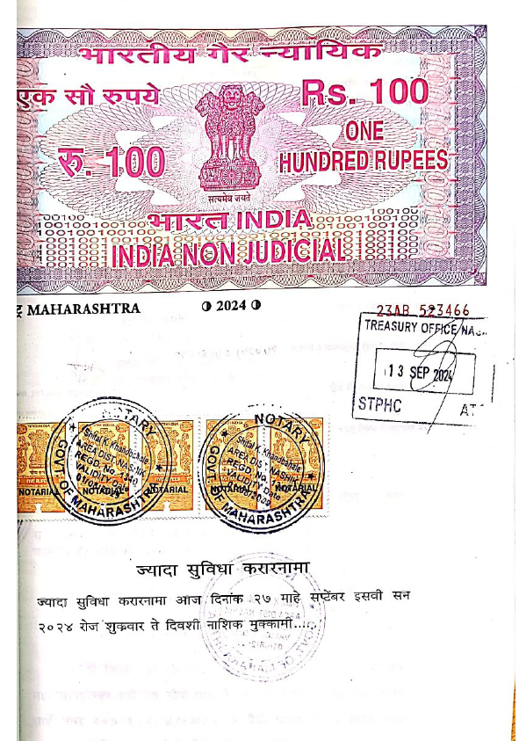
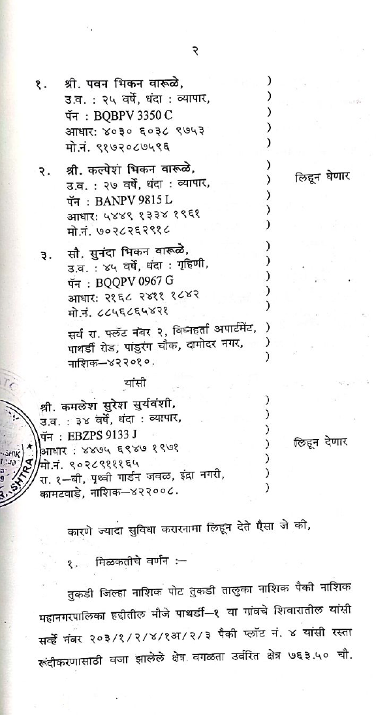

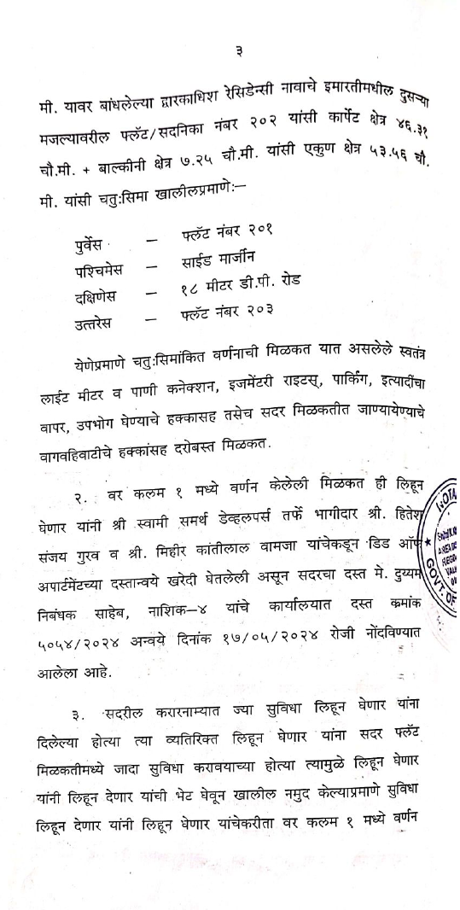
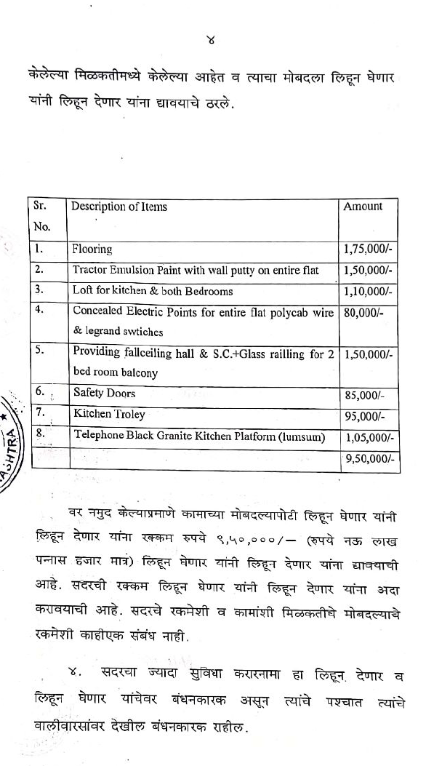

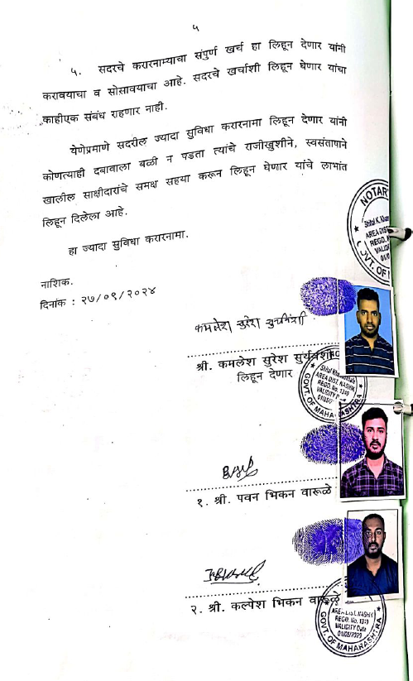
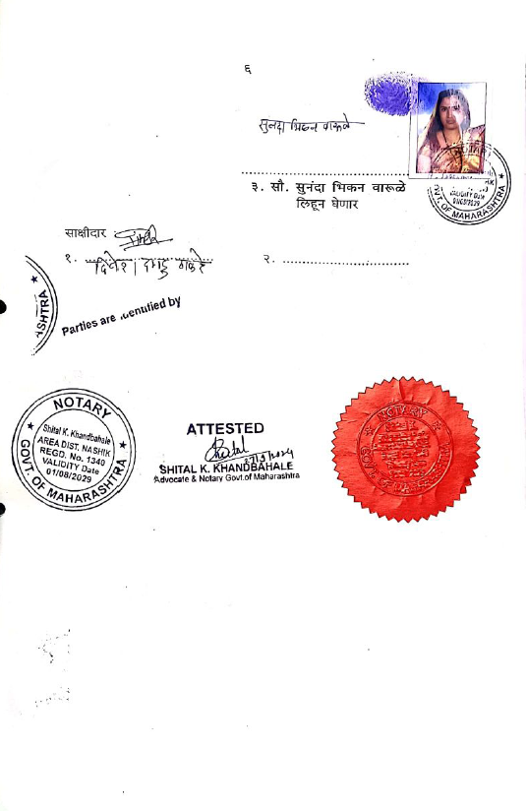

The Extra Work amount is Rs.9,50,000/- (Rupees Nine Lakh Fifty Thousand Only.)

